**Computer Graphics Class Assignment3**

2017029470 김종원

1. **Which requirement you implemented**
2. **Manipulate the camera in the same was as in ClassAssignment1**

Toggle perspective projection / orthogonal projection by pressing ‘v’ key.

Orbiting, panning, and zooming are implemented. (Also reference grid plane.)

1. **Load a bvh file and render it**
2. Open a bvh file by drag-and-drop to my viewer window.

I use glfwSetDropCallback to open a bvh file. When I drop a bvh file into a window, only one bvh file is rendered at a time.

1. Read the bvh file and render the “skeleton” (t-pose) of the motion when I load the file by drag-and-drop.

I read the bvh file and renders the t-pose skeleton with no rotation being applied to transitional joints and rotational joints using hierarchical structure. I connected parent joints with child joints and end effector joint with the end site.

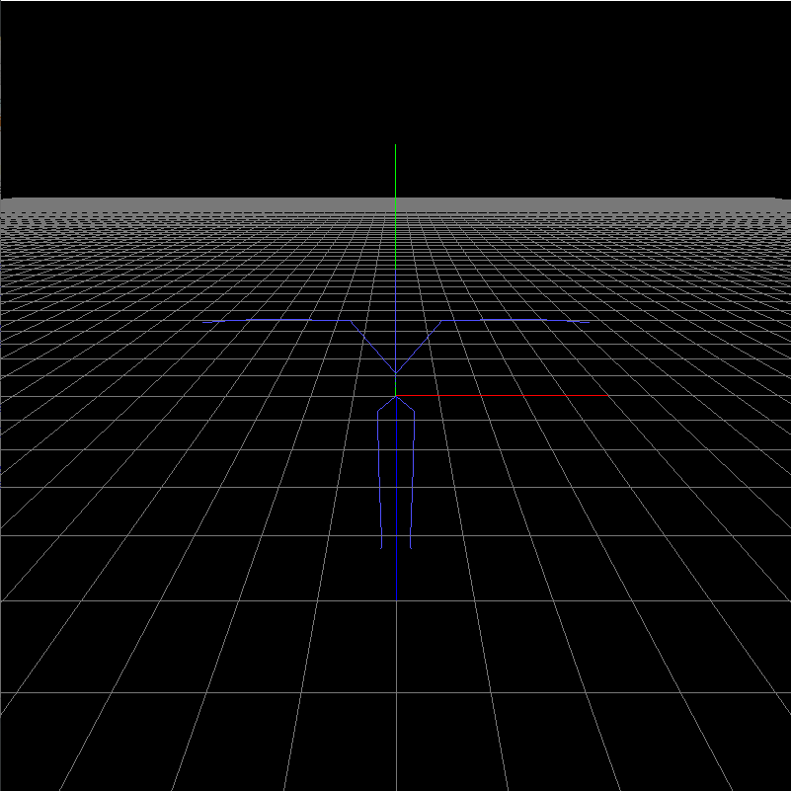 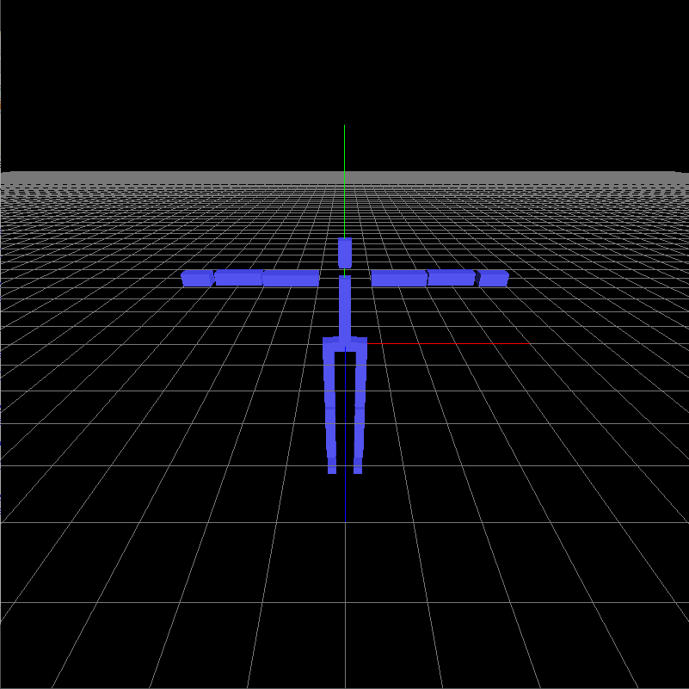 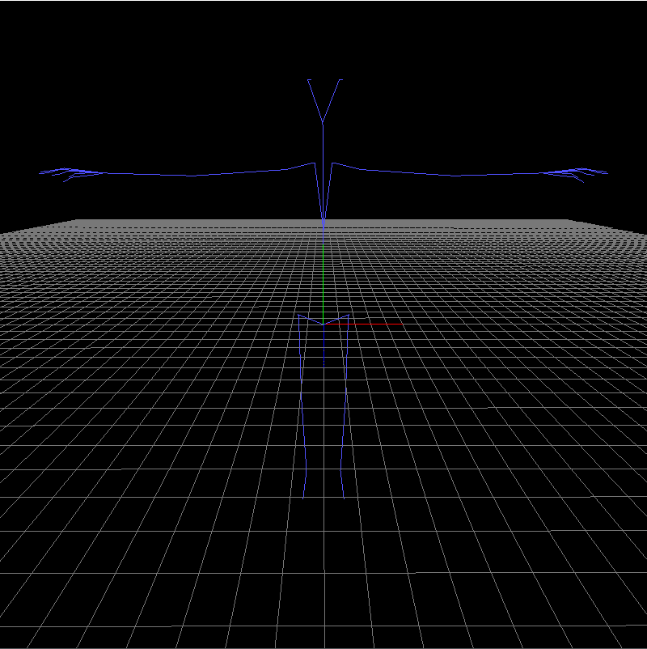

When the offset of the bvh file is large and it is difficult to see it with the bvh viewer window, I scaled the offset and degree of transition.

1. Animate the loaded motion if I press the <spacebar> key.

I draw the frame of the motion as time passed. After the last frame is drawn, the motion is automatically played back by redrawing from the first frame to the last frame.

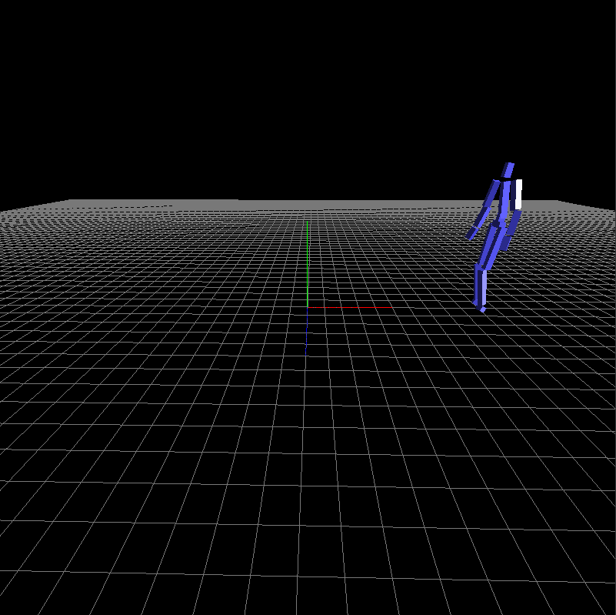 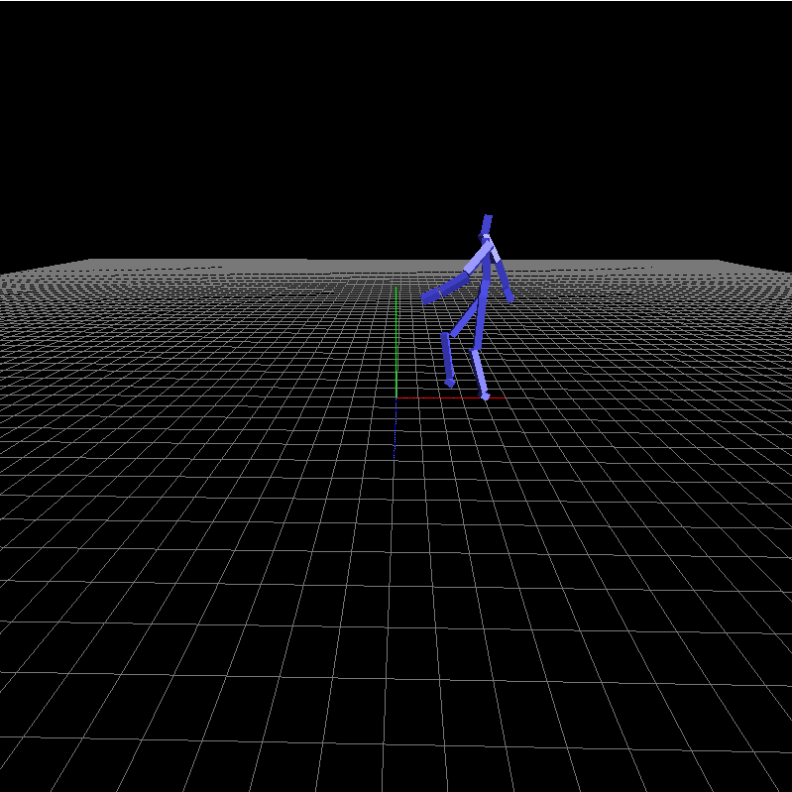 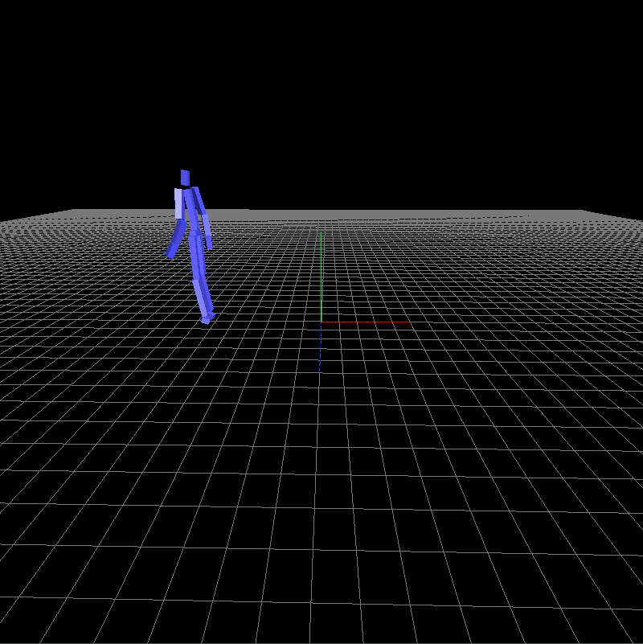

1. When open a bvh file, print out the following information of the bvh file to stdout.
2. 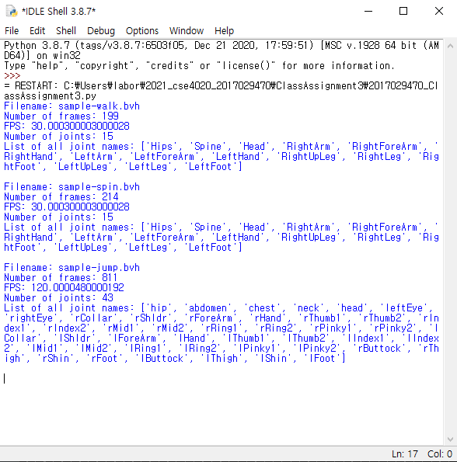file name
3. number of frames
4. FPS (which is 1/FrameTime)
5. Number of joints (including root)
6. List of all joint names
7. **(Extra credits)** Use a box to draw each body part instead of a line segment

I draw each body with boxes instead of line segment. And the boxes are rendered with shading and lighting settings. I only implement this ‘sample-walk.bvh’ file, not ‘sample-spin.bvh’.

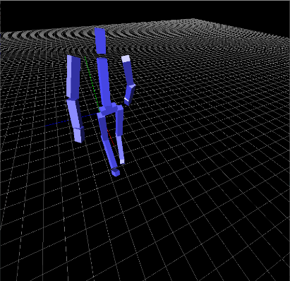 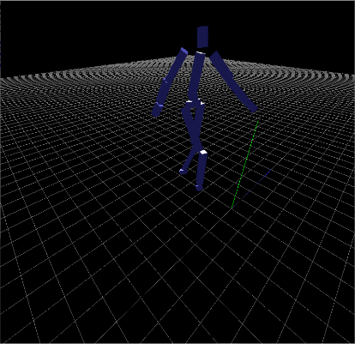 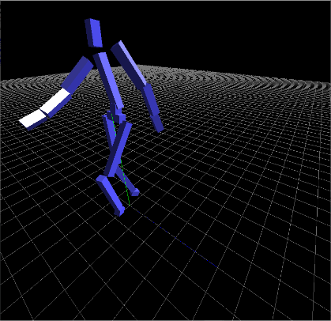

1. **A hyperlink to the video uploaded to internet video streaming services**

I downloaded the bvh files from, <http://motion.hahasoha.net/>

<https://youtu.be/MZE2-fQvpaY>