**Lab04: Traffic Light Controller**

2021-19655 조원우

**Screenshot of Simulation Waveforms & TCL console**

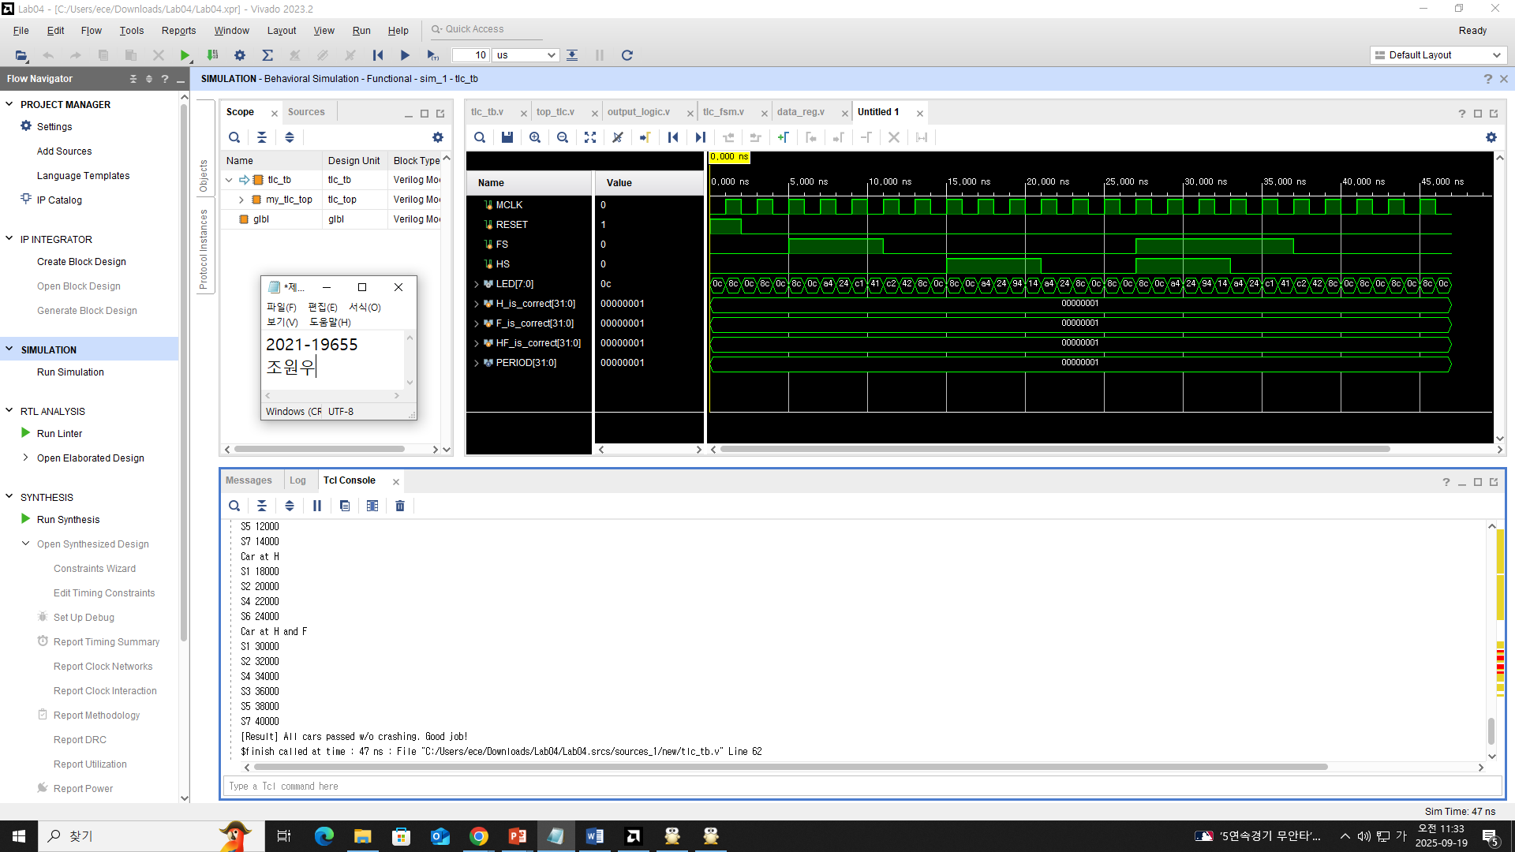

**Screenshot of Implementation Results**  
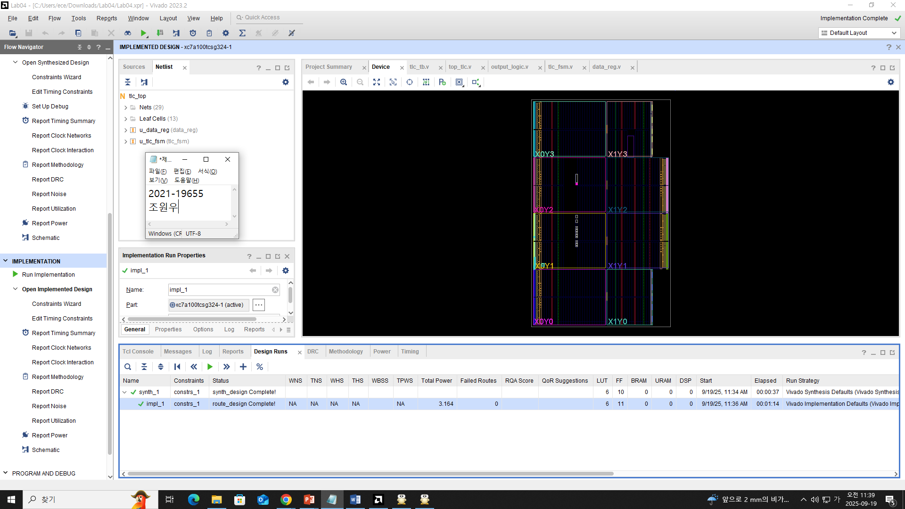

**The file “tlc_fsm.v” was attached: FSM implemented by case logic**