

**CS 1632 Software Quality Assurance**

**Deliverable 4**

Your Name:

(Note: this is an individual project. No groups allowed.)

1. **Optimized Feature 1**
   1. Write the name of the feature optimized (the label on the button)
   2. Write the name(s) of the method(s) you refactored to optimize this feature
   3. Insert a screenshot of VisualVM CPU profiling ***after*** optimizing Feature 1. Please include only the “Hot spots” window in the screenshot. See below example. This is the profile after pressing the “Load” button. You can see that there was 1 invocation of MainPanel.load and 50 invocations of Cell.setAlive. The durations were too short to measure reliably (this is probably not a feature you want to focus on).

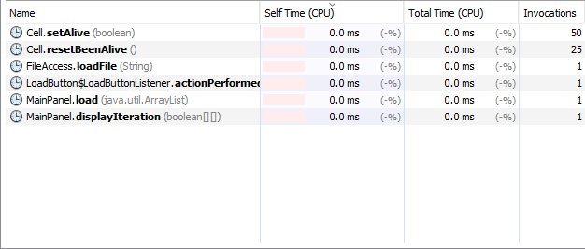

1. **Optimized Feature 2**
   1. Write the name of the feature optimized (the label on the button)
   2. Write the name(s) of the method(s) you refactored to optimize this feature
   3. Insert a screenshot of VisualVM CPU profiling ***after*** optimizing Feature 2. Please show only the profile for Feature 2 (do not invoke Feature 1 while profiling). Please include only the “Hot spots” window in the screenshot, as before.