Build a Wireless Sensing Unit to Integrate Sensor Data with Virtual Reality for Balance Training

**Task 1:**

The goal of this task is to build a sensor unit that can be attached or strapped to a human and with any movement, the sensor unit wirelessly transmits (Bluetooth preferred) the sensor data to a program (e.g., mixed reality) that can process and visualize the sensor data. The sensor unit is a combination of the actual sensor (9-DoF), Bluetooth module, battery, and any other required components. The goals of this task are:

1. Research on commonly available 9-DoF sensors (Accelerometer, Gyroscope, and Magnetometer) and identify a prime candidate.
   1. We previously tried LSM9DS1 - https://learn.adafruit.com/adafruit-lsm9ds1-accelerometer-plus-gyro-plus-magnetometer-9-dof-breakout/overview. We are looking to see if there are any other sensors which can fit our needs.
   2. We would like you to consider BNO055. https://learn.adafruit.com/adafruit-bno055-absolute-orientation-sensor/overview
      1. Other suggestions are welcomed.
2. Calibrate the sensor
3. Write the software that reads the sensor data and send the data via Bluetooth to another program (python or C++ or Java) to process it.

It is preferred that the software that reads the sensor data to be persisted in the sensor unit. We do not want to upload the software to the sensor unit every time we want to collect the data.

1. Write a program (python or C++ or Java) that accepts and processes the sensor data.
2. The data needs to be transmitted from the sensor to the program that is processing the sensor data with minimal latency.
3. Optional - Design (3-D printer schema) a container to hold the sensor unit that is modular and easy to strap to a human.

The Figure 1 visualizes the goal of this task. The “blue box” is the sensor unit attached to a human. When the human makes any movement such as a sway to the left or right, or bend back or front, the sensor data is communicated to the processing program.

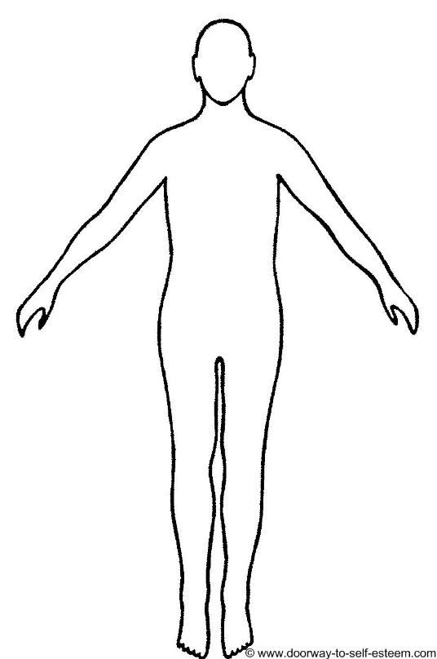

**Figure 1:** Wearable sensor positioned on the lumbar region of the human subject. Sensor data is communicated to processing software.

**Task 2:**

Following building and testing the sensor unit in Task 1, this task is focused on developing a virtual reality (VR) program to integrate the sensor data with the environment to provide biofeedback during a proof-of-concept balance training intervention in healthy individuals. Specifically, this task necessitates streaming sensor data in real-time obtained from a sensor unit on the lumbar region of the human subject (Figure 1) into a VR environment. The VR environment will consist of a cursor, representing the sensor on the individual, and a series of targets that the individual will interact with via the cursor (Figure 2). Additionally, the protocol will involve manipulating the sensor feedback to create a sensory perturbation (i.e. visuomotor rotation). A visuomotor rotation alters the trajectory of the cursor (e.g. 45 degree rotation) such that the user must alter their movements to reach the designated target (Figure 3). The goals of this task are:

* + - 1. Design and develop VR environment based on the researcher’s requirements
      2. Integrate streaming sensor data in real-time with the VR environment

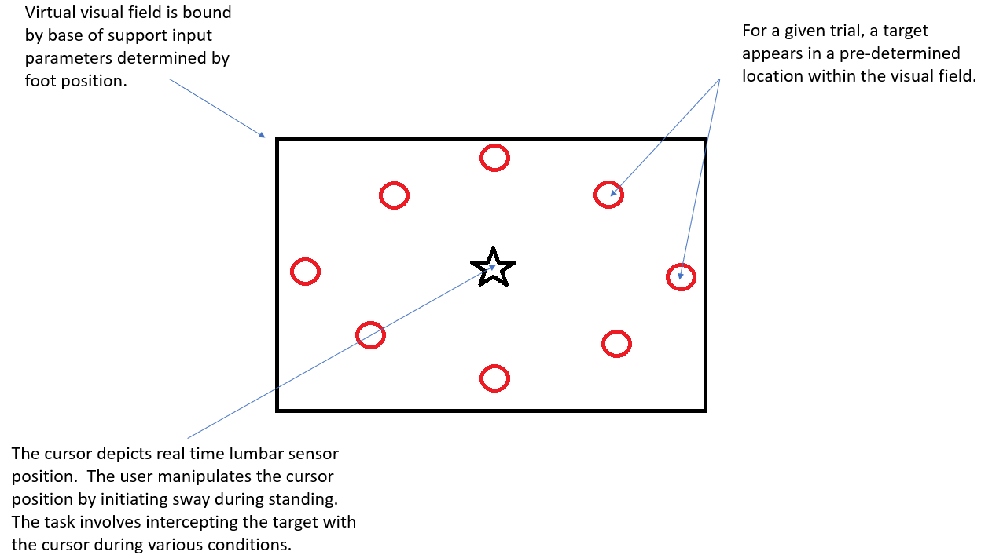

**Figure 2**: Components of the virtual environment.

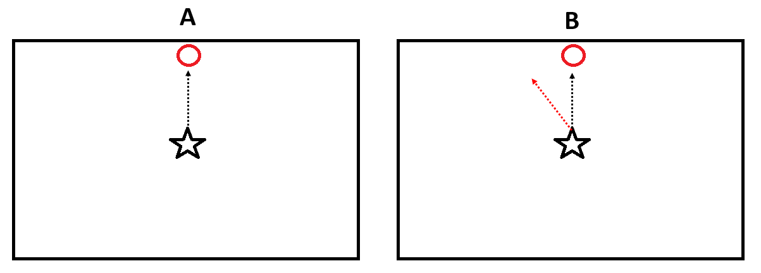

**Figure 3**: Target intercepting task in normal and perturbed feedback. A – represent a normal feedback condition, where the visual feedback matches the sway direction of the subject (black arrow). B – represents a visuomotor rotation, where the visual feedback of the cursor (red arrow) is rotated (e.g. 45 degrees) from the actual movement trajectory (black arrow), requiring corrective response by the subject to intercept the target.