CMP-5036A Search Engine Project: Research Log Document
Student Name or ID: Kurt Canillas
Project Domain: Video Games
Date Started: 1st January 2026
Log Introduction & Domain Rationale:
A. Project Aim:

The goal for this search engine project is to design, implement, and evaluate a Python-based Information retrieval system capable of indexing a collection of real-world HTML documents and returning a ranked list of relevant results for user queries. The system is designed to support interactive querying through command-line interface and to demonstrate the complete Information Retrieval pipeline, including document parsing, tokenisation, inverted indexing, ranking, and evaluation.

Alongside building a working search engine, I will also be conducting experiments to critically evaluate different retrieval techniques. This includes comparing baseline and advanced ranking models (TF-IDF and BM25), analysing the impact of preprocessing techniques such as stop-word removal, stemming, and lemmatization, and assessing extensions such as field weighting. The effectiveness of these retrieval techniques will be measured using evaluation metrics, primarily Precision@10 and Recall@10, across a set of predefined queries.

Overall, my project aims to provide a practical and experimental understanding of how different Information Retrieval techniques affect search quality, and to justify design decisions using evidence rather than assumptions.

B. Domain Selection Justification:

Explain your choice of dataset. Why was this domain the most suitable for your project's technical goals? Consider data structure, potential for implementing ranking algorithms, and opportunities for advanced features.
The Videogames dataset was selected as the domain for this project due to its strong alignment with both the technical and experimental goals of the assignment. The dataset consists of 727 HTML documents representing videogame-related web pages, alongside a labelled CSV file containing structured metadata such as publisher and genre. This combination of semi-structured HTML content and structured metadata makes the domain particularly suitable for Information Retrieval experimentation.
From a technical perspective, the dataset exhibits realistic challenges commonly encountered in web search, including noisy HTML markup, navigation elements, mixed use of letters, numbers, punctuation, and accented characters (e.g. “Pokémon”), and variable document lengths. These characteristics provide an appropriate testbed for implementing and evaluating preprocessing techniques, tokenisation strategies, and ranking algorithms such as TF-IDF and BM25.
The domain also supports a wide range of query types, including known-item searches (specific game titles), broad semantic queries (e.g. game genres), and metadata-driven queries (e.g. publisher-based searches). This diversity allows for meaningful comparative experiments and highlights the strengths and limitations of different retrieval models. In particular, the presence of clear document fields such as titles and body text enables advanced experiments such as field weighting, while the availability of publisher and genre metadata supports defensible relevance judgements without requiring subjective manual labelling.
Finally, the moderate size of the dataset allows for full indexing and repeated experimentation without performance constraints, making it well suited for controlled evaluation and iterative development. As a result, the videogames domain provides both practical realism and sufficient structure to explore core and advanced Information Retrieval techniques in depth

Research & Development Entries:
Entry #: 1
Date: 01/01/2026
1. Focus of this Session:
Analysing the coursework specification to identify required information retrieval techniques, experimental components, and deliverables, and assessing the suitability of the Videogames dataset as the project domain.
2. Actions Taken & Resources Used:
I conducted a detailed analysis of the coursework specification to identify all mandatory technical requirements, including the implementation of core Information Retrieval techniques such as tokenisation, inverted indexing, ranking, and evaluation. I also identified required experimental comparisons, deliverables, and the emphasis placed on empirical evaluation and critical reflection.
These requirements were mapped into a structured development plan to ensure that each stage of the Information Retrieval pipeline (parsing, indexing, ranking, and evaluation) would be implemented and evaluated incrementally, allowing for controlled experimental comparisons. This planning phase also involved reviewing the marking criteria to prioritise features that directly impact retrieval effectiveness and experimental depth.
I assessed the provided Videogames dataset and confirmed its suitability due to its moderate scale, realistic HTML structure, and presence of both unstructured text and structured metadata. The dataset supports a variety of query types, including algorithms and preprocessing techniques. The availability of identifiable document fields (e.g. titles, publishers, genres) also enables advanced experiments such as field weighting and metadata-based relevance judgements.

Finally, I created the initial project structure in PyCharm, separating the system into modular components (e.g., parsing, tokenisation, indexing, ranking, and evaluation) to support experimentation, reproducibility, and iterative refinement throughout the project.
3. Outcomes & Findings:
- Technical Output: Produced a detailed development plan aligned with the coursework specification, including a clear breakdown of required Information Retrieval components, experiments, and milestones. Established a modular project structure in PyCharm to support incremental system development and controlled experimentation.

- Conceptual Learning: Developed a clearer understanding of how Information Retrieval systems are composed of interconnected stages, and how early design decisions help ensure experimental comparisons are meaningful and aligned with assessment objectives.
4. Challenges & Pivots:
- Challenge: Interpreting the coursework requirements and determining how to structure the system to support both implementation and experimentation

- Solution/Pivot: Addressed this by breaking the project into stages that mirror the standard Information Retrieval pipeline, allowing each component to be developed, tested, and reflected upon independently while maintaining experimental control.
5. Reflection & Next Steps:
- Reflection: This session highlighted the importance of thoroughly understanding both the technical and experimental expectations of an Information Retrieval project before beginning implementation. Early planning helped ensure that later experiments would be meaningful, comparable, and grounded in established IR concepts.

- Next Steps: Begin implementing the document parsing stage by converting the raw HTML files into structured textual representations using BeautifulSoup, forming the foundation for tokenisation, indexing and ranking in subsequent sessions.

Entry #: 2
Date: 02/01/2026
1. Focus of this Session:
Parsing raw HTML documents into structured representations suitable for indexing and retrieval
2. Actions Taken & Resources Used:
I first analysed the structure of several HTML files in the Videogames dataset to distinguish meaningful document content form navigational and boilerplate elements. This analysis revealed that each webpage contained a clearly identifiable title and a large body of mixed content, including menus, scripts, and footer elements that are not relevant to retrieval.

Based on this analysis, I designed the document representation to explicitly separate title and body fields. This design decision suppers later experiments such as field weighting, where title terms can be boosted relative to body terms, and Named Entity Recognition (NER), which performs more effectively on cleaner, semantically meaningful text.

To implement this, I used BeautifulSoup over regular expressions as real-world HTML is often malformed and inconsistent. Using a DOM-based parser ensures robust extraction and mirrors real-world web crawling practices used in real-world Information Retrieval systems.

Non-content HTML elements such as scripts, navigation bars, and headers were explicitly removed to reduce noise terms that would otherwise negatively affect indexing and ranking quality.

- Search Queries/Research:
  - Query or Prompt: "How to remove tags using BeautifulSoup”
  - Result: Found related answers from Scraperapi using tag.decompose()

- Code/Implementation:
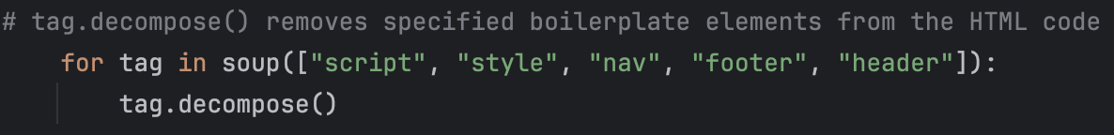
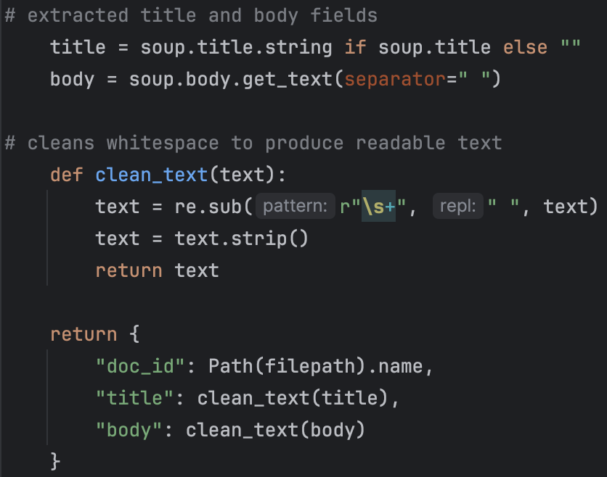
  - Removed non-content tags using BeautifulSoup’s ‘.decompose()’ method to reduce noise terms that would negatively affect indexing and retrieval precision.

  - Title and body text are extracted separate and stored in a structured document representation
  - Ensures each document has a unique identifier and clearly defined fields, allowing later stages of the retrieval pipeline to apply different preprocessing and weighting strategies to different document components.

- Key Resources:
  - https://www.scraperapi.com/blog/data-cleaning-beautifulsoup-how-to-remove-tags/ - Used to understand what ‘.decompose()’ does and how it can be used to remove HTML elements entirely, preventing unwanted text from being indexed
3. Outcomes & Findings:
- Technical Output: Successfully implemented a HTML parsing module that converts each webpage into a structured document containing a unique document ID, title field, and cleaned body text. Verified correct operation by parsing all 727 documents I the Videogames dataset without errors

- Conceptual Learning: Learned that removing boilerplate HTML elements significantly improves the quality of extracted text by reducing non-informative terms such as navigation links and script content. This reinforced the understanding that early preprocessing decisions directly affect the effectiveness of later Information Retrieval stages, particularly tokenisation, inverted indexing, and term-based ranking models.
4. Challenges & Pivots:
- Challenge: Encountered an empty document collection due to incorrect relative path resolution when running scripts from the /src directory.

- Solution/Pivot: Resolved by anchoring dataset paths to the project root using Path(__file__).resolve(), ensuring portability and reproducibility of the system.
5. Reflection & Next Steps:
- Reflection: This session highlighted how critical early-stage preprocessing decisions are in an Information Retrieval systems. By structuring documents into distinct fields and removing non-content HTML elements, the document representations became more suitable for accurate tokenisation and ranking. This will reduce noise in the inverted index and increase the effectiveness of term-based ranking methods such as TF-IDF and BM25. The debugging process also reinforced the importance of reproducible file handling when working with large document collections.

- Next Steps:
  - Implement tokenisation, stop-word removal, and optional stemming to prepare documents for indexing
  - Build an inverted index over the parsed document collection
  - Begin initial retrieval experiments using a baseline ranking model

Entry #: 3
Date: 03/01/2026
1. Focus of this Session:
Implementing document tokenisation and constructing an inverted index to enable term-based retrieval.
2. Actions Taken & Resources Used:
Building on the HTML parsing and text cleaning completed in the previous session, I implemented the preprocessing and indexing stages of the Information Retrieval pipeline. The objective of this session was to convert cleaned document text into indexable tokens and to construct an inverted index that supports efficient ranking and retrieval.
I implemented a modular tokenisation and normalisation pipeline using the Natural Language Toolkit (NLTK). This pipeline included word tokenisation, lowercasing, stop-word removal, and Porter stemming. NLTK was selected due to its widespread adoption in Information Retrieval research, transparency of implementation, and suitability for controlled experimental comparisons.
The order of preprocessing operations was carefully chosen. Tokens are first normalised (lower-cased) before stop-word removal, ensuring consistency with the stop-word list, and stemming is applied last to collapse morphological variants. This design ensures that preprocessing decisions can later be enabled or disabled independently during experimentation.
Token lists were explicitly attached to each document representation to separate preprocessing from indexing. This avoids redundant computation during experimentation and ensures that alternative ranking and evaluation strategies can reuse the same tokenised representations.
Once tokenisation was complete, I constructed an inverted index using Python dictionaries and the Counter class from the standard library. The inverted index maps each unique term to a postings list containing document identifiers and term frequencies, forming the core data structure required for ranking algorithms such as TF-IDF and BM25.
I tested this implementation on the full Videogames dataset (727 documents). The resulting index contained approximately 7,500 unique terms, which is consistent with expectations for a medium-sized document collection after stop-word removal and stemming.
Search Queries/Research:
  - Query or Prompt: “NLTK tokenisation, stop word removal, and stemming”
  - Result: Found relevant information on Medium
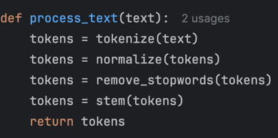
- Code/Implementation:
  - Implemented a reusable process_text() function combining tokenisation, normalisation, stop-word removal, and stemming

  - Attached token lists directly to each document representation

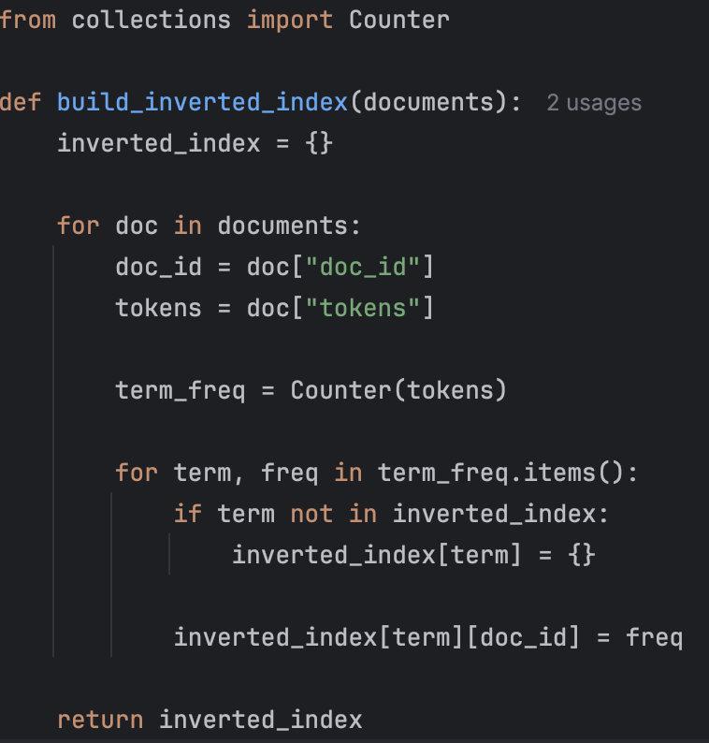
  - Constructed the inverted index using a dictionary of posting lists, where each term maps to document identifiers and term frequencies

- Key Resources:
  - https://medium.com/@abhishekjainindore24/all-about-tokenization-stop-words-stemming-and-lemmatization-in-nlp-1620ffaf0f87 - Provided the concepts of Tokenization, Stop Words, Stemming, and Lemmatization.
3. Outcomes & Findings:
- Technical Output: Successfully implemented a complete preprocessing and indexing pipeline that converts raw HTML document text into a structured inverted index. The system correctly indexed all 727 documents and produced a postings-based index suitable for term-based retrieval and ranking

- Conceptual Learning: Gained a deeper understanding of how preprocessing decisions directly affect retrieval effectiveness. In particular, stemming improves recall by collapsing morphological variants, while stop-word removal reduces noise and index size.
4. Challenges & Pivots:
- Challenge: Initially encountered a KeyError during index construction due to tokens not being attached to document representations.

- Solution/Pivot: Resolved by explicitly separating preprocessing and indexing stages, storing token lists within each document prior to index construction. This reinforced the importance of clear pipeline separation in IR system design.
5. Reflection & Next Steps:
- Reflection: This session demonstrated how tokenisation and inverted indexing together form the backbone of the Information Retrieval system. When inspecting the token output, it revealed the presence of some non-content accessibility terms (“skip”, “main”), highlighting opportunities for further cleaning and controlled experimentation on noise reduction. Implementing the pipeline in a modular manner also ensures that alternative preprocessing configurations can be evaluated systematically.

- Next Steps:
  - Implement a baseline ranking model (TF-IDF or BM25) using the constructed inverted index
  - Add a simple query processing interface to retrieve and rank documents
  - Begin evaluation experiments to analyse the impact of preprocessing and ranking choices on retrieval effectiveness

Entry #: 4
Date: 04/01/2026
1. Focus of this Session:
Implement term-weighting and ranking using TF-IDF, followed by retrieval evaluation using Precision@k.
2. Actions Taken & Resources Used:
Building on the inverted index and preprocessing pipeline developed in the previous sessions, the focus today was implementing a ranking function and formal evaluation measures. The objective was to transform the indexed document collection into a ranked retrieval system and establish a baseline against which later ranking models could be compared.
I implemented a TF-IDF weighting scheme using the inverted index. Term Frequency (TF) was derived directly from postings list, while the Inverse Document Frequency (IDF) I computed using the logarithmic formula. TF-IDF was selected as the baseline ranking model because it is widely used vector-space retrieval approach and provides strong reference point for later experimentation with more advanced ranking methods such as BM25.

I also implemented a query processing pipeline to ensure that user queries undergo the same tokenisation, stop-word removal, and stemming steps used during indexing. Query terms are matched against the inverted index, and document scores are accumulated by summing TF-IDF contributions across all matching query terms. Ranked results are then returned in descending order of relevance score.

To evaluate retrieval effectiveness, I implemented Precision@k, measuring the proportion of relevant documents in the top-k ranked results. Precision@k was chosen as an initial metric due to its relevance to ranked retrieval scenarios, where users typically inspect only the highest-ranked documents. The evaluation function were validated using both synthetic test cases with known relevance and real dataset queries from the Videogames dataset.

- Search Queries/Research:
  - Query or Prompt: TF-IDF ranking in information retrieval
  - Result: Found relevant information on GeeksforGeeks

- Query or Prompt: TF-IDF ranking implementation in Python
- Result: Found relevant information on Medium

- Query or Prompt: Precision@k evaluation metric information retrieval
- Result: Found relevant information on Keylabs

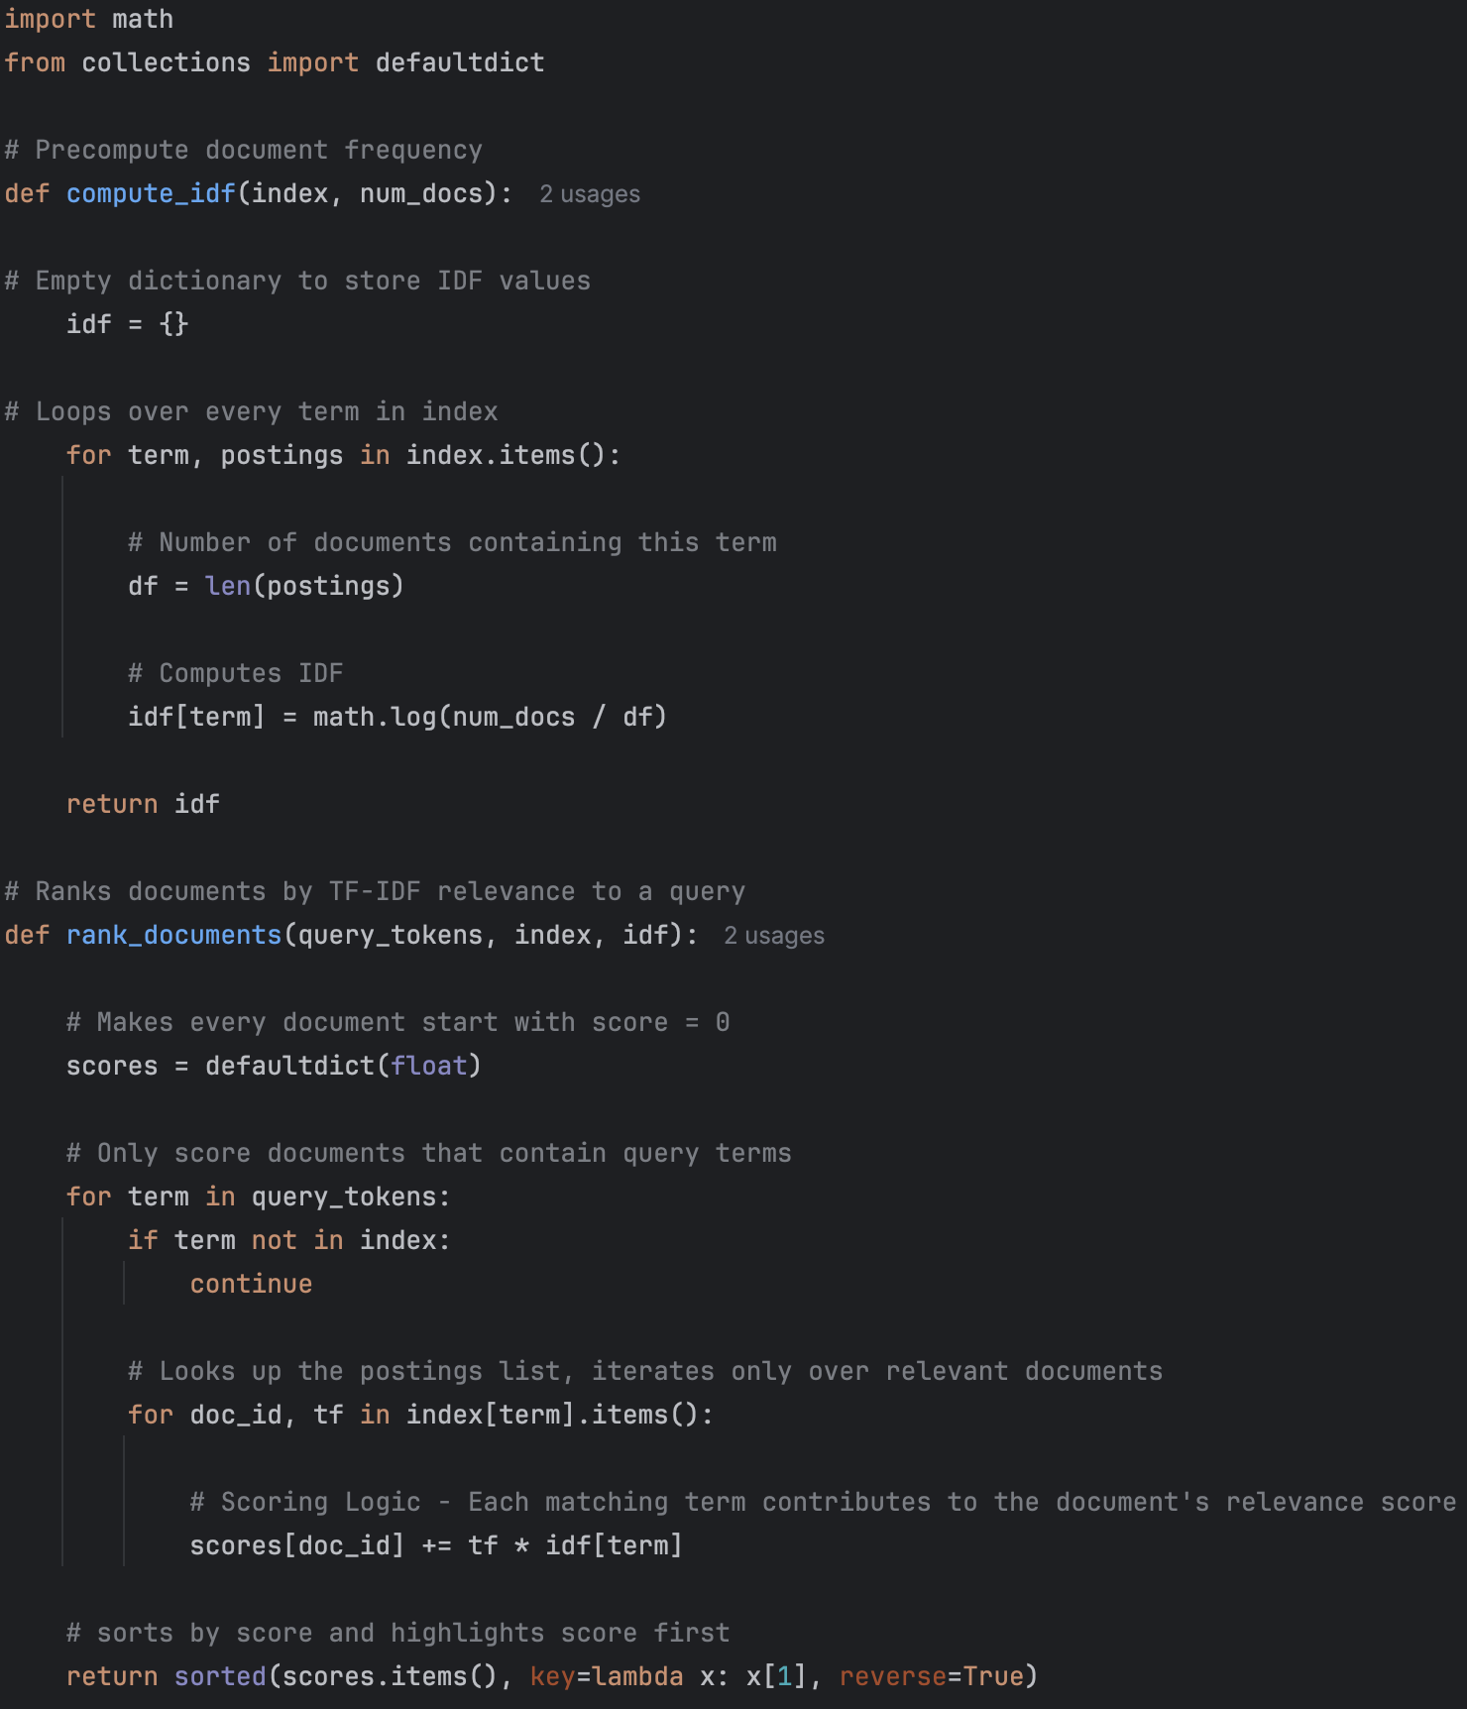
- Code/Implementation:

  - IDF values were computed from the inverted index
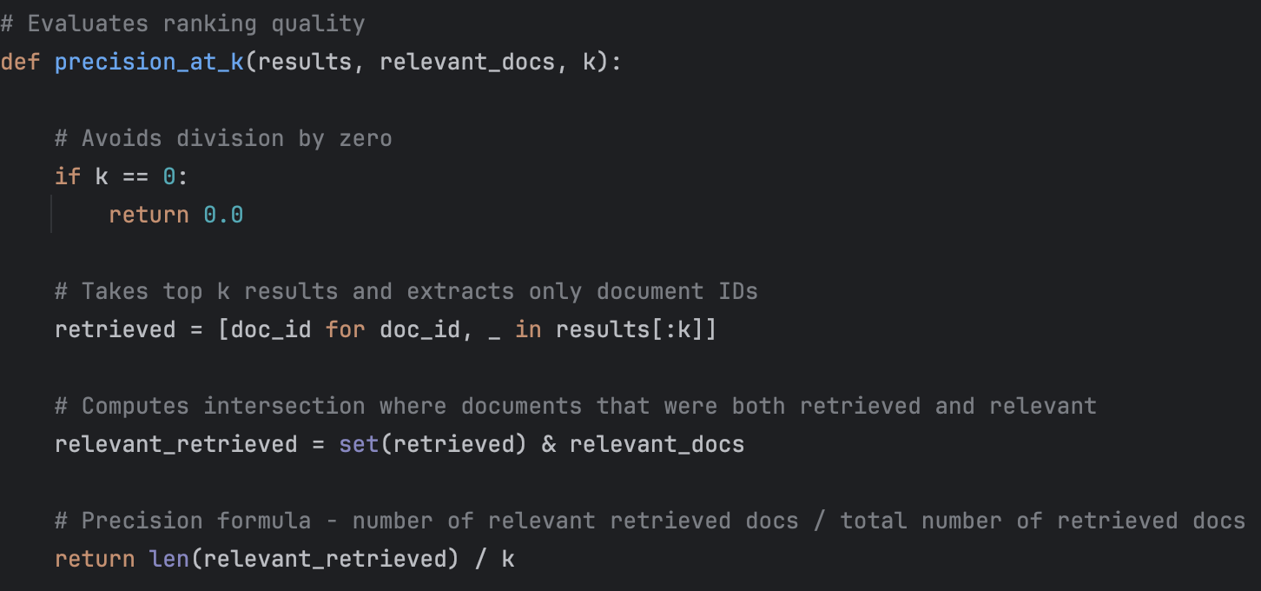
  - Implemented document ranking by accumulating TF-IDF scores for documents containing query terms

- Precision@k implementation to evaluate ranking quality at a fixed cutoff

- Key Resources:
  - https://www.geeksforgeeks.org/nlp/tf-idf-model-for-page-ranking/ - Provided explanations and examples of TF-IDF and how to implement it
  - https://medium.com/@coldstart_coder/understanding-and-implementing-tf-idf-in-python-a325d1301484 - Provided the theory behind how to calculate TF and IDF and its implementations in Python
  - https://keylabs.ai/blog/understanding-precision-at-k-p-k/ - Provided explanations of Precision@k and helped further my understand of its concept and how to implement it.
  - Generative AI – Used for further research on these concepts to help further my understanding and used as a mentor during implementation for timely feedback
3. Outcomes & Findings:
My initial TF-IDF testing confirmed that rare terms such as ‘pokemon’ receive high IDF weights, while ubiquitous terms such as ‘nintendo’ and ‘game’ correctly receive near-zero weights. Single-term queries produced identical scores when term frequency was equal across documents, consistent with TF-IDF theory.

- Technical Output: Implemented a functioning ranked retrieval system capable of returning TF-IDF-weighted document results for user queries. Precision@k successfully evaluated retrieval quality across multiple queries and cut-off values.

- Conceptual Learning: Observed that TF-IDF effectively emphasises rare, discriminative terms while down-weighting ubiquitous terms (e.g. “Nintendo” and “game”). Single-term queries with equal term frequencies across documents produced identical scores, confirming the implementation was correct and reinforcing the limitations of bag-of-word ranking models.
4. Challenges & Pivots:
- Challenge: Initial test results produced identical TF-IDF scores for some queries, which initially appeared incorrect

- Solution/Pivot: Through manual verification, I confirmed that this behaviour was normal when term frequency and IDF values are identical across documents, highlighting the importance of controlled validation and TF-IDF’s limitations.
5. Reflection & Next Steps:
- Reflection: This session demonstrated how ranking and evaluation can transform an indexed collection into a measurable retrieval system. Precision@k provided a clear, interpretable metric for evaluating top-ranked results, while also showing limitations of TF-IDF for single-term and frequency-balanced queries.

- Next Steps:
  - Introduce additional evaluation metrics such as Recall@k or Mean Average Precision
  - Experiment with improved weighting schemes (IDF smoothing or BM25)
  - Analyse the impact of preprocessing decisions on retrieval effectiveness

Entry #: 5
Date: 06/01/2026
1. Focus of this Session:
Baseline system evaluation using Precision@K and initial experimentation with smoothed IDF.
2. Actions Taken & Resources Used:
In this session I focused on evaluating the baseline ranked retrieval system and introduced a controlled refinement to the TF-IDF weighting scheme. The primary goal was to establish a reliable and measurable baseline before introducing more advanced ranking models.
I implemented Precision@k as the primary evaluation metric. Before applying it to real dataset queries, I validated the correctness of the metric using controlled test cases with known relevance sets. These included partial relevance, and edge cases where k = 0. This validation step ensured that the evaluation framework behaved correctly before being used in experimental comparisons.
The baseline TF-IDF ranking model was evaluated using representative videogame queries. Relevance sets were derived from the provided CSV file, allowing Precision@10 scores to be computed for selected queries. The results I received established a quantitative baseline against which future improvements can be compared.
Additionally, I implemented smoothed IDF as an alternative weighting scheme. The smoothed formulation was introduced to address zero-weight issues observed for ubiquitous terms (e.g. “game, “Nintendo”) under the standard IDF formulation. I calculated both smoothed and unsmoothed IDF values and compared them to validate the change and ensure it was functioning correctly.
- Search Queries/Research:
  - Query or Prompt: Why is Precision@k good for evaluation
  - Result: Found relevant information on Evidentlyai

  - Query or Prompt: How to smooth TF-IDF
  - Result: Found relevant information on Scikit-learn

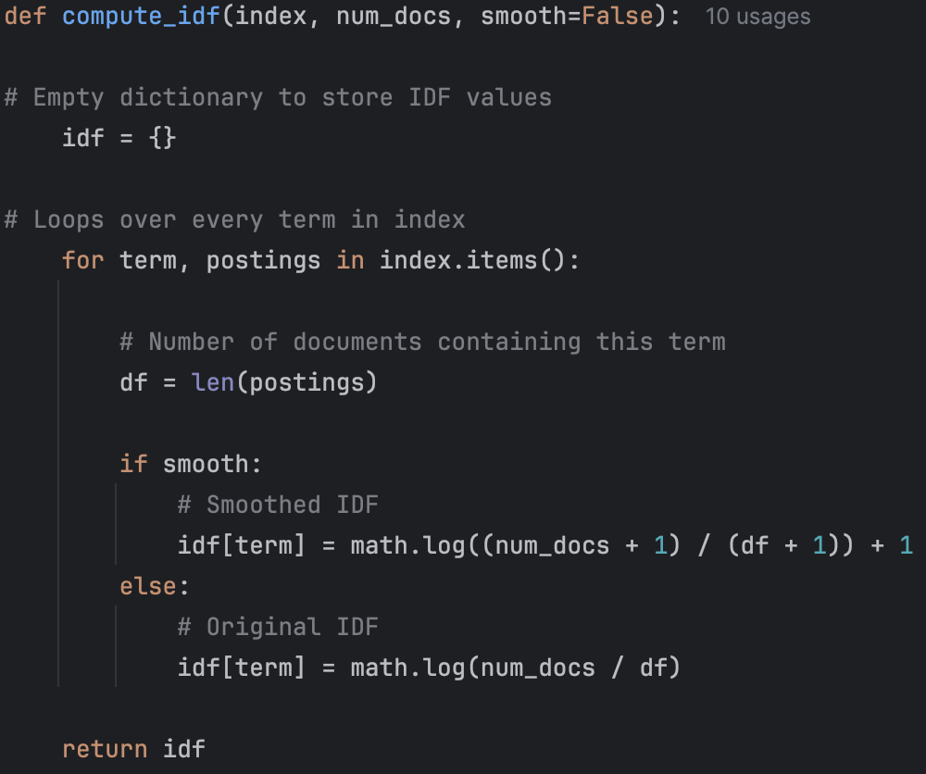
- Code/Implementation:

  - Implemented smoothed IDF alongside the original formulation to enable controlled comparison
  - Both IDF variant retain in system, allowing baseline and refined weighting schemes to be evaluated side by side under identical conditions

- Key Resources:
  - https://www.evidentlyai.com/ranking-metrics/precision-recall-at-k#:~:text=Precision%20and%20Recall%20are%20the,two%20of%20the%20suggested%20items – Thorough explanations of Precision@k and its pros/cons, effectiveness, etc.
  - https://scikit-learn.org/stable/modules/generated/sklearn.feature_extraction.text.TfidfTransformer.html - Shows an example of how to smooth TF-IDF formula
3. Outcomes & Findings:
- Technical Output: Validated an evaluation framework capable of computing Precision@k for ranked retrieval results. Obtained Precision@10 scores for selected queries, and integrated smoothed IDF into my ranking pipeline

- Conceptual Learning: Precision@k provides a clear and interpretable measure of early retrieval effectiveness, making it well suited for ranked search scenarios. Smoothed IDF prevents zero-weight terms while preserving rare, discriminative terms, which results in more stable scoring behaviour.
4. Challenges & Pivots:
- Challenge: Precision@k value of 0.4 was observed when a value of 0.0 was expected.
- Solution/Pivot: Through manually rereading the code, I realised that I had inputted the incorrect k value into my test.

- Challenge: Keeping Baseline results separate from improvements
- Solution/Pivot: Both my original IDF and smoothed IDF had to be kept in the system at the same time. By doing this, it made it possible to compare the two approaches fairly and ensured that any differences in performance were caused by the weighting change rather than by accidental configurations.
5. Reflection & Next Steps:
- Reflection: This session established a reliable baseline for evaluating retrieval effectiveness. By introducing evaluation metrics early, it becomes possible to judge future changes using numbers and evidence rather than guessing, meaning any improvements I make can be shown to help or not help the system.
Introducing smoothed IDF improved the way terms are weighting without changed the core TF-IDF model. It also fixed issues where very common terms had no impact on ranking, while still allowing fair comparisons with the original IDF approach. By having both versions tested side by side, any differences in performance can be directly linked to weighting change rather than other factors.

- Next Steps:
  - Introduce Recall@k
  - Experiment with BM25 and see the difference between BM25 and TF-IDF

Entry #: 6
Date: 08/01/2026
1. Focus of this Session:
Evaluation of retrieval effectiveness using Precision@k and Recall@k, and refactoring my system pipeline for clarity and maintainability.
2. Actions Taken & Resources Used:
In this session, I focused on extending the evaluation framework by implementing Recall@k alongside Precision@k, allowing retrieval effectiveness to be assessed more comprehensively. Precision@k measures the proportion of retrieved documents in the top-k that are relevant, while Recall@k measires the proportion of all relevant documents that successfully retrieved within the top-k results. Using both metrics together provides a more balanced view of system performance.
Both metrics were implemented in ranker.py to maintain conceptual grouping with other ranking and evaluation logic. To test these metrics, I constructed test cases with known retrieved and relevant document sets, including edge cases such as empty relevance sets.
I applied Precision@k and Recall@k to real TF-IDF ranking outputs using relevance labels from the videogames dataset CSV. The evaluation was conducted at k = 5 and k = 10 for realistic queries such as “pokemon”.
Furthermore, I refactored my main.py to improve readability, modularity, and experimental control. This refactoring:
- Isolated document loading and preprocessing
- Separated index construction
- Encapsulated retrieval and evaluation logic into functions
- Clearly distinguished baseline (unsmoothed IDF) from experimental (smoothed IDF) configurations
By doing this, it significantly improved maintainability and will prevent accidental mixing of configurations. It also enables me to easily tweak and change the code when testing and implementing BM25.
- Search Queries/Research:
  - Query or Prompt: "How to implement recall@k”
  - Result: Found a post on InsideLearningMachines explaining what Precision@k and Recall@k is and how to implement them.

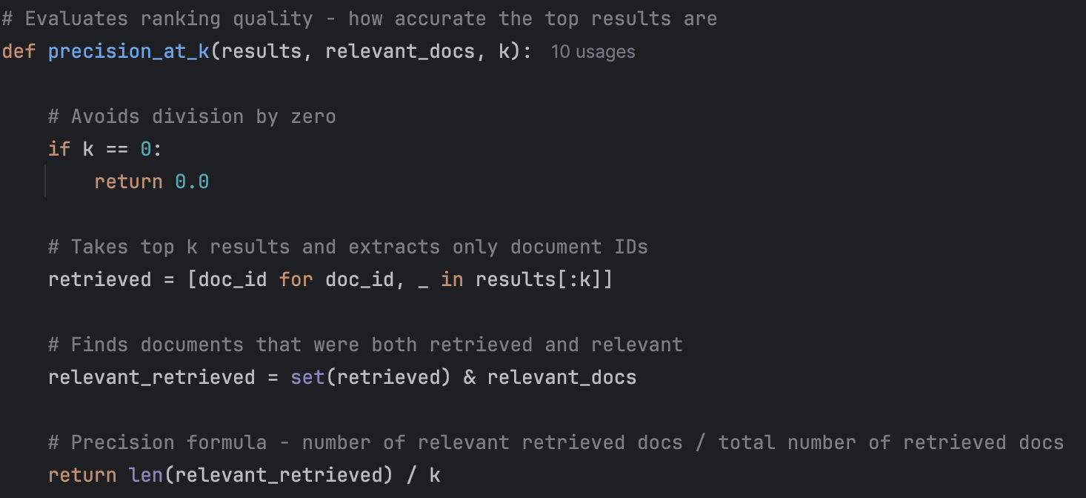
- Code/Implementation:

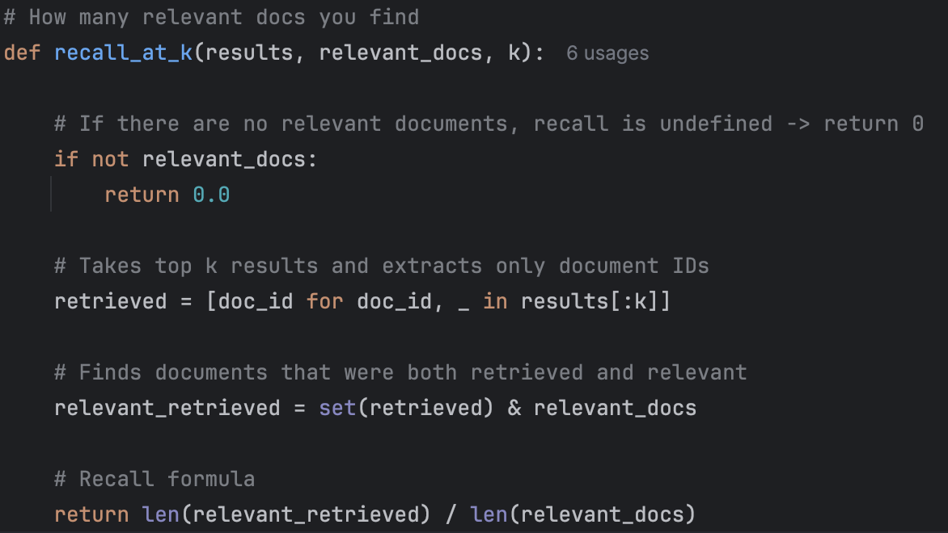
  - Query or Prompt: "How to implement Recall@k”
  - Result: Found a post on InsideLearningMachines explaining what Precision@k and Recall@k is and how to implement them.

- Key Resources:
  - https://insidelearningmachines.com/precisionk_and_recallk/ - Provided me with explanations and Python examples of how to implement these evaluation metrics. There is also an attached YouTube video which further helped my understanding.
3. Outcomes & Findings:
- Technical Output: Fully functioning Precision@k and Recall@k metrics.
- Conceptual Learning: Precision and recall measure different aspects of retrieval effectiveness and must be interpreted together for more accurate results.

- Technical Output: Validated evaluation pipeline using real dataset queries.
- Conceptual Learning: Evaluation requires explicit relevance labels; ranking alone is insufficient.

- Technical Output: Refactored system architecture with clearer execution flow
- Conceptual Learning: Having a clear, constructed system architecture helps improve maintainability and allows for easier modification and improvements in the future
4. Challenges & Pivots:
- Challenge: Risk of biased or subjective evaluation when judging retrieval quality informally.
- Solution/Pivot: Introduced formal evaluation metrics using relevance labels, ensuring objectivity and reproducibility
5. Reflection & Next Steps:
- Reflection: Establishing evaluation metric early provides a reliable foundation for measuring future improvements. Without formal metrics such as Precision@k and Recall@k, system quality cannot be assessed objectively. Refactoring the system at this stage prevents technical debt as more complex models are introduced, such as BM25.

- Next Steps:
  - Implement BM25 as an alternative ranking model
  - Compare TF-IDF and BM25 using Precision@k and Recall@k
Entry #: 7
Date: 09/01/2026
1. Focus of this Session:
Implement BM25 ranking algorithm and conduct controlled experimental comparisons between TF-IDF and BM25 using Precision@k and Recall@k.
2. Actions Taken & Resources Used:
During this session I implemented BM25 ranking algorithm and compared its performance against the existing TF-IDF baseline under controlled conditions. The aim was to determine whether BM25 provided measurable improvements in retrieval effectiveness when applied to real-world HTML documents.
Before implementation, I reviewed the conceptual differences between TF-IDF and BM25, focusing on term-frequency and document length normalisation. These properties are particularly important when working with web-style documents, where longer pages may contain many repeated terms that should not disproportionately influence ranking.
- Search Queries/Research:
  - Query or Prompt: "Why is BM25 more efficient than TF-IDF"
  - Result: Found an article on Medium explaining the benefits of BM25 and which ranking system is better.

  - Query or Prompt: bm25 vs tf-idf using Precision@k and Recall@K
  - Result: Found article on KMW Technology

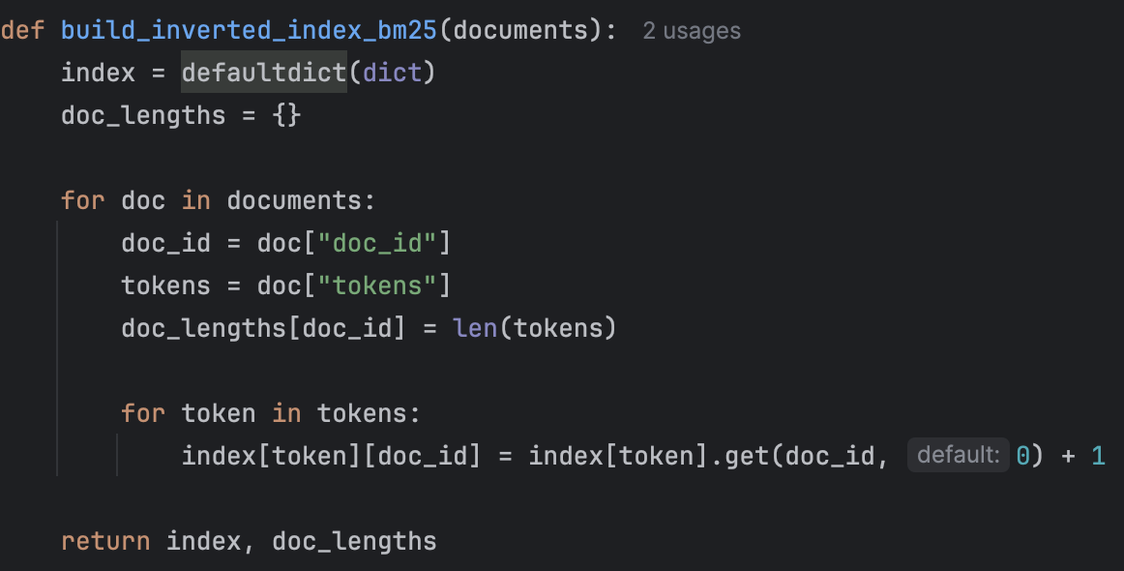
- Code/Implementation:
  - I first modified the indexing process to store document lengths alongside term frequencies. For each document, the total number of processed tokens was recorded, allowing later calculation of the average document length across the entire collection. This was necessary because BM25 explicitly adjusts scores based on how long a document is relative to the collection average, unlike TF-IDF.
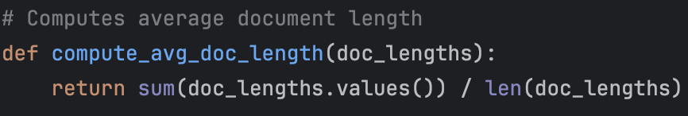
  - This is required for document length normalisation in BM25

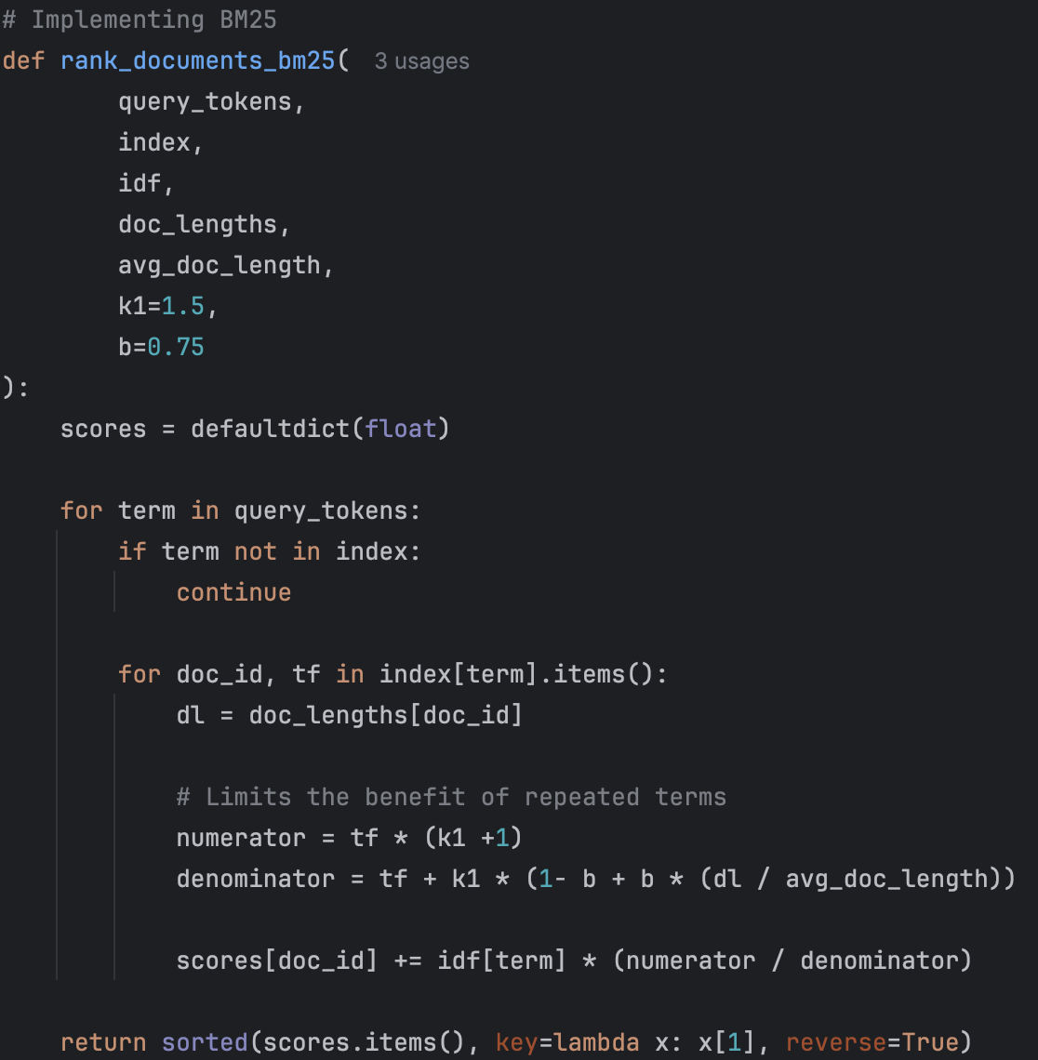

  - I then implemented BM25 ranking function using standard parameter values (k1 = 1.5, b = 0.75). This method iterates over documents that only contain query terms (via inverted index), computes the length-normalised score for each matching term, and aggregates scores across the query. This ensures that BM25 is integrated with my existing retrieval pipeline.
  - Next, I designed a controlled experiment to compare TF-IDF and BM25 fairly. I evaluated both models using the same:
    - Preprocessed document collection
    - Inverted index
    - Smoothed IDF values
    - Query (“mario)
    - Manually defined relevance set
  - For the query ‘mario’, BM25 achieved higher Precision@10 and Recall@10 than TF-IDF. While TF-IDF retrieved one non-relevant document within the top 10, BM25 successfully promoted an additional relevant Mario game, resulting in perfect Precision@10 and improved recall. This demonstrates the benefit of BM25’s term-frequency saturation and document length normalisation for franchise-based queries.
- Key Resources:
  - https://medium.com/@kimdoil1211/bm25-for-developers-a-guide-to-smarter-keyword-search-e6d83e8c8c8c - Helped my understanding of BM25 and how I could implement It into my current system.
  - https://medium.com/mlworks/why-bm25-algorithm-over-tf-idf-67bc009d20de - Helped my understanding of the differences between TF-IDF and BM25.
  - https://kmwllc.com/index.php/2020/03/20/understanding-tf-idf-and-bm-25/ - Explains step by step on how to develop BM25

3. Outcomes & Findings:
- Technical Output: Successfully integrated BM25 into my existing IR system
- Conceptual Learning: BM25 can outperform TF-IDF by reducing the influence of noisy, long HTML pages.

- Technical Output: Implemented document length normalisation and TF saturation.
- Conceptual Learning: Improvements are query-dependent and must be demonstrated using controlled experiments.

- Technical Output: Performed TF-IDF vs BM25 comparison using Precision@10 and Recall@10.
- Conceptual Learning: Evaluation metrics are essential for making defensible performance claims.

4. Challenges & Pivots:
- Challenge: Mistakenly used the BM25 ranker for both TF-IDF and BM25 during experimentation, producing identical results.
- Solution/Pivot: Clearly separated ranking functions and verified outputs by inspecting top 10 rankings.

- Challenge: Passed raw query strings, causing character-level iteration instead of token-level matching.
- Solution/Pivot: Ensured all queries were processed using the same tokenisation pipeline as documents.
5. Reflection & Next Steps:
- Reflection: This session demonstrated that BM25 provides measurable improvements over TF-IDF. The result highlights the importance of document length normalisation when working with real-world HTML data. Having controlled experiments was essential to ensure accurate comparisons and to make a calculated decision on whether BM25 made a difference in efficiency in my system.
- Next Steps:
  - Review the system against the coursework brief and identify missing components
  - Implement these changes into my current system
Entry #: 08
Date: 10/01/2026
1. Focus of this Session:
Finalising the core retrieval system by improving usability and document parsing and evaluating the impact of stop-word removal and stemming on retrieval effectiveness using TF-IDF and BM25.
2. Actions Taken & Resources Used:
In this session, I focused on two parallel objectives: improving system usability and conducting controlled preprocessing experiments. I achieved this through:
Implementing a Command-Line Interface (CLI)
- I added an interactive query input so users can issue their own queries at runtime. This transformed my system from a static test harness into a usable search engine.
Implementing ranked output to both the console and a generated file
- For each query the user inputs, it will print the top-ranked results to the console and saves the top-ranked documents (with scores and titles) to a timestamped .txt file.
Improved HTML parser to reduce noise (nav/footer/header junk)
- I refined the current parser to extract text primarily from the <body> element rather than the entire HTML document, reducing navigation menus, headers, and footer clutter that negatively affects ranking quality
After I made these improvements to my system, I then refactored my tokenisation pipeline to be configurable. I can now allow stop-word removal and stemming to be enabled or disabled independently. This was a necessary changed so that I can conduct controlled preprocessing experiments.
I evaluated four configurations:
- Stopwords ON, Stemming ON
- Stopwords OFF, Stemming ON
- Stopwords ON, Stemming OFF
- Stopwords OFF, Stemming OFF
I used ‘Arcade type games’ and ‘Game published by Atari’ for this experiment and measured the retrieval effectiveness of Precision@10 and Recall@10 for both TF-IDF and BM25.
The stop-word and stemming experiments revealed that preprocessing choices affect TF-IDF much more strongly than BM25. For broad genre queries like Arcade type games, stemming reduced TF-IDF precision by collapsing important lexical distinctions, while BM25 remained stable due to its length normalisation and term frequency saturation. For publisher-based queries, stemming degraded TF-IDF performance by altering proper nouns such as Atari, confirming that morphological normalisation is not universally beneficial.
- Search Queries/Research:
  - Query or Prompt: What is the effect of stop word removal on a information retrieval system
  - Result: Found relevant Generative AI overview on google

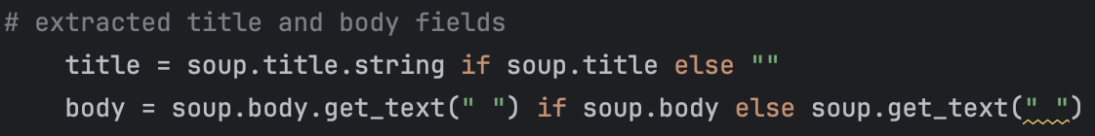
- Code/Implementation:
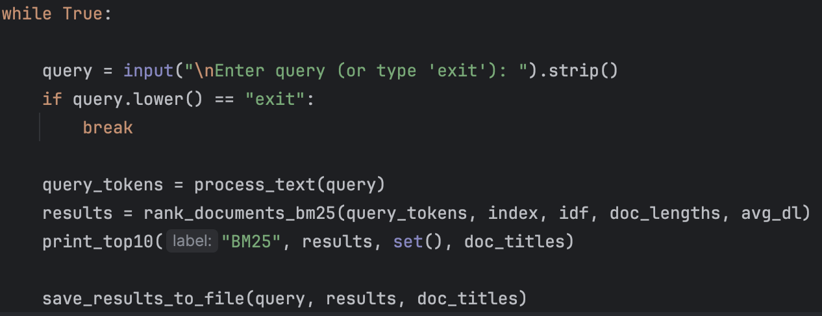
  - I initially had “ body = soup.get_text(“ “), but to make it so it primarily extracts form the body element rather than the entire document, I specified beautifulsoup to extract directly form the body, e.g. soup.body.get_text()
  - Command-Line Interface
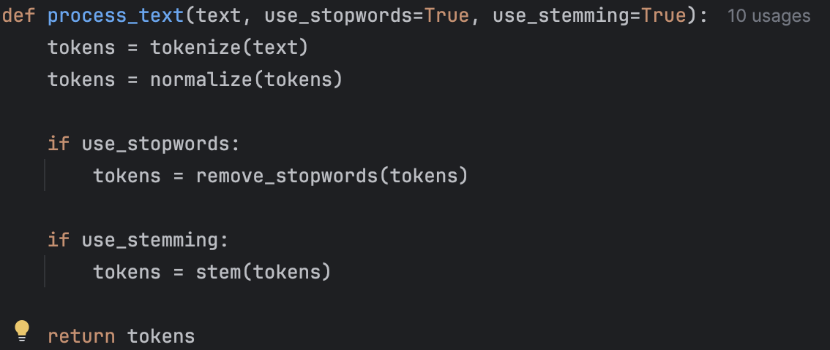

  - Configurable tokenisation
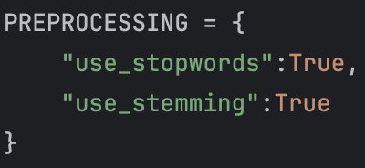

  - Preprocessing Configuration control

- Key Resources:
  - Google Generative AI Overview – Stop-word removal improves effectiveness by focusing on meaningful words but may remove useful contextual terms.

  - Generative AI – Used AI to provide explanations and feedback when debugging code or anything I was unsure of. Aligns with UEA AI policy by using Generative AI as a mentor/tutor.
3. Outcomes & Findings:
- Technical Output: Implemented a usable CLI-based search engine with result logging
- Conceptual Learning: Transitions my system from a static test harness into an interactive search engine, allowing users to search for any desired queries.

- Technical Output: Reduced HTML noise by improving parsing
- Conceptual Learning: Reducing noise allows for cleaner and more effective ranking

- Technical Output: Evaluated four preprocessing configurations across two required queries
- Conceptual Learning: Stop-word removal had minimal impact for the tested queries, but stemming significantly reduced TF-IDF precision for both tested queries. BM25 stayed efficient and stable across all preprocessing configurations

- Technical Output: Generated Precision@10 and Recall@10 results
- Conceptual Learning: Learned that BM25 remained basically unchanged for all preprocessing configurations, highlighting its accuracy over TF-IDF

4. Challenges & Pivots:
- Challenge: Results file created by the CLI was saved to a new folder in my /src directory instead of being saved directly to my /results directory
- Solution/Pivot: Initially I had ‘out_directory=”results”’ but it was a relative path, meaning it is relative to the current working directory, which in this case is /src. To solve this problem, I anchored my results folder to the project root, not to /src.
5. Reflection & Next Steps:
- Reflection: After this session, I now have transformed my system from a static test harness to a usable search engine. It has also highlighted that preprocessing decisions substantially affect the performance of TF-IDF, whilst BM25 remains practically unchanged. My system is now stable, usable, and ready for further experiments
- Next Steps:
  - Run controlled experiments on the required videogame queries
  - Compare TF-IDF and BM25 using Precision@10 and Recall@10

Entry #: 09
Date: 12/08/2026
1. Focus of this Session:
Compare TF-IDF model against BM25 ranking model using Precision@10 and Recall@10 with the required videogame queries.
2. Actions Taken & Resources Used:
In this session, I started systematic evaluation. My primary objective was to test the effectiveness of the implemented retrieval models across the six required videogame queries specified in the coursework brief. I ensured that the evaluation process was reproducible, controlled, and aligned with Information Retrieval practices.
I implemented an experiment pipeline that:
- Loads and preprocesses the entire document collection once
- Builds a single inverted index compatible with both TF-IDF and BM25
- Runs both ranking models on identical queries
- Computes Precision@10 and Recall@10
- Prints ranked outputs with relevance annotations for inspection and presentation
- Search Queries/Research:
  - Query or Prompt: bm25 vs tf-idf using Precision@k and Recall@K
  - Result: Article on KMW Technology

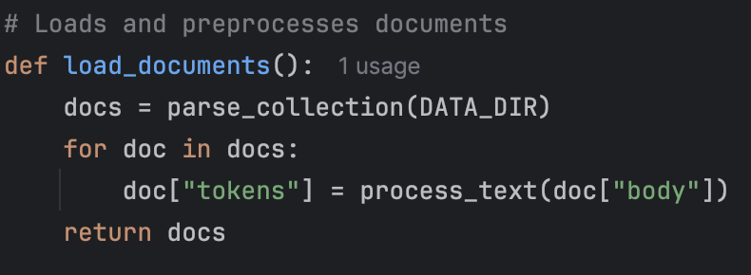
- Code/Implementation:

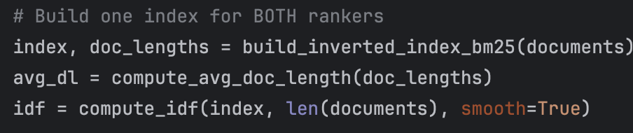
  - Ensures all documents are parsed and tokenised consistently before indexing
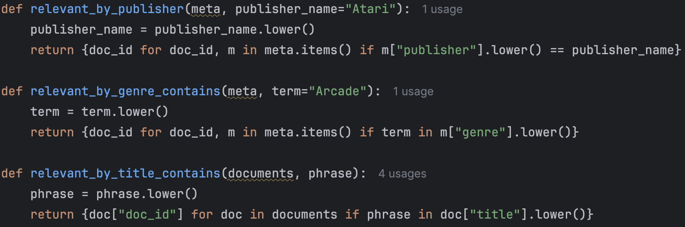
  - Single index that supports both TF-IDF and BM25 ranking which ensures fair comparison between the models

  - I derived relevance sets using the metadata-based relevance (CSV) for publisher and genre queries.
Title-based relevance for specific game queries.
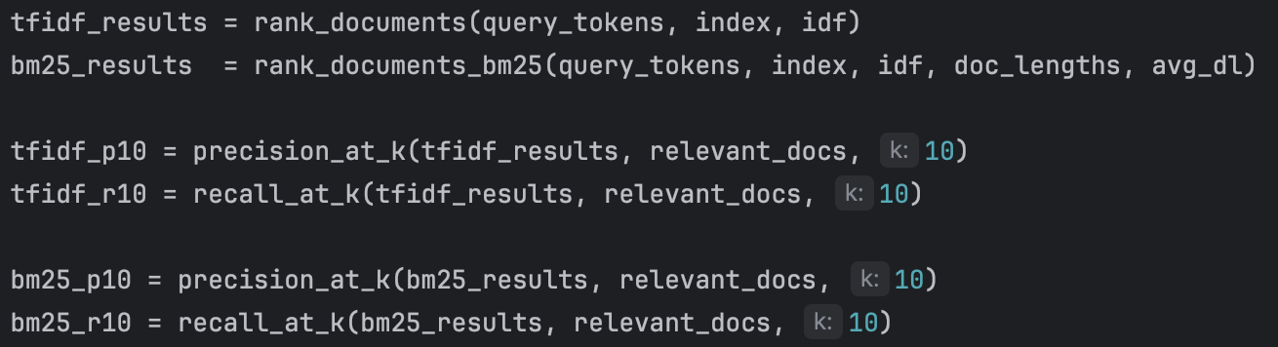
  - This approach avoided manual relevance labelling whilst remaining transparent and defensible

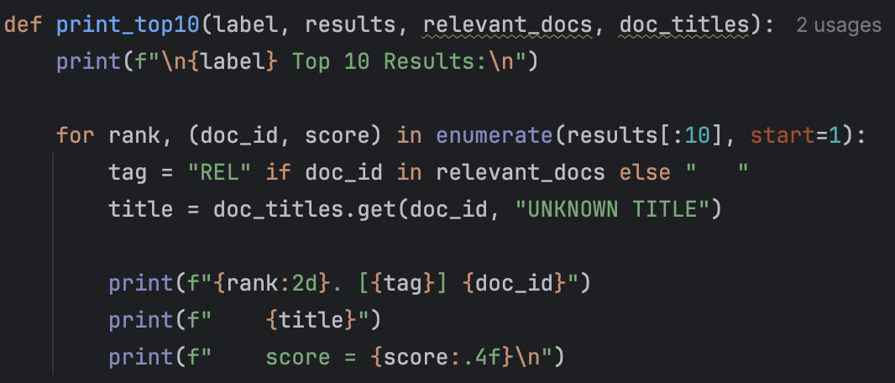
  - Ran TF-IDF and BM25 with evaluation, ensuring both ranking models were evaluated using identical queries and relevance sets
  - Printed the top 10 results with titles and relevance markers to further validate judgements and produce presentation evidence
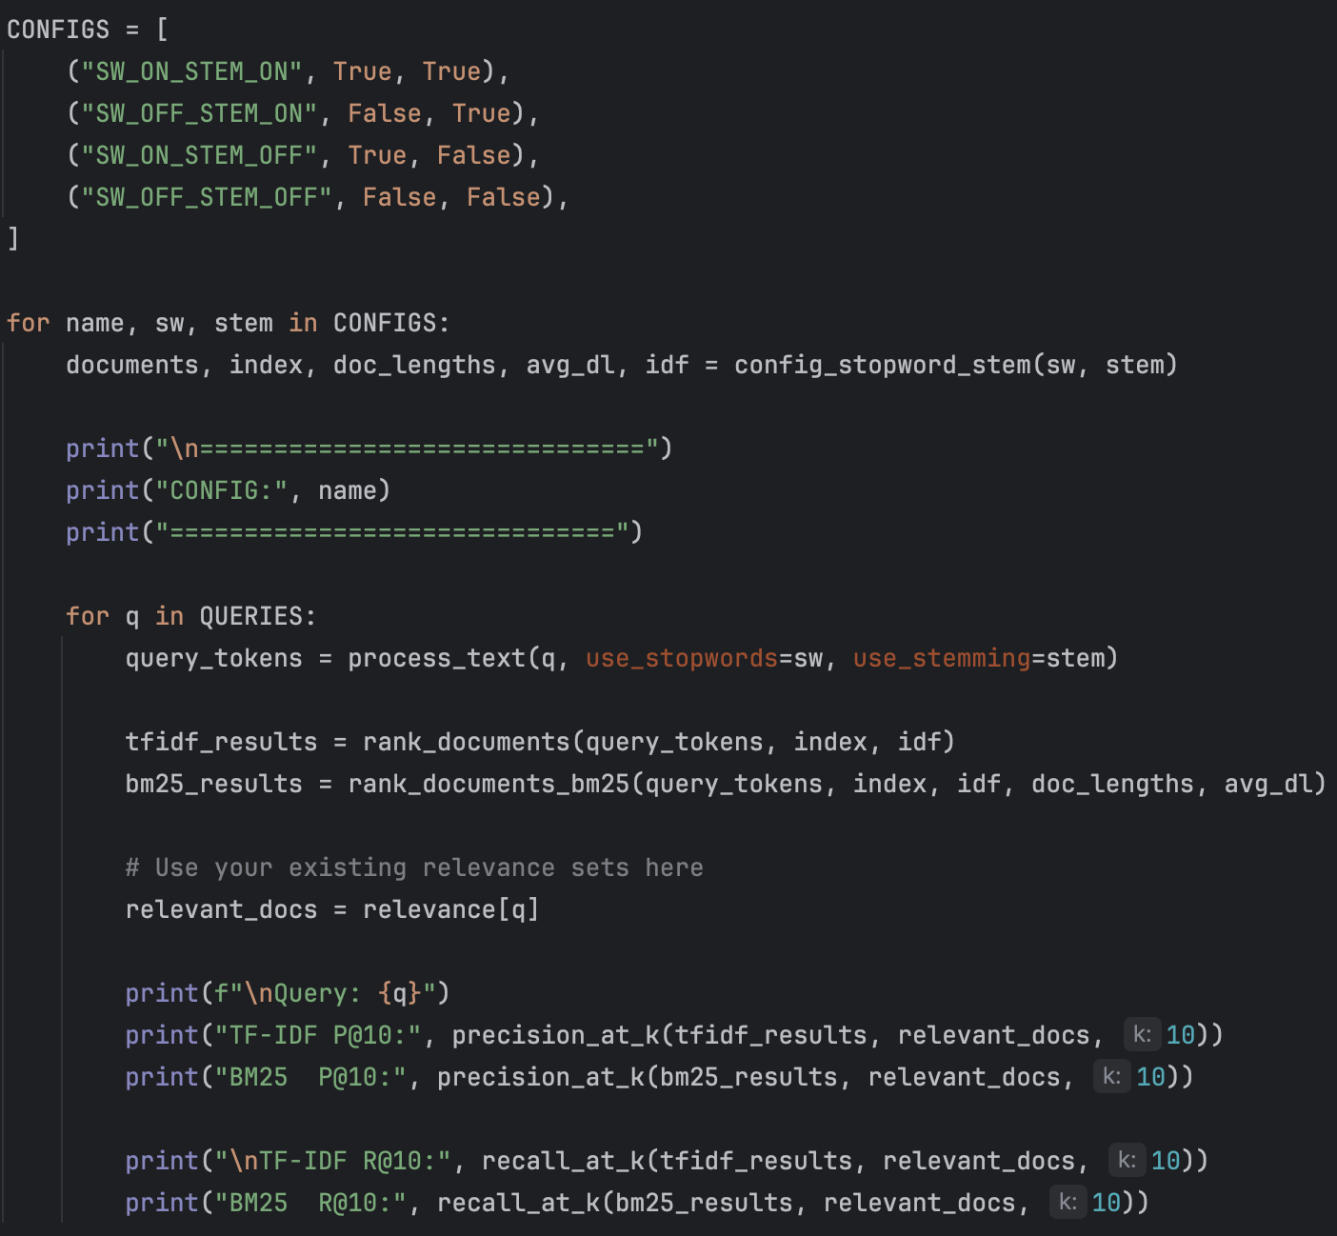
  - This allowed me to manually inspect the ranking quality and confirm that the correct documents were being prioritised.

- Experiment to compare TF-IDF vs BM25 under identical conditions, e.g. stop words on/off and stemming on/off
The results of my experiment demonstrate BM25 consistently outperforms TF-IDF for broad and metadata-driven queries, such as “Arcade type games” and “Game published by Atari”. In these cases, BM25’s document length normalisation and term-frequency saturation allow it to prioritise relevant documents more effectively, resulting in higher Precision@10 and Recall@10.

- Key Resources:
  - https://kmwllc.com/index.php/2020/03/20/understanding-tf-idf-and-bm-25/ - Helpful explanations and methods on how to use TF-IDF and BM25 for ranking

  - Generative AI – I used AI to help with debugging and methodological clarification which aligns with the UEA AI policy (Generative AI as a tutor)
3. Outcomes & Findings:
- Technical Output: Successfully evaluated TF-IDF and BM25 across all six required videogame queries
- Conceptual Learning: Learned that Precision@10 is sensitive to relevance set size and is less informative for known-item searches.

- Technical Output: Computed Precision@10 and Recall@10 for each query
- Conceptual Learning: Observed that BM25’s length normalisation improves performance on broad or metadata-driven queries.

- Technical Output: Verified that BM25 outperformed or matched TF-IDF on multi-document relevance queries (e.g. ‘Game published by Atari’, ‘Arcade type games’)
- Conceptual Learning: BM25 is a significant improvement than TF-IDF with my chosen dataset as it provides far more accurate results than what TF-IDF produces.
4. Challenges & Pivots:
- Challenge: ‘No relevant documents’ error when testing ‘Pokemon Trozei’ query
- Solution/Pivot: Switched from using the substring “pokemon trozei” to just “trozei” as the query rather than the full title which ensured robust and reproducible relevance identification.

- Challenge: Top 10 results were not printing when I ran the code

- Solution/Pivot: Initially I had defined print_top10() but I never called it. So I called print_top10() inside the query loop for the query I was searching for (e.g. Pokemon Trozei)
5. Reflection & Next Steps:
- Reflection: This session I shifted from constructing my system to experimental evaluation. I established a controlled and repeatable evaluation pipeline which significantly improved my confidence in observing results. Comparing between TF-IDF and BM25 demonstrated that ranking quality depends strongly on query type and document characteristics.
Across the six required queries, BM25 achieved a higher average Precision@10 than TF-IDF, indicating more consistent early-rank relevance.

- Next Steps:
  - Implement Lemmatization
  - Run experiments with different configurations for lemmatization, e.g. Stemming only, Lemmatization only, No stemming/lemm

Entry #: 10
Date: 15/01/2026
1. Focus of this Session:
Implementing lemmatization as an alternative linguistic preprocessing technique and evaluating its impact on retrieval effectiveness compared to stemming and baseline configurations.
2. Actions Taken & Resources Used:
The focus of this session was to introduce lemmatization into the preprocessing pipeline and to measure how it affects retrieval performance within my existing system. Lemmatization is a normalisation technique that reduces words to their dictionary (lemma) form, potentially preserving semantic meaning better than stemming.
I extended my existing configurable tokenisation pipeline to support lemmatization using WordNetLemmatizer from NLTK. To improve the accuracy of lemmatization, I implemented Part-of-Speech (POS) tagging, allowing words to be lemmatized based on their grammatical role (e.g., noun, verb, adjective). This design decision ensured that the lemmatization process was more precise than naïve.
To maintain controlled experimentation, lemmatization was implemented as mutually exclusive with stemming. This ensured that any observed differences in retrieval effectiveness could be attributed solely to the choice of morphological normalisation technique rather than to overlapping preprocessing effects.
I then conducted retrieval experiments using the six required queries. Lemmatization was compared against:
- Baseline preprocessing (stop-words enabled, no stemming or lemmatization)
- Stemming-based preprocessing
- No morphological normalisation
- Search Queries/Research:
  - Query or Prompt: "How to implement lemmatization"

  - Result: Found relevant information on GeeksforGeeks which provided explanations of what lemmatization is and examples of how to implement it

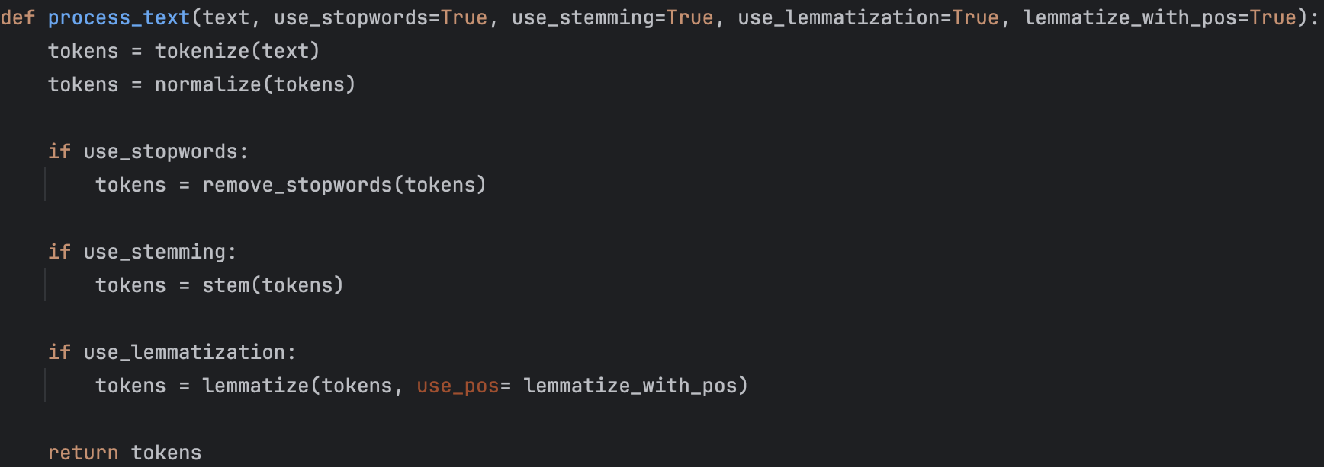
- Code/Implementation:

- Extended process_text() to support lemmatization via a configurable flag
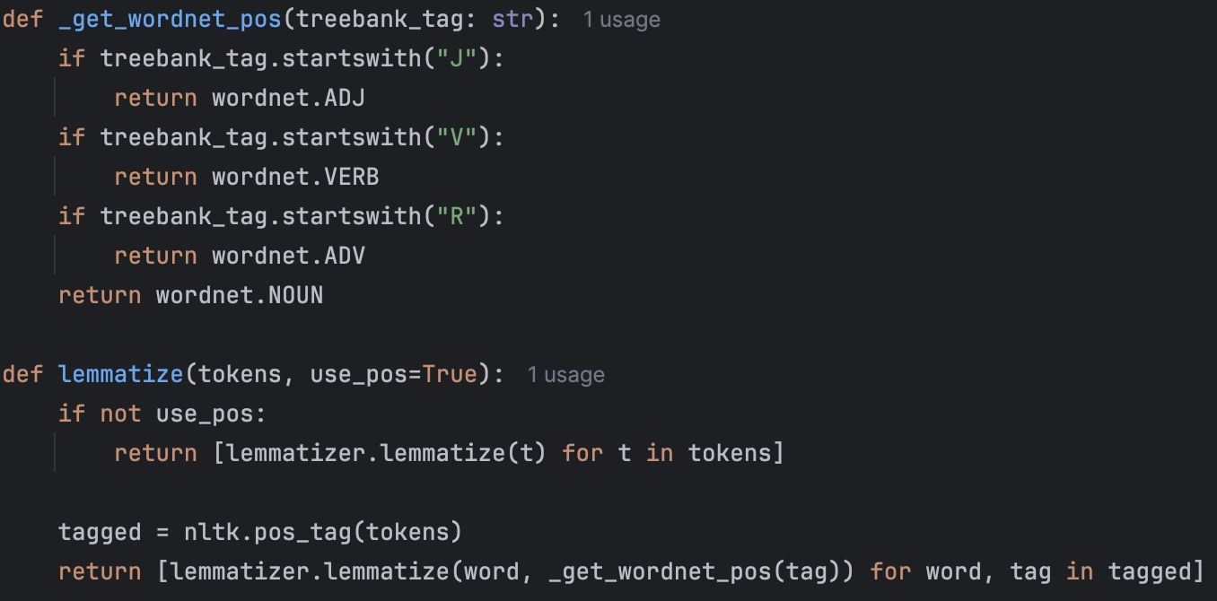

- Integrated WordNetLemmatizer with optional POS tagging
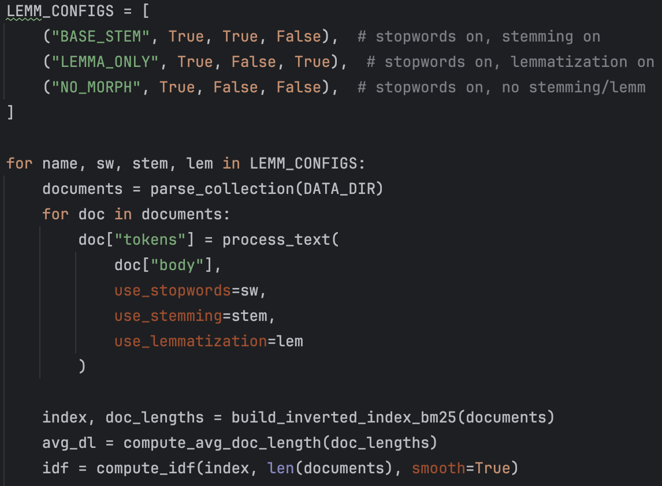
- Ensured that consistent preprocessing was applied

- Updated my experiment runner to compare stemming vs lemmatization under identical conditions with stop words on

- Key Resources:
  - https://www.geeksforgeeks.org/python/python-lemmatization-with-nltk/ - Used to understand lemmatization behaviour and the steps on how to implement it

  - Generative AI – Used as a tutor for clarifying implementation details and experimental design. Used in line with UEA policy for learning support and debugging
3. Outcomes & Findings:
- Technical Output: Successfully integrated lemmatization into the preprocessing pipeline and evaluated its impact using TF-IDF and BM25 models across the required videogame queries

- Conceptual Learning: Lemmatization did not consistently improve retrieval effectiveness over stemming or baseline configurations. For TF-IDF, lemmatization occasionally improved recall for general terms but often reduced precision by normalising terms that should remain distinct. For proper nouns and franchise names (e.g. game titles and publishers), lemmatization provided little to no benefit.
BM25 remained stable across all preprocessing configurations, reinforcing earlier findings that BM25 is less sensitive to linguistic preprocessing due to its document length normalisation and term-frequency saturation.
4. Challenges & Pivots:
- Challenge: Risk of overlapping preprocessing effects when combining stemming and lemmatization, which would invalidate experimental comparisons.

- Solution/Pivot: Enforced mutual exclusivity between stemming and lemmatization in the preprocessing pipeline. This ensured clean, controlled comparisons and maintained experimental validity.
5. Reflection & Next Steps:
- Reflection: During this session I found that while lemmatization is often presented as an improvement over stemming, my experiments showed that its effectiveness depends heavily on the dataset and query types. In the videogame domain, where proper nouns and named entities are dominant, lemmatization offered limited advantages and occasionally reduced precision.
By measuring these effects using formal evaluation metrics, I was able to make a defensible, evidenced-based conclusion rather than relying on intuition.

- Next Steps:
  - Research field weighting and the uses of it
  - Implement Field weighting into my current ranking system
  - Conduct experiments of its effect
Entry #: 11
Date: 20/01/2026
1. Focus of this Session:
Researching, implementing and evaluating field weighting as an advanced ranking technique.
2. Actions Taken & Resources Used:
In this session I extended my retrieval system with field-based weighting. My document parse already separated each document into a title field and body field and one over body tokens. This allowed ranking scores to be computed independently for each field using both TF-IDF and BM25, without altering the core ranking algorithms.
I then implemented a weighted score-combination strategy, where the final document relevance score was computed as a weighted sum of title-based and body-based scores. A higher weight was assigned to the title field to reflect its assumed importance. The weighting configuration was kept simple and fixed throughout the experiment to ensure interpretability and avoid overfitting.
To evaluate the impact of field weighting, I ran controlled experiments using the six required videogame queries. Field-weighted TF-IDF and BM25 results were compared against their baseline counterparts using Precision@10 and Recall@10. This ensured that any differences could be attributed to the introduction of field weighting.
- Search Queries/Research:
  - Query or Prompt: What does field weighting measure in Information Retrieval
  - Result: Found relevant explanations from Generated AI Overview on Google

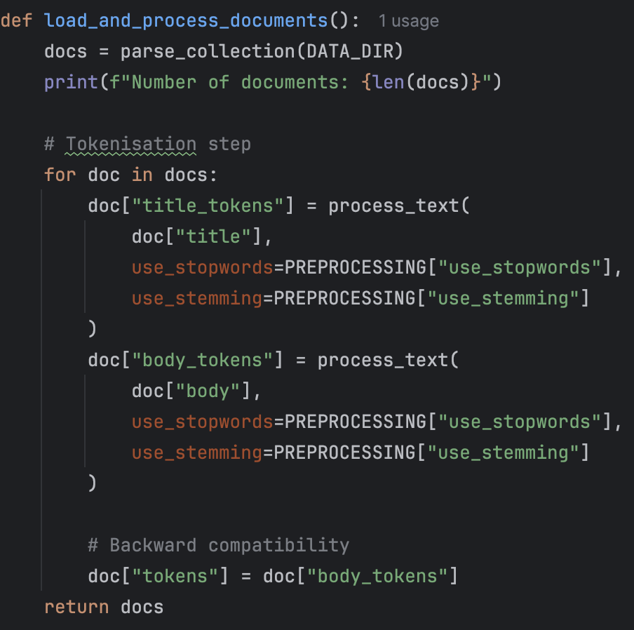
- Code/Implementation:

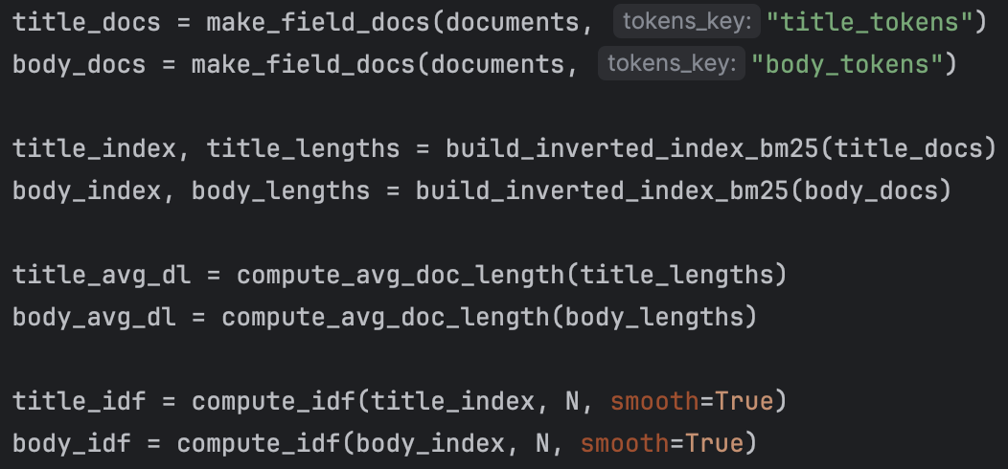
- Created separate token lists for title and body fields during preprocessing

- Built independent inverted indexes and document-length statistics for each field.
- Two separate indexes and two doc-length maps
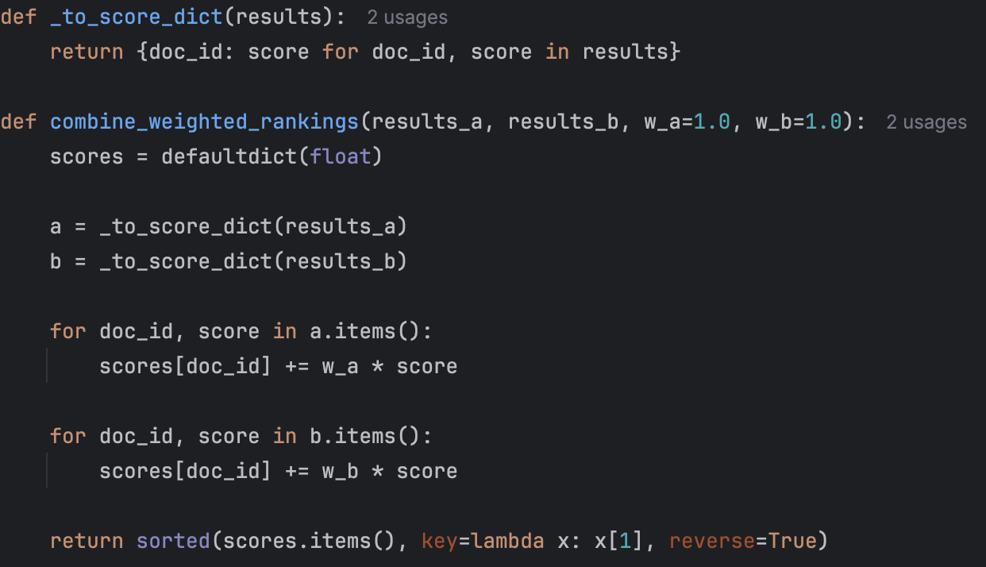
- Implemented weighted score combination for TF-IDF and BM25
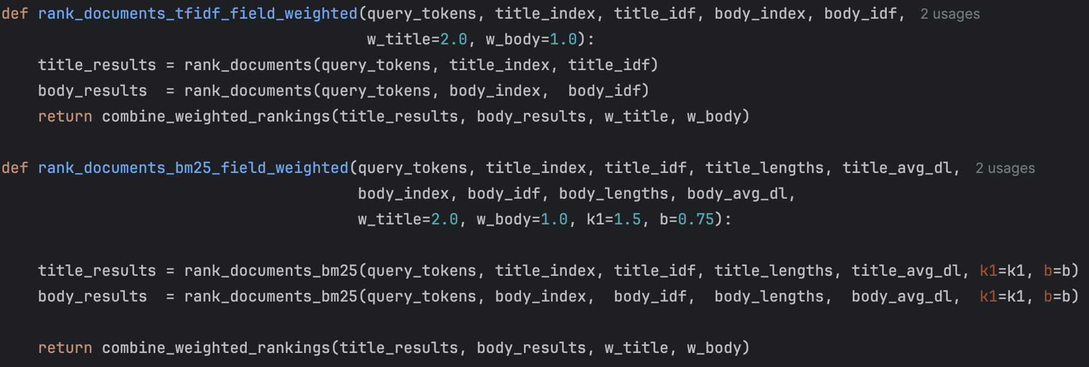

- Integrated field-weighted ranking into existing experimental pipeline
- This computes the title score and the body score and combines them using the weights

- Key Resources:
  - https://www.clickrank.ai/seo-glossary/w/what-is-weighted-bm25-variants/ - Explanations on how BM25 can be field weighted and reasons why you should use it
  - Generative AI – Used as a tutor to help my understanding on field weighting and how it could be used in a retrieval system.
3. Outcomes & Findings:
- Technical Output: Successfully implemented field-weighted TF-IDF and BM25 ranking models and evaluated them across all six required videogame queries using Precision@10 and Recall@10
- Conceptual Learning: Showed that field weighting did not universally improve retrieval effectiveness. For known-item and title-specific queries (e.g. Pokémon Trozei, The Sims 2 Apartment Pets), field weighting had little impact on Precision@10 or Recall@10, as the correct documents were already retrieved at top ranks under baseline models.
For broader or metadata-driven queries (e.g. Arcade type games, Game published by Atari), field weighting occasionally reduced recall. This occurred because relevant information for these queries is often distributed across document body text rather than concentrated in titles, meaning that boosting the title field reduced the influence of relevant body content.
These results demonstrate that field weighting is query-dependent and most effective when boosted field is highly discriminative for the user’s information need.
4. Challenges & Pivots:
- Challenge: Accidentally mixed baseline and field-weighted indexes
- Solution/Pivot: I separated index variables clearly and verified outputs by inspecting rankings for known-item queries

- Challenge: Inconsistent preprocessing between title and body fields
- Solution/Pivot: I enforced shared use of process_text() for all fields and queries

5. Reflection & Next Steps:
- Reflection: This session highlighted that advanced ranking techniques do not guarantee performance improvements in all cases. Field weighting proved effective only under specific conditions, particularly for known-item searches where titles are highly informative. The experiment reinforced the importance of understanding query intent and document structure when applying ranking enhancements.
- Next Steps:
  - Review all my experiment results and turn them into comparative tables and graphs
  - Prepare presentation slides, highlighting my experimental findings and limitations
  - Finalise my research log

Project Timeline & Milestones
Date | Milestone / Goal | Status (Planned/In Progress/Completed) | Notes / Log Entry Link
01-01-26 | Domain Selection & Rationale | Completed | Entry #1
02-01-26 | HTML Parsing & Document Structuring | Completed | Entry #2
03-01-26 | Tokenisation & Inverted Index Construction | Completed | Entry #3
04-01-26 | Implement TF-IDF Ranking & Precision@k | Completed | Entry #4
06-01-26 | Baseline Evaluation & Smoothed IDF | Completed | Entry #5
08-01-26 | Recall@k & Evaluation Pipeline Refactoring | Completed | Entry #6
09-01-26 | Implement BM25 & TF-IDF vs BM25 comparison | Completed | Entry #7
10-01-26 | Stop-word & Stemming Experiments + CLI | Completed | Entry #8
12-01-26 | Evaluation on the 6 Required Videogame Queries | Completed | Entry #9
15-01-26 | Lemmatization Implementation & Evaluation | Completed | Entry #10
20/01/26 | Field Weighting Extension & Evaluation | Completed | Entry #11

Final Project Summary & Self-Evaluation

1. Overall Outcome:
The outcome of this project is a fully functional Information Retrieval search engine prototype capable of indexing and retrieving documents from a real-world videogame HTML dataset. The system implements a complete IR pipeline, including HTML parsing, configurable text preprocessing, inverted indexing, ranking using TF-IDF and BM25, and formal evaluation using Precision@10 and Recall@10.
2. Key Successes:
One of the key successes of this project was the implementation and controlled comparison of TF-IDF and BM25. By evaluating both models under identical conditions across the six required queries, I demonstrated that BM25 consistently outperformed TF-IDF for broad and metadata-driven queries such as “Arcade type games” and “Game published by Atari”. This was supported by higher Precision@10 and Recall@10 values and reinforced by inspection of top-ranked results.
Another major success was the systematic evaluation framework. Implementing Precision@k and Recall@k early allowed every subsequent change to be evaluated quantitatively rather than subjectively. This made it possible to demonstrate not only improvements but also cases where advanced techniques (e.g. lemmatization or field weighting) did not improve performance, which strengthened the validity of the conclusions.
The field-weighting extension represents a further success. Separate title and body indexes were constructed, and weighted score combination was applied to both TF-IDF and BM25. Although field weighting did not universally improve results, the experiment demonstrated strong independent thinking and revealed important insights about query intent and document structure.
Finally, the system’s modular design—with clear separation between parsing, preprocessing, indexing, ranking, and evaluation—made experimentation reliable, reproducible, and easy to extend.

3. Major Learnings:
The most important conceptual insight gained from this project is that Information Retrieval performance is highly dependent on query type and data characteristics. Techniques often described as “improvements” in theory—such as stemming, lemmatization, or field weighting—do not guarantee better results in practice.
Through experimentation, I learned that:
- TF-IDF is highly sensitive to preprocessing choices, particularly stemming and stop-word removal.
- BM25 is more robust, remaining stable across preprocessing configurations due to document length normalisation and term-frequency saturation.
- Advanced techniques must be justified empirically, not assumed to be beneficial.
This reinforced the importance of controlled experimentation, formal evaluation metrics, and evidence-based reasoning in Information Retrieval system design.
4. Areas for Improvement:
If more time were available, several improvements could be explored:
- Learning optimal field weights automatically rather than using fixed values.
- Introducing additional evaluation metrics such as Mean Average Precision (MAP) for deeper ranking analysis.
- Expanding field-based retrieval to include additional metadata such as publisher or genre as independent ranking fields.
- Improving query understanding through lightweight query expansion or synonym handling.
- Scaling the system to larger datasets to further stress-test performance and efficiency.
These enhancements would build naturally on the existing modular system architecture.

5. Reflection on the Process:

Maintaining a detailed research log throughout the project had a significant positive impact on both workflow and learning. Writing each entry forced me to:

- Justify design decisions explicitly
- Reflect on why certain techniques worked or failed
- Maintain experimental discipline and reproducibility
- Identify mistakes early and correct them systematically
The research log helped me structure the project timeline, preventing scope creep and ensuring steady progress toward the coursework objectives. It also helped me keep track of my progress and plan my future entries that I would be creating.
Overall, the process reinforced good research practice and deepened my understanding of Information retrieval as an experimental discipline rather than just a programming task.

Log History:
Created: 01/01/2026
Last Updated: 29/01/2026

