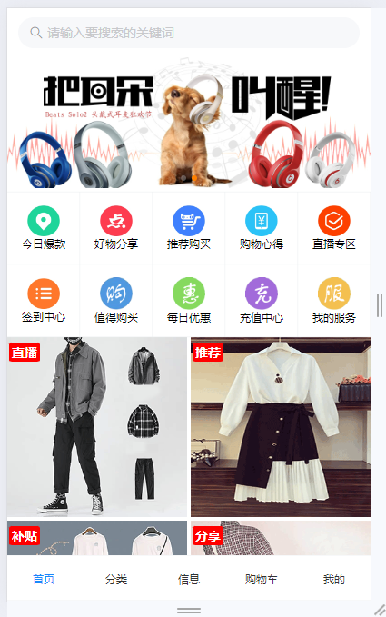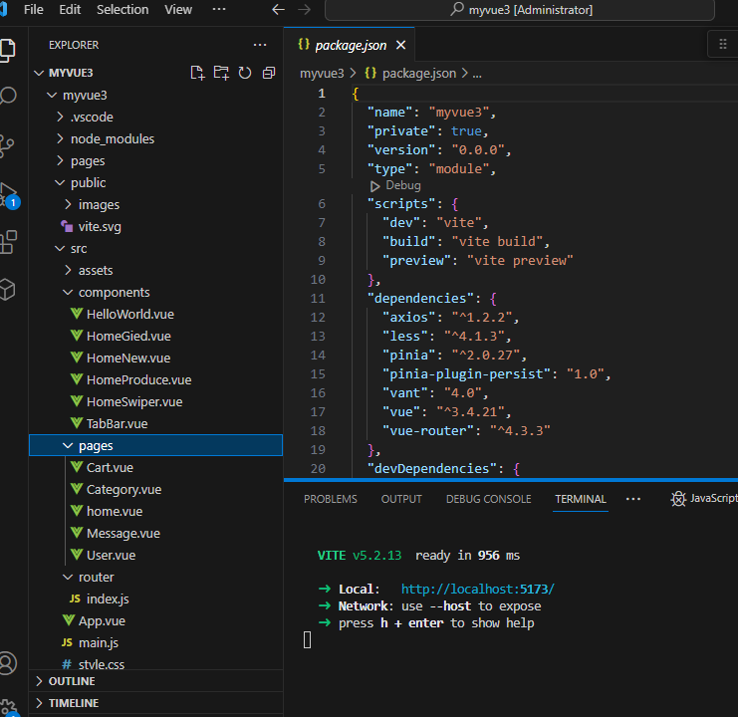

代码：home.vue

<template>

        <!-- 首页--头部搜索框 -->

        <van-search placeholder="请输入要搜索的关键词" shape="round" v-model="value"

            @search="onSearch" @cancel="onCancel"></van-search>

        <!-- 轮播图 -->

        <homeSwiper></homeSwiper>

        <!-- 功能 -->

        <HomeGied></HomeGied>

        <!-- 产品信息 -->

        <HomeProduce></HomeProduce>

        <!-- 每周上新 -->

        <HomeNew></HomeNew>

</template>

<script setup>

import { ref } from 'vue'

import { showToast } from 'vant';

import homeSwiper from '../components/HomeSwiper.vue'

import HomeGied from '../components/HomeGied.vue'

import HomeProduce from '../components/HomeProduce.vue'

import HomeNew from '../components/HomeNew.vue'

const value = ref('')

const onSearch=val=>showToast(val)

const onCancel=()=>showToast("取消")

</script>

