Fall 2026 | Report # – 09/24/2026 | Haiyi Li

——————————————————————————————————————
I. Task achieved Last Week
——————————————————————————————————————
- Read EEG Conformer: Convolutional Transformer for EEG Decoding and Visualization (Song, Zheng, Liu & Gao, IEEE TNSRE 31:710–719, 2023) and audited the authors’ released code (github.com/eeyhsong/EEG-Conformer).
- Checked every claim that can be verified from the paper and the code alone: the convolution-module architecture (Table I), the parameter counts behind Fig. 4 and the “+17.6% parameters” claim, the accuracy–kappa relation and per-subject averages in Tables II–IV, and the nine Wilcoxon significance claims.
- Reproduced Dataset I (BCI Competition IV 2a) end to end on CARC: downloaded the open BNCI release, ported the authors’ MATLAB preprocessing to Python, and ran 72 GPU jobs — 9 subjects × 3 seeds × 3 evaluation protocols, 2000 epochs each.
- Measured how much of the reported 78.66% comes from the model and how much from the rule the code uses to pick which epoch to report.
- Catalogued the places where the released code does not match the method as described in the paper.

——————————————————————————————————————
II. Feedback and Interaction
——————————————————————————————————————
- Prof. Kuo’s Feedback

- Labmates Feedback

——————————————————————————————————————
III. Report
——————————————————————————————————————
1. The architecture and cost claims reproduce exactly
I rebuilt the network from conformer.py and checked it against the paper. Table I matches the code line for line: temporal convolution 1→40 with kernel (1,25), spatial convolution 40→40 with kernel (22,1), average pooling (1,75) with stride (1,15). A 22×1000 trial becomes 61 tokens of 40 dimensions, which flatten to the 2440-wide vector the classifier expects.
Parameter counts agree to the digit. The model has 789,816 parameters at depth 6 and 671,496 with the self-attention module removed — an increase of 17.62%, against the 17.6% the paper states in its Discussion. Each encoder block costs 19,720 parameters, so the model reaches 967,296 at depth 15; the parameter curves in Fig. 4 sit on exactly these values for both datasets (the 3-channel Dataset II variant starts at 642,597 and ends at 938,397).
Training cost is also as advertised: I measured 0.56 s/epoch across CARC GPUs (range 0.36–0.84 s depending on card type) against the paper’s 0.27 s/epoch on an RTX 3090.
2. The tables are internally consistent — the significance claims mostly are not
Every kappa in Tables II–IV is exactly (accuracy − p_e)/(1 − p_e) with p_e = 1/4, 1/2 and 1/3, and every Conformer row averages to the figure printed in the “average” column. All nine Conformer cells in Table II are exact integer multiples of 1/288, which confirms the evaluation really is the full 288-trial session E, as described. One bookkeeping error: in Table III the EEGNet row averages to 80.81, but the table prints 80.48 — and the text’s “+4.15% over EEGNet” is computed from the printed value, not from the row.
The significance claims are the weak point. Re-running a Wilcoxon signed-rank test on the paper’s own per-subject numbers (n = 9, so the smallest attainable two-sided p is 0.0039) supports the comparisons against FBCSP on Dataset I (p = 0.008), ConvNet (p = 0.039), EEGNet on Dataset I (p = 0.0497) and EEGNet on Dataset II (p = 0.004). The comparisons against FBCSP and ConvNet on Dataset II reach p < 0.05 only one-sided (p = 0.055 and 0.074 two-sided). But the three claims on Dataset I against C2CM, FBCNet and DRDA — each written as “(p < 0.05)” — give p = 0.203, 0.129 and 0.129 two-sided, and 0.102, 0.065 and 0.065 one-sided. On the paper’s own numbers, Conformer is not significantly better than C2CM, FBCNet or DRDA on Dataset I.
3. The headline 78.66% is a maximum over 2000 evaluations of the test set
This is the substantive finding. In ExP.train() the full 288-trial test session is scored after every one of the 2000 epochs, and the script keeps bestAcc = max over those 2000 scores; main() then averages that per-subject maximum across the nine subjects. There is no validation set — the authors left the comment “! please please recheck if you need validation set” in get_source_data(). So the reported number is chosen using the test labels, and the epoch that wins is different for every subject and seed: in my runs the winning epoch ranges from 468 to 1996 (median 1427), and 78% of them fall after epoch 1000 — long past the point where training loss has converged. Test accuracy never settles; it oscillates for the full 2000 epochs, so the longer the run, the higher the maximum.
Reproducing the paper’s protocol exactly, I get 78.72% averaged over 9 subjects × 3 seeds, against the 78.66% in Table II — the pipeline reproduces. But the same runs settle at 68.77% when you average the last 100 epochs instead of taking the maximum, a gap of 9.95 points (± 3.37, n = 27 runs). Re-running with 20% of session T held out as a validation set and the epoch chosen by validation accuracy — the protocol the paper implies — gives 70.01%, i.e. κ = 0.6001 rather than the reported 0.7155.
The cleanest way to see the size of the effect is a control: train on scrambled training labels, leaving the test labels intact, and apply the same rule. The model cannot have learned anything, yet “best accuracy over 2000 epochs” reports 35.15% (subjects 1–6, 18 runs) against a chance level of 25.00% (the same runs sit at 25.79% over their last 100 epochs). Roughly 10 points of apparent accuracy are manufactured by the selection rule alone, before any real signal is involved.
4. The baselines were not selected the same way
The comparison in Table II is only meaningful if the baselines were scored under the same rule, so I checked. The paper never states how the baseline numbers were obtained — there is no sentence saying they were re-implemented, re-run, or quoted — and the release contains no baseline code, so the protocol behind those rows cannot be recovered from the paper or the repository.
Two rows can be traced indirectly. The ConvNet, EEGNet, C2CM and FBCNet cells are all exact integer counts out of 288, consistent with a genuine full-session evaluation. The FBCSP and DRDA cells are not: FBCSP’s are round numbers (76.00, 56.50, 81.25 …) and DRDA’s nine cells average to 74.697 while the row prints 74.74 with a matching kappa of 0.6632 — the printed average and kappa agree with each other but not with the cells above them, which is what copying a summary figure out of a source paper looks like.
What is checkable is what those methods did originally, and it is the opposite of Conformer. Schirrmeister et al. (ConvNet) “splits the training set into a training and validation fold and stops the first phase of the training when validation accuracy does not improve”, and state that “all reported accuracies have been determined on an independent test set”. Lawhern et al. (EEGNet) “run 500 training iterations (epochs) and perform validation stopping, saving the model weights which produced the lowest validation set loss”, on a three-way train/validation/test split. FBCSP is not iteratively trained at all, so a per-epoch maximum cannot arise for it in any form.
So wherever the Table II baselines came from their own papers, Conformer’s number was chosen with the test labels and theirs were not. That asymmetry runs in Conformer’s favour and is roughly the size of the margins being claimed.
5. Where the released code and the paper disagree
• The classifier is described as “two fully-connected layers”; the code uses three (2440→256→32→4). The global-average-pooling head the Discussion suggests as an alternative is defined in ClassificationHead but never called in forward().
• conformer_BCIIV2b.py uses depth 10 and 5 attention heads, and conformer_seed_1s_5fold.py uses 5 heads and 600 epochs — the paper states N = 6 and h = 10 throughout.
• The S&R augmentation the paper presents as part of the method is defined but never called in the SEED script, so the 95.30% in Table IV was produced without it.
• preprocessing/BCIIV2a.m hard-codes subject_index = 6 on its second line, overriding the function argument. preprocessing/BCIIV2b.m allocates 120 trials per session and then takes randperm(120), but sessions 3–5 of Dataset II hold 160 trials each. That script can therefore only yield a 240-trial test set, whereas eight of the nine Table III cells are consistent with 320 trials and five of them with nothing else; subject 2’s 65.71% fits neither 240 nor 320.
• In visualization/CAT.py, target_category = 2 is set but never passed to the GradCAM call, so the maps explain whichever class the model predicts. More importantly, the CAM is computed on the 61-token time axis and then resized to 22×1000, so it is identical for all 22 electrodes: the spatial structure in the Class Activation Topography figures comes entirely from the raw EEG channel means, re-weighted in time. The model’s spatial filter never enters the map.
• Every run seeds with np.random.randint(2021), so results are not reproducible run to run. Across my three seeds the per-subject spread of the paper’s statistic averages ±0.74 points and reaches ±1.59 on the worst subject, which is the same order as several of the gaps the paper calls improvements.
6. Bottom line
The model is real and the engineering claims hold up: the architecture, the parameter budget and the training cost are all exactly as described, and my reproduction of the authors’ own pipeline lands within 0.05 points of Table II. What does not hold up is the reporting protocol. The headline numbers on all three datasets are maxima over per-epoch test-set evaluations with no validation split, which inflates them by roughly 10 points on Dataset I — larger than the margin over every baseline in Table II except FBCSP.
That does not by itself mean the baselines were better. Their protocol is undocumented, and the 70.01% I measure under validation-based selection also carries 20% less training data, so it cannot simply be set against Table II either. The conclusion is narrower but more useful: the ranking in Table II is not testable from the paper alone. The figures 78.66 / 84.63 / 95.30 should not be quoted as reference points, and if we benchmark against Conformer we have to re-run it and every baseline under one common protocol — fixed seeds, a real validation split, and a reported epoch chosen without ever touching the test labels.
Table A. BCI IV 2a test accuracy (%). Reproduced rows are means over 3 seeds; the last row trains on scrambled labels and was run for subjects 1–6 only (chance = 25.00).
Subject | S1 | S2 | S3 | S4 | S5 | S6 | S7 | S8 | S9 | Avg
Paper, Table II | 88.19 | 61.46 | 93.40 | 78.13 | 52.08 | 65.28 | 92.36 | 88.19 | 88.89 | 78.66
Reproduced — paper’s rule (best epoch) | 89.12 | 60.07 | 93.17 | 80.90 | 52.78 | 62.73 | 92.48 | 87.50 | 89.70 | 78.72
Reproduced — mean of last 100 epochs | 80.03 | 46.20 | 86.91 | 71.18 | 40.98 | 53.56 | 77.34 | 80.78 | 81.93 | 68.77
Reproduced — validation-selected epoch | 84.26 | 48.96 | 86.34 | 71.30 | 41.67 | 54.51 | 76.97 | 81.37 | 84.72 | 70.01
Scrambled labels — paper’s rule | 38.66 | 32.29 | 40.74 | 36.46 | 31.71 | 31.02 | - | - | - | 35.15
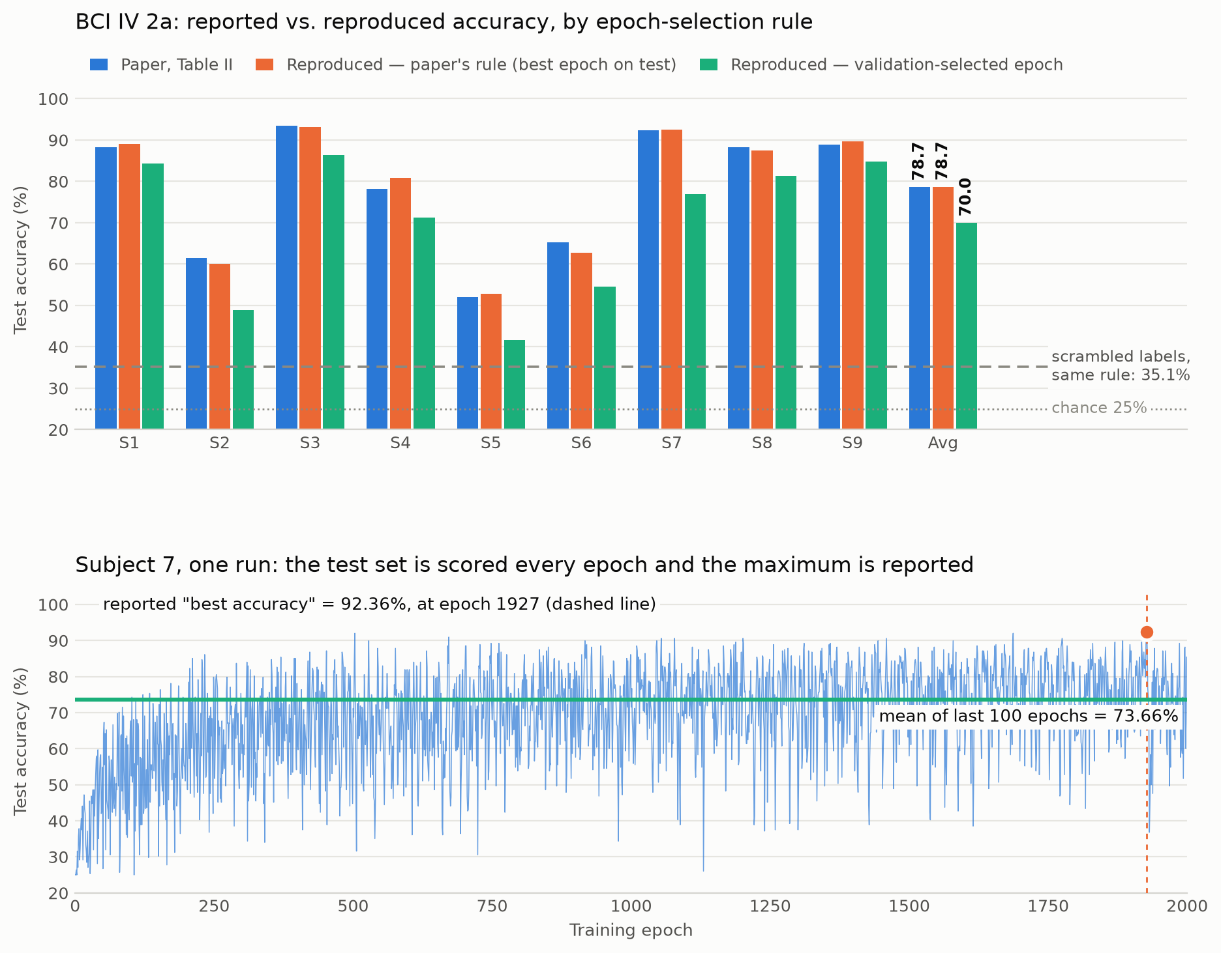
Figure A. Top: reported vs. reproduced accuracy under each epoch-selection rule. Bottom: a single run, showing the spike that becomes the reported number.

——————————————————————————————————————
IV. Plan for next week
——————————————————————————————————————
- Re-run Conformer on Datasets II and III (BCI IV 2b, SEED) under the same three protocols, so all three headline numbers have a validation-selected counterpart.
- Re-run the CNN baselines (ConvNet, EEGNet) under the identical protocol — the Table II comparison is only meaningful if the baselines were selected the same way.
- Write the corrected protocol (fixed seeds, validation split, report the final or averaged-tail epoch) into our own training harness so anything we compare against Conformer is measured the same way.
- Re-do the CAT visualization with the target class actually passed to GradCAM, and check whether a channel-resolved attribution changes the motor-cortex conclusion.

