Fall 2026 | Report # – 11/01/2026 | Wooyoung Kim

——————————————————————————————————————
I. Task achieved Last Week
——————————————————————————————————————
- Added sleep staging: ran the five reviewed models on Sleep-EDF Expanded (Sleep Cassette: 78 subjects, 153 nights) through CBraMod's released sleep-staging pipeline, on one age-stratified 62 / 8 / 8 subject split with seeds 0–4: CBraMod (pre-trained and from scratch), LaBraM-Base, EEG Conformer, EEGNet, and braindecode's ATCNet and DeepSleepNet (35 runs), plus braindecode's CBraMod, LaBraM, EEG Conformer and EEGNet in the same pipeline (20 runs).
- Validated two sleep-staging methods with their authors' released code: DeepSleepNet (Supratak et al., IEEE TNSRE 2017) and L-SeqSleepNet (Phan et al., IEEE JBHI 2023), each with its paper's Sleep-EDF-20 protocol (20 folds) and on the shared Sleep-EDF-78 split (3 runs each).
- Scored every model on one common test set (20,976 epochs of the 8 test subjects) and added the comparison script tools/compare_sleepedf.py.
- Reorganized the repository into one experiment per method (the EEGNet runs formerly inside CBraMod's experiment moved to methods/eegnet), added the Sleep-EDF experiments (code, logs, predictions, READMEs) and updated README, SUMMARY and RESULTS.
- SEED, the dataset first planned, was not run: its license application is pending.
——————————————————————————————————————
II. Feedback and Interaction
——————————————————————————————————————
- Prof. Kuo’s Feedback

- Labmates Feedback

——————————————————————————————————————
III. Report
——————————————————————————————————————
- Sleep-EDF, and one pipeline for every model
Data. Sleep-EDF Expanded (PhysioNet sleep-edfx 1.0.0), Sleep Cassette study: 153 nights of 78 healthy subjects aged 25–101, scored by technicians in R&K stages (mapped to W, N1, N2, N3, REM). It is the most used sleep-staging benchmark (966 citations of its reference paper, 761 works naming it in title or abstract). Fpz-Cz and Pz-Oz, the sleep period ± 30 min of wake, 30-s epochs.
One pipeline. Only the two sleep models' papers report Sleep-EDF. The other five models were therefore run through CBraMod's released sleep-staging code (its ISRUC path). Each model's encoder replaces CBraMod's backbone and encodes each 30-s epoch of a 20-epoch sequence; the released head (Linear → 512, one Transformer layer across the 20 epochs, a classifier), trainer, checkpoint rule (best validation κ), seeds 0–4 and metric code are the same for every model. Subjects are split by age (62 / 8 / 8), because Sleep-EDF subject numbers follow age and an index split would test only the oldest subjects.
Two sleep models. DeepSleepNet (raw-signal CNNs, then a BiLSTM across 25 epochs) and L-SeqSleepNet (a spectrogram epoch encoder, then BiLSTMs within and across subsequences of a 200-epoch sequence) were run with their authors' released TensorFlow code: with their papers' Sleep-EDF-20 protocols, and with their own training on the shared Sleep-EDF-78 split. All models are compared on the 20,976 test epochs that every model scores.
Table 1. What was run on Sleep-EDF (experiment folders under methods/).
Model | Implementation | Training | Runs | Experiment
CBraMod (pre-trained / no pre-training) | released code and weights | CBraMod pipeline | 5 + 5 | cbramod/finetune-sleepedf
LaBraM-Base | released code and weights | CBraMod pipeline | 5 | labram/sleepedf-cbramod-pipeline
EEG Conformer | released model | CBraMod pipeline | 5 | eeg-conformer/sleepedf-cbramod-pipeline
EEGNet | our PyTorch EEGNet-8,2 | CBraMod pipeline | 5 | eegnet/sleepedf-cbramod-pipeline
ATCNet | braindecode (code is TF) | CBraMod pipeline | 5 | atcnet/braindecode-sleepedf
DeepSleepNet | braindecode (single-epoch) | CBraMod pipeline | 5 | deepsleepnet/braindecode-sleepedf
DeepSleepNet | released code (TF 1.15) | its own | 3 | deepsleepnet/sleepedf78-cbramod-split
L-SeqSleepNet | released code (TF 1.15) | its own | 3 | l-seqsleepnet/sleepedf78-cbramod-split
CBraMod, LaBraM, Conformer, EEGNet | braindecode 1.8.1 | CBraMod pipeline | 5 each | <method>/braindecode-sleepedf

- The two sleep models reproduce their papers on Sleep-EDF-20
Table 2. Released code with the papers' protocols on Sleep-EDF-20 (20 subjects, 39 nights, Fpz-Cz); all folds pooled.
Model, protocol | Test epochs | Accuracy, ours (paper) | Macro-F1 | κ | Per-stage F1 W / N1 / N2 / N3 / REM, ours (paper)
DeepSleepNet, 20-fold CV | 41,950 | 81.8 (82.0) | 76.7 (76.9) | 0.754 (0.76) | 86.0 / 45.7 / 85.2 / 84.3 / 82.4 (84.7 / 46.6 / 85.9 / 84.8 / 82.4)
L-SeqSleepNet, LOSO (1 of 5 repetitions) | 46,241 | 86.1 (86.3 ± 0.2) | 79.4 (79.3 ± 0.4) | 0.811 (0.813) | 92.1 / 46.1 / 88.2 / 86.2 / 84.6 (91.6 / 45.3 / 88.5 / 86.2 / 85.2)

DeepSleepNet reproduces on exactly the paper's epochs. All three overall metrics are within 0.6 points, per-stage F1 within 1.4. The test set holds 41,950 epochs, the paper's count, because the released predict.py drops each night's last n mod 25 epochs; the paper's class counts are those after the drop.
L-SeqSleepNet reproduces once its run scripts are fixed. The released scripts pass subject 0's test list to every fold, so folds 2–20 would score a subject in their own training data; here each fold is tested on its own subject. The released evaluation batch (640 sequences × 200 epochs) does not fit a 12 GB GPU and was reduced, which does not change predictions. The scripts also differ from the paper (20 subsequences × 10 epochs and a fixed 11,000 steps, against 10 × 20 with early stopping); the paper's own ablation finds 20 × 10 better. The released evaluate.py gives the same numbers as our scoring.
The same subject is hardest for both. Subject 11 has the lowest accuracy in both reproductions (DeepSleepNet 0.606, L-SeqSleepNet 0.670); subject spread is far larger than the paper's repetition SD.
- Sleep-EDF-78: every model on the same split and test epochs
Table 3. Common test set (20,976 epochs, 8 test subjects): mean over runs (κ: ± SD), per-stage F1. n: runs. Pipeline models: seeds 0–4, epoch with the best validation κ; sleep models with their own released code: 3 runs.
Model | Impl. | n | κ | Bal. acc. | Macro-F1 | W | N1 | N2 | N3 | REM
LaBraM-Base (bd) | braindecode | 5 | 0.777 ± 0.006 | 0.767 | 0.767 | 0.95 | 0.44 | 0.84 | 0.80 | 0.80
LaBraM-Base | released | 5 | 0.773 ± 0.009 | 0.761 | 0.762 | 0.94 | 0.43 | 0.84 | 0.80 | 0.79
L-SeqSleepNet (own released code) | released (TF) | 3 | 0.773 ± 0.004 | 0.756 | 0.758 | 0.93 | 0.41 | 0.85 | 0.78 | 0.83
ATCNet (bd) | braindecode | 5 | 0.771 ± 0.004 | 0.743 | 0.750 | 0.95 | 0.38 | 0.84 | 0.80 | 0.78
CBraMod (bd) | braindecode | 5 | 0.768 ± 0.013 | 0.739 | 0.753 | 0.95 | 0.41 | 0.84 | 0.79 | 0.77
CBraMod | released | 5 | 0.768 ± 0.011 | 0.754 | 0.754 | 0.95 | 0.42 | 0.83 | 0.80 | 0.78
DeepSleepNet (bd) | braindecode | 5 | 0.762 ± 0.021 | 0.767 | 0.752 | 0.94 | 0.42 | 0.84 | 0.81 | 0.76
CBraMod, no pre-training | released | 5 | 0.745 ± 0.010 | 0.732 | 0.734 | 0.93 | 0.38 | 0.82 | 0.81 | 0.72
DeepSleepNet (own released code) | released (TF) | 3 | 0.703 ± 0.010 | 0.725 | 0.714 | 0.93 | 0.43 | 0.75 | 0.70 | 0.76
EEG Conformer (bd) | braindecode | 5 | 0.701 ± 0.034 | 0.680 | 0.692 | 0.90 | 0.37 | 0.83 | 0.71 | 0.66
EEG Conformer | released | 5 | 0.688 ± 0.019 | 0.645 | 0.658 | 0.91 | 0.35 | 0.81 | 0.56 | 0.66
EEGNet | our PyTorch | 5 | 0.681 ± 0.015 | 0.685 | 0.679 | 0.90 | 0.31 | 0.80 | 0.79 | 0.59
EEGNet (bd) | braindecode | 5 | 0.681 ± 0.016 | 0.687 | 0.682 | 0.91 | 0.33 | 0.79 | 0.77 | 0.61

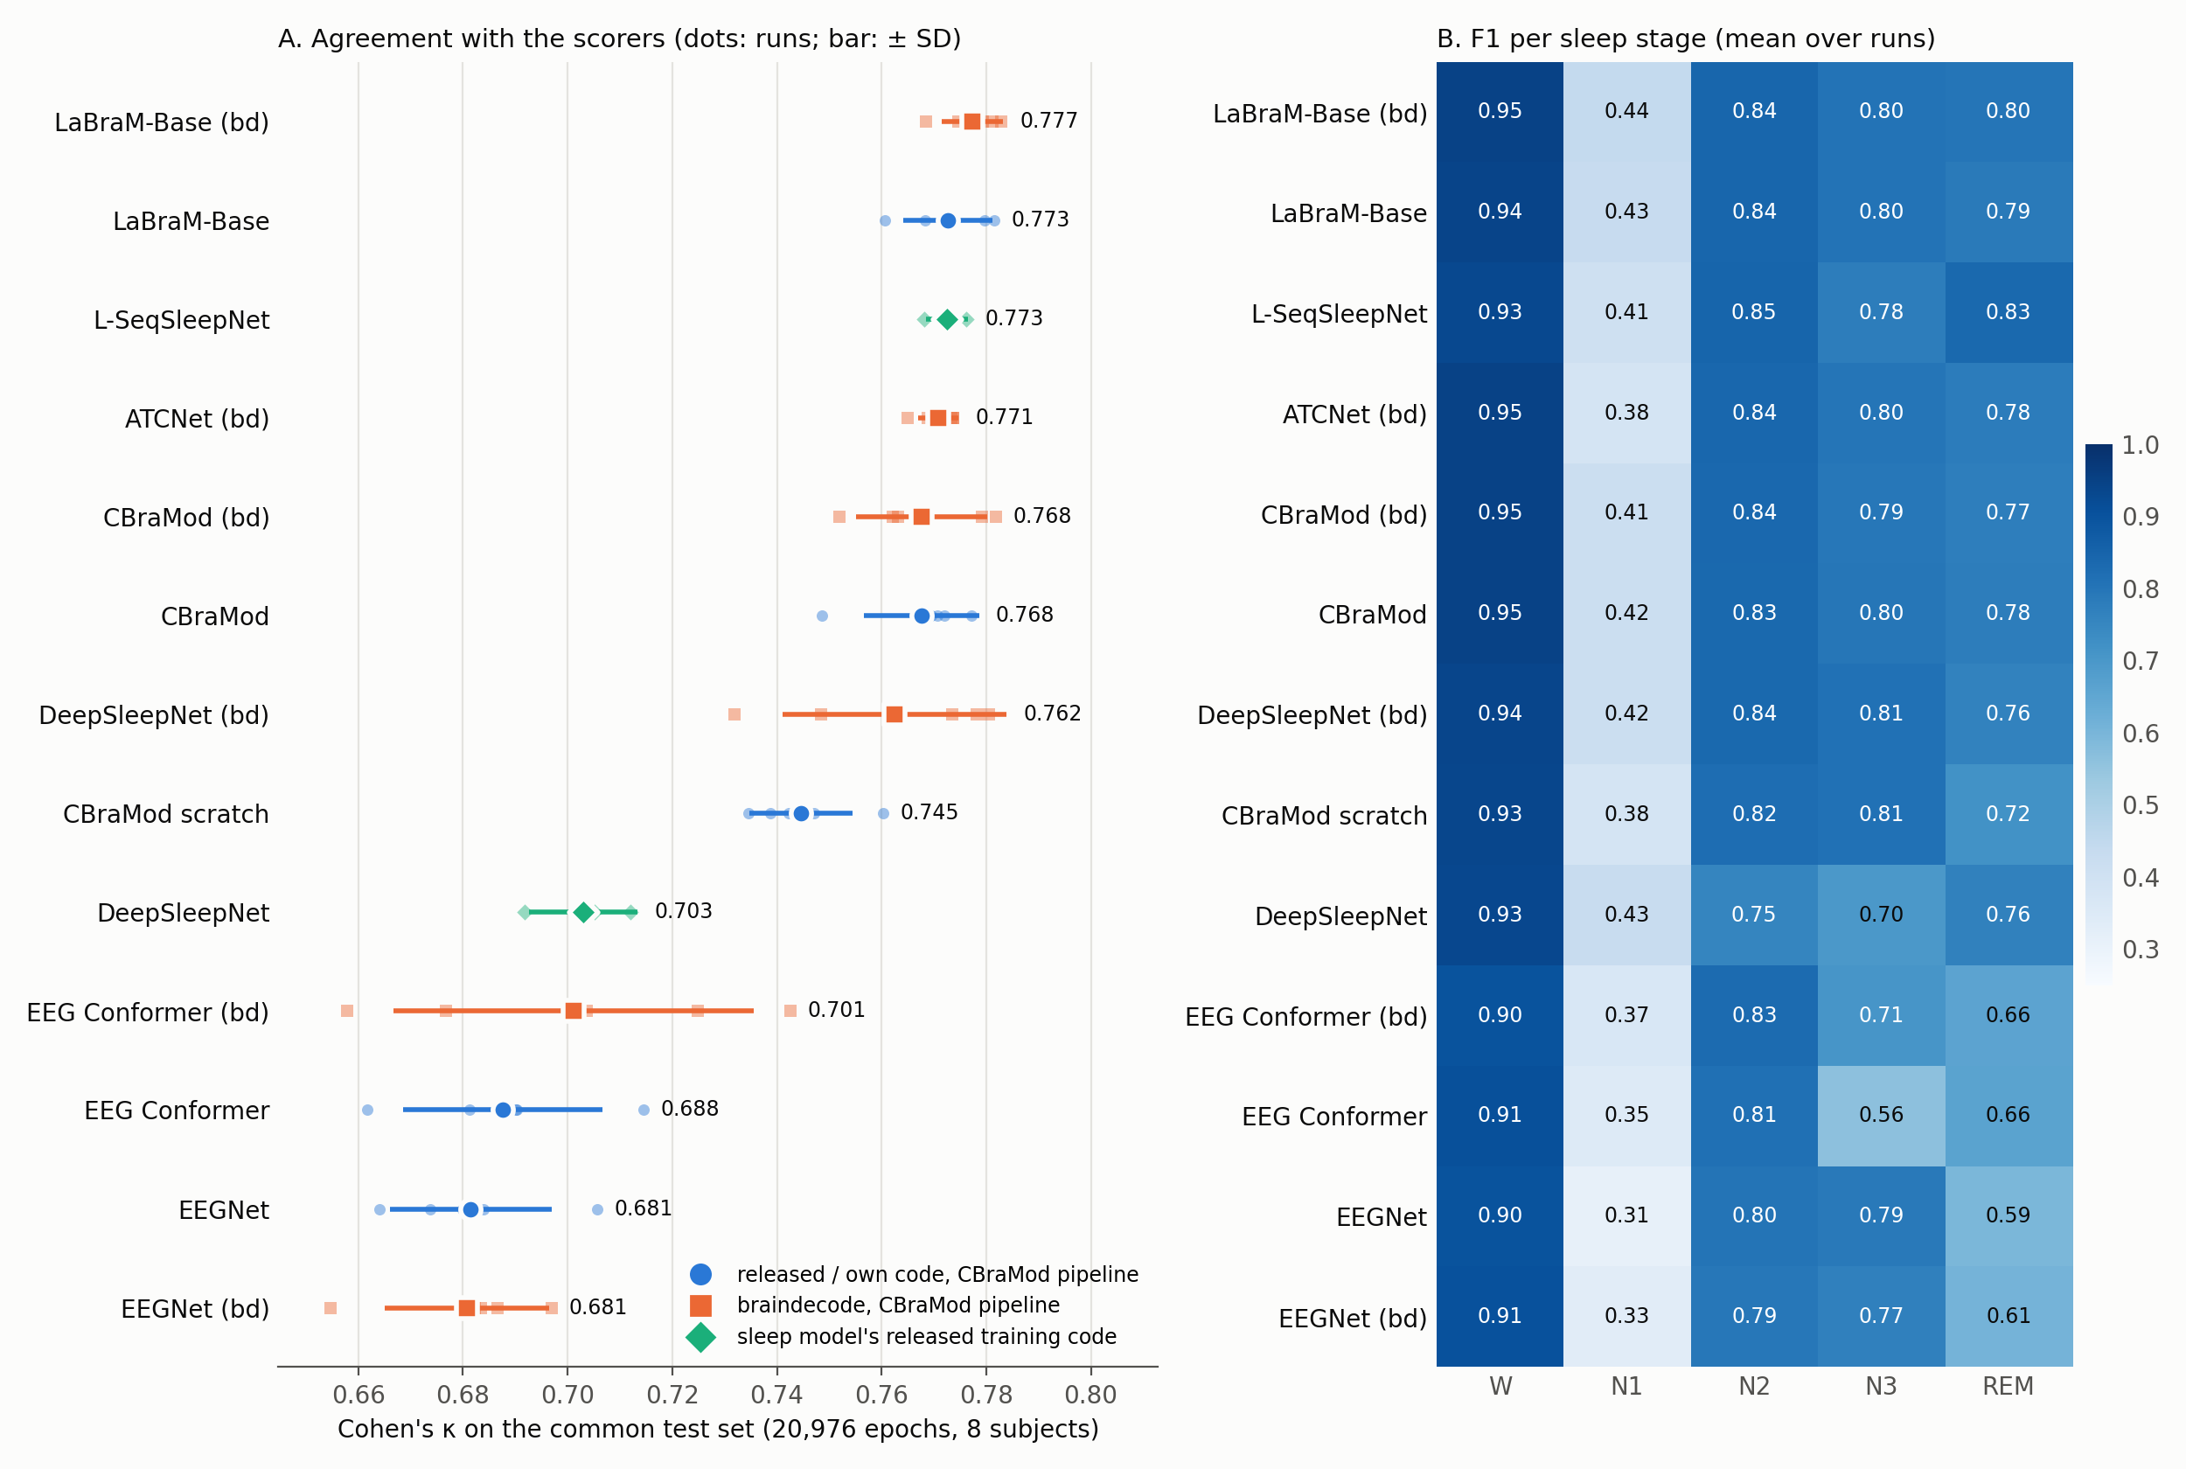
Figure A. Left: κ per run (small marks) and mean ± SD per model; colour and marker: implementation and training. Right: F1 per sleep stage, mean over runs.
Four models tie at the top. LaBraM-Base, L-SeqSleepNet (own released code), ATCNet (bd) and CBraMod reach κ 0.768–0.773; no pair of them differs significantly (smallest p = 0.40). ATCNet's encoder has 112k parameters and no pre-training (CBraMod − ATCNet -0.003 κ, p = 0.56). braindecode's re-run of LaBraM-Base, with the same encoder, has the highest κ of all runs (0.777) and is within noise of all four (smallest p = 0.08).
Pre-training helps on sleep data. Pre-trained CBraMod is +0.023 κ above CBraMod from scratch (p = 0.009), and LaBraM-Base +0.028 (p = 0.001). On CBraMod's four public motor-imagery and clinical datasets, pre-training helped only on PhysioNet-MI.
The small supervised models trail. EEG Conformer (0.688) and EEGNet (0.681) are 0.080 and 0.086 κ below CBraMod (both p < 0.001). EEGNet, the best model on BCI-IV-2a in CBraMod's pipeline, is the weakest here, in both implementations. The released Conformer's N3 F1 is 0.56 (braindecode's: 0.71) against ≥ 0.77 for the other pipeline models.
Stage profile. N1 is the hardest stage for every model (F1 0.31–0.44). L-SeqSleepNet, with 200 epochs of context, has the best REM F1 (0.834; the others ≤ 0.800). Validation selection is close to the best test epoch for every pipeline model (+0.005 to +0.037 κ).
Table 4. Pairwise tests on the common test set: A − B, mean over runs, Welch p over runs (5 vs. 5, or vs. 3).
A − B | κ | Balanced acc. | Macro-F1
LaBraM-Base − CBraMod | +0.005 (p = 0.43) | +0.008 (p = 0.44) | +0.008 (p = 0.34)
L-SeqSleepNet (own released code) − CBraMod | +0.005 (p = 0.40) | +0.002 (p = 0.86) | +0.005 (p = 0.53)
L-SeqSleepNet (own released code) − LaBraM-Base | 0.000 (p = 0.96) | -0.005 (p = 0.70) | -0.004 (p = 0.70)
CBraMod − ATCNet (bd) | -0.003 (p = 0.56) | +0.011 (p = 0.076) | +0.004 (p = 0.45)
CBraMod − CBraMod, no pre-training | +0.023 (p = 0.009) | +0.022 (p = 0.030) | +0.019 (p = 0.050)
LaBraM-Base − CBraMod, no pre-training | +0.028 (p = 0.001) | +0.030 (p = 0.026) | +0.027 (p = 0.021)
CBraMod − EEG Conformer | +0.080 (p < 0.001) | +0.109 (p < 0.001) | +0.095 (p < 0.001)
CBraMod − EEGNet | +0.086 (p < 0.001) | +0.068 (p < 0.001) | +0.075 (p < 0.001)
L-SeqSleepNet (own released code) − DeepSleepNet (own released code) | +0.070 (p = 0.003) | +0.031 (p = 0.078) | +0.044 (p = 0.009)
DeepSleepNet (bd) − DeepSleepNet (own released code) | +0.059 (p = 0.002) | +0.042 (p = 0.011) | +0.038 (p = 0.010)
DeepSleepNet (bd) − CBraMod | -0.005 (p = 0.65) | +0.013 (p = 0.027) | -0.001 (p = 0.87)

- DeepSleepNet: its released training rule, not the model, falls short on Sleep-EDF-78
With its own released code DeepSleepNet reaches κ 0.703 on Sleep-EDF-78, the weakest sequence model; braindecode's single-epoch DeepSleepNet inside CBraMod's pipeline reaches 0.762 (+0.059 κ, p = 0.002; balanced accuracy +0.042, p = 0.011; with braindecode's LaBraM-Base the highest of all models). The released code keeps the final model of 200 fine-tuning epochs and only prints the validation set. On this training set, 3.5 times Sleep-EDF-20's, validation accuracy peaks at fine-tuning epoch 7–10 (0.78–0.79) and falls to 0.75–0.76 while training accuracy reaches 0.99 (Figure B). Its N2 and N3 F1 (0.75, 0.70) are far below its Sleep-EDF-20 result (0.85, 0.84).
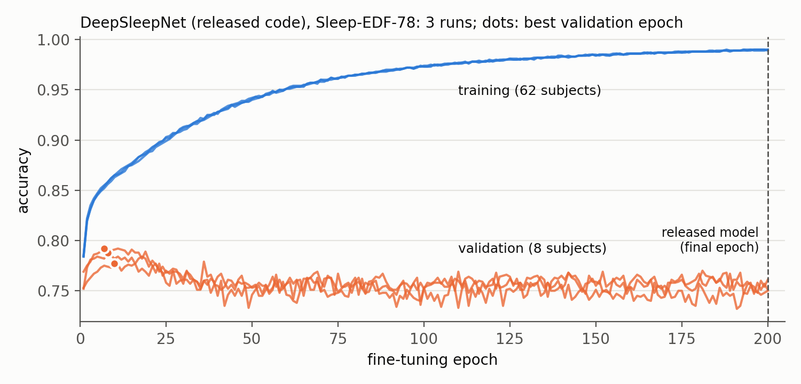
Figure B. Released DeepSleepNet on Sleep-EDF-78: training and validation accuracy per fine-tuning epoch, 3 runs; dots: best validation epoch. The released model is the last epoch.
- braindecode vs. the original implementations on Sleep-EDF
Table 5. braindecode − original implementation in the same pipeline, common test set, Welch p over seeds 0–4 (EEGNet: against our PyTorch EEGNet).
Model | κ, released / ours | κ, braindecode | braindecode − original, κ | Balanced acc.
CBraMod | 0.768 | 0.768 | 0.000 (p = 0.99) | -0.014 (p = 0.17)
LaBraM-Base | 0.773 | 0.777 | +0.005 (p = 0.36) | +0.006 (p = 0.56)
EEG Conformer | 0.688 | 0.701 | +0.014 (p = 0.47) | +0.035 (p = 0.089)
EEGNet | 0.681 | 0.681 | -0.001 (p = 0.95) | +0.001 (p = 0.89)

All four braindecode re-runs are within noise of the original implementations in κ (all p ≥ 0.36) and in balanced accuracy (all p ≥ 0.089). LaBraM-Base's two encoders give identical features on Sleep-EDF input (checked in float64), so its runs differ only by random draws. CBraMod matches to the fourth decimal (κ +0.0001, p = 0.99): here both implementations feed the released sequence head, and their encoders differ only by the pre-trained proj_out braindecode keeps. That is consistent with braindecode's own task head causing the 0.02 balanced-accuracy gap on PhysioNet-MI found earlier. EEGNet matches our PyTorch EEGNet despite braindecode's max-norm constraint, batch-norm defaults and Glorot initialisation. Of the 20 per-stage F1 tests one differs: braindecode's EEG Conformer scores N3 F1 0.71 against 0.56 (p = 0.047). Its attention scaling and its larger micro-batch (batch norm over 32 sequences instead of 4) both differ, and these runs cannot separate the two.
- Issues found in the released code
L-SeqSleepNet. Run scripts test every fold on subject 0's list, while evaluate.py scores fold n against its own subject; scripts and paper differ in sequence folding and stopping; the evaluation batch needs more than 12 GB; the released data are unfiltered although the preparation script band-passes 0.3–40 Hz; Table III cites DeepSleepNet's per-stage F1 as 86.7 / 45.5 / 85.1 / 83.3 / 82.6, where DeepSleepNet's own Table IV gives 84.7 / 46.6 / 85.9 / 84.8 / 82.4.
DeepSleepNet. prepare_physionet.py stops at SC4362F0 on Sleep-EDF-78 (its hypnogram runs 5 h past the recording; 82 of 153 nights unwritten), so the 78-subject data were written by a port checked against the released files; no model selection, so the fixed 200 fine-tuning epochs overfit on a larger training set.
braindecode. DeepSleepNet is single-epoch (its BiLSTM sees one epoch, as its docstring says) and uses standard LSTM gates instead of peepholes, so it is not the released model; L-SeqSleepNet is not in braindecode.
- Conclusion
Both sleep models reproduce their papers on Sleep-EDF-20 (DeepSleepNet 81.8% vs. 82.0%, L-SeqSleepNet 86.1% vs. 86.3%), L-SeqSleepNet only after fixing its run scripts' test list.
On Sleep-EDF-78, under one split and test set, the foundation models, L-SeqSleepNet and ATCNet tie (κ 0.768–0.773); pre-training is worth about 0.02–0.03 κ; EEG Conformer and EEGNet trail by about 0.08.
DeepSleepNet's released training rule costs it about 0.06 κ on the larger dataset; the same architecture family trained with validation-based selection is among the best.

——————————————————————————————————————
IV. Plan for next week
——————————————————————————————————————
- DeepSleepNet on Sleep-EDF-78 with validation-based checkpoint selection (its released trainer prints the validation accuracy already), to confirm that the final-model rule causes the gap.
- L-SeqSleepNet: repetitions 2–5 on Sleep-EDF-20, to compare with the paper's SD.
- ISRUC, CBraMod's own sleep benchmark, through the same pipeline: a published number to check the pipeline against.
- SEED for all models once the license is approved. Carry-over: braindecode issues upstream; TUH access.

