Fall 2026 | Report # – 11/08/2026 | Wooyoung Kim

——————————————————————————————————————
I. Task achieved Last Week
——————————————————————————————————————
- Obtained SEED and SEED-V (BCMI license download links) and STEW (IEEE DataPort) and prepared them; SEED-V in CBraMod's released format gives exactly the paper's 117,744 samples.
- Ran every model on SEED and SEED-V through CBraMod's released SEED-V pipeline, under its trial split and a subject split, seeds 0–4 (210 runs), plus L-SeqSleepNet off-label (12 runs).
- Validated the two papers that report SEED with their own protocols: EEG Conformer's released 5-fold code (120 runs) and DGCNN's two protocols, including the DGCNN authors' own TensorFlow code, run unmodified (10 runs).
- Added DGCNN (Song et al., IEEE TAC 2020): written from the authors' archived TensorFlow code, checked against braindecode's DGCNN (identical outputs), validated on SEED, and run on every dataset in the repository (BCI-IV-2a within- and cross-subject, PhysioNet-MI, Mumtaz2016, MentalArithmetic, Sleep-EDF, SEED, SEED-V, STEW).
- Added STEW (mental workload): every model with 7-fold GroupKFold across subjects (4-s windows, 25% overlap at 128 Hz), rest vs. task and 3 rating levels (980 runs).
- Updated the repository: 31 new experiment folders, RESULTS.md, SUMMARY.md, the datasets registry and the method READMEs; added mcl-server2 (8 RTX A6000, shared) for the STEW and subject-split runs.
- All runs finished; this revision (2026-11-09) adds ATCNet's subject-split runs, which ended after the meeting, and the DGCNN authors' own code.
——————————————————————————————————————
II. Feedback and Interaction
——————————————————————————————————————
- Prof. Kuo’s Feedback

- Labmates Feedback

——————————————————————————————————————
III. Report
——————————————————————————————————————
- Three datasets, one pipeline per dataset
SEED and SEED-V. SEED (15 subjects × 3 sessions × 15 film clips of about 4 min, positive / neutral / negative) and SEED-V (16 × 3 × 15, five emotions) run through CBraMod's released SEED-V code: 1-s samples of 62 channels at 200 Hz, its trainer and metric code, with only the model swapped. Two splits: CBraMod's trial split (every subject in training and test; clips 1–5 train, 6–10 validate, 11–15 test) and a subject split (SEED 9 / 3 / 3, SEED-V 10 / 3 / 3). SEED-V's trial split is the CBraMod paper's protocol (Table 2).
STEW. 48 subjects, Emotiv EPOC, 14 channels at 128 Hz, 150 s at rest and 150 s during the SIMKAP multitasking test, with a 1–9 workload rating after each. As specified: 4-s windows with 25% overlap (4,704 windows), sklearn GroupKFold(n_splits=7) by subject; validation = the next fold. Tasks: rest vs. task (48 subjects) and 3 rating levels (1–3 / 4–6 / 7–9; 45 subjects). CBraMod and LaBraM read the same windows resampled to 200 Hz, which their weights require.
Does GroupKFold need a random seed? GroupKFold takes no seed (random_state without shuffle=True raises an error) and is deterministic in one environment, but its folds are not portable: every STEW subject has the same number of windows, and with such ties the assignment depends on the numpy / scikit-learn version (fold 0 = subjects 3, 10, 17, 31, 38, 45, 48 with sklearn 1.6.1 / numpy 2.0.2; 6, 13, 20, 27, 34, 41, 48 with sklearn 1.9.1 / numpy 1.26.4). The folds are therefore pinned in a committed file. Training seeds are still needed: 5 per fold.
Table 1. What was run (experiment folders under methods/).
Dataset | Protocol | Models | Runs
SEED, SEED-V | CBraMod's SEED-V pipeline, trial and subject splits, seeds 0–4 | all eight; braindecode twins of five | 210 + 12
SEED | EEG Conformer's released 5-fold code; the same with clips held out | EEG Conformer | 120
SEED | DGCNN's protocols: each session 9 → 6 clips; leave one subject out | DGCNN, linear SVM | 87 job runs
STEW | 7-fold GroupKFold across subjects, two tasks, seeds 0–4 | all eight; braindecode twins of five | 980 + 42
BCI-IV-2a, PhysioNet-MI, Mumtaz2016, MentalArithmetic, Sleep-EDF | the existing pipelines | DGCNN (ours and braindecode) | 60 + 54 + 10

- DGCNN: implementation and what the paper's 90.40% measures
Code. The paper is closed access. The authors' code (EEG-TAC.zip, TensorFlow) was linked from the first author's page, now offline; the Wayback Machine's 2022 capture holds it. It has no license, so the repository fetches it by script (pinned SHA-256) instead of committing it. Our PyTorch port follows it line by line (one Chebyshev layer with a learned, asymmetric adjacency, 64 filters, a 256-unit layer); with the same weights it gives the same outputs as braindecode's DGCNN (to 1e-7). Run unmodified (TensorFlow 1.15, 5 runs, after checking its sources), the authors' code gives the same numbers as our port (Table 2).
The reported rule. In eeg_DE.py the validation set is the test set; the reported accuracy is the peak over ~80 test evaluations during training, averaged over each subject's two best sessions of three.
Table 2. DGCNN on SEED (de_LDS features, 5 runs; accuracy %). Within subject: each session, first 9 clips train, last 6 test. Paper: 90.40 and 79.95.
Rule | Best 2 of 3 sessions | All 3 sessions
Authors' code, unmodified: peak of ~80 test evaluations (their rule) | 87.59 | 82.87
Authors' code, unmodified: last step | 81.45 | 75.05
Our port: peak of ~80 test evaluations (the authors' rule) | 87.69 | 82.97
Our port: last step, authors' lr 0.07 | 81.39 | 74.62
Our port: last step, lr 0.01 chosen on clips 8–9 | 83.12 | 77.79
Linear SVM, C chosen on clips 8–9 |  | 79.42
Linear SVM, C chosen on the test set | 87.89 | 82.37
Leave one subject out, last step, lr 0.01 (paper 79.95) |  | 77.58 (SVM 58.85)

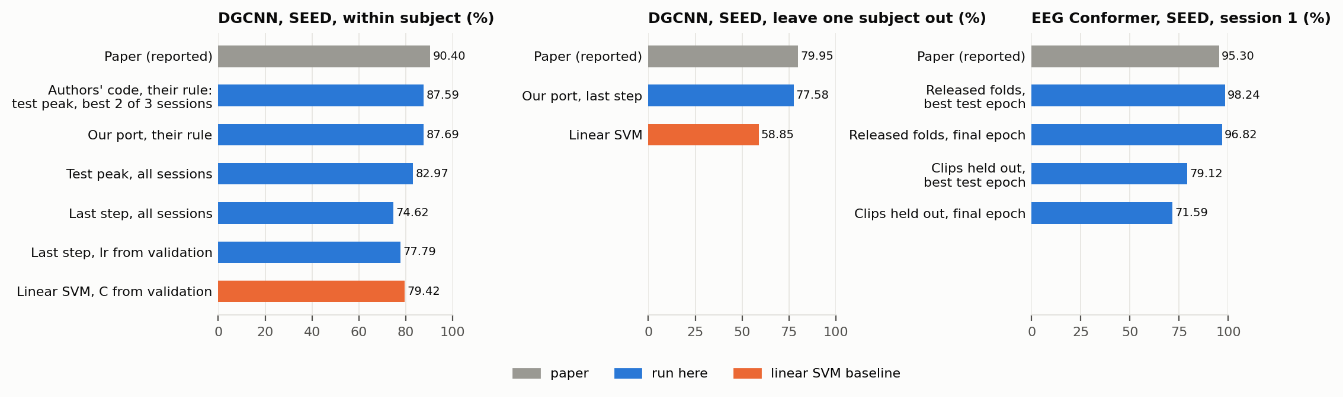
Figure A. What the reported SEED numbers depend on. Left: DGCNN within subject under the authors' rule (their own code and our port) and without test selection; middle: DGCNN across subjects; right: EEG Conformer's released folds (inside clips) against whole clips held out.
Within subject the reported number is mostly selection. Under the authors' rule their own code, run unmodified, gives 87.59 (best of 5 runs 88.22) and our port 87.69 (p = 0.75): both 2.7 pp short of the paper, so the gap is not the port but something the archive does not hold, most likely the DE input files. Without the two test-set choices the same runs give 74.62, or 77.79 with a learning rate chosen on validation clips.
A linear SVM ties it. On identical features and split, with nothing chosen on the test set: DGCNN 77.79, SVM 79.42 (Wilcoxon over 15 subjects, p = 0.33). The paper's lead over SVM (90.40 vs. the literature's 83.99) does not appear on identical data and selection.
Across subjects the paper holds. Leave one subject out, last step, no test selection: 77.58 against the paper's 79.95 and 58.85 for the SVM (p = 0.0001). Both z-score each session with its own statistics (the test subject's too), which the authors' archive does not settle.
- EEG Conformer's SEED number: folds inside clips
Table 3. EEG Conformer on SEED, session 1, 15 subjects (accuracy %, SD over subjects). Paper / README: 95.30 (5-fold).
Epoch rule | 5 folds inside clips (released) | First 9 clips → last 6 | Difference (Wilcoxon p)
best epoch on test (released) | 98.24 ± 1.06 | 79.12 ± 11.91 | +19.12 (0.0001)
final epoch | 96.82 ± 1.71 | 71.59 ± 12.54 | +25.23 (0.0001)

Reproduces, but measures clip recognition. The released code reproduces and exceeds the reported number. Its folds are cut inside each 4-minute clip, so a test window's neighbours one second away are in training; with whole clips held out the same model, session and training lose 25 points at the final epoch.
- Every model on SEED and SEED-V
Table 4. Balanced accuracy, mean over seeds 0–4, CBraMod's SEED-V pipeline (chance: SEED 0.333, SEED-V 0.200).
Model | SEED, trial | SEED, subject | SEED-V, trial | SEED-V, subject
LaBraM-Base | 0.630 | 0.582 | 0.414 | 0.221
CBraMod | 0.616 | 0.544 | 0.396 | 0.222
CBraMod, no pre-training | 0.587 | – | 0.274 | –
DGCNN | 0.574 | 0.521 | 0.387 | 0.256
DeepSleepNet (bd) | 0.591 | 0.503 | 0.400 | 0.242
ATCNet (bd) | 0.489 | 0.541 | 0.270 | 0.253
EEG Conformer | 0.536 | 0.538 | 0.320 | 0.237
EEGNet | 0.491 | 0.523 | 0.289 | 0.247

Table 5. SEED-V, trial split, against the CBraMod paper (Table 2); Welch p from means, SDs and n = 5.
Model | Bal. acc., paper | Bal. acc., ours (Δ, p) | κ, paper | κ, ours (Δ, p)
CBraMod | 0.4091 | 0.3962 (-0.0129, p = 0.041) | 0.2569 | 0.2501 (-0.0068, p = 0.377)
LaBraM-Base | 0.3976 | 0.4136 (+0.0160, p = 0.069) | 0.2386 | 0.2661 (+0.0275, p = 0.041)
EEG Conformer | 0.3537 | 0.3205 (-0.0332, p = 0.003) | 0.1772 | 0.1464 (-0.0308, p = 0.031)
EEGNet | 0.2961 | 0.2894 (-0.0067, p = 0.313) | 0.1006 | 0.1133 (+0.0127, p = 0.145)

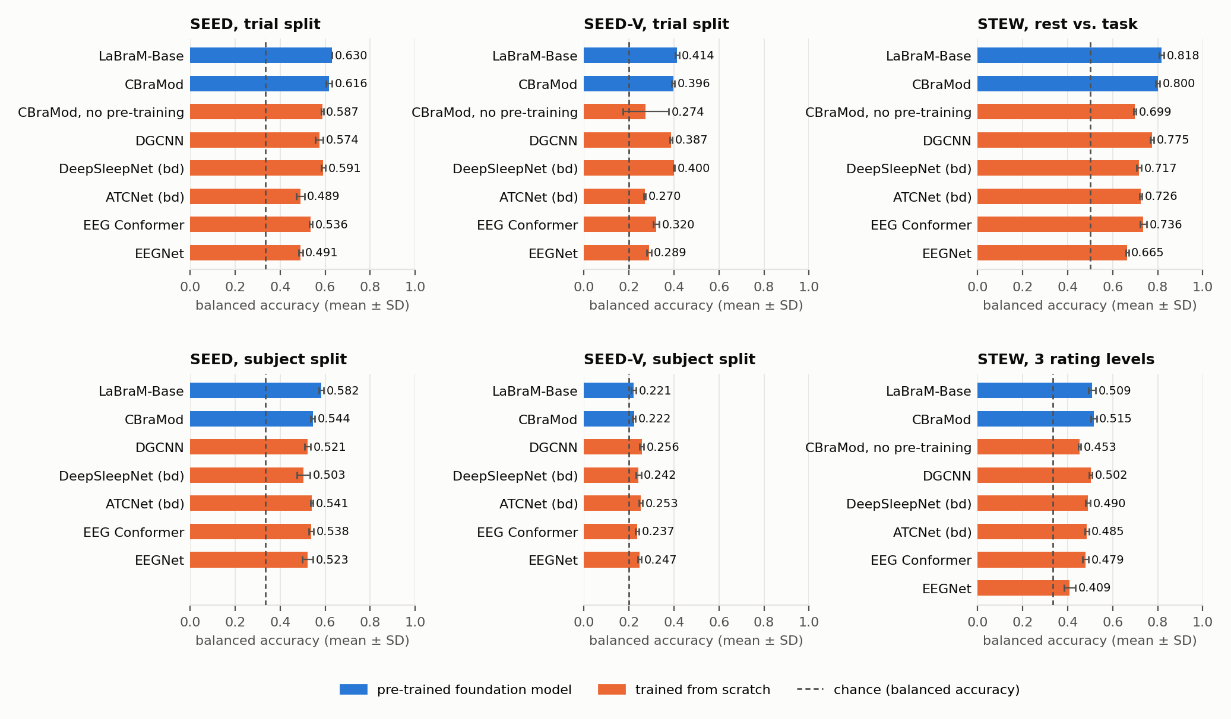
Figure B. Every model on SEED, SEED-V and STEW (balanced accuracy, mean ± SD over seeds 0–4; dashed: chance). Blue: pre-trained foundation models; orange: trained from scratch.
SEED-V reproduces, with LaBraM-Base on top. CBraMod's κ and weighted F1 are within noise of its paper on SEED-V and its balanced accuracy is 0.013 lower (p = 0.041): its closest match to its paper in this repository (on its four other datasets 9 of 12 metrics were significantly lower). But LaBraM-Base beats it there (0.414 vs. 0.396, p = 0.011), the reverse of the paper's ranking, and leads on SEED too.
Across subjects SEED-V is at chance. Every model scores 0.22–0.26 balanced accuracy for 5 classes (κ 0.02–0.07); the foundation models do worst. Published SEED-V numbers depend on the test subjects being in the training set.
Pre-training mostly makes training reliable. Without pre-training, 3 of 5 seeds of CBraMod on SEED-V never leave chance; the two that train match the pre-trained model. On SEED, pre-training adds 0.029 (p = 0.007).
Other models. braindecode's DeepSleepNet (single 1-s window) is level with CBraMod on SEED-V's trial split (0.400 vs. 0.396). DGCNN beats EEG Conformer and EEGNet on both trial splits. L-SeqSleepNet, off-label on 30-s windows of three channels, reaches a clip vote of 0.51 on SEED's trial split; its subject-split score (0.79) is not valid: its 20-window sequences can read the fixed clip order. braindecode's ATCNet is the weakest model on SEED-V's trial split (0.270): its training loss falls only from 1.60 to 1.42 in 50 epochs (chance level 1.61; EEGNet 1.41, CBraMod 0.40), so it underfits 1-s samples under CBraMod's training settings; on Sleep-EDF's 30-s epochs it tied CBraMod. Across subjects it loses nothing: 0.541 on SEED, level with CBraMod and second to LaBraM-Base, 0.052 above its trial split (p = 0.002); EEGNet also gains (+0.032), while the foundation models, DGCNN and DeepSleepNet lose 0.05–0.09.
- STEW: mental workload
Table 6. STEW, 7-fold GroupKFold across subjects, mean over seeds 0–4 (each seed scored on its pooled 7 test folds).
Model | Rest vs. task: accuracy | κ | 3 levels: accuracy | κ
LaBraM-Base | 0.818 | 0.636 | 0.567 | 0.313
CBraMod | 0.800 | 0.600 | 0.566 | 0.315
CBraMod, no pre-training | 0.699 | 0.397 | 0.496 | 0.205
DGCNN | 0.775 | 0.549 | 0.552 | 0.297
DeepSleepNet (bd) | 0.717 | 0.434 | 0.547 | 0.270
ATCNet (bd) | 0.726 | 0.451 | 0.529 | 0.257
EEG Conformer | 0.736 | 0.473 | 0.512 | 0.246
EEGNet | 0.665 | 0.330 | 0.497 | 0.139
L-SeqSleepNet (30-s windows, 3 runs) | 0.767 | 0.533 | 0.541 | 0.272

Rest vs. task. LaBraM-Base 0.818, CBraMod 0.800 (p = 0.022), DGCNN 0.775 (the best without pre-training; braindecode's DGCNN on the same DE input 0.783), EEG Conformer 0.736, ATCNet 0.726, EEGNet 0.665. Pre-training adds 0.10 (p < 0.001), CBraMod's largest significant gain in the repository. The spread across folds (SD 0.05–0.06) is four to eight times the spread across seeds.
3 rating levels are hard across subjects. At most 0.574 accuracy (braindecode's LaBraM-Base; majority class 0.467) and κ 0.33. The dataset paper's 69% / κ 0.46 comes from a feature-selection pipeline whose cross-validation its abstract does not state.
L-SeqSleepNet. Off-label, on 30-s windows of three channels (one 5-window sequence per recording), the sleep model reaches 0.767 on rest vs. task, between DGCNN and EEG Conformer, and 0.541 (κ 0.27) on 3 levels. A 30-s window holds 7.5 times the signal of a 4-s window, so this does not rank the architectures.
- DGCNN on the other datasets
Table 7. Balanced accuracy on CBraMod's splits (seeds 0–4); CBraMod, LaBraM-Base and EEGNet from the earlier runs.
Dataset | DGCNN (DE input) | DGCNN (bd, raw) | CBraMod | LaBraM-Base | EEGNet
PhysioNet-MI | 0.482 | 0.578 | 0.626 | 0.610 | 0.595
BCI-IV-2a | 0.346 | 0.452 | 0.457 | 0.448 | 0.529
Mumtaz2016 | 0.962 | 0.871 | 0.893 | 0.890 | 0.883
MentalArithmetic | 0.624 | 0.559 | 0.589 | 0.656 | 0.557

The input decides. On band power DGCNN is the best model on Mumtaz2016 (0.962) and second to LaBraM-Base on MentalArithmetic; on motor imagery raw samples beat DE by 0.09–0.11 and it is last, including within subject on BCI-IV-2a (44.4% vs. 70.0% for EEG Conformer, validation-selected). On Sleep-EDF-78 it reaches κ 0.694, level with EEG Conformer and EEGNet.
- braindecode vs. the original implementations
Within noise on the easier tasks, about 0.02 lower for two models on the harder ones. On SEED's trial split and STEW's rest vs. task every braindecode model is within noise of the original (all p ≥ 0.06). On the two harder tasks braindecode's CBraMod (its own one-layer head again) and EEG Conformer fall about 0.02 behind: on SEED-V by 0.018 (p = 0.011) and 0.024 (p = 0.019), on STEW's 3 levels by 0.021 (p = 0.021) and 0.022 (p = 0.018); DGCNN on our DE input is 0.011 lower on SEED-V (p = 0.005). braindecode's DGCNN ships with raw samples as node features, which costs 0.05–0.11 on every dataset except motor imagery.
- Issues found
DGCNN. The reported 90.40% validates on the test set, keeps the peak of ~80 test evaluations and averages each subject's best 2 of 3 sessions; on SEED's distributed DE features the authors' own code reaches 87.6%, not 90.40%; the archive holds no subject-independent script and does not say which DE smoothing was used. torcheeg's DGCNN uses powers of the adjacency matrix, not Chebyshev polynomials.
EEG Conformer. conformer_seed_1s_5fold.py makes its folds inside clips (96.8% vs. 71.6% with clips held out).
CBraMod. The released model_for_seedv.py crashes with its default head (a .view before a 4-D rearrange), and the released Trainer crashes when validation κ never exceeds 0; both worked around outside upstream/.
Datasets. SEED-V ships subject 7's first session twice (the repaired copy lacks two channels); LaBraM's own SEED-V result uses a 20-subject version that is not public; GroupKFold folds on STEW depend on library versions.
- Conclusion
Both papers that report SEED reproduce under their own rules, and both rules inflate the number: DGCNN's by selecting on the test set (90.4% reported, 77.8% without), EEG Conformer's by splitting inside clips (96.8% vs. 71.6%). DGCNN's across-subject result holds up (77.6% vs. 79.95%) and is its real strength over a linear SVM.
CBraMod's SEED-V benchmark reproduces within noise in κ, but LaBraM-Base, run the same way, is better there, on SEED and on STEW's rest vs. task; and across subjects SEED-V is at chance for every model.
On STEW the foundation models lead and pre-training matters most; three workload levels are barely decodable across subjects.

——————————————————————————————————————
IV. Plan for next week
——————————————————————————————————————
- DGCNN: the authors' own code reaches 87.6%, not 90.40%; read the paper (closed access) for how its DE features were made, and ask the authors for the input files.
- L-SeqSleepNet on SEED with sequences confined to one clip, to confirm that its subject-split score reads the clip order.
- Carry-over: DREAMER for DGCNN (access by request); ISRUC; TUH access; braindecode issues upstream (including DGCNN's raw-input default).

