Team 5:
Brandon Cannaday
Gabriel Golcher
Anthony Panozzo
Michael Kuehl
Adam Westhusing

Distributed Peer Review Plug-in for TRAC
Architecture Overview

For

William Nagel

Senior Project
2005 - 2006

REVISION HISTORY
Revision | Date | Author(s) | Description
1.0 | 03/20/2006 | Michael Kuehl | Initial release.
1.1 | 03/23/2006 | Brandon Cannaday | Diagrams added.
1.2 | 03/28/2006 | Brandon Cannaday | Renamed needed filenames, sequence diagrams.

Table of Contents

1. Overview 2
2. Database Backend 2
3. Viewable Page Code Behinds 3
4. Viewable Page Templates 4
5. AJAX Callback Pages 4
6. Miscellaneous 5
7. Program Flow 5

1. Overview

There are four major components in the design of the peer review plug-in. These are: the database backend, the code for the viewable pages, the viewable pages templates, and the AJAX callback pages. See Figure 1.1 for a general diagram of system interaction.
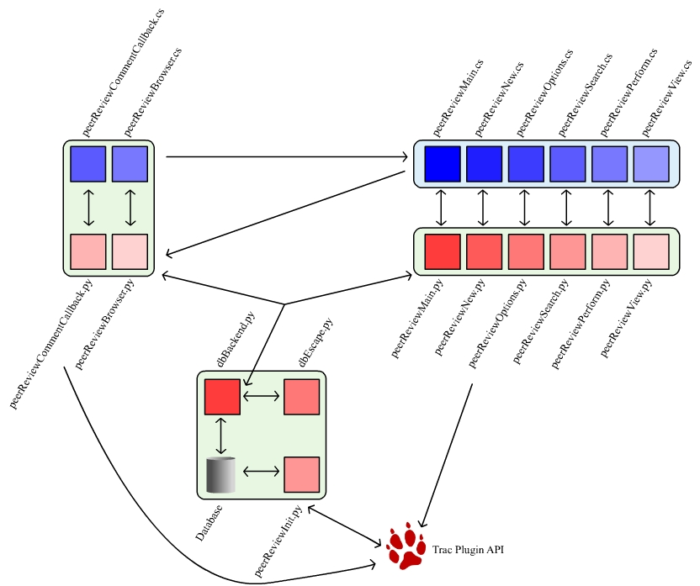
Figure 1.1 – System Interaction Diagram

2. Database Backend

The database backend is made up of:
- dbBackend.py
- dbEscape.py
- db.py
- init.py
- CodeReviewStruct.py
- ReviewCommentStruct.py
- ReviewFilesStruct.py
- ReviewersStruct.py.

Init.py and db.py are used in the initial plug-in install. Init.py implements the Trac interface IEnvironmentSetupParticipant, which allows it to affect the Trac environment itself (specifically, the database). When the plug-in is installed, methods in init.py are called and the tables defined in db.py are created in the local Trac database. Other than the initial install, neither of these files is ever used.

All of the struct.py files are simple classes meant to deal with rows from their respective tables. For instance, rows from the CodeReviews table are placed in instances of CodeReviewStruct. Each of these classes has a “save” method, making for easy row creation and updating.

dbEscape.py holds a very simple function which escapes strings for database queries. It is used in the various struct classes and in dbBackend.

dbBackend.py is the major way most of the plugin interacts with the database. It holds a number of methods that create various queries, send the queries to the database, and return the results (usually in the form of structs or arrays of structs). This class and the save methods of the struct files are the only places that there is raw SQL – which allows for easy identification of SQL syntax errors and other mistakes.

3. Viewable Page Code Behinds

This component is made up of the following files:
- peerReviewMain.py
- peerReviewNew.py
- peerReviewOptions.py
- peerReviewSearch.py
- peerReviewPerform.py
- peerReviewView.py

Each of these files directly relates to a viewable page template of the same name (but a different extension). They all implement the Trac provided interfaces IRequestHandler and INavigationContributor. These allow Trac to match the URL given by a user to the correct Python code file. All of these files use dbBackend to talk to the tables used for code reviews, and in fact, almost all database interaction is done through these files. These files are also responsible for basic error checking of user input, as well as authentication checking.

peerReviewMain.py does two other things that are important for the correct functioning of the plug-in. It creates the basic “Peer Review” link in the row of major links in the Trac interface, using one of the methods provided by the INavigationContributor interface. It also creates the two types of permissions used by the code review plug-in – CODE_REVIEW_DEV and CODE_REVIEW_MGR. It does this by implementing the Trac provided interface IPermissionRequestor, which allows this class to interact with Trac’s permission system.

4. Viewable Page Templates

These are the templates used:
- peerReviewMain.cs
- peerReviewNew.cs
- peerReviewOptions.cs
- peerReviewSearch.cs
- peerReviewPerform.cs
- peerReviewView.cs

Each of these files is a ClearSilver template file, and directly relates to both a Python file of the same name, and a page viewable by a user. These files contain all of the HTML and Javascript used for the plug-in. They take information from their corresponding Python file and use very simple logic and loops to create the page. This distinction between code behind logic and display logic creates very readable and understandable code.

5. AJAX Callback Pages

The files in this component are:
- peerReviewBrowser.py
- peerReviewCommentCallback.py
- peerReviewBrowser.cs
- peerReviewCommentCallback.cs

These files are very similar to the code-behind files and the template files, except for the fact that they should never be called directly by a user, and are never meant to be viewed by themselves. They are called by javascript in other pages – specifically peerReviewNew calls peerReviewBrowser and peerReviewPerform calls peerReviewCommentCallback.

peerReviewBrowser allows for seamless browsing of the repository when creating a code review. Browser calls are sent by peerReviewNew through Javascript to this page, and the results are placed in the peerReviewNew page dynamically.

peerReviewCommentCallback allows for seamless viewing and creation of comments when performing a code review. Here, any calls relating to comments are sent by peerReviewPerform through Javascript to this page, and the results are placed in the peerReviewPerform page dynamically.

6. Miscellaneous

There is one file not mentioned in any of these components: It is __init__.py. This is the file that the Trac plug-in system expects to exist in any plug-in. It tells Trac which files it should load directly into the system. In most cases, if anyone adds any new files to the plug-in, they will need to be listed in this file.

7. Program Flow

Below are example program flows to see how the client, web server, and database interact during common user actions.

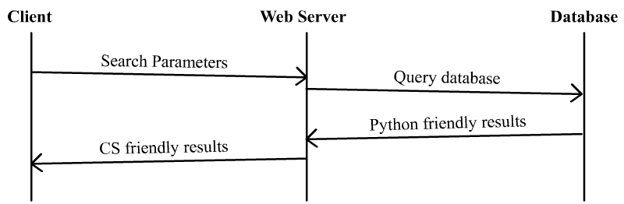
Figure 7.1: Search program flow sequence diagram

Figure 7.1 is an example peer review search. The client sends the web server (peerReviewSearch.py) the search criteria through POST data. peerReviewSearch.py then makes a call to the database through dbBackend.py to obtain search results. The results are sent back to peerReviewSearch.py and then formatted for easy parsing with ClearSilver.

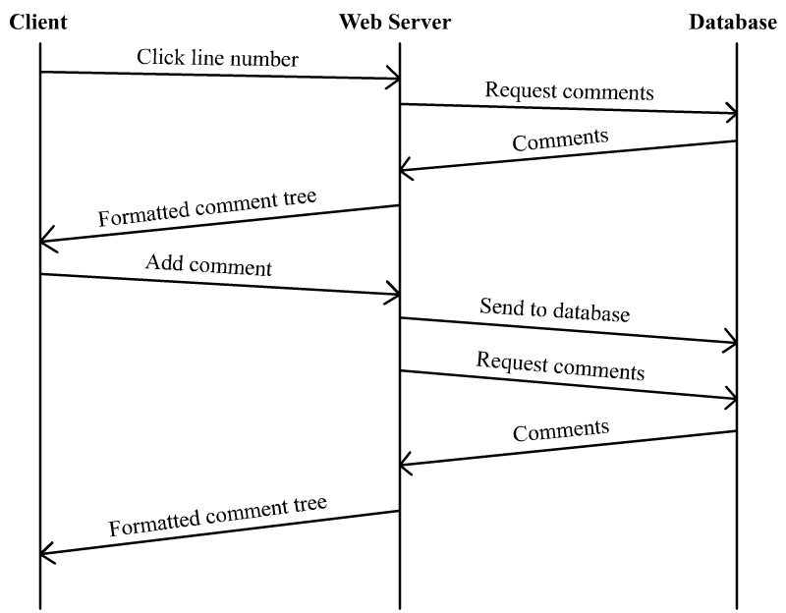
Figure 7.2: Add comment program flow sequence diagram

Figure 7.2 is an example of a user adding a comment to a line of code. In this example, the line selected already has comments added to it. The user first selects a line. An AJAX callback is then made to peerReviewCommentCallback.py to obtain the comments that have been added to this line. peerReviewCommentCallback.py then returns the HTML for a formatted comment tree structure. The user then adds a comment. The comment is sent back to peerReviewCommentCallback.py and the comment is added to the database. The new tree of comments is then requested again from the database and the new comment tree is returned to the user.

