Name: ___________________

FISH 406: Parasite Ecology
Practice Final

Deadline:

This exam must be submitted by 1:30pm on Friday, 6 December 2024 (unless you have made other arrangements with Chelsea).

For those taking the exam in a DRS testing center:

Have questions? Call or text Chelsea at 831-324-3076. She’ll be standing by to take your call.

SIGN THIS HONOR CODE STATEMENT BEFORE STARTING THE EXAM:

By signing my name below, I affirm that I have not given or received any unauthorized help on this exam, and that all work is my own.

________________________________________

- (10 points)
  - Name at least three qualities of a good biocontrol agent.

  - Why did the introduction of myxomatosis fail to eradicate Australia’s invasive rabbit populations?

  - Schistosomiasis has been eliminated in some parts of the Caribbean through effective, sustainable biological control. Describe the successful biological control approach.

- (10 points)
Match the parasite or vector to its anatomical features. Be careful! Some species may not have their features listed, and others may have more than one feature listed. Points will be deducted for wrong answers.

Parasite / vector

Pediculus humanus capitis
Triatoma infestans
Phthirius pubis
Pulex irritans
Mosquitoes
Trypanosoma brucei
Plasmodium falciparum
Ixodes spp.
Simulium spp.
Pediculus humanus humanus

________________
________________
________________
________________
________________
________________
________________
________________
________________
________________

- chelicerae
- proboscis
- bilaterally flattened
- dorsoventrally flattened
- backward-facing setae
- halteres
- serrated cutting mouthparts
- undulating membrane
- apical complex

- (10 points) Plasmodium spp. parasites use their human and mosquito hosts very differently. Where is this parasite and what is it doing when it is in its mosquito host? Where is it and what is it doing in the human host?

- (10 points) Toxoplasma gondii

  - Why is infection with T. gondii a problem for rodent intermediate hosts?

  - How does T. gondii, a terrestrial parasite, end up in marine habitats, where it infects sea otters?

  - Name three individual-level factors (i.e., individual behaviors, customs, habits) that contribute to human risk of infection with T. gondii.

  - Name three epidemiological factors (i.e., geographic, abiotic, biotic) that contribute to human risk of infection with T. gondii.

  - Explain the pattern displayed in the following graph from Lafferty (2006 Proceedings of the Royal Society B):

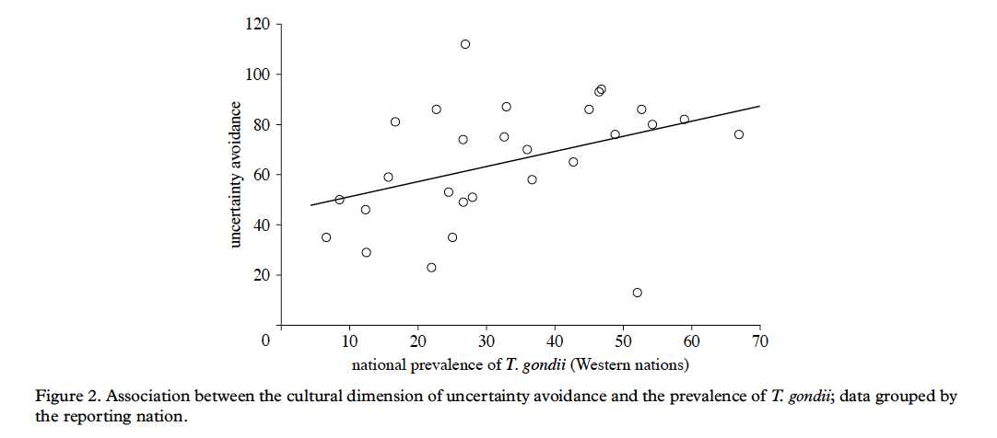

- (10 points) You are a doctor who volunteers for Doctors Without Borders, travelling the world to provide free medical care to people who live in poor rural areas. During your travels, you encounter people with the following symptoms. What parasite do they have and how did they acquire it? You must identify the species of the parasite (either with a very specific common name or the Latin name).

  - itchy head, small particles attached to hairs

  - abdominal pain, diarrhea, stool watery with bloody mucus

  - large, open sore on the skin, hunter who spends time in deep forest

  - large, open sore on the skin, fisherman who spends time wading in ponds

  - severe pain, tumor-like growths on skin and in respiratory tract

- (20 points) Ecosystems vary in the number of parasite species they contain. In which ecosystems are parasites likely to be important? In which ecosystems are parasites likely to be unimportant? Give three examples of each.

- (20 points) Armand Kuris and his colleagues sampled free-living and parasitic species in three salt marshes on the west coast of North America (Kuris et al. 2008 Nature). They were able to measure the density and biomass of most of these species. Some of their findings are summarized in the graph below. Explain the general conclusions of these two graphs:

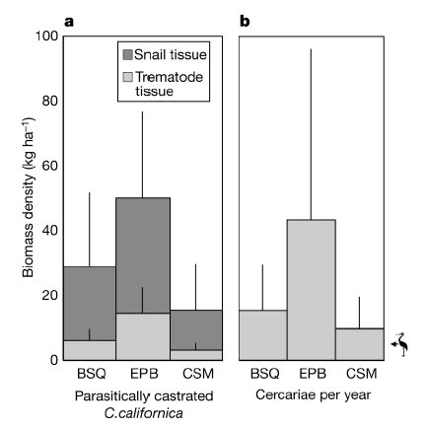

- (10 points) Define these terms and provide an example system (host and parasite species) from lecture or lab.

  - intermediate host

  - sylvatic

  - myiasis

  - synanthropic

  - vector

BONUS (5 points):

Government administrators living and working in tropical colonies of the British Empire had a favorite cocktail. What was it and why did they like it?

