

XJTLU Entrepreneur College (Taicang)
Module Code and Title | ENT208TC Industry Readiness
School Title | XJTLU Entrepreneur College (Taicang)
Assignment Title | Technical Documentation
Submission Deadline | Friday 15 May, 2026 before 23:59 (Beijing Time, GMT+8)
Session and Group | [Session 2 — Group 10]
Student IDs | [2363002, 2361876, 2361834, 2361475, 2363258, 2360691, 2361710]
Final Word Count | 2023
If you agree to let the university use your work anonymously for teaching and learning purposes, please type “yes” here. | Yes

I certify that I have read and understood the University’s Policy for dealing with Plagiarism, Collusion, and the Fabrication of Data (available on Learning Mall Online). With reference to this policy, I certify that:
- My work does not contain any instances of plagiarism and/or collusion. My work does not contain any fabricated data.
By uploading my assignment onto Learning Mall Online, I formally declare that all of the above information is true to the best of my knowledge and belief.
Scoring — For Tutor Use
Student ID | D
Stage of Marking | Marker Code | Learning Outcomes Achieved (F/P/M/D) |  |  |  |  | Final Score
 |  | A | B | C | D | E
1st Marker — red pen
Moderation — green pen | IM Initials | The original mark has been accepted by the moderator: Y / N |  |  |  |  | Y / N
2nd Marker if needed



Comprehensive technical reference enabling another developer to understand, maintain, and deploy your product. Includes a strategic IP analysis section. Target length: 6–9 pages (excluding references and cover page). File name: Session[X]Group[Y]_TechnicalDoc.docx
✓ Submission checklist — confirm before uploading
√ 6–9 pages (excluding references and cover page)
√ Font: Calibri or Times New Roman, 12pt, 1.5 line spacing, justified
√ File: Session[X]Group[Y]_TechnicalDoc.docx (.docx or .pdf)
√ Cover page: group number + all 7 student IDs
√ Section 1 — system architecture diagram included
√ Section 2 — technology choices justified with alternatives
√ Section 3 — deployment guide: someone else can run your project
√ Section 4 — IP Strategy: novelty, prior art, patent decision
√ Section 5 — limitations and future work
√ All references in APA 7th edition (not counted in page limit)

Section 1 — System Architecture
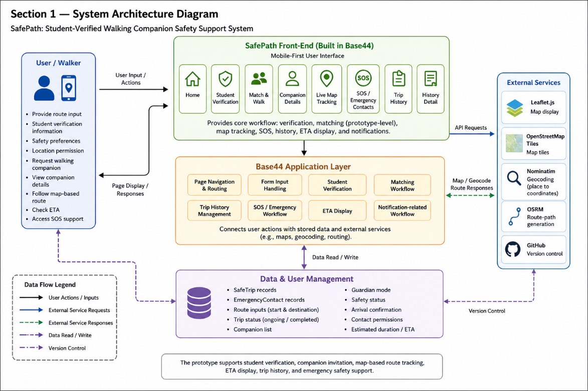
Component overview
User / Walker
The User / Walker provides route input, student verification information, safety preferences, location permission, and emergency actions. The user can request a walking companion, view companion details, follow the map-based route, check ETA, and access SOS support.
SafePath Front-End (Built in Base44)
The front-end includes Home, Student Verification, Match & Walk, Companion Details, Live Map Tracking, SOS / Emergency Contacts, Trip History, and History Detail pages. It provides a mobile-first interface for the main safety walking workflow.
Base44 Application Layer
Base44 handles page navigation, form input, student verification, matching workflow, trip history, SOS workflow, ETA display, and notification-related workflow. It connects user actions with stored data and map-related functions.
Data & User Management
This component stores SafeTrip and EmergencyContact data, including route inputs, start and destination information, trip status, companion list, guardian mode, safety status, arrival confirmation, emergency contacts, contact permissions, and estimated duration information.
External Services
External services include Leaflet.js, OpenStreetMap tiles, Nominatim / OSRM, and GitHub. Leaflet.js and OpenStreetMap tiles support map display, Nominatim / OSRM support geocoding and route-path generation where available, and GitHub supports version control. Other core functions are mainly developed and managed within Base44.
Data flow
A typical user journey starts when the user completes student verification and selects Match & Walk. The user enters a starting point and destination, and Base44 processes the route input, sends matching requests to relevant nearby users, supports companion information viewing, and manages trip history, SOS workflow, and notification-related workflow.
The map page uses Leaflet.js and OpenStreetMap tiles to display live location and support the map-based walking flow. The trip detail page can also use geocoding and routing services to show the route path between the start point and destination. During the trip, the user can view the route, check companion information, view estimated duration / ETA, and access SOS / Emergency Contacts if needed. The current prototype supports student verification, map display, companion invitation, companion information viewing, trip history details, route path generation, ETA display, and notification-related safety support.
Section 2 — Technology Justification
Technology / Tool | What we chose | Alternatives considered | Why we chose this
Application development, UI, and workflow | Base44 | React Native, Flutter, native Android/iOS | Base44 was chosen because it supports fast prototype development with built-in UI, workflow logic, data handling, and deployment support. It is used for the main app pages, student verification, matching flow, trip history, SOS workflow, ETA display, and notification-related workflow. The trade-off is less low-level control than custom development frameworks.
Map and Location Service | Leaflet.js + OpenStreetMap tiles + Nominatim / OSRM | Google Maps API, Mapbox, static maps | Leaflet.js and OpenStreetMap tiles were chosen because they support interactive map display without requiring a paid map API key. Nominatim is used to convert place names into coordinates, and OSRM is used in the trip detail page to generate a walking route polyline when available. This is suitable for a prototype, but the trade-off is that map loading, geocoding, route display, live tracking, and ETA reliability depend on external public services, internet access, device location availability, and correct configuration.
Data management and verification | Base44-managed data structure, student verification | Firebase, Supabase, PostgreSQL, MongoDB | Base44-managed data handling is suitable for storing user information, student verification information / prototype verification state, emergency contacts, route inputs, trip records, ETA-related information, and preferences in the prototype.
Emergency Support and Notification Workflow | Base44-managed SOS and notification-related workflow | SMS alerts, email alerts, in-app only alerts, third-party emergency APIs | The SOS and notification-related workflow is mainly managed within the Base44-based prototype. In the current version, emergency actions are simulated through the app interface, while emergency contact information is stored for the intended safety workflow. This keeps the prototype simple, but real emergency dispatch, SMS alerts, and guardian notification would require stronger integration before real-world deployment.
The main technical risks are limited customisation, location privacy, map reliability, matching reliability, ETA accuracy, and notification reliability. Because most functions are built in Base44, development is fast, but the team has less control over low-level backend logic and third-party integrations. To manage this risk, the prototype focuses on validating the full user flow first: student verification, companion matching, map-based route display, ETA display, trip history, SOS workflow, and notification-related safety support. Location privacy remains important because SafePath handles route inputs, emergency contacts, and active trip information. The app should avoid unnecessary long-term tracking and provide fallback safety options when no suitable companion is available.
Section 3 — Deployment Guide
Environment requirements
Requirement | Version / Notes
GitHub repository | Stores project code and version history
Base44 access | Needed for editing and exporting the prototype
Leaflet.js, OpenStreetMap, Nominatim / OSRM | Used for map display, geocoding, and route-path generation through external public services.
Web browser, internet & location permission | Required for testing the Base44 app, loading the map, checking the published version, and allowing real-time map tracking.
Student verification test data | Needed to test the student verification and matching flow.
Setup steps
1. Clone the repository: git clone https://github.com/woodWUDE/SafePath
2. Install dependencies: Not required for the current Base44 prototype.
3. Configure environment variables: No environment variables are required. Leaflet.js, OpenStreetMap tiles, Nominatim, and OSRM are accessed through external public services.
4. Run the application: Open the Base44 published link: https://woodoo-safe-path-walk.base44.app
5. Verify it is working: Complete or skip the prototype student verification, enter a start point and destination, check the companion invitation flow, view companion profiles, start the walking session, allow browser location permission when prompted, confirm that the live map and ETA / duration display appear, open Trip History and History Detail, and test the SOS / Emergency Contacts workflow.
Common issues and solutions
Problem | Likely cause | Solution
The map does not display correctly | Leaflet CDN files failed to load, or the map container has no fixed height | Check the internet connection, confirm that Leaflet CSS and JavaScript are included, and set the map container height, for example #map { height: 300px; }.
Real-time location does not update | Browser or device location permission is blocked, GPS is unavailable, or the device network connection is unstable. | Allow location permission in the browser or device settings, refresh the page, and test on a device with location services enabled.
ETA or notification-related workflow does not work correctly | Route information, live location updates, emergency contact data, or prototype state may be incomplete. | Re-enter the route information, confirm that the map loads correctly, check that location permission is enabled, and test the SOS / Emergency Contacts workflow again.
Section 4 — IP Strategy
Novelty analysis
SafePath is not completely new because existing products already provide SOS alerts, location sharing, live tracking, and emergency contacts. Its novelty lies in combining these features into a student-verified, route-based walking companion workflow. Unlike Life360, SafePath focuses on temporary walking trips rather than continuous family tracking. Unlike bSafe, it combines emergency support with companion matching before or during the trip. Unlike campus escort services, it allows peer matching through a mobile app based on route, time, student verification, map-based walking support, and ETA display.
Prior art (2–3 examples)
Existing product / patent | What it does | How your solution differs
Life360 | Provides location sharing, family safety features, and SOS alerts. | SafePath focuses on temporary walking trips and adds student-verified peer companion matching, route-based walking support, and ETA display.
bSafe | Offers SOS alerts, live GPS tracking, and guardian features. | SafePath combines emergency support with student verification and walking companion matching to reduce risk before or during a trip.
Campus Safe Walk / Escort Services | Provides walking escorts in campus areas, often through staff, volunteers, or security teams. | SafePath allows app-based peer matching between verified students and is not limited by fixed service hours or manual escort request processes.
Patent decision
No. Although SafePath combines student verification, companion matching, live map tracking, ETA display, and notification-related emergency support, most individual functions already exist in prior products. The novelty is mainly in integration rather than a completely new technical invention. Considering cost, time, enforceability, and uncertainty, seeking a patent is not practical. The project’s value is more related to usability, trust, student network effects, and implementation quality.
Alternative protection
SafePath can protect its advantage through user trust, student verification, campus partnerships, and network effects. Internal logic such as matching rules, safety workflows, notification triggers, and risk-handling procedures can also be treated as trade secrets.
Section 5 — Limitations & Future Work
Known limitations
Limitation | Why it exists | Impact on users
Map function depends on external map resources | The map page uses Leaflet.js, OpenStreetMap tiles, Nominatim, and OSRM, so map loading, geocoding, and route-path generation depend on internet access and external public services. | If the map resources fail to load, users may not be able to view the route path correctly.
Student verification is prototype-level | Student verification is implemented within the Base44-managed prototype workflow rather than through a full university SSO or official institutional database. | It improves trust in the prototype, but stronger institutional verification would be needed before real campus deployment.
Matching reliability is prototype-level | The current matching flow uses prototype companion candidates and simulated invitation responses rather than a fully live multi-user matching backend. | Users can test the intended matching experience, but real-world matching reliability still depends on enough verified users, live availability, and stronger backend validation.
ETA may not always be fully accurate | ETA depends on route information, map loading, live location updates, and network conditions. | Users can use ETA as a helpful estimate, but they should not treat it as a guaranteed arrival time.
Future work
• Feature improvement — Improve matching accuracy through stronger route similarity checks, walking time overlap, live user availability, and clearer companion suitability indicators.
• Safety and verification improvement — Improve route deviation detection, emergency escalation rules, notification handling, guardian status updates, and stronger student verification through university email or SSO.
• Technical debt and research question — Improve GitHub structure, deployment consistency, documentation, and testing records. A key research question is how to balance real-time safety, privacy, and matching efficiency without collecting unnecessary location data.

References
Base44. (n.d.). GitHub integration. Base44 Support Documentation. https://docs.base44.com/
Leaflet. (n.d.). Leaflet quick start guide. https://leafletjs.com/examples/quick-start/
OpenStreetMap Foundation. (n.d.). Tile usage policy. https://operations.osmfoundation.org/policies/tiles/
Life360. (n.d.). SOS alerts. https://support.life360.com/hc/en-us/articles/23053474049687-SOS-Alerts
bSafe. (n.d.). bSafe personal safety app. https://www.getbsafe.com/
Nominatim. (n.d.). Nominatim documentation. https://nominatim.org/
Project OSRM. (n.d.). OSRM API documentation. https://project-osrm.org/docs/

