# Personal Knowledge Graphs

Subatomic: Book of essays about “Connected Thinking to Boost Productivity, Creativity, and Discovery.”

## Useful

(Ackerman)

Editors: Ivo Velitchkov and George Anadiotis.  
ISBN: 9781914549090

#epigraph  
It is said that wisdom is built on the foundations of knowledge, and a road is paved by experience. - Dr. Ashleigh Faith (Velitchkov and Anadiotis)

## Curiosity

Curiosity is not so much about filling in gaps in our knowledge as it is about making connections. In a graph world, curiosity plays at the edge. It is edgework. (Velitchkov and Anadiotis 17)

/#definition  
> Knowledge “can be understood as a system of interconnected propositions linked by inferential relations,” wrote Shaun Gallagher (2022) about the ideas of Edmund Husserl. (Velitchkov and Anadiotis 18)

What does Gallagher mean? What are interconnected propositions, and what are inferential relations? Propositions are ideas. Inferential relationships are harder to write about. Sometimes the relationships are plain. Both ideas speak to the same topic. Sometimes the relationship between both ideas is reminiscent of a third idea. Often the relationship is something felt. There is a felt sense of connectedness.

## Hero’s Journey Graphic

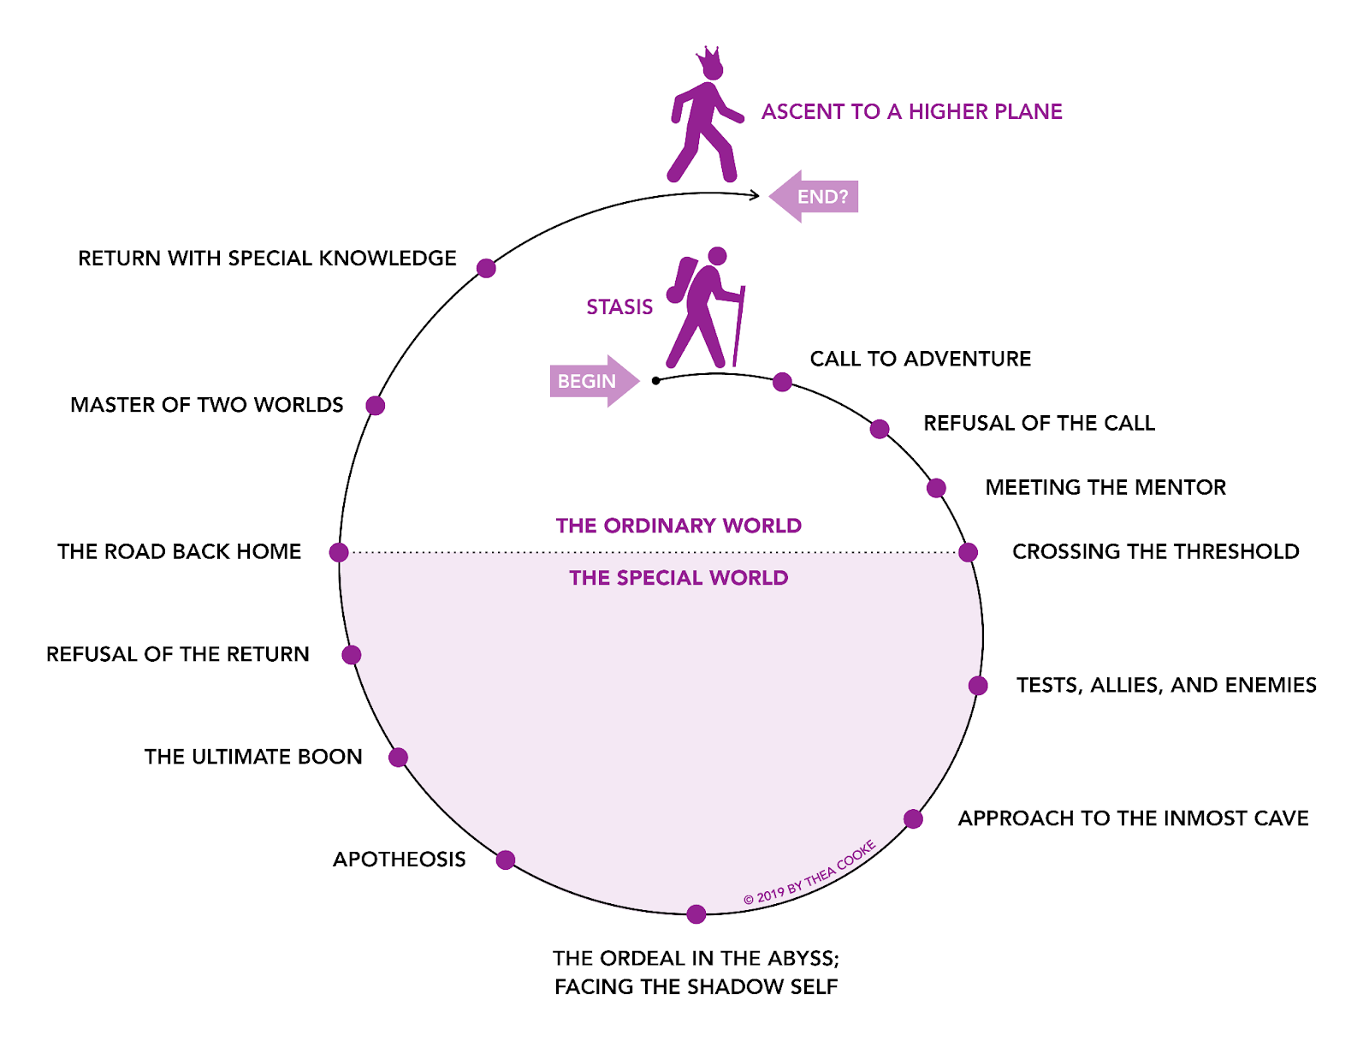

## Works Cited

Ackerman, Diane. *The Planets: A Cosmic Pastoral: [Poems]*. Morrow, 1976.

Velitchkov, Ivo, and George Anadiotis. *Personal Knowledge Graphs: Connected Thinking to Boost Productivity, Creativity and Discovery*. Exapt Press, 2023.