Similarity to Right-Triangle Trigonometry, Student Edition

Similarity to Right-Triangle Trigonometry
Student Edition. Tasks, diagrams and workspace for the unit.
Every diagram carries a written description as well, so the figure can be read aloud or read without seeing it.

Two Rules for Making a Triangle Bigger

Two rules are on the board. Rule A: add the same amount to every side. Rule B: multiply every side by the same number. Both rules make a triangle bigger.

Task 1: Two rules, three steps each
Look at Figure 1 and Figure 2. Both start from the same 4-6-8 triangle. Figure 1 adds 3 to every side each time. Figure 2 multiplies every side by 1.5 each time.
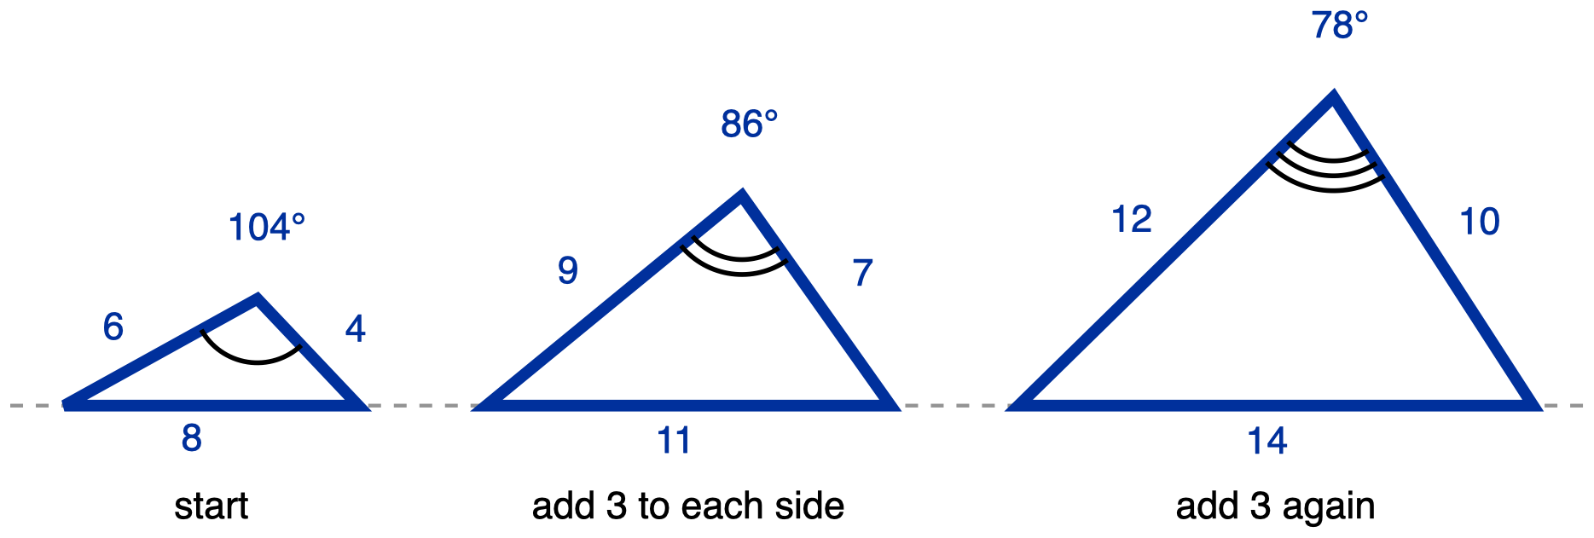
Figure 1. Rule A, add 3 to every side: 4-6-8, then 7-9-11, then 10-12-14.
Description: Three triangles stand on one grey dashed horizontal reference line, all drawn to the same scale and growing from left to right. Each triangle's longest side is its horizontal base sitting on that line, and the apex is above the base, nearer the right base vertex than the left, because the shortest side is the one on the right. No vertex letters are used. Left triangle: base 8, left side 6, right side 4. Middle triangle: base 11, left side 9, right side 7. Right triangle: base 14, left side 12, right side 10, so every side of each triangle is 3 longer than the matching side of the triangle before it. All nine lengths are given; there is no unknown, and the dashed line carries no measure. Only the apex angle of each triangle is marked, and none of them is a right angle: the left apex carries one arc labelled 104 degrees, the middle apex carries two concentric arcs labelled 86 degrees, and the right apex carries three concentric arcs labelled 78 degrees. The three different arc counts state that the three marked angles are not congruent to one another; no congruence or similarity relationship is claimed anywhere in the figure. Captions under the triangles, left to right: start, add 3 to each side, add 3 again.
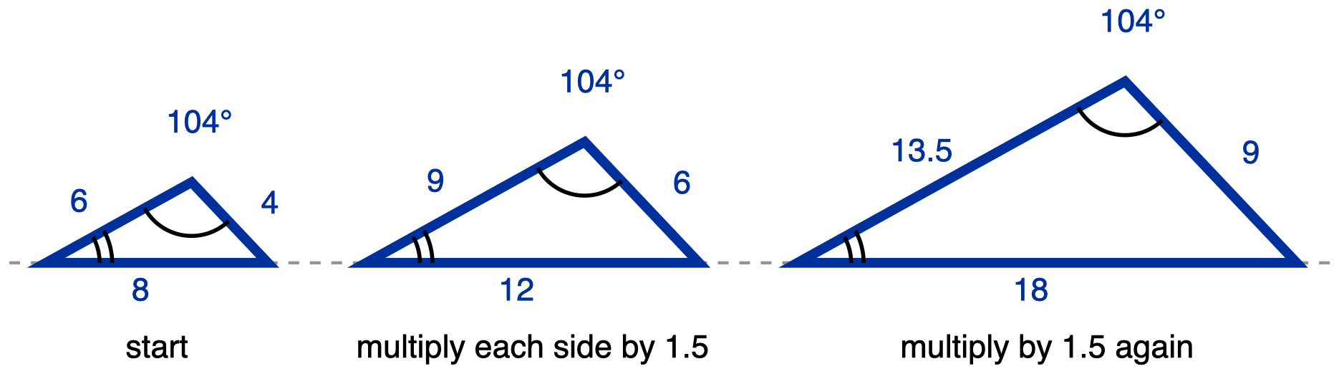
Figure 2. Rule B, multiply every side by 1.5: 4-6-8, then 6-9-12, then 9-13.5-18.
Description: Three triangles stand on one grey dashed horizontal reference line, all drawn to the same scale and growing from left to right. Each triangle's longest side is its horizontal base sitting on that line, and the apex is above the base, nearer the right base vertex than the left, because the shortest side is the one on the right. No vertex letters are used. Left triangle: base 8, left side 6, right side 4. Middle triangle: base 12, left side 9, right side 6. Right triangle: base 18, left side 13.5, right side 9, so every side of each triangle is 1.5 times the matching side of the triangle before it. All nine lengths are given; there is no unknown, and the dashed line carries no measure. Two angles are marked in each triangle and neither is a right angle. The apex angle carries one arc in all three triangles and is labelled 104 degrees in all three. The angle at the left base vertex, the smallest angle in each triangle, carries two concentric arcs in all three triangles and is not labelled with a measure. The angle at the right base vertex is not marked. Because one arc appears at all three apexes those three angles are congruent, and because two arcs appear at all three left base vertices those three angles are congruent; the third angle of each triangle then follows from the angle sum, so all three triangles have the same three angles. Captions under the triangles, left to right: start, multiply each side by 1.5, multiply by 1.5 again.
(a) Write the next triangle in each chain.
Rule A (add 3): 4-6-8 → 7-9-11 → 10-12-14 →

Rule B (multiply by 1.5): 4-6-8 → 6-9-12 → 9-13.5-18 →

(b) Read the widest angle off each figure and record it.
 | first triangle | second triangle | third triangle
Rule A, widest angle
Rule B, widest angle

(c) Which rule kept the shape? Write one sentence, and name what you looked at.

✋
Tools for Task 1: a four-function calculator is allowed. No notes, cards or posters about similar figures. You may answer (c) in writing, by marking the figures and adding a two-word label, or out loud to your teacher.

Task 2: Similar or Not?
In each pair the sides are listed shortest to longest, so they already correspond in order. For each pair, write the comparison you ran, then circle your answer. All three are required.
Pair | Triangle 1 | Triangle 2 | Your comparison | Similar?
(i) | 3, 4, 5 | 9, 12, 15 |  | yes / no
(ii) | 5, 7, 9 | 8, 10, 12 |  | yes / no
(iii) | 6, 8, 10 | 6, 8, 11 |  | yes / no

✋
Tools for Task 2: a four-function calculator is allowed. No notes, cards or posters about similar figures, and no worked example. You may write your comparison, or say it aloud to your teacher and have it written down.

Task 3: One Factor, and What Happens to the Angle
Triangle STU is similar to triangle PQR, with S matching P, T matching Q, and U matching R.
 | triangle PQR | triangle STU
one side | PQ = 6 cm | ST = 15 cm
a second side | PR = 10 cm | SU = ?
the angle between those two sides | m∠P = 55° | m∠S = ?

(a) Find SU. Show the factor you used.

(b) Give m∠S.
m∠S =

(c) Another student answered SU = 19 cm and m∠S = 64°. Name the rule that student used, and say in one sentence why it fails.

✋
Tools for Task 3: a four-function calculator is allowed. No drawing of these two triangles is supplied and none is needed: part (b) is answered by reasoning, not by measuring. You may write your answers or say them aloud to your teacher and have them written down.

Exit Ticket

Name

A reference triangle has sides 4 cm, 6 cm, 8 cm.
- Candidate A has sides 7 cm, 9 cm, 11 cm.
- Candidate B has sides 6 cm, 9 cm, 12 cm.
Sides are listed shortest to longest in all three, so they correspond in order.
(a) Which candidate is similar to the reference triangle? Circle one: A / B
(b) Show the comparison you used for both candidates, then write one sentence saying what your comparison shows.
Candidate A

Candidate B

What it shows

✋
Tools for the exit ticket: a four-function calculator is allowed. No figure of these triangles is supplied. No notes, cards or posters about similar figures. You may write part (b) or say it aloud to your teacher and have it written down word for word. Both parts are required either way.

Day 2 · Similar Triangles

Name: ______________________________ Date: ______________
Three tasks, all three required. There is nothing to choose between.
✋
How to read the drawings. The same number of arcs at a vertex means the same angle measure. A single chevron on two segments means those two segments are parallel. The heaviest line is the unknown you are looking for, the next heaviest carries a measure you are given, and a plain line is just part of the figure.

Task 1 · Which vertex goes with which
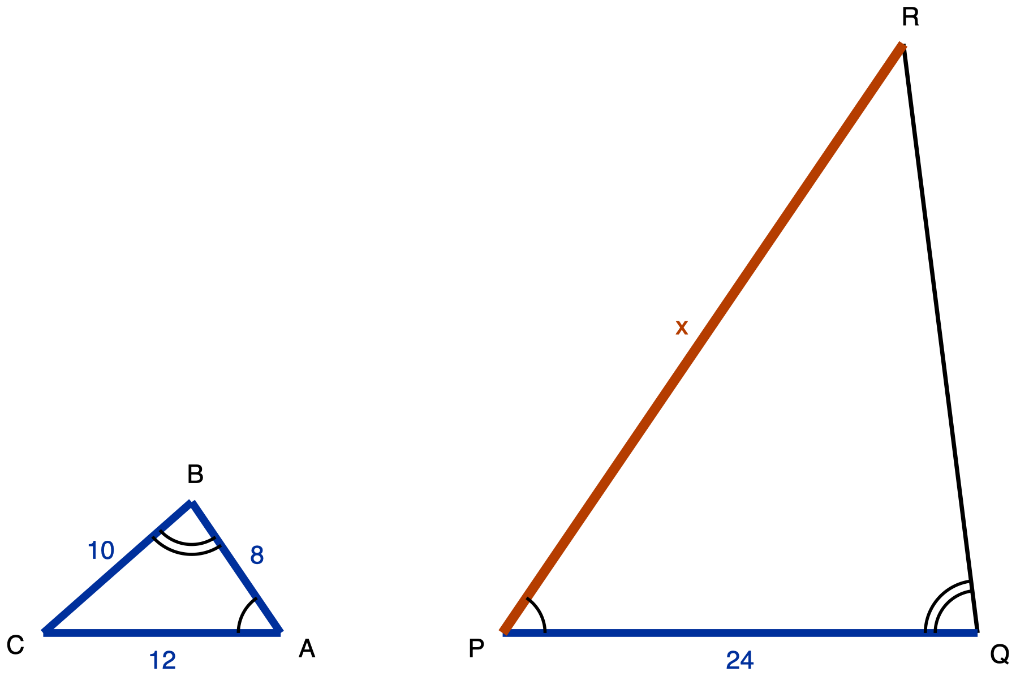
Figure 2.1. Triangles ABC and PQR.
Description: Two separate triangles side by side, both sitting on the same horizontal baseline. Neither is a right triangle. Left triangle ABC: C is the bottom-left vertex, A is the bottom-right vertex, and B is above the baseline, roughly two-thirds of the way from C toward A, so the triangle is wide and low. Segment CA runs along the baseline and measures 12, a given measure. Segment AB runs up and to the left from A to B and measures 8, a given measure. Segment BC runs down and to the left from B to C and measures 10, a given measure. Vertex A carries one arc, between segment AC and segment AB. Vertex B carries two concentric arcs, between segment BC and segment BA. Vertex C carries no arc. Right triangle PQR: P is the bottom-left vertex, Q is the bottom-right vertex, and R is high above the baseline and close to the right, almost above Q, so the triangle is tall and narrow. Segment PQ runs along the baseline and measures 24, a given measure. Segment RP runs from R down and to the left to P; it is the longest side, it is the unknown quantity, and it is labelled x. Segment QR runs from Q up and slightly to the left to R; it carries no measure and is drawn as plain skeleton line. Vertex P carries one arc, between segment PQ and segment PR. Vertex Q carries two concentric arcs, between segment QP and segment QR. Vertex R carries no arc. The figure asks which vertex of PQR corresponds to which vertex of ABC, which side pairs with which, and what x is.
Two triangles are drawn. The arcs at the vertices tell you which angles are congruent: the same number of arcs means the same angle measure. The triangles are drawn in different positions on purpose.
✋
Calculator allowed. No ruler and no protractor.

Work in this order. Do not skip to (c).
(a) Write the correspondence in letters.
A ↔ ____________ B ↔ ____________ C ↔ ____________
(b) Using your letters from (a), write which side of the first triangle pairs with which side of the second.
AB pairs with ____________ BC pairs with ____________ CA pairs with ____________
(c) Find x. Show the ratio you used.
Show the ratio you used

Record your answer in whichever one of these three formats suits you. All three earn the same credit:
- as a written proportion and its solution;
- as your three-row correspondence table with the arithmetic beside it;
- spoken to your teacher, who will write the numerals down for you.

Task 2 · Prove it
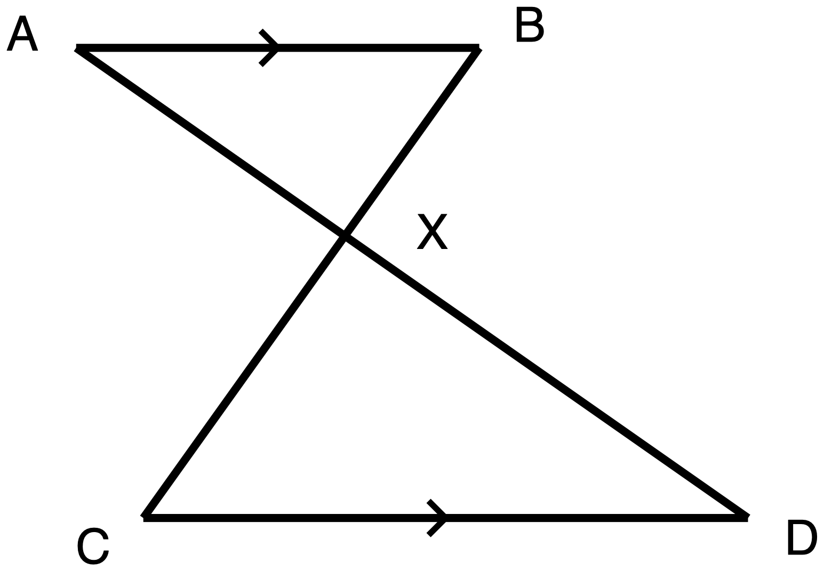
Figure 2.2. Segments AD and BC cross at X.
Description: One connected figure, shaped like a bow tie lying on its side, drawn entirely in plain skeleton line weight. No lengths are given anywhere and no angles are marked with arcs. Points: A is at the top left. B is at the top right, on the same horizontal line as A. C is at the bottom left and D is at the bottom right, on the same horizontal line as each other and lower than A and B. C sits slightly to the right of directly below A; D sits well to the right of directly below B. X is a single point in the middle of the figure, below the line AB and above the line CD, a little to the left of centre. Segments: AB is horizontal across the top. CD is horizontal across the bottom, and CD is longer than AB. AD runs from A down and to the right, passing through X, and continues to D. BC runs from B down and to the left, passing through X, and continues to C. The two long segments cross at X, and X is the only crossing point. Marks: a single chevron sits at the midpoint of AB and a single chevron sits at the midpoint of CD; those two chevrons mark AB parallel to CD. There are no other marks. Two triangles are formed: the upper one has vertices A, X and B; the lower one has vertices D, X and C, and it is the larger of the two. X is not the midpoint of either long segment, since the part of AD from A to X is shorter than the part from X to D, and the part of BC from B to X is shorter than the part from X to C.
Segments AD and BC cross at X. The single chevron on AB and the single chevron on CD tell you that AB is parallel to CD. Nothing else is marked, and no lengths are given.
✋
Calculator allowed, though there is nothing to compute. No ruler and no protractor: you are proving this, not measuring it. No reference card.

Prove that the two triangles in this figure are similar. Your proof must name the criterion you are using and must justify every angle fact you claim.
Your proof

Then write the similarity statement, putting the second triangle's letters in the order that matches the first triangle's.
△ A X B ~ △ ______ ______ ______
Record the proof in whichever one of these five formats suits you. All five earn the same credit:
- two-column, statements and reasons;
- a paragraph;
- a flowchart;
- spoken to your teacher, who will mark your sheet "oral";
- an annotated diagram with your justifications numbered on it.

Exit ticket · Day 2

Name: ______________________________ Date: ______________
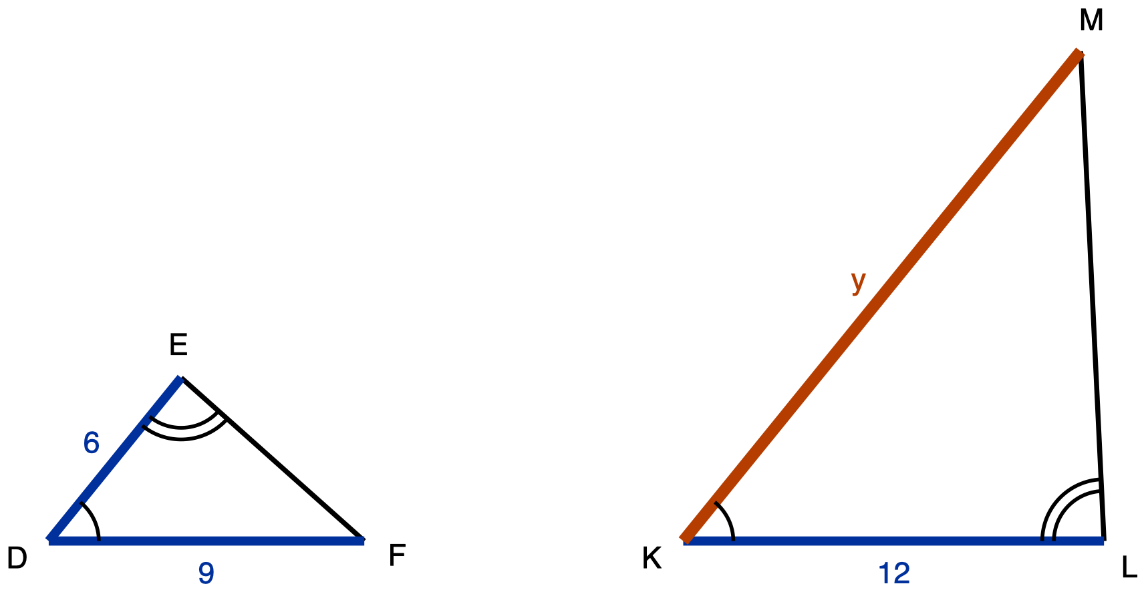
Figure 2.3. Triangles DEF and KLM.
Description: Two separate triangles side by side, both sitting on the same horizontal baseline. Neither is a right triangle. Left triangle DEF: D is the bottom-left vertex, F is the bottom-right vertex, and E is above the baseline, somewhat left of centre, so the triangle is wide and low. Segment FD runs along the baseline and measures 9, a given measure. Segment DE runs up and to the right from D to E and measures 6, a given measure. Segment EF runs down and to the right from E to F; it carries no measure and is drawn as plain skeleton line. Vertex D carries one arc, between segment DF and segment DE. Vertex E carries two concentric arcs, between segment ED and segment EF. Vertex F carries no arc. Right triangle KLM: K is the bottom-left vertex, L is the bottom-right vertex, and M is high above the baseline and close to the right, almost above L, so the triangle is tall and narrow. Segment KL runs along the baseline and measures 12, a given measure. Segment MK runs from M down and to the left to K; it is the longest side, it is the unknown quantity, and it is labelled y. Segment LM runs from L up and slightly to the left to M; it carries no measure and is drawn as plain skeleton line. Vertex K carries one arc, between segment KL and segment KM. Vertex L carries two concentric arcs, between segment LK and segment LM. Vertex M carries no arc. The figure asks which vertex of KLM corresponds to which vertex of DEF, which side pairs with which, and what y is.
Same rules as Task 1: the same number of arcs means the same angle measure, and the two triangles are drawn in different positions.
✋
Calculator allowed. No ruler and no protractor. Task 1 and your answers to it go in your folder before you start.

(a) Write the correspondence in letters.
D ↔ ____________ E ↔ ____________ F ↔ ____________
(b) Write which side pairs with which.
DE pairs with ____________ EF pairs with ____________ FD pairs with ____________
(c) Find y. Show the ratio you used.

You may write your answers or say them to your teacher at the door.

Day 3 · SSS and SAS Similarity

Name: ______________________________ Date: ______________

Task 1 · Which side goes with which?
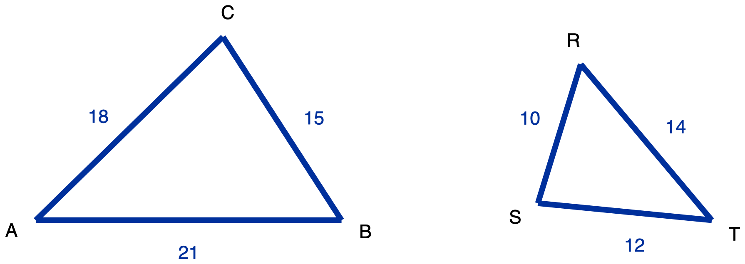
Figure 1. Triangles ABC and TRS. Every side is labelled and no angles are marked.
Description: Two triangles side by side, both with all three sides carrying a given measure, and no angle marked anywhere. Left triangle ABC sits with its longest side horizontal along the bottom: A is the bottom-left vertex, B the bottom-right vertex, and C the apex above them, closer to B than to A. Segment AB is the horizontal bottom side and measures 21. Segment BC runs up and to the left from B to C and measures 15. Segment CA runs down and to the left from C to A and measures 18. Right triangle TRS is smaller and turned, so none of its sides is horizontal or vertical: T is the rightmost vertex and sits at the same height as A and B, R is the topmost vertex up and to the left of T, and S is the leftmost vertex low down and only slightly above T's level. Segment TR runs up and to the left from T to R and measures 14. Segment RS runs down and slightly to the left from R to S and measures 10. Segment ST runs down and to the right from S to T and measures 12. There are no congruence marks, no angle arcs and no tick marks, so nothing in the drawing states which side of ABC corresponds to which side of TRS.
Triangle ABC and triangle TRS are drawn above. Every side of both triangles is labelled. No angles are marked.
- a. Work out which side of triangle TRS corresponds to each side of triangle ABC. Show the three quotients you used.
- b. Are the two triangles similar? If they are, write the similarity statement with the letters in matching order, and give the scale factor.
- c. Name the criterion that lets you answer part (b) from side lengths alone.
Tools for this task: a calculator is permitted. A ruler or protractor is not: the figure is a drawing, not a measuring instrument, and measuring it would replace the reasoning with a check. You may write your pairs directly on the figure, say your answer to your teacher instead of writing it, or set it out as a three-row table instead of a similarity statement.

Task 2 · The angle in the middle
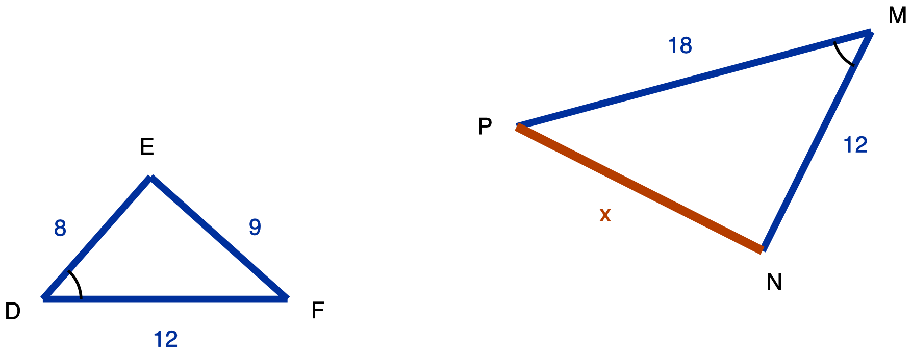
Figure 2. Triangles DEF and MNP. The arc at D and the arc at M mark those two angles congruent.
Description: Two triangles side by side in different orientations, with one marked angle in each. Left triangle DEF: D is the bottom-left vertex, F the bottom-right vertex, and E the apex above and between them, nearer to D. Segment DF is horizontal along the bottom and measures 12. Segment DE runs up and to the right from D to E and measures 8. Segment EF runs down and to the right from E to F and measures 9. A single arc is drawn at vertex D, between arm DF and arm DE. Right triangle MNP is larger than DEF and turned about 195 degrees relative to it, so no side is horizontal: M is the top-right vertex, P the leftmost vertex well below and to the left of M, and N the bottom vertex, below M and to the right of P. Segment MP runs down and to the left from M to P and measures 18. Segment MN runs down and to the left from M to N and measures 12. Segment NP runs up and to the left from N to P; its length is unknown and is labelled x. A single arc is drawn at vertex M, between arm MP and arm MN. The two arcs carry the same count, which states that angle D and angle M are congruent, and that is the only correspondence information in the figure.
In the figure, the single arc at D and the single arc at M mark those two angles congruent. Triangle DEF has DE = 8, DF = 12 and EF = 9. Triangle MNP has MN = 12 and MP = 18. Side NP is unknown and is labelled x.
- a. There are two ways to pair the sides of DEF with the sides of MNP. Test both. Write down which one gives equal ratios, and say where the marked angles sit in that pairing.
- b. Show that the two triangles are similar and name the criterion you used.
- c. Find x.
Tools for this task: a calculator is permitted. A card or note printing the SAS similarity criterion is not: part (b) asks you to name the criterion and say why it applies, so a card that prints it would answer the question. Ruler and protractor are not permitted. You may write your answer, annotate the figure, or give it orally.

Task 3 · No picture this time
✋
Read this before you start. For both parts of Task 3, drawing the situation is part of the answer, not a way of getting to it. Write every measurement on the object it belongs to before you write any equation. A correct number with no labelled drawing is an incomplete answer.

3a. A flagpole 12 m tall casts a shadow 20 m long. At the same moment, a fence post standing beside it casts a shadow 5 m long. How tall is the fence post?
Your labelled drawing and working for 3a

3b. A maple tree casts a shadow 42 m long. A signpost 3 m tall standing beside it casts a shadow 7 m long. How tall is the maple?
Your labelled drawing and working for 3b

Tools for Task 3: a calculator is permitted. Blank paper and a straight edge are permitted and are required. You will not be given a diagram, and the prose will not be read aloud, because turning the sentence into two triangles is the part of this task being assessed. If you need the text in large print or in braille, ask: those give you the same words to work out for yourself. If you may produce your diagram with drawing software, by dictating it to someone who draws exactly what you say, or by arranging cut segment strips, any of those is a complete answer.

Exit ticket · Day 3

Name: ______________________________ Date: ______________
Triangle JKL and triangle PQR are similar. The letters are not written in corresponding order. The two sets of side lengths are listed below.
Triangle JKL | Triangle PQR
JK = 24 | PQ = 12
KL = 18 | QR = ?
LJ = 21 | RP = 14

- a. Write the similarity statement with the letters in matching order.
- b. Find QR.
- c. In one sentence, say what told you which side of triangle PQR pairs with JK.
Tools for this ticket: a calculator is permitted. A ruler and a protractor are not, and there is no diagram to measure. The stem may be read aloud, enlarged, or brailled on request. All three parts may be given orally to your teacher instead of written.

Task 1 · Two claims, three cuts

Task 1 · Two claims, three cuts
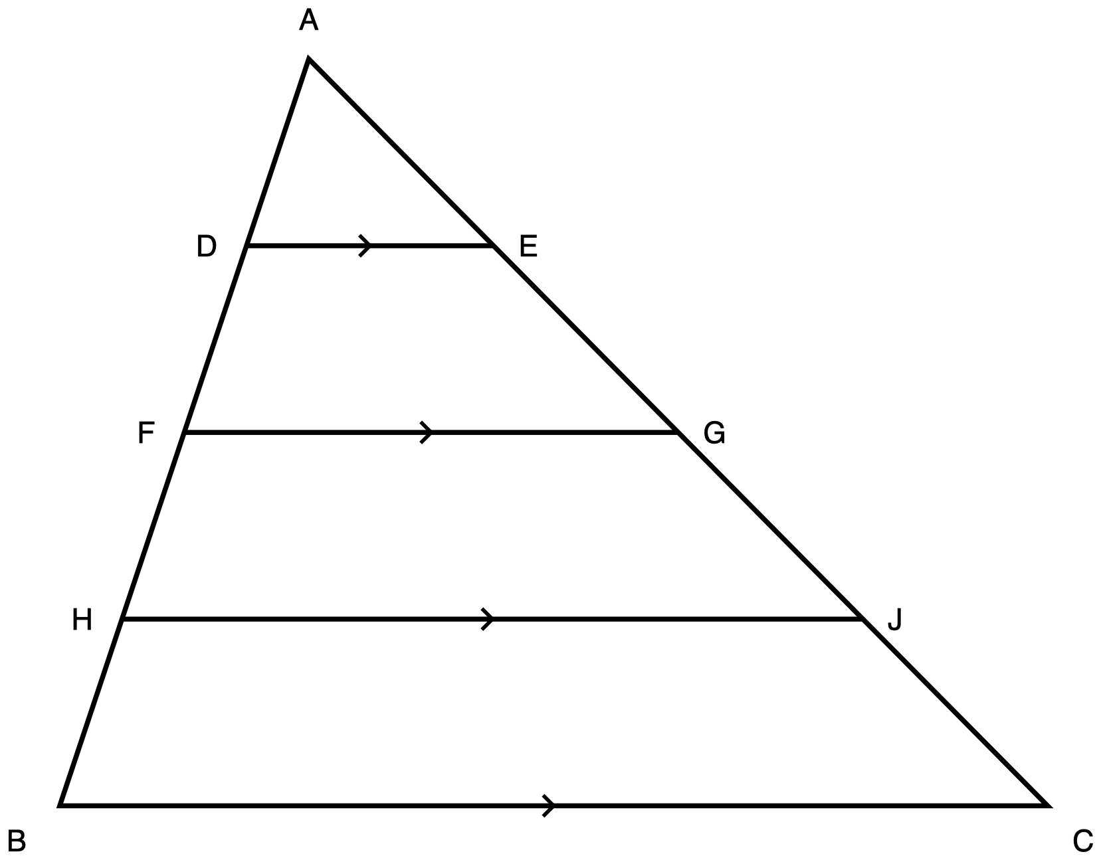
Figure 1. Triangle ABC cut by three segments, each parallel to side BC.
Description: One triangle with apex A at the top and side BC horizontal along the bottom, B at the bottom left and C at the bottom right. Six further points sit on the two slanted sides. Reading down the left side from A to B in order: A, D, F, H, B, with D about a quarter of the way down, F about half way and H about three quarters. Reading down the right side from A to C in order: A, E, G, J, C, positioned so that E is level with D, G is level with F, and J is level with H. Three horizontal segments cross the inside of the triangle: DE nearest A, then FG, then HJ nearest BC, each running from its point on AB across to its point on AC. DE, FG, HJ and BC each carry a single chevron at the midpoint, which puts all four in the same parallel class, so DE, FG and HJ are each parallel to BC and to one another. There are no angle arcs and no right-angle marks anywhere. No length is printed on the drawing.
Triangle ABC has AB = 12 cm and AC = 16 cm. Three segments are drawn across it: DE, then FG, then HJ. The single chevron on each of them, matching the one on BC, says that all four are parallel.
Two people in your class disagree.
✋
Amount claim. A cut parallel to BC leaves the same length below it on AB as it leaves on AC.
Ratio claim. A cut parallel to BC leaves the same fraction of AB below it as it leaves of AC.

(a) Before you measure anything, write down which claim you are backing. One line.

(b) Fill in the table. All twelve lengths are given below the table; you are sorting them, not measuring them.
Cut | On AB, from A | Rest of AB | On AC, from A | Rest of AC | Are "rest of AB" and "rest of AC" equal? | (from A on AB) ÷ (rest of AB) | (from A on AC) ÷ (rest of AC)
DE | AD = | DB = | AE = | EC =
FG | AF = | FB = | AG = | GC =
HJ | AH = | HB = | AJ = | JC =

Lengths, in centimetres. On AB: AD = 3, DB = 9, AF = 6, FB = 6, AH = 9, HB = 3. On AC: AE = 4, EC = 12, AG = 8, GC = 8, AJ = 12, JC = 4.
(c) One line: which claim survives all three rows, and which row killed the other one first?

Tools on this task: calculator permitted; the two quotient columns are arithmetic, not the point. Work with a partner.

Task 2 · Prove it

Task 2 · Prove it
Use Figure 1, cut DE only.

Figure 1, again. Use cut DE.
Description: One triangle with apex A at the top and side BC horizontal along the bottom, B at the bottom left and C at the bottom right. Six further points sit on the two slanted sides. Reading down the left side from A to B in order: A, D, F, H, B, with D about a quarter of the way down, F about half way and H about three quarters. Reading down the right side from A to C in order: A, E, G, J, C, positioned so that E is level with D, G is level with F, and J is level with H. Three horizontal segments cross the inside of the triangle: DE nearest A, then FG, then HJ nearest BC, each running from its point on AB across to its point on AC. DE, FG, HJ and BC each carry a single chevron at the midpoint, which puts all four in the same parallel class, so DE, FG and HJ are each parallel to BC and to one another. There are no angle arcs and no right-angle marks anywhere. No length is printed on the drawing.
In triangle ABC, D lies on AB and E lies on AC, and DE is parallel to BC (that is what the matching chevrons say).
Prove that AD/DB = AE/EC.
✋
Required route, stated here and not hidden in the marking. Your argument must go through a similarity of triangles that the parallel produces. A proof that reaches the conclusion without ever establishing that two triangles are similar does not satisfy this task. You will not be penalised later for a route you were not warned about, so it is being named now.

Record your proof in whichever one of these you prefer. All five are worth the same.
- a two-column proof, statements on the left and reasons on the right
- a paragraph proof, in sentences
- a flowchart proof, with arrows
- an oral defence: put your hand up and talk your teacher through it, nothing written
- an annotated diagram, with short captions on your own copy of the figure
Your proof

Tools on this task: calculator permitted, though there is nothing to compute. A reference card stating the AA similarity criterion is permitted; that is Day 2's result and it is an input to your argument, not your argument. A card stating or proving the Triangle Proportionality Theorem is not permitted, because that theorem is what you are being asked to prove. Ask for the task to be read aloud if you want it; the figure carries the configuration, so nothing is given away.

Task 3 · Now decide, using the converse

Task 3 · Now decide, using the converse
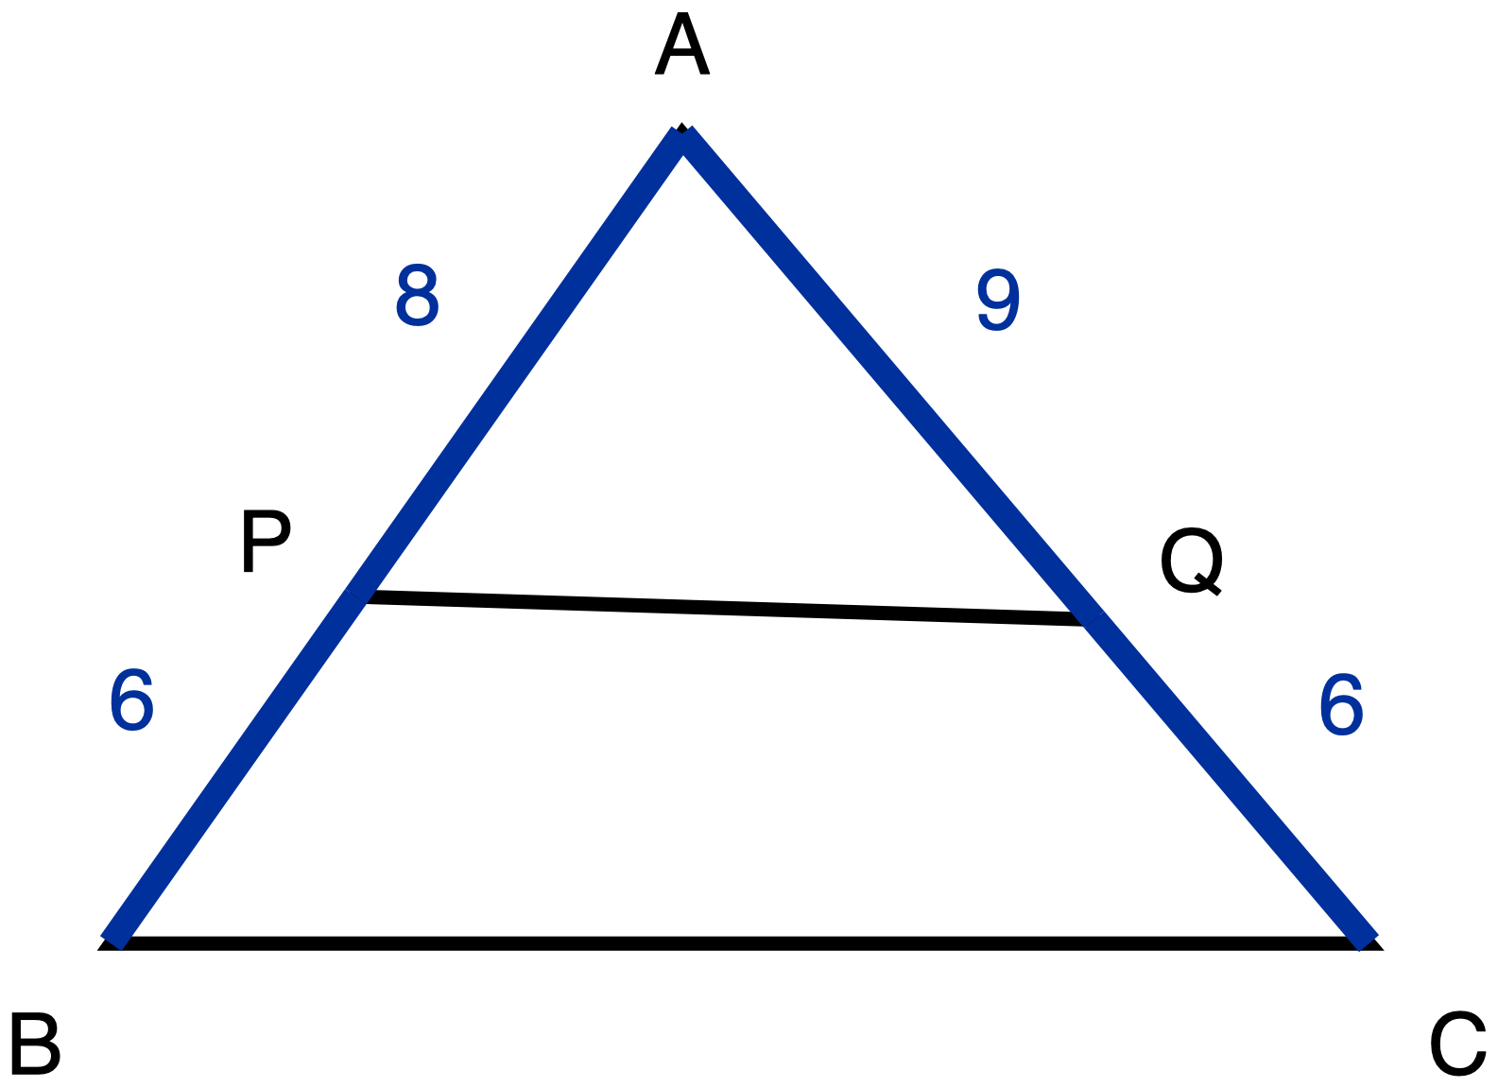
Figure 2. Triangle ABC with segment PQ drawn across it and four lengths given.
Description: One triangle with apex A at the top and side BC horizontal along the bottom, B at the bottom left and C at the bottom right. P sits on side AB, a little past half way down from A. Q sits on side AC, also a little past half way down from A, and very slightly lower than P. Segment PQ joins P to Q and is drawn as a plain line with no measure printed. The two parts of side AB are drawn heavier than the plain skeleton because both are given: AP is 8 and PB is 6. The two parts of side AC are drawn heavier for the same reason: AQ is 9 and QC is 6. BC is a plain line with no measure printed. There is no chevron anywhere in this figure and there are no angle marks, because whether PQ is parallel to BC is exactly what is being asked. The drawing is to scale and PQ is in fact not parallel to BC, but the difference is smaller than one part in thirty and cannot be settled by looking.
The converse of what you proved in Task 2 says: if a segment joining a point on one side of a triangle to a point on another divides those two sides in equal ratios, then that segment is parallel to the third side.
In triangle ABC, P lies on AB and Q lies on AC.
AP = 8 · PB = 6 · AQ = 9 · QC = 6
Is PQ parallel to BC? Decide, then justify. Your justification must show both of these:
- the two quantities you compared, written out, and
- the name of the theorem that lets the comparison settle the question.
✋
The picture will not tell you. This figure is drawn accurately and it carries no chevrons on purpose, because whether PQ is parallel is exactly what you are being asked. Answering from how it looks is not answering.

Record your answer in whichever one of these you prefer.
- a written statement showing both ratios and naming the theorem
- your own copy of the figure, with the ratios written on the sides, your conclusion circled, and the theorem named in three words (a full sentence is not required and is not worth more)
- orally to your teacher
Your decision and your justification

Tools on this task: calculator permitted; the division is not what is being measured. Reference cards stating the AA criterion or the forward Triangle Proportionality Theorem are permitted; a card stating the converse is not, because the converse is the warrant you are being asked to supply. Read-aloud available on request.

Task 4 · Exit ticket

Task 4 · Exit ticket
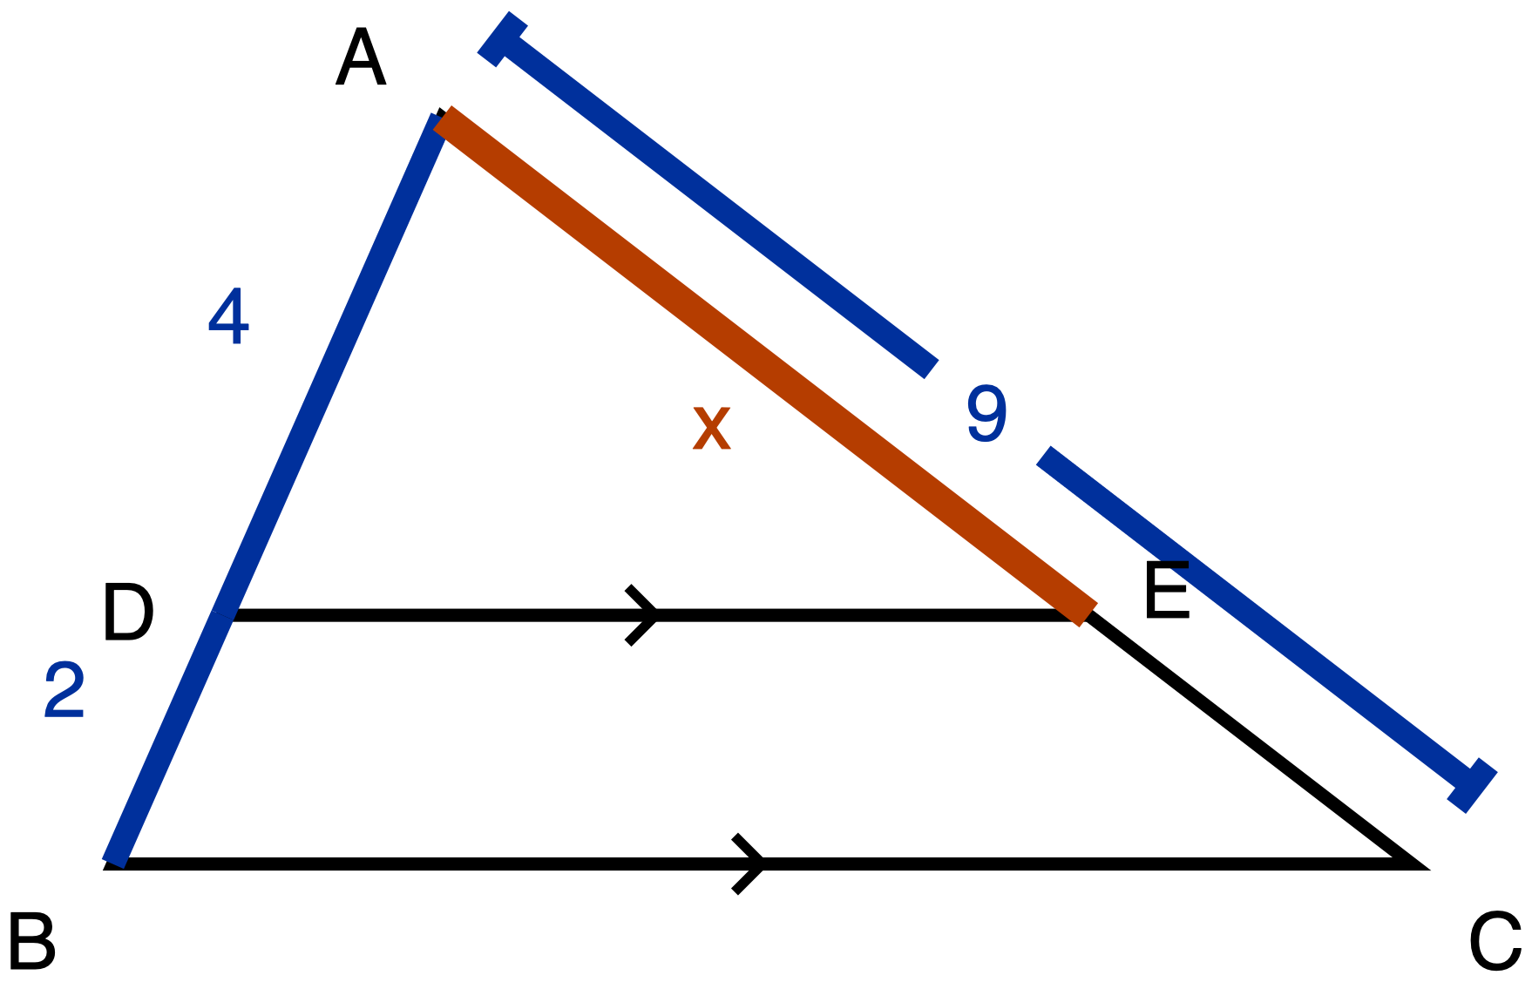
Figure 3. Triangle ABC with DE parallel to BC; AD, DB and AC given, AE unknown.
Description: One triangle with apex A at the top and side BC horizontal along the bottom, B at the bottom left and C at the bottom right. D sits on side AB, two thirds of the way down from A towards B. E sits on side AC, level with D, two thirds of the way from A towards C. On the left side, AD is 4 and DB is 2, both given measures and both drawn heavier than the plain skeleton, so AB is 6 in total. On the right side, the segment from A to E is the unknown: it is the heaviest line in the whole figure and is labelled x. The remaining piece from E down to C is a plain line with no measure of its own. Running outside the triangle, alongside and parallel to side AC, there is a separate straight dimension line with a short cross tick at each end and a gap at its centre where the numeral 9 sits; that line gives the whole of AC as 9. DE and BC are plain lines, and each carries a single chevron at its midpoint, so DE is parallel to BC, which is given rather than something to be decided. There are no angle arcs and no right-angle marks.
In triangle ABC, D lies on AB and E lies on AC, and DE is parallel to BC.
AD = 4 · DB = 2 · AC = 9
(a) Find AE.
AE =

(b) Justify part (a): name the theorem that licenses your step, and write out the proportion you used.
Theorem and proportion

✋
Both parts are required. A number on its own is not a complete answer to this ticket.

You may write your answer on this sheet, write it on the figure, or give it to your teacher out loud. The three are worth the same.
Tools on this ticket: calculator permitted. A reference card printing the Triangle Proportionality Theorem, or printing AD/DB = AE/EC, is not permitted on this ticket, because naming that warrant is half of what the ticket asks you for. Read-aloud available on request; the figure carries the configuration and all three given lengths, so hearing the words read out gives nothing away.

The figures, described in words

The figures, described in words
These descriptions are part of the handout. If you cannot see a figure, you should be able to redraw it from what follows.

Figure 1
Figure type and orientation. One triangle, apex at the top, with its bottom side horizontal.
Points. A is the apex, at the top. B is the bottom left corner and C is the bottom right corner, and the side BC between them is horizontal. Six more points sit on the two slanted sides. Reading down the left side from A to B, in order: A, then D, then F, then H, then B, with D about a quarter of the way down, F about half way and H about three quarters. Reading down the right side from A to C, in order: A, then E, then G, then J, then C, positioned so that E is level with D, G is level with F, and J is level with H.
Segments. AB, AC and BC are the three sides of the triangle, drawn as plain skeleton lines. DE, FG and HJ are three straight segments drawn across the inside of the triangle, each running from its point on AB across to its point on AC, and each is horizontal. No length is printed anywhere on this figure. The lengths AB = 12 cm and AC = 16 cm, and the twelve piece lengths, are given in the Task 1 text, not on the drawing.
Marked angles. None. There are no angle arcs and no right-angle squares anywhere in this figure.
What the marks state. DE, FG, HJ and BC each carry a single chevron at their midpoint, pointing left. One chevron on all four puts all four in the same parallel class: DE, FG and HJ are each parallel to BC, and therefore to one another.
The question the figure poses. Does a cut parallel to BC leave equal lengths below it on the two slanted sides, or equal fractions of them? And, for Task 2 using cut DE: given that DE is parallel to BC, why is AD divided by DB equal to AE divided by EC?

Figure 2
Figure type and orientation. One triangle, apex at the top, with its bottom side horizontal.
Points. A is the apex. B is the bottom left corner, C is the bottom right corner, and BC is horizontal. P sits on side AB, a little past half way down from A. Q sits on side AC, also a little past half way down from A. Q sits very slightly lower than P.
Segments. AP is 8 and PB is 6; together they make side AB, and both are drawn heavier than the plain skeleton because both are given measures. AQ is 9 and QC is 6; together they make side AC, and both are likewise drawn heavier as given measures. BC is a plain skeleton line with no measure printed. PQ is a plain skeleton line joining P to Q, with no measure printed.
Marked angles. None.
What the marks state. Nothing, and that is deliberate. There is no chevron anywhere in this figure. Whether PQ is parallel to BC is the question Task 3 asks, so the figure does not assert it. The drawing is to scale and PQ is in fact not parallel to BC, but the difference is smaller than one part in thirty and cannot be settled by looking at it.
The question the figure poses. Is PQ parallel to BC, and what warrants the answer?

Figure 3
Figure type and orientation. One triangle, apex at the top, with its bottom side horizontal.
Points. A is the apex. B is the bottom left corner, C is the bottom right corner, and BC is horizontal. D sits on side AB, two thirds of the way down from A towards B. E sits on side AC, level with D, two thirds of the way from A towards C.
Segments. On the left side, AD is 4 and DB is 2, both given measures and both drawn heavier than the plain skeleton, so AB is 6 in total. On the right side, the segment from A to E is the unknown: it is labelled x and is the heaviest line in the whole figure. The remaining piece from E down to C is a plain skeleton line with no measure of its own. Running outside the triangle, alongside and parallel to side AC, there is a separate straight dimension line with a short cross tick at each end and a gap at its centre where the numeral 9 sits; that line gives the whole of AC as 9. DE and BC are plain skeleton lines.
Marked angles. None. There are no angle arcs and no right-angle squares in this figure.
What the marks state. DE carries a single chevron at its midpoint and BC carries a single chevron at its midpoint. Matching single chevrons put the two segments in the same parallel class, so DE is parallel to BC. This is given, not something to be decided.
The question the figure poses. What is x, the length AE, and what theorem and proportion license the step that finds it?

Task A. Take the picture apart

Not scored. Everyone does it.
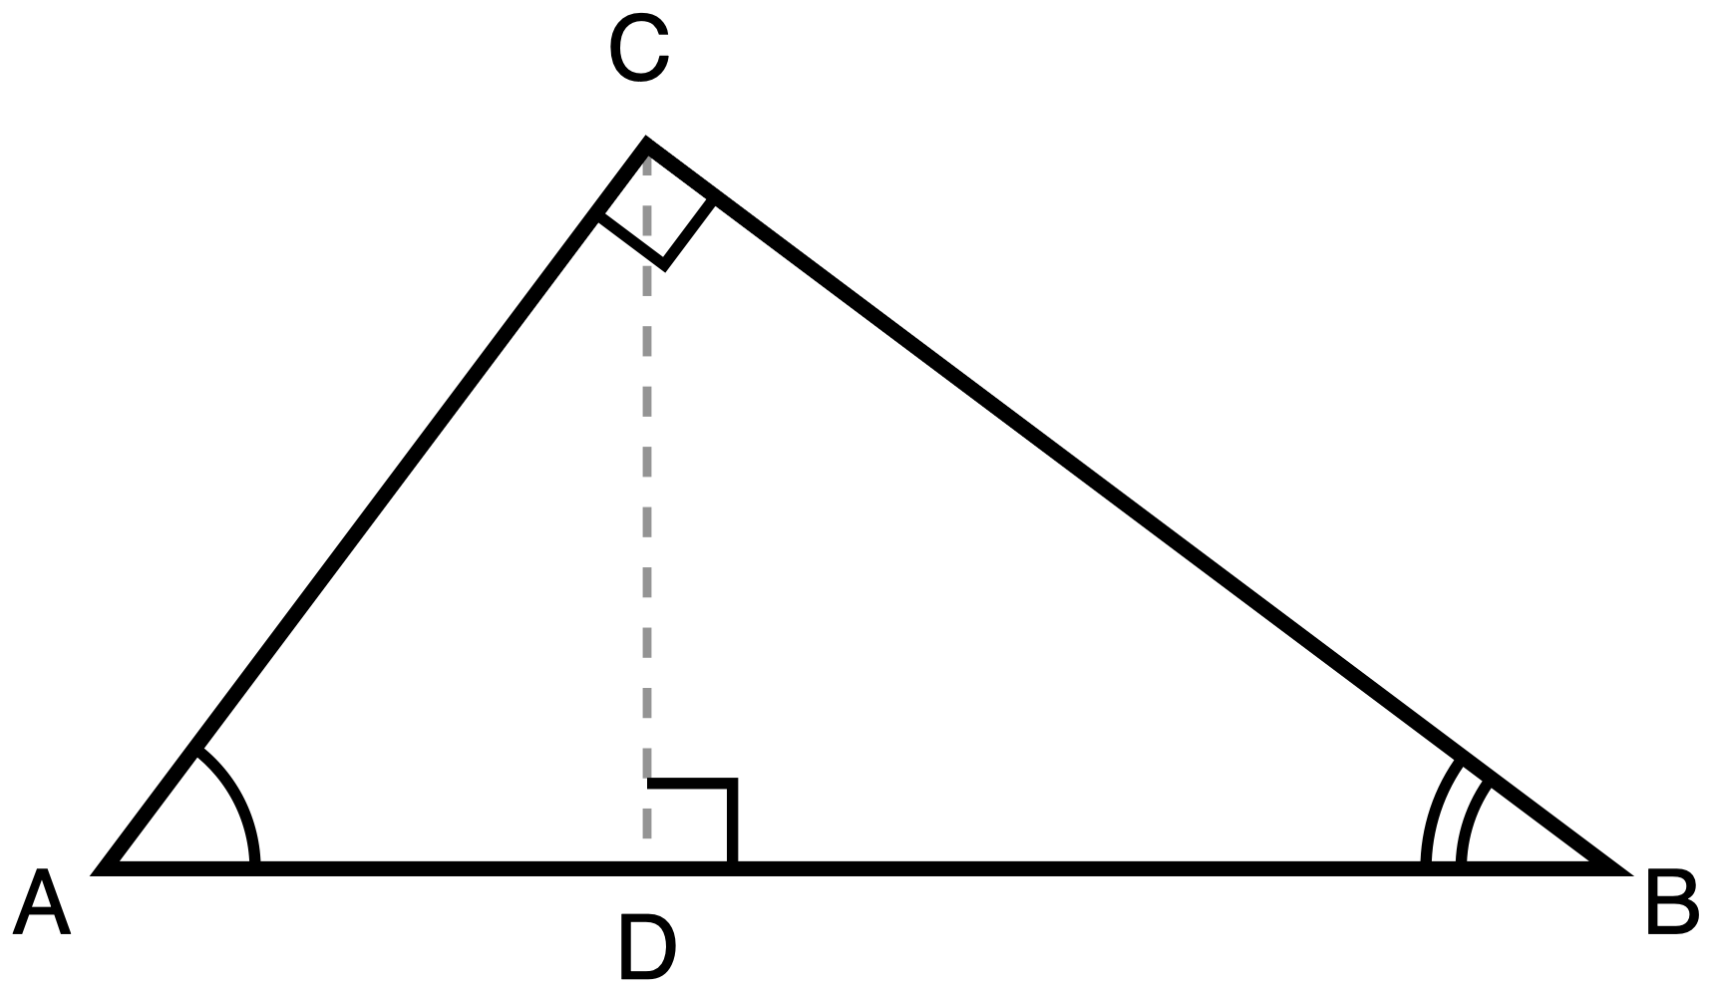
Figure 5.1
Description: Right triangle ABC has its right angle at C and its hypotenuse AB lying horizontally at the bottom, A on the left and B on the right. The altitude CD is drawn as a dashed construction line from C down to the point D on AB, and D lies nearer to A than to B. Angle A carries one arc and angle B carries two arcs. Right-angle squares mark the angle at C and the angle at D. No lengths are given.
Triangle ABC has its right angle at C. CD is the altitude from C to the hypotenuse AB, so CD meets AB at a right angle.
Work on Figure 5.1 above.
- Trace the figure. Then trace each triangle you can find in it, separately, into the space below. Carry the vertex letters across: a vertex called C in the big picture is still called C when you have it on its own.
- Turn every one of your traced triangles the same way, so that all of them have the right angle in the same corner.
- Write down how many triangles you found.
You may trace with tracing paper, or cut a second copy up with scissors, or copy by hand, whichever gets the triangles apart fastest for you. If drawing accurate triangles is the slow part for you rather than finding them, ask for the blank outline sheet and label those instead.
Your separated triangles

How many triangles did you find?

Task B. The same argument, with numbers

Tools for this task: a four-function or scientific calculator is permitted, and so are a ruler and your traced triangles from Task A. A sheet listing relationships between the legs and the hypotenuse segments is not permitted on this task, and neither is a card printing a² + b² = c², because those print the results this task is asking you to produce.

Figure 5.1
Description: Right triangle ABC has its right angle at C and its hypotenuse AB lying horizontally at the bottom, A on the left and B on the right. The altitude CD is drawn as a dashed construction line from C down to the point D on AB, and D lies nearer to A than to B. Angle A carries one arc and angle B carries two arcs. Right-angle squares mark the angle at C and the angle at D. No lengths are given.
In Figure 5.1, the measurements are:
Segment | AC | BC | AB | CD | AD | DB
Length | 15 | 20 | 25 | 12 | 9 | 16

Using the similar triangles you separated in Task A, and no other method:
(a) Write the similarity statement relating triangle ACD to triangle ABC, with the vertices in corresponding order. Then say which pair of angles you matched first, and why they are congruent.

(b) From your statement in (a), write a proportion and cross-multiply it. You should get a statement about AC². Check it with the numbers in the table.

(c) Do (a) and (b) again for triangle CBD and triangle ABC. You should get a statement about BC².

(d) Add your two results. Show that they give 15² + 20² = 25².

How you present your work is up to you. Every one of these is a complete answer:
- a two-column statement-and-reason layout
- a paragraph
- a flowchart or arrow diagram
- the proportions written straight onto your separated triangles with arrows
- explaining it out loud to your teacher while they write it down

Task C. The same argument, with letters
Tools for this task: a calculator is permitted, but there is nothing in this task to compute with it. Your Task B page stays on the desk and you may look back at it. A part-filled proof with the reasons already written in is not permitted, and neither is a printed list of the relationships between the legs and the hypotenuse segments, or a card printing a² + b² = c².
In Figure 5.1, let BC = a, AC = b and AB = c.
Using the three similar triangles formed by the altitude to the hypotenuse, and no other method, prove that a² + b² = c².
Two things about that instruction, said plainly so nothing is hidden:
- This unit is asking for the similarity route specifically. A proof that cuts the squares up and rearranges the pieces is a real proof of the same theorem, and it is not an answer to this task. If that is the proof you know, write it on the back, and then do this one.
- Your proof has to say why each pair of triangles is similar, not just that it is.
Present it in whichever of the five forms from Task B you want.
Your proof

Exit ticket

Tools for this item: a calculator is permitted; there is nothing to compute. Tracing paper, an overlay, or scissors and a second copy of the figure are permitted, and there is blank space below for you to redraw the triangles apart if that helps. Take the time you need. If you are not finished when the period ends, keep this and hand it in at the start of next lesson.
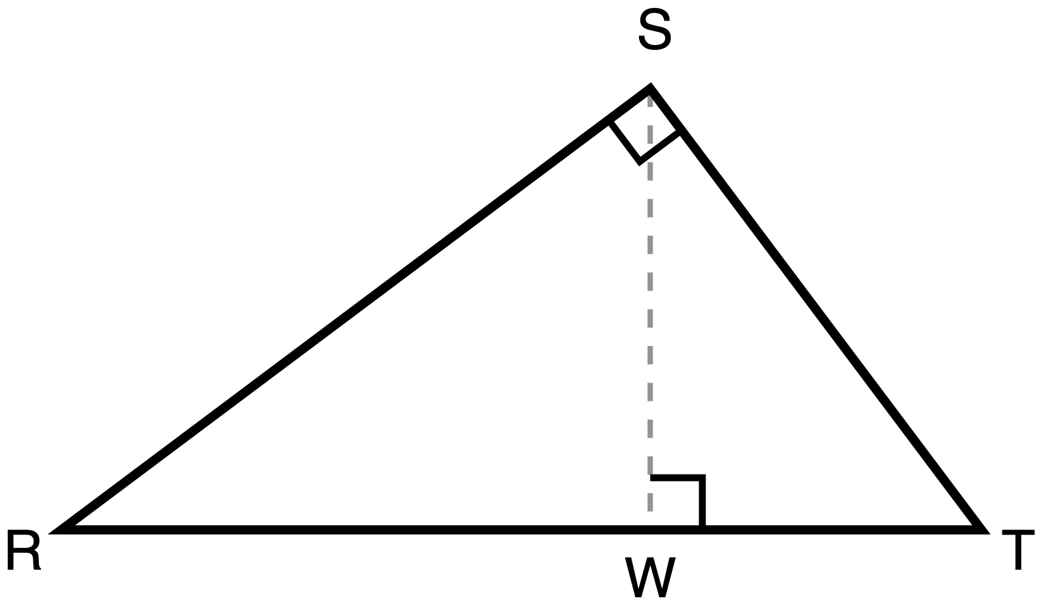
Figure 5.3
Description: Right triangle RST has its right angle at S and its hypotenuse RT lying horizontally at the bottom, R on the left and T on the right. The altitude SW is drawn as a dashed construction line from S down to the point W on RT, and W lies nearer to T than to R, so the apex leans to the right. Right-angle squares mark the angle at S and the angle at W. No angle arcs are marked and no lengths are given.
Right triangle RST has its right angle at S. SW is the altitude from S to the hypotenuse RT. This is not the triangle from today's lesson. Look at where the altitude meets RT before you decide anything.
1. Name the three triangles in this figure that are similar to one another. Then write two similarity statements, each one comparing a small triangle to the whole triangle RST, with the vertices in corresponding order.

2. Write one proportion that follows from one of your similarity statements and that, when you cross-multiply it, gives the square of one of the two legs of triangle RST. State which leg it gives.

3. In one sentence: how did you decide which vertex of the small triangle matches which vertex of RST? (This part is not marked right or wrong. It tells your teacher what to do next.)

Blank space for redrawing

Task 1 · What do you think will happen?

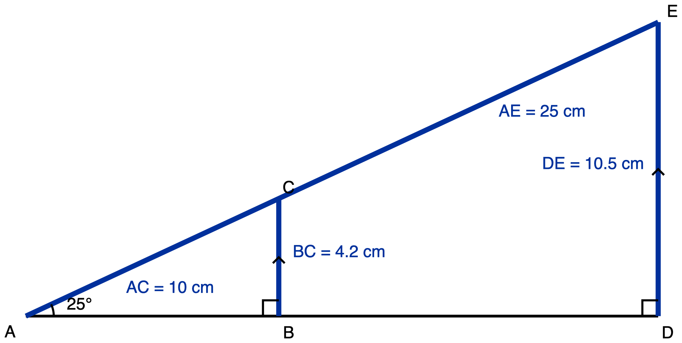
Figure 1. Triangle ABC and triangle ADE share the 25 degree angle at A.
Description: A ray from A rises at 25 degrees above a horizontal ray from the same point A. Two vertical segments, BC and DE, drop from the rising ray to the horizontal one, making two right triangles ABC and ADE that share the angle at A. In the small triangle AC is 10 cm and BC is 4.2 cm. In the large triangle AE is 25 cm and DE is 10.5 cm. The two vertical segments are marked parallel.
Figure 1 in words: Two right triangles, one drawn inside the other, sharing a corner, with the base horizontal along the bottom. A is at the far left, at the shared corner. B is on the base, about two fifths of the way from A to the right-hand end. D is at the right-hand end of the base. C is directly above B, and E is directly above D at the top right. C and E both lie on one straight slanted line that starts at A and rises to the right, with C between A and E. The base from A to D is a plain skeleton line and is not measured. On the slanted line, A to C is 10 cm and A to E is 25 cm. The vertical segment from B up to C is 4.2 cm and the vertical segment from D up to E is 10.5 cm. A single arc at A, between the base and the slanted line, is labelled 25 degrees, and that one angle belongs to both triangles at once. There is a right-angle square at B and a right-angle square at D. A single chevron on BC and a single chevron on DE mark those two segments as parallel.
Part 1, before you measure anything. Look at Figure 1. Triangle ABC and triangle ADE share the angle at A, which measures 25 degrees. Triangle ADE is 2.5 times the size of triangle ABC.
When a right triangle with a 25 degree angle is made bigger, what do you think happens to (the side opposite the 25 degree angle) ÷ (the hypotenuse)? Does it get bigger, get smaller, or stay the same?
Write your prediction now, in one sentence, and keep it

Part 2, after the class table is filled in. Your group has one row of that table. Copy the whole table down here, then read it down each column.
Hypotenuse (cm) | Side opposite the 25 degree angle (cm) | Quotient
8
12
16
20
24

State what happened to the quotient (side opposite the 25 degree angle) ÷ (hypotenuse) as the triangles got bigger, and state what happened to the side lengths.
Two sentences. One about the quotient, one about the side lengths

✋
Tools for this task: a ruler for the measuring, and a calculator or pencil arithmetic for the one division. No ratio table, chart, or calculator key that gives you a ratio from an angle: the point of this task is what your own column of numbers does.

Task 2 · Why it had to happen
Use Figure 1 again. Angle A is 25 degrees. AC = 10 cm and BC = 4.2 cm. AE = 25 cm and DE = 10.5 cm.

Figure 1, repeated. You may mark on this copy.
Description: A ray from A rises at 25 degrees above a horizontal ray from the same point A. Two vertical segments, BC and DE, drop from the rising ray to the horizontal one, making two right triangles ABC and ADE that share the angle at A. In the small triangle AC is 10 cm and BC is 4.2 cm. In the large triangle AE is 25 cm and DE is 10.5 cm. The two vertical segments are marked parallel.
Explain, using similarity, why triangle ABC and triangle ADE have to give the same value for (the side opposite the 25 degree angle) ÷ (the hypotenuse), before anybody divides anything.
Your explanation has to get from "the angle at A is the same" to "the quotients are equal". Say every step. You may write it in sentences, say it to your teacher, or write it on the diagram by marking the equal angles, ringing the sides that correspond, and writing the two equal quotients.
Your explanation

✋
Tools for this task: nothing needed. There is nothing to compute here. No ratio table and no calculator key that gives a ratio from an angle, because that would do the reasoning this question is asking you for.

Task 3 · Using it on a triangle nobody measured
The class found that for a 25 degree angle, (side opposite) ÷ (hypotenuse) = 0.42.
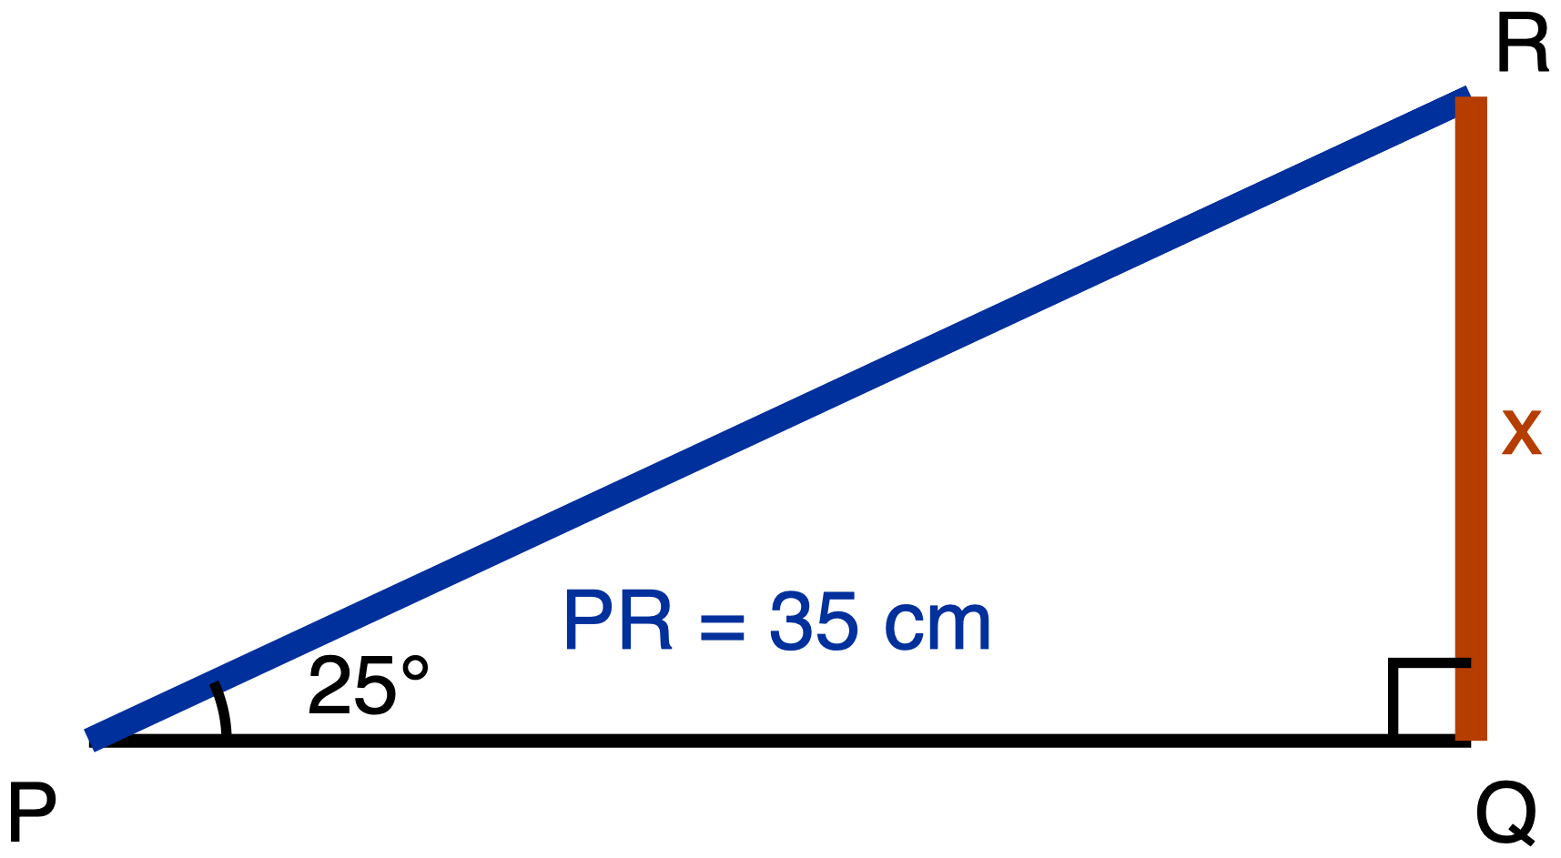
Figure 2. Right triangle PQR, with a 25 degree angle at P and hypotenuse 35 cm.
Description: Right triangle PQR has its right angle at Q, with PQ horizontal at the bottom and QR vertical on the right. The angle at P measures 25 degrees. The hypotenuse PR is given as 35 cm. The vertical side QR, which is the side opposite the 25 degree angle, is the unknown and is labelled x.
Figure 2 in words: One right triangle, with its horizontal side along the bottom and its vertical side on the right. P is at the bottom left, Q at the bottom right directly right of P, and R at the top right directly above Q. P to Q is horizontal, a plain skeleton line, not measured. P to R is the slanted hypotenuse, given as 35 cm. Q to R is vertical, is the side opposite the angle at P, and is the unknown: it is drawn as the heaviest line in the figure and labelled x. A single arc at P, between the base PQ and the hypotenuse PR, is labelled 25 degrees, and there is a right-angle square at Q.
Triangle PQR has its right angle at Q, the angle at P is 25 degrees, and the hypotenuse PR is 35 cm. The side QR, opposite the 25 degree angle, is marked x.
Use the class's ratio for 25 degrees to find x, to the nearest tenth of a centimetre. Write the equation you used as well as the answer.
Equation and answer

✋
Tools for this task: a calculator, and the class's ratio table or a printed ratio table if you want one. You are not being asked to remember the ratio here; you are being asked what to do with it.

Task 4 · What changes, and what does not
Triangle ABC is the small triangle in Figure 1. It has AC = 10 cm, BC = 4.2 cm and AB = 9.1 cm, with a 25 degree angle at A. Imagine it enlarged by a scale factor of 3.
For each row, determine whether the quantity changes or stays the same. Where it changes, give the new value.
Quantity | Changes or stays the same? | New value, if it changes
The length of BC
The perimeter of the triangle
The measure of the angle at A
The quotient BC ÷ AC

✋
Tools for this task: a calculator for the perimeter. No ratio table and no calculator key that gives a ratio from an angle, because the last row of this table is the thing you are being asked about.

Exit ticket · Day 6

Name: ____________________________
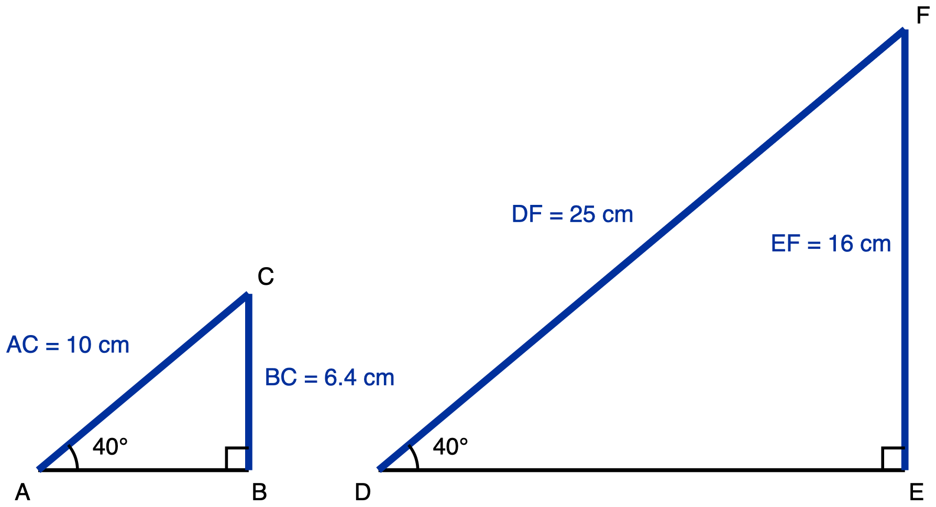
Figure 3. Triangle ABC and triangle DEF, each with a 40 degree angle.
Description: Two right triangles are drawn side by side in the same orientation, both with the horizontal side at the bottom and the vertical side on the right. Triangle ABC on the left has a 40 degree angle at A, hypotenuse AC of 10 cm and vertical side BC of 6.4 cm. Triangle DEF on the right has a 40 degree angle at D, hypotenuse DF of 25 cm and vertical side EF of 16 cm. The single arc at A and the single arc at D mark those two angles equal.
Figure 3 in words: Two separate right triangles, side by side, drawn in the same orientation, both with the horizontal side along the bottom and the vertical side on the right. The left triangle is much smaller than the right one; they do not touch and they share no points. In the left triangle, A is at the bottom left, B at the bottom right, and C directly above B. The base A to B is a plain skeleton line and is not measured, the hypotenuse A to C is 10 cm, and the vertical side B to C, opposite the angle at A, is 6.4 cm. In the right triangle, D is at the bottom left, E at the bottom right, and F directly above E. The base D to E is a plain skeleton line and is not measured, the hypotenuse D to F is 25 cm, and the vertical side E to F, opposite the angle at D, is 16 cm. A single arc at A is labelled 40 degrees and a single arc at D is labelled 40 degrees; the two angles carry the same number of arcs, which is what states they are equal. There is a right-angle square at B and a right-angle square at E.
Triangle ABC has a 40 degree angle at A, with AC = 10 cm and BC = 6.4 cm. Triangle DEF has a 40 degree angle at D, with DF = 25 cm and EF = 16 cm.
(a) Compute BC ÷ AC and EF ÷ DF.

(b) Explain, using similarity, why your two answers to (a) are equal.

(c) A third right triangle also has a 40 degree angle, and its hypotenuse is 40 cm. Predict the length of the side opposite the 40 degree angle, and state how you know.

✋
Tools for this ticket: pencil arithmetic or a calculator for the one division and the one multiplication. Not permitted: a ratio table, a ratio chart, an app, or a calculator's sin, cos or tan key. Those give you a ratio straight from an angle, which is the thing this ticket is asking whether you understand.

Task 1: Which leg is doing which job

You may use: a calculator (there is nothing to calculate in this task), and a tracing-paper copy of the triangle that you may turn around.
You may not use: a printed table of sine, cosine or tangent values, or a copy of this triangle with the legs already labelled.
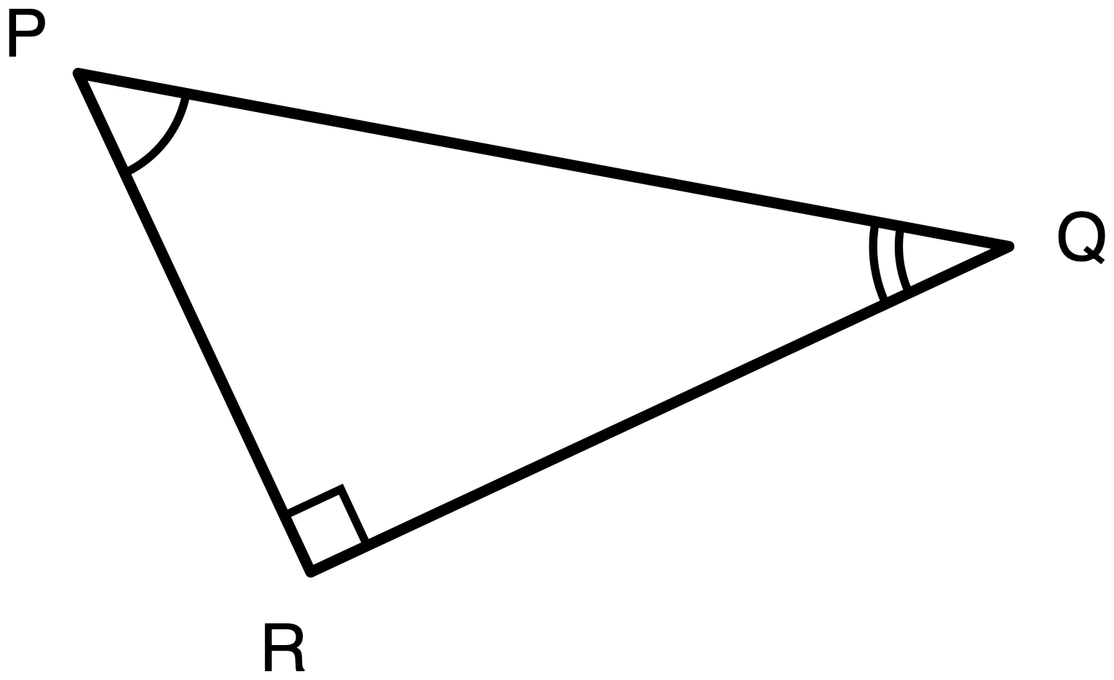
Figure 7.1. Triangle PQR, right angle at R.
Description: A right triangle, drawn tilted so that no side is horizontal or vertical. Three vertices are labelled P, Q and R. P is at the upper left. Q is at the right, a little lower than P. R is at the bottom, below P and slightly to its right. The three sides are: leg PR, running down and slightly right from P to R; leg QR, running from R up and to the right to Q, and it is the longer of the two legs; and side PQ, running from P down and to the right to Q, which is the longest side of the three. No side has a length given, and no side is marked as given or as unknown. The angle at R, between RP and RQ, is a right angle and is marked with a small square. The acute angle at P, between PR and PQ, is marked with one arc. The acute angle at Q, between QR and QP, is marked with two concentric arcs. The arc counts are here only to tell the two acute angles apart so they can be referred to unambiguously; they do not assert that any angles in this figure are congruent, and no congruence or similarity is claimed anywhere in this drawing.
Triangle PQR has its right angle at R.
(a) Relative to angle P, name:
- the opposite leg: ______________________
- the adjacent leg: ______________________
- the hypotenuse: ______________________
(b) Relative to angle Q, name:
- the opposite leg: ______________________
- the adjacent leg: ______________________
- the hypotenuse: ______________________
(c) In one sentence, how did you decide?

Task 2: The same triangle, from both of its acute angles

You may use: a calculator, and the definition card below. You will not be marked down for using the card.
You may not use: a copy of this triangle with the legs already labelled "opposite" and "adjacent" for either angle.
Answers may be a fraction or a decimal. Both are accepted.
Definition card: For an acute angle θ in a right triangle: sine of θ = opposite ÷ hypotenuse · cosine of θ = adjacent ÷ hypotenuse · tangent of θ = opposite ÷ adjacent
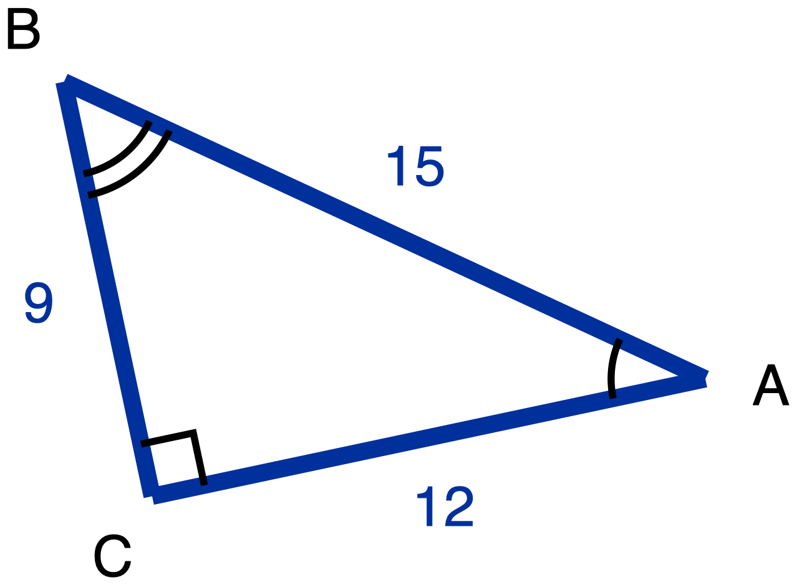
Figure 7.2. Triangle ABC, right angle at C, with AC = 12, BC = 9 and AB = 15.
Description: A right triangle, drawn tilted so that no side is horizontal or vertical. Three vertices are labelled A, B and C. B is at the upper left and is the highest of the three. A is at the right and lower than B. C is at the lower left, below B. The three sides are: leg BC, running from B down to C, with given length 9, the shorter leg; leg CA, running from C to the right and slightly up to A, with given length 12, the longer leg; and side AB, running from A up and to the left to B, with given length 15, the longest side. All three lengths are given, so all three sides are drawn in the heavier given weight and all three numerals are in the given colour. Nothing in this figure is marked as an unknown. The angle at C, between CA and CB, is a right angle and is marked with a small square. The acute angle at A, between AC and AB, is marked with one arc. The acute angle at B, between BC and BA, is marked with two concentric arcs. The arc counts are here only to tell the two acute angles apart; they do not assert that any angles are congruent, and no congruence or similarity is claimed in this drawing.
(a) Relative to angle A. First name the sides, then write the ratios.
- opposite leg: ______________ adjacent leg: ______________ hypotenuse: ______________
- sin A = ______________ cos A = ______________ tan A = ______________
(b) Relative to angle B. Same triangle. Name the sides again before you write anything else.
- opposite leg: ______________ adjacent leg: ______________ hypotenuse: ______________
- sin B = ______________ cos B = ______________ tan B = ______________
Working

Exit ticket: Day 7

You may use: a calculator (nothing here needs one), the definition card (it asks for no ratio, so it will not help), and a tracing-paper copy of the triangle you may turn.
You may not use: Task 1 or Task 2 (turn them face down), or a printed table of sine, cosine or tangent values, or a copy of this triangle with the legs already labelled.
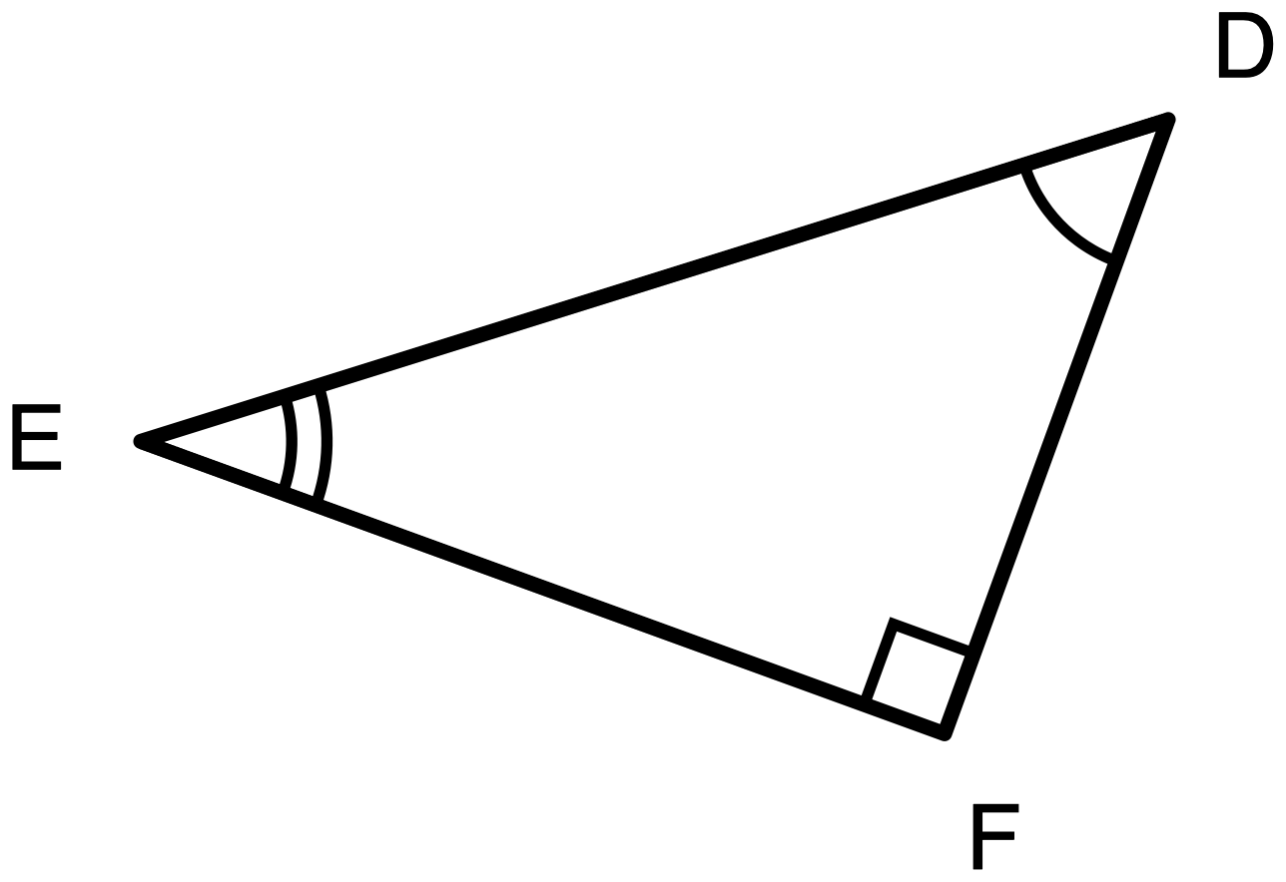
Figure 7.3. Triangle DEF, right angle at F.
Description: A right triangle, drawn tilted so that no side is horizontal or vertical, and at a different tilt from either figure used earlier in the lesson. Three vertices are labelled D, E and F. D is at the upper right and is the highest of the three. E is at the far left, lower than D. F is at the lower right, below D. The three sides are: leg DF, running from D down to F, the shorter leg; leg EF, running from E to the right and down to F, the longer leg; and side DE, running from D down and to the left to E, which is the longest side of the three. No side has a length given, and no side is marked as given or as unknown. The angle at F, between FD and FE, is a right angle and is marked with a small square. The acute angle at D, between DF and DE, is marked with one arc. The acute angle at E, between EF and ED, is marked with two concentric arcs. The arc counts are here only to tell the two acute angles apart; they do not assert that any angles are congruent, and no congruence or similarity is claimed in this drawing.
Triangle DEF has its right angle at F.
(a) Relative to angle D:
- opposite leg: ______________________
- adjacent leg: ______________________
- hypotenuse: ______________________
(b) Relative to angle E:
- opposite leg: ______________________
- adjacent leg: ______________________

Task 1 · Half a square

Each task states its own tools. Read that line. It is not the same on every task.
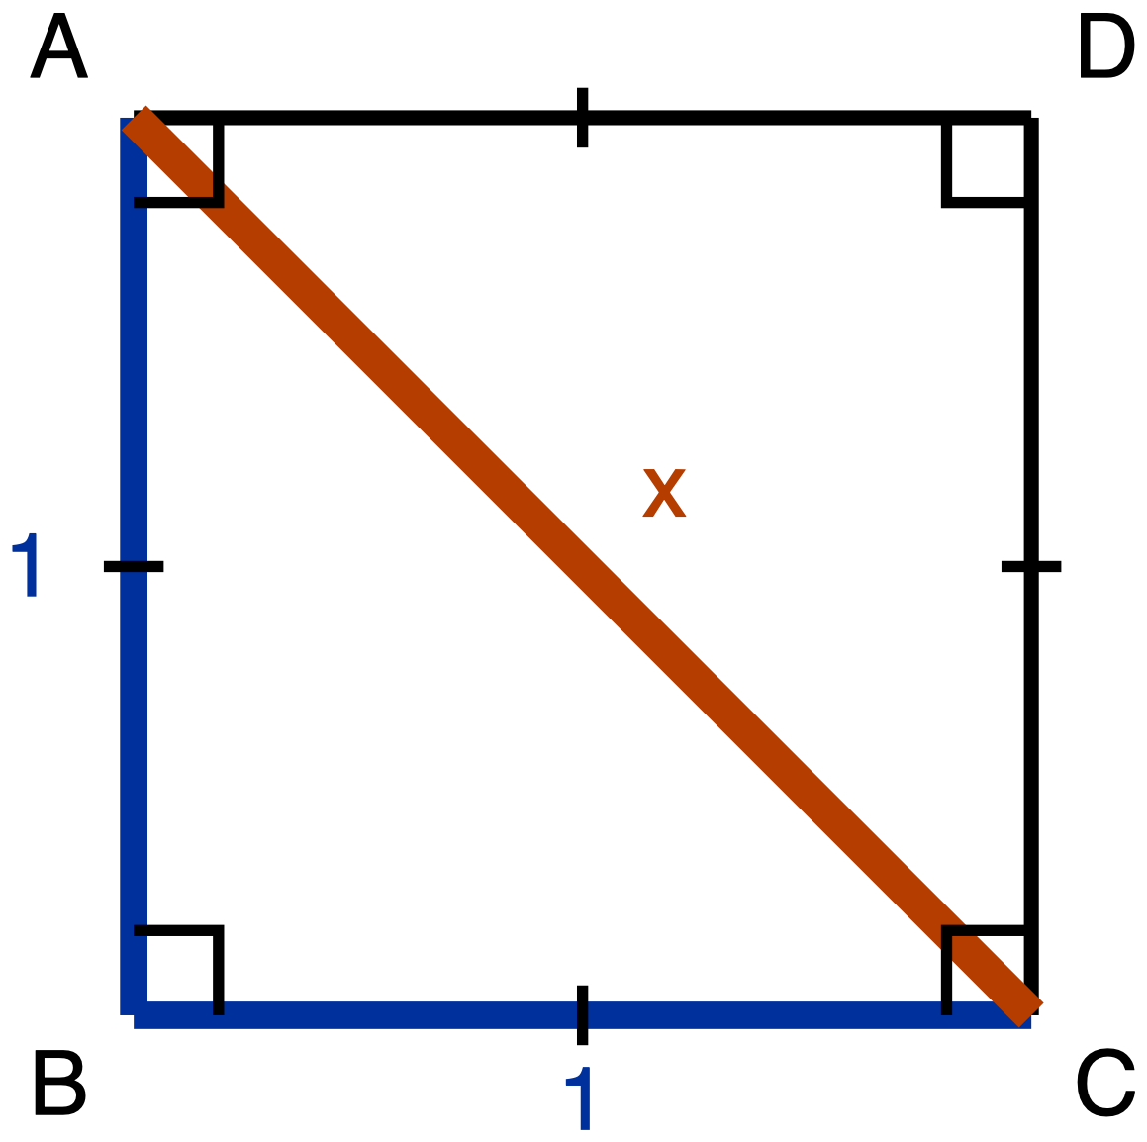
Figure 1. Square ABCD of side 1 with the diagonal from A to C drawn.
Description: Square ABCD has vertices A top left, B bottom left, C bottom right and D top right. A single tick on each of the four sides marks them congruent, and a right-angle square sits at each of the four corners. Sides AB and BC are given as 1. The diagonal AC is drawn and its length is unknown, labelled x; it passes through the corners of the right-angle marks at A and at C.
Square ABCD has side length 1, and its diagonal AC is drawn.
Derive the three angle measures and the three side lengths of triangle ABC. Give the side lengths in exact form.
The required route is the square's diagonal. Your argument has to say what the diagonal does to the corner angle at A and at C, and it has to use the Pythagorean Theorem to get AC. Writing down "45-45-90" and "1 : 1 : √2" from memory is not what this task is asking for, and it will not count as an answer, because the thing being asked for is where those values come from.
Record your derivation in whichever one of these you prefer:
- an annotated diagram, with the angle measures and the algebra written on the figure
- a paragraph
- a two-column statement and reason chain
- an oral walkthrough at the figure, which I will write down as you give it
✋
Tools for this task. No calculator: this task asks for exact form, and a calculator gives you a decimal instead of the answer. No special-triangle reference card: it prints the ratio you are deriving. Straightedge and blank paper are yours, and redrawing triangle ABC on its own, away from the square, is a good first move.

Your derivation

Task 2 · Half an equilateral triangle

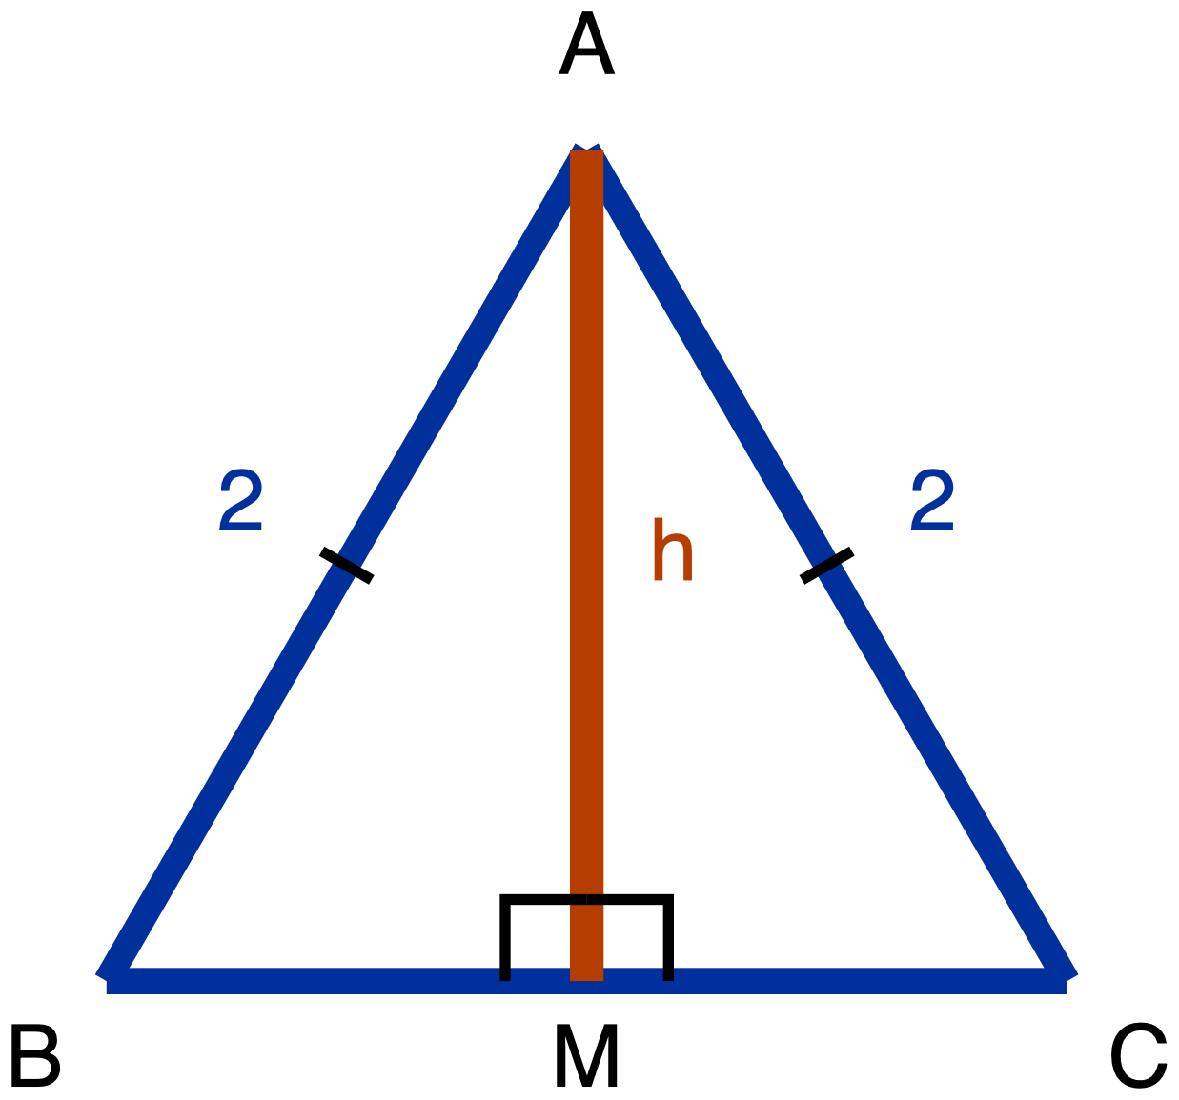
Figure 2. Equilateral triangle ABC of side 2 with the altitude from A drawn to BC.
Description: Equilateral triangle ABC has apex A at the top, B at the bottom left and C at the bottom right, with BC horizontal. Every side is 2; single ticks on AB and AC mark them congruent and both carry the numeral 2. The altitude from A meets BC at M, and the two right angles at M are marked. The length of the altitude AM is unknown and labelled h. Nothing in the drawing states where M sits along BC or what the altitude does to angle A.
Equilateral triangle ABC has side length 2. The altitude from A meets BC at M.
Derive the three angle measures and the three side lengths of triangle ABM. Give the side lengths in exact form.
The required route is the equilateral triangle's altitude. Before any arithmetic, your argument has to answer both of these:
- What does the altitude do to angle A?
- What does the altitude do to side BC?
Then use the Pythagorean Theorem to get AM.
✋
Do this first. Redraw triangle ABM on its own, away from the equilateral triangle, turned the same way it sits in the figure. Tracing paper and scissors are on the front desk if you would rather trace or cut it out. Everyone does this step.

You have the same four response choices as Task 1: an annotated diagram, a paragraph, a two-column statement and reason chain, or an oral walkthrough that I will write down as you give it.
✋
Tools for this task. No calculator: exact form is asked for. No special-triangle reference card: it prints the ratio you are deriving. Tracing paper, scissors, straightedge and blank paper are all yours.

Your derivation

Special-triangle reference card

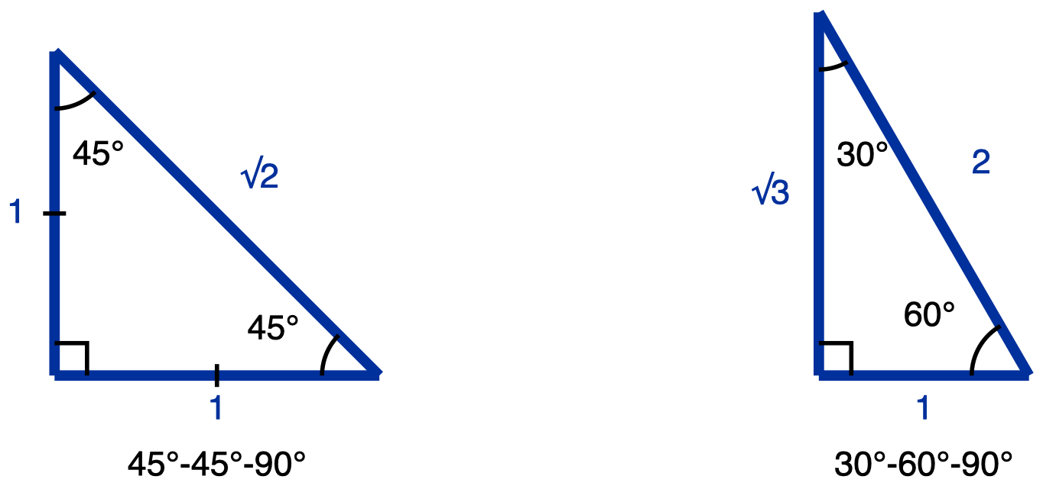
Figure 3. The special-triangle reference card.
Description: Two right triangles side by side, both with the right angle at the bottom left and both drawn in the same orientation. The left one has two 45 degree angles, legs of 1 and 1 marked congruent by a single tick each, and hypotenuse root 2. The right one has a 30 degree angle at the top and a 60 degree angle at the bottom right, a short bottom leg of 1, a long left leg of root 3, and hypotenuse 2. This card supplies the two ratios; it does not derive them.
This card gives you the two ratios, 1 : 1 : √2 and 1 : √3 : 2, each written in side order from shortest to longest.
Use it on Tasks 3, 4 and 5. It is not available on Task 1, on Task 2, or on the exit ticket, because on those three it would print the thing you are being asked to work out.

Tasks 3, 4 and 5

Task 3 · Using the 45-45-90 ratio
A 45-45-90 triangle has legs of length 7. Give the length of its hypotenuse in exact form.
✋
Tools for this task. The special-triangle reference card is on your desk and you may use it, because this task asks you to apply the ratio, not to produce it. No calculator: the answer is a radical, not a decimal. Write your answer, or say it to me and I will write it down.

Task 4 · Using the 30-60-90 ratio
A 30-60-90 triangle has hypotenuse 14. Give the shorter leg and the longer leg, both in exact form.
✋
Tools for this task. Reference card: yes, same reason as Task 3. Calculator: no, same reason as Task 3. Write your answer or say it to me.

Task 5 · Running the 45-45-90 ratio backwards
A 45-45-90 triangle has hypotenuse 6. Give the length of each leg in exact form.
This is Task 3 turned around: there you were given a leg and asked for the hypotenuse, and here you are given the hypotenuse and asked for a leg. The card gives you the ratio. Which way to run it is yours, and so is finishing the answer: exact form does not leave a radical underneath a fraction bar.
✋
Tools for this task. Reference card: yes, same reason as Tasks 3 and 4. Calculator: no, and this time for two reasons. Exact form is asked for, and a calculator would do the division for you, which is the step this task is about. The worked example stays up on the board; its numbers are not these numbers. Write your answer, or say it to me and I will write it down.

Show your reasoning

Exit ticket

Name: ______________________________
A 30-60-90 triangle has short leg 5.
(a) Give the hypotenuse and the longer leg, both in exact form.
(a)

(b) In one sentence, state how you know which of your two values is the hypotenuse and which is the longer leg.
(b)

✋
Tools for this ticket. The reference card has been collected, because it prints the very thing part (b) asks you to work out. No calculator, for that same reason and because exact form is asked for. For part (b) you may write a sentence, say it to me and I will write it down word for word, or write a comparison of the two numbers instead of a sentence: a comparison is a complete answer to (b) if it settles which value is larger.

Day 9 · Tasks

Task 1 · One leg, two names
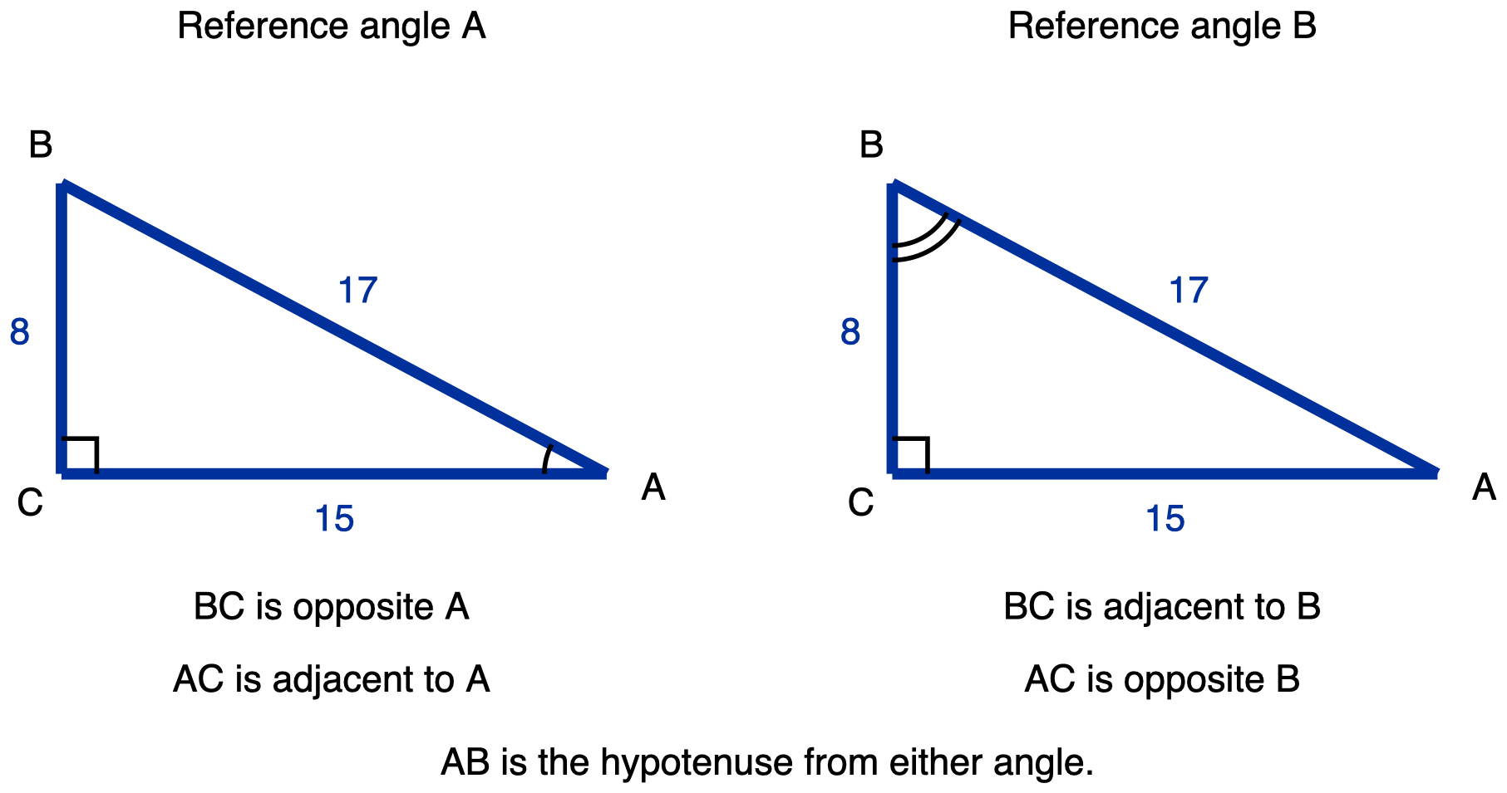
Figure 9.1. The same right triangle ABC drawn twice. Left panel: angle A is the reference angle. Right panel: angle B is the reference angle.
Description: Two panels side by side, each holding the same right triangle, drawn with one leg horizontal along the bottom and one leg vertical on the left. The panels are captioned 'Reference angle A' on the left and 'Reference angle B' on the right. Points, in the same position in both panels: C is the bottom-left corner and holds the right angle; A is the bottom-right corner, level with C; B is directly above C, higher than both. Segments, identical in both panels and all three given: CA is the horizontal bottom leg and measures 15; CB is the vertical left leg and measures 8; AB runs from the bottom-right corner up to the top-left corner and is the hypotenuse, measuring 17. All three are drawn at the heavier given weight. The right angle at C carries a small square in both panels and is never drawn as an arc. In the left panel only, the angle at A carries a single arc, marking it as the reference angle there. In the right panel only, the angle at B carries two concentric arcs, marking it as the reference angle there. No angle carries an arc in both panels. The two panels are the same triangle, so every side and angle in the left panel equals its counterpart in the right; the differing arc counts distinguish the two acute angles from one another, not the two panels. Captions under each panel: left, 'BC is opposite A' and 'AC is adjacent to A'; right, 'BC is adjacent to B' and 'AC is opposite B'; and centred beneath both, 'AB is the hypotenuse from either angle.'
The right angle is at C. BC = 8, AC = 15, AB = 17.
(a) Write sin A as a fraction of two named sides of this triangle. Write cos B as a fraction of two named sides of this triangle.

(b) Those two fractions are the same fraction. Explain why. Your explanation must name the one leg that is opposite angle A and adjacent to angle B, and must say why that one leg plays both roles.
✋
Restating the rule, sine equals cosine of the complement, without naming that leg does not answer part (b).

Your explanation

✋
Tools: a calculator is allowed and will not help. No formula card, no table of sine and cosine values. You may answer part (b) out loud to your teacher, in writing, or by annotating the figure.

Task 2 · Does it work for tangent?
Two students disagree.
✋
Nadia: tan 25° = tan 65°, because 25° and 65° are complements and that is how sine and cosine work.
Omar: that cannot be right.

Draw one right triangle with acute angles 25° and 65°, or use the blank one your teacher can give you. Label the leg opposite the 25° angle and the leg opposite the 65° angle.

(a) Write tan 25° as a fraction of those two legs. Write tan 65° as a fraction of the same two legs.

(b) Use your two fractions to say who is right.

(c) State the relationship that does hold between tan θ and tan(90° − θ).

✋
An answer that only reports calculator values does not answer this item. The two fractions are what is being asked for.

✋
Tools: a calculator is allowed as a check on your own answer. No formula card, no table of tangent values.

Task 3 · Same function, or a sine and a cosine?
(a) In a right triangle, two acute angles satisfy sin(3x + 12)° = cos(x + 30)°.
(b) In a different right triangle, two angles satisfy sin(3x + 12)° = sin(x + 30)°.
For each part, in this order:
- Write one sentence saying how the two angles are related.
- Write the equation that follows from your sentence.
- Solve for x.
- Check: substitute your x back in and confirm both angle measures are strictly between 0° and 90°.
✋
Both parts are required. The two parts do not have the same answer, and the difference between them is the point.

Part (a)

Part (b)

✋
Tools: a plain or scientific calculator is allowed for the arithmetic. No graphing calculator and no equation solver. No formula card. A table of sine and cosine values is allowed and will not help you here, because your unknown is inside the angle.

Task 4 · Solve for y
Solve for y:
sin 32° = cos(y + 18°), where (y + 18)° is the measure of an acute angle.
Write the angle relationship you are using as a sentence before you write any equation. Show your working.
The relationship I am using

My working

✋
Tools: no calculator on this item. The arithmetic is 90 − 32 and then 58 − 18, and a calculator with sine and cosine keys would answer the question without you using the relationship, which is the thing this item is checking. No formula card, no table of sine and cosine values.

Exit Ticket · Day 9

Name: ______________________________ Class: ____________ Date: ____________
✋
Task page, notes and notebooks closed and away. No calculator.

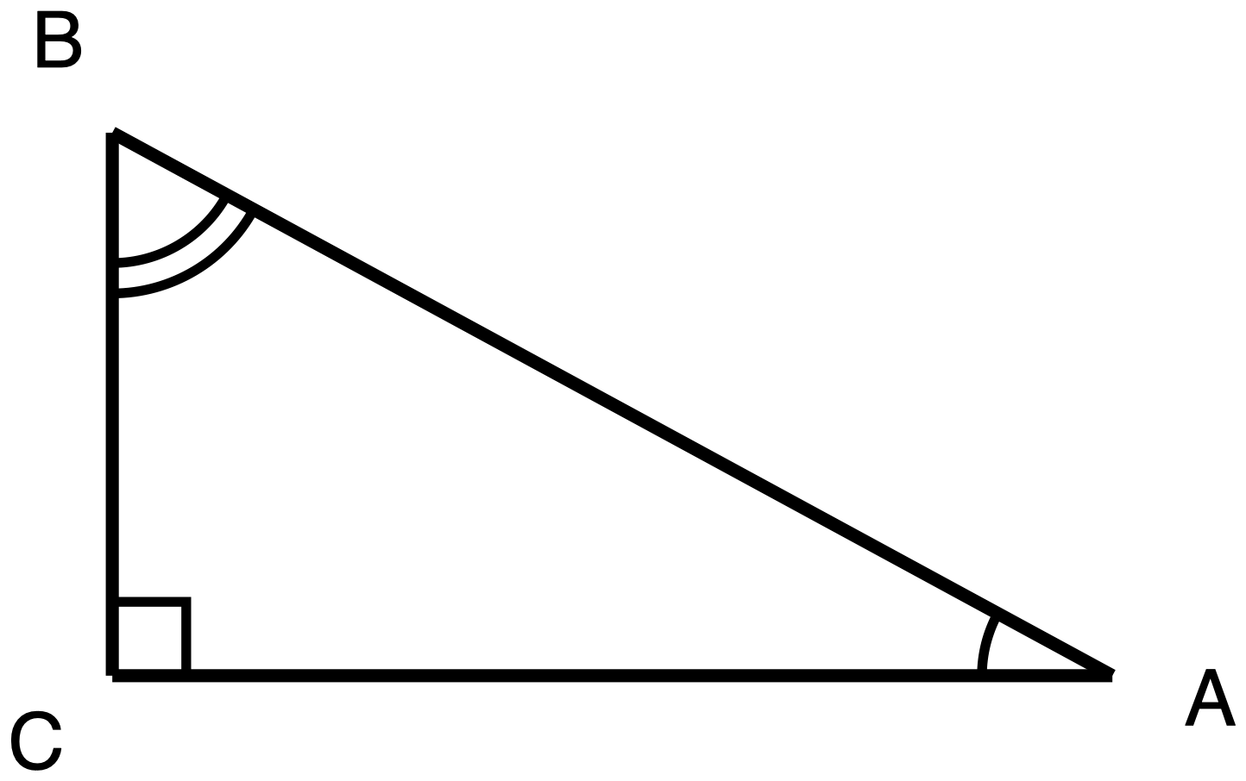
Figure 9.2. Right triangle ABC, right angle at C.
Description: A single right triangle, one leg horizontal along the bottom and one leg vertical on the left. C is the bottom-left corner and holds the right angle; A is the bottom-right corner, level with C; B is directly above C and is the highest point. CA is the horizontal bottom leg; CB is the vertical left leg; AB runs from the bottom-right corner up to the top-left corner and is the hypotenuse. No side length and no angle measure is printed anywhere on the figure. The right angle at C carries a small square. The angle at A carries a single arc. The angle at B carries two concentric arcs. The right angle is never drawn as an arc, so the arcs mark the two acute angles only, and the differing arc counts say that A and B are two different angles rather than a congruent pair. No two segments and no two angles are marked congruent.
You are told that sin A = 0.6.
(a) The cosine of which angle in this triangle equals 0.6? Name it.

(b) Justify your answer, using the fact that A and B are the two acute angles of this triangle.

(c) Say why the answer cannot be angle C.

✋
All three parts are required. You may write your answers, say (b) and (c) to your teacher with (a) written down, or answer by annotating the figure.

Angles of Elevation and Depression · Task 1, Prove it before you use it

✋
You may use a straightedge. You do not need a calculator for this task. You may not use a protractor: this task asks you to prove the two angles are equal, not to measure them. This task may be read aloud to you if you ask. The figure is handed to you with the task, so hearing the words read out takes nothing away from what is being asked. Task 1 is the only item today where that is so: read the tools line on each of the others.

Look at Figure 10.1.
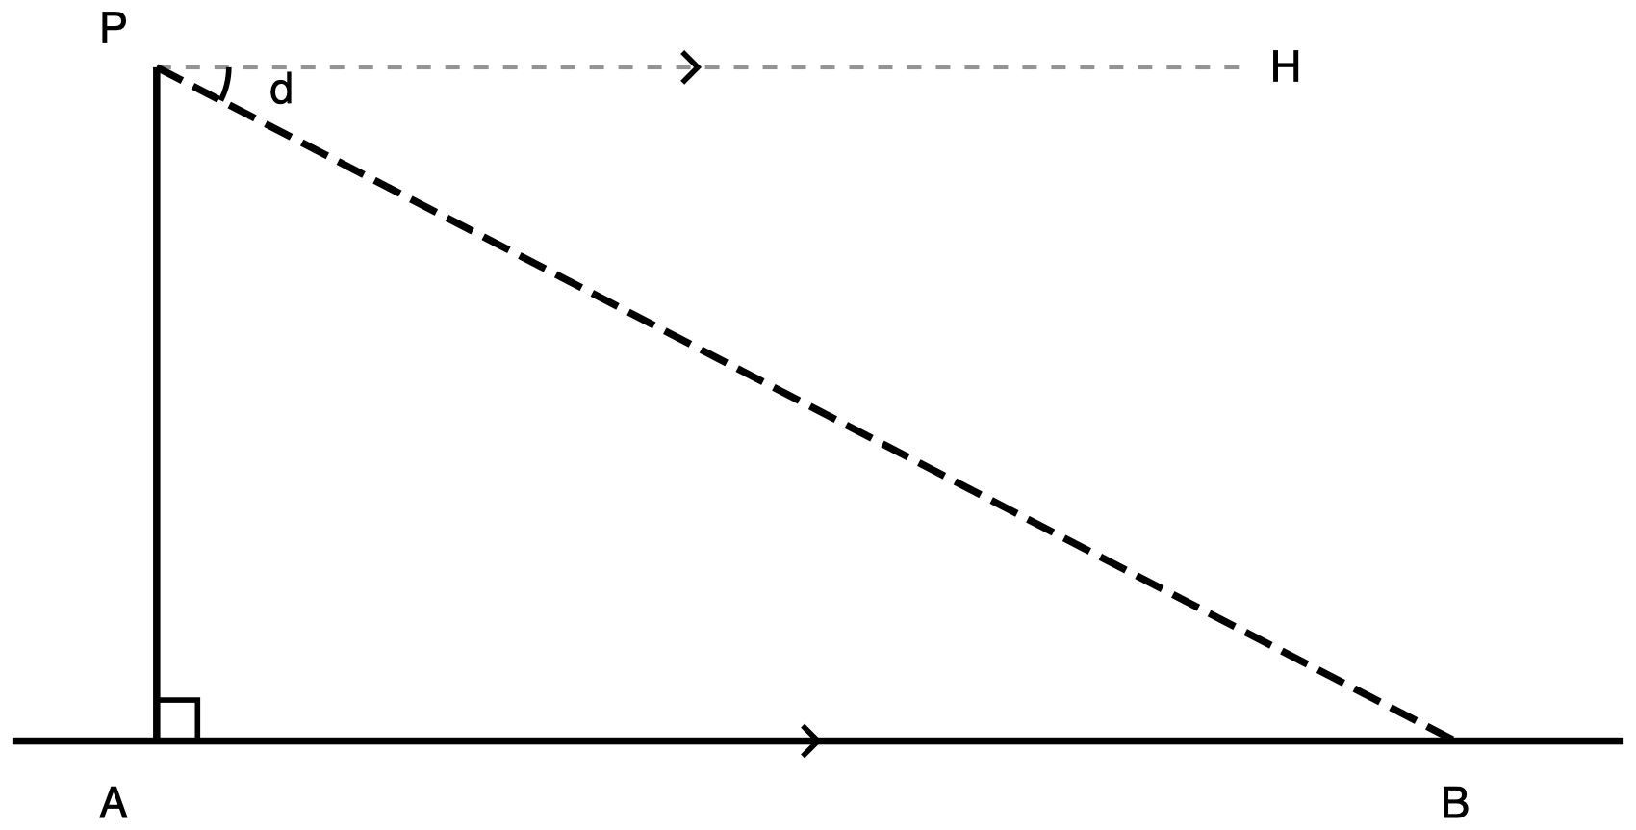
Figure 10.1. An observer at P on a cliff top sights a boat at B.
Description: A wide scene with a vertical cliff on the left and open water to the right. Four labelled points: A at the foot of the cliff on the water line at lower left; P directly above A at the top of the cliff; B on the water line well to the right of A, about three and a half cliff-heights away; and H up and to the right of P at the far end of a horizontal ray from P. The cliff face PA is vertical and solid. The water line is horizontal and solid and runs past A on the left and past B on the right, so AB is a portion of a longer line. PH is a grey, finely dashed horizontal construction ray from P to the right, the observer's horizontal. PB is drawn from P down to the right to B with a long dash pattern, the line of sight. A small square at A marks the right angle between the cliff and the water line. One single arc at P, between ray PH and ray PB, is labelled d, the angle of depression. A single chevron at the midpoint of PH and a matching single chevron on the water line between A and B state that those two lines are parallel. The angle at B between ray BA and ray BP is not marked, and no segment carries a number.
An observer stands at P, on top of a cliff. A boat sits at B, on the water. PA is the cliff face. AB is the water line. PH is the observer's horizontal line of sight, drawn as a grey dashed ray. The chevrons mark PH and the water line as parallel. The dashed line PB is the observer's line of sight to the boat.
The single arc at P marks d, the angle of depression from the observer down to the boat.
The angle of elevation from the boat up to the observer is the angle at B between ray BA and ray BP. It is not marked on the figure.
(a) Mark that angle on your copy and label it e.
(b) Prove that d = e. Your proof must name the two parallel lines, name the transversal, and name the angle relationship you are using.
You may write your proof as a two-column proof, as a paragraph, as a flowchart, or as an annotated diagram, or you may present it out loud. Choose the one that lets you show the argument most clearly. The format is not being marked. The argument is.
Your proof

Task 2 · The van

✋
A calculator or a printed table of tangent values is permitted. No diagram is supplied for this task, and you should not look for one. The scene is not read aloud on this task. Your teacher will read the lettered instructions to anyone who asks, and will not read the paragraph describing the guard, the deck and the van, because turning that paragraph into a drawing is half of what this task measures. Large print, braille, extra time, extra space and a scribe who draws exactly what you say are all available and take nothing away.

A security guard stands at the rail of an observation deck 78 m above the street. She sights a parked van at an angle of depression of 31°.
(a) Draw the scene. Your drawing must show the guard's horizontal line of sight, the street, the line of sight to the van, and the 31° angle marked where it is actually measured.
Your drawing

(b) Name the two parallel lines and the transversal in your drawing. State the angle at the van that is equal to 31°, and give the reason.

(c) Find the horizontal distance from the base of the building to the van. Round to the nearest metre.
Show your reasoning

Task 3 · The tree

✋
A calculator or a printed table of tangent values is permitted. No diagram is supplied. The scene is not read aloud on this task. The lettered instructions will be read to anyone who asks; the paragraph describing you, the ground and the tree will not, because turning that paragraph into a drawing is part of what this task measures. Large print, braille, extra time, extra space and a scribe who draws exactly what you say are all available and take nothing away.

You are standing on level ground, 24 m from the base of a tree. Your eyes are 1.6 m above the ground. Standing, you are 1.75 m tall. You look up at the top of the tree and measure an angle of elevation of 38°.
(a) Draw the scene. Draw yourself as a vertical segment from the ground up to your eyes, with the triangle sitting on top of it.
Your drawing

(b) Find the height of the tree. Round to the nearest tenth of a metre.
Show your reasoning

(c) In one sentence: which measurement of you, 1.6 m or 1.75 m, belongs in your calculation, and why?

Task 4 · The swimmer

✋
A calculator or a printed table of tangent values is permitted. No diagram is supplied. The scene is not read aloud on this task. The lettered instructions will be read to anyone who asks; the paragraph describing the lifeguard, her tower and the swimmer will not, because turning that paragraph into a drawing is part of what this task measures. Large print, braille, extra time, extra space and a scribe who draws exactly what you say are all available and take nothing away.

A lifeguard sits in her tower with her eyes 5.2 m above the water. She sights a swimmer at an angle of depression of 12°.
(a) Draw the scene, including both horizontal lines.
Your drawing

(b) Find how far the swimmer is from the base of the tower, measured along the water. Round to the nearest tenth of a metre.
Show your reasoning

(c) In one sentence: did you add anything to the answer your triangle gave you? Say why, or why not.

Exit ticket

✋
A calculator or a printed table of tangent values is permitted. No diagram is supplied, and no protractor. Answer all three parts. The scene is not read aloud on this ticket. The lettered instructions will be read to anyone who asks; the paragraph describing the observer, the cliff and the boat will not, because turning that paragraph into a drawing is part of what this ticket measures. Large print, braille, extra time, extra space and a scribe who draws exactly what you say are all available and take nothing away.

An observer stands at the edge of a cliff 60 m above the sea. She sights a boat at an angle of depression of 25°.
(a) State the angle of elevation from the boat up to the observer, and give the reason it has that measure.

(b) Find the horizontal distance from the foot of the cliff to the boat. Round to the nearest metre.
Show your reasoning

(c) On your diagram, mark the 25° angle. Between which two rays is it measured? Name them both.
Your diagram, and the two rays

Quiz 1: Similarity Criteria

Name: ______________________________ Date: ______________ Period: ______
Seven items. All seven are required; there is nothing to choose between. You have 45 minutes.
✋
Read the tools line on each item. They are not all the same. What is allowed on one item may not be allowed on the next.

A written description of every figure is printed at the end of this sheet. Ask for it if you need it.

How to read the marks on the figures
- A number of arcs drawn at a vertex names a congruence class: angles carrying the same number of arcs are congruent to each other.
- A single chevron on two segments marks those segments parallel.
- Line weight carries role: the heaviest line is the unknown quantity, the next heaviest is a given measure, and the plain line is the figure's skeleton.

Item 1
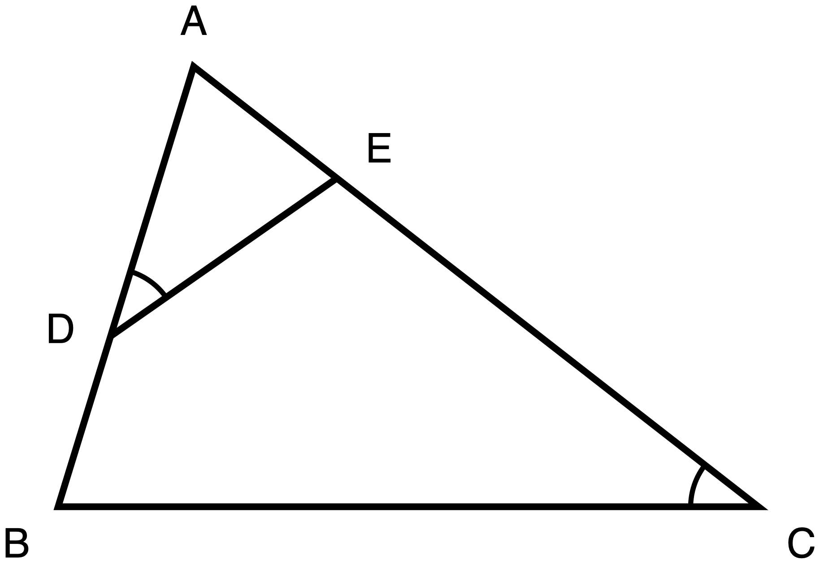
Figure 1. Triangle ABC with D on AB and E on AC, one arc at D matching one arc at C.
Description: Triangle ABC has vertex A at the top and side BC horizontal along the bottom, with B at the bottom left and C at the bottom right. D lies on side AB, low down and close to B. E lies on side AC, high up and close to A. Segment DE is drawn across the inside of the triangle and is clearly not parallel to BC. One arc marks angle ADE at D, and one arc marks angle ACB at C. No lengths are given anywhere.
In triangle ABC, D lies on side AB and E lies on side AC. The single arc at D and the single arc at C mark those two angles congruent: ∠ADE ≅ ∠ACB. Nothing else is marked, and no lengths are given.
Prove that two of the triangles in this figure are similar. Your proof must name the criterion you are using, and must justify every angle fact you claim.
Then write the similarity statement, putting the second triangle's letters in the order that matches the first triangle's.
△ A D E ~ △ ______ ______ ______
✋
Tools for this item: a calculator is permitted, though there is nothing to compute. A ruler or a protractor is not: you are proving this, not measuring it. No reference card. You may redraw the two triangles separately, in your own hand, on your own paper.

Record the proof in whichever one of these five formats suits you. All five earn the same credit:
- two-column, statements and reasons;
- a paragraph;
- a flowchart;
- spoken to your teacher, who will mark your sheet “oral”;
- an annotated diagram with your justifications numbered on it.
Your proof

Item 2
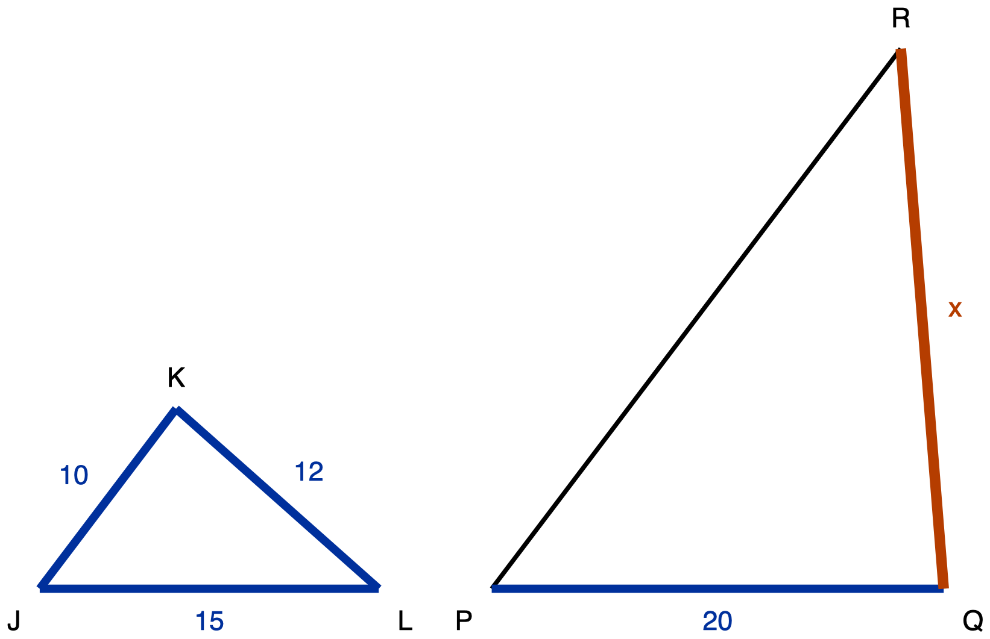
Figure 2. Triangles JKL and PQR, drawn in different orientations, with QR unknown.
Description: Two separate triangles stand side by side on the same horizontal baseline. On the left, triangle JKL is wide and low, with its longest side LJ lying along the baseline; JK is 10, KL is 12 and LJ is 15. On the right, triangle PQR is tall and narrow and is twice the size, with its shortest side PQ lying along the baseline; PQ is 20 and the side QR, from the bottom right vertex up to R, is the unknown quantity and is labelled x. The side RP carries no measure. No angles are marked in either triangle.
Triangle JKL is similar to triangle PQR, with the letters written in matching order:
△ J K L ~ △ P Q R
In triangle JKL, JK = 10, KL = 12 and LJ = 15. In triangle PQR, PQ = 20 and QR is unknown and labelled `x`. The two triangles are drawn in different positions on purpose.
(a) Write which side of triangle PQR pairs with each side of triangle JKL.
JK pairs with ______ KL pairs with ______ LJ pairs with ______
(b) Find x, the length of QR. Circle one.
A 16 B 22 C 24 D 30

✋
Tools for this item: a calculator is permitted. A ruler or a protractor is not: the figure is a drawing, not a measuring instrument. No table of corresponding sides. You may redraw either triangle in your own hand, in any position you like.

You may write your answers or say them to your teacher, who will record them.

Item 3
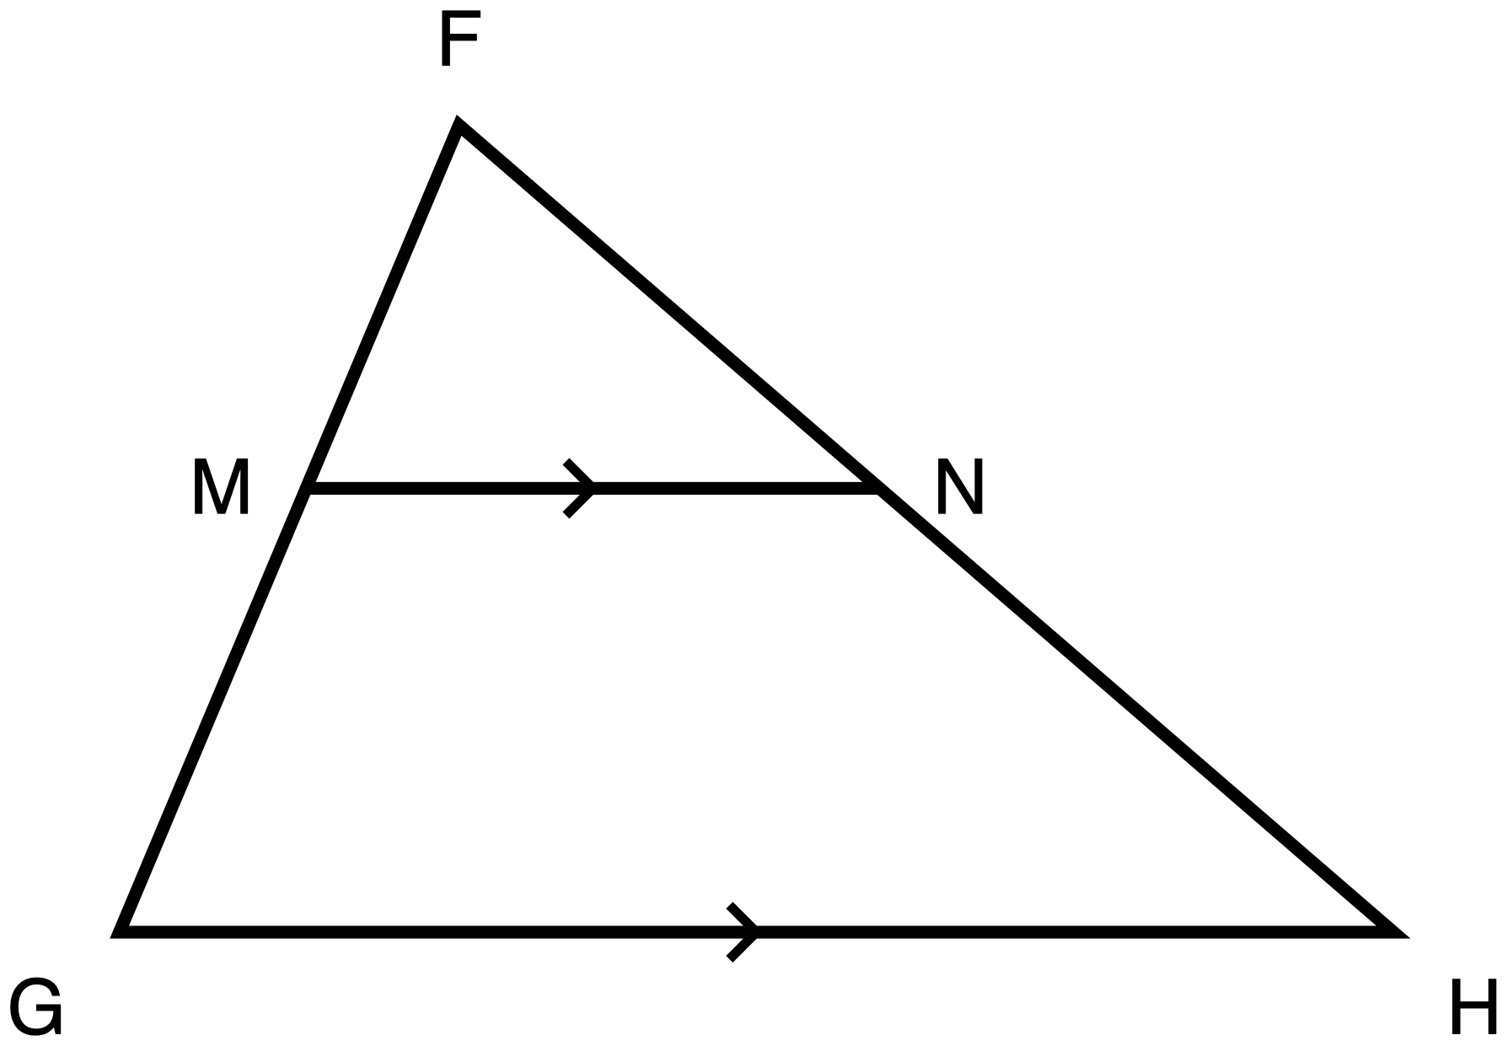
Figure 3. Triangle FGH with M on FG and N on FH, and MN marked parallel to GH.
Description: Triangle FGH has vertex F at the top and side GH horizontal along the bottom, with G at the bottom left and H at the bottom right. M lies on side FG and N lies on side FH, both a little under halfway down from F. Segment MN runs horizontally between them. A single chevron sits at the midpoint of MN and a matching single chevron sits at the midpoint of GH, marking those two segments parallel. No lengths are given and no angles are marked.
In triangle FGH, M lies on side FG and N lies on side FH. The matching single chevrons on MN and on GH tell you that MN is parallel to GH. No lengths are given.
Prove that FM/MG = FN/NH.
✋
Your proof must go through a similarity. Establish that two triangles in this figure are similar, then use the proportional sides that follow from it. A proof that never establishes a similarity does not satisfy this item, and this is stated here rather than held back for the marking.

✋
Tools for this item: a calculator is permitted, though there is nothing to compute. A ruler or a protractor is not. A card stating the AA similarity criterion is permitted. A card stating or proving the Triangle Proportionality Theorem is not: that theorem is what you are being asked to prove.

Record the proof in whichever one of these five formats suits you. All five earn the same credit: two-column; a paragraph; a flowchart; spoken to your teacher; an annotated diagram with short captions.
Your proof

Item 4
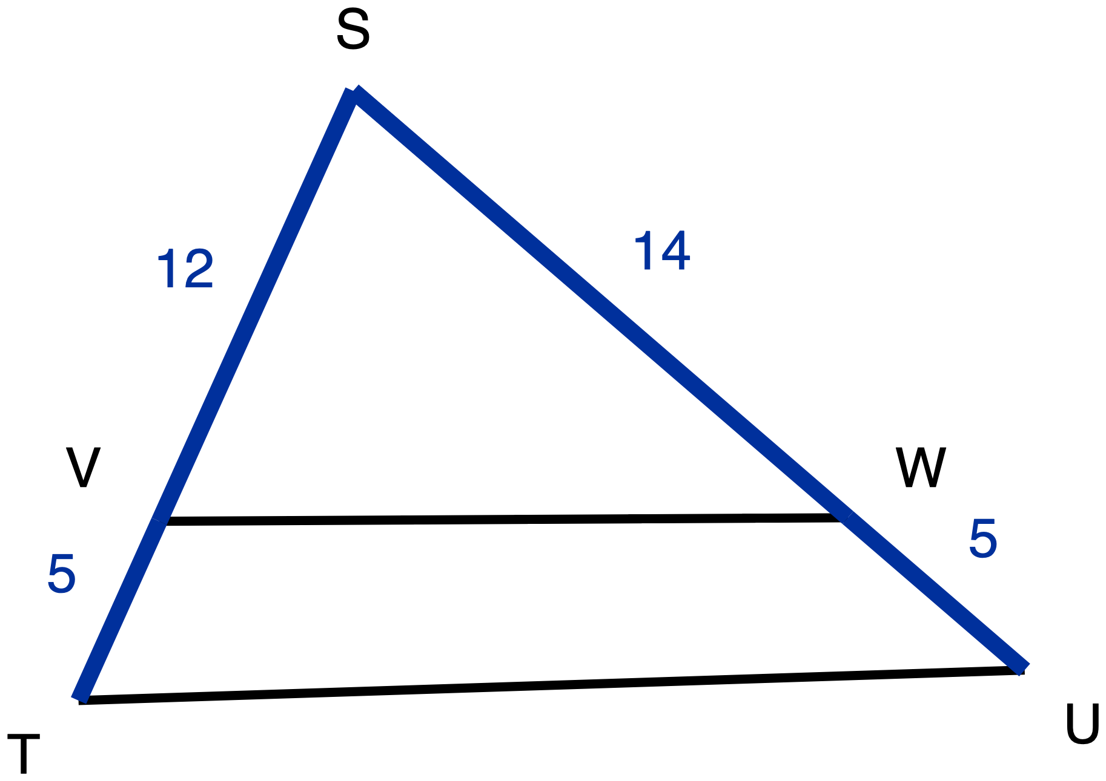
Figure 4. Triangle STU cut by segment VW, with SV, VT, SW and WU all given.
Description: Triangle STU has vertex S at the top, T at the bottom left and U at the bottom right. V lies on side ST and W lies on side SU, both roughly three quarters of the way down from S. Segment VW runs between them. On ST, SV is 12 and VT is 5. On SU, SW is 14 and WU is 5. No chevrons or other parallel marks appear anywhere in the figure, and no angles are marked.
In triangle STU, V lies on side ST and W lies on side SU.
SV = 12 VT = 5 SW = 14 WU = 5
Decide whether VW is parallel to TU. Show the comparison you used, and name the theorem that warrants your decision.
✋
Tools for this item: a calculator is permitted. A ruler or a protractor is not, and on this item that matters more than on the others: the figure is drawn to scale, but the question turns on a difference far too small for any measurement you could make on paper to settle. The drawing will not answer this for you. A card stating the AA similarity criterion or the Triangle Proportionality Theorem is permitted. A card stating the converse of that theorem is not.

Record your decision and your warrant in whichever one of these three formats suits you. All three earn the same credit:
- a written statement naming the theorem and showing both ratios;
- the two ratios written onto the figure, your decision circled, and the theorem named in a few words beside it;
- spoken to your teacher.
Your decision and your warrant

Item 5
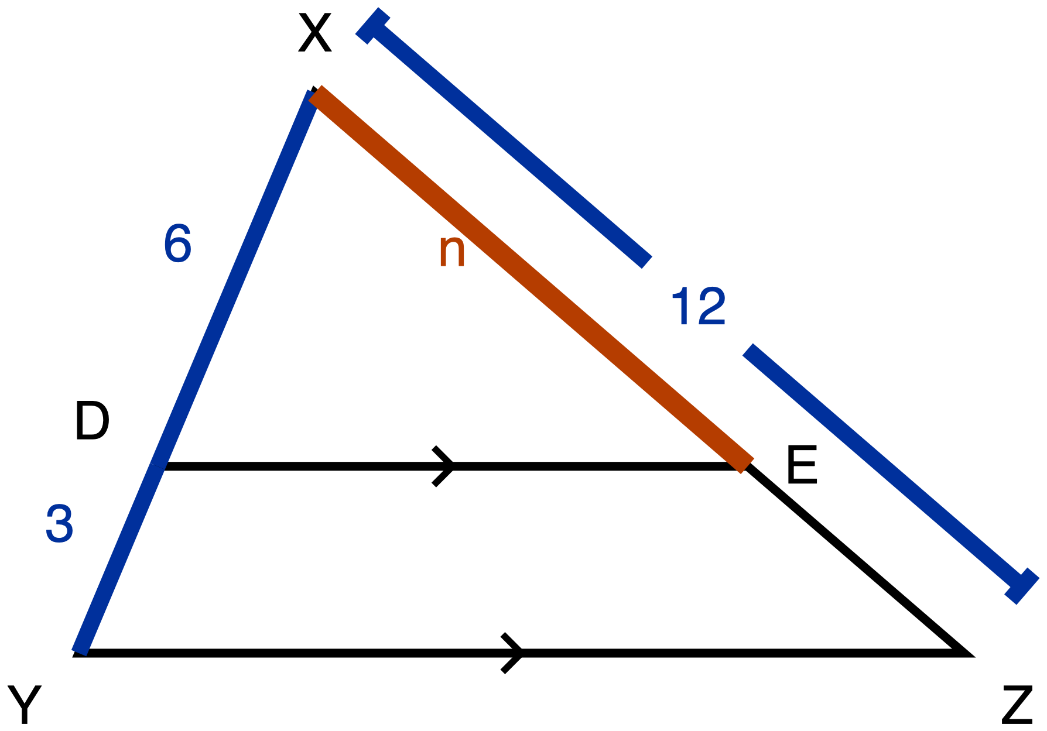
Figure 5. Triangle XYZ with DE parallel to YZ. XD, DY and XZ given, XE unknown.
Description: Triangle XYZ has vertex X at the top and side YZ horizontal along the bottom, with Y at the bottom left and Z at the bottom right. D lies on XY and E lies on XZ, and segment DE carries a single chevron matching the one on YZ, so DE is parallel to YZ. On side XY, XD is 6 and DY is 3. A dimension line running outside side XZ, broken at its centre for the numeral, gives the whole side XZ as 12. The segment from X to E is the heaviest line in the figure and is labelled n, the length being solved for.
In triangle XYZ, D lies on side XY and E lies on side XZ. The matching single chevrons on DE and on YZ tell you that DE is parallel to YZ.
XD = 6 DY = 3 XZ = 12 (the whole side)
Find XE. Then name the theorem that licenses your step, and write the proportion you used.
✋
A number on its own is not a complete answer. Both parts are required.

✋
Tools for this item: a calculator is permitted. A ruler or a protractor is not. A card stating the Triangle Proportionality Theorem, or printing XD/DY = XE/EZ, is not permitted: that statement is the warrant you are being asked to produce.

You may write your answer on this sheet or onto the figure, whichever suits you, or say it to your teacher or a scribe.
XE, the theorem, and the proportion you used

Item 6
✋
No figure is supplied for this item, and none will be. Read it yourself; it will not be read aloud. Turning the sentence into two triangles is the part of this item being assessed.

Drawing the situation is part of the answer, not a way of getting to it. Write every measurement on the object it belongs to before you write any equation. A correct number with no labelled drawing is an incomplete answer.
Problem: A tree is 8 m tall and casts a shadow 12 m long. At the same moment, a lamp post 6 m tall stands beside it. How long is the lamp post's shadow?
✋
Tools for this item: a calculator is permitted. Blank paper and a straight edge are permitted and are required. If you need the text in large print or in braille, ask: those give you the same words to work out for yourself. If you may produce your drawing with drawing software, by dictating it to someone who draws exactly what you say, or by arranging cut segment strips, any of those is a complete answer.

Your labelled drawing

Your proportion and your answer

Item 7
✋
No figure is supplied for this item, and none will be. Read it yourself; it will not be read aloud.

Drawing both beds is part of the answer. Write every measurement on the side it belongs to before you write any equation.
Problem: A landscaper is laying out two triangular flower beds. The first bed has sides of 12 m, 15 m and 9 m. A stake marks the corner where the 15 m side and the 9 m side meet. The second bed has two sides measuring 18 m and 30 m, and the corner where those two sides meet is the same size as the staked corner in the first bed. The second bed's third side has not been measured.
(a) Are the two beds similar? Show the ratios you tested, and name the criterion that decides it.
(b) Find the length of the second bed's third side.
✋
Tools for this item: a calculator is permitted. Blank paper and a straight edge are permitted and are required. No card printing the similarity criteria: part (a) asks you to name one. Large print or braille on request.

Your labelled drawing of both beds

(a) The ratios you tested, and the criterion

(b) The second bed's third side

Figure Descriptions

These descriptions are part of the quiz, not an extra. If you cannot see a drawing, you should be able to redraw it from what follows.

Legend, common to all five figures
- A number of arcs drawn at a vertex names a congruence class: angles carrying the same number of arcs are congruent to each other.
- A single chevron on two segments marks those segments parallel.
- Line weight carries role: the heaviest line is the unknown quantity, the next heaviest is a given measure, and the plain line is the figure's skeleton.

Figure 1
Type and orientation. One triangle, drawn in plain skeleton weight throughout, with a segment across its inside. No lengths anywhere.
Points. A is at the top, well to the left of centre. B is at the bottom left. C is at the bottom right, and B and C sit on the same horizontal line, so side BC is horizontal along the bottom. D lies on side AB, low down and closer to B than to A: it is about five eighths of the way from A down to B. E lies on side AC, high up and closer to A than to C: it is about a quarter of the way from A along to C.
Segments. AB runs from A down and slightly left to B. AC runs from A down and to the right to C, and is the longest side. BC is horizontal across the bottom. DE runs from D up and to the right to E, across the inside of the triangle. DE is visibly not parallel to BC, and it is not marked parallel to anything. No segment carries a measure and no segment is a given or an unknown; every line is skeleton.
Marked angles. One arc at D, in the angle between DA and DE, that is angle ADE. One arc at C, in the angle between CA and CB, that is angle ACB. There are no other marks anywhere in the figure, and no right angles.
What the marks encode. The single arc at D and the single arc at C are the same congruence class, so angle ADE is congruent to angle ACB. Nothing else is stated by the drawing.
The question the figure poses. Prove that two of the triangles in the figure are similar, naming the criterion, and state the correspondence the proof establishes.

Figure 2
Type and orientation. Two separate triangles, side by side, both sitting on the same horizontal baseline. Neither is a right triangle. The two are drawn to the same scale, and the right-hand one is twice the size of the left-hand one.
Left triangle, JKL. J is the bottom-left vertex, L is the bottom-right vertex, and K is above the baseline, a little left of centre. The triangle is wide and low. Segment LJ runs along the baseline and measures 15, a given measure; it is the longest side of this triangle. Segment JK runs up and to the right from J to K and measures 10, a given measure; it is the shortest side. Segment KL runs down and to the right from K to L and measures 12, a given measure. No angle is marked at any vertex.
Right triangle, PQR. P is the bottom-left vertex, Q is the bottom-right vertex, and R is high above the baseline and close to the right, almost directly above Q. The triangle is tall and narrow. Segment PQ runs along the baseline and measures 20, a given measure; it is the shortest side of this triangle. Segment QR runs from Q almost straight up to R; it is the unknown quantity, it is the heaviest line in the figure, and it is labelled `x`. Segment RP runs from R down and to the left to P; it is the longest side, it carries no measure, and it is drawn as plain skeleton. No angle is marked at any vertex.
What the marks encode. Nothing. There are no arcs, ticks or chevrons anywhere in this figure. The correspondence between the two triangles is stated only in the item's text, as △ J K L ~ △ P Q R, and the drawn positions of the two triangles deliberately do not agree with that letter order.
The question the figure poses. Which side of PQR pairs with each side of JKL, and what is `x`.

Figure 3
Type and orientation. One triangle with a segment cutting across it, drawn in plain skeleton weight throughout. No lengths anywhere.
Points. F is at the top, left of centre. G is at the bottom left and H is at the bottom right, on the same horizontal line, so side GH is horizontal along the bottom. M lies on side FG and N lies on side FH; both are a little under halfway down from F, and MN is horizontal.
Segments. FG runs from F down and to the left to G. FH runs from F down and to the right to H, and is the longest side. GH is horizontal across the bottom. MN is horizontal, running from M on the left to N on the right. No segment carries a measure; every line is skeleton.
Marked angles. None. There are no arcs anywhere in this figure, and no right angles.
What the marks encode. A single chevron sits at the midpoint of MN and a matching single chevron sits at the midpoint of GH. Those two chevrons are the same class and mark MN parallel to GH. There are no other marks. In particular, no corresponding angles are marked: identifying them is part of the proof.
The question the figure poses. Prove, through a similarity, that FM divided by MG equals FN divided by NH.

Figure 4
Type and orientation. One triangle with a segment cutting across it. Four of the segments carry given measures.
Points. S is at the top, left of centre. T is at the bottom left. U is at the bottom right and sits very slightly higher than T, so side TU is close to horizontal but not exactly. V lies on side ST, about three quarters of the way down from S. W lies on side SU, about three quarters of the way down from S.
Segments and their roles. On side ST: SV runs from S down to V and measures 12, a given measure; VT runs from V down to T and measures 5, a given measure. On side SU: SW runs from S down to W and measures 14, a given measure; WU runs from W down to U and measures 5, a given measure. VW runs from V across to W and carries no measure; it is plain skeleton. TU runs along the bottom from T to U and carries no measure; it is plain skeleton. There is no unknown quantity in this figure and no segment is drawn at the unknown weight.
Marked angles. None anywhere.
What the marks encode. Nothing. The figure carries no chevrons and no parallel marks of any kind. Whether VW is parallel to TU is the question, not a given. The drawing is to scale, but the question turns on a difference far too small for any measurement you could make on paper to settle.
The question the figure poses. Is VW parallel to TU, and what theorem warrants the answer.

Figure 5
Type and orientation. One triangle with a segment cutting across it parallel to the base, plus a dimension line running outside one side.
Points. X is at the top, left of centre. Y is at the bottom left and Z is at the bottom right, on the same horizontal line, so side YZ is horizontal along the bottom. D lies on side XY, two thirds of the way from X down to Y. E lies on side XZ, two thirds of the way from X along to Z. DE is horizontal.
Segments and their roles. On side XY: XD runs from X down to D and measures 6, a given measure; DY runs from D down to Y and measures 3, a given measure. DE runs from D across to E and carries no measure; it is plain skeleton. YZ runs along the bottom and carries no measure; it is plain skeleton. Side XZ is plain skeleton, and its whole length is given as 12 by a separate dimension line drawn parallel to XZ and offset outside the triangle, with a short cross-tick at each end and a break at its centre where the numeral 12 sits. The segment from X to E is the heaviest line in the figure: it is the unknown quantity and it is labelled `n`.
Marked angles. None anywhere.
What the marks encode. A single chevron sits at the midpoint of DE and a matching single chevron sits at the midpoint of YZ. Those two chevrons are the same class and mark DE parallel to YZ. There are no other marks.
The question the figure poses. Find XE, name the theorem that licenses the step, and write the proportion used.

Quiz 2: Ratios in Right Triangles

Name: ________________________________ Date: ____________
Seven questions. Answer every one. There is no choice of questions on this paper.
✋
Each question has its own two lines saying what you may use and what you may not use. They are not the same from question to question. Read both lines before you start each question.

1. Two triangles, one angle
You may use: a calculator, though there is nothing on this question to calculate.
You may not use: a printed table of sine, cosine or tangent values; a calculator's sin, cos or tan key; any app that gives a ratio from an angle; or a copy of the figure with side lengths written on it.
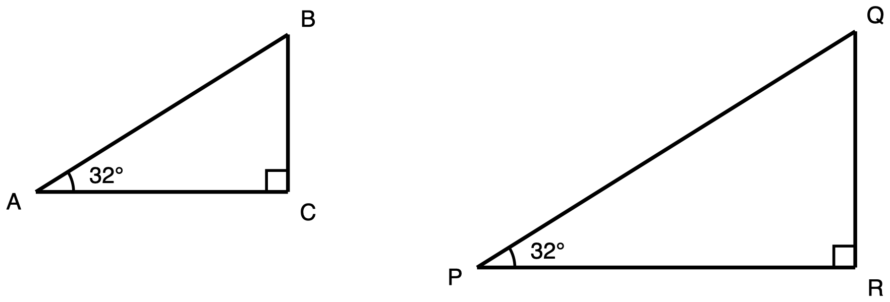
Figure 1. Two right triangles of different sizes, each with a 32° acute angle.
Description: Two separate right triangles drawn side by side, each with a horizontal bottom side and a vertical right-hand side. The second is visibly larger than the first, about half as tall again and half as wide again. In the first triangle, A is at the lower left, C is at the lower right level with A, and B is directly above C. Side AC runs horizontally from A to C, side CB runs vertically from C up to B, and side AB runs from A up and to the right to B and is the longest of the three. No side carries a length and no side is marked as unknown. The angle at C, between CA and CB, is a right angle marked with a small square. The acute angle at A, between AC and AB, carries one arc and is labelled 32 degrees. The second triangle is arranged the same way: P at the lower left, R at the lower right level with P, Q directly above R, with PR horizontal, RQ vertical, and PQ running from P up to the right to Q as the longest side. No side carries a length. The angle at R is a right angle marked with a small square, and the acute angle at P, between PR and PQ, carries one arc and is labelled 32 degrees. The two 32 degree angles carry one arc each.
Triangle ABC has its right angle at C and a 32° angle at A. Triangle PQR has its right angle at R and a 32° angle at P. Triangle PQR is larger than triangle ABC.
No side lengths are given for either triangle, and none are needed.
Explain why BC ÷ AB and QR ÷ PQ must be the same number.
Saying that the two quotients are equal is not an explanation. Give the reason.

2. What moves when the triangle grows
You may use: a calculator, though nothing here needs one.
You may not use: a printed table of sine, cosine or tangent values; a calculator's sin, cos or tan key; or any app that gives a ratio from an angle.
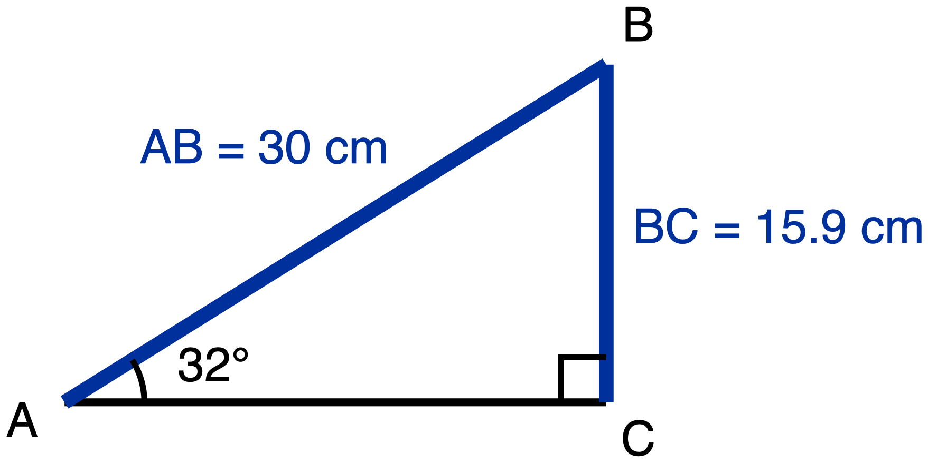
Figure 2. Right triangle ABC, right angle at C, 32° angle at A, hypotenuse 30 cm.
Description: One right triangle with a horizontal bottom side and a vertical right-hand side. A is at the lower left, C is at the lower right level with A, and B is directly above C. Leg AC runs horizontally from A to C and carries no measure. Leg CB runs vertically from C up to B and is given as 15.9 cm. Side AB runs from A up and to the right to B, is the hypotenuse, and is given as 30 cm. Nothing in the figure is marked as unknown. The angle at C, between CA and CB, is a right angle marked with a small square. The acute angle at A, between AC and AB, carries one arc and is labelled 32 degrees. BC is the side opposite that 32 degree angle.
Triangle ABC has its right angle at C and a 32° angle at A. The hypotenuse AB is 30 cm and BC, the side opposite the 32° angle, is 15.9 cm.
Triangle ABC is now enlarged by a scale factor of 3. The enlarged triangle still has a 32° angle. Write s for the length of the side opposite the 32° angle in the enlarged triangle, and h for the length of its hypotenuse.
Determine which statement about the enlarged triangle is true. Circle one letter.
- A. s is three times BC, and s ÷ h is three times BC ÷ AB.
- B. s is three times BC, and s ÷ h is equal to BC ÷ AB.
- C. s is the same length as BC, and s ÷ h is equal to BC ÷ AB.
- D. s is three times BC, and s ÷ h cannot be found unless the enlarged triangle is measured.

3. The same triangle, from each of its acute angles
You may use: a calculator; a tracing-paper copy of the triangle that you may turn around. Answers may be left as fractions.
You may not use: a copy of this triangle with the legs already labelled “opposite” and “adjacent” for either angle; a card stating a rule for deciding which leg is which; a printed table of sine, cosine or tangent values.
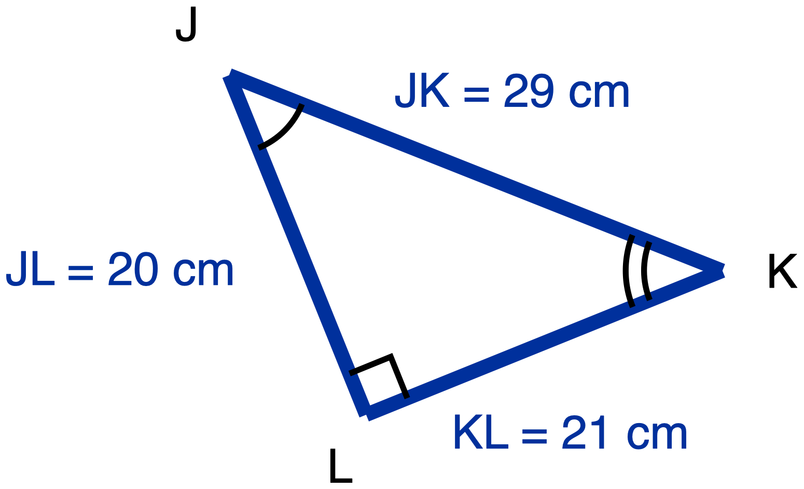
Figure 3. Right triangle JKL drawn tilted, right angle at L, sides 20 cm, 21 cm and 29 cm.
Description: One right triangle drawn tilted so that no side is horizontal or vertical. J is at the upper left and is the highest of the three vertices. K is at the right, lower than J. L is at the bottom, below and to the right of J. Leg JL runs from J down and slightly right to L and is given as 20 cm. Leg KL runs from L up and to the right to K and is given as 21 cm. Side JK runs from J down and to the right to K, is the longest of the three, and is given as 29 cm. All three lengths are given and nothing is marked as unknown. The angle at L, between LJ and LK, is a right angle marked with a small square. The acute angle at J, between JL and JK, carries one arc. The acute angle at K, between KL and KJ, carries two concentric arcs. The arc counts are present only to tell the two acute angles apart so they can be referred to unambiguously; they do not claim that any angles are congruent.
Triangle JKL has its right angle at L. JL = 20 cm, KL = 21 cm and JK = 29 cm.
(a) Relative to angle J:
- the opposite leg is: ____________
- the adjacent leg is: ____________
- tan J = ____________
(b) Relative to angle K:
- the opposite leg is: ____________
- the adjacent leg is: ____________
- tan K = ____________
(c) In one sentence, how did you decide which leg is the opposite leg in part (b)?

4. A number with no triangle beside it
You may use: a calculator, though there is nothing here to calculate.
You may not use: a printed table of sine, cosine or tangent values; a calculator's sin, cos or tan key; any app that gives a ratio from an angle; or any triangle you have drawn for another question on this paper.
✋
There is no figure for this question. You are not missing one.

In class the line sin 32° = 0.53 was written on the board. No triangle was drawn beside it, and none was named.
Explain why writing a single number for sin 32°, with no triangle named, is legitimate. Circle one letter.
- A. Because every right triangle with a 32° angle is similar to every other one, so (side opposite the 32° angle) ÷ (hypotenuse) is the same in all of them.
- B. Because the triangles measured in class happened to give quotients that came out close to each other.
- C. It is not legitimate. sin 32° cannot be written as a single number until the side lengths of one particular right triangle are known.
- D. Because 0.53 is the value for a medium-sized right triangle. A larger right triangle with a 32° angle gives a larger value, and a smaller one gives a smaller value.

5. Using a ratio you have been given

You may use: a calculator; a printed ratio table or ratio card if you want one. You are not being asked to remember a ratio on this question, so a table cannot help you and will not be marked down.
You may not use: a copy of this triangle with the legs already labelled “opposite” and “adjacent” relative to the 40° angle; a worked example of the same question with different numbers.
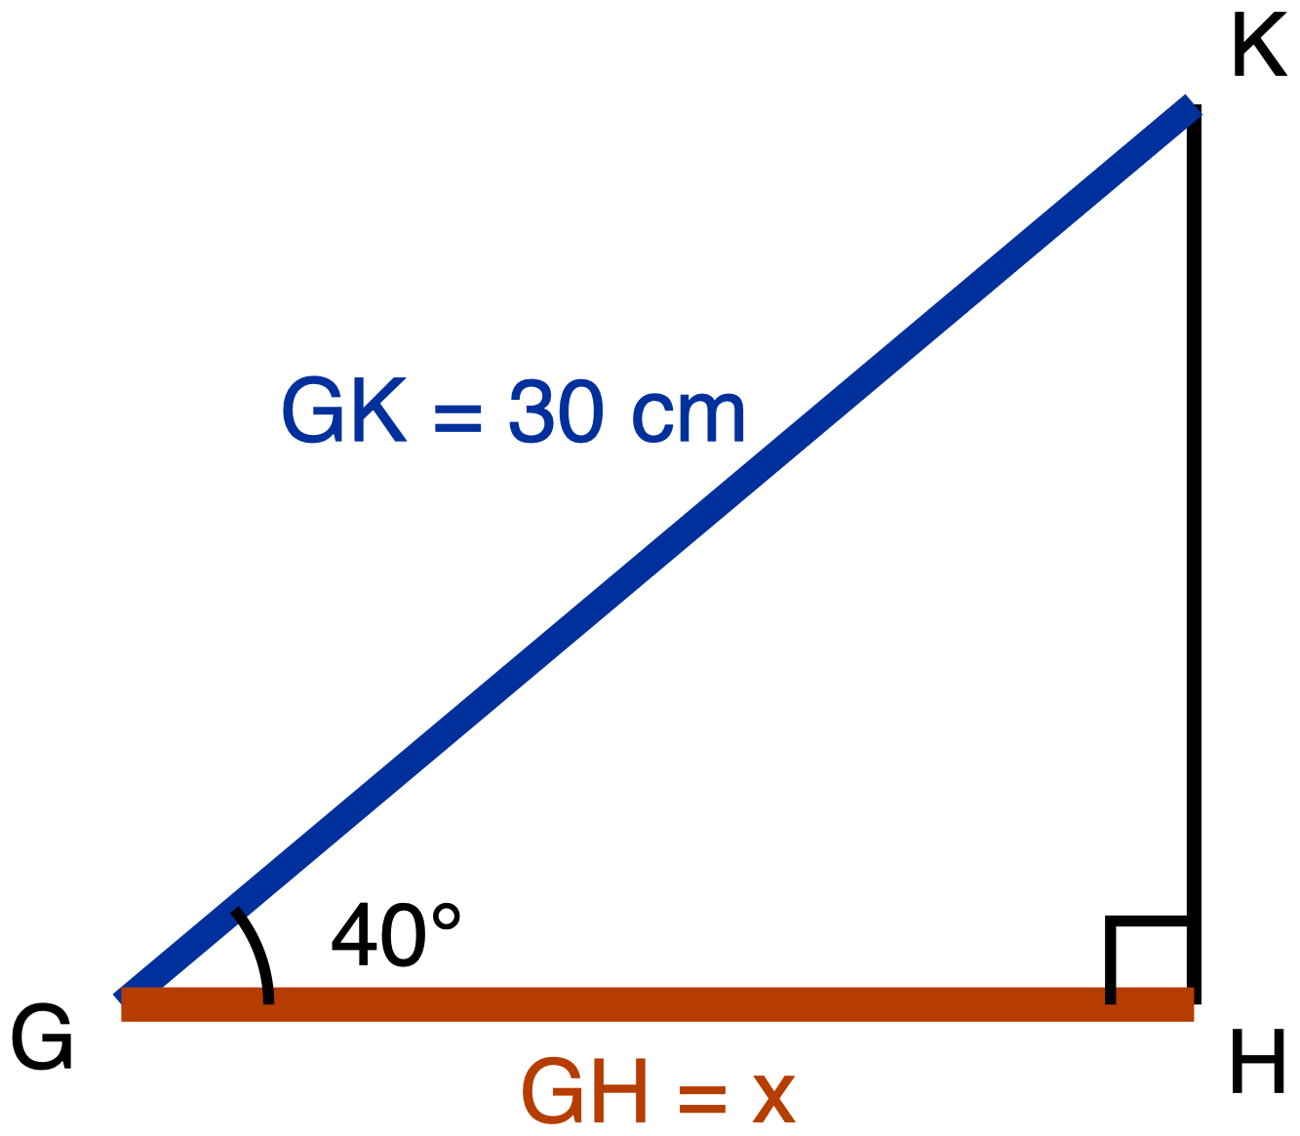
Figure 4. Right triangle GHK, right angle at H, 40° angle at G, hypotenuse 30 cm, leg GH marked x.
Description: One right triangle with a horizontal bottom side and a vertical right-hand side. G is at the lower left, H is at the lower right level with G, and K is directly above H. Leg GH runs horizontally from G to H, is the unknown, and is labelled x; it is drawn as the heaviest line in the figure. Leg HK runs vertically from H up to K and carries no measure. Side GK runs from G up and to the right to K, is the hypotenuse, and is given as 30 cm. The angle at H, between HG and HK, is a right angle marked with a small square. The acute angle at G, between GH and GK, carries one arc and is labelled 40 degrees. GH is the leg adjacent to that 40 degree angle; HK is the leg opposite it.
For a 40° acute angle in a right triangle:
✋
(side adjacent) ÷ (hypotenuse) = 0.77 and (side opposite) ÷ (hypotenuse) = 0.64. In the names given in class, cos 40° = 0.77 and sin 40° = 0.64. Both values are printed here for you.

Triangle GHK has its right angle at H and a 40° angle at G. The hypotenuse GK is 30 cm. The leg GH is marked x.
Use the values above to find x, to the nearest tenth of a centimetre. Circle one letter.
- A. x = 19.2 cm
- B. x = 23.1 cm
- C. x = 39.0 cm
- D. x cannot be found. The values 0.77 and 0.64 came from a different right triangle.

6. Carrying a ratio to a bigger triangle
You may use: a calculator; a printed ratio table or ratio card if you want one, though no angle on this question is given in degrees, so a table has nothing in it to look up.
You may not use: the scale factor between the two triangles, if someone offers it; a statement that the two triangles are similar; a worked example of the same two triangles with different numbers.
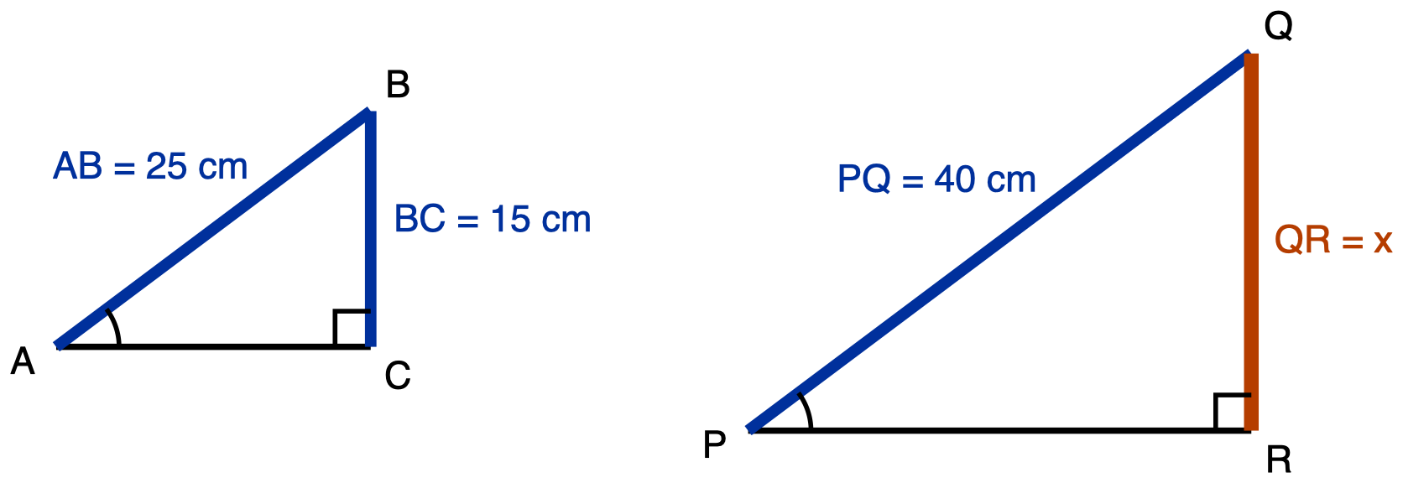
Figure 5. Two right triangles whose marked acute angles are equal, the second larger.
Description: Two separate right triangles drawn side by side, each with a horizontal bottom side and a vertical right-hand side; the second is visibly larger than the first. In the first triangle, A is at the lower left, C is at the lower right level with A, and B is directly above C. Leg AC runs horizontally from A to C and carries no measure. Leg CB runs vertically from C up to B and is given as 15 cm. Side AB runs from A up and to the right to B, is the hypotenuse, and is given as 25 cm. The angle at C is a right angle marked with a small square. The acute angle at A, between AC and AB, carries one arc and no degree measure. BC is the side opposite that marked angle. In the second triangle, P is at the lower left, R is at the lower right level with P, and Q is directly above R. Leg PR runs horizontally from P to R and carries no measure. Leg RQ runs vertically from R up to Q, is the unknown, and is labelled x; it is drawn as the heaviest line in the figure. Side PQ runs from P up and to the right to Q, is the hypotenuse, and is given as 40 cm. The angle at R is a right angle marked with a small square. The acute angle at P, between PR and PQ, carries one arc and no degree measure. QR is the side opposite that marked angle. The angle at A and the angle at P each carry exactly one arc, and that matching arc count is the only place in the drawing where the equality of the two angles is recorded.
Triangles ABC and PQR are both right triangles. The right angle in ABC is at C; the right angle in PQR is at R. The angle at A and the angle at P are equal. Each carries one arc in the figure, which is what states that equality.
In triangle ABC the hypotenuse AB is 25 cm, and BC, the side opposite the marked angle, is 15 cm. In triangle PQR the hypotenuse PQ is 40 cm, and QR, the side opposite the marked angle, is marked x.
Find x. Circle one letter.
- A. x = 24 cm
- B. x = 30 cm
- C. x = 66.7 cm
- D. x cannot be found unless triangle PQR is measured.

7. Finding the third side first
You may use: a calculator; a card printing a² + b² = c². You are being asked to use the Pythagorean Theorem here, not to prove it, so the card will not be marked down. Answers to (b) may be a fraction or a decimal.
You may not use: a copy of this triangle with the legs already labelled “opposite” and “adjacent” relative to angle D; a worked example of the same two steps with different numbers.
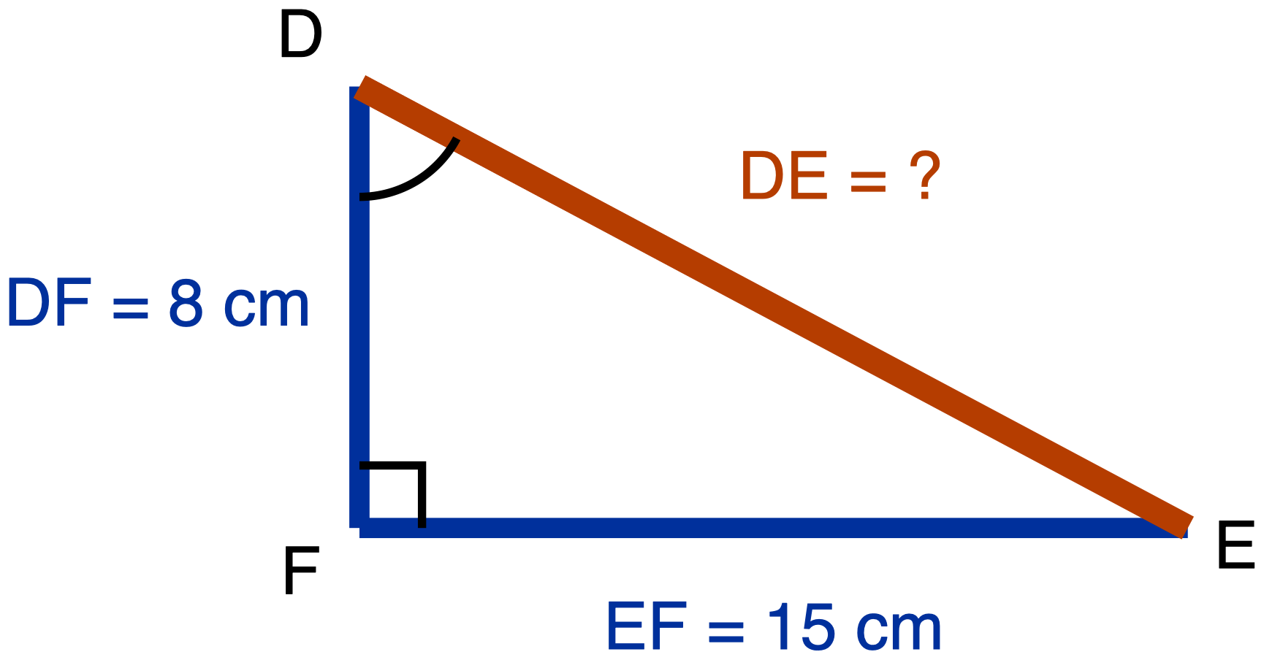
Figure 6. Right triangle DEF, right angle at F, legs 8 cm and 15 cm, hypotenuse unknown.
Description: One right triangle. D is at the upper left, F is directly below D at the lower left, and E is at the lower right level with F. Leg DF runs vertically from D down to F and is given as 8 cm. Leg EF runs horizontally from F to the right to E and is given as 15 cm. Side DE runs from D down and to the right to E, is the hypotenuse, is the unknown, and is labelled with a question mark; it is drawn as the heaviest line in the figure. The angle at F, between FD and FE, is a right angle marked with a small square. The acute angle at D, between DF and DE, carries one arc and no degree measure. Relative to angle D, EF is the opposite leg and DF is the adjacent leg.
Triangle DEF has its right angle at F. DF = 8 cm and EF = 15 cm. The hypotenuse DE is not given.
(a) Find DE. Write the equation you used as well as the answer.

DE = ____________ cm
(b) Write sin D as a ratio of two sides of this triangle.
sin D = ____________
✋
Part (b) is marked using your own answer to part (a). A wrong answer in (a) costs you one mark, not two.

Quiz 3. Special Triangles and Complements

Quiz 3. Special Triangles and Complements
Name: ______________________________ Date: __________________

How this quiz is issued
Read this before you start. It is not a rule about the quiz; it is a description of how the paper reaches you.
This quiz comes in three parts, and each part is collected before the next one is handed out.
Part | Items | What is on your desk
A | 1, 2 | Blank paper, tracing paper and scissors if you want them. No reference card.
B | 3, 4 | The special-triangle reference card, handed out at the start of Part B.
C | 5 to 9 | The reference card is collected before Part C is handed out.

Every item states its own tools, on the item. They are not the same on every item: the reference card is denied on items 1 and 2, allowed on items 3 and 4, and collected before item 5. The calculator ruling changes five times as you go down the quiz. Read the tools line every time. There is no quiz-wide tools rule.
✋
No formula sheet, identity card or cofunction reference is issued or displayed anywhere on this quiz, on any item, in either part of a question.

Every item on this quiz is required. There is nothing to choose between.

Part A. Deriving the two ratios

Part A. Deriving the two ratios
No reference card. Blank paper, tracing paper, scissors and a straightedge are yours.

Item 1. Half a square
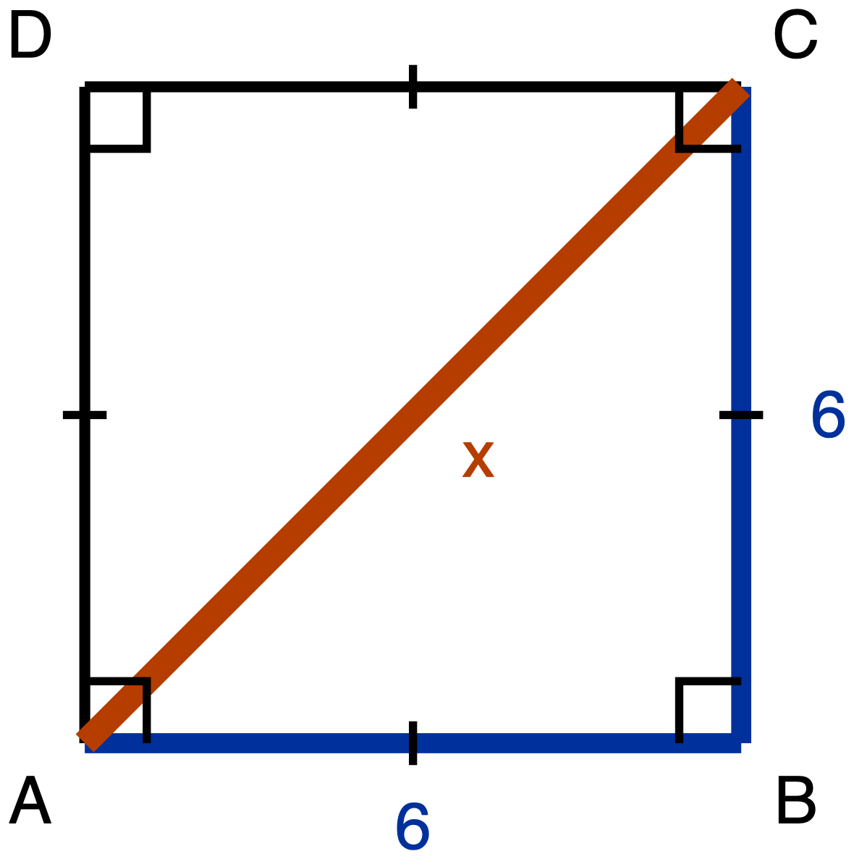
Figure 1. Item 1. Square ABCD of side 6, with the diagonal AC drawn.
Description: A square ABCD drawn with its sides vertical and horizontal. A is the bottom left corner, B is the bottom right corner, C is directly above B at the top right, and D is directly above A at the top left. The diagonal AC is drawn from the bottom left corner up to the top right corner; its length is unknown and it is labelled x. Side AB along the bottom is labelled 6 and side BC up the right is labelled 6; sides CD and DA are drawn as plain lines and carry no numeral. A single congruence tick sits at the midpoint of each of the four sides, so all four sides are marked congruent to one another. A right-angle square sits at each of the four corners A, B, C and D, and the diagonal passes through the corner of the right-angle mark at A and again through the one at C, so each of those two right angles is drawn split by the diagonal. There are no angle arcs anywhere in the figure, and nothing marks the two parts of a split corner angle as congruent to each other.
Square ABCD has side length 6, and its diagonal AC is drawn.
(a) Derive the three angle measures and the three side lengths of triangle ABC. Give the side lengths in exact form, which means a radical where one is needed and not a decimal approximation.
(b) Write the ratio AB : BC : AC in simplest form.
The route this item requires is the square's own diagonal. Your argument has to say what the square tells you about angle ABC and about the lengths AB and BC, and it has to use the Pythagorean Theorem to get AC. Writing down "45-45-90" and "1 : 1 : √2" from memory is not an answer to this item, because what is being asked for is where those values come from. You are told this before you start.
Record your derivation in whichever one of these you prefer:
- an annotated diagram, with the angle measures and the algebra written on the figure
- a paragraph
- a two-column statement and reason chain
- a flowchart
- an oral walkthrough at the figure, which I will write down word for word as you give it
Tools for this item: No calculator. No special-triangle reference card. No formula sheet or identity card of any kind, here or anywhere on this quiz. Straightedge, blank paper, tracing paper and scissors are yours, and redrawing triangle ABC on its own, away from the square, is a good first move.
Item 1 (a) and (b). Show your derivation

Item 2. Half an equilateral triangle
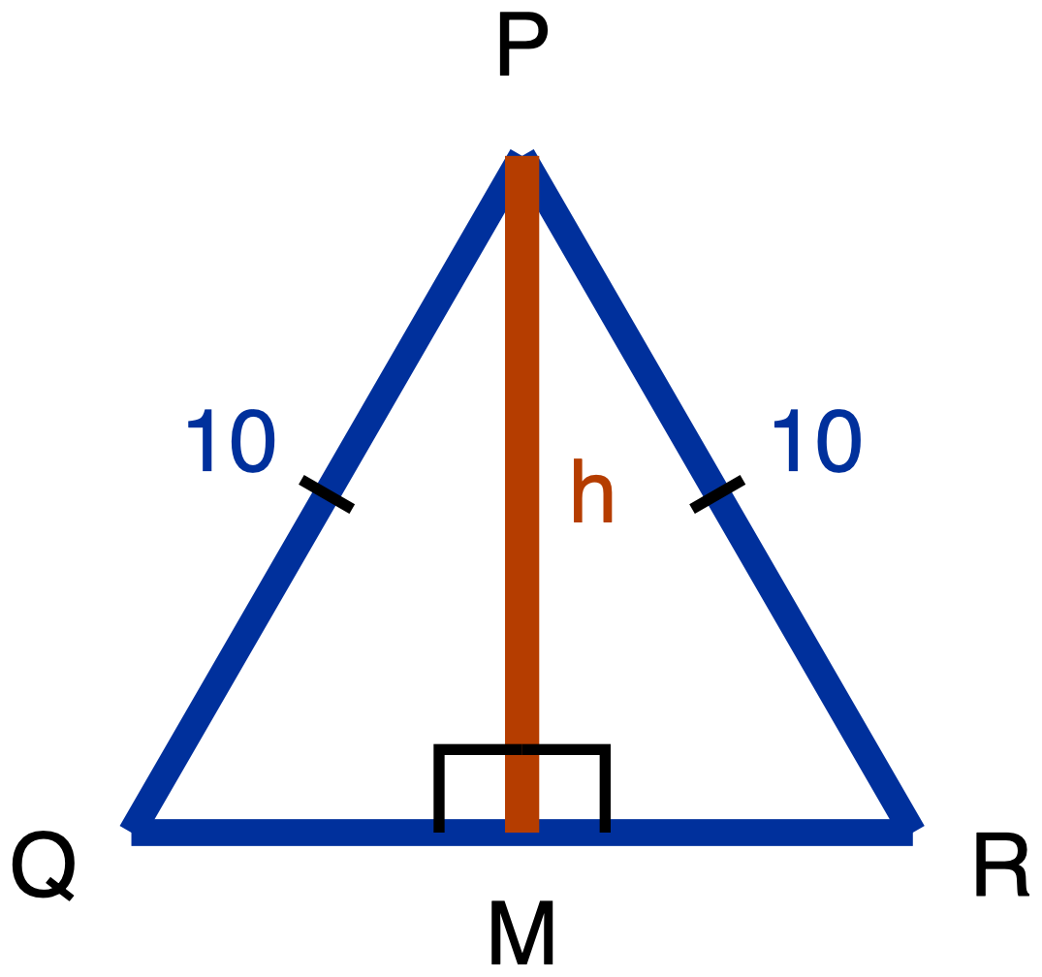
Figure 2. Item 2. Equilateral triangle PQR of side 10, with the altitude from P meeting QR at M.
Description: A triangle PQR drawn point up with its base horizontal along the bottom. P is the apex at the top, centred; Q is the bottom left vertex; R is the bottom right vertex. M lies on QR and is the point where a vertical segment from P meets the base. PQ, the left slant side, is labelled 10, and PR, the right slant side, is labelled 10; each of those two sides carries a single congruence tick, marking them congruent to each other. The base QR carries no numeral and no tick. The segment PM runs from P straight down to M; it is the unknown and is labelled h. Two right-angle squares sit at M, one on each side of PM, marking angle PMQ and angle PMR as right angles. There is no angle arc at P, at Q or at R. M is drawn at the centre of QR, but nothing in the figure's marks asserts that it is the midpoint.
Equilateral triangle PQR has side length 10. The altitude from P meets QR at M.
(a) Derive the three angle measures and the three side lengths of triangle PQM. Give the side lengths in exact form.
(b) Write the ratio QM : PM : PQ in simplest form.
(c) In your simplified ratio, one of the two larger numbers is the hypotenuse's. Say which one, and state in one sentence how you know, without using a calculator.
The route this item requires is the equilateral triangle's altitude. Before any arithmetic, your argument has to answer both of these:
- What does the altitude do to angle P?
- What does the altitude do to side QR?
Nothing on the figure tells you where M sits along QR. That is something to establish, not something given. Then use the Pythagorean Theorem to get PM.
Same five ways of recording your derivation as Item 1. Part (c) may be a sentence, a written comparison of the two numbers, or said aloud to me.
Tools for this item: No calculator. No special-triangle reference card. No formula sheet or identity card of any kind. Straightedge, blank paper, tracing paper and scissors are yours.
Item 2 (a) and (b). Show your derivation

Item 2 (c). Which value is the hypotenuse's, and how you know

Hand Part A in before you take Part B.

Part B. Using the two ratios

Part B. Using the two ratios
The special-triangle reference card is on your desk for both of these items, and you may use it. It is collected at the end of Part B.

Item 3. A 30-60-90 triangle
A 30-60-90 triangle has shorter leg 8.
Which pair gives its hypotenuse and its longer leg, both in exact form? Exact form means a radical where one is needed, not a decimal approximation. Choose one.
- A. hypotenuse 16, longer leg 8√3
- B. hypotenuse 8√3, longer leg 16
- C. hypotenuse 16, longer leg 8√2
- D. hypotenuse 16, longer leg 13.86
Write the letter, circle it, point at it, or say it to me.
Tools for this item: The special-triangle reference card is allowed. No calculator. No formula sheet or identity card of any kind.
Item 3. Your letter

Item 4. Two triangles, two directions
(a) A 45-45-90 triangle has legs of length 9. Give its hypotenuse in exact form.
(b) A 30-60-90 triangle has hypotenuse 22. Give its shorter leg and its longer leg, both in exact form.
Write your answers, write them onto a blank triangle outline if you would rather (ask and I will give you one), or say them to me and I will write them down.
Tools for this item: The reference card is allowed. No calculator. No formula sheet or identity card of any kind. The card gives you the two ratios; deciding which ratio each part needs, and which direction to run it, is yours.
Item 4 (a)

Item 4 (b)

Hand Part B in, and hand the reference card back, before you take Part C.

Part C. Sine, cosine, and complements

Part C. Sine, cosine, and complements
The special-triangle reference card has been collected. There is no formula sheet and no identity card on this quiz.

Item 5. Which side does the work
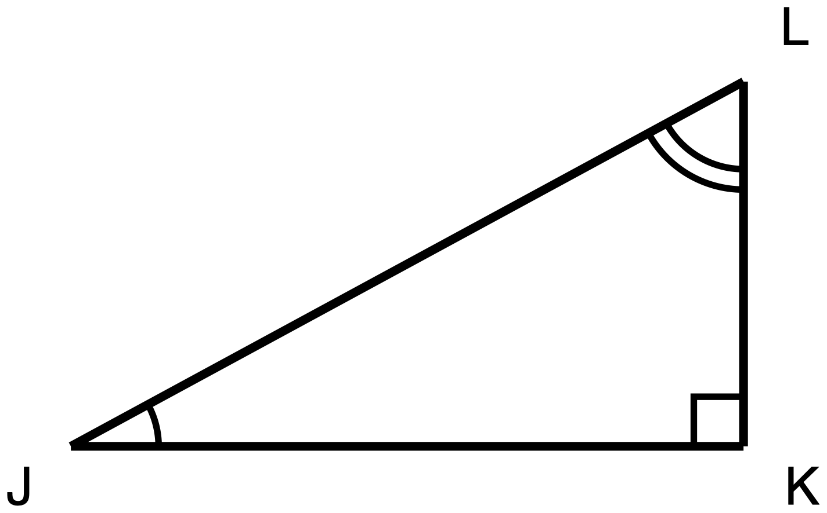
Figure 3. Item 5. Right triangle JKL, right angle at K, no measures given.
Description: A right triangle JKL with one leg horizontal along the bottom and one leg vertical on the right. J is the bottom left corner, K is the bottom right corner and holds the right angle, and L is directly above K and is the highest point. JK is the horizontal bottom leg, KL is the vertical right leg, and JL runs from the bottom left corner up to the top right corner and is the hypotenuse. No side length and no angle measure is printed anywhere in the figure, and all three sides are drawn at the same plain weight. The right angle at K carries a small square, the angle at J carries a single arc, and the angle at L carries two concentric arcs, so the differing arc counts mark J and L as two different angles rather than a congruent pair. No two segments and no two angles are marked congruent.
Right triangle JKL has its right angle at K.
(a) Name the one side of this triangle that is opposite angle J and is also adjacent to angle L. Then say in one sentence why a single side can play both of those roles.
(b) Use your answer to (a) to explain why sin J = cos L. Write each of them as a fraction of two named sides.
(c) Trey says the answer to (b) is really that sin J = cos K, because K is the other angle named in the triangle. Give one reason Trey's equation cannot be right.
Answer in writing, by annotating a second copy of the figure (ask and I will give you one), or out loud to me, and I will write it down word for word.
Tools for this item: A calculator is allowed, and there is not a single number in this item. No table of sine and cosine values. No formula sheet or identity card.
Item 5 (a)

Item 5 (b)

Item 5 (c)

Item 6. Which equation is always true
In right triangle DEF, the right angle is at E.
Which one of these is true for every triangle of that kind? Choose one.
- A. sin D = cos E
- B. sin D = cos F
- C. sin D = sin F
- D. tan D = tan F
Write the letter, circle it, point at it, or say it to me. If it helps, ask me for a blank right-triangle outline with D, E and F already lettered on it.
Tools for this item: No calculator with sine, cosine or tangent keys. A four-function calculator is allowed. No table of sine and cosine values. No formula sheet or identity card.
Item 6. Your letter

Item 7. Solving for x
For some value of x, sin(4x + 10)° = cos(2x + 20)°, and both (4x + 10)° and (2x + 20)° are acute angles.
(a) Write one sentence saying how those two angle measures are related to each other. Then write the equation that sentence gives you.
(b) Solve your equation for x.
(c) Give both angle measures, and check that both of them are acute.
Part (a) is required and is not a warm-up: the equation has to come from a stated fact about the two angles, not from a remembered template. You may dictate your sentence and your equation and I will write them down.
Tools for this item: A four-function or scientific calculator is allowed for the arithmetic. No graphing calculator and no equation solver. No table of sine and cosine values. No formula sheet or identity card.
Item 7 (a). Your sentence, then your equation

Item 7 (b). Solve for x

Item 7 (c). Both angle measures, and the acute check

Part C, continued

Part C, continued

Item 8. Solving for y
Solve for y:
✋
sin 40° = cos(y + 15°), where (y + 15)° is an acute angle.

Before you write any equation, write down in words the step where you use the relationship between sine and cosine. Then solve, and check that (y + 15)° really is acute.
Tools for this item: No calculator with sine, cosine or inverse keys. A four-function calculator is allowed; the arithmetic here is 90 − 40 and then 50 − 15. No table of sine and cosine values. No formula sheet or identity card.
Item 8. The step in words, then your solution and your check

Item 9. From one angle to its partner
In a right triangle, one acute angle measures 30°, and sin 30° = 1/2.
(a) Name the other acute angle of that triangle.
(b) Give the value of the cosine of the angle you named in (a), without computing any ratio from any triangle, and say in one sentence how you know.
That restriction in (b) is the point of the item: the route being measured is the relationship between an angle and its complement, not a second trip through opposite over hypotenuse.
Answer in writing, out loud to me, or by writing the two angle measures and the cosine value onto a blank triangle outline with one phrase giving your reason. Ask if you want the outline.
Tools for this item: No calculator. No table of sine and cosine values. No formula sheet or identity card. The special-triangle reference card was collected at the end of Part B.
Item 9 (a)

Item 9 (b). The value, and how you know

Hand Part C in when you are finished.

Final Exam · How this exam is issued

Final Exam · Similarity to Right-Triangle Trigonometry. Twenty-eight items, in three parts.
Read this page before you start. It is not a rule about the mathematics; it is a description of how the paper reaches you.
This exam comes in three parts, and each part is collected before the next one is handed out.
Part | Items | How the paper reaches you
A | 1 to 15 | Handed out first. Collected before Part B is handed out.
B | 16 to 23 | Handed out once Part A has been collected. Collected before Part C is handed out.
C | 24 to 28 | Handed out once Part B has been collected.

That table is about paper, not about tools. It gives you nothing and it takes nothing away.
✋
Every item states its own tools, on the item, and the item's own line is the only tools ruling on this paper. They are not the same on every item: a thing one item hands you is a thing the next item refuses, and that is deliberate. The calculator ruling changes eleven times as you go down the paper, and the special-triangle reference card is refused, then allowed, then refused again, item by item. Nothing outside an item gives you a tool: not this page, not a part heading, not the item before. Read the tools line on the item you are working, every time.

No formula sheet, identity card, cofunction reference or wall display printing the relationship between sine and cosine is issued or shown anywhere on this exam, on any item, in any part. That is the one sentence on this page that rules on a tool; it is a refusal and never a permission, and all twenty-eight items repeat it on their own tools lines.
Every item on this exam is required. There is nothing to choose between. Where an item offers you several ways to write your answer down, that is a choice about how to record one required answer, not a choice about which questions to attempt.
Extended time is available on every item on this paper, because no item here is measuring how fast you work.

Part A · Similarity, proof, the invariant ratio, and the two special triangles

Fifteen items. Each one states its own tools, and this line rules on none of them.

Item 1 · The same two triangles, turned
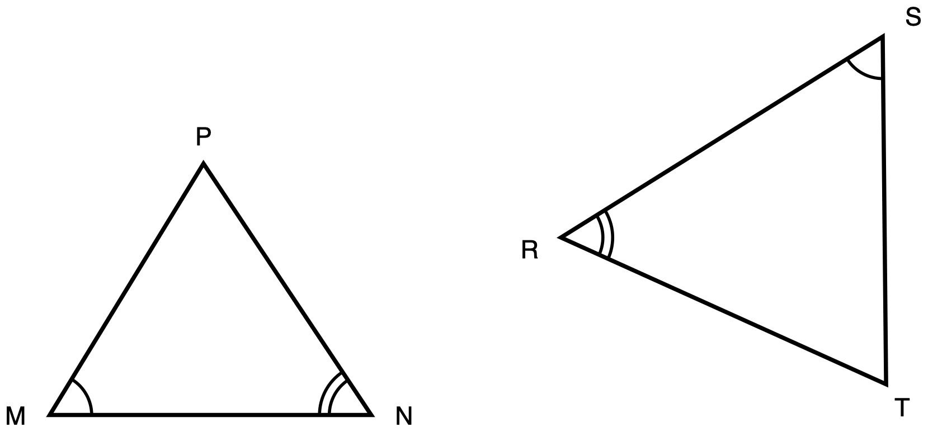
Figure 1. Triangles MNP and SRT, drawn in different orientations.
Description: Triangle MNP sits on the left with side MN horizontal along the bottom and vertex P above it. Triangle SRT sits on the right, larger and turned so that no side of it is horizontal. Angle M and angle S each carry one arc. Angle N and angle R each carry two concentric arcs. No side length is given anywhere and nothing is marked as unknown.
Triangle MNP and triangle SRT are drawn in different orientations. Angle M and angle S each carry one arc, so those two angles are congruent. Angle N and angle R each carry two arcs, so those two are congruent as well.
(a) Write the similarity statement for these two triangles, with the vertices in corresponding order.
(b) Prove that the two triangles are similar. Name the criterion you used and say why it applies here.
(c) Name the side of triangle SRT that corresponds to MN.
Take your correspondence from the arcs, not from where the triangles sit on the page.
Record your work in whichever one of these you prefer:
- an annotated diagram, with the correspondence and the reasons written on the figure
- a paragraph
- a two-column statement and reason chain
- a flowchart
- an oral walkthrough at the figure, which I will write down word for word as you give it
✋
Turning one triangle to face the same way as the other is a good first move.

Tools for this item: A calculator is allowed and there is nothing here to compute: this item contains no numbers. No ruler and no protractor. No card printing the similarity criteria. No formula sheet or identity card of any kind. No special-triangle reference card. Yours on this item: blank paper, a straightedge, tracing paper and scissors, the straightedge as a drawing edge and never laid along the printed figure.
(a) Similarity statement

(b) Proof, with the criterion named

(c) Side of SRT corresponding to MN

Item 2 · A triangle cut by a segment
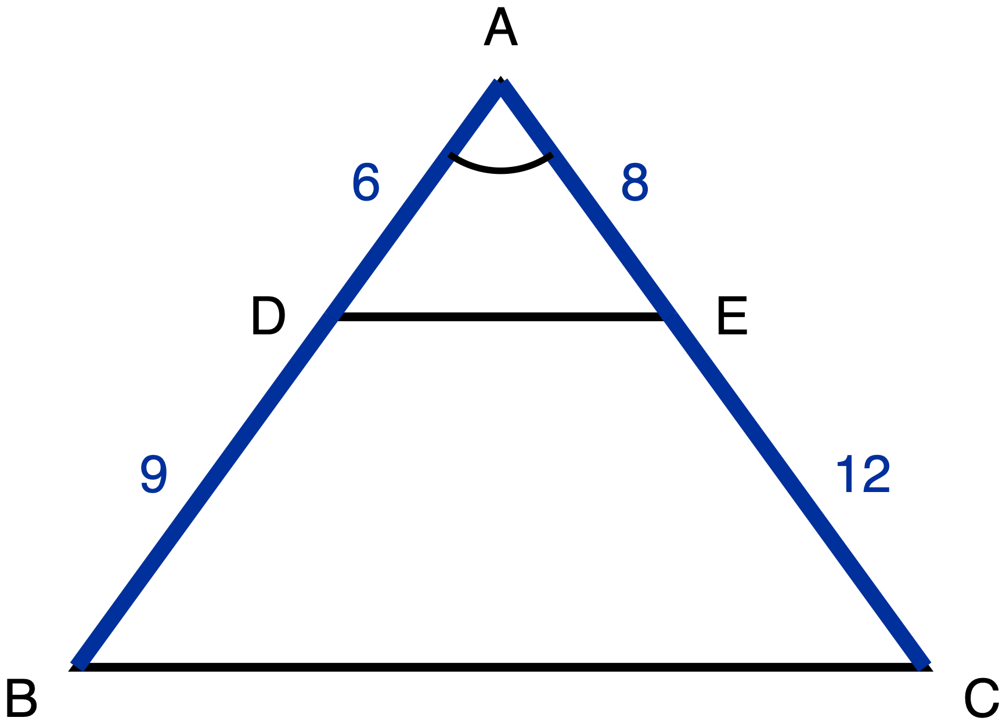
Figure 2. Triangle ABC with D on AB, E on AC, and the segment DE drawn.
Description: Triangle ABC has vertex A at the top and side BC horizontal along the bottom. D lies on AB and E lies on AC, and the segment DE is drawn across the triangle. AD is 6 and DB is 9 on the left side; AE is 8 and EC is 12 on the right side. All four of those part-lengths are given measures. Angle A carries one arc. Nothing is marked as unknown.
In triangle ABC, D lies on AB and E lies on AC, and the segment DE is drawn. AD = 6, DB = 9, AE = 8 and EC = 12.
(a) Prove that triangle ADE is similar to triangle ABC. Name the criterion you used and say why it applies here.
(b) Write the ratio DE : BC in simplest form.
✋
Nothing on the figure says that DE is parallel to BC. If your argument needs that, it is something for you to establish, not something you are given.

Same five ways of recording your work as Item 1.
Tools for this item: A four-function calculator is allowed for the two divisions. No ruler. No card printing the similarity criteria. No formula sheet or identity card of any kind. No special-triangle reference card. Yours on this item: blank paper, a straightedge, tracing paper and scissors, the straightedge as a drawing edge and never laid along the printed figure.
(a) Proof, with the criterion named

(b) DE : BC

Item 3 · Two triangles, one upside down
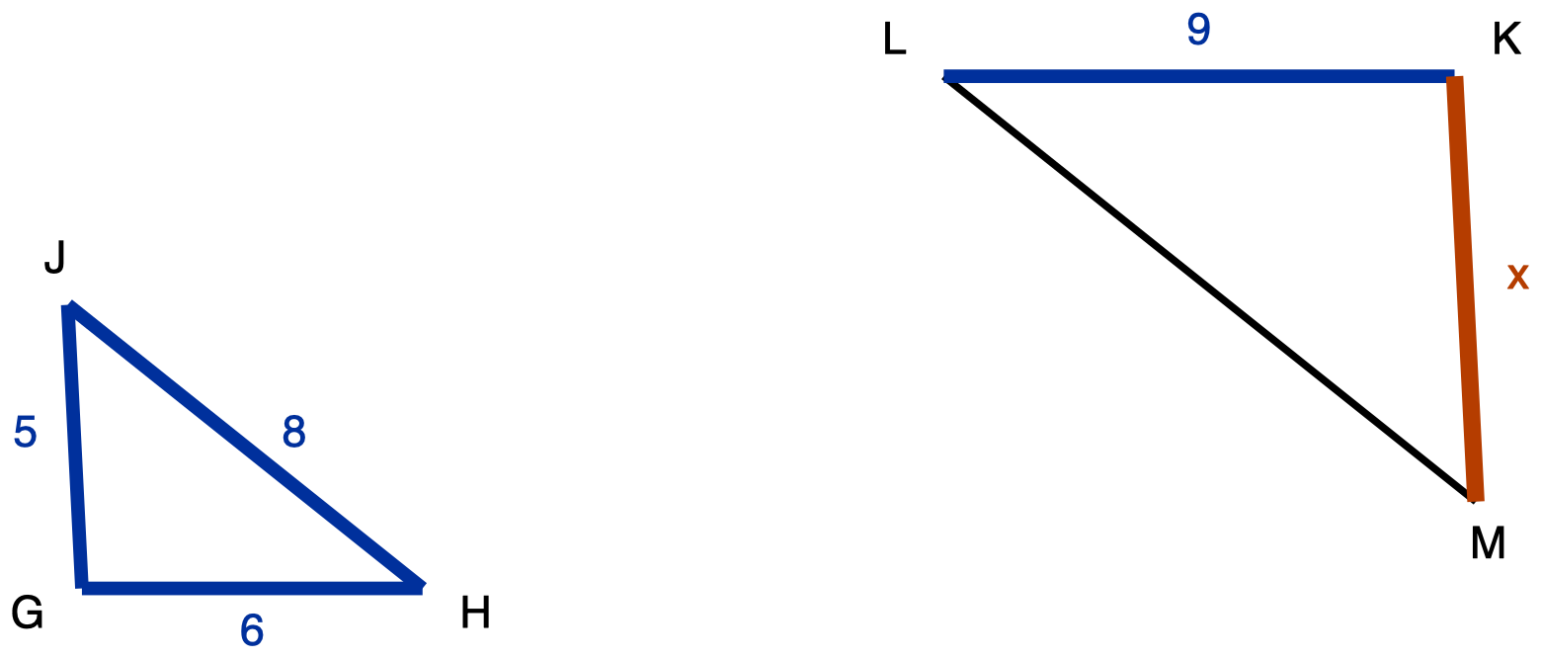
Figure 3. Triangle GHJ and the larger triangle KLM, drawn upside down relative to it.
Description: Triangle GHJ is on the left with side GH horizontal along the bottom and vertex J above it. Its three sides are given: GH is 6, HJ is 8 and GJ is 5. Triangle KLM is on the right, larger and turned upside down, so KL runs along its top rather than its bottom. KL is given as 9. LM is drawn plain and carries no numeral. KM is the unknown and is labelled x.
Triangle GHJ is similar to triangle KLM. In triangle GHJ, GH = 6, HJ = 8 and GJ = 5. In triangle KLM, KL = 9. Triangle KLM is drawn upside down relative to triangle GHJ.
What is the length of KM, marked x on the figure? Choose one.
- A. 6.75
- B. 7.5
- C. 8
- D. 10.8
Write the letter, circle it, point at it, or say it to me.
Tools for this item: A four-function calculator is allowed. No ruler. No formula sheet or identity card of any kind. No special-triangle reference card. Blank paper and a straightedge are yours as drawing materials, the straightedge never laid along the printed figure.
Your answer

Item 4 · Sides given out of order
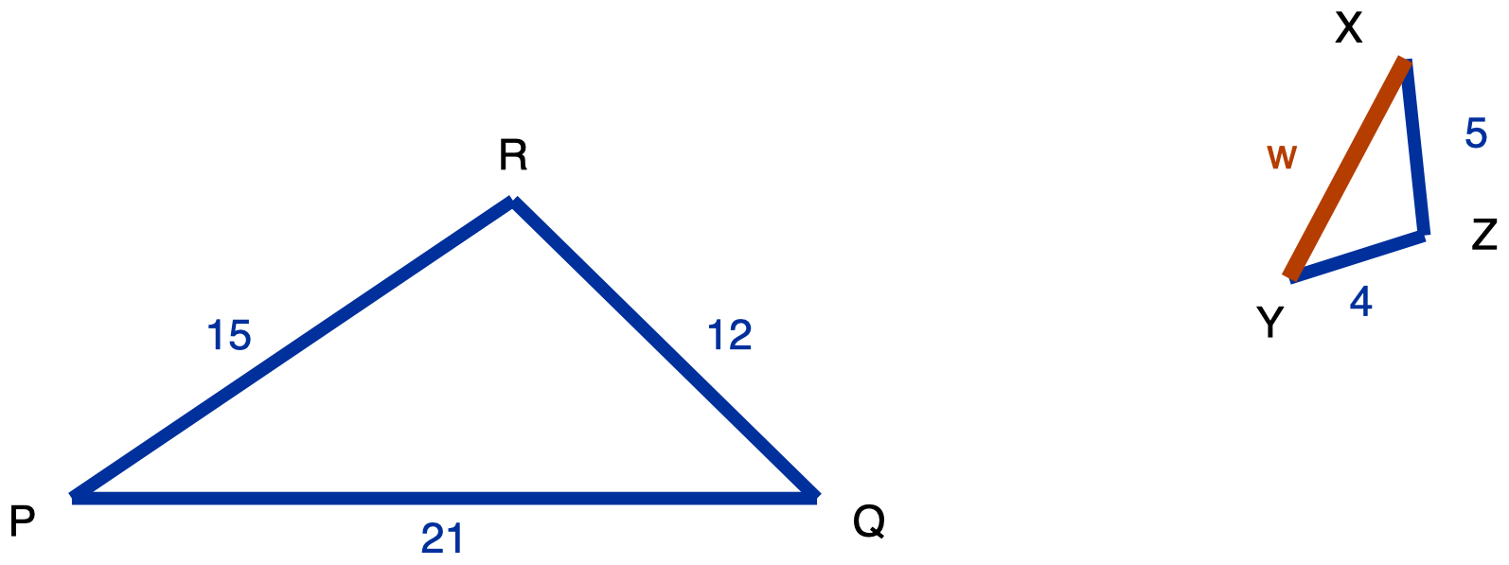
Figure 4. Triangle PQR and the smaller triangle XYZ.
Description: Triangle PQR is on the left with PQ horizontal along the bottom and R above it. PQ is 21, QR is 12 and PR is 15, all given. Triangle XYZ is on the right, much smaller and rotated so that none of its sides is horizontal. YZ is 4 and XZ is 5, both given. XY is the unknown and is labelled w. No angle is marked in either triangle.
Triangle PQR and triangle XYZ are similar. In triangle PQR, PQ = 21, QR = 12 and PR = 15. In triangle XYZ, YZ = 4 and XZ = 5.
(a) Write the similarity statement for these two triangles, with the vertices in corresponding order.
(b) Find XY, marked w on the figure.
The side lengths of the second triangle are not listed in the order that matches the first. Work out which side goes with which before you write any ratio. Ask me for a blank three-row table to write your pairs into if you would like one.
Tools for this item: A four-function calculator is allowed. No ruler. No formula sheet or identity card of any kind. No special-triangle reference card. Blank paper and a straightedge are yours as drawing materials, the straightedge never laid along the printed figure.
(a) Similarity statement

(b) XY = w

Item 5 · The flagpole
There is no figure for this item, and there will not be one. Drawing the situation is part of what is being assessed.
A flagpole standing on level ground casts a shadow 14 m long. At the same moment, a vertical post 1.8 m tall casts a shadow 2.4 m long. The sun's rays reach the flagpole and the post from the same direction, so the two right triangles formed by the object, its shadow and the ray are similar.
Draw both triangles. Write every measurement onto the triangle it belongs to. Then find the height of the flagpole.
Use as much space and as much paper as you want. If writing is the slow part for you, do your drawing yourself and then tell me the equation and the answer, and I will write those down.
Tools for this item: A four-function calculator is allowed. No diagram is supplied for this item, and none will be. No formula sheet or identity card of any kind. I can read the instructions to you, and I cannot read the situation to you. No special-triangle reference card. Blank paper, a straightedge, tracing paper and scissors are yours; there is no printed figure here, so the straightedge is purely a drawing edge.
Your drawing

Equation and answer

Item 6 · The survey
No figure for this item either, for the same reason.
From a point S on level ground, the distance to a tree T is 40 m and the distance to a rock R is 25 m. A stake A is driven into the ground on the straight line from S to T, 16 m from S. A second stake B is driven on the straight line from S to R, 10 m from S.
(a) Draw the situation and label it.
(b) Decide whether triangle SAB is similar to triangle STR. Name the criterion you used.
(c) The tree and the rock are 52 m apart. How far apart are the two stakes?
Tools for this item: A four-function calculator is allowed. No diagram is supplied. No formula sheet or identity card of any kind. I can read the instructions to you and not the situation. No special-triangle reference card. Blank paper, a straightedge, tracing paper and scissors are yours; there is no printed figure here, so the straightedge is purely a drawing edge.
(a) Your drawing, labelled

(b) Similar or not, and the criterion

(c) Distance between the stakes

Item 7 · A line parallel to one side
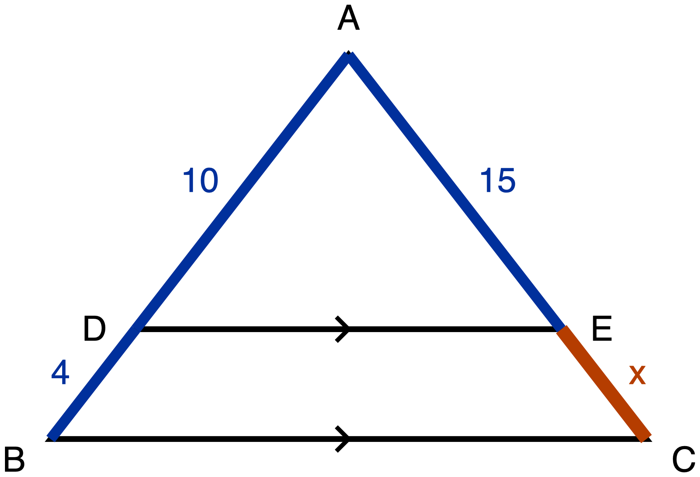
Figure 5. Triangle ABC with DE marked parallel to BC.
Description: Triangle ABC has vertex A at the top and BC horizontal along the bottom. D lies on AB and E lies on AC, and DE is drawn across the triangle. A single chevron sits on DE and a single chevron sits on BC, marking those two segments parallel. AD is 10, DB is 4 and AE is 15, all given. EC is the unknown and is labelled x.
In triangle ABC, D lies on AB and E lies on AC. The single chevron on DE and the single chevron on BC mark those two segments parallel. AD = 10, DB = 4 and AE = 15.
(a) Name the theorem that lets you find EC here, and say why it applies to this figure.
(b) Find EC, marked x on the figure.
(c) Write down the proportion you used, and say in one sentence why it is a proportion of ratios and not of differences.
✋
A number on its own is not an answer to this item. Part (a) and part (c) are what is being measured, and part (b) is how you show it working.

Answer in writing, by writing onto the figure, or out loud to me.
Tools for this item: A four-function calculator is allowed. No ruler. No card printing the Triangle Proportionality Theorem. No formula sheet or identity card of any kind. No special-triangle reference card. Blank paper and a straightedge are yours as drawing materials, the straightedge never laid along the printed figure.
(a) The theorem, and why it applies

(b) EC = x

(c) The proportion, and the one sentence

Item 8 · Is it parallel?
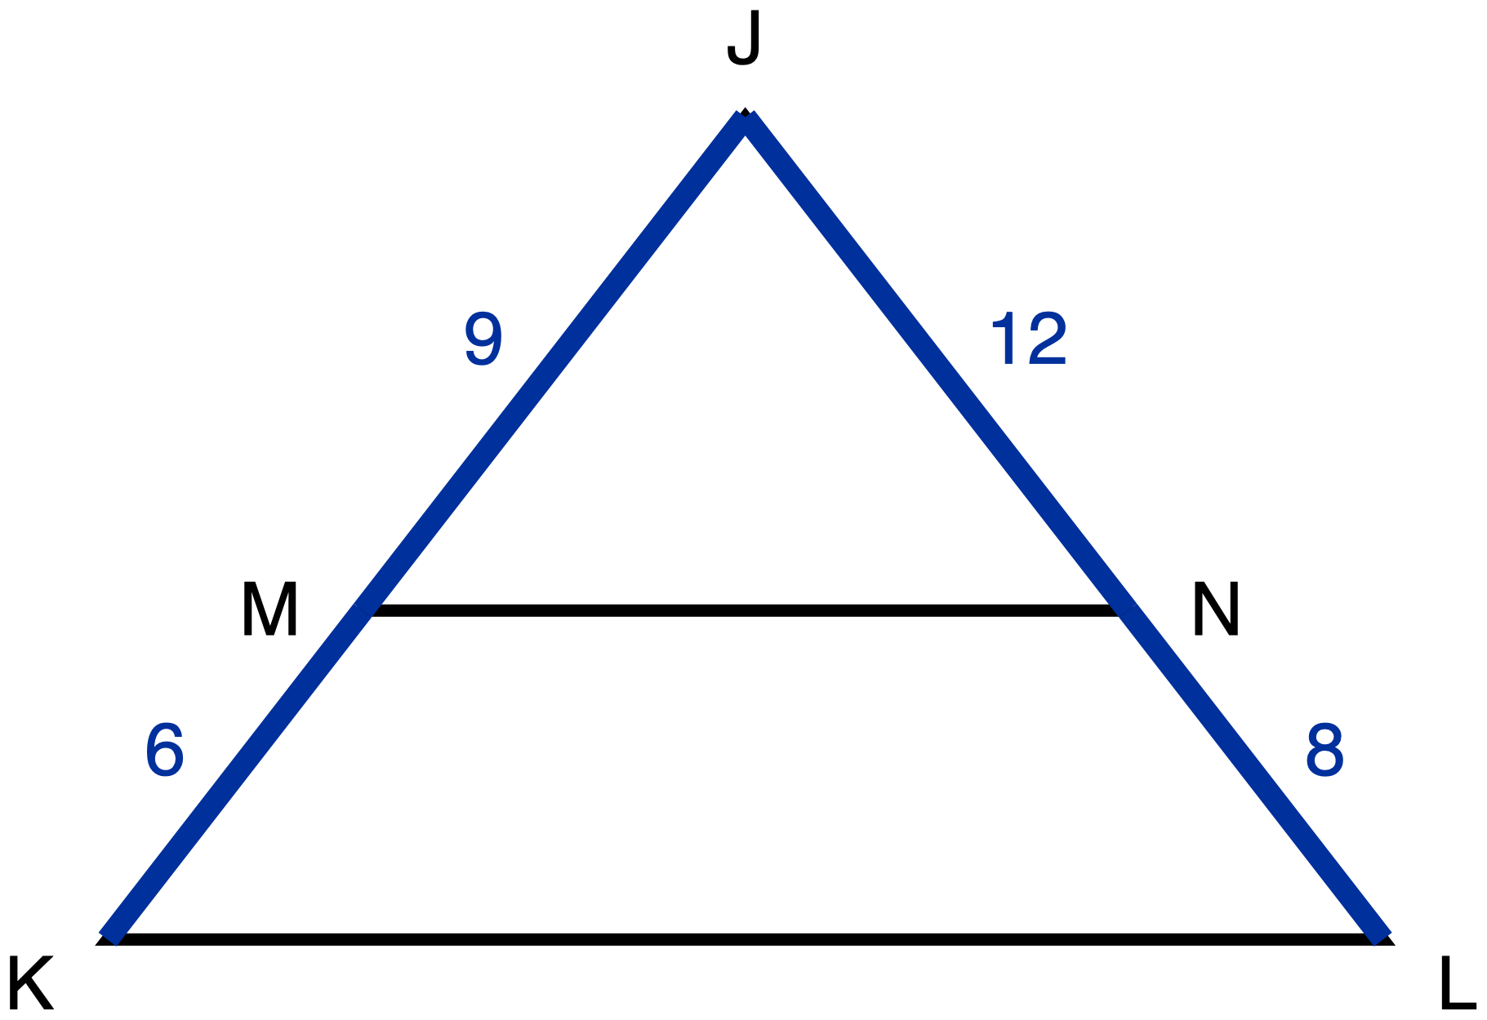
Figure 6. Triangle JKL with MN drawn across it.
Description: Triangle JKL has vertex J at the top and KL horizontal along the bottom. M lies on JK and N lies on JL, and MN is drawn across the triangle. JM is 9, MK is 6, JN is 12 and NL is 8, all given. There is no chevron on MN and no chevron on KL, so nothing in the figure asserts that the two segments are parallel. Nothing is marked as unknown.
In triangle JKL, M lies on JK and N lies on JL, and the segment MN is drawn. JM = 9, MK = 6, JN = 12 and NL = 8.
(a) Decide whether MN is parallel to KL.
(b) Justify your decision: name the theorem you used and show the computation it rests on.
✋
Nothing on this figure is marked parallel. That is the question, not a given.

Answer in writing, by writing onto the figure, or out loud to me.
Tools for this item: A four-function calculator is allowed. No ruler, no protractor and no straightedge. No part heading, no cover page and no earlier item issues you a tool that this item has not. No formula sheet or identity card of any kind. No special-triangle reference card. Blank paper, tracing paper and scissors are yours.
(a) Parallel or not

(b) The theorem, and the computation

Item 9 · The three triangles in one figure
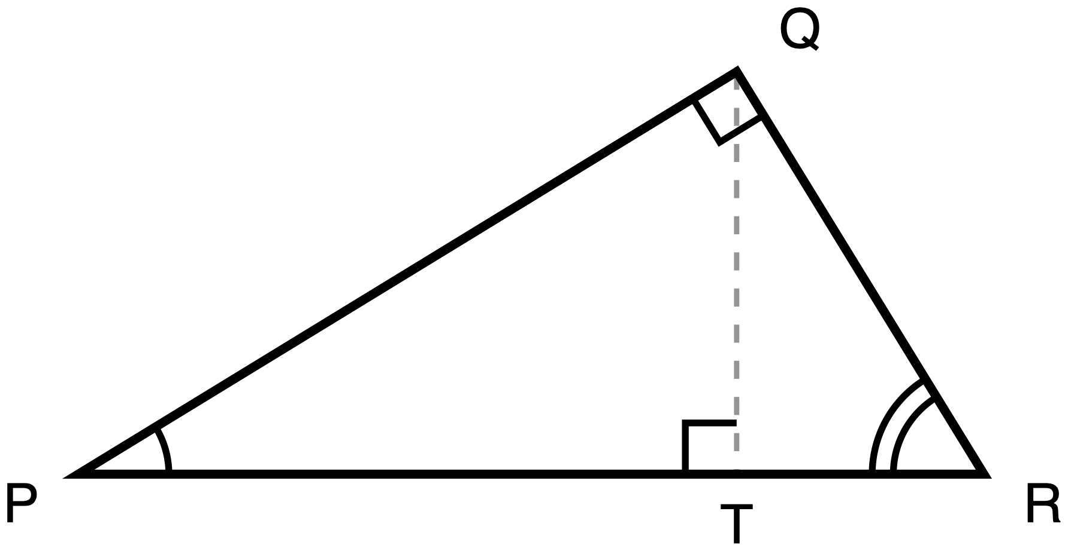
Figure 7. Right triangle PQR with the altitude QT to the hypotenuse PR.
Description: Right triangle PQR has its right angle at Q and its hypotenuse PR lying horizontally along the bottom, P on the left and R on the right. Q sits above PR, nearer to R than to P. The altitude QT is drawn as a dashed construction line from Q down to the point T on PR. A right-angle square marks the angle at Q and another marks the angle at T. Angle P carries one arc and angle R carries two arcs. No length is given.
Right triangle PQR has its right angle at Q. QT is the altitude from Q to the hypotenuse PR, so QT meets PR at a right angle.
✋
Everything in this item comes from the three similar triangles that the altitude creates. That route is what is being measured.

(a) Name the three triangles in this figure that are similar to one another.
(b) Write two similarity statements, each one comparing a small triangle to the whole triangle PQR, with the vertices in corresponding order.
(c) From one of your statements in (b), write a proportion which, when you cross-multiply it, gives PQ². Say which statement you used.
Answer in writing, by writing onto your own separated triangles, or out loud to me.
✋
Taking this figure apart is a sensible first move. Tracing paper, scissors, blank triangle outlines and a second clean copy of the figure are on the front desk for anybody who wants them.

Tools for this item: A calculator is allowed and there is nothing to compute: this item contains no numbers. Tracing paper, scissors, a second clean copy of the figure and a blank triangle-outline sheet are all yours, and I will offer them to everybody. What is not allowed is a set of triangles that has already been separated and lettered for you, a printed list of the relationships between the legs and the hypotenuse segments, or a part-completed proof. No formula sheet or identity card of any kind. No special-triangle reference card. Blank paper and a straightedge are yours as drawing materials, the straightedge never laid along the printed figure.
Working space: separate the triangles here

(a) The three similar triangles

(b) Two similarity statements

(c) The proportion, and which statement it came from

Item 10 · Pythagoras, from the similar triangles
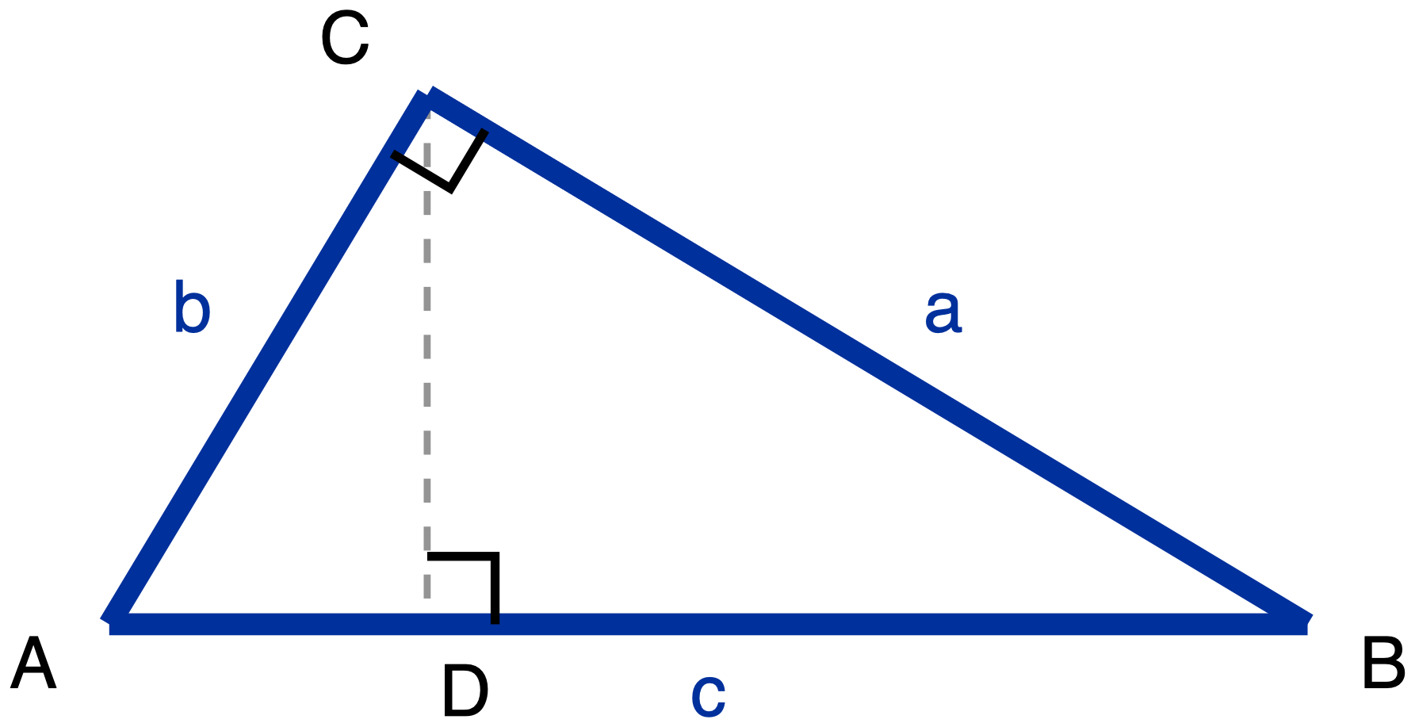
Figure 8. Right triangle ABC with legs a and b, hypotenuse c, and the altitude CD.
Description: Right triangle ABC has its right angle at C and its hypotenuse AB lying horizontally along the bottom, A on the left and B on the right. C sits above AB, nearer to A than to B. The three sides carry letters rather than numbers: BC is a, AC is b and AB is c. The altitude CD is drawn as a dashed construction line from C down to the point D on AB. A right-angle square marks the angle at C and another marks the angle at D.
Right triangle ABC has its right angle at C. CD is the altitude from C to the hypotenuse AB. Let BC = a, AC = b and AB = c.
Using the three similar triangles formed by the altitude to the hypotenuse, and no other method, prove that a² + b² = c². Your proof has to say why each pair of triangles is similar, not just that it is.
Two things about that instruction, said plainly here:
- This unit is asking for the similarity route specifically. A proof that cuts the squares up and rearranges the pieces is a real proof of the same theorem, and it is not an answer to this item. If that is the proof you know, write it on the back of the page, and then do this one.
- Your Part A answer to Item 9 stays on the desk and you may look back at it. Item 9 gives you two similarity statements. It does not give you the reasons, and the reasons are what this item is asking for.
Present it in whichever of the five forms from Item 1 you want.
Tools for this item: Same as Item 9: a calculator is allowed and there is nothing to compute; tracing paper, scissors, blank outlines and a second copy of the figure are yours; a pre-separated lettered set, a printed list of the altitude relationships, a part-completed proof and a card printing a² + b² = c² are all not allowed. No formula sheet or identity card of any kind. No special-triangle reference card. Blank paper and a straightedge are yours as drawing materials, the straightedge never laid along the printed figure.
Your proof

Item 11 · Two triangles, one angle
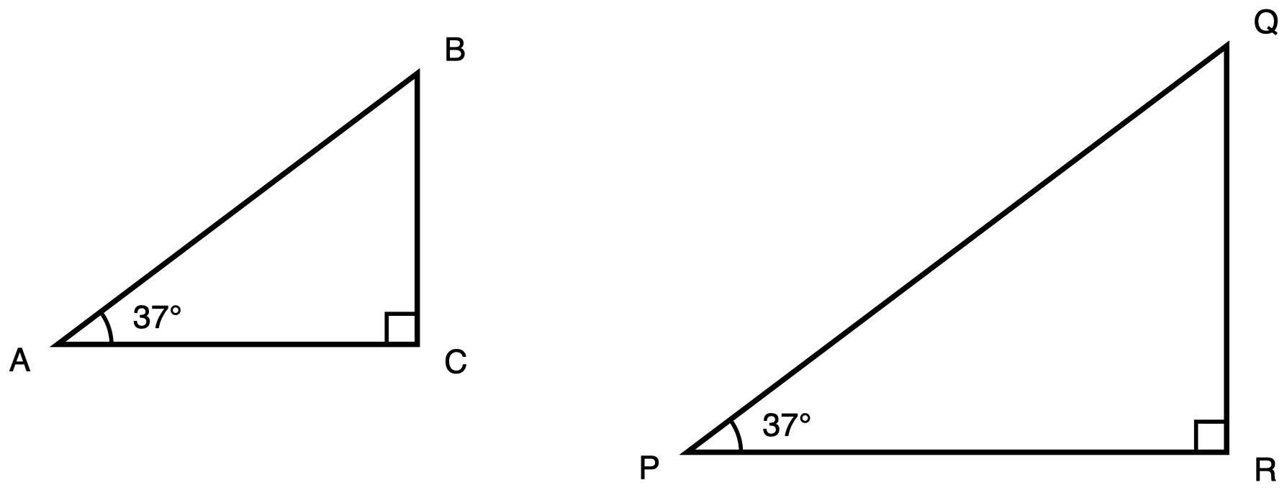
Figure 9. Two right triangles, each carrying a 37° angle.
Description: Two separate right triangles stand side by side, the right-hand one visibly larger. Triangle ABC has its right angle at C and a 37 degree angle at A, marked with one arc. Triangle PQR has its right angle at R and a 37 degree angle at P, marked with one arc as well. No side length is given in either triangle and nothing is marked as unknown.
Triangle ABC has its right angle at C and a 37° angle at A. Triangle PQR has its right angle at R and a 37° angle at P. Triangle PQR is visibly larger. No side length is given in either triangle.
Explain why sin 37° has the same value in triangle ABC as it has in triangle PQR. Your explanation has to run through similarity, and you are not asked to compute any ratio.
No numbers appear in this item other than the two 37s printed on the figure.
Answer in writing, by annotating a second copy of the figure, or out loud to me.
Tools for this item: A four-function calculator is allowed and there is nothing for it to do. No sin, cos or tan key on any calculator. No printed table of sine, cosine or tangent values. No ruler. No formula sheet or identity card of any kind. No special-triangle reference card. Blank paper and a straightedge are yours as drawing materials, the straightedge never laid along the printed figure.
Your explanation

Item 12 · Dana and Priya
No figure for this item, because there is no particular triangle in it.
Dana says: if you multiply every side of a right triangle by 3, you multiply the sine of each of its acute angles by 3.
Priya says: the sine of each acute angle does not change at all.
(a) Who is right?
(b) Give the reason, using similarity.
(c) Name one quantity in that triangle that does get multiplied by 3, and one that does not change.
✋
Part (c) is not a bonus. Saying what changes, in the same answer as what does not, is the point of the item.

Answer in writing, in a two-column "changes / does not change" table with your reason written underneath it, or out loud to me. Ask if you want the blank table.
Tools for this item: A four-function calculator is allowed and there is nothing for it to do. No sin, cos or tan key and no printed value table. Blank paper and a straightedge are yours if you would like to draw a triangle to think with. No formula sheet or identity card of any kind. No special-triangle reference card.
(a) Who is right

(b) The reason, using similarity

(c) Changes / does not change

Item 13 · The same triangle, from each of its acute angles
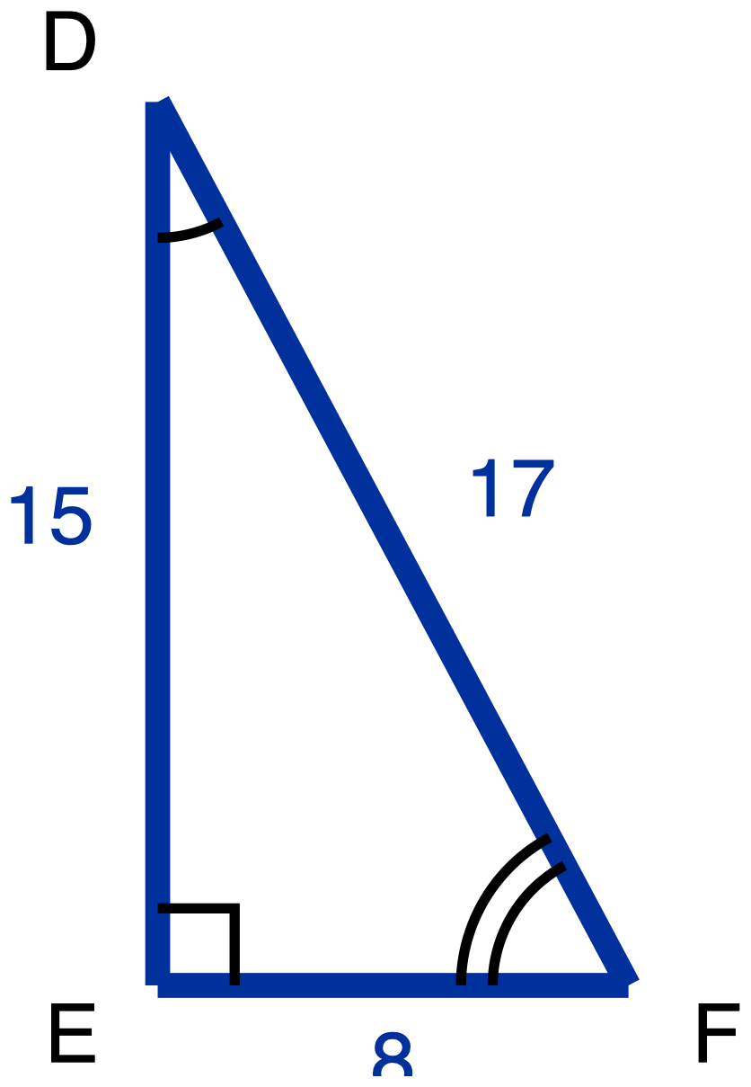
Figure 10. Right triangle DEF with sides 15, 8 and 17.
Description: Right triangle DEF has its right angle at E. DE is the vertical leg on the left and is given as 15. EF is the horizontal leg along the bottom and is given as 8. DF is the hypotenuse, running from the top down to the right, and is given as 17. Angle D carries one arc and angle F carries two arcs. Nothing is marked as unknown.
Right triangle DEF has its right angle at E, with DE = 15, EF = 8 and DF = 17.
(a) Relative to angle D, name the opposite leg, the adjacent leg and the hypotenuse. Then write tan D as a fraction.
(b) Do the same relative to angle F: name the opposite leg, the adjacent leg and the hypotenuse, then write tan F as a fraction.
(c) In one sentence, say why two of those three names change between (a) and (b) and one of them does not.
Answer in writing, by writing the names onto your own copies of the figure, or out loud to me.
Tools for this item: A four-function calculator is allowed, though both answers are fractions. No copy of this triangle with the legs already labelled "opposite" and "adjacent" for either angle. No printed table of sine, cosine or tangent values, and no definition card. Tracing paper you may turn is yours. No formula sheet or identity card of any kind. No special-triangle reference card. Blank paper and a straightedge are yours as drawing materials, the straightedge never laid along the printed figure.
(a) Names relative to angle D, and tan D

(b) Names relative to angle F, and tan F

(c) One sentence

Item 14 · Half a square
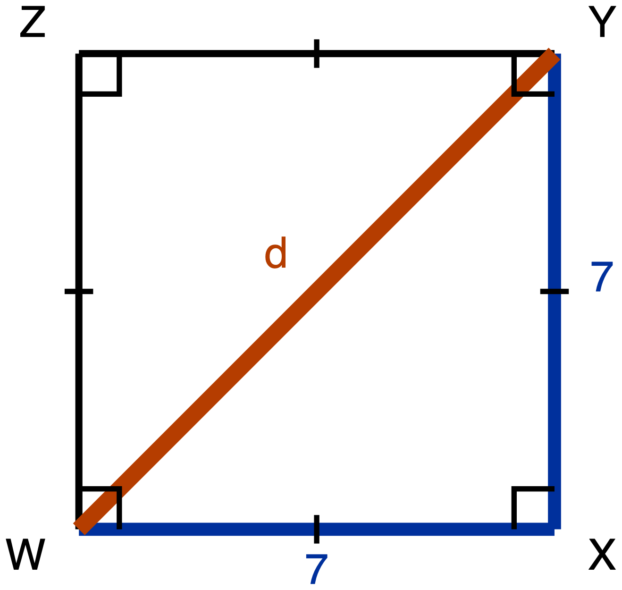
Figure 11. Square WXYZ with the diagonal WY drawn.
Description: Square WXYZ is drawn with its sides vertical and horizontal. W is the bottom left corner, X the bottom right, Y the top right and Z the top left. The diagonal WY runs from the bottom left corner up to the top right corner and is the unknown, labelled d. WX and XY are given measures, each 7. A right-angle square sits at each of the four corners and a single tick sits on each of the four sides, marking them congruent.
Square WXYZ has side length 7, and its diagonal WY is drawn.
(a) Derive the three angle measures and the three side lengths of triangle WXY. Give the side lengths in exact form, which means a radical where one is needed and not a decimal approximation.
(b) Write the ratio WX : XY : WY in simplest form.
✋
The route this item requires is the square's own properties and the Pythagorean Theorem. Your argument has to say what the square tells you about angle WXY and about the lengths WX and XY, and it has to use the Pythagorean Theorem to reach WY. Writing down "45-45-90, so 1 : 1 : √2" from memory is not an answer to this item.

Same five ways of recording your derivation as Item 1.
✋
Redrawing triangle WXY on its own, away from the square, is a good first move.

Tools for this item: No calculator. No special-triangle reference card. No formula sheet or identity card of any kind. Straightedge, blank paper, tracing paper and scissors are yours.
(a) Your derivation: three angles and three sides

(b) WX : XY : WY

Item 15 · Half an equilateral triangle
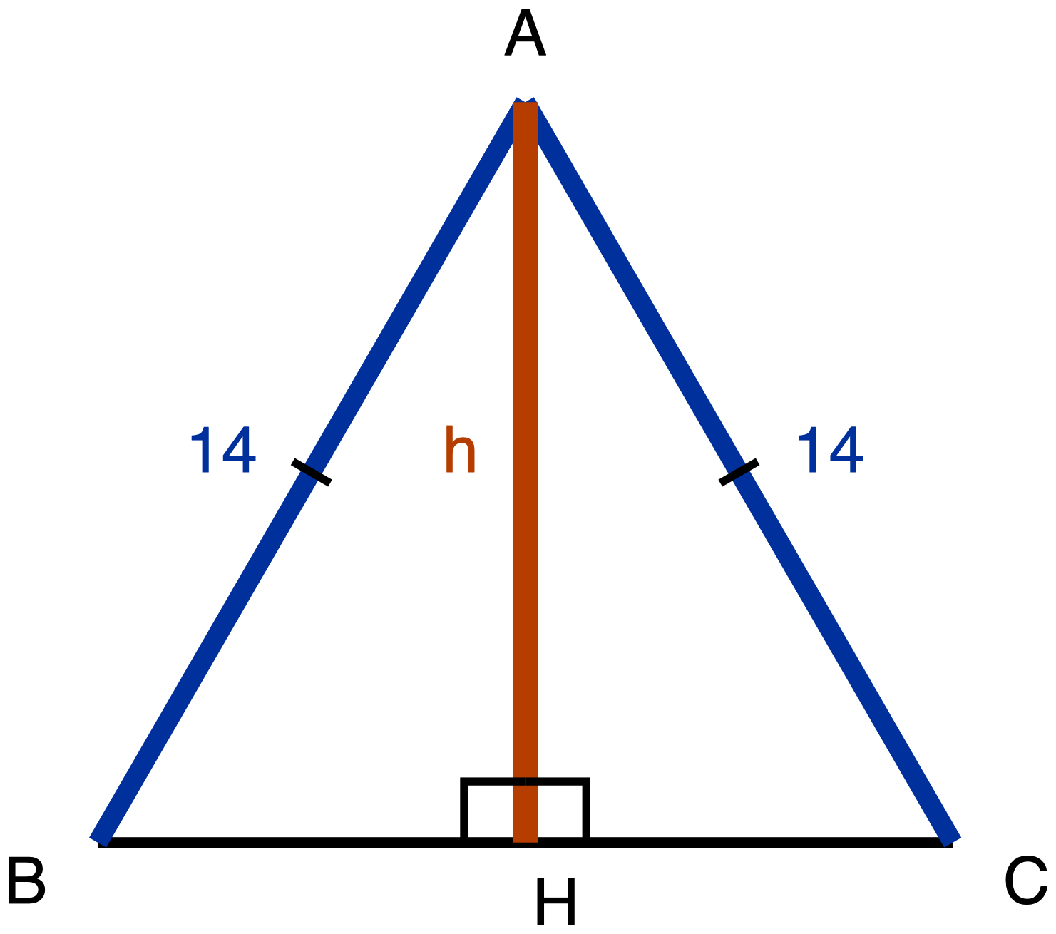
Figure 12. Equilateral triangle ABC with the segment AH drawn to BC.
Description: Equilateral triangle ABC is drawn point up, with BC horizontal along the bottom, B on the left and C on the right. A segment runs from the apex A straight down to the point H on BC. AB and AC are given measures, each 14, and each carries a single tick marking them congruent. BC is drawn plain and carries no numeral and no tick, and neither BH nor HC carries a tick, so nothing in the figure states where H sits along BC. AH is the unknown and is labelled h. Two right-angle squares sit at H, one on each side of AH.
Equilateral triangle ABC has side length 14. The segment AH runs from A to the point H on BC, and it meets BC at a right angle.
(a) Derive the three angle measures and the three side lengths of triangle ABH. Give the side lengths in exact form.
(b) Write the ratio BH : AH : AB in simplest form.
(c) In your simplified ratio, one of the two larger numbers is the hypotenuse's. Say which one, and state in one sentence how you know, without using a calculator.
✋
The route this item requires is the equilateral triangle's own altitude. Before any arithmetic, your argument has to answer both of these: what does AH do to angle A, and what does AH do to side BC? Nothing on the figure tells you where H sits along BC. That is something to establish, not something given. Then use the Pythagorean Theorem to reach AH.

Same five ways of recording your derivation as Item 1. Part (c) may be a sentence, a written comparison of the two numbers, or said aloud to me.
Tools for this item: No calculator. No special-triangle reference card. No formula sheet or identity card of any kind. Straightedge, blank paper, tracing paper and scissors are yours.
(a) Your derivation: three angles and three sides

(b) BH : AH : AB

(c) Which value is the hypotenuse's, and how you know

✋
Hand Part A in before you take Part B.

Part B · Using the ratios, and building the triangle yourself

Eight items. Each one states its own tools, and this line rules on none of them.

Item 16 · A 30-60-90 triangle
A 30-60-90 triangle has hypotenuse 24.
Which pair gives its shorter leg and its longer leg, both in exact form? Exact form means a radical where one is needed, not a decimal approximation. Choose one.
- A. shorter leg 12, longer leg 12√3
- B. shorter leg 12√3, longer leg 12
- C. shorter leg 12, longer leg 12√2
- D. shorter leg 12, longer leg 20.78
Write the letter, circle it, point at it, or say it to me.
Tools for this item: The special-triangle reference card is allowed on this item, and is issued for it. No calculator. No formula sheet or identity card of any kind.
Your answer

Item 17 · Both directions
(a) A 45-45-90 triangle has hypotenuse 20. Give the length of each leg in exact form.
(b) A 45-45-90 triangle has legs of length 13. Give its hypotenuse in exact form.
Write your answers, write them onto a blank triangle outline if you would rather (ask and I will give you one), or say them to me and I will write them down.
Tools for this item: The special-triangle reference card is allowed on this item, and is issued for it. No calculator. No formula sheet or identity card of any kind. The card gives you the ratio; deciding which direction to run it in each part is yours.
(a) Each leg

(b) Hypotenuse

Item 18 · Find the leg
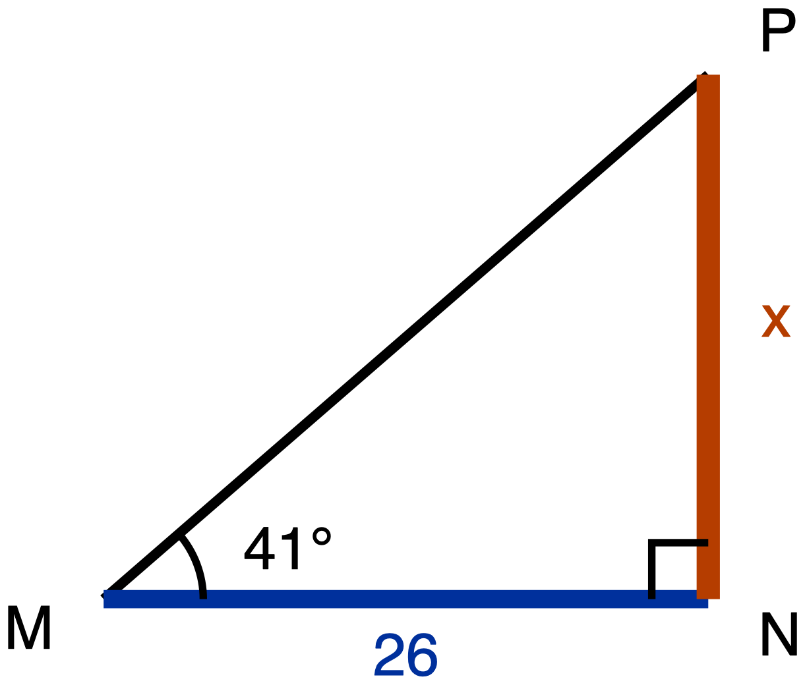
Figure 13. Right triangle MNP with a 41° angle at M.
Description: Right triangle MNP has its right angle at N. MN is the horizontal leg along the bottom, M on the left, and is a given measure of 26. NP is the vertical leg on the right, running upward from N, and is the unknown, labelled x. MP is the hypotenuse. The angle at M carries one arc and is labelled 41 degrees. Nothing else is given.
Right triangle MNP has its right angle at N. The angle at M is 41°, and MN = 26.
Find NP, marked x on the figure, to the nearest tenth.
Write the equation you used as well as the answer.
Tools for this item: A scientific calculator with sine, cosine and tangent is allowed and you will need one. A printed table of tangent values is equally allowed if you would rather use one, and it will get you to the same place. The special-triangle reference card is allowed on this item and has nothing to offer here: 41° is not a special angle. No copy of this triangle with the legs already labelled "opposite" and "adjacent". No formula sheet or identity card of any kind.
Equation and answer

Item 19 · Two legs, two tangents
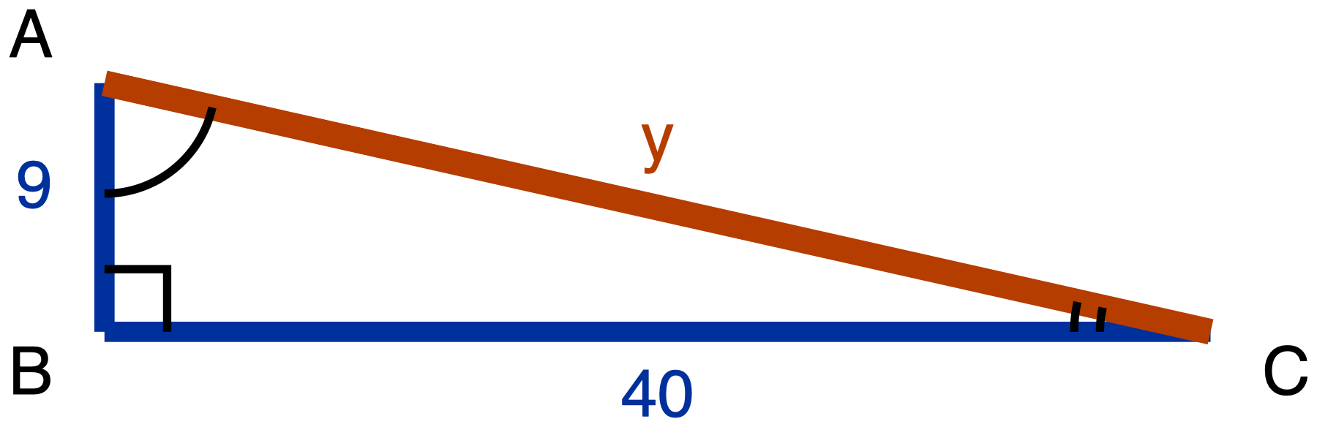
Figure 14. Right triangle ABC with legs 9 and 40.
Description: Right triangle ABC has its right angle at B. AB is the short vertical leg on the left and is a given measure of 9. BC is the long horizontal leg along the bottom and is a given measure of 40. AC runs from the top of the short leg down to the far end of the long leg; it is the unknown and is labelled y. Angle A carries one arc and angle C carries two arcs.
Right triangle ABC has its right angle at B, with AB = 9 and BC = 40.
(a) Find AC, marked y on the figure.
(b) Write tan A and tan C, each as a fraction in lowest terms.
Tools for this item: A four-function or scientific calculator is allowed for the square root. The sine, cosine and tangent keys are allowed and have nothing to do here: no angle measure appears anywhere in this item. The special-triangle reference card is allowed on this item and does not apply: this is not a special triangle. No copy of this triangle with the legs already labelled for either angle. No formula sheet or identity card of any kind.
(a) AC = y

(b) tan A and tan C

Item 20 · The swimmer
No figure for this item, and there will not be one. Drawing the situation is part of what is being assessed.
A lifeguard stands at the edge of a cliff, 68 m above the water, and sights a swimmer out to sea. The angle of depression of her line of sight is 22°.
(a) Draw the situation. Your drawing must show the horizontal line that the angle of depression is measured from.
(b) Find the horizontal distance from the foot of the cliff to the swimmer, to the nearest metre.
(c) There is an angle at the swimmer's position that also measures 22°. Name it, and say why it must be equal to the angle of depression.
Tools for this item: A scientific calculator or a printed tangent table is allowed and you will need one of them. The special-triangle reference card is allowed on this item and has nothing to offer: 22° is not a special angle. No diagram is supplied for this item, and none will be. No poster, worked example or display showing where an angle of depression sits. No formula sheet or identity card of any kind. I can read the instructions to you, and I cannot read the situation to you.
(a) Your drawing, with the horizontal shown

(b) Horizontal distance

(c) The angle, and why it is equal

Item 21 · The radio mast
No figure for this item either, for the same reason.
Malik is 1.75 m tall and his eyes are 1.6 m above the ground. Standing on level ground, 85 m from the foot of a radio mast, he measures the angle of elevation to the top of the mast as 34°.
Find the height of the mast, to the nearest tenth of a metre.
✋
Your drawing must show Malik as a vertical segment from the ground up to his eyes, with the triangle sitting on top of it.

Tools for this item: A scientific calculator or a printed tangent table is allowed and you will need one. No diagram is supplied. The special-triangle reference card is allowed on this item and has nothing to offer: 34° is not a special angle. No card, prompt or display about what to do with the observer's height. No formula sheet or identity card of any kind. Instructions read aloud yes, situation read aloud no, same as Item 20.
Your drawing

Equation and answer

Item 22 · The flagpole, from the same spot
No figure, same reason.
Without moving, Malik turns and sights the top of a flagpole 46 m away. The angle of elevation of his line of sight to the top of the flagpole is 28°.
(a) How much higher than Malik's eyes is the top of the flagpole? Give your answer to the nearest tenth of a metre.
(b) Does his eye height of 1.6 m matter for the quantity part (a) asked you for? Answer yes or no, and give the reason from your own drawing.
Tools for this item: As Item 21: a scientific calculator or a tangent table, no supplied diagram, no card or prompt about the observer's height, no formula sheet or identity card of any kind, instructions read aloud but not the situation. The special-triangle reference card is allowed on this item and has nothing to offer: 28° is not a special angle.
(a) Height above Malik's eyes

(b) Yes or no, and the reason from your drawing

Item 23 · The drone
No figure, same reason.
A drone hovers 120 m directly above a marker on level ground. From the drone, the angle of depression to a gate on the same ground is 39°.
(a) Draw the situation, showing the horizontal that the angle is measured from.
(b) Find the distance along the ground from the marker to the gate, to the nearest metre.
(c) Find the straight-line distance from the drone to the gate, to the nearest metre. Say which of the two methods available to you you used, and say why the Pythagorean Theorem is available to you here.
✋
Part (c) can be done without part (b). If your part (b) went wrong, part (c) is still worth doing, and it will be marked on its own.

Tools for this item: As Item 20: a scientific calculator or a tangent table, no supplied diagram, no poster or worked example showing the placement of an angle of depression, no formula sheet or identity card of any kind, instructions read aloud but not the situation. The special-triangle reference card is allowed on this item and has nothing to offer: 39° is not a special angle.
(a) Your drawing, with the horizontal shown

(b) Ground distance

(c) Straight-line distance, the method, and why Pythagoras is available

✋
Hand Part B in, and hand back anything Part B's own items issued you, before you take Part C.

Part C · Sine, cosine, and complements

Five items. Each one states its own tools, and this line rules on none of them.

Item 24 · Which side does the work
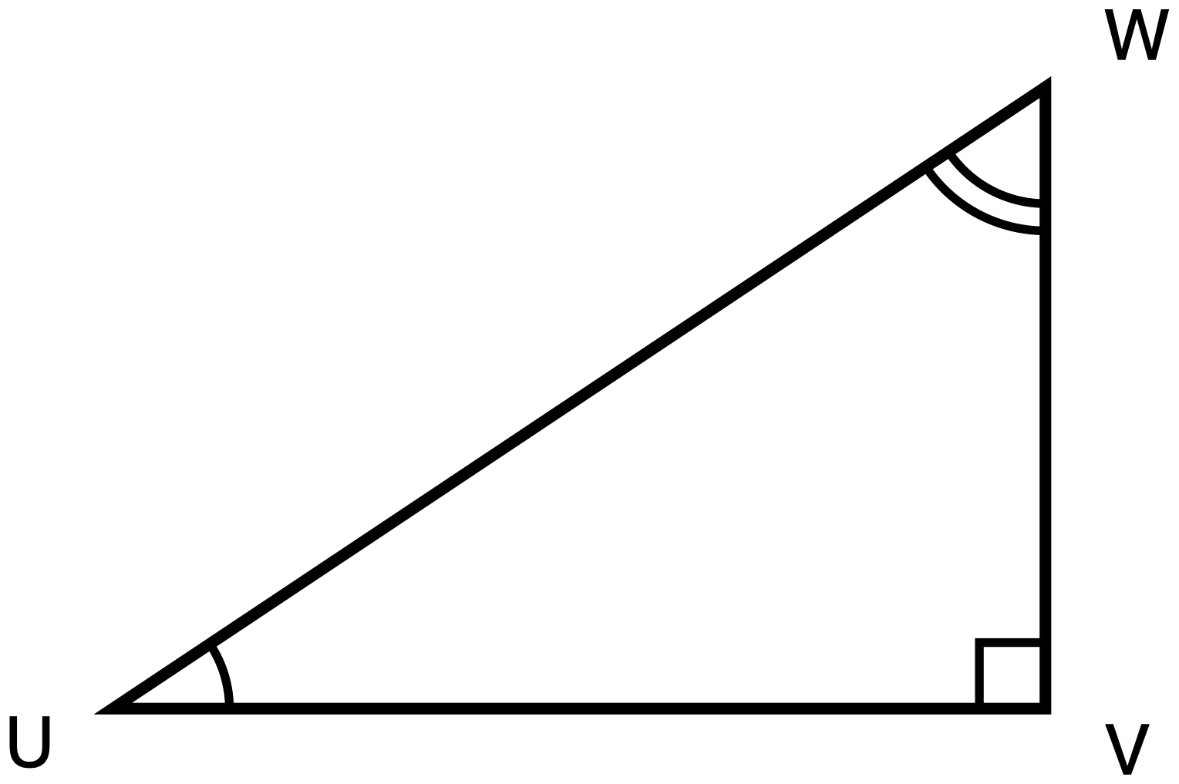
Figure 15. Right triangle UVW.
Description: Right triangle UVW has its right angle at V. UV is the horizontal leg along the bottom, with U on the left. VW is the vertical leg on the right, running upward from V. UW is the hypotenuse, running from the bottom left up to the top right. The angle at U carries one arc and the angle at W carries two arcs. No numeral appears anywhere in the figure and nothing is marked as unknown.
Right triangle UVW has its right angle at V.
(a) Name the one side of this triangle that is opposite angle U and is also adjacent to angle W. Then say in one sentence why a single side can play both of those roles.
(b) Use your answer to (a) to explain why sin U = cos W. Write each of them as a fraction of two named sides.
(c) Ravi says the answer to (b) is really that sin U = cos V, because V is the other angle named in the triangle. Give one reason Ravi's equation cannot be right.
Answer in writing, by annotating a second copy of the figure (ask and I will give you one), or out loud to me, and I will write it down word for word.
Tools for this item: A calculator is allowed and will not help you: there is not a single number in this item. No table of sine and cosine values. No formula sheet or identity card printing the relationship between sine and cosine. No special-triangle reference card.
(a) The side, and why one side can play both roles

(b) sin U and cos W as fractions of named sides

(c) One reason Ravi cannot be right

Item 25 · Which equation is always true
In right triangle GHK, the right angle is at H.
Which one of these is true for every triangle of that kind? Choose one.
- A. sin G = cos H
- B. sin G = sin K
- C. sin G = cos K
- D. tan G = tan K
Write the letter, circle it, point at it, or say it to me. If it helps, ask me for a blank right-triangle outline with G, H and K already lettered on it.
Tools for this item: No calculator with sine, cosine or tangent keys. A four-function calculator is allowed and has nothing to do here. No table of sine and cosine values. No special-triangle reference card. No formula sheet or identity card printing the relationship between sine and cosine.
Your answer

Item 26 · Solving for x
For some value of x, cos(7x + 4)° = sin(3x + 6)°, and both (7x + 4)° and (3x + 6)° are acute angles.
(a) Write one sentence saying how those two angle measures are related to each other. Then write the equation that sentence gives you.
(b) Solve your equation for x.
(c) Give both angle measures, and check that they really can be the two acute angles of one right triangle.
✋
Part (a) is required and is not a warm-up: the equation has to come from a stated fact about the two angles, not from a remembered template. You may dictate your sentence and your equation and I will write them down.

Tools for this item: A four-function or scientific calculator is allowed for the arithmetic. No graphing calculator and no equation solver. A table of sine and cosine values is not supplied and would show you nothing here, because x sits inside both angles. No formula sheet or identity card printing the relationship between sine and cosine. No special-triangle reference card.
(a) The sentence, and the equation it gives

(b) x =

(c) Both angle measures, and the check

Item 27 · Solving for w
Solve for w:
cos 24° = sin(w + 11°), where (w + 11)° is an acute angle.
Before you write any equation, write down in words the step where you use the relationship between sine and cosine. Then solve, and check that (w + 11)° really is acute.
Tools for this item: No calculator with sine, cosine or inverse keys. A four-function calculator is allowed. No table of sine and cosine values. No formula sheet or identity card printing the relationship between sine and cosine. No special-triangle reference card.
The relationship in words, then your working

Item 28 · From one ratio to its partner
In right triangle ABC, the right angle is at C, and sin A = 20/29.
(a) Give the value of cos B, and say in one sentence how you know.
(b) Ravi says cos C is also 20/29. Give one reason he cannot be right.
✋
Do not compute a third side, and do not compute any ratio from any triangle. The route being measured in (a) is the relationship between an angle and its complement.

Answer in writing, out loud to me, or by writing the angle names and the value onto a blank lettered triangle outline with one phrase giving your reason. Ask if you want the outline.
Tools for this item: No calculator with sine, cosine or inverse keys. A four-function calculator is allowed and you will not need it. No table of sine and cosine values. No formula sheet or identity card printing the relationship between sine and cosine. No special-triangle reference card.
(a) cos B, and how you know

(b) One reason Ravi cannot be right

Appendix · Figure descriptions

Every figure on this exam is described here in words. A reader must be able to redraw the figure from its description without seeing it. Ask for this appendix at any point during any part of the exam.

Figure 1, triangles MNP and SRT
- Type and orientation. Two separate triangles side by side, neither of them right-angled. The left one sits flat, with one side horizontal along the bottom. The right one is turned, so none of its sides is horizontal, and it is a little larger.
- Points. In the left triangle, M is the bottom left vertex, N is the bottom right vertex level with M, and P is above and between them, nearer to M than to N. In the right triangle, S is the highest vertex and sits toward the right, R is the leftmost vertex and sits lower than S, and T is the lowest vertex and sits below S.
- Segments. MN, NP and PM in the left triangle, and SR, RT and TS in the right one. All six are drawn at the plain skeleton weight and none carries a numeral. No segment anywhere in this figure is marked as a given measure or as an unknown.
- Marked angles. The angle at M carries one arc. The angle at S carries one arc. The angle at N carries two concentric arcs. The angle at R carries two concentric arcs. There is no arc at P and no arc at T, and there is no right angle anywhere in the figure.
- Congruence. The arc counts are the whole of it. One arc at M and one arc at S say those two angles are congruent. Two arcs at N and two arcs at R say those two are congruent. Nothing in the figure states any side congruence, and nothing states a correspondence in letters.

Figure 2, triangle ABC cut by DE
- Type and orientation. One triangle, drawn point up, with its base horizontal along the bottom, and a shorter segment drawn across it nearer the apex.
- Points. A is the apex, at the top and centred. B is the bottom left vertex. C is the bottom right vertex. D lies on AB, closer to A than to B. E lies on AC, closer to A than to C, and E is level with D.
- Segments. AB is the left side and is drawn in two parts: AD, a given measure of 6, and DB, a given measure of 9. AC is the right side, also in two parts: AE, a given measure of 8, and EC, a given measure of 12. BC is the base, drawn plain, carrying no numeral. DE runs from D across to E, also drawn plain and carrying no numeral. Nothing is marked as unknown.
- Marked angles. The angle at A carries one arc. There is no other angle mark anywhere and there is no right angle in the figure.
- Congruence and parallelism. None is marked. There is no chevron on DE and no chevron on BC, so the figure does not state that they are parallel; that is something to be established.

Figure 3, triangles GHJ and KLM
- Type and orientation. Two separate triangles. The left one sits flat with a side horizontal along its bottom. The right one is larger and drawn upside down relative to it, so its longest horizontal side runs along its top rather than its bottom.
- Points. In the left triangle, G is the bottom left vertex, H is the bottom right vertex level with G, and J is above and slightly to the left of G. In the right triangle, L is the top left vertex, K is the top right vertex level with L, and M is below and to the right of K.
- Segments. In the left triangle all three sides are given measures: GH is 6, HJ is 8 and GJ is 5. In the right triangle, KL is a given measure of 9; LM is drawn plain and carries no numeral; KM is the unknown and is labelled x.
- Marked angles. None. There is no arc and no right angle anywhere in this figure.
- Congruence. None is marked. The two triangles are stated similar in the item text, not on the figure.

Figure 4, triangles PQR and XYZ
- Type and orientation. Two separate triangles. The left one is large and sits flat, with its longest side horizontal along the bottom. The right one is much smaller, roughly a third the size, and is rotated so that none of its sides is horizontal.
- Points. In the left triangle, P is the bottom left vertex, Q is the bottom right vertex level with P, and R is above and between them, nearer to Q than to P. In the right triangle, X is the top vertex, Y is the bottom left vertex and Z is the rightmost vertex, sitting between X and Y in height.
- Segments. In the left triangle all three sides are given measures: PQ is 21, QR is 12 and PR is 15. In the right triangle, YZ is a given measure of 4 and XZ is a given measure of 5. XY is the unknown and is labelled w.
- Marked angles. None. No arc and no right angle anywhere.
- Congruence. None is marked. The similarity is stated in the item text.

Figure 5, triangle ABC with DE parallel to BC
- Type and orientation. One triangle, point up, base horizontal along the bottom, with a shorter segment drawn across it about two thirds of the way down from the apex.
- Points. A is the apex, at the top and centred. B is the bottom left vertex, C is the bottom right vertex. D lies on AB and E lies on AC, and D and E are level with each other.
- Segments. AB is drawn in two parts: AD, a given measure of 10, and DB, a given measure of 4. AC is drawn in two parts: AE, a given measure of 15, and EC, which is the unknown and is labelled x. BC is the base, drawn plain, carrying no numeral. DE runs from D to E, drawn plain.
- Marked angles. None. There is no arc and no right angle in this figure.
- Parallelism. A single chevron sits at the midpoint of DE and a single chevron sits at the midpoint of BC. One chevron is one parallel class, so the two segments are marked parallel to each other. That is given, not asked.

Figure 6, triangle JKL with MN drawn across it
- Type and orientation. One triangle, point up, base horizontal along the bottom, with a shorter segment drawn across it a little above the middle.
- Points. J is the apex, at the top and centred. K is the bottom left vertex, L is the bottom right vertex. M lies on JK and N lies on JL, and M and N are level with each other.
- Segments. JK is drawn in two parts: JM, a given measure of 9, and MK, a given measure of 6. JL is drawn in two parts: JN, a given measure of 12, and NL, a given measure of 8. KL is the base, drawn plain. MN runs from M to N, drawn plain. Nothing is marked as unknown.
- Marked angles. None. No arc and no right angle anywhere.
- Parallelism. None is marked. There is no chevron on MN and no chevron on KL. Whether the two are parallel is the question the item asks, so the figure does not assert it.

Figure 7, right triangle PQR with the altitude QT
- Type and orientation. One right triangle with its hypotenuse horizontal along the bottom and its right-angled vertex above, plus a vertical segment dropping from that vertex to the hypotenuse.
- Points. P is the bottom left vertex. R is the bottom right vertex, level with P. Q is above the segment PR, nearer to R than to P. T lies on PR and is the point where the segment from Q meets it, directly below Q.
- Segments. PR is the hypotenuse along the bottom, drawn plain. PQ and QR are the two legs, drawn plain. QT runs from Q straight down to T and is drawn as a dashed construction line. No segment in this figure carries a numeral and nothing is marked as unknown.
- Marked angles. A right-angle square sits at Q, between the arms QP and QR. A second right-angle square sits at T, between the arms TQ and TP. The angle at P carries one arc. The angle at R carries two concentric arcs. A right angle is never drawn as an arc, so the arcs mark the two acute angles only, and the differing arc counts say that P and R are two different angles rather than a congruent pair.
- Congruence. No two segments are marked congruent anywhere in this figure.

Figure 8, right triangle ABC with legs a and b, hypotenuse c, and the altitude CD
- Type and orientation. One right triangle with its hypotenuse horizontal along the bottom and its right-angled vertex above, plus a vertical segment dropping from that vertex to the hypotenuse.
- Points. A is the bottom left vertex. B is the bottom right vertex, level with A. C is above the segment AB, nearer to A than to B. D lies on AB directly below C.
- Segments. The three sides of the triangle carry letters instead of numbers, and each is drawn at the given-measure weight: BC is labelled a, AC is labelled b, and AB, the hypotenuse along the bottom, is labelled c. CD runs from C straight down to D and is drawn as a dashed construction line, carrying no label. Nothing is marked as unknown.
- Marked angles. A right-angle square sits at C, between the arms CA and CB. A second right-angle square sits at D, between the arms DC and DB. There is no arc anywhere in this figure.
- Congruence. None is marked.

Figure 9, two right triangles sharing a 37 degree angle
- Type and orientation. Two separate right triangles standing side by side, each with one leg horizontal along its bottom and one leg vertical on its right. The right-hand triangle is visibly larger than the left-hand one.
- Points. In the left triangle, A is the bottom left vertex, C is the bottom right vertex level with A and holds the right angle, and B is directly above C. In the right triangle, P is the bottom left vertex, R is the bottom right vertex level with P and holds the right angle, and Q is directly above R.
- Segments. All six sides are drawn plain and none carries a numeral. Nothing is marked as unknown. There is no length information anywhere in this figure.
- Marked angles. A right-angle square sits at C and another at R. The angle at A carries one arc and is labelled 37 degrees. The angle at P carries one arc and is labelled 37 degrees. No other angle is marked.
- Congruence. The matching single arcs and the two printed 37s are the only statement the figure makes about the two triangles.

Figure 10, right triangle DEF with sides 15, 8 and 17
- Type and orientation. One right triangle, with one leg vertical on the left and one leg horizontal along the bottom.
- Points. E is the bottom left vertex and holds the right angle. D is directly above E and is the highest point. F is to the right of E, level with it.
- Segments. DE is the vertical leg on the left, a given measure of 15. EF is the horizontal leg along the bottom, a given measure of 8. DF is the hypotenuse, running from D down to the right to F, a given measure of 17. Nothing is marked as unknown.
- Marked angles. A right-angle square sits at E, between the arms ED and EF. The angle at D carries one arc. The angle at F carries two concentric arcs. A right angle is never drawn as an arc, so the arcs mark the two acute angles only, and the differing counts say D and F are two different angles rather than a congruent pair.
- Congruence. None is marked.

Figure 11, square WXYZ with the diagonal WY
- Type and orientation. A square, drawn with its sides vertical and horizontal, with one diagonal drawn across it from the bottom left corner to the top right corner.
- Points. W is the bottom left corner. X is to the right of W, at the bottom right. Y is directly above X, at the top right. Z is directly above W at the top left, and directly to the left of Y.
- Segments. WX is the bottom side, a given measure of 7. XY is the right side, a given measure of 7. YZ is the top side and ZW is the left side; both are drawn plain and carry no numeral. WY runs from the bottom left corner up to the top right corner; it is the unknown and is labelled d.
- Marked angles. A right-angle square sits at each of the four corners, W, X, Y and Z. There are no angle arcs anywhere in this figure. The diagonal WY passes through the corner of the right-angle mark at W, and again through the one at Y, so each of those two right angles is drawn as split by the diagonal. Nothing in the figure marks the two parts of a split corner angle as congruent to each other; that is something to establish, not something given.
- Congruence. A single tick sits at the midpoint of each of the four sides, WX, XY, YZ and ZW. One tick is one congruence class, so all four sides are marked congruent to one another.

Figure 12, equilateral triangle ABC with the segment AH
- Type and orientation. A triangle drawn point up, with its base horizontal along the bottom, and a vertical segment running from the apex down to the base.
- Points. A is the apex, at the top and centred. B is the bottom left vertex. C is the bottom right vertex. H lies on BC and is the point where the segment from A meets it. H is drawn at the centre of BC, but nothing in the figure's marks asserts that it is the midpoint; that is something to be established, not something given.
- Segments. AB is the left slant side, a given measure labelled 14. AC is the right slant side, a given measure labelled 14. BC is the base, drawn plain and carrying no numeral, because the item states the side length. AH runs from A straight down to H; it is the unknown and is labelled h.
- Marked angles. Two right-angle squares sit at H, one on each side of AH, marking angle AHB and angle AHC as right angles. No other angle is marked. There is no arc at A, at B or at C.
- Congruence. A single tick on AB and a single tick on AC mark those two sides congruent. There is no tick on BC, and there is no tick on BH or on HC, so the figure states nothing about where H sits along BC. That the triangle is equilateral with every side 14 is stated in the item, not fully marked on the figure.

Figure 13, right triangle MNP with a 41 degree angle at M
- Type and orientation. One right triangle, with one leg horizontal along the bottom and one leg vertical on the right.
- Points. M is the bottom left vertex. N is the bottom right vertex, level with M, and holds the right angle. P is directly above N and is the highest point.
- Segments. MN is the horizontal leg along the bottom, a given measure of 26. NP is the vertical leg on the right, running upward from N, and it is the unknown, labelled x. MP is the hypotenuse, running from M up to P, drawn plain and carrying no numeral.
- Marked angles. A right-angle square sits at N, between the arms NM and NP. The angle at M carries one arc and is labelled 41 degrees. There is no mark at P.
- Congruence. None is marked.

Figure 14, right triangle ABC with legs 9 and 40
- Type and orientation. One right triangle, long and low, with one short leg vertical on the left and one long leg horizontal along the bottom.
- Points. B is the bottom left vertex and holds the right angle. A is directly above B and is the highest point, only a little above it. C is far to the right of B, level with it.
- Segments. AB is the short vertical leg on the left, a given measure of 9. BC is the long horizontal leg along the bottom, a given measure of 40. AC runs from A down to the right to C; it is the unknown and is labelled y.
- Marked angles. A right-angle square sits at B, between the arms BA and BC. The angle at A carries one arc. The angle at C carries two concentric arcs. A right angle is never drawn as an arc, so the arcs mark the two acute angles only.
- Congruence. None is marked.

Figure 15, right triangle UVW
- Type and orientation. One right triangle, with one leg horizontal along the bottom and one leg vertical on the right.
- Points. U is the bottom left vertex. V is the bottom right vertex, level with U, and holds the right angle. W is directly above V and is the highest point.
- Segments. UV is the horizontal bottom leg. VW is the vertical right leg. UW runs from the bottom left vertex up to the top right vertex and is the hypotenuse. All three are drawn plain because none of them carries a measure, and no numeral appears anywhere in the figure.
- Marked angles. The right angle at V carries a small square. The angle at U carries a single arc. The angle at W carries two concentric arcs. A right angle is never drawn as an arc, so the arcs mark the two acute angles only, and the differing arc counts say that U and W are two different angles rather than a congruent pair.
- Congruence. None. No two segments and no two angles in this figure are marked congruent.

Practice Exam · Similarity to Right-Triangle Trigonometry

Name: ______________________________ Date: ________________
28 items, in three parts. Every item is required.

What this paper is, said plainly before you start
This is a practice form of the final exam. It is not a separate exam. Item 7 here asks you to do exactly what item 7 asks you to do there, in the same way, with the same tools allowed and the same tools denied. Only the numbers, the letters, the contexts and the figures are different.
- No item is shared with the final. Every number and every scenario on this paper was chosen for it. Memorising an answer here buys you nothing there.
- Doing well here is not evidence that you are ready. It is evidence that you can do these twenty-eight things on one particular set of numbers. This is a rehearsal, not a second opinion.
- The tool rules are not relaxed because this is practice. They are the final's rules, item for item.

How this exam is issued
This exam comes in three parts, and each part is collected before the next one is handed out.
Part | Items | How the paper reaches you
A | 1 to 15 | Handed out first. Collected before Part B is handed out.
B | 16 to 23 | Handed out once Part A has been collected. Collected before Part C is handed out.
C | 24 to 28 | Handed out once Part B has been collected.

That table is about paper, not about tools. It gives you nothing and it takes nothing away.
✋
Every item states its own tools, on the item, and the item's own line is the only tools ruling on this paper. They are not the same on every item: a thing one item hands you is a thing the next item refuses. The calculator ruling changes eleven times as you go down the paper, and the special-triangle reference card is refused, then allowed, then refused again, item by item. Nothing outside an item gives you a tool: not this page, not a part heading, not the item before. Read the tools line on the item you are working, every time.

No formula sheet, identity card, cofunction reference or wall display printing the relationship between sine and cosine is issued or shown anywhere on this exam, on any item, in any part. That is the one sentence on this page that rules on a tool; it is a refusal and never a permission, and all twenty-eight items repeat it on their own tools lines.
Every item on this exam is required. There is nothing to choose between. Where an item offers you several ways to write your answer down, that is a choice about how to record one required answer, not a choice about which questions to attempt.
Suggested timing. Parts A and B in one 50-minute period, Part C in the next. Extended time is available on every item on this paper, because no item here is measuring how fast you work.

Part A · Similarity, proof, the invariant ratio, and the two special triangles

Part A · Items 1 to 15
Fifteen items. Each one states its own tools, and this line rules on none of them.

Item 1 · The same two triangles, turned
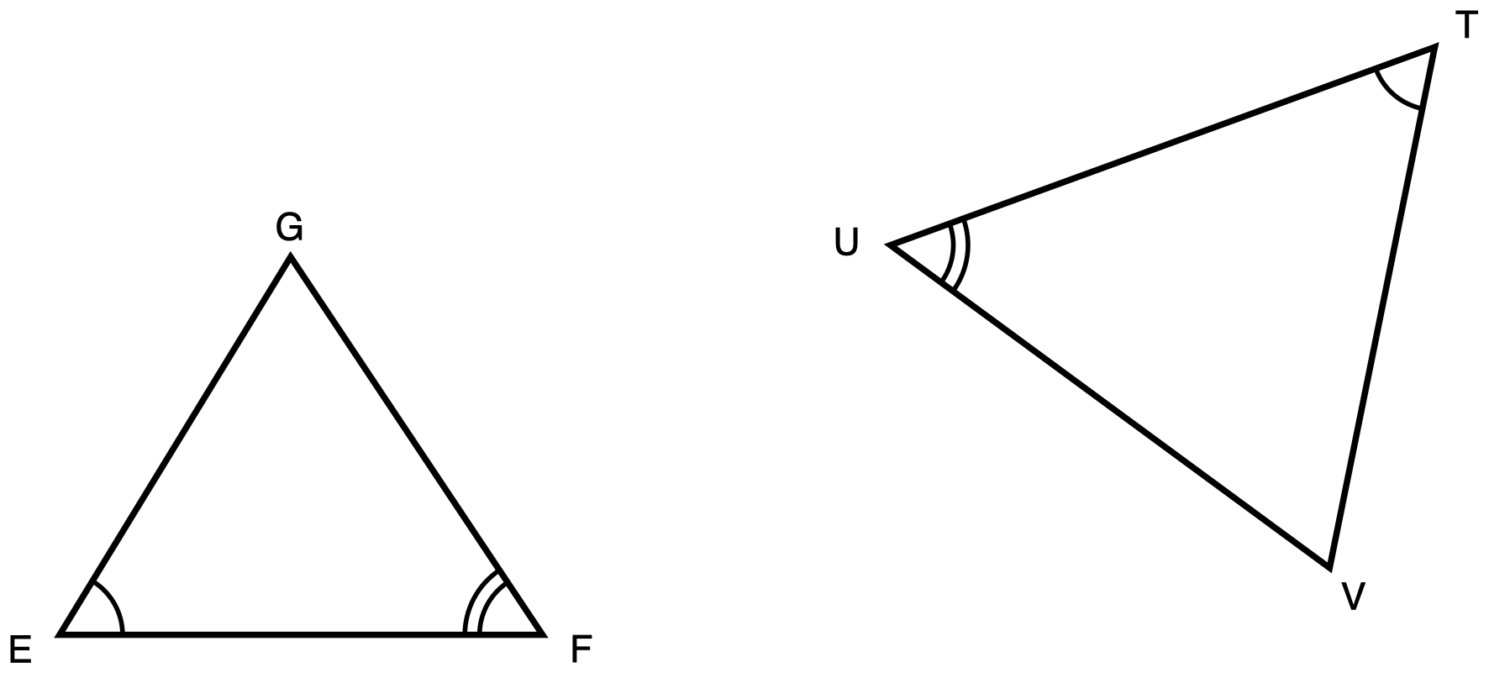
Figure 1. Triangles EFG and TUV, drawn in different orientations, with matching angle arcs.
Description: Triangle EFG sits on the left with side EF horizontal along the bottom and vertex G above it, nearer to F than to E. Triangle TUV sits on the right, larger and turned so that no side of it is horizontal: T is the highest vertex and sits toward the right, U is the leftmost vertex and sits lower than T, and V is the lowest vertex, below T and to its left. Angle E and angle T each carry one arc. Angle F and angle U each carry two concentric arcs. There is no arc at G and none at V, and there is no right angle anywhere. No side length is given anywhere and nothing is marked as unknown.
Triangle EFG and triangle TUV are drawn in different orientations. Angle E and angle T each carry one arc, so those two angles are congruent. Angle F and angle U each carry two arcs, so those two are congruent as well.
Take your correspondence from the arcs, not from where the triangles sit on the page.
Tools for this item: A calculator is allowed and there is nothing here to compute. No ruler and no protractor. No card printing the similarity criteria. No formula sheet or identity card of any kind. No special-triangle reference card. Yours on this item: blank paper, a straightedge, tracing paper and scissors, the straightedge as a drawing edge and never laid along the printed figure. Turning one triangle to face the same way as the other is a good first move.
✋
Record your work in whichever one of these you prefer:

- an annotated diagram, with the correspondence and the reasons written on the figure
- a paragraph
- a two-column statement and reason chain
- a flowchart
- an oral walkthrough at the figure, which I will write down word for word as you give it
(a) Write the similarity statement for these two triangles, with the vertices in corresponding order.

(b) Prove that the two triangles are similar. Name the criterion you used and say why it applies here.
Your work

(c) Name the side of triangle TUV that corresponds to EF.

Item 2 · A triangle cut by a segment
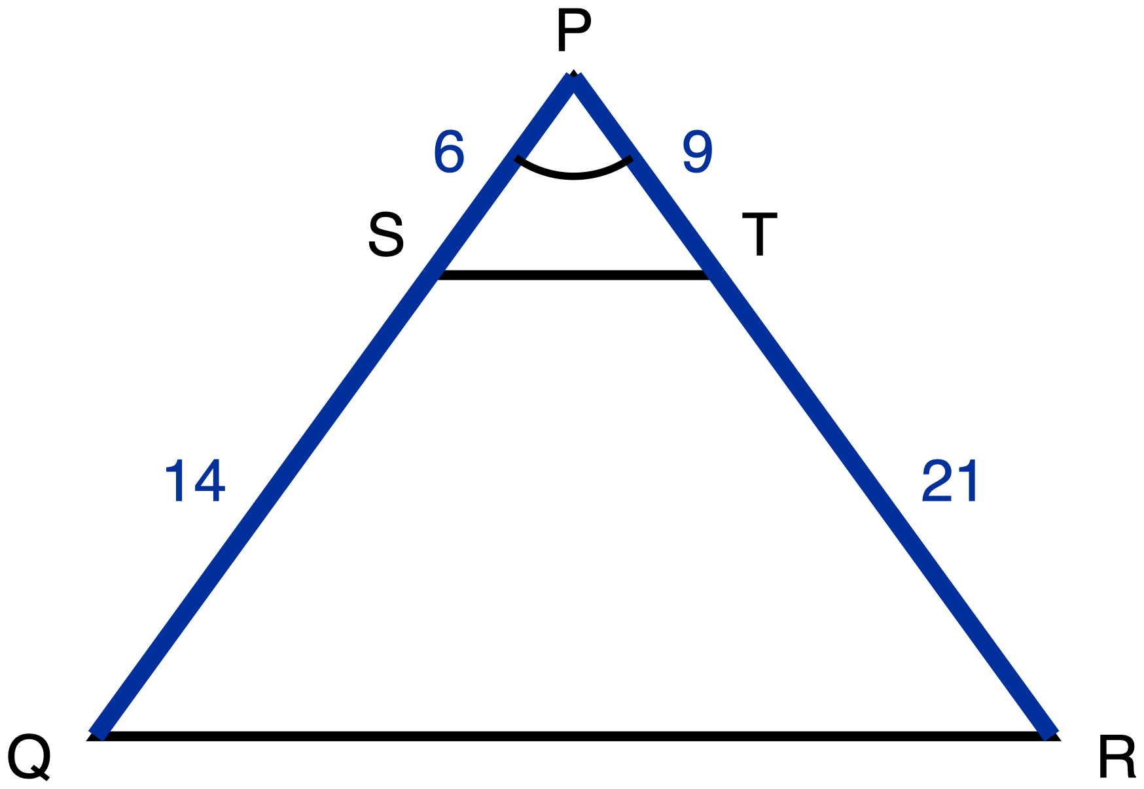
Figure 2. Triangle PQR with S on PQ and T on PR, and the segment ST drawn.
Description: Triangle PQR has vertex P at the top, centred, and side QR horizontal along the bottom with Q at the bottom left and R at the bottom right. S lies on PQ and T lies on PR, both much closer to P than to the base, and S and T are level with each other. The segment ST is drawn across the triangle. On the left side, PS is a given measure of 6 and SQ is a given measure of 14. On the right side, PT is a given measure of 9 and TR is a given measure of 21. QR and ST are drawn plain and carry no numeral. Angle P carries one arc. There is no chevron on ST and none on QR, so the figure does not state that they are parallel. Nothing is marked as unknown.
In triangle PQR, S lies on PQ and T lies on PR, and the segment ST is drawn. PS = 6, SQ = 14, PT = 9 and TR = 21.
Nothing on the figure says that ST is parallel to QR. If your argument needs that, it is something for you to establish, not something you are given.
Tools for this item: A four-function calculator is allowed for the two divisions. No ruler. No card printing the similarity criteria. No formula sheet or identity card of any kind. No special-triangle reference card. Yours on this item: blank paper, a straightedge, tracing paper and scissors, the straightedge never laid along the printed figure.
✋
Same five ways of recording your work as Item 1.

(a) Prove that triangle PST is similar to triangle PQR. Name the criterion you used and say why it applies here.
Your work

(b) Write the ratio ST : QR in simplest form.

Item 3 · Two triangles, one upside down
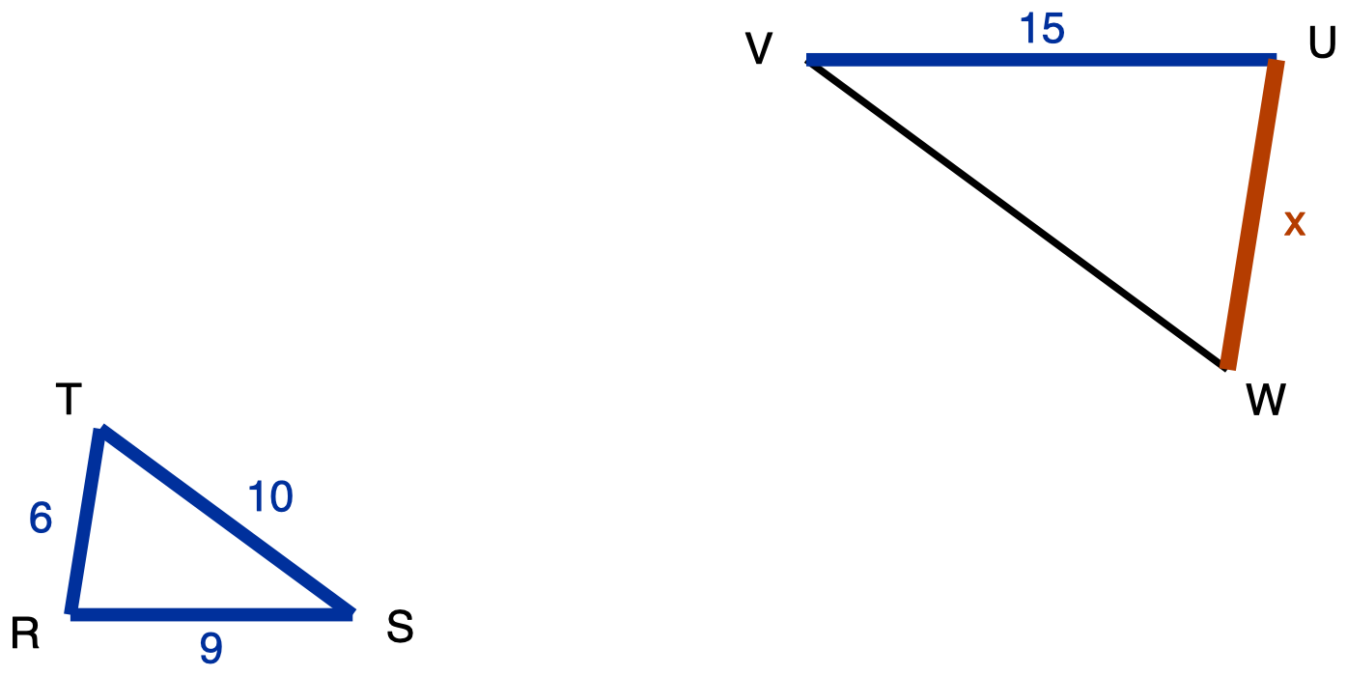
Figure 3. Triangle RST and the larger triangle UVW, drawn upside down relative to it.
Description: Triangle RST is on the left with side RS horizontal along the bottom, R at the bottom left, S at the bottom right, and vertex T above R and only slightly to its right. Its three sides are given measures: RS is 9, ST is 10 and RT is 6. Triangle UVW is on the right, larger and drawn upside down relative to the first, so its horizontal side UV runs along its top rather than its bottom: U is the top right vertex, V is the top left vertex level with U, and W is below and slightly to the left of U. UV is a given measure of 15. VW is drawn plain and carries no numeral. UW is the unknown and is labelled x. No angle is marked anywhere in the figure.
Triangle RST is similar to triangle UVW. In triangle RST, RS = 9, ST = 10 and RT = 6. In triangle UVW, UV = 15. Triangle UVW is drawn upside down relative to triangle RST.
What is the length of UW, marked x on the figure? Choose one.
- A. 10
- B. 12
- C. 13.5
- D. 22.5
Tools for this item: A four-function calculator is allowed. No ruler. No formula sheet or identity card of any kind. No special-triangle reference card. Blank paper and a straightedge are yours as drawing materials, the straightedge never laid along the printed figure.
✋
Write the letter, circle it, point at it, or say it to me.

Item 4 · Sides given out of order
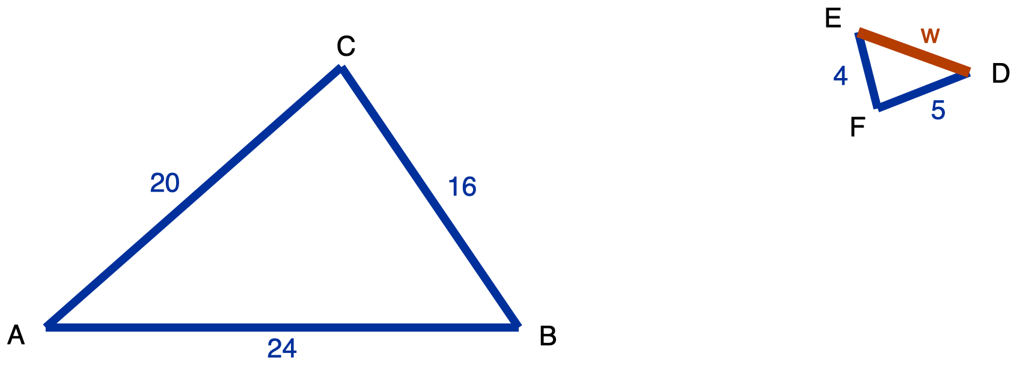
Figure 4. Triangle ABC and the smaller triangle DEF, turned so that no two sides line up.
Description: Triangle ABC is on the left and is large, with AB horizontal along the bottom, A at the bottom left, B at the bottom right, and C above and between them, nearer to B. AB is 24, BC is 16 and AC is 20, all given measures. Triangle DEF is on the right, roughly a quarter the size, and rotated so that none of its sides is horizontal: D is the rightmost vertex and the highest by a little, E is the top left vertex, and F is the bottom vertex, below and between D and E. EF is a given measure of 4 and DF is a given measure of 5. DE is the unknown and is labelled w. No angle is marked in either triangle.
Triangle ABC and triangle DEF are similar. In triangle ABC, AB = 24, BC = 16 and AC = 20. In triangle DEF, EF = 4 and DF = 5.
The side lengths of the second triangle are not listed in the order that matches the first. Work out which side goes with which before you write any ratio. Ask me for a blank three-row table to write your pairs into if you would like one.
Tools for this item: A four-function calculator is allowed. No ruler. No formula sheet or identity card of any kind. No special-triangle reference card. Blank paper and a straightedge are yours as drawing materials, the straightedge never laid along the printed figure.
(a) Write the similarity statement for these two triangles, with the vertices in corresponding order.

(b) Find DE, marked w on the figure.

Item 5 · The tree
There is no figure for this item, and there will not be one. Drawing the situation is part of what is being assessed.
A tree standing on level ground casts a shadow 21 m long. At the same moment, a vertical fence post 1.5 m tall casts a shadow 3.5 m long. The sun's rays reach the tree and the post from the same direction, so the two right triangles formed by the object, its shadow and the ray are similar.
Use as much space and as much paper as you want. If writing is the slow part for you, do your drawing yourself and then tell me the equation and the answer, and I will write those down.
Tools for this item: A four-function calculator is allowed. No diagram is supplied for this item, and none will be. No formula sheet or identity card of any kind. I can read the instructions to you, and I cannot read the situation to you. No special-triangle reference card. Blank paper, a straightedge, tracing paper and scissors are yours; there is no printed figure here, so the straightedge is purely a drawing edge.
Draw both triangles. Write every measurement onto the triangle it belongs to. Then find the height of the tree.
Your work

Item 6 · The survey
No figure for this item either, for the same reason.
From a point N on level ground, the distance to a lamppost L is 45 m and the distance to a bench B is 27 m. A marker P is driven into the ground on the straight line from N to L, 15 m from N. A second marker Q is driven on the straight line from N to B, 9 m from N.
Tools for this item: A four-function calculator is allowed. No diagram is supplied. No formula sheet or identity card of any kind. I can read the instructions to you and not the situation. No special-triangle reference card. Blank paper, a straightedge, tracing paper and scissors are yours; there is no printed figure here, so the straightedge is purely a drawing edge.
(a) Draw the situation and label it.
Your work

(b) Decide whether triangle NPQ is similar to triangle NLB. Name the criterion you used.

(c) The lamppost and the bench are 54 m apart. How far apart are the two markers?

Item 7 · A line parallel to one side
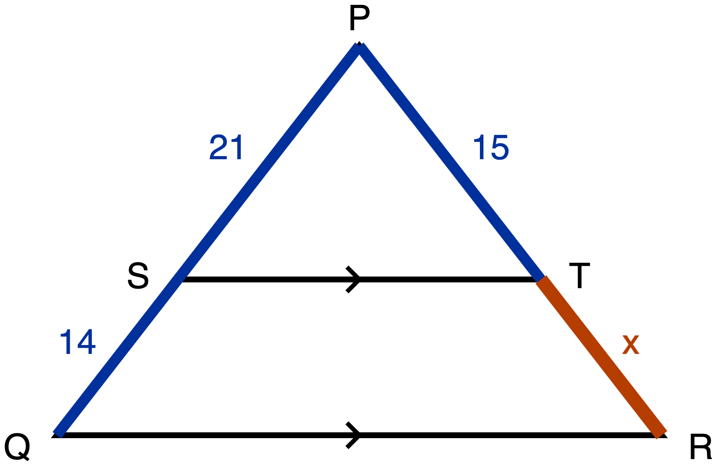
Figure 5. Triangle PQR with ST drawn parallel to QR, and TR unknown.
Description: Triangle PQR has vertex P at the top, centred, and QR horizontal along the bottom with Q at the bottom left and R at the bottom right. S lies on PQ and T lies on PR, level with each other, about three fifths of the way down from the apex, and the segment ST is drawn across the triangle. A single chevron sits at the midpoint of ST and a single chevron sits at the midpoint of QR, marking those two segments parallel to each other. PS is a given measure of 21, SQ is a given measure of 14 and PT is a given measure of 15. TR is the unknown and is labelled x. QR and ST carry no numeral. There is no angle mark anywhere in the figure.
In triangle PQR, S lies on PQ and T lies on PR. The single chevron on ST and the single chevron on QR mark those two segments parallel. PS = 21, SQ = 14 and PT = 15.
A number on its own is not an answer to this item, and that is said here rather than left in a marking scheme: part (a) and part (c) are what is being measured, and part (b) is how you show it working.
Tools for this item: A four-function calculator is allowed. No ruler. No card printing the Triangle Proportionality Theorem. No formula sheet or identity card of any kind. No special-triangle reference card. Blank paper and a straightedge are yours as drawing materials, the straightedge never laid along the printed figure.
✋
Answer in writing, by writing onto the figure, or out loud to me.

(a) Name the theorem that lets you find TR here, and say why it applies to this figure.

(b) Find TR, marked x on the figure.

(c) Write down the proportion you used, and say in one sentence why it is a proportion of ratios and not of differences.

Item 8 · Is it parallel?
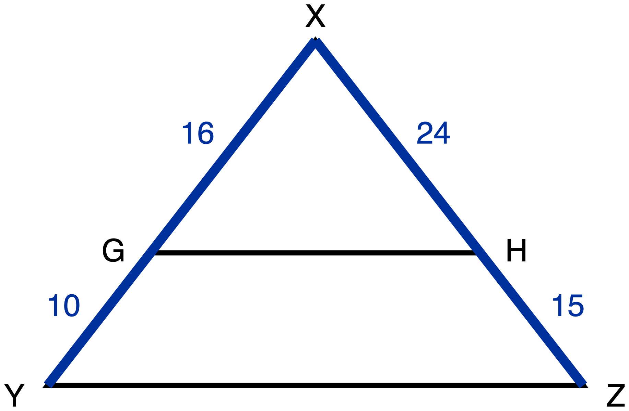
Figure 6. Triangle XYZ with GH drawn across it and nothing marked parallel.
Description: Triangle XYZ has vertex X at the top, centred, and YZ horizontal along the bottom with Y at the bottom left and Z at the bottom right. G lies on XY and H lies on XZ, level with each other, about two thirds of the way down from the apex, and the segment GH is drawn across the triangle. XG is a given measure of 16, GY is a given measure of 10, XH is a given measure of 24 and HZ is a given measure of 15. YZ and GH are drawn plain. There is no chevron on GH and no chevron on YZ, so nothing in the figure asserts that the two segments are parallel. No angle is marked and nothing is marked as unknown.
In triangle XYZ, G lies on XY and H lies on XZ, and the segment GH is drawn. XG = 16, GY = 10, XH = 24 and HZ = 15.
Nothing on this figure is marked parallel. That is the question, not a given.
Tools for this item: A four-function calculator is allowed. No ruler, no protractor and no straightedge. No part heading, no cover page and no earlier item issues you a tool that this item has not. No formula sheet or identity card of any kind. No special-triangle reference card. Blank paper, tracing paper and scissors are yours.
✋
Answer in writing, by writing onto the figure, or out loud to me.

(a) Decide whether GH is parallel to YZ.

(b) Justify your decision: name the theorem you used and show the computation it rests on.
Your work

Item 9 · The three triangles in one figure
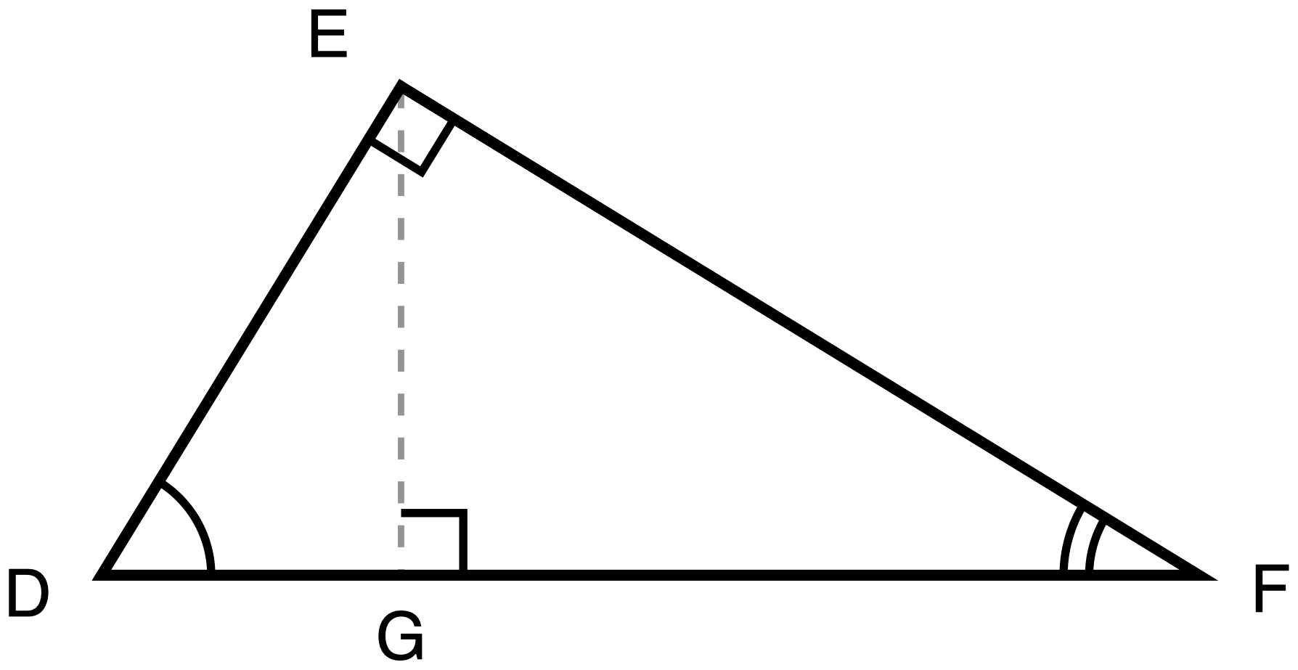
Figure 7. Right triangle DEF with the altitude EG dropped to the hypotenuse DF.
Description: Right triangle DEF has its right angle at E and its hypotenuse DF lying horizontally along the bottom, D at the bottom left and F at the bottom right. E sits above DF, nearer to D than to F. The altitude EG is drawn as a dashed construction line from E straight down to the point G on DF. A right-angle square sits at E between the arms ED and EF, and a second right-angle square sits at G between the arms GE and GF. The angle at D carries one arc and the angle at F carries two concentric arcs, so the arcs mark the two acute angles only. No segment carries a numeral, no length is given, and nothing is marked as unknown.
Right triangle DEF has its right angle at E. EG is the altitude from E to the hypotenuse DF, so EG meets DF at a right angle.
Everything in this item comes from the three similar triangles that the altitude creates. That route is what is being measured, and it is stated here rather than left in a marking scheme.
Tools for this item: A calculator is allowed and there is nothing to compute. Tracing paper, scissors, a second clean copy of the figure and a blank triangle-outline sheet are all yours, and I will offer them to everybody. Not allowed: a set of triangles that has already been separated and lettered for you, a printed list of the relationships between the legs and the hypotenuse segments, or a part-completed proof. No formula sheet or identity card of any kind. No special-triangle reference card. Blank paper and a straightedge are yours as drawing materials, the straightedge never laid along the printed figure.
✋
Answer in writing, by writing onto your own separated triangles, or out loud to me.

(a) Name the three triangles in this figure that are similar to one another.

(b) Write two similarity statements, each one comparing a small triangle to the whole triangle DEF, with the vertices in corresponding order.

(c) From one of your statements in (b), write a proportion which, when you cross-multiply it, gives DE². Say which statement you used.
Your work

Item 10 · Pythagoras, from the similar triangles
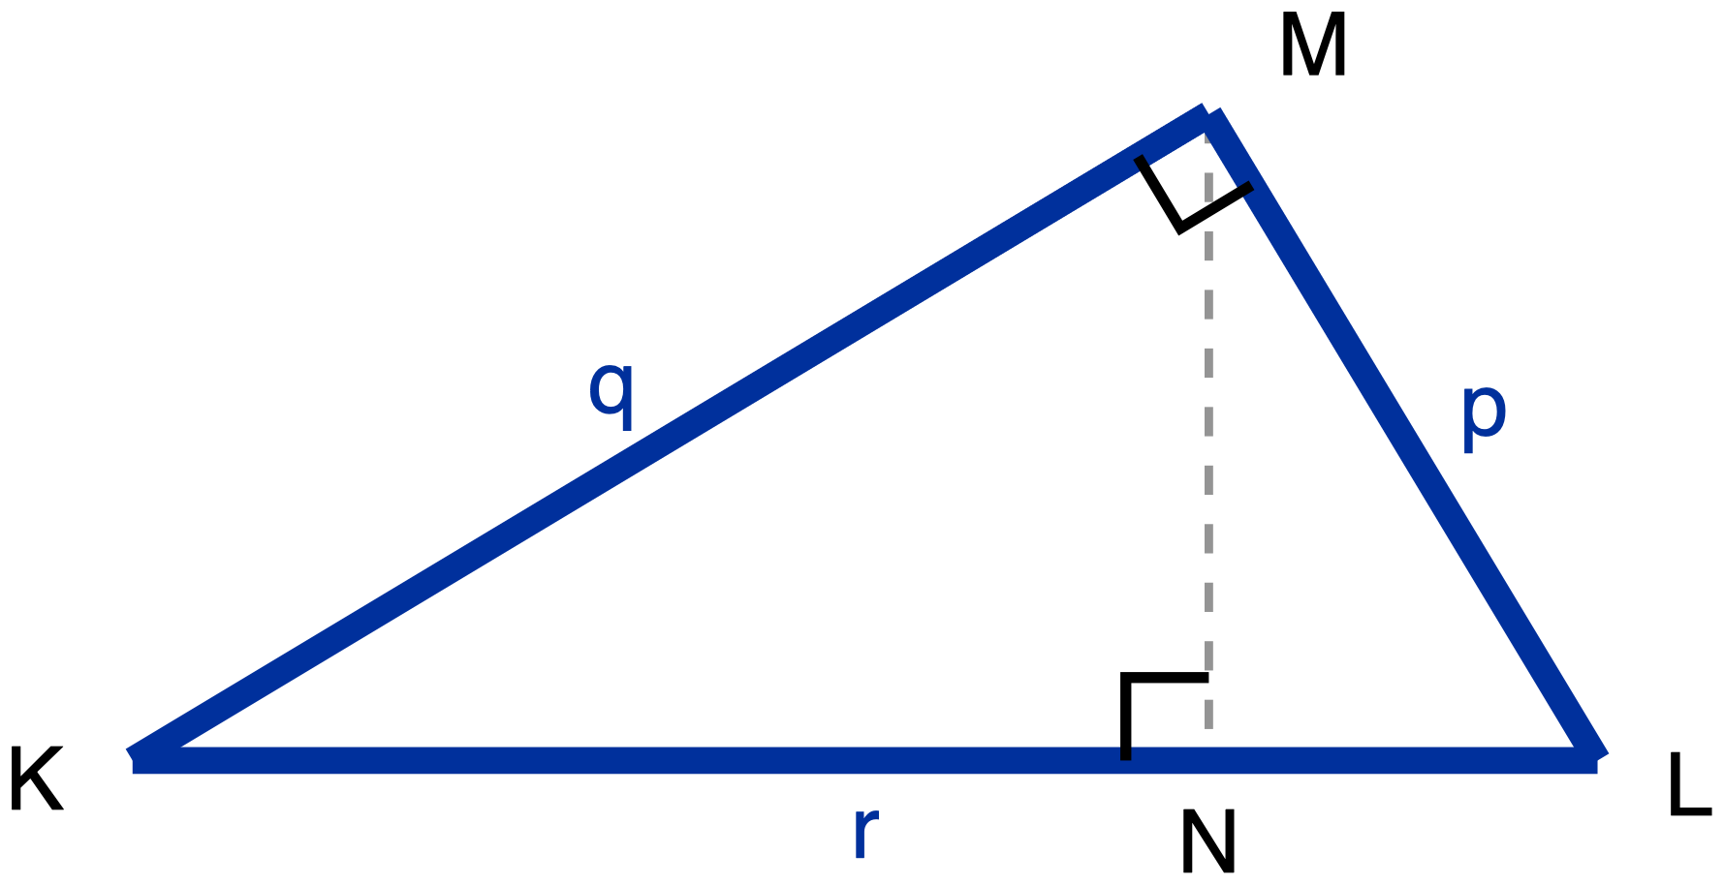
Figure 8. Right triangle KLM, legs p and q, hypotenuse r, with the altitude MN drawn to KL.
Description: Right triangle KLM has its right angle at M and its hypotenuse KL lying horizontally along the bottom, K at the bottom left and L at the bottom right. M sits above KL, nearer to L than to K. The three sides carry letters rather than numbers: LM is labelled p, KM is labelled q, and KL is labelled r. The altitude MN is drawn as a dashed construction line from M straight down to the point N on KL and carries no label. A right-angle square sits at M between the arms MK and ML, and a second right-angle square sits at N between the arms NM and NK. There is no arc anywhere in the figure and nothing is marked as unknown.
Right triangle KLM has its right angle at M. MN is the altitude from M to the hypotenuse KL. Let LM = p, KM = q and KL = r.
Using the three similar triangles formed by the altitude to the hypotenuse, and no other method, prove that p² + q² = r². Your proof has to say why each pair of triangles is similar, not just that it is.
Two things about that instruction, said plainly here so that nothing is hidden in a marking scheme:
- This unit is asking for the similarity route specifically. A proof that cuts the squares up and rearranges the pieces is a real proof of the same theorem, and it is not an answer to this item. If that is the proof you know, write it on the back of the page, and then do this one.
- Your Part A answer to Item 9 stays on the desk and you may look back at it. Item 9 gives you two similarity statements. It does not give you the reasons, and the reasons are what this item is asking for.
Tools for this item: Same as Item 9: a calculator is allowed and there is nothing to compute; tracing paper, scissors, blank outlines and a second copy of the figure are yours. Not allowed: a pre-separated lettered set, a printed list of the altitude relationships, a part-completed proof, or a card printing the Pythagorean statement. No formula sheet or identity card of any kind. No special-triangle reference card. Blank paper and a straightedge are yours as drawing materials, the straightedge never laid along the printed figure.
Present your proof in whichever of the five forms from Item 1 you want.
Your work

Item 11 · Two triangles, one angle
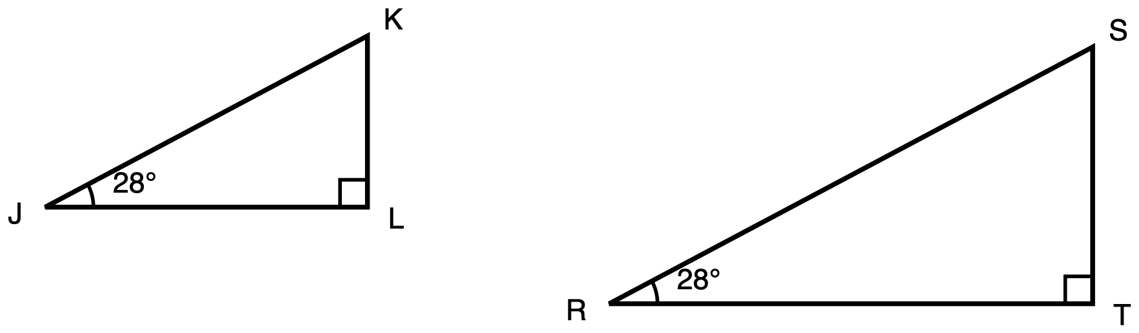
Figure 9. Two right triangles of different sizes, each with a 28 degree acute angle.
Description: Two separate right triangles stand side by side, each with one leg horizontal along its bottom and one leg vertical on its right, the right-hand triangle visibly the larger. In the left triangle, J is the bottom left vertex, L is the bottom right vertex level with J and holds the right angle, and K is directly above L. In the right triangle, R is the bottom left vertex, T is the bottom right vertex level with R and holds the right angle, and S is directly above T. A right-angle square sits at L and another at T. The angle at J carries one arc and is labelled 28 degrees, and the angle at R carries one arc and is labelled 28 degrees. All six sides are drawn plain, no side length is given anywhere, and nothing is marked as unknown.
Triangle JKL has its right angle at L and a 28° angle at J. Triangle RST has its right angle at T and a 28° angle at R. Triangle RST is visibly larger. No side length is given in either triangle.
Tools for this item: A four-function calculator is allowed and there is nothing for it to do. No sin, cos or tan key on any calculator. No printed table of sine, cosine or tangent values. No ruler. No formula sheet or identity card of any kind. No special-triangle reference card. Blank paper and a straightedge are yours as drawing materials, the straightedge never laid along the printed figure.
✋
Answer in writing, by annotating a second copy of the figure, or out loud to me.

Explain why sin 28° has the same value in triangle JKL as it has in triangle RST. Your explanation has to run through similarity, and you are not asked to compute any ratio. No numbers appear in this item other than the two 28s printed on the figure.
Your work

Item 12 · Noor and Theo
No figure for this item, because there is no particular triangle in it.
Noor says: if you multiply every side of a right triangle by 4, you multiply the sine of each of its acute angles by 4.
Theo says: the sine of each acute angle does not change at all.
Part (c) is not a bonus. Saying what changes, in the same answer as what does not, is the point of the item.
Tools for this item: A four-function calculator is allowed and there is nothing for it to do. No sin, cos or tan key and no printed value table. Blank paper and a straightedge are yours if you would like to draw a triangle to think with. No formula sheet or identity card of any kind. No special-triangle reference card.
✋
Answer in writing, in a two-column "changes / does not change" table with your reason written underneath it, or out loud to me. Ask if you want the blank table.

(a) Who is right?

(b) Give the reason, using similarity.
Your work

(c) Name one quantity in that triangle that does get multiplied by 4, and one that does not change.

Item 13 · The same triangle, from each of its acute angles
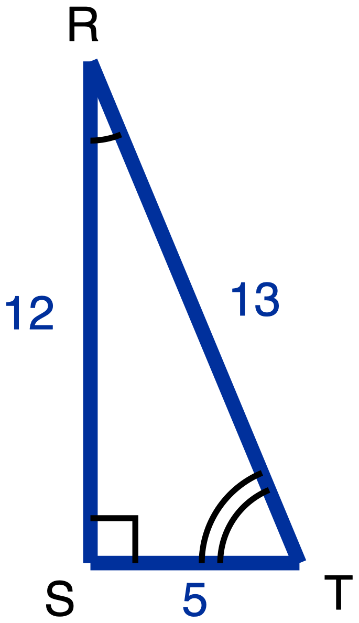
Figure 10. Right triangle RST with legs 12 and 5 and hypotenuse 13.
Description: Right triangle RST is tall and narrow, with its right angle at S, the bottom left vertex. RS is the vertical leg on the left, running up from S to R, the highest point, and is a given measure of 12. ST is the horizontal leg along the bottom, running right from S to T, and is a given measure of 5. RT is the hypotenuse, running from R down to the right to T, and is a given measure of 13. A right-angle square sits at S. The angle at R carries one arc and the angle at T carries two concentric arcs, so the arcs mark the two acute angles only. Nothing is marked as unknown.
Right triangle RST has its right angle at S, with RS = 12, ST = 5 and RT = 13.
Tools for this item: A four-function calculator is allowed, though both answers are fractions. No copy of this triangle with the legs already labelled "opposite" and "adjacent" for either angle. No printed table of sine, cosine or tangent values, and no definition card. Tracing paper you may turn is yours. No formula sheet or identity card of any kind. No special-triangle reference card. Blank paper and a straightedge are yours as drawing materials, the straightedge never laid along the printed figure.
✋
Answer in writing, by writing the names onto your own copies of the figure, or out loud to me.

(a) Relative to angle R, name the opposite leg, the adjacent leg and the hypotenuse. Then write tan R as a fraction.

(b) Do the same relative to angle T: name the opposite leg, the adjacent leg and the hypotenuse, then write tan T as a fraction.

(c) In one sentence, say why two of those three names change between (a) and (b) and one of them does not.

Item 14 · Half a square
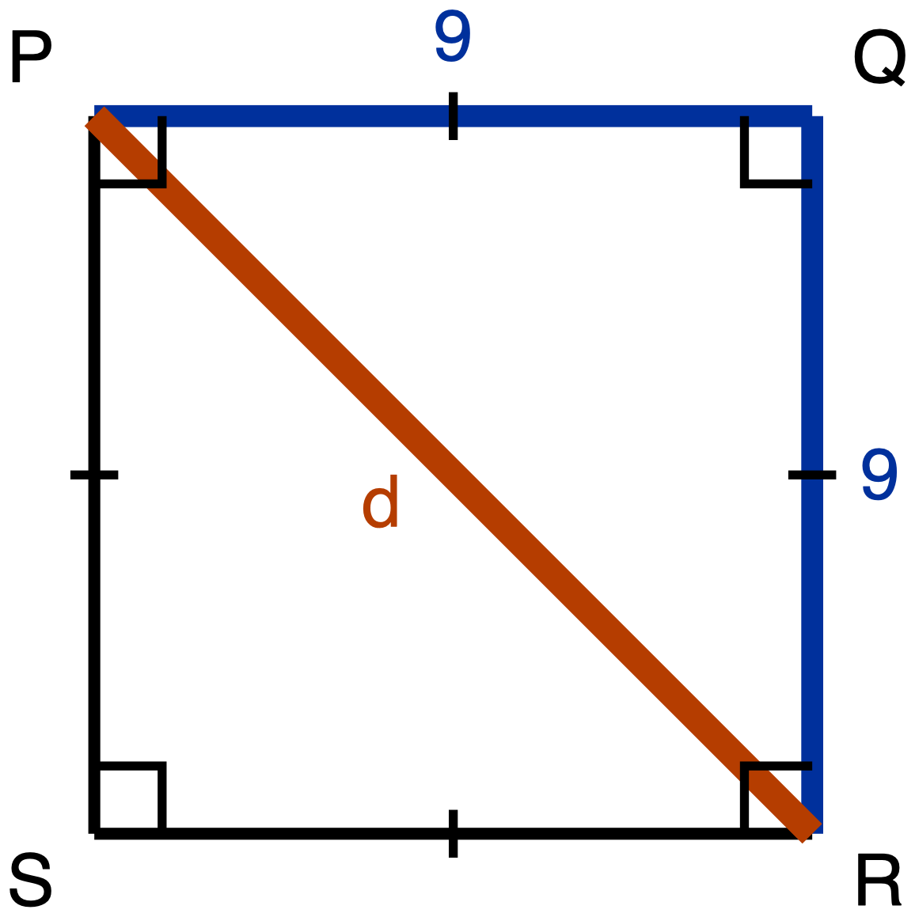
Figure 11. Square PQRS of side 9 with the diagonal PR drawn.
Description: Square PQRS is drawn with its sides vertical and horizontal and is lettered clockwise from the top left: P is the top left corner, Q the top right, R the bottom right and S the bottom left. PQ is the top side, a given measure of 9, and QR is the right side, a given measure of 9. RS and SP are drawn plain and carry no numeral. A single tick sits at the midpoint of each of the four sides, marking all four congruent to one another. A right-angle square sits at each of the four corners. The diagonal PR runs from the top left corner down to the bottom right corner and is the unknown, labelled d; it passes through the corner of the right-angle mark at P and again through the one at R, so each of those two right angles is drawn as split by the diagonal, and nothing marks the two parts of a split corner as congruent to each other.
Square PQRS has side length 9, and its diagonal PR is drawn.
The route this item requires is the square's own properties and the Pythagorean Theorem. Your argument has to say what the square tells you about angle PQR and about the lengths PQ and QR, and it has to use the Pythagorean Theorem to reach PR. Writing down "45-45-90, so 1 : 1 : √2" from memory is not an answer to this item, because what is being asked for is where those values come from. That requirement is stated here rather than left in a marking scheme, so you know it before you start.
Tools for this item: No calculator. No special-triangle reference card. No formula sheet or identity card of any kind. Straightedge, blank paper, tracing paper and scissors are yours, and redrawing triangle PQR on its own, away from the square, is a good first move.
✋
Same five ways of recording your derivation as Item 1.

(a) Derive the three angle measures and the three side lengths of triangle PQR. Give the side lengths in exact form, which means a radical where one is needed and not a decimal approximation.
Your work

(b) Write the ratio PQ : QR : PR in simplest form.

Item 15 · Half an equilateral triangle
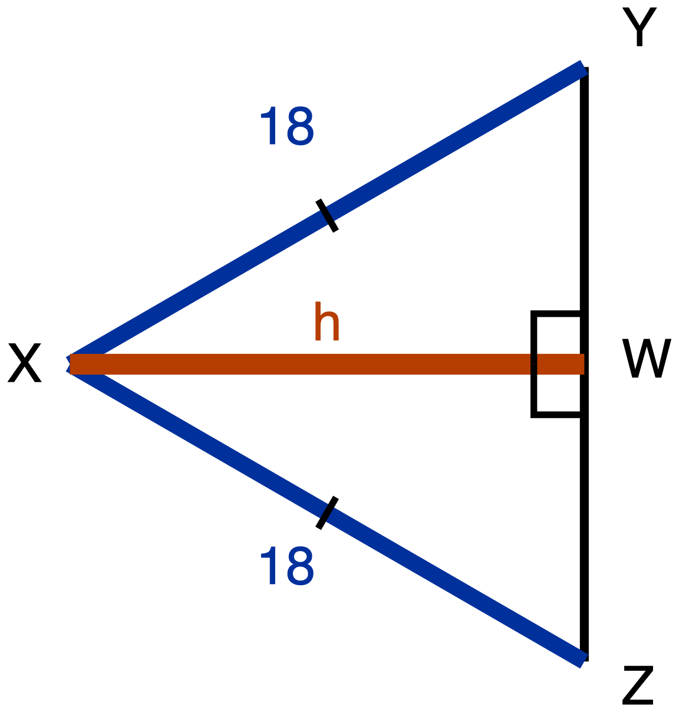
Figure 12. Equilateral triangle XYZ of side 18 with XW drawn from X to YZ.
Description: Equilateral triangle XYZ is drawn on its side and pointing left, with the side YZ upright on the right, Y at the top right and Z at the bottom right directly below Y, and the apex X out to the left, level with the middle of YZ. A segment runs horizontally from X across to the point W on YZ. XY is the upper slant side and XZ is the lower slant side; each is a given measure labelled 18, and each carries a single tick marking the two congruent. YZ is drawn plain and carries no numeral and no tick, and neither YW nor WZ carries a tick, so nothing in the figure states where W sits along YZ. XW is the unknown and is labelled h. Two right-angle squares sit at W, one above XW and one below it, marking angle XWY and angle XWZ as right angles. There is no arc at X, at Y or at Z.
Equilateral triangle XYZ has side length 18. The segment XW runs from X to the point W on YZ, and it meets YZ at a right angle.
The route this item requires is the equilateral triangle's own altitude. Before any arithmetic, your argument has to answer both of these:
- What does XW do to angle X?
- What does XW do to side YZ?
Nothing on the figure tells you where W sits along YZ. That is something to establish, not something given. Then use the Pythagorean Theorem to reach XW.
Tools for this item: No calculator. No special-triangle reference card. No formula sheet or identity card of any kind. Straightedge, blank paper, tracing paper and scissors are yours.
✋
Same five ways of recording your derivation as Item 1. Part (c) may be a sentence, a written comparison of the two numbers, or said aloud to me.

(a) Derive the three angle measures and the three side lengths of triangle XYW. Give the side lengths in exact form.
Your work

(b) Write the ratio YW : XW : XY in simplest form.

(c) In your simplified ratio, one of the two larger numbers is the hypotenuse's. Say which one, and state in one sentence how you know, without using a calculator.

Hand Part A in before you take Part B.

Part B · Using the ratios, and building the triangle yourself

Part B · Items 16 to 23
Eight items. Each one states its own tools, and this line rules on none of them.
✋
The special-triangle reference card is issued with this part and will be collected at the end of it, along with the paper.

Item 16 · A 30-60-90 triangle
A 30-60-90 triangle has hypotenuse 18.
Which pair gives its shorter leg and its longer leg, both in exact form? Exact form means a radical where one is needed, not a decimal approximation. Choose one.
- A. shorter leg 9, longer leg 9√2
- B. shorter leg 9√3, longer leg 9
- C. shorter leg 9, longer leg 15.59
- D. shorter leg 9, longer leg 9√3
Tools for this item: The special-triangle reference card is allowed on this item, and is issued for it. No calculator. No formula sheet or identity card of any kind.
✋
Write the letter, circle it, point at it, or say it to me.

Item 17 · Both directions
Tools for this item: The special-triangle reference card is allowed on this item, and is issued for it. No calculator. No formula sheet or identity card of any kind. The card gives you the ratio; deciding which direction to run it in each part is yours.
✋
Write your answers, write them onto a blank triangle outline if you would rather (ask and I will give you one), or say them to me and I will write them down.

(a) A 45-45-90 triangle has hypotenuse 16. Give the length of each leg in exact form.

(b) A 45-45-90 triangle has legs of length 11. Give its hypotenuse in exact form.

Item 18 · Find the leg
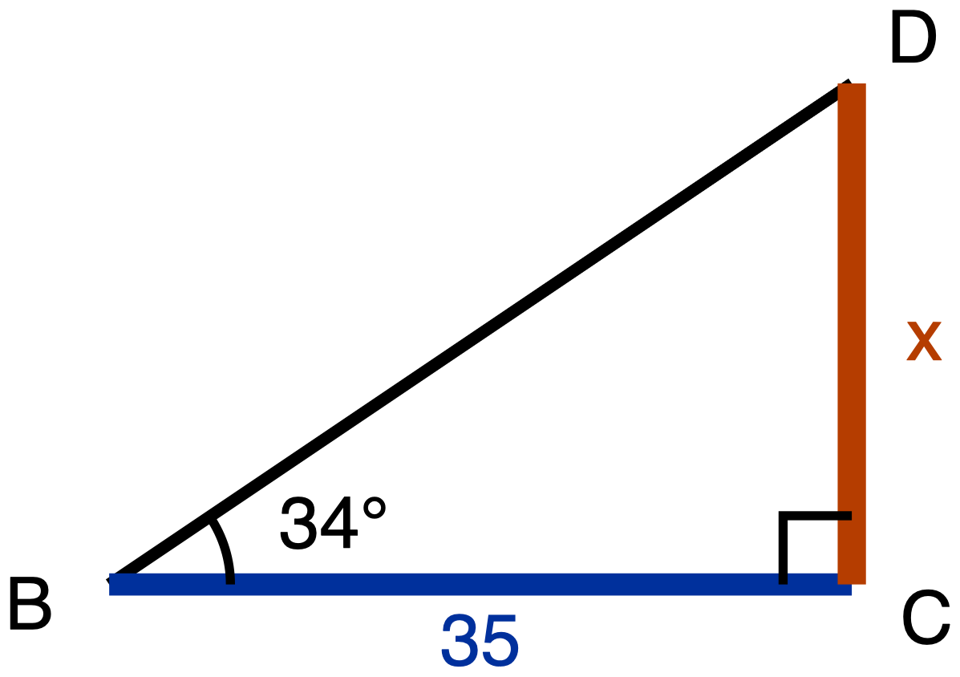
Figure 13. Right triangle BCD with a 34 degree angle at B and BC given as 35.
Description: Right triangle BCD has its right angle at C. BC is the horizontal leg along the bottom, with B at the bottom left and C at the bottom right, and is a given measure of 35. CD is the vertical leg on the right, running upward from C to D, the highest point, and it is the unknown, labelled x. BD is the hypotenuse, running from B up to D, drawn plain and carrying no numeral. A right-angle square sits at C between the arms CB and CD. The angle at B carries one arc and is labelled 34 degrees. There is no mark at D.
Right triangle BCD has its right angle at C. The angle at B is 34°, and BC = 35.
Tools for this item: A scientific calculator with sine, cosine and tangent is allowed and you will need one. A printed table of tangent values is equally allowed if you would rather use one. The special-triangle reference card is allowed on this item and has nothing to offer here: 34° is not a special angle. No copy of this triangle with the legs already labelled "opposite" and "adjacent". No formula sheet or identity card of any kind.
Find CD, marked x on the figure, to the nearest tenth. Write the equation you used as well as the answer.
Your work

Item 19 · Two legs, two tangents
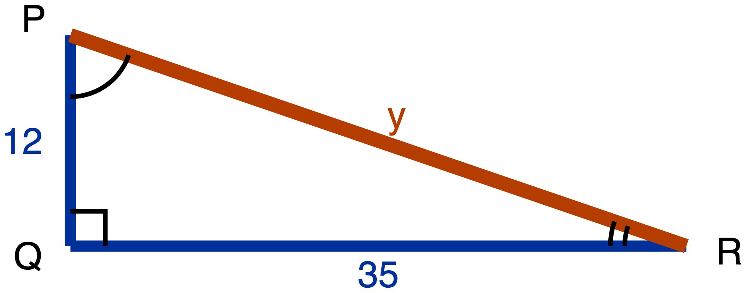
Figure 14. Right triangle PQR with legs 12 and 35 and the hypotenuse unknown.
Description: Right triangle PQR is long and low, with its right angle at Q, the bottom left vertex. PQ is the short vertical leg on the left, running up from Q to P a little above it, and is a given measure of 12. QR is the long horizontal leg along the bottom, running far to the right from Q to R, and is a given measure of 35. PR runs from P down to the right to R; it is the unknown and is labelled y. A right-angle square sits at Q between the arms QP and QR. The angle at P carries one arc and the angle at R carries two concentric arcs, so the arcs mark the two acute angles only.
Right triangle PQR has its right angle at Q, with PQ = 12 and QR = 35.
Tools for this item: A four-function or scientific calculator is allowed for the square root. The sine, cosine and tangent keys are allowed. The special-triangle reference card is allowed on this item and does not apply: this is not a special triangle. No copy of this triangle with the legs already labelled for either angle. No formula sheet or identity card of any kind.
(a) Find PR, marked y on the figure.

(b) Write tan P and tan R, each as a fraction in lowest terms.

Item 20 · The deer
No figure for this item, and there will not be one. Drawing the situation is part of what is being assessed.
A ranger stands at the edge of a lookout, 54 m above the floor of a valley, and sights a deer out on the valley floor. The angle of depression of her line of sight is 31°.
Tools for this item: A scientific calculator or a printed tangent table is allowed and you will need one of them. The special-triangle reference card is allowed on this item and has nothing to offer: 31° is not a special angle. No diagram is supplied for this item, and none will be. No poster, worked example or display showing where an angle of depression sits. No formula sheet or identity card of any kind. I can read the instructions to you, and I cannot read the situation to you.
(a) Draw the situation. Your drawing must show the horizontal line that the angle of depression is measured from.
Your work

(b) Find the horizontal distance from the foot of the lookout to the deer, to the nearest metre.

(c) There is an angle at the deer's position that also measures 31°. Name it, and say why it must be equal to the angle of depression.
Your work

Item 21 · The water tower
No figure for this item either, for the same reason.
Marisol is 1.68 m tall and her eyes are 1.55 m above the ground. Standing on level ground, 72 m from the foot of a water tower, she measures the angle of elevation to the top of the tower as 29°.
Your drawing must show Marisol as a vertical segment from the ground up to her eyes, with the triangle sitting on top of it.
Tools for this item: A scientific calculator or a printed tangent table is allowed and you will need one. No diagram is supplied. The special-triangle reference card is allowed on this item and has nothing to offer: 29° is not a special angle. No card, prompt or display about what to do with the observer's height. No formula sheet or identity card of any kind. Instructions read aloud yes, situation read aloud no, same as Item 20.
Find the height of the tower, to the nearest tenth of a metre.
Your work

Item 22 · The chimney, from the same spot
No figure, same reason.
Without moving, Marisol turns and sights the top of a chimney 58 m away. The angle of elevation of her line of sight to the top of the chimney is 24°.
Tools for this item: As Item 21: a scientific calculator or a tangent table, no supplied diagram, no card or prompt about the observer's height, no formula sheet or identity card of any kind, instructions read aloud but not the situation. The special-triangle reference card is allowed on this item and has nothing to offer: 24° is not a special angle.
(a) How much higher than Marisol's eyes is the top of the chimney? Give your answer to the nearest tenth of a metre.
Your work

(b) Does her eye height of 1.55 m matter for the quantity part (a) asked you for? Answer yes or no, and give the reason from your own drawing.

Item 23 · The balloon
No figure, same reason.
A balloon hovers 90 m directly above a post on level ground. From the balloon, the angle of depression to a shed on the same ground is 40°.
Part (c) can be done without part (b). If your part (b) went wrong, part (c) is still worth doing, and it will be marked on its own.
Tools for this item: As Item 20: a scientific calculator or a tangent table, no supplied diagram, no poster or worked example showing the placement of an angle of depression, no formula sheet or identity card of any kind, instructions read aloud but not the situation. The special-triangle reference card is allowed on this item and has nothing to offer: 40° is not a special angle.
(a) Draw the situation, showing the horizontal that the angle is measured from.
Your work

(b) Find the distance along the ground from the post to the shed, to the nearest metre.

(c) Find the straight-line distance from the balloon to the shed, to the nearest metre. Say which of the two methods available to you you used, and say why the Pythagorean Theorem is available to you here.
Your work

Hand Part B in, and hand back anything Part B's own items issued you, before you take Part C.

Part C · Sine, cosine, and complements

Part C · Items 24 to 28
Five items. Each one states its own tools, and this line rules on none of them.

Item 24 · Which side does the work
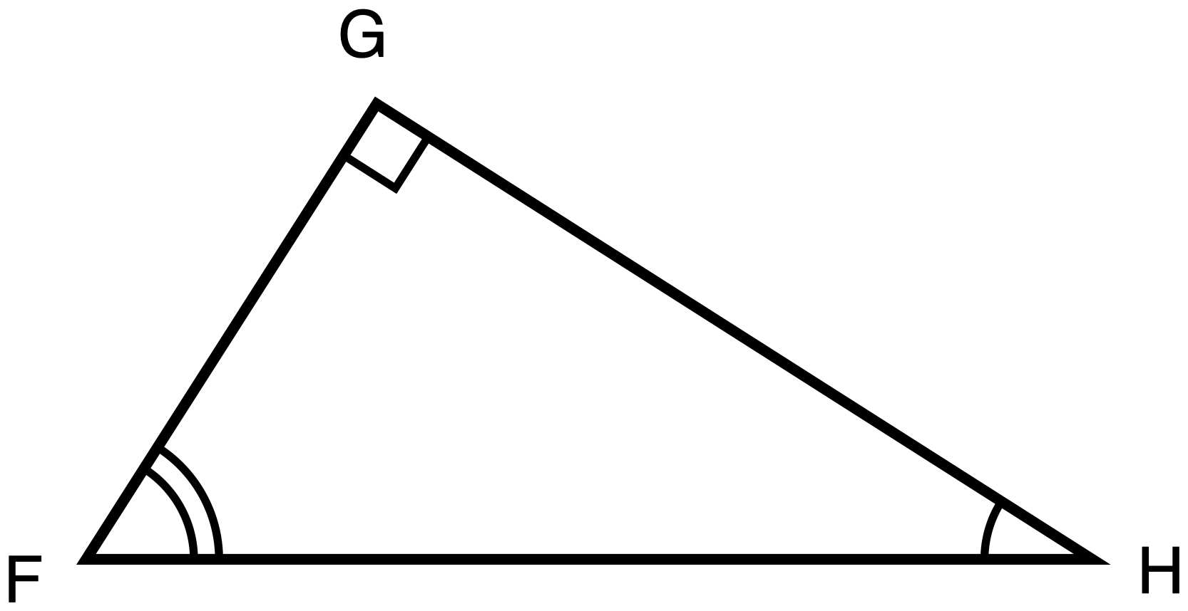
Figure 15. Right triangle FGH, resting on its hypotenuse, with no measures given.
Description: Right triangle FGH rests on its hypotenuse: FH is horizontal along the bottom, F at the bottom left and H at the bottom right a long way from it. G sits above the segment FH and holds the right angle; it is nearer to F than to H and is the highest point. Neither leg is horizontal and neither is vertical: FG is the shorter leg, slanting up to the right from F to G, and GH is the longer leg, slanting down to the right from G to H. The right angle at G carries a small square set square to the two legs rather than to the page. The angle at H carries a single arc and the angle at F carries two concentric arcs, so the arcs mark the two acute angles only, and the angle at F is drawn visibly the larger of the two. All three sides are drawn plain, no numeral appears anywhere, and nothing is marked as unknown.
Right triangle FGH has its right angle at G. The hypotenuse FH lies along the bottom of the figure, so neither of the two legs is flat and neither is upright.
Tools for this item: A calculator is allowed and will not help you: there is not a single number in this item. No table of sine and cosine values. No formula sheet or identity card printing the relationship between sine and cosine. No special-triangle reference card. Redrawing the figure in a familiar orientation on your own scrap paper is permitted and is a good first move.
✋
Answer in writing, by annotating a second copy of the figure (ask and I will give you one), or out loud to me, and I will write it down word for word.

(a) Name the one side of this triangle that is opposite angle H and is also adjacent to angle F. Then say in one sentence why a single side can play both of those roles.
Your work

(b) Use your answer to (a) to explain why sin H = cos F. Write each of them as a fraction of two named sides.
Your work

(c) Amara says the answer to (b) is really that sin H = cos G, because G is the other angle named in the triangle. Give one reason Amara's equation cannot be right.

Item 25 · Which equation is always true
In right triangle RST, the right angle is at S.
Which one of these is true for every triangle of that kind? Choose one.
- A. sin R = sin T
- B. sin R = cos T
- C. tan R = tan T
- D. sin R = cos S
Tools for this item: No calculator with sine, cosine or tangent keys. A four-function calculator is allowed and has nothing to do here. No table of sine and cosine values. No special-triangle reference card. No formula sheet or identity card printing the relationship between sine and cosine.
✋
Write the letter, circle it, point at it, or say it to me. If it helps, ask me for a blank right-triangle outline with R, S and T already lettered on it.

Item 26 · Solving for x
For some value of x, cos(6x + 5)° = sin(4x + 15)°, and both (6x + 5)° and (4x + 15)° are acute angles.
Part (a) is required and is not a warm-up: the equation has to come from a stated fact about the two angles, not from a remembered template. You may dictate your sentence and your equation and I will write them down.
Tools for this item: A four-function or scientific calculator is allowed for the arithmetic. No graphing calculator and no equation solver. No table of sine and cosine values is supplied. No formula sheet or identity card printing the relationship between sine and cosine. No special-triangle reference card.
(a) Write one sentence saying how those two angle measures are related to each other. Then write the equation that sentence gives you.

(b) Solve your equation for x.

(c) Give both angle measures, and check that they really can be the two acute angles of one right triangle.

Item 27 · Solving for w
Solve for w:
✋
cos 38° = sin(w + 17°), where (w + 17)° is an acute angle.

Before you write any equation, write down in words the step where you use the relationship between sine and cosine. Then solve, and check that (w + 17)° really is acute.
Tools for this item: No calculator with sine, cosine or inverse keys. A four-function calculator is allowed; the arithmetic here is 90 − 38 and then 52 − 17. No table of sine and cosine values. No formula sheet or identity card printing the relationship between sine and cosine. No special-triangle reference card.
Write the relationship step in words, then solve, then run the check.
Your work

Item 28 · From one ratio to its partner
In right triangle PQR, the right angle is at R, and sin P = 8/17.
Do not compute a third side, and do not compute any ratio from any triangle. The route being measured in (a) is the relationship between an angle and its complement, and that restriction is stated here rather than left in a marking scheme.
Tools for this item: No calculator with sine, cosine or inverse keys. A four-function calculator is allowed and you will not need it. No table of sine and cosine values. No formula sheet or identity card printing the relationship between sine and cosine. No special-triangle reference card.
✋
Answer in writing, out loud to me, or by writing the angle names and the value onto a blank lettered triangle outline with one phrase giving your reason. Ask if you want the outline.

(a) Give the value of cos Q, and say in one sentence how you know.

(b) Jonah says cos R is also 8/17. Give one reason he cannot be right.

End of the practice exam.

