Similarity to Right-Triangle Trigonometry, Teacher Edition

Similarity to Right-Triangle Trigonometry
Teacher Edition. A two-week grade 9-10 geometry unit covering CCSS-M HSG-SRT.B.4, B.5, C.6, C.7 and C.8. Ten lessons, three quizzes, a final exam and a parallel-form practice exam, with answer keys and per-distractor rationales.
✋
Similarity comes first and the Pythagorean Theorem is its payoff. Days 1 to 4 build the similarity criteria; Day 5 derives Pythagoras from the altitude-to-hypotenuse configuration. No current textbook surveyed proves it this way in the lesson that introduces the theorem, so a unit taught in the conventional order can satisfy every computational demand of B.4 and never actually meet the standard.

✋
Tool policy is set per item, never per paper. Do not issue a formula sheet for the whole exam: on the complementary-angle items the relationship sin(theta) = cos(90 - theta) IS what is being measured, so a shared sheet answers those items for the student. Each item states what is permitted on it.

Licensed CC BY 4.0. Everything here is original expression written from the standard text.

Day 1: Scaling and the Additive Trap

Standard: HSG-SRT.B.5, use similarity and congruence criteria to solve and prove. Day 1 is the prerequisite day for that standard: it builds the proportional reasoning the similarity criteria depend on, and it is not itself a graded B.5 day. The full statement of the standard is set down in Day 2, the first day that teaches a similarity criterion.
Learning goal: Students decide whether two triangles are similar by comparing corresponding sides multiplicatively, and can say what the comparison shows about the sides and about the angles.
Duration: One 50-minute period. The phase table sums to exactly 50 minutes. Each phase's minutes include its own transition, and there is no unallocated buffer.
Materials: The student handout (Task 1, Task 2, Task 3 and the exit ticket), Figure 1 and Figure 2 printed or projected, board space wide enough to hold the two chains side by side for the whole lesson, four-function calculators.
Barrier this day removes: The additive-scaling intuition: that making a figure bigger means adding a constant to every side.
✋
Nothing on Day 1 names AA, SAS or SSS similarity. Day 1 buys one thing: the student stops reaching for subtraction when asked whether one figure is a scaled copy of another. Every criterion in Days 2 to 4 is unusable until that reach is broken.

Phase sequence at a glance
# | Phase | Minutes
1 | Two claims on trial | 7
2 | Run both rules three steps | 13
3 | The angle question | 6
4 | Run the comparison | 13
5 | Synthesis | 5
6 | Exit ticket | 6

Total: 7 + 13 + 6 + 13 + 5 + 6 = 50 minutes. If a phase runs long it borrows from the phase after it. The one thing to cut, if you must cut, is named in the answer key.

Running the phases

Pose the question: making a triangle bigger without changing its shape, what exactly do you do to the sides? Take two answers from the room and write both on the board as named student claims, not as options you are offering.
- Rule A. Add the same amount to every side.
- Rule B. Multiply every side by the same number.
Do not indicate which is right. Transition, last 2 minutes: hand out the student sheet and both figures while the two claims stay on the board.

Task 1, parts (a) and (b). The class works from Figure 1, which is Rule A applied twice, and Figure 2, which is Rule B applied twice, and continues each chain one more step on paper. Hold the verdict until the third step is on the board.
Rule A's triangles are 4-6-8, then 7-9-11, then 10-12-14, then 13-15-17; the widest angle closes 104°, 86°, 78°, and keeps closing. Rule B's are 4-6-8, then 6-9-12, then 9-13.5-18, then 13.5-20.25-27; the widest angle stays 104° forever.
Transition, last 2 minutes: the two chains go up on the board side by side and stay there for the rest of the lesson.
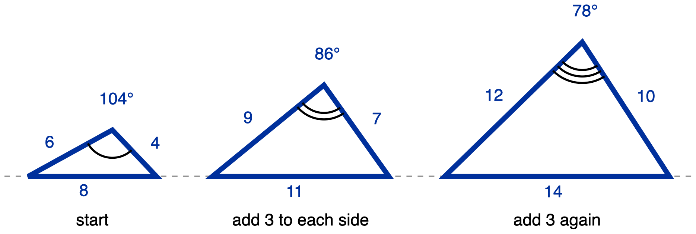
Figure 1. Rule A, add 3 to every side: 4-6-8, then 7-9-11, then 10-12-14.
Description: Three triangles stand on one grey dashed horizontal reference line, all drawn to the same scale and growing from left to right. Each triangle's longest side is its horizontal base sitting on that line, and the apex is above the base, nearer the right base vertex than the left, because the shortest side is the one on the right. No vertex letters are used. Left triangle: base 8, left side 6, right side 4. Middle triangle: base 11, left side 9, right side 7. Right triangle: base 14, left side 12, right side 10, so every side of each triangle is 3 longer than the matching side of the triangle before it. All nine lengths are given; there is no unknown, and the dashed line carries no measure. Only the apex angle of each triangle is marked, and none of them is a right angle: the left apex carries one arc labelled 104 degrees, the middle apex carries two concentric arcs labelled 86 degrees, and the right apex carries three concentric arcs labelled 78 degrees. The three different arc counts state that the three marked angles are not congruent to one another; no congruence or similarity relationship is claimed anywhere in the figure. Captions under the triangles, left to right: start, add 3 to each side, add 3 again.
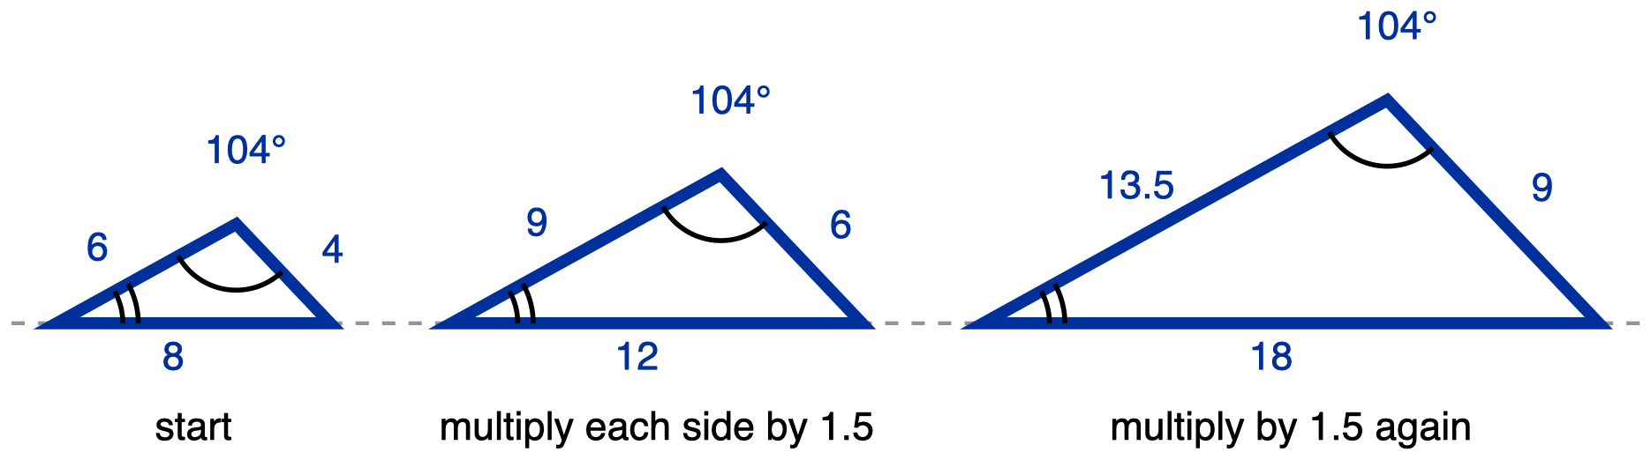
Figure 2. Rule B, multiply every side by 1.5: 4-6-8, then 6-9-12, then 9-13.5-18.
Description: Three triangles stand on one grey dashed horizontal reference line, all drawn to the same scale and growing from left to right. Each triangle's longest side is its horizontal base sitting on that line, and the apex is above the base, nearer the right base vertex than the left, because the shortest side is the one on the right. No vertex letters are used. Left triangle: base 8, left side 6, right side 4. Middle triangle: base 12, left side 9, right side 6. Right triangle: base 18, left side 13.5, right side 9, so every side of each triangle is 1.5 times the matching side of the triangle before it. All nine lengths are given; there is no unknown, and the dashed line carries no measure. Two angles are marked in each triangle and neither is a right angle. The apex angle carries one arc in all three triangles and is labelled 104 degrees in all three. The angle at the left base vertex, the smallest angle in each triangle, carries two concentric arcs in all three triangles and is not labelled with a measure. The angle at the right base vertex is not marked. Because one arc appears at all three apexes those three angles are congruent, and because two arcs appear at all three left base vertices those three angles are congruent; the third angle of each triangle then follows from the angle sum, so all three triangles have the same three angles. Captions under the triangles, left to right: start, multiply each side by 1.5, multiply by 1.5 again.

Ask what happened to the angles under each rule, and make the class answer out loud rather than nodding. Under Rule A the widest angle moved twice. Under Rule B it did not move at all. This is the half of the misconception that Task 3 will test and that most lessons skip.
Transition, last 1 minute: name what the class has just established as the day's tool, in one sentence: shape is kept by one shared multiplier, and the angles are the tell.

Task 2, all three pairs required, then Task 3, the correspondence table. Students work in pairs, writing the comparison before the verdict. Circulate against the watch-for list later in this plan.
Transition, last 2 minutes: collect nothing; ask two pairs to have their Task 2 pair (iii) answer ready to say aloud.

Whole class, worked on the two chains still on the board. Take Task 2 pair (iii) from the two pairs you primed.
✋
Synthesis question. Both rules made every side longer. Name what the multiplying rule keeps that the adding rule destroys, and name the one comparison you can run on any two triangles to tell the two rules apart.

Expected: the multiplying rule keeps the angles, and therefore the shape. The comparison is dividing each pair of corresponding sides and checking whether you get the same number every time. Accept "ratio", "scale factor" or "how many times longer". Do not require the word similar yet.

Independent, silent, collected. Two things have to come off the walls before this phase starts; they are listed next.

Clear the walls before the exit ticket
Nothing may be visible that states a rule, a scale factor, or a definition of similar figures. Two specific things:
- Any card, poster or slide stating what similar figures are (equal angles, proportional sides). On Task 1, Task 2 and the exit ticket that sentence is the answer, not a reference.
- Any worked similar / not-similar example. It performs the comparison the tasks exist to elicit.
✋
A four-function calculator is permitted on all four assessed pieces, and this is not a concession. Dividing 6 by 4 is not what any Day 1 task is measuring. Deciding to divide rather than to subtract is.

The misconception to expect: additive instead of multiplicative scaling
What you will see. Asked whether a larger triangle is similar to a smaller one, the student subtracts corresponding sides and checks whether the same number was added to each. The same rule then runs past its domain onto the angles: if the figure grew, grow everything, so an angle gets the same number added to it.
The move. Put both candidate rules on the board as named student claims and extend each one three steps rather than one. Do not announce which rule is correct before the third iteration. Then run the angle half explicitly, and get the class to say out loud that under Rule B the angles did not move at all.

Two adjustments this lesson makes to that move, and why
- At one step the additive rule usually does not look wrong. With these numbers it already looks a little wrong at one step, because +3 is large relative to a 4-6-8 triangle and the widest angle moves 18° on the first step. Do not lean on that. Lean on the third step, where the drift is unarguable. A student who is unconvinced at step one is behaving reasonably, and telling them the shape "obviously" changed teaches them their eye is the instrument. It is not; the comparison is.
- The chains in the two figures are drawn to one shared scale, so Rule B's triangles really are bigger on the page and Rule A's really do change shape. Do not redraw them to equal size on the board. The whole argument is that one operation grows a figure and keeps its shape while the other grows it and does not.
Where this error is documented, quoted rather than adapted:
✋
Ohio Department of Education and Workforce. Spring 2022 Geometry Item Release and Scoring Guide, Question 6, 0-point sample-response note: "The student may think the rule for the side lengths is to add 3 instead of setting up a ratio of 2:5. The student may then add 5 to the angle measure, or 45 + 5 = 50, because the length of WX is 5 inches."

Answer key

Task 1
(a) Rule A next: 13-15-17. Rule B next: 13.5-20.25-27.
(b) Widest angle in each chain:
 | first triangle | second triangle | third triangle
Rule A, widest angle | 104° | 86° | 78°
Rule B, widest angle | 104° | 104° | 104°

(c) Rule B kept the shape. Evidence: the widest angle is the same in all three of Rule B's triangles and different in all three of Rule A's.

Task 2
Pair | Answer | The comparison
(i) 3, 4, 5 and 9, 12, 15 | Similar | 9 ÷ 3 = 12 ÷ 4 = 15 ÷ 5 = 3. One factor for all three pairs.
(ii) 5, 7, 9 and 8, 10, 12 | Not similar | 8 ÷ 5 = 1.6, 10 ÷ 7 ≈ 1.43, 12 ÷ 9 ≈ 1.33. Three different factors, even though +3 was added to every side.
(iii) 6, 8, 10 and 6, 8, 11 | Not similar | 6 ÷ 6 = 1, 8 ÷ 8 = 1, 11 ÷ 10 = 1.1. Neither rule holds here: nothing was added to two of the sides and nothing was multiplied consistently.

Task 3
(a) Factor 15 ÷ 6 = 2.5, so SU = 10 × 2.5 = 25 cm.
(b) m∠S = 55°.
(c) That student used the adding rule: 15 − 6 = 9, so they added 9 to the side (10 + 9 = 19) and 9 to the angle (55 + 9 = 64). It fails because scaling multiplies every side by one factor and leaves every angle where it was.
✋
If Phase 4 overruns, cut Task 3 and set it as the next lesson's warm-up. Do not cut Task 2 pair (iii) and do not shorten the exit ticket phase: pair (iii) and the ticket are the two places this lesson can find out whether it worked.

Exit ticket and key
The ticket. Reference triangle 4, 6, 8 cm. Candidate A: 7, 9, 11 cm. Candidate B: 6, 9, 12 cm. Which candidate is similar to the reference? Show the comparison you used for both candidates.
The key. Candidate B. 6 ÷ 4 = 1.5, 9 ÷ 6 = 1.5, 12 ÷ 8 = 1.5. One factor, all three pairs. Candidate A fails: 7 ÷ 4 = 1.75, 9 ÷ 6 = 1.5, 11 ÷ 8 = 1.375, three different factors.
What a student holding the misconception answers instead: Candidate A. They run the additive rule mechanically, not carelessly: 7 − 4 = 3, 9 − 6 = 3, 11 − 8 = 3. The same number was added to every side, so under that rule A is the scaled copy. The same rule then actively rejects B: 6 − 4 = 2, 9 − 6 = 3, 12 − 8 = 4 are three different amounts, so B looks like the one that changed shape. The misconception does not merely fail to find B. It points at A and argues against B.
Why the two answers differ. The candidates were chosen so that the two rules disagree. A is exactly +3 on every side and is not proportional. B is exactly ×1.5 on every side and is not equidistant. There is no shared answer for the two rules to hide behind, so a student cannot land on the key while holding the misconception, and cannot land on A while running the correct comparison.
✋
Part (b) is not optional. Part (a) alone is a two-way choice, so a guess scores 50% of the time and a correct circle is not evidence of anything. The shown comparison is what makes the ticket diagnostic: a student who divides has the reasoning, a student who subtracts has the misconception, and a student who writes neither has told you they have no procedure at all. Do not reduce the ticket to part (a), even when that is offered in good faith as a way to lower the writing load. The writing load is properly reduced by letting the student say part (b) aloud to a scribe, which keeps the comparison and removes the pen.

Why the ticket has no figure. Drawn to scale, Candidate A and Candidate B differ visibly in shape, so a printed diagram would let the answer be read off by eye and the comparison would never be run. Numbers only is deliberate, not a production shortcut.

While students work: what to watch for
For Phases 2 and 4. Each line names the behaviour, then what it means, then what to do about it now rather than after marking.
- A minus sign where a division should be. The single highest-value thing to see. A student writing 9 − 3 = 6 and 12 − 4 = 8 on Task 2 pair (i) is running the additive rule live. Do not correct the arithmetic. Ask: how many times longer is 9 than 3? and let them run the same question on the next pair.
- A correct verdict with an empty comparison column. On Task 2 pair (i) the answer is yes, and a student can reach it by eye because 3-4-5 and 9-12-15 look alike. The empty column is the finding, not the verdict. Ask them to fill it before they move on; without it you cannot tell this student from a guesser, and neither can the exit ticket.
- The angle half. On Task 3(b), a student who writes anything other than 55° has run the rule past its domain onto an angle measure. This is the half of the misconception that Ohio's scoring note records and that a sides-only lesson never surfaces. It is worth stopping the pair for.
- Overcorrection, from about Phase 3 onward. A student who has just watched the additive rule fail may start answering "not similar" to everything, including Task 2 pair (i), which is similar. Pair (i) exists to catch that, and pair (iii) exists to stop the mirror error, deciding every pair is similar if you squint. If you see either pattern, put pair (i) and pair (iii) next to each other and ask which rule was actually run on each. This guard responds to a documented finding: breaking the illusion of linearity without teaching which model applies when produces overcorrection (Van Dooren et al. 2004). No claim is made here about how much the guard helps.
- Silence at the comparison step. A student who can say which candidate looks right but writes nothing may be stuck on recording rather than on reasoning. That is what the scribed oral option is for, on every task and on the ticket. Offer it before you offer a hint; a hint changes what you are measuring, and the scribe does not.
Feedback on the collected ticket should be specific, tied to the named error, and forward-looking, not a bare mark. For a student who circled A: "You compared by subtracting. Subtracting tells you how much longer; the question is how many times longer. Run 6 ÷ 4 and 9 ÷ 6 and 12 ÷ 8 on Candidate B and see what you get."

Reading the figures aloud
Full spoken descriptions of the two figures, for any student who is not reading them by eye. Read the numbered points in order.

Figure 1, adding 3 to every side
- Type and orientation. Three triangles side by side, all drawn to one shared scale, growing from left to right. A single grey dashed horizontal reference line runs the width of the figure; each triangle's longest side is its horizontal base sitting on that line.
- Points. No vertex letters are used. Each triangle has a left base vertex, a right base vertex, and an apex above the base. In all three the apex sits nearer the right base vertex than the left, because the shortest side is the one on the right.
- Segments. Left triangle: base 8, left side 6, right side 4. Middle triangle: base 11, left side 9, right side 7. Right triangle: base 14, left side 12, right side 10. Every one of these nine lengths is a given measure; there is no unknown in this figure. The dashed horizontal line is a construction line and carries no measure.
- Marked angles. Only the apex angle of each triangle is marked, and none of the marked angles is a right angle. Left triangle: one arc, labelled 104 degrees. Middle triangle: two concentric arcs, labelled 86 degrees. Right triangle: three concentric arcs, labelled 78 degrees.
- What the marks encode. The three marked angles carry three different arc counts, which states that they belong to three different congruence classes: they are not congruent to one another. No congruence or similarity relationship is claimed anywhere in this figure.
- Captions, left to right. "start", "add 3 to each side", "add 3 again".
- The question the figure poses. Adding 3 to every side made each triangle bigger. Did it make a triangle of the same shape? The three labelled apex angles are the evidence.

Figure 2, multiplying every side by 1.5
- Type and orientation. Three triangles side by side, all drawn to one shared scale, growing from left to right. A single grey dashed horizontal reference line runs the width of the figure; each triangle's longest side is its horizontal base sitting on that line.
- Points. No vertex letters are used. Each triangle has a left base vertex, a right base vertex, and an apex above the base. In all three the apex sits nearer the right base vertex than the left, because the shortest side is the one on the right.
- Segments. Left triangle: base 8, left side 6, right side 4. Middle triangle: base 12, left side 9, right side 6. Right triangle: base 18, left side 13.5, right side 9. Every one of these nine lengths is a given measure; there is no unknown in this figure. The dashed horizontal line is a construction line and carries no measure.
- Marked angles. Two angles are marked in each triangle, and neither is a right angle. The apex angle carries one arc in all three triangles and is labelled 104 degrees in all three. The angle at the left base vertex, which is the smallest angle in each triangle, carries two concentric arcs in all three triangles and is not labelled with a measure. The angle at the right base vertex is not marked.
- What the marks encode. One arc appears at the apex of all three triangles, so those three apex angles are congruent to each other. Two arcs appear at the left base vertex of all three triangles, so those three angles are congruent to each other. The third angle of each triangle then follows from the angle sum of a triangle, so all three triangles have the same three angles.
- Captions, left to right. "start", "multiply each side by 1.5", "multiply by 1.5 again".
- The question the figure poses. Multiplying every side by 1.5 made each triangle bigger. Did it make a triangle of the same shape? The matching arc counts across the three triangles, and the repeated 104 degrees, are the evidence.

Two notes before you teach it
✋
No outcome claim. Nothing in this lesson's design is claimed to produce a measured achievement gain. The misconception targeting is grounded in evidence about what goes wrong in this content, not in outcome literature about instructional design, and the two should not be conflated.

✋
Not an accommodation decision. The response options and tool policies here remove barriers class-wide. They do not assign, remove or substitute for any student's documented IEP or 504 accommodation, and no line in this plan may be read by a teacher or team as grounds to decline one.

Day 2 · The AA Similarity Criterion

Grade 9-10 · 50 minutes · one class period
Standard: HSG-SRT.B.5. "Use congruence and similarity criteria for triangles to solve problems and to prove relationships in geometric figures."
Learning goal: Students decide which vertex of one triangle corresponds to which vertex of another from the angle marks, state the similarity relationship in the letter order those marks fix, and use that correspondence to prove a similarity by AA and to compute an unknown side.
Materials: Student handout, one per student, printed with all three figures. Calculators, permitted on every task. Board space that can hold three student predictions for the whole period. Rulers and protractors are deliberately withheld on all three tasks, because the figures are drawn to scale and a measured answer skips the correspondence entirely.
Prior knowledge to reactivate, not re-teach: Day 1 established that similar figures scale multiplicatively, not additively. Today needs one line of that and no more: the sides get multiplied by the same factor and the angles do not move at all. The second half of that sentence is the whole reason two angles can be enough.

The barrier this day removes
A student who reads correspondence off where the triangles sit on the page has a rule that has worked on every diagram they have ever seen, because textbooks almost always draw similar figures in matching orientation. The rule is not carelessness. It is a correct generalisation from a biased sample of pictures, and it breaks the first time a triangle is rotated. Day 2 is where the rotation arrives.
The marks are the relevant feature and the position on the page is the eye-catching one. Until today, nothing has forced the student to prefer the first over the second.
✋
The variations offered on these tasks, calculator use, choice of response format, and answering aloud, are barriers removed for the whole class. Nothing here overrides an individual student's documented accommodation. An IEP or 504 accommodation stands regardless of what is written on the handout.

How the period runs
The minutes below sum to 50 exactly. Each transition sits inside the phase that owns it, so there is no unallocated buffer to spend.

- 1 min. Put the Day 1 result on the board in one sentence: the sides get multiplied by the same factor and the angles do not move.
- 4 min. Ask: "How few facts about two triangles are enough to be sure they are similar? Three sides? Two? One?" Take three predictions, write them up, and leave them up for the rest of the period.
- 1 min. Hand out the student sheet face down and ask for it to stay that way.

- 8 min. Draw one triangle and mark two of its angles, one arc and two arcs. Draw a second triangle already rotated, carrying the same two arcs, and ask what must be true of the third angle. Elicit the angle sum, then the scaling from Day 1. Name the result: two pairs of congruent angles are enough, and that is AA.
- 2 min. Write the similarity statement in letters on the board and say out loud which mark each letter came from.
- 1 min. Sheets turned over, class moves to Task 1.

- 2 min. Read the three prompts aloud and state the required order of work: letters first, ratio second.
- 9 min. Students work. Circulate using the move set out in the misconception section below.
- 2 min. One student reads out their three-part correspondence only, not their answer, and the class checks it against the arcs.

- 3 min. On the crossing-segments figure, name what is given and what is not, and state the response formats available.
- 8 min. Partners build the proof.
- 2 min. Two pairs read their first two lines aloud, not the whole proof, so the class hears where the two angle facts came from.

- Whole class, no writing. The question is in the synthesis section below.

- Silent and independent, on the third figure. Collected at the door.

The misconception to expect, and the move for it
What it looks like. Given two similar triangles whose vertices are not in matching visual positions, the student builds the proportion from whichever sides are easiest to see rather than from the correspondence the marks fix. Bottom side with bottom side, upper-left side with upper-left side.
This is the single most common failure on numeric similar-triangle items. On a released state Geometry item, two separate zero-point sample responses carried the same scoring annotation: "The student may fail to find correct corresponding sides of the triangles, and thus creates an incorrect proportion." Both wrong answers came from proportions built by pairing sides that sat near each other on the page.
Source of the quotation: Ohio Department of Education and Workforce, Spring 2022 Geometry Item Release and Scoring Guide, Question 27.

The move, in the order it has to happen
- Never show the pair in matching orientation today. The second triangle you draw in Phase 2 is rotated before anyone has written anything. If the first example a student meets is aligned, the position rule survives the lesson intact.
- Letters before ratios, every time. Every student writes A ↔ __, B ↔ __, C ↔ __ on the page before any fraction is written. This is a required step, not an optional aid.
- Annotate the diagram from the letters, not the letters from the diagram. The direction of this step is the lesson. A student who writes the correspondence by looking at the picture has done the thing the day exists to stop.
- When a wrong proportion appears, do not correct the arithmetic. Ask which vertex of the second triangle corresponds to B, and wait. The proportion collapses on its own, and the student, not the teacher, is the one who knocks it over.

While students work: what to watch for
Watch for | What it means | What to do about it now
A student writes a fraction before writing any letters | The required order has been skipped, and the correspondence is about to be read off the picture | Cover the numbers with your hand. Ask for the letters.
A student's finger traces the two bottom sides, then the two left sides | The position misconception in progress, and visible before any answer exists | Ask which vertex of the second triangle corresponds to B, and wait. Do not name the error.
A student pairs C with R correctly but cannot say why | The elimination step is doing real work and is legitimate, since only one pairing is left once two are fixed | Ask them to say the elimination out loud. It is a valid reason and should be named as one.
A student counts arcs at one vertex, then guesses the rest | Partial use of the marks. Half the class will do this on Task 1, and it is the thing Task 1 exists to surface | Send them back to count all four marked vertices before writing anything.
A student measures the drawing with the edge of a ruler or a pencil | The figures are drawn to scale, so this returns an answer without a correspondence ever being decided | Remove the tool. This is why both tasks deny it.
On Task 2, a student writes △AXB ~ △CXD | The position read, now inside a proof. A and C are both on the left of the drawing | Ask what the angles at A and at C would have to be for that statement to hold.

Task 1 · Which vertex goes with which
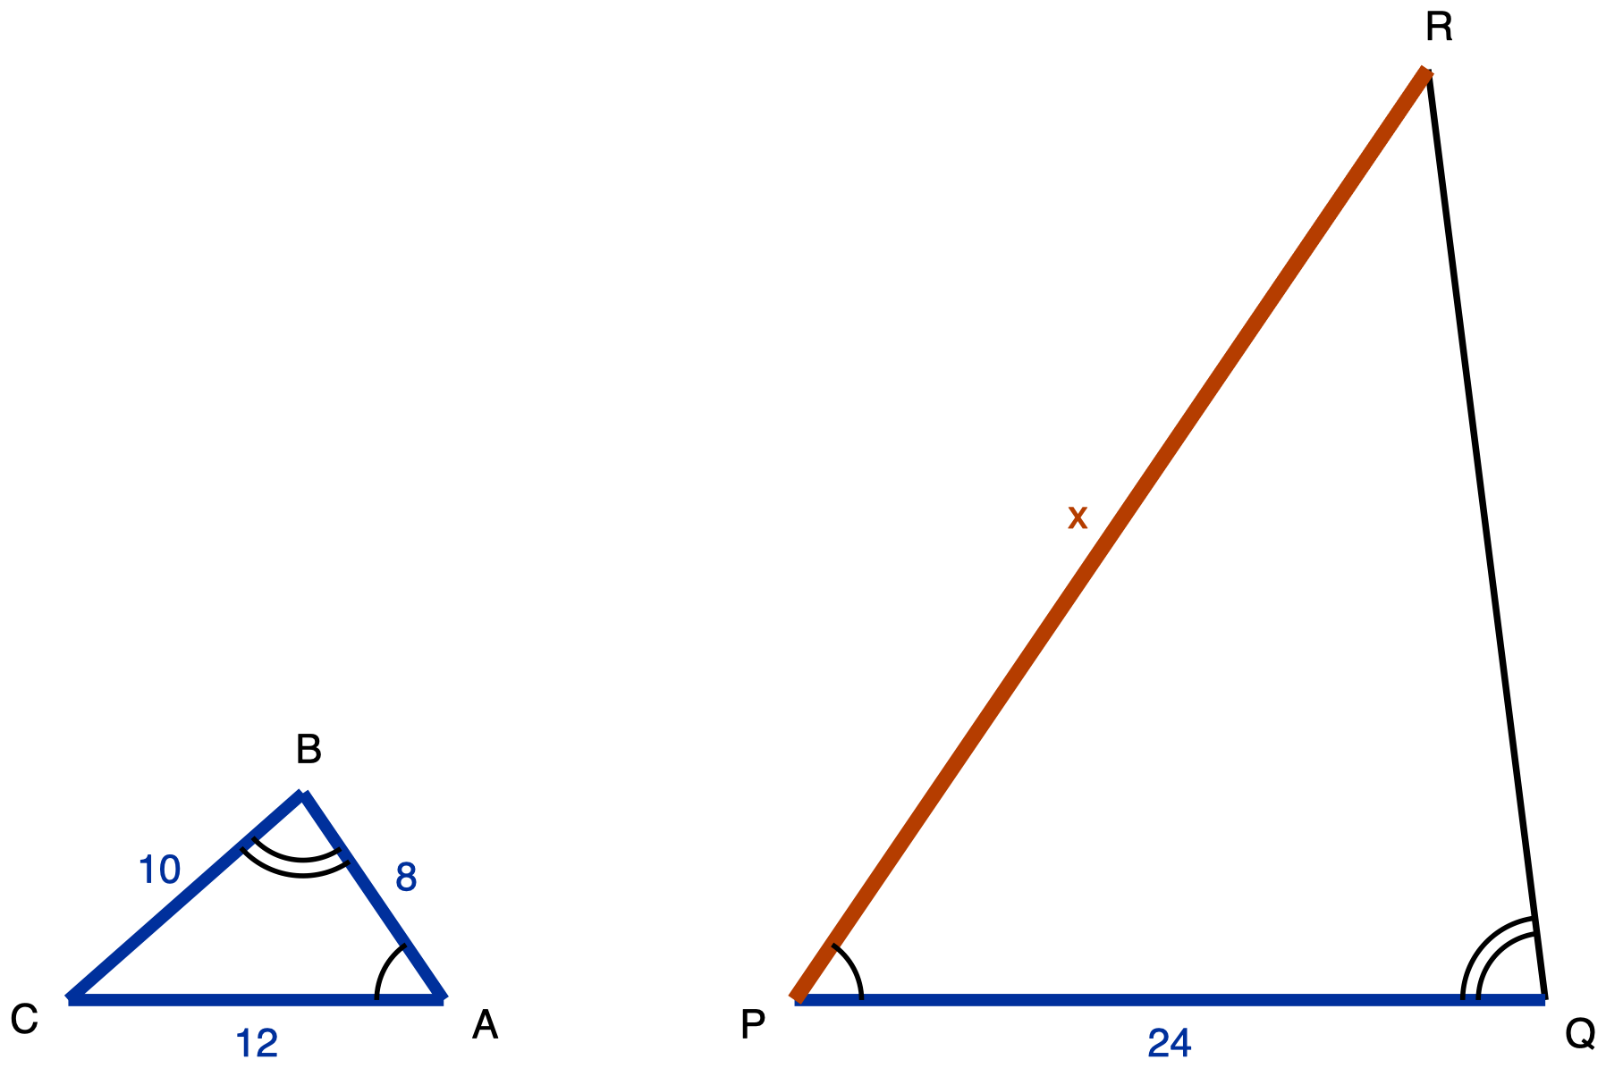
Figure 2.1. Triangles ABC and PQR, similar by AA and drawn in different orientations.
Description: Two separate triangles side by side, both sitting on the same horizontal baseline. Neither is a right triangle. Left triangle ABC: C is the bottom-left vertex, A is the bottom-right vertex, and B is above the baseline, roughly two-thirds of the way from C toward A, so the triangle is wide and low. Segment CA runs along the baseline and measures 12, a given measure. Segment AB runs up and to the left from A to B and measures 8, a given measure. Segment BC runs down and to the left from B to C and measures 10, a given measure. Vertex A carries one arc, between segment AC and segment AB. Vertex B carries two concentric arcs, between segment BC and segment BA. Vertex C carries no arc. Right triangle PQR: P is the bottom-left vertex, Q is the bottom-right vertex, and R is high above the baseline and close to the right, almost above Q, so the triangle is tall and narrow. It is drawn to the same scale as ABC but is three times its size. Segment PQ runs along the baseline and measures 24, a given measure. Segment RP runs from R down and to the left to P; it is the longest side, it is the unknown quantity, and it is labelled x. Segment QR runs from Q up and slightly to the left to R; it carries no measure and is drawn as plain skeleton line. Vertex P carries one arc, between segment PQ and segment PR. Vertex Q carries two concentric arcs, between segment QP and segment QR. Vertex R carries no arc. The figure asks which vertex of PQR corresponds to which vertex of ABC, which side pairs with which, and what x is.
What students are asked. (a) Write the correspondence in letters.
(b) Using those letters, write which side of the first triangle pairs with which side of the second.
(c) Find x, showing the ratio used. Tools: calculator permitted, no ruler and no protractor, no worked example. Students may answer (c) as a written proportion, as a three-row correspondence table with the arithmetic beside it, or spoken to you for you to write down.

Answer key
- (a) A ↔ P, B ↔ Q, C ↔ R. One arc at A and one arc at P give A ↔ P. Two arcs at B and two at Q give B ↔ Q. C ↔ R follows by elimination, and saying so out loud is a valid reason.
- (b) AB pairs with PQ. BC pairs with QR. CA pairs with RP.
- (c) PQ ÷ AB = 24 ÷ 8 = 3. RP = 3 × CA = 3 × 12, so x = 36.
✋
Full credit requires (a) and (b) to be right. A correct 36 sitting under a wrong correspondence is a coincidence, not an answer.

Wrong answers to expect, and what each one tells you
Answer | How the student got there | What it tells you
20 | Paired CA with PQ, bottom with bottom, factor 24 ÷ 12 = 2, then paired RP with BC because both are the upper-left side. | This is the position misconception. The whole item was answered from where the sides sit on the page.
24 | Factor 3 found correctly, then RP paired with AB. | Correspondence started right and was abandoned halfway. Closer than 20, and it needs a different response: send them back to (b), not to (a).
30 | Factor 3 found correctly, then RP paired with BC. | Same as above. Send them back to (b).
A ratio with x on top and 8 underneath | Arithmetic slip, not a correspondence error, provided (a) and (b) are right. | Do not treat this as the misconception. Correct the algebra and move on.

Task 2 · Prove it
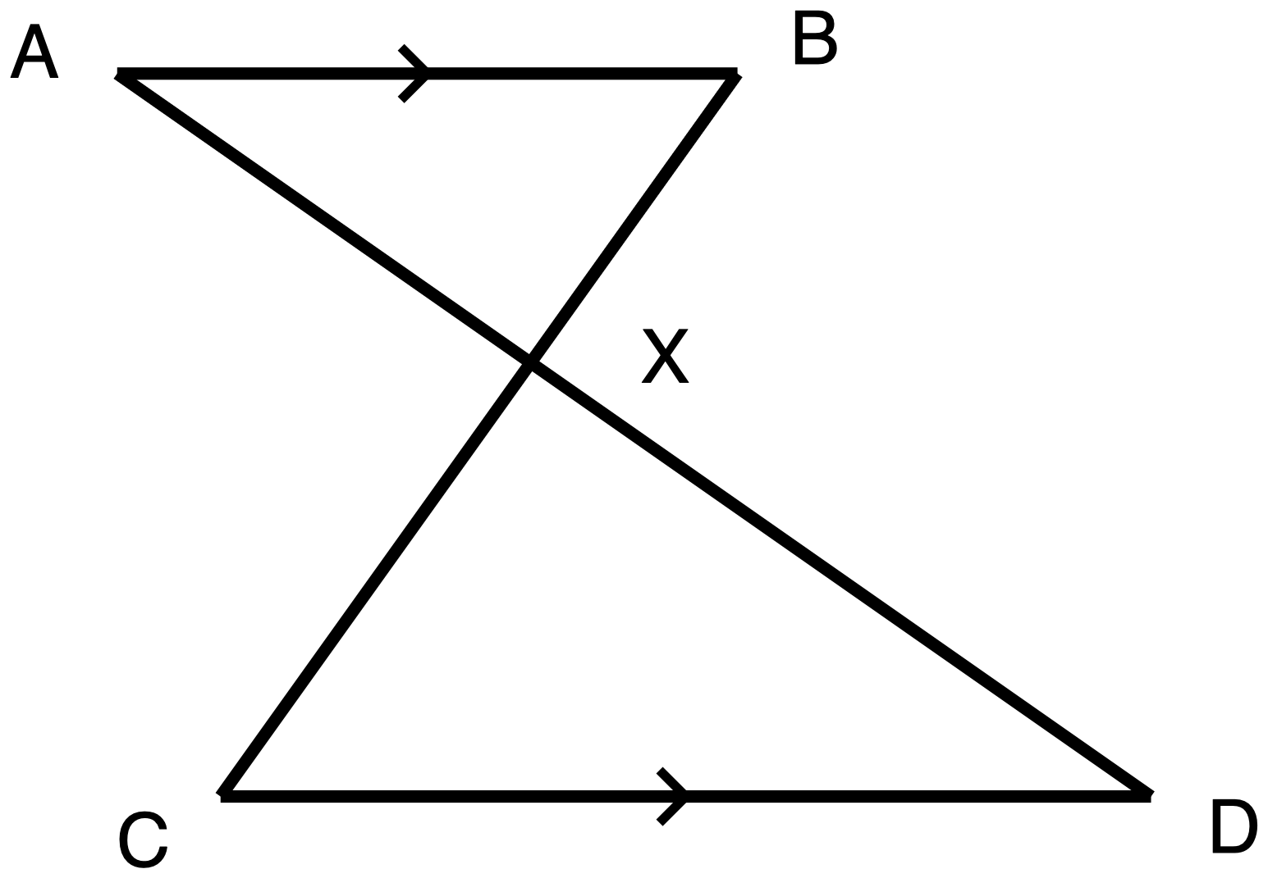
Figure 2.2. Segments AD and BC crossing at X between the parallel segments AB and CD.
Description: One connected figure, shaped like a bow tie lying on its side, drawn entirely in plain skeleton line weight. No lengths are given anywhere and no angles are marked with arcs. Points: A is at the top left. B is at the top right, on the same horizontal line as A. C is at the bottom left and D is at the bottom right, on the same horizontal line as each other and lower than A and B. C sits slightly to the right of directly below A; D sits well to the right of directly below B. X is a single point in the middle of the figure, below the line AB and above the line CD, a little to the left of centre. Segments: AB is horizontal across the top. CD is horizontal across the bottom, and CD is longer than AB. AD runs from A down and to the right, passing through X, and continues to D. BC runs from B down and to the left, passing through X, and continues to C. The two long segments cross at X, and X is the only crossing point. Marks: a single chevron sits at the midpoint of AB and a single chevron sits at the midpoint of CD; those two chevrons mark AB parallel to CD. There are no other marks. Two triangles are formed: the upper one has vertices A, X and B; the lower one has vertices D, X and C, and it is the larger of the two. X is not the midpoint of either long segment, since the part of AD from A to X is shorter than the part from X to D, and the part of BC from B to X is shorter than the part from X to C. The figure asks for a proof that triangle AXB is similar to triangle DXC, and for the correspondence the proof establishes.
What students are asked. Prove that the two triangles in the figure are similar, naming the criterion used and justifying every angle fact claimed, then write the similarity statement with the second triangle's letters in the order that matches the first triangle's. Tools: calculator permitted, though there is nothing to compute, no ruler and no protractor, no reference card. Proofs may be given two-column, as a paragraph, as a flowchart, spoken to you and marked "oral", or as an annotated diagram with numbered justifications.

Answer key
Given: AB is parallel to CD, and segments AD and BC meet at X.
Statement | Reason
AB ∥ CD | Given, marked by the single chevrons
∠AXB ≅ ∠DXC | Vertical angles are congruent
∠XAB ≅ ∠XDC | Alternate interior angles, AB ∥ CD cut by transversal AD
△AXB ~ △DXC | AA: two pairs of congruent angles

Similarity statement: △ A X B ~ △ D X C, that is, A ↔ D, X ↔ X, B ↔ C.
- Accept any valid pairing of two angle facts. A proof using ∠XAB ≅ ∠XDC together with ∠XBA ≅ ∠XCD, both by alternate interior angles across the two different transversals, is equally correct and does not need the vertical-angle step.
- A proof that uses only the vertical angles is incomplete. One pair is not AA.
- Do not accept △AXB ~ △CXD. It is not a re-lettering of the answer, it is a false statement about this figure.
✋
What this task tells you that Task 1 cannot. Task 1 can be passed by a student who has learned "count the arcs" as a procedure without believing that position is irrelevant. This task cannot, because a position read here produces △AXB ~ △CXD, which is false for this figure: X does not sit at equal distances along the two crossing segments. If a student writes that statement and then defends it, the belief is still intact, and Day 3 should open on this figure again.

Synthesis question
Whole class, spoken, no writing.
✋
Two triangles are similar. Someone looks at the two drawings and pairs the side along the bottom of one with the side along the bottom of the other. Name one thing on the page that could show them they are wrong, and one thing that could not.

The answer worth landing. The arc counts could show them, and the position of a side could not, because position is a fact about the drawing and the arcs are a fact about the triangles.

Exit ticket and its key
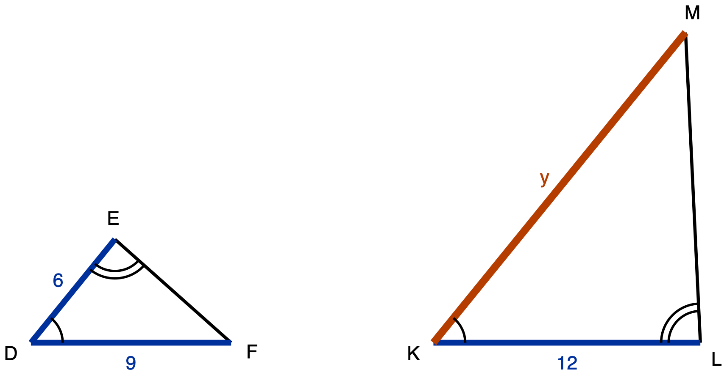
Figure 2.3. Triangles DEF and KLM, similar by AA and drawn in different orientations.
Description: Two separate triangles side by side, both sitting on the same horizontal baseline. Neither is a right triangle. Left triangle DEF: D is the bottom-left vertex, F is the bottom-right vertex, and E is above the baseline, somewhat left of centre, so the triangle is wide and low. Segment FD runs along the baseline and measures 9, a given measure. Segment DE runs up and to the right from D to E and measures 6, a given measure. Segment EF runs down and to the right from E to F; it carries no measure and is drawn as plain skeleton line. Vertex D carries one arc, between segment DF and segment DE. Vertex E carries two concentric arcs, between segment ED and segment EF. Vertex F carries no arc. Right triangle KLM: K is the bottom-left vertex, L is the bottom-right vertex, and M is high above the baseline and close to the right, almost above L, so the triangle is tall and narrow. It is drawn to the same scale as DEF but is twice its size. Segment KL runs along the baseline and measures 12, a given measure. Segment MK runs from M down and to the left to K; it is the longest side, it is the unknown quantity, and it is labelled y. Segment LM runs from L up and slightly to the left to M; it carries no measure and is drawn as plain skeleton line. Vertex K carries one arc, between segment KL and segment KM. Vertex L carries two concentric arcs, between segment LK and segment LM. Vertex M carries no arc. The figure asks which vertex of KLM corresponds to which vertex of DEF, which side pairs with which, and what y is.
Three parts, in order: name the vertex correspondence, name the side pairing, find y. Calculator permitted, no ruler and no protractor. Students put Task 1 and their answers to it in their folder before they start, and may write their answers or say them to you at the door.

Key
- (a) D ↔ K, E ↔ L, F ↔ M.
- (b) DE pairs with KL. EF pairs with LM. FD pairs with MK.
- (c) KL ÷ DE = 12 ÷ 6 = 2. MK = 2 × FD = 2 × 9, so y = 18.

Reading the ticket
Mark the parts in order, and treat (a) as the diagnostic part. Part (c) on its own can be reached by ranking side lengths rather than by reading the marks: y is the longest side of the second triangle and 9 is the longest labelled side of the first, and doubling gets there. A ticket with (c) right and (a) wrong is not a pass.
Why this ticket separates the two groups. In DEF the longest side, FD = 9, is drawn along the bottom. In KLM the shortest side, KL = 12, is drawn along the bottom, and the longest side MK is the long diagonal. KLM is a rotation as well as an enlargement, so the vertex carrying two arcs sits at the top of DEF and at the bottom right of KLM. Position and marks point at different vertices, and a student cannot follow both.
Part | Correct | A student reading position, not marks | Why they differ
(a) | D ↔ K, E ↔ L, F ↔ M | D ↔ K, E ↔ M, F ↔ L | The two-arc vertex is E, at the top of DEF. Position pairs top with top, giving E ↔ M. The arcs pair E with L, at the bottom right. D ↔ K agrees under both readings and is not diagnostic on its own.
(b) | DE with KL, EF with LM, FD with MK | FD with KL, DE with MK, EF with LM | Follows mechanically from (a). Bottom with bottom gives FD with KL.
(c) | 12 ÷ 6 = 2, so y = 2 × 9 = 18 | 12 ÷ 9 = 4/3, so y = 4/3 × 6 = 8 | A different pairing gives a different scale factor and therefore a different number. 8 and 18 are not close, not roundings of each other, and not reachable from one another by an arithmetic slip.

✋
Do not redraw KLM in matching orientation. If both triangles were drawn the same way up, position and marks would agree, a student holding the misconception would also arrive at 18, and the ticket would pass them. The rotation is the only thing in the item that makes the misconception fail visibly rather than accidentally succeed.

Figure descriptions to print alongside the drawings
These are required, not supplementary. Print them and give them to any student who cannot use the drawing, alongside the handout rather than instead of it. Each one is ordered so the figure can be redrawn from it: figure type and orientation, then every labelled point, then every segment with its measure and role, then every marked angle, then the question the figure poses.
✋
One edit to make before you hand these out. The descriptions of Figures 2.1 and 2.3 below each state the scale factor outright, three times the size and twice the size. A student working from the description alone can answer part (c) from that sentence without ever deciding a correspondence. Strike those two clauses from any copy you give a student. Every labelled measure they need is still in the text. The alt text attached to the drawings on the student handout already has them removed.

Legend, common to all three figures: A number of arcs drawn at a vertex names a congruence class: angles carrying the same number of arcs are congruent to each other. A single chevron on two segments marks those segments parallel. Line weight carries role: the heaviest line is the unknown quantity, the next heaviest is a given measure, and the plain line is the figure's skeleton.

Figure 2.1, Task 1
Two separate triangles, side by side, both sitting on the same horizontal baseline. Neither is a right triangle.
Left triangle, ABC. C is the bottom-left vertex, A is the bottom-right vertex, and B is above the baseline, roughly two-thirds of the way from C toward A. The triangle is wide and low. Segment CA runs along the baseline and measures 12, a given measure. Segment AB runs up and to the left from A to B and measures 8, a given measure. Segment BC runs down and to the left from B to C and measures 10, a given measure. Vertex A carries one arc, between segment AC and segment AB. Vertex B carries two concentric arcs, between segment BC and segment BA. Vertex C carries no arc.
Right triangle, PQR. P is the bottom-left vertex, Q is the bottom-right vertex, and R is high above the baseline and close to the right, almost above Q. The triangle is tall and narrow, and it is drawn to the same scale as ABC but is three times its size. Segment PQ runs along the baseline and measures 24, a given measure. Segment RP runs from R down and to the left to P; it is the longest side, it is the unknown quantity, and it is labelled x. Segment QR runs from Q up and slightly to the left to R; it carries no measure and is drawn as plain skeleton. Vertex P carries one arc, between segment PQ and segment PR. Vertex Q carries two concentric arcs, between segment QP and segment QR. Vertex R carries no arc.
The question the figure poses. Which vertex of PQR corresponds to which vertex of ABC, which side pairs with which, and what is x.

Figure 2.2, Task 2
One connected figure, shaped like a bow tie lying on its side, drawn entirely in plain skeleton weight. No lengths are given anywhere and no angles are marked with arcs.
Points. A is at the top left. B is at the top right, on the same horizontal line as A. C is at the bottom left and D is at the bottom right, on the same horizontal line as each other, lower than A and B. C sits slightly to the right of directly below A; D sits well to the right of directly below B. X is a single point in the middle of the figure, below the line AB and above the line CD, a little to the left of centre.
Segments. AB is horizontal across the top. CD is horizontal across the bottom, and CD is longer than AB. AD runs from A down and to the right, passing through X, and continues to D. BC runs from B down and to the left, passing through X, and continues to C. The two long segments cross at X, and X is the only crossing point.
Marks. A single chevron sits at the midpoint of AB and a single chevron sits at the midpoint of CD. Those two chevrons mark AB parallel to CD. There are no other marks.
Two triangles are formed. The upper one has vertices A, X and B. The lower one has vertices D, X and C, and it is the larger of the two. X is not the midpoint of either long segment: the part of AD from A to X is shorter than the part from X to D, and the part of BC from B to X is shorter than the part from X to C.
The question the figure poses. Prove that triangle AXB is similar to triangle DXC, and state the correspondence the proof establishes.

Figure 2.3, exit ticket
Two separate triangles, side by side, both sitting on the same horizontal baseline. Neither is a right triangle.
Left triangle, DEF. D is the bottom-left vertex, F is the bottom-right vertex, and E is above the baseline, somewhat left of centre. The triangle is wide and low. Segment FD runs along the baseline and measures 9, a given measure. Segment DE runs up and to the right from D to E and measures 6, a given measure. Segment EF runs down and to the right from E to F; it carries no measure and is drawn as plain skeleton. Vertex D carries one arc, between segment DF and segment DE. Vertex E carries two concentric arcs, between segment ED and segment EF. Vertex F carries no arc.
Right triangle, KLM. K is the bottom-left vertex, L is the bottom-right vertex, and M is high above the baseline and close to the right, almost above L. The triangle is tall and narrow, and it is drawn to the same scale as DEF but is twice its size. Segment KL runs along the baseline and measures 12, a given measure. Segment MK runs from M down and to the left to K; it is the longest side, it is the unknown quantity, and it is labelled y. Segment LM runs from L up and slightly to the left to M; it carries no measure and is drawn as plain skeleton. Vertex K carries one arc, between segment KL and segment KM. Vertex L carries two concentric arcs, between segment LK and segment LM. Vertex M carries no arc.
The question the figure poses. Which vertex of KLM corresponds to which vertex of DEF, which side pairs with which, and what is y.

Day 3 · SSS and SAS Similarity

Standard. HSG-SRT.B.5: use similarity criteria to solve problems and prove geometric relationships.
Day 3 of 10 · Grades 9 to 10 · 50 minutes
Learning goal: Students decide which sides of two triangles correspond, and then use SSS or SAS to settle whether the triangles are similar and to find a missing length. The decision is made from the vertex correspondence, never from where a number happens to sit on the page or in a list.
Day 2 established that correspondence is read off the marks, not off position, for AA. Day 3 carries the same demand into a setting where no angle marks are available at all (SSS), into a setting where one mark decides everything (SAS), and then removes the diagram entirely.
The barrier this lesson removes: Setting up a proportion by which numbers sit next to each other, rather than by which sides actually correspond. It is Day 2's critical-features barrier recurring in a new form, where the salient feature (adjacency in the text) is not the relevant one.
Materials: Task sheet (Tasks 1 to 3) for every student. Exit-ticket half-sheets, held back until Phase 5. Blank paper and a straight edge for every student, out on desks before Phase 4. Calculators. Board space for the day's question, which stays up for the whole period.
✋
Each task carries its own tool policy, and it is printed on the student sheet. They differ from task to task on purpose, so read all three before you announce any blanket rule to the room.

Lesson at a glance
Phase | Min | What happens
1 · Retrieval, and today's question | 7 | Yesterday's rotated AA pair back on the board for 2 minutes, one question only: what told you which angle matched which? Then today's question goes up and stays up. Hand out the task sheet.
2 · SSS, built under rotation | 12 | Task 1 in pairs, then whole class. Six lengths, no marks, so position cannot help. Students sort out the pairing by ratio; the class states the SSS criterion in its own words and it goes on the board. Collect the wrong pairings before the right one.
3 · SAS, and the word included | 11 | Task 2. Two arcs are the only marks. Students test both ways of pairing the sides and find that only one puts the marked angles between the proportional pair. Land the criterion with the word included underlined, then find x.
4 · No diagram supplied | 13 | Tasks 3a and 3b back to back, in that order, without telling students they differ. Blank paper and straight edge out; the diagram is a required step, not an aid. Then the debrief. This is the phase the day exists for.
5 · Synthesis, then the exit ticket | 7 | 2 minutes on the synthesis question, whole class, answers said out loud. Then 5 minutes on the exit ticket, sheets down, individually.

Minutes sum to 50. Each phase's count includes its own hand-out, settling and clean-up time. There is no separate transition allowance, because an invisible buffer is where a 50-minute plan quietly becomes a 58-minute plan.

The misconception to expect, and the move for it
What it is. In a similarity problem the student pairs numbers by where they sit in the given text or list, rather than by which object each measurement belongs to. Every task today is built against it.
The documented case, quoted rather than paraphrased:
✋
"The fact that the numbers 100 and 20 appear next to each other may tempt students to set up the proportion 20/100 = 24/x, or 100/20 = 24/x. Have them draw a diagram to see which distances they are actually [comparing]."

CK-12 Foundation (2009), Trigonometry Teacher's Edition, Common Errors, "Angles in Triangles" item 9. CC BY-SA 3.0 United States, quoted with attribution and not adapted.
Why it happens, in one line for the board if you want it there. In most word problems a student has ever met, quantities that belong together are named together. Similarity problems break that convention, because the natural English sentence orders measurements by object and therefore places non-corresponding numbers side by side. The student is running a heuristic that is usually right.

The move
- Make the diagram a graded step, not an optional aid. In Phase 4 the drawing is part of the answer. A correct number with no diagram is not a complete response, and this is stated on the student sheet before students start, not applied afterwards.
- Every measurement is written on the figure it belongs to before any equation appears. That single act is what the pairing decision consists of.
- Run the agreeing case and the disagreeing case back to back, without saying which is which. Task 3a's sentence order happens to match the correspondence; Task 3b's does not. Students who use adjacency get 3a right and 3b wrong, and the pair makes that visible in a way neither item alone can. Do not signal the difference in advance. If you do, the class learns "watch out for tricky wording" instead of "adjacency was never the reason."
- When a wrong proportion appears, do not correct the arithmetic. Ask which object owns each number. Let the proportion collapse on its own.

Phase 1 · Retrieval, and today's question

- Put yesterday's rotated AA pair back on the board for 2 minutes and ask one question only: what told you which angle matched which? The answer wanted is the arcs.
- Write today's question on the board and leave it there for the whole period.
- Hand out the task sheet.
✋
Today's question, on the board for the whole period: when am I allowed to write two numbers as a ratio?

Phase 2 · SSS, built under rotation

Task 1, in pairs, then whole class. The figure gives six lengths and no marks, so position cannot help. Students sort out the pairing by ratio, then the class states the SSS similarity criterion in its own words and it goes on the board.
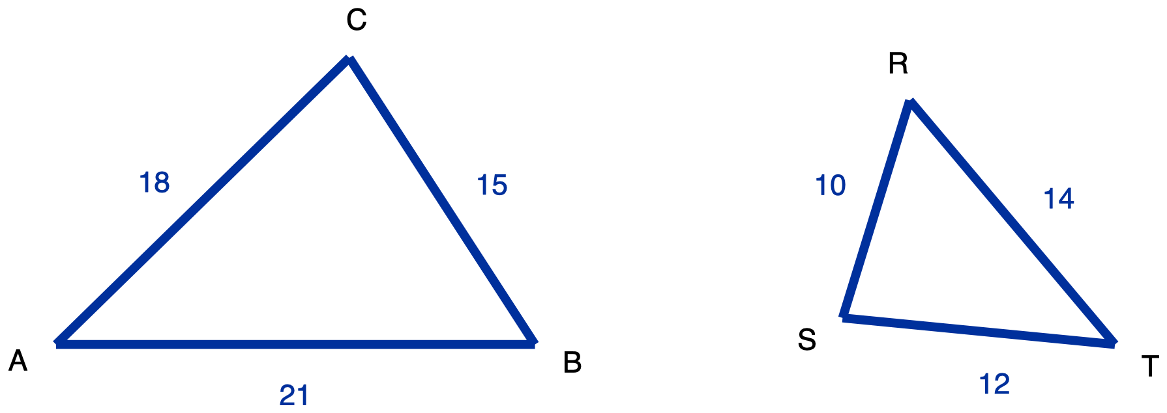
Figure 1. Triangles ABC and TRS, all six sides given, drawn in different orientations. No angle is marked.
Description: Two triangles side by side, both with all three sides carrying a given measure, and no angle marked anywhere. Left triangle ABC sits with its longest side horizontal along the bottom: A is the bottom-left vertex, B the bottom-right vertex, and C the apex above them, closer to B than to A. Segment AB is the horizontal bottom side and measures 21. Segment BC runs up and to the left from B to C and measures 15. Segment CA runs down and to the left from C to A and measures 18. Right triangle TRS is smaller and turned, so none of its sides is horizontal or vertical: T is the rightmost vertex and sits at the same height as A and B, R is the topmost vertex up and to the left of T, and S is the leftmost vertex low down and only slightly above T's level. Segment TR runs up and to the left from T to R and measures 14. Segment RS runs down and slightly to the left from R to S and measures 10. Segment ST runs down and to the right from S to T and measures 12. There are no congruence marks, no angle arcs and no tick marks, so nothing in the drawing states which side of ABC corresponds to which side of TRS.
What students are asked. (a) Which side of TRS corresponds to each side of ABC, showing the three quotients used.
(b) Are they similar, and if so the similarity statement with letters in matching order plus the scale factor.
(c) Name the criterion that answers (b) from side lengths alone.
Answer, Task 1: AB pairs with TR (21 and 14), BC with RS (15 and 10), CA with ST (18 and 12). Every quotient is 3/2. The triangles are similar, △ABC ~ △TRS, with each side of ABC one and a half times the corresponding side of TRS. Criterion: SSS similarity.
✋
Collect wrong answers before the key. Take three answers from the room, including "they are not similar." A student pairing AB with RS, BC with ST and CA with TR gets 21/10, 15/12 and 18/14, which are not equal, and concludes correctly from a wrong pairing that the triangles fail SSS. Write those three quotients on the board next to the right ones. That wrong answer is not a slip. It is a complete, internally consistent piece of work built on one bad decision, and it is worth two minutes of the room's attention.

What to watch for while pairs work
- The order the quotients are written in. A student who writes 21/10, 15/12, 18/14 has paired by drawn position. A student who writes 21/14, 15/10, 18/12 has paired by size or by testing. The pairing shows in the first thing they write, before any answer exists.
- "The bottom one goes with the bottom one." That is Day 2's misconception still live, and it needs the Day 2 correction, not today's.
- A student who says "not similar" is not necessarily wrong-headed. Ask which side they paired with which. If the pairing was positional, the conclusion followed correctly from it, and that is worth saying to them in those words.

Phase 3 · SAS, and the word included

Task 2. Two arcs are the only marks in the figure. Students must test both ways of pairing the sides and find that only one puts the marked angles between the proportional pair. Land the criterion with the word included underlined, then find x.
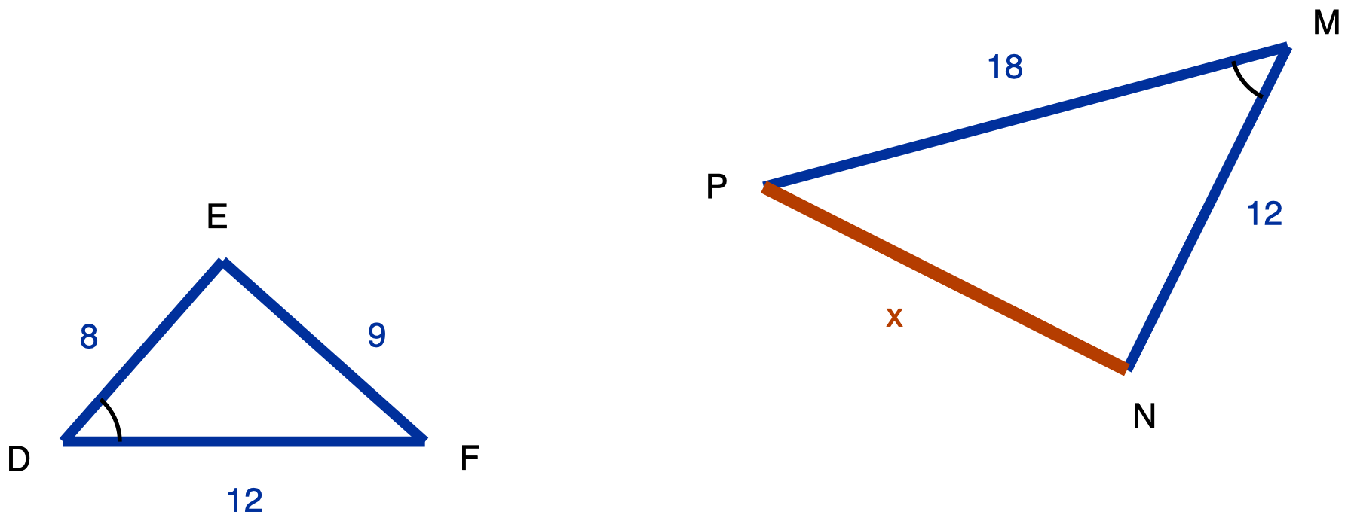
Figure 2. Triangles DEF and MNP, with one arc marking angle D and angle M congruent.
Description: Two triangles side by side in different orientations, with one marked angle in each. Left triangle DEF: D is the bottom-left vertex, F the bottom-right vertex, and E the apex above and between them, nearer to D. Segment DF is horizontal along the bottom and measures 12. Segment DE runs up and to the right from D to E and measures 8. Segment EF runs down and to the right from E to F and measures 9. A single arc is drawn at vertex D, between arm DF and arm DE. Right triangle MNP is larger than DEF and turned about 195 degrees relative to it, so no side is horizontal: M is the top-right vertex, P the leftmost vertex well below and to the left of M, and N the bottom vertex, below M and to the right of P. Segment MP runs down and to the left from M to P and measures 18. Segment MN runs down and to the left from M to N and measures 12. Segment NP runs up and to the left from N to P; its length is unknown and is labelled x. A single arc is drawn at vertex M, between arm MP and arm MN. The two arcs carry the same count, which states that angle D and angle M are congruent, and that is the only correspondence information in the figure.
What students are asked. (a) Test both pairings, say which gives equal ratios and where the marked angles sit in it.
(b) Show the triangles are similar and name the criterion.
(c) Find x.
Answer, Task 2: (a) Pairing DE with MN and DF with MP gives 8/12 = 2/3 and 12/18 = 2/3, equal. Pairing DE with MP and DF with MN gives 8/18 = 4/9 and 12/12 = 1, not equal. In the pairing that works, angle D sits between DE and DF and angle M sits between MN and MP, so the congruent angles are the included angles of the proportional pairs.
(b) Two pairs of sides proportional with the included angles congruent, so SAS similarity: △DEF ~ △MNP with scale factor 2/3.
(c) EF pairs with NP, so 9/x = 2/3 and x = 13.5.
✋
The trap to expect. The numeral 12 appears in both triangles, on DF and on MN, which are not corresponding sides. Expect at least one student to pair them because the numbers match. That pairing gives ratio 1 against 8/18, fails, and produces "not similar." It is the day's misconception wearing different clothes, and it is the cleanest possible illustration that a number is not a reason.

What to watch for while pairs work
- The two 12s being paired. Ask which angle sits between the two sides they paired.
- Only one pairing being tested. Part (a) asks for both. A student who tests the first pairing, finds 2/3 twice and stops has got the right answer without doing the item. Ask them what the other pairing would have given.
- The word "included" going missing. A student who says "two sides and an angle" has SSA, which is not a similarity criterion. This is the phase's critical feature.

Phase 4 · No diagram supplied

Tasks 3a and 3b, back to back, in that order, without telling students they differ. Blank paper and a straight edge out; the diagram is a required step, not an aid. This is the phase the day exists for.
- 3a. A flagpole 12 m tall casts a shadow 20 m long. At the same moment, a fence post standing beside it casts a shadow 5 m long. How tall is the fence post?
- 3b. A maple tree casts a shadow 42 m long. A signpost 3 m tall standing beside it casts a shadow 7 m long. How tall is the maple?
Answer, Task 3a: Corresponding sides are height with height and shadow with shadow, so 12/20 = h/5 and the post is 3 m tall. Here the sentence order agrees with the correspondence: 12 and 20 belong to the same object and sit next to each other, so a student pairing by adjacency gets this right. That is why 3a alone tells you nothing.
Answer, Task 3b: h/42 = 3/7, so the maple is 18 m tall. Adjacency distractor: 42 and 3 sit next to each other and belong to different objects and different roles. Writing 42/3 = h/7 gives h = 98 m; the reciprocal version, 3/42 = h/7, gives h = 0.5 m. Both are the answer obtained by swapping which object owns which measurement.

The debrief diagram
✋
Show Figure 3 only after students have drawn their own. Projecting it beforehand supplies the pairing and deletes both items.

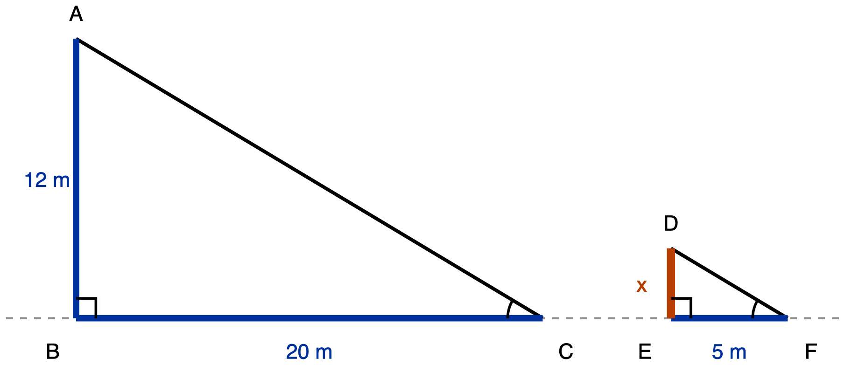
Figure 3. Task 3a drawn as two similar right triangles, with each measurement written on the object it belongs to. Debrief use only.
Description: Two right triangles standing on a common horizontal, drawn to one scale, showing a flagpole and a fence post with their shadows. A dashed horizontal construction line runs the full width of the figure and represents level ground; both triangles sit on it. Left triangle ABC is the flagpole: B is on the ground line towards the left, A is directly above B, and C is on the ground line well to the right of B. Segment AB is the flagpole, vertical, measuring 12 m. Segment BC is the flagpole's shadow, horizontal along the ground, measuring 20 m. Segment AC runs from the top of the pole down to the tip of the shadow. A right-angle square is drawn at B, and a single arc is drawn at C between arm CB along the ground and arm CA up to the top of the pole. Right triangle DEF is the fence post, one quarter the size of ABC and to the right of it on the same ground line: E is on the ground line, D is directly above E, and F is on the ground line to the right of E. Segment DE is the post, vertical, with unknown height labelled x. Segment EF is the post's shadow, horizontal, measuring 5 m. Segment DF runs from the top of the post down to the tip of its shadow. A right-angle square is drawn at E, and a single arc at F between arm FE along the ground and arm FD up to the top of the post. The right-angle squares at B and E mark those angles congruent and both right; the arcs at C and F carry the same count and mark those angles congruent. A corresponds to D, B to E, and C to F.
Use it to make one point: the drawing is not decoration and it is not a check. It is where the pairing decision was made. Everything after it is arithmetic.

What to watch for while students work
- Whether a diagram appears at all before the first equation. A student who writes 42/3 = x/7 straight down, with no drawing, is the case in front of you. Do not correct the arithmetic. Point at the 42 and ask what it measures. Then point at the 3.
- Each student's 3a against their 3b. Right on 3a and adjacency-wrong on 3b is the diagnostic pattern, and this is the only place in the lesson where it is visible. Right on both with a labelled diagram on both is the target. Wrong on both usually means the proportion itself is the problem, not the pairing, and that is a Day 1 issue.
- A diagram drawn after the answer. Some students will produce the number and then draw the picture to satisfy the instruction. The drawing is meant to be where the decision gets made, so ask them to talk you through the picture and see whether it agrees with what they wrote.
✋
Why this phase supplies no diagram, in case it reads as a gap. The scaffolding fade that has students building their own diagrams from prose belongs to Days 9 and 10. The diagram is not removed here, it is moved into the response and made mandatory: a straight edge is issued, the drawing is named as a graded step on the sheet, and a worked model is shown at the debrief. Days 9 and 10 do none of that. Day 3 also cannot avoid it, because the misconception this day is built on is documented on a word problem with no diagram, and a day that supplies a diagram to every item cannot confront it. Figure 1 carrying no angle arcs is the same kind of apparent departure: on an SSS item the arcs would state the correspondence, and the correspondence is the answer.

Phase 5 · Synthesis, then the exit ticket

Synthesis question, 2 minutes, out loud
> Two numbers were printed next to each other. What has to be true about them before you are allowed to write them as a ratio?
The answer wanted: they have to be corresponding sides, meaning sides that play the same role in the two figures under one fixed vertex correspondence. Nothing about being adjacent in a sentence, in a list, or in a picture makes two numbers corresponding. Take answers out loud, not in writing.

Exit ticket, 5 minutes, individually, task sheets down
Triangle JKL and triangle PQR are similar, and the stem says in so many words that the letters are not written in corresponding order. Given: JK = 24, KL = 18, LJ = 21, and PQ = 12, QR = ?, RP = 14. The student writes the similarity statement, finds QR, and says in one sentence what settled the pairing.
✋
Do not print or state a vertex order. Letter order in a similarity statement is the correspondence, so supplying it answers all three parts at once. The stem says there is an order and declines to give it, which is what makes the item an item.

Key: (a) △JKL ~ △RQP.
(b) QR = 16.
(c) The ratios settled it, and nothing else could have: 12/18 and 14/21 are both 2/3, so PQ pairs with KL and RP pairs with LJ, which forces P to correspond to L, Q to K and R to J. JK therefore pairs with RQ, the segment written QR. Check: 16/24 = 2/3, 12/18 = 2/3, 14/21 = 2/3, all three agreeing, scale factor 2/3.
Marking the wrong answers: A student pairing by printed order pairs JK with PQ, KL with QR, LJ with RP, takes 12/24 = 1/2 and gets QR = 9, writing the statement as △JKL ~ △PQR and part (c) as some version of "they were both listed first." A student who instead takes the scale from the third pair, 14/21 = 2/3, gets QR = 12. Twelve is not a near miss, it is the correct scale factor applied to the wrong slot, so do not mark it as one. Part (c) is what stops a lucky 16 from passing: a student who lands on 16 without the pairing argument cannot say what settled it.
What the ticket does not certify. It rules out today's misconception on this one configuration. It is not a mastery check on SSS or SAS, and it sits deliberately below the unit's cut-score standard. A below-target exit ticket on one day is not evidence the lesson failed.

Day 4. Triangle Proportionality Theorem and its converse

Day 4. Triangle Proportionality Theorem and its converse
Standard: HSG-SRT.B.4, prove theorems about triangles. Today's theorem: a line parallel to one side of a triangle divides the other two sides proportionally, together with its converse.
Duration: 50 minutes, in five phases. The minutes below sum to 50 exactly, with transitions inside the phases rather than between them.
Materials: The student handout, one per student, with Figure 1 printed 160 mm wide and Figures 2 and 3 printed 78 mm wide. Board space that can hold the Phase A tally for the whole period. Calculators. Reference cards stating the AA similarity criterion for Tasks 2 and 3.

Learning goal
Students prove that a line drawn parallel to one side of a triangle divides the other two sides in equal ratios, and use the converse of that theorem to decide whether a given segment is parallel to a side. The proof route runs through a similarity, and that requirement is stated openly in the task, not held back in the marking.

Where this day sits
Day 3 closed the similarity criteria, SSS and SAS. Day 5 uses the altitude-to-hypotenuse configuration to get the Pythagorean Theorem out of similarity. Today is the hinge: the first proof of a triangle theorem, and the first time the additive rule refuted on Day 1 is deliberately walked back into the room in a new shape, to see whether that refutation survived the change of setting.
✋
The transfer is the lesson. The same underlying error reappearing in a structurally different setting is run here as a check, not as new instruction.

Phase sequence, 50 minutes

Phase sequence, 50 minutes

Put Figure 1 up. Do not name the theorem. Write two claims on the board as competing student positions, not as a right answer beside a wrong one.
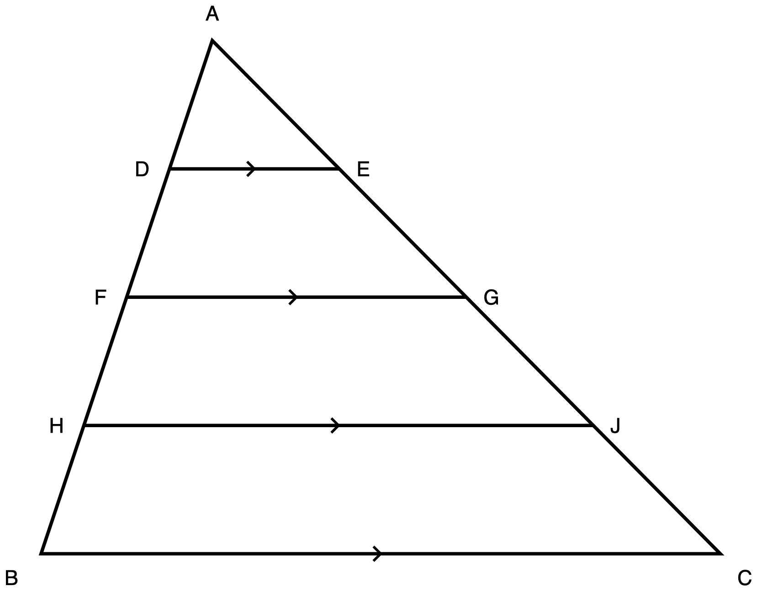
Figure 1. Triangle ABC cut by three segments, each parallel to side BC.
Description: One triangle with apex A at the top and side BC horizontal along the bottom, B at the bottom left and C at the bottom right. Six further points sit on the two slanted sides. Reading down the left side from A to B in order: A, D, F, H, B, with D about a quarter of the way down, F about half way and H about three quarters. Reading down the right side from A to C in order: A, E, G, J, C, positioned so that E is level with D, G is level with F, and J is level with H. Three horizontal segments cross the inside of the triangle: DE nearest A, then FG, then HJ nearest BC, each running from its point on AB across to its point on AC. DE, FG, HJ and BC each carry a single chevron at the midpoint, which puts all four in the same parallel class, so DE, FG and HJ are each parallel to BC and to one another. There are no angle arcs and no right-angle marks anywhere. No length is printed on the drawing.
- The amount claim. A segment parallel to BC cuts the same length off AB as it cuts off AC. If it leaves 9 below the cut on one side, it leaves 9 below the cut on the other.
- The ratio claim. A segment parallel to BC cuts AB and AC in the same ratio. If it leaves a third of one side below the cut, it leaves a third of the other.
Every student writes down on paper which claim they are backing, before any data appears. Give that two minutes, then take a show of hands and record the tally on the board, where it stays visible for the rest of the period. Close the phase by handing out the measurement table for Phase B. That handout is the transition: the claims are now on the record, and the next twelve minutes test them.

Students work in pairs on Task 1, filling the table for all three cuts on Figure 1, then writing the one-line verdict at the foot of it. Circulate.
✋
Do not correct the amount claim verbally. The table is the refutation, and it has to land as a class result. That is the whole reason for tabulating three cuts rather than one.

At minute 10 of this phase, stop the room and collect the last columns on the board across all three cuts. Read the pattern out loud with the class rather than for them: the amount left below the cut differs between the two sides in every row, and the two ratios agree in every row. That reading is the transition into the proof.

Task 2. Students prove the theorem for cut DE on Figure 1.
The first three minutes are whole class: establish out loud that DE parallel to BC makes AB a transversal cutting two parallel lines, and let a student say what that gives. Do not write the angle congruences on the board or on the figure. Naming which angles correspond is the first inferential step of the proof and it belongs to the student, which is why Figure 1 ships with parallel chevrons and no angle arcs.
The remaining eleven minutes are individual writing, in the student's chosen proof format. Circulate with the observation notes at the end of this plan open.

Three minutes: state the converse and put it beside the forward theorem, so the two are visibly different sentences with the arrow running opposite ways. Seven minutes: Task 3, on Figure 2.
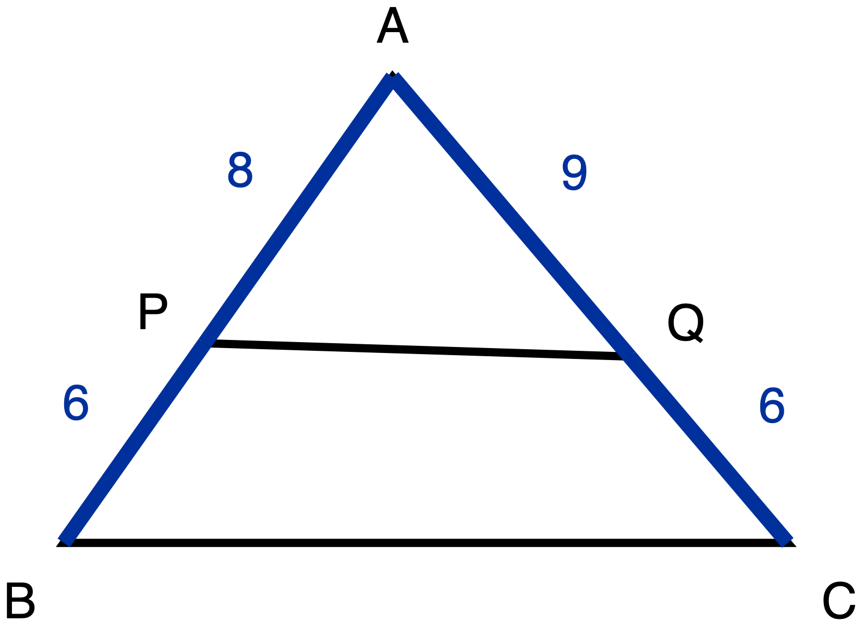
Figure 2. Triangle ABC with segment PQ drawn across it and four lengths given.
Description: One triangle with apex A at the top and side BC horizontal along the bottom, B at the bottom left and C at the bottom right. P sits on side AB, a little past half way down from A. Q sits on side AC, also a little past half way down from A, and very slightly lower than P. Segment PQ joins P to Q and is drawn as a plain line with no measure printed. The two parts of side AB are drawn heavier than the plain skeleton because both are given: AP is 8 and PB is 6. The two parts of side AC are drawn heavier for the same reason: AQ is 9 and QC is 6. BC is a plain line with no measure printed. There is no chevron anywhere in this figure and there are no angle marks, because whether PQ is parallel to BC is exactly what is being asked. The drawing is to scale and PQ is in fact not parallel to BC, but the difference is smaller than one part in thirty and cannot be settled by looking.
This is where the amount claim gets its second and last chance to appear, and it usually does: the two off-cuts on Figure 2 are equal, so a student running the amount rule will answer "parallel" with confidence. Note who does. Do not resolve it in front of the room. The exit ticket needs the misconception still live in whoever holds it.

Task 4, on Figure 3. Collect. Six minutes is a floor for the slowest writer, not a speed target, and nothing on this ticket is scored for pace.
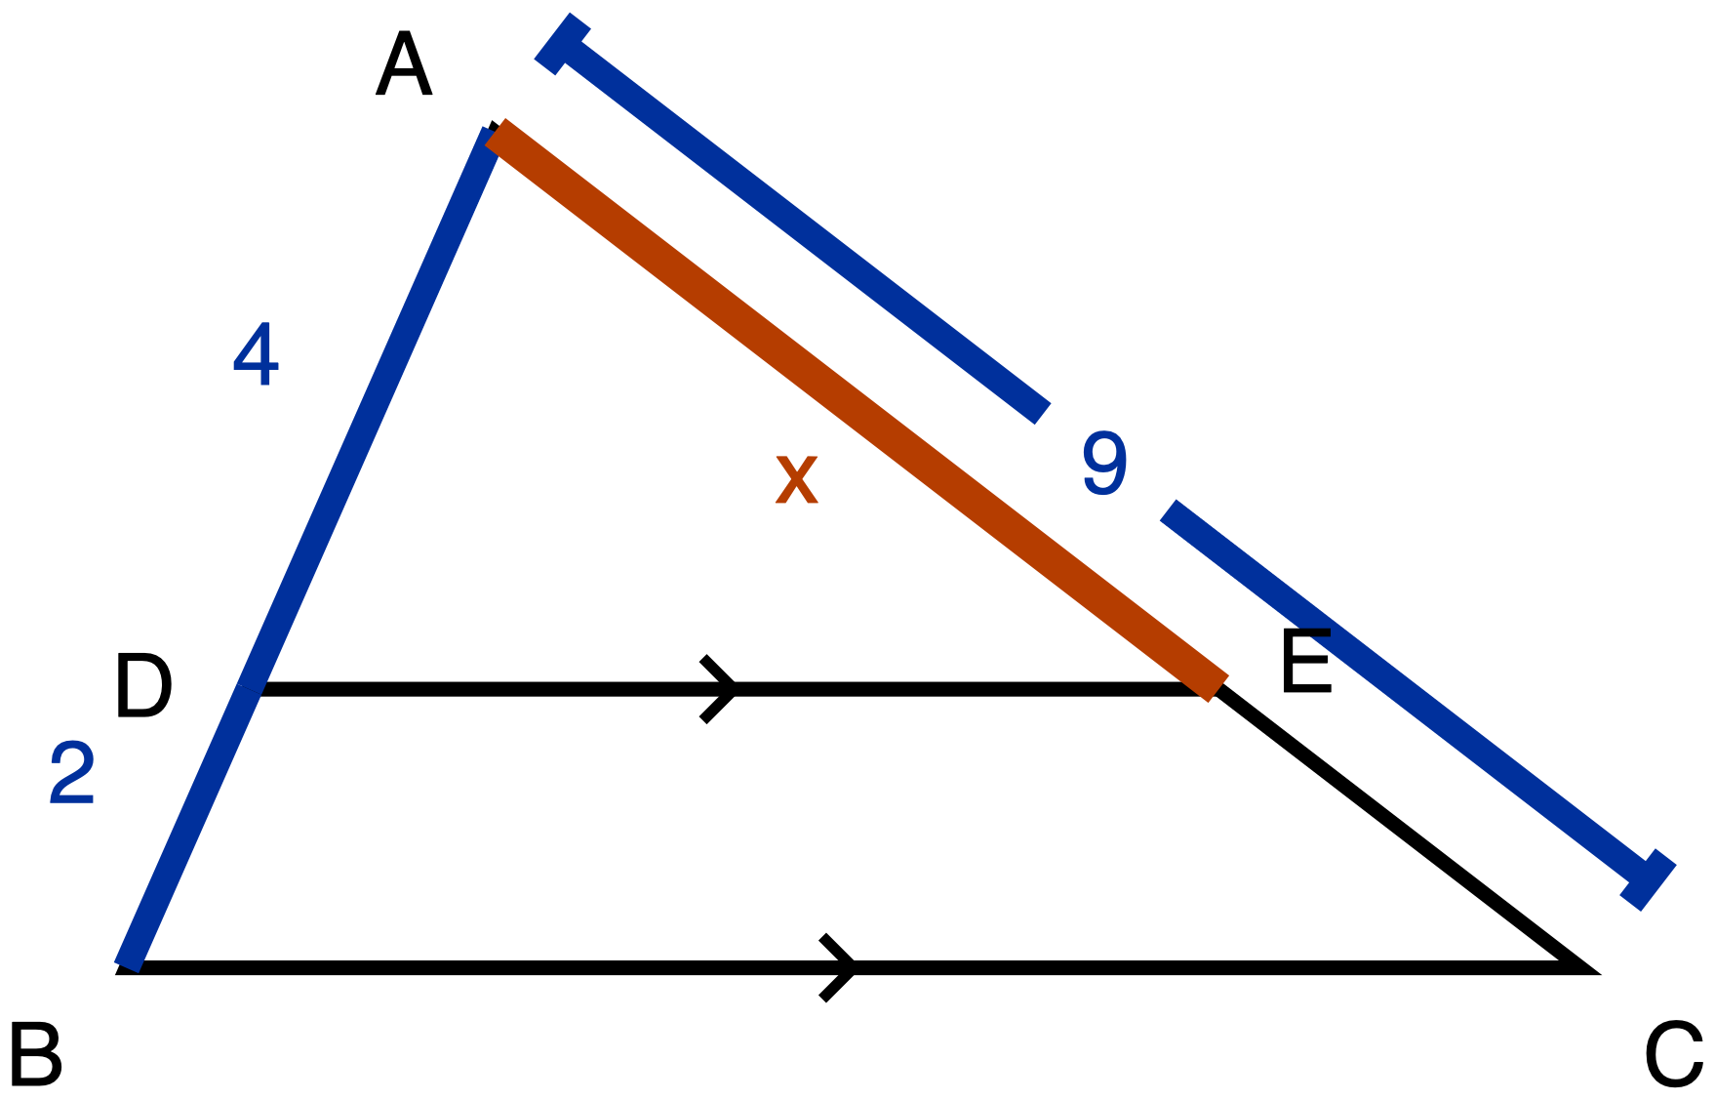
Figure 3. Triangle ABC with DE parallel to BC; AD, DB and AC given, AE unknown.
Description: One triangle with apex A at the top and side BC horizontal along the bottom, B at the bottom left and C at the bottom right. D sits on side AB, two thirds of the way down from A towards B. E sits on side AC, level with D, two thirds of the way from A towards C. On the left side, AD is 4 and DB is 2, both given measures and both drawn heavier than the plain skeleton, so AB is 6 in total. On the right side, the segment from A to E is the unknown: it is the heaviest line in the whole figure and is labelled x. The remaining piece from E down to C is a plain line with no measure of its own. Running outside the triangle, alongside and parallel to side AC, there is a separate straight dimension line with a short cross tick at each end and a gap at its centre where the numeral 9 sits; that line gives the whole of AC as 9. DE and BC are plain lines, and each carries a single chevron at its midpoint, so DE is parallel to BC, which is given rather than something to be decided. There are no angle arcs and no right-angle marks.
8 + 12 + 14 + 10 + 6 = 50.

The misconception to expect, and what to do about it

The misconception to expect, and what to do about it
The error. A student treats a segment parallel to one side as splitting the other two sides by equal amounts rather than in equal ratios. In the exit-ticket configuration the reasoning runs: the cut takes 2 off one side, so it takes 2 off the other, so EC = 2 and AE = 7.
Why the additive reading is not stupid here, which is the part that changes how you respond. Day 1 refuted "add a constant" for scaling a whole figure. Nothing the student has been told transfers that refutation to a cut inside a single triangle, and a cut looks more like subtraction than like scaling. The parallel segment also looks locally like a translation of BC, which genuinely is a same-distance-everywhere operation. The additive reading has a visual warrant here that it did not have on Day 1.
Teacher move. Refute it with the table, not with the theorem. Three cuts at three heights, all columns tabulated, before the theorem is named. The lengths left below each cut are not equal across the two sides in any row, and they change from row to row; the two ratios agree in every row. Let the table do the work, then say plainly that this is Day 1's question asked in a new place, and name it as such.
✋
An honest warning. This anticipated error is inferred by analogy from a documented Day 1 error about additive scaling. There is no error data specific to the Triangle Proportionality Theorem behind it. If you observe a different dominant error in your room today, treat the exit ticket as under-specified rather than as broken: that is information about the anticipated challenge, not about your students, and it is worth writing down. This day's anticipated error is the weakest-evidenced in the unit and the one most likely to need replacing.

Synthesis question

Synthesis question
Ask it at the close of Phase D, in writing, one sentence each.
✋
On Day 1 we killed the rule "to make a figure bigger, add the same amount to every side." Today's triangle is not being made bigger at all, it is being cut. What is the same about the two questions, and what is different?

The answer worth hearing. Both ask whether a relationship between two lengths is preserved by adding or by multiplying, and in both the answer is multiplying. What is different is that scaling produces a second figure while a parallel cut produces two pieces of one figure, which is exactly why the refutation did not carry itself across without being carried.

Answer keys

Answer keys

Task 1, the investigation table
Triangle ABC on Figure 1, with AB = 12 cm and AC = 16 cm. Not a scored item; it is the shared evidence the rest of the lesson stands on.
Cut | On AB, from A | Rest of AB | On AC, from A | Rest of AC | Rest of AB and rest of AC equal? | (from A on AB) ÷ (rest of AB) | (from A on AC) ÷ (rest of AC)
DE | AD = 3 | DB = 9 | AE = 4 | EC = 12 | no, 9 against 12 | 3/9 = 1/3 | 4/12 = 1/3
FG | AF = 6 | FB = 6 | AG = 8 | GC = 8 | no, 6 against 8 | 6/6 = 1 | 8/8 = 1
HJ | AH = 9 | HB = 3 | AJ = 12 | JC = 4 | no, 3 against 4 | 9/3 = 3 | 12/4 = 3

Verdict line. The amount claim fails in every row, and fails by a different margin each time: 3, then 2, then 1. The ratio claim holds in every row.

Task 2, the proof
Given: D on AB, E on AC, DE parallel to BC. Prove AD/DB = AE/EC.
Statement | Reason
1. DE is parallel to BC. | Given, and marked by the matching chevrons.
2. ∠ADE ≅ ∠ABC. | AB is a transversal cutting the two parallel lines DE and BC; these are corresponding angles.
3. ∠A ≅ ∠A. | Same angle.
4. △ADE ~ △ABC. | AA, from steps 2 and 3.
5. AD/AB = AE/AC. | Corresponding sides of similar triangles are proportional.
6. AB = AD + DB and AC = AE + EC. | D lies between A and B; E lies between A and C.
7. AD/(AD + DB) = AE/(AE + EC). | Substituting 6 into 5.
8. AD·AE + AD·EC = AE·AD + AE·DB, so AD·EC = AE·DB, so AD/DB = AE/EC. | Cross-multiplying 7 and cancelling the common term.

A student may reach step 4 through ∠AED ≅ ∠ACB instead of ∠ADE ≅ ∠ABC. Both are corresponding angles, and either one together with ∠A gives AA. Accept both.
✋
A proof that never establishes a similarity does not satisfy this task, and the task itself says so to the student. The requirement is named in the prompt and here, so that no student is penalised after the fact for a route they were never told was excluded.

Task 3, the converse
AP = 8, PB = 6, AQ = 9, QC = 6.
- AP/PB = 8/6 = 4/3.
- AQ/QC = 9/6 = 3/2.
- 4/3 ≠ 3/2, so PQ is not parallel to BC, by the converse of the Triangle Proportionality Theorem.
Equivalent and fully acceptable route: AP/AB = 8/14 = 4/7 and AQ/AC = 9/15 = 3/5, and 4/7 ≠ 3/5. The whole-to-part comparison and the part-to-part comparison are equivalent tests. Accept either, and accept a decimal comparison (1.33 against 1.5, or 0.571 against 0.6) as showing the same thing.
What the amount rule answers here. PB = 6 and QC = 6, the same amount taken off each side, so parallel. Wrong. The numbers on Figure 2 were chosen so that the off-cuts are exactly equal, which is what makes the amount rule commit itself here instead of hedging.
The figure will not settle it. Figure 2 is drawn to scale, and PQ genuinely is not parallel to BC, but the discrepancy is under one part in thirty and is invisible at print size. A student who answers by looking has not answered. The scored object is the warrant, so say that when you set the task.

Task 4, the exit ticket
Two parts, both required. A bare numeral is not a passing response.
- Value: AE = 6.
- Warrant: DE is parallel to BC, so by the Triangle Proportionality Theorem AD/DB = AE/EC. Since AD/DB = 4/2 = 2, AE = 2·EC. AE + EC = AC = 9, so 3·EC = 9, EC = 3, and AE = 6.

Reading the collected exit tickets

Reading the collected exit tickets
Sort into four piles, not two.
Response | Reading
AE = 6 with a written proportion and the theorem named | Has it.
AE = 7 | The amount rule, applied cleanly: the cut takes 2 off AB, so it takes 2 off AC, giving EC = 2 and AE = 9 − 2 = 7. Use the feedback line below.
AE = 18 | The proportion set up as AD/DB = AE/AC, giving 4/2 = AE/9. An arithmetic and setup slip, not today's misconception. It self-refutes, since AE = 18 is longer than the whole side AC = 9, and that is worth saying back to the student.
AE = 6 with the warrant blank, or "because it's proportional" | Undetermined, and the most important pile. The value alone does not distinguish a student who has the theorem from one who divided 9 by 3 and doubled it because the numbers were convenient. Ask this student the question out loud before the next lesson; it takes fifteen seconds.

Why 7 and 6 come apart. The two routes divide AC differently. The ratio route splits 9 in the ratio 2:1 and lands on 6 and 3. The amount route subtracts DB from AC and lands on 7 and 2. The ticket is failed on the value alone.
The ticket also catches it on the justification. A student on the amount route who leaves the warrant blank has visibly not produced it. A student on the amount route who does write AD/DB = AE/EC is refuted by their own numbers: 4/2 = 2 but 7/2 = 3.5, so the proportion they wrote contradicts the answer they gave. Either way the failure is checkable on the page rather than inferred from a wrong number.
✋
Feedback, not a mark. For a 7: "You took the same length off each side. A parallel cut takes the same fraction off each side, not the same length. Run it again with AD/DB = AE/EC, and check that your AE and EC add up to 9."

Tools and reference cards, per task

Tools and reference cards, per task
There is deliberately no single tool line for this lesson. Each task carries its own ruling, decided by what that task measures.
Task | Ruling
Task 1 | Calculator permitted; the two quotient columns are arithmetic, not the point. Pair work.
Task 2 | Calculator permitted, though there is nothing to compute. A card stating the AA similarity criterion is permitted. A card stating or proving the Triangle Proportionality Theorem is not. Read-aloud on request.
Task 3 | Calculator permitted. Cards stating AA or the forward Triangle Proportionality Theorem are permitted; a card stating the converse is not. Read-aloud on request.
Task 4 | Calculator permitted. A card printing the Triangle Proportionality Theorem, or printing AD/DB = AE/EC, is not permitted. Read-aloud on request; the figure carries the configuration and all three given lengths, so hearing the words gives nothing away.

✋
The one ruling worth flagging before you teach it, because it looks inconsistent and is not: a reference card printing the Triangle Proportionality Theorem is permitted on Task 2 and denied on the exit ticket. On Task 2 the theorem is the thing being proved, so its statement is already in the prompt and a card adds nothing. On the exit ticket the theorem's statement is the warrant the student is asked to produce, so the same card hands over the answer.

What to watch for while circulating

What to watch for while circulating

During Phase B, at the table
Look for a pair who fill the "are they equal?" column correctly in all three rows and still write the amount claim on the verdict line. The table only refutes the claim if the student reads the table; a student can complete twelve cells accurately and never compare them. This is the cheapest place in the whole lesson to catch the misconception, twenty-eight minutes before the ticket.

During Phase B, listening
The audible signature is the phrase "it takes the same off both sides", or a student writing DB = EC anywhere. Note who says it. Do not correct it in Phase B; the table is about to.

During Phase C, in the proofs
Three different things look similar on the page and are not.
- A proof that reaches AD/AB = AE/AC and stops. That statement is true and is genuinely step 5 of the argument. The student has the similarity and has not converted whole-to-part into part-to-part. This is an incomplete proof, not the day's misconception. Prompt: "your proportion is about whole sides, and the theorem is about the pieces; what are AB and AC made of?"
- A proof that asserts the proportion from the Phase B table. This is generalising from three cases, not proving. Point at the required route and ask which two triangles are similar, and why.
- A proof that gets corresponding angles from DE and BC but pairs them across the wrong transversal. Not today's misconception; it is Day 2's correspondence habit surfacing. Ask which line is the transversal for the pair they wrote.

During Phase D, on Task 3
A student who answers "parallel" here is running the amount rule, and the numbers on Figure 2 were built so that this is the only way to reach that answer. Note them and leave it. They need to still hold the misconception when the ticket goes out, or the ticket cannot detect it. This is the one place in the lesson where withholding the correction is deliberate, and it is worth being able to say why if a coteacher asks.

Day 5. Pythagoras from Similarity

HS Geometry, similarity to right-triangle trigonometry. Grade 9-10. One 50-minute period.
Standard: HSG-SRT.B.4, proving theorems about triangles. Today: the Pythagorean Theorem derived from similar right triangles.
Learning goal: Students prove that a² + b² = c² for a right triangle by using the three similar triangles that the altitude to the hypotenuse creates, and they can state the vertex correspondence that makes each proportion legitimate.
That second clause is not decoration. It is the clause the exit ticket measures, and it is where the day's difficulty sits.
Materials: Task A page carrying Figure 5.1, one per student. Tracing paper or patty paper, or a second printed copy of Figure 5.1 with scissors. The optional blank outline sheet: three empty right-triangle outlines in one orientation, no vertex labels, no arcs. The Tasks B and C page. The exit ticket carrying Figure 5.3. Figure 5.2 ready to display, for Phase 5 only.
Why this day exists. Nearly every textbook introduces the Pythagorean Theorem by dissection or rearrangement. That is a valid proof, and it is not the one this standard names. Days 1 to 4 built the similarity criteria so that today can spend them. Nothing here is new similarity machinery: the whole lesson is one configuration and what falls out of it. Day 2 installed the angle-angle criterion this day rests on.

The figures, and when each one is in front of a student
Figure | What it is | When it reaches a student
Figure 5.1 | Right triangle ABC, right angle at C, altitude CD to hypotenuse AB, D nearer A. Angle A one arc, angle B two arcs, right-angle squares at C and D. | Phase 1, on the Task A page, one per student
Figure 5.2 | The same three triangles drawn apart on one baseline, all turned the same way, with the arc counts carried across. | Phase 5 only. Not before.
Figure 5.3 | Right triangle RST, right angle at S, altitude SW to RT, W nearer T. No arcs, no numerals. | Phase 6, printed on the exit ticket

✋
Figure 5.2 is the answer to Phase 2. If it is on the desk during Phase 2 the day is over: students read the separation instead of producing it, and the exit ticket then measures whether they can copy a printed figure. Display it at Phase 5, after every student has their own separation on paper, as the shared reference the class checks itself against.

Figure 5.3 is deliberately a mirror of Figure 5.1. In the lesson figure the apex leans left, so the narrow small triangle sits on the left. On the ticket the apex leans right, so the narrow one sits on the right. A student who memorised the letter pattern by page position cannot transfer it. The mapping has to be read off the right-angle marks and the foot of the altitude, which is exactly the tracking work this day is about. This is the same move Day 2 makes with rotation, and it is stated here so it does not read as a trick.
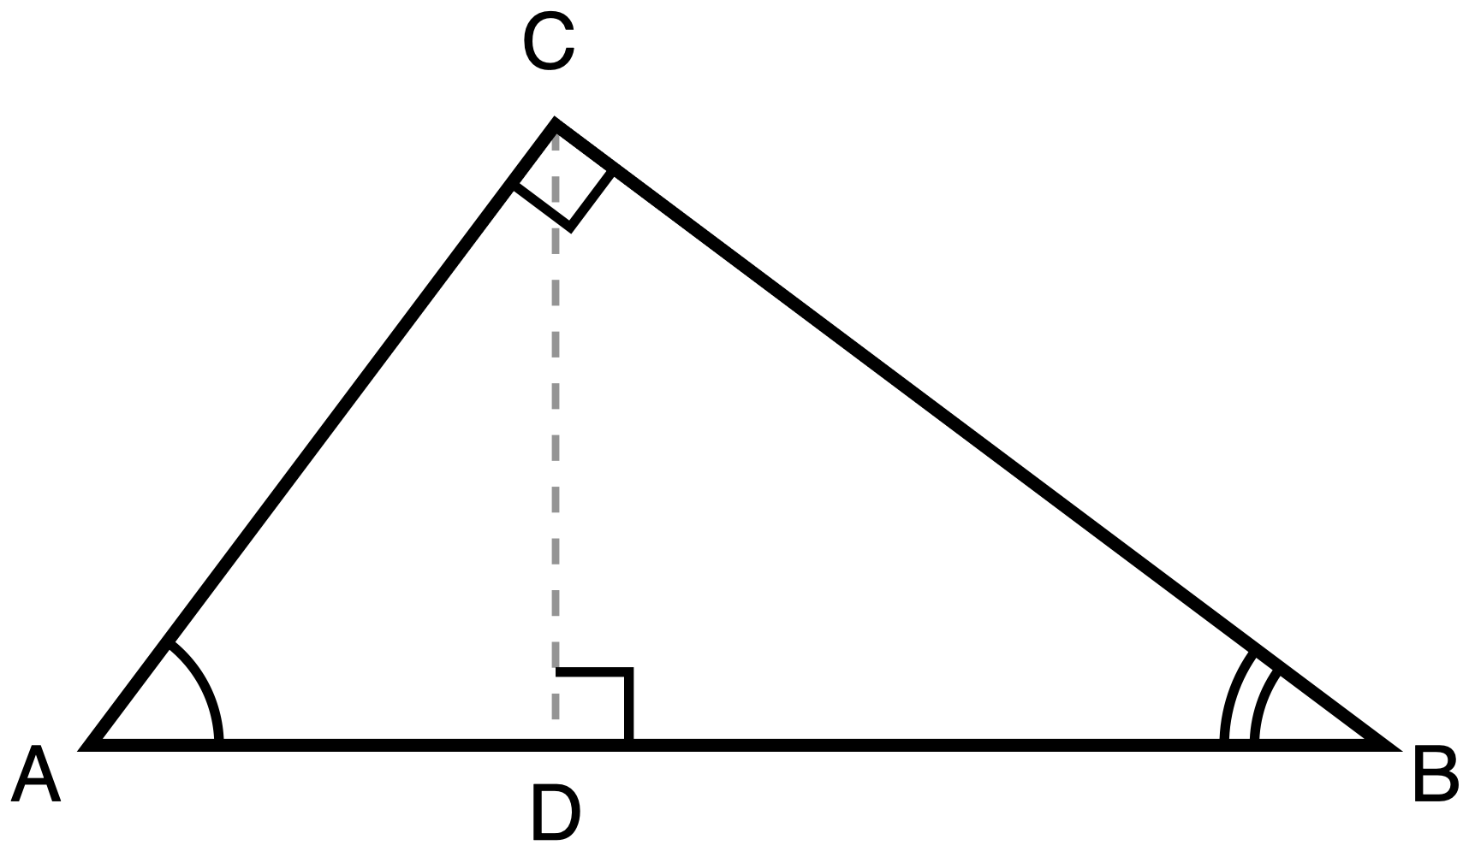
Figure 5.1. Right triangle ABC with the altitude from C to hypotenuse AB at D.
Description: Right triangle ABC has its right angle at C and its hypotenuse AB lying horizontally at the bottom, A on the left and B on the right. The altitude CD is drawn as a dashed construction line from C down to the point D on AB, and D lies nearer to A than to B. Angle A carries one arc and angle B carries two arcs. Right-angle squares mark the angle at C and the angle at D. No lengths are given.
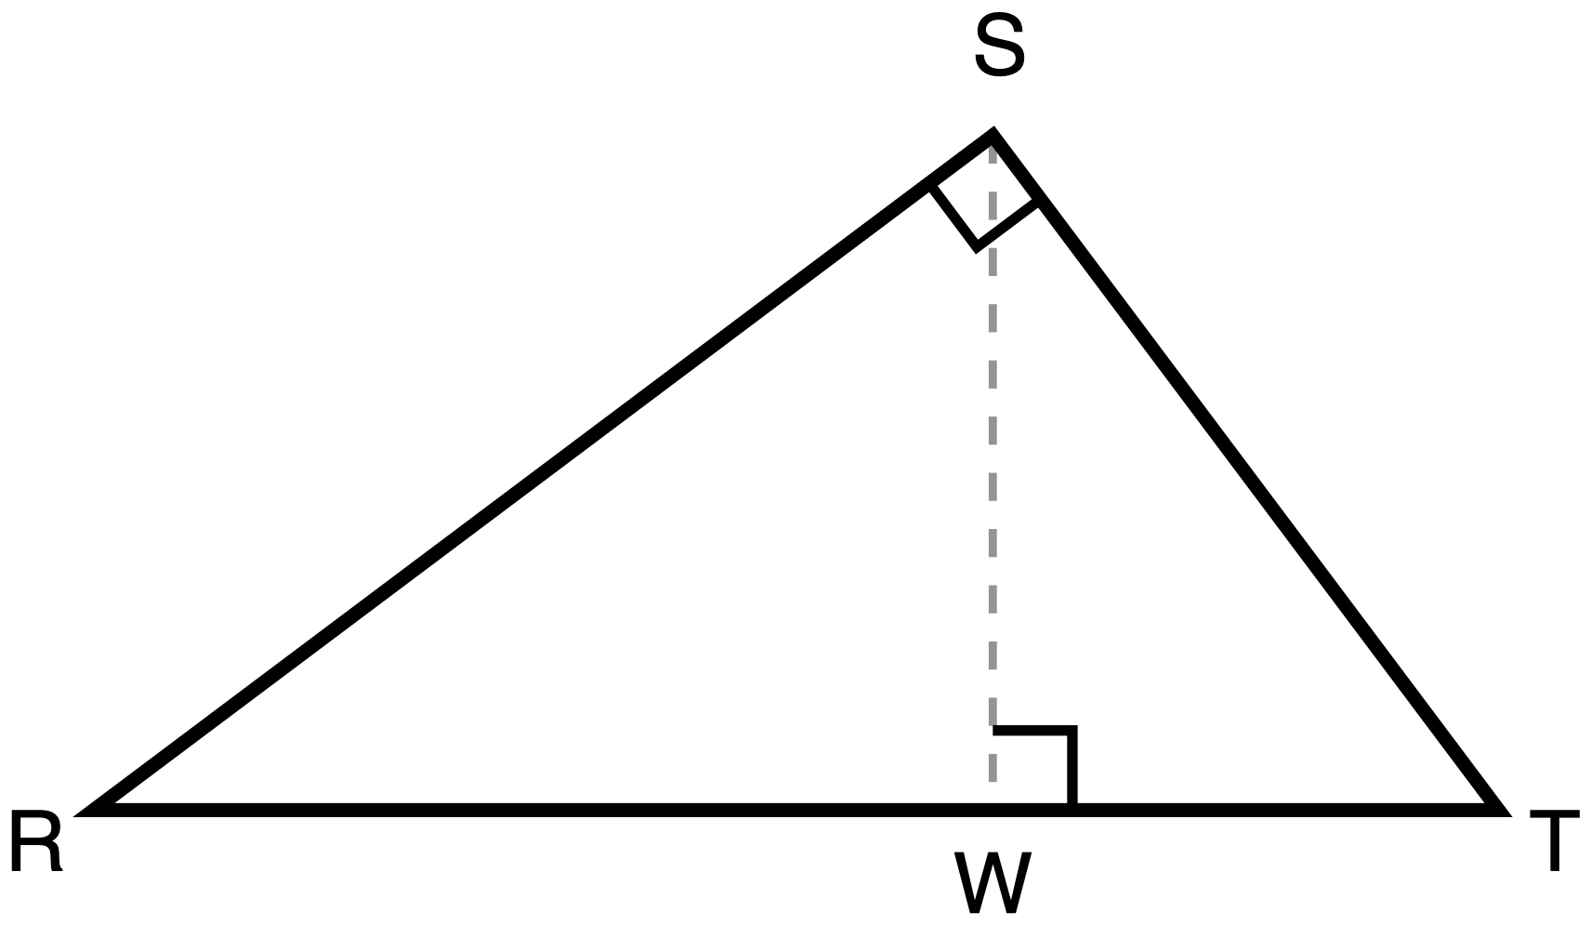
Figure 5.3. Right triangle RST with the altitude from S to hypotenuse RT at W. This figure is printed on the exit ticket.
Description: Right triangle RST has its right angle at S and its hypotenuse RT lying horizontally at the bottom, R on the left and T on the right. The altitude SW is drawn as a dashed construction line from S down to the point W on RT, and W lies nearer to T than to R, so the apex leans to the right. Right-angle squares mark the angle at S and the angle at W. No angle arcs are marked and no lengths are given.

Phase sequence, 50 minutes

Put a right triangle on the board with no altitude. Ask what is true about the two acute angles: they sum to 90°, from Day 2's work. Now drop the altitude from the right angle to the hypotenuse and ask one question. How many triangles are in this picture now? Take answers. "Two" is common, and it is the first sign of the day's difficulty. Do not correct it. Write both answers up and move on. Distribute the Task A page in the last minute of this phase, so the handout sits inside the phase rather than between phases.

Every student traces or copies the three triangles and redraws them apart, and all turned the same way, carrying the vertex labels across. Tracing paper, patty paper, or a second printed copy with scissors are all on the table. Circulate. Do not show the finished separation, do not draw it on the board, and do not tell a stuck student which three triangles there are. Ask them instead to run a finger along one triangle's three sides and read out the vertices they touch.
✋
This phase is not assessed. Nothing is recorded against a student here. Scoring the separation would score the scaffold rather than the mathematics.

Task B. With the three separated triangles on the desk, students write the two similarity statements, turn each into a proportion, cross-multiply, and add. The numbers are chosen so every value is a whole number and nothing is ambiguous: AC = 15, BC = 20, AB = 25, CD = 12, AD = 9, DB = 16. The reason this phase exists at all is sequencing: the proportions are seen to produce a true statement before any letters have to be carried.

Task C. The same argument in letters, producing a² + b² = c². Students who finish the two proportions early are asked to write the reason for each similarity (AA, and which angle pair), not to start a new problem.

Display Figure 5.2, now that every student has their own separation on paper. Then ask the synthesis question, take two or three answers, and do not resolve it into a rule.
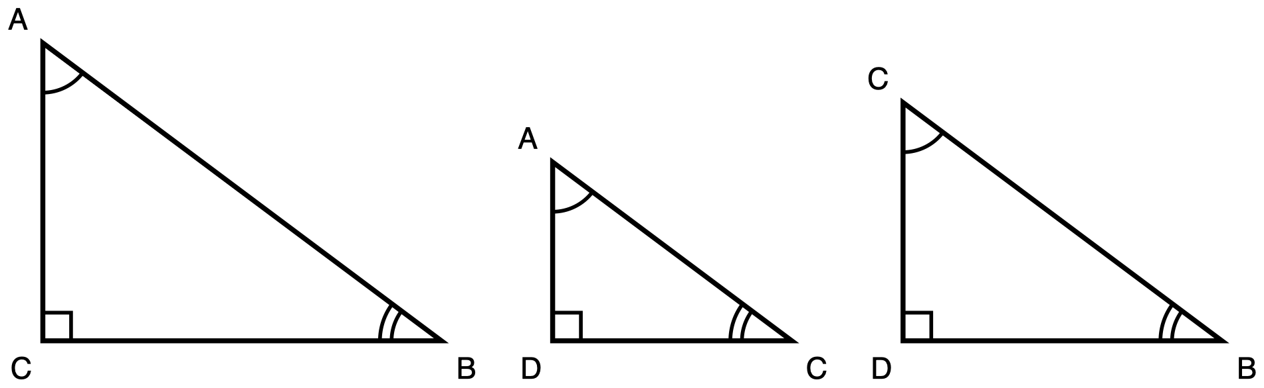
Figure 5.2. The three triangles of Figure 5.1 drawn apart, all in one orientation. Display at Phase 5 only.
Description: The three overlapping triangles from the altitude figure are redrawn separately, left to right, all standing on one baseline and all turned the same way: the right angle at the bottom-left corner, the one-arc angle at the top-left, the two-arc angle at the bottom-right. Left is the whole triangle ABC, with C at the bottom-left right angle, A at the top-left and B at the bottom-right. Middle is triangle ACD, with D at the bottom-left right angle, A at the top-left and C at the bottom-right. Right is triangle CBD, with D at the bottom-left right angle, C at the top-left and B at the bottom-right. They are drawn to their true relative sizes, so the leftmost is the largest and the middle triangle is the smallest. Matching arc counts state the correspondence: every top-left vertex carries one arc, every bottom-right vertex carries two.
✋
Synthesis question. Every step of today's argument came from a pair of similar triangles, except one: AD + DB = AB. Why is that the step that turns two separate facts about the legs into the Pythagorean Theorem?

Take answers, do not resolve. The answer worth hearing is that the two similarities each give a fact about one leg and about one piece of the hypotenuse, and the only thing that fuses them is that the two pieces make up the whole. If nobody gets there, that is a fine place to open Day 6.

Hand out the ticket, which carries Figure 5.3 and a blank half-page every student may redraw in. Collect. Extended time is permitted on this item. The mechanism is simple: any student who is not finished keeps the ticket and returns it at the start of the next period, with no penalty and no negotiation at the door. What this item measures is the validity of an argument, not the speed of producing one, so "pencils down" here would deny an accommodation the item is meant to allow.
7 + 12 + 10 + 11 + 3 + 7 = 50.

The misconception to expect, and the move for it
This is the best-documented single difficulty in this part of the curriculum. Shown the altitude-to-hypotenuse figure, a student cannot say which vertex of a small triangle corresponds to which vertex of the large one, because the three triangles share edges and sit at three different orientations. Asked for a proportion, they build one out of segments that are next to each other in the picture, or they write nothing at all. The failure sits upstream of the similarity reasoning: students who handle AA fluently on two separated triangles still stall here.
The move, and it is not "explain it more clearly". Do not present the proof. Require the separation first, from every student, in their own hand or with their own scissors.
✋
"Many students have trouble rotating shapes in their minds, or seeing individual polygons when they are overlapping. It is helpful for these students to draw the triangles separately and oriented in the same direction." CK-12 Foundation (2010), Geometry Teacher's Edition, chapter 2, Common Errors, "Using Similar Right Triangles", under the heading Separate the Three Triangles.

The same source carries a prediction worth having: after a few rounds of turning and redrawing, students stop needing to do it. Two other accounts of this activity agree that students cannot follow this proof as a passive explanation and have to draw and label it themselves, which is why the tracing is built into the lesson rather than offered as an optional aid.
Two honesty notes to keep in the room.
- What is documented is the configuration barrier, the tracking of vertices across overlapping triangles. Nothing in the evidence behind this lesson documents how students fail when writing the similarity proof of Pythagoras. If the dominant error you see today is in the argument rather than in the tracking, you are seeing something the research does not cover. Record it and pass it on. Do not conclude the ticket is broken.
- "Two triangles" in Phase 1 is not a wrong answer to punish. It is the barrier announcing itself before any mathematics has been asked for.

What is permitted on each task
There is no blanket "calculators permitted" line on any page of this package, and none should be added. Each scored task carries its own policy.
Task | Calculator | Not permitted on this task
Task B | Permitted. The arithmetic is 15 × 15 and 9 × 25, and it is not what the task measures. | A labelled separation of the three triangles; a printed list of the similar-right-triangle relations; a card printing a² + b² = c²; a worked model of the same argument
Task C | Permitted, and inert. There is no arithmetic in this task. | All of the above, plus a part-filled two-column proof shell and a teacher-supplied worked numeric case
Exit ticket | Permitted, and inert. The ticket carries no numerals. | All of the above, plus the blank separation template, side lengths printed on the figure, and angle arcs printed on the figure

On the blank separation template (three empty outlines in one orientation, no vertex labels, no arcs): permitted on Tasks B and C, not permitted on the exit ticket. That is not an inconsistency. On Tasks B and C the template removes a drawing load and supplies no correspondence. On the ticket, the first task is to identify the three triangles, which the template would answer.
Scribe note. A scribe on any of the three tasks writes what the student says, in the order they say it. A scribe who reorders statements into a tidy proof has produced the proof.
Proctoring note. Read-aloud is permitted throughout: the geometry is in the figure, and the prose only issues the instruction. Extended time is permitted throughout, including on the exit ticket.
✋
The similarity route is what these items ask for, and the students are told so in the task itself. A dissection or rearrangement proof of a² + b² = c² is a valid proof and is not an answer to these items. That requirement is printed in the stem of every scored task on this day, in the words the student reads. If a student hands in a correct dissection proof, they have not been caught by a hidden rule: say the item asked for the similarity route, credit the mathematics they did, and give them the item again. Do not deduct silently.

Answer key, Task B
With AC = 15, BC = 20, AB = 25, AD = 9, DB = 16, CD = 12.
- △ACD ~ △ABC, correspondence A↔A, C↔B, D↔C. Matched first: the shared angle A, plus the right angle at D against the right angle at C, so AA. Proportion AD/AC = AC/AB, cross-multiplied AC² = AD · AB, that is 15² = 9 × 25 = 225. True.
- △CBD ~ △ABC, correspondence C↔A, B↔B, D↔C. Matched first: the shared angle B, plus the right angle at D against the right angle at C, so AA. Proportion DB/BC = BC/AB, cross-multiplied BC² = DB · AB, that is 20² = 16 × 25 = 400. True.
- Adding: 225 + 400 = 625, and AB² = 25² = 625. Equivalently AC² + BC² = AB(AD + DB) = AB · AB.

Answer key, Task C
With BC = a, AC = b, AB = c.
- ∠ADC and ∠BDC are right angles, because CD is the altitude to AB.
- In △ACD and △ABC: ∠A is shared and ∠ADC ≅ ∠ACB. By AA, △ACD ~ △ABC.
- Corresponding sides give AD/AC = AC/AB, so AC² = AD · AB, that is b² = AD · c.
- In △CBD and △ABC: ∠B is shared and ∠BDC ≅ ∠BCA. By AA, △CBD ~ △ABC.
- Corresponding sides give DB/BC = BC/AB, so BC² = DB · AB, that is a² = DB · c.
- Adding steps 3 and 5: a² + b² = c(AD + DB).
- D is on AB, so AD + DB = AB = c. Therefore a² + b² = c².
Any of the five presentation formats offered on the student page that carries these seven steps is a complete answer. A flowchart that shows the two AA arguments feeding two proportions feeding one sum is worth the same as a two-column proof.

Exit ticket, the key and how to mark it
The bar this ticket is built to clear: a student holding this day's main misconception must get it wrong. Not "less confident". Wrong.

Figure 5.3, as the student sees it on the ticket.
Description: Right triangle RST has its right angle at S and its hypotenuse RT lying horizontally at the bottom, R on the left and T on the right. The altitude SW is drawn as a dashed construction line from S down to the point W on RT, and W lies nearer to T than to R, so the apex leans to the right. Right-angle squares mark the angle at S and the angle at W. No angle arcs are marked and no lengths are given.
The key.
- The three triangles: △RST, △RWS, △SWT.
- △RWS ~ △RST, correspondence R↔R, W↔S, S↔T. The shared angle is R; the right angle at W matches the right angle at S.
- △SWT ~ △RST, correspondence S↔R, W↔S, T↔T. The shared angle is T; the right angle at W matches the right angle at S.
- A proportion satisfying part 2: RW/RS = RS/RT, cross-multiplying to RS² = RW · RT, the square of leg RS. Or WT/ST = ST/RT, giving ST² = WT · RT, the square of leg ST.
What a student holding the misconception writes instead. Reading the correspondence off page position: the small triangle RWS has R at the bottom-left, W at the bottom-right and S at the top, and the whole triangle RST has R at the bottom-left, T at the bottom-right and S at the top. Position matching therefore gives R↔R, W↔T, S↔S, and the student writes △RWS ~ △RTS, from which they write RW/RT = WS/TS. The other small triangle gives △WST ~ △RST and WS/RS = WT/RT.
Why those are checkably wrong. The drawn figure has these actual lengths, which you have and the student does not: RS = 20, ST = 15, RT = 25, RW = 16, WT = 9, SW = 12.
- Key: RW/RS = 16/20 = 0.8 and RS/RT = 20/25 = 0.8. Equal, as a true proportion must be.
- Position-matched first statement: RW/RT = 16/25 = 0.64 and WS/TS = 12/15 = 0.8. Not equal. The proportion is false.
- Position-matched second statement: WS/RS = 12/20 = 0.6 and WT/RT = 9/25 = 0.36. Not equal. False.
The position-matched correspondence also fails on its face with no arithmetic at all: it sends the right angle at W to the acute angle at T, and a similarity statement cannot map a right angle to an acute one. Either check is available to a teacher marking twenty tickets in ten minutes.
Why the ticket cannot be passed by pattern-matching the lesson. Figure 5.3 is a mirror of Figure 5.1. A student who memorised "A↔A, C↔B, D↔C" as a letter string and transferred it by page position lands on the wrong triangle. A student who understood that the foot of the altitude corresponds to the right-angle vertex of the whole triangle transfers it correctly in either orientation, which is precisely the difference the ticket is built to detect.
Blanks are results. This misconception often produces a blank or an incoherent proportion rather than a clean wrong answer. That is why the ticket is constructed-response and not multiple-choice: a blank part 1 is a meaningful, scoreable result here, and part 3 tells you whether the student had no method or ran a positional one.

What to watch for while they work
All of this is diagnostic. None of it is recorded as a score.
Phase 1, before any work. Who says "two triangles"? That answer is the barrier surfacing before the mathematics starts, and it is the cheapest signal you will get all period. Note the names. Do not correct.
Phase 2, the separation. This is the phase to spend your attention on.
- Two triangles, not three. The commonest form: the student separates the two small triangles and leaves the original figure as "the picture", never treating △ABC as one of the three. Ask them to trace the outside of the whole figure.
- Orientation not carried. Three triangles on the page, each left in the orientation it had in the original. The separation has removed the overlap but not the rotation, and rotation is half of the difficulty. Ask them to turn each one until the right angle is in the same corner.
- Labels not carried. Three correct triangles with no letters on them, or with fresh letters invented. The vertex letters are the entire point: without them there is nothing to write a correspondence in.
- Traces the sides but not the vertices. A student who can outline a triangle but cannot name which vertices they touched has separated the shapes without separating the correspondence. The finger-along-the-sides prompt from Phase 2 is for exactly this student.
Phases 3 and 4, the proportions.
- A proportion built from segments that are adjacent in the picture rather than from a correspondence. This is the misconception's own signature. Do not correct the arithmetic. Ask which vertex of triangle ACD corresponds to B in triangle ABC, and let the proportion collapse on its own.
- A correspondence written in a valid order and then never used. Some students write △ACD ~ △ABC correctly and then build the proportion from whatever is convenient. The similarity statement and the proportion have to agree, and this is the moment to say so.
- Similarity asserted without a reason. "They are similar because they look it" passes Task B and fails Task C, where the reason is required.
Phase 6, the ticket. Part 3 is the diagnostic channel. "I turned them the same way and matched the right angles" is the day landing. "The top one goes with the top one" is a positional method stated out loud, and that is the student to see tomorrow, whatever they scored on parts 1 and 2.
A boundary on all of the above. What is documented is this day's tracking barrier. How students fail when writing this proof is not documented anywhere in the evidence behind this lesson. If the room's dominant error is in the argument rather than in the tracking, that is real and it is outside what this lesson's sources cover. Write it down and pass it on rather than reading the ticket as broken.

Day 6 · Side Ratios Depend Only on the Angle

Standard: HSG-SRT.C.6, side ratios in right triangles are properties of the angles.
✋
"Understand that by similarity, side ratios in right triangles are properties of the angles in the triangle, leading to definitions of trigonometric ratios for acute angles."

Duration: 50 minutes, in six phases.
Learning goal: Students can explain, by similarity, why the ratio of two sides of a right triangle is fixed by the acute angle and not by the size of the triangle, and can use that fact to find a length in a triangle nobody has measured.
Where this sits: Day 5 proved the Pythagorean Theorem from similarity. Day 7 names sine, cosine and tangent. Today sits between them and supplies the fact those names are names for.
Materials: One 25 degree ray sheet per group, all sheets identical. A ruler for every student. Calculators. A results table drawn on the board or projected, with a row for each group and three columns: hypotenuse, side opposite the 25 degree angle, quotient. Figures 1 to 3 for display. The student handout, Tasks 1 to 4. The exit ticket half sheet.

Two words in the standard do the work today
- By similarity. The reasoning route is part of what is being learned, not a means the student may swap out. A lesson that establishes the invariance numerically and never says why has not taught this standard.
- Properties of the angles. This is the whole claim, and it is the claim the day's misconception denies.

What today deliberately does not do
The names sine, cosine and tangent are not used, and the relative labels "opposite" and "adjacent" are not installed as a labelling scheme. Both arrive on Day 7, whose own difficulty is that those labels move when the reference angle moves. Today every ratio is named by its actual segments, for example BC ÷ AC, with the phrase "the side opposite the 25 degree angle" used descriptively to say which segment is meant.
✋
There is no single tools policy for this lesson, and none should be added. Each task carries its own, printed on the student handout, because a shared rule would quietly permit a ratio table on the two tasks that exist to see whether the student can reason without one.

Phase sequence, 50 minutes
Transitions sit inside the phases that own them. Note that the teaching order of the tasks is 1, 2, 4, 3: Task 4 is worked in Phase 4 and Task 3 in Phase 5. The handout keeps the printed order 1 to 4.

- One minute reactivating Day 5's similar triangles.
- Display Figure 1.
- Ask the question in Task 1 Part 1. Every student writes a prediction and keeps it.
- Do not comment on any prediction. Collect nothing yet.
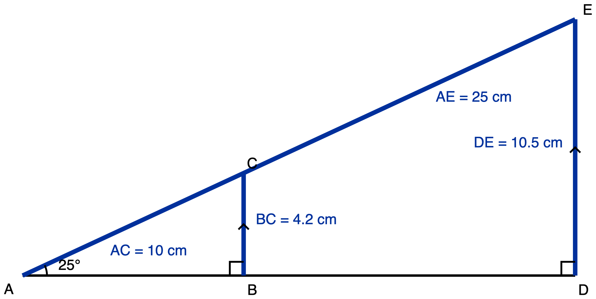
Figure 1. Two right triangles sharing one 25 degree angle at A, one 2.5 times the other.
Description: A ray from A rises at 25 degrees above a horizontal ray from the same point A. Two vertical segments, BC and DE, drop from the rising ray to the horizontal one, making two right triangles ABC and ADE that share the angle at A. In the small triangle AC is 10 cm and BC is 4.2 cm. In the large triangle AE is 25 cm and DE is 10.5 cm. The two vertical segments are marked parallel.

- One minute to move into groups. Every group gets the same 25 degree ray sheet.
- Assign each group one hypotenuse length: 8, 12, 16, 20, 24 cm.
- Groups mark that distance along the slanted ray, drop the perpendicular to the base, measure the vertical side, divide, and write their three numbers on the class table at the front.
- Last 3 minutes: read the table down aloud, column by column. Students write Task 1 Part 2.
✋
On the spread in the pooled column. Rulers give roughly 0.42 with the last digit wandering; 0.41 to 0.43 is a normal class table. Name it as ruler error the moment it appears, before a student names it as evidence against the invariance. This is the sentence that gets you into Phase 3: measurement is why the numbers nearly agree, similarity is why they must exactly agree.

- Point out that the quotient column is the same to two decimal places and the length columns are not.
- Ask what would make that necessary rather than lucky.
- Build the chain on the board from the class's own words: same angle at A, both have a right angle, so similar by AA, so corresponding sides are proportional, so the quotients are equal.
- Students write Task 2.

Run Task 4. Say the point twice, out loud: the quotient does not change when the triangle grows, and the side lengths do. A student who leaves today believing that nothing changes under scaling has been taught the mirror error.

Run Task 3, the payoff. A length in a triangle nobody in the room has measured, obtained from an angle. Allow one minute to display Figure 2 and read the stem.

One minute on the synthesis question, whole class, spoken, no writing. Four minutes on the exit ticket, handed in at the door.
✋
Synthesis question. Two right triangles both have a 25 degree angle. One fits on this page. The other is the size of the football field. What is different about them, what is identical, and which of those two answers is the one that lets you work out a length on the field from a drawing on the page?
The answer you are listening for names the sides as different, the angle and the quotient as identical, and the quotient as the one that travels.

✋
The phase order is load-bearing, not a preference. Phase 1 must precede Phase 2 or the prediction is contaminated. Phase 2 must precede Phase 3, or you supply the noticing that Task 1 Part 2 exists to see the students do for themselves.

The misconception to expect, and the move
The belief: the side ratio depends on the size of the right triangle it is taken from.
It shows up in three ways over the lesson. The student predicts, before computing, that the larger triangle has the larger quotient. After computing matching values, the student treats the match as a coincidence of the numbers chosen and cannot produce a reason. Asked for a ratio in an unfamiliar-sized triangle, the student asks for that triangle's dimensions as though the answer depends on them.
✋
"Many students have trouble understanding that the sine, cosine, and tangent of a specific angle measure do not depend on the size of the right triangle used to take the ratio."
CK-12 Foundation (2010). Geometry Teacher's Edition, chapter 2, Common Errors, "Right Triangle Trigonometry", under the heading "Use Similar Triangles".

Why it happens, in one line. Every quantity the student has met so far does change when a figure grows. Side length grows, perimeter grows, area grows faster. The ratio is the first invariant in the course, and the student is generalising correctly from everything they have been taught. The exception has to be argued for, not announced.

The move, in three parts
- Have the class measure rather than be told. That is Phase 2, and it is why the invariance arrives as a class result and not as a claim from the front.
- Then require the reason: same angle, so the triangles are similar, so corresponding sides are proportional, so the quotient is unchanged. That is Phase 3, and it is the part that cannot be skipped.
- Say the two halves in the same breath. That is Phase 4: the ratio does not change when the triangle grows, and the sides do.
✋
The overcorrection this lesson is designed not to cause. Van Dooren, De Bock, Hessels, Janssens and Verschaffel (2004) recorded non-linear strategies wrongly applied to genuinely linear items rising from 13 percent at pretest to 36 percent at post and at retention, in a teaching experiment that broke the illusion of linearity without teaching which model applies when. Phase 4 and Task 4 exist because of that number. A student who leaves believing "geometry does not scale" is worse off than the one who arrived, because that error was manufactured by the teaching.

One honest note on the evidence. This misconception is attested as teacher observation rather than measured from released test data. It is real and well attested. If the dominant error in your room turns out to be a different one, treat the exit ticket as under-specified for your class rather than broken.

Answer key, Tasks 1 to 4

Task 1 Part 1, the prediction
Not scored. It is an instructional move and an observation cue. Collect it, read it, do not mark it.

Task 1 Part 2
The quotient stayed the same, near 0.42, across every group. The side lengths did not stay the same; they grew, and the biggest triangle's sides are three times the smallest's.
Accept any wording carrying both halves. A response carrying only the first half is not yet the answer to this item, and that is the response Task 4 exists to catch.

Task 2
- Angle A is shared: it is literally the same angle, not two equal ones.
- Angle ABC and angle ADE are both right angles.
- Two pairs of equal angles give similar triangles by AA.
- Corresponding sides of similar triangles are proportional, and AE = 2.5 × AC while DE = 2.5 × BC, so DE ÷ AE = (2.5 × BC) ÷ (2.5 × AC) = BC ÷ AC.
Numerically 4.2 ÷ 10 = 0.42 and 10.5 ÷ 25 = 0.42, but the numbers confirm the argument rather than being it. An answer that only computes the two quotients has not answered this item.

Task 3
x = 0.42 × 35 = 14.7 cm. Also accept 14.8 cm, from a student using a more precise value of the ratio such as 0.423. Both are correct at this stage and the difference is the precision of the class's rulers, not a mistake. Mark the setup, x = ratio × hypotenuse, not the third digit.

Task 4
Triangle ABC scaled by a factor of 3, from AC = 10 cm, BC = 4.2 cm, AB = 9.1 cm.
Quantity | Changes or stays the same | New value
The length of BC | changes | 12.6 cm
The perimeter of the triangle | changes | 69.9 cm, from 23.3 cm
The measure of the angle at A | stays the same | 25 degrees
The quotient BC ÷ AC | stays the same | 0.42

Two rows change, two hold. A student who marks all four "stays the same" has the overcorrection, not the idea, and needs the first two rows worked out loud, not the last two repeated.

Exit ticket, key and diagnosis
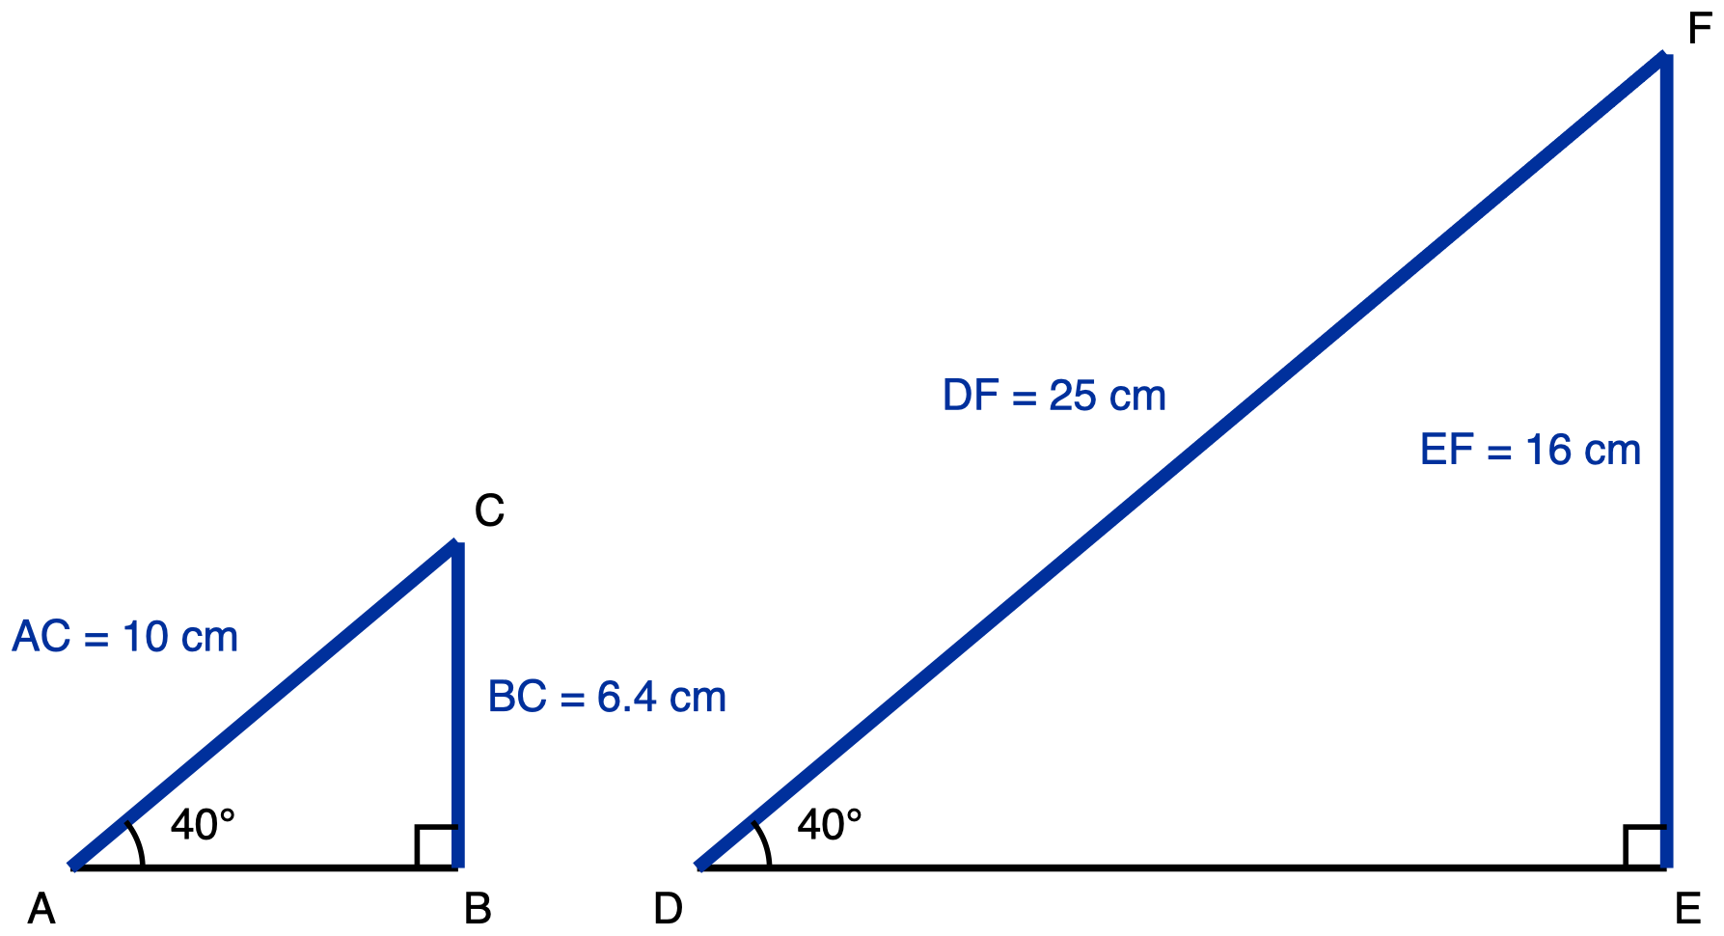
Figure 3. Two separate right triangles, each with a 40 degree angle, one much larger.
Description: Two right triangles are drawn side by side in the same orientation, both with the horizontal side at the bottom and the vertical side on the right. Triangle ABC on the left has a 40 degree angle at A, hypotenuse AC of 10 cm and vertical side BC of 6.4 cm. Triangle DEF on the right has a 40 degree angle at D, hypotenuse DF of 25 cm and vertical side EF of 16 cm. The single arc at A and the single arc at D mark those two angles equal.

The key
- (a) 0.64 and 0.64.
- (b) Both triangles have a 40 degree angle and a right angle, so they are similar by AA. Corresponding sides are therefore proportional, with DEF 2.5 times ABC, and multiplying the top and the bottom of a fraction by the same 2.5 leaves it unchanged, so 16 ÷ 25 = 6.4 ÷ 10.
- (c) 25.6 cm, because the third triangle also has a 40 degree angle and a right angle, so it is similar to both, so the same 0.64 applies: 0.64 × 40 = 25.6.

What a student holding the misconception writes instead
Part (c) is the one that fails, in one of two forms. A student who believes the quotient is a property of the particular triangle cannot carry 0.64 into a triangle nobody measured, so either they write that there is not enough information and ask for the third triangle's other measurements, or they scale the quotient along with the triangle: the third hypotenuse is 4 times the first, so the quotient becomes 0.64 × 4 = 2.56 and the side comes out at 102.4 cm, longer than the hypotenuse it sits inside.
Neither is a less confident version of the key. 25.6 against "not enough information" is the difference between having the idea and not having it, and 25.6 against 102.4 is a miss by a factor of 4.
✋
Part (c) may not be dropped for time. Division is division: a student holding the misconception can compute 16 ÷ 25 = 0.64 correctly while believing it is a coincidence of the numbers on this particular page. Part (b) catches that in the explanation and part (c) catches it in a number. Part (a) alone diagnoses nothing.

Feedback that closes the loop
For a ticket that gets (a) right and (c) wrong: "You found both quotients were 0.64 and then said the third triangle needed more measurements. The 40 degree angle is what fixes the quotient, not the triangle's size, and the third triangle has that same angle, so it is similar to both of yours and 0.64 applies to it too. Redo (c) with 0.64."
A tick and a cross does not close this loop, because the misconception is a belief and the mark does not name it.

What to watch for while they work
Phase 1, the written predictions: The cleanest read of the room you will get all day, because it happens before any data exists to be reasoned from. Note who writes "it gets bigger". Those are the students to stand near in Phase 3, not Phase 2: in Phase 2 they will measure correctly and learn nothing.
Phase 2, at the tables: Listen for a group re-measuring because their quotient "should" be bigger than the group with the smaller triangle. That is the misconception overriding the ruler, and it is worth more than any answer on the sheet. Also check that the assigned hypotenuse is measured along the slanted ray and not along the base; a group measuring the wrong segment gets a quotient near 0.9 and will conclude the invariance is false.
Phase 2 into 3, at the pooled table: The harder form of the misconception sounds like agreement: "they came out the same because of the numbers we picked". A student saying this has accepted the data and rejected the claim, and they will not be moved by more data. They need Phase 3's chain, so do not let it pass as a correct answer.
Phase 3, in Task 2: Watch for an explanation that says "similar" without saying why the triangles are similar. Ask which two angles they used. A student who names only the 25 degree angle has half the AA criterion and does not yet have the argument. The right angle is the half they forget, because it is marked rather than stated.
Phase 4, in Task 4: The overcorrection watch. A student marking "stays the same" on the perimeter row has taken today's lesson to be "geometry does not scale". Work the first two rows aloud with anyone who does this before they leave.
Phase 5, in Task 3: Note who asks for more of triangle PQR's measurements before using 0.42. That question is the misconception's signature: asking for the triangle's dimensions as though the answer depends on them. It is the same student profile as the Phase 1 predictions, and this is your last chance to see it before the ticket.
On the tickets themselves: Sort by part (c), not by part (a). Part (a) will be near-universally correct and tells you almost nothing. "Not enough information" in part (c) is a diagnosis, not a blank, and it earns the feedback sentence above, not a cross.

Day 7. Naming Sine, Cosine and Tangent

Standard: HSG-SRT.C.6, side ratios in right triangles are properties of angles. Duration: 50 minutes.
Today lands the clause the rest of the unit leans on: leading to definitions. Day 6 established that the ratio does not move when the triangle grows. That result is what makes a definition possible at all, and today is where the definition gets written down and given three names.

Learning goal
The student can determine which leg of a right triangle is the opposite leg and which is the adjacent leg relative to a stated acute angle, for a triangle drawn in any orientation, and can apply the definitions of sine, cosine and tangent taken relative to that angle to compute the three ratios from supplied side lengths.
✋
Student-facing wording, for the board: Opposite and adjacent are jobs, not places. Today we find out who is doing which job, and we learn the three names that depend on the answer.

The barrier is the first half of that goal. Recognising which sides is not a fact about the drawing, and that is the whole difficulty of the day.

Where the day sits
Day 6 finished with a class result and a reason: same angle, so the triangles are similar, so corresponding sides are proportional, so the quotient does not change. Today converts that result into three names. Day 8 derives the special-triangle ratios. Day 9 proves the complementary relationship, and Day 9's proof is built directly on the labelling skill installed today.
Quiz 2 sits immediately after today, and it may assess only general, non-special right triangles. Everything this lesson teaches is inside that boundary. What is deliberately left out, and why, is set out below.
Materials: Task 1 sheet (Figure 7.1), Task 2 sheet (Figure 7.2) and exit-ticket sheet (Figure 7.3), printed as three separate sheets. Tracing-paper copies of the triangles that students may turn. Calculators. Board space for the three definitions and for the notation line.

Phase sequence, 50 minutes
Transitions, handout distribution and collection are costed inside the phases below. There is no buffer, and the sub-totals in each phase sum to that phase's figure.
Phase | Min | What happens
1 · Reactivate, then break the assumption | 8 | 3 recall Day 6's result and its reason, from a student not from you · 5 put Figure 7.1 up, ask the room to point to the leg opposite angle P, then the leg opposite angle Q, and let the disagreement stand
2 · The pointing rule, on Figure 7.1 | 12 | 2 distribute Task 1 and demonstrate the gesture · 7 students complete Task 1 individually while you circulate · 3 two students share, one per reference angle
3 · Naming the three ratios | 10 | 6 build the three definitions on the board as roles, with Day 6 named as the reason a definition is possible · 2 the notation line · 2 students copy the three definitions onto the Task 2 sheet's definition card
4 · First application, one triangle from both angles | 12 | 1 distribute Task 2 · 8 students complete parts (a) and (b) on Figure 7.2 · 3 share out, both parts side by side on the board
5 · Synthesis, then the exit ticket | 8 | 3 synthesis question, whole class, oral · 5 exit ticket individually on Figure 7.3, distributed and collected inside the five

8 + 12 + 10 + 12 + 8 = 50.

Running the phases

Get Day 6's result and its reason back in the room from a student, not from you. Then put Figure 7.1 up and ask the room to point to the leg opposite angle P, and then the leg opposite angle Q.
✋
Phase 1 is not a warm-up and the 5 minutes are not padding. The disagreement about which leg is opposite angle P is the barrier made audible. If you resolve it in the first thirty seconds the rest of the lesson is a rule to be memorised, which is precisely the shape that lets the day's misconception survive contact with instruction. Let two students give incompatible answers, let the room notice that both sound reasonable, then move on without adjudicating. Phase 2 adjudicates it with a method rather than with your authority.

Distribute Task 1 and demonstrate the gesture yourself before anyone writes. Students work individually while you circulate. Close with two students sharing, one per reference angle, so the class hears the same triangle answered two different ways.

Build the three definitions on the board as roles. For an acute angle θ in a right triangle:
Name | Ratio
sine of θ | opposite ÷ hypotenuse
cosine of θ | adjacent ÷ hypotenuse
tangent of θ | opposite ÷ adjacent

Say out loud what is not in those three lines: not one of them names a side of any drawing. Each names a role, and Phase 2 is the only thing that assigns the role.
Why the definition is legal at all. If the ratio changed when the triangle changed size, "sine of 40 degrees" would not be a number. It would be a number-per-triangle, and you could not write it down without also drawing the triangle. Day 6's similarity argument is what makes the three names above refer to anything. Say this. Do not assume the class has carried it forward from yesterday.
The notation line, one sentence, then stop. `sin A` is the name of an operation with an input, not a quantity multiplied by A. Write `sin A` next to `3A` on the board, ask what the leading symbol is in each, and move on. It costs two minutes today and nothing today tests it, but it is the ground the Day 9 distribution error stands on, so it is worth planting here.
Close the phase by having students copy the three definitions onto the definition card on their Task 2 sheet.

Distribute Task 2. Students complete parts (a) and (b) on Figure 7.2 while you circulate. Share out with both parts written side by side on the board, so the exchange of the two legs is visible in one glance.

Ask the synthesis question orally, whole class, and take answers aloud. Do not put it on paper. Then hand out the exit ticket, give five minutes, and collect inside the five.
Synthesis question (spoken, not written): Two students are looking at the same right triangle. One says the 9 cm side is the opposite side. The other says the 9 cm side is the adjacent side. Neither of them has made a mistake. What is different about the two questions they were answering?

The misconception to expect, and the move
What it looks like. The student labels the two legs "opposite" and "adjacent" once, as though the labels were properties of the drawing, and keeps those labels when the question switches to the other acute angle. Asked for opposite and adjacent relative to angle A and then relative to angle B, the student gives the same two answers both times.
Why it happens, and why it is not carelessness. Every geometric label these students have met so far is welded to the object: hypotenuse, vertex, base, altitude. "Opposite" and "adjacent" are the first labels in the course indexed to a choice the reader makes, and nothing in the words signals that. The hypotenuse makes it worse by sitting in the same figure and being genuinely fixed, so the figure offers a working example of the wrong reading. A student who has only ever labelled diagrams where angle A was the reference has never had a fixed scheme fail.
The move, and it is a gesture before it is a sentence. Make the physical test the required first step of every ratio setup, not an optional aid, and require it visibly:
✋
"If you point to 'your angle' then the leg you are touching is adjacent and the leg you are not touching is opposite. The hypotenuse is always the longest side."

The value of the gesture is mechanical rather than mnemonic: it cannot be performed without first choosing an angle. That is the whole reason it works where a sentence does not. A student cannot point at nothing, so the relabelling gets re-derived instead of recalled.
Then run the same single triangle twice on the same page, once from each acute angle. Task 1 does this with no numbers and Task 2 does it with numbers. The flip has to be seen, not described. A student who is told the labels change will agree with you and change nothing.

What today deliberately leaves out
Students will notice that sin A and cos B come out the same in Task 2. Both are 3/5. This is not an accident and they are right to notice it.
Do not name it, do not prove it, do not call it a rule. Write the observation on the board as an open question with the student's name on it, and say it will be settled on Day 9. Three reasons, and the first is the real one:
- Day 9's lesson is built to derive this from the labelling work done today, and its own exit ticket depends on students meeting the relationship as something proved rather than announced. Naming it today converts a Day 9 discovery into a Day 7 assertion, and an assertion is exactly what students over-generalise here: they extend it to tangent, which is false.
- Quiz 2 follows today and cannot assess the complementary relationship at all. Teaching it today puts content in the room that the next instrument is not built to measure.
- The relationship is genuinely hard, and for a documented reason: on Florida's 2025 released items a cofunction question scored 40% correct against a whole-test range of roughly 21 to 81 percent. It earns a full day, and it has one.
Also not today: the special triangles (Day 8), angles of elevation or depression (Day 10), and any item where an angle is given in degrees rather than as a marked vertex. Every ratio on this day comes from supplied side lengths.

Tool policy, in the words you need at the photocopier
✋
Do not print a tools line at the top of the student packet. Not "calculators permitted," not "reference sheets allowed," not anything. Each task on the student sheet carries its own line and they are not the same line.

The specific failure this prevents on Day 7: a blanket "calculators and reference cards permitted" header would silently allow a printed table of sine, cosine and tangent values on Task 1 and on the exit ticket, and both of those deny it. One line at the top would quietly overturn two of the day's four assessment rules without anyone noticing, because it would look generous rather than wrong.
The one aid worth stating positively, because a teacher will otherwise deny it out of caution: the definition card is permitted on Task 2, and Task 2 may not be marked down for using it. Recalling which name goes with which ratio is not what Task 2 measures, on the day the names are first spoken.

Task 1 and its answers
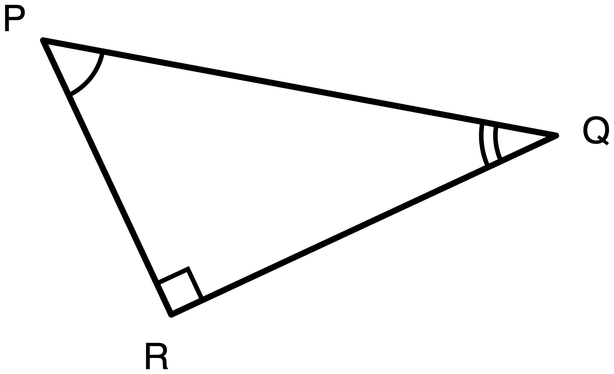
Figure 7.1. Triangle PQR, right angle at R. No side lengths are given.
Description: A right triangle, drawn tilted so that no side is horizontal or vertical. Three vertices are labelled P, Q and R. P is at the upper left. Q is at the right, a little lower than P. R is at the bottom, below P and slightly to its right. The three sides are: leg PR, running down and slightly right from P to R; leg QR, running from R up and to the right to Q, and it is the longer of the two legs; and side PQ, running from P down and to the right to Q, which is the longest side of the three. No side has a length given, and no side is marked as given or as unknown. The angle at R, between RP and RQ, is a right angle and is marked with a small square. The acute angle at P, between PR and PQ, is marked with one arc. The acute angle at Q, between QR and QP, is marked with two concentric arcs. The arc counts are here only to tell the two acute angles apart so they can be referred to unambiguously; they do not assert that any angles in this figure are congruent, and no congruence or similarity is claimed anywhere in this drawing.
The task. Triangle PQR has its right angle at R.
(a) Relative to angle P, name the opposite leg, the adjacent leg and the hypotenuse.
(b) Relative to angle Q, name the same three.
(c) In one sentence, how did you decide?
Tools on this sheet. A calculator (there is nothing to calculate) and a tracing-paper copy of the triangle that may be turned. Not permitted: a printed table of sine, cosine or tangent values, or a copy of this triangle with the legs already labelled.
Answers: The two legs exchange roles. PQ does not move.
Relative to | Opposite leg | Adjacent leg | Hypotenuse
angle P | QR | PR | PQ
angle Q | PR | QR | PQ

For part (c), accept any correct reason: the pointing test, or the opposite leg is the one that does not touch the angle.

Task 2 and its answers
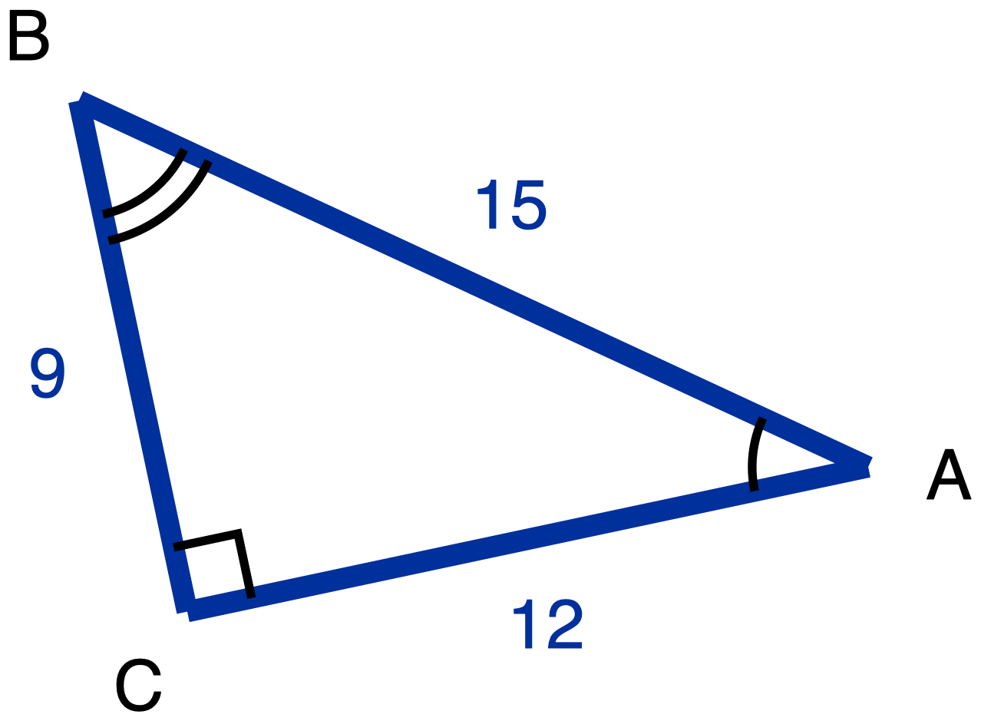
Figure 7.2. Triangle ABC, right angle at C, with AC = 12, BC = 9 and AB = 15.
Description: A right triangle, drawn tilted so that no side is horizontal or vertical. Three vertices are labelled A, B and C. B is at the upper left and is the highest of the three. A is at the right and lower than B. C is at the lower left, below B. The three sides are: leg BC, running from B down to C, with given length 9, the shorter leg; leg CA, running from C to the right and slightly up to A, with given length 12, the longer leg; and side AB, running from A up and to the left to B, with given length 15, the longest side. All three lengths are given, so all three sides are drawn in the heavier given weight and all three numerals are in the given colour. Nothing in this figure is marked as an unknown. The angle at C, between CA and CB, is a right angle and is marked with a small square. The acute angle at A, between AC and AB, is marked with one arc. The acute angle at B, between BC and BA, is marked with two concentric arcs. The arc counts are here only to tell the two acute angles apart; they do not assert that any angles are congruent, and no congruence or similarity is claimed in this drawing.
The task. (a) Relative to angle A, name the sides first, then write sin A, cos A and tan A.
(b) Relative to angle B, same triangle, name the sides again before writing anything else, then write sin B, cos B and tan B.
Tools on this sheet. A calculator and the definition card, and the card may not be marked down for. Not permitted: a copy of this triangle with the legs already labelled "opposite" and "adjacent" for either angle. A fraction or a decimal is accepted; lowest terms are not required, though they are shown below.
Answers: Right angle at C, AC = 12, BC = 9, AB = 15.
Relative to | opposite | adjacent | sine | cosine | tangent
angle A | BC = 9 | AC = 12 | 9/15 = 3/5 | 12/15 = 4/5 | 9/12 = 3/4
angle B | AC = 12 | BC = 9 | 12/15 = 4/5 | 9/15 = 3/5 | 12/9 = 4/3

✋
The misconception response, so you can recognise it at a glance while circulating: part (b) identical to part (a). That is sin B = 3/5, cos B = 4/5, tan B = 3/4.

Exit ticket and key
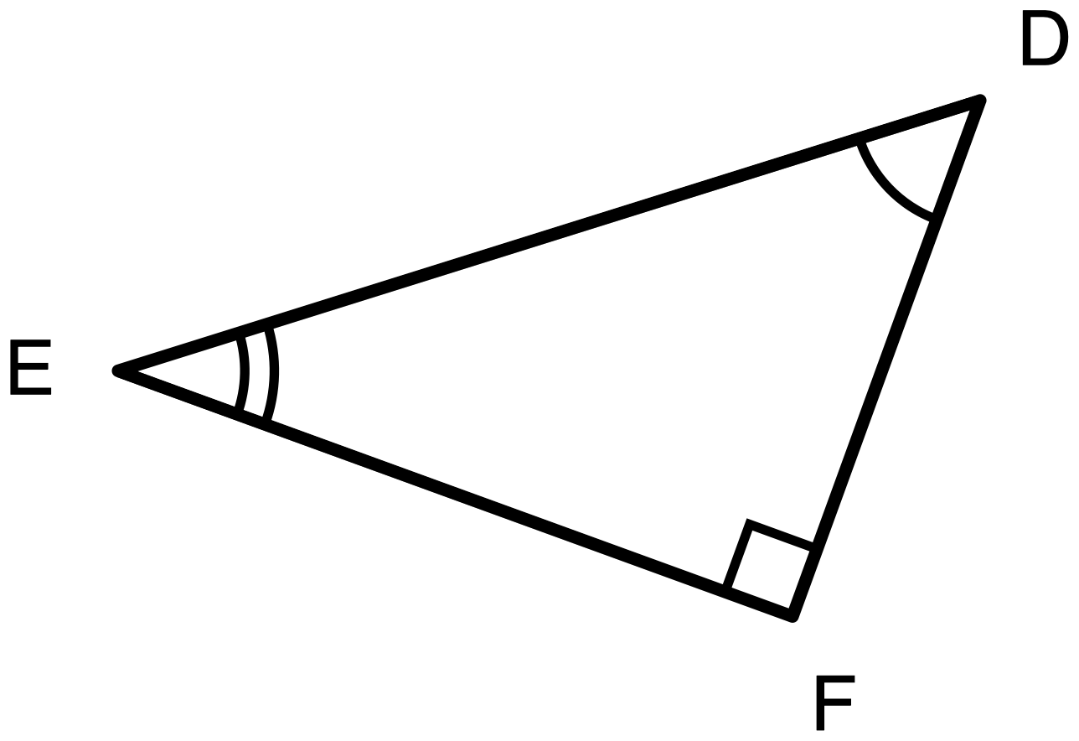
Figure 7.3. Triangle DEF, right angle at F, drawn at a tilt used nowhere else in the lesson.
Description: A right triangle, drawn tilted so that no side is horizontal or vertical, and at a different tilt from either figure used earlier in the lesson. Three vertices are labelled D, E and F. D is at the upper right and is the highest of the three. E is at the far left, lower than D. F is at the lower right, below D. The three sides are: leg DF, running from D down to F, the shorter leg; leg EF, running from E to the right and down to F, the longer leg; and side DE, running from D down and to the left to E, which is the longest side of the three. No side has a length given, and no side is marked as given or as unknown. The angle at F, between FD and FE, is a right angle and is marked with a small square. The acute angle at D, between DF and DE, is marked with one arc. The acute angle at E, between EF and ED, is marked with two concentric arcs. The arc counts are here only to tell the two acute angles apart; they do not assert that any angles are congruent, and no congruence or similarity is claimed in this drawing.
The ticket. Triangle DEF, right angle at F.
(a) Relative to angle D, name the opposite leg, the adjacent leg and the hypotenuse.
(b) Relative to angle E, name the opposite leg and the adjacent leg.
Relative to | Opposite leg | Adjacent leg | Hypotenuse
angle D | EF | DF | DE
angle E | DF | EF | not asked

What a student holding the misconception writes instead. Part (a) correct, because a fixed scheme assigned from angle D produces the right answer the first time. Part (b): opposite EF, adjacent DF, the identical pair, carried straight over from part (a), because under a fixed scheme there is nothing to recompute.
Why those differ, mechanically. The key requires the two legs to exchange roles between the parts. A labelling scheme welded to the drawing returns the same pair whatever angle is named, so it is structurally incapable of producing an exchange. This is not a difficulty threshold the misconception might scrape past on a good day. It is a shape the misconception cannot output.
The hypotenuse is the control, and it is on the ticket for that reason. DE is genuinely fixed and is correctly the same whichever angle is the reference, so part (a) asks for it and part (b) does not. A student who has the construct changes exactly the two legs and leaves DE alone. A student who has not changes nothing at all. The ticket therefore separates nothing changed because nothing should have from nothing changed because I never looked again. That is why the two parts are not symmetric.
✋
The honest limit. There are two legs and two roles, so a student who is merely unsure and guesses on part (b) has an even chance of landing on the key. That does not weaken the ticket as a detector of the misconception, because a student who holds it does not guess: they apply a rule they believe and repeat themselves. It does mean the ticket is a reliable detector of the misconception and a poor detector of uncertainty. Catch the second case with an oral probe, not a harder ticket.

While you circulate: what to watch for
You are not watching for effort or for correct arithmetic. You are watching for whether the labelling gets re-derived when the reference angle moves. This applies during Task 1 in Phase 2 and Task 2 in Phase 4.
What you see | What it means | What to do in the moment
Student writes part (a), then writes part (b) without looking back at the figure | The strongest single tell. The labels are being copied, not re-derived. | Do not correct the answer. Ask: "point at angle Q. Which leg are you touching?" Let the contradiction arrive from their own finger.
Part (b) is identical to part (a) | The misconception, confirmed on the page | Same probe. The gesture is the correction; a verbal rule is not.
Student turns the paper before answering part (b) | Good sign. They are re-deriving, using rotation as the tool. | Leave them alone. Note it; this student can explain the flip to the class in the Phase 4 share-out.
Student points at the angle before writing | The gesture has installed | Leave them alone.
Student calls a leg "the bottom one" or "the vertical one" | Position-based labelling, one step upstream of the misconception, and the reason every figure is tilted | Ask what they would call it if you rotated the page 90 degrees.
Student labels correctly but assigns the ratios by matching the card top-to-bottom against the sides top-to-bottom | Not the misconception. A card-reading slip. | Point at the card's word "opposite" and ask which side that is here. Quick to fix.
Student says "wait, sin A and cos B are the same" | Not an error. This is Day 9 arriving early. | Write it on the board with their name on it as an open question. Do not explain it.

Marking the exit ticket, and reading a low pile
- Sort into two piles only: part (b) legs exchanged, and part (b) legs not exchanged. Nothing else on the ticket sorts students. Do not sort on the hypotenuse; every student who gets part (a) at all will get DE, and it is there as a control, not as a discriminator.
- Where part (b) is correct but the ticket shows no working, no annotation and no sign the figure was revisited, probe orally at the start of Day 8. Hand the student the same figure and ask for the adjacent leg relative to angle D. Thirty seconds. This closes the guessing gap; a harder ticket would not.
- Feedback on a wrong part (b) must name the move, not the mark. The useful sentence is forward-looking and specific: "You labelled from D and then kept those labels for E. Point at E and tell me which leg you are touching. That one is adjacent, and it is the other leg this time." A bare cross tells the student the answer was wrong and leaves the fixed scheme intact.
✋
The one thing a low pile does not mean. If most of the class fails part (b), that is a signal about Phase 2's minutes, not about the class. The most common cause is Phase 1 being resolved too early, so the room never experienced the disagreement that makes the pointing test feel necessary rather than fussy. Re-run Phases 1 and 2 on Day 8 before the special triangles. Day 8's derivation does not depend on the labelling, so there is room.

Attribution
The quoted pointing rule in the misconception section is adapted from Illustrative Mathematics, IM High School Geometry, Unit 4 Lesson 4. © 2019 Illustrative Mathematics. Licensed under the Creative Commons Attribution 4.0 license, https://creativecommons.org/licenses/by/4.0/. Changes were made to the original material. The Illustrative Mathematics name and logo are not subject to the Creative Commons license.

Day 8 · Half a Square and Half an Equilateral Triangle

Standard: HSG-SRT.C.8. Use trigonometric ratios and the Pythagorean Theorem to solve right triangles in applied problems. Today is the derive half of that standard: students produce the 45-45-90 and 30-60-90 side ratios from the constructions that generate them, rather than applying ratios handed to them. The applied half of the sentence lands on Day 10.
Duration: 50 minutes. 6 + 9 + 14 + 8 + 9 + 4 = 50. Transitions sit inside the phases that own them, and there is no unallocated buffer anywhere in this plan, because a buffer is where a phase silently runs over.
Learning goal: Students derive the 45-45-90 and 30-60-90 side ratios from the two constructions that produce them, a square cut by its diagonal and an equilateral triangle cut by an altitude, and can say which value belongs on which side and why. That second clause is not decoration. It is the half of the goal the exit ticket measures, and it is where students fail.
Materials: Task 1 and Task 2 printed with their figures, face up on every desk from the start. Tracing paper and scissors on the front desk. A class set of the special-triangle reference card, handed out at 0:37 and collected by hand at 0:46. Board space for the named claims from Phase 1, which stay up all period. Straightedges and blank paper. No calculators on any task today, on every item, because every item asks for exact form.

The barrier this day removes
An unexamined assumption that cutting a symmetric figure in half produces a familiar triangle type by default, without tracking which angle got cut and what the cut did to it. A student can hold "half of a square is a 45-45-90 triangle" and "half of an equilateral triangle is a 30-60-90 triangle" as two remembered facts with no mechanism underneath either, and from the outside the two constructions look interchangeable: both halve a figure with equal sides, both produce a right triangle.
They are not interchangeable, and the difference is the whole lesson.
 | What the cut is | What it does to the angle it passes through | What it does to the opposite side
Square | A diagonal, joining two opposite vertices | Splits a 90° corner into two 45° angles, at both ends | Nothing. It does not meet a side at an interior point
Equilateral triangle | An altitude from one vertex | Splits the 60° apex into two 30° angles, at one end | Cuts the opposite side in half

The salient feature, a figure being halved, is not the relevant one. The relevant feature, what happened to the specific angle the cut passed through, has to be pointed at before students attend to it. Today's version of that demand is smaller than Day 5's tracking work, two triangles from one cut rather than three from an altitude, but it is the same kind of demand.

Phase sequence, 50 minutes

Both figures face up on every desk from the start: the square with its diagonal, and the equilateral triangle with its altitude.
- 0:00-0:04 Each student writes two lines, alone and silently. For each figure: what does the drawn line do to the angle it passes through, and what kind of triangle do you expect the half to be? No conferring, no answers offered.
- 0:04-0:05 Take three predictions aloud. Write each on the board as a named claim ("Amara's claim: the altitude cuts the 60° into two 30° angles"). Rule on none of them. The claims stay on the board all period and get checked off as the derivations settle them.
- 0:05-0:06 Students turn to Task 1 and read the stem. This minute belongs to Phase 1, not to Phase 2.
✋
Naming the claims and refusing to adjudicate is deliberate. A prediction that is corrected in the same breath is not tested, it is overwritten, and the belief survives underneath.

Task 1. Square ABCD of side 1, diagonal AC drawn.
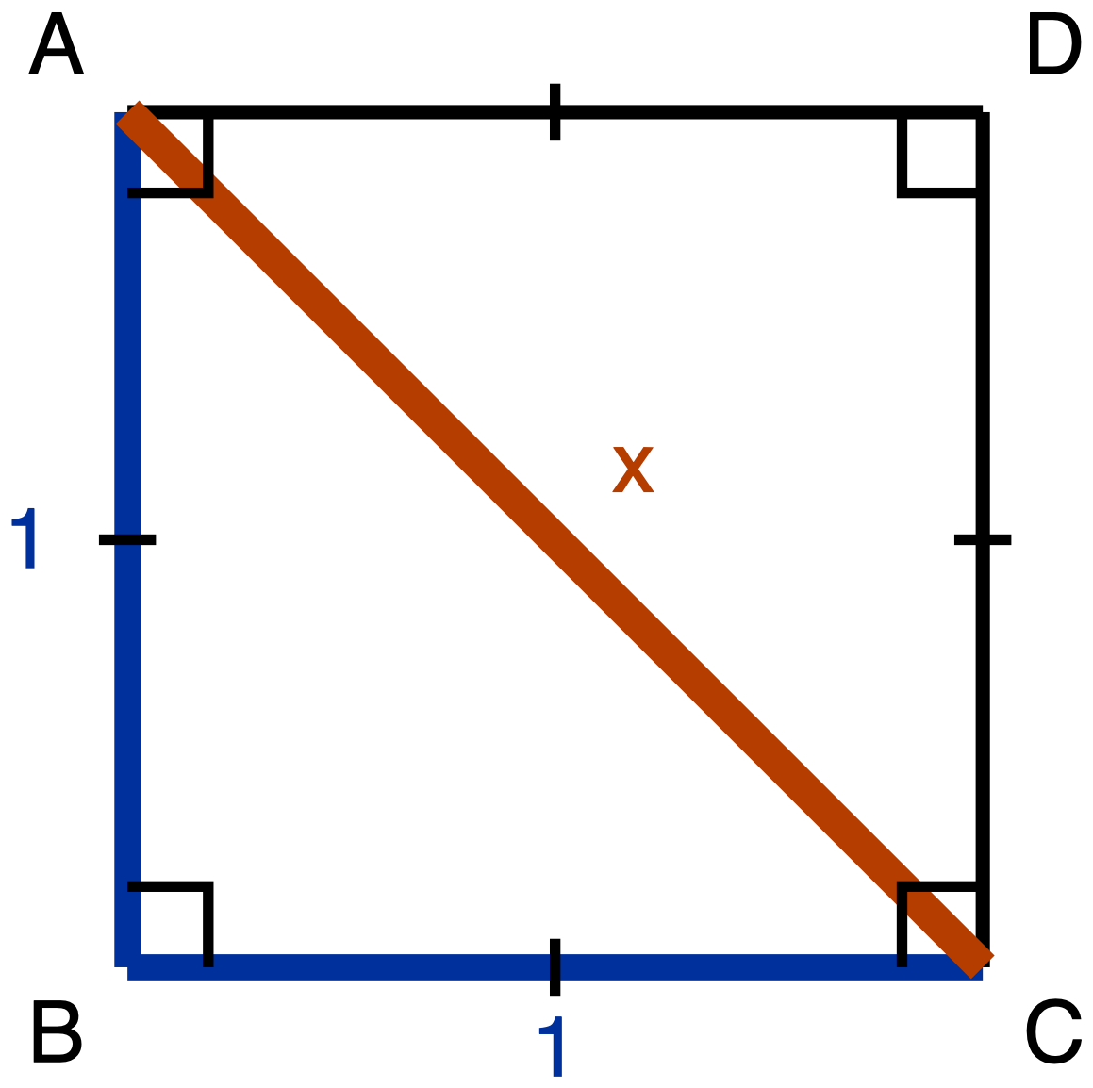
Figure 1. Square ABCD of side 1 with the diagonal from A to C drawn.
Description: Square ABCD has vertices A top left, B bottom left, C bottom right and D top right. A single tick on each of the four sides marks them congruent, and a right-angle square sits at each of the four corners. Sides AB and BC are given as 1. The diagonal AC is drawn and its length is unknown, labelled x; it passes through the corners of the right-angle marks at A and at C.
- 0:06-0:10 Individual work. Circulate and read what students write first. The productive first move is redrawing triangle ABC away from the square; the unproductive one is writing "45-45-90" and stopping.
- 0:10-0:13 Pairs. Each partner reads the other's argument and asks one question: where does your 45 come from?
- 0:13-0:15 One pair reads its derivation aloud. Record on the board only the angle chain, and write the vertex letters exactly, because the right angle of triangle ABC is at B and not at A.
The board chain, in full: ABCD is a square, so angle ABC is 90° and AB = BC; triangle ABC is therefore isosceles, so angles BAC and BCA are congruent; the three angles sum to 180° and angle ABC has taken 90° of that, so BAC and BCA sum to 90° and each is 45°. Leave the side chain in students' own notes. Board space is finite, and the side chain is the part they will have to reconstruct on Task 2 anyway.

Task 2. Equilateral triangle ABC of side 2, altitude from A meeting BC at M. This is the longer phase, because the altitude does two things and the algebra has a subtraction under a radical.
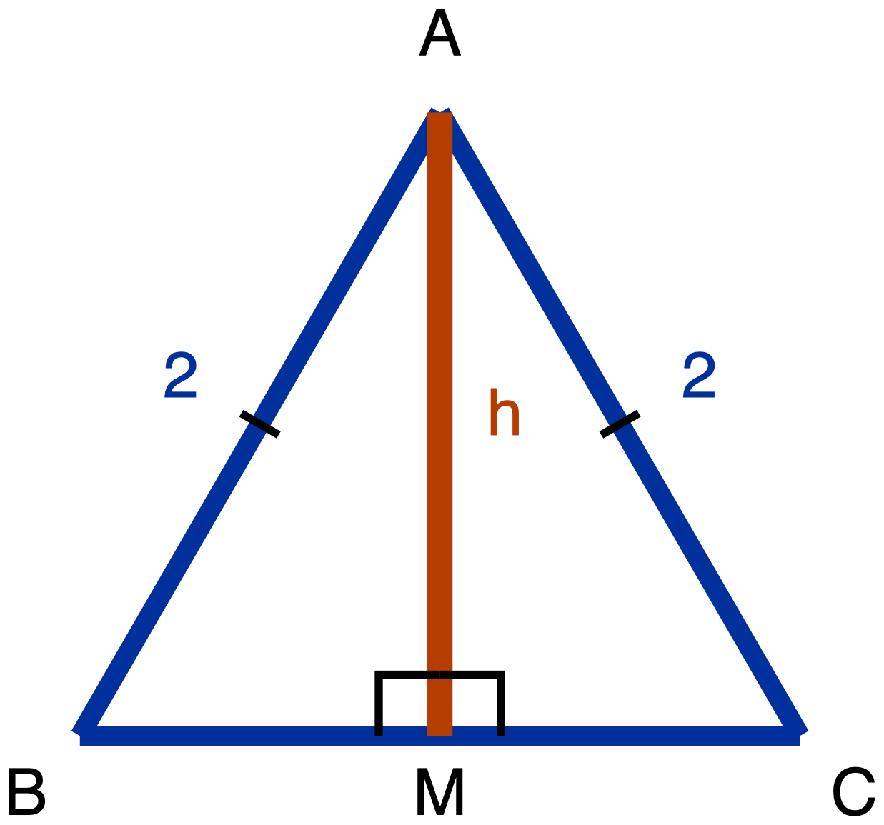
Figure 2. Equilateral triangle ABC of side 2 with the altitude from A drawn to BC.
Description: Equilateral triangle ABC has apex A at the top, B at the bottom left and C at the bottom right, with BC horizontal. Every side is 2; single ticks on AB and AC mark them congruent and both carry the numeral 2. The altitude from A meets BC at M, and the two right angles at M are marked. The length of the altitude AM is unknown and labelled h. Nothing in the drawing states where M sits along BC or what the altitude does to angle A.
- 0:15-0:17 Everybody separates the triangle before anybody writes an argument. Redraw triangle ABM on blank paper in the orientation it sits in the figure, or trace it, or cut it out. Tracing paper and scissors are on the front desk. This is a required step, not an option for students who want it.
- 0:17-0:24 Individual then pair work on the derivation.
- 0:24-0:27 Whole class, on the two-part question only: what did the altitude do to angle A, and what did it do to BC? Get both answers stated separately, by two different students. A class that has only the first half has not removed today's barrier.
- 0:27-0:29 Every student writes `1 : √3 : 2` in their own notes in side order, shortest to longest, with the words "short leg," "long leg," "hypotenuse" written under the three values. Watch this minute. It is the first place the misconception becomes visible.

The misconception phase. Nothing new is taught here. A check is installed.
- 0:29-0:31 The synthesis question, asked and discussed, not written. See below.
- 0:31-0:34 On the board: a 30-60-90 triangle with short leg 1 has the other two sides √3 and 2. Ask, with no calculator on any desk: which is bigger, √3 or 2? Take the vote before taking a reason. Then install both checks.
- 0:34-0:37 Deliberate contrast. Write a wrong assignment on the board yourself (hypotenuse √3, longer leg 2) and ask the class to refute it in two different ways. The two ways are the two checks. A student who can only produce one has one check, not two.
- 0:37 Hand out the reference card, and say out loud, now, that it will be collected before the exit ticket, and why: it prints the thing the ticket asks them to work out. Saying this at handout rather than at collection is what keeps it from feeling like a trick.
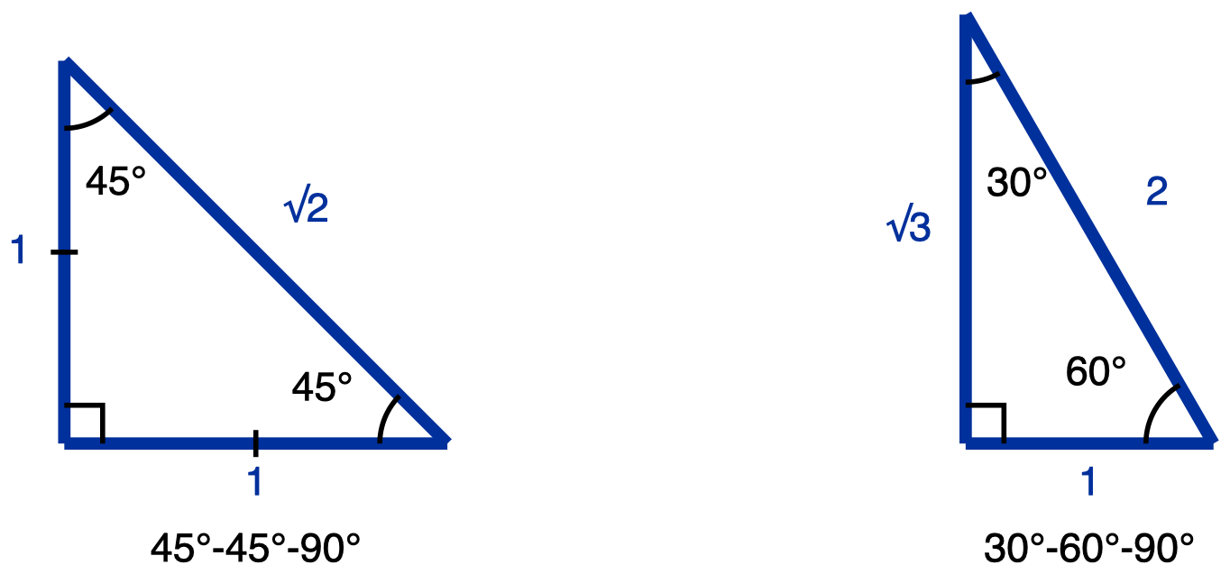
Figure 3. The special-triangle reference card, handed out at 0:37 and collected at 0:46.
Description: Two right triangles side by side, both with the right angle at the bottom left and both drawn in the same orientation. The left one has two 45 degree angles, legs of 1 and 1 marked congruent by a single tick each, and hypotenuse root 2. The right one has a 30 degree angle at the top and a 60 degree angle at the bottom right, a short bottom leg of 1, a long left leg of root 3, and hypotenuse 2. This card supplies the two ratios; it does not derive them.
Synthesis question (0:29): Both cuts halved a figure whose sides are all equal, and both halves are right triangles. So why does the square give 45-45-90 and the equilateral triangle give 30-60-90? Answer by naming what each cut did to the angle it passed through.
The answer you are listening for has two parts, and a class that gives only the first has not landed it: the diagonal split a 90° angle into two 45° angles, and it did that at both ends; the altitude split a 60° angle into two 30° angles, and it did that at one end while also cutting the opposite side in half.

Tasks 3, 4 and 5. The reference card is on the desk and is allowed on all three. Calculators are not, on any of them, because all three ask for exact form.
The order of the three tasks is itself the teaching. Task 3 runs the 45-45-90 forwards, leg to hypotenuse: one multiplication. Task 4 runs the 30-60-90 backwards, hypotenuse to legs: a halving and then one multiplication, with no radical ever in a denominator. The board work at 0:41 then runs the 45-45-90 backwards, which is neither of those. It is a division by a radical, and it needs a step nothing else in this unit needs. Students meet the reversal first in the form where it is easy, and meet the hard form immediately afterwards with the easy one still on the board to be compared against.
- 0:37-0:39 Task 3.
- 0:39-0:41 Task 4. This asks for both legs, so it is the first place students have to make the slot assignment themselves. With the card present they can look it up, and that is the intended scaffold at this point in the period: support is planned to shrink, and this is where the shrink is scheduled. A correct Task 4 is therefore not evidence that a student holds the assignment.
- 0:41-0:44 The reverse direction on the 45-45-90, on the board, teacher-led. See the three lines below.
- 0:44-0:46 Task 5, the rehearsal, on different numbers, with the board example still up and the card still on the desk. Both of those soften the task and both are meant to. A correct Task 5 is not evidence that a student holds this direction unsupported.

The board work at 0:41, line by line
Draw a 45-45-90 with the hypotenuse marked 10 and both legs unknown. Ask the room to read the ratio off the card, in side order: leg : leg : hypotenuse = 1 : 1 : √2. Then write these three lines, saying each one aloud as you write it.
- Every 45-45-90 triangle is that one scaled by some factor x, so its legs are x and x and its hypotenuse is x√2.
- Here the hypotenuse is 10, so x√2 = 10, and therefore x = 10/√2.
- `10/√2` is a correct length and it is not an answer in exact form, because exact form does not leave a radical in a denominator. Multiply above and below by √2, which is multiplying by 1: `(10/√2) · (√2/√2) = 10√2 / 2 = 5√2`. Each leg is 5√2.
Then run the size check from Phase 4 on the answer, out loud, with no calculator: is 5√2 shorter than 10, as a leg must be? 5√2 is 5 times √2 and 10 is 5 times 2, so the question is whether √2 is less than 2, and √2 is less than √4, which is 2. Yes. This is the same check installed at 0:31, reused on a new answer twenty minutes later, and reusing it here is worth more than adding a third check.

Why the reverse direction is harder, and why it is not a memory problem
Students who multiply by √2 without hesitating will stall on dividing by it. The stall has three causes worth naming, because each one is repaired by a different sentence and none of them is repaired by repeating the ratio.
- The answer does not look like an answer. Multiplying by a radical leaves the radical where it already was, and the result looks like every exact-form answer they have written today. Dividing puts the radical in a denominator, a position none of their answers has ever occupied, so `10/√2` reads as unfinished work even to a student who produced it correctly.
- The work is not over when the division is done. `10/√2` is correct and is not the answer. This is the only task in the day where a correct line has to be rewritten rather than boxed, and a student who has learned that a correct line ends the problem will stop one step early.
- The rewrite looks like cheating. Multiplying by `√2/√2` is multiplying by 1, and a student tracking arithmetic rather than form reads it as changing the length. Say this one aloud while you write it: "√2 over √2 is 1, so this does not change how long the leg is, only how it is written."

- 0:46-0:47 Cards collected, physically, by hand, all of them. Calculators away. Desks clear. This minute is part of the assessment, not housekeeping: a card left on one desk invalidates that student's ticket exactly the way a shared formula sheet would.
- 0:47-0:50 Exit ticket.

The misconception to expect, and the move
What it is. Having derived the 30-60-90 ratio as 1 : √3 : 2, the student assigns √3 to the hypotenuse rather than to the longer leg. Given a 30-60-90 triangle with short leg 5, the student answers hypotenuse 5√3 and longer leg 10.
Why it happens. The student has to rank √3 against 2 and has not internalised that √3 is about 1.73. Written as a radical, √3 carries more symbolic weight than a bare 2 and reads as the more complicated, and therefore larger, quantity. The one ordering fact the student does own, that the hypotenuse is the longest side, does not help until the two candidates can be ranked.
✋
Do not re-teach the ratio. Re-teaching treats this as a memory failure, and it is not one. The student has the ratio. What is missing is a way to rank the two numbers in it.

The move. Install a size check that runs without a calculator, and install it twice, from two independent directions, so a student who forgets one still has the other.
- The radical comparison. √3 is less than √4. √4 is 2. So √3 is less than 2, and √3 cannot be the longest side. Say this as a comparison of radicals, never as "√3 is about 1.73." A student working in exact-value mode has deliberately put the decimal away, and handing it back re-opens the door the exact-value convention closed.
- The angle-side ordering. The longest side lies opposite the largest angle. In a right triangle the largest angle is the 90°, and the side opposite it is the hypotenuse. So the hypotenuse is the longest side, and the longest side cannot be √3 when a 2 is sitting next to it.
CK-12's Geometry Teacher's Edition puts the first check in one line, under a heading that is itself the mnemonic, Two is Greater Than the Square Root of Three: "Just bring to the students' attention that 2 > √3." (CK-12 Foundation, 2010, Geometry Teacher's Edition, chapter 2, Common Errors, "Special Right Triangles.")

If you hear "half an equilateral triangle is two 45-45-90 triangles"
You may well hear this in Phase 1. It is a plausible belief, and Phase 3 refutes it directly: the apex is 60°, not 90°, so halving it gives 30°, not 45°. Note it in your own records as something your room produced. Do not treat it as today's target error; the day is built around the √3-on-the-hypotenuse swap above, and the exit ticket measures that one.

Answer key
Task 1: Angles: 90° at B, 45° at A, 45° at C. Sides: AB = 1, BC = 1, AC = √2. Derivation: ABCD is a square, so angle ABC is 90° and AB = BC; triangle ABC is therefore isosceles, so angles BAC and BCA are congruent; the three angles sum to 180°, so those two sum to 90° and each is 45°. Then 1² + 1² = AC², so AC² = 2 and AC = √2. Ratio in side order: 1 : 1 : √2.
Task 2: Angles: 90° at M, 60° at B, 30° at BAM. Sides: BM = 1, AM = √3, AB = 2. Derivation: triangles ABM and ACM are congruent (AB = AC, AM shared, right angles at M), so BM = MC and each is half of BC, which is 1; and angle BAM = angle CAM, so each is half of the 60° apex, which is 30°. Angle B is 60° because ABC is equilateral. Then 1² + AM² = 2², so AM² = 3 and AM = √3. Ratio in side order: 1 : √3 : 2.
Task 3: Hypotenuse = 7√2.
Task 4: Shorter leg = 7, longer leg = 7√3.
Task 5: Each leg = 3√2. Route: the legs are x and x and the hypotenuse is x√2, so x√2 = 6 and x = 6/√2; then `(6/√2)·(√2/√2) = 6√2/2 = 3√2`. Accept `6/√2` as correct work and not as a final answer, and say why when you hand it back: a radical is left in the denominator. Size check, no calculator: 3√2 against 6 is √2 against 2, and √2 < √4 = 2, so the leg is shorter than the hypotenuse, as it must be. A student who answers 6√2 has multiplied where the direction called for dividing. Send them to the size check, not to the ratio, because 6√2 is longer than the hypotenuse it came from.
Exit ticket: (a) Hypotenuse 10, longer leg 5√3. (b) Either check: √3 < √4 = 2, so 5√3 < 10, so 5√3 is not the longest side. Or: the longest side lies opposite the largest angle, the largest angle is the 90°, so the hypotenuse is the longest side.

Why the ticket has two parts
Part (a) alone would let a student pass who has the right answer for no reason, having memorised "the 2 goes on the hypotenuse" without being able to rank √3 against 2. That student still holds the barrier. Part (b) closes it: they cannot produce the size check, because they have never run it. Part (b) alone would let a student pass who can recite "√3 is less than 2" while still writing the values in the wrong slots, which happens more than it sounds like it should. Part (a) closes that. Part (b) is where the ticket stops being scoreable and starts being diagnostic.

Tools, item by item
✋
Do not announce a tools rule for the period. The rule changes twice inside these 50 minutes, and an announced blanket rule is what makes students stop reading the per-task line. Each task states its own tools, and those lines are printed on the student sheet.

Item | Calculator | Reference card | Read-aloud
Task 1, derive 45-45-90 | Denied, exact form asked for | Denied, it prints the answer being derived | Permitted
Task 2, derive 30-60-90 | Denied, exact form asked for | Denied, it prints the answer being derived | Permitted
Task 3, use 45-45-90 | Denied, exact form asked for | Permitted | Permitted
Task 4, use 30-60-90 | Denied, exact form asked for | Permitted | Permitted
Task 5, use 45-45-90 in reverse | Denied, exact form asked for and a calculator performs the division and skips the rewrite | Permitted | Permitted
Exit ticket | Denied, exact form and it performs the ranking part (b) asks for | Denied, it prints the slot assignment being measured | Permitted

The card flips twice, and that is why it is handed out at 0:37 and collected at 0:46 rather than sitting on the desk all period. The calculator denial on Task 5 is the only one on this sheet resting on two grounds rather than one, and the second ground is the load-bearing one: a calculator does not merely return a decimal there, it performs the division that the task exists to make students perform by hand and rewrite.
✋
These are statements about what the items measure. They are not decisions about any individual student. A student whose IEP or 504 plan grants a calculator, a scribe, extended time, or anything else keeps it today, whatever this table says. If that plan and this table collide on the exit ticket, the plan wins, and you note on the ticket that it did, so the score is read correctly later.

What to watch for while you circulate

Phase 1, the predictions
Watch for a student who writes a triangle type for each figure but writes nothing about what the line does to the angle. That is the barrier stated in the student's own hand: two remembered facts with no mechanism. Do not correct it. It is a prediction, it is on the board as a named claim, and Phases 2 and 3 are what settle it. Correcting here overwrites the belief instead of testing it.

Phase 3, the two-part bisection
This is the highest-value two minutes of the period to be circulating. Watch for students who answer only one half of the two-part question.
- "The altitude cuts angle A in half" and nothing about BC. This student will get BM wrong or will guess it.
- "The altitude cuts BC in half" and nothing about angle A. This student gets the sides but cannot say why the angles are 30 and 60, and will not be able to reconstruct the ratio next week.
Both are the barrier, showing up as a partial answer rather than a wrong one, which is why a teacher scanning for wrong answers misses them. Also watch for students who never physically separated triangle ABM and are trying to reason inside the overlapped figure. Send them back to the separation step. It is required for a reason, and it is the step most likely to be skipped by students who believe they do not need it.

Phase 4, at the vote
Count the hands for "√3 is bigger." That count is your best single estimate of how many students hold the misconception in the room, and it is more reliable than anything Task 4 will tell you, because the card is on the desk during Task 4. With the card present, Task 4 measures application of a supplied ratio. It cannot distinguish a student who holds the slot assignment from one who read it off the card thirty seconds earlier, and it is not supposed to. The evidence for the assignment is the exit ticket, and only the exit ticket.

On the ticket, sort the wrong answers into three piles, not one
What you see | What it is | What to do
Hypotenuse 5√3, longer leg 10 | The target misconception. The exact transposition | The feedback line below. This is the size check, not the ratio
Hypotenuse 10, longer leg 5√2 | Wrong special triangle, not the target misconception | Back to Task 2's derivation. The size check will not help
(a) correct, (b) blank or "because it just is" | The assignment is memorised, not held | The size check, and ask for it orally before they leave if there is time

The third pile is the one the ticket exists to surface, and the one a numeric-only ticket would have scored as a pass. Note also that 5√3 is about 8.66 and 10 is 10, so the first pile is not a near miss. It is an exact swap, and the swap is the misconception's mechanical signature.
Feedback line for the transposed answer: "You have both numbers, and they are the right two numbers. Rank them before you place them. √3 is less than √4, and √4 is 2. Now put the larger one opposite the right angle and try part (b) again."

What a good period looks like at 0:46
Every student has, in their own notes: two figures redrawn separately from their parents, two angle chains, two side chains, and `1 : √3 : 2` written in side order with the three side names under it. If the notes have the ratio but not the two chains, the period produced two more memorised facts, which is what today was designed to prevent.

Day 9 · The Complementary Angle Relationship

Standard: HSG-SRT.C.7 — Explain and use the relationship between the sine and cosine of complementary angles. Day 9 is the only day of the unit that teaches this standard.
Duration: 50 minutes. Grade band 9-10.
Learning goal: Students explain, from the structure of a single right triangle, why the sine of one acute angle equals the cosine of the other, and use that relationship to solve for an unknown sitting inside an angle expression.
The explain half and the use half are not two lessons stapled together. The use half is solvable by a memorised template. The geometric reason is the thing that makes the template survive being forgotten, so the tasks are built to ask for the reason in the student's own words and in terms of named sides.
Materials: Task page (Tasks 1 to 4), one per student. Exit ticket half-sheets, cut and kept separate until the last six minutes. A way to display the unmarked triangle (Figure 9.2) in Phase 1 and the shared-leg summary (Figure 9.3) in Phase 4. Board space that stays clear all lesson for A + B = 90°. Blank right triangles for any student who would rather not draw one in Task 2. Plain or scientific calculators (see the tool notes below).
✋
Three things to do before the bell. (1) Cover any cofunction card or trigonometric identity poster on the wall. This standard is the one in the unit where a printed form of the relationship simply hands over the answer, so it is denied for this lesson and for Quiz 3.
(2) Figure 9.3 is a display figure only. It names the shared leg and both of its roles, which is exactly what Tasks 1 and 2 and the exit ticket ask students to produce, so it is deliberately not printed on the student task page. Put it up at the start of Phase 4 and take it down before the ticket.
(3) The exit ticket is closed-notebook. In Phase 3 students write the relationship in their own words; a ticket answered by copying that sentence measures transcription, not understanding.

✋
Where this meets an individual accommodation. If a student holds a documented note-sheet or memory-aid accommodation and that sheet carries the sine-cosine complement relationship, the closed-notebook instruction and that accommodation point in opposite directions. This lesson removes barriers for the class; it does not assign, decline or substitute for any individual student's documented accommodation, and nothing here is grounds for declining one. That decision belongs to the student's team. It is named here so it is not settled silently at the classroom door.

✋
Read-aloud is permitted on every item today. Each Day 9 item either supplies its figure or is purely symbolic, so no student is being asked to build a geometric structure out of prose.

Before You Teach: Where the Bridge Lands
The load-bearing fact of this lesson is a fact about shape, not about symbols:
✋
A right triangle has exactly two legs and exactly two acute angles. The leg that is opposite one acute angle is the leg adjacent to the other.

Everything else follows in one step. The three angles sum to 180° and one of them is already 90°, so the two acute angles sum to 90°: they are complements, and each is determined by the other. Sine of the first angle is the opposite leg over the hypotenuse. Cosine of the second is the adjacent leg over the hypotenuse. Those are the same two segments, so they are the same fraction. No unit circle is required, and none is used here.
This is the direct payoff of two earlier days:
- Day 7 built the skill of re-deriving opposite and adjacent from whichever angle is the reference. Day 9 shows that the two labels the same leg receives are not a nuisance of the notation, they are a structural necessity.
- Day 6 established that a ratio belongs to the angle, not to the triangle. Two angles locked together by complementarity therefore have ratios locked together too.
Day 8 sits between Day 7's labelling work and this lesson, so Phase 1 reactivates the labelling rather than assuming it is still warm. Reactivate, do not re-teach: two minutes of pointing, not a re-lesson.

Lesson at a Glance
Minutes sum to 50. Transitions sit inside the phases that own them; there is no unallocated buffer.
# | Phase | Min | What happens
1 | Reactivate the two labels | 8 | The pointing test at A and then at B on an unmarked triangle; get A + B = 90° out of the class with the reason. Hand out the task page.
2 | The shared leg | 12 | Task 1, individually then in pairs, then sin A and cos B written side by side on the board. Close the door on the right angle.
3 | Name it, then test its edge | 10 | Students write the relationship in their own words, then Task 2, the tangent disagreement.
4 | Use it | 14 | Figure 9.3 goes up. Tasks 3 and 4, sentence before equation. Task 3(a) and 3(b) contrasted on the board.
5 | Synthesis and exit ticket | 6 | The synthesis question out loud, then the ticket on a separate half-sheet, closed-notebook.

Phase-by-Phase Plan

Display Figure 9.2, which carries no measures. Run Day 7's pointing test twice on the same triangle: point at A, the leg you are touching is adjacent, the leg you are not touching is opposite; now point at B and do it again. Two minutes of that.
Then ask what the two acute angles must sum to, and get 90° out of the class with the reason, 180 minus the right angle, rather than as a recalled fact. Write A + B = 90° on the board and leave it up for the whole lesson. Use the last minute to hand out the task page and settle.
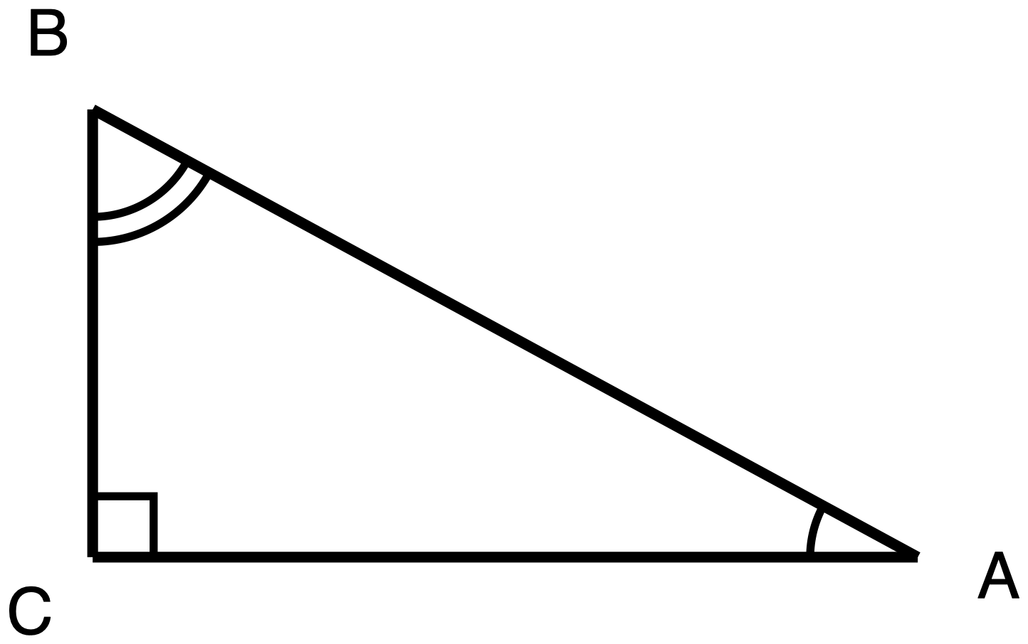
Figure 9.2. Right triangle ABC with the right angle at C and no measures given. Display in Phase 1; it is also the exit ticket figure.
Description: A single right triangle, one leg horizontal along the bottom and one leg vertical on the left. C is the bottom-left corner and holds the right angle; A is the bottom-right corner, level with C; B is directly above C and is the highest point. CA is the horizontal bottom leg; CB is the vertical left leg; AB runs from the bottom-right corner up to the top-left corner and is the hypotenuse. All three are drawn at the plain skeleton weight because none carries a given measure, and no numeral appears anywhere in the figure. The right angle at C carries a small square. The angle at A carries a single arc. The angle at B carries two concentric arcs. The right angle is never drawn as an arc, so the arcs mark the two acute angles only, and the differing arc counts say that A and B are two different angles rather than a congruent pair. No two segments and no two angles are marked congruent.

Students work Task 1 on Figure 9.1, individually for 4 minutes, then in pairs for 4. Circulate against the watch-for table below.
Final 4 minutes, whole class: take one pair's fractions and write sin A = BC/AB and cos B = BC/AB side by side on the board. Let the class say what they notice before you say it. Then close the door on the right angle, using the move set out in the next section.
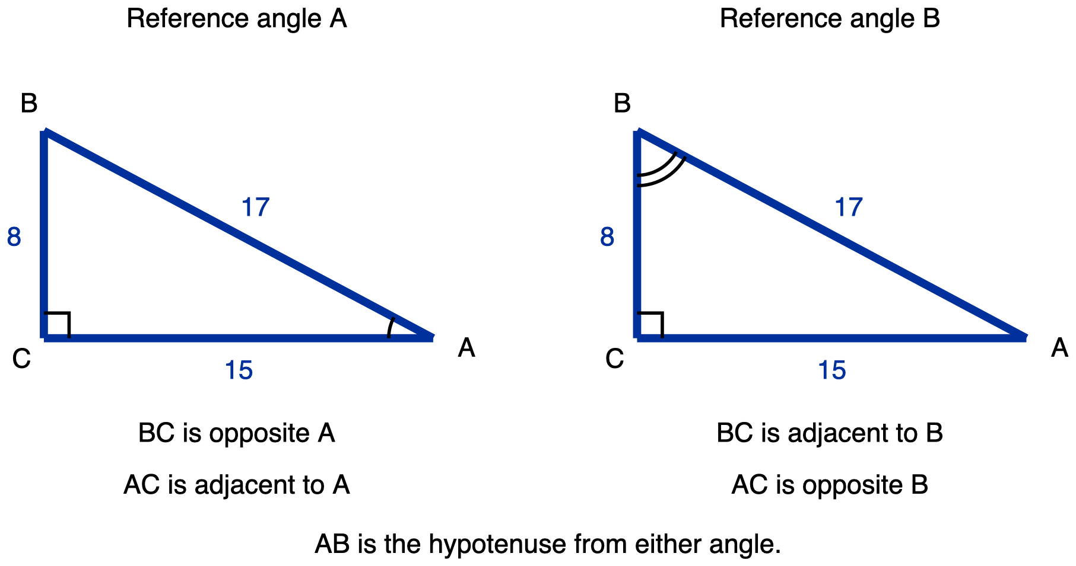
Figure 9.1. One right triangle drawn twice, named first from angle A and then from angle B. This is the Task 1 figure and it is printed on the student page.
Description: Two panels side by side, each holding the same right triangle, drawn with one leg horizontal along the bottom and one leg vertical on the left. The panels are captioned 'Reference angle A' on the left and 'Reference angle B' on the right. Points, in the same position in both panels: C is the bottom-left corner and holds the right angle; A is the bottom-right corner, level with C; B is directly above C, higher than both. Segments, identical in both panels and all three given: CA is the horizontal bottom leg and measures 15; CB is the vertical left leg and measures 8; AB runs from the bottom-right corner up to the top-left corner and is the hypotenuse, measuring 17. All three are drawn at the heavier given weight. The right angle at C carries a small square in both panels and is never drawn as an arc. In the left panel only, the angle at A carries a single arc, marking it as the reference angle there. In the right panel only, the angle at B carries two concentric arcs, marking it as the reference angle there. No angle carries an arc in both panels. The two panels are the same triangle, so every side and angle in the left panel equals its counterpart in the right; the differing arc counts distinguish the two acute angles from one another, not the two panels. Captions under each panel: left, 'BC is opposite A' and 'AC is adjacent to A'; right, 'BC is adjacent to B' and 'AC is opposite B'; and centred beneath both, 'AB is the hypotenuse from either angle.'

3 minutes: every student writes the relationship in their own words in their notebook. Do not supply a sentence to copy. The wording is theirs, and you will read four or five of them over shoulders (see the watch-for table).
7 minutes: Task 2, the tangent disagreement. Keep Figure 9.3 off the board for this whole phase.

2 minutes: put Figure 9.3 up as the summary of what the class has just built.
12 minutes: Task 3 then Task 4, with the standing requirement that the angle-relationship sentence is written before any equation. Take Task 3(a) and 3(b) side by side on the board in the last 3 minutes. That contrast is the whole point of the item.
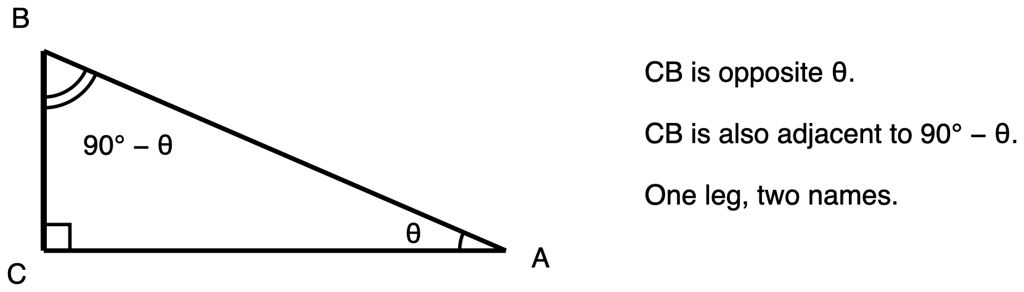
Figure 9.3. The shared leg CB, opposite one acute angle and adjacent to the other. Display only: put it up at the start of Phase 4 and take it down before the exit ticket.
Description: A single right triangle on the left half of the figure, one leg horizontal along the bottom and one leg vertical on the left, with three lines of caption text to its right. C is the bottom-left corner and holds the right angle; A is the bottom-right corner, level with C; B is directly above C and is the highest point. CA is the horizontal bottom leg, drawn at the plain skeleton weight; AB is the hypotenuse, running from the bottom-right corner up to the top-left corner, also at skeleton weight; CB is the vertical left leg and is drawn one step heavier, at the emphasis weight, because it is the segment the figure exists to discuss. No segment carries a numeric measure. The right angle at C carries a small square. The angle at A carries a single arc and is labelled with the Greek letter theta, printed inside the triangle near A. The angle at B carries two concentric arcs and is labelled 90 degrees minus theta, printed inside the triangle near B. The two different arc counts mark A and B as two different angles, and the labels state that the two acute angles are complements, since theta and 90 degrees minus theta sum to 90 degrees. No pair of segments and no pair of angles is marked congruent. Three caption lines to the right of the triangle read: 'CB is opposite theta.', 'CB is also adjacent to 90 degrees minus theta.', and 'One leg, two names.'

2 minutes on the synthesis question, answered out loud by two or three students:
✋
A right triangle has only two acute angles. Why does that single fact force sine and cosine to be linked, and why does it not link tangent to its own complement in the same way?

The answer you are listening for joins the day together: sine of one acute angle and cosine of the other are built from the same pair of sides, the shared leg over the hypotenuse, so they are equal. The two tangents are built from the same pair of legs but in opposite order, so they are reciprocals, not equals.
Then take Figure 9.3 down, have task pages and notebooks closed and away, and issue the exit ticket as a separate half-sheet. 4 minutes to write. Collect at the door.

The Misconception to Expect, and the Move
The one to plan for. The student knows the relationship pairs an angle with some other angle, and takes the other angle to be the right angle. In right triangle PQR with the right angle at P, they choose sin Q = cos P instead of sin Q = cos R. This is well documented on released state assessment items, in the published rationale for the wrong option.
Why it happens, in one line. The right angle is the most salient angle in the figure. It is marked, it is named in the problem, and it is the angle students have been told to find first in every right-triangle task so far. The complement of Q means nothing visually, so the most available other angle gets substituted.
The move, in Phase 2, and it is a computation rather than a warning. Ask the class what the cosine of the right angle even is. Then close the option instead of warning against it. Two routes are available; use whichever one your class has grounds for.
- Route A, always available in this unit. The ratio definitions built in Days 6 and 7 are defined from the two acute angles of a right triangle. Angle C is not one of them, so cos C is not a ratio this triangle offers, and C is not a candidate at all.
- Route B, only if your class has already met cosine beyond the acute range. cos 90° = 0 for every right triangle, and 0 cannot equal a non-zero sine.
✋
Choose the route deliberately. This unit has not built cosine outside the acute angles of a right triangle: Days 6 and 7 define the ratios from an acute angle's opposite, adjacent and hypotenuse, and nothing in Days 1 to 8 introduces the unit circle. If your students met cos 90° = 0 in an earlier course, Route B is the sharper close because it is numerical. If they have not, Route B asks them to accept a value the unit never derived, and Route A is the one to use. The exit ticket key accepts either.

Four secondary errors also live on this day, and each has a task built to surface it:
What the student does | Where this lesson meets it
Finds the right partner angle but keeps the wrong function: sin Q = sin R | Task 1 forces both ratios to be written as fractions of named segments, which is where sin B and cos B visibly differ
Over-generalises to tangent: tan 25° = tan 65° | Task 2, built as a conjecture to be settled rather than a warning to be issued
Sets the two angle arguments equal, or sums them to 180 | Task 3, where the same-function case sits next to the cofunction case on one page
Distributes the cosine over a sum, reading cos(y + 18°) as a coefficient times a bracket | Task 4, constructed response, so the distribution shows in the work

Answer Key

Task 1 · One leg, two names
(a) sin A = BC / AB = 8/17. cos B = BC / AB = 8/17.
(b) They are the same fraction because BC is one single leg, and a right triangle has only two legs and only two acute angles: the leg that does not touch A is the leg that touches B. So the leg opposite A is the same leg that is adjacent to B, and both ratios put it over the same hypotenuse.
What this item catches: an answer that says sine equals cosine of the complement and stops. The stem tells the student in advance that this does not answer part (b), so it is a stated requirement of the item and not a penalty hidden in a rubric. It also catches the student who writes sin B = 8/17 rather than cos B and does not notice that the function has to change.

Task 2 · Does it work for tangent?
Take one right triangle with acute angles 25° and 65°, with leg p opposite the 25° angle and leg q opposite the 65° angle. Then tan 25° = p/q and tan 65° = q/p.
(a) p/q and q/p. (b) The two fractions are reciprocals, so tan 25° · tan 65° = 1. They are equal only if p = q, which would make both angles 45°. Nadia is wrong; Omar is right. (c) In general, tan(90° − θ) = 1 / tan θ.
What this item catches: the answer yes, equal, because 25 and 65 are complements. The contrast with sine and cosine is the payoff: sine and cosine share a numerator and a denominator, while the two tangents swap them.

Task 3 · Same function, or a sine and a cosine?
(a) The two angles are complementary. (3x + 12) + (x + 30) = 90, so 4x = 48 and x = 12. The angles are 48° and 42°, both acute, so the answer survives the check.
(b) The two angles are equal. 3x + 12 = x + 30, so 2x = 18 and x = 9. Both angles are 39°, acute, so this survives too.
What this item catches: a student who equates the arguments in part (a) gets x = 9, which is part (b)'s answer sitting in part (a)'s box, and that is visible to you at a glance. A student who sums to 180 in part (a) gets 4x = 138 and x = 34.5, giving angles of 115.5° and 64.5°. The required acute check is what makes that answer fail in the student's own hand rather than only in yours.

Task 4 · Solve for y
32° and (y + 18)° are complements, so 32 + (y + 18) = 90, giving y + 18 = 58 and y = 40.
What this item catches: distributing the cosine over the bracket produces no clean value and leaves visible wreckage in the working, which is exactly why this item is constructed response and why the calculator is denied on it. It also catches equating the arguments, y + 18 = 32 giving y = 14, and summing to 180 to get y = 130, which the acute condition in the stem rules out.

Exit Ticket and Key
Separate half-sheet, issued after task pages and notebooks are closed and away. No calculator. Uses Figure 9.2, right triangle ABC with the right angle at C. Given sin A = 0.6:
- Name the angle in this triangle whose cosine equals 0.6.
- Justify it, using the fact that A and B are the two acute angles of this triangle.
- Say why the answer cannot be angle C.

Key
(a) Angle B.
(b) A and B are the two acute angles of this triangle, so A + B = 90° and B is A's complement. The leg opposite A is the same leg that is adjacent to B, so sin A and cos B are the same fraction of the same two sides, and both are 0.6. A 3-4-5 triangle realises it: 3/5 = 0.6.
(c) Either route is accepted. Route A: the sine and cosine ratios in this unit are defined from the acute angles of a right triangle, and C is not one of them, so C is not a candidate. Route B, if your class has grounds for it: cos C = cos 90° = 0, which is not 0.6.
✋
Why all three parts are required. A student who pairs A with the right angle answers angle C to part (a), so part (a) alone separates them. Part (c) then removes the escape route: they would have to argue why C is right at the same moment the item asks why C is impossible. A bare B with no justification does not meet the ticket either, which is what stops a two-way guess from passing. The stem says so to the student.

Feedback to write on a ticket answering C
Specific, tied to the named error, and forward-looking: You paired A with the right angle. The complement of an acute angle is always the other acute angle, never the 90° one. Look at the Task 1 figure again, find the one leg that is opposite A and adjacent to B, then try part (b) again.

What to do with the tickets
Sort into three piles, not two: B with a side-based justification, B with a rule-only justification, and C. The middle pile is the one that matters for tomorrow. Those students will pass most items and will fail the moment an item makes the right angle salient, which is exactly what Quiz 3 does.
✋
Read the numbers against a baseline before reading them as a design fault. Cofunction items run hard on released state assessments: one recent state report shows a cofunction item at 40% correct against a whole-test range of roughly 21 to 81%. A below-target Day 9 ticket rate is not on its own evidence that the lesson failed.

While Students Work: What to Watch For
The middle column is what you are actually seeing. The right column is the next move, not a correction to announce.

Phase 2, Task 1
What you see | What it means | Next move
Student writes sine equals cosine of the complement and stops | They have the rule and not the reason. Not yet an error, but it is what the right-angle error hides behind. | Point at the figure and ask one question: which single leg is in both fractions? Do not name it for them.
Student writes cos B = 15/17 | They read adjacent to B off the left panel, where 15 is adjacent to A. The labelling is still fixed to the drawing rather than to the reference angle. This is Day 7's error recurring. | Run the pointing test at B out loud. The leg you are touching at B is the adjacent one.
Student writes sin B where cos B was asked | The partner angle is right and the function did not change. | Ask them to write sin B as a fraction as well, then put sin B and cos B side by side. The refutation is the two different fractions, not your say-so.
Student asks whether it still works if the triangle is bigger | Day 6's invariance is live and being transferred. A good sign, not a delay. | Confirm, and ask them why in one sentence. It costs thirty seconds and consolidates Day 6.

Phases 2 and 3, the right-angle question
What you see | What it means | Next move
Student names angle C as the partner, in any context | The day's primary misconception. This is the one to log by name, because it is what the exit ticket is built to catch. | Do not correct it. Ask what the cosine of the right angle would even be, and run Route A or Route B depending on what your class has grounds for. Then leave A + B = 90° visible for the rest of the lesson; this error returns the moment the board is wiped.
Student hesitates between B and C rather than answering | Partial hold on the structure. The ticket will not distinguish this from a firm grasp. | Ask for the reason before the answer. If the reason is they are the two acute ones, they have it.

Phase 3, the sentence students write in their own words
Read four or five of these over shoulders. You are looking for one thing: does the sentence mention the angles only, or does it mention the sides? A sentence about angles alone, such as sine of an angle is the cosine of its complement, is the memorisable form, and it is the form that decays into the right-angle error and into over-generalising to tangent. A sentence that mentions the shared leg is the one that survives. If nearly all of the class wrote the angles-only version, spend Task 2 more slowly: that item is what converts the rule back into a fact about sides.

Phase 3, Task 2
What you see | What it means | Next move
Yes, they are equal, because 25 and 65 are complements | The relationship has been abstracted into a general law about complements. | Do not warn. Ask for the two fractions. The reciprocal falls out of the student's own writing, and a student who has written it cannot keep the over-generalisation.
Student reaches straight for the calculator | Reasonable instinct, and the stem already rules it out as an answer. | Let them check numerically, then ask for the fractions. The numbers settle who is right; only the fractions say why.

Phase 4, Tasks 3 and 4
What you see | What it means | Next move
Equation written before the sentence | The template is running ahead of the reason. This is where the argument errors enter. | Ask them to say the sentence out loud, then check whether their equation matches what they just said.
x = 9 in Task 3(a) | They equated the arguments. It is also part (b)'s answer. | Show them their own two parts side by side and ask what is different about the two left-hand sides. One letter.
x = 34.5 in Task 3(a) | They reached for the triangle angle sum and summed to 180. | Send them to their own step 4. The angle comes out at 115.5°, which cannot sit in a right triangle. Let the check do the work.
cos y + 50, or any expansion of the bracket in Task 4 | The function name is being read as a coefficient. | Put cos(y + 18°) next to 3(y + 18) and ask what the leading symbol is in each. Then, if the class has values available, cos(30° + 60°) against cos 30° + cos 60°. One computation ends it.

Day 10 · Angles of Elevation and Depression

Standard: HSG-SRT.C.8. Trigonometric ratios and the Pythagorean Theorem, applied, to solve real right triangles. Today sits on the tangent component: using the tangent ratio to solve real-world problems, finding lengths and angles.
Duration: 50 minutes, in five phases.
Materials: Printed copies of Task 1 with its figure. Printed copies of Tasks 2, 3 and 4 and the exit ticket. A board for Phase 1. A visualiser or document camera for Phase 3. Calculators or printed tables of tangent values. Figure 10.2 and Figure 10.3 are for display and teacher reference only and are never handed out. No protractors on any item today.

Learning goal
Students turn a described sighting into a right triangle in which the angle of elevation or depression is drawn where it is actually measured, against a horizontal, and then use the tangent ratio to find a length nobody could reach with a tape measure.

Where this day sits
This is the last day of the unit and the first one where nothing is supplied. Days 1 to 3 handed students diagrams with correspondence marks already on them. Day 9 handed them a right triangle and asked about its two acute angles. Today the prose is the only input, and building the figure is half of what is being assessed. That is the planned end of the unit's fade, not an unusual demand invented for the last lesson.

Phase sequence
Minutes sum to 50 exactly. Transitions live inside the phases; there is no separate buffer, because a buffer is where a plan hides the minutes it has not accounted for.

Board only. Draw one horizontal at an observer's eye and a second at an object below. Name both as horizontal, and therefore parallel. Add the line of sight last and name it the transversal. No triangle is drawn in this phase and no number is used. The six minutes include the minute it takes to get the class settled and looking at the board.

Hand out Task 1 with Figure 10.1. Students mark the unmarked angle at B and prove d = e. Four minutes individually, four in pairs, three for two students to present two different proof formats, one to distribute Task 2. Display Figure 10.2 only after the proofs have been presented.

No diagram is supplied and none will be. Three minutes for students to draw before anyone computes, circulating and looking only at where the arc landed. Six minutes to finish parts (b) and (c). Three minutes to compare two student diagrams under the visualiser, one correct and one with the angle inside the triangle, with the student's permission. One minute to hand out Tasks 3 and 4 together.

Both tasks, in this order, both compulsory. Five minutes on Task 3, four on Task 4, two to put the two part (c) answers side by side and let the class notice that the same question got opposite answers.

Three minutes on the synthesis question, whole class, no writing. Five minutes on the exit ticket, collected at the door.

The misconception to expect, and the move for it

What students do
Told that the angle of depression from a cliff top to a boat is 25 degrees, the student draws that angle at the cliff-top vertex, between the vertical cliff face and the line of sight, and computes with it there. The triangle is the right triangle. The angle is 65 degrees away from where it belongs. Every step after that is wrong while the work looks finished and confident.

Why it happens, and why a warning does not fix it
The angle of depression is measured against a horizontal line of sight that is not drawn in the scene and does not exist as a physical object in it. Every other angle these students have used in geometry sat between two drawn segments. Asked to place an angle at a vertex where only two segments meet, they place it between them, because that is the only thing the figure offers.

What to do about it
Draw the two horizontals first, before there is any triangle on the board. Name them, say out loud that both are horizontal and therefore parallel, and only then draw the line of sight as the transversal. Prove the angle of depression and the angle of elevation equal as alternate interior angles, and do that proof before a single ratio is computed. Then let students choose which of the two equal angles to work with, because by then both are on the page and either is legitimate.
✋
The rule this proof replaces, stated by a publisher of teacher notes: "Pay close attention to the placement of the angle of elevation outside the right triangle, not inside." (Texas Instruments, 2022, Angles of Depression and Elevation, TI-Nspire teacher notes.)

The proof is worth more than the rule because it survives a student forgetting the rule. The rule has to be recalled at the moment of drawing, which is exactly the moment a student who has forgotten it will not know they need it. EngageNY's Geometry Module 2, Lesson 29 and Georgia's curriculum both sequence it this way, proof before computation.

A second error, on the offset
Having correctly computed the vertical leg from an angle measured at eye level, a student reports that leg as the height of the object and stops. A second group adds the observer's full standing height instead of the ground-to-eye measurement. Tasks 3 and 4 are built as a matched pair against this: Task 3 needs the offset, Task 4 does not, and neither task says which is which.
The question to use while circulating is ORISE's own: "Why did you need to add your height in order to get the height of the object?" The answer you are listening for is that it is the measurement from the ground to the eyes, not to the top of the head, that belongs there. (Oak Ridge Institute for Science and Education, How Tall is that Tree? We need Trigonometry!)

Tools and supports, item by item
✋
Do not write a tools line at the top of the student handout. There is no "calculators permitted" header on this day and no formula sheet. Each item carries its own policy on the item itself, which is where a student and a proctor both read it.

Item | Calculator or tangent table | Read-aloud | Extended time | Not permitted
Task 1 | Permitted, and irrelevant: nothing here is computed | Permitted, the figure ships with the item | Permitted | Protractor or any angle-measuring tool; any pre-filled proof skeleton; any card stating that the two angles are equal
Task 2 | Permitted | Denied | Permitted | Any supplied or partly supplied diagram; any poster or worked example showing where an angle of depression is measured
Task 3 | Permitted | Denied | Permitted | Any supplied diagram; any card saying to add the observer's height
Task 4 | Permitted | Denied | Permitted | Any supplied diagram; any hint that this task differs from Task 3
Exit ticket | Permitted | Denied | Permitted | Any supplied diagram; any reference to the configuration or its equality left on the board; protractor

Task 1 is the only item today where read-aloud is permitted, because it is the only item whose figure is supplied. On the other four the student builds the figure from the prose, and that extraction is part of what is being measured, so reading the prose aloud would remove it.
✋
Proctoring note, and it needs saying out loud to any second adult in the room. The read-aloud denial on Tasks 2, 3, 4 and the ticket is the accommodation most likely to be offered informally and kindly, mid-lesson, by someone who has not read why it is denied. It does not look like a modification. It looks like help. Anyone supporting in the room should know before the lesson starts that they may read the instructions aloud and may not read the scenario aloud.

And the line this does not cross. A student with a documented IEP or 504 read-aloud accommodation keeps it. Nothing above overrides an individual plan; that is a decision for the team, taken with the purpose of the task in front of them.
No item-selection choice. Every student does all four tasks and all three parts of the exit ticket. Do not turn Tasks 3 and 4 into "pick one". They are a matched pair, and each one is diagnostic only because the other exists.

The tasks, with answers

Task 1 · Prove it before you use it
Students are handed Figure 10.1. An observer stands at P, on top of a cliff. A boat sits at B, on the water. PA is the cliff face, AB the water line, PH the observer's horizontal line of sight drawn as a grey dashed ray, and PB the line of sight to the boat. The single arc at P marks d, the angle of depression. The angle of elevation at B, between ray BA and ray BP, is not marked.
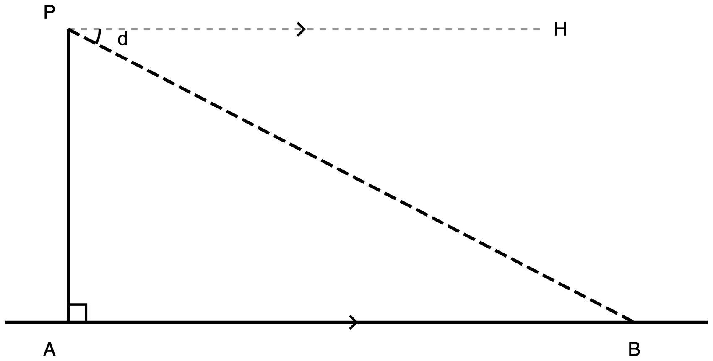
Figure 10.1. The task figure, handed to students with Task 1.
Description: A wide scene with a vertical cliff on the left and open water to the right. Four labelled points: A at the foot of the cliff on the water line at lower left; P directly above A at the top of the cliff; B on the water line well to the right of A, about three and a half cliff-heights away; and H up and to the right of P at the far end of a horizontal ray from P. The cliff face PA is vertical and solid. The water line is horizontal and solid and runs past A on the left and past B on the right, so AB is a portion of a longer line. PH is a grey, finely dashed horizontal construction ray from P to the right, the observer's horizontal. PB is drawn from P down to the right to B with a long dash pattern, the line of sight. A small square at A marks the right angle between the cliff and the water line. One single arc at P, between ray PH and ray PB, is labelled d, the angle of depression. A single chevron at the midpoint of PH and a matching single chevron on the water line between A and B state that those two lines are parallel. The angle at B between ray BA and ray BP is deliberately left unmarked, and no segment carries a number.
(a) Mark the angle at B between ray BA and ray BP, and label it e. (b) Prove that d = e, naming the two parallel lines, the transversal, and the angle relationship. Any format is accepted: two-column, paragraph, flowchart, annotated diagram, or presented out loud. The format is not marked. The argument is.
Answer, Task 1: The angle at B is the one between ray BA and ray BP. Proof: PH is horizontal and the water line AB is horizontal, so PH is parallel to AB. The line of sight PB is a transversal cutting both. Angle d (angle HPB) and angle e (angle PBA) are alternate interior angles, therefore d = e.
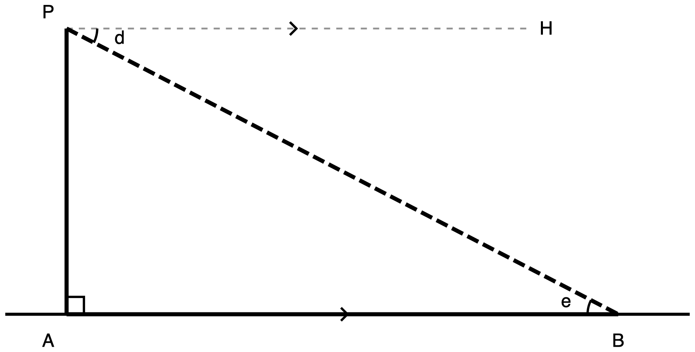
Figure 10.2. The finished configuration. Display it after the student proofs, never before, and do not hand it out.
Description: The same cliff-and-boat scene as Figure 10.1, with the same four labelled points P, A, B and H in the same relative positions, now marked up as it stands after the proof. The three sides of right triangle PAB are drawn one step heavier than the rest of the figure: the vertical cliff PA, the horizontal base AB along the water, and the line of sight PB, which keeps its long dash pattern. The water line continues past A and past B at the lighter weight, so the emphasised AB is visibly the part belonging to the triangle. PH is unchanged, a grey finely dashed horizontal construction ray from P to the right. A small square at A marks the right angle. One single arc at P between ray PH and ray PB is labelled d. One single arc at B between ray BA and ray BP is labelled e. The two arcs have the same count, and it is that equal count, not the colours or the positions, which states that d and e are congruent. A single chevron on PH and a matching single chevron on the water line state that those lines are parallel. No segment carries a number.

Task 2 · The van
A security guard stands at the rail of an observation deck 78 m above the street. She sights a parked van at an angle of depression of 31°. Students draw the scene themselves, name the parallel lines and transversal, state the equal angle at the van, and find the horizontal distance.
Answer, Task 2: (a) The 31° angle sits at the guard, between her horizontal ray and her line of sight, outside the triangle.
(b) The guard's horizontal and the street are parallel; the line of sight is the transversal; the angle of elevation at the van is 31° by alternate interior angles.
(c) tan 31° = 78 / distance, so distance = 78 / tan 31° = 129.8 m, so 130 m. Watch for 47 m, which is 78 × tan 31°.

Task 3 · The tree
A student stands on level ground 24 m from the base of a tree, eyes 1.6 m above the ground, standing height 1.75 m, and measures an angle of elevation of 38° to the treetop. Students draw the scene with themselves as a vertical segment from the ground up to their eyes, find the height of the tree, and say in one sentence which measurement of themselves belongs in the calculation.
Answer, Task 3: (b) The triangle gives 24 × tan 38° = 18.75 m from eye level to the treetop. The eye is 1.6 m above the ground, so the tree is 18.75 + 1.6 = 20.4 m.
(c) 1.6 m, the ground-to-eye height, because the triangle's base sits at eye level, not at the top of the head. Watch for 18.8 m, the offset dropped, and 20.5 m, standing height used in place of eye height.
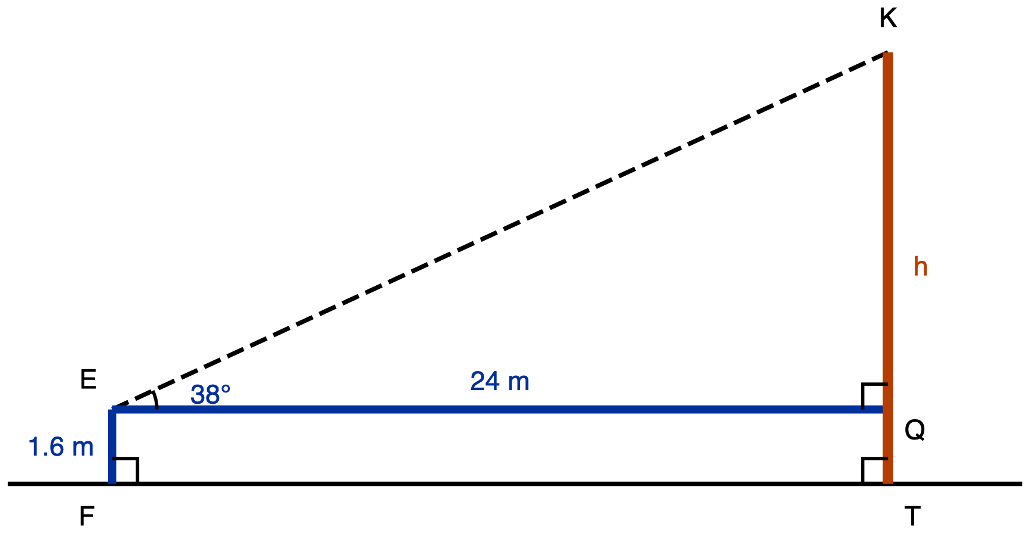
Figure 10.3. Task 3 drawn correctly, for the teacher's reference only. Do not hand it out: drawing it is part (a).
Description: An angle-of-elevation scene, drawn wide, with an observer standing on level ground at the left and a tree at the right. Five labelled points: F is the observer's feet on the ground line at the left; E is the observer's eye, directly above F a short way up; T is the base of the tree on the ground line far to the right of F; Q is directly above T at exactly the same height as E; K is the top of the tree, directly above Q, the highest point in the figure. The ground line is horizontal and solid, running past F on the left and past T on the right. FE, the observer drawn as a vertical segment, is a given measure labelled 1.6 m and drawn heavier than the ground line. EQ, the horizontal at eye level from the observer across to the tree, is a given measure labelled 24 m at the same weight. TK, the full height of the tree from the ground to its top, is the unknown, labelled h, drawn at the heaviest weight, and it spans the whole tree so it passes through Q. EK is the line of sight from the eye to the treetop, long-dashed, carrying no measure. Three right angles are each marked with a small square: at F between the ground and FE, at Q between QE and QK, and at T between the ground and the tree. One single arc at E, between ray EQ and ray EK, is labelled 38 degrees, the given angle of elevation. No congruence marks appear anywhere in the figure.

Task 4 · The swimmer
A lifeguard sits in her tower with her eyes 5.2 m above the water. She sights a swimmer at an angle of depression of 12°. Students draw the scene including both horizontal lines, find the distance from the base of the tower to the swimmer along the water, and say in one sentence whether they added anything to what the triangle gave them.
Answer, Task 4: (a) Both horizontals, the lifeguard's at 5.2 m and the water.
(b) tan 12° = 5.2 / distance, so distance = 5.2 / tan 12° = 24.5 m.
(c) Nothing is added. The 5.2 m was already measured from the water up to her eyes, so the triangle's vertical leg is the whole drop, and its horizontal leg is exactly the distance the question asked for. Watch for 1.1 m, which is 5.2 × tan 12°.

While you circulate
What to watch for, and what each sighting means. Every line here is tied to one of the two errors above; none of it is a general impression.
- Phase 1, at the board. Watch whether anyone reaches for a triangle before the two horizontals are drawn. That impulse is the misconception arriving early, and it is cheaper to meet it here than on Task 2.
- Task 1(a), the highest-value thirty seconds of the lesson. Look only at where the student put the arc at B. A student who marks the angle between the cliff face and the line of sight, or who marks an angle at P instead, will fail Task 2 the same way. Do not correct it with the answer. Ask: which line is the boat's horizontal?
- Task 1(b). A proof that says the angles look the same, or that they are opposite, has the conclusion without the argument. Ask which two lines are parallel, and let the proof rebuild itself.
- Task 2(a), before anyone computes. This is the diagnostic moment, and it is visible from two metres away. The 31° arc belongs between the guard's horizontal ray and the line of sight. If it sits between the building wall and the line of sight, the error is live in that student.
- Task 2(c). 47 m is the signature of a misplaced angle. But it is also what a student gets who places the angle correctly and then uses 59° at the van instead of 31°, so do not diagnose from the number. Ask part (b) back: which two rays is your 31° between?
- Task 3(b). Three numbers, three meanings. 20.4 m is the key. 18.8 m means the offset was dropped entirely. 20.5 m means standing height was used in place of eye height; that student has the modelling idea and the wrong measurement, and needs a different sentence back than the student who dropped the offset.
- Task 4(c). A student who writes "I added 5.2" has learned a rule rather than the question. The 5.2 m was already measured from the water up to her eyes, so the triangle already spans the whole vertical drop. This answer shows whether Task 3 taught a habit or a decision.
- The tell that the day landed. A student draws both horizontal lines before drawing the triangle, without being told to, on Task 4. That is the move being taught, showing up unprompted on the last task of the unit.
✋
Feedback, when the tickets come back. A bare correct or incorrect mark wastes a diagnostic ticket. Tie the response to the named error and point forward: "your 25° is sitting between the cliff and your line of sight; the angle of depression is measured from the horizontal, so redraw the horizontal first and try part (b) again."

Synthesis question, Phase 5
Ask it whole class, at the start of Phase 5, and take answers out loud rather than in writing.
✋
Two people work out the distance to the boat. One uses the angle at the cliff top, the other uses the angle at the boat. They get the same answer. Why must they? And what exactly goes wrong if the observer measures her angle from the cliff face instead of from her horizontal?

The first half should get back the alternate-interior-angle argument from Phase 2. The second half should get back that measuring from the cliff face gives her the complement of the angle she wants, so she would multiply by the tangent where she should have divided by it. That is not a small slip: it puts the boat too close by a factor of 1 over tan squared of the sighting angle, which for the 25° sighting in the exit ticket is about 4.6 times, and grows sharply as the sighting angle gets shallower.

Exit ticket, with key
An observer stands at the edge of a cliff 60 m above the sea. She sights a boat at an angle of depression of 25°. Three parts, all compulsory: state the angle of elevation with its reason, find the horizontal distance from the foot of the cliff to the boat, and name the two rays the 25° angle sits between.
Key: (a) 25°. The observer's horizontal and the sea surface are both horizontal and therefore parallel, the line of sight is the transversal, so the angle of depression and the angle of elevation are alternate interior angles and are equal.
(b) tan 25° = 60 / distance, so distance = 60 / tan 25° = 128.7, so 129 m.
(c) Between the observer's horizontal ray, pointing out to sea, and the ray from the observer to the boat. It sits at the observer's eye, outside the triangle formed by the cliff, the sea and the line of sight.

What a student holding the misconception writes
Part | Key | What the misconception produces
(a) | 25° | 65°, because with 25° placed at the cliff-top vertex inside the right triangle, the other acute angle is the one at the boat, and 90 − 25 = 65
(b) | 129 m | 28 m. The key divides, 60 / tan 25° = 128.7. The misconception multiplies, 60 × tan 25° = 28.0, because with 25° at the top vertex the horizontal distance reads as opposite and the cliff as adjacent
(c) | The observer's horizontal ray and the ray to the boat | The cliff face and the ray to the boat. This is the error stated in the student's own words, and it is the part that cannot be reached by luck

Why the ticket has three parts. Part (b) alone would not separate the two ways of getting it wrong. A student who places the angle correctly against the horizontal but takes the elevation angle to be its complement, 65°, computes 60 / tan 65° = 28.0 m, the same number the misplaced angle produces, because tan 25° and 1 / tan 65° are the same quantity. Part (c) asks for the placement explicitly. Part (a) separates the two errors again: both students say 65°, but they name different rays.
A student cannot pass by parroting. Suppose a student repeats "elevation equals depression, so 25°" from Phase 2 without having taken on the placement. Part (a) passes. Part (b) still fails, because when they draw the triangle to compute they put the 25° at the top vertex and multiply, reaching 28 m. Part (c) fails, because they name the cliff face. Two of three parts are wrong, and both wrong answers are specific and checkable.
✋
This ticket rules out one named error. It does not certify mastery at the final-exam standard, and it should not be scored as though it did.

Quiz 1, Similarity Criteria: Teacher Edition

Standards assessed. Two, given by code and gist. The full statements are set down in the lessons that first teach them, Day 4 and Day 2.
- HSG-SRT.B.4, proving triangle theorems from givens by deduction.
- HSG-SRT.B.5, use similarity and congruence criteria to solve and prove.
Placement: After Day 4, the Triangle Proportionality Theorem and its converse.
Length: Seven items, all compulsory. 45 minutes, one period. The 45 minutes is a floor for the slowest writer, not a speed target.
Figures: Five drawings, used by items 1 through 5. Items 6 and 7 supply no figure by design. The long descriptions printed at the end of the student sheet are required, not supplementary: they must be printed or delivered alongside the drawings for any student who needs them.

Item map
Item | Standard | What it asks for | Figure | Read-aloud
1 | HSG-SRT.B.5 | Proof: AA similarity from two marked angles, plus the correspondence | Figure 1 | Permitted
2 | HSG-SRT.B.5 | Side correspondence, then a scale computation. Four options on part (b) | Figure 2 | Permitted
3 | HSG-SRT.B.4 | Proof of the Triangle Proportionality Theorem, routed through a similarity | Figure 3 | Permitted
4 | HSG-SRT.B.4 | Converse test: is the cut segment parallel, and what warrants the decision | Figure 4 | Permitted
5 | HSG-SRT.B.4 | Find a length, name the theorem, write the proportion | Figure 5 | Permitted
6 | HSG-SRT.B.5 | Modeling from prose: shadow lengths, no diagram given | None, by design | DENIED
7 | HSG-SRT.B.5 | Modeling from prose: SAS similarity and a missing side, no diagram given | None, by design | DENIED

What this quiz does not cover, and why that is deliberate
Nothing here touches the trigonometric standards. Nothing trigonometric has been taught by Day 4: the ratios are named on Day 7, the special triangles derived on Day 8, the complementary relationship on Day 9. An item using any of that would test a construct the student has had no opportunity to build.

Before You Set the Quiz: Tools, Read-Aloud, and Proctoring

Every item states its own tool policy. Do not add a shared header.
This sheet carries no “calculators permitted” header and no formula sheet, and it must never acquire one. The seven tool lines are not identical. A card stating the Triangle Proportionality Theorem is permitted on item 3 and denied on item 5, because on item 3 the theorem is the thing being proved and on item 5 its statement is the answer being asked for. A shared header would silently overwrite both rulings.
✋
Items 6 and 7 must not be read aloud, to anyone, in any form. They supply no diagram, and turning the sentence into two triangles is the thing those two items exist to measure. Reading the prose aloud performs that step for the student, which makes it a modification rather than an accommodation. This is the accommodation most likely to be offered informally mid-quiz, precisely because it looks generous.

What is available on items 6 and 7: large print, braille, extra time, a separate space, a calculator, and a scribe who draws exactly what the student says. All of those hand the student the same sentence to work out. A read-aloud hands them a parse.
A scribe on items 6 and 7 draws what the student says and nothing more. A scribe who decides where the triangles go, or which measurement belongs to which object, has performed the construct. Say that out loud to a co-teacher before the period starts.
If a student is read items 6 or 7, mark those two items as not administered rather than scoring them. What they measured was no longer extraction from prose.
Items 1 to 5 all permit read-aloud. Each supplies its own figure, so the prose restates the drawing rather than encoding structure the student has to extract.

No ruler and no protractor, on any item
Every figure is drawn to scale, which means a measuring instrument returns an answer without the correspondence, the parallel, or the proportion ever having been decided. That reasoning is exactly what items 1 to 5 exist to elicit. Items 6 and 7 issue a straight edge as a drawing aid, and their numbers come only from the prose.

Extended time, on every item
No item here is a fluency check and nothing is timed for automaticity, so every item permits extended time.

No item-selection choice
All seven items are compulsory. No item is optional, no item is offered as an alternative to another, and no item may be dropped for a student who is running short. Dropping one changes which construct that student was sampled on, which breaks comparability across the class. The four answer options on item 2(b) are a response format on one compulsory item, not a choice of which item to answer.

Three sentences not to say in the room
Each of these is, on its own, the whole construct of the item it belongs to.
- That the split in item 5 is by ratio and not by equal amounts.
- That equal off-cuts in item 4 do not make a segment parallel.
- Which two sides of each bed in item 7 meet at the marked corner.
✋
Item 4's figure will not settle item 4. It is drawn to scale and VW genuinely is not parallel to TU, but the two directions differ by under two degrees, roughly one part in thirty, which is inside the error of any measurement a student could make on paper with a school ruler. A student who answers “not parallel” from the look of the drawing has reached the right conclusion by a route the item does not credit. The scored object is the warrant. Say that when you set the quiz, exactly as Day 4's lesson says it when setting its own converse task.

The Instrument, as the Students Sit It

Seven items. All seven are required; there is nothing to choose between. Read the tools line on each item. They are not all the same.

Item 1
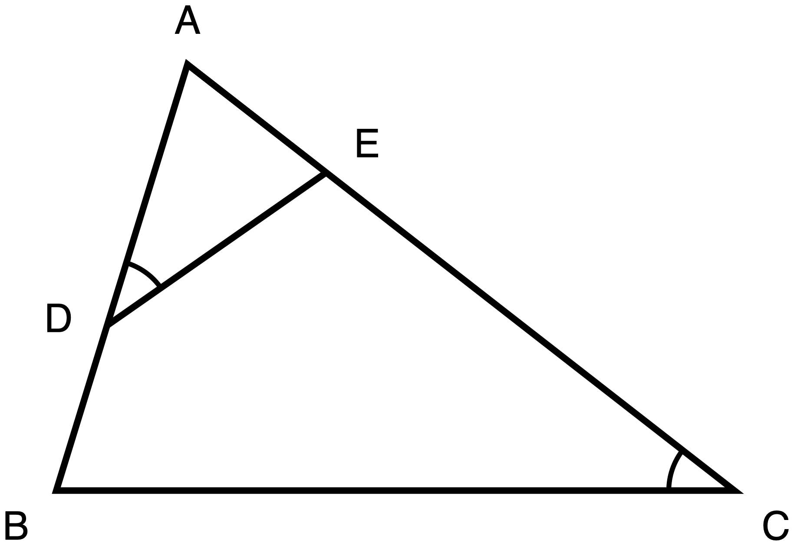
Figure 1. Triangle ABC with D on AB and E on AC, one arc at D matching one arc at C.
Description: Triangle ABC has vertex A at the top and side BC horizontal along the bottom, with B at the bottom left and C at the bottom right. D lies on side AB, low down and close to B. E lies on side AC, high up and close to A. Segment DE is drawn across the inside of the triangle and is clearly not parallel to BC. One arc marks angle ADE at D, and one arc marks angle ACB at C. No lengths are given anywhere.
In triangle ABC, D lies on side AB and E lies on side AC. The single arc at D and the single arc at C mark those two angles congruent: ∠ADE ≅ ∠ACB. Nothing else is marked, and no lengths are given.
Prove that two of the triangles in this figure are similar. The proof must name the criterion used, and must justify every angle fact claimed. Then the similarity statement, second triangle's letters in the order matching the first: △ A D E ~ △ ______ ______ ______
Tools: calculator permitted, though there is nothing to compute. No ruler, no protractor. No reference card. The student may redraw the two triangles separately, in their own hand, on their own paper. Five response formats offered, all earning the same credit: two-column, paragraph, flowchart, spoken to the teacher, annotated diagram.

Item 2
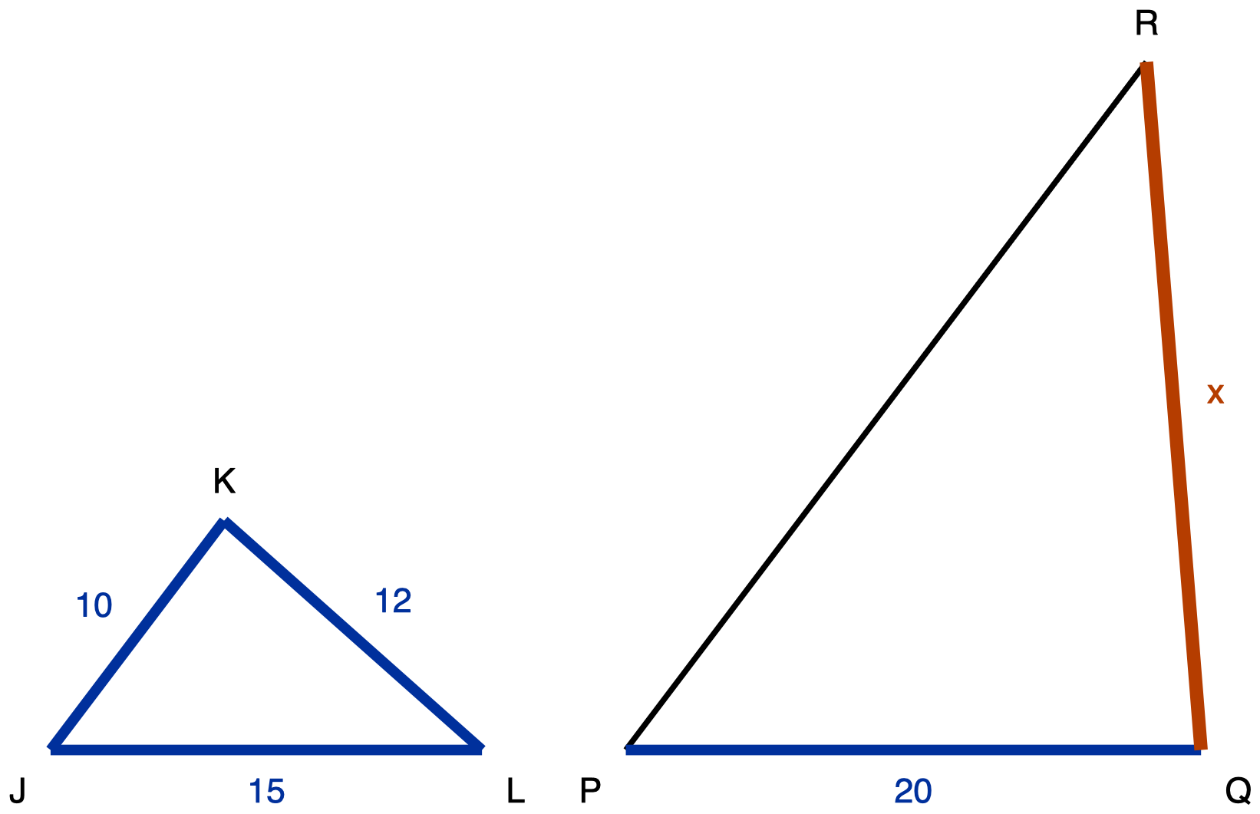
Figure 2. Triangles JKL and PQR, drawn in different orientations, with QR unknown.
Description: Two separate triangles stand side by side on the same horizontal baseline. On the left, triangle JKL is wide and low, with its longest side LJ lying along the baseline; JK is 10, KL is 12 and LJ is 15. On the right, triangle PQR is tall and narrow and is twice the size, with its shortest side PQ lying along the baseline; PQ is 20 and the side QR, from the bottom right vertex up to R, is the unknown quantity and is labelled x. The side RP carries no measure. No angles are marked in either triangle.
Triangle JKL is similar to triangle PQR, letters written in matching order: △ J K L ~ △ P Q R. In triangle JKL, JK = 10, KL = 12 and LJ = 15. In triangle PQR, PQ = 20 and QR is unknown, labelled `x`. The two triangles are drawn in different positions on purpose.
(a) Which side of PQR pairs with each side of JKL. (b) Find `x`, the length of QR, circling one of A 16, B 22, C 24, D 30.
Tools: calculator permitted. No ruler, no protractor. No table of corresponding sides. The student may redraw either triangle in their own hand, in any position. Answers may be written or spoken to the teacher, who records them.

Item 3
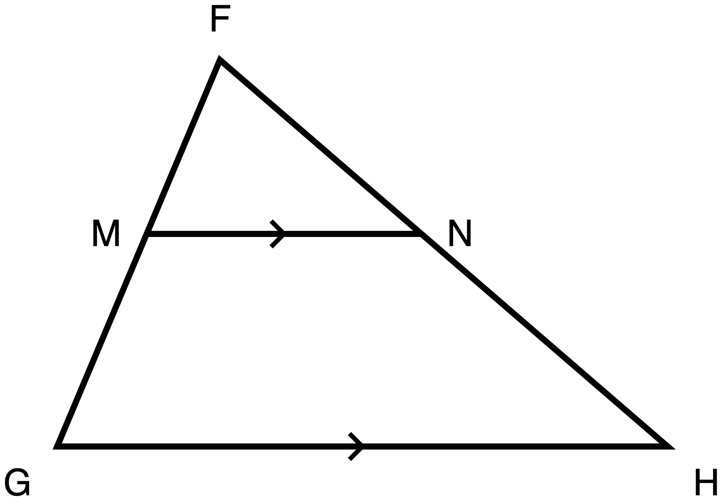
Figure 3. Triangle FGH with M on FG and N on FH, and MN marked parallel to GH.
Description: Triangle FGH has vertex F at the top and side GH horizontal along the bottom, with G at the bottom left and H at the bottom right. M lies on side FG and N lies on side FH, both a little under halfway down from F. Segment MN runs horizontally between them. A single chevron sits at the midpoint of MN and a matching single chevron sits at the midpoint of GH, marking those two segments parallel. No lengths are given and no angles are marked.
In triangle FGH, M lies on side FG and N lies on side FH. Matching single chevrons on MN and on GH tell the student that MN is parallel to GH. No lengths are given. Prove that FM/MG = FN/NH.
The student sheet states, in the stem rather than held back for the marking, that the proof must go through a similarity, and that a proof which never establishes a similarity does not satisfy the item.
Tools: calculator permitted, though there is nothing to compute. No ruler, no protractor. A card stating the AA similarity criterion *is* permitted. A card stating or proving the Triangle Proportionality Theorem is not: that theorem is what the student is being asked to prove. Same five response formats as item 1.

Item 4
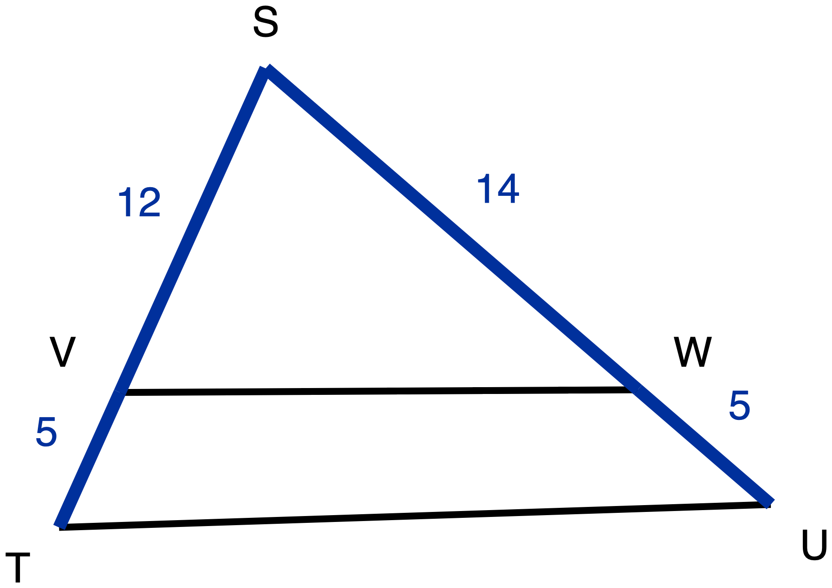
Figure 4. Triangle STU cut by segment VW, with SV, VT, SW and WU all given.
Description: Triangle STU has vertex S at the top, T at the bottom left and U at the bottom right. V lies on side ST and W lies on side SU, both roughly three quarters of the way down from S. Segment VW runs between them. On ST, SV is 12 and VT is 5. On SU, SW is 14 and WU is 5. No chevrons or other parallel marks appear anywhere in the figure, and no angles are marked.
In triangle STU, V lies on side ST and W lies on side SU. SV = 12, VT = 5, SW = 14, WU = 5. Decide whether VW is parallel to TU. Show the comparison used, and name the theorem that warrants the decision.
Tools: calculator permitted. No ruler, no protractor, and the student sheet says why this matters more here than elsewhere: the figure is to scale, but the question turns on a difference far too small for any paper measurement to settle. A card stating the AA similarity criterion or the Triangle Proportionality Theorem is permitted. A card stating the converse of that theorem is not. Three response formats, all earning the same credit: a written statement, the ratios written onto the figure with the decision circled, or spoken to the teacher.

Item 5
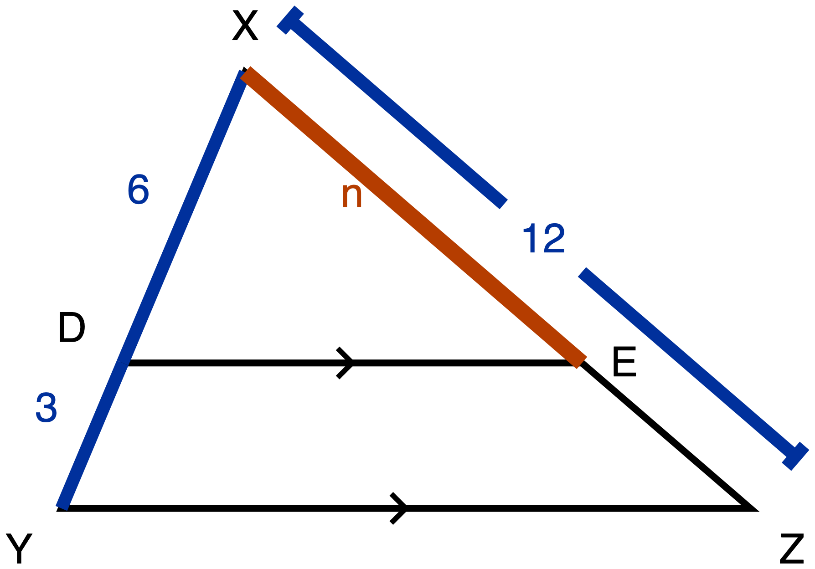
Figure 5. Triangle XYZ with DE parallel to YZ. XD, DY and XZ given, XE unknown.
Description: Triangle XYZ has vertex X at the top and side YZ horizontal along the bottom, with Y at the bottom left and Z at the bottom right. D lies on XY and E lies on XZ, and segment DE carries a single chevron matching the one on YZ, so DE is parallel to YZ. On side XY, XD is 6 and DY is 3. A dimension line running outside side XZ, broken at its centre for the numeral, gives the whole side XZ as 12. The segment from X to E is the heaviest line in the figure and is labelled n, the length being solved for.
In triangle XYZ, D lies on side XY and E lies on side XZ. Matching single chevrons on DE and on YZ tell the student that DE is parallel to YZ. XD = 6, DY = 3, XZ = 12, the whole side. Find XE. Then name the theorem that licenses the step, and write the proportion used. The sheet states that a number on its own is not a complete answer and that both parts are required.
Tools: calculator permitted. No ruler, no protractor. A card stating the Triangle Proportionality Theorem, or printing XD/DY = XE/EZ, is not permitted: that statement is the warrant being asked for. The answer may be written on the sheet or onto the figure, or said to the teacher or a scribe.

Item 6
No figure, by design, and no read-aloud. The sheet tells the student that turning the sentence into two triangles is the part being assessed, that drawing the situation is part of the answer rather than a way of getting to it, and that a correct number with no labelled drawing is an incomplete answer.
> A tree is 8 m tall and casts a shadow 12 m long. At the same moment, a lamp post 6 m tall stands beside it. How long is the lamp post's shadow?
Tools: calculator permitted. Blank paper and a straight edge are permitted and required. Large print or braille on request. The drawing may be produced with software, dictated to someone who draws exactly what is said, or built from cut segment strips; any of those is a complete answer.

Item 7
No figure, by design, and no read-aloud. The sheet tells the student that drawing both beds is part of the answer, and that every measurement goes on the side it belongs to before any equation is written.
> A landscaper is laying out two triangular flower beds. The first bed has sides of 12 m, 15 m and 9 m. A stake marks the corner where the 15 m side and the 9 m side meet. The second bed has two sides measuring 18 m and 30 m, and the corner where those two sides meet is the same size as the staked corner in the first bed. The second bed's third side has not been measured.
(a) Are the two beds similar? Show the ratios tested, and name the criterion that decides it. (b) Find the length of the second bed's third side.
Tools: calculator permitted. Blank paper and a straight edge are permitted and required. No card printing the similarity criteria: part (a) asks the student to name one. Large print or braille on request.

How to Use This Key, and Three Things It Deliberately Does Not Do

✋
Teacher only. No part of the answer key that follows should be issued to students.

1. It does not set a cut score, and none should be added later without evidence. No evidence available bears on how a class should be expected to perform on these two standards after four days. A cut score set here would be exam design driven by aspiration. What is given instead, per item, is a criterion-referenced pass standard: what a response has to contain to count as evidence that the student holds the construct.
2. It does not attach point values. Inventing a weighting would put a claim about relative importance into the instrument that nothing supports. If your school requires a mark, weight the seven items equally and say so. That is a defensible default.
3. It does not turn a design ruling into an accommodation decision. Every denial on this instrument is a class-wide design ruling about what an item measures. None of it decides anything belonging to an IEP or 504 team, and no line in this key may be read as grounds to decline a documented accommodation.
✋
The per-distractor rationales below are the most useful part of this document. They tell you what a particular wrong answer means, which is what decides where you send the student back to, rather than only that the answer was wrong.

Answer Key, Item 1

Figure 1, again, for marking.
Description: Triangle ABC has vertex A at the top and side BC horizontal along the bottom, with B at the bottom left and C at the bottom right. D lies on side AB, low down and close to B. E lies on side AC, high up and close to A. Segment DE is drawn across the inside of the triangle and is clearly not parallel to BC. One arc marks angle ADE at D, and one arc marks angle ACB at C. No lengths are given anywhere.

The key
Given: ∠ADE ≅ ∠ACB, marked by the single arc at D and the single arc at C.
Statement | Reason
∠ADE ≅ ∠ACB | Given, marked by the matching single arcs
∠A ≅ ∠A | The same angle: triangle ADE and triangle ACB share it
△ADE ~ △ACB | AA: two pairs of congruent angles

Similarity statement: △ A D E ~ △ A C B, that is, A ↔ A, D ↔ C, E ↔ B.
A student who adds the third pair, ∠AED ≅ ∠ABC by the angle sum, and then cites AA is fully correct. The third pair is redundant, not wrong.

Wrong responses to expect, and what produces each
Response | The reasoning error that produces it | Evidence status
△ADE ~ △ABC | The position read. D sits on AB and E sits on AC, so the student pairs D with B and E with C by where they are in the drawing rather than by the arcs. This is not a re-lettering of the key: it is a false statement about this figure, because it would require ∠ADE ≅ ∠ABC, that is DE parallel to BC, and DE is visibly not parallel to BC. | Documented error: correspondence read off position rather than off the marks. Ohio Department of Education and Workforce, Spring 2022 Geometry Item Release and Scoring Guide, Q27, both zero-point notes open: “The student may fail to find correct corresponding sides of the triangles, and thus creates an incorrect proportion.”
“DE is parallel to BC, so ∠ADE ≅ ∠ABC by corresponding angles” | Pattern-matching the picture to Day 4's configuration, which it superficially resembles. The parallel is not given, is not marked, and is false here. The student has imported a fact rather than reading the figure. | Not a documented misconception. A figure-recognition error, worth separating from the position read because the repair differs: send this student back to the marks, not to the correspondence.
A proof citing only ∠A ≅ ∠A | One pair is not AA. The student found the easy congruence, the shared angle, and stopped. Day 2's key makes the identical ruling on its own bow-tie item: a proof using only the vertical angles is incomplete. | Item design, not a misconception.
A proof that measures the two angles with a protractor and reports them equal | Measuring returns the given rather than using it. If this appears, a protractor got into the room. | Item design. The tool is denied on this item for exactly this reason.

Pass standard
Two angle facts, each justified, and the criterion named, plus a similarity statement in a correspondence consistent with the two facts. The similarity statement alone is not a pass, and a correct statement under a one-fact proof is not a pass. Format is free: two-column, paragraph, flowchart, oral, and annotated diagram all earn the same credit.

Feedback, not a mark
✋
For △ADE ~ △ABC: “You paired D with B and E with C because that is where they sit in the picture. The arcs pair D with C. Check what would have to be true of DE and BC for your statement to hold, and then look at the drawing again.”

Answer Key, Item 2

Figure 2, again, for marking.
Description: Two separate triangles stand side by side on the same horizontal baseline. On the left, triangle JKL is wide and low, with its longest side LJ lying along the baseline; JK is 10, KL is 12 and LJ is 15. On the right, triangle PQR is tall and narrow and is twice the size, with its shortest side PQ lying along the baseline; PQ is 20 and the side QR, from the bottom right vertex up to R, is the unknown quantity and is labelled x. The side RP carries no measure. No angles are marked in either triangle.

The key
(a) JK pairs with PQ. KL pairs with QR. LJ pairs with RP. The letter order in △JKL ~ △PQR fixes J ↔ P, K ↔ Q, L ↔ R, and the side pairing follows from it.
(b) C, x = 24. PQ ÷ JK = 20 ÷ 10 = 2, so QR = 2 × KL = 2 × 12 = 24.
✋
Full credit requires (a) and (b). A circled C sitting under a wrong pairing is a coincidence, not an answer. Scoring (b) alone is a scoring drift, not an accommodation.

The four options, and the specific error behind each distractor
Option | Verdict | Where it comes from
A · 16 | Distractor | The full position read. Both triangles sit on the same baseline, so the student pairs the two bottom sides, LJ with PQ, giving a scale factor of 20 ÷ 15 = 4/3. Then QR is paired with KL because both are the right-hand rising side of their triangle, and 12 × 4/3 = 16. Every step after the first is arithmetically correct. The whole item was answered from position. This is the single most informative wrong answer on the instrument: a student who circles A has almost certainly also written LJ with PQ in part (a), and the two halves confirm each other.
B · 22 | Distractor | Additive instead of multiplicative scaling. JK = 10 becomes PQ = 20, so the student reads the change as “add 10” rather than “multiply by 2”, and applies the same addition to KL: 12 + 10 = 22. Note carefully that this student has the correspondence right and the operation wrong, which is the opposite repair from option A. Documented: Ohio Spring 2022, Q6, where the student adds 3 instead of setting up a ratio of 2:5, then adds 5 to an angle measure because one side was 5.
C · 24 | KEY | Correspondence from the letter order, factor 2, applied to KL.
D · 30 | Distractor | The position read again, but with only one entry displaced. The student finds the scale factor correctly from JK ↔ PQ, then multiplies the wrong side of JKL: LJ = 15 instead of KL = 12, giving 30. Diagnostic note: 30 is in fact the true length of RP, which is unlabelled on the figure, so a student choosing D has computed a real length of the right-hand triangle and attached it to the wrong side. It reads as a near miss and is not one: the correspondence broke halfway.

✋
How to tell A from D when marking, in one look. Check part (a). A student on A has the bottom sides paired with each other. A student on D has part (a) right and has then multiplied the wrong number, so send them back to part (b), not to part (a).

Pass standard
All three pairings correct in (a), and C circled in (b).

Feedback
- For A: “You paired the side along the bottom of one triangle with the side along the bottom of the other. Position is a fact about the drawing; the letters in △JKL ~ △PQR are a fact about the triangles. Write J ↔ P, K ↔ Q, L ↔ R first, then pair the sides from the letters.”
- For B: “Your pairing is right. Twenty is not ten plus ten here, it is ten times two. Scale multiplies; it does not add. Run it again with the factor.”

Answer Key, Item 3

Figure 3, again, for marking.
Description: Triangle FGH has vertex F at the top and side GH horizontal along the bottom, with G at the bottom left and H at the bottom right. M lies on side FG and N lies on side FH, both a little under halfway down from F. Segment MN runs horizontally between them. A single chevron sits at the midpoint of MN and a matching single chevron sits at the midpoint of GH, marking those two segments parallel. No lengths are given and no angles are marked.

The key
Given: MN is parallel to GH, marked by the matching chevrons. Prove FM/MG = FN/NH.
- MN ∥ GH. Given, marked by the matching chevrons.
- ∠FMN ≅ ∠FGH. FG is a transversal cutting the two parallel lines MN and GH; these are corresponding angles.
- ∠F ≅ ∠F. The same angle.
- △FMN ~ △FGH. AA, from steps 2 and 3.
- FM/FG = FN/FH. Corresponding sides of similar triangles are proportional.
- FG = FM + MG and FH = FN + NH. M lies between F and G; N lies between F and H.
- FM/(FM + MG) = FN/(FN + NH). Substituting 6 into 5.
- FM·FN + FM·NH = FN·FM + FN·MG, so FM·NH = FN·MG, so FM/MG = FN/NH. Cross-multiplying 7 and cancelling the common term.
A student may reach step 4 through ∠FNM ≅ ∠FHG instead of ∠FMN ≅ ∠FGH. Both are corresponding angles across their own transversal, and either one with ∠F gives AA. Accept both.

Wrong responses to expect, and what produces each
Response | The reasoning error that produces it | Evidence status
“MN ∥ GH, so FM/MG = FN/NH by the Triangle Proportionality Theorem.” | Circular. The theorem being cited is the theorem being proved. This is the most likely wrong response on the item, and it is a structural error rather than a misconception: the student has the right fact and no argument for it. It is also why a card printing the theorem is denied on this item and permitted elsewhere. | Item design. Not a documented misconception.
A proof that reaches step 5 and stops | FM/FG = FN/FH is a true and correctly derived statement, and it is not what was asked. The conversion from whole-to-part into part-to-part is the last inferential step and it is the one students skip. Partial credit territory: the similarity is established and the proportion is right; the final conversion is missing. | Item design.
“∠FMN ≅ ∠FGH by alternate interior angles” | Wrong angle-pair name, right structure. F is not between the two parallels, so the pair on transversal FG is corresponding, not alternate interior. The congruence claimed is still true. Mark the reason and not the proof: the deductive structure survives. | Item design, distinguished here so it is not scored as a proof failure.
An area, dissection or coordinate argument | Does not satisfy this item, which names the similarity route. The item stem says so on the student's own copy, so no student is penalised after the fact for a route they were never told was excluded. | Item design, disclosed in the stem.

Pass standard
A similarity established from two justified angle facts, the proportional-sides step, and the conversion to the part-to-part form. Steps 6 to 8 may be compressed: a student who writes “FG = FM + MG, so FM/(FM+MG) = FN/(FN+NH), which rearranges to FM/MG = FN/NH” has done the work. What may not be missing is the similarity itself.

Feedback
✋
For the circular response: “You have named the right theorem. This item asks you to prove it, so you cannot use it as your reason. Start from the parallel: what does it give you about the angles at M and at G?”

Answer Key, Item 4

Figure 4, again, for marking.
Description: Triangle STU has vertex S at the top, T at the bottom left and U at the bottom right. V lies on side ST and W lies on side SU, both roughly three quarters of the way down from S. Segment VW runs between them. On ST, SV is 12 and VT is 5. On SU, SW is 14 and WU is 5. No chevrons or other parallel marks appear anywhere in the figure, and no angles are marked.

The key
- SV/VT = 12/5 = 2.4
- SW/WU = 14/5 = 2.8
- 2.4 ≠ 2.8, so VW is not parallel to TU, by the converse of the Triangle Proportionality Theorem.
Equivalent and fully acceptable route: SV/ST = 12/17 ≈ 0.706 and SW/SU = 14/19 ≈ 0.737, and 0.706 ≠ 0.737. The whole-to-part comparison and the part-to-part comparison are equivalent tests. Accept either, and accept a decimal or a common-denominator comparison as showing the same thing.

Wrong responses to expect, and what produces each
Response | The reasoning error that produces it | Evidence status
“Parallel, because it takes 5 off each side.” | The cut is read as removing the same length from each of the other two sides rather than splitting them in the same ratio. VT and WU are both 5, so the amount rule commits itself here instead of hedging. This is the item's primary target, and it is why the two off-cuts were made equal. | Inferred, not documented. No source records a student error specific to this configuration. This one is reasoned by analogy from additive-instead-of-multiplicative scaling, whose evidence is real. If you observe a different dominant error, the item is under-specified rather than broken, and what you saw is worth reporting.
“Parallel” or “not parallel”, with the drawing cited as the reason. | Answering by eye. The figure is to scale and the true answer is “not parallel”, so half of these students land on the key by a route the item does not credit. The scored object is the warrant. | Item design.
“Not parallel, because 12/14 is not 1.” | Comparing SV with SW and VT with WU, that is, comparing the two triangles' sides to each other rather than comparing each side's own two parts. It reaches the right conclusion from a comparison that tests nothing: two triangles do not have to have equal sides for a segment to be parallel. Mark the conclusion right and the warrant absent. | Item design, a comparison-selection error rather than a documented misconception. It is why the item does not pre-print which two ratios to form.
“Not parallel”, with no theorem named. | The decision without the warrant. The warrant is half the item. | Item design.

Pass standard
Both ratios shown, the comparison stated, the decision correct, and the converse of the Triangle Proportionality Theorem named as the warrant. Naming it as “the converse of the side-splitter theorem”, or describing it accurately in the student's own words, is a pass. The name is not the construct, the warrant is.

Feedback
✋
For “takes 5 off each side”: “You took the same length off each side. A parallel cut takes the same fraction off each side, not the same length. Divide 12 by 5 and 14 by 5 and compare what you get.”

Answer Key, Item 5

Figure 5, again, for marking.
Description: Triangle XYZ has vertex X at the top and side YZ horizontal along the bottom, with Y at the bottom left and Z at the bottom right. D lies on XY and E lies on XZ, and segment DE carries a single chevron matching the one on YZ, so DE is parallel to YZ. On side XY, XD is 6 and DY is 3. A dimension line running outside side XZ, broken at its centre for the numeral, gives the whole side XZ as 12. The segment from X to E is the heaviest line in the figure and is labelled n, the length being solved for.

The key
Two parts, both required. A bare numeral is not a passing response.
- Value: XE = 8.
- Warrant: DE is parallel to YZ, so by the Triangle Proportionality Theorem XD/DY = XE/EZ. Since XD/DY = 6/3 = 2, XE = 2·EZ. XE + EZ = XZ = 12, so 3·EZ = 12, EZ = 4, and XE = 8.
Equivalent and fully acceptable route: XD/XY = XE/XZ, that is 6/9 = XE/12, so XE = 8. The whole-to-part form is the same theorem and reaches the same answer. Accept it.

Wrong responses to expect, and what produces each
Response | The reasoning error that produces it | Evidence status
XE = 9 | The cut takes 3 off XY, so the student takes 3 off XZ: EZ = 3, therefore XE = 12 − 3 = 9. Same same-length-off-each-side mechanism as item 4, transposed onto this item's numbers. It cannot reach 8 by luck: the amount route lands on 8 only if DY = EZ, that is only if 3 = 4. | Inferred, not documented. Same disclosure as item 4.
XE = 24 | Reading the proportion as XD/DY = XE/XZ, giving 2 = XE/12. It self-refutes, since XE = 24 is longer than the whole side XZ = 12, and that is worth saying back to the student. | Score this as a proportion-setup error, not as the same-length misconception. The two are separate slips.
XE = 4 | The right proportion solved for the wrong segment: EZ was found and reported as XE. Arithmetic and reading, not reasoning. | Item design.
A bare “8” | Not a pass, and this is the way this item most plausibly degrades in practice. A student who writes 8 with no warrant may have the theorem, or may have divided 12 by 3 and stopped, and the item cannot tell them apart. | Accepting it is a scoring drift, not an accommodation.

✋
The item catches the same-length error on two independent channels, which is why the warrant clause is not decoration. A student on the amount route who leaves the warrant blank has visibly not produced it. A student on the amount route who does write XD/DY = XE/EZ is refuted by their own numbers: 6/3 = 2 but 9/3 = 3, so the proportion they wrote contradicts the answer they gave. Either way the failure is checkable on the page rather than inferred from a wrong number.

Pass standard
XE = 8, the theorem named, and the proportion written. Two of three is not a pass.

Feedback
✋
For 9: “You took the same length off each side. A parallel cut splits both sides in the same ratio. XD/DY is 6 over 3, which is 2, so XE has to be twice EZ, and the two of them add to 12.”

Answer Key, Item 6

The key
The lamp post's shadow is 9 m.
The reasoning the drawing has to make visible: the sun's rays reach both objects at the same angle at the same moment, and both objects stand vertically on the same ground, so each object with its shadow forms a right triangle, and the two right triangles are similar by AA. Corresponding sides are therefore proportional:
tree height / tree shadow = lamp post height / lamp post shadow, so 8/12 = 6/s, so s = 9.
The within-object form, 8/12 = 2/3 so every shadow here is 1.5 times its object, is the same reasoning and is fully acceptable.

Wrong answers to expect, and what produces each
Answer | The reasoning error that produces it | Evidence status
16 m | The adjacency pairing. In the sentence, “12” (the tree's shadow) and “6” (the lamp post's height) sit next to each other across the boundary between the two clauses, and they are not corresponding. The student writes 6/12 = 8/s and gets 16. | Documented. CK-12 Foundation, Trigonometry Teacher's Edition, Common Errors: “The fact that the numbers 100 and 20 appear next to each other may tempt students to set up the proportion 20/100 = 24/x, or 100/20 = 24/x. Have them draw a diagram to see which distances they are actually [comparing].”
4 m | The reciprocal adjacency pairing: the same wrong pairing written the other way up, 12/6 = 8/s. | Documented. CK-12 names both forms in one sentence, as quoted above.
10 m | Additive instead of multiplicative. The tree is 8 and the lamp post is 6, so the student reads the difference as “2 shorter” and takes 2 off the shadow: 12 − 2 = 10. | Documented. Ohio Spring 2022, Q6.
9 m with no labelled drawing | Not a complete answer, and this is stated on the student's own sheet. The drawing is where the pairing decision was made; without it the item has measured the arithmetic and not the modelling. | Day 3's ratified ruling on its own no-diagram tasks, carried here.

✋
Why 16 and 4 are the informative pair. They are the two ways of writing the same wrong correspondence, and a student who produces either has made one decision badly rather than several. The repair is the same for both and it is not about arithmetic: put the 12 on the tree's shadow and the 6 on the lamp post before writing anything.

Pass standard
A labelled drawing showing two objects and two shadows with each measurement on the thing it measures, a proportion built from corresponding parts, and 9 m. The drawing may be hand-drawn, produced with software, dictated to a scribe who draws exactly what is said, or built from cut segment strips. All four earn the same credit.

Feedback
✋
For 16 or 4: “You paired the tree's shadow with the lamp post's height because they sit next to each other in the sentence. Draw both objects with their own shadows and write each number on the thing it measures, then look again at which two numbers belong together.”

Answer Key, Item 7

The key
(a) The two beds are similar, by SAS similarity. There are two ways to pair the sides at the equal corner, and both have to be tested:
Pairing tested | Ratios | Verdict
15 with 18, and 9 with 30 | 15/18 ≈ 0.833 and 9/30 = 0.3 | Not equal, so this pairing fails
15 with 30, and 9 with 18 | 15/30 = 0.5 and 9/18 = 0.5 | Equal, so this is the pairing

Under the second pairing the two sides that include the equal corner are proportional, in the ratio 1 : 2, and the included angles are congruent because the stem says the corners are the same size. That is SAS similarity. Scale factor from the first bed to the second is 2.
(b) The second bed's third side is 24 m. The first bed's third side is 12 m, and it is the side opposite the staked corner, so it corresponds to the second bed's unmeasured side, which is opposite the equal corner. 12 × 2 = 24.

Wrong answers to expect, and what produces each
Answer | The reasoning error that produces it | Evidence status
“Not similar” | The adjacency pairing in its list-order form. The first bed's corner sides are named in the order 15 then 9; the second bed's are named 18 then 30. The student pairs them by list position, gets 15/18 and 9/30, finds them unequal, and concludes correctly from a wrong pairing that the beds fail. This is not carelessness: it is a complete, internally consistent piece of work built on one bad decision, and it is worth two minutes of the room's attention. The item's sentence order was written to make this the tempting pairing. | Documented, same CK-12 evidence as item 6, plus Day 3's own “test both ways” design.
“Not similar” after testing only one pairing | The student tried 15 with 18, found it failed, and stopped. Distinguishable from the row above by whether any second pairing appears on the page. The repair is different: this student has the right method and stopped one step early. | Item design. Day 3's Task 2 is built on the same “test both” demand.
14.4 m | The list-order pairing carried through instead of abandoned: scale factor 18/15 = 1.2, so 12 × 1.2 = 14.4. Same single bad decision as the first row, pushed one step further, and it produces a specific checkable number rather than a verdict. | Derived from the same adjacency pairing error.
27 m | Additive instead of multiplicative. 15 becomes 30, so the student reads it as “add 15” and applies the same addition to the third side: 12 + 15 = 27. | Documented. Ohio Spring 2022, Q6.
6 m | Correct similarity, inverted scale factor: 12 × 1/2 instead of 12 × 2. The student has scaled from the larger bed to the smaller one by mistake. Arithmetic direction, not correspondence: mark (a) and send them back to (b) only. | Item design.
24 m with the criterion unnamed, or with no drawing | Not a complete answer. Part (a) asks for the criterion, and the drawing is where the pairing decision was made. | Item design, disclosed on the student's sheet.

✋
The one thing to check first when marking. Look for a second pairing on the page before looking at the answer. A student who tested both pairings and chose the one with equal ratios has the construct, whatever they then did with the arithmetic. A student who tested one has not, even if they landed on 24.

Pass standard
A labelled drawing of both beds; both pairings tested, or the correct pairing shown with its two equal ratios; SAS similarity named; and 24 m. Naming the criterion as “SAS” or describing it accurately in the student's own words both count.

Feedback
✋
For “not similar”: “You paired 15 with 18 and 9 with 30 because that is the order they are written in. There are two ways to pair those sides and the sentence order is not one of the reasons to prefer either. Try the other pairing and compare the ratios again.”

Misconception Coverage Across the Instrument
Misconception | Evidence | Items that target it | Does applying it produce a specific wrong answer?
Additive instead of multiplicative scaling | Documented. Ohio Spring 2022, Q6 | 2 (option B, 22), 6 (10 m), 7 (27 m) | Yes, a different number in each case, none of them a rounding of the key
Correspondence read off position, not off the marks or the letter order | Documented. Ohio Spring 2022, Q27 | 1 (△ADE ~ △ABC), 2 (option A, 16; option D, 30) | Yes, and on item 1 the wrong statement is false about the figure, not merely a different lettering
Proportion built by textual adjacency, not by object pairing | Documented. CK-12 Trigonometry Teacher's Edition | 6 (16 m and 4 m), 7 (“not similar”, 14.4 m) | Yes, in both directions on item 6, and as both a verdict and a value on item 7
A parallel cut takes the same length off each side rather than the same fraction | Inferred, and it must be reported as inferred | 4 (“parallel”), 5 (XE = 9) | Yes, and on item 5 it fails on two independent channels, the value and the warrant
Cannot track overlapping triangles in a dense configuration | Documented. CK-12 Geometry Teacher's Edition | Not targeted. Present in miniature on item 1: triangle ADE is nested inside triangle ACB, sharing the angle at A, and the correspondence crosses (D with C, E with B) rather than running down the page. Two nested triangles is well below the three-overlapping-triangle load, and there is no rotation between them, so the item is not built on this barrier. A student may redraw them apart in their own hand for exactly this reason; handing them a pre-separated redraw is denied. | Not applicable here. This barrier generates a blank or an incoherent proportion rather than a specific wrong answer.

✋
The same-length-off-each-side error is the one to say out loud in a department meeting. Two of this instrument's seven items are built on it, and no source in the corpus documents a student error specific to the Triangle Proportionality configuration. It was constructed by analogy from additive-instead-of-multiplicative scaling, whose evidence is real, into a configuration where no error data exists. A teacher who observes a different dominant error on items 4 and 5 should treat those items as under-specified, not as broken, and should report what they saw. That is a request for evidence, not a hedge.

Nothing in this key overrides an individual student's documented accommodation. The response variations offered on the student sheet are barriers removed class-wide. An IEP or 504 accommodation stands regardless.

Quiz 2, Ratios in Right Triangles: Teacher Edition

Seven questions, 11 marks. Sit this quiz after Day 7. Questions 1 to 4 assess HSG-SRT.C.6; questions 5 to 7 assess HSG-SRT.C.8.
Nothing on this paper uses the complementary-angle relationship (Day 9), a special triangle (Day 8), or an angle of elevation or depression (Day 10). No ratio has to be recalled from a degree measure anywhere on the paper. Question 5 is the only item that needs a numeric ratio for a named degree measure, and it prints both values in its own stem for every student.

Marks at a glance
Q | What it asks | Standard | Type | Marks
1 | Why two right triangles sharing an acute angle give the same quotient | C.6 | Constructed | 2
2 | What does and does not change when the triangle is enlarged | C.6 | Selected, key B | 1
3 | Opposite and adjacent from each acute angle of one triangle | C.6 | Constructed | 3
4 | Why sin 32° can be a single number with no triangle named | C.6 | Selected, key A | 1
5 | Using a supplied ratio to find a leg | C.8 | Selected, key B | 1
6 | Carrying a ratio from one triangle to a larger similar one | C.8 | Selected, key A | 1
7 | Pythagoras first, then sine as a ratio of two sides | C.8 | Constructed | 2
 |  |  | Total | 11

✋
There is no single tools line for this quiz, and none should be added. Every question carries its own, and they are not the same. A blanket header saying “calculators and reference sheets permitted” would quietly overturn four of the seven questions while looking generous. The full policy is on the next page.

Tool policy, question by question
This is the page to have at the photocopier. The policies genuinely differ from question to question.
Q | Calculator | Ratio table or card | a² + b² = c² card | Read-aloud | Extended time
1 | Permitted, inert | DENIED | n/a | Permitted | Permitted
2 | Permitted, inert | DENIED | n/a | Permitted | Permitted
3 | Permitted, inert | DENIED (inert here) | n/a | Permitted | Permitted
4 | Permitted, inert | DENIED | n/a | Permitted | Permitted
5 | Permitted | Permitted | n/a | Permitted | Permitted
6 | Permitted | Permitted (inert) | n/a | Permitted | Permitted
7 | Permitted | Permitted (inert) | Permitted | Permitted | Permitted

The three lines that are easy to get backwards
1. The ratio table splits the paper in half, so the paper has to be printed in halves. Questions 1 to 4 deny it; questions 5 to 7 permit it. The denial is not about the artifact, it is about what the artifact performs. On questions 1 to 4 a printed table displays the very invariance the student is being asked to argue for. Print questions 5 to 7 on their own sheet, and issue any ratio card with that sheet only. If a table sits on a desk during questions 1 to 4, those four items are invalidated, and the invalidation is silent.
2. The a² + b² = c² card is permitted on question 7, and Day 5 denies it. Both are correct. Day 5's verb is prove, so a card printing the statement supplies the conclusion being derived. Question 7's verb is find, so the same card supplies a precondition and not the thing being measured. Classify the aid against what the question measures, never against the standard code.
3. Read-aloud is permitted on every question here, and that needs saying out loud. Read-aloud is denied on modelling items, where building the figure out of prose is part of the task, and a proctor who has absorbed that rule may deny it here out of caution. There are no modelling items on Quiz 2. Every question supplies its figure or is definitional, so denying read-aloud would remove a support without protecting anything.
No formula sheet is issued with this instrument. Quiz 2 carries no HSG-SRT.C.7 items, so the standing rule that one shared formula sheet invalidates every C.7 item on a paper has nothing to bite on here.
✋
Nothing in this policy assigns, removes or substitutes for an individual student's documented accommodation. A student's IEP or 504 accommodation stands regardless of what any line above permits or denies class-wide.

The paper as the students sit it

Reproduced here so you can read the instrument straight through before marking. The student copy follows the same order and carries workspace.

1. Two triangles, one angle
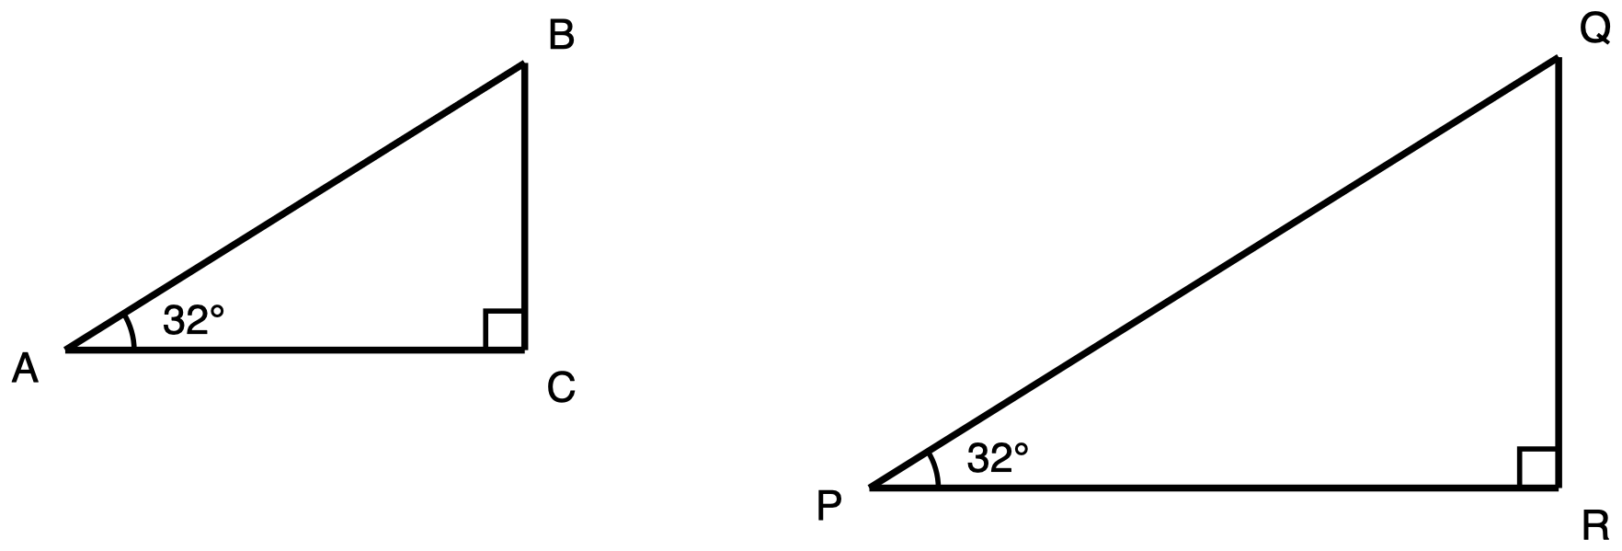
Figure 1. Two right triangles of different sizes, each with a 32° acute angle.
Description: Two separate right triangles drawn side by side, each with a horizontal bottom side and a vertical right-hand side. The second is visibly larger than the first, about half as tall again and half as wide again. In the first triangle, A is at the lower left, C is at the lower right level with A, and B is directly above C. Side AC runs horizontally from A to C, side CB runs vertically from C up to B, and side AB runs from A up and to the right to B and is the longest of the three. No side carries a length and no side is marked as unknown. The angle at C, between CA and CB, is a right angle marked with a small square. The acute angle at A, between AC and AB, carries one arc and is labelled 32 degrees. The second triangle is arranged the same way: P at the lower left, R at the lower right level with P, Q directly above R, with PR horizontal, RQ vertical, and PQ running from P up to the right to Q as the longest side. No side carries a length. The angle at R is a right angle marked with a small square, and the acute angle at P, between PR and PQ, carries one arc and is labelled 32 degrees. The two 32 degree angles carry one arc each.
You may use: a calculator, though there is nothing on this question to calculate.
You may not use: a printed table of sine, cosine or tangent values; a calculator's sin, cos or tan key; any app that gives a ratio from an angle; or a copy of the figure with side lengths written on it.
Triangle ABC has its right angle at C and a 32° angle at A. Triangle PQR has its right angle at R and a 32° angle at P. Triangle PQR is larger than triangle ABC. No side lengths are given for either triangle, and none are needed.
Explain why BC ÷ AB and QR ÷ PQ must be the same number. Saying that the two quotients are equal is not an explanation. Give the reason.

2. What moves when the triangle grows
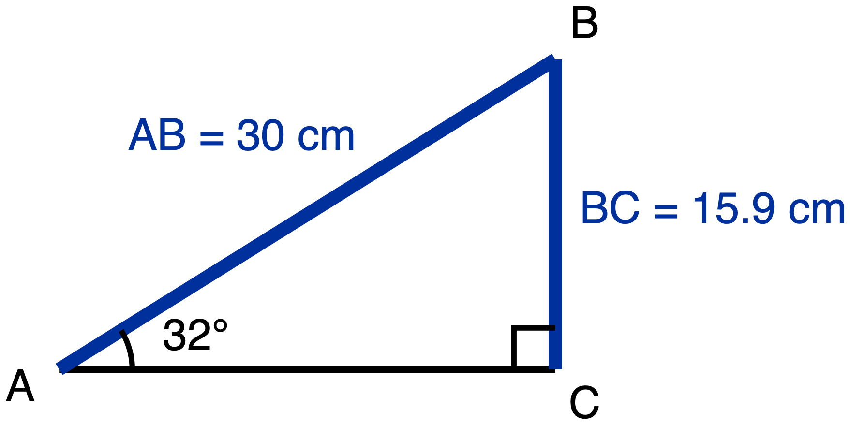
Figure 2. Right triangle ABC, right angle at C, 32° angle at A, hypotenuse 30 cm.
Description: One right triangle with a horizontal bottom side and a vertical right-hand side. A is at the lower left, C is at the lower right level with A, and B is directly above C. Leg AC runs horizontally from A to C and carries no measure. Leg CB runs vertically from C up to B and is given as 15.9 cm. Side AB runs from A up and to the right to B, is the hypotenuse, and is given as 30 cm. Nothing in the figure is marked as unknown. The angle at C, between CA and CB, is a right angle marked with a small square. The acute angle at A, between AC and AB, carries one arc and is labelled 32 degrees. BC is the side opposite that 32 degree angle.
You may use: a calculator, though nothing here needs one.
You may not use: a printed table of sine, cosine or tangent values; a calculator's sin, cos or tan key; or any app that gives a ratio from an angle.
Triangle ABC has its right angle at C and a 32° angle at A. The hypotenuse AB is 30 cm and BC, the side opposite the 32° angle, is 15.9 cm. Triangle ABC is now enlarged by a scale factor of 3. The enlarged triangle still has a 32° angle. Write s for the length of the side opposite the 32° angle in the enlarged triangle, and h for the length of its hypotenuse.
Determine which statement about the enlarged triangle is true. Circle one letter.
- A. s is three times BC, and s ÷ h is three times BC ÷ AB.
- B. s is three times BC, and s ÷ h is equal to BC ÷ AB.
- C. s is the same length as BC, and s ÷ h is equal to BC ÷ AB.
- D. s is three times BC, and s ÷ h cannot be found unless the enlarged triangle is measured.

3. The same triangle, from each of its acute angles
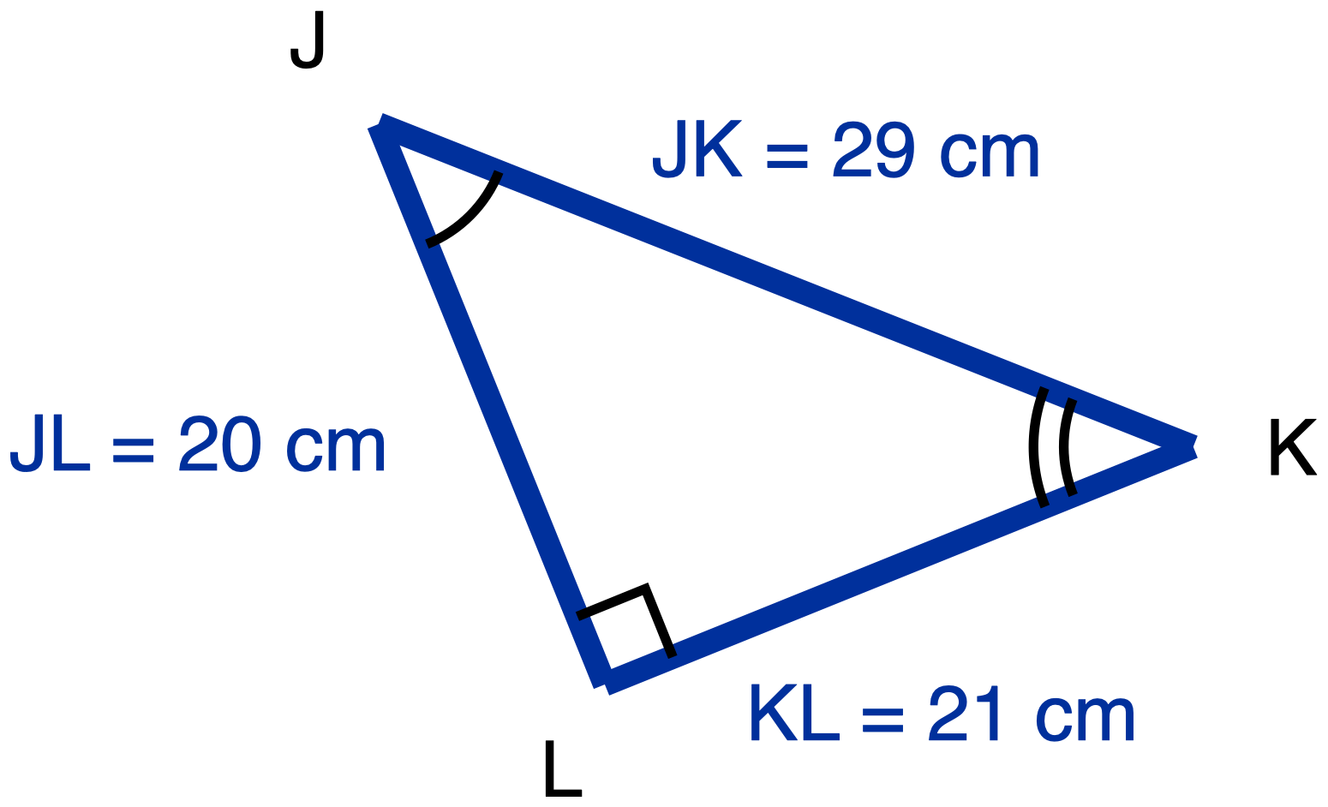
Figure 3. Right triangle JKL drawn tilted, right angle at L, sides 20 cm, 21 cm and 29 cm.
Description: One right triangle drawn tilted so that no side is horizontal or vertical. J is at the upper left and is the highest of the three vertices. K is at the right, lower than J. L is at the bottom, below and to the right of J. Leg JL runs from J down and slightly right to L and is given as 20 cm. Leg KL runs from L up and to the right to K and is given as 21 cm. Side JK runs from J down and to the right to K, is the longest of the three, and is given as 29 cm. All three lengths are given and nothing is marked as unknown. The angle at L, between LJ and LK, is a right angle marked with a small square. The acute angle at J, between JL and JK, carries one arc. The acute angle at K, between KL and KJ, carries two concentric arcs. The arc counts are present only to tell the two acute angles apart so they can be referred to unambiguously; they assert no congruence and no similarity is claimed anywhere in the drawing.
You may use: a calculator; a tracing-paper copy of the triangle that you may turn around. Answers may be left as fractions.
You may not use: a copy of this triangle with the legs already labelled “opposite” and “adjacent” for either angle; a card stating a rule for deciding which leg is which; a printed table of sine, cosine or tangent values.
Triangle JKL has its right angle at L. JL = 20 cm, KL = 21 cm and JK = 29 cm.
(a) Relative to angle J, name the opposite leg, name the adjacent leg, and write tan J. (b) Do the same relative to angle K. (c) In one sentence, how did you decide which leg is the opposite leg in part (b)?

4. A number with no triangle beside it
No figure. This question deliberately supplies no diagram; a triangle would answer the question.
You may use: a calculator, though there is nothing here to calculate.
You may not use: a printed table of sine, cosine or tangent values; a calculator's sin, cos or tan key; any app that gives a ratio from an angle; or any triangle you have drawn for another question on this paper.
In class the line sin 32° = 0.53 was written on the board. No triangle was drawn beside it, and none was named.
Explain why writing a single number for sin 32°, with no triangle named, is legitimate. Circle one letter.
- A. Because every right triangle with a 32° angle is similar to every other one, so (side opposite the 32° angle) ÷ (hypotenuse) is the same in all of them.
- B. Because the triangles measured in class happened to give quotients that came out close to each other.
- C. It is not legitimate. sin 32° cannot be written as a single number until the side lengths of one particular right triangle are known.
- D. Because 0.53 is the value for a medium-sized right triangle. A larger right triangle with a 32° angle gives a larger value, and a smaller one gives a smaller value.

5. Using a ratio you have been given
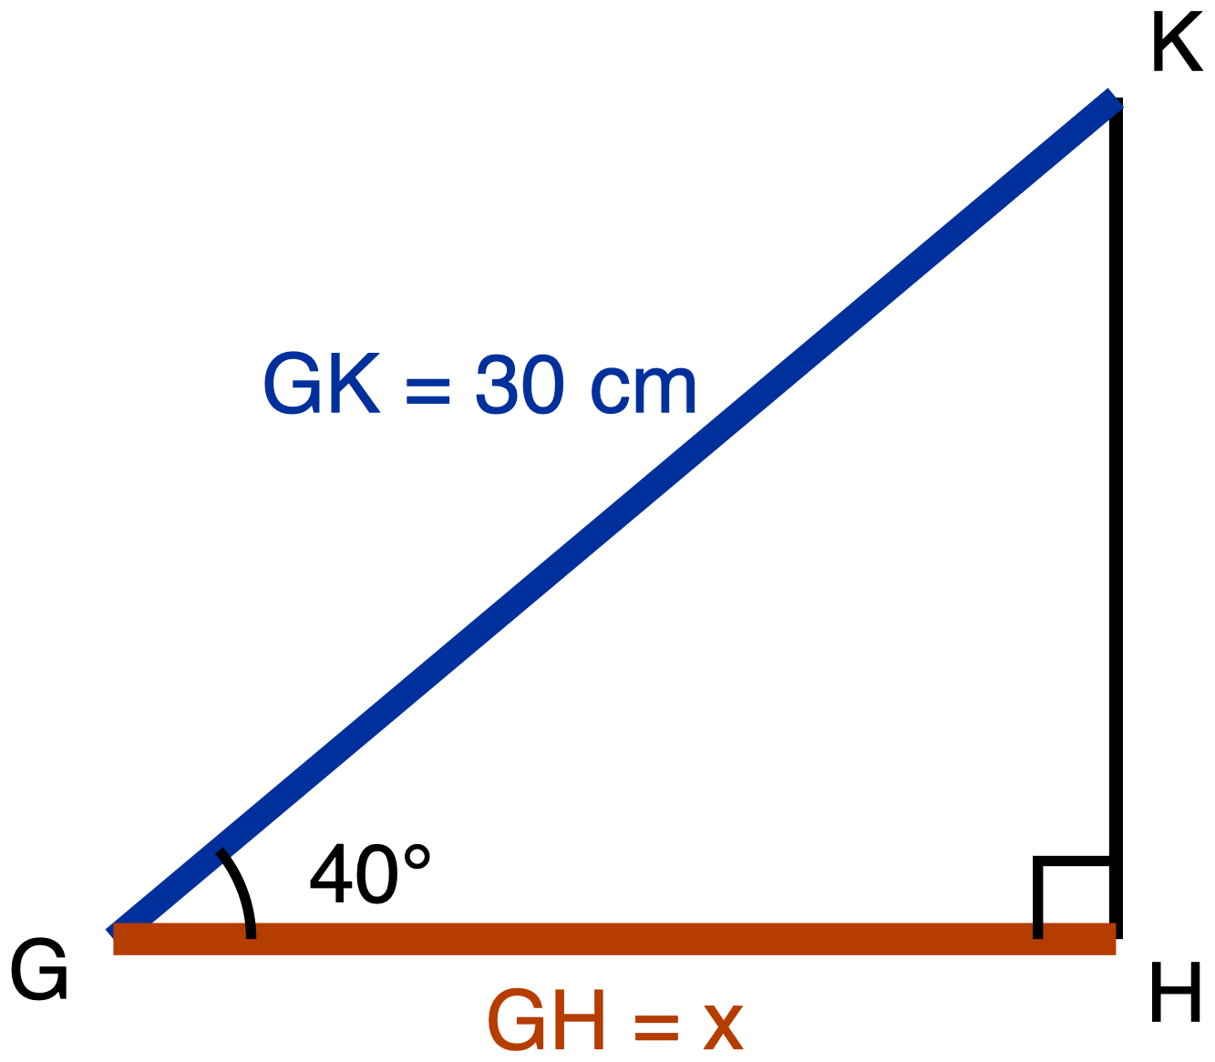
Figure 4. Right triangle GHK, right angle at H, 40° angle at G, hypotenuse 30 cm, leg GH marked x.
Description: One right triangle with a horizontal bottom side and a vertical right-hand side. G is at the lower left, H is at the lower right level with G, and K is directly above H. Leg GH runs horizontally from G to H, is the unknown, and is labelled x; it is drawn as the heaviest line in the figure. Leg HK runs vertically from H up to K and carries no measure. Side GK runs from G up and to the right to K, is the hypotenuse, and is given as 30 cm. The angle at H, between HG and HK, is a right angle marked with a small square. The acute angle at G, between GH and GK, carries one arc and is labelled 40 degrees. GH is the leg adjacent to that 40 degree angle; HK is the leg opposite it.
You may use: a calculator; a printed ratio table or ratio card if you want one. You are not being asked to remember a ratio on this question, so a table cannot help you and will not be marked down.
You may not use: a copy of this triangle with the legs already labelled “opposite” and “adjacent” relative to the 40° angle; a worked example of the same question with different numbers.
For a 40° acute angle in a right triangle: (side adjacent) ÷ (hypotenuse) = 0.77 and (side opposite) ÷ (hypotenuse) = 0.64. In the names given in class, cos 40° = 0.77 and sin 40° = 0.64. Both values are printed on the student paper.
Triangle GHK has its right angle at H and a 40° angle at G. The hypotenuse GK is 30 cm. The leg GH is marked x.
Use the values above to find x, to the nearest tenth of a centimetre. Circle one letter.
- A. x = 19.2 cm
- B. x = 23.1 cm
- C. x = 39.0 cm
- D. x cannot be found. The values 0.77 and 0.64 came from a different right triangle.

6. Carrying a ratio to a bigger triangle
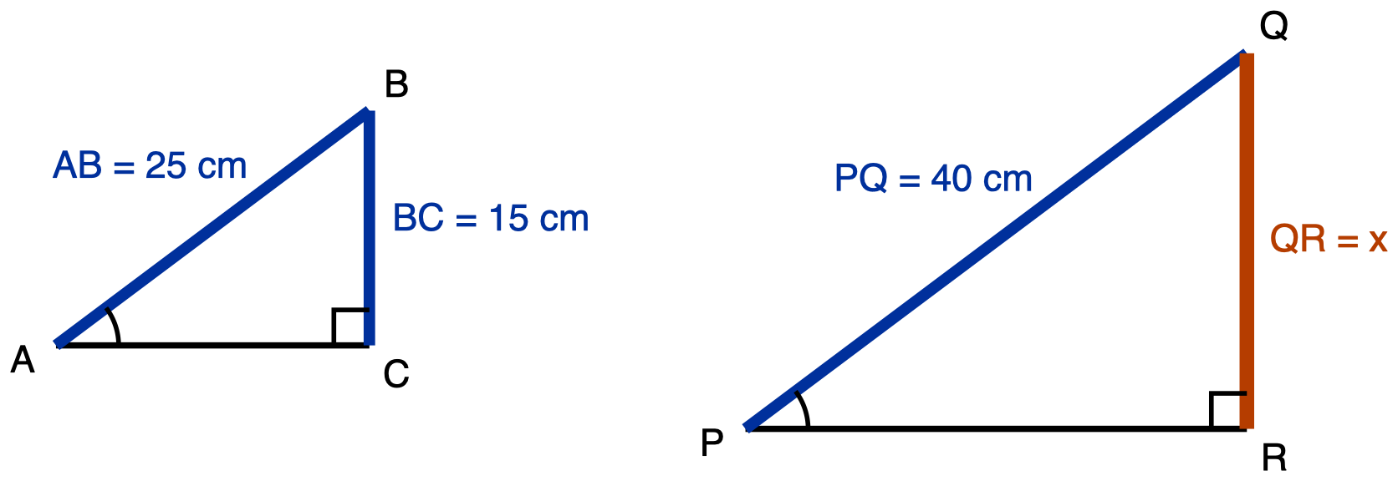
Figure 5. Two right triangles whose marked acute angles are equal, the second larger.
Description: Two separate right triangles drawn side by side, each with a horizontal bottom side and a vertical right-hand side; the second is visibly larger than the first. In the first triangle, A is at the lower left, C is at the lower right level with A, and B is directly above C. Leg AC runs horizontally from A to C and carries no measure. Leg CB runs vertically from C up to B and is given as 15 cm. Side AB runs from A up and to the right to B, is the hypotenuse, and is given as 25 cm. The angle at C is a right angle marked with a small square. The acute angle at A, between AC and AB, carries one arc and no degree measure. BC is the side opposite that marked angle. In the second triangle, P is at the lower left, R is at the lower right level with P, and Q is directly above R. Leg PR runs horizontally from P to R and carries no measure. Leg RQ runs vertically from R up to Q, is the unknown, and is labelled x; it is drawn as the heaviest line in the figure. Side PQ runs from P up and to the right to Q, is the hypotenuse, and is given as 40 cm. The angle at R is a right angle marked with a small square. The acute angle at P, between PR and PQ, carries one arc and no degree measure. QR is the side opposite that marked angle. The angle at A and the angle at P each carry exactly one arc, and that matching arc count is the only place in the drawing where the equality of the two angles is recorded.
You may use: a calculator; a printed ratio table or ratio card if you want one, though no angle on this question is given in degrees, so a table has nothing in it to look up.
You may not use: the scale factor between the two triangles, if someone offers it; a statement that the two triangles are similar; a worked example of the same two triangles with different numbers.
Triangles ABC and PQR are both right triangles. The right angle in ABC is at C; the right angle in PQR is at R. The angle at A and the angle at P are equal. Each carries one arc in the figure, which is what states that equality. In triangle ABC the hypotenuse AB is 25 cm, and BC, the side opposite the marked angle, is 15 cm. In triangle PQR the hypotenuse PQ is 40 cm, and QR, the side opposite the marked angle, is marked x.
Find x. Circle one letter.
- A. x = 24 cm
- B. x = 30 cm
- C. x = 66.7 cm
- D. x cannot be found unless triangle PQR is measured.

7. Finding the third side first
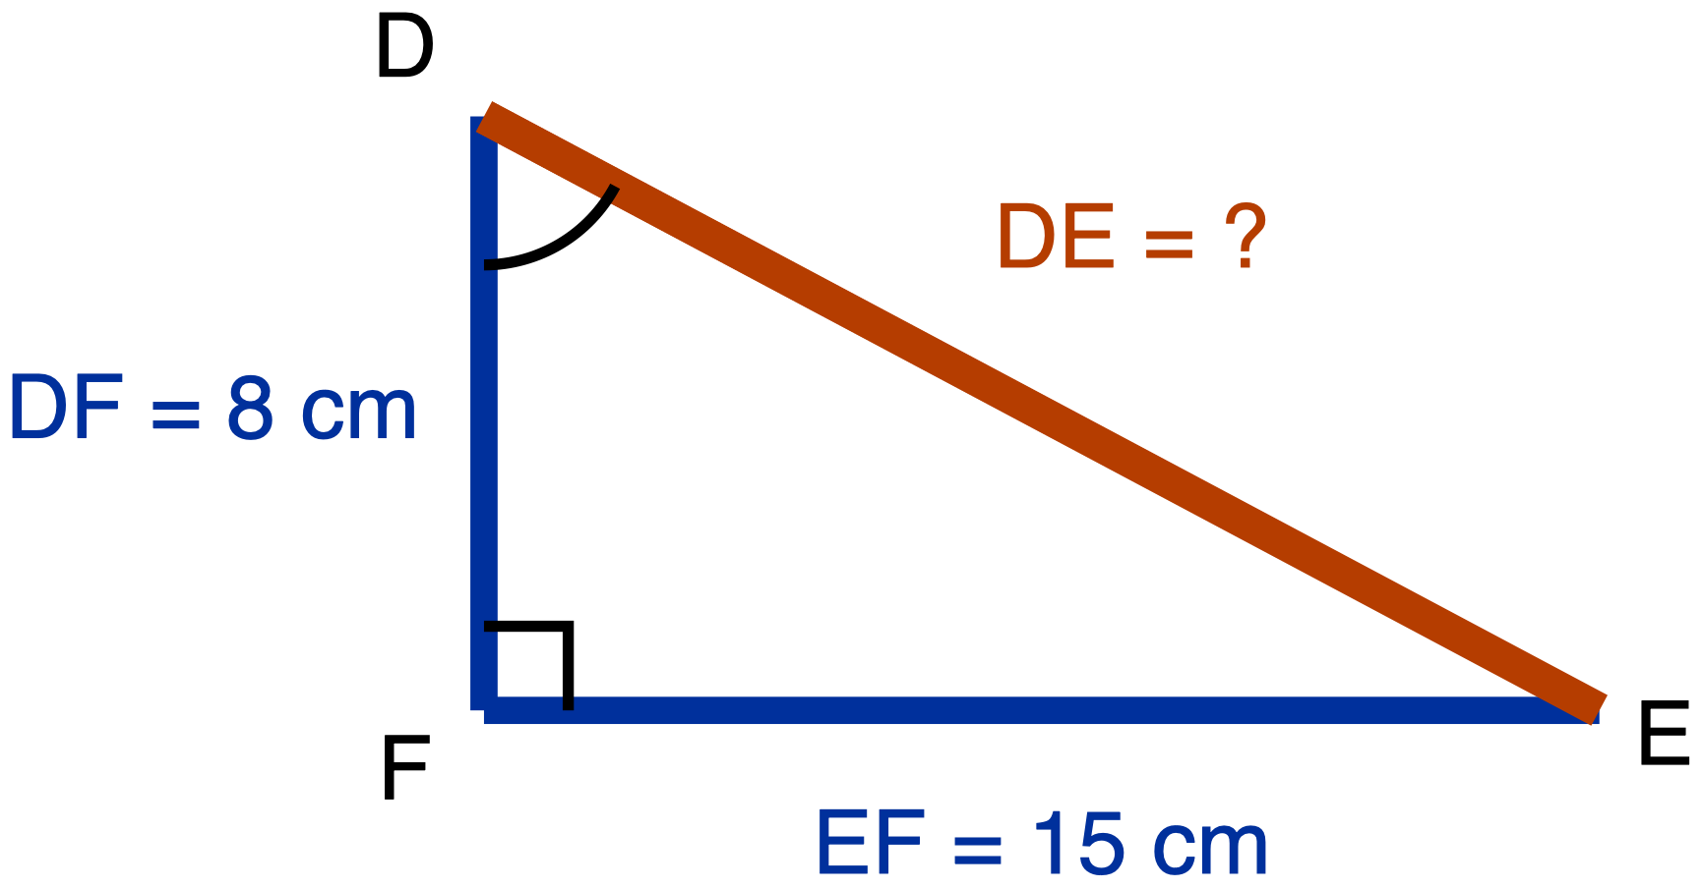
Figure 6. Right triangle DEF, right angle at F, legs 8 cm and 15 cm, hypotenuse unknown.
Description: One right triangle. D is at the upper left, F is directly below D at the lower left, and E is at the lower right level with F. Leg DF runs vertically from D down to F and is given as 8 cm. Leg EF runs horizontally from F to the right to E and is given as 15 cm. Side DE runs from D down and to the right to E, is the hypotenuse, is the unknown, and is labelled with a question mark; it is drawn as the heaviest line in the figure. The angle at F, between FD and FE, is a right angle marked with a small square. The acute angle at D, between DF and DE, carries one arc and no degree measure. Relative to angle D, EF is the opposite leg and DF is the adjacent leg.
You may use: a calculator; a card printing a² + b² = c². You are being asked to use the Pythagorean Theorem here, not to prove it, so the card will not be marked down. Answers to (b) may be a fraction or a decimal.
You may not use: a copy of this triangle with the legs already labelled “opposite” and “adjacent” relative to angle D; a worked example of the same two steps with different numbers.
Triangle DEF has its right angle at F. DF = 8 cm and EF = 15 cm. The hypotenuse DE is not given.
(a) Find DE. Write the equation you used as well as the answer. (b) Write sin D as a ratio of two sides of this triangle.
✋
Part (b) is marked using the student's own answer to part (a). A wrong answer in (a) costs one mark, not two. This is printed on the student paper as well.

Answer key, Question 1: Two triangles, one angle

2 marks. The figure carries no numerals anywhere, deliberately.
The answer. Both triangles have a right angle and a 32° angle, so their third angles are equal too, and by AA the two triangles are similar. (1 mark.) Similar triangles have proportional corresponding sides, so BC and QR stand in the same ratio to AB and PQ, which is exactly the statement that BC ÷ AB and QR ÷ PQ are the same number. (1 mark.)
Accept this equivalent argument in full: triangle PQR is a scale copy of triangle ABC by some factor k, so QR = k × BC and PQ = k × AB, and QR ÷ PQ = (k × BC) ÷ (k × AB) = BC ÷ AB. The factor cancels.
✋
Do not score this on a rubric built for numeric accuracy. There is no number in the item. The two marks are for reaching similarity and for getting from similarity to the equal quotients. A student who states the conclusion without either is at zero, not at one.

Anticipated wrong responses
What the student writes | What it means, and what to do
“They are equal because the triangles are the same shape”, and nothing more | The equality is being treated as an observation rather than as a consequence. The student states the conclusion with the reason clause empty. 0 marks.
“Both have a 32° angle”, then stops | Half the argument. The 32° angle plus the right angle is what gives similarity; similarity is what gives proportional sides. The premise is named and the inference is not made. 1 mark, and the feedback should name the missing step, not the missing mark.
“They are not equal. PQR is bigger, so its quotient is bigger” | The strongest form of the size-dependence error: the student predicts before computing that the larger triangle will have the larger opposite-over-hypotenuse ratio. This is the single most persistent misconception in the unit. 0 marks.
“I cannot answer this, no side lengths are given” | The same misconception in its withholding form: asked for a ratio in an unfamiliar-sized triangle, the student asks for dimensions as though the answer depended on them. 0 marks. This response is why the figure carries no numerals; a figure with lengths would let this student compute two quotients and never notice they hold the belief.

Answer key, Question 2: What moves when the triangle grows
Key: B. 1 mark.
Why B. Enlarging by a scale factor of 3 multiplies every length by 3, so s is three times BC. It multiplies the numerator and the denominator of s ÷ h by the same 3, so that quotient is unchanged. Both halves are true at once, and only option B says so.

What each wrong answer means
A. s is three times BC, and s ÷ h is three times BC ÷ AB. The scale factor applied to the quotient as well as to the sides, because every measurement the student has met before this point does grow when the figure grows. In numbers this is the student who computes 0.6 for a small triangle and 1.2 for its scale-2 copy. Option A is that error stated in words rather than in numbers, and it is the primary form of the misconception.
C. s is the same length as BC, and s ÷ h is equal to BC ÷ AB. The overcorrection. A student who took “the ratio does not change when you enlarge the triangle” from Day 6 without the other half now applies “nothing changes” to a quantity that genuinely does. This is a known teaching hazard: non-linear strategies wrongly applied to genuinely linear items rise sharply when “not everything scales” is taught without teaching which model applies when. If this option draws heavily, the repair is Day 6 Phase 3, not this question. The two halves have to be said in the same breath: the ratio does not change when the triangle grows, and the sides do.
D. s is three times BC, and s ÷ h cannot be found unless the enlarged triangle is measured. The side-length half is right, and the ratio is still being treated as a property of a particular triangle rather than of the angle. This is a weaker form than A: A asserts the ratio moves with size, D only refuses to commit without measuring. A student choosing D may hold the invariance and not trust it, which is a different conversation from a student choosing A.

Answer key, Question 3: The same triangle, from each of its acute angles
3 marks. The figure is drawn at a tilt used nowhere else on the paper.
 | Opposite leg | Adjacent leg | Tangent
(a) relative to angle J | KL = 21 cm | JL = 20 cm | tan J = 21/20
(b) relative to angle K | JL = 20 cm | KL = 21 cm | tan K = 20/21

One mark for (a), one for (b), one for (c). Decimals accepted throughout: 1.05 and 0.95 to two decimal places.
(c) Accept any answer that shows the assignment being re-derived from the angle. The pointing test (“I pointed at K, and the leg I was touching is the adjacent one”) and the equivalent statement (“the opposite leg is the one that does not touch the angle”) both earn the mark. Do not accept a positional answer: “it is the one going up to the left” does not earn it, because that is the very habit the tilt is there to break.
✋
The two legs must exchange roles between (a) and (b). The hypotenuse JK does not move and is not asked for in either part. That exchange is the whole discriminator on this item. Sorting rule for a class set: two piles only, (b) legs exchanged and (b) legs not exchanged. Nothing else on this item sorts students.

Anticipated wrong responses
What the student writes | What it means, and what to do
(b) identical to (a): opposite KL, adjacent JL, tan K = 21/20 | Opposite and adjacent welded to the drawing. The labels were assigned once from angle J and carried over, because under a scheme tied to the picture there is nothing to recompute. 0 marks for (b). This is the error the tilted figure exists to expose.
tan J = 21/29, or tan K = 20/29 | The hypotenuse used where the adjacent leg belongs. A different error, and a quick one to repair: point at the word “adjacent” and ask which side that is here. Score the leg-naming lines on their own merits; they are often correct.
(c) answered as “the bottom leg” or “the long one” | Position-based labelling, one step upstream of the welded-labels error. 0 marks for (c) even where (a) and (b) are right, because the item asks how the decision was made and this answer says it was not made from the angle.
Answers correct but visibly copied: (b) written with no glance back at the figure, no annotation, no turning of the page | Not scoreable from the paper, and not a reason to withhold marks. There are two legs and two roles, so a student who is merely unsure has an even chance of landing on the key. Use a thirty-second oral probe instead: point at K and ask which leg you are touching.

Answer key, Question 4: A number with no triangle beside it
No figure, deliberately: supplying a triangle would answer the question. Key: A. 1 mark.
Why A. The line sin 32° = 0.53 is a claim that one number belongs to the angle. That is only possible if every right triangle carrying a 32° angle produces the same quotient, and they do, because they are all similar to one another. This is the “leading to definitions” clause of HSG-SRT.C.6 assessed directly, and no other item on this paper reaches it.

What each wrong answer means
B. Because the triangles measured in class happened to give quotients that came out close to each other. The student accepts the fact and denies it a cause: the match is treated as a coincidence of the numbers chosen rather than as a consequence of similarity. That is a different repair from a student who denies the fact.
C. It is not legitimate. sin 32° cannot be written as a single number until the side lengths of one particular right triangle are known. The withholding form: the student asks for the triangle's dimensions as though the answer depended on them. This is the option that makes the item worth its slot, because a student holding this belief can still answer question 2 correctly by pattern and can still compute every ratio on questions 3 and 7.
D. Because 0.53 is the value for a medium-sized right triangle. A larger right triangle with a 32° angle gives a larger value, and a smaller one gives a smaller value. The primary form: the prediction that the larger triangle has the larger ratio.
✋
Three options, three forms of one misconception, and that is the design. Which one a student picks is the information this item returns: D denies the invariance, C withholds judgment until measured, B accepts the invariance and denies it a reason. Only B and C are recoverable in a single conversation.

Answer key, Question 5: Using a ratio you have been given
Key: B, x = 23.1 cm. 1 mark.
Why B. GH is the leg adjacent to the 40° angle at G, so the ratio that applies is (adjacent) ÷ (hypotenuse) = 0.77. Then x = 0.77 × 30 = 23.1 cm.
What the item leaves for the student, since both ratios are printed. Choosing which of the two printed ratios belongs to the leg asked for, and deciding to multiply rather than divide. Neither is supplied. Printing both values is required, not generous: recalling a ratio from a degree measure has not been taught by Day 7, so an item demanding it would be testing something the students have not been given.

What each wrong answer means
A. x = 19.2 cm. This is 0.64 × 30. The ratio belonging to the opposite leg used for the adjacent leg: welded labelling transposed from naming a leg to selecting a ratio. It is deliberately the primary distractor, because 0.64 is a perfectly real ratio for this triangle. It is simply not the one asked for, so it does not look wrong.
C. x = 39.0 cm. This is 30 ÷ 0.77, the quotient set up upside down: the student wrote 0.77 = 30 ÷ x instead of x ÷ 30. The self-check that catches it is that 39.0 cm is a leg longer than its own 30 cm hypotenuse, which is the same impossibility as a sine or cosine greater than 1.
D. x cannot be found. The values 0.77 and 0.64 came from a different right triangle. The ratio treated as a property of the triangle it came from rather than of the angle. This option sits on a procedural item on purpose: a student can hold that belief and still be fluent at the vocabulary of every conceptual item, and this is where it surfaces as a refusal to compute.

Answer key, Question 6: Carrying a ratio to a bigger triangle
Key: A, x = 24 cm. 1 mark.
Why A. The marked angles at A and at P are equal and both triangles have a right angle, so the triangles are similar and the ratio (side opposite the marked angle) ÷ (hypotenuse) is the same in both. In ABC that ratio is 15 ÷ 25 = 0.6. So x = 0.6 × 40 = 24 cm.

What each wrong answer means
✋
B. x = 30 cm is the highest-value wrong answer on the whole paper. The hypotenuse grew from 25 to 40, an increase of 15, so the student adds 15 to the 15 cm side and answers 30. That is additive scaling where multiplicative scaling belongs, and it is a Day 1 failure surviving into Day 7. A student who picks B here while answering questions 2 and 4 correctly has the invariance and has lost the proportional reasoning underneath it. No other item on this paper can tell you that.

C. x = 66.7 cm. This is 40 ÷ 0.6, the same inverted setup as question 5's option C, caught by the same self-check: 66.7 cm is a leg longer than its own 40 cm hypotenuse. A student choosing C on both question 5 and question 6 has one habit, not two errors, and the fix is one sentence: write the quotient the way the definition writes it, then solve.
D. x cannot be found unless triangle PQR is measured. As in question 5. A student choosing D here and on question 5 has shown you the size-dependence belief twice on the procedural half of the paper after possibly answering the conceptual half correctly, which is worth more than either data point alone.

Answer key, Question 7: Finding the third side first
2 marks.
(a) 8² + 15² = 64 + 225 = 289, so DE = √289 = 17 cm. (1 mark. The equation must appear; a bare 17 with no working earns the mark only if the working is visible on the figure.)
(b) Relative to angle D, the opposite leg is EF = 15 and the hypotenuse is DE = 17, so sin D = 15/17. (1 mark. Accept 0.88, or 0.882.)
✋
Part (b) is marked against the student's own part (a) value. A student who answers (a) as 23 and then writes sin D = 15/23 has made one error, not two, and scores 1 of 2. Without this rule, part (b) would silently be measuring part (a).

Anticipated wrong responses
What the student writes | What it means, and what to do
(b) 8/17 | This is sin E, the ratio taken from the other acute angle. The opposite leg was assigned as though the labels belonged to the drawing rather than to the named angle. Same error as question 5's option A in a different costume, and a student who makes both has one habit, not two.
(b) 15/8 | The tangent slot used for sine. The answer exceeds 1, and the self-check catches it: no sine of an acute angle can exceed 1, because the opposite leg is never longer than the hypotenuse.
(a) 23 cm | The two legs added instead of their squares. This is a procedure slip on prior-grade content (8.G.B.7). Repair it as arithmetic, not as similarity, and do not go hunting for a Day 5 to Day 7 cause that is not there.
(a) about 12.7 cm | √(15² − 8²) = √161. The theorem applied with DE treated as a leg rather than as the hypotenuse. The quick diagnostic is that 12.7 is shorter than one of the legs it is supposed to span.

✋
Do not read a wrong (a) as a Day 5 failure. Day 5 is about proving a² + b² = c² by similarity. This item is about using it. A student can hold the proof and slip on the arithmetic, and the reverse is also common. This item carries no evidence about whether a student can prove the theorem, and must not be read as though it did.

Reading the paper as a diagnosis, not a score

Which wrong answer a student gives tells you which day to repair. That is the point of the whole design.
What you see | What it points at | Where the repair is
Q2 → A, or Q4 → D, or Q1 “the bigger one has the bigger ratio” | Size-dependence in its strongest form: the ratio moves with the triangle | Day 6, Phases 2 and 3. The invariance has to arrive as a class result with a reason attached, not as an announcement
Q4 → B, or Q1 with no reason clause | Size-dependence in its weakest form: the fact is accepted, the cause is missing | Day 6, Phase 3 only. One conversation, not a re-teach
Q4 → C, or Q5 → D, or Q6 → D | The same belief as a refusal to commit without measuring | Day 6, and check whether the student answered Q2 correctly by pattern
Q2 → C | Overcorrection: “nothing changes when you scale” | Day 6, Phase 3. Both halves in the same breath
Q3 (b) same as (a), or Q5 → A, or Q7 (b) = 8/17 | Opposite and adjacent welded to the drawing | Day 7, Phases 1 and 2. The pointing gesture, re-run. A verbal rule will not do it
Q6 → B | Additive instead of multiplicative scaling, surviving into Day 7 | Day 1. This is the only item on the paper that can tell you so, and it is the most consequential single signal here
Q5 → C and Q6 → C together | One inverted-setup habit, not two errors | Ten minutes. Write the quotient as the definition writes it, then solve
Q7 (a) wrong, everything else right | Prior-grade arithmetic, not a Day 5 to Day 7 cause | Arithmetic, separately

What a score means, and what it does not
A defensible “meets standard” on this paper is 8 of 11. That is 73 per cent, and it is set deliberately below the level instinct reaches for.
The argument. On live released state items, right-triangle trigonometry sits well below the test median. Florida BEST 2025 publishes percent-correct on released items: a cofunction-in-disguise item scored 40 per cent correct, and two other trigonometry items scored 36 and 31 per cent, against a whole-test range of roughly 21 to 81 per cent.
What that licenses and what it does not. Those are single cold exposures on a broad exam; your students will have had five days of unit-specific, similarity-first instruction on exactly this content, so treating 31 to 40 per cent as a prediction here would overstate the transfer. Treating those numbers as irrelevant would understate a real and well-documented difficulty. The operating rule is the middle: do not set a “meets standard” cut above roughly 75 to 80 per cent on questions 5 to 7 (the 4-mark procedural portion), and do not read a single below-target item as evidence a lesson failed until you have read it against that baseline.

Feedback to return with the marks
The diagnosis is only worth having if it comes back to the student. Every mark returned should carry a sentence that is specific, tied to the named error, and forward-looking. A bare cross tells the student the answer was wrong and leaves the reasoning intact.
- Question 3, part (b) not exchanged: “You labelled from J and then kept those labels for K. Point at K and tell me which leg you are touching. That one is the adjacent leg, and it is the other leg this time.”
- Question 6, option B: “You added 15 because the hypotenuse grew by 15. Enlarging multiplies every side by the same factor, it does not add the same amount to each. What did 25 get multiplied by to reach 40?”
- Question 2 or 4, the size-dependence options: “The quotient is fixed by the angle, not by the triangle. Draw any right triangle you like with a 32° angle and check it against mine.”
- Question 5 or 6, the inverted setup: “Your answer is a leg longer than its own hypotenuse. That cannot happen. Write the quotient the way the definition writes it and try again.”

Quiz 3. Special Triangles and Complements

Quiz 3. Special Triangles and Complements
Nine items. Items 1 to 4 assess deriving and using the two special right triangles (HSG-SRT.C.8). Items 5 to 9 assess the relationship between the sine of an acute angle and the cosine of its complement (HSG-SRT.C.7).
Placement: after Day 9. It assesses Day 8's special-triangle derivations and Day 9's complementary-angle relationship, and nothing later. Nothing on it depends on Day 10, so no item uses an angle of elevation or depression.
Two items are multiple choice and seven are constructed response. Every item is required; there is nothing for a student to choose between.
Materials: Blank paper, tracing paper, scissors and straightedges on the front desk for Part A. One special-triangle reference card per student, handed out at the start of Part B and collected by hand at the end of it. Blank right-triangle outlines for students who ask (items 4, 6 and 9). A second copy of the item 5 figure for students who want to annotate it.
✋
The answer key section of this document, and the feedback lines that follow it, are for you. Do not hand any part of them to a student.

Issuing the quiz

Issuing the quiz: three parts, each collected before the next goes out
This is not classroom-management fussiness. The special-triangle reference card is denied on items 1 and 2, permitted on items 3 and 4, and denied again on items 5 to 9. A card that sits on the desk all period makes the first ruling untrue and answers item 9 by the one route item 9 forbids.
Part | Items | Hand out | Collect
A | 1, 2 | Part A, with tracing paper and scissors on the front desk | Part A, before Part B goes out
B | 3, 4 | Part B and the special-triangle reference card | Part B and every card, by hand
C | 5 to 9 | Part C | Part C

Say at the start of Part B that the card will be collected at the end of it, and why. Day 8 handled the same card the same way, for the same reason. Announcing the collection at handout rather than at collection is what keeps it from feeling like a trick.
✋
Count the cards back. One card left on one desk during Part C invalidates that student's item 9: the printed 30-60-90 ratio lets them compute the answer the exact way item 9 asks them not to.

What is not on any desk, or any wall, at any point
No formula sheet, no cofunction identity card, no sine and cosine value table, and no poster or board display carrying sin θ = cos(90° − θ) in any form. On items 5 to 9 that relationship is the thing being measured, so printing it anywhere prints the answer.
✋
Check the walls before Part A, not before Part C. One shared display anywhere in the room during any part of the period compromises five of the nine items.

Read-aloud and extended time: offer both
Read-aloud is permitted on all nine items, and you should offer it. There are no applied modelling items on this quiz, so the read-aloud restriction that applies to applied items elsewhere in the unit does not apply here. A proctor who denies read-aloud on this quiz out of caution is removing a legitimate support for no reason.
Extended time is permitted on all nine items. No item on this quiz is a fluency check.

Where an individual plan collides with a tool ruling
A student whose IEP or 504 plan grants a reference sheet, a note card, a calculator, a scribe or extended time keeps it, whatever this document says. Two collisions are foreseeable here:
- A documented note-card accommodation whose card carries the sine and cosine relationship, against the denial on items 5 to 9.
- A documented calculator accommodation, against the exact-form requirement on items 1 to 4 and the evaluation denial on items 6, 8 and 9.
✋
The plan wins. Note on the paper that it did, so the score is read correctly later, and take the collision to the student's team rather than deciding it at the desk. The tool rulings on this quiz remove barriers for the class; they do not make decisions that belong to a team.

The paper, as the students receive it

The paper, as the students receive it
Reproduced below so you can read what each student is holding. Every item states its own tools, on the item, and the rulings are not the same on every item. There is no quiz-wide tools rule.

Blank paper, tracing paper, scissors and a straightedge are theirs.

Item 1. Half a square
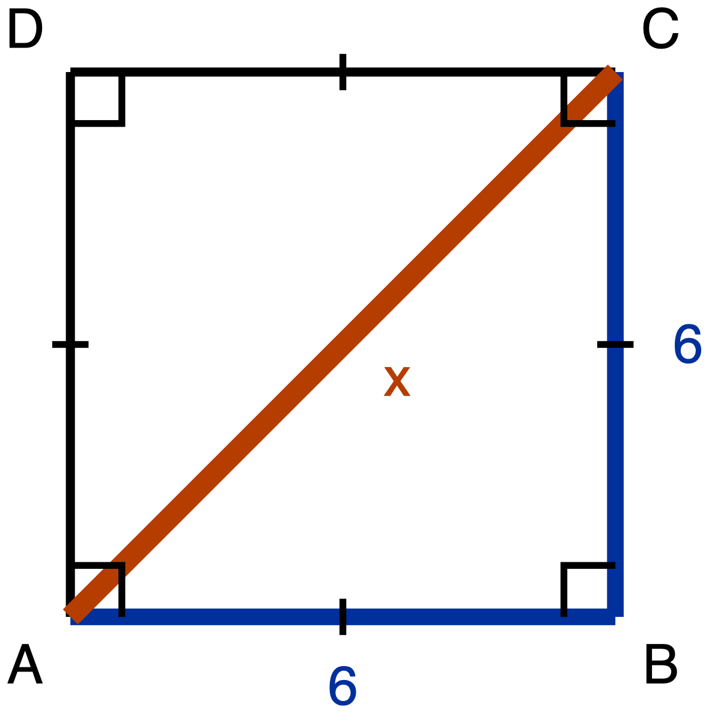
Figure 1. Item 1. Square ABCD of side 6, with the diagonal AC drawn.
Description: A square ABCD drawn with its sides vertical and horizontal. A is the bottom left corner, B is the bottom right corner, C is directly above B at the top right, and D is directly above A at the top left. The diagonal AC is drawn from the bottom left corner up to the top right corner; its length is unknown and it is labelled x. Side AB along the bottom is labelled 6 and side BC up the right is labelled 6; sides CD and DA are drawn as plain lines and carry no numeral. A single congruence tick sits at the midpoint of each of the four sides, so all four sides are marked congruent to one another. A right-angle square sits at each of the four corners A, B, C and D, and the diagonal passes through the corner of the right-angle mark at A and again through the one at C, so each of those two right angles is drawn split by the diagonal. There are no angle arcs anywhere in the figure, and nothing marks the two parts of a split corner angle as congruent to each other.
Square ABCD has side length 6, and its diagonal AC is drawn.
(a) Derive the three angle measures and the three side lengths of triangle ABC. Give the side lengths in exact form, which means a radical where one is needed and not a decimal approximation.
(b) Write the ratio AB : BC : AC in simplest form.
The route this item requires is the square's own diagonal. Your argument has to say what the square tells you about angle ABC and about the lengths AB and BC, and it has to use the Pythagorean Theorem to get AC. Writing down "45-45-90" and "1 : 1 : √2" from memory is not an answer to this item, because what is being asked for is where those values come from. You are told this before you start.
Record your derivation in whichever one of these you prefer:
- an annotated diagram, with the angle measures and the algebra written on the figure
- a paragraph
- a two-column statement and reason chain
- a flowchart
- an oral walkthrough at the figure, which I will write down word for word as you give it
Tools for this item: No calculator. No special-triangle reference card. No formula sheet or identity card of any kind, here or anywhere on this quiz. Straightedge, blank paper, tracing paper and scissors are yours, and redrawing triangle ABC on its own, away from the square, is a good first move.

Item 2. Half an equilateral triangle
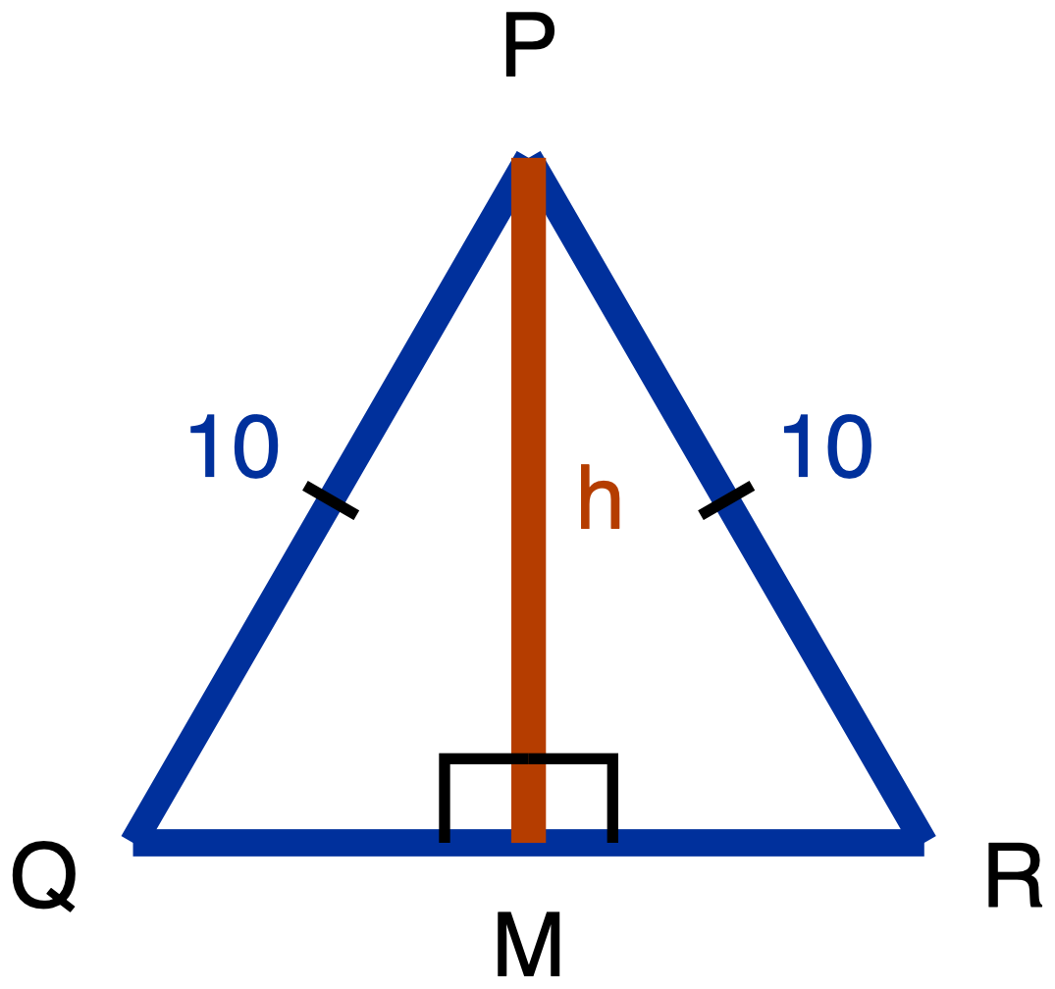
Figure 2. Item 2. Equilateral triangle PQR of side 10, with the altitude from P meeting QR at M.
Description: A triangle PQR drawn point up with its base horizontal along the bottom. P is the apex at the top, centred; Q is the bottom left vertex; R is the bottom right vertex. M lies on QR and is the point where a vertical segment from P meets the base. PQ, the left slant side, is labelled 10, and PR, the right slant side, is labelled 10; each of those two sides carries a single congruence tick, marking them congruent to each other. The base QR carries no numeral and no tick. The segment PM runs from P straight down to M; it is the unknown and is labelled h. Two right-angle squares sit at M, one on each side of PM, marking angle PMQ and angle PMR as right angles. There is no angle arc at P, at Q or at R. M is drawn at the centre of QR, but nothing in the figure's marks asserts that it is the midpoint.
Equilateral triangle PQR has side length 10. The altitude from P meets QR at M.
(a) Derive the three angle measures and the three side lengths of triangle PQM. Give the side lengths in exact form.
(b) Write the ratio QM : PM : PQ in simplest form.
(c) In your simplified ratio, one of the two larger numbers is the hypotenuse's. Say which one, and state in one sentence how you know, without using a calculator.
The route this item requires is the equilateral triangle's altitude. Before any arithmetic, your argument has to answer both of these:
- What does the altitude do to angle P?
- What does the altitude do to side QR?
Nothing on the figure tells you where M sits along QR. That is something to establish, not something given. Then use the Pythagorean Theorem to get PM.
Same five ways of recording your derivation as Item 1. Part (c) may be a sentence, a written comparison of the two numbers, or said aloud to me.
Tools for this item: No calculator. No special-triangle reference card. No formula sheet or identity card of any kind. Straightedge, blank paper, tracing paper and scissors are yours.
Students hand Part A in before Part B is issued.

The paper, Parts B and C

Item 3. A 30-60-90 triangle
A 30-60-90 triangle has shorter leg 8.
Which pair gives its hypotenuse and its longer leg, both in exact form? Exact form means a radical where one is needed, not a decimal approximation. Choose one.
- A. hypotenuse 16, longer leg 8√3
- B. hypotenuse 8√3, longer leg 16
- C. hypotenuse 16, longer leg 8√2
- D. hypotenuse 16, longer leg 13.86
Write the letter, circle it, point at it, or say it to me.
Tools for this item: The special-triangle reference card is allowed. No calculator. No formula sheet or identity card of any kind.

Item 4. Two triangles, two directions
(a) A 45-45-90 triangle has legs of length 9. Give its hypotenuse in exact form.
(b) A 30-60-90 triangle has hypotenuse 22. Give its shorter leg and its longer leg, both in exact form.
Write your answers, write them onto a blank triangle outline if you would rather (ask and I will give you one), or say them to me and I will write them down.
Tools for this item: The reference card is allowed. No calculator. No formula sheet or identity card of any kind. The card gives you the two ratios; deciding which ratio each part needs, and which direction to run it, is yours.
Collect Part B and every reference card, by hand, before Part C is issued.

Item 5. Which side does the work
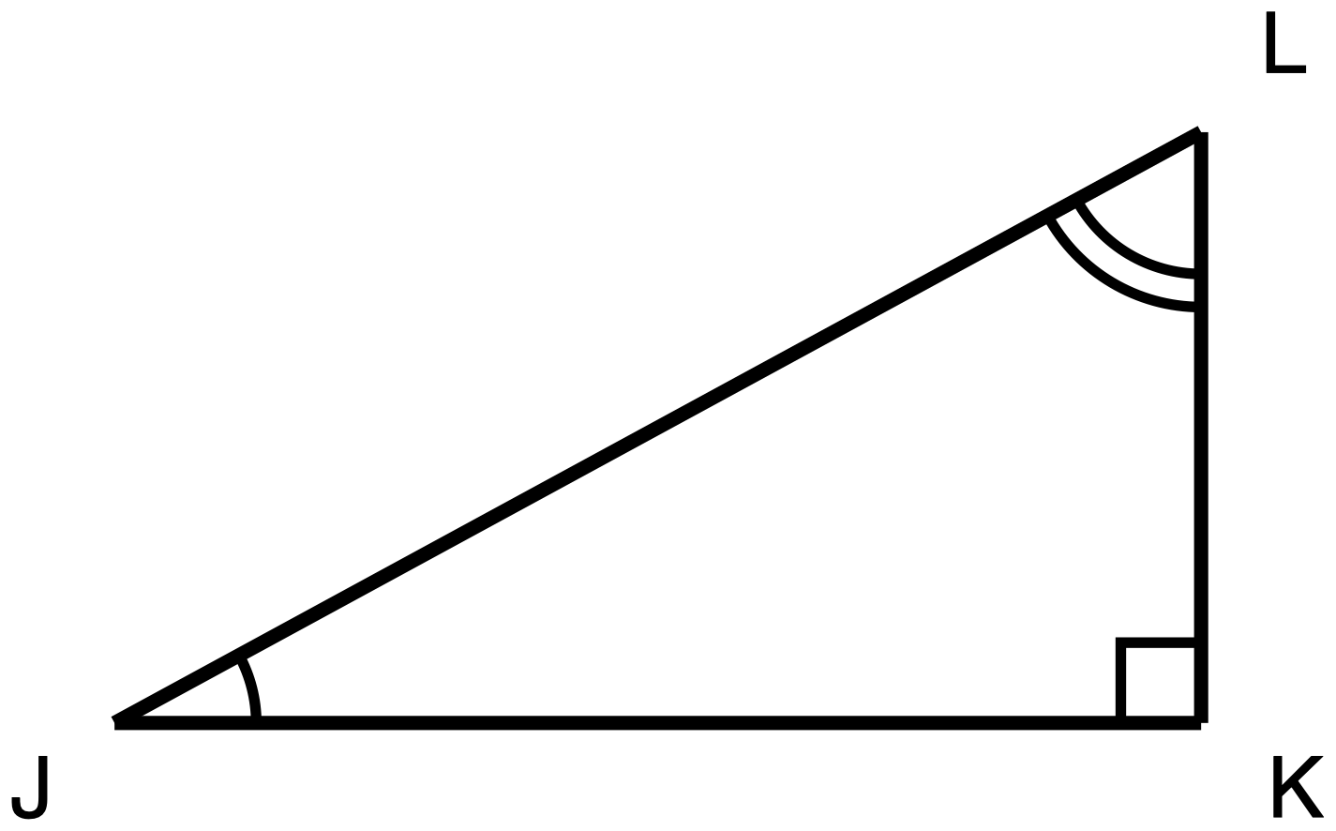
Figure 3. Item 5. Right triangle JKL, right angle at K, no measures given.
Description: A right triangle JKL with one leg horizontal along the bottom and one leg vertical on the right. J is the bottom left corner, K is the bottom right corner and holds the right angle, and L is directly above K and is the highest point. JK is the horizontal bottom leg, KL is the vertical right leg, and JL runs from the bottom left corner up to the top right corner and is the hypotenuse. No side length and no angle measure is printed anywhere in the figure, and all three sides are drawn at the same plain weight. The right angle at K carries a small square, the angle at J carries a single arc, and the angle at L carries two concentric arcs, so the differing arc counts mark J and L as two different angles rather than a congruent pair. No two segments and no two angles are marked congruent.
Right triangle JKL has its right angle at K.
(a) Name the one side of this triangle that is opposite angle J and is also adjacent to angle L. Then say in one sentence why a single side can play both of those roles.
(b) Use your answer to (a) to explain why sin J = cos L. Write each of them as a fraction of two named sides.
(c) Trey says the answer to (b) is really that sin J = cos K, because K is the other angle named in the triangle. Give one reason Trey's equation cannot be right.
Answer in writing, by annotating a second copy of the figure (ask and I will give you one), or out loud to me, and I will write it down word for word.
Tools for this item: A calculator is allowed, and there is not a single number in this item. No table of sine and cosine values. No formula sheet or identity card.

Item 6. Which equation is always true
In right triangle DEF, the right angle is at E.
Which one of these is true for every triangle of that kind? Choose one.
- A. sin D = cos E
- B. sin D = cos F
- C. sin D = sin F
- D. tan D = tan F
Write the letter, circle it, point at it, or say it to me. If it helps, ask me for a blank right-triangle outline with D, E and F already lettered on it.
Tools for this item: No calculator with sine, cosine or tangent keys. A four-function calculator is allowed. No table of sine and cosine values. No formula sheet or identity card.

Item 7. Solving for x
For some value of x, sin(4x + 10)° = cos(2x + 20)°, and both (4x + 10)° and (2x + 20)° are acute angles.
(a) Write one sentence saying how those two angle measures are related to each other. Then write the equation that sentence gives you.
(b) Solve your equation for x.
(c) Give both angle measures, and check that both of them are acute.
Part (a) is required and is not a warm-up: the equation has to come from a stated fact about the two angles, not from a remembered template. You may dictate your sentence and your equation and I will write them down.
Tools for this item: A four-function or scientific calculator is allowed for the arithmetic. No graphing calculator and no equation solver. No table of sine and cosine values. No formula sheet or identity card.

Item 8. Solving for y
Solve for y:
✋
sin 40° = cos(y + 15°), where (y + 15)° is an acute angle.

Before you write any equation, write down in words the step where you use the relationship between sine and cosine. Then solve, and check that (y + 15)° really is acute.
Tools for this item: No calculator with sine, cosine or inverse keys. A four-function calculator is allowed; the arithmetic here is 90 − 40 and then 50 − 15. No table of sine and cosine values. No formula sheet or identity card.

Item 9. From one angle to its partner
In a right triangle, one acute angle measures 30°, and sin 30° = 1/2.
(a) Name the other acute angle of that triangle.
(b) Give the value of the cosine of the angle you named in (a), without computing any ratio from any triangle, and say in one sentence how you know.
That restriction in (b) is the point of the item: the route being measured is the relationship between an angle and its complement, not a second trip through opposite over hypotenuse.
Answer in writing, out loud to me, or by writing the two angle measures and the cosine value onto a blank triangle outline with one phrase giving your reason. Ask if you want the outline.
Tools for this item: No calculator. No table of sine and cosine values. No formula sheet or identity card. The special-triangle reference card was collected at the end of Part B.

Answer key, Part A

Answer key, Part A
Every wrong answer below is named and tied to the reasoning that produces it. The constructed-response items get the same treatment as the multiple-choice ones, under What you will see, and what it means, because a wrong answer you cannot name is a wrong answer you cannot give feedback on.

Item 1. Half a square
- Angles: 90° at B, 45° at A, 45° at C.
- Sides: AB = 6, BC = 6, AC = 6√2.
- Ratio AB : BC : AC = 1 : 1 : √2.
The derivation, in the form the item asks for: ABCD is a square, so angle ABC is 90° and AB = BC = 6. Triangle ABC therefore has two congruent sides, so the angles opposite them, angle BAC and angle BCA, are congruent. The three angles of a triangle sum to 180° and angle ABC has taken 90° of that, so BAC and BCA sum to 90° and each is 45°. Then 6² + 6² = AC², so AC² = 72 and AC = √72 = 6√2.
✋
A second correct route, and accept it in full: the diagonal of a square bisects the corner angles it passes through, so angle BAC is half of the 90° at A. A student who asserts the bisection without an argument has assumed what the isosceles route proves. Ask for the reason, do not mark it wrong outright, and note which route the class actually reached for.

What you see | What it is | What to do
"45-45-90, so 1 : 1 : √2", with no argument | Not an answer to this item. The stem states the required route in the student's own copy, so this is a stated requirement and not a hidden penalty | Give it back with the route sentence circled. This is the one wrong answer on Part A that is a reading failure rather than a mathematical one
AC = 12 | The 30-60-90 doubling rule imported into a 45-45-90 triangle. This is the wrong special triangle, and it is a different error from the transposition error in item 2 | Back to the derivation, not to the size check. The size check will not help a student who reached for the wrong ratio
AC = 8.49 | The correct value in the wrong form. Answering an exact-value question with a decimal is a documented error class in this cluster | The value is right and the form is not. Say so in those words: the radical is the answer here, the decimal is a report of it
30° and 60° at A and C | A belief that halving a symmetric figure produces 30 and 60. This is not a documented misconception. The citation once carried for it was checked and found not to exist | Your room's evidence is real evidence. Note it in your own records and treat it as an observation, not as a cited error

Item 2. Half an equilateral triangle
- Angles: 90° at M, 60° at Q, 30° at angle QPM.
- Sides: QM = 5, PM = 5√3, PQ = 10.
- (b) QM : PM : PQ = 1 : √3 : 2.
- (c) The 2. Either reason is a complete answer: √3 is less than √4 and √4 is 2, so √3 cannot be the largest of the three values; or the longest side of a triangle lies opposite its largest angle, the largest angle here is the 90° at M, the side opposite it is PQ, so PQ is the longest and its ratio value is 2.
The derivation, in the form the item asks for: Triangles PQM and PRM have PQ = PR (the triangle is equilateral), PM in common, and right angles at M, so they are congruent. Therefore QM = MR, and since QM + MR = QR = 10, each is 5. Also angle QPM = angle RPM, and together they are the 60° apex angle, so each is 30°. Angle Q is 60° because PQR is equilateral. Then 5² + PM² = 10², so PM² = 75 and PM = √75 = 5√3.
✋
Both halves of the altitude question are required, and this is where you look. A student who says only that the altitude bisects angle P gets the angles and guesses QM. A student who says only that it bisects QR gets the sides and cannot say why the angles are 30 and 60. Both are the Day 8 barrier showing up as a partial answer rather than a wrong one, which is exactly why a teacher scanning for wrong answers misses them.

What you see | What it is | What to do
(b) written as 1 : 2 : √3, or (c) answered "√3" | The transposition. This is the day's primary misconception and the quiz's primary for the special-triangle standard. The student has both correct values and assigns √3 to the hypotenuse because a radical carries more symbolic weight than a bare 2 and reads as the larger quantity | The size check, in both of its forms, and ask for it out loud before they leave if there is time. Feedback line below
(a) correct and (c) blank, or (c) answered "because it just is" | The slot assignment is memorised, not held. This student passes a numeric-only item and fails this one | The same size check. This is the pile item 2(c) exists to surface, and a numeric-only version of this item would have scored it as a pass
PM = 5√2 | The 45-45-90 ratio imported into a 30-60-90 triangle. This is the wrong special triangle, not the transposition | Back to the derivation. The size check does not address this
QM = 10, or QM left as an unknown | The altitude's effect on QR was never established. Half the barrier | Ask which two triangles are congruent and why. The bisection of QR falls out of that, and asserting it without the congruence is the gap
Angles given as 45° and 45° | The same halving belief as item 1. Not a documented misconception | Note it, do not report it upward as cited

Answer key, Part B

Answer key, Part B

Item 3. A 30-60-90 triangle
Key: A. hypotenuse 16, longer leg 8√3.
Option | What choosing it means
A. hypotenuse 16, longer leg 8√3 | Key. The ratio is 1 : √3 : 2 in side order, so with the shorter leg at 8 the longer leg is 8√3 and the hypotenuse is 16
B. hypotenuse 8√3, longer leg 16 | The transposition, exactly. Both values are right and both are in the wrong slot. The student ranks √3 above 2 because √3 is written as a radical and reads as the more complicated, therefore larger, quantity. This transposition works as a distractor on every special-triangle item and needs no separate design. A student picking B has the ratio and does not have the ordering
C. hypotenuse 16, longer leg 8√2 | The wrong special triangle, in its partial form. The hypotenuse comes from the 30-60-90 ratio and the leg from the 45-45-90 one. This is a wrong answer that is not the transposition and that needs different feedback, and the option exists so you can tell the two apart on the page instead of guessing
D. hypotenuse 16, longer leg 13.86 | The right value in the wrong form. Answering an exact-value question with a decimal is a documented error class. The stem says "exact form" and defines it, so this is a stated requirement of the item, not a hidden penalty. If a future edit takes that phrase out of the stem, take option D out with it

✋
A limit on what item 3 can tell you, stated because it is easy to over-read. The reference card is on the desk for item 3. With the card present, this item measures application of a supplied ratio, and it cannot distinguish a student who holds the slot assignment from one who read it off the card thirty seconds earlier. That is by design. The evidence for the slot assignment on this quiz is item 2(c), and only item 2(c). A student who picks B here has failed even with the card in front of them, which is worth noticing; a student who picks A here has told you nothing about whether they hold the transposition error.

Item 4. Two triangles, two directions
- (a) hypotenuse = 9√2.
- (b) shorter leg = 11, longer leg = 11√3.
What you see | What it is | What to do
(a) 9√3 | The 30-60-90 ratio applied to a 45-45-90 triangle. Wrong special triangle, not the transposition | Back to item 1's derivation. Ask what the diagonal of a square does that the altitude of an equilateral triangle does not
(a) 18 | The 30-60-90 doubling rule imported: the student halved or doubled where the 45-45-90 triangle multiplies by √2. Same wrong-triangle family as the line above, arriving without a radical at all | Same response. The absence of a radical is the tell
(a) 12.73 | Correct value, decimal form | Name the form, not the value
(b) shorter leg 11√3, longer leg 11 | The transposition, surviving the card. A student who read the card and still crossed the two slots has a reading of the card, not the ratio | The size check. Then have them point at the card and say which column is which
(b) shorter leg 11, longer leg 11√2 | Wrong special triangle for the longer leg only, with the halving done correctly. Not the transposition | Back to the derivation for the longer leg
(b) shorter leg 22/√3 or 22√3/3 | The student took the hypotenuse to be the √3 slot and divided by √3. This is the transposition's mechanism running in reverse, and it produces an answer larger than the true shorter leg, which is a second tell | The size check, then re-run the item from the ratio in side order

✋
Both parts of item 4 are required and neither substitutes for the other. Part (a) runs a ratio forward, from a leg to a hypotenuse. Part (b) runs one backward, from a hypotenuse to two legs. A student who has memorised one direction of one triangle passes half of this item, which is the point of its being in two parts.

Answer key, Part C

Answer key, Part C

Item 5. Which side does the work
- (a) KL. A single side can play both roles because a right triangle has only two legs, and the two acute angles sit at the two ends of the hypotenuse. Each leg touches one acute angle and does not touch the other, so each leg is adjacent to one acute angle and opposite the other. KL touches K and L and does not touch J, so it is adjacent to angle L and opposite angle J.
- (b) sin J = KL / JL, opposite over hypotenuse, and cos L = KL / JL, adjacent over hypotenuse. The two fractions have the same numerator and the same denominator, so they are the same number, and therefore sin J = cos L.
- (c) K is the right angle. Either reason is complete: the relationship pairs an acute angle with its complement, and the complement of J inside this triangle is the other acute angle L, not K; or the cosine of the right angle is 0 for every right triangle, and the sine of an acute angle is never 0, so the equation cannot hold. Accept as well a student who says the unit's sine and cosine ratios are defined for acute angles, so K has no such ratio here at all. That is the more careful answer, not a weaker one.
What you see | What it is | What to do
(a) answered "JK" | The leg adjacent to J named instead of the leg opposite it. This is the Day 7 error recurring: a labelling scheme fixed to the drawing instead of re-derived from whichever angle is under discussion | The physical test Day 7 installed: point at the angle, the leg you are touching is the adjacent one. It cannot be performed without first choosing an angle, which is the whole point
(b) written as a claim with no fractions | The equality asserted rather than shown. The two fractions are the explanation; without them there is nothing to check | Ask for both ratios written as fractions of named sides. When both are on the page the argument finishes itself
(c) "Trey is right", or (c) blank | The right angle taken as the partner angle. This is the quiz's primary misconception for the complements standard. The right angle is the most salient angle in the figure, it is marked, and "the complement of J" means nothing visually, so the student substitutes the most available other angle | Compute the cosine of the right angle in front of them. It is 0 for every right triangle, so it can never equal a nonzero sine. That computation removes the option rather than warning against it
(c) "because K is 90°" and nothing else | True and not yet a reason. 90 appears in both "the 90° angle" and "the angle that completes J to 90°", which is precisely why the two get confused | Ask the follow-up out loud: so what is the cosine of K?

Item 6. Which equation is always true
Key: B. sin D = cos F.
Option | What choosing it means
A. sin D = cos E | The right angle taken as the partner. The student knows the relationship pairs an angle with another one and takes the other one to be the right angle. Numerically: cos E = cos 90° = 0, and sin D is never 0 for an acute D
B. sin D = cos F | Key. D and F are the two acute angles of a right triangle, so they are complementary, and the sine of one equals the cosine of the other. Holds for every such triangle
C. sin D = sin F | Right partner angle, wrong function. The student finds the correct partner angle and then keeps the function the question started with. The angle swap has a visual anchor in the figure; the sine-to-cosine change does not, so a student who learned the relationship as a sentence about angles rather than about a shared side keeps the original function. sin D and sin F are equal only when both are 45°
D. tan D = tan F | The relationship over-generalised to tangent. The rule "the ratio of an angle equals the ratio of its complement" is well formed, economical, and false for tangent. The "co-" prefix positively encourages it, since cotangent exists and is named the same way. Written as fractions of the same two legs, tan D and tan F are reciprocals, so their product is 1 and they are equal only at 45°

✋
What the option set is doing: three of the four options carry three different documented errors, and no option is filler. If the class splits across A, C and D rather than piling onto one, that is three different repairs, not one, and the feedback lines below give all three.

Item 7. Solving for x
- (a) The two angle measures are complementary: they add to 90°. Equation: (4x + 10) + (2x + 20) = 90.
- (b) 6x + 30 = 90, so 6x = 60 and x = 10.
- (c) 4(10) + 10 = 50° and 2(10) + 20 = 40°. Both are acute, and 50 + 40 = 90, so the answer checks.
What you see | What it is | What to do
4x + 10 = 2x + 20, giving x = 5 | The two arguments set equal. Every previous equation with a function on both sides was solved by equating arguments, because the functions matched. Here they do not, and the difference between cos and sin is one letter in a place the student has learned to skim | Put cos(4x + 10)° = cos(2x + 20)° next to the item's own equation and ask which one equates arguments and why. The distinction is invisible unless both are on the page
(4x + 10) + (2x + 20) = 180, giving x = 25 | The same error's second population, importing the triangle angle sum. The student knows a rule about angles summing to something, cannot recall which sum, and reaches for the one they use most | Part (c) is the repair and it is already in the item: at x = 25 the angles are 110° and 70°, and 110° is not acute. Have them run (c) on their own answer
(b) and (c) correct, (a) missing or written as "cofunction rule" | The 90 came from a template rather than from a stated fact about the two angles. The answer is right and the reasoning is not evidenced | Ask for the sentence out loud. The repair is to require the sentence before the equation so the 90 has a source
(c) skipped | The check is the part that catches the 180 route, and it is required | Hand it back for (c) only

Item 8. Solving for y
The relationship step, in words: 40° and the angle inside the cosine are complementary, so sin 40° = cos 50°. Therefore y + 15 = 50 and y = 35. Check: (35 + 15)° = 50°, which is acute.
What you see | What it is | What to do
A stray "cos y" in the working, and no clean numeric answer | Cosine distributed over the bracket. cos(y + 15) is typographically identical to a coefficient multiplying a bracket, and distributing over a bracket is one of the most heavily drilled moves the student owns. This is the error this item is built for, and it is why the item is constructed response: on multiple choice it produces nothing to select | Put cos(y + 15°) beside 3(y + 15) and ask what the leading symbol is in each case. Then kill the rule with numbers the class can check: cos(30° + 60°) is 0, while cos 30° + cos 60° is about 1.37
y + 15 = 40, giving y = 25 | The arguments set equal again, in a one-sided equation | Same repair as item 7, the same-function against cofunction contrast
40 + y + 15 = 180, giving y = 125 | The 180 variant. The acute constraint in the stem is what kills it: (125 + 15)° = 140° | Have them run the acute check the stem asks for
y = 50 | The complement found correctly and then reported in place of y. This is an incomplete solution, not a misconception, and it is labelled that way deliberately: the student has the relationship and stopped one subtraction early | Do not give the cofunction repair. Ask what the question asked for

Item 9. From one angle to its partner
- (a) 60°. The three angles of a right triangle sum to 180°, the right angle has taken 90°, so the two acute angles sum to 90°, and the other acute angle is 90 − 30 = 60°.
- (b) 1/2. The cosine of an angle equals the sine of its complement, 30° and 60° are complementary, so cos 60° = sin 30° = 1/2.
What you see | What it is | What to do
(a) 90° | The right angle taken as the partner, in its cleanest form. If a student answers 90° in (a), (b) is downstream of it and should not be marked twice | Compute cos 90° with them. It is 0, not 1/2, and the computation removes the option instead of warning against it
(b) √3/2 | The angle kept at 30° and the function changed, giving cos 30° instead of cos 60°. This is the fourth cell of the error grid, alongside the wrong angle with the right function and the right angle with the wrong function | Write sin 30° and cos 30° as fractions of the same triangle's sides and ask whether they are the same two sides. They are not, and that is the answer
(b) 0 | The right angle named in (a) and then its cosine correctly evaluated. The arithmetic is right and the angle is wrong | Praise the evaluation, then go back to (a). This student can check their own work and did not check the angle
(b) correct and the "how you know" clause blank | Right answer, no evidence. With only two acute angles in play, a guess lands on 60° half the time | Ask for the reason out loud before they leave. That clause is the whole diagnostic value of the item
A computed ratio in (b), from a drawn 30-60-90 triangle | Not wrong mathematics, and not the route the item measures. The stem denies it explicitly, in the student's own copy | Give partial credit for the mathematics and mark the route. Then ask for the complement answer as well. This is a stated requirement, not a hidden one, so it does not become a penalty for a correct answer

Scoring

Scoring
✋
No cut score above roughly 75 to 80% on this quiz.

The only difficulty data this cluster has comes from released state items: a cofunction item scored 40% correct, and two other trigonometry items scored 36% and 31%, against a whole-test range of roughly 21 to 81%. That population's exposure is not this unit's, and treating 31 to 40% as a prediction for a quiz following two days of targeted instruction would overstate the transfer. Treating those numbers as irrelevant would understate a real and well-documented difficulty. A cut score assuming 90% or better on the complements items is exam design driven by aspiration.
Do not read a below-target score on any single complements item as evidence the lesson failed. Read it against that baseline first. Five complements items are on this quiz precisely because one item measures this relationship noisily: at a baseline near 40%, a single item does not separate a student who holds the relationship from one who does not.
Score items 1, 2 and 5 on the reasoning, not only on the final claim. Items 1 and 2 are proof items whose whole point is the derivation, and item 5's whole point is the naming of the shared side. A rubric built for numeric accuracy will mark a memorised correct answer as mastery on all three.
Weight the two multiple-choice items as one point each, and do not weight them up because they are quick to mark. Items 3 and 6 sample one decision each. Items 2 and 5 sample a derivation and an explanation, and they carry most of what this quiz can tell you.

Feedback lines

Feedback lines
Specific, tied to the named error, and forward-looking rather than a mark. Written to be said or copied as they stand.
Error | Line
The transposition, item 2(c) or item 3 option B | "You have both numbers, and they are the right two numbers. Rank them before you place them. √3 is less than √4, and √4 is 2. Now put the larger one opposite the right angle and try it again."
Wrong special triangle, items 1, 3 option C, 4 | "This is the other special triangle's ratio. Go back to your own derivation and check what the cut did to the angle it passed through: a diagonal splits 90 into 45 and 45, an altitude splits 60 into 30 and 30."
Decimal for an exact value, item 3 option D, items 1 and 4 | "Your value is right. The form is not what was asked for. A radical is the answer here; the decimal is a report of it."
Right angle taken as the partner, items 5(c), 6 option A, 9(a) | "You paired the angle with the right angle. The complement is always the other acute angle. Check it: what is the cosine of the right angle? Now try again with the angle you have left."
Right partner, wrong function, item 6 option C | "You found the right partner angle and kept the wrong function. Write both ratios as fractions of the same triangle's sides and look at which two sides each one uses. The function has to change because the same leg is opposite one angle and adjacent to the other."
Over-generalised to tangent, item 6 option D | "That works for sine and cosine and not for tangent. Write tan of each acute angle as a fraction of the same two legs. One is the reciprocal of the other, so their product is 1, not their difference."
Arguments set equal, items 7 and 8 | "You set the two angles equal. They are not equal, they are complementary, so they add to 90. Say which of the two it is in words before you write the equation, every time."
Cosine distributed, item 8 | "cos is the name of a function, not a number multiplying a bracket, so it does not distribute. Check it with numbers: cos(30° + 60°) is 0, and cos 30° + cos 60° is about 1.37."
Opposite and adjacent fixed to the drawing, item 5(a) | "Point at the angle. The leg you are touching is the adjacent one, the leg you are not touching is the opposite one. The labels move when the angle moves."
Right answer, blank justification, items 2(c), 5(c), 9(b) | "The answer is right. Now tell me how you know, because that is the part the item is actually asking for. Say it to me if writing it is the slow part."

Final Exam · Teacher overview and administration

Final Exam · Similarity to Right-Triangle Trigonometry. The cumulative instrument for the unit. Twenty-eight items in three parts, and nothing is withheld from it.
Standards: HSG-SRT.B.4, B.5, C.6, C.7 and C.8. All five, cumulative.
Placement: After Day 10. Nothing on this paper depends on anything later.
Items: 28. Three multiple choice (items 3, 16 and 25), twenty-five constructed response.
Suggested timing: Parts A and B in one 50-minute period, Part C in the next. This is a proposal, not a rule. Extended time is permitted on every item on this paper.
✋
The answer key in this document is for you. Do not hand any part of it to a student.

How to issue it, and why the collection order matters
The exam is in three parts and each part is collected before the next is handed out. This is not classroom-management fussiness. The special-triangle reference card is denied on items 1 to 15, permitted on items 16 to 23, and denied again on items 24 to 28, and a card that sits on the desk all period makes the first and third rulings untrue.
Part | Items | Hand out | Collect
A | 1 to 15 | Part A, plus tracing paper, scissors, blank paper, straightedges and blank triangle-outline sheets on the front desk | Part A, before Part B goes out
B | 16 to 23 | Part B and the special-triangle reference card | Part B and every card, by hand
C | 24 to 28 | Part C | Part C

Say at the start of Part B that the card will be collected at the end of it, and why. Day 8 and Quiz 3 handled the same card the same way. Announcing the collection at handout rather than at collection is what keeps it from feeling like a trick.
✋
Count the cards back. One card left on one desk during Part C invalidates that student's items 25 and 28, because a printed 30-60-90 ratio settles item 25 by trial and gives item 28 a worked route the stem forbids.

What is not on any desk or wall at any point
No formula sheet, no cofunction identity card, no sine and cosine value table, no poster or board display carrying sin θ = cos(90° − θ) in any form, and no poster or worked example showing where an angle of depression is measured.
✋
Check the walls before Part A, not before Part C. One shared formula sheet anywhere on an instrument carrying cofunction items invalidates those items, which here is five of the twenty-eight, and this is the only instrument in the unit carrying all five standards at once.

Read-aloud: permitted on twenty-two items, denied on six
Denied on items 5, 6, 20, 21, 22 and 23. Those six are the modelling items. On each of them the student builds the figure from prose, and that extraction is half of what is being measured, so reading the scenario aloud removes the construct rather than a barrier.
Permitted on the other twenty-two, and you should offer it. A proctor who denies read-aloud across the whole paper out of caution is removing a legitimate accommodation from twenty-two items for no reason.
The split, in the words to say to a second adult in the room before the exam starts. On items 5, 6 and 20 to 23 you may read the instructions aloud and you may not read the situation aloud. This is the accommodation most likely to be offered informally by a well-meaning proctor mid-exam, precisely because it looks generous. It does not look like a modification. It looks like help.
Extended time is permitted on all twenty-eight items. No item on this paper is a fluency check.

The tool rulings change eleven times, and each item says so on itself
Do not summarise the tool policy at the front of the room. Every item carries its own line and the students have been told to read it every time. The four rulings a proctor is most likely to relax by accident:
- No ruler and no protractor on items 1, 2, 3, 4, 7, 8 and 11. Every one of those figures is drawn to scale, so a ruler answers the item without the reasoning.
- No calculator at all on items 14 to 17. Exact form is the answer on all four.
- No sin, cos or tan key on items 11, 12, 25, 27 and 28. On each, one keystroke replaces the thing being measured.
- The tangent table on items 18 and 20 to 23 is permitted and is a real accommodation, not a grudging one. A student who cannot drive a calculator's key sequence reliably reaches the same place with it, and nothing about the construct changes.
A note for whoever is invigilating. An item's tools line rules on the room as well as on the desk. Where an item refuses a card, a table, a poster or a display, the refusal covers anything in view on a wall or a screen, and it has to be down before that item is worked. Where an item names a material as yours, issue it on that item: a material issued for one item is not thereby issued for the next, and a card an item names is collected when that item is collected.

The individual-plan collision, named and not resolved here
A student whose IEP or 504 plan grants a reference sheet, a note card, a calculator, a scribe, read-aloud or extended time keeps it, whatever this key says. This paper carries more foreseeable collisions than any other instrument in the unit:
- A documented read-aloud accommodation against the denial on items 5, 6 and 20 to 23.
- A documented calculator accommodation against the exact-form denials on items 14 to 17 and the evaluation denials on items 11, 12, 25, 27 and 28.
- A documented reference-card or note-card accommodation whose card carries either the cofunction relationship or the special-triangle ratios.
✋
The plan wins. Note on the paper that it did, so the score is read correctly later, and take it to the student's team rather than deciding it at the desk. This register removes barriers for the class; it does not make decisions that belong to a team.

The instrument · Part A, items 1 to 15

Similarity, proof, the invariant ratio, and the two special triangles. Fifteen items. Each one states its own tools.

Item 1 · The same two triangles, turned
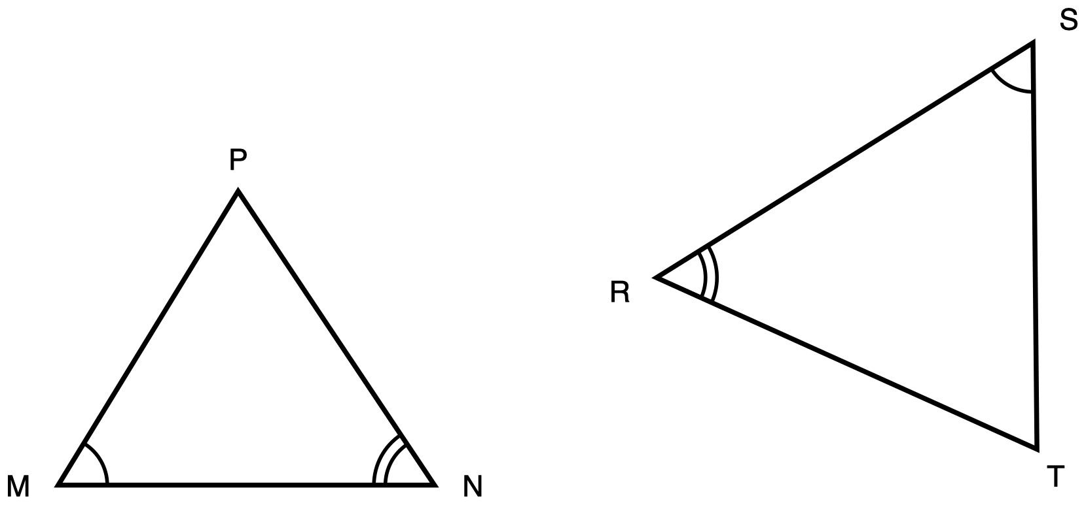
Figure 1. Triangles MNP and SRT, drawn in different orientations.
Description: Triangle MNP sits on the left with side MN horizontal along the bottom and vertex P above it. Triangle SRT sits on the right, larger and turned so that no side of it is horizontal. Angle M and angle S each carry one arc. Angle N and angle R each carry two concentric arcs. No side length is given anywhere and nothing is marked as unknown.
Triangle MNP and triangle SRT are drawn in different orientations. Angle M and angle S each carry one arc, so those two angles are congruent. Angle N and angle R each carry two arcs, so those two are congruent as well.
(a) Write the similarity statement for these two triangles, with the vertices in corresponding order.
(b) Prove that the two triangles are similar. Name the criterion you used and say why it applies here.
(c) Name the side of triangle SRT that corresponds to MN.
Take your correspondence from the arcs, not from where the triangles sit on the page.
Record your work in whichever one of these you prefer:
- an annotated diagram, with the correspondence and the reasons written on the figure
- a paragraph
- a two-column statement and reason chain
- a flowchart
- an oral walkthrough at the figure, which I will write down word for word as you give it
✋
Turning one triangle to face the same way as the other is a good first move.

Tools for this item: A calculator is allowed and there is nothing here to compute: this item contains no numbers. No ruler and no protractor. No card printing the similarity criteria. No formula sheet or identity card of any kind. No special-triangle reference card. Yours on this item: blank paper, a straightedge, tracing paper and scissors, the straightedge as a drawing edge and never laid along the printed figure.

Item 2 · A triangle cut by a segment
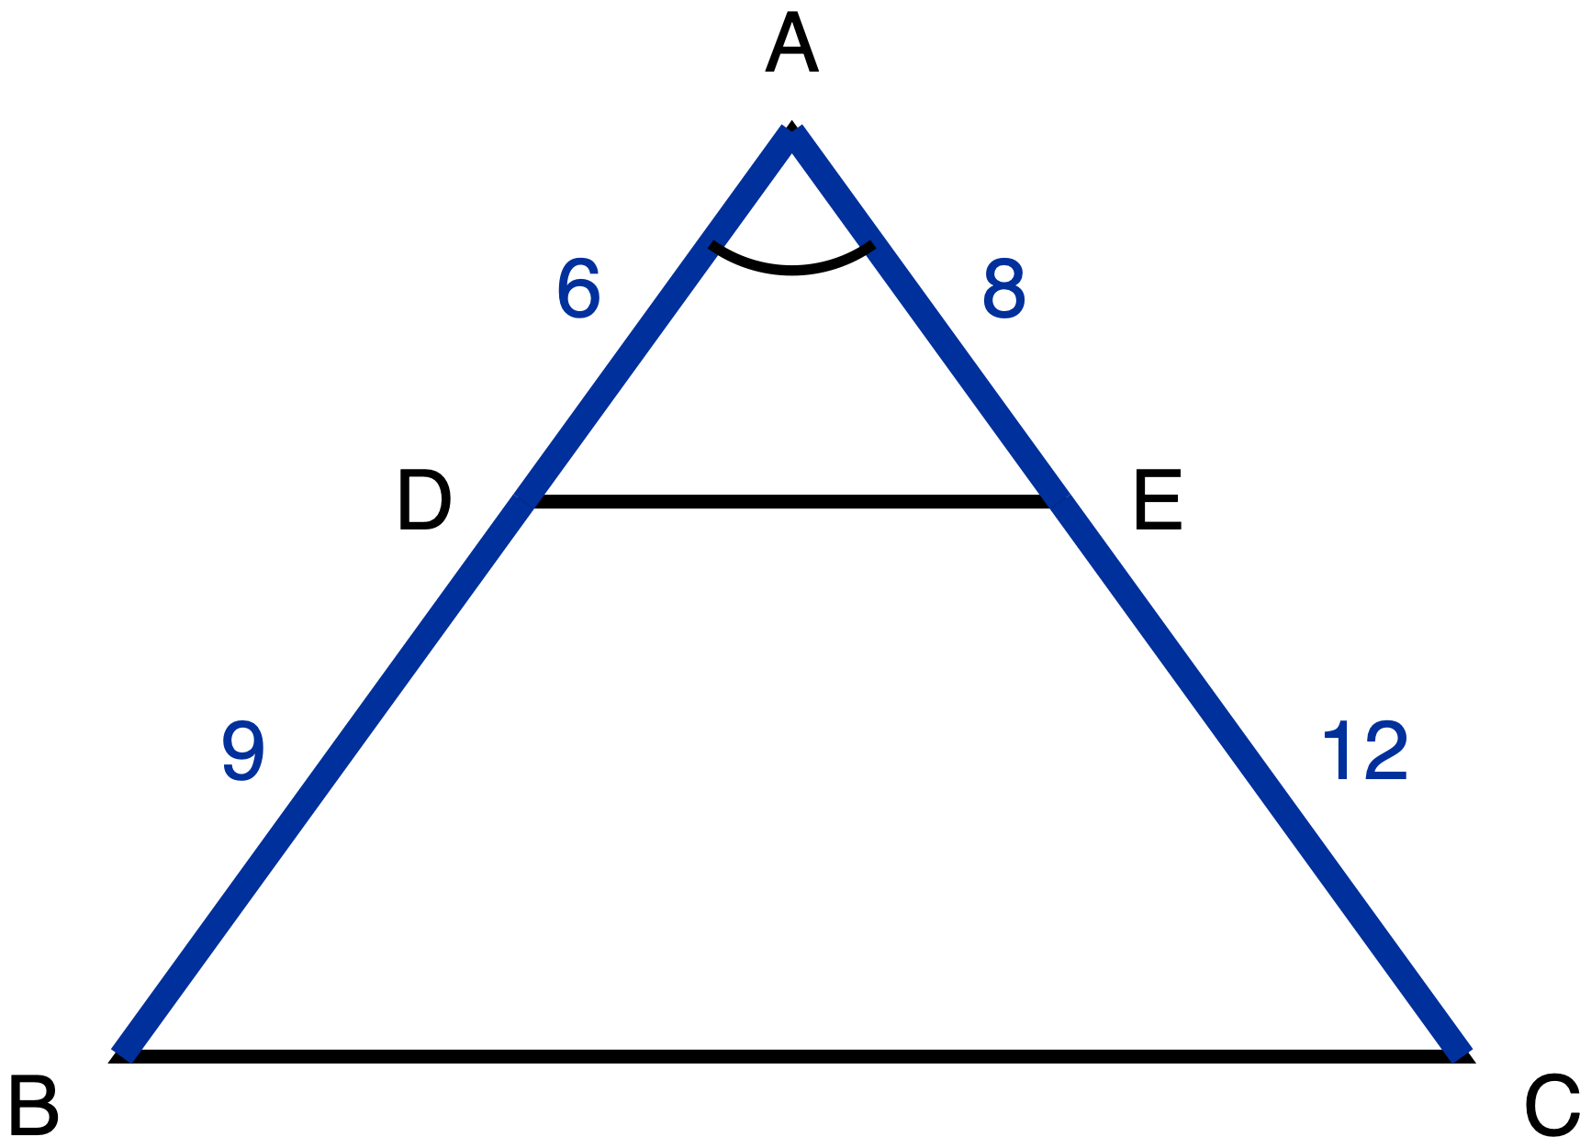
Figure 2. Triangle ABC with D on AB, E on AC, and the segment DE drawn.
Description: Triangle ABC has vertex A at the top and side BC horizontal along the bottom. D lies on AB and E lies on AC, and the segment DE is drawn across the triangle. AD is 6 and DB is 9 on the left side; AE is 8 and EC is 12 on the right side. All four of those part-lengths are given measures. Angle A carries one arc. Nothing is marked as unknown.
In triangle ABC, D lies on AB and E lies on AC, and the segment DE is drawn. AD = 6, DB = 9, AE = 8 and EC = 12.
(a) Prove that triangle ADE is similar to triangle ABC. Name the criterion you used and say why it applies here.
(b) Write the ratio DE : BC in simplest form.
✋
Nothing on the figure says that DE is parallel to BC. If your argument needs that, it is something for you to establish, not something you are given.

Same five ways of recording your work as Item 1.
Tools for this item: A four-function calculator is allowed for the two divisions. No ruler. No card printing the similarity criteria. No formula sheet or identity card of any kind. No special-triangle reference card. Yours on this item: blank paper, a straightedge, tracing paper and scissors, the straightedge as a drawing edge and never laid along the printed figure.

Item 3 · Two triangles, one upside down
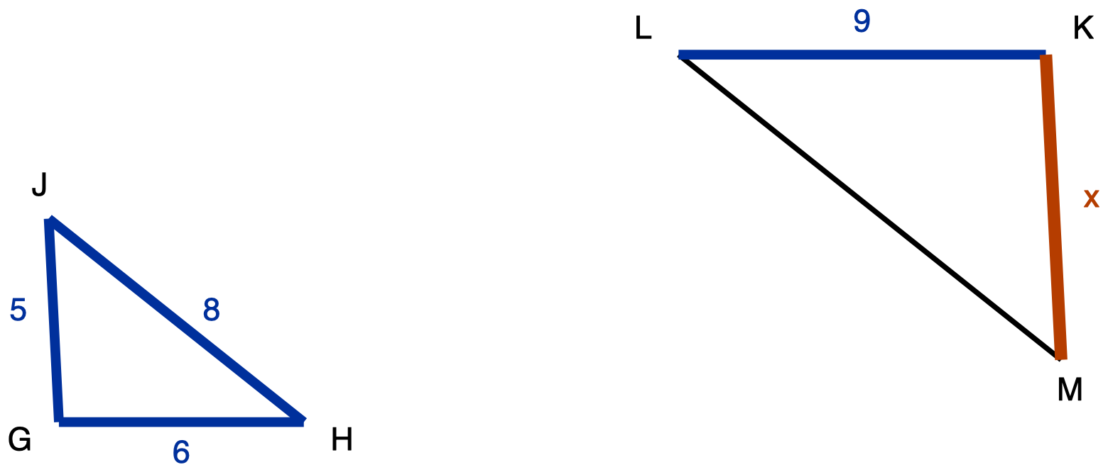
Figure 3. Triangle GHJ and the larger triangle KLM, drawn upside down relative to it.
Description: Triangle GHJ is on the left with side GH horizontal along the bottom and vertex J above it. Its three sides are given: GH is 6, HJ is 8 and GJ is 5. Triangle KLM is on the right, larger and turned upside down, so KL runs along its top rather than its bottom. KL is given as 9. LM is drawn plain and carries no numeral. KM is the unknown and is labelled x.
Triangle GHJ is similar to triangle KLM. In triangle GHJ, GH = 6, HJ = 8 and GJ = 5. In triangle KLM, KL = 9. Triangle KLM is drawn upside down relative to triangle GHJ.
What is the length of KM, marked x on the figure? Choose one.
- A. 6.75
- B. 7.5
- C. 8
- D. 10.8
Write the letter, circle it, point at it, or say it to me.
Tools for this item: A four-function calculator is allowed. No ruler. No formula sheet or identity card of any kind. No special-triangle reference card. Blank paper and a straightedge are yours as drawing materials, the straightedge never laid along the printed figure.

Item 4 · Sides given out of order
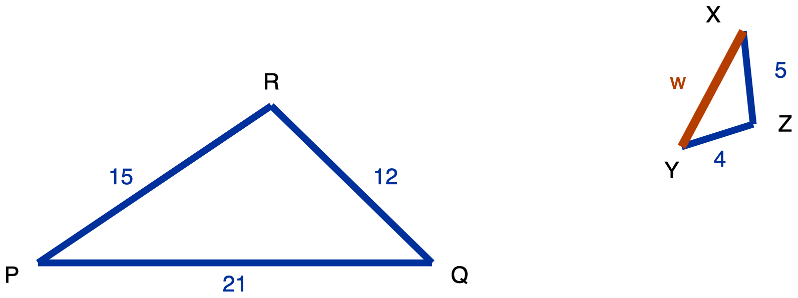
Figure 4. Triangle PQR and the smaller triangle XYZ.
Description: Triangle PQR is on the left with PQ horizontal along the bottom and R above it. PQ is 21, QR is 12 and PR is 15, all given. Triangle XYZ is on the right, much smaller and rotated so that none of its sides is horizontal. YZ is 4 and XZ is 5, both given. XY is the unknown and is labelled w. No angle is marked in either triangle.
Triangle PQR and triangle XYZ are similar. In triangle PQR, PQ = 21, QR = 12 and PR = 15. In triangle XYZ, YZ = 4 and XZ = 5.
(a) Write the similarity statement for these two triangles, with the vertices in corresponding order.
(b) Find XY, marked w on the figure.
The side lengths of the second triangle are not listed in the order that matches the first. Work out which side goes with which before you write any ratio. Ask me for a blank three-row table to write your pairs into if you would like one.
Tools for this item: A four-function calculator is allowed. No ruler. No formula sheet or identity card of any kind. No special-triangle reference card. Blank paper and a straightedge are yours as drawing materials, the straightedge never laid along the printed figure.

Item 5 · The flagpole
There is no figure for this item, and there will not be one. Drawing the situation is part of what is being assessed.
A flagpole standing on level ground casts a shadow 14 m long. At the same moment, a vertical post 1.8 m tall casts a shadow 2.4 m long. The sun's rays reach the flagpole and the post from the same direction, so the two right triangles formed by the object, its shadow and the ray are similar.
Draw both triangles. Write every measurement onto the triangle it belongs to. Then find the height of the flagpole.
Use as much space and as much paper as you want. If writing is the slow part for you, do your drawing yourself and then tell me the equation and the answer, and I will write those down.
Tools for this item: A four-function calculator is allowed. No diagram is supplied for this item, and none will be. No formula sheet or identity card of any kind. I can read the instructions to you, and I cannot read the situation to you. No special-triangle reference card. Blank paper, a straightedge, tracing paper and scissors are yours; there is no printed figure here, so the straightedge is purely a drawing edge.

Item 6 · The survey
No figure for this item either, for the same reason.
From a point S on level ground, the distance to a tree T is 40 m and the distance to a rock R is 25 m. A stake A is driven into the ground on the straight line from S to T, 16 m from S. A second stake B is driven on the straight line from S to R, 10 m from S.
(a) Draw the situation and label it.
(b) Decide whether triangle SAB is similar to triangle STR. Name the criterion you used.
(c) The tree and the rock are 52 m apart. How far apart are the two stakes?
Tools for this item: A four-function calculator is allowed. No diagram is supplied. No formula sheet or identity card of any kind. I can read the instructions to you and not the situation. No special-triangle reference card. Blank paper, a straightedge, tracing paper and scissors are yours; there is no printed figure here, so the straightedge is purely a drawing edge.

Item 7 · A line parallel to one side
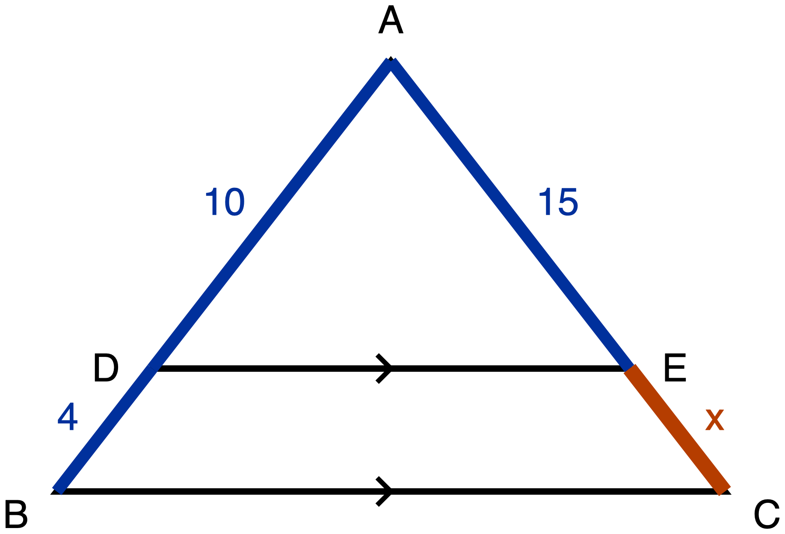
Figure 5. Triangle ABC with DE marked parallel to BC.
Description: Triangle ABC has vertex A at the top and BC horizontal along the bottom. D lies on AB and E lies on AC, and DE is drawn across the triangle. A single chevron sits on DE and a single chevron sits on BC, marking those two segments parallel. AD is 10, DB is 4 and AE is 15, all given. EC is the unknown and is labelled x.
In triangle ABC, D lies on AB and E lies on AC. The single chevron on DE and the single chevron on BC mark those two segments parallel. AD = 10, DB = 4 and AE = 15.
(a) Name the theorem that lets you find EC here, and say why it applies to this figure.
(b) Find EC, marked x on the figure.
(c) Write down the proportion you used, and say in one sentence why it is a proportion of ratios and not of differences.
✋
A number on its own is not an answer to this item. Part (a) and part (c) are what is being measured, and part (b) is how you show it working.

Answer in writing, by writing onto the figure, or out loud to me.
Tools for this item: A four-function calculator is allowed. No ruler. No card printing the Triangle Proportionality Theorem. No formula sheet or identity card of any kind. No special-triangle reference card. Blank paper and a straightedge are yours as drawing materials, the straightedge never laid along the printed figure.

Item 8 · Is it parallel?
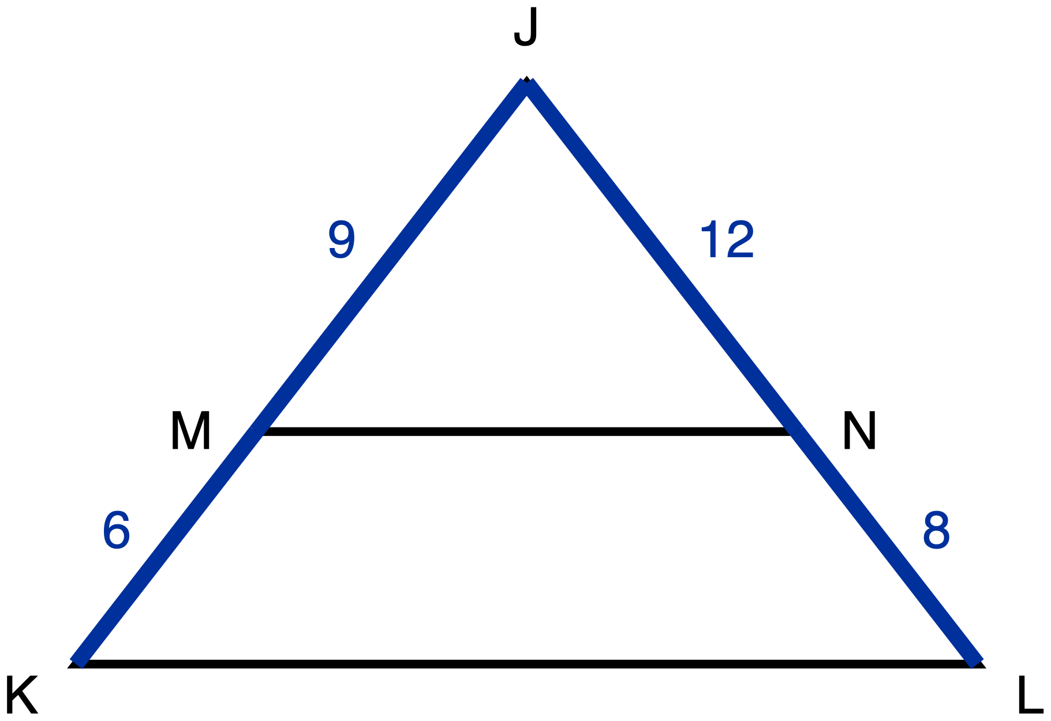
Figure 6. Triangle JKL with MN drawn across it.
Description: Triangle JKL has vertex J at the top and KL horizontal along the bottom. M lies on JK and N lies on JL, and MN is drawn across the triangle. JM is 9, MK is 6, JN is 12 and NL is 8, all given. There is no chevron on MN and no chevron on KL, so nothing in the figure asserts that the two segments are parallel. Nothing is marked as unknown.
In triangle JKL, M lies on JK and N lies on JL, and the segment MN is drawn. JM = 9, MK = 6, JN = 12 and NL = 8.
(a) Decide whether MN is parallel to KL.
(b) Justify your decision: name the theorem you used and show the computation it rests on.
✋
Nothing on this figure is marked parallel. That is the question, not a given.

Answer in writing, by writing onto the figure, or out loud to me.
Tools for this item: A four-function calculator is allowed. No ruler, no protractor and no straightedge. No part heading, no cover page and no earlier item issues you a tool that this item has not. No formula sheet or identity card of any kind. No special-triangle reference card. Blank paper, tracing paper and scissors are yours.

Item 9 · The three triangles in one figure
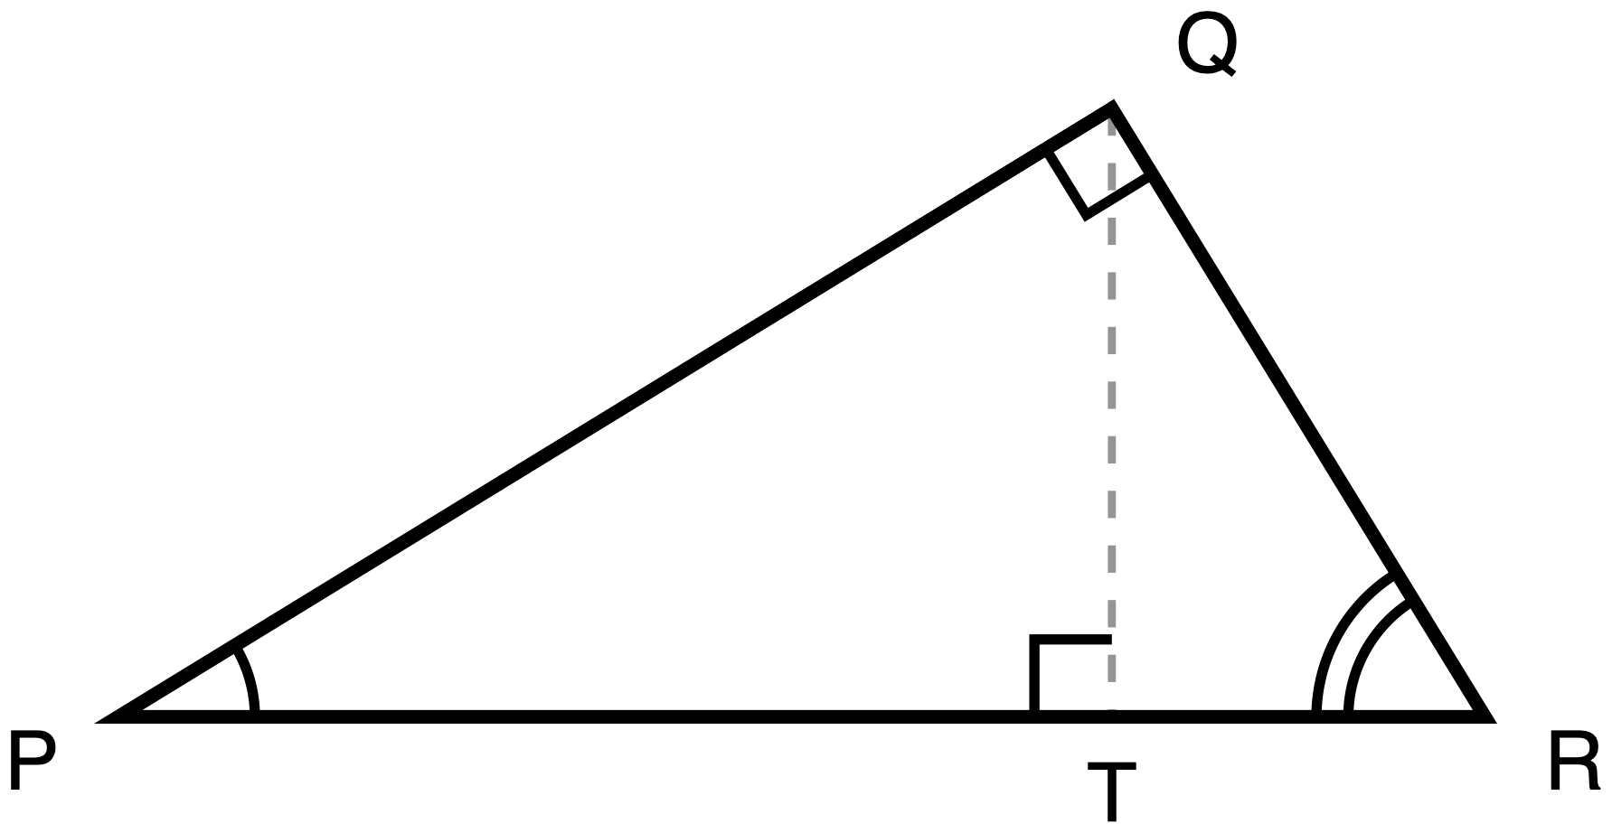
Figure 7. Right triangle PQR with the altitude QT to the hypotenuse PR.
Description: Right triangle PQR has its right angle at Q and its hypotenuse PR lying horizontally along the bottom, P on the left and R on the right. Q sits above PR, nearer to R than to P. The altitude QT is drawn as a dashed construction line from Q down to the point T on PR. A right-angle square marks the angle at Q and another marks the angle at T. Angle P carries one arc and angle R carries two arcs. No length is given.
Right triangle PQR has its right angle at Q. QT is the altitude from Q to the hypotenuse PR, so QT meets PR at a right angle.
✋
Everything in this item comes from the three similar triangles that the altitude creates. That route is what is being measured.

(a) Name the three triangles in this figure that are similar to one another.
(b) Write two similarity statements, each one comparing a small triangle to the whole triangle PQR, with the vertices in corresponding order.
(c) From one of your statements in (b), write a proportion which, when you cross-multiply it, gives PQ². Say which statement you used.
Answer in writing, by writing onto your own separated triangles, or out loud to me.
✋
Taking this figure apart is a sensible first move. Tracing paper, scissors, blank triangle outlines and a second clean copy of the figure are on the front desk for anybody who wants them.

Tools for this item: A calculator is allowed and there is nothing to compute: this item contains no numbers. Tracing paper, scissors, a second clean copy of the figure and a blank triangle-outline sheet are all yours, and I will offer them to everybody. What is not allowed is a set of triangles that has already been separated and lettered for you, a printed list of the relationships between the legs and the hypotenuse segments, or a part-completed proof. No formula sheet or identity card of any kind. No special-triangle reference card. Blank paper and a straightedge are yours as drawing materials, the straightedge never laid along the printed figure.

Item 10 · Pythagoras, from the similar triangles
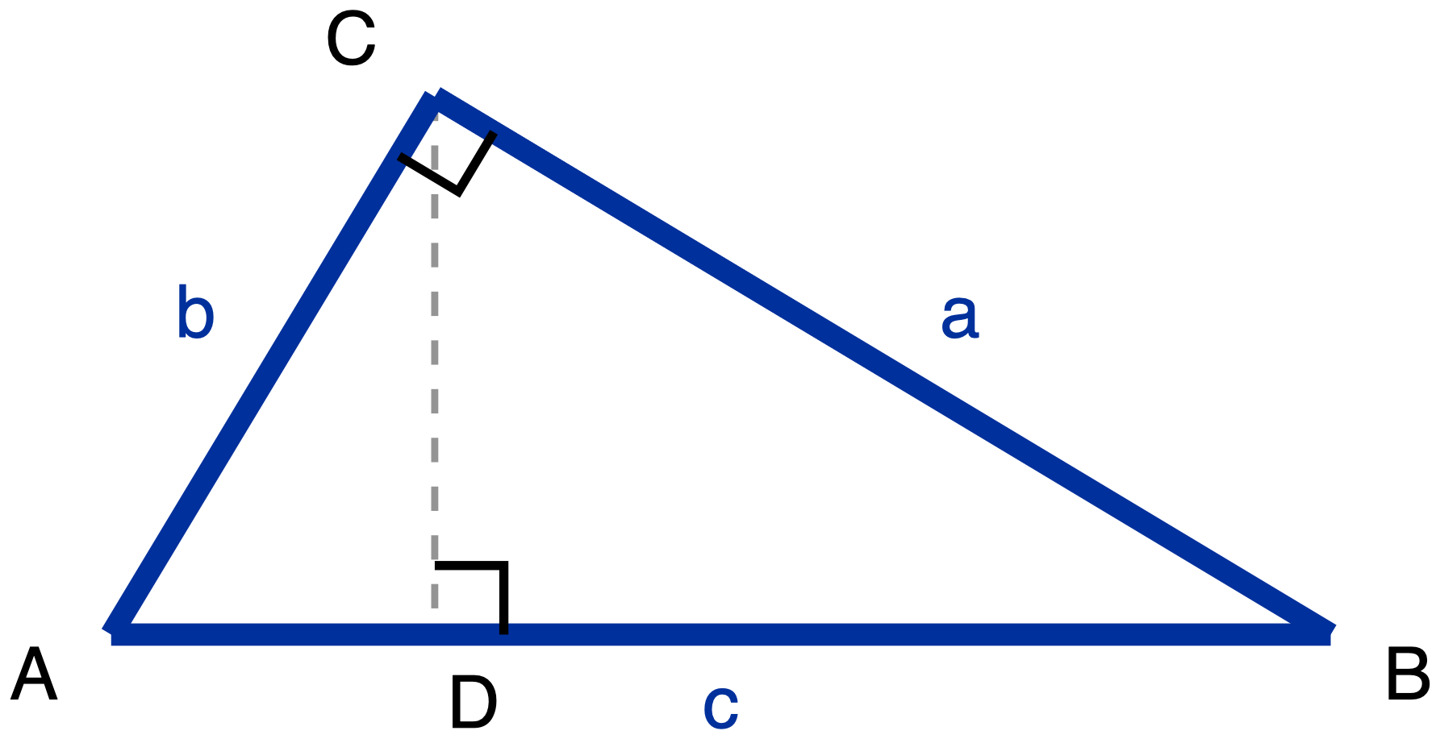
Figure 8. Right triangle ABC with legs a and b, hypotenuse c, and the altitude CD.
Description: Right triangle ABC has its right angle at C and its hypotenuse AB lying horizontally along the bottom, A on the left and B on the right. C sits above AB, nearer to A than to B. The three sides carry letters rather than numbers: BC is a, AC is b and AB is c. The altitude CD is drawn as a dashed construction line from C down to the point D on AB. A right-angle square marks the angle at C and another marks the angle at D.
Right triangle ABC has its right angle at C. CD is the altitude from C to the hypotenuse AB. Let BC = a, AC = b and AB = c.
Using the three similar triangles formed by the altitude to the hypotenuse, and no other method, prove that a² + b² = c². Your proof has to say why each pair of triangles is similar, not just that it is.
Two things about that instruction, said plainly here:
- This unit is asking for the similarity route specifically. A proof that cuts the squares up and rearranges the pieces is a real proof of the same theorem, and it is not an answer to this item. If that is the proof you know, write it on the back of the page, and then do this one.
- Your Part A answer to Item 9 stays on the desk and you may look back at it. Item 9 gives you two similarity statements. It does not give you the reasons, and the reasons are what this item is asking for.
Present it in whichever of the five forms from Item 1 you want.
Tools for this item: Same as Item 9: a calculator is allowed and there is nothing to compute; tracing paper, scissors, blank outlines and a second copy of the figure are yours; a pre-separated lettered set, a printed list of the altitude relationships, a part-completed proof and a card printing a² + b² = c² are all not allowed. No formula sheet or identity card of any kind. No special-triangle reference card. Blank paper and a straightedge are yours as drawing materials, the straightedge never laid along the printed figure.

Item 11 · Two triangles, one angle
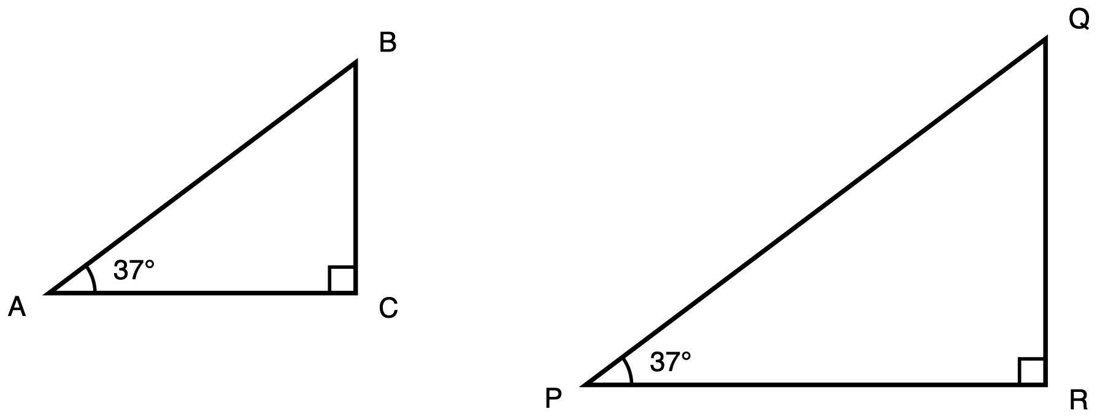
Figure 9. Two right triangles, each carrying a 37° angle.
Description: Two separate right triangles stand side by side, the right-hand one visibly larger. Triangle ABC has its right angle at C and a 37 degree angle at A, marked with one arc. Triangle PQR has its right angle at R and a 37 degree angle at P, marked with one arc as well. No side length is given in either triangle and nothing is marked as unknown.
Triangle ABC has its right angle at C and a 37° angle at A. Triangle PQR has its right angle at R and a 37° angle at P. Triangle PQR is visibly larger. No side length is given in either triangle.
Explain why sin 37° has the same value in triangle ABC as it has in triangle PQR. Your explanation has to run through similarity, and you are not asked to compute any ratio.
No numbers appear in this item other than the two 37s printed on the figure.
Answer in writing, by annotating a second copy of the figure, or out loud to me.
Tools for this item: A four-function calculator is allowed and there is nothing for it to do. No sin, cos or tan key on any calculator. No printed table of sine, cosine or tangent values. No ruler. No formula sheet or identity card of any kind. No special-triangle reference card. Blank paper and a straightedge are yours as drawing materials, the straightedge never laid along the printed figure.

Item 12 · Dana and Priya
No figure for this item, because there is no particular triangle in it.
Dana says: if you multiply every side of a right triangle by 3, you multiply the sine of each of its acute angles by 3.
Priya says: the sine of each acute angle does not change at all.
(a) Who is right?
(b) Give the reason, using similarity.
(c) Name one quantity in that triangle that does get multiplied by 3, and one that does not change.
✋
Part (c) is not a bonus. Saying what changes, in the same answer as what does not, is the point of the item.

Answer in writing, in a two-column "changes / does not change" table with your reason written underneath it, or out loud to me. Ask if you want the blank table.
Tools for this item: A four-function calculator is allowed and there is nothing for it to do. No sin, cos or tan key and no printed value table. Blank paper and a straightedge are yours if you would like to draw a triangle to think with. No formula sheet or identity card of any kind. No special-triangle reference card.

Item 13 · The same triangle, from each of its acute angles
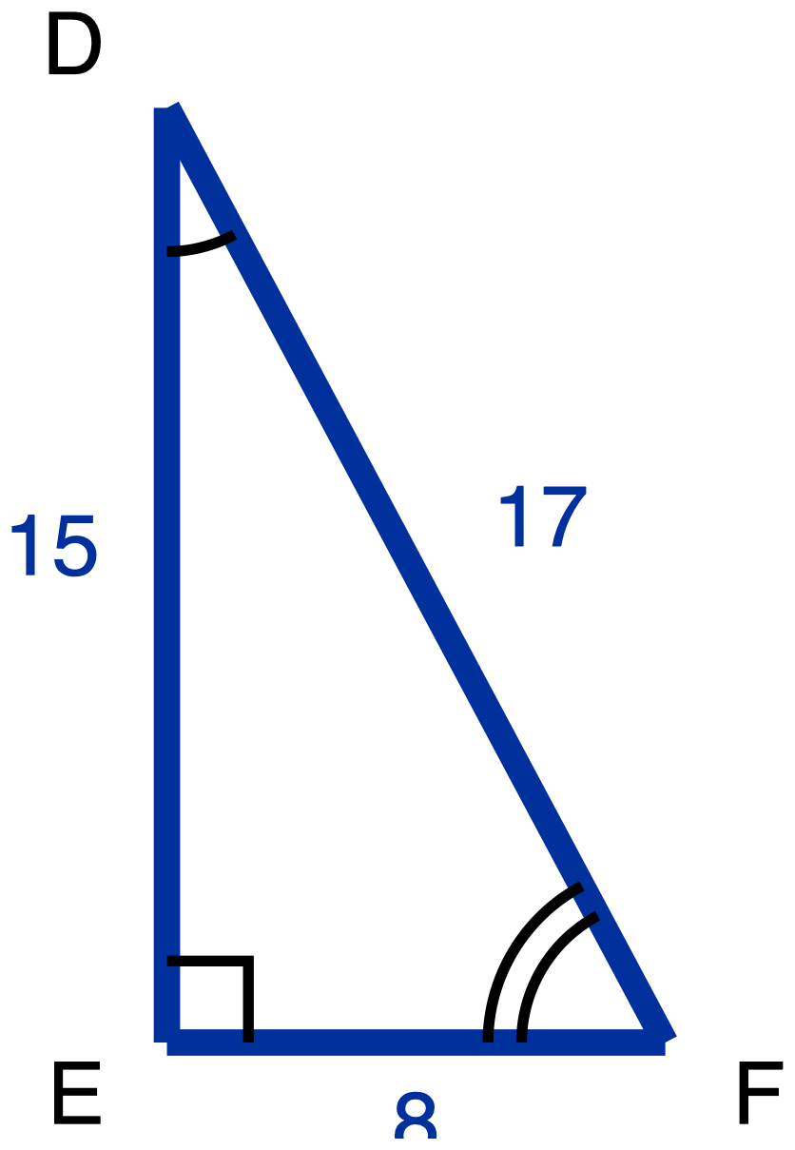
Figure 10. Right triangle DEF with sides 15, 8 and 17.
Description: Right triangle DEF has its right angle at E. DE is the vertical leg on the left and is given as 15. EF is the horizontal leg along the bottom and is given as 8. DF is the hypotenuse, running from the top down to the right, and is given as 17. Angle D carries one arc and angle F carries two arcs. Nothing is marked as unknown.
Right triangle DEF has its right angle at E, with DE = 15, EF = 8 and DF = 17.
(a) Relative to angle D, name the opposite leg, the adjacent leg and the hypotenuse. Then write tan D as a fraction.
(b) Do the same relative to angle F: name the opposite leg, the adjacent leg and the hypotenuse, then write tan F as a fraction.
(c) In one sentence, say why two of those three names change between (a) and (b) and one of them does not.
Answer in writing, by writing the names onto your own copies of the figure, or out loud to me.
Tools for this item: A four-function calculator is allowed, though both answers are fractions. No copy of this triangle with the legs already labelled "opposite" and "adjacent" for either angle. No printed table of sine, cosine or tangent values, and no definition card. Tracing paper you may turn is yours. No formula sheet or identity card of any kind. No special-triangle reference card. Blank paper and a straightedge are yours as drawing materials, the straightedge never laid along the printed figure.

Item 14 · Half a square
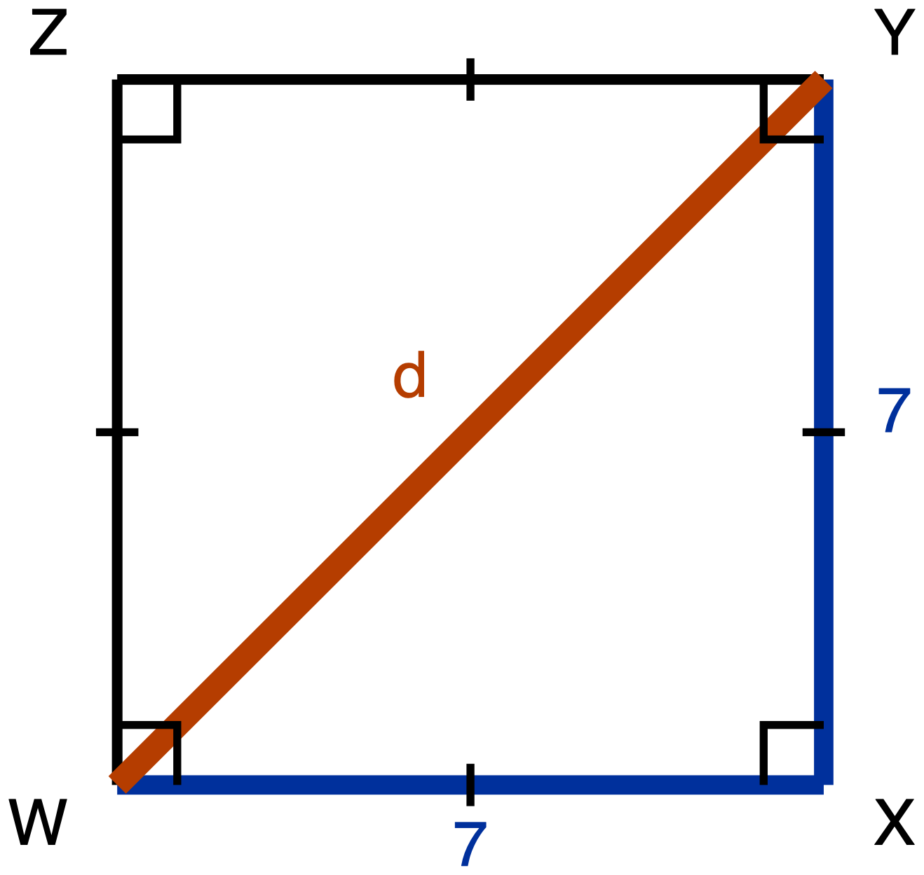
Figure 11. Square WXYZ with the diagonal WY drawn.
Description: Square WXYZ is drawn with its sides vertical and horizontal. W is the bottom left corner, X the bottom right, Y the top right and Z the top left. The diagonal WY runs from the bottom left corner up to the top right corner and is the unknown, labelled d. WX and XY are given measures, each 7. A right-angle square sits at each of the four corners and a single tick sits on each of the four sides, marking them congruent.
Square WXYZ has side length 7, and its diagonal WY is drawn.
(a) Derive the three angle measures and the three side lengths of triangle WXY. Give the side lengths in exact form, which means a radical where one is needed and not a decimal approximation.
(b) Write the ratio WX : XY : WY in simplest form.
✋
The route this item requires is the square's own properties and the Pythagorean Theorem. Your argument has to say what the square tells you about angle WXY and about the lengths WX and XY, and it has to use the Pythagorean Theorem to reach WY. Writing down "45-45-90, so 1 : 1 : √2" from memory is not an answer to this item.

Same five ways of recording your derivation as Item 1.
✋
Redrawing triangle WXY on its own, away from the square, is a good first move.

Tools for this item: No calculator. No special-triangle reference card. No formula sheet or identity card of any kind. Straightedge, blank paper, tracing paper and scissors are yours.

Item 15 · Half an equilateral triangle
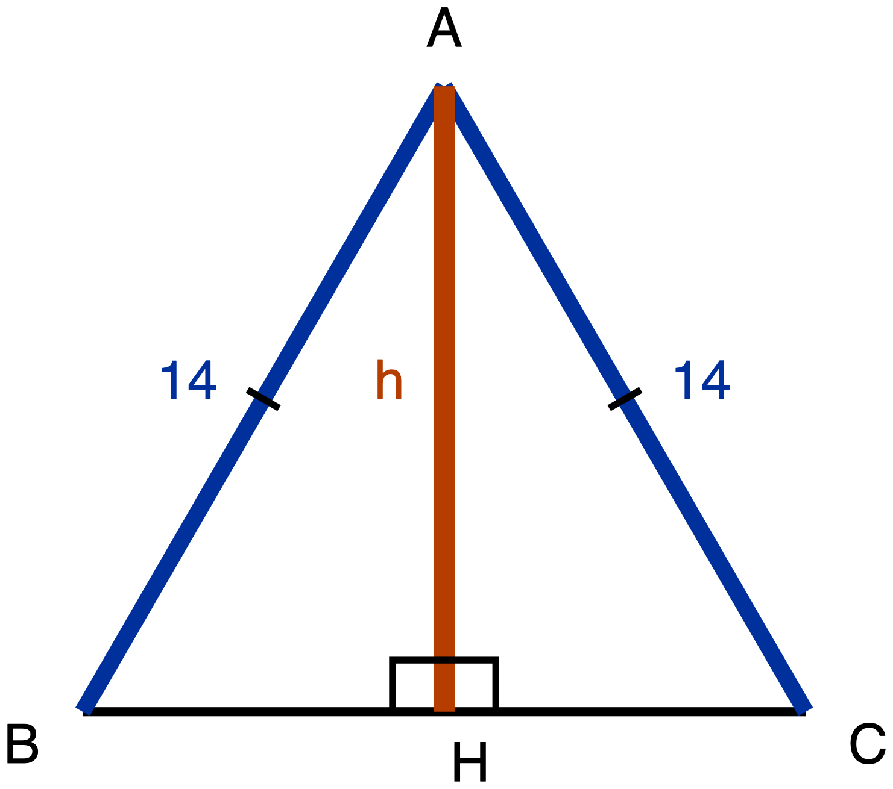
Figure 12. Equilateral triangle ABC with the segment AH drawn to BC.
Description: Equilateral triangle ABC is drawn point up, with BC horizontal along the bottom, B on the left and C on the right. A segment runs from the apex A straight down to the point H on BC. AB and AC are given measures, each 14, and each carries a single tick marking them congruent. BC is drawn plain and carries no numeral and no tick, and neither BH nor HC carries a tick, so nothing in the figure states where H sits along BC. AH is the unknown and is labelled h. Two right-angle squares sit at H, one on each side of AH.
Equilateral triangle ABC has side length 14. The segment AH runs from A to the point H on BC, and it meets BC at a right angle.
(a) Derive the three angle measures and the three side lengths of triangle ABH. Give the side lengths in exact form.
(b) Write the ratio BH : AH : AB in simplest form.
(c) In your simplified ratio, one of the two larger numbers is the hypotenuse's. Say which one, and state in one sentence how you know, without using a calculator.
✋
The route this item requires is the equilateral triangle's own altitude. Before any arithmetic, your argument has to answer both of these: what does AH do to angle A, and what does AH do to side BC? Nothing on the figure tells you where H sits along BC. That is something to establish, not something given. Then use the Pythagorean Theorem to reach AH.

Same five ways of recording your derivation as Item 1. Part (c) may be a sentence, a written comparison of the two numbers, or said aloud to me.
Tools for this item: No calculator. No special-triangle reference card. No formula sheet or identity card of any kind. Straightedge, blank paper, tracing paper and scissors are yours.
✋
Collect Part A before Part B is handed out.

The instrument · Part B, items 16 to 23

Using the ratios, and building the triangle yourself. Eight items. Each one states its own tools.
✋
Issue the special-triangle reference card with Part B, and say at handout that it will be collected at the end of Part B.

Item 16 · A 30-60-90 triangle
A 30-60-90 triangle has hypotenuse 24.
Which pair gives its shorter leg and its longer leg, both in exact form? Exact form means a radical where one is needed, not a decimal approximation. Choose one.
- A. shorter leg 12, longer leg 12√3
- B. shorter leg 12√3, longer leg 12
- C. shorter leg 12, longer leg 12√2
- D. shorter leg 12, longer leg 20.78
Write the letter, circle it, point at it, or say it to me.
Tools for this item: The special-triangle reference card is allowed on this item, and is issued for it. No calculator. No formula sheet or identity card of any kind.

Item 17 · Both directions
(a) A 45-45-90 triangle has hypotenuse 20. Give the length of each leg in exact form.
(b) A 45-45-90 triangle has legs of length 13. Give its hypotenuse in exact form.
Write your answers, write them onto a blank triangle outline if you would rather (ask and I will give you one), or say them to me and I will write them down.
Tools for this item: The special-triangle reference card is allowed on this item, and is issued for it. No calculator. No formula sheet or identity card of any kind. The card gives you the ratio; deciding which direction to run it in each part is yours.

Item 18 · Find the leg
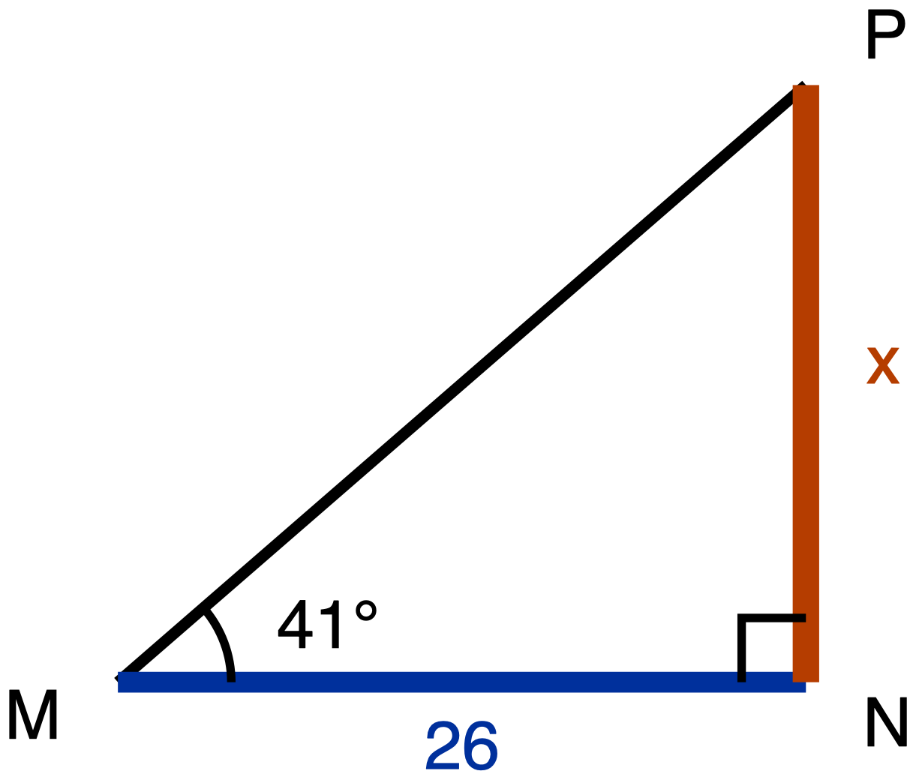
Figure 13. Right triangle MNP with a 41° angle at M.
Description: Right triangle MNP has its right angle at N. MN is the horizontal leg along the bottom, M on the left, and is a given measure of 26. NP is the vertical leg on the right, running upward from N, and is the unknown, labelled x. MP is the hypotenuse. The angle at M carries one arc and is labelled 41 degrees. Nothing else is given.
Right triangle MNP has its right angle at N. The angle at M is 41°, and MN = 26.
Find NP, marked x on the figure, to the nearest tenth.
Write the equation you used as well as the answer.
Tools for this item: A scientific calculator with sine, cosine and tangent is allowed and you will need one. A printed table of tangent values is equally allowed if you would rather use one, and it will get you to the same place. The special-triangle reference card is allowed on this item and has nothing to offer here: 41° is not a special angle. No copy of this triangle with the legs already labelled "opposite" and "adjacent". No formula sheet or identity card of any kind.

Item 19 · Two legs, two tangents
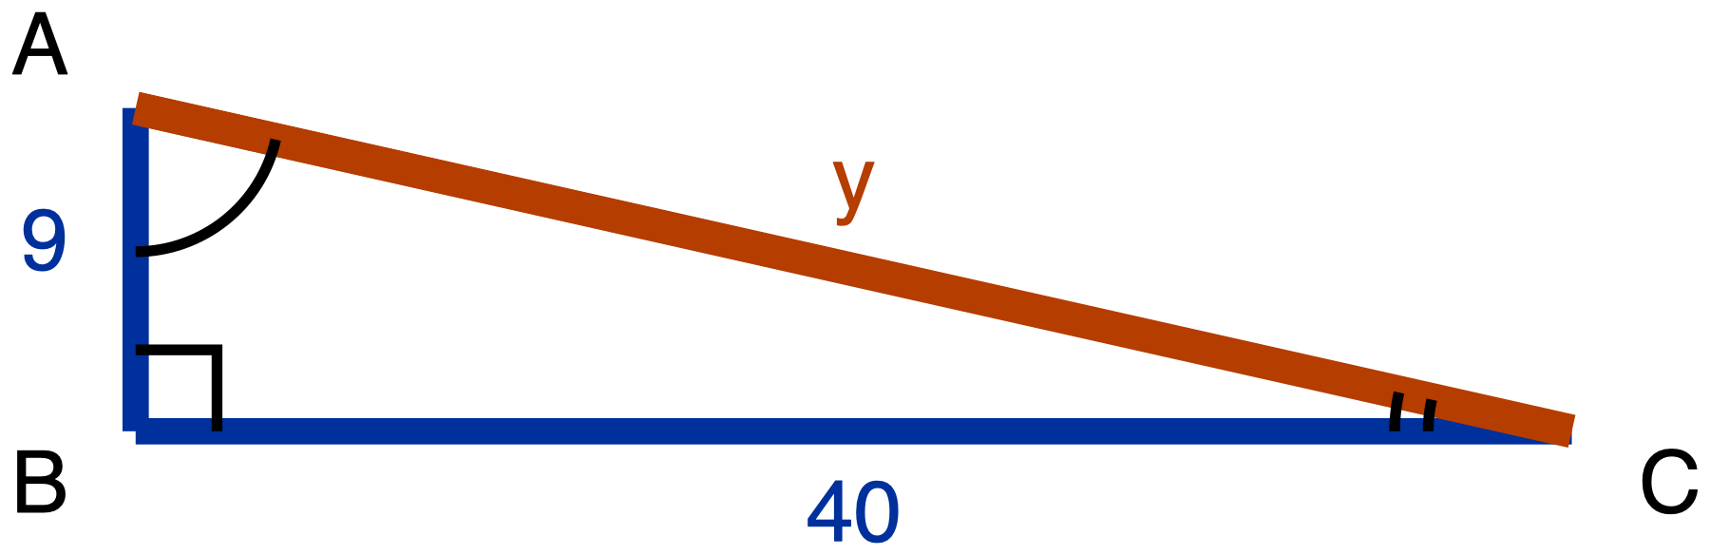
Figure 14. Right triangle ABC with legs 9 and 40.
Description: Right triangle ABC has its right angle at B. AB is the short vertical leg on the left and is a given measure of 9. BC is the long horizontal leg along the bottom and is a given measure of 40. AC runs from the top of the short leg down to the far end of the long leg; it is the unknown and is labelled y. Angle A carries one arc and angle C carries two arcs.
Right triangle ABC has its right angle at B, with AB = 9 and BC = 40.
(a) Find AC, marked y on the figure.
(b) Write tan A and tan C, each as a fraction in lowest terms.
Tools for this item: A four-function or scientific calculator is allowed for the square root. The sine, cosine and tangent keys are allowed and have nothing to do here: no angle measure appears anywhere in this item. The special-triangle reference card is allowed on this item and does not apply: this is not a special triangle. No copy of this triangle with the legs already labelled for either angle. No formula sheet or identity card of any kind.

Item 20 · The swimmer
No figure for this item, and there will not be one. Drawing the situation is part of what is being assessed.
A lifeguard stands at the edge of a cliff, 68 m above the water, and sights a swimmer out to sea. The angle of depression of her line of sight is 22°.
(a) Draw the situation. Your drawing must show the horizontal line that the angle of depression is measured from.
(b) Find the horizontal distance from the foot of the cliff to the swimmer, to the nearest metre.
(c) There is an angle at the swimmer's position that also measures 22°. Name it, and say why it must be equal to the angle of depression.
Tools for this item: A scientific calculator or a printed tangent table is allowed and you will need one of them. The special-triangle reference card is allowed on this item and has nothing to offer: 22° is not a special angle. No diagram is supplied for this item, and none will be. No poster, worked example or display showing where an angle of depression sits. No formula sheet or identity card of any kind. I can read the instructions to you, and I cannot read the situation to you.

Item 21 · The radio mast
No figure for this item either, for the same reason.
Malik is 1.75 m tall and his eyes are 1.6 m above the ground. Standing on level ground, 85 m from the foot of a radio mast, he measures the angle of elevation to the top of the mast as 34°.
Find the height of the mast, to the nearest tenth of a metre.
✋
Your drawing must show Malik as a vertical segment from the ground up to his eyes, with the triangle sitting on top of it.

Tools for this item: A scientific calculator or a printed tangent table is allowed and you will need one. No diagram is supplied. The special-triangle reference card is allowed on this item and has nothing to offer: 34° is not a special angle. No card, prompt or display about what to do with the observer's height. No formula sheet or identity card of any kind. Instructions read aloud yes, situation read aloud no, same as Item 20.

Item 22 · The flagpole, from the same spot
No figure, same reason.
Without moving, Malik turns and sights the top of a flagpole 46 m away. The angle of elevation of his line of sight to the top of the flagpole is 28°.
(a) How much higher than Malik's eyes is the top of the flagpole? Give your answer to the nearest tenth of a metre.
(b) Does his eye height of 1.6 m matter for the quantity part (a) asked you for? Answer yes or no, and give the reason from your own drawing.
Tools for this item: As Item 21: a scientific calculator or a tangent table, no supplied diagram, no card or prompt about the observer's height, no formula sheet or identity card of any kind, instructions read aloud but not the situation. The special-triangle reference card is allowed on this item and has nothing to offer: 28° is not a special angle.

Item 23 · The drone
No figure, same reason.
A drone hovers 120 m directly above a marker on level ground. From the drone, the angle of depression to a gate on the same ground is 39°.
(a) Draw the situation, showing the horizontal that the angle is measured from.
(b) Find the distance along the ground from the marker to the gate, to the nearest metre.
(c) Find the straight-line distance from the drone to the gate, to the nearest metre. Say which of the two methods available to you you used, and say why the Pythagorean Theorem is available to you here.
✋
Part (c) can be done without part (b). If your part (b) went wrong, part (c) is still worth doing, and it will be marked on its own.

Tools for this item: As Item 20: a scientific calculator or a tangent table, no supplied diagram, no poster or worked example showing the placement of an angle of depression, no formula sheet or identity card of any kind, instructions read aloud but not the situation. The special-triangle reference card is allowed on this item and has nothing to offer: 39° is not a special angle.
✋
Collect Part B and every reference card, by hand and counted, before Part C is handed out.

The instrument · Part C, items 24 to 28

Sine, cosine, and complements. Five items. Each one states its own tools.

Item 24 · Which side does the work
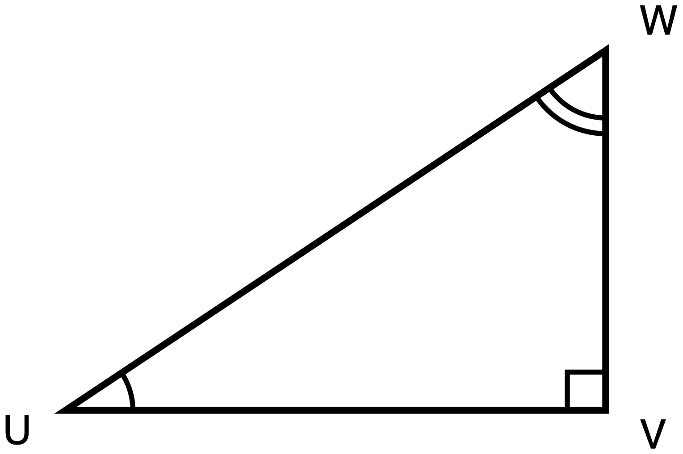
Figure 15. Right triangle UVW.
Description: Right triangle UVW has its right angle at V. UV is the horizontal leg along the bottom, with U on the left. VW is the vertical leg on the right, running upward from V. UW is the hypotenuse, running from the bottom left up to the top right. The angle at U carries one arc and the angle at W carries two arcs. No numeral appears anywhere in the figure and nothing is marked as unknown.
Right triangle UVW has its right angle at V.
(a) Name the one side of this triangle that is opposite angle U and is also adjacent to angle W. Then say in one sentence why a single side can play both of those roles.
(b) Use your answer to (a) to explain why sin U = cos W. Write each of them as a fraction of two named sides.
(c) Ravi says the answer to (b) is really that sin U = cos V, because V is the other angle named in the triangle. Give one reason Ravi's equation cannot be right.
Answer in writing, by annotating a second copy of the figure (ask and I will give you one), or out loud to me, and I will write it down word for word.
Tools for this item: A calculator is allowed and will not help you: there is not a single number in this item. No table of sine and cosine values. No formula sheet or identity card printing the relationship between sine and cosine. No special-triangle reference card.

Item 25 · Which equation is always true
In right triangle GHK, the right angle is at H.
Which one of these is true for every triangle of that kind? Choose one.
- A. sin G = cos H
- B. sin G = sin K
- C. sin G = cos K
- D. tan G = tan K
Write the letter, circle it, point at it, or say it to me. If it helps, ask me for a blank right-triangle outline with G, H and K already lettered on it.
Tools for this item: No calculator with sine, cosine or tangent keys. A four-function calculator is allowed and has nothing to do here. No table of sine and cosine values. No special-triangle reference card. No formula sheet or identity card printing the relationship between sine and cosine.

Item 26 · Solving for x
For some value of x, cos(7x + 4)° = sin(3x + 6)°, and both (7x + 4)° and (3x + 6)° are acute angles.
(a) Write one sentence saying how those two angle measures are related to each other. Then write the equation that sentence gives you.
(b) Solve your equation for x.
(c) Give both angle measures, and check that they really can be the two acute angles of one right triangle.
✋
Part (a) is required and is not a warm-up: the equation has to come from a stated fact about the two angles, not from a remembered template. You may dictate your sentence and your equation and I will write them down.

Tools for this item: A four-function or scientific calculator is allowed for the arithmetic. No graphing calculator and no equation solver. A table of sine and cosine values is not supplied and would show you nothing here, because x sits inside both angles. No formula sheet or identity card printing the relationship between sine and cosine. No special-triangle reference card.

Item 27 · Solving for w
Solve for w:
cos 24° = sin(w + 11°), where (w + 11)° is an acute angle.
Before you write any equation, write down in words the step where you use the relationship between sine and cosine. Then solve, and check that (w + 11)° really is acute.
Tools for this item: No calculator with sine, cosine or inverse keys. A four-function calculator is allowed. No table of sine and cosine values. No formula sheet or identity card printing the relationship between sine and cosine. No special-triangle reference card.

Item 28 · From one ratio to its partner
In right triangle ABC, the right angle is at C, and sin A = 20/29.
(a) Give the value of cos B, and say in one sentence how you know.
(b) Ravi says cos C is also 20/29. Give one reason he cannot be right.
✋
Do not compute a third side, and do not compute any ratio from any triangle. The route being measured in (a) is the relationship between an angle and its complement.

Answer in writing, out loud to me, or by writing the angle names and the value onto a blank lettered triangle outline with one phrase giving your reason. Ask if you want the outline.
Tools for this item: No calculator with sine, cosine or inverse keys. A four-function calculator is allowed and you will not need it. No table of sine and cosine values. No formula sheet or identity card printing the relationship between sine and cosine. No special-triangle reference card.

Answer key · Part A, items 1 to 15

Every wrong answer below is named, and every one is tied to the specific reasoning that produces it. The constructed-response items get the same treatment as the multiple-choice ones, under What you will see, and what it means, because a wrong answer you cannot name is a wrong answer you cannot give feedback on.

Item 1 · The same two triangles, turned
Key.
- (a) △MNP ~ △SRT. The one arc pairs M with S, the two arcs pair N with R, so P pairs with T.
- (b) AA similarity. Two pairs of angles are marked congruent, and two pairs of congruent angles are enough, because the third pair follows from the angle sum.
- (c) SR.
What you will see, and what it means.
What you see | What it is | What to do
△MNP ~ △RST | Correspondence read off the drawn position rather than off the arcs. Position is the louder signal, and until a student has been burned by a rotation, "the vertex on the left matches the vertex on the left" has worked on every diagram they have seen. | Ask which vertex of the second triangle carries one arc. The statement collapses on its own. Do not correct the letters for them.
(c) answered RT or ST | The same error, showing in the side pairing rather than in the vertex pairing. | Same move: go back to the arcs, then read the side off the corrected statement.
(b) answered "they look the same shape" | The conclusion asserted rather than argued. Not a criterion. | Ask which two facts about angles they are actually using. The name follows.
(b) answered SSS or SAS | A criterion named that the figure gives no data for: there is not a single length in this item. | Point at the figure and ask where the side lengths are.
A ruler or protractor in use | Not a wrong answer, a wrong route, and the item denies it in the student's own copy. | Remove the tool, note it on the paper, and let the student finish from the arcs.

Item 2 · A triangle cut by a segment
Key.
- (a) △ADE ~ △ABC, by SAS similarity. AD/AB = 6/15 = 2/5 and AE/AC = 8/20 = 2/5, so the two pairs of sides about angle A are in the same ratio, and angle A is the included angle in both triangles because it is common to them.
- (b) DE : BC = 2 : 5.
✋
A second correct route, accept it in full. AD/DB = 6/9 = 2/3 and AE/EC = 8/12 = 2/3, so by the converse of the Triangle Proportionality Theorem DE is parallel to BC; then the corresponding angles give AA similarity. This is a longer road to the same place and it is completely valid. Note which route the class reached for: it tells you whether Day 3 or Day 4 is the more available memory.

What you will see, and what it means.
What you see | What it is | What to do
AD/DB compared with AE/AC, or any proportion mixing a part with a whole | The commonest slip on this configuration, and it is an arithmetic-setup slip rather than a misconception. Labelled that way deliberately. | Ask what each of the four lengths measures. The mismatch shows itself.
"Not similar, because 15 − 6 = 9 and 20 − 8 = 12 are different" | Additive scaling surfacing in a new configuration: same difference rather than same ratio. | The Day 1 move, compressed: ask what happens to the two numbers if the whole figure is scaled again. Differences move, ratios do not.
(b) answered 2 : 3, or 6 : 15 unreduced | The part-to-part ratio given where the part-to-whole was asked for, or the right ratio left unsimplified. | The first needs the question re-read; the second is a form note, not a mathematical one. Say which it is.
(a) answered "AA, because DE is parallel to BC" with no argument for the parallelism | The parallelism assumed rather than established. The figure deliberately carries no chevron. | Ask what on the figure tells them the two segments are parallel. Nothing does. Then the SAS route or the converse route is the answer.
A ruler in use on DE and BC | Wrong route; denied in the student's own copy. | Remove it and note it.

Item 3 · Two triangles, one upside down
Key: B. 7.5
What each option means.
Option | What choosing it tells you
A. 6.75 | Correspondence read off the page: one entry of the proportion displaced by a position. The student writes 6/x = 8/9, pairing GH with KM and HJ with KL. Both pairings are wrong by one step around the triangle.
B. 7.5 | Key. GH pairs with KL, so the scale factor is 9/6 = 1.5, and GJ pairs with KM, so KM = 5 × 1.5 = 7.5.
C. 8 | Additive scaling. The student sees 9 − 6 = 3 and adds 3 to GJ. This is the Day 1 error surviving into a Day 3 configuration, and it is worth noticing on a final exam because it means the multiplicative rule never displaced the additive one, it only sat on top of it.
D. 10.8 | Correspondence read off the page, in its crossed form: 6/x = 5/9, pairing GJ with KL. This is the larger of the two correspondence answers and it is the one to watch for, because a student who picks it has a correspondence, just not this one.

What the option set is doing. Three of the four options are documented errors carrying two different diagnoses. A class splitting between A and D has a correspondence problem; a class picking C has a scaling problem, and those are two different repairs. The feedback lines at the end of this key give both.

Item 4 · Sides given out of order
Key.
- (a) △PQR ~ △XYZ. PR/XZ = 15/5 = 3, QR/YZ = 12/4 = 3, so the scale factor is 3 and P pairs with X, Q with Y, R with Z.
- (b) XY = 7, from PQ/XY = 3.
What you will see, and what it means.
What you see | What it is | What to do
21/4 = w/5, giving w = 26.25, or 21/5 = w/4, giving w = 16.8 | Textual adjacency: the numbers paired by where they sit in the list rather than by which side each belongs to. The list order is scrambled relative to correspondence order precisely so this cannot land on the right answer by luck. | Ask which side of XYZ is the longest, and which side of PQR is the longest. The pairing follows from the objects, not the order.
w = 11 or w = 13 | Additive scaling again: the constant difference (15 − 5 = 10, or 12 − 4 = 8) subtracted from 21. | Same repair as item 3 option C.
(b) right, (a) missing or written as PQR ~ ZYX | The scale factor found without the correspondence being written down. The value is right and the evidence is not. | Ask for the statement out loud. On a rotated pair this is the step that decides everything downstream.
A blank pairing table asked for and used | Not an error. It is a permitted accommodation and the item says so. | Nothing. Note who used it, for your own records.

Item 5 · The flagpole
Key: The two triangles are similar, so h/14 = 1.8/2.4, giving h = 10.5 m.
A correct drawing shows two right triangles: one with a vertical side 1.8 and a horizontal side 2.4, one with a vertical side h and a horizontal side 14, and each number written on the triangle it belongs to.
What you will see, and what it means.
What you see | What it is | What to do
14/1.8 = h/2.4, giving h ≈ 18.7 m | Textual adjacency: the object paired with the other object's shadow. The 14 and the 1.8 sit next to each other across the two sentences, and adjacency is a heuristic that is usually right and is here systematically wrong. | The drawing is the repair, and it is required by the stem for exactly this reason. Ask which triangle the 14 belongs to, then which triangle the 1.8 belongs to.
1.8/14 = h/2.4, giving h ≈ 0.31 m | The same error in its reciprocal form. Worth flagging separately only because a student who writes it has usually not sanity-checked an answer smaller than the post. | Ask whether a flagpole can be a third of a metre tall. Then the repair above.
A correct proportion and no drawing | The extraction happened in the student's head and cannot be seen. Do not mark this wrong. | Give the marks. Note it: on the next no-diagram item you cannot tell whether that student is modelling or pattern-matching, and item 6 is where you look.
A drawing with the 14 and the 2.4 on the same triangle | The error caught before the arithmetic, which is the best place to catch it. | Point at the two shadows and ask which pole made each one.
Someone asks you to read the scenario out | The denied accommodation, and it will be asked for. | "I can read you the instructions. I cannot read you the situation." Say it that way, and say it once at the start of the paper so it is not a surprise at the desk.

Item 6 · The survey
Key.
- (b) Similar, by SAS similarity. SA/ST = 16/40 = 2/5 and SB/SR = 10/25 = 2/5, and the angle at S is common to both triangles, so it is the included angle in both.
- (c) AB = 20.8 m, from AB/TR = 2/5 and TR = 52.
What you will see, and what it means.
What you see | What it is | What to do
"Not similar, because 40 − 16 = 24 and 25 − 10 = 15 are not equal" | Additive comparison used as the similarity test. This is Day 1's error, on the last day of the unit, in a configuration Day 1 never showed. | The Day 1 iteration move, spoken: what happens to those two differences if the whole survey is redrawn at twice the size? They double. What happens to the two ratios? Nothing.
AB = 28, from 52 − 24 | The additive rule carried through to the answer rather than stopping at the decision. | Same repair.
16/25 = AB/52, giving AB ≈ 33.3 | Textual adjacency: the 16 paired with the rock's distance rather than with the tree's. The two sentences put them next to each other. | The drawing. Ask which two measurements lie along the same straight line.
(b) answered "similar" with no criterion | Not an answer to the item, and the stem asks for the criterion in the student's own copy. | Hand it back with the criterion clause circled.
A correct decision and a wrong AB | Usually the scale factor inverted: 52 × 5/2 = 130. | Ask whether the stakes can be further apart than the tree and the rock. The check is available to the student without you.

Item 7 · A line parallel to one side
Key.
- (a) The Triangle Proportionality Theorem: a line parallel to one side of a triangle divides the other two sides proportionally. It applies here because the chevrons state that DE is parallel to BC, and D and E lie on the other two sides.
- (b) AD/DB = AE/EC, so 10/4 = 15/EC and EC = 6.
- (c) The theorem says the two sides are divided in the same ratio, not by the same amount. Accept any sentence carrying that distinction.
✋
A second correct route, accept it in full. AD/AB = AE/AC gives 10/14 = 15/AC, so AC = 21 and EC = 21 − 15 = 6. Both proportions are true and both are the theorem.

What you will see, and what it means.
What you see | What it is | What to do
EC = 4 | The cut treated as taking the same amount off each side. This error is inferred rather than documented: no source in the unit's evidence base records a student error specific to this theorem, so if your room's dominant error is a different one, that is real evidence and this item is under-specified rather than broken. | The three-cuts table from Day 4: take three parallel cuts at different heights and tabulate. The differences move; the ratios do not.
10/4 = 15/AC, giving AC = 6 and then a negative EC | The part-to-part proportion set equal to a part-to-whole one. An arithmetic-setup slip, and it should be treated separately from the equal-amounts error. | Ask what AC measures and what DB measures. A negative length is a check the student can run alone.
(b) right, (a) and (c) blank | The number reached by pattern rather than by warrant. This is the pile this item exists to find: a numeric-only version of this item would score it as mastery. | Ask for the theorem name out loud before they leave. The stem asked for it, so this is not a hidden penalty.
A ruler in use | Wrong route; denied in the student's own copy. | Remove it and note it.

Item 8 · Is it parallel?
Key.
- (a) Yes, MN is parallel to KL.
- (b) JM/MK = 9/6 = 3/2 and JN/NL = 12/8 = 3/2. The two sides are divided in the same ratio, so by the converse of the Triangle Proportionality Theorem, MN is parallel to KL.
What you will see, and what it means.
What you see | What it is | What to do
"No, because 9 − 6 = 3 and 12 − 8 = 4" | The equal-amounts error again, and here it produces the wrong decision, not just a wrong number. That is what makes this item the sharper of the two proportionality items. | The same three-cuts table. Then put items 7 and 8 side by side and ask what the two have in common.
"Yes" with the ratios computed and the theorem not named | The computation without the warrant. The converse is what licenses the conclusion, and the forward theorem does not. | Ask which direction of the theorem they used. Most students have only ever used the forward one, and naming the difference is the item.
"Yes, they look parallel" | Not an answer, and the figure is deliberately unmarked. | Ask what on the figure says so. Nothing does.
The forward theorem named instead of the converse | A real distinction and a fine one. Give most of the credit and name the gap: the forward theorem starts from parallel; this item ends at it. | Say the two sentences back to back. The difference is audible.
A ruler or protractor in use | Wrong route, and on this item it settles the whole question. Denied in the student's own copy. | Remove it and note it. This is the item where the tool matters most on the paper.

Item 9 · The three triangles in one figure
Key.
- (a) △PTQ, △QTR and △PQR.
- (b) △PTQ ~ △PQR (P with P, T with Q, Q with R) and △QTR ~ △PQR (Q with P, T with Q, R with R). Either two of the three available statements, in corresponding order.
- (c) From △PTQ ~ △PQR: PT/PQ = PQ/PR, which cross-multiplies to PQ² = PT · PR.
What you will see, and what it means.
What you see | What it is | What to do
Nothing written, or a proportion built from segments that are next to each other in the picture | The overlapping-triangle tracking barrier, the best-documented difficulty in this cluster. The figure asks the student to hold three overlapping triangles at three orientations before any mathematics starts, and that is a visual-tracking load separable from whether they understand similarity. Students who can prove AA fluently on two separated triangles still stall here. | The tools are on the front desk and they are for everybody: trace, cut, redraw all three the same way up, carry the letters across. Do not talk them through the correspondence. The separation is the accommodation; the correspondence is the item.
Three triangles named correctly, statements in the wrong order | The tracking barrier cleared and the correspondence not yet carried across. | Ask which vertex of the small triangle holds the right angle, then which vertex of the big one does.
(c) giving QT² or QR² instead of PQ² | A valid proportion from a valid similarity, answering a different question. Not wrong mathematics. | Give credit for the proportion and ask which leg the stem named. Then have them find the statement that produces it.
(b) written as △PTQ ~ △PRQ | The whole triangle's letters transposed. Easy to make and easy to catch. | Ask where the right angle is in each of the two names.
A pre-separated lettered set of triangles on the desk | Not an accommodation; it carries the correspondence. Denied in the student's own copy. | Take it back, give them the blank outlines instead, and note it.

Item 10 · Pythagoras, from the similar triangles
Key.
△ACD ~ △ABC: both have a right angle (at D and at C) and they share angle A, so by AA they are similar with A matching A, C matching B and D matching C. Therefore AD/AC = AC/AB, so b² = c · AD.
△CBD ~ △ABC: both have a right angle (at D and at C) and they share angle B, so by AA they are similar with C matching A, B matching B and D matching C. Therefore BD/BC = BC/AB, so a² = c · BD.
Adding: a² + b² = c(BD + AD) = c · AB = c · c = c².
✋
The similarity route is part of what this unit's proof items measure, not a matter of student preference, and the stem says so in the student's own copy. It names the dissection proof as a real proof of the same theorem that is not an answer to this item, and offers the back of the page for it. A hidden penalty for a correct answer is exactly what that disclosure exists to prevent, so nothing about this ruling lives in a marking scheme.

What you will see, and what it means.
What you see | What it is | What to do
A dissection or rearrangement proof | A correct proof of the theorem, and not an answer to this item. The stem told them, in advance, in writing. | Read the stem back with them. Take the dissection proof on the back of the page as evidence of what they know, and ask for this one. Do not score it as a mathematical error, because it is not one.
Both similarities asserted with no reason given for either | The half of the proof the stem specifically asks for. Naming the shared angle and the two right angles is the argument. | Ask why △ACD is similar to △ABC. Two facts, and they are both on the figure.
b² = c · AD reached and the argument stopping there | One of the two halves. Common, and it is a completeness gap rather than an understanding gap. | Ask what the other small triangle gives them, then what AD + BD is.
AD + BD written as something other than c | The last step lost. The two segments make the whole hypotenuse and that is the hinge of the whole proof. | Point at the figure. It is one sentence.
A correct proof of a² + b² = c² that never mentions the altitude | Almost always the dissection route in disguise, or a memorised algebraic identity. | Ask which three triangles they used. The answer tells you which route it really was.

Item 11 · Two triangles, one angle
Key: Each triangle has a 37° angle and a right angle, so by AA the two triangles are similar. Similar triangles have proportional corresponding sides, so the quotient of the side opposite the 37° angle by the hypotenuse is the same in both. That quotient is sin 37°, so it is the same in both.
What you will see, and what it means.
What you see | What it is | What to do
"The bigger triangle has a bigger sine", or a prediction that the ratio grows | Bigger triangle, bigger ratio: the day's primary difficulty for the ratio-invariance standard. Every measurement the student has met so far does change when the figure grows: side length, perimeter, area. The ratio is the first invariant quantity in the course and nothing in prior experience marks it as a different kind of object. | Give the reason, not the fact. Say both halves in the same breath: the ratio does not change when the triangle grows, and the sides do.
"Because they are the same shape" and nothing else | True, and not yet an argument. "Same shape" is what similarity means, not why the ratio follows from it. | Ask what similarity gives you about the sides. The word is proportional, and once it is on the page the argument finishes itself.
A numeric answer, 0.6 or 0.60 | The observation supplied in place of the explanation, and the item asks for no numbers. | Ask what that number would have to do with the two triangles. This student may hold the construct; the item cannot tell you until they say why.
A calculator's sin key in use, or a value table | Wrong route, denied in the student's own copy for exactly this reason. | Remove it, note it, and ask the question again with nothing on the desk.
"Because sin 37° is always sin 37°" | Circular. It restates the claim as its own reason. | Ask what would have to be true of two triangles for their ratios to differ. The similarity argument is on the other side of that question.

Item 12 · Dana and Priya
Key.
- (a) Priya.
- (b) Multiplying every side by 3 produces a similar triangle with the same angles. In the new triangle the side opposite an acute angle is 3 times the old one and the hypotenuse is 3 times the old one, so the quotient is (3 × opposite) / (3 × hypotenuse), which is the old quotient unchanged.
- (c) Multiplied by 3: every side length, and the perimeter. Unchanged: every angle measure, and every side ratio, including all three trigonometric ratios. A student who says the area is multiplied by 9 is right and has answered a question that was not asked; take it as a correct extra, not as part (c)'s answer.
Why part (c) is not padding, and what to do if the class skips it. Van Dooren and colleagues (2004) report that teaching "not everything scales" without teaching which model applies when produces over-correction: non-linear strategies wrongly applied to genuinely linear items rose from 13% at pretest to 36% at post-test and at retention. A student who has learned "trig ratios never change" as an isolated rule is one step from "nothing changes". Part (c) is the check on that, and a class that answers (a) and (b) confidently and leaves (c) blank has told you something worth knowing.
What you will see, and what it means.
What you see | What it is | What to do
Dana chosen | Bigger triangle, bigger ratio, in its cleanest form, stated as a choice rather than inferred from a prediction. | The reason from part (b), then part (c) immediately, so the invariance and the variance arrive together.
Priya chosen, (b) answered "because it stays the same" | The conclusion restated as its reason. | Ask what happens to the top of the fraction and to the bottom of it. Two numbers, both tripled.
(c) answered "nothing changes" | The over-correction. This is the mirror-image error the item exists to catch, and it looks like a correct answer if you are only scanning parts (a) and (b). | Ask how long the sides are now. This is the one wrong answer on the paper that a hurried marker will read as right.
(c) answered "the area is multiplied by 3" | A real error about area scaling, and outside this unit's content. | Note it for your own records. Do not repair it here; it is not what this item measures.

Item 13 · The same triangle, from each of its acute angles
Key.
- (a) Relative to angle D: opposite EF, adjacent DE, hypotenuse DF. tan D = 8/15.
- (b) Relative to angle F: opposite DE, adjacent EF, hypotenuse DF. tan F = 15/8.
- (c) The hypotenuse is fixed by the right angle, so it does not depend on which acute angle you pick. "Opposite" and "adjacent" are defined relative to the chosen angle, and there are only two legs, so when the reference angle moves the two legs swap roles.
What you will see, and what it means.
What you see | What it is | What to do
tan D = 8/15 and tan F = 8/15, or the same three names given twice | Opposite and adjacent fixed to the drawing rather than re-derived from the angle. Every geometric label the student has met before is fixed to the object: hypotenuse, vertex, base, altitude. "Opposite" and "adjacent" are the first ones indexed to a choice the reader makes, and nothing in the notation signals that. | The physical test Day 7 installed: point at the angle; the leg you are touching is the adjacent one, the leg you are not touching is the opposite one. It cannot be performed without first choosing an angle, which is the whole value of it.
(a) and (b) correct, (c) blank | The flip performed and not yet understood as a rule. This is the pile part (c) exists to separate. | Ask it out loud before they leave: why did two of the three names change?
(c) answered "because the triangle turned" | A misreading: the triangle did not move, the question did. | Put both parts on one page and ask what actually changed between them.
DF given as opposite or adjacent for either angle | The hypotenuse pulled into the pair. Less common, and it means the third name is not yet fixed either. | The physical test names the hypotenuse first, and it is always the longest side.
A definition card or a value table in use | Denied on this item and permitted on Day 7, and that is not an inconsistency: Day 7 was learning the definitions and this item asks what the words depend on. | Remove it, note it, and if the student asks why it was allowed before, the answer above is the right one to give them.

Item 14 · Half a square
Key.
- Angles: 90° at X, 45° at W, 45° at Y.
- Sides: WX = 7, XY = 7, WY = 7√2.
- (b) WX : XY : WY = 1 : 1 : √2.
The derivation, in the form the item asks for. WXYZ is a square, so angle WXY is 90° and WX = XY = 7. Triangle WXY therefore has two congruent sides, so the angles opposite them, angle XWY and angle XYW, are congruent. The three angles sum to 180° and angle WXY has taken 90° of that, so the other two sum to 90° and each is 45°. Then 7² + 7² = WY², so WY² = 98 and WY = √98 = 7√2.
✋
A second correct route, accept it in full. The diagonal of a square bisects the corner angles it passes through, so angle XWY is half of the 90° at W. A student who asserts the bisection with no argument has assumed what the isosceles route proves; ask for the reason, do not mark it wrong outright, and note which route the class reached for.

What you will see, and what it means.
What you see | What it is | What to do
"45-45-90, so 1 : 1 : √2", with no argument | Not an answer to this item. The stem states the required route in the student's own copy, so this is a stated requirement, not a hidden penalty. | Give it back with the route sentence circled. This is a reading failure, not a mathematical one.
WY = 14 | The 30-60-90 doubling rule imported into a 45-45-90 triangle. The Day 8 lesson names this class of error, confusing the two special triangles, as distinct from the slot-transposition error. | Back to the derivation, not to the size check. The size check does not help a student who reached for the wrong ratio.
WY = 9.90 | The correct value in the wrong form. Answering an exact-value question with a decimal is a documented error class in its own right. | The value is right and the form is not. Say it in those words: the radical is the answer here, the decimal is a report of it.
Angles given as 30° and 60° | An undocumented belief about what halving a symmetric figure produces. Do not report this as a documented misconception: the citation once carried for a belief of this shape was checked and found not to exist. | Your room's evidence is real evidence. Note it in your own records and treat it as an observation, not as a cited error.

Item 15 · Half an equilateral triangle
Key.
- Angles: 90° at H, 60° at B, 30° at angle BAH.
- Sides: BH = 7, AH = 7√3, AB = 14.
- (b) BH : AH : AB = 1 : √3 : 2.
- (c) The 2. Either reason is a complete answer: √3 is less than √4, and √4 is 2, so √3 cannot be the largest of the three values; or the longest side of a triangle lies opposite its largest angle, the largest angle here is the 90° at H, and the side opposite it is AB, so AB is the longest and its ratio value is 2.
The derivation, in the form the item asks for. Triangles ABH and ACH have AB = AC (the triangle is equilateral), AH in common, and right angles at H, so they are congruent. Therefore BH = HC, and since BH + HC = BC = 14, each is 7. Also angle BAH = angle CAH, and together they make the 60° apex angle, so each is 30°. Angle B is 60° because ABC is equilateral. Then 7² + AH² = 14², so AH² = 147 and AH = √147 = 7√3.
✋
Both halves of the altitude question are required, and this is where you look. A student who says only that AH bisects angle A gets the angles and guesses BH. A student who says only that it bisects BC gets the sides and cannot say why the angles are 30 and 60. Both are the Day 8 barrier showing up as a partial answer rather than a wrong one, which is exactly why a teacher scanning for wrong answers misses them.

What you will see, and what it means.
What you see | What it is | What to do
(b) written as 1 : 2 : √3, or (c) answered √3 | The slot transposition, the day's primary difficulty and this paper's primary for the special-triangle standard. The student has both correct values and assigns √3 to the hypotenuse because a radical carries more symbolic weight than a bare 2 and reads as the larger quantity. | The size check, in both of its forms, and ask for it out loud before they leave if there is time. The feedback line is at the end of this key.
(a) correct and (c) blank, or (c) answered "because it just is" | The slot assignment memorised, not held. This student passes a numeric-only item and fails this one. | The same size check. This is the pile part (c) exists to surface.
AH = 7√2 | The 45-45-90 ratio imported into a 30-60-90 triangle. Not the slot transposition, and it needs different feedback. | Back to the derivation. The size check does not address this.
BH = 14, or BH left unknown | AH's effect on BC never established. Half the barrier. | Ask which two triangles are congruent and why. The bisection of BC falls out of that; asserting it without the congruence is the gap.
Angles given as 45° and 45° | The same undocumented halving belief as item 14. Not a documented misconception. | Note it, do not report it upward as cited.

Answer key · Part B, items 16 to 23

Item 16 · A 30-60-90 triangle
Key: A. shorter leg 12, longer leg 12√3
What each option means.
Option | What choosing it tells you
A. shorter 12, longer 12√3 | Key. The ratio is 1 : √3 : 2 in side order, so with the hypotenuse at 24 the shorter leg is 12 and the longer leg is 12√3.
B. shorter 12√3, longer 12 | The slot transposition, exactly. Both values are right and both are in the wrong slot: the student ranks √3 above 2 because √3 is written as a radical and reads as the more complicated, therefore larger, quantity. This transposition works as a distractor on every special-triangle item and needs no separate design. A student picking B has the ratio and does not have the ordering.
C. shorter 12, longer 12√2 | The wrong special triangle, in its partial form: the halving comes from the 30-60-90 ratio and the leg from the 45-45-90 one. The Day 8 lesson names this explicitly as a wrong answer that is not the slot transposition and that needs different feedback. This option exists so you can tell the two apart on the page instead of guessing.
D. shorter 12, longer 20.78 | The right value in the wrong form. Answering an exact-value question with a decimal is a documented error class. The stem says "exact form" and defines it, so this is a stated requirement, not a hidden penalty. If a future edit takes that phrase out of the stem, take option D out with it.

✋
A limit on what this item can tell you, stated because it is easy to over-read. The special-triangle reference card is on the desk for item 16. With the card present this item measures application of a supplied ratio, and it cannot distinguish a student who holds the slot assignment from one who read it off the card thirty seconds earlier. That is by design: on an apply item, recall is not the tested skill. The evidence for the slot assignment on this paper is item 15(c), and only item 15(c). A student who picks B here has failed even with the card in front of them, which is worth noticing; a student who picks A here has told you nothing.

Item 17 · Both directions
Key.
- (a) each leg = 10√2.
- (b) hypotenuse = 13√2.
What you will see, and what it means.
What you see | What it is | What to do
(a) 20√2 | The ratio run in the wrong direction: multiplied by √2 where it should have been divided. | Ask which is longer in a right triangle, a leg or the hypotenuse. The check is theirs to run.
(a) 10 | The 30-60-90 halving rule imported into a 45-45-90 triangle. Wrong special triangle, not the slot transposition. | Back to item 14's derivation. Ask what the diagonal of a square does that the altitude of an equilateral triangle does not.
(a) 14.14, or (b) 18.38 | Correct values, decimal form. | Name the form, not the value.
(b) 13√3 | The 30-60-90 ratio applied to a 45-45-90 triangle. | Same repair as the halving error above.
(b) 26 | The doubling rule imported, arriving without a radical at all. The absence of a radical is the tell. | Same repair.
(a) right and (b) wrong, or the reverse | A ratio memorised in one direction. This is the point of the item being in two parts, and a single-direction item would have scored it as mastery. | Run the two parts back to back with the card in front of them and ask which one multiplies.

Item 18 · Find the leg
Key: The 41° angle is at M, NP is the side opposite it and MN is the side adjacent to it, so tan 41° = NP / 26 and NP = 26 tan 41° ≈ 22.6.
What you will see, and what it means.
What you see | What it is | What to do
17.1, from 26 sin 41° | MN treated as the hypotenuse. MN is a leg; MP is the hypotenuse and it is not given. | Ask which side is opposite the right angle. That is the only side that can be the hypotenuse.
19.6, from 26 cos 41° | The adjacent leg's ratio used to find the opposite one. A ratio-selection error, not a labelling one. | Ask which side the 41° angle is touching and which it is not.
29.9, from 26 tan 49° | Opposite and adjacent taken from the other acute angle. The student has computed 90 − 41 and worked from P instead of from M, which is a legitimate ratio of this triangle, so it does not look wrong. | The physical test again. Then ask which angle the stem gave them.
The equation right and the answer out by a factor of 10 or in radians | A calculator-mode slip, not a misconception. | Check the mode with them and move on. Do not give the ratio feedback for this.
A tangent table in use instead of a calculator | Not an error. A permitted, equivalent aid, and the item says so. | Nothing.

Item 19 · Two legs, two tangents
Key.
- (a) 9² + 40² = 81 + 1600 = 1681, so AC = 41.
- (b) tan A = 40/9 and tan C = 9/40.
What you will see, and what it means.
What you see | What it is | What to do
tan A = tan C = 40/9, or the same fraction twice | One labelling used for both angles. On this item the tell is unmistakable, because 40/9 and 9/40 are visibly different numbers. | The physical test. Then ask which leg angle A is touching.
tan A = 9/40 and tan C = 40/9, both inverted | The two ratios computed correctly and attached to the wrong angles. Half the labelling error: the flip was performed, in the wrong direction. | Point at A and ask which leg is opposite it. One question fixes both.
tan written with the hypotenuse in it, 40/41 or 9/41 | Tangent confused with sine or cosine. A definition slip rather than a labelling one, and it needs different feedback. | Write the three definitions out and ask which two sides tangent uses.
(a) AC = 49, or 31 | The two legs added or subtracted rather than squared. An arithmetic-setup slip. | Ask whether the hypotenuse can be the sum of the two legs. The triangle inequality answers it.
(a) right, (b) blank | Ran out of time or out of confidence. On a 28-item paper this is worth separating from an error. | Note which it was if you can tell. The scoring notes say how to weigh it.

Item 20 · The swimmer
Key.
- (b) The 68 m cliff is the side opposite the 22° angle at the swimmer's position, and the horizontal distance is the side adjacent to it, so tan 22° = 68 / d and d = 68 / tan 22° ≈ 168 m.
- (c) The angle of elevation from the swimmer up to the lifeguard. The lifeguard's horizontal and the swimmer's horizontal are both horizontal, so they are parallel, and the line of sight is a transversal, which makes the angle of depression at the top and the angle of elevation at the bottom alternate interior angles, and therefore equal.
What you will see, and what it means.
What you see | What it is | What to do
27 m, from 68 × tan 22° | The angle of depression drawn inside the triangle at the cliff top, between the cliff face and the line of sight. This is the primary difficulty on the applied items. The angle of depression is defined against a horizontal line of sight that is not drawn in the figure and does not exist as a physical object in the scene, so a student asked to place an angle at a vertex where only two segments meet places it between them, because that is the only thing the figure offers. The word "depression" also suggests downward from the top, which is where the student puts it. | Draw the two horizontals first, before any triangle, and name them parallel. Then the line of sight as a transversal. Prove the equality before computing anything, which is what part (c) is for and why part (c) is in the item.
A drawing with no horizontal line at all | The same error, caught before the arithmetic. This is the best place to catch it and it is why part (a) asks for the drawing explicitly. | Ask what the 22° is measured from. There is nothing on their page to measure it from.
168 with the angle drawn correctly and (c) blank | The computation held and the reason not yet available. The answer is right and the modelling evidence is thin. | Ask for (c) out loud. The alternate-interior-angle argument is the thing that survives forgetting the rule.
(c) answered "because they are the same angle" | The conclusion restated. Not the reason. | Ask which two lines are parallel and which line crosses them both.
An answer smaller than 68 | Worth flagging on its own: the swimmer is out to sea and the cliff is 68 m high, so at a shallow 22° sighting the distance has to be the larger of the two. | Teach the check, not just the fix. It is available before any of the mathematics is reviewed.

Item 21 · The radio mast
Key: The triangle's base sits at eye level, 1.6 m above the ground. Its vertical leg is 85 × tan 34° ≈ 57.3 m, which is the height of the mast above Malik's eyes. The height of the mast is therefore 57.3 + 1.6 ≈ 58.9 m.
What you will see, and what it means.
What you see | What it is | What to do
57.3 m | The observer's eye height never added. The triangle the student built is correct and its answer is a real quantity, so nothing inside the mathematics signals that the work is unfinished. The gap is between the model and the situation: the triangle's base sits at eye level, not on the ground, and that offset is invisible once the diagram is drawn, because a diagram usually shows the horizontal as if it were the ground. | Require the observer drawn as a segment from the ground to the eye, with the triangle on top of it, and then ask: what did your triangle actually measure?
59.1 m | The second population of the same error: the standing height 1.75 added instead of the ground-to-eye 1.6. This is the more sophisticated version, because the modelling step was performed and the wrong measurement was used. | Do not give the eye-height feedback line. This student has the model. Ask where the base of their triangle sits: at his eyes, so the offset is the ground-to-eye measurement.
A drawing with the triangle sitting on the ground | The error caught before the arithmetic. | Ask where his eyes are in the drawing. They are not on the page yet.
58.9 with no drawing | Right answer, no visible model. Do not mark it wrong. | Give the marks and note it. Item 22 is where you find out whether the student is modelling or adding a number reflexively.
Someone asks you to read the situation out | The denied accommodation. | "Instructions yes, situation no." Same words as item 5.

Item 22 · The flagpole, from the same spot
Key.
- (a) 46 × tan 28° ≈ 24.5 m above Malik's eyes.
- (b) No. The question asks for the height above his eyes, which is exactly the vertical leg of the triangle whose base sits at eye level, so the ground-to-eye offset is not part of it.
✋
This item and item 21 are a matched pair, and neither is diagnostic without the other. Pair the add-the-offset item with a deliberately contrasting item where the offset does not belong, so students learn to ask whether it matters rather than to add a number reflexively. Item 21 alone rewards the reflex. Item 22 alone rewards ignoring the offset. Read the two together, per student, before you conclude anything about either.

Item 21 | Item 22 | What that student is doing
58.9 | 24.5 | Modelling. They asked the question both times.
57.3 | 24.5 | The offset is never added, in either direction.
58.9 | 26.1 | The reflex. The offset is added every time, and item 21 scored as correct by luck. This pair is the only place on the paper where you can see it.
57.3 | 26.1 | Inconsistent: the two answers contradict each other. Ask which one they believe.

What you will see, and what it means.
What you see | What it is | What to do
26.1 m | The offset added where it does not belong. This is the over-correction of the eye-height error, and the two need opposite feedback. | Ask what the base of their triangle sits on, and what the question asked for. Both are at eye level, so nothing needs adding.
(b) answered "no" with no reason | The right decision and no evidence for it. With a yes-or-no question, a guess lands half the time. | Ask for the reason out loud. That clause is the whole diagnostic value of part (b).
(b) answered "yes, because you always add your height" | The reflex stated as a rule, which is the clearest form of it you will get. | Put items 21 and 22 side by side and ask what the two questions actually asked for. Day 10 ran this contrast in class for the same reason.

Item 23 · The drone
Key.
- (b) The 120 m is opposite the 39° angle at the gate and the ground distance is adjacent to it, so tan 39° = 120 / d and d = 120 / tan 39° ≈ 148 m.
- (c) ≈ 191 m. Either route is correct and both should be accepted in full: Pythagoras, since the drone is directly above the marker the triangle is right-angled at the marker, so the slant distance is √(120² + 148²) ≈ 190.7 ≈ 191; or a second ratio, sin 39° = 120 / slant, giving 120 / sin 39° ≈ 190.7 ≈ 191. The Pythagorean route is available because "directly above" is what makes the angle at the marker a right angle, and both legs are known once (b) is done.
✋
Scoring rule for part (c), and it is a rule rather than a preference. Error propagation down a chained multi-step problem is an instrument-design hazard, not a student misconception. This item is chained, so it is built so that part (c) does not have to depend on part (b): the ratio route reaches the slant distance from the 120 and the 39° alone. Mark part (c) on its own method. A student whose (b) is wrong and whose (c) is correctly executed from their own (b) has made one error, not two.

Part (c)'s third sentence is scored generously, and here is why. Asking a student to choose between two methods and justify the availability of the second is one step past anything the ten lesson packages ask for. Day 10's synthesis question has the same shape and it is spoken, not written or scored. Any sentence that identifies the right angle at the marker as what licenses Pythagoras is a full answer; do not require more.
What you will see, and what it means.
What you see | What it is | What to do
(b) 97 m, from 120 × tan 39° | The angle placed inside the triangle at the drone. Same repair as item 20, and seeing it here after item 20 tells you the drawing habit did not transfer. | Two horizontals first, then the transversal, then the angle.
(c) computed from a wrong (b) and correctly executed | Propagation, not a second error. Do not mark it twice. | Mark the method. Say so on the paper so the student can see why.
(c) answered with no method named | The value without the reflection the part asks for. | One sentence is enough. Ask which two numbers went into their calculation.
(c) 190.7 left unrounded, or 191 given as 190 | A rounding-instruction slip. | Name it as a form note. The mathematics is done.
A slant distance smaller than 148 | Worth flagging on its own: the hypotenuse cannot be shorter than a leg. | Teach the check. It catches this without any review of the trigonometry.

Answer key · Part C, items 24 to 28

Item 24 · Which side does the work
Key.
- (a) VW. A single side can play both roles because a right triangle has only two legs and the two acute angles sit at the two ends of the hypotenuse. Each leg touches one acute angle and does not touch the other, so each leg is adjacent to one acute angle and opposite the other. VW touches V and W and does not touch U, so it is adjacent to angle W and opposite angle U.
- (b) sin U = VW / UW, opposite over hypotenuse, and cos W = VW / UW, adjacent over hypotenuse. The two fractions have the same numerator and the same denominator, so they are the same number, and therefore sin U = cos W.
- (c) V is the right angle. Either reason is complete: the relationship pairs an acute angle with its complement, and the complement of U inside this triangle is the other acute angle W, not V; or cos V = cos 90° = 0 for every right triangle, and the sine of an acute angle is never 0, so the equation cannot hold. Accept as well a student who says this unit defines sine and cosine for acute angles, so V has no such ratio here at all. That is the more careful answer, not a weaker one.
What you will see, and what it means.
What you see | What it is | What to do
(a) answered UV | The leg adjacent to U named instead of the leg opposite it. The opposite-and-adjacent labelling error recurring on the last part of the paper, fixed to the drawing instead of re-derived from the angle under discussion. | The physical test: point at the angle, the leg you are touching is the adjacent one. It cannot be performed without first choosing an angle.
(b) written as a claim with no fractions | The equality asserted rather than shown. The two fractions are the explanation; without them there is nothing to check. | Ask for both ratios as fractions of named sides. When both are on the page the argument finishes itself.
(c) "Ravi is right", or (c) blank | The right angle taken as the partner, this paper's primary cofunction difficulty. The right angle is the most salient angle in the figure, it is marked, it is named in the problem, and "the complement of U" means nothing visually, so the student substitutes the most available other angle. Nothing in the picture distinguishes "the angle that completes U to 90°" from "the 90° angle", because both sentences contain 90. | Compute the cosine of the right angle in front of them. It is 0 for every right triangle, so it can never equal a nonzero sine. That computation removes the option rather than warning against it.
(c) "because V is 90°" and nothing else | True and not yet a reason. | Ask the follow-up out loud: so what is the cosine of V?

Item 25 · Which equation is always true
Key: C. sin G = cos K
What each option means.
Option | What choosing it tells you
A. sin G = cos H | The right angle taken as the partner. The student knows the relationship pairs an angle with another one and takes the other one to be the right angle. Numerically: cos H = cos 90° = 0, and sin G is never 0 for an acute G.
B. sin G = sin K | The correct partner angle found and the wrong function kept. The angle swap has a visual anchor in the figure; the sine-to-cosine change does not, so a student who learned the identity as a sentence about angles rather than about a shared side keeps whichever function the question started with. sin G and sin K are equal only when both are 45°.
C. sin G = cos K | Key. G and K are the two acute angles of a right triangle, so they are complementary, and the sine of one equals the cosine of the other. Holds for every such triangle.
D. tan G = tan K | The relationship over-generalised into a law about complements in general. "The ratio of an angle equals the ratio of its complement" is well formed, economical and false for tangent, and the "co-" prefix positively encourages it, since cotangent exists and is named the same way. Written as fractions of the same two legs, tan G and tan K are reciprocals, so their product is 1 and they are equal only at 45°.

What the option set is doing. Three of the four options are documented cofunction misconceptions carrying three different errors, and no option is filler. If the class splits across A, B and D rather than piling onto one, that is three different repairs, not one, and the feedback lines give all three. Option D is the only probe on this paper for the over-generalisation to tangent.

Item 26 · Solving for x
Key.
- (a) The two angle measures are complementary: they add to 90°. Equation: (7x + 4) + (3x + 6) = 90.
- (b) 10x + 10 = 90, so 10x = 80 and x = 8.
- (c) 7(8) + 4 = 60° and 3(8) + 6 = 30°. Both are acute and 60 + 30 = 90, so they can be the two acute angles of one right triangle.
What you will see, and what it means.
What you see | What it is | What to do
7x + 4 = 3x + 6, giving x = 0.5 | The arguments set equal. Every previous equation with a function on both sides was solved by equating arguments, because the functions matched. Here they do not, and the difference between cos and sin is one letter in a place the student has learned to skim. Part (c) as worded catches this: the two angles come out at 7.5° each, which sum to 15° and cannot be the two acute angles of a right triangle. | Put cos(7x + 4)° = cos(3x + 6)° next to the item's own equation and ask which one equates arguments and why. The distinction is invisible unless both are on the page.
(7x + 4) + (3x + 6) = 180, giving x = 17 | The second population of the same error, importing the triangle angle sum. The student knows a rule about angles summing to something, cannot recall which sum, and reaches for the one they use most. At x = 17 the angles are 123° and 57°, and 123° is not acute. | Part (c) is the repair and it is already in the item. Have them run (c) on their own answer.
(b) and (c) correct, (a) missing or written as "cofunction rule" | The 90 came from a template rather than from a stated fact about the two angles. The answer is right and the construct is not evidenced. | Ask for the sentence out loud. The repair is to require the sentence before the equation so the 90 has a source.
(c) skipped | The check is the part that catches both wrong routes, and it is required. | Hand it back for (c) only.

Item 27 · Solving for w
Key: 24° and (w + 11)° are complementary, so cos 24° = sin 66°. Therefore w + 11 = 66 and w = 55. Check: (55 + 11)° = 66°, which is acute.
What you will see, and what it means.
What you see | What it is | What to do
A stray "sin w" in the working, and no clean numeric answer | sin distributed over the bracket: the distributive property over-transferred. sin(w + 11) is typographically identical to a coefficient multiplying a bracket, and distributing over a bracket is one of the most heavily drilled moves the student owns. This is the error this item is built for, and it is why the item is constructed response: on multiple choice it produces nothing to select. | Put sin(w + 11°) beside 3(w + 11) and ask what the leading symbol is in each case. Then kill the rule with numbers the class can check: cos(30° + 60°) is 0, while cos 30° + cos 60° is about 1.37.
w + 11 = 24, giving w = 13 | The arguments set equal, recurring in a one-sided equation. | Same repair as item 26, the same-function against cofunction contrast.
24 + w + 11 = 180, giving w = 145 | The 180 variant of the same error. The acute constraint in the stem is what kills it: (145 + 11)° = 156°. | Have them run the acute check the stem asks for.
w = 66 | The complement found correctly and then reported in place of w. This is an incomplete solution, not a misconception, and it is labelled that way deliberately: the student has the relationship and stopped one subtraction early. | Do not give the cofunction repair. Ask what the question asked for.
The relationship step in words missing | The stem asks for it in the student's own copy, so it is a stated requirement of the item and not a hidden penalty. It is also what makes the distribution error visible at all. | Hand it back for that step only.

Item 28 · From one ratio to its partner
Key.
- (a) cos B = 20/29. A and B are the two acute angles of a right triangle, so they are complementary, and the cosine of an angle equals the sine of its complement.
- (b) C is the right angle, and cos 90° = 0, not 20/29. Accept equally a student who says this unit defines these ratios for acute angles, so C has no such ratio in this triangle.
What you will see, and what it means.
What you see | What it is | What to do
(a) answered cos C = 20/29, or (b) "Ravi is right" | The right angle taken as the partner, in its cleanest form. If a student answers this in (a), (b) is downstream of it and should not be marked twice. | Compute cos 90° with them. It is 0, not 20/29, and the computation removes the option instead of warning against it.
(a) answered sin B = 20/29 | The angle kept and the function kept. This is only true when both acute angles are 45°, and sin 45° is about 0.707, not 0.690. | Write sin A and sin B as fractions of the same triangle's sides and ask whether they are the same two sides. They are not.
(a) answered 21/29 | The third side computed (29² − 20² = 441 = 21²) and a fresh ratio taken. The value is wrong and the route is the one the stem forbids, so this is two separate notes. | Mark the route, then the value. cos B is adjacent-over-hypotenuse from B's point of view, and the leg B is touching is the 20, so cos B = 20/29. The 21 is the leg opposite B, which makes 21/29 sin B and not cos B.
(a) answered 20/29 with the 21 shown in the working | The forbidden route arriving at the right answer, which it does: a 20-21-29 triangle is real and cos B genuinely is 20/29 by that route. The stem denies it in the student's own copy, before the student writes anything. | Give credit for the mathematics and mark the route, in those words. Then ask for the complement answer as well. This is a stated requirement, not a hidden one, so it does not become a penalty for a correct answer.
(a) correct and the "how you know" clause blank | Right answer, no evidence. With only two acute angles in play, a guess lands half the time. | Ask for the reason out loud before they leave. That clause is the whole diagnostic value of the item.

Scoring

✋
No cut score above roughly 75 to 80% on the cofunction and special-triangle portions of this exam. The only difficulty data this cluster has is Florida BEST 2025's released cofunction item, which scored 40% correct, and two other right-triangle trig items, which scored 36% and 31%, against a whole-test range of roughly 21 to 81%. That population's exposure is not this unit's, and treating 31 to 40% as a direct prediction for a final exam following ten days of targeted, similarity-first instruction would overstate the transfer. Treating those numbers as irrelevant would understate a real and well-documented difficulty. A cut score assuming 90%+ on items 24 to 28 is exam design driven by aspiration, not by evidence.

Do not read a below-target score on any single cofunction item as evidence the lesson failed. Read it against that baseline first. Five cofunction items are on this paper precisely because one item measures this construct noisily: at a national baseline near 40%, a single item does not separate a student who holds the relationship from one who does not.
Pace the paper for that reality. Twenty-eight items across two periods is not generous on a construct whose national baseline sits near the bottom of a state test's range. If the room is running out of time in Part C, that is a pacing failure of this instrument and not a finding about the students. Extended time is permitted on every item and should be offered before it is requested.
Score the proof items on the reasoning, not only on the final claim. Items 1, 2, 7, 8, 9, 10, 14 and 15 are proof-family items whose construct is the argument. A rubric built for numeric accuracy will mark a memorised correct answer as mastery on all eight.
Weight the three multiple-choice items as one point each and do not weight them up because they are quick to mark. Items 3, 16 and 25 sample one decision each. Items 10, 15 and 24 sample a proof, a derivation with a justification, and an explanation, and they carry most of what this paper can tell you.
Two items are a matched pair and must be read together: items 21 and 22, per the table at item 22. Scoring them independently loses the only reading this paper offers of whether a student is modelling or adding a number by reflex.
Two items rest on inferred rather than documented error evidence: items 7 and 8, built against the equal-amounts error. If your room's dominant error on those two is something else, that is real evidence and the items are under-specified, not broken. Note what you actually see.
✋
Nothing in this key is a decision belonging to an IEP or 504 team. A documented accommodation outranks every tool ruling on this paper.

Feedback lines

Specific, tied to the named error, and forward-looking rather than a mark. Written to be said or copied as they stand.
Error, and where it shows | Line to say or copy
Additive scaling. Items 3 option C, 4, 6 | "You compared the two figures by subtracting. Similar figures are the same by a factor, not by an amount. Try it again by dividing, and check that all three ratios come out the same."
Correspondence read off the page. Items 1, 3 options A and D | "Your correspondence came off the page, not off the marks. Find the vertex with one arc in each triangle and pair those two first. Then read the sides off the statement, not off the picture."
Textual adjacency. Items 4, 5, 6 | "The two numbers you paired sit next to each other in the sentence, and they belong to different objects. Draw both triangles and write each measurement onto the one it came from before you write any ratio."
Equal amounts, not equal ratios. Items 7 and 8 | "A line parallel to one side splits the other two in the same ratio, not by the same amount. Take three parallel cuts at different heights and tabulate them: the differences move, the ratios do not."
Overlapping-triangle tracking. Items 9 and 10 | "The three triangles are on top of each other and that is the hard part, not the mathematics. Trace them apart, turn them all the same way up, and carry the letters across. Then write the correspondence."
Bigger triangle, bigger ratio. Items 11 and 12 | "You have the fact and not the reason. Same angle, plus the right angle, means the triangles are similar; similar means the sides are proportional; proportional sides means the quotient is unchanged. Say all four steps out loud, and then say what does grow."
The over-correction, nothing changes. Item 12(c) | "Careful. The ratios do not change and the sides certainly do. Say both halves in the same breath, every time, or you will end up thinking nothing scales."
Opposite and adjacent fixed to the drawing. Items 13, 18, 19, 24(a) | "Point at the angle. The leg you are touching is the adjacent one, the leg you are not touching is the opposite one. The labels move when the angle moves, and the hypotenuse does not move at all."
Slot transposition, √3 ranked above 2. Items 15(c), 16 option B, 17 | "You have both numbers, and they are the right two numbers. Rank them before you place them: √3 is less than √4, and √4 is 2. Now put the larger one opposite the right angle and try it again."
Wrong special triangle. Items 14, 16 option C, 17 | "This is the other special triangle's ratio. Go back to your own derivation and check what the cut did to the angle it passed through: a diagonal splits 90 into 45 and 45, an altitude splits 60 into 30 and 30."
Decimal for an exact value. Items 14, 16 option D, 17 | "Your value is right. The form is not what was asked for. A radical is the answer here; the decimal is a report of it."
The right angle taken as the partner. Items 24(c), 25 option A, 28 | "You paired the angle with the right angle. The complement is always the other acute angle. Check it: what is the cosine of the right angle? Now try again with the angle you have left."
Right partner angle, wrong function. Item 25 option B | "You found the right partner angle and kept the wrong function. Write both ratios as fractions of the same triangle's sides and look at which two sides each one uses. The function has to change because the same leg is opposite one angle and adjacent to the other."
Cofunction over-generalised to tangent. Item 25 option D | "That works for sine and cosine and not for tangent. Write the tangent of each acute angle as a fraction of the same two legs. One is the reciprocal of the other, so their product is 1."
Arguments set equal. Items 26 and 27 | "You set the two angles equal. They are not equal, they are complementary, so they add to 90. Say which of the two it is in words before you write the equation, every time."
sin distributed over a bracket. Item 27 | "sin is the name of a function, not a number multiplying a bracket, so it does not distribute. Check it with numbers: cos(30° + 60°) is 0, and cos 30° + cos 60° is about 1.37."
Angle of depression drawn inside the triangle. Items 20 and 23 | "Draw the two horizontals before you draw the triangle. The angle of depression is measured from the observer's horizontal, not from the cliff face, and the angle of elevation at the other end is equal to it because they are alternate interior angles."
Observer's eye height never added. Item 21 | "Your triangle is right and it did not measure what the question asked for. Its base is at your eyes, not on the ground. What did your triangle actually measure, and what is missing underneath it?"
The reflex, offset added every time. Item 22 | "Ask before you add. Sometimes the offset belongs and sometimes it does not, and the way to tell is to look at where the base of your own triangle is sitting."
Right answer, blank justification. Items 15(c), 22(b), 24(c), 28(a) | "The answer is right. Now tell me how you know, because that is the part the item is actually asking for. Say it to me if writing it is the slow part."
Route named in the stem, other route taken. Items 10, 14, 15, 28 | "This is real mathematics and it is not the route the question named, and the question named it on the paper before you started. Keep what you wrote. Now do the one that was asked for."

Practice Exam · Similarity to Right-Triangle Trigonometry

Standards. HSG-SRT.B.4, B.5, C.6, C.7 and C.8. All five, cumulative.
Placement. After Day 10, alongside the final exam. Nothing on this paper depends on anything later.
28 items in three parts, 15 figures. Teacher copy: the paper as issued, then the full key.
What this paper is: A parallel form of the final exam, not a separate exam. Item n here measures exactly what item n measures on the final, in the same way, with the same tools allowed and the same tools denied, at the same difficulty. Only the numbers, the letters, the contexts and the figures are different. No item is shared between the two papers.
✋
A score on this paper is not independent evidence that a student is ready for the final. The two papers sample the same twenty-eight things by design, so a high score here says the student can do those twenty-eight things on one particular set of numbers, which is exactly what a rehearsal tells you and not more. A second, independent reading of readiness would have to come from an instrument built to a different design, and this unit does not contain one. If you report practice-exam results to a parent, a colleague or an administrator, report them as a rehearsal.

What it is genuinely good for: Diagnosis before the final, at item-level resolution, against the same fifteen documented misconceptions the final probes. Every "what you will see" row in the key tells you which repair a student needs, and the feedback lines at the end are written to be said as they stand. Used that way it is worth the period it costs.

Before the exam

How it is issued
The exam is in three parts and each part is collected before the next is handed out. This is not classroom-management fussiness. The special-triangle reference card is denied on items 1 to 15, permitted on items 16 to 23, and denied again on items 24 to 28, and a card that sits on the desk all period makes the first and third rulings untrue.
Part | Items | Hand out | Collect
A | 1 to 15 | Part A, plus tracing paper, scissors, blank paper, straightedges and blank triangle-outline sheets on the front desk | Part A, before Part B goes out
B | 16 to 23 | Part B and the special-triangle reference card | Part B and every card, by hand
C | 24 to 28 | Part C | Part C

✋
The pressure to relax this on a practice paper is real, and it should be refused. "It's only practice" is the argument that will be made, in the room, probably by a well-meaning adult. It does not hold: relaxing the sequencing does not make the practice gentler, it makes items 14 and 15 measure application instead of derivation, which means the student rehearses a different item from the one the final will ask. The whole value of a parallel form is that it is parallel.

- Say at the start of Part B that the card will be collected at the end of it, and why. Day 8 and Quiz 3 handled the same card the same way. Announcing the collection at handout rather than at collection is what keeps it from feeling like a trick.
- Count the cards back. One card left on one desk during Part C invalidates that student's items 25 and 28, because a printed 30-60-90 ratio settles item 25 by trial and gives item 28 a worked route the stem forbids.

What is not on any desk or wall at any point
No formula sheet, no cofunction identity card, no sine and cosine value table, no poster or board display carrying the relationship between sine and cosine in any form, and no poster or worked example showing where an angle of depression is measured. Check the walls before Part A, not before Part C. One shared formula sheet anywhere on an instrument carrying cofunction items invalidates those items, which here is five of the twenty-eight.

Read-aloud: permitted on twenty-two items, denied on six, and the six are the ones that matter
Denied on items 5, 6, 20, 21, 22 and 23. Those six are the applied modelling items. On each of them the student builds the figure from prose, and that extraction is half of what is being measured, so reading the scenario aloud removes what the item measures rather than removing a barrier.
Permitted on the other twenty-two, and you should offer it. A proctor who denies read-aloud across the whole paper out of caution is removing a legitimate accommodation from twenty-two items for no reason.
The split, in the words to say to a second adult in the room before the exam starts. On items 5, 6 and 20 to 23 you may read the instructions aloud and you may not read the situation aloud. It does not look like a modification. It looks like help.
Extended time is permitted on all twenty-eight items. No item on this paper is a fluency check.

The tool rulings change eleven times, and each item says so on itself
Do not summarise the tool policy at the front of the room. Every item carries its own line and the students have been told to read it every time. The four rulings a proctor is most likely to relax by accident:
- No ruler and no protractor on items 1, 2, 3, 4, 7, 8 and 11. Every one of those figures is drawn to scale, so a ruler answers the item without the reasoning.
- No calculator at all on items 14 to 17. Exact form is the answer on all four.
- No sin, cos or tan key on items 11, 12, 25, 27 and 28. On each, one keystroke replaces the thing being measured.
- The tangent table on items 18 and 20 to 23 is permitted and is a real accommodation, not a grudging one. A student who cannot drive a calculator's key sequence reliably reaches the same place with it, and nothing about what the item measures changes.

The individual-plan collision, named and not resolved here
A student whose IEP or 504 plan grants a reference sheet, a note card, a calculator, a scribe, read-aloud or extended time keeps it, whatever this key says. The three foreseeable collisions:
- A documented read-aloud accommodation against the denial on items 5, 6 and 20 to 23.
- A documented calculator accommodation against the exact-form denials on items 14 to 17 and the evaluation denials on items 11, 12, 25, 27 and 28.
- A documented reference-card or note-card accommodation whose card carries either the cofunction relationship or the special-triangle ratios.
The plan wins. Note on the paper that it did, so the score is read correctly later, and take it to the student's team rather than deciding it at the desk. Nothing in this key is a decision belonging to an IEP or 504 team.

Timing, and the two cuts that cost more than they look like they cost
Suggested timing. Parts A and B in one 50-minute period, Part C in the next. This is a proposal, not a rule. Extended time is permitted on every item on this paper.
If you have to shorten this paper for time, two cuts cost more than they appear to, and both are named here so the decision is made with open eyes:
- Items 21 and 22 are a matched pair. Cutting either one destroys the only reading this paper offers of whether a student is modelling or adding the observer's height by reflex. Cut both or neither.
- Item 25's option C is the only probe on this paper for the over-generalisation of the sine-cosine relationship to tangent. Cutting item 25 removes that diagnosis entirely, and nothing else on either paper replaces it.

The paper as issued · Part A, items 1 to 15

Part A · Similarity, proof, the invariant ratio, and the two special triangles
Fifteen items. Each one states its own tools, and this line rules on none of them.

Item 1 · The same two triangles, turned
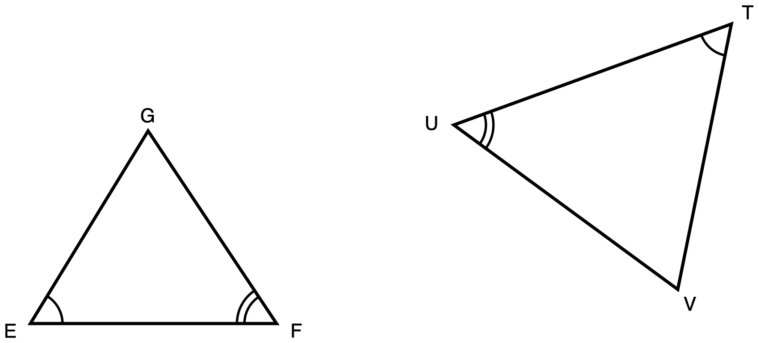
Figure 1. Triangles EFG and TUV, drawn in different orientations, with matching angle arcs.
Description: Triangle EFG sits on the left with side EF horizontal along the bottom and vertex G above it, nearer to F than to E. Triangle TUV sits on the right, larger and turned so that no side of it is horizontal: T is the highest vertex and sits toward the right, U is the leftmost vertex and sits lower than T, and V is the lowest vertex, below T and to its left. Angle E and angle T each carry one arc. Angle F and angle U each carry two concentric arcs. There is no arc at G and none at V, and there is no right angle anywhere. No side length is given anywhere and nothing is marked as unknown.
Triangle EFG and triangle TUV are drawn in different orientations. Angle E and angle T each carry one arc, so those two angles are congruent. Angle F and angle U each carry two arcs, so those two are congruent as well.
Take your correspondence from the arcs, not from where the triangles sit on the page.
Tools for this item: A calculator is allowed and there is nothing here to compute: this item contains no numbers. No ruler and no protractor: this figure is drawn to scale, so measuring it would hand the student the matching angles without a correspondence ever being decided, and deciding the correspondence is the item. No card printing the similarity criteria, because naming the criterion and saying why it applies is what is being asked for. No formula sheet or identity card of any kind, here or anywhere on this exam. No special-triangle reference card. Theirs on this item: blank paper, a straightedge, tracing paper and scissors, the straightedge as a drawing edge and never laid along the printed figure.
✋
Record your work in whichever one of these you prefer:

- an annotated diagram, with the correspondence and the reasons written on the figure
- a paragraph
- a two-column statement and reason chain
- a flowchart
- an oral walkthrough at the figure, which I will write down word for word as you give it
(a) Write the similarity statement for these two triangles, with the vertices in corresponding order.
(b) Prove that the two triangles are similar. Name the criterion you used and say why it applies here.
(c) Name the side of triangle TUV that corresponds to EF.

Item 2 · A triangle cut by a segment
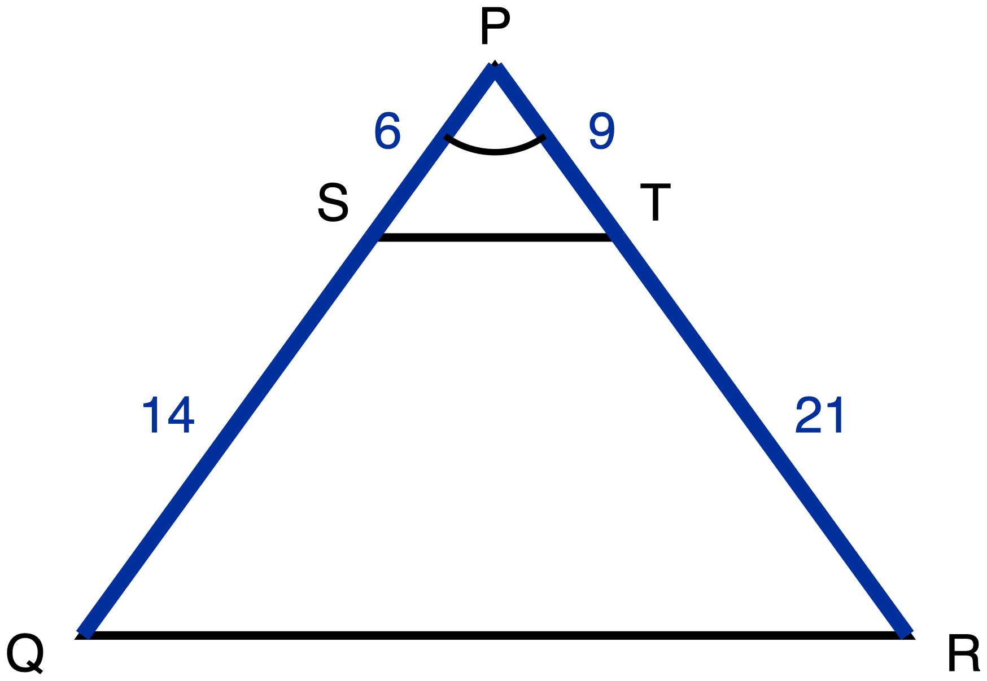
Figure 2. Triangle PQR with S on PQ and T on PR, and the segment ST drawn.
Description: Triangle PQR has vertex P at the top, centred, and side QR horizontal along the bottom with Q at the bottom left and R at the bottom right. S lies on PQ and T lies on PR, both much closer to P than to the base, and S and T are level with each other. The segment ST is drawn across the triangle. On the left side, PS is a given measure of 6 and SQ is a given measure of 14. On the right side, PT is a given measure of 9 and TR is a given measure of 21. QR and ST are drawn plain and carry no numeral. Angle P carries one arc. There is no chevron on ST and none on QR, so the figure does not state that they are parallel. Nothing is marked as unknown.
In triangle PQR, S lies on PQ and T lies on PR, and the segment ST is drawn. PS = 6, SQ = 14, PT = 9 and TR = 21.
Nothing on the figure says that ST is parallel to QR. If your argument needs that, it is something for you to establish, not something you are given.
Tools for this item: A four-function calculator is allowed for the two divisions. No ruler: the figure is drawn to scale, so measuring ST and QR would answer part (b) without any criterion being used. No card printing the similarity criteria. No formula sheet or identity card of any kind. No special-triangle reference card. Theirs: blank paper, a straightedge, tracing paper and scissors, the straightedge never laid along the printed figure.
✋
Same five ways of recording your work as Item 1.

(a) Prove that triangle PST is similar to triangle PQR. Name the criterion you used and say why it applies here.
(b) Write the ratio ST : QR in simplest form.

Item 3 · Two triangles, one upside down
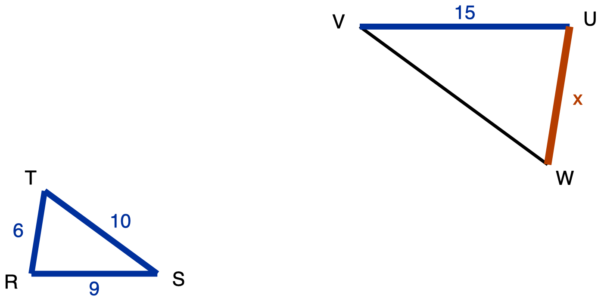
Figure 3. Triangle RST and the larger triangle UVW, drawn upside down relative to it.
Description: Triangle RST is on the left with side RS horizontal along the bottom, R at the bottom left, S at the bottom right, and vertex T above R and only slightly to its right. Its three sides are given measures: RS is 9, ST is 10 and RT is 6. Triangle UVW is on the right, larger and drawn upside down relative to the first, so its horizontal side UV runs along its top rather than its bottom: U is the top right vertex, V is the top left vertex level with U, and W is below and slightly to the left of U. UV is a given measure of 15. VW is drawn plain and carries no numeral. UW is the unknown and is labelled x. No angle is marked anywhere in the figure.
Triangle RST is similar to triangle UVW. In triangle RST, RS = 9, ST = 10 and RT = 6. In triangle UVW, UV = 15. Triangle UVW is drawn upside down relative to triangle RST.
What is the length of UW, marked x on the figure? Choose one.
- A. 10
- B. 12
- C. 13.5
- D. 22.5
Tools for this item: A four-function calculator is allowed. No ruler: the two triangles are drawn at their true relative sizes, so measuring UW and RT and dividing would give the answer without any correspondence being decided. No formula sheet or identity card of any kind. No special-triangle reference card. Blank paper and a straightedge are theirs as drawing materials, the straightedge never laid along the printed figure.
✋
Write the letter, circle it, point at it, or say it to me.

Item 4 · Sides given out of order
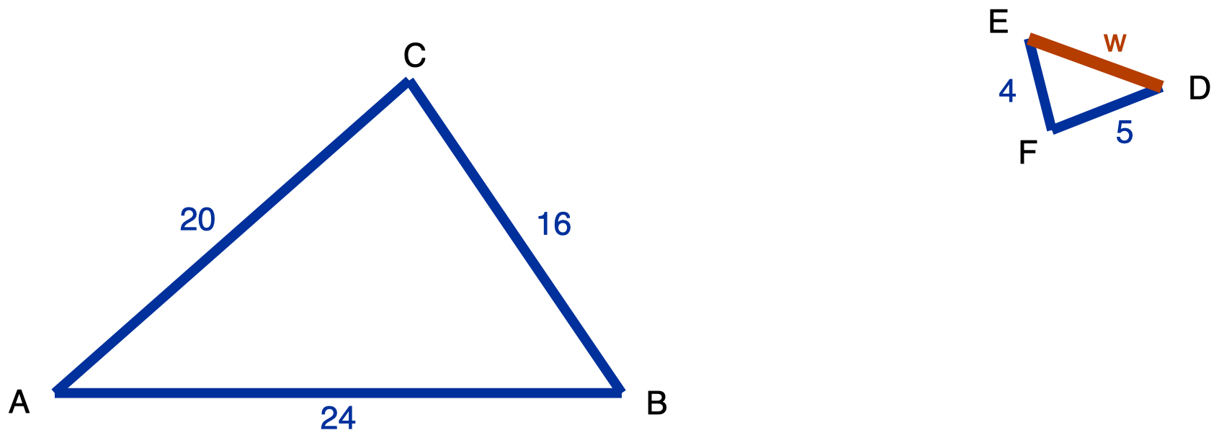
Figure 4. Triangle ABC and the smaller triangle DEF, turned so that no two sides line up.
Description: Triangle ABC is on the left and is large, with AB horizontal along the bottom, A at the bottom left, B at the bottom right, and C above and between them, nearer to B. AB is 24, BC is 16 and AC is 20, all given measures. Triangle DEF is on the right, roughly a quarter the size, and rotated so that none of its sides is horizontal: D is the rightmost vertex and the highest by a little, E is the top left vertex, and F is the bottom vertex, below and between D and E. EF is a given measure of 4 and DF is a given measure of 5. DE is the unknown and is labelled w. No angle is marked in either triangle.
Triangle ABC and triangle DEF are similar. In triangle ABC, AB = 24, BC = 16 and AC = 20. In triangle DEF, EF = 4 and DF = 5.
The side lengths of the second triangle are not listed in the order that matches the first. Work out which side goes with which before you write any ratio. Ask me for a blank three-row table to write your pairs into if you would like one.
Tools for this item: A four-function calculator is allowed. No ruler: the two triangles are drawn at their true relative sizes. No formula sheet or identity card of any kind. No special-triangle reference card. Blank paper and a straightedge are theirs as drawing materials, the straightedge never laid along the printed figure. A blank pairing table is a permitted accommodation on this item and is issued on request.
(a) Write the similarity statement for these two triangles, with the vertices in corresponding order.
(b) Find DE, marked w on the figure.

Item 5 · The tree
There is no figure for this item, and there will not be one. Drawing the situation is part of what is being assessed.
A tree standing on level ground casts a shadow 21 m long. At the same moment, a vertical fence post 1.5 m tall casts a shadow 3.5 m long. The sun's rays reach the tree and the post from the same direction, so the two right triangles formed by the object, its shadow and the ray are similar.
Use as much space and as much paper as you want. If writing is the slow part for you, do your drawing yourself and then tell me the equation and the answer, and I will write those down.
Tools for this item: A four-function calculator is allowed. No diagram is supplied for this item, and none will be. No formula sheet or identity card of any kind. The instructions may be read aloud and the situation may not, because turning that description into two triangles is half of what this item is measuring. No special-triangle reference card. Blank paper, a straightedge, tracing paper and scissors are theirs; there is no printed figure here, so the straightedge is purely a drawing edge.
Draw both triangles. Write every measurement onto the triangle it belongs to. Then find the height of the tree.

Item 6 · The survey
No figure for this item either, for the same reason.
From a point N on level ground, the distance to a lamppost L is 45 m and the distance to a bench B is 27 m. A marker P is driven into the ground on the straight line from N to L, 15 m from N. A second marker Q is driven on the straight line from N to B, 9 m from N.
Tools for this item: A four-function calculator is allowed. No diagram is supplied. No formula sheet or identity card of any kind. The instructions may be read aloud and the situation may not, for the same reason as Item 5. No special-triangle reference card. Blank paper, a straightedge, tracing paper and scissors are theirs; there is no printed figure here, so the straightedge is purely a drawing edge.
(a) Draw the situation and label it.
(b) Decide whether triangle NPQ is similar to triangle NLB. Name the criterion you used.
(c) The lamppost and the bench are 54 m apart. How far apart are the two markers?

Item 7 · A line parallel to one side
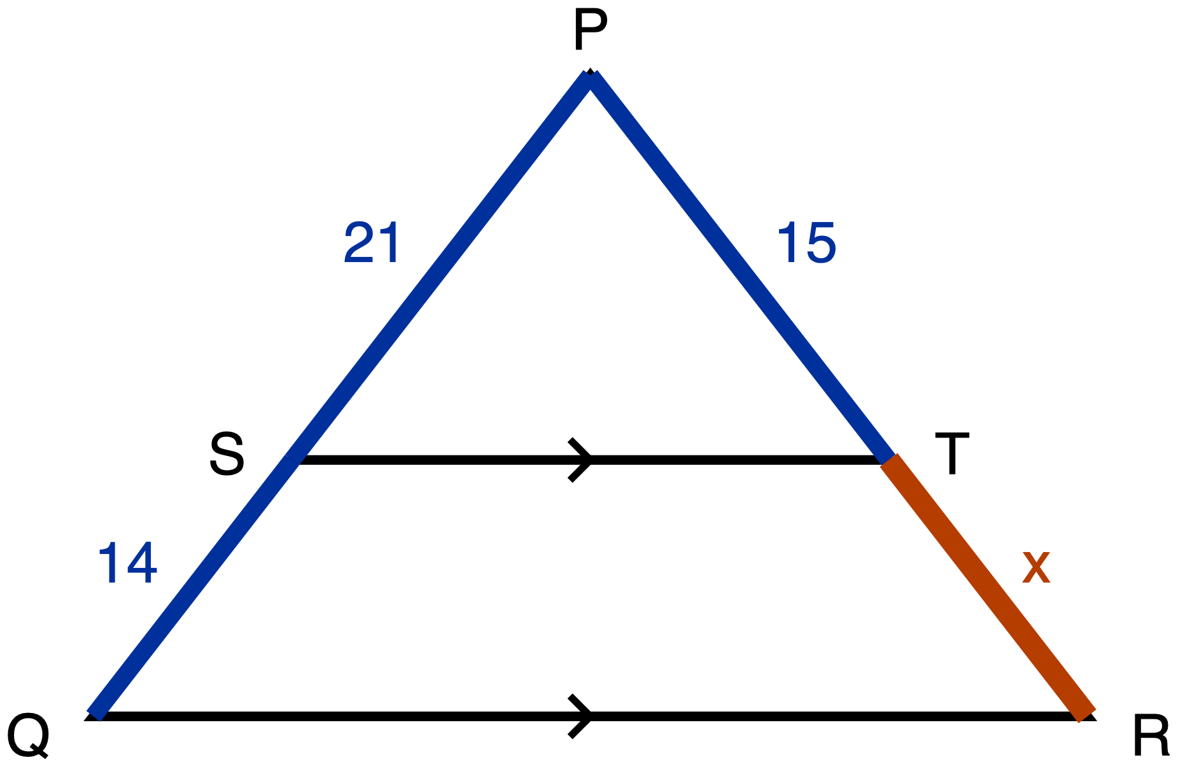
Figure 5. Triangle PQR with ST drawn parallel to QR, and TR unknown.
Description: Triangle PQR has vertex P at the top, centred, and QR horizontal along the bottom with Q at the bottom left and R at the bottom right. S lies on PQ and T lies on PR, level with each other, about three fifths of the way down from the apex, and the segment ST is drawn across the triangle. A single chevron sits at the midpoint of ST and a single chevron sits at the midpoint of QR, marking those two segments parallel to each other. PS is a given measure of 21, SQ is a given measure of 14 and PT is a given measure of 15. TR is the unknown and is labelled x. QR and ST carry no numeral. There is no angle mark anywhere in the figure.
In triangle PQR, S lies on PQ and T lies on PR. The single chevron on ST and the single chevron on QR mark those two segments parallel. PS = 21, SQ = 14 and PT = 15.
A number on its own is not an answer to this item, and that is said here rather than left in a marking scheme: part (a) and part (c) are what is being measured, and part (b) is how you show it working.
Tools for this item: A four-function calculator is allowed. No ruler: the figure is drawn to scale, so measuring TR would give the number without the theorem. No card printing the Triangle Proportionality Theorem. No formula sheet or identity card of any kind. No special-triangle reference card. Blank paper and a straightedge are theirs as drawing materials, the straightedge never laid along the printed figure.
✋
Answer in writing, by writing onto the figure, or out loud to me.

(a) Name the theorem that lets you find TR here, and say why it applies to this figure.
(b) Find TR, marked x on the figure.
(c) Write down the proportion you used, and say in one sentence why it is a proportion of ratios and not of differences.

Item 8 · Is it parallel?
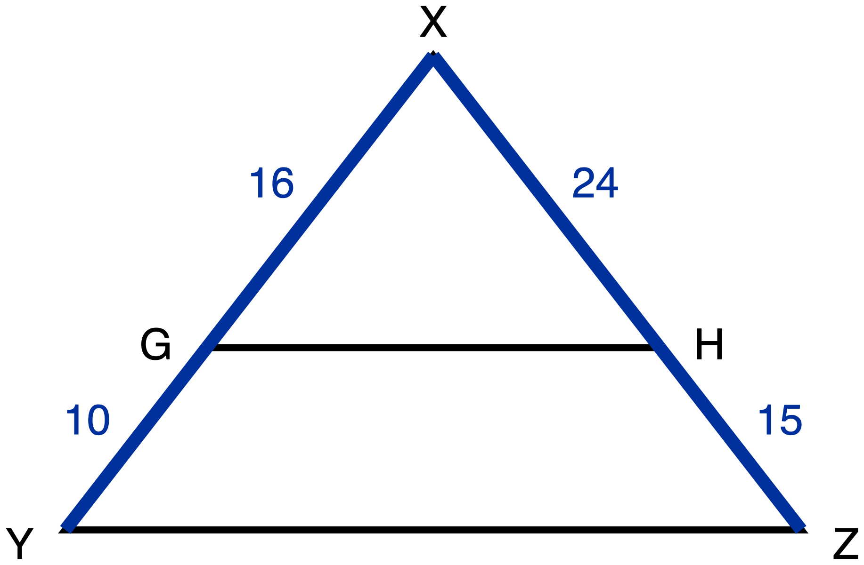
Figure 6. Triangle XYZ with GH drawn across it and nothing marked parallel.
Description: Triangle XYZ has vertex X at the top, centred, and YZ horizontal along the bottom with Y at the bottom left and Z at the bottom right. G lies on XY and H lies on XZ, level with each other, about two thirds of the way down from the apex, and the segment GH is drawn across the triangle. XG is a given measure of 16, GY is a given measure of 10, XH is a given measure of 24 and HZ is a given measure of 15. YZ and GH are drawn plain. There is no chevron on GH and no chevron on YZ, so nothing in the figure asserts that the two segments are parallel. No angle is marked and nothing is marked as unknown.
In triangle XYZ, G lies on XY and H lies on XZ, and the segment GH is drawn. XG = 16, GY = 10, XH = 24 and HZ = 15.
Nothing on this figure is marked parallel. That is the question, not a given.
Tools for this item: A four-function calculator is allowed. No ruler, no protractor and no straightedge: the figure is drawn to scale, so laying a straightedge along GH and YZ, or measuring the two angles at X, would settle the question without the theorem, and the theorem is the item. The straightedge is refused here for exactly the reason the ruler is, and no part heading, no cover page and no earlier item issues one that this item has not. No formula sheet or identity card of any kind. No special-triangle reference card. Blank paper, tracing paper and scissors are theirs.
✋
Answer in writing, by writing onto the figure, or out loud to me.

(a) Decide whether GH is parallel to YZ.
(b) Justify your decision: name the theorem you used and show the computation it rests on.

Item 9 · The three triangles in one figure
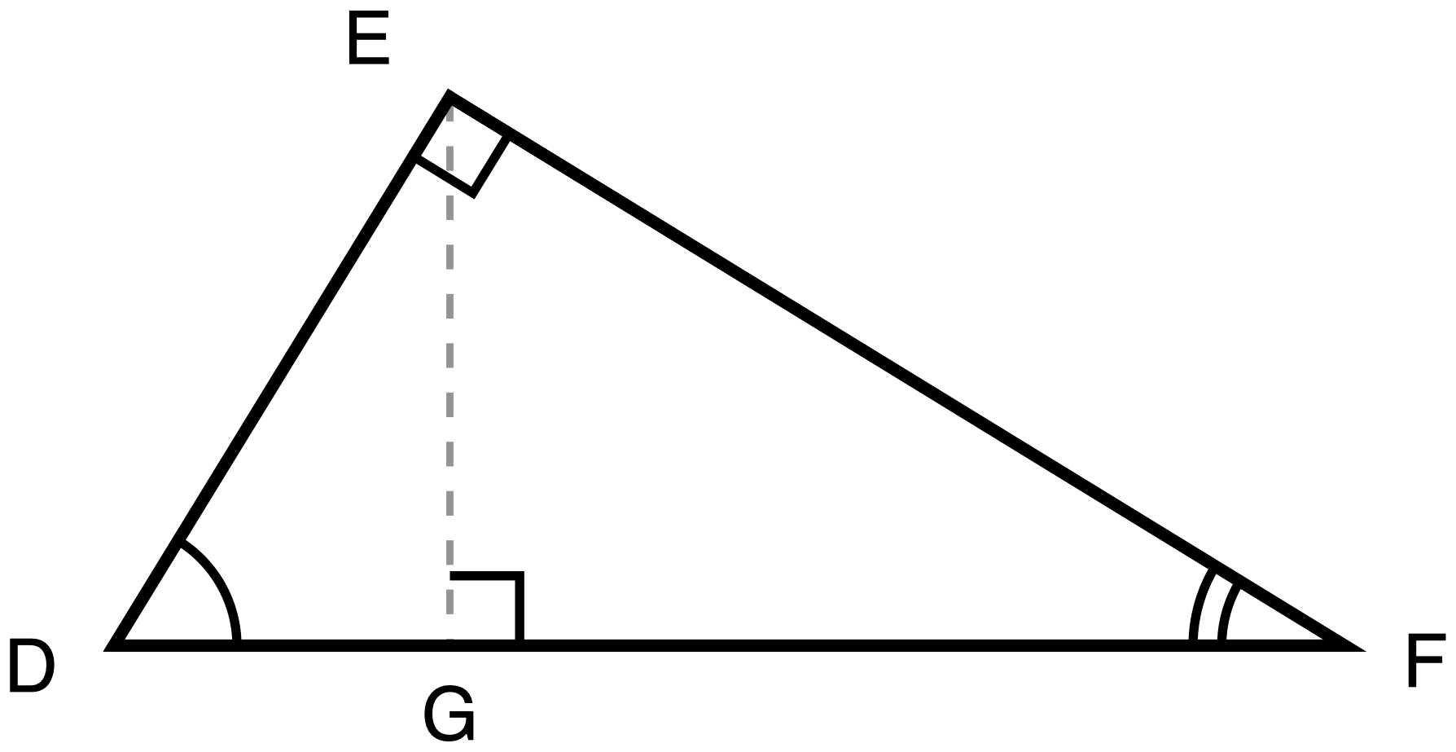
Figure 7. Right triangle DEF with the altitude EG dropped to the hypotenuse DF.
Description: Right triangle DEF has its right angle at E and its hypotenuse DF lying horizontally along the bottom, D at the bottom left and F at the bottom right. E sits above DF, nearer to D than to F. The altitude EG is drawn as a dashed construction line from E straight down to the point G on DF. A right-angle square sits at E between the arms ED and EF, and a second right-angle square sits at G between the arms GE and GF. The angle at D carries one arc and the angle at F carries two concentric arcs, so the arcs mark the two acute angles only. No segment carries a numeral, no length is given, and nothing is marked as unknown.
Right triangle DEF has its right angle at E. EG is the altitude from E to the hypotenuse DF, so EG meets DF at a right angle.
Everything in this item comes from the three similar triangles that the altitude creates. That route is what is being measured, and it is stated here rather than left in a marking scheme.
Tools for this item: A calculator is allowed and there is nothing to compute: this item contains no numbers. Tracing paper, scissors, a second clean copy of the figure and a blank triangle-outline sheet are all theirs, and offer them to everybody, because taking this figure apart is the sensible first move and it was the sensible first move on Day 5 too. What is not allowed is a set of triangles that has already been separated and lettered for them, a printed list of the relationships between the legs and the hypotenuse segments, or a part-completed proof: those carry the correspondence, which is what the item is asking the student to produce. No formula sheet or identity card of any kind. No special-triangle reference card. Blank paper and a straightedge are theirs as drawing materials, the straightedge never laid along the printed figure.
✋
Answer in writing, by writing onto your own separated triangles, or out loud to me.

(a) Name the three triangles in this figure that are similar to one another.
(b) Write two similarity statements, each one comparing a small triangle to the whole triangle DEF, with the vertices in corresponding order.
(c) From one of your statements in (b), write a proportion which, when you cross-multiply it, gives DE². Say which statement you used.

Item 10 · Pythagoras, from the similar triangles
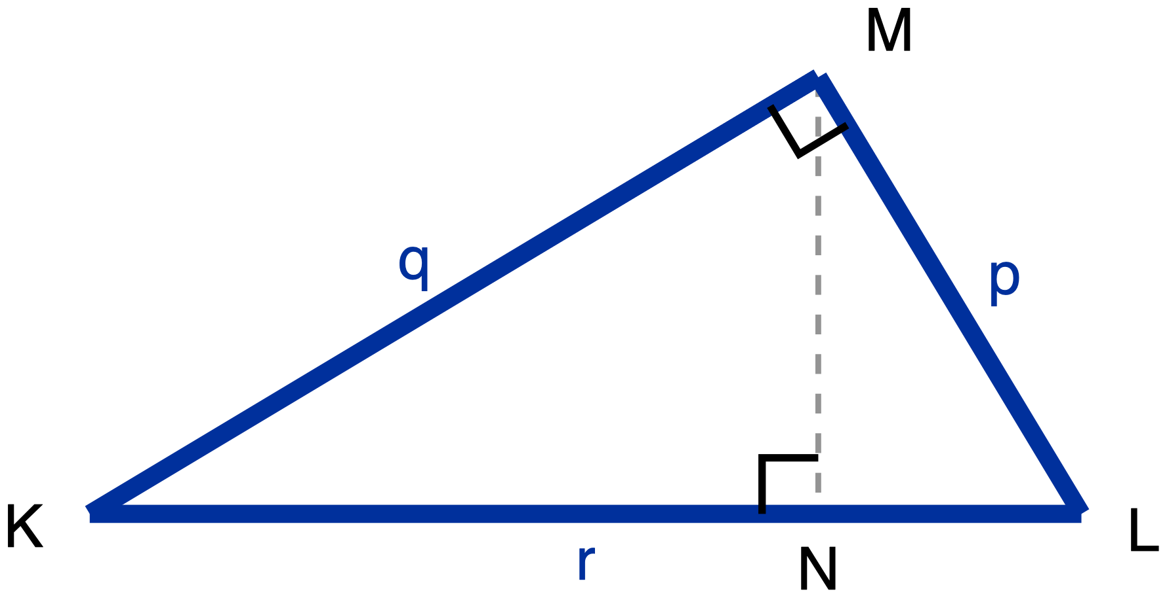
Figure 8. Right triangle KLM, legs p and q, hypotenuse r, with the altitude MN drawn to KL.
Description: Right triangle KLM has its right angle at M and its hypotenuse KL lying horizontally along the bottom, K at the bottom left and L at the bottom right. M sits above KL, nearer to L than to K. The three sides carry letters rather than numbers: LM is labelled p, KM is labelled q, and KL is labelled r. The altitude MN is drawn as a dashed construction line from M straight down to the point N on KL and carries no label. A right-angle square sits at M between the arms MK and ML, and a second right-angle square sits at N between the arms NM and NK. There is no arc anywhere in the figure and nothing is marked as unknown.
Right triangle KLM has its right angle at M. MN is the altitude from M to the hypotenuse KL. Let LM = p, KM = q and KL = r.
Using the three similar triangles formed by the altitude to the hypotenuse, and no other method, prove that p² + q² = r². Your proof has to say why each pair of triangles is similar, not just that it is.
Two things about that instruction, said plainly here so that nothing is hidden in a marking scheme:
- This unit is asking for the similarity route specifically. A proof that cuts the squares up and rearranges the pieces is a real proof of the same theorem, and it is not an answer to this item. If that is the proof you know, write it on the back of the page, and then do this one.
- Your Part A answer to Item 9 stays on the desk and you may look back at it. Item 9 gives you two similarity statements. It does not give you the reasons, and the reasons are what this item is asking for.
Tools for this item: Same as Item 9: a calculator is allowed and there is nothing to compute; tracing paper, scissors, blank outlines and a second copy of the figure are theirs; a pre-separated lettered set, a printed list of the altitude relationships, a part-completed proof and a card printing the Pythagorean statement are all not allowed. No formula sheet or identity card of any kind. No special-triangle reference card. Blank paper and a straightedge are theirs as drawing materials, the straightedge never laid along the printed figure.
Present your proof in whichever of the five forms from Item 1 you want.

Item 11 · Two triangles, one angle
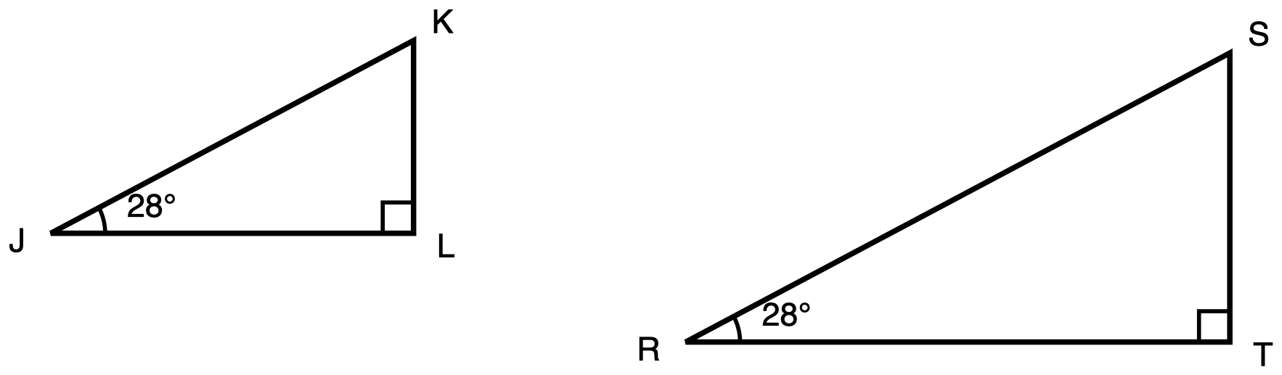
Figure 9. Two right triangles of different sizes, each with a 28 degree acute angle.
Description: Two separate right triangles stand side by side, each with one leg horizontal along its bottom and one leg vertical on its right, the right-hand triangle visibly the larger. In the left triangle, J is the bottom left vertex, L is the bottom right vertex level with J and holds the right angle, and K is directly above L. In the right triangle, R is the bottom left vertex, T is the bottom right vertex level with R and holds the right angle, and S is directly above T. A right-angle square sits at L and another at T. The angle at J carries one arc and is labelled 28 degrees, and the angle at R carries one arc and is labelled 28 degrees. All six sides are drawn plain, no side length is given anywhere, and nothing is marked as unknown.
Triangle JKL has its right angle at L and a 28° angle at J. Triangle RST has its right angle at T and a 28° angle at R. Triangle RST is visibly larger. No side length is given in either triangle.
Tools for this item: A four-function calculator is allowed and there is nothing for it to do. No sin, cos or tan key on any calculator: one keystroke returns a single value for sin 28°, and that single value is exactly the thing this item is asking the student to explain. No printed table of sine, cosine or tangent values, for the same reason: two equal entries in a table show that it happens and not why. No ruler: measuring both triangles and dividing produces the observation, not the reason. No formula sheet or identity card of any kind. No special-triangle reference card. Blank paper and a straightedge are theirs as drawing materials, the straightedge never laid along the printed figure.
✋
Answer in writing, by annotating a second copy of the figure, or out loud to me.

Explain why sin 28° has the same value in triangle JKL as it has in triangle RST. Your explanation has to run through similarity, and you are not asked to compute any ratio. No numbers appear in this item other than the two 28s printed on the figure.

Item 12 · Noor and Theo
No figure for this item, because there is no particular triangle in it.
Noor says: if you multiply every side of a right triangle by 4, you multiply the sine of each of its acute angles by 4.
Theo says: the sine of each acute angle does not change at all.
Part (c) is not a bonus. Saying what changes, in the same answer as what does not, is the point of the item.
Tools for this item: A four-function calculator is allowed and there is nothing for it to do. No sin, cos or tan key and no printed value table, for the same reason as Item 11. Blank paper and a straightedge are theirs if they would like to draw a triangle to think with. No formula sheet or identity card of any kind. No special-triangle reference card.
✋
Answer in writing, in a two-column "changes / does not change" table with your reason written underneath it, or out loud to me. Ask if you want the blank table.

(a) Who is right?
(b) Give the reason, using similarity.
(c) Name one quantity in that triangle that does get multiplied by 4, and one that does not change.

Item 13 · The same triangle, from each of its acute angles
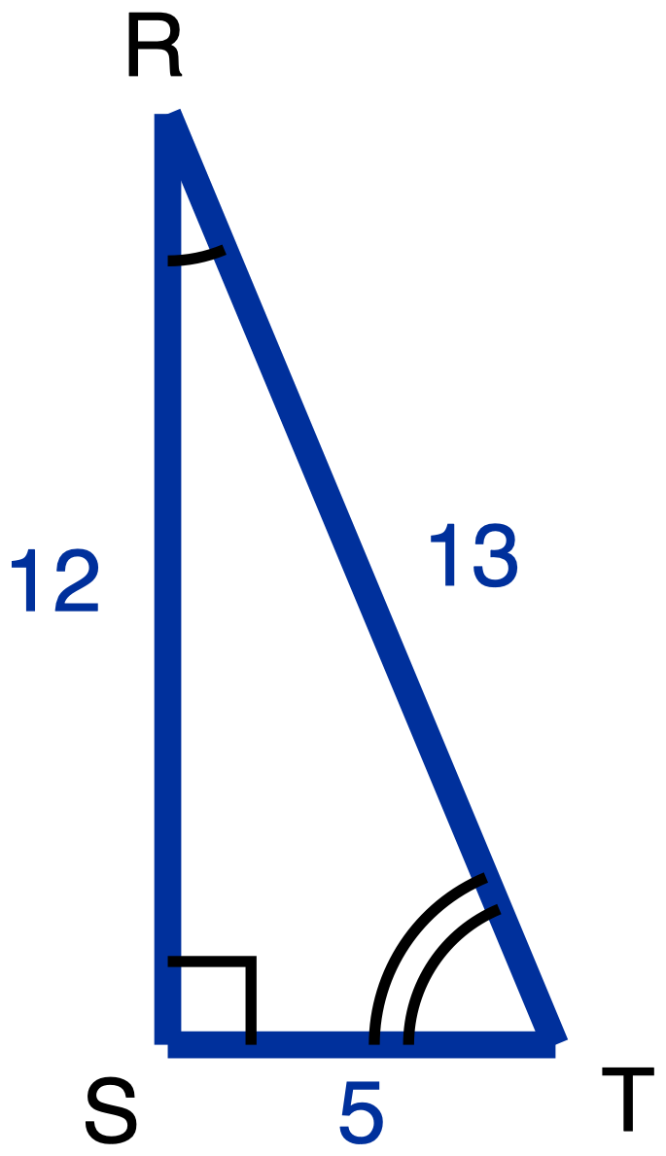
Figure 10. Right triangle RST with legs 12 and 5 and hypotenuse 13.
Description: Right triangle RST is tall and narrow, with its right angle at S, the bottom left vertex. RS is the vertical leg on the left, running up from S to R, the highest point, and is a given measure of 12. ST is the horizontal leg along the bottom, running right from S to T, and is a given measure of 5. RT is the hypotenuse, running from R down to the right to T, and is a given measure of 13. A right-angle square sits at S. The angle at R carries one arc and the angle at T carries two concentric arcs, so the arcs mark the two acute angles only. Nothing is marked as unknown.
Right triangle RST has its right angle at S, with RS = 12, ST = 5 and RT = 13.
Tools for this item: A four-function calculator is allowed, though both answers are fractions. No copy of this triangle with the legs already labelled "opposite" and "adjacent" for either angle, because producing those labels is the item. No printed table of sine, cosine or tangent values, and no definition card: part (c) asks what the words "opposite" and "adjacent" depend on, and a card that prints them in fixed form supplies the distinction being measured. Tracing paper they may turn is theirs. No formula sheet or identity card of any kind. No special-triangle reference card. Blank paper and a straightedge are theirs as drawing materials, the straightedge never laid along the printed figure.
✋
Answer in writing, by writing the names onto your own copies of the figure, or out loud to me.

(a) Relative to angle R, name the opposite leg, the adjacent leg and the hypotenuse. Then write tan R as a fraction.
(b) Do the same relative to angle T: name the opposite leg, the adjacent leg and the hypotenuse, then write tan T as a fraction.
(c) In one sentence, say why two of those three names change between (a) and (b) and one of them does not.

Item 14 · Half a square
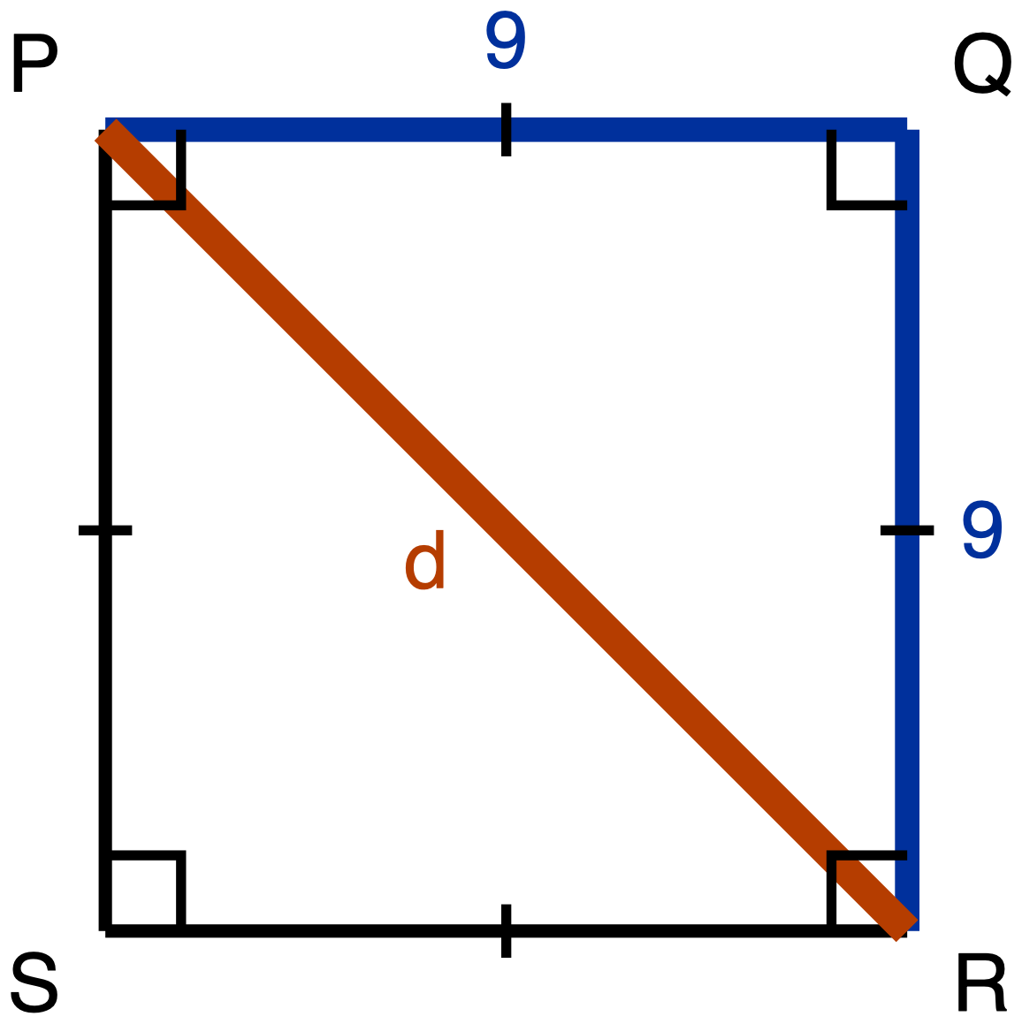
Figure 11. Square PQRS of side 9 with the diagonal PR drawn.
Description: Square PQRS is drawn with its sides vertical and horizontal and is lettered clockwise from the top left: P is the top left corner, Q the top right, R the bottom right and S the bottom left. PQ is the top side, a given measure of 9, and QR is the right side, a given measure of 9. RS and SP are drawn plain and carry no numeral. A single tick sits at the midpoint of each of the four sides, marking all four congruent to one another. A right-angle square sits at each of the four corners. The diagonal PR runs from the top left corner down to the bottom right corner and is the unknown, labelled d; it passes through the corner of the right-angle mark at P and again through the one at R, so each of those two right angles is drawn as split by the diagonal, and nothing marks the two parts of a split corner as congruent to each other.
Square PQRS has side length 9, and its diagonal PR is drawn.
The route this item requires is the square's own properties and the Pythagorean Theorem. Your argument has to say what the square tells you about angle PQR and about the lengths PQ and QR, and it has to use the Pythagorean Theorem to reach PR. Writing down "45-45-90, so 1 : 1 : √2" from memory is not an answer to this item, because what is being asked for is where those values come from. That requirement is stated here rather than left in a marking scheme, so you know it before you start.
Tools for this item: No calculator: the answer is a radical, and a calculator hands the student a decimal instead of the answer. No special-triangle reference card: it prints the ratio being derived, and no item before item 16 issues one. No formula sheet or identity card of any kind. Straightedge, blank paper, tracing paper and scissors are theirs, and redrawing triangle PQR on its own, away from the square, is a good first move.
✋
Same five ways of recording your derivation as Item 1.

(a) Derive the three angle measures and the three side lengths of triangle PQR. Give the side lengths in exact form, which means a radical where one is needed and not a decimal approximation.
(b) Write the ratio PQ : QR : PR in simplest form.

Item 15 · Half an equilateral triangle
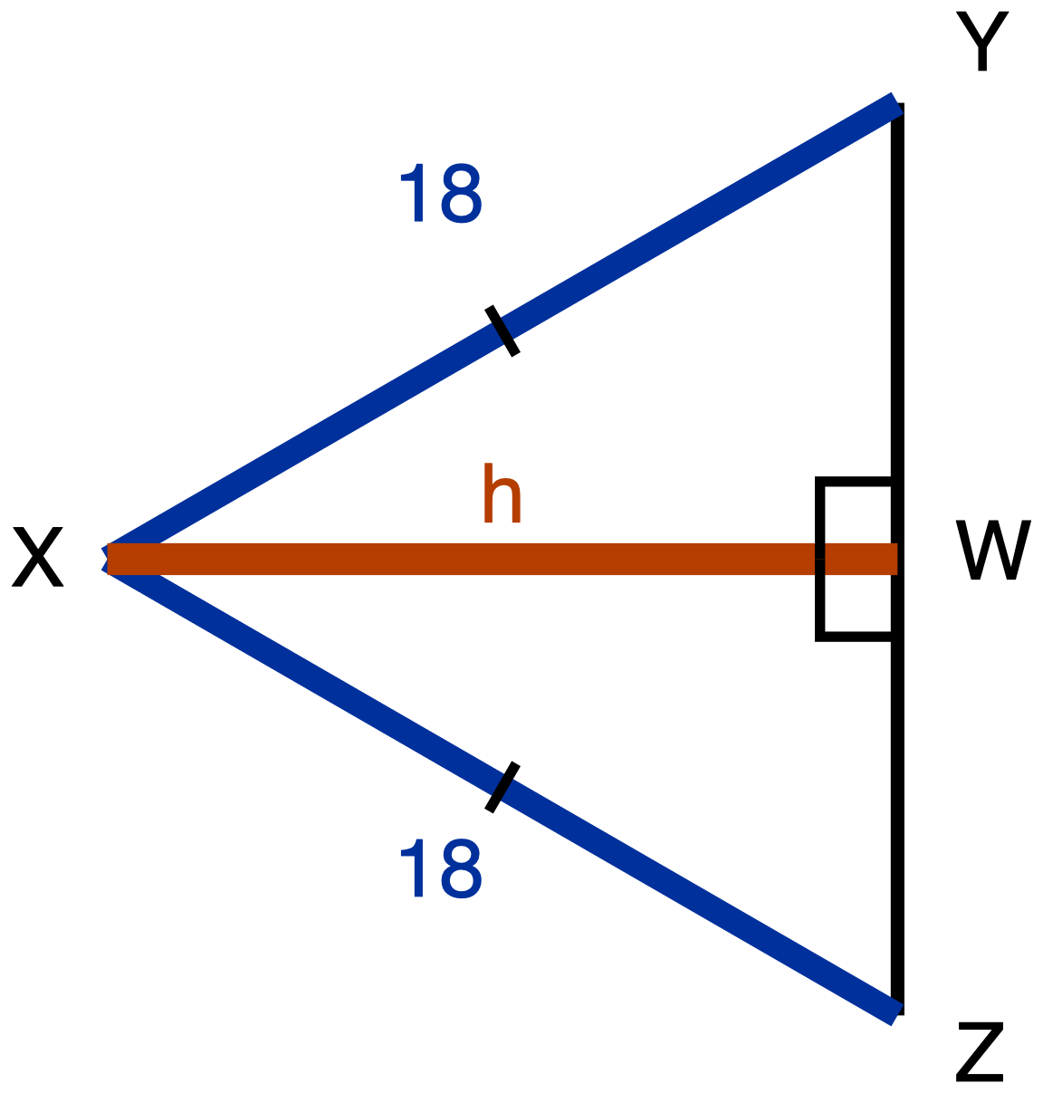
Figure 12. Equilateral triangle XYZ of side 18 with XW drawn from X to YZ.
Description: Equilateral triangle XYZ is drawn on its side and pointing left, with the side YZ upright on the right, Y at the top right and Z at the bottom right directly below Y, and the apex X out to the left, level with the middle of YZ. A segment runs horizontally from X across to the point W on YZ. XY is the upper slant side and XZ is the lower slant side; each is a given measure labelled 18, and each carries a single tick marking the two congruent. YZ is drawn plain and carries no numeral and no tick, and neither YW nor WZ carries a tick, so nothing in the figure states where W sits along YZ. XW is the unknown and is labelled h. Two right-angle squares sit at W, one above XW and one below it, marking angle XWY and angle XWZ as right angles. There is no arc at X, at Y or at Z.
Equilateral triangle XYZ has side length 18. The segment XW runs from X to the point W on YZ, and it meets YZ at a right angle.
The route this item requires is the equilateral triangle's own altitude. Before any arithmetic, your argument has to answer both of these:
- What does XW do to angle X?
- What does XW do to side YZ?
Nothing on the figure tells you where W sits along YZ. That is something to establish, not something given. Then use the Pythagorean Theorem to reach XW.
Tools for this item: No calculator, for two reasons: exact form is asked for in (a), and in (c) a calculator would do the comparison that (c) is asking the student to do. No special-triangle reference card: it prints both the ratio in (b) and the answer to (c), and no item before item 16 issues one. No formula sheet or identity card of any kind. Straightedge, blank paper, tracing paper and scissors are theirs.
✋
Same five ways of recording your derivation as Item 1. Part (c) may be a sentence, a written comparison of the two numbers, or said aloud to me.

(a) Derive the three angle measures and the three side lengths of triangle XYW. Give the side lengths in exact form.
(b) Write the ratio YW : XW : XY in simplest form.
(c) In your simplified ratio, one of the two larger numbers is the hypotenuse's. Say which one, and state in one sentence how you know, without using a calculator.

The paper as issued · Part B, items 16 to 23

Part B · Using the ratios, and building the triangle yourself
Eight items. Each one states its own tools, and this line rules on none of them.
✋
Hand the special-triangle reference card out with Part B, say that it will be collected at the end of Part B, and count every card back.

Item 16 · A 30-60-90 triangle
A 30-60-90 triangle has hypotenuse 18.
Which pair gives its shorter leg and its longer leg, both in exact form? Exact form means a radical where one is needed, not a decimal approximation. Choose one.
- A. shorter leg 9, longer leg 9√2
- B. shorter leg 9√3, longer leg 9
- C. shorter leg 9, longer leg 15.59
- D. shorter leg 9, longer leg 9√3
Tools for this item: The special-triangle reference card is allowed on this item, and is issued for it, because this item asks the student to apply the ratio, not to produce it. No calculator: exact form is what is being asked for, and a calculator hands them a decimal. No formula sheet or identity card of any kind.
✋
Write the letter, circle it, point at it, or say it to me.

Item 17 · Both directions
Tools for this item: The special-triangle reference card is allowed on this item, and is issued for it, same reason as Item 16. No calculator: exact form again. No formula sheet or identity card of any kind. The card gives the ratio; deciding which direction to run it in each part is the student's.
✋
Write your answers, write them onto a blank triangle outline if you would rather (ask and I will give you one), or say them to me and I will write them down.

(a) A 45-45-90 triangle has hypotenuse 16. Give the length of each leg in exact form.
(b) A 45-45-90 triangle has legs of length 11. Give its hypotenuse in exact form.

Item 18 · Find the leg
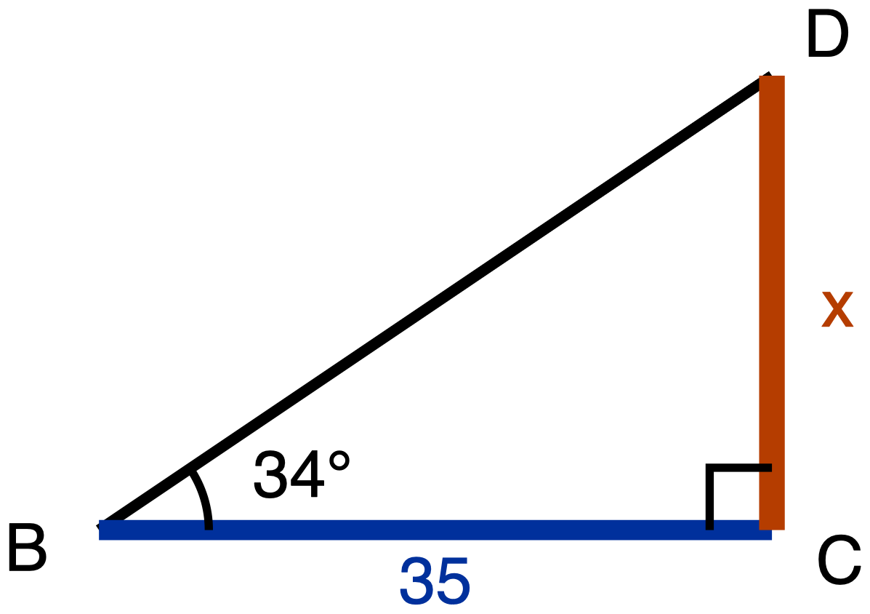
Figure 13. Right triangle BCD with a 34 degree angle at B and BC given as 35.
Description: Right triangle BCD has its right angle at C. BC is the horizontal leg along the bottom, with B at the bottom left and C at the bottom right, and is a given measure of 35. CD is the vertical leg on the right, running upward from C to D, the highest point, and it is the unknown, labelled x. BD is the hypotenuse, running from B up to D, drawn plain and carrying no numeral. A right-angle square sits at C between the arms CB and CD. The angle at B carries one arc and is labelled 34 degrees. There is no mark at D.
Right triangle BCD has its right angle at C. The angle at B is 34°, and BC = 35.
Tools for this item: A scientific calculator with sine, cosine and tangent is allowed and the student will need one, because a decimal answer is being asked for. A printed table of tangent values is equally allowed if they would rather use one, and it reaches the same place. The special-triangle reference card is allowed on this item and has nothing to offer here: 34° is not a special angle. No copy of this triangle with the legs already labelled "opposite" and "adjacent", because deciding which leg is which, relative to the 34° angle, is half of this item. No formula sheet or identity card of any kind.
Find CD, marked x on the figure, to the nearest tenth. Write the equation you used as well as the answer.

Item 19 · Two legs, two tangents
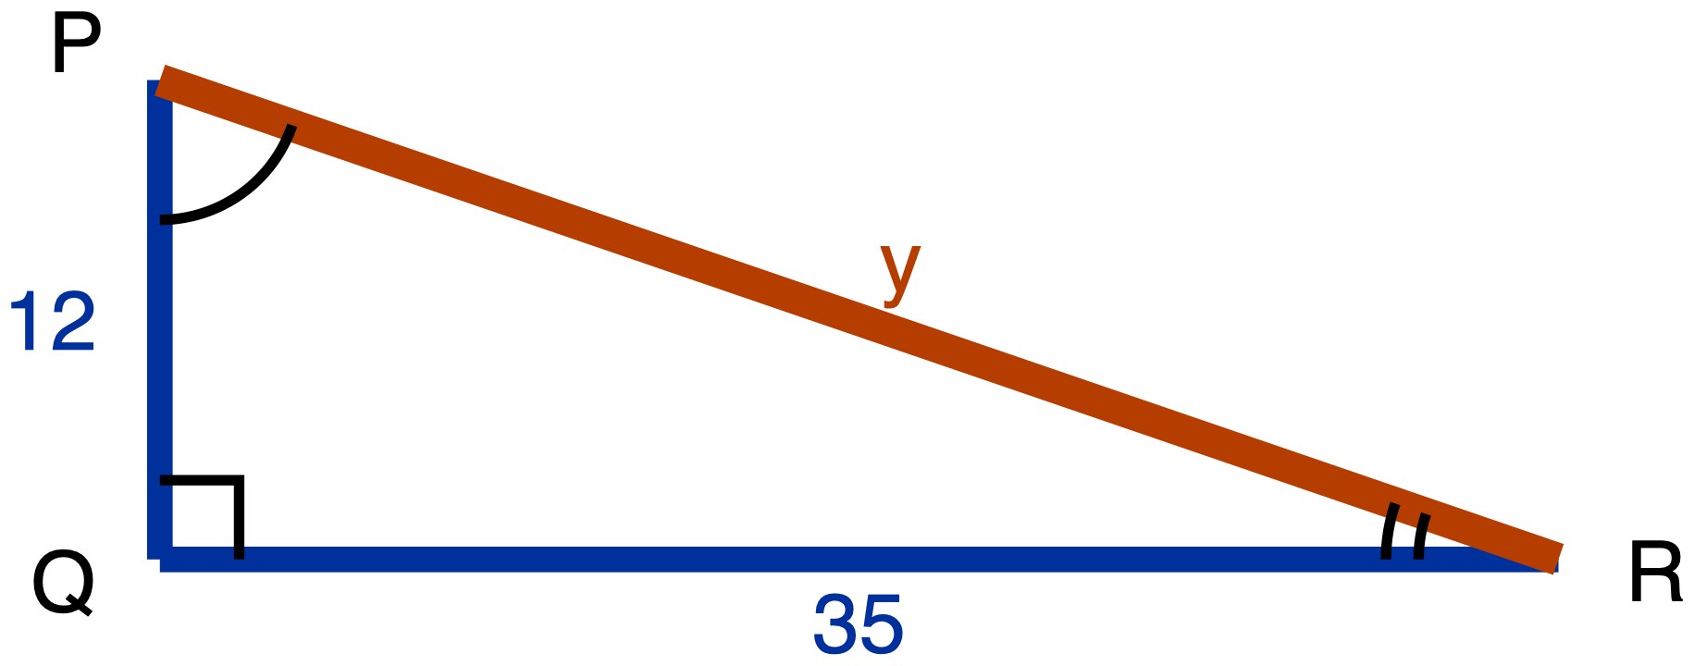
Figure 14. Right triangle PQR with legs 12 and 35 and the hypotenuse unknown.
Description: Right triangle PQR is long and low, with its right angle at Q, the bottom left vertex. PQ is the short vertical leg on the left, running up from Q to P a little above it, and is a given measure of 12. QR is the long horizontal leg along the bottom, running far to the right from Q to R, and is a given measure of 35. PR runs from P down to the right to R; it is the unknown and is labelled y. A right-angle square sits at Q between the arms QP and QR. The angle at P carries one arc and the angle at R carries two concentric arcs, so the arcs mark the two acute angles only.
Right triangle PQR has its right angle at Q, with PQ = 12 and QR = 35.
Tools for this item: A four-function or scientific calculator is allowed for the square root. The sine, cosine and tangent keys are allowed and have nothing to do here, because no angle measure appears anywhere in this item. The special-triangle reference card is allowed on this item and does not apply: this is not a special triangle. No copy of this triangle with the legs already labelled for either angle. No formula sheet or identity card of any kind.
(a) Find PR, marked y on the figure.
(b) Write tan P and tan R, each as a fraction in lowest terms.

Item 20 · The deer
No figure for this item, and there will not be one. Drawing the situation is part of what is being assessed.
A ranger stands at the edge of a lookout, 54 m above the floor of a valley, and sights a deer out on the valley floor. The angle of depression of her line of sight is 31°.
Tools for this item: A scientific calculator or a printed tangent table is allowed and the student will need one of them. The special-triangle reference card is allowed on this item and has nothing to offer: 31° is not a special angle. No diagram is supplied for this item, and none will be. No poster, worked example or display showing where an angle of depression sits. No formula sheet or identity card of any kind. The instructions may be read aloud and the situation may not, because turning that description into a triangle with the horizontal drawn in the right place is what this item is measuring.
(a) Draw the situation. Your drawing must show the horizontal line that the angle of depression is measured from.
(b) Find the horizontal distance from the foot of the lookout to the deer, to the nearest metre.
(c) There is an angle at the deer's position that also measures 31°. Name it, and say why it must be equal to the angle of depression.

Item 21 · The water tower
No figure for this item either, for the same reason.
Marisol is 1.68 m tall and her eyes are 1.55 m above the ground. Standing on level ground, 72 m from the foot of a water tower, she measures the angle of elevation to the top of the tower as 29°.
Your drawing must show Marisol as a vertical segment from the ground up to her eyes, with the triangle sitting on top of it.
Tools for this item: A scientific calculator or a printed tangent table is allowed and the student will need one. No diagram is supplied. The special-triangle reference card is allowed on this item and has nothing to offer: 29° is not a special angle. No card, prompt or display about what to do with the observer's height. No formula sheet or identity card of any kind. Instructions read aloud yes, situation read aloud no, same as Item 20.
Find the height of the tower, to the nearest tenth of a metre.

Item 22 · The chimney, from the same spot
No figure, same reason.
Without moving, Marisol turns and sights the top of a chimney 58 m away. The angle of elevation of her line of sight to the top of the chimney is 24°.
Tools for this item: As Item 21: a scientific calculator or a tangent table, no supplied diagram, no card or prompt about the observer's height, no formula sheet or identity card of any kind, instructions read aloud but not the situation. The special-triangle reference card is allowed on this item and has nothing to offer: 24° is not a special angle.
(a) How much higher than Marisol's eyes is the top of the chimney? Give your answer to the nearest tenth of a metre.
(b) Does her eye height of 1.55 m matter for the quantity part (a) asked you for? Answer yes or no, and give the reason from your own drawing.

Item 23 · The balloon
No figure, same reason.
A balloon hovers 90 m directly above a post on level ground. From the balloon, the angle of depression to a shed on the same ground is 40°.
Part (c) can be done without part (b). If your part (b) went wrong, part (c) is still worth doing, and it will be marked on its own.
Tools for this item: As Item 20: a scientific calculator or a tangent table, no supplied diagram, no poster or worked example showing the placement of an angle of depression, no formula sheet or identity card of any kind, instructions read aloud but not the situation. The special-triangle reference card is allowed on this item and has nothing to offer: 40° is not a special angle.
(a) Draw the situation, showing the horizontal that the angle is measured from.
(b) Find the distance along the ground from the post to the shed, to the nearest metre.
(c) Find the straight-line distance from the balloon to the shed, to the nearest metre. Say which of the two methods available to you you used, and say why the Pythagorean Theorem is available to you here.

The paper as issued · Part C, items 24 to 28

Part C · Sine, cosine, and complements
Five items. Each one states its own tools, and this line rules on none of them.
✋
Every card issued for Part B must be back in your hand before Part C goes out. A printed 30-60-90 ratio settles item 25 by trial and gives item 28 a route its stem forbids.

Item 24 · Which side does the work
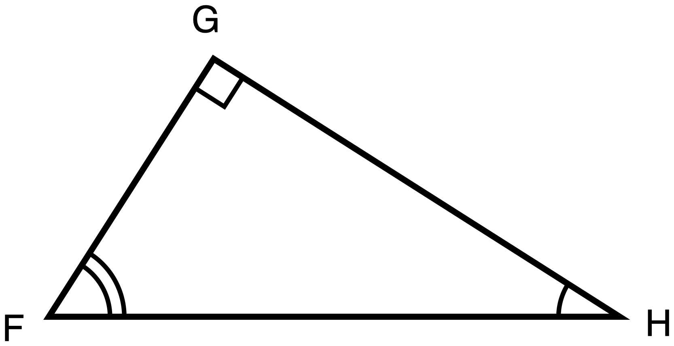
Figure 15. Right triangle FGH, resting on its hypotenuse, with no measures given.
Description: Right triangle FGH rests on its hypotenuse: FH is horizontal along the bottom, F at the bottom left and H at the bottom right a long way from it. G sits above the segment FH and holds the right angle; it is nearer to F than to H and is the highest point. Neither leg is horizontal and neither is vertical: FG is the shorter leg, slanting up to the right from F to G, and GH is the longer leg, slanting down to the right from G to H. The right angle at G carries a small square set square to the two legs rather than to the page. The angle at H carries a single arc and the angle at F carries two concentric arcs, so the arcs mark the two acute angles only, and the angle at F is drawn visibly the larger of the two. All three sides are drawn plain, no numeral appears anywhere, and nothing is marked as unknown.
Right triangle FGH has its right angle at G. The hypotenuse FH lies along the bottom of the figure, so neither of the two legs is flat and neither is upright.
Tools for this item: A calculator is allowed and will not help: there is not a single number in this item. No table of sine and cosine values: reading two equal entries off a table would report the equality without the side ever being named, and naming the side is the item. No formula sheet or identity card printing the relationship between sine and cosine, because that relationship is what this item is measuring. No special-triangle reference card. Redrawing the figure in a familiar orientation on scrap paper is permitted and is a good first move; supplying it redrawn is not.
✋
Answer in writing, by annotating a second copy of the figure (ask and I will give you one), or out loud to me, and I will write it down word for word.

(a) Name the one side of this triangle that is opposite angle H and is also adjacent to angle F. Then say in one sentence why a single side can play both of those roles.
(b) Use your answer to (a) to explain why sin H = cos F. Write each of them as a fraction of two named sides.
(c) Amara says the answer to (b) is really that sin H = cos G, because G is the other angle named in the triangle. Give one reason Amara's equation cannot be right.

Item 25 · Which equation is always true
In right triangle RST, the right angle is at S.
Which one of these is true for every triangle of that kind? Choose one.
- A. sin R = sin T
- B. sin R = cos T
- C. tan R = tan T
- D. sin R = cos S
Tools for this item: No calculator with sine, cosine or tangent keys: with one, picking any pair of acute angles and testing all four options settles the item by trial instead of by the relationship, and the relationship is what is being measured. A four-function calculator is allowed and has nothing to do here. No table of sine and cosine values, for the same reason as the calculator. No special-triangle reference card: with one a student could pick a 30-60-90 triangle and settle the four options off printed ratios, which is the same bypass by a third route. No formula sheet or identity card printing the relationship between sine and cosine.
✋
Write the letter, circle it, point at it, or say it to me. If it helps, ask me for a blank right-triangle outline with R, S and T already lettered on it.

Item 26 · Solving for x
For some value of x, cos(6x + 5)° = sin(4x + 15)°, and both (6x + 5)° and (4x + 15)° are acute angles.
Part (a) is required and is not a warm-up: the equation has to come from a stated fact about the two angles, not from a remembered template. You may dictate your sentence and your equation and I will write them down.
Tools for this item: A four-function or scientific calculator is allowed for the arithmetic. No graphing calculator and no equation solver: either one returns x without the angle relationship part (a) asks for. A table of sine and cosine values is not supplied and would show nothing here, because x sits inside both angles and no listed value evaluates either one. No formula sheet or identity card printing the relationship between sine and cosine, because choosing between "the two angles are equal" and "the two angles add to 90" is the whole of this item. No special-triangle reference card.
(a) Write one sentence saying how those two angle measures are related to each other. Then write the equation that sentence gives you.
(b) Solve your equation for x.
(c) Give both angle measures, and check that they really can be the two acute angles of one right triangle.

Item 27 · Solving for w
Solve for w:
✋
cos 38° = sin(w + 17°), where (w + 17)° is an acute angle.

Before you write any equation, write down in words the step where you use the relationship between sine and cosine. Then solve, and check that (w + 17)° really is acute.
Tools for this item: No calculator with sine, cosine or inverse keys: cos 38° evaluates in one keystroke and an inverse sine hands the angle straight back, which answers the item without the relationship ever being used. A four-function calculator is allowed; the arithmetic here is 90 − 38 and then 52 − 17. No table of sine and cosine values, which carries cos 38° and sin 52° as two equal entries and is the same shortcut by a slower route. No formula sheet or identity card printing the relationship between sine and cosine, because that relationship is the step this item asks the student to write down. No special-triangle reference card.
Write the relationship step in words, then solve, then run the check.

Item 28 · From one ratio to its partner
In right triangle PQR, the right angle is at R, and sin P = 8/17.
Do not compute a third side, and do not compute any ratio from any triangle. The route being measured in (a) is the relationship between an angle and its complement, and that restriction is stated here rather than left in a marking scheme.
Tools for this item: No calculator with sine, cosine or inverse keys: with one, part (a) is an inverse sine, a subtraction and a cosine, and none of those three is what is being measured. A four-function calculator is allowed and will not be needed. No table of sine and cosine values, which pairs 8/17 with its complement directly. No formula sheet or identity card printing the relationship between sine and cosine, because that relationship is the route (a) is measuring. No special-triangle reference card, which is irrelevant at 8/17 and refused rather than left unruled.
✋
Answer in writing, out loud to me, or by writing the angle names and the value onto a blank lettered triangle outline with one phrase giving your reason. Ask if you want the outline.

(a) Give the value of cos Q, and say in one sentence how you know.
(b) Jonah says cos R is also 8/17. Give one reason he cannot be right.

Answer key · Part A, items 1 to 15

Answer key · Part A, items 1 to 15
Every wrong answer below is named, and every one is tied to the specific reasoning that produces it. The constructed-response items get the same treatment as the multiple-choice ones, under What you will see, and what it means, because a wrong answer you cannot name is a wrong answer you cannot give feedback on.

Item 1 · The same two triangles, turned
- (a) △EFG ~ △TUV. The one arc pairs E with T, the two arcs pair F with U, so G pairs with V.
- (b) AA similarity. Two pairs of angles are marked congruent, and two pairs of congruent angles are enough, because the third pair follows from the angle sum.
- (c) TU.
What you will see, and what it means.
What you see | What it is | What to do
△EFG ~ △UTV | The correspondence read off the drawn position rather than off the arcs. U is the leftmost vertex of the second triangle and E is the leftmost of the first, so position pairs them. Until a student has been burned by a rotation, "the vertex on the left matches the vertex on the left" has worked on every diagram they have seen | Ask which vertex of the second triangle carries one arc. The statement collapses on its own. Do not correct the letters for them
(c) answered "UT" or "UV" | The same error, showing in the side pairing rather than in the vertex pairing | Same move: go back to the arcs, then read the side off the corrected statement
(b) answered "they look the same shape" | The conclusion asserted rather than argued. Not a criterion | Ask which two facts about angles they are actually using. The name follows
(b) answered "SSS" or "SAS" | A criterion named that the figure gives no data for: there is not a single length in this item | Point at the figure and ask where the side lengths are
A ruler or protractor in use | Not a wrong answer, a wrong route, and the item denies it in the student's own copy | Remove the tool, note it on the paper, and let the student finish from the arcs

Item 2 · A triangle cut by a segment
- (a) △PST ~ △PQR, by SAS similarity. PS/PQ = 6/20 = 3/10 and PT/PR = 9/30 = 3/10, so the two pairs of sides about angle P are in the same ratio, and angle P is the included angle in both triangles because it is common to them.
- (b) ST : QR = 3 : 10.
✋
A second correct route, accept it in full. PS/SQ = 6/14 = 3/7 and PT/TR = 9/21 = 3/7, so by the converse of the Triangle Proportionality Theorem ST is parallel to QR; then the corresponding angles give AA similarity. This is a longer road to the same place and it is completely valid. Note which route the class reached for: it tells you whether Day 3 or Day 4 is the more available memory.

What you will see, and what it means.
What you see | What it is | What to do
PS/SQ compared with PT/PR, or any proportion mixing a part with a whole | The commonest slip on this configuration, and it is an arithmetic-setup slip rather than a misconception. Labelled that way deliberately | Ask what each of the four lengths measures. The mismatch shows itself
"Not similar, because 20 − 6 = 14 and 30 − 9 = 21 are different" | Additive comparison surfacing in a new configuration: same difference rather than same ratio | The Day 1 move, compressed: ask what happens to the two numbers if the whole figure is scaled again. Differences move, ratios do not
(b) answered 3 : 7, or 6 : 20 unreduced | The part-to-part ratio given where the part-to-whole was asked for, or the right ratio left unsimplified | The first needs the question re-read; the second is a form note, not a mathematical one. Say which it is
(a) answered "AA, because ST is parallel to QR" with no argument for the parallelism | The parallelism assumed rather than established. The figure deliberately carries no chevron | Ask what on the figure tells them the two segments are parallel. Nothing does. Then the SAS route or the converse route is the answer
A ruler in use on ST and QR | Wrong route; denied in the student's own copy | Remove it and note it

Item 3 · Two triangles, one upside down
Key: A. 10.
Option | What choosing it tells you
A. 10 | Key. RS pairs with UV, so the scale factor is 15/9 = 5/3, and RT pairs with UW, so UW = 6 × 5/3 = 10
B. 12 | Additive scaling. The student sees 15 − 9 = 6 and adds 6 to RT. This is the Day 1 error surviving into a Day 3 configuration, and it is worth noticing on a practice exam because it means the multiplicative rule never displaced the additive one, it only sat on top of it
C. 13.5 | A correspondence error: one entry of the proportion displaced by a position. The student writes 9/x = 10/15, pairing RS with UW and ST with UV. Both pairings are wrong by one step around the triangle
D. 22.5 | The same correspondence error in its crossed form: 9/x = 6/15, pairing RT with UV. This is the largest of the wrong answers and it is the one to watch for, because a student who picks it has a correspondence, just not this one

The key is at A here and at B on the final. The option letters were deliberately moved so that a student cannot carry a letter across from the practice paper to the real one. The four diagnoses are the same four, in the same proportions.
What the option set is doing. Three of the four options are documented errors carrying two different diagnoses. A class splitting between C and D has a correspondence problem; a class picking B has a scaling problem, and those are two different repairs. The feedback lines at the end of this key give both.

Item 4 · Sides given out of order
- (a) △ABC ~ △DEF. AC/DF = 20/5 = 4 and BC/EF = 16/4 = 4, so the scale factor is 4 and A pairs with D, B with E, C with F.
- (b) DE = 6, from AB/DE = 4.
What you will see, and what it means.
What you see | What it is | What to do
24/4 = w/5, giving w = 30, or 24/5 = w/4, giving w = 19.2 | Textual adjacency: the numbers paired by where they sit in the list rather than by which side each belongs to. The list order is scrambled relative to correspondence order precisely so this cannot land on the right answer by luck | Ask which side of DEF is the longest, and which side of ABC is the longest. The pairing follows from the objects, not the order
w = 9 or w = 12 | Additive scaling again: the constant difference (20 − 5 = 15, or 16 − 4 = 12) subtracted from 24 | Same repair as item 3 option B
(b) right, (a) missing or written as "ABC ~ FED" | The scale factor found without the correspondence being written down. The value is right and the evidence is not | Ask for the statement out loud. On a rotated pair this is the step that decides everything downstream
A blank pairing table asked for and used | Not an error. It is a permitted accommodation on this item | Nothing. Note who used it, for your own records

Item 5 · The tree
Key. The two triangles are similar, so h/21 = 1.5/3.5, giving h = 9 m.
A correct drawing shows two right triangles: one with a vertical side 1.5 and a horizontal side 3.5, one with a vertical side h and a horizontal side 21, and each number written on the triangle it belongs to.
What you will see, and what it means.
What you see | What it is | What to do
21/1.5 = h/3.5, giving h = 49 m | Textual adjacency: the object paired with the other object's shadow. The 21 and the 1.5 sit next to each other across the two sentences, and adjacency is a heuristic that is usually right and is here systematically wrong | The drawing is the repair, and the stem requires it for exactly this reason. Ask which triangle the 21 belongs to, then which triangle the 1.5 belongs to
1.5/21 = h/3.5, giving h = 0.25 m | The same error in its reciprocal form. Worth flagging separately only because a student who writes it has usually not sanity-checked an answer a quarter of a metre tall | Ask whether a tree can be shorter than the fence post beside it. Then the repair above
A correct proportion and no drawing | The extraction happened in the student's head and cannot be seen. Do not mark this wrong | Give the marks. Note it: on the next no-diagram item you cannot tell whether that student is modelling or pattern-matching, and item 6 is where you look
A drawing with the 21 and the 3.5 on the same triangle | The error caught before the arithmetic, which is the best place to catch it | Point at the two shadows and ask which object made each one
Someone asks you to read the scenario out | The denied accommodation, and it will be asked for | "I can read you the instructions. I cannot read you the situation." Say it that way, and say it once at the start of the paper so it is not a surprise at the desk

Item 6 · The survey
- (b) Similar, by SAS similarity. NP/NL = 15/45 = 1/3 and NQ/NB = 9/27 = 1/3, and the angle at N is common to both triangles, so it is the included angle in both.
- (c) PQ = 18 m, from PQ/LB = 1/3 and LB = 54.
What you will see, and what it means.
What you see | What it is | What to do
"Not similar, because 45 − 15 = 30 and 27 − 9 = 18 are not equal" | Additive comparison used as the similarity test. This is Day 1's error, on the last day of the unit, in a configuration Day 1 never showed | The Day 1 iteration move, spoken: what happens to those two differences if the whole survey is redrawn at twice the size? They double. What happens to the two ratios? Nothing
PQ = 24, from 54 − 30 | The additive rule carried through to the answer rather than stopping at the decision | Same repair
15/27 = PQ/54, giving PQ = 30 | Textual adjacency: the 15 paired with the bench's distance rather than with the lamppost's. The two sentences put them next to each other | The drawing. Ask which two measurements lie along the same straight line
(b) answered "similar" with no criterion | Not an answer to the item, and the stem asks for the criterion in the student's own copy | Hand it back with the criterion clause circled
A correct decision and a wrong PQ | Usually the scale factor inverted: 54 × 3 = 162 | Ask whether the markers can be further apart than the lamppost and the bench. The check is available to the student without you

Item 7 · A line parallel to one side
- (a) The Triangle Proportionality Theorem: a line parallel to one side of a triangle divides the other two sides proportionally. It applies here because the chevrons state that ST is parallel to QR, and S and T lie on the other two sides.
- (b) PS/SQ = PT/TR, so 21/14 = 15/TR and TR = 10.
- (c) The theorem says the two sides are divided in the same ratio, not by the same amount. Accept any sentence carrying that distinction.
✋
A second correct route, accept it in full. PS/PQ = PT/PR gives 21/35 = 15/PR, so PR = 25 and TR = 25 − 15 = 10. Both proportions are true and both are the theorem.

What you will see, and what it means.
What you see | What it is | What to do
TR = 14 | The cut treated as taking the same amount off each side. This error is inferred rather than documented. Nothing in the source corpus behind this unit records a student error specific to this theorem, so if your room's dominant error is a different one, that is real evidence and this item is under-specified rather than broken | The three-cuts table from Day 4: take three parallel cuts at different heights and tabulate. The differences move; the ratios do not
21/14 = 15/PR, giving PR = 10 and then a negative TR | The part-to-part proportion set equal to a part-to-whole one. An arithmetic-setup slip, and it is treated separately | Ask what PR measures and what SQ measures. A negative length is a check the student can run alone
(b) right, (a) and (c) blank | The number reached by pattern rather than by warrant. This is the pile this item exists to find: a numeric-only version of this item would score it as mastery | Ask for the theorem name out loud before they leave. The stem asked for it, so this is not a hidden penalty
A ruler in use | Wrong route; denied in the student's own copy | Remove it and note it

Item 8 · Is it parallel?
- (a) Yes, GH is parallel to YZ.
- (b) XG/GY = 16/10 = 8/5 and XH/HZ = 24/15 = 8/5. The two sides are divided in the same ratio, so by the converse of the Triangle Proportionality Theorem, GH is parallel to YZ.
What you will see, and what it means.
What you see | What it is | What to do
"No, because 16 − 10 = 6 and 24 − 15 = 9" | The same-amount error again, and here it produces the wrong decision, not just a wrong number. That is what makes this item the sharper of the two proportionality items | The same three-cuts table. Then put items 7 and 8 side by side and ask what the two have in common
"Yes" with the ratios computed and the theorem not named | The computation without the warrant. The converse is what licenses the conclusion, and the forward theorem does not | Ask which direction of the theorem they used. Most students have only ever used the forward one, and naming the difference is the item
"Yes, they look parallel" | Not an answer, and the figure is deliberately unmarked | Ask what on the figure says so. Nothing does
The forward theorem named instead of the converse | A real distinction and a fine one. Give most of the credit and name the gap: the forward theorem starts from parallel; this item ends at it | Say the two sentences back to back. The difference is audible
A ruler or protractor in use | Wrong route, and on this item it settles the whole question. Denied in the student's own copy | Remove it and note it. This is the item where the tool matters most on the paper

Item 9 · The three triangles in one figure
- (a) △DGE, △EGF and △DEF.
- (b) △DGE ~ △DEF (D with D, G with E, E with F) and △EGF ~ △DEF (E with D, G with E, F with F). Either two of the three available statements, in corresponding order.
- (c) From △DGE ~ △DEF: DG/DE = DE/DF, which cross-multiplies to DE² = DG · DF.
What you will see, and what it means.
What you see | What it is | What to do
Nothing written, or a proportion built from segments that are next to each other in the picture | The overlapping-triangles barrier, the best-documented difficulty in this cluster. The figure asks the student to hold three overlapping triangles at three orientations before any mathematics starts, and that is a visual-tracking load separable from whether they understand similarity. Students who can prove AA fluently on two separated triangles still stall here | The tools are on the front desk and they are for everybody: trace, cut, redraw all three the same way up, carry the letters across. Do not talk them through the correspondence. The separation is the accommodation; the correspondence is the item
Three triangles named correctly, statements in the wrong order | The tracking barrier cleared and the correspondence not yet carried across | Ask which vertex of the small triangle holds the right angle, then which vertex of the big one does
(c) giving EG² or EF² instead of DE² | A valid proportion from a valid similarity, answering a different question. Not wrong mathematics | Give credit for the proportion and ask which leg the stem named. Then have them find the statement that produces it
(b) written as △DGE ~ △DFE | The whole triangle's letters transposed. Easy to make and easy to catch | Ask where the right angle is in each of the two names
A pre-separated lettered set of triangles on the desk | Not an accommodation; it carries the correspondence. Denied in the student's own copy | Take it back, give them the blank outlines instead, and note it

Item 10 · Pythagoras, from the similar triangles
△KNM ~ △KML: both have a right angle (at N and at M) and they share angle K, so by AA they are similar with K matching K, N matching M and M matching L. Therefore KN/KM = KM/KL, so q² = r · KN.
△MNL ~ △KML: both have a right angle (at N and at M) and they share angle L, so by AA they are similar with M matching K, N matching M and L matching L. Therefore LN/LM = LM/LK, so p² = r · LN.
Adding: p² + q² = r(LN + KN) = r · KL = r · r = r².
✋
Why the route is required, and why that is not a hidden penalty. The similarity route is part of what this unit's proof items measure, not a preference about presentation. The stem says so in the student's own copy, names the dissection proof as a real proof of the same theorem that is not an answer to this item, and offers the back of the page for it. A hidden penalty for a correct answer is exactly what the stem is written to prevent.

What you will see, and what it means.
What you see | What it is | What to do
A dissection or rearrangement proof | A correct proof of the theorem, and not an answer to this item. The stem told them, in advance, in writing | Read the stem back with them. Take the dissection proof on the back of the page as evidence of what they know, and ask for this one. Do not score it as a mathematical error, because it is not one
Both similarities asserted with no reason given for either | The half of the proof the stem specifically asks for. Naming the shared angle and the two right angles is the argument | Ask why △KNM is similar to △KML. Two facts, and they are both on the figure
q² = r · KN reached and the argument stopping there | One of the two halves. Common, and it is a completeness gap rather than an understanding gap | Ask what the other small triangle gives them, then what KN + LN is
KN + LN written as something other than r | The last step lost. The two segments make the whole hypotenuse and that is the hinge of the whole proof | Point at the figure. It is one sentence
A correct proof of p² + q² = r² that never mentions the altitude | Almost always the dissection route in disguise, or a memorised algebraic identity | Ask which three triangles they used. The answer tells you which route it really was

Item 11 · Two triangles, one angle
Key. Each triangle has a 28° angle and a right angle, so by AA the two triangles are similar. Similar triangles have proportional corresponding sides, so the quotient of the side opposite the 28° angle by the hypotenuse is the same in both. That quotient is sin 28°, so it is the same in both.
What you will see, and what it means.
What you see | What it is | What to do
"The bigger triangle has a bigger sine", or a prediction that the ratio grows | The ratio expected to scale with the triangle, the day's primary difficulty for the invariant-ratio standard. Every measurement the student has met so far does change when the figure grows: side length, perimeter, area. The ratio is the first invariant quantity in the course and nothing in prior experience marks it as a different kind of object | The reason, not the fact. Say both halves in the same breath: the ratio does not change when the triangle grows, and the sides do
"Because they are the same shape" and nothing else | True, and not yet an argument. "Same shape" is what similarity means, not why the ratio follows from it | Ask what similarity gives you about the sides. The word is proportional, and once it is on the page the argument finishes itself
A numeric answer, 0.47, or "about a half" | The observation supplied in place of the explanation, and the item asks for no numbers | Ask what that number would have to do with the two triangles. This student may hold the idea; the item cannot tell you until they say why
A calculator's sin key in use, or a value table | Wrong route, denied in the student's own copy for exactly this reason | Remove it, note it, and ask the question again with nothing on the desk
"Because sin 28° is always sin 28°" | Circular. It restates the claim as its own reason | Ask what would have to be true of two triangles for their ratios to differ. The similarity argument is on the other side of that question

Item 12 · Noor and Theo
- (a) Theo.
- (b) Multiplying every side by 4 produces a similar triangle with the same angles. In the new triangle the side opposite an acute angle is 4 times the old one and the hypotenuse is 4 times the old one, so the quotient is (4 × opposite) / (4 × hypotenuse), which is the old quotient unchanged.
- (c) Multiplied by 4: every side length, and the perimeter. Unchanged: every angle measure, and every side ratio, including all three trigonometric ratios. A student who says the area is multiplied by 16 is right and has answered a question that was not asked; take it as a correct extra, not as part (c)'s answer.
✋
Why part (c) is not padding, and what to do if the class skips it. Van Dooren and colleagues (2004) report that teaching "not everything scales" without teaching which model applies when produces over-correction: non-linear strategies wrongly applied to genuinely linear items rose from 13% at pretest to 36% at post and at retention. A student who has learned "trig ratios never change" as an isolated rule is one step from "nothing changes". Part (c) is the check on that, and a class that answers (a) and (b) confidently and leaves (c) blank has told you something worth knowing. This is evidence about how students learn this content; it is not a claim about any framework's outcomes.

What you will see, and what it means.
What you see | What it is | What to do
Noor chosen | The ratio expected to scale, in its cleanest form, stated as a choice rather than inferred from a prediction | The reason from part (b), then part (c) immediately, so the invariance and the variance arrive together
Theo chosen, (b) answered "because it stays the same" | The conclusion restated as its reason | Ask what happens to the top of the fraction and to the bottom of it. Two numbers, both multiplied by four
(c) answered "nothing changes" | The over-correction. This is the mirror-image error the item exists to catch, and it looks like a correct answer if you are only scanning parts (a) and (b) | Ask how long the sides are now. This is the one wrong answer on the paper that a hurried marker will read as right
(c) answered "the area is multiplied by 4" | A real error about area scaling, and outside this unit's content | Note it for your own records. Do not repair it here; it is not what this item measures

Item 13 · The same triangle, from each of its acute angles
- (a) Relative to angle R: opposite ST, adjacent RS, hypotenuse RT. tan R = 5/12.
- (b) Relative to angle T: opposite RS, adjacent ST, hypotenuse RT. tan T = 12/5.
- (c) The hypotenuse is fixed by the right angle, so it does not depend on which acute angle you pick. "Opposite" and "adjacent" are defined relative to the chosen angle, and there are only two legs, so when the reference angle moves the two legs swap roles.
What you will see, and what it means.
What you see | What it is | What to do
tan R = 5/12 and tan T = 5/12, or the same three names given twice | Labels fixed to the drawing rather than re-derived from the angle. Every geometric label the student has met before is fixed to the object: hypotenuse, vertex, base, altitude. "Opposite" and "adjacent" are the first ones indexed to a choice the reader makes, and nothing in the notation signals that | The physical test Day 7 installed: point at the angle; the leg you are touching is the adjacent one, the leg you are not touching is the opposite one. It cannot be performed without first choosing an angle, which is the whole value of it
(a) and (b) correct, (c) blank | The flip performed and not yet understood as a rule. This is the pile part (c) exists to separate | Ask it out loud before they leave: why did two of the three names change?
(c) answered "because the triangle turned" | A misreading: the triangle did not move, the question did | Put both parts on one page and ask what actually changed between them
RT given as opposite or adjacent for either angle, or a tangent written as 5/13 or 12/13 | The hypotenuse pulled into the pair. Less common, and it means the third name is not yet fixed either | The physical test names the hypotenuse first, and it is always the longest side
A definition card or a value table in use | Denied on this item and permitted on Day 7, and that is not an inconsistency: Day 7 was learning the definitions and this item asks what the words depend on | Remove it, note it, and if the student asks why it was allowed before, the answer above is the right one to give them

Item 14 · Half a square
- Angles: 90° at Q, 45° at P, 45° at R.
- Sides: PQ = 9, QR = 9, PR = 9√2.
- (b) PQ : QR : PR = 1 : 1 : √2.
The derivation, in the form the item asks for. PQRS is a square, so angle PQR is 90° and PQ = QR = 9. Triangle PQR therefore has two congruent sides, so the angles opposite them, angle QPR and angle QRP, are congruent. The three angles sum to 180° and angle PQR has taken 90° of that, so the other two sum to 90° and each is 45°. Then 9² + 9² = PR², so PR² = 162 and PR = √162 = 9√2.
✋
A second correct route, accept it in full. The diagonal of a square bisects the corner angles it passes through, so angle QPR is half of the 90° at P. A student who asserts the bisection with no argument has assumed what the isosceles route proves; ask for the reason, do not mark it wrong outright, and note which route the class reached for.

What you will see, and what it means.
What you see | What it is | What to do
"45-45-90, so 1 : 1 : √2", with no argument | Not an answer to this item. The stem states the required route in the student's own copy, so this is a stated requirement, not a hidden penalty | Give it back with the route sentence circled. This is a reading failure, not a mathematical one
PR = 18 | The 30-60-90 doubling rule imported into a 45-45-90 triangle. Day 8's lesson names this class of error, confusing the two special triangles, as distinct from the transposition error | Back to the derivation, not to the size check. The size check does not help a student who reached for the wrong ratio
PR = 12.73 | The correct value in the wrong form. Answering an exact-value question with a decimal is a documented error class in its own right | The value is right and the form is not. Say it in those words: the radical is the answer here, the decimal is a report of it
Angles given as 30° and 60° | An undocumented belief about what halving a symmetric figure produces. Do not report this as a documented misconception. The citation this unit once carried for a belief of this shape was checked and found not to exist | Your room's evidence is real evidence. Note it in your own records and treat it as an observation, not as a cited error

Item 15 · Half an equilateral triangle
- Angles: 90° at W, 60° at Y, 30° at angle YXW.
- Sides: YW = 9, XW = 9√3, XY = 18.
- (b) YW : XW : XY = 1 : √3 : 2.
- (c) The 2. Either reason is a complete answer: √3 is less than √4, and √4 is 2, so √3 cannot be the largest of the three values; or the longest side of a triangle lies opposite its largest angle, the largest angle here is the 90° at W, and the side opposite it is XY, so XY is the longest and its ratio value is 2.
The derivation, in the form the item asks for. Triangles XYW and XZW have XY = XZ (the triangle is equilateral), XW in common, and right angles at W, so they are congruent. Therefore YW = WZ, and since YW + WZ = YZ = 18, each is 9. Also angle YXW = angle ZXW, and together they make the 60° apex angle, so each is 30°. Angle Y is 60° because XYZ is equilateral. Then 9² + XW² = 18², so XW² = 243 and XW = √243 = 9√3.
✋
Both halves of the altitude question are required, and this is where you look. A student who says only that XW bisects angle X gets the angles and guesses YW. A student who says only that it bisects YZ gets the sides and cannot say why the angles are 30 and 60. Both are the Day 8 barrier showing up as a partial answer rather than a wrong one, which is exactly why a teacher scanning for wrong answers misses them.

What you will see, and what it means.
What you see | What it is | What to do
(b) written as 1 : 2 : √3, or (c) answered "√3" | The transposition of the two larger values, the day's primary difficulty and this paper's primary for the special-triangle standard. The student has both correct values and assigns √3 to the hypotenuse because a radical carries more symbolic weight than a bare 2 and reads as the larger quantity | The size check, in both of its forms, and ask for it out loud before they leave if there is time. Feedback line at the end of this key
(a) correct and (c) blank, or (c) answered "because it just is" | The slot assignment memorised, not held. This student passes a numeric-only item and fails this one | The same size check. This is the pile part (c) exists to surface
XW = 9√2 | The 45-45-90 ratio imported into a 30-60-90 triangle. This is the wrong-special-triangle error, not the transposition | Back to the derivation. The size check does not address this
YW = 18, or YW left unknown | XW's effect on YZ never established. Half the barrier | Ask which two triangles are congruent and why. The bisection of YZ falls out of that; asserting it without the congruence is the gap
Angles given as 45° and 45° | The same undocumented halving belief as item 14. Not a documented misconception | Note it, do not report it upward as cited

Answer key · Part B, items 16 to 23

Answer key · Part B, items 16 to 23

Item 16 · A 30-60-90 triangle
Key: D. shorter leg 9, longer leg 9√3.
Option | What choosing it tells you
A. shorter 9, longer 9√2 | The wrong special triangle, in its partial form: the halving comes from the 30-60-90 ratio and the leg from the 45-45-90 one. Day 8's lesson names this explicitly as a wrong answer that is not the transposition error and that needs different feedback. This option exists so you can tell the two apart on the page instead of guessing
B. shorter 9√3, longer 9 | The exact transposition. Both values are right and both are in the wrong slot: the student ranks √3 above 2 because √3 is written as a radical and reads as the more complicated, therefore larger, quantity. This transposition works as a distractor on every special-triangle item. A student picking B has the ratio and does not have the ordering
C. shorter 9, longer 15.59 | The right value in the wrong form. Answering an exact-value question with a decimal is a documented error class. The stem says "exact form" and defines it, so this is a stated requirement, not a hidden penalty. If a future edit takes that phrase out of the stem, take option C out with it
D. shorter 9, longer 9√3 | Key. The ratio is 1 : √3 : 2 in side order, so with the hypotenuse at 18 the shorter leg is 9 and the longer leg is 9√3

The key is at D here and at A on the final, deliberately. The four diagnoses are the same four.
✋
A limit on what this item can tell you, stated because it is easy to over-read. The special-triangle reference card is on the desk for item 16. With the card present this item measures application of a supplied ratio, and it cannot distinguish a student who holds the slot assignment from one who read it off the card thirty seconds earlier. That is by design: on an application item, recall is not the tested skill. The evidence for the slot assignment on this paper is item 15(c), and only item 15(c). A student who picks B here has failed even with the card in front of them, which is worth noticing; a student who picks D here has told you nothing about whether they hold the transposition error.

Item 17 · Both directions
- (a) each leg = 8√2.
- (b) hypotenuse = 11√2.
What you will see, and what it means.
What you see | What it is | What to do
(a) 16√2 | The ratio run in the wrong direction: multiplied by √2 where it should have been divided | Ask which is longer in a right triangle, a leg or the hypotenuse. The check is theirs to run
(a) 8 | The 30-60-90 halving rule imported into a 45-45-90 triangle. Wrong special triangle, not the transposition | Back to item 14's derivation. Ask what the diagonal of a square does that the altitude of an equilateral triangle does not
(a) 11.31, or (b) 15.56 | Correct values, decimal form. The exact-value error class | Name the form, not the value
(b) 11√3 | The 30-60-90 ratio applied to a 45-45-90 triangle | Same repair as the halving error above
(b) 22 | The doubling rule imported, arriving without a radical at all. The absence of a radical is the tell | Same repair
(a) right and (b) wrong, or the reverse | A ratio memorised in one direction. This is the point of the item being in two parts, and a single-direction item would have scored it as mastery | Run the two parts back to back with the card in front of them and ask which one multiplies

Item 18 · Find the leg
Key. The 34° angle is at B, CD is the side opposite it and BC is the side adjacent to it, so tan 34° = CD / 35 and CD = 35 tan 34° ≈ 23.6.
What you will see, and what it means.
What you see | What it is | What to do
19.6, from 35 sin 34° | BC treated as the hypotenuse. BC is a leg; BD is the hypotenuse and it is not given | Ask which side is opposite the right angle. That is the only side that can be the hypotenuse
29.0, from 35 cos 34° | The adjacent leg's ratio used to find the opposite one. A ratio-selection error, not a labelling one | Ask which side the 34° angle is touching and which it is not
51.9, from 35 tan 56° | The labelling error: the ratio taken from the other acute angle. The student has computed 90 − 34 and worked from D instead of from B, which is a legitimate ratio of this triangle, so it does not look wrong | The physical test again. Then ask which angle the stem gave them
The equation right and the answer out by a factor of 10 or in radians | A calculator-mode slip, not a misconception | Check the mode with them and move on. Do not give the ratio feedback for this
A tangent table in use instead of a calculator | Not an error. A permitted, equivalent aid | Nothing

Item 19 · Two legs, two tangents
- (a) 12² + 35² = 144 + 1225 = 1369, so PR = 37.
- (b) tan P = 35/12 and tan R = 12/35.
What you will see, and what it means.
What you see | What it is | What to do
tan P = tan R = 35/12, or the same fraction twice | One labelling used for both angles. On this item the tell is unmistakable, because 35/12 and 12/35 are visibly different numbers | The physical test. Then ask which leg angle P is touching
tan P = 12/35 and tan R = 35/12, both inverted | The two ratios computed correctly and attached to the wrong angles. Half of the labelling error: the flip was performed, in the wrong direction | Point at P and ask which leg is opposite it. One question fixes both
tan written with the hypotenuse in it, 35/37 or 12/37 | Tangent confused with sine or cosine. A definition slip rather than a labelling one, and it needs different feedback | Write the three definitions out and ask which two sides tangent uses
(a) PR = 47, or 23 | The two legs added or subtracted rather than squared. An arithmetic-setup slip | Ask whether the hypotenuse can be the sum of the two legs. The triangle inequality answers it
(a) right, (b) blank | Ran out of time or out of confidence. On a 28-item paper this is worth separating from an error | Note which it was if you can tell. The scoring notes say how to weigh it

Item 20 · The deer
- (b) The 54 m lookout is the side opposite the 31° angle at the deer's position, and the horizontal distance is the side adjacent to it, so tan 31° = 54 / d and d = 54 / tan 31° ≈ 90 m.
- (c) The angle of elevation from the deer up to the ranger. The ranger's horizontal and the deer's horizontal are both horizontal, so they are parallel, and the line of sight is a transversal, which makes the angle of depression at the top and the angle of elevation at the bottom alternate interior angles, and therefore equal.
What you will see, and what it means.
What you see | What it is | What to do
32 m, from 54 × tan 31° | The angle of depression drawn inside the triangle, at the lookout, between the cliff face and the line of sight. This is the day's primary difficulty for the applied items. The angle of depression is defined against a horizontal line of sight that is not drawn in the figure and does not exist as a physical object in the scene, so a student asked to place an angle at a vertex where only two segments meet places it between them, because that is the only thing the figure offers. The word "depression" also suggests downward from the top, which is where the student puts it | Draw the two horizontals first, before any triangle, and name them parallel. Then the line of sight as a transversal. Prove the equality before computing anything, which is what part (c) is for and why part (c) is in the item
A drawing with no horizontal line at all | The same error, caught before the arithmetic. This is the best place to catch it and it is why part (a) asks for the drawing explicitly | Ask what the 31° is measured from. There is nothing on their page to measure it from
90 with the angle drawn correctly and (c) blank | The computation held and the reason not yet available. The answer is right and the modelling evidence is thin | Ask for (c) out loud. The alternate-interior-angle argument is the thing that survives forgetting the rule
(c) answered "because they are the same angle" | The conclusion restated. Not the reason | Ask which two lines are parallel and which line crosses them both
An answer smaller than 54 | Worth flagging on its own: at a shallow 31° sighting the horizontal distance has to be the larger of the two | Teach the check, not just the fix. It is available before any of the mathematics is reviewed

Item 21 · The water tower
Key. The triangle's base sits at eye level, 1.55 m above the ground. Its vertical leg is 72 × tan 29° ≈ 39.9 m, which is the height of the tower above Marisol's eyes. The height of the tower is therefore 39.9 + 1.55 ≈ 41.5 m.
What you will see, and what it means.
What you see | What it is | What to do
39.9 m | The observer's eye height never added. The triangle the student built is correct and its answer is a real quantity, so nothing inside the mathematics signals that the work is unfinished. The gap is between the model and the situation: the triangle's base sits at eye level, not on the ground, and that offset is invisible once the diagram is drawn, because a diagram usually shows the horizontal as if it were the ground | Require the observer drawn as a segment from the ground to the eye, with the triangle on top of it, and then ask: what did your triangle actually measure?
41.6 m | The second population of the same error: the standing height 1.68 added instead of the ground-to-eye 1.55. This is the more sophisticated version, because the modelling step was performed and the wrong measurement was used. 41.5 and 41.6 are one tenth apart, so read the working, not only the number | Do not give the never-added feedback line. This student has the model. Ask where the base of their triangle sits: at her eyes, so the offset is the ground-to-eye measurement
A drawing with the triangle sitting on the ground | The error caught before the arithmetic | Ask where her eyes are in the drawing. They are not on the page yet
41.5 with no drawing | Right answer, no visible model. Do not mark it wrong | Give the marks and note it. Item 22 is where you find out whether the student is modelling or adding a number reflexively
Someone asks you to read the situation out | The denied accommodation | "Instructions yes, situation no." Same words as item 5

Item 22 · The chimney, from the same spot
- (a) 58 × tan 24° ≈ 25.8 m above Marisol's eyes.
- (b) No. The question asks for the height above her eyes, which is exactly the vertical leg of the triangle whose base sits at eye level, so the ground-to-eye offset is not part of it.
✋
This item and item 21 are a matched pair, and neither is diagnostic without the other. The repair for the eye-height error prescribes exactly this: pair the add-the-offset item with a deliberately contrasting item where the offset does not belong, so students learn to ask whether it matters rather than to add a number reflexively. Item 21 alone rewards the reflex. Item 22 alone rewards ignoring the offset. Read the two together, per student, before you conclude anything about either.

Item 21 | Item 22 | What that student is doing
41.5 | 25.8 | Modelling. They asked the question both times
39.9 | 25.8 | The offset is never added, in either direction
41.5 | 27.4 | The reflex. The offset is added every time, and item 21 scored as correct by luck. This pair is the only place on the paper where you can see it
39.9 | 27.4 | Inconsistent: the two answers contradict each other. Ask which one they believe

What you will see, and what it means.
What you see | What it is | What to do
27.4 m | The offset added where it does not belong. This is the over-correction, not the eye-height error, and the two need opposite feedback | Ask what the base of their triangle sits on, and what the question asked for. Both are at eye level, so nothing needs adding
(b) answered "no" with no reason | The right decision and no evidence for it. With a yes-or-no question, a guess lands half the time | Ask for the reason out loud. That clause is the whole diagnostic value of part (b)
(b) answered "yes, because you always add your height" | The reflex stated as a rule, which is the clearest form of it you will get | Put items 21 and 22 side by side and ask what the two questions actually asked for. Day 10 ran this contrast in class for the same reason

Item 23 · The balloon
- (b) The 90 m is opposite the 40° angle at the shed and the ground distance is adjacent to it, so tan 40° = 90 / d and d = 90 / tan 40° ≈ 107 m.
- (c) ≈ 140 m. Either route is correct and both should be accepted in full: Pythagoras, since the balloon is directly above the post the triangle is right-angled at the post, so the slant distance is √(90² + 107.3²) ≈ 140.0 ≈ 140; or a second ratio, sin 40° = 90 / slant, giving 90 / sin 40° ≈ 140.0 ≈ 140. The Pythagorean route is available because "directly above" is what makes the angle at the post a right angle, and both legs are known once (b) is done.
✋
Scoring rule for part (c), and it is a rule rather than a preference. Error propagation down a chained multi-step problem is an instrument-design hazard, not a student misconception. This item is chained, so it is built so that part (c) does not have to depend on part (b): the ratio route reaches the slant distance from the 90 and the 40° alone. Mark part (c) on its own method. A student whose (b) is wrong and whose (c) is correctly executed from their own (b) has made one error, not two.

Part (c)'s third sentence is scored generously, and here is why. Asking a student to choose between two methods and justify the availability of the second is one step past anything the ten lesson packages ask for. Day 10's synthesis question has the same shape and it is spoken, not written or scored. Any sentence that identifies the right angle at the post as what licenses Pythagoras is a full answer; do not require more. The part stays in because it is what stops the item collapsing into a single propagating computation.
What you will see, and what it means.
What you see | What it is | What to do
(b) 76 m, from 90 × tan 40° | The angle of depression placed inside the triangle at the balloon. Same repair as item 20, and seeing it here after item 20 tells you the drawing habit did not transfer | Two horizontals first, then the transversal, then the angle
(c) computed from a wrong (b) and correctly executed | Propagation, not a second error. Do not mark it twice | Mark the method. Say so on the paper so the student can see why
(c) answered with no method named | The value without the reflection the part asks for | One sentence is enough. Ask which two numbers went into their calculation
(c) 140.0 left unrounded, or 140 given as 139 | A rounding-instruction slip | Name it as a form note. The mathematics is done
A slant distance smaller than 107 | Worth flagging on its own: the hypotenuse cannot be shorter than a leg | Teach the check. It catches this without any review of the trigonometry

Answer key · Part C, items 24 to 28

Answer key · Part C, items 24 to 28

Item 24 · Which side does the work
- (a) FG. A single side can play both roles because a right triangle has only two legs and the two acute angles sit at the two ends of the hypotenuse. Each leg touches one acute angle and does not touch the other, so each leg is adjacent to one acute angle and opposite the other. FG touches F and G and does not touch H, so it is adjacent to angle F and opposite angle H.
- (b) sin H = FG / FH, opposite over hypotenuse, and cos F = FG / FH, adjacent over hypotenuse. The two fractions have the same numerator and the same denominator, so they are the same number, and therefore sin H = cos F.
- (c) G is the right angle. Either reason is complete: the relationship pairs an acute angle with its complement, and the complement of H inside this triangle is the other acute angle F, not G; or cos G = cos 90° = 0 for every right triangle, and the sine of an acute angle is never 0, so the equation cannot hold. Accept as well a student who says this unit defines sine and cosine for acute angles, so G has no such ratio here at all. That is the more careful answer, not a weaker one.
✋
A note on the figure, because it is the one thing that changed shape. This triangle rests on its hypotenuse, so neither leg lies flat and neither stands upright, and the right-angle square at G is set square to the two legs rather than to the page. A student who has only ever met a right triangle with one leg along the bottom may need a moment to find the hypotenuse. That moment is the item working as intended: the answer to (a) is fixed by which angle you are standing at, not by where the side sits on the paper, and this drawing removes the postural shortcut that the final's figure leaves available. Redrawing it in a familiar orientation on scrap paper is permitted and is a good first move; supplying it redrawn is not.

What you will see, and what it means.
What you see | What it is | What to do
(a) answered "GH" | The leg adjacent to H named instead of the leg opposite it: a labelling fixed to the drawing instead of re-derived from the angle under discussion, recurring on the last part of the paper. On this figure the slip has a second flavour worth separating from the first: GH is the longer, lower-slanting side, and a student who reaches for it because it looks like the base has read the page rather than the angle | The physical test: point at the angle, the leg you are touching is the adjacent one. It cannot be performed without first choosing an angle
(b) written as a claim with no fractions | The equality asserted rather than shown. The two fractions are the explanation; without them there is nothing to check | Ask for both ratios as fractions of named sides. When both are on the page the argument finishes itself
(c) "Amara is right", or (c) blank | The partner angle taken to be the right angle, this paper's primary cofunction difficulty. The right angle is the most salient angle in the figure, it is marked, it is named in the problem, and "the complement of H" means nothing visually, so the student substitutes the most available other angle. Nothing in the picture distinguishes "the angle that completes H to 90°" from "the 90° angle", because both sentences contain 90 | Compute the cosine of the right angle in front of them. It is 0 for every right triangle, so it can never equal a nonzero sine. That computation removes the option rather than warning against it
(c) "because G is 90°" and nothing else | True and not yet a reason | Ask the follow-up out loud: so what is the cosine of G?

Item 25 · Which equation is always true
Key: B. sin R = cos T.
Option | What choosing it tells you
A. sin R = sin T | The correct partner angle found and the wrong function kept. The angle swap has a visual anchor in the figure; the sine-to-cosine change does not, so a student who learned the relationship as a sentence about angles rather than about a shared side keeps whichever function the question started with. sin R and sin T are equal only when both are 45°
B. sin R = cos T | Key. R and T are the two acute angles of a right triangle, so they are complementary, and the sine of one equals the cosine of the other. Holds for every such triangle
C. tan R = tan T | The relationship over-generalised into a law about complements in general. "The ratio of an angle equals the ratio of its complement" is well formed, economical and false for tangent, and the "co-" prefix positively encourages it, since cotangent exists and is named the same way. Written as fractions of the same two legs, tan R and tan T are reciprocals, so their product is 1 and they are equal only at 45°
D. sin R = cos S | The partner angle taken to be the right angle. The student knows the relationship pairs an angle with another one and takes the other one to be the right angle. A released state assessment item builds a distractor on exactly this substitution and its published scoring notes name it as the error targeted. Numerically: cos S = cos 90° = 0, and sin R is never 0 for an acute R

The key is at B here and at C on the final, and the four options are in a different order, deliberately. The four diagnoses are the same four.
What the option set is doing. Three of the four options are documented cofunction misconceptions carrying three different errors, and no option is filler. If the class splits across A, C and D rather than piling onto one, that is three different repairs, not one, and the feedback lines give all three.
✋
Option C is the only probe on this paper for the over-generalisation to tangent, and it is worth protecting. The part of item 19 that would have handed Part B students the reciprocal-tangent fact was cut for exactly this reason on the final, and it stays cut here. On a practice paper the leak would be worse than on the final, because a student who met it here would carry it into the real thing.

Item 26 · Solving for x
- (a) The two angle measures are complementary: they add to 90°. Equation: (6x + 5) + (4x + 15) = 90.
- (b) 10x + 20 = 90, so 10x = 70 and x = 7.
- (c) 6(7) + 5 = 47° and 4(7) + 15 = 43°. Both are acute and 47 + 43 = 90, so they can be the two acute angles of one right triangle.
What you will see, and what it means.
What you see | What it is | What to do
6x + 5 = 4x + 15, giving x = 5 | The arguments set equal. Every previous equation with a function on both sides was solved by equating arguments, because the functions matched. Here they do not, and the difference between cos and sin is one letter in a place the student has learned to skim. Part (c) as worded catches this: the two angles come out at 35° each, which sum to 70° and cannot be the two acute angles of a right triangle | Put cos(6x + 5)° = cos(4x + 15)° next to the item's own equation and ask which one equates arguments and why. The distinction is invisible unless both are on the page
(6x + 5) + (4x + 15) = 180, giving x = 16 | The second population of the same error, importing the triangle angle sum. The student knows a rule about angles summing to something, cannot recall which sum, and reaches for the one they use most. At x = 16 the angles are 101° and 79°, and 101° is not acute | Part (c) is the repair and it is already in the item. Have them run (c) on their own answer
(b) and (c) correct, (a) missing or written as "cofunction rule" | The 90 came from a template rather than from a stated fact about the two angles. The answer is right and the reasoning is not evidenced | Ask for the sentence out loud. The repair is to require the sentence before the equation so the 90 has a source
(c) skipped | The check is the part that catches both wrong routes, and it is required | Hand it back for (c) only

Item 27 · Solving for w
Key. 38° and (w + 17)° are complementary, so cos 38° = sin 52°. Therefore w + 17 = 52 and w = 35. Check: (35 + 17)° = 52°, which is acute.
What you will see, and what it means.
What you see | What it is | What to do
A stray "sin w" in the working, and no clean numeric answer | The distributive property over-transferred. sin(w + 17) is typographically identical to a coefficient multiplying a bracket, and distributing over a bracket is one of the most heavily drilled moves the student owns. This is the error this item is built for, and it is why the item is constructed response: on multiple choice it produces nothing to select | Put sin(w + 17°) beside 3(w + 17) and ask what the leading symbol is in each case. Then kill the rule with numbers the class can check: cos(30° + 60°) is 0, while cos 30° + cos 60° is about 1.37
w + 17 = 38, giving w = 21 | The arguments set equal, recurring in a one-sided equation | Same repair as item 26, the same-function against cofunction contrast
38 + w + 17 = 180, giving w = 125 | The 180 variant of the same error. The acute constraint in the stem is what kills it: (125 + 17)° = 142° | Have them run the acute check the stem asks for
w = 52 | The complement found correctly and then reported in place of w. This is an incomplete solution, not a misconception, and it is labelled that way deliberately: the student has the relationship and stopped one subtraction early | Do not give the cofunction repair. Ask what the question asked for
The relationship step in words missing | The stem asks for it in the student's own copy, so it is a stated requirement of the item and not a hidden penalty. It is also what makes the distribution error visible at all | Hand it back for that step only

Item 28 · From one ratio to its partner
- (a) cos Q = 8/17. P and Q are the two acute angles of a right triangle, so they are complementary, and the cosine of an angle equals the sine of its complement.
- (b) R is the right angle, and cos 90° = 0, not 8/17. Accept equally a student who says this unit defines these ratios for acute angles, so R has no such ratio in this triangle.
What you will see, and what it means.
What you see | What it is | What to do
(a) answered cos R = 8/17, or (b) "Jonah is right" | The right angle taken as the partner, in its cleanest form. If a student answers this in (a), (b) is downstream of it and should not be marked twice | Compute cos 90° with them. It is 0, not 8/17, and the computation removes the option instead of warning against it
(a) answered sin Q = 8/17 | The angle kept and the function kept. This is only true when both acute angles are 45°, and sin 45° is about 0.707, not 0.471 | Write sin P and sin Q as fractions of the same triangle's sides and ask whether they are the same two sides. They are not
(a) answered 15/17 | The third side computed (17² − 8² = 225 = 15²) and a fresh ratio taken. The value is wrong and the route is the one the stem forbids, so this is two separate notes | Mark the route, then the value. cos Q is adjacent-over-hypotenuse from Q's point of view, and the leg Q is touching is the 8, so cos Q = 8/17. The 15 is the leg opposite Q, which makes 15/17 sin Q and not cos Q
(a) answered 8/17 with the 15 shown in the working | The forbidden route arriving at the right answer, which it does: an 8-15-17 triangle is real and cos Q genuinely is 8/17 by that route. The stem denies it in the student's own copy, before the student writes anything | Give credit for the mathematics and mark the route, in those words. Then ask for the complement answer as well. This is a stated requirement, not a hidden one, so it does not become a penalty for a correct answer
(a) correct and the "how you know" clause blank | Right answer, no evidence. With only two acute angles in play, a guess lands half the time | Ask for the reason out loud before they leave. That clause is the whole diagnostic value of the item

Scoring

Score this paper the way you would score the final, and then read it as a rehearsal. The two are the same instrument in different clothes, so a scoring rule that differs between them makes the practice score uninformative about the real one.
✋
No cut score above roughly 75 to 80% on the sine-cosine and special-triangle portions. The only difficulty data this cluster has: Florida BEST 2025's released cofunction item scored 40% correct, and two other right-triangle trigonometry items scored 36% and 31%, against a whole-test range of roughly 21 to 81%. That population's exposure is not this unit's, and treating 31 to 40% as a direct prediction for a paper following ten days of targeted, similarity-first instruction would overstate the transfer. Treating those numbers as irrelevant would understate a real and well-documented difficulty. A cut score assuming 90%+ on items 24 to 28 is exam design driven by aspiration, not by evidence.

- Do not read a below-target score on any single cofunction item as evidence the lesson failed. Read it against that baseline first. Five cofunction items are on this paper precisely because one item measures this noisily.
- Do not read a good practice score as readiness. The two papers sample the same twenty-eight things, so this paper tells you which of them a student can do today and does not give you a second, independent estimate of anything.
- Pace the paper for the same reality as the final. Twenty-eight items across two periods is not generous. If the room is running out of time in Part C, that is a pacing failure of this instrument and not a finding about the students, and it is a pacing failure the final will repeat unless you act on it. Extended time is permitted on every item and should be offered before it is requested.
- Score the proof items on the reasoning, not only on the final claim. Items 1, 2, 7, 8, 9, 10, 14 and 15 are proof-family items whose whole point is the argument. A rubric built for numeric accuracy will mark a memorised correct answer as mastery on all eight.
- Weight the three multiple-choice items as one point each and do not weight them up because they are quick to mark. Items 3, 16 and 25 sample one decision each. Items 10, 15 and 24 sample a proof, a derivation with a justification, and an explanation, and they carry most of what this paper can tell you.
- Two items are a matched pair and must be read together: items 21 and 22, per the table at item 22. Their two answers sit a tenth of a metre apart on item 21, so read the working.
- Two items rest on inferred rather than documented error evidence: items 7 and 8. If your room's dominant error on those two is something else, that is real evidence and the items are under-specified, not broken. Note what you actually see, and note it before the final rather than after.
✋
No effect size is attached to any design choice on this instrument, and nothing here claims that sitting this paper improves a final-exam score. The misconception targeting rests on evidence about how students fail at this content, and that is a different evidence base from any framework's outcome literature. Do not conflate the two when results are reported to anyone.

Feedback lines

Specific, tied to the named error, and forward-looking rather than a mark. Written to be said or copied as they stand. These are the final exam's lines, because they repair the same errors.
Error | Line
Additive rather than multiplicative comparison, items 3 option B, 4, 6 | "You compared the two figures by subtracting. Similar figures are the same by a factor, not by an amount. Try it again by dividing, and check that all three ratios come out the same."
Correspondence read off the page, items 1, 3 options C and D | "Your correspondence came off the page, not off the marks. Find the vertex with one arc in each triangle and pair those two first. Then read the sides off the statement, not off the picture."
Numbers paired by textual adjacency, items 4, 5, 6 | "The two numbers you paired sit next to each other in the sentence, and they belong to different objects. Draw both triangles and write each measurement onto the one it came from before you write any ratio."
Same amount rather than same ratio on a parallel cut, items 7 and 8 | "A line parallel to one side splits the other two in the same ratio, not by the same amount. Take three parallel cuts at different heights and tabulate them: the differences move, the ratios do not."
The overlapping-triangles barrier, items 9 and 10 | "The three triangles are on top of each other and that is the hard part, not the mathematics. Trace them apart, turn them all the same way up, and carry the letters across. Then write the correspondence."
The ratio expected to scale with the triangle, items 11 and 12 | "You have the fact and not the reason. Same angle, plus the right angle, means the triangles are similar; similar means the sides are proportional; proportional sides means the quotient is unchanged. Say all four steps out loud, and then say what does grow."
The over-correction, item 12(c) | "Careful. The ratios do not change and the sides certainly do. Say both halves in the same breath, every time, or you will end up thinking nothing scales."
Opposite and adjacent fixed to the drawing, items 13, 18, 19, 24(a) | "Point at the angle. The leg you are touching is the adjacent one, the leg you are not touching is the opposite one. The labels move when the angle moves, and the hypotenuse does not move at all."
√3 and 2 transposed in a special-triangle ratio, items 15(c), 16 option B, 17 | "You have both numbers, and they are the right two numbers. Rank them before you place them: √3 is less than √4, and √4 is 2. Now put the larger one opposite the right angle and try it again."
Wrong special triangle, items 14, 16 option A, 17 | "This is the other special triangle's ratio. Go back to your own derivation and check what the cut did to the angle it passed through: a diagonal splits 90 into 45 and 45, an altitude splits 60 into 30 and 30."
Decimal given for an exact value, items 14, 16 option C, 17 | "Your value is right. The form is not what was asked for. A radical is the answer here; the decimal is a report of it."
The right angle taken as the partner, items 24(c), 25 option D, 28 | "You paired the angle with the right angle. The complement is always the other acute angle. Check it: what is the cosine of the right angle? Now try again with the angle you have left."
Right partner angle, wrong function, item 25 option A | "You found the right partner angle and kept the wrong function. Write both ratios as fractions of the same triangle's sides and look at which two sides each one uses. The function has to change because the same leg is opposite one angle and adjacent to the other."
Over-generalised to tangent, item 25 option C | "That works for sine and cosine and not for tangent. Write the tangent of each acute angle as a fraction of the same two legs. One is the reciprocal of the other, so their product is 1."
Arguments set equal instead of complementary, items 26 and 27 | "You set the two angles equal. They are not equal, they are complementary, so they add to 90. Say which of the two it is in words before you write the equation, every time."
sin distributed over a bracket, item 27 | "sin is the name of a function, not a number multiplying a bracket, so it does not distribute. Check it with numbers: cos(30° + 60°) is 0, and cos 30° + cos 60° is about 1.37."
Angle of depression drawn inside the triangle, items 20 and 23 | "Draw the two horizontals before you draw the triangle. The angle of depression is measured from the observer's horizontal, not from the cliff face, and the angle of elevation at the other end is equal to it because they are alternate interior angles."
Observer's eye height never added, item 21 | "Your triangle is right and it did not measure what the question asked for. Its base is at your eyes, not on the ground. What did your triangle actually measure, and what is missing underneath it?"
The offset added by reflex, item 22 | "Ask before you add. Sometimes the offset belongs and sometimes it does not, and the way to tell is to look at where the base of your own triangle is sitting."
Right answer, blank justification, items 15(c), 22(b), 24(c), 28(a) | "The answer is right. Now tell me how you know, because that is the part the item is actually asking for. Say it to me if writing it is the slow part."
Route named in the stem, other route taken, items 10, 14, 15, 28 | "This is real mathematics and it is not the route the question named, and the question named it on the paper before you started. Keep what you wrote. Now do the one that was asked for."

