2017 Season Data (see table in GitHub) / Correlations between covariates:

* Strong negative (-0.7 to -1.0)
  + Herbicide & Hardwood Density 10-50cm
  + Last Burn & Time Since Burn (duh)
  + Last Thin & Time Since Thinned (duh)
  + Perimeter-Area Ratio & Perimeter-Area metric (duh)
  + Perimeter-Area Ratio & Core Area Index (duh)
  + Protected@30km & Ag@30km
  + Ag@30km & HighDev@30km
  + **Evergreen@5km & Ag@5km**
  + **Evergreen@5km & OpenDev@30km**
  + **Evergreen@5km & Grass@30km**
  + **Evergreen@5km & Ag@30km**
  + HighDev@30km & OpenDev@30km
* Weak negative (-0.5 to -0.699)
  + Tree Height & Live Crown Ratio
  + Ag@5km & HighDev@30km
  + **Evergreen@1km & OpenDev@30km**
  + **Evergreen@30km & Ag@5km**
  + **Evergreen@30km & Ag@30km**
  + Protected@30km & Grass@5km
  + Schrubs@5km & Grass@30km
  + Schrubs@30km & OpenDev@30km

*\*\*In general, and especially because of the positive correlations (to follow on next page), I think I need to revisit my low-intensity-development (LowDev), medium/high-intensity-development (HighDev), and open development (OpenDev) – and impervious surface (Impervious) layers and pick a representative one, because most are correlated, and these correlations with different land cover types. Either only one, or two (because OpenDev is something slightly different, which I think birds definitely use).*

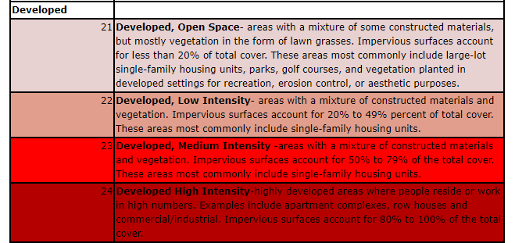

*This page does NOT include the many that were + correlated between the 1km and 500m, 10km and 5km, etc. within the same land cover type. I ignored those as I don’t ever plan to include them in the same models.*

* Weak positive (0.5 to 0.699)
  + Hardwood density at 10cm & Hardwood density at 50cm
  + **Evergreen@30km & FG_herb (forbs & grasses at shortest level)**
  + Grass30km & Ag5km
  + Grass30km & Ag30km
  + Ag@30km & OpenDev@30km
  + OpenDev@5km & Impervious@5km
  + OpenDev@30km & LowDev@30km
  + OpenDev@1km & LowDev1km
  + OpenDev@5km & HighDev5km
  + **HydricSoils rating & Patch Area**
  + **Hydric Soils rating & Core Area Index**
* Strong positive (0.7 to 1.0)
  + Canopy Cover & Basal Area
  + Age & Number of Thins
  + Hardwood density at 100cm & Hardwood density at 50cm (duh)
  + Hardwood density 1050 & Hardwood density at 10cm (duh)
  + Hardwood density 1050 & Hardwood density at 50cm (duh)
  + Hardwood@shrub height (~1m) & Hardwood density at 100cm
  + HighDev@500m & Impervious@500m (pick one going forward)
  + HighDev@1km & Impervious@1km
  + HighDev@5km & Impervious@5km
  + OpenDev@5km & LowDev@5km
  + OpenDev@1km & OpenDev@500m
  + OpenDev@30km & Impervious@30km
  + LowDev@30km & Impervious@30km
  + LowDev@5km & HighDev@5km
  + LowDev5km & Impervious@5km
  + LowDev1km & LowDev500m
  + OpenDev@30km & LowDev@30km
  + **HighDev@30km & Evergreen@5km**
  + **ProtectedArea@30km & Evergreen@5km**
  + **Water30km & ProtectedArea@30km**
  + **CoreAreaIndex & OpenDev@30km**
  + FractalDimensionIndex & ShapeIndex (duh – only use one of these two)
  + Patch Area & Core Area Index (pick only one of these two)
  + SiteIndex of Primary Soils & Forest Productivity Site Index (duh – I calculated one based on the other, I will only use one going forward)
  + Schrubs30km & Evergreen5km
  + Schrubs30km & HighDev30km
  + Schrubs1km & Hardwood Density at 100cm