Results early trial - overall SR

Jesse Wood

April 15, 2018

## R Markdown

This is an R Markdown document. Markdown is a simple formatting syntax for authoring HTML, PDF, and MS Word documents. For more details on using R Markdown see <http://rmarkdown.rstudio.com>.

Setup

library("unmarked")

## Warning: package 'unmarked' was built under R version 3.3.2

## Loading required package: reshape

## Warning: package 'reshape' was built under R version 3.3.2

## Loading required package: lattice

## Warning: package 'lattice' was built under R version 3.3.3

## Loading required package: Rcpp

## Warning: package 'Rcpp' was built under R version 3.3.2

setwd("C:/Users/woodj/Documents/GRAD SCHOOL - CLEMSON/Project-Specific/R work/USDA-songbirds/USDA-songbirds")

# Evaluate Audio Counts (AC) vs Point Counts (PC)

#File read-in  
# as of 04/12, the "one visit" from AC includes a few too many species (UNKNS unsorted)  
methodSR <-read.csv("17_1by1_ACPC_SR.csv") #SR by 1 visit each - Site Type SR  
summary(methodSR)

## SiteName Type SR X   
## Abercrombie_0B_E_AB: 2 AC:29 Min. : 9.00 Mode:logical   
## Abercrombie_1B_2 : 2 PC:29 1st Qu.:13.25 NA's:58   
## Blease_3B_6 : 2 Median :16.50   
## Blease_3B_9 : 2 Mean :15.83   
## Bryson_2B_9 : 2 3rd Qu.:18.00   
## Burnett_1B_5 : 2 Max. :25.00   
## (Other) :46   
## X.1 X.2 X.3 X.4   
## Mode:logical Mode:logical Mode:logical Mode:logical   
## NA's:58 NA's:58 NA's:58 NA's:58   
##   
##   
##   
##   
##   
## X.5   
## Mode:logical   
## NA's:58   
##   
##   
##   
##   
##

str(methodSR)

## 'data.frame': 58 obs. of 9 variables:  
## $ SiteName: Factor w/ 29 levels "Abercrombie_0B_E_AB",..: 3 3 4 4 5 5 7 7 8 8 ...  
## $ Type : Factor w/ 2 levels "AC","PC": 1 2 1 2 1 2 1 2 1 2 ...  
## $ SR : int 16 17 14 18 11 15 11 11 12 18 ...  
## $ X : logi NA NA NA NA NA NA ...  
## $ X.1 : logi NA NA NA NA NA NA ...  
## $ X.2 : logi NA NA NA NA NA NA ...  
## $ X.3 : logi NA NA NA NA NA NA ...  
## $ X.4 : logi NA NA NA NA NA NA ...  
## $ X.5 : logi NA NA NA NA NA NA ...

plot(methodSR$SR ~ methodSR$Type)

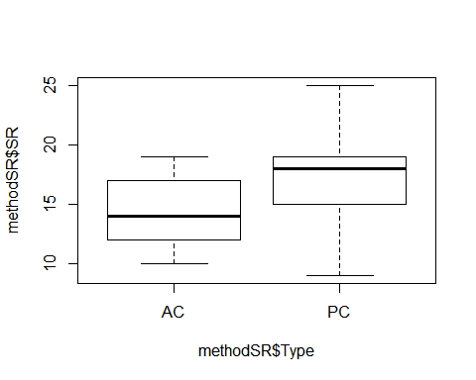

#plot(SR ~ Type, data=methodSR) #same as above

evaluation<-lm(SR ~ Type, methodSR)  
summary(evaluation) #looks important/significant!

##   
## Call:  
## lm(formula = SR ~ Type, data = methodSR)  
##   
## Residuals:  
## Min 1Q Median 3Q Max   
## -8.2069 -2.3879 0.1724 2.5517 7.7931   
##   
## Coefficients:  
## Estimate Std. Error t value Pr(>|t|)   
## (Intercept) 14.4483 0.6047 23.891 <2e-16 ***  
## TypePC 2.7586 0.8552 3.226 0.0021 **   
## ---  
## Signif. codes: 0 '***' 0.001 '**' 0.01 '*' 0.05 '.' 0.1 ' ' 1  
##   
## Residual standard error: 3.257 on 56 degrees of freedom  
## Multiple R-squared: 0.1567, Adjusted R-squared: 0.1416   
## F-statistic: 10.4 on 1 and 56 DF, p-value: 0.002101

confint(evaluation, level=0.95)

## 2.5 % 97.5 %  
## (Intercept) 13.236818 15.65973  
## TypePC 1.045361 4.47188

anova(evaluation)

## Analysis of Variance Table  
##   
## Response: SR  
## Df Sum Sq Mean Sq F value Pr(>F)   
## Type 1 110.34 110.345 10.404 0.002101 **  
## Residuals 56 593.93 10.606   
## ---  
## Signif. codes: 0 '***' 0.001 '**' 0.01 '*' 0.05 '.' 0.1 ' ' 1

# Audio Count Data Only

## all 4 audio visits pooled ##

#sr_covs CSV file is SR by sites by point counts (pooled 1-4) file (NP flyovers excluded)  
richness <-read.csv("sr_covs.csv") #SR by sites by point count overall SR #all effort  
summary(richness)

## Site SR Treatment Nthins   
## :13 Min. :19.00 :13 Min. :0.000   
## Battlewood_1B_8 : 1 1st Qu.:22.00 0B:12 1st Qu.:1.000   
## Battlewood_1B_E_B: 1 Median :25.00 1B:13 Median :2.000   
## Blease_3B_6 : 1 Mean :25.08 2B:12 Mean :1.784   
## Blease_3B_9 : 1 3rd Qu.:27.00 3B:14 3rd Qu.:2.000   
## Bryson_1B_9 : 1 Max. :33.00 Max. :6.000   
## (Other) :46 NA's :13 NA's :13   
## Nburns BA Herbicide Age   
## Min. : 0.000 Min. : 38.00 Min. :0.0000 Min. :15.00   
## 1st Qu.: 1.000 1st Qu.: 74.50 1st Qu.:0.0000 1st Qu.:21.00   
## Median : 2.000 Median : 90.00 Median :1.0000 Median :26.00   
## Mean : 2.078 Mean : 85.31 Mean :0.5882 Mean :26.98   
## 3rd Qu.: 3.000 3rd Qu.: 97.00 3rd Qu.:1.0000 3rd Qu.:31.00   
## Max. :12.000 Max. :124.00 Max. :1.0000 Max. :57.00   
## NA's :13 NA's :13 NA's :13 NA's :13   
## Parea   
## Min. : 15.84   
## 1st Qu.: 29.45   
## Median : 46.92   
## Mean : 78.01   
## 3rd Qu.: 97.75   
## Max. :267.63   
## NA's :13

str(richness)

## 'data.frame': 64 obs. of 9 variables:  
## $ Site : Factor w/ 52 levels "","Battlewood_1B_8",..: 2 3 4 5 6 7 8 9 10 11 ...  
## $ SR : int 21 24 33 27 22 23 27 21 25 22 ...  
## $ Treatment: Factor w/ 5 levels "","0B","1B","2B",..: 3 3 5 5 3 4 5 3 2 4 ...  
## $ Nthins : int 1 1 2 2 3 3 3 2 0 1 ...  
## $ Nburns : int 1 1 4 12 1 2 3 1 0 2 ...  
## $ BA : int 81 84 102 87 92 91 90 77 100 81 ...  
## $ Herbicide: int 0 0 1 1 1 1 1 1 0 1 ...  
## $ Age : int 32 20 32 37 35 35 35 29 27 42 ...  
## $ Parea : num 127 45.6 70 38.3 32.3 ...

#var(richness[2:5])  
#mean(richness[2:2])  
#mean(richness$SR)

richness <-read.csv("sr_covs.csv") #SR by sites by point count overall SR #all effort  
richness$Herbicide <- factor(richness$Herbicide)  
sapply(richness, mean, na.rm=TRUE)

## Warning in mean.default(X[[i]], ...): argument is not numeric or logical:  
## returning NA  
  
## Warning in mean.default(X[[i]], ...): argument is not numeric or logical:  
## returning NA  
  
## Warning in mean.default(X[[i]], ...): argument is not numeric or logical:  
## returning NA

## Site SR Treatment Nthins Nburns BA Herbicide   
## NA 25.078431 NA 1.784314 2.078431 85.313725 NA   
## Age Parea   
## 26.980392 78.011471

library(psych)

## Warning: package 'psych' was built under R version 3.3.3

sumtable <- describeBy(richness, group=richness$Treatment)

## Warning in FUN(newX[, i], ...): no non-missing arguments to min; returning  
## Inf

## Warning in FUN(newX[, i], ...): no non-missing arguments to min; returning  
## Inf  
  
## Warning in FUN(newX[, i], ...): no non-missing arguments to min; returning  
## Inf  
  
## Warning in FUN(newX[, i], ...): no non-missing arguments to min; returning  
## Inf  
  
## Warning in FUN(newX[, i], ...): no non-missing arguments to min; returning  
## Inf  
  
## Warning in FUN(newX[, i], ...): no non-missing arguments to min; returning  
## Inf  
  
## Warning in FUN(newX[, i], ...): no non-missing arguments to min; returning  
## Inf

## Warning in FUN(newX[, i], ...): no non-missing arguments to max; returning  
## -Inf  
  
## Warning in FUN(newX[, i], ...): no non-missing arguments to max; returning  
## -Inf  
  
## Warning in FUN(newX[, i], ...): no non-missing arguments to max; returning  
## -Inf  
  
## Warning in FUN(newX[, i], ...): no non-missing arguments to max; returning  
## -Inf  
  
## Warning in FUN(newX[, i], ...): no non-missing arguments to max; returning  
## -Inf  
  
## Warning in FUN(newX[, i], ...): no non-missing arguments to max; returning  
## -Inf  
  
## Warning in FUN(newX[, i], ...): no non-missing arguments to max; returning  
## -Inf

sumtable

##   
## Descriptive statistics by group   
## group:   
## vars n mean sd median trimmed mad min max range skew kurtosis  
## Site* 1 13 1 0 1 1 0 1 1 0 NaN NaN  
## SR 2 0 NaN NA NA NaN NA Inf -Inf -Inf NA NA  
## Treatment* 3 13 1 0 1 1 0 1 1 0 NaN NaN  
## Nthins 4 0 NaN NA NA NaN NA Inf -Inf -Inf NA NA  
## Nburns 5 0 NaN NA NA NaN NA Inf -Inf -Inf NA NA  
## BA 6 0 NaN NA NA NaN NA Inf -Inf -Inf NA NA  
## Herbicide* 7 0 NaN NA NA NaN NA Inf -Inf -Inf NA NA  
## Age 8 0 NaN NA NA NaN NA Inf -Inf -Inf NA NA  
## Parea 9 0 NaN NA NA NaN NA Inf -Inf -Inf NA NA  
## se  
## Site* 0  
## SR NA  
## Treatment* 0  
## Nthins NA  
## Nburns NA  
## BA NA  
## Herbicide* NA  
## Age NA  
## Parea NA  
## --------------------------------------------------------   
## group: 0B  
## vars n mean sd median trimmed mad min max range  
## Site* 1 12 28.83 15.47 31.50 28.60 25.20 10.00 50.00 40.00  
## SR 2 12 23.83 2.86 23.50 23.80 2.22 19.00 29.00 10.00  
## Treatment* 3 12 2.00 0.00 2.00 2.00 0.00 2.00 2.00 0.00  
## Nthins 4 12 1.08 0.51 1.00 1.10 0.00 0.00 2.00 2.00  
## Nburns 5 12 0.00 0.00 0.00 0.00 0.00 0.00 0.00 0.00  
## BA 6 12 98.58 10.84 97.50 98.60 6.67 76.00 121.00 45.00  
## Herbicide* 7 12 1.33 0.49 1.00 1.30 0.00 1.00 2.00 1.00  
## Age 8 12 22.25 4.27 22.00 22.10 4.45 16.00 30.00 14.00  
## Parea 9 12 82.69 57.51 61.56 79.79 49.67 18.27 176.03 157.76  
## skew kurtosis se  
## Site* 0.08 -1.78 4.47  
## SR 0.26 -0.90 0.82  
## Treatment* NaN NaN 0.00  
## Nthins 0.16 0.31 0.15  
## Nburns NaN NaN 0.00  
## BA 0.04 0.23 3.13  
## Herbicide* 0.62 -1.74 0.14  
## Age 0.05 -1.08 1.23  
## Parea 0.56 -1.35 16.60  
## --------------------------------------------------------   
## group: 1B  
## vars n mean sd median trimmed mad min max range  
## Site* 1 13 24.31 14.87 29.00 24.18 11.86 2.00 48.0 46.00  
## SR 2 13 23.69 3.45 24.00 23.55 2.97 19.00 30.0 11.00  
## Treatment* 3 13 3.00 0.00 3.00 3.00 0.00 3.00 3.0 0.00  
## Nthins 4 13 1.46 0.66 1.00 1.36 0.00 1.00 3.0 2.00  
## Nburns 5 13 1.00 0.00 1.00 1.00 0.00 1.00 1.0 0.00  
## BA 6 13 89.46 18.87 92.00 89.91 16.31 50.00 124.0 74.00  
## Herbicide* 7 13 1.46 0.52 1.00 1.45 0.00 1.00 2.0 1.00  
## Age 8 13 24.77 6.38 23.00 24.73 8.90 15.00 35.0 20.00  
## Parea 9 13 80.62 86.98 37.36 71.07 29.17 15.84 250.5 234.66  
## skew kurtosis se  
## Site* -0.27 -1.43 4.12  
## SR 0.59 -0.83 0.96  
## Treatment* NaN NaN 0.00  
## Nthins 0.93 -0.45 0.18  
## Nburns NaN NaN 0.00  
## BA -0.12 -0.36 5.23  
## Herbicide* 0.14 -2.13 0.14  
## Age 0.00 -1.51 1.77  
## Parea 1.05 -0.60 24.12  
## --------------------------------------------------------   
## group: 2B  
## vars n mean sd median trimmed mad min max range  
## Site* 1 12 26.92 14.20 21.50 27.00 18.53 7.00 46.00 39  
## SR 2 12 25.08 3.68 25.50 25.00 2.97 19.00 32.00 13  
## Treatment* 3 12 4.00 0.00 4.00 4.00 0.00 4.00 4.00 0  
## Nthins 4 12 1.75 0.75 2.00 1.70 1.48 1.00 3.00 2  
## Nburns 5 12 2.00 0.00 2.00 2.00 0.00 2.00 2.00 0  
## BA 6 12 79.33 9.96 81.50 79.30 13.34 66.00 93.00 27  
## Herbicide* 7 12 1.83 0.39 2.00 1.90 0.00 1.00 2.00 1  
## Age 8 12 26.17 7.06 26.00 25.60 2.22 16.00 42.00 26  
## Parea 9 12 54.92 39.97 42.55 47.06 23.23 25.18 163.18 138  
## skew kurtosis se  
## Site* 0.14 -1.79 4.10  
## SR 0.02 -0.86 1.06  
## Treatment* NaN NaN 0.00  
## Nthins 0.36 -1.33 0.22  
## Nburns NaN NaN 0.00  
## BA -0.02 -1.64 2.87  
## Herbicide* -1.57 0.53 0.11  
## Age 0.64 -0.06 2.04  
## Parea 1.58 1.64 11.54  
## --------------------------------------------------------   
## group: 3B  
## vars n mean sd median trimmed mad min max range  
## Site* 1 14 28.00 16.16 25.50 28.00 24.46 4.00 52.00 48.00  
## SR 2 14 27.43 3.32 27.00 27.50 3.71 21.00 33.00 12.00  
## Treatment* 3 14 5.00 0.00 5.00 5.00 0.00 5.00 5.00 0.00  
## Nthins 4 14 2.71 1.07 2.50 2.50 0.74 2.00 6.00 4.00  
## Nburns 5 14 4.93 2.79 3.50 4.50 0.74 3.00 12.00 9.00  
## BA 6 14 75.21 21.72 75.50 75.83 21.50 38.00 105.00 67.00  
## Herbicide* 7 14 1.71 0.47 2.00 1.75 0.00 1.00 2.00 1.00  
## Age 8 14 33.79 7.57 32.00 32.58 3.71 25.00 57.00 32.00  
## Parea 9 14 91.38 88.39 50.34 82.50 31.89 21.69 267.63 245.94  
## skew kurtosis se  
## Site* 0.01 -1.39 4.32  
## SR -0.17 -0.81 0.89  
## Treatment* NaN NaN 0.00  
## Nthins 1.93 3.48 0.29  
## Nburns 1.22 0.31 0.74  
## BA -0.49 -1.08 5.81  
## Herbicide* -0.85 -1.36 0.13  
## Age 1.92 3.52 2.02  
## Parea 1.11 -0.47 23.62

#write.table(sumtable, file="C:/Users/woodj/Documents/GRAD SCHOOL - CLEMSON/Project-Specific/R work/USDA-songbirds/USDA-songbirds/SR_summary_by_Treatment.xls",sep="\t")

#begin simple explorations of some exp variables  
plot(richness$SR ~ richness$Age)

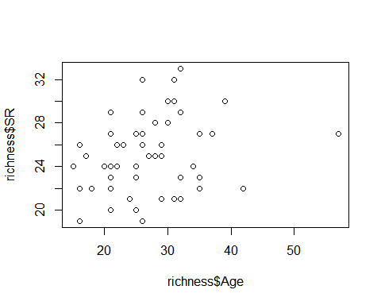

plot(richness$SR ~ richness$Nburns)

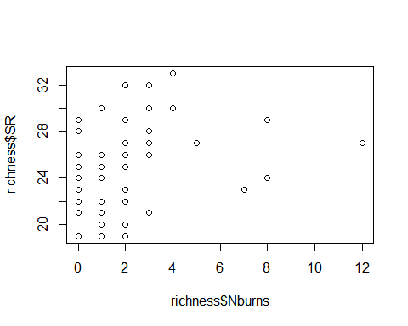

plot(richness$SR ~ richness$BA)

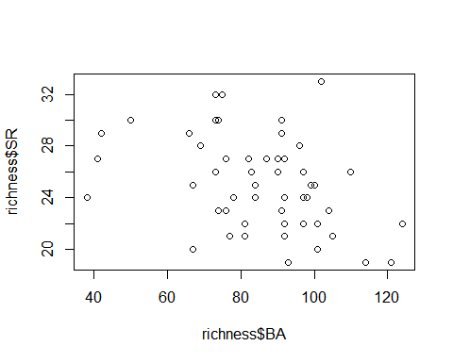

plot(richness$SR ~ richness$Parea)

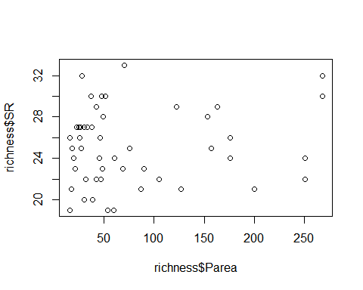

lm(SR ~ Treatment, richness)

##   
## Call:  
## lm(formula = SR ~ Treatment, data = richness)  
##   
## Coefficients:  
## (Intercept) Treatment1B Treatment2B Treatment3B   
## 23.833 -0.141 1.250 3.595

summary(lm(SR ~ Treatment, richness)) #3B statistically different from others

##   
## Call:  
## lm(formula = SR ~ Treatment, data = richness)  
##   
## Residuals:  
## Min 1Q Median 3Q Max   
## -6.4286 -1.9583 -0.0833 1.9167 6.9167   
##   
## Coefficients:  
## Estimate Std. Error t value Pr(>|t|)   
## (Intercept) 23.8333 0.9646 24.708 < 2e-16 ***  
## Treatment1B -0.1410 1.3377 -0.105 0.91649   
## Treatment2B 1.2500 1.3642 0.916 0.36418   
## Treatment3B 3.5952 1.3145 2.735 0.00877 **   
## ---  
## Signif. codes: 0 '***' 0.001 '**' 0.01 '*' 0.05 '.' 0.1 ' ' 1  
##   
## Residual standard error: 3.341 on 47 degrees of freedom  
## (13 observations deleted due to missingness)  
## Multiple R-squared: 0.1873, Adjusted R-squared: 0.1354   
## F-statistic: 3.609 on 3 and 47 DF, p-value: 0.01993

plot(SR ~ Treatment, data=richness)

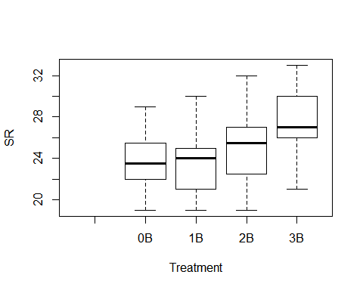

lm(SR ~ Herbicide, richness)

##   
## Call:  
## lm(formula = SR ~ Herbicide, data = richness)  
##   
## Coefficients:  
## (Intercept) Herbicide1   
## 24.9524 0.2143

summary(lm(SR ~ Herbicide, richness)) #nothing going on here - no stat sig difference bw 0 or 1

##   
## Call:  
## lm(formula = SR ~ Herbicide, data = richness)  
##   
## Residuals:  
## Min 1Q Median 3Q Max   
## -6.1667 -3.0595 0.0476 1.8333 7.8333   
##   
## Coefficients:  
## Estimate Std. Error t value Pr(>|t|)   
## (Intercept) 24.9524 0.7918 31.514 <2e-16 ***  
## Herbicide1 0.2143 1.0324 0.208 0.836   
## ---  
## Signif. codes: 0 '***' 0.001 '**' 0.01 '*' 0.05 '.' 0.1 ' ' 1  
##   
## Residual standard error: 3.628 on 49 degrees of freedom  
## (13 observations deleted due to missingness)  
## Multiple R-squared: 0.0008785, Adjusted R-squared: -0.01951   
## F-statistic: 0.04308 on 1 and 49 DF, p-value: 0.8364

plot(SR ~ Herbicide, data=richness)

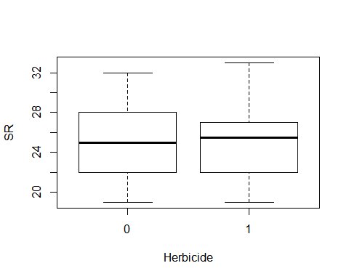

lm(SR ~ Nthins, data=richness)

##   
## Call:  
## lm(formula = SR ~ Nthins, data = richness)  
##   
## Coefficients:  
## (Intercept) Nthins   
## 23.4323 0.9226

plot(SR ~ Nthins, data=richness)

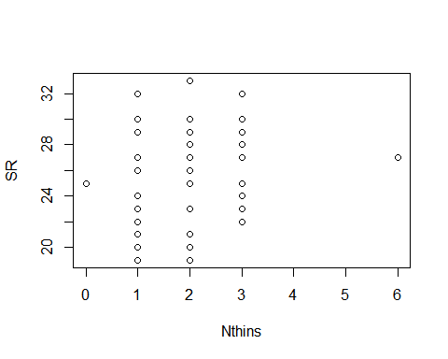

interaction.plot(richness$Treatment, richness$Nburns, richness$SR)

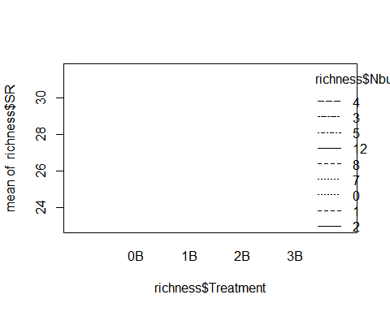

summary(lm(SR ~ Parea, richness)) #so no species-area relationsip?

##   
## Call:  
## lm(formula = SR ~ Parea, data = richness)  
##   
## Residuals:  
## Min 1Q Median 3Q Max   
## -5.9659 -2.8232 -0.0645 2.2594 7.9717   
##   
## Coefficients:  
## Estimate Std. Error t value Pr(>|t|)   
## (Intercept) 24.588955 0.750510 32.763 <2e-16 ***  
## Parea 0.006274 0.007125 0.881 0.383   
## ---  
## Signif. codes: 0 '***' 0.001 '**' 0.01 '*' 0.05 '.' 0.1 ' ' 1  
##   
## Residual standard error: 3.602 on 49 degrees of freedom  
## (13 observations deleted due to missingness)  
## Multiple R-squared: 0.01558, Adjusted R-squared: -0.004509   
## F-statistic: 0.7756 on 1 and 49 DF, p-value: 0.3828

fit<-lm(SR ~ Treatment + BA + Parea, data=richness)  
summary(fit)

##   
## Call:  
## lm(formula = SR ~ Treatment + BA + Parea, data = richness)  
##   
## Residuals:  
## Min 1Q Median 3Q Max   
## -5.6831 -1.9952 0.1006 2.0590 7.3397   
##   
## Coefficients:  
## Estimate Std. Error t value Pr(>|t|)   
## (Intercept) 29.003672 2.986197 9.713 1.29e-12 ***  
## Treatment1B -0.665758 1.328051 -0.501 0.6186   
## Treatment2B 0.336821 1.438655 0.234 0.8160   
## Treatment3B 2.134971 1.460230 1.462 0.1507   
## BA -0.059403 0.029515 -2.013 0.0502 .   
## Parea 0.008294 0.006726 1.233 0.2240   
## ---  
## Signif. codes: 0 '***' 0.001 '**' 0.01 '*' 0.05 '.' 0.1 ' ' 1  
##   
## Residual standard error: 3.25 on 45 degrees of freedom  
## (13 observations deleted due to missingness)  
## Multiple R-squared: 0.2638, Adjusted R-squared: 0.1821   
## F-statistic: 3.226 on 5 and 45 DF, p-value: 0.01423

confint(fit, level=0.95)

## 2.5 % 97.5 %  
## (Intercept) 22.989161422 3.501818e+01  
## Treatment1B -3.340590699 2.009074e+00  
## Treatment2B -2.560778526 3.234421e+00  
## Treatment3B -0.806084135 5.076026e+00  
## BA -0.118849054 4.396554e-05  
## Parea -0.005253564 2.184068e-02

anova(fit)

## Analysis of Variance Table  
##   
## Response: SR  
## Df Sum Sq Mean Sq F value Pr(>F)   
## Treatment 3 120.91 40.302 3.8155 0.01612 *  
## BA 1 33.40 33.398 3.1619 0.08213 .  
## Parea 1 16.06 16.059 1.5204 0.22397   
## Residuals 45 475.32 10.563   
## ---  
## Signif. codes: 0 '***' 0.001 '**' 0.01 '*' 0.05 '.' 0.1 ' ' 1

plot(SR ~ Age, ann=FALSE, type="n", xlim=c(10,60), ylim=c(10,40), data=richness)  
lines(SR~Age,lwd=2, data=richness)

