Results early trial - overall SR

Jesse Wood

April 15, 2018

## R Markdown

This is an R Markdown document. Markdown is a simple formatting syntax for authoring HTML, PDF, and MS Word documents. For more details on using R Markdown see <http://rmarkdown.rstudio.com>.

Setup

library("unmarked")

## Loading required package: reshape

## Loading required package: lattice

## Loading required package: parallel

## Loading required package: Rcpp

library("ggplot2")  
setwd("C:/Users/woodj/Documents/GRAD SCHOOL - CLEMSON/Project-Specific/R work/USDA-songbirds/USDA-songbirds")

# Evaluate Audio Counts (AC) vs Point Counts (PC)

#File read-in  
# as of 04/12, the "one visit" from AC includes a few too many species (UNKNS unsorted)  
methodSR1 <-read.csv("17_1by1_ACPC_SR.csv") #SR by 1 visit each - Site Type SR  
summary(methodSR1)

## SiteName Type SR Sdate   
## Abercrombie_0B_E_AB: 2 AC:29 Min. : 8.00 Min. :42865   
## Abercrombie_1B_2 : 2 PC:29 1st Qu.:12.00 1st Qu.:42867   
## Blease_3B_6 : 2 Median :14.00 Median :42873   
## Blease_3B_9 : 2 Mean :14.16 Mean :42878   
## Bryson_2B_9 : 2 3rd Qu.:16.00 3rd Qu.:42888   
## Burnett_1B_5 : 2 Max. :21.00 Max. :42915   
## (Other) :46   
## Stime Pdate Pmin Peffort Year   
## Min. :353.0 Min. :43181 Min. :12.00 Min. :1.000 A:58   
## 1st Qu.:404.0 1st Qu.:43185 1st Qu.:18.00 1st Qu.:2.000   
## Median :435.0 Median :43189 Median :22.00 Median :2.000   
## Mean :447.7 Mean :43189 Mean :23.76 Mean :2.517   
## 3rd Qu.:496.2 3rd Qu.:43193 3rd Qu.:30.00 3rd Qu.:3.000   
## Max. :589.0 Max. :43196 Max. :55.00 Max. :4.000   
## NA's :29 NA's :29 NA's :29

str(methodSR1)

## 'data.frame': 58 obs. of 9 variables:  
## $ SiteName: Factor w/ 29 levels "Abercrombie_0B_E_AB",..: 3 4 5 7 8 12 13 14 15 16 ...  
## $ Type : Factor w/ 2 levels "AC","PC": 1 1 1 1 1 1 1 1 1 1 ...  
## $ SR : int 15 14 11 10 11 16 13 17 14 11 ...  
## $ Sdate : int 42868 42881 42896 42898 42888 42889 42895 42892 42875 42887 ...  
## $ Stime : int 570 403 497 380 503 382 479 481 580 409 ...  
## $ Pdate : int 43181 43181 43186 43195 43196 43182 43188 43188 43188 43188 ...  
## $ Pmin : int 26 23 17 20 32 31 18 20 25 18 ...  
## $ Peffort : int 3 2 1 2 3 3 2 2 4 3 ...  
## $ Year : Factor w/ 1 level "A": 1 1 1 1 1 1 1 1 1 1 ...

plot(methodSR1$SR ~ methodSR1$Type)

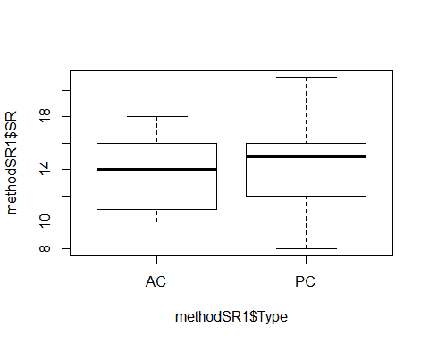

#plot(SR ~ Type, data=methodSR) #same as above

evaluation1<-lm(SR ~ Type, methodSR1)  
summary(evaluation1) #looks important/significant!

##   
## Call:  
## lm(formula = SR ~ Type, data = methodSR1)  
##   
## Residuals:  
## Min 1Q Median 3Q Max   
## -6.6207 -2.6207 0.3103 1.3793 6.3793   
##   
## Coefficients:  
## Estimate Std. Error t value Pr(>|t|)   
## (Intercept) 13.6897 0.5282 25.919 <2e-16 ***  
## TypePC 0.9310 0.7469 1.246 0.218   
## ---  
## Signif. codes: 0 '***' 0.001 '**' 0.01 '*' 0.05 '.' 0.1 ' ' 1  
##   
## Residual standard error: 2.844 on 56 degrees of freedom  
## Multiple R-squared: 0.027, Adjusted R-squared: 0.00962   
## F-statistic: 1.554 on 1 and 56 DF, p-value: 0.2178

confint(evaluation1, level=0.95)

## 2.5 % 97.5 %  
## (Intercept) 12.6316062 14.747704  
## TypePC -0.5652727 2.427342

anova(evaluation1)

## Analysis of Variance Table  
##   
## Response: SR  
## Df Sum Sq Mean Sq F value Pr(>F)  
## Type 1 12.57 12.5690 1.5537 0.2178  
## Residuals 56 453.03 8.0899

#File read-in  
# a few UNKNs still but reduced to 1 or 2  
methodSR2 <-read.csv("17_2by2_ACPC_SR.csv") #SR by count #2 each - Site Type SR  
#summary(methodSR2)  
str(methodSR2)

## 'data.frame': 58 obs. of 9 variables:  
## $ SiteName: Factor w/ 29 levels "Abercrombie_0B_E_AB",..: 3 4 5 7 8 12 13 14 15 16 ...  
## $ Type : Factor w/ 2 levels "AC","PC": 1 1 1 1 1 1 1 1 1 1 ...  
## $ SR : int 17 15 11 9 9 16 13 10 17 13 ...  
## $ Sdate : int 42867 42882 42893 42901 42887 42890 42900 42893 42874 42887 ...  
## $ Stime : int 426 353 553 355 354 558 386 425 521 514 ...  
## $ Pdate : int 43201 43201 43203 43209 43210 43202 43205 43205 43206 43205 ...  
## $ Pmin : int 39 25 27 14 15 15 18 22 15 21 ...  
## $ Peffort : int 4 3 3 1 1 2 2 2 2 2 ...  
## $ Year : Factor w/ 1 level "A": 1 1 1 1 1 1 1 1 1 1 ...

plot(methodSR2$SR ~ methodSR2$Type) #AC slightly higher, but totally overlap

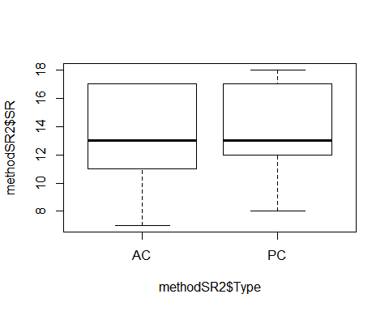

#plot(SR ~ Type, data=methodSR) #same as above

evaluation2<-lm(SR ~ Type, methodSR2)  
summary(evaluation2) #this visit is NOT significant!

##   
## Call:  
## lm(formula = SR ~ Type, data = methodSR2)  
##   
## Residuals:  
## Min 1Q Median 3Q Max   
## -6.2414 -2.1724 -0.2414 3.0345 4.0345   
##   
## Coefficients:  
## Estimate Std. Error t value Pr(>|t|)   
## (Intercept) 13.2414 0.5561 23.810 <2e-16 ***  
## TypePC 0.7241 0.7865 0.921 0.361   
## ---  
## Signif. codes: 0 '***' 0.001 '**' 0.01 '*' 0.05 '.' 0.1 ' ' 1  
##   
## Residual standard error: 2.995 on 56 degrees of freedom  
## Multiple R-squared: 0.01491, Adjusted R-squared: -0.002679   
## F-statistic: 0.8477 on 1 and 56 DF, p-value: 0.3611

confint(evaluation2, level=0.95)

## 2.5 % 97.5 %  
## (Intercept) 12.1273124 14.355446  
## TypePC -0.8513906 2.299666

anova(evaluation2)

## Analysis of Variance Table  
##   
## Response: SR  
## Df Sum Sq Mean Sq F value Pr(>F)  
## Type 1 7.60 7.6034 0.8477 0.3611  
## Residuals 56 502.28 8.9692

#File read-in  
# a few UNKNs still but reduced to 1 or 2  
methodSR3 <-read.csv("17_3by3_ACPC_SR.csv") #SR by count #3 each - Site Type SR  
#summary(methodSR3)  
str(methodSR3)

## 'data.frame': 58 obs. of 9 variables:  
## $ SiteName: Factor w/ 29 levels "Abercrombie_0B_E_AB",..: 3 4 5 7 8 12 13 14 15 16 ...  
## $ Type : Factor w/ 2 levels "AC","PC": 1 1 1 1 1 1 1 1 1 1 ...  
## $ SR : int 10 16 11 15 16 15 14 13 15 13 ...  
## $ Sdate : int 42880 42883 42912 42898 42887 42898 42899 42894 42875 42885 ...  
## $ Stime : int 363 500 380 513 559 507 526 359 395 566 ...  
## $ Pdate : int 43214 43214 43216 43219 43220 43215 43216 43216 43217 43216 ...  
## $ Pmin : int 18 15 14 17 12 16 14 15 19 14 ...  
## $ Peffort : int 1 2 2 3 2 3 2 1 3 2 ...  
## $ Year : Factor w/ 1 level "A": 1 1 1 1 1 1 1 1 1 1 ...

plot(methodSR3$SR ~ methodSR3$Type) #

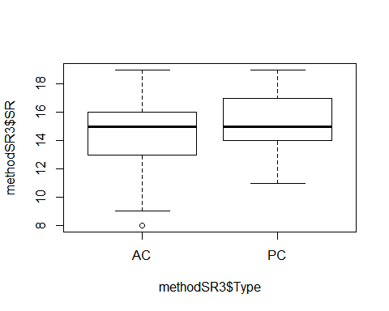

#plot(SR ~ Type, data=methodSR) #same as above

evaluation3<-lm(SR ~ Type, methodSR3)  
summary(evaluation3) #this visit is NOT significant!

##   
## Call:  
## lm(formula = SR ~ Type, data = methodSR3)  
##   
## Residuals:  
## Min 1Q Median 3Q Max   
## -6.4828 -1.4828 0.5172 1.5172 4.5172   
##   
## Coefficients:  
## Estimate Std. Error t value Pr(>|t|)   
## (Intercept) 14.4828 0.4607 31.436 <2e-16 ***  
## TypePC 0.6552 0.6515 1.006 0.319   
## ---  
## Signif. codes: 0 '***' 0.001 '**' 0.01 '*' 0.05 '.' 0.1 ' ' 1  
##   
## Residual standard error: 2.481 on 56 degrees of freedom  
## Multiple R-squared: 0.01774, Adjusted R-squared: 0.0001965   
## F-statistic: 1.011 on 1 and 56 DF, p-value: 0.3189

confint(evaluation3, level=0.95)

## 2.5 % 97.5 %  
## (Intercept) 13.5598595 15.405658  
## TypePC -0.6500041 1.960349

anova(evaluation3)

## Analysis of Variance Table  
##   
## Response: SR  
## Df Sum Sq Mean Sq F value Pr(>F)  
## Type 1 6.22 6.2241 1.0112 0.3189  
## Residuals 56 344.69 6.1552

# 3 visits pooled - I think need to recalc 3-visit SR for PC data! (not 4th visit!)

#File read-in  
# a few UNKNs - not treated well yet! have to rerun eventually  
methodOSR <-read.csv("17_all3_ACPC_SR.csv") #SR by 3 counts pooled SR  
#summary(methodOSR)  
str(methodOSR)

## 'data.frame': 58 obs. of 3 variables:  
## $ SiteName: Factor w/ 29 levels "Abercrombie_0B_E_AB",..: 3 4 5 7 8 12 13 14 15 16 ...  
## $ Type : Factor w/ 2 levels "AC","PC": 1 1 1 1 1 1 1 1 1 1 ...  
## $ SR : int 23 22 17 23 23 24 23 26 24 20 ...

plot(methodOSR$SR ~ methodOSR$Type)

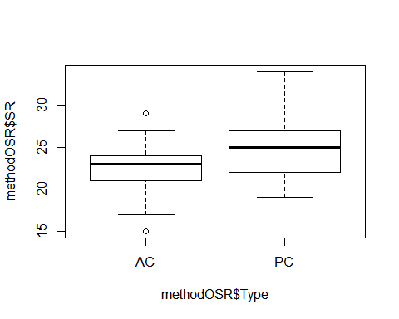

evaluationOSR<-lm(SR ~ Type, methodOSR)  
summary(evaluationOSR)

##   
## Call:  
## lm(formula = SR ~ Type, data = methodOSR)  
##   
## Residuals:  
## Min 1Q Median 3Q Max   
## -7.3793 -2.3276 0.2241 1.6207 8.8276   
##   
## Coefficients:  
## Estimate Std. Error t value Pr(>|t|)   
## (Intercept) 22.3793 0.6773 33.042 < 2e-16 ***  
## TypePC 2.7931 0.9578 2.916 0.00509 **   
## ---  
## Signif. codes: 0 '***' 0.001 '**' 0.01 '*' 0.05 '.' 0.1 ' ' 1  
##   
## Residual standard error: 3.647 on 56 degrees of freedom  
## Multiple R-squared: 0.1318, Adjusted R-squared: 0.1163   
## F-statistic: 8.503 on 1 and 56 DF, p-value: 0.005091

confint(evaluationOSR, level=0.95)

## 2.5 % 97.5 %  
## (Intercept) 21.0225342 23.736087  
## TypePC 0.8743322 4.711875

anova(evaluationOSR)

## Analysis of Variance Table  
##   
## Response: SR  
## Df Sum Sq Mean Sq F value Pr(>F)   
## Type 1 113.12 113.121 8.5034 0.005091 **  
## Residuals 56 744.97 13.303   
## ---  
## Signif. codes: 0 '***' 0.001 '**' 0.01 '*' 0.05 '.' 0.1 ' ' 1

# Point Count Data Only

## all 4 PC visits pooled ##

#sr_covs CSV file is SR by sites by point counts (pooled 1-4) file (NP flyovers excluded)  
richness <-read.csv("sr_covs.csv") #SR by sites by point count overall SR #all effort  
summary(richness)

## Site SR Treatment Nthins   
## Battlewood_1B_8 : 1 Min. :19.00 0B:12 Min. :0.000   
## Battlewood_1B_E_B: 1 1st Qu.:22.00 1B:13 1st Qu.:1.000   
## Blease_3B_6 : 1 Median :25.00 2B:12 Median :2.000   
## Blease_3B_9 : 1 Mean :25.08 3B:14 Mean :1.784   
## Bryson_1B_9 : 1 3rd Qu.:27.00 3rd Qu.:2.000   
## Bryson_2B_9 : 1 Max. :33.00 Max. :6.000   
## (Other) :45   
## Nburns BA Herbicide Age   
## Min. : 0.000 Min. : 38.00 Min. :0.0000 Min. :15.00   
## 1st Qu.: 1.000 1st Qu.: 74.50 1st Qu.:0.0000 1st Qu.:21.00   
## Median : 2.000 Median : 90.00 Median :1.0000 Median :26.00   
## Mean : 2.078 Mean : 85.31 Mean :0.5882 Mean :26.98   
## 3rd Qu.: 3.000 3rd Qu.: 97.00 3rd Qu.:1.0000 3rd Qu.:31.00   
## Max. :12.000 Max. :124.00 Max. :1.0000 Max. :57.00   
##   
## Parea   
## Min. : 15.84   
## 1st Qu.: 29.45   
## Median : 46.92   
## Mean : 78.01   
## 3rd Qu.: 97.75   
## Max. :267.63   
##

str(richness)

## 'data.frame': 51 obs. of 9 variables:  
## $ Site : Factor w/ 51 levels "Battlewood_1B_8",..: 1 2 3 4 5 6 7 8 9 10 ...  
## $ SR : int 21 24 33 27 22 23 27 21 25 22 ...  
## $ Treatment: Factor w/ 4 levels "0B","1B","2B",..: 2 2 4 4 2 3 4 2 1 3 ...  
## $ Nthins : int 1 1 2 2 3 3 3 2 0 1 ...  
## $ Nburns : int 1 1 4 12 1 2 3 1 0 2 ...  
## $ BA : int 81 84 102 87 92 91 90 77 100 81 ...  
## $ Herbicide: int 0 0 1 1 1 1 1 1 0 1 ...  
## $ Age : int 32 20 32 37 35 35 35 29 27 42 ...  
## $ Parea : num 127 45.6 70 38.3 32.3 ...

#var(richness[2:5])  
#mean(richness[2:2])  
#mean(richness$SR)

lm(SR ~ Site, richness)

##   
## Call:  
## lm(formula = SR ~ Site, data = richness)  
##   
## Coefficients:  
## (Intercept) SiteBattlewood_1B_E_B   
## 2.100e+01 3.000e+00   
## SiteBlease_3B_6 SiteBlease_3B_9   
## 1.200e+01 6.000e+00   
## SiteBryson_1B_9 SiteBryson_2B_9   
## 1.000e+00 2.000e+00   
## SiteBryson_3B_E_B SiteBurnett_Pauline_1B_5   
## 6.000e+00 -2.490e-14   
## SiteCreswell_0B_8 SiteCreswell_2B_10   
## 4.000e+00 1.000e+00   
## SiteGosnell_0B_5A SiteGosnell_0B_5B   
## 5.000e+00 3.000e+00   
## SiteHood_Creek_0B_7 SiteHood_Creek_0B_HC   
## 2.000e+00 3.000e+00   
## SiteHoward_2B_4 SiteHudson_2B_7   
## -1.000e+00 1.100e+01   
## SiteHudson_2B_8 SiteKemp_0B_10   
## 5.000e+00 2.000e+00   
## SiteKemp_1B_1 SiteKemp_2B_2   
## 3.000e+00 4.000e+00   
## SiteKemp_2B_5 SiteKemp_3B_11   
## -2.000e+00 6.000e+00   
## SiteKessler_3B_4 SiteKessler_3B_5A   
## -2.050e-14 9.000e+00   
## SiteKessler_3B_5B SiteLivingston_3B_10   
## 1.100e+01 9.000e+00   
## SiteMathis_1B_6 SiteMathis_1B_7   
## 9.000e+00 9.000e+00   
## SiteMills_0B_9 SiteMills_1B_4   
## 7.000e+00 5.000e+00   
## SiteMills_1B_45 SiteShealy_0B_2   
## 4.000e+00 1.000e+00   
## SiteShealy_0B_4 SiteShealy_1B_3A   
## 8.000e+00 1.000e+00   
## SiteShealy_1B_3B SiteShealy_1B_E_S   
## 3.000e+00 -1.000e+00   
## SiteShealy_2B_3 SiteSuggs_0B_E_S   
## 6.000e+00 2.000e+00   
## SiteSwanson_2B_E_SW SiteSwanson_3B_2   
## 4.000e+00 7.000e+00   
## SiteTimberhaven_2B_1 SiteTimberhaven_3B_7   
## 5.000e+00 8.000e+00   
## SiteTimberhaven_3B_8 SiteTurkey_Rd_2B_6A   
## 3.000e+00 8.000e+00   
## SiteTurkey_Rd_2B_6B SiteTurner_Abercrombie_0B_E_AB   
## 6.000e+00 1.000e+00   
## SiteTurner_Abercrombie_1B_2 SiteTurner_Honea_Path_0B_1   
## -2.000e+00 -2.000e+00   
## SiteTurner_Honea_Path_0B_6 SiteTurner_Honea_Path_3B_1   
## -2.487e-14 6.000e+00   
## SiteTurner_Honea_Path_3B_3   
## 5.000e+00

summary(lm(SR ~ Site, richness))

##   
## Call:  
## lm(formula = SR ~ Site, data = richness)  
##   
## Residuals:  
## ALL 51 residuals are 0: no residual degrees of freedom!  
##   
## Coefficients:  
## Estimate Std. Error t value Pr(>|t|)  
## (Intercept) 2.100e+01 NA NA NA  
## SiteBattlewood_1B_E_B 3.000e+00 NA NA NA  
## SiteBlease_3B_6 1.200e+01 NA NA NA  
## SiteBlease_3B_9 6.000e+00 NA NA NA  
## SiteBryson_1B_9 1.000e+00 NA NA NA  
## SiteBryson_2B_9 2.000e+00 NA NA NA  
## SiteBryson_3B_E_B 6.000e+00 NA NA NA  
## SiteBurnett_Pauline_1B_5 -2.490e-14 NA NA NA  
## SiteCreswell_0B_8 4.000e+00 NA NA NA  
## SiteCreswell_2B_10 1.000e+00 NA NA NA  
## SiteGosnell_0B_5A 5.000e+00 NA NA NA  
## SiteGosnell_0B_5B 3.000e+00 NA NA NA  
## SiteHood_Creek_0B_7 2.000e+00 NA NA NA  
## SiteHood_Creek_0B_HC 3.000e+00 NA NA NA  
## SiteHoward_2B_4 -1.000e+00 NA NA NA  
## SiteHudson_2B_7 1.100e+01 NA NA NA  
## SiteHudson_2B_8 5.000e+00 NA NA NA  
## SiteKemp_0B_10 2.000e+00 NA NA NA  
## SiteKemp_1B_1 3.000e+00 NA NA NA  
## SiteKemp_2B_2 4.000e+00 NA NA NA  
## SiteKemp_2B_5 -2.000e+00 NA NA NA  
## SiteKemp_3B_11 6.000e+00 NA NA NA  
## SiteKessler_3B_4 -2.050e-14 NA NA NA  
## SiteKessler_3B_5A 9.000e+00 NA NA NA  
## SiteKessler_3B_5B 1.100e+01 NA NA NA  
## SiteLivingston_3B_10 9.000e+00 NA NA NA  
## SiteMathis_1B_6 9.000e+00 NA NA NA  
## SiteMathis_1B_7 9.000e+00 NA NA NA  
## SiteMills_0B_9 7.000e+00 NA NA NA  
## SiteMills_1B_4 5.000e+00 NA NA NA  
## SiteMills_1B_45 4.000e+00 NA NA NA  
## SiteShealy_0B_2 1.000e+00 NA NA NA  
## SiteShealy_0B_4 8.000e+00 NA NA NA  
## SiteShealy_1B_3A 1.000e+00 NA NA NA  
## SiteShealy_1B_3B 3.000e+00 NA NA NA  
## SiteShealy_1B_E_S -1.000e+00 NA NA NA  
## SiteShealy_2B_3 6.000e+00 NA NA NA  
## SiteSuggs_0B_E_S 2.000e+00 NA NA NA  
## SiteSwanson_2B_E_SW 4.000e+00 NA NA NA  
## SiteSwanson_3B_2 7.000e+00 NA NA NA  
## SiteTimberhaven_2B_1 5.000e+00 NA NA NA  
## SiteTimberhaven_3B_7 8.000e+00 NA NA NA  
## SiteTimberhaven_3B_8 3.000e+00 NA NA NA  
## SiteTurkey_Rd_2B_6A 8.000e+00 NA NA NA  
## SiteTurkey_Rd_2B_6B 6.000e+00 NA NA NA  
## SiteTurner_Abercrombie_0B_E_AB 1.000e+00 NA NA NA  
## SiteTurner_Abercrombie_1B_2 -2.000e+00 NA NA NA  
## SiteTurner_Honea_Path_0B_1 -2.000e+00 NA NA NA  
## SiteTurner_Honea_Path_0B_6 -2.487e-14 NA NA NA  
## SiteTurner_Honea_Path_3B_1 6.000e+00 NA NA NA  
## SiteTurner_Honea_Path_3B_3 5.000e+00 NA NA NA  
##   
## Residual standard error: NaN on 0 degrees of freedom  
## Multiple R-squared: 1, Adjusted R-squared: NaN   
## F-statistic: NaN on 50 and 0 DF, p-value: NA

plot(SR ~ Site, data=richness)

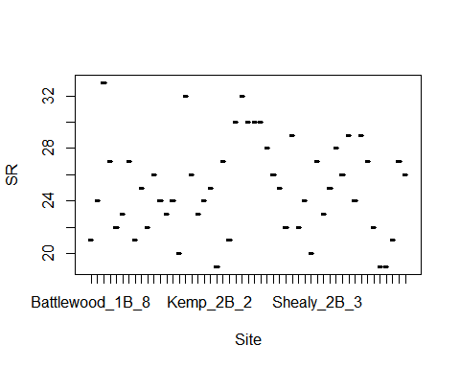

#richness <-read.csv("sr_covs.csv") #SR by sites by point count overall SR #all effort  
#richness$Herbicide <- factor(richness$Herbicide)  
#sapply(richness, mean, na.rm=TRUE)  
#library(psych)  
#sumtable <- describeBy(richness, group=richness$Treatment)  
#sumtable  
#write.table(sumtable, file="C:/Users/woodj/Documents/GRAD SCHOOL - CLEMSON/Project-Specific/R work/USDA-songbirds/USDA-songbirds/SR_summary_by_Treatment.xls",sep="\t")

#begin simple explorations of some exp variables  
plot(richness$SR ~ richness$Age)

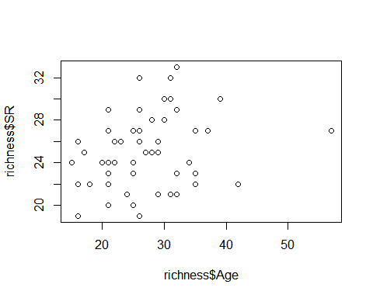

plot(richness$SR ~ richness$Nburns)

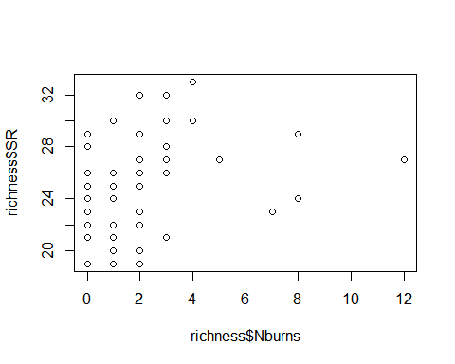

plot(richness$SR ~ richness$BA)

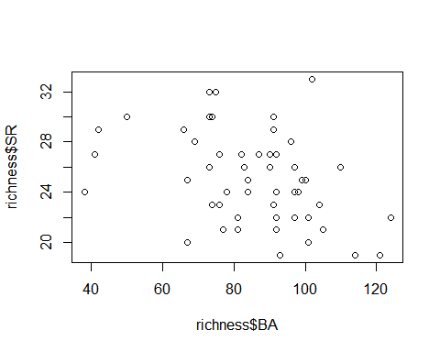

plot(richness$SR ~ richness$Parea)

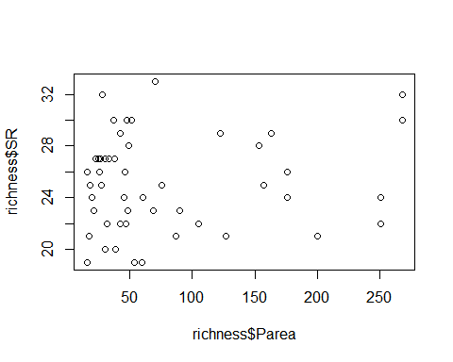

lm(SR ~ Treatment, richness)

##   
## Call:  
## lm(formula = SR ~ Treatment, data = richness)  
##   
## Coefficients:  
## (Intercept) Treatment1B Treatment2B Treatment3B   
## 23.833 -0.141 1.250 3.595

summary(lm(SR ~ Treatment, richness)) #3B statistically different from others

##   
## Call:  
## lm(formula = SR ~ Treatment, data = richness)  
##   
## Residuals:  
## Min 1Q Median 3Q Max   
## -6.4286 -1.9583 -0.0833 1.9167 6.9167   
##   
## Coefficients:  
## Estimate Std. Error t value Pr(>|t|)   
## (Intercept) 23.8333 0.9646 24.708 < 2e-16 ***  
## Treatment1B -0.1410 1.3377 -0.105 0.91649   
## Treatment2B 1.2500 1.3642 0.916 0.36418   
## Treatment3B 3.5952 1.3145 2.735 0.00877 **   
## ---  
## Signif. codes: 0 '***' 0.001 '**' 0.01 '*' 0.05 '.' 0.1 ' ' 1  
##   
## Residual standard error: 3.341 on 47 degrees of freedom  
## Multiple R-squared: 0.1873, Adjusted R-squared: 0.1354   
## F-statistic: 3.609 on 3 and 47 DF, p-value: 0.01993

plot(SR ~ Treatment, data=richness)

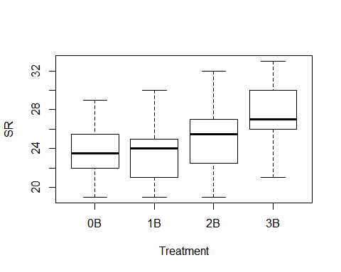

confint(lm(richness$SR~richness$Treatment))

## 2.5 % 97.5 %  
## (Intercept) 21.8927982 25.773869  
## richness$Treatment1B -2.8320637 2.550012  
## richness$Treatment2B -1.4943312 3.994331  
## richness$Treatment3B 0.9507344 6.239742

lm(SR ~ Herbicide, richness)

##   
## Call:  
## lm(formula = SR ~ Herbicide, data = richness)  
##   
## Coefficients:  
## (Intercept) Herbicide   
## 24.9524 0.2143

summary(lm(SR ~ Herbicide, richness)) #nothing going on here - no stat sig difference bw 0 or 1

##   
## Call:  
## lm(formula = SR ~ Herbicide, data = richness)  
##   
## Residuals:  
## Min 1Q Median 3Q Max   
## -6.1667 -3.0595 0.0476 1.8333 7.8333   
##   
## Coefficients:  
## Estimate Std. Error t value Pr(>|t|)   
## (Intercept) 24.9524 0.7918 31.514 <2e-16 ***  
## Herbicide 0.2143 1.0324 0.208 0.836   
## ---  
## Signif. codes: 0 '***' 0.001 '**' 0.01 '*' 0.05 '.' 0.1 ' ' 1  
##   
## Residual standard error: 3.628 on 49 degrees of freedom  
## Multiple R-squared: 0.0008785, Adjusted R-squared: -0.01951   
## F-statistic: 0.04308 on 1 and 49 DF, p-value: 0.8364

plot(SR ~ Herbicide, data=richness)

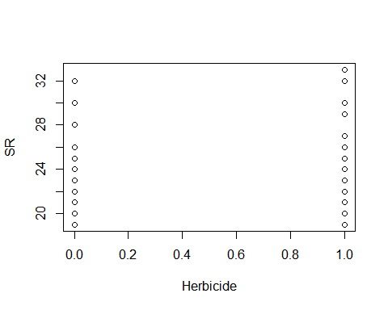

lm(SR ~ Nthins, data=richness)

##   
## Call:  
## lm(formula = SR ~ Nthins, data = richness)  
##   
## Coefficients:  
## (Intercept) Nthins   
## 23.4323 0.9226

plot(SR ~ Nthins, data=richness)

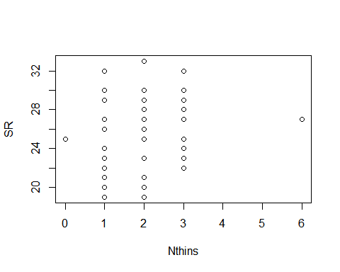

interaction.plot(richness$Treatment, richness$Nburns, richness$SR)

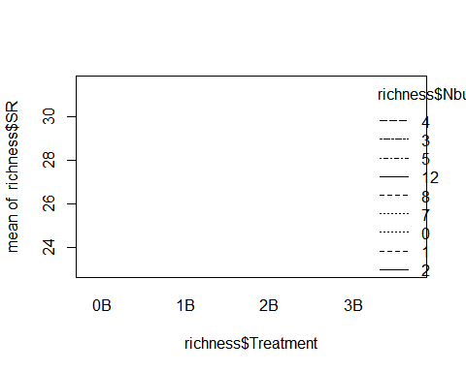

summary(lm(SR ~ Nthins, data=richness))

##   
## Call:  
## lm(formula = SR ~ Nthins, data = richness)  
##   
## Residuals:  
## Min 1Q Median 3Q Max   
## -6.2774 -2.3548 -0.3548 1.7613 7.7226   
##   
## Coefficients:  
## Estimate Std. Error t value Pr(>|t|)   
## (Intercept) 23.4323 1.0243 22.876 <2e-16 ***  
## Nthins 0.9226 0.5036 1.832 0.073 .   
## ---  
## Signif. codes: 0 '***' 0.001 '**' 0.01 '*' 0.05 '.' 0.1 ' ' 1  
##   
## Residual standard error: 3.512 on 49 degrees of freedom  
## Multiple R-squared: 0.0641, Adjusted R-squared: 0.045   
## F-statistic: 3.356 on 1 and 49 DF, p-value: 0.07304

plot(SR ~ Nthins, ann=FALSE, data=richness)

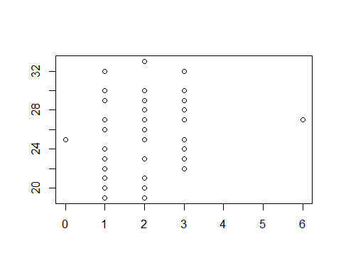

summary(lm(SR ~ Parea, richness)) #so no species-area relationsip?

##   
## Call:  
## lm(formula = SR ~ Parea, data = richness)  
##   
## Residuals:  
## Min 1Q Median 3Q Max   
## -5.9659 -2.8232 -0.0645 2.2594 7.9717   
##   
## Coefficients:  
## Estimate Std. Error t value Pr(>|t|)   
## (Intercept) 24.588955 0.750510 32.763 <2e-16 ***  
## Parea 0.006274 0.007125 0.881 0.383   
## ---  
## Signif. codes: 0 '***' 0.001 '**' 0.01 '*' 0.05 '.' 0.1 ' ' 1  
##   
## Residual standard error: 3.602 on 49 degrees of freedom  
## Multiple R-squared: 0.01558, Adjusted R-squared: -0.004509   
## F-statistic: 0.7756 on 1 and 49 DF, p-value: 0.3828

fit<-lm(SR ~ Treatment + BA + Parea, data=richness)  
summary(fit)

##   
## Call:  
## lm(formula = SR ~ Treatment + BA + Parea, data = richness)  
##   
## Residuals:  
## Min 1Q Median 3Q Max   
## -5.6831 -1.9952 0.1006 2.0590 7.3397   
##   
## Coefficients:  
## Estimate Std. Error t value Pr(>|t|)   
## (Intercept) 29.003672 2.986197 9.713 1.29e-12 ***  
## Treatment1B -0.665758 1.328051 -0.501 0.6186   
## Treatment2B 0.336821 1.438655 0.234 0.8160   
## Treatment3B 2.134971 1.460230 1.462 0.1507   
## BA -0.059403 0.029515 -2.013 0.0502 .   
## Parea 0.008294 0.006726 1.233 0.2240   
## ---  
## Signif. codes: 0 '***' 0.001 '**' 0.01 '*' 0.05 '.' 0.1 ' ' 1  
##   
## Residual standard error: 3.25 on 45 degrees of freedom  
## Multiple R-squared: 0.2638, Adjusted R-squared: 0.1821   
## F-statistic: 3.226 on 5 and 45 DF, p-value: 0.01423

confint(fit, level=0.95)

## 2.5 % 97.5 %  
## (Intercept) 22.989161422 3.501818e+01  
## Treatment1B -3.340590699 2.009074e+00  
## Treatment2B -2.560778526 3.234421e+00  
## Treatment3B -0.806084135 5.076026e+00  
## BA -0.118849054 4.396554e-05  
## Parea -0.005253564 2.184068e-02

anova(fit)

## Analysis of Variance Table  
##   
## Response: SR  
## Df Sum Sq Mean Sq F value Pr(>F)   
## Treatment 3 120.91 40.302 3.8155 0.01612 *  
## BA 1 33.40 33.398 3.1619 0.08213 .  
## Parea 1 16.06 16.059 1.5204 0.22397   
## Residuals 45 475.32 10.563   
## ---  
## Signif. codes: 0 '***' 0.001 '**' 0.01 '*' 0.05 '.' 0.1 ' ' 1

plot(SR ~ Age, ann=FALSE, type="n", xlim=c(10,60), ylim=c(10,40), data=richness)  
lines(SR~Age,lwd=2, data=richness)

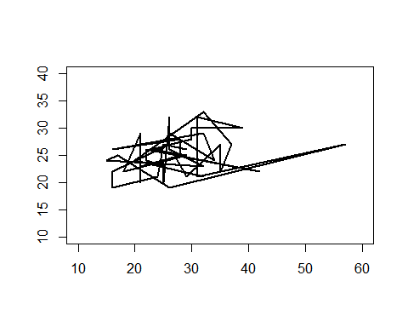

richness <-read.csv("sr_covs.csv")  
levels(richness$Treatment)

## [1] "0B" "1B" "2B" "3B"

quantiles_95<-function(x){  
 r<-quantile(x,probs=c(0.025,0.25,0.5,0.75,0.975))  
 names(r)<-c("ymin","lower","middle","upper","ymax")  
 r  
}  
  
ggplot(data=richness,aes(x=Treatment,y=SR,fill=Treatment))+guides(fill=F)+stat_summary(fun.data=quantiles_95,geom="boxplot")+scale_fill_brewer(type="seq",direction=1,palette="Greens")+labs(x="Burn treatment",y="# of species")+coord_cartesian(ylim=c(19, 33)) +   
 scale_y_continuous(breaks=seq(18, 34, 2))+  
 theme(panel.border = element_blank(),panel.grid.major = element_blank(),panel.grid.minor = element_blank())

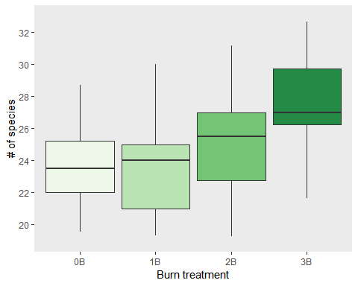

#removed geom_jitter()