Results trial - SR

Jesse Wood

June 22, 2018

## R Markdown

This is an R Markdown document. Markdown is a simple formatting syntax for authoring HTML, PDF, and MS Word documents. For more details on using R Markdown see <http://rmarkdown.rstudio.com>.

Setup

library("unmarked")

## Warning: package 'unmarked' was built under R version 3.3.2

## Loading required package: reshape

## Warning: package 'reshape' was built under R version 3.3.2

## Loading required package: lattice

## Warning: package 'lattice' was built under R version 3.3.3

## Loading required package: Rcpp

## Warning: package 'Rcpp' was built under R version 3.3.2

setwd("C:/Users/woodj/Documents/GRAD SCHOOL - CLEMSON/Project-Specific/R work/USDA-songbirds/USDA-songbirds")

# Evaluate Audio Counts (AC) vs Point Counts (PC)

#File read-in  
# as of 6/22, this one-visit breakdown has had unknowns REMOVED now (in both AC + PC)  
methodSR1 <-read.csv("17_1by1_ACPC_SR.csv") #SR by 1 visit each - Site Type SR  
summary(methodSR1)

## SiteName Type SR Sdate   
## Abercrombie_0B_E_AB: 2 AC:29 Min. : 8.00 Min. :42865   
## Abercrombie_1B_2 : 2 PC:29 1st Qu.:12.00 1st Qu.:42867   
## Blease_3B_6 : 2 Median :14.00 Median :42873   
## Blease_3B_9 : 2 Mean :14.16 Mean :42878   
## Bryson_2B_9 : 2 3rd Qu.:16.00 3rd Qu.:42888   
## Burnett_1B_5 : 2 Max. :21.00 Max. :42915   
## (Other) :46   
## Stime Pdate Pmin Peffort Year   
## Min. :353.0 Min. :43181 Min. :12.00 Min. :1.000 A:58   
## 1st Qu.:404.0 1st Qu.:43185 1st Qu.:18.00 1st Qu.:2.000   
## Median :435.0 Median :43189 Median :22.00 Median :2.000   
## Mean :447.7 Mean :43189 Mean :23.76 Mean :2.517   
## 3rd Qu.:496.2 3rd Qu.:43193 3rd Qu.:30.00 3rd Qu.:3.000   
## Max. :589.0 Max. :43196 Max. :55.00 Max. :4.000   
## NA's :29 NA's :29 NA's :29

str(methodSR1)

## 'data.frame': 58 obs. of 9 variables:  
## $ SiteName: Factor w/ 29 levels "Abercrombie_0B_E_AB",..: 3 4 5 7 8 12 13 14 15 16 ...  
## $ Type : Factor w/ 2 levels "AC","PC": 1 1 1 1 1 1 1 1 1 1 ...  
## $ SR : int 15 14 11 10 11 16 13 17 14 11 ...  
## $ Sdate : int 42868 42881 42896 42898 42888 42889 42895 42892 42875 42887 ...  
## $ Stime : int 570 403 497 380 503 382 479 481 580 409 ...  
## $ Pdate : int 43181 43181 43186 43195 43196 43182 43188 43188 43188 43188 ...  
## $ Pmin : int 26 23 17 20 32 31 18 20 25 18 ...  
## $ Peffort : int 3 2 1 2 3 3 2 2 4 3 ...  
## $ Year : Factor w/ 1 level "A": 1 1 1 1 1 1 1 1 1 1 ...

#plot(methodSR1$SR ~ methodSR1$Type) #same as below  
plot(SR ~ Type, data=methodSR1)

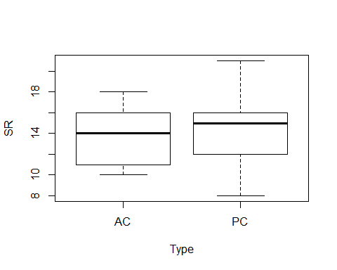

plot(SR ~ Sdate, data=methodSR1)

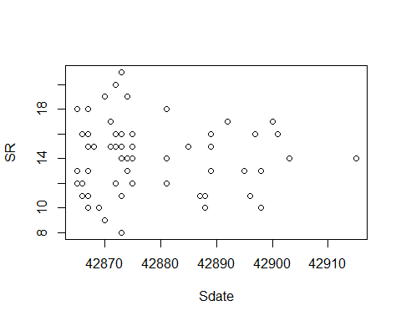

plot(SR ~ Stime, data=methodSR1)

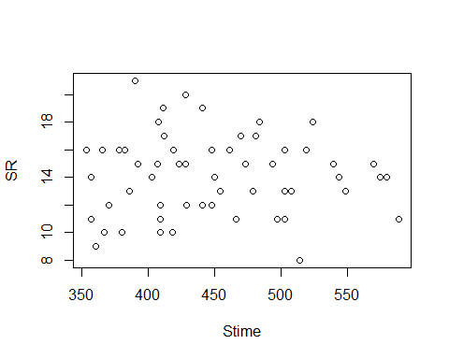

plot(SR ~ Pdate, data=methodSR1)

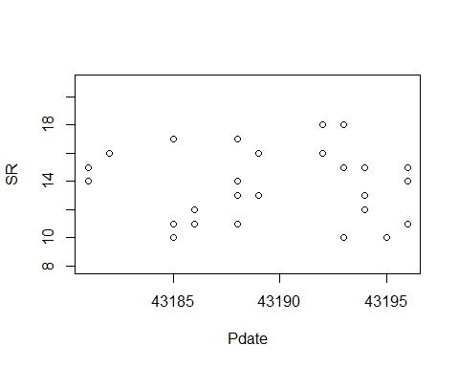

plot(SR ~ Pmin, data=methodSR1)

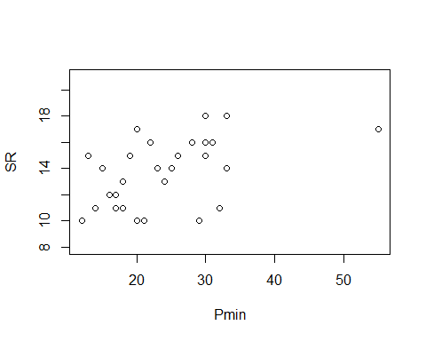

plot(SR ~ Peffort, data=methodSR1)

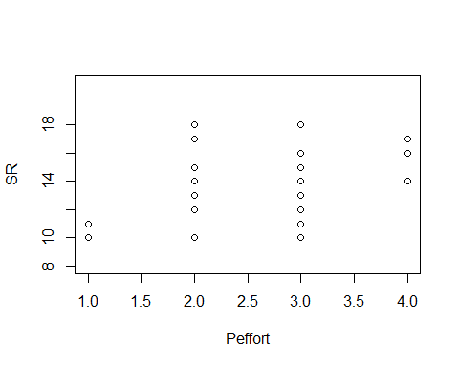

evaluation1<-lm(SR ~ Type, methodSR1) #non-significant  
summary(evaluation1)

##   
## Call:  
## lm(formula = SR ~ Type, data = methodSR1)  
##   
## Residuals:  
## Min 1Q Median 3Q Max   
## -6.6207 -2.6207 0.3103 1.3793 6.3793   
##   
## Coefficients:  
## Estimate Std. Error t value Pr(>|t|)   
## (Intercept) 13.6897 0.5282 25.919 <2e-16 ***  
## TypePC 0.9310 0.7469 1.246 0.218   
## ---  
## Signif. codes: 0 '***' 0.001 '**' 0.01 '*' 0.05 '.' 0.1 ' ' 1  
##   
## Residual standard error: 2.844 on 56 degrees of freedom  
## Multiple R-squared: 0.027, Adjusted R-squared: 0.00962   
## F-statistic: 1.554 on 1 and 56 DF, p-value: 0.2178

confint(evaluation1, level=0.95)

## 2.5 % 97.5 %  
## (Intercept) 12.6316062 14.747704  
## TypePC -0.5652727 2.427342

anova(evaluation1)

## Analysis of Variance Table  
##   
## Response: SR  
## Df Sum Sq Mean Sq F value Pr(>F)  
## Type 1 12.57 12.5690 1.5537 0.2178  
## Residuals 56 453.03 8.0899

evaluation2<-lm(SR ~ Sdate, methodSR1) #non-significant  
summary(evaluation2)

##   
## Call:  
## lm(formula = SR ~ Sdate, data = methodSR1)  
##   
## Residuals:  
## Min 1Q Median 3Q Max   
## -6.207 -2.266 0.178 1.791 6.793   
##   
## Coefficients:  
## Estimate Std. Error t value Pr(>|t|)  
## (Intercept) 472.42738 1335.20568 0.354 0.725  
## Sdate -0.01069 0.03114 -0.343 0.733  
##   
## Residual standard error: 2.88 on 56 degrees of freedom  
## Multiple R-squared: 0.002099, Adjusted R-squared: -0.01572   
## F-statistic: 0.1178 on 1 and 56 DF, p-value: 0.7327

confint(evaluation2, level=0.95)

## 2.5 % 97.5 %  
## (Intercept) -2.202311e+03 3.147166e+03  
## Sdate -7.306831e-02 5.169259e-02

anova(evaluation2)

## Analysis of Variance Table  
##   
## Response: SR  
## Df Sum Sq Mean Sq F value Pr(>F)  
## Sdate 1 0.98 0.9774 0.1178 0.7327  
## Residuals 56 464.63 8.2969

evaluation3<-lm(SR ~ Stime, methodSR1) #non-significant  
summary(evaluation3)

##   
## Call:  
## lm(formula = SR ~ Stime, data = methodSR1)  
##   
## Residuals:  
## Min 1Q Median 3Q Max   
## -6.1135 -2.1670 -0.0735 1.8209 6.8085   
##   
## Coefficients:  
## Estimate Std. Error t value Pr(>|t|)   
## (Intercept) 14.4368997 2.7095171 5.328 1.83e-06 ***  
## Stime -0.0006292 0.0059922 -0.105 0.917   
## ---  
## Signif. codes: 0 '***' 0.001 '**' 0.01 '*' 0.05 '.' 0.1 ' ' 1  
##   
## Residual standard error: 2.883 on 56 degrees of freedom  
## Multiple R-squared: 0.0001969, Adjusted R-squared: -0.01766   
## F-statistic: 0.01103 on 1 and 56 DF, p-value: 0.9167

confint(evaluation3, level=0.95)

## 2.5 % 97.5 %  
## (Intercept) 9.00908475 19.86471469  
## Stime -0.01263296 0.01137452

anova(evaluation3)

## Analysis of Variance Table  
##   
## Response: SR  
## Df Sum Sq Mean Sq F value Pr(>F)  
## Stime 1 0.09 0.0917 0.011 0.9167  
## Residuals 56 465.51 8.3127

evaluation4<-lm(SR ~ Pdate, methodSR1) #non-significant  
summary(evaluation4)

##   
## Call:  
## lm(formula = SR ~ Pdate, data = methodSR1)  
##   
## Residuals:  
## Min 1Q Median 3Q Max   
## -3.6981 -2.6838 0.3119 2.3062 4.3062   
##   
## Coefficients:  
## Estimate Std. Error t value Pr(>|t|)  
## (Intercept) -4.811e+01 4.350e+03 -0.011 0.991  
## Pdate 1.431e-03 1.007e-01 0.014 0.989  
##   
## Residual standard error: 2.569 on 27 degrees of freedom  
## (29 observations deleted due to missingness)  
## Multiple R-squared: 7.475e-06, Adjusted R-squared: -0.03703   
## F-statistic: 0.0002018 on 1 and 27 DF, p-value: 0.9888

confint(evaluation4, level=0.95)

## 2.5 % 97.5 %  
## (Intercept) -8973.0917070 8876.8773986  
## Pdate -0.2052181 0.2080798

anova(evaluation4)

## Analysis of Variance Table  
##   
## Response: SR  
## Df Sum Sq Mean Sq F value Pr(>F)  
## Pdate 1 0.001 0.0013 2e-04 0.9888  
## Residuals 27 178.206 6.6002

evaluation5<-lm(SR ~ Pmin, methodSR1) #significant + linear relationship   
summary(evaluation5)

##   
## Call:  
## lm(formula = SR ~ Pmin, data = methodSR1)  
##   
## Residuals:  
## Min 1Q Median 3Q Max   
## -4.4217 -1.3267 0.1147 1.5337 3.8353   
##   
## Coefficients:  
## Estimate Std. Error t value Pr(>|t|)   
## (Intercept) 10.37127 1.21584 8.530 3.83e-09 ***  
## Pmin 0.13967 0.04808 2.905 0.00724 **   
## ---  
## Signif. codes: 0 '***' 0.001 '**' 0.01 '*' 0.05 '.' 0.1 ' ' 1  
##   
## Residual standard error: 2.242 on 27 degrees of freedom  
## (29 observations deleted due to missingness)  
## Multiple R-squared: 0.2381, Adjusted R-squared: 0.2099   
## F-statistic: 8.439 on 1 and 27 DF, p-value: 0.007243

confint(evaluation5, level=0.95)

## 2.5 % 97.5 %  
## (Intercept) 7.87657479 12.8659590  
## Pmin 0.04101968 0.2383222

anova(evaluation5)

## Analysis of Variance Table  
##   
## Response: SR  
## Df Sum Sq Mean Sq F value Pr(>F)   
## Pmin 1 42.436 42.436 8.439 0.007243 **  
## Residuals 27 135.771 5.029   
## ---  
## Signif. codes: 0 '***' 0.001 '**' 0.01 '*' 0.05 '.' 0.1 ' ' 1

evaluation6<-lm(SR ~ Peffort, methodSR1) #significant + linear relationship  
summary(evaluation6)

##   
## Call:  
## lm(formula = SR ~ Peffort, data = methodSR1)  
##   
## Residuals:  
## Min 1Q Median 3Q Max   
## -4.2500 -1.4107 -0.0893 1.7500 4.9107   
##   
## Coefficients:  
## Estimate Std. Error t value Pr(>|t|)   
## (Intercept) 10.7679 1.3579 7.930 1.59e-08 ***  
## Peffort 1.1607 0.5107 2.273 0.0312 *   
## ---  
## Signif. codes: 0 '***' 0.001 '**' 0.01 '*' 0.05 '.' 0.1 ' ' 1  
##   
## Residual standard error: 2.354 on 27 degrees of freedom  
## (29 observations deleted due to missingness)  
## Multiple R-squared: 0.1606, Adjusted R-squared: 0.1295   
## F-statistic: 5.165 on 1 and 27 DF, p-value: 0.03122

confint(evaluation6, level=0.95)

## 2.5 % 97.5 %  
## (Intercept) 7.9817589 13.553955  
## Peffort 0.1128175 2.208611

anova(evaluation6)

## Analysis of Variance Table  
##   
## Response: SR  
## Df Sum Sq Mean Sq F value Pr(>F)   
## Peffort 1 28.618 28.6176 5.1653 0.03122 *  
## Residuals 27 149.589 5.5403   
## ---  
## Signif. codes: 0 '***' 0.001 '**' 0.01 '*' 0.05 '.' 0.1 ' ' 1

# Visit 2

#File read-in  
# as of 6/22, this one-visit breakdown has had unknowns REMOVED now (in both AC + PC)  
methodSR2 <-read.csv("17_2by2_ACPC_SR.csv") #SR by count #2 each - Site Type SR  
#summary(methodSR2)  
str(methodSR2)

## 'data.frame': 58 obs. of 9 variables:  
## $ SiteName: Factor w/ 29 levels "Abercrombie_0B_E_AB",..: 3 4 5 7 8 12 13 14 15 16 ...  
## $ Type : Factor w/ 2 levels "AC","PC": 1 1 1 1 1 1 1 1 1 1 ...  
## $ SR : int 17 15 11 9 9 16 13 10 17 13 ...  
## $ Sdate : int 42867 42882 42893 42901 42887 42890 42900 42893 42874 42887 ...  
## $ Stime : int 426 353 553 355 354 558 386 425 521 514 ...  
## $ Pdate : int 43201 43201 43203 43209 43210 43202 43205 43205 43206 43205 ...  
## $ Pmin : int 39 25 27 14 15 15 18 22 15 21 ...  
## $ Peffort : int 4 3 3 1 1 2 2 2 2 2 ...  
## $ Year : Factor w/ 1 level "A": 1 1 1 1 1 1 1 1 1 1 ...

plot(methodSR2$SR ~ methodSR2$Type) #more equalized

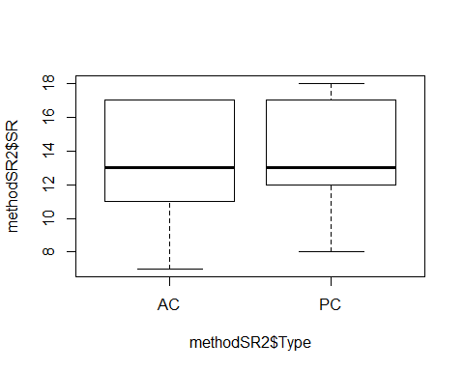

#plot(SR ~ Type, data=methodSR) #same as above

evaluation7<-lm(SR ~ Type, methodSR2) #non-sig  
summary(evaluation7)

##   
## Call:  
## lm(formula = SR ~ Type, data = methodSR2)  
##   
## Residuals:  
## Min 1Q Median 3Q Max   
## -6.2414 -2.1724 -0.2414 3.0345 4.0345   
##   
## Coefficients:  
## Estimate Std. Error t value Pr(>|t|)   
## (Intercept) 13.2414 0.5561 23.810 <2e-16 ***  
## TypePC 0.7241 0.7865 0.921 0.361   
## ---  
## Signif. codes: 0 '***' 0.001 '**' 0.01 '*' 0.05 '.' 0.1 ' ' 1  
##   
## Residual standard error: 2.995 on 56 degrees of freedom  
## Multiple R-squared: 0.01491, Adjusted R-squared: -0.002679   
## F-statistic: 0.8477 on 1 and 56 DF, p-value: 0.3611

confint(evaluation7, level=0.95)

## 2.5 % 97.5 %  
## (Intercept) 12.1273124 14.355446  
## TypePC -0.8513906 2.299666

anova(evaluation7)

## Analysis of Variance Table  
##   
## Response: SR  
## Df Sum Sq Mean Sq F value Pr(>F)  
## Type 1 7.60 7.6034 0.8477 0.3611  
## Residuals 56 502.28 8.9692

evaluation8<-lm(SR ~ Sdate, methodSR2) #non-signficant  
summary(evaluation8)

##   
## Call:  
## lm(formula = SR ~ Sdate, data = methodSR2)  
##   
## Residuals:  
## Min 1Q Median 3Q Max   
## -5.8460 -1.9060 -0.4742 2.8878 4.6436   
##   
## Coefficients:  
## Estimate Std. Error t value Pr(>|t|)  
## (Intercept) -1.670e+03 1.805e+03 -0.925 0.359  
## Sdate 3.926e-02 4.209e-02 0.933 0.355  
##   
## Residual standard error: 2.994 on 56 degrees of freedom  
## Multiple R-squared: 0.0153, Adjusted R-squared: -0.002281   
## F-statistic: 0.8703 on 1 and 56 DF, p-value: 0.3549

confint(evaluation8, level=0.95)

## 2.5 % 97.5 %  
## (Intercept) -5.285771e+03 1945.435061  
## Sdate -4.504543e-02 0.123568

anova(evaluation8)

## Analysis of Variance Table  
##   
## Response: SR  
## Df Sum Sq Mean Sq F value Pr(>F)  
## Sdate 1 7.80 7.8028 0.8703 0.3549  
## Residuals 56 502.08 8.9657

evaluation9<-lm(SR ~ Stime, methodSR2) #non-signficant  
summary(evaluation9)

##   
## Call:  
## lm(formula = SR ~ Stime, data = methodSR2)  
##   
## Residuals:  
## Min 1Q Median 3Q Max   
## -6.9286 -2.2504 -0.4554 3.2237 4.5839   
##   
## Coefficients:  
## Estimate Std. Error t value Pr(>|t|)   
## (Intercept) 12.594291 2.727452 4.618 2.31e-05 ***  
## Stime 0.002309 0.006173 0.374 0.71   
## ---  
## Signif. codes: 0 '***' 0.001 '**' 0.01 '*' 0.05 '.' 0.1 ' ' 1  
##   
## Residual standard error: 3.014 on 56 degrees of freedom  
## Multiple R-squared: 0.002491, Adjusted R-squared: -0.01532   
## F-statistic: 0.1398 on 1 and 56 DF, p-value: 0.7098

confint(evaluation9, level=0.95)

## 2.5 % 97.5 %  
## (Intercept) 7.13054821 18.0580339  
## Stime -0.01005809 0.0146752

anova(evaluation9)

## Analysis of Variance Table  
##   
## Response: SR  
## Df Sum Sq Mean Sq F value Pr(>F)  
## Stime 1 1.27 1.2701 0.1398 0.7098  
## Residuals 56 508.61 9.0823

evaluation10<-lm(SR ~ Pdate, methodSR2) #non-signficant  
summary(evaluation10)

##   
## Call:  
## lm(formula = SR ~ Pdate, data = methodSR2)  
##   
## Residuals:  
## Min 1Q Median 3Q Max   
## -5.5476 -2.5476 -0.0518 3.1362 4.6404   
##   
## Coefficients:  
## Estimate Std. Error t value Pr(>|t|)  
## (Intercept) -8110.3587 8634.0999 -0.939 0.356  
## Pdate 0.1880 0.1998 0.941 0.355  
##   
## Residual standard error: 3.199 on 27 degrees of freedom  
## (29 observations deleted due to missingness)  
## Multiple R-squared: 0.03175, Adjusted R-squared: -0.004115   
## F-statistic: 0.8852 on 1 and 27 DF, p-value: 0.3551

confint(evaluation10, level=0.95)

## 2.5 % 97.5 %  
## (Intercept) -2.582607e+04 9605.3510340  
## Pdate -2.220103e-01 0.5980534

anova(evaluation10)

## Analysis of Variance Table  
##   
## Response: SR  
## Df Sum Sq Mean Sq F value Pr(>F)  
## Pdate 1 9.057 9.0575 0.8852 0.3551  
## Residuals 27 276.253 10.2316

evaluation11<-lm(SR ~ Pmin, methodSR2) #non-signficant  
summary(evaluation11)

##   
## Call:  
## lm(formula = SR ~ Pmin, data = methodSR2)  
##   
## Residuals:  
## Min 1Q Median 3Q Max   
## -5.7089 -2.8355 -0.0886 3.2911 4.5442   
##   
## Coefficients:  
## Estimate Std. Error t value Pr(>|t|)   
## (Intercept) 10.8104 2.0794 5.199 1.79e-05 ***  
## Pmin 0.1266 0.1038 1.219 0.233   
## ---  
## Signif. codes: 0 '***' 0.001 '**' 0.01 '*' 0.05 '.' 0.1 ' ' 1  
##   
## Residual standard error: 3.165 on 27 degrees of freedom  
## (29 observations deleted due to missingness)  
## Multiple R-squared: 0.05215, Adjusted R-squared: 0.01704   
## F-statistic: 1.485 on 1 and 27 DF, p-value: 0.2335

confint(evaluation11, level=0.95)

## 2.5 % 97.5 %  
## (Intercept) 6.54388554 15.076891  
## Pmin -0.08650866 0.339646

anova(evaluation11)

## Analysis of Variance Table  
##   
## Response: SR  
## Df Sum Sq Mean Sq F value Pr(>F)  
## Pmin 1 14.878 14.878 1.4855 0.2335  
## Residuals 27 270.432 10.016

evaluation12<-lm(SR ~ Peffort, methodSR2) #signficant + linear relationship!  
summary(evaluation12)

##   
## Call:  
## lm(formula = SR ~ Peffort, data = methodSR2)  
##   
## Residuals:  
## Min 1Q Median 3Q Max   
## -4.291 -2.090 -0.291 1.910 6.112   
##   
## Coefficients:  
## Estimate Std. Error t value Pr(>|t|)   
## (Intercept) 8.6866 1.6653 5.216 1.7e-05 ***  
## Peffort 2.2015 0.7634 2.884 0.00762 **   
## ---  
## Signif. codes: 0 '***' 0.001 '**' 0.01 '*' 0.05 '.' 0.1 ' ' 1  
##   
## Residual standard error: 2.842 on 27 degrees of freedom  
## (29 observations deleted due to missingness)  
## Multiple R-squared: 0.2355, Adjusted R-squared: 0.2072   
## F-statistic: 8.316 on 1 and 27 DF, p-value: 0.007625

confint(evaluation12, level=0.95)

## 2.5 % 97.5 %  
## (Intercept) 5.2696008 12.103533  
## Peffort 0.6351016 3.767883

anova(evaluation12)

## Analysis of Variance Table  
##   
## Response: SR  
## Df Sum Sq Mean Sq F value Pr(>F)   
## Peffort 1 67.183 67.183 8.3161 0.007625 **  
## Residuals 27 218.127 8.079   
## ---  
## Signif. codes: 0 '***' 0.001 '**' 0.01 '*' 0.05 '.' 0.1 ' ' 1

# Visit 3

#File read-in  
# as of 6/22, this one-visit breakdown has had unknowns REMOVED now (in both AC + PC)  
methodSR3 <-read.csv("17_3by3_ACPC_SR.csv") #SR by count #3 each - Site Type SR  
#summary(methodSR3)  
str(methodSR3)

## 'data.frame': 58 obs. of 9 variables:  
## $ SiteName: Factor w/ 29 levels "Abercrombie_0B_E_AB",..: 3 4 5 7 8 12 13 14 15 16 ...  
## $ Type : Factor w/ 2 levels "AC","PC": 1 1 1 1 1 1 1 1 1 1 ...  
## $ SR : int 10 16 11 15 16 15 14 13 15 13 ...  
## $ Sdate : int 42880 42883 42912 42898 42887 42898 42899 42894 42875 42885 ...  
## $ Stime : int 363 500 380 513 559 507 526 359 395 566 ...  
## $ Pdate : int 43214 43214 43216 43219 43220 43215 43216 43216 43217 43216 ...  
## $ Pmin : int 18 15 14 17 12 16 14 15 19 14 ...  
## $ Peffort : int 1 2 2 3 2 3 2 1 3 2 ...  
## $ Year : Factor w/ 1 level "A": 1 1 1 1 1 1 1 1 1 1 ...

plot(methodSR3$SR ~ methodSR3$Type) #

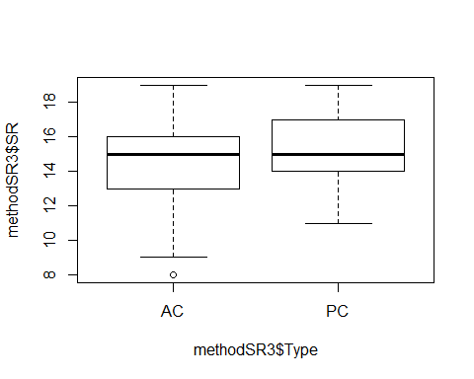

#plot(SR ~ Type, data=methodSR) #same as above

evaluation13<-lm(SR ~ Type, methodSR3) #non-significant  
summary(evaluation13)

##   
## Call:  
## lm(formula = SR ~ Type, data = methodSR3)  
##   
## Residuals:  
## Min 1Q Median 3Q Max   
## -6.4828 -1.4828 0.5172 1.5172 4.5172   
##   
## Coefficients:  
## Estimate Std. Error t value Pr(>|t|)   
## (Intercept) 14.4828 0.4607 31.436 <2e-16 ***  
## TypePC 0.6552 0.6515 1.006 0.319   
## ---  
## Signif. codes: 0 '***' 0.001 '**' 0.01 '*' 0.05 '.' 0.1 ' ' 1  
##   
## Residual standard error: 2.481 on 56 degrees of freedom  
## Multiple R-squared: 0.01774, Adjusted R-squared: 0.0001965   
## F-statistic: 1.011 on 1 and 56 DF, p-value: 0.3189

confint(evaluation13, level=0.95)

## 2.5 % 97.5 %  
## (Intercept) 13.5598595 15.405658  
## TypePC -0.6500041 1.960349

anova(evaluation13)

## Analysis of Variance Table  
##   
## Response: SR  
## Df Sum Sq Mean Sq F value Pr(>F)  
## Type 1 6.22 6.2241 1.0112 0.3189  
## Residuals 56 344.69 6.1552

evaluation14<-lm(SR ~ Sdate, methodSR3) #non-significant  
summary(evaluation14)

##   
## Call:  
## lm(formula = SR ~ Sdate, data = methodSR3)  
##   
## Residuals:  
## Min 1Q Median 3Q Max   
## -6.8866 -1.8141 0.1803 1.1926 4.1625   
##   
## Coefficients:  
## Estimate Std. Error t value Pr(>|t|)  
## (Intercept) 206.337032 280.706677 0.735 0.465  
## Sdate -0.004464 0.006543 -0.682 0.498  
##   
## Residual standard error: 2.493 on 56 degrees of freedom  
## Multiple R-squared: 0.008245, Adjusted R-squared: -0.009465   
## F-statistic: 0.4655 on 1 and 56 DF, p-value: 0.4979

confint(evaluation14, level=0.95)

## 2.5 % 97.5 %  
## (Intercept) -355.9860131 7.686601e+02  
## Sdate -0.0175718 8.643044e-03

anova(evaluation14)

## Analysis of Variance Table  
##   
## Response: SR  
## Df Sum Sq Mean Sq F value Pr(>F)  
## Sdate 1 2.89 2.8931 0.4655 0.4979  
## Residuals 56 348.02 6.2147

evaluation15<-lm(SR ~ Stime, methodSR3) #significant +!  
summary(evaluation15)

##   
## Call:  
## lm(formula = SR ~ Stime, data = methodSR3)  
##   
## Residuals:  
## Min 1Q Median 3Q Max   
## -5.8695 -1.4798 -0.0926 1.9894 4.6864   
##   
## Coefficients:  
## Estimate Std. Error t value Pr(>|t|)   
## (Intercept) 9.770069 2.280365 4.284 7.27e-05 ***  
## Stime 0.011387 0.005103 2.232 0.0297 *   
## ---  
## Signif. codes: 0 '***' 0.001 '**' 0.01 '*' 0.05 '.' 0.1 ' ' 1  
##   
## Residual standard error: 2.399 on 56 degrees of freedom  
## Multiple R-squared: 0.08167, Adjusted R-squared: 0.06527   
## F-statistic: 4.98 on 1 and 56 DF, p-value: 0.02966

confint(evaluation15, level=0.95)

## 2.5 % 97.5 %  
## (Intercept) 5.201948610 14.33818996  
## Stime 0.001165657 0.02160904

anova(evaluation15)

## Analysis of Variance Table  
##   
## Response: SR  
## Df Sum Sq Mean Sq F value Pr(>F)   
## Stime 1 28.66 28.6600 4.9804 0.02966 *  
## Residuals 56 322.25 5.7545   
## ---  
## Signif. codes: 0 '***' 0.001 '**' 0.01 '*' 0.05 '.' 0.1 ' ' 1

evaluation16<-lm(SR ~ Pdate, methodSR3) #significant +!  
summary(evaluation16)

##   
## Call:  
## lm(formula = SR ~ Pdate, data = methodSR3)  
##   
## Residuals:  
## Min 1Q Median 3Q Max   
## -5.7995 -1.1018 0.2005 0.8516 3.8516   
##   
## Coefficients:  
## Estimate Std. Error t value Pr(>|t|)   
## (Intercept) -3.566e+04 1.028e+04 -3.468 0.00177 **  
## Pdate 8.256e-01 2.380e-01 3.469 0.00177 **  
## ---  
## Signif. codes: 0 '***' 0.001 '**' 0.01 '*' 0.05 '.' 0.1 ' ' 1  
##   
## Residual standard error: 2.259 on 27 degrees of freedom  
## (29 observations deleted due to missingness)  
## Multiple R-squared: 0.3083, Adjusted R-squared: 0.2827   
## F-statistic: 12.04 on 1 and 27 DF, p-value: 0.001767

confint(evaluation16, level=0.95)

## 2.5 % 97.5 %  
## (Intercept) -5.676408e+04 -14562.663674  
## Pdate 3.373026e-01 1.313807

anova(evaluation16)

## Analysis of Variance Table  
##   
## Response: SR  
## Df Sum Sq Mean Sq F value Pr(>F)   
## Pdate 1 61.433 61.433 12.036 0.001767 **  
## Residuals 27 137.809 5.104   
## ---  
## Signif. codes: 0 '***' 0.001 '**' 0.01 '*' 0.05 '.' 0.1 ' ' 1

plot(SR ~ Pdate, methodSR3)

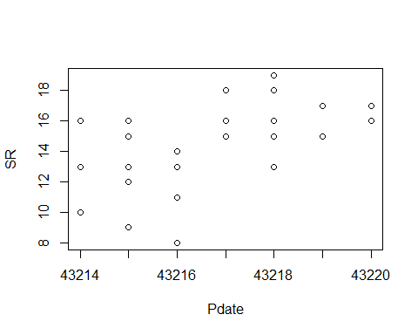

plot(evaluation16)

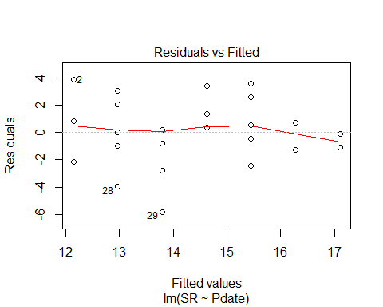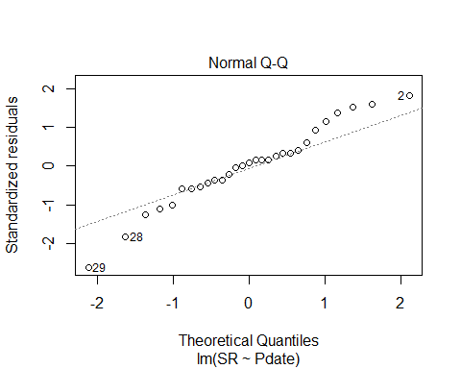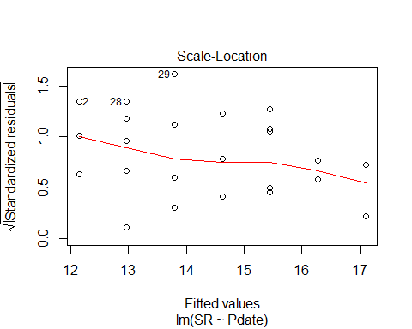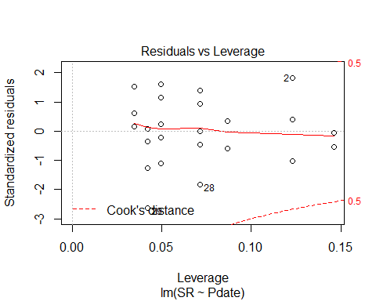

evaluation17<-lm(SR ~ Pmin, methodSR3) #non-significant  
summary(evaluation17)

##   
## Call:  
## lm(formula = SR ~ Pmin, data = methodSR3)  
##   
## Residuals:  
## Min 1Q Median 3Q Max   
## -6.5262 -1.4892 0.5479 1.5108 4.5294   
##   
## Coefficients:  
## Estimate Std. Error t value Pr(>|t|)   
## (Intercept) 14.74878 3.95723 3.727 0.000907 ***  
## Pmin -0.01854 0.27361 -0.068 0.946464   
## ---  
## Signif. codes: 0 '***' 0.001 '**' 0.01 '*' 0.05 '.' 0.1 ' ' 1  
##   
## Residual standard error: 2.716 on 27 degrees of freedom  
## (29 observations deleted due to missingness)  
## Multiple R-squared: 0.0001701, Adjusted R-squared: -0.03686   
## F-statistic: 0.004594 on 1 and 27 DF, p-value: 0.9465

confint(evaluation17, level=0.95)

## 2.5 % 97.5 %  
## (Intercept) 6.6292149 22.8683359  
## Pmin -0.5799547 0.5428658

anova(evaluation17)

## Analysis of Variance Table  
##   
## Response: SR  
## Df Sum Sq Mean Sq F value Pr(>F)  
## Pmin 1 0.034 0.0339 0.0046 0.9465  
## Residuals 27 199.207 7.3781

evaluation18<-lm(SR ~ Peffort, methodSR3) #close but not sig  
summary(evaluation18)

##   
## Call:  
## lm(formula = SR ~ Peffort, data = methodSR3)  
##   
## Residuals:  
## Min 1Q Median 3Q Max   
## -5.1809 -1.5293 -0.1809 1.4707 4.8191   
##   
## Coefficients:  
## Estimate Std. Error t value Pr(>|t|)   
## (Intercept) 11.8324 1.4707 8.045 1.21e-08 ***  
## Peffort 1.3484 0.7084 1.903 0.0677 .   
## ---  
## Signif. codes: 0 '***' 0.001 '**' 0.01 '*' 0.05 '.' 0.1 ' ' 1  
##   
## Residual standard error: 2.551 on 27 degrees of freedom  
## (29 observations deleted due to missingness)  
## Multiple R-squared: 0.1183, Adjusted R-squared: 0.08566   
## F-statistic: 3.623 on 1 and 27 DF, p-value: 0.06769

confint(evaluation18, level=0.95)

## 2.5 % 97.5 %  
## (Intercept) 8.8148135 14.850080  
## Peffort -0.1050804 2.801889

anova(evaluation18)

## Analysis of Variance Table  
##   
## Response: SR  
## Df Sum Sq Mean Sq F value Pr(>F)   
## Peffort 1 23.574 23.5738 3.6233 0.06769 .  
## Residuals 27 175.668 6.5062   
## ---  
## Signif. codes: 0 '***' 0.001 '**' 0.01 '*' 0.05 '.' 0.1 ' ' 1

# 3 visits pooled - redone with only 3 PC visits this time (not 4)

#File read-in  
# UNKNS NOT INCLUDED IN THIS!  
methodOSR <-read.csv("17_all3_ACPC_SR.csv") #SR by 3 counts pooled SR with unkns extracted  
#summary(methodOSR)  
str(methodOSR)

## 'data.frame': 58 obs. of 3 variables:  
## $ SiteName: Factor w/ 29 levels "Abercrombie_0B_E_AB",..: 3 4 5 7 8 12 13 14 15 16 ...  
## $ Type : Factor w/ 2 levels "AC","PC": 1 1 1 1 1 1 1 1 1 1 ...  
## $ SR : int 23 22 17 23 23 24 23 26 24 20 ...

plot(methodOSR$SR ~ methodOSR$Type)

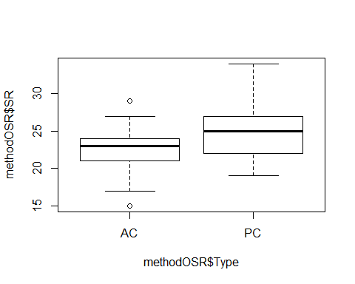

evaluationOSR<-lm(SR ~ Type, methodOSR)  
summary(evaluationOSR)

##   
## Call:  
## lm(formula = SR ~ Type, data = methodOSR)  
##   
## Residuals:  
## Min 1Q Median 3Q Max   
## -7.3793 -2.3276 0.2241 1.6207 8.8276   
##   
## Coefficients:  
## Estimate Std. Error t value Pr(>|t|)   
## (Intercept) 22.3793 0.6773 33.042 < 2e-16 ***  
## TypePC 2.7931 0.9578 2.916 0.00509 **   
## ---  
## Signif. codes: 0 '***' 0.001 '**' 0.01 '*' 0.05 '.' 0.1 ' ' 1  
##   
## Residual standard error: 3.647 on 56 degrees of freedom  
## Multiple R-squared: 0.1318, Adjusted R-squared: 0.1163   
## F-statistic: 8.503 on 1 and 56 DF, p-value: 0.005091

confint(evaluationOSR, level=0.95)

## 2.5 % 97.5 %  
## (Intercept) 21.0225342 23.736087  
## TypePC 0.8743322 4.711875

anova(evaluationOSR)

## Analysis of Variance Table  
##   
## Response: SR  
## Df Sum Sq Mean Sq F value Pr(>F)   
## Type 1 113.12 113.121 8.5034 0.005091 **  
## Residuals 56 744.97 13.303   
## ---  
## Signif. codes: 0 '***' 0.001 '**' 0.01 '*' 0.05 '.' 0.1 ' ' 1

# 3 visits pooled - redone with only 3 PC visits this time (not 4)

# Investigate date (survey date + process date)

###### BELOW THIS LINE, NOT UPDATED WITH UNKNS REMOVED

# Point Count Data Only

## all 4 PC visits pooled ##

#sr_covs CSV file is SR by sites by point counts (pooled 1-4) file (NP flyovers excluded)  
richness <-read.csv("sr_covs.csv") #SR by sites by point count overall SR #all effort  
summary(richness)

## Site SR Treatment Nthins   
## :13 Min. :19.00 :13 Min. :0.000   
## Battlewood_1B_8 : 1 1st Qu.:22.00 0B:12 1st Qu.:1.000   
## Battlewood_1B_E_B: 1 Median :25.00 1B:13 Median :2.000   
## Blease_3B_6 : 1 Mean :25.08 2B:12 Mean :1.784   
## Blease_3B_9 : 1 3rd Qu.:27.00 3B:14 3rd Qu.:2.000   
## Bryson_1B_9 : 1 Max. :33.00 Max. :6.000   
## (Other) :46 NA's :13 NA's :13   
## Nburns BA Herbicide Age   
## Min. : 0.000 Min. : 38.00 Min. :0.0000 Min. :15.00   
## 1st Qu.: 1.000 1st Qu.: 74.50 1st Qu.:0.0000 1st Qu.:21.00   
## Median : 2.000 Median : 90.00 Median :1.0000 Median :26.00   
## Mean : 2.078 Mean : 85.31 Mean :0.5882 Mean :26.98   
## 3rd Qu.: 3.000 3rd Qu.: 97.00 3rd Qu.:1.0000 3rd Qu.:31.00   
## Max. :12.000 Max. :124.00 Max. :1.0000 Max. :57.00   
## NA's :13 NA's :13 NA's :13 NA's :13   
## Parea   
## Min. : 15.84   
## 1st Qu.: 29.45   
## Median : 46.92   
## Mean : 78.01   
## 3rd Qu.: 97.75   
## Max. :267.63   
## NA's :13

str(richness)

## 'data.frame': 64 obs. of 9 variables:  
## $ Site : Factor w/ 52 levels "","Battlewood_1B_8",..: 2 3 4 5 6 7 8 9 10 11 ...  
## $ SR : int 21 24 33 27 22 23 27 21 25 22 ...  
## $ Treatment: Factor w/ 5 levels "","0B","1B","2B",..: 3 3 5 5 3 4 5 3 2 4 ...  
## $ Nthins : int 1 1 2 2 3 3 3 2 0 1 ...  
## $ Nburns : int 1 1 4 12 1 2 3 1 0 2 ...  
## $ BA : int 81 84 102 87 92 91 90 77 100 81 ...  
## $ Herbicide: int 0 0 1 1 1 1 1 1 0 1 ...  
## $ Age : int 32 20 32 37 35 35 35 29 27 42 ...  
## $ Parea : num 127 45.6 70 38.3 32.3 ...

#var(richness[2:5])  
#mean(richness[2:2])  
#mean(richness$SR)

richness <-read.csv("sr_covs.csv") #SR by sites by point count overall SR #all effort  
richness$Herbicide <- factor(richness$Herbicide)  
sapply(richness, mean, na.rm=TRUE)

## Warning in mean.default(X[[i]], ...): argument is not numeric or logical:  
## returning NA  
  
## Warning in mean.default(X[[i]], ...): argument is not numeric or logical:  
## returning NA  
  
## Warning in mean.default(X[[i]], ...): argument is not numeric or logical:  
## returning NA

## Site SR Treatment Nthins Nburns BA Herbicide   
## NA 25.078431 NA 1.784314 2.078431 85.313725 NA   
## Age Parea   
## 26.980392 78.011471

library(psych)

## Warning: package 'psych' was built under R version 3.3.3

sumtable <- describeBy(richness, group=richness$Treatment)

## Warning in FUN(newX[, i], ...): no non-missing arguments to min; returning  
## Inf

## Warning in FUN(newX[, i], ...): no non-missing arguments to min; returning  
## Inf  
  
## Warning in FUN(newX[, i], ...): no non-missing arguments to min; returning  
## Inf  
  
## Warning in FUN(newX[, i], ...): no non-missing arguments to min; returning  
## Inf  
  
## Warning in FUN(newX[, i], ...): no non-missing arguments to min; returning  
## Inf  
  
## Warning in FUN(newX[, i], ...): no non-missing arguments to min; returning  
## Inf  
  
## Warning in FUN(newX[, i], ...): no non-missing arguments to min; returning  
## Inf

## Warning in FUN(newX[, i], ...): no non-missing arguments to max; returning  
## -Inf  
  
## Warning in FUN(newX[, i], ...): no non-missing arguments to max; returning  
## -Inf  
  
## Warning in FUN(newX[, i], ...): no non-missing arguments to max; returning  
## -Inf  
  
## Warning in FUN(newX[, i], ...): no non-missing arguments to max; returning  
## -Inf  
  
## Warning in FUN(newX[, i], ...): no non-missing arguments to max; returning  
## -Inf  
  
## Warning in FUN(newX[, i], ...): no non-missing arguments to max; returning  
## -Inf  
  
## Warning in FUN(newX[, i], ...): no non-missing arguments to max; returning  
## -Inf

sumtable

##   
## Descriptive statistics by group   
## group:   
## vars n mean sd median trimmed mad min max range skew kurtosis  
## Site* 1 13 1 0 1 1 0 1 1 0 NaN NaN  
## SR 2 0 NaN NA NA NaN NA Inf -Inf -Inf NA NA  
## Treatment* 3 13 1 0 1 1 0 1 1 0 NaN NaN  
## Nthins 4 0 NaN NA NA NaN NA Inf -Inf -Inf NA NA  
## Nburns 5 0 NaN NA NA NaN NA Inf -Inf -Inf NA NA  
## BA 6 0 NaN NA NA NaN NA Inf -Inf -Inf NA NA  
## Herbicide* 7 0 NaN NA NA NaN NA Inf -Inf -Inf NA NA  
## Age 8 0 NaN NA NA NaN NA Inf -Inf -Inf NA NA  
## Parea 9 0 NaN NA NA NaN NA Inf -Inf -Inf NA NA  
## se  
## Site* 0  
## SR NA  
## Treatment* 0  
## Nthins NA  
## Nburns NA  
## BA NA  
## Herbicide* NA  
## Age NA  
## Parea NA  
## --------------------------------------------------------   
## group: 0B  
## vars n mean sd median trimmed mad min max range  
## Site* 1 12 28.83 15.47 31.50 28.60 25.20 10.00 50.00 40.00  
## SR 2 12 23.83 2.86 23.50 23.80 2.22 19.00 29.00 10.00  
## Treatment* 3 12 2.00 0.00 2.00 2.00 0.00 2.00 2.00 0.00  
## Nthins 4 12 1.08 0.51 1.00 1.10 0.00 0.00 2.00 2.00  
## Nburns 5 12 0.00 0.00 0.00 0.00 0.00 0.00 0.00 0.00  
## BA 6 12 98.58 10.84 97.50 98.60 6.67 76.00 121.00 45.00  
## Herbicide* 7 12 1.33 0.49 1.00 1.30 0.00 1.00 2.00 1.00  
## Age 8 12 22.25 4.27 22.00 22.10 4.45 16.00 30.00 14.00  
## Parea 9 12 82.69 57.51 61.56 79.79 49.67 18.27 176.03 157.76  
## skew kurtosis se  
## Site* 0.08 -1.78 4.47  
## SR 0.26 -0.90 0.82  
## Treatment* NaN NaN 0.00  
## Nthins 0.16 0.31 0.15  
## Nburns NaN NaN 0.00  
## BA 0.04 0.23 3.13  
## Herbicide* 0.62 -1.74 0.14  
## Age 0.05 -1.08 1.23  
## Parea 0.56 -1.35 16.60  
## --------------------------------------------------------   
## group: 1B  
## vars n mean sd median trimmed mad min max range  
## Site* 1 13 24.31 14.87 29.00 24.18 11.86 2.00 48.0 46.00  
## SR 2 13 23.69 3.45 24.00 23.55 2.97 19.00 30.0 11.00  
## Treatment* 3 13 3.00 0.00 3.00 3.00 0.00 3.00 3.0 0.00  
## Nthins 4 13 1.46 0.66 1.00 1.36 0.00 1.00 3.0 2.00  
## Nburns 5 13 1.00 0.00 1.00 1.00 0.00 1.00 1.0 0.00  
## BA 6 13 89.46 18.87 92.00 89.91 16.31 50.00 124.0 74.00  
## Herbicide* 7 13 1.46 0.52 1.00 1.45 0.00 1.00 2.0 1.00  
## Age 8 13 24.77 6.38 23.00 24.73 8.90 15.00 35.0 20.00  
## Parea 9 13 80.62 86.98 37.36 71.07 29.17 15.84 250.5 234.66  
## skew kurtosis se  
## Site* -0.27 -1.43 4.12  
## SR 0.59 -0.83 0.96  
## Treatment* NaN NaN 0.00  
## Nthins 0.93 -0.45 0.18  
## Nburns NaN NaN 0.00  
## BA -0.12 -0.36 5.23  
## Herbicide* 0.14 -2.13 0.14  
## Age 0.00 -1.51 1.77  
## Parea 1.05 -0.60 24.12  
## --------------------------------------------------------   
## group: 2B  
## vars n mean sd median trimmed mad min max range  
## Site* 1 12 26.92 14.20 21.50 27.00 18.53 7.00 46.00 39  
## SR 2 12 25.08 3.68 25.50 25.00 2.97 19.00 32.00 13  
## Treatment* 3 12 4.00 0.00 4.00 4.00 0.00 4.00 4.00 0  
## Nthins 4 12 1.75 0.75 2.00 1.70 1.48 1.00 3.00 2  
## Nburns 5 12 2.00 0.00 2.00 2.00 0.00 2.00 2.00 0  
## BA 6 12 79.33 9.96 81.50 79.30 13.34 66.00 93.00 27  
## Herbicide* 7 12 1.83 0.39 2.00 1.90 0.00 1.00 2.00 1  
## Age 8 12 26.17 7.06 26.00 25.60 2.22 16.00 42.00 26  
## Parea 9 12 54.92 39.97 42.55 47.06 23.23 25.18 163.18 138  
## skew kurtosis se  
## Site* 0.14 -1.79 4.10  
## SR 0.02 -0.86 1.06  
## Treatment* NaN NaN 0.00  
## Nthins 0.36 -1.33 0.22  
## Nburns NaN NaN 0.00  
## BA -0.02 -1.64 2.87  
## Herbicide* -1.57 0.53 0.11  
## Age 0.64 -0.06 2.04  
## Parea 1.58 1.64 11.54  
## --------------------------------------------------------   
## group: 3B  
## vars n mean sd median trimmed mad min max range  
## Site* 1 14 28.00 16.16 25.50 28.00 24.46 4.00 52.00 48.00  
## SR 2 14 27.43 3.32 27.00 27.50 3.71 21.00 33.00 12.00  
## Treatment* 3 14 5.00 0.00 5.00 5.00 0.00 5.00 5.00 0.00  
## Nthins 4 14 2.71 1.07 2.50 2.50 0.74 2.00 6.00 4.00  
## Nburns 5 14 4.93 2.79 3.50 4.50 0.74 3.00 12.00 9.00  
## BA 6 14 75.21 21.72 75.50 75.83 21.50 38.00 105.00 67.00  
## Herbicide* 7 14 1.71 0.47 2.00 1.75 0.00 1.00 2.00 1.00  
## Age 8 14 33.79 7.57 32.00 32.58 3.71 25.00 57.00 32.00  
## Parea 9 14 91.38 88.39 50.34 82.50 31.89 21.69 267.63 245.94  
## skew kurtosis se  
## Site* 0.01 -1.39 4.32  
## SR -0.17 -0.81 0.89  
## Treatment* NaN NaN 0.00  
## Nthins 1.93 3.48 0.29  
## Nburns 1.22 0.31 0.74  
## BA -0.49 -1.08 5.81  
## Herbicide* -0.85 -1.36 0.13  
## Age 1.92 3.52 2.02  
## Parea 1.11 -0.47 23.62

#write.table(sumtable, file="C:/Users/woodj/Documents/GRAD SCHOOL - CLEMSON/Project-Specific/R work/USDA-songbirds/USDA-songbirds/SR_summary_by_Treatment.xls",sep="\t")

#begin simple explorations of some exp variables  
plot(richness$SR ~ richness$Age)

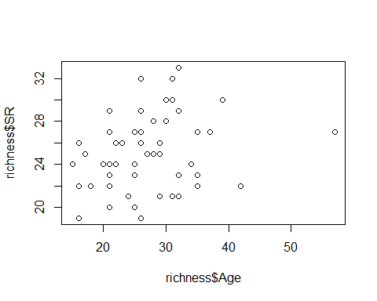

plot(richness$SR ~ richness$Nburns)

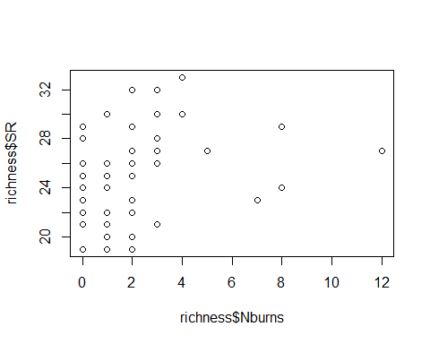

plot(richness$SR ~ richness$BA)

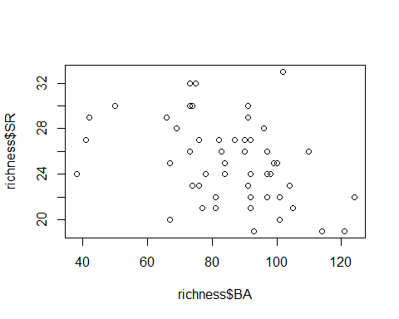

plot(richness$SR ~ richness$Parea)

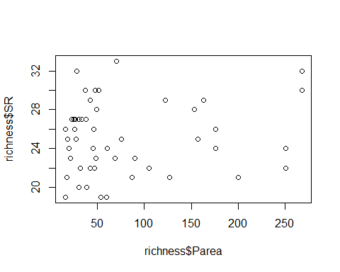

lm(SR ~ Treatment, richness)

##   
## Call:  
## lm(formula = SR ~ Treatment, data = richness)  
##   
## Coefficients:  
## (Intercept) Treatment1B Treatment2B Treatment3B   
## 23.833 -0.141 1.250 3.595

summary(lm(SR ~ Treatment, richness)) #3B statistically different from others

##   
## Call:  
## lm(formula = SR ~ Treatment, data = richness)  
##   
## Residuals:  
## Min 1Q Median 3Q Max   
## -6.4286 -1.9583 -0.0833 1.9167 6.9167   
##   
## Coefficients:  
## Estimate Std. Error t value Pr(>|t|)   
## (Intercept) 23.8333 0.9646 24.708 < 2e-16 ***  
## Treatment1B -0.1410 1.3377 -0.105 0.91649   
## Treatment2B 1.2500 1.3642 0.916 0.36418   
## Treatment3B 3.5952 1.3145 2.735 0.00877 **   
## ---  
## Signif. codes: 0 '***' 0.001 '**' 0.01 '*' 0.05 '.' 0.1 ' ' 1  
##   
## Residual standard error: 3.341 on 47 degrees of freedom  
## (13 observations deleted due to missingness)  
## Multiple R-squared: 0.1873, Adjusted R-squared: 0.1354   
## F-statistic: 3.609 on 3 and 47 DF, p-value: 0.01993

plot(SR ~ Treatment, data=richness)

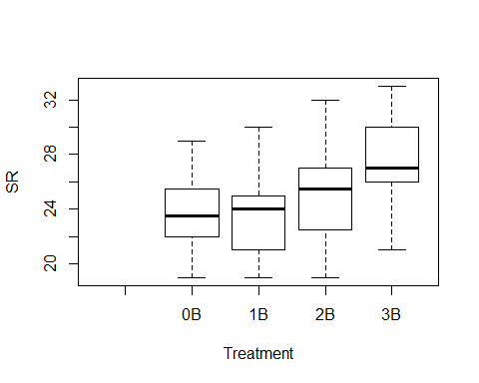

lm(SR ~ Herbicide, richness)

##   
## Call:  
## lm(formula = SR ~ Herbicide, data = richness)  
##   
## Coefficients:  
## (Intercept) Herbicide1   
## 24.9524 0.2143

summary(lm(SR ~ Herbicide, richness)) #nothing going on here - no stat sig difference bw 0 or 1

##   
## Call:  
## lm(formula = SR ~ Herbicide, data = richness)  
##   
## Residuals:  
## Min 1Q Median 3Q Max   
## -6.1667 -3.0595 0.0476 1.8333 7.8333   
##   
## Coefficients:  
## Estimate Std. Error t value Pr(>|t|)   
## (Intercept) 24.9524 0.7918 31.514 <2e-16 ***  
## Herbicide1 0.2143 1.0324 0.208 0.836   
## ---  
## Signif. codes: 0 '***' 0.001 '**' 0.01 '*' 0.05 '.' 0.1 ' ' 1  
##   
## Residual standard error: 3.628 on 49 degrees of freedom  
## (13 observations deleted due to missingness)  
## Multiple R-squared: 0.0008785, Adjusted R-squared: -0.01951   
## F-statistic: 0.04308 on 1 and 49 DF, p-value: 0.8364

plot(SR ~ Herbicide, data=richness)

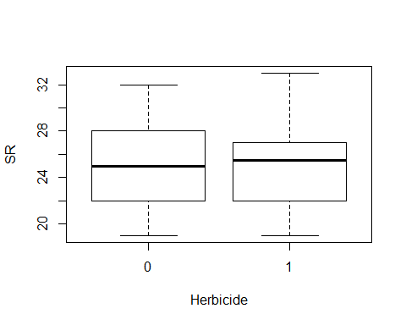

lm(SR ~ Nthins, data=richness)

##   
## Call:  
## lm(formula = SR ~ Nthins, data = richness)  
##   
## Coefficients:  
## (Intercept) Nthins   
## 23.4323 0.9226

plot(SR ~ Nthins, data=richness)

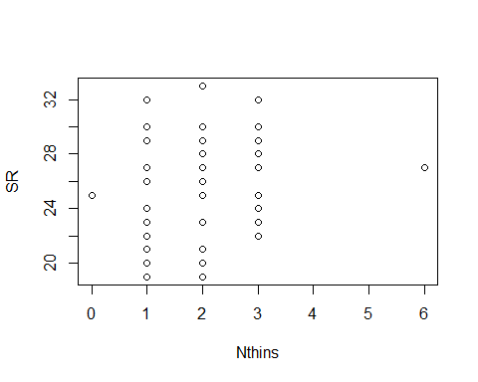

interaction.plot(richness$Treatment, richness$Nburns, richness$SR)

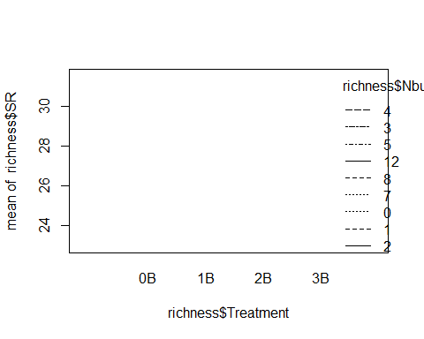

summary(lm(SR ~ Parea, richness)) #so no species-area relationsip?

##   
## Call:  
## lm(formula = SR ~ Parea, data = richness)  
##   
## Residuals:  
## Min 1Q Median 3Q Max   
## -5.9659 -2.8232 -0.0645 2.2594 7.9717   
##   
## Coefficients:  
## Estimate Std. Error t value Pr(>|t|)   
## (Intercept) 24.588955 0.750510 32.763 <2e-16 ***  
## Parea 0.006274 0.007125 0.881 0.383   
## ---  
## Signif. codes: 0 '***' 0.001 '**' 0.01 '*' 0.05 '.' 0.1 ' ' 1  
##   
## Residual standard error: 3.602 on 49 degrees of freedom  
## (13 observations deleted due to missingness)  
## Multiple R-squared: 0.01558, Adjusted R-squared: -0.004509   
## F-statistic: 0.7756 on 1 and 49 DF, p-value: 0.3828

fit<-lm(SR ~ Treatment + BA + Parea, data=richness)  
summary(fit)

##   
## Call:  
## lm(formula = SR ~ Treatment + BA + Parea, data = richness)  
##   
## Residuals:  
## Min 1Q Median 3Q Max   
## -5.6831 -1.9952 0.1006 2.0590 7.3397   
##   
## Coefficients:  
## Estimate Std. Error t value Pr(>|t|)   
## (Intercept) 29.003672 2.986197 9.713 1.29e-12 ***  
## Treatment1B -0.665758 1.328051 -0.501 0.6186   
## Treatment2B 0.336821 1.438655 0.234 0.8160   
## Treatment3B 2.134971 1.460230 1.462 0.1507   
## BA -0.059403 0.029515 -2.013 0.0502 .   
## Parea 0.008294 0.006726 1.233 0.2240   
## ---  
## Signif. codes: 0 '***' 0.001 '**' 0.01 '*' 0.05 '.' 0.1 ' ' 1  
##   
## Residual standard error: 3.25 on 45 degrees of freedom  
## (13 observations deleted due to missingness)  
## Multiple R-squared: 0.2638, Adjusted R-squared: 0.1821   
## F-statistic: 3.226 on 5 and 45 DF, p-value: 0.01423

confint(fit, level=0.95)

## 2.5 % 97.5 %  
## (Intercept) 22.989161422 3.501818e+01  
## Treatment1B -3.340590699 2.009074e+00  
## Treatment2B -2.560778526 3.234421e+00  
## Treatment3B -0.806084135 5.076026e+00  
## BA -0.118849054 4.396554e-05  
## Parea -0.005253564 2.184068e-02

anova(fit)

## Analysis of Variance Table  
##   
## Response: SR  
## Df Sum Sq Mean Sq F value Pr(>F)   
## Treatment 3 120.91 40.302 3.8155 0.01612 *  
## BA 1 33.40 33.398 3.1619 0.08213 .  
## Parea 1 16.06 16.059 1.5204 0.22397   
## Residuals 45 475.32 10.563   
## ---  
## Signif. codes: 0 '***' 0.001 '**' 0.01 '*' 0.05 '.' 0.1 ' ' 1

plot(SR ~ Age, ann=FALSE, type="n", xlim=c(10,60), ylim=c(10,40), data=richness)  
lines(SR~Age,lwd=2, data=richness)

