# Week 13 Practical

# Duties of a DBA

## Examine each of these carefully, screen captures and notes can be used as proof of completion. Perform any additional setup as required to complete these tasks.

Part 1:

* Check the previous night’s SQL Server database and transaction log backups and SQL Server Agent jobs for errors.

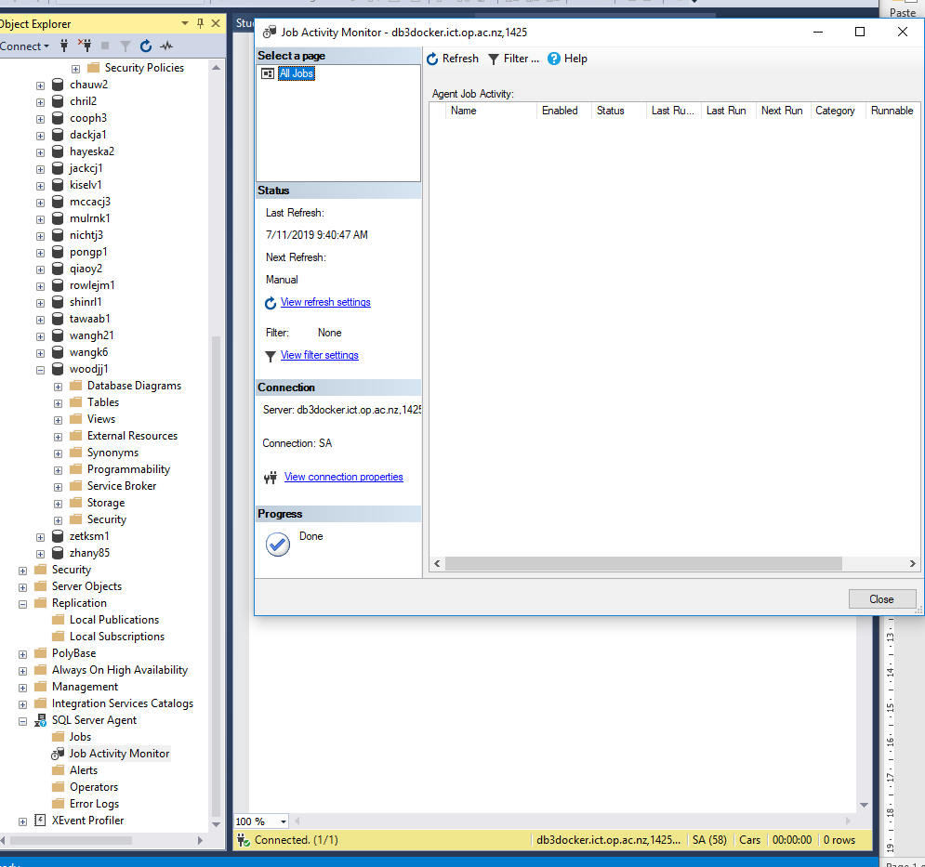

* Automate a daily backup schedule (Full and Differential)

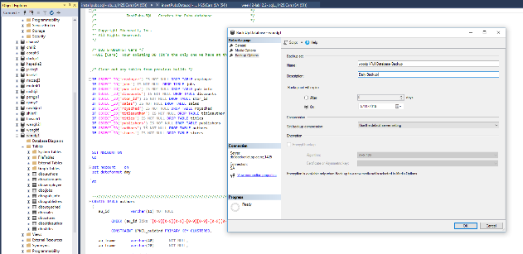

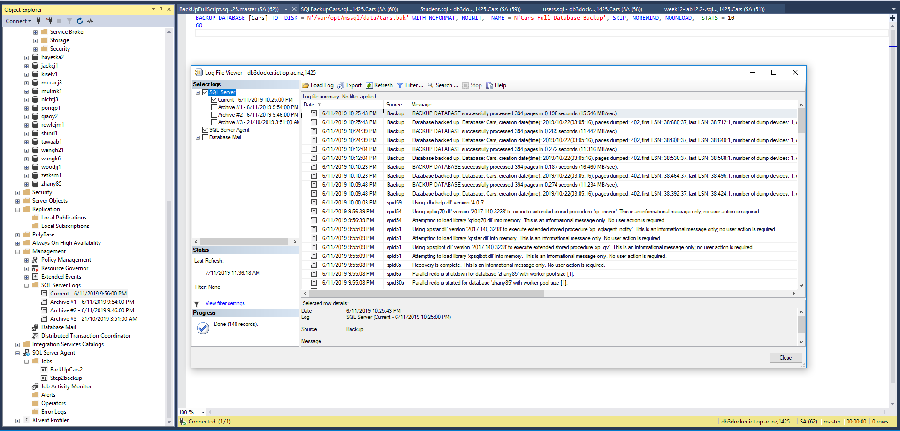

SELECT d.name,

MAX(b.backup_finish_date) AS backup_finish_date

FROM master.sys.sysdatabases d

LEFT OUTER JOIN msdb..backupset b

ON b.database_name = d.name

AND b.type = 'L'

GROUP BY d.name

ORDER BY backup_finish_date DESC

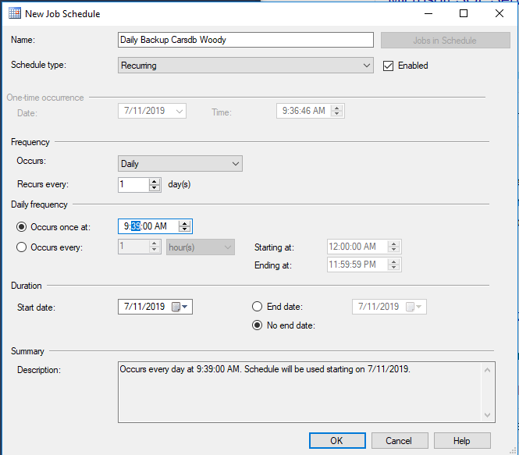

*Backup wizard for full backup*

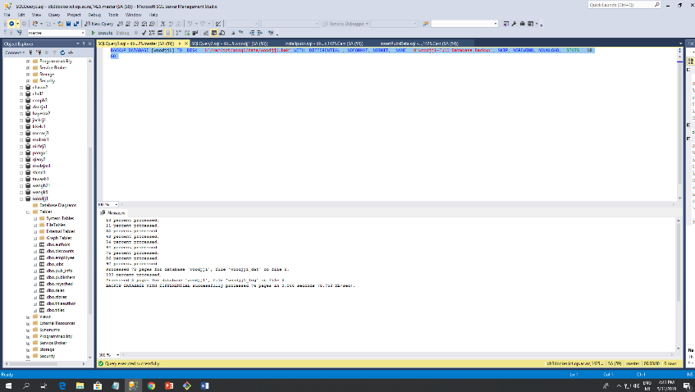

*Run script for differential backup*

* Check all databases to make sure all are up and not marked as suspect. Check previous DBCC CHECKDB for errors.

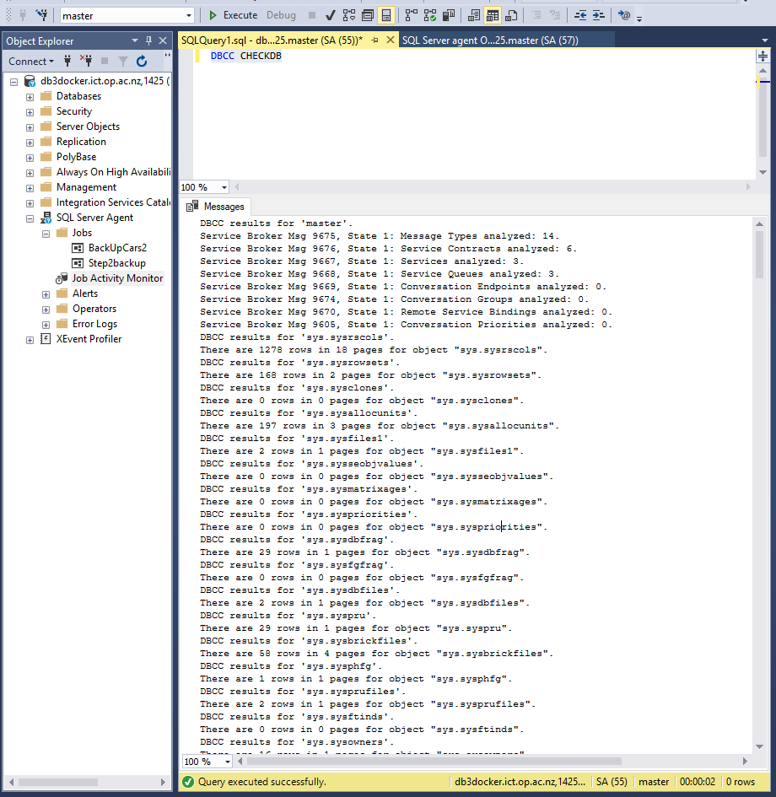

*Run DBCC CHECKDB*

* Check SQL Server Log File entries for warnings and errors and determine if any entries warrant further investigation. Export and save the current log file.

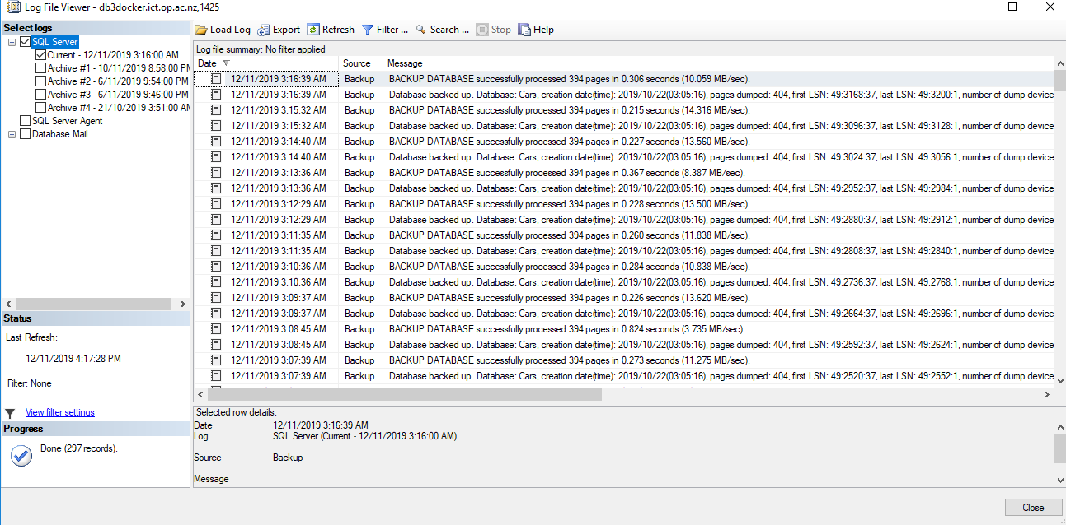

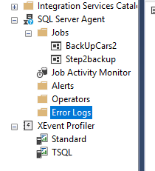

* Look for any security policy violations. Look for resources on the server, such as file sizes and disk space, and audit growth for long-term projections.

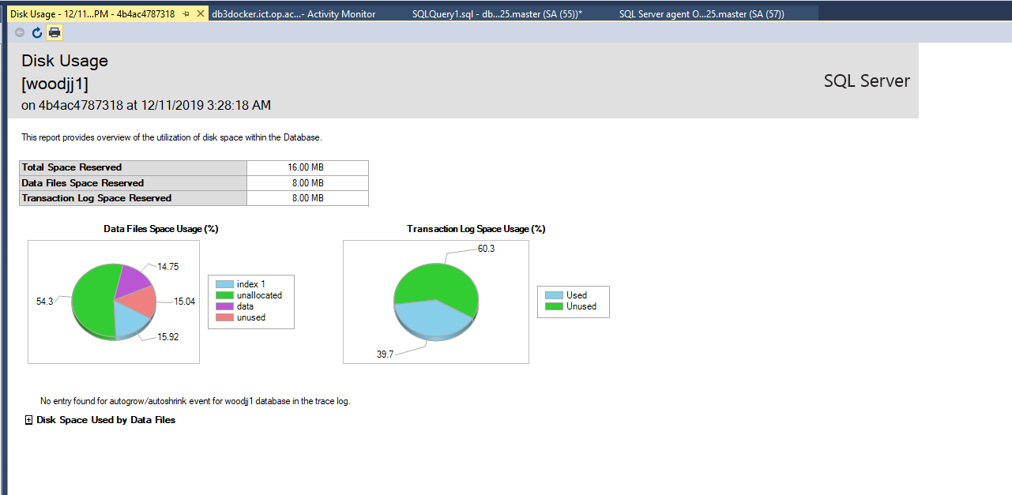

* Explore using long-running queries or tasks, Perform, etc. to generate data. Set up a sensible logging report to monitor disk and memory usage.

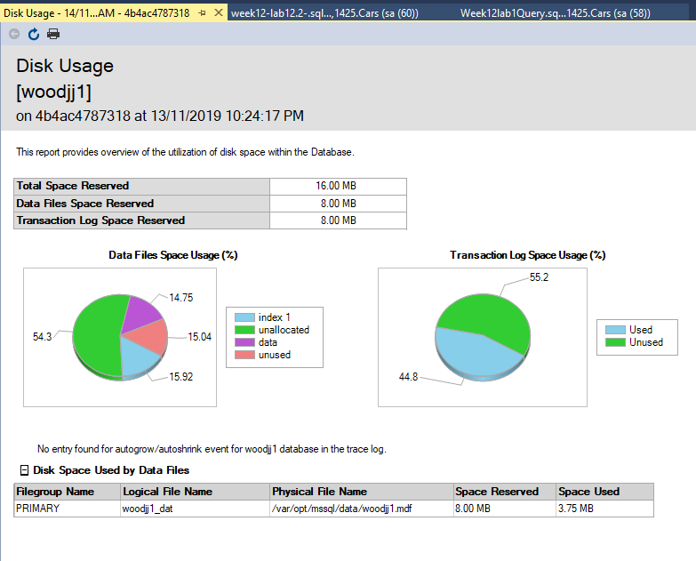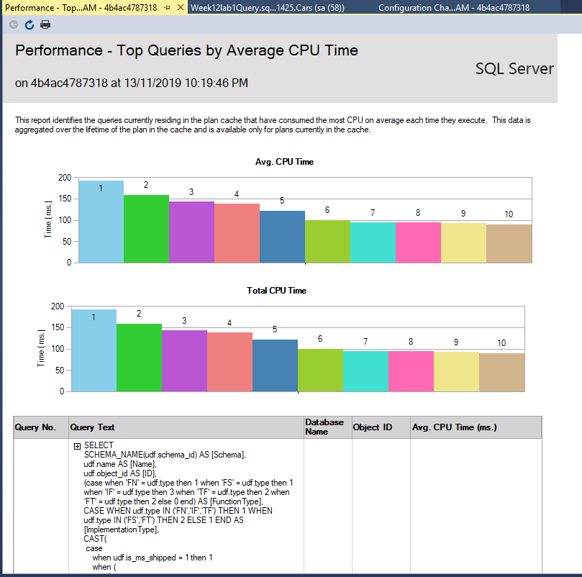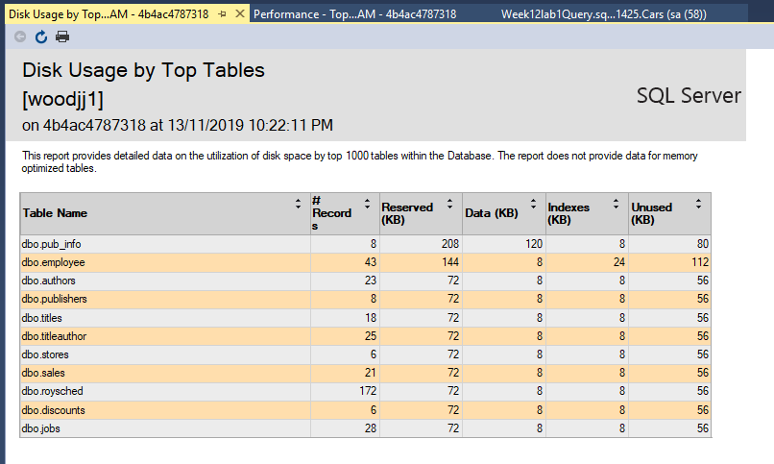

* What about your Container? What sort of usage data can you extract.

### Use your pubs database

Part 2. Task 1 (Task 2 will follow next week)

You want to recover a single table from a database backup – why?

It is the only table effected by a recent data loss.

Restoring an entire backup can take a significant amount of time, and you are under a lot of pressure to get it done fast

Perform the necessary data adjustments to check your solution is correct (delete rows etc). Provide a script for each of the following scenarios:

1. The table still exists, but only some rows were deleted, restore the deleted data only.
2. The table has been too badly damaged; restore the table structure and all the data.