Logical Modelling and Normalisation

This is a checkpoint. You may work in pairs. Due Friday Week 12 (25th Oct), 5.00 pm

- Convert the entity-relationship diagram below into a relational schema (logical model for a relational DBMS).
    - List any additional entities you feel this model should have (but won’t be used in this exercise)?
    - Represent your logical model using a UML-style diagram or tableName(column, column, column….) notation, as you prefer. Be sure to clearly indicate all primary and foreign keys.
    - Include a table which, for each column in your database, states the SQL Server data type and gives a brief description of the purpose of the field (i.e. an abridged data dictionary).

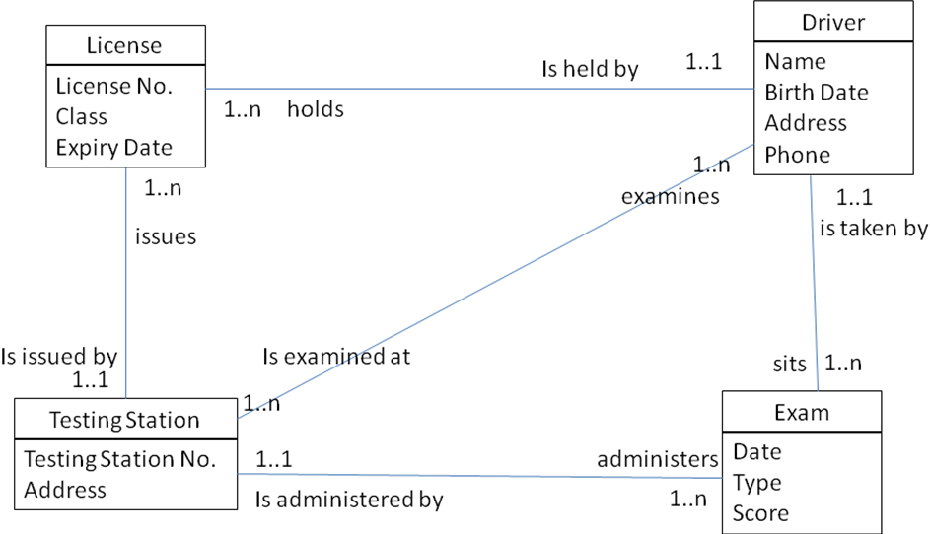

Note that this ERD contains a ternary relationship – that is, a relationship involving three entities. We did not discuss specifically how to translate higher-order relationships into relational schemata. However, you should be able to generalise from the treatment of a binary many-to-many relationship. Hint: A composite primary key may contain any number of fields.

- The schema below represents a database for storing information about the plays showing in South Island theatres. It is not normalised. Convert it to 3rd Normal Form. Carefully illustrate the process you follow (there should be three steps: UNF -> 1NF; 1NF->2NF; 2NF->3NF)

Theatre:
  - Theatre Name
  - Theatre Location
  - No of Seats
  - Year Founded
  - Manager
  - Manager Contact Number
  - Play 1
    - Name, Genre, # performances, Author, Author address
  - Play 2
    - Name, Genre, # performances, Author, Author address
  - Play 3
    - Name, Genre, # performances, Author, Author address

