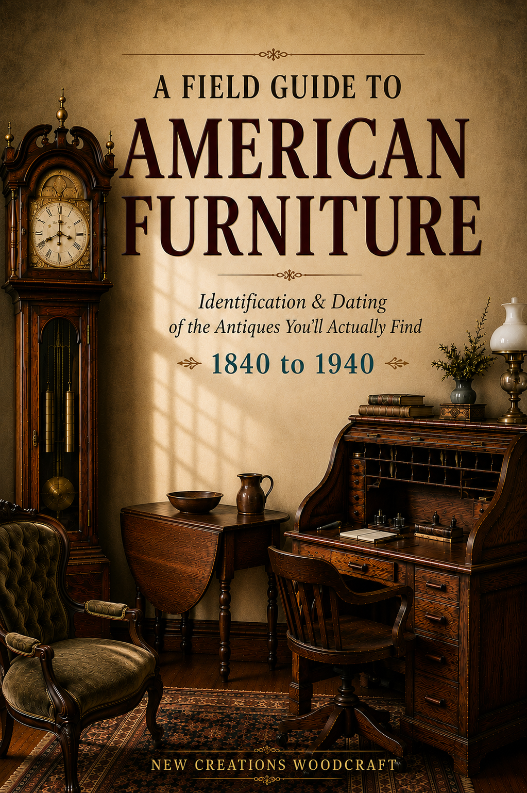

PART I · THE METHOD

How to use this guide
This guide is built in three parts, and they work together.
- Part I, the Method (this section), teaches you how to read a piece: the order to look in, and why construction beats style.
- Part II, the Forms, is thirty chapters on the pieces you will actually meet, each with a fast "rule it out" test and a careful "confirm it" path.
- Part III, the Reference Atlases, in the back, teaches the skills the form chapters assume: how to identify a wood, a nail, a joint, a finish. When a chapter says "read the dovetails," the back of the book shows you how.
You do not have to read it cover to cover. Find your piece in Part II, run the test, and flip to the atlases in Part III when you need to confirm a detail.

The field process
Real identification follows an order. Experts do not stare and guess; they run a sequence, fast at first and careful only when a piece earns it. Six steps.
- Look. What is the form? Start with shape and structure, not style or age. Is it a chair, a chest, a desk, a table? Then narrow: a chest of drawers or a dresser, a sideboard or a buffet. The form chapters in Part II each open with a ten-second test for exactly this.
- Rule it out fast. Most candidates die in seconds on one disqualifier. No plank seat with socketed legs, it is not a Windsor. No knee opening, it is not a dressing table. Eliminate quickly so you only slow down for real possibilities.
- Read the construction. Once a piece is on the short list, stop looking at the surface and read how it was built. Open a drawer, turn it over, look at the joints, the fasteners, the saw marks, the woods. This is where age lives. (Part III shows you how to read each of these.)
- Date by layers, and stack the evidence. No single clue dates a piece. A wire nail, a machine dovetail, a circular-saw arc, each is one layer. Three or more pointing the same way is a conclusion; one is a hint. The period-or-reproduction decision tree below is this habit in one picture.
- Compare to look-alikes. Confirm by ruling out the close cousins. Sideboard or buffet or server? Settee or sofa? Each form chapter carries the comparison that matters.
- Estimate value, then call it. Judge value as a range and a direction (common and modest, or premium when original), not a fixed price, because region, condition, and a buyer's emotion move money more than a book can. Then commit to a verdict, and be honest about your confidence.

The single most useful tool: stack the tells
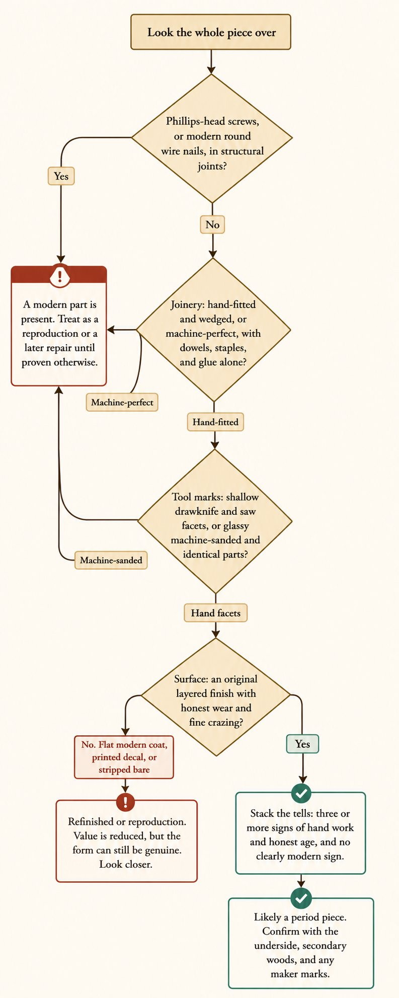
The tree above is the method in miniature. It runs the quick-kill checks first (modern screws, machine joinery), then tool marks, then surface, and it never decides on one clue. You will meet it again in chapter after chapter, on different forms, because the habit is always the same: eliminate fast, then stack the evidence.

Style is the weakest evidence
Here is the rule that separates a careful eye from a fooled one: style tells you the least about age. A piece can be made in any year to look like any period. Colonial Revival reproductions copied eighteenth-century forms for decades. So style suggests a date; construction proves it. When the look says one thing and the nails and dovetails say another, believe the construction.
Style still matters, for naming the look and the market, just not for proving the year. Use it last, after the construction has spoken.

A short timeline of American furniture styles, 1840 to 1940
This is the window the guide covers, and these are the looks you will meet. Use it to name a style, then date the piece by construction.
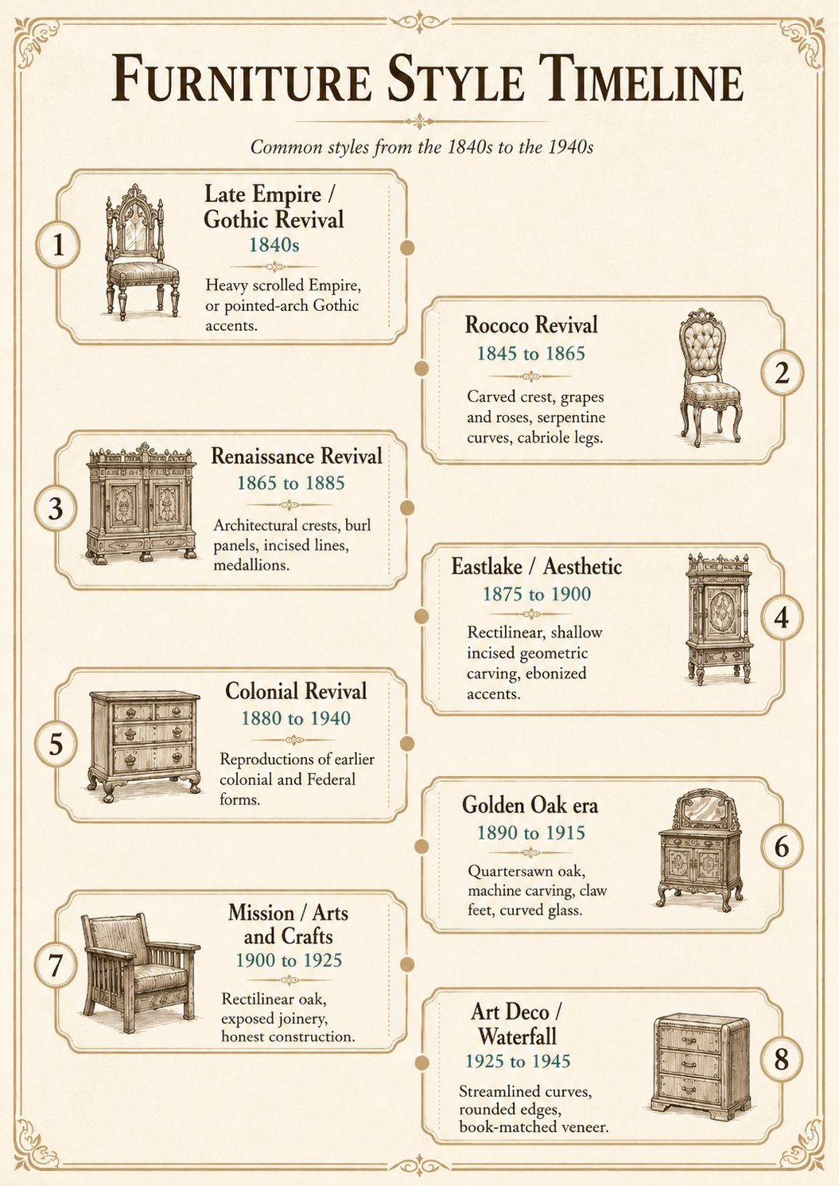
Remember the lag: private bedroom furniture and rural and Southern production trail urban fashion, sometimes by a decade or more. A plain painted piece can look older than it is.

The four Method diagrams
Four diagrams carry the Method, and you will meet them again throughout the book:
- The period-or-reproduction decision tree
- Three nails, three eras (hand-wrought, cut, and wire)
- Hand-cut vs machine-cut dovetails
- Slotted vs Phillips screws
The full detail behind each lives in the Part III atlases.

PART II · THE FORMS · Seating

SEATING

Windsor Chair
also called: spindle chair · sack-back · bow-back · comb-back · fan-back · hoop-back · "Colonial" chair
Era: 1840 ██████████ 1940. The form's roots open c. 1720; the highlighted band, 1840 to 1940, is what you will actually find.
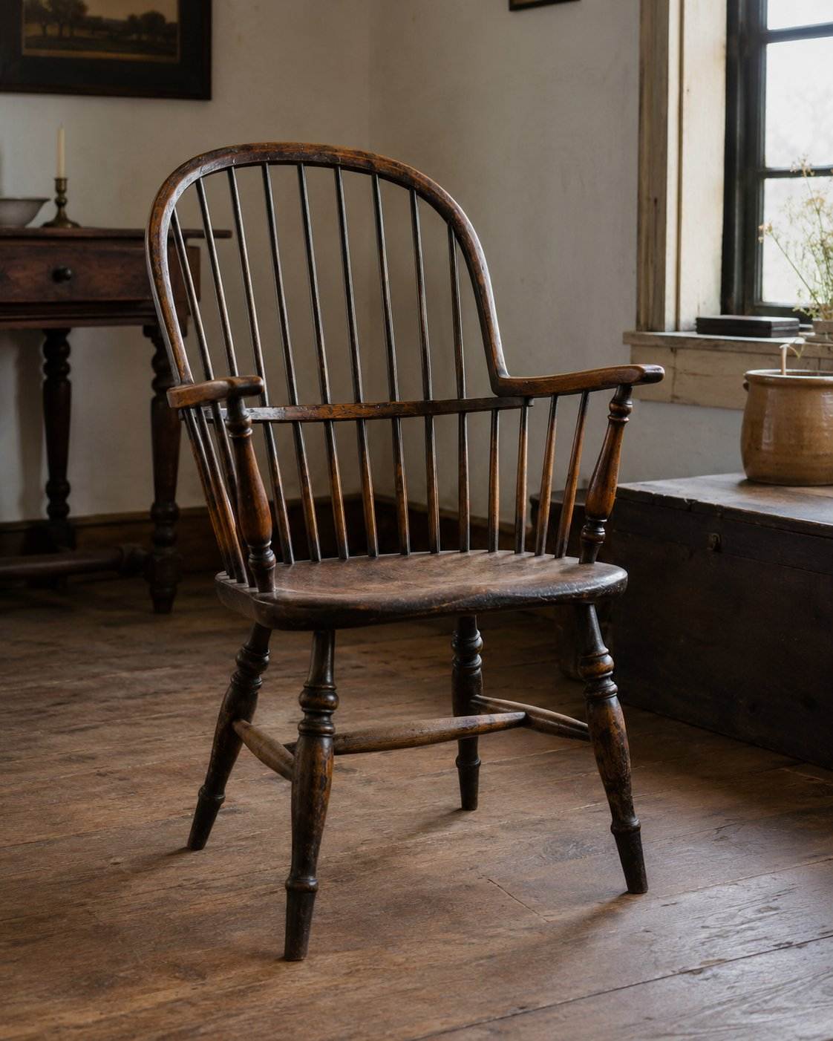

Rule it out in 10
Look at the seat and where the legs go. A Windsor has a solid carved wooden plank seat, with the legs socketed straight up into the underside: no apron, no frame, no rails under the seat.
Upholstered, rush, or cane seat? **Not a Windsor.** Legs joined to an apron or a square frame? **Not a Windsor.** Plank seat, with legs driven straight into it and splayed out? **Short list. Keep going.**

What it is
The Windsor isn't a style, it's a construction system. Everything about it hangs off one idea: a thick solid-wood plank seat that serves as the structural hub. The back spindles socket down into the seat, the legs socket up into it, and the legs splay outward for stability. The back is built from turned spindles and a shaped crest, never the flat rail-and-stile frame of an ordinary chair.
It's one of the great American forms. Philadelphia, New England, and New York were major centers, with the golden age running c. 1740 to 1820. But here's the field reality for this guide's era: genuine 18th-century Windsors are largely museum-and-auction pieces. What you'll actually meet from 1840 onward is 19th-century continuation and, by a wide margin, Colonial Revival reproductions (c. 1870 to today). So the money question is almost never "is it a Windsor?" It's "is it period, or a revival reproduction?" That call is the rest of this page.

On the short list? Confirm it
The defining features (you want most of these):
- Solid plank seat, usually saddle-shaped (carved hollows for the sitter)
- Back spindles socketed into the seat, not mortised into a rail
- Legs socketed into the seat underside, splayed
- Turned legs, stretchers, and posts
- A back type from the family below, but never a rail-and-stile frame
Know it by its back (the subtypes, your quick visual key):
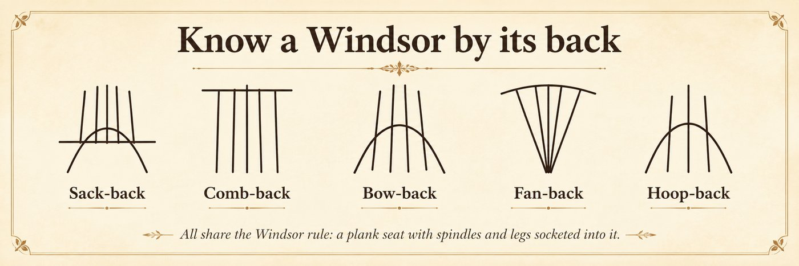
Sack-back · Comb-back · Bow-back · Fan-back · Continuous-arm · Hoop-back

Date it
Tool marks | Fasteners/joints | Wood | Finish | Wear
Hand drawknife and spokeshave facets, slight irregularity, point period. Uniform, sanded-smooth, identical parts point machine or repro. | Wedged through-tenon sockets, hand-fitted, point period. Modern screws, dowels, glue-only, or perfectly round machine sockets point revival. | Multiple woods chosen by job (pine seat, maple or birch legs, oak or hickory bent parts) point period craft. One uniform wood throughout points factory repro. | Original milk or oil paint (Windsors were almost always painted) with honest layered wear is period gold. Clear-stained "natural wood" or thick modern poly points revival. | Genuine underside and stretcher wear, settled splay, old shrinkage point period. Crisp, even, no real wear points recent.
The headline call: period (pre-1900) versus Colonial Revival reproduction (1870 to present). No single clue decides it: stack the layers. Three or more pointing "hand and old" means likely period; machine tells anywhere mean treat it as revival until proven otherwise.
See the Fastener Atlas (wedged joints), Wood Atlas (multi-wood), Finishes Atlas (milk paint), and Joinery Atlas (socketed through-tenon).

Do not confuse it with
- Ladderback: horizontal slats between two rear posts; a real (often rush) seat in a frame. No plank seat, no socketed spindles, so not a Windsor.
- Spindle-back chair (generic): "spindle-back" just describes a look. A Windsor requires the plank seat and socketed construction; spindles alone aren't enough.
- "Windsor-style" reproduction: looks the part but shows modern machining, fasteners, finish, and tool marks. This is the one that actually fools people (see Date it).

What it is worth, in plain terms
The spread is enormous and hinges entirely on period versus repro. A documented 18th to early-19th-century painted Windsor is a serious antique; a 20th-century Colonial Revival example is decorator furniture. Get the dating right before you price it.

Watch for
- Revival repros sold as period: the number-one trap. Machine-uniform parts and modern finish.
- Stripped paint: refinishing an original-painted Windsor down to bare wood destroys value. Original paint is the prize.
- Replaced or re-pegged legs, married tops and bases: check that wear, wood, and patina agree across the whole chair.

SEATING

The Rocking Chair
also called: rocker, Boston rocker, platform rocker, nursing rocker, Lincoln rocker
Era: 1840 ██████████████████ 1940. The American rocker is everywhere from about 1800 on. Type and construction date it.
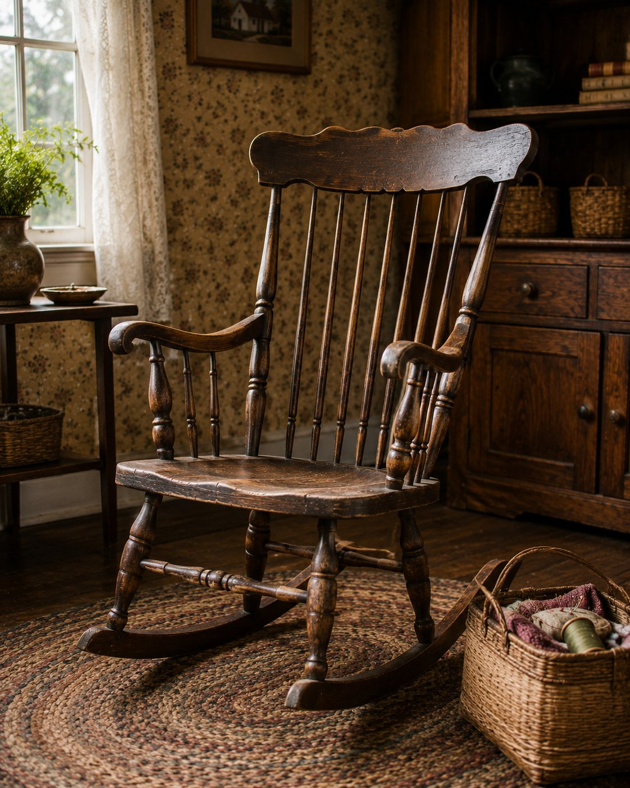

Rule it out in 10
A rocking chair rocks, either on curved runners under the legs or on a spring platform base. That is the whole gate.
Then ask one question that decides value more than any other: are the rockers original to the chair? Adding rockers to a plain chair was a common alteration, and runners break and get replaced.

What it is, and the family you will meet
"Rocking chair" is a motion, not a single design, so you will meet several types. Know them on sight:
- Boston and Windsor rockers. Plank or shaped seat, turned spindle back, often painted and stenciled. (Full treatment in the Windsor chapter and the companion article.)
- Ladderback rocker. Horizontal slats between two posts, usually a woven rush seat.
- Pressed-back rocker. Oak factory chair, about 1890 to 1910, with a design stamped into the crest by machine.
- Platform or spring rocker. Rocks on springs over a stationary base, popular from the 1870s. If it rocks without runners touching the floor, it is this.
- Upholstered parlor rocker (Lincoln rocker). A framed, padded, high-back Victorian rocker.

On the short list, confirm and date it
- The rockers. Check that runner wood, wear, and the joints where runners meet the legs all agree and look old and settled. Fresh cuts or mismatched wood mean added or replaced.
- Construction. Hand facets and wedged joints and cut nails point earlier; machine-uniform parts, pressed decoration, and wire nails point to the factory era. (Method section, and the period-or-reproduction tree.)
- The surface. On painted and stenciled rockers, an original decorated surface is the prize, and stripping it destroys value. You have heard this before, which is the point.

Do not confuse it with
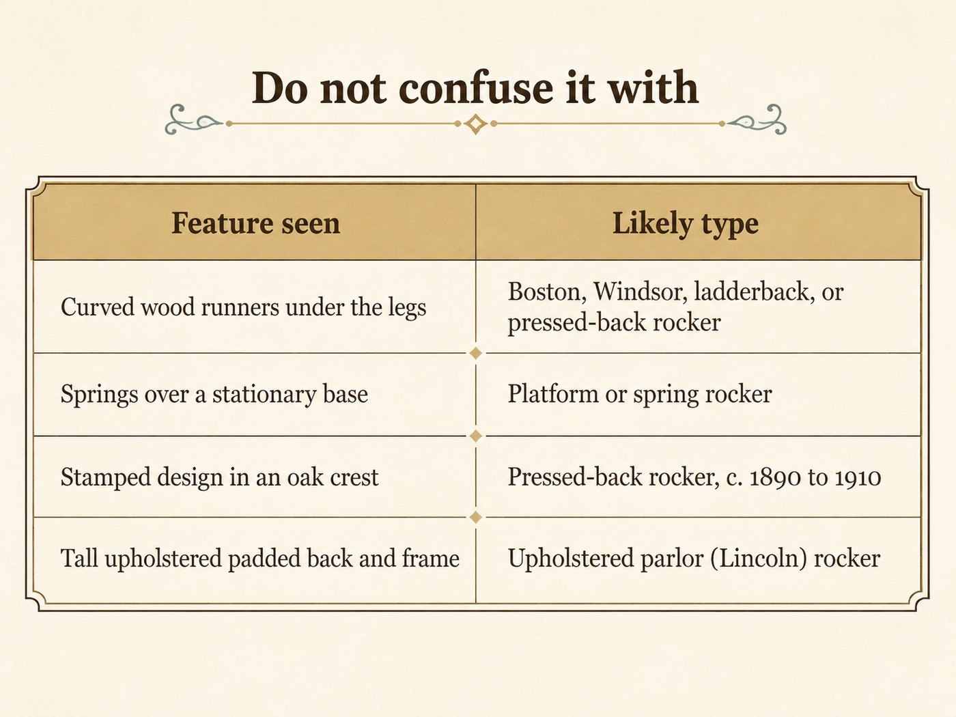

What hurts the value
- Replaced or added rockers, or a botched runner repair.
- Stripped original paint on a Boston or country rocker.
- Married parts, a top and base that do not agree.

What it is worth, in plain terms
Most country and factory rockers are common and modest, useful and very saleable. Value climbs toward premium with an early hand-made example, original rockers, and an original painted or stenciled surface. Originality, again, does the lifting.

Quick field routine
First, confirm it rocks, on runners or a spring platform. Second, judge whether the rockers are original. Third, name the type from the list above. Fourth, date by construction and protect the original surface.
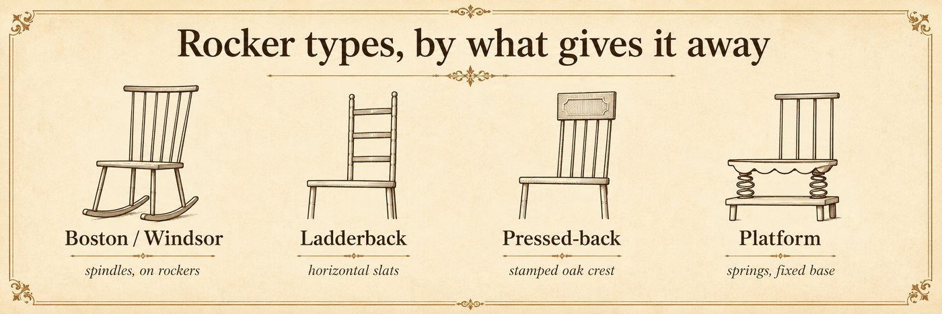

SEATING

The Morris Chair
also called: Mission Morris chair, bow-arm or flat-arm Morris chair, adjustable-back chair
Era: 1840 ░░░░░░ 1895 ████████ 1925 ▒░ 1940. English Arts and Crafts origins, American heyday roughly 1895 to 1925.
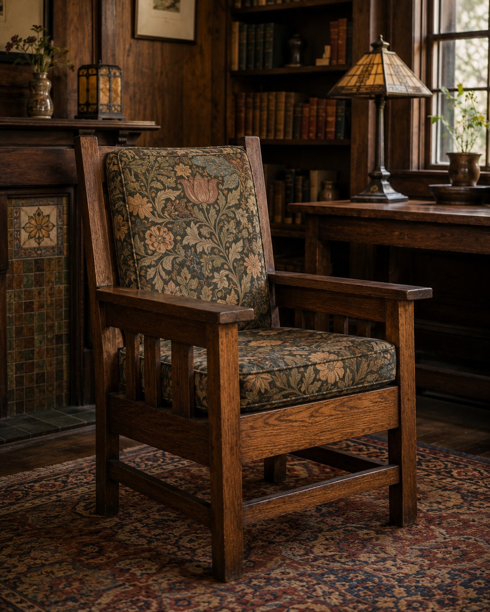

Rule it out in 10
A Morris chair is a lounge chair with an adjustable reclining back held by a visible manual mechanism: a rod, pegs, a notched bracket, or a hinged support you move by hand. Add an exposed wood frame and broad arms.
If the recline is hidden mechanical hardware, that is a recliner. If the back is fixed, it is an ordinary armchair or lounge chair. The visible back-adjustment rod is the Morris chair's signature.

What it is
The Morris chair is the great Arts and Crafts lounge chair, descended from English designs associated with William Morris and made strongest in America from about 1895 to 1925 in Mission and Craftsman furniture. Its identity is structural: an exposed, dominant wood frame, broad flat arms wide enough for a book or a cup, loose seat and back cushions, and a back whose angle you set by hand with a rod dropped into notches, pegs, or a hinged support. American examples are typically quartersawn white oak with a rectilinear silhouette and honest joinery, often exposed through-tenons and wedge keys.
The key habit: read the mechanism, not the upholstery. Cushions and covers are replaced constantly, so they tell you little. The adjustable back and the exposed frame are what make it a Morris chair.

On the short list, confirm and date it
- The visible back-adjustment mechanism, the surest single feature.
- An exposed quartersawn oak frame, rectilinear, with broad arms.
- Exposed through-tenons and wedge keys, the Mission construction signature.
- Date by frame construction and finish, not by the cushions. Machine-uniform reproduction frames and modern fasteners give away later copies. (Run the period-or-reproduction tree.)
A note on makers: Stickley names carry real value, but Mission vocabulary alone is not a Stickley attribution. Many competitors and later revivals use the same look. Do not attribute to Stickley, Limbert, Roycroft, or any maker without a mark, a label, a documented model match, or strong provenance.

Do not confuse it with
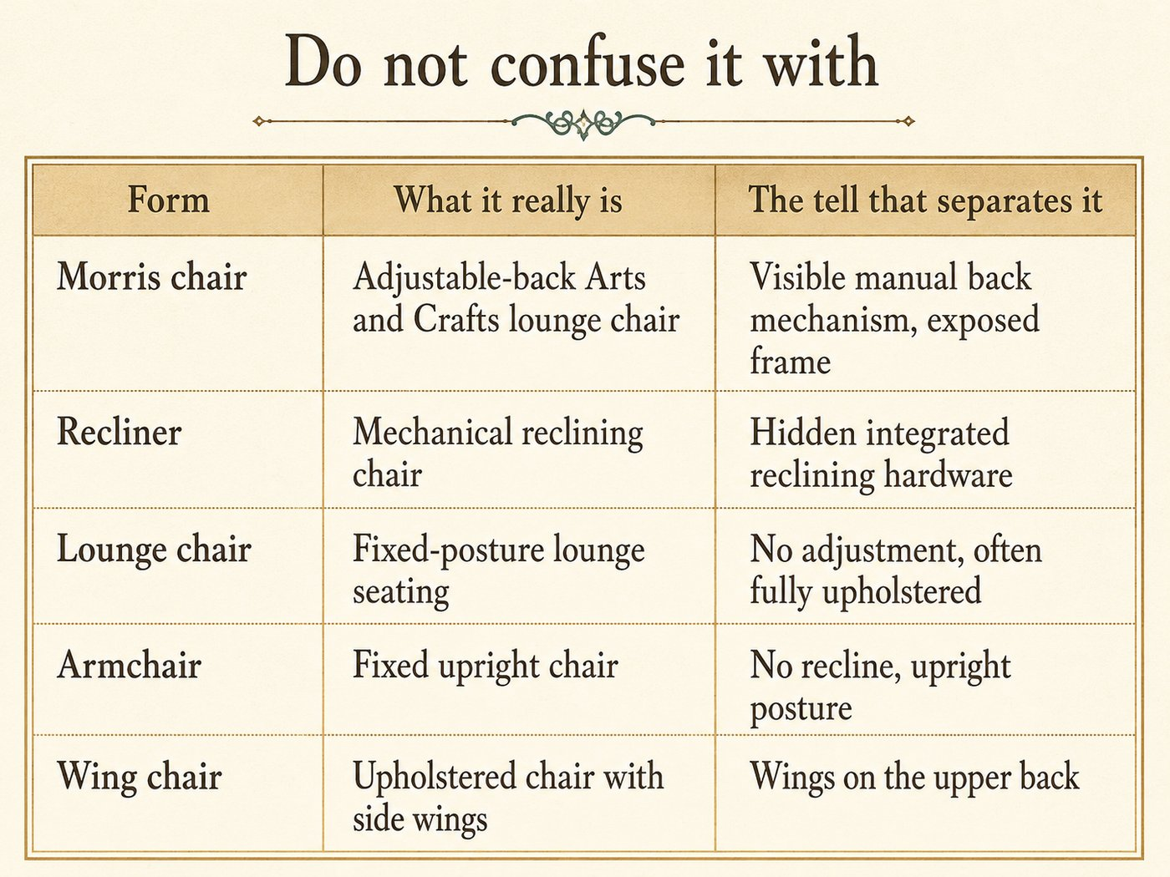

What hurts the value
- Reproductions sold as period Mission, and false Stickley attributions.
- A broken or replaced back mechanism, or a refinished and stripped oak frame.
- (Replaced cushions are normal and do not hurt much. The frame and mechanism are what matter.)

What it is worth, in plain terms
A documented Stickley or named maker Morris chair in original oak and finish is premium, sometimes well into it. A generic period Mission Morris chair is desirable but moderate, and later reproductions are common and modest. The frame, the finish, the mechanism, and any real maker mark set the range.

Quick field routine
First, find the mechanism. Visible manual back adjustment, or it is not a Morris chair. Second, read the frame. Exposed quartersawn oak, through-tenons, broad arms. Third, date by frame and finish, ignore the cushions. Fourth, resist the Stickley name without hard proof.

SEATING

The Wing Chair
also called: wingback chair, fireside chair, easy chair (early)
Era: 1840 ██████████████████ 1940. The form is old, from the 1600s, but what you will find is mostly Federal and Colonial Revival. Read the legs.
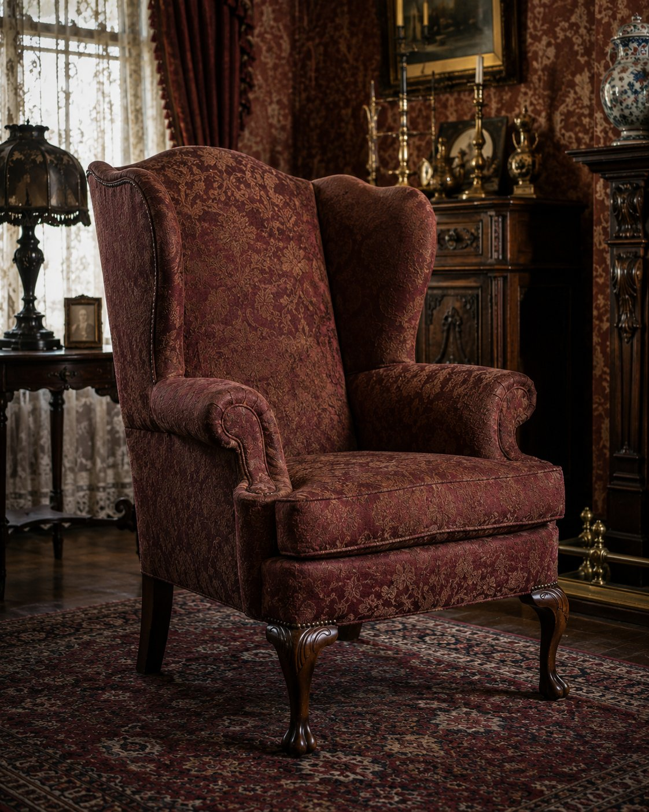

Rule it out in 10
A wing chair has side wings that project forward from the upper back, up around where your head and shoulders sit. That is the defining feature, present even on small or plain examples.
No wings, no wing chair. An upholstered chair without those forward-projecting side panels is an armchair, a club chair, or a lounge chair.

What it is
The wing chair began as a fireside chair: the wings blocked drafts, held warmth around the sitter, and supported the head during reading or dozing. The back is tall, commonly 38 to 50 inches, the wings reach above the shoulders, and the arms usually sweep down from the wing fronts. The frame is most often fully upholstered, though early American, Federal, and revival examples show exposed wood at the legs and stretchers.
Because the upholstery is almost always later, the legs are your clock.

On the short list, date it by the legs
The cover gets replaced; the legs rarely do. Read them.
Legs and feet | Period it points to
Turned legs joined by box stretchers, ball or Spanish feet | William and Mary / early Georgian, c. 1690 to 1730
Cabriole legs, pad or trifid feet | Queen Anne, c. 1720 to 1760
Cabriole legs, ball-and-claw feet | Chippendale, mid 1700s
Tapered or reeded straight legs | Federal and Hepplewhite, c. 1790 to 1820
Bracket, block, or revival cabriole legs, machine construction | Colonial Revival, c. 1880 to 1940
In the 1840 to 1940 window of this guide, most wing chairs you meet are Federal and Colonial Revival. Confirm with construction (Method section): machine work and modern fasteners place a chair in the revival era no matter how "early" the legs are styled to look.

Do not confuse it with
Form | What it really is | The tell that separates it
Wing chair | Upholstered chair with forward side wings | The wings on the upper back
Armchair | Upholstered or wood chair with arms | No wings
Club chair | Low, deep upholstered lounge chair | No wings, lower back
Lounge chair | Posture-based relaxed seating | No wings, often reclined

What hurts the value
- A married or replaced base, or later feet on an old frame.
- Worn-out structure under the upholstery (frame, springs, webbing), which matters more than the visible cover.
- (A later, well-done re-cover is expected and does not hurt much. Read the frame and legs.)

What it is worth, in plain terms
A genuine eighteenth-century wing chair with an original frame and good lines is premium and serious. A Federal or Colonial Revival example, which is what you will usually find, is moderate, and a worn twentieth-century reproduction is common and modest. Frame quality, leg period, and structural condition set the range, not the fabric.

Quick field routine
First, confirm the wings projecting forward from the upper back. Second, read the legs against the period table. Third, confirm the period with construction, machine work means revival. Fourth, judge the frame and structure under the cover, not the cover.
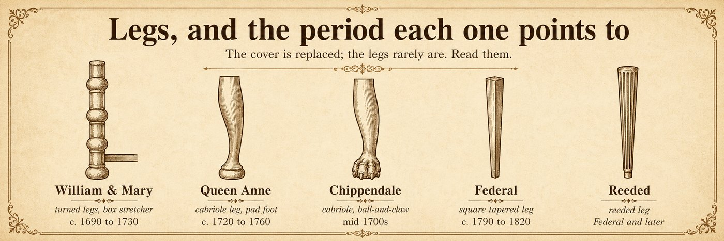

SEATING

The Settee
also called: parlor settee, hall settee, cane-back settee, settee bench
Era: 1840 ██████████ 1930 ▒░ 1940. Made since the 1700s, with a strong Victorian parlor run, c. 1840 to 1930.
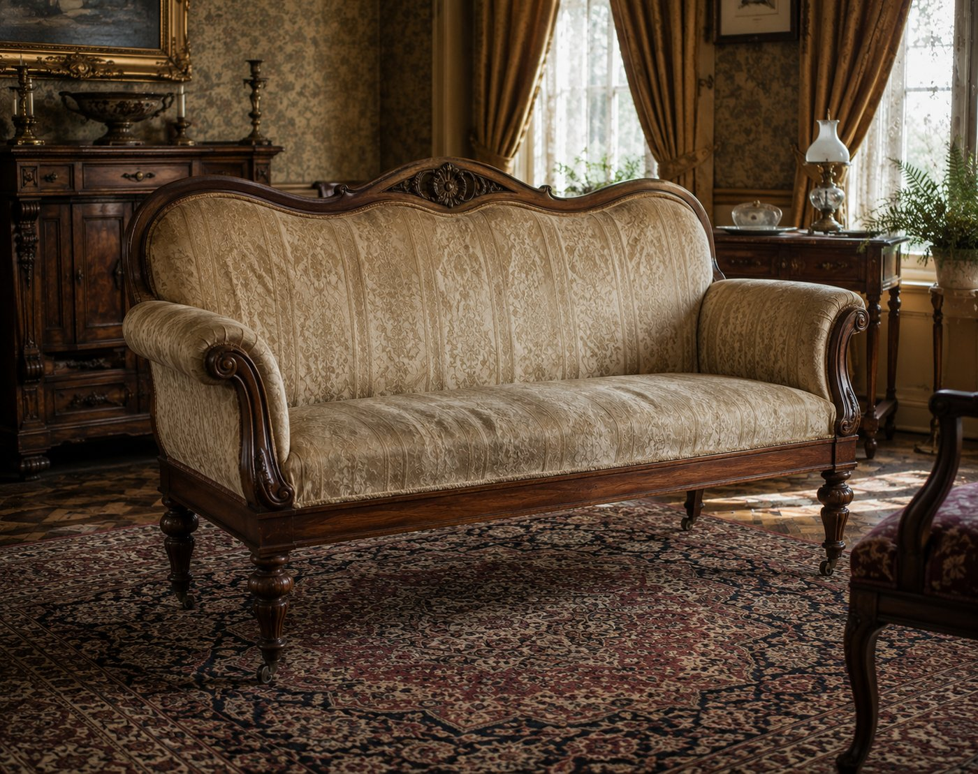

Rule it out in 10
A settee is small, upright, and chair-like multi-user seating with a back, usually for two, commonly 42 to 65 inches wide. It often looks like two chairs joined or an elongated chair.
If it is wide, deep, and soft for lounging, that is a sofa. If it is hard, plain, and shallow with an optional back, that is a bench. The settee sits between them: formal, upright, chair-like.

What it is
The settee is parlor and hall seating, lighter and more formal than a sofa. It may be fully upholstered, partly upholstered, or an exposed wood frame with a cane, slat, or spindle back, and it frequently comes as part of a matched parlor suite with side chairs and an armchair. Its strongest American run is Victorian, roughly 1840 to 1930, across Rococo Revival, Renaissance Revival, Eastlake, and Aesthetic Movement, with continuous Colonial Revival production after.
Arms are common but optional, and arms alone do not turn a settee into a sofa. The deciding traits are scale, upright posture, and chair-like frame.

On the short list, confirm and date it
- Confirm scale and posture: narrower than a sofa, more upright, chair-derived.
- Look for suite context: a matching side chair or armchair strongly supports a parlor settee reading.
- Date by frame and construction, as with any seating. The visible style (Rococo Revival carving, Eastlake incising) suggests period, but confirm with joinery, fasteners, and finish. Cane and upholstery are commonly replaced.

Do not confuse it with
Form | What it really is | The tell that separates it
Settee | Small, upright, chair-like seat for two | Narrow, formal, chair-derived frame
Sofa | Larger, deeper lounge seating | Wider, softer, lounge posture
Loveseat | Small two-seat sofa | Deeper and softer than a settee
Bench | Simple elongated seat | Harder, shallower, back optional
Settle | High paneled-back seat | Tall enclosed panel back, architectural

What hurts the value
- Replaced cane or upholstery done poorly, and refinished carved frames.
- A broken suite, the settee separated from its matching chairs (the set is worth more together).

What it is worth, in plain terms
A carved Victorian parlor settee, especially with its matching chairs as a suite, is desirable, and the complete suite sells for more than the parts. A plain or heavily restored single settee is common and modest. Carving quality, original surface, and suite completeness set the range.

Quick field routine
First, confirm scale and posture: small, upright, chair-like. Second, look for matching suite pieces. Third, date by frame and construction, not the replaced cane or cover. Fourth, separate from sofa (bigger, softer) and bench (harder, simpler).

SEATING

The Victorian Sofa
also called: sofa, settee (loosely), camelback, Grecian or recamier, Rococo Revival sofa
Era: 1840 ██████████ 1910 ▒░ 1940. Upholstered multi-user lounge seating, with the classic Victorian parlor run c. 1840 to 1910.
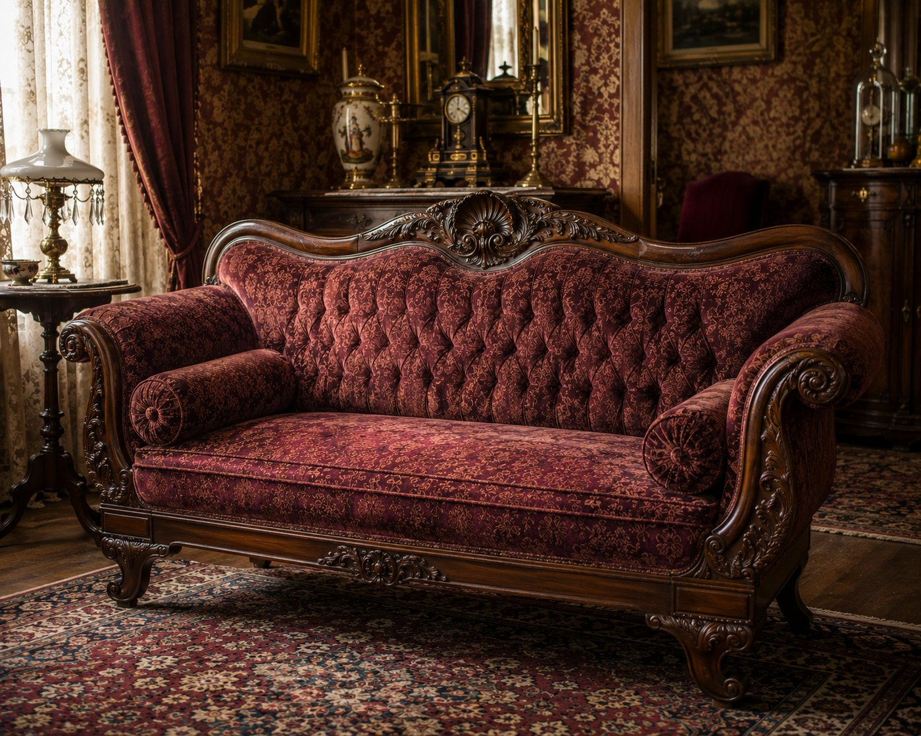

Rule it out in 10
A sofa is wide, deep, upholstered lounge seating for two or more, with a back and usually arms. It is larger and softer than a settee, and harder to mistake once you compare scale.
If it is small, upright, and chair-like, that is a settee. If it is hard and shallow, that is a bench. The sofa is the deep, soft, multi-user lounge piece of the parlor.

What it is, and the Victorian shapes
You will mostly meet Victorian and early twentieth-century examples. Learn the silhouettes:
- Grecian or recamier, c. 1840s, a scrolled-end couch with one raised end, Empire into early Victorian.
- Rococo Revival, c. 1850 to 1865, the classic carved Victorian sofa: a serpentine carved crest with grapes, roses, or finger-roll molding, on cabriole legs, often attributed in spirit to the Belter and Meeks tradition (attribute by name only with proof).
- Renaissance Revival, c. 1865 to 1885, more architectural, with crests, burl panels, and incised lines.
- Eastlake, c. 1880 to 1900, rectilinear with shallow incised decoration.

On the short list, date the frame, not the cover
This is the sofa's lesson. The upholstery is almost always a later re-cover, so it dates nothing. Turn the piece over and read what does not change:
- The legs and the carved crest, which carry the style and period.
- The springs. Hand-tied coil springs on a webbed frame point to the nineteenth or early twentieth century; modern foam and sinuous wire springs point later or to a rebuild.
- The frame construction, joinery, and fasteners (Method section).
A fresh cover over an old hand-tied, well-carved frame is a period sofa that has simply been reupholstered. A new cover over modern foam and staples is a modern sofa.

Do not confuse it with
Form | What it really is | The tell that separates it
Sofa | Wide, deep, soft lounge seating | Lounge scale and posture, multi-user
Settee | Small, upright, chair-like seat | Narrower, more formal, chair-derived
Loveseat | Small two-seat sofa | Sofa construction, just shorter
Daybed | Horizontal reclining or sleeping piece | Mattress-like, made to lie on
Chaise longue | Single-user extended-leg recliner | One seat, long leg rest

What hurts the value
- A broken-up parlor suite (sofa parted from its matching chairs).
- Cut-down or married frames, and a rebuild that replaced hand-tied springs with foam.
- (Reupholstery itself is expected and does not kill value, as long as the frame is sound and original.)

What it is worth, in plain terms
A finely carved Rococo Revival sofa with a sound original frame, especially as part of a suite, is premium. A plain Victorian or early-twentieth-century sofa is moderate to modest, and value rests on the carving, the frame, and suite completeness rather than on the current fabric.

Quick field routine
First, confirm sofa scale: wide, deep, soft, multi-user. Second, read the silhouette for the Victorian style and period. Third, flip it and date the frame, legs, and springs, not the cover. Fourth, check for marriage and look for matching suite pieces.
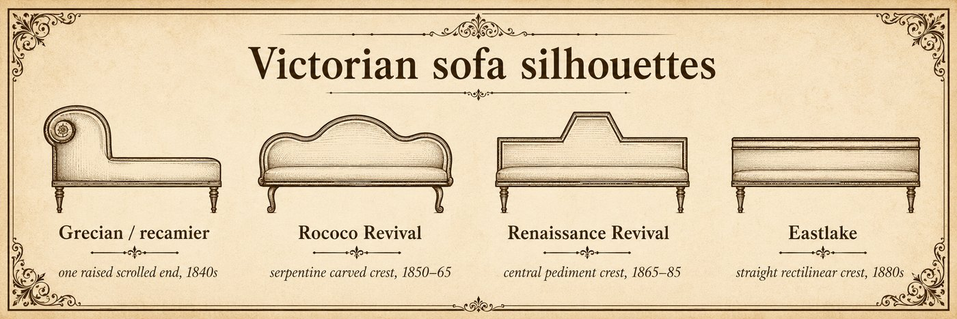

Tables

TABLES

The Parlor Table
also called: center table (loosely), marble-top table, lamp table, Victorian occasional table
Era: 1840 ░░ 1850 ██████████ 1915 ▒░ 1940. The decorative sitting-room table of the Victorian home, c. 1850 to 1915.
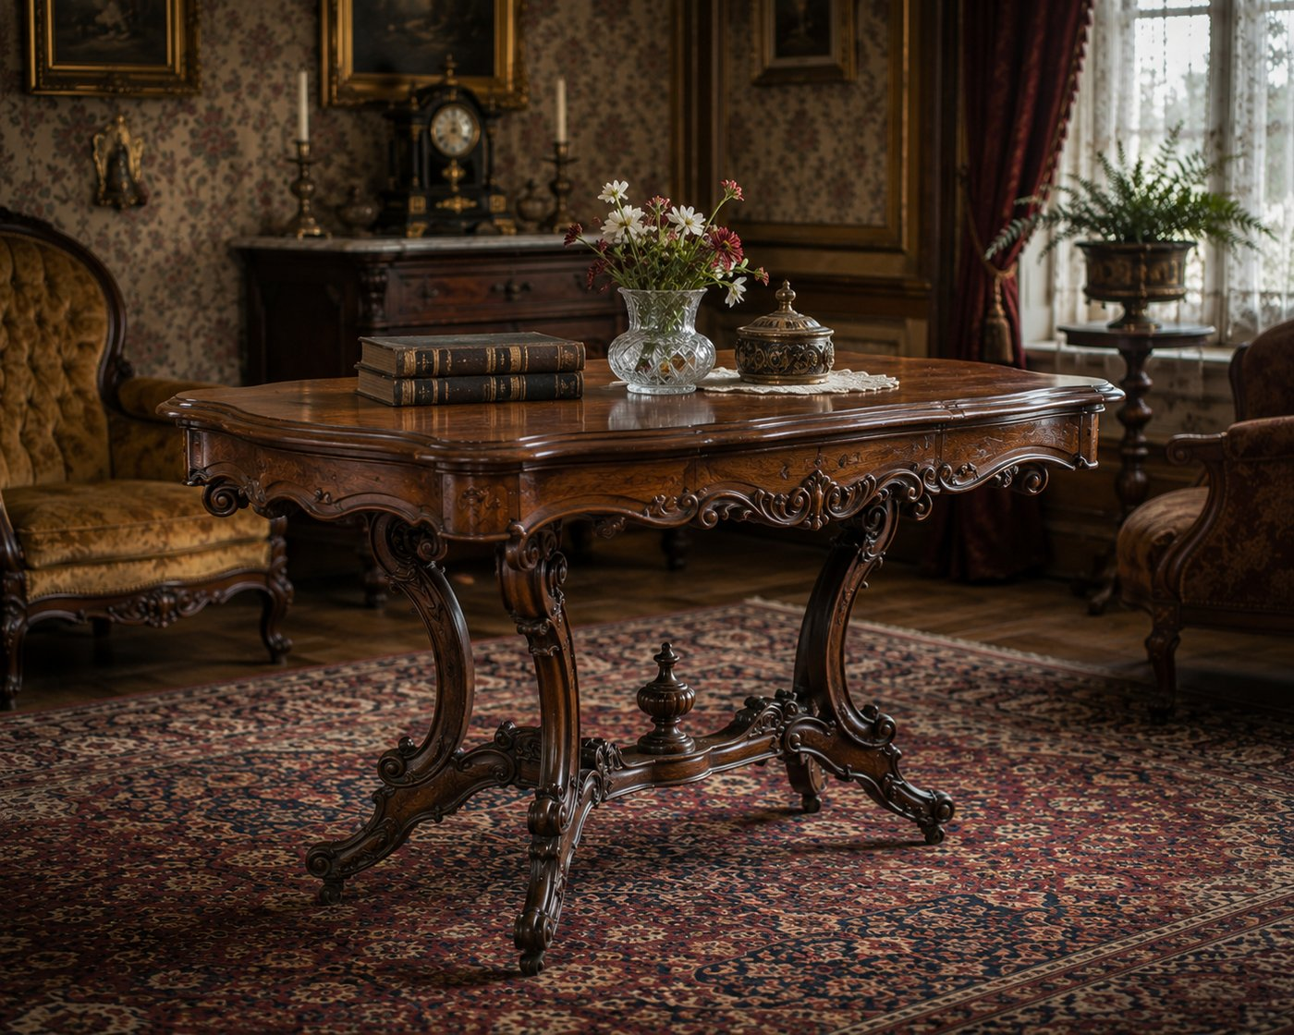

Rule it out in 10
A parlor table is a small-to-medium decorative table, commonly 24 to 36 inches across and 28 to 32 inches tall, made to face the room in a Victorian parlor and hold a lamp, an album, a vase, or refreshments.
If it is large and meant to anchor the center of the room, that is a center table. If it is plain and seating-adjacent, that is a side table. The parlor table is the small, ornamented, room-facing piece of the sitting room.

What it is
The parlor table is Victorian decorative furniture, made roughly 1850 to 1915 for the parlor, sitting room, and front room. Tops are often marble or other stone, or carved, inlaid, or veneered wood, frequently shaped: oval, round, serpentine, or square with cut corners. Bases range from a central pedestal to four cabriole or turned legs. The ornament tracks the era: Rococo scrollwork, Renaissance Revival cartouches, Eastlake incised lines and ebonized accents, and Golden Oak machine carving. It often belongs to a matched parlor suite with the sofa, settee, and chairs.

On the short list, confirm and date it
- Read the style vocabulary for the period (Rococo, Renaissance Revival, Eastlake, Golden Oak), then confirm with construction: machine work, joinery, secondary woods, and fasteners (Method section).
- Mind the marble. Marble tops are often replaced, recut, or married to a base. Check the fit, the overhang, the edge profile, the underside support, and whether wear agrees. A perfect modern slab on an old base is a marriage.
- Mind the casters. Replaced casters are extremely common, and a later rubber or metal caster can fool a quick read into dating the whole table too late. Judge the table by its frame and joinery, not by a wheel that has likely been swapped. (We watched the engine itself get fooled by exactly this.)

Do not confuse it with
Form | What it really is | The tell that separates it
Parlor table | Small decorative sitting-room table | 24 to 36 inches, ornamented, room-facing, 1850 to 1915
Center table | Larger room-anchoring table | Bigger, centrally placed, more visual weight
Side table | Seating-adjacent utility table | Plainer, no parlor-suite vocabulary
Lamp table | Lamp-support table | Defined by function, any period

What hurts the value
- A married or replaced marble top sold as original.
- Replaced casters and hardware, and refinishing that strips an ebonized or incised surface.
- A broken parlor suite.

What it is worth, in plain terms
A marble-top Victorian parlor table, especially with good carving or as part of a suite, is desirable. A plain or refinished single table is common and modest. The marble being original, the surface being honest, and the suite being intact set the range.

Quick field routine
First, confirm scale and decorative, room-facing character. Second, read style, then confirm with construction. Third, judge the marble: original or married. Fourth, ignore the casters for dating, they are usually replaced.
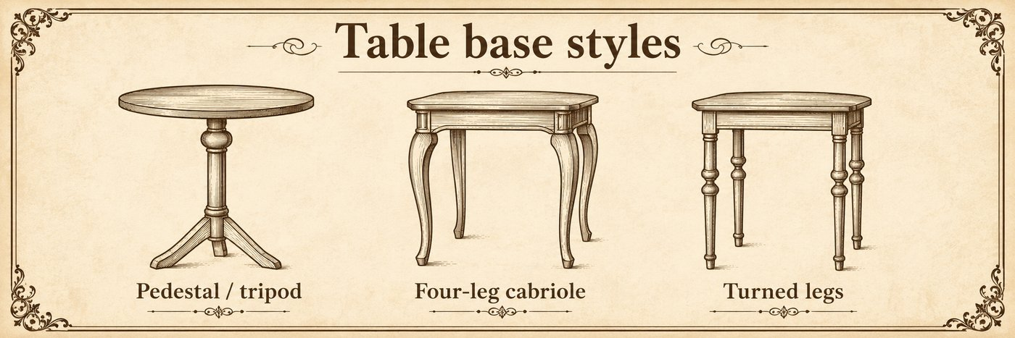

TABLES

The Drop-Leaf Table
also called: leaf table, falling-leaf table; family includes gateleg and Pembroke
Era: 1840 ██████████████████ 1940. Made throughout American furniture history. Construction dates it.
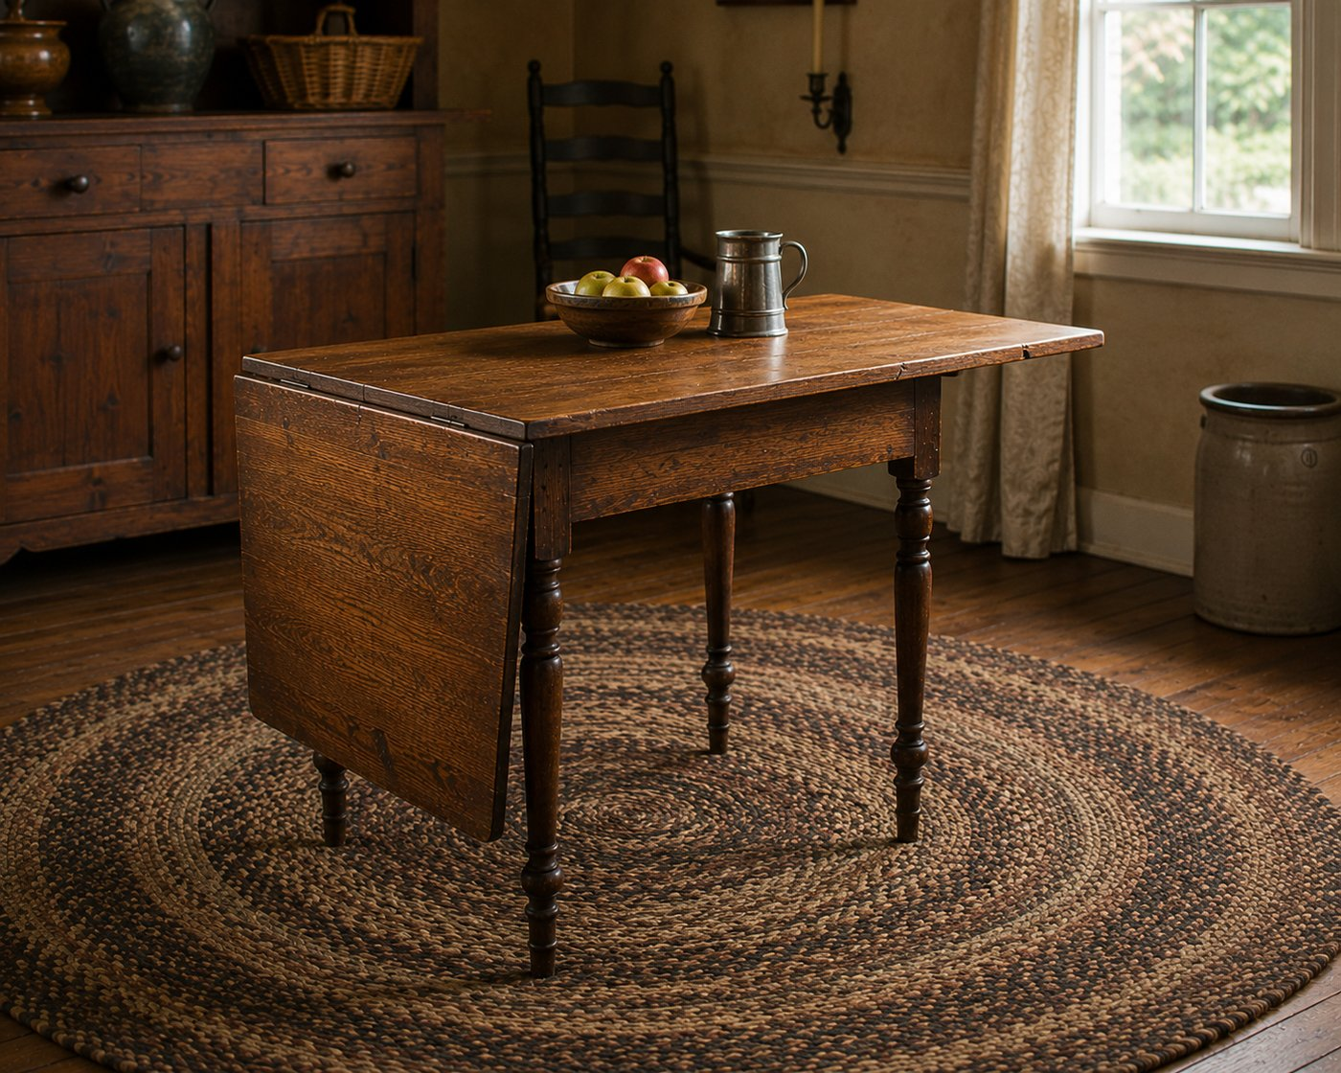

Rule it out in 10
A drop-leaf table has hinged leaves attached to a fixed center section that hang down when closed and lift to lock horizontal when open. The hinge-and-leaf is the defining mechanism.
If the table expands by pulling apart and dropping in separate boards, that is an extension table, not a drop-leaf. The drop-leaf grows by raising leaves that were always attached.

What it is
The drop-leaf is the space-saver of the household: narrow against a wall when closed, a full surface when the leaves come up. The leaves meet the center on a rule joint (a shaped, interlocking hinge edge) and are held up by a support that varies by type:
- Swing legs that pivot out (this is the gateleg subtype, its own chapter).
- Brackets or fly rails that fold out.
- Simple swing supports.
It can serve as a dining, kitchen, tea, or occasional table depending on size. Two refined members of the family get their own chapters: the gateleg (swing-leg gates) and the Pembroke (compact, with a drawer).

On the short list, confirm and date it
- Confirm the rule joint and the leaf supports.
- Date by construction, since the form spans centuries: hinge type, secondary woods, saw marks, fasteners, and the wear arcs on the underside where supports have swung for decades. (Method section.)

Do not confuse it with
Form | What it really is | The tell that separates it
Drop-leaf table | Hinged leaves that lift and lock | Attached leaves, rule joint, fold-out support
Extension table | Expands with slides and inserts | Pulls apart, adds separate boards
Gateleg table | Drop-leaf with swing-leg gates | Swinging leg-and-stretcher assemblies
Pembroke table | Compact drop-leaf with a drawer | Small, refined, drawer in the apron

What hurts the value
- Replaced leaves or re-hinged joints, and warped or cracked leaves.
- Married or cut-down tops and bases.

What it is worth, in plain terms
Plain drop-leaf tables are common and modest, everyday and useful. Value rises with age, good wood, and honest construction, and with the more refined family members (a fine early gateleg or Federal Pembroke). Construction and originality, as always.

Quick field routine
First, confirm the lift-and-lock leaves and the rule joint. Second, identify the support type, which may name it a gateleg. Third, date by construction and underside wear. Fourth, check the leaves and supports are original.
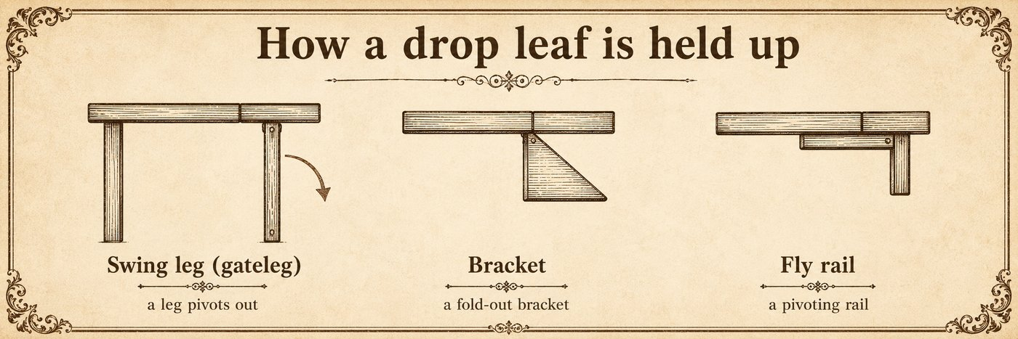

TABLES

The Gateleg Table
also called: gate-leg table, drop-leaf gateleg, Jacobean-style gateleg
Era: 1840 ██████████████████ 1940. The form is old, from the 1670s, but Colonial Revival copies flood the 1900s. Construction tells the truth.
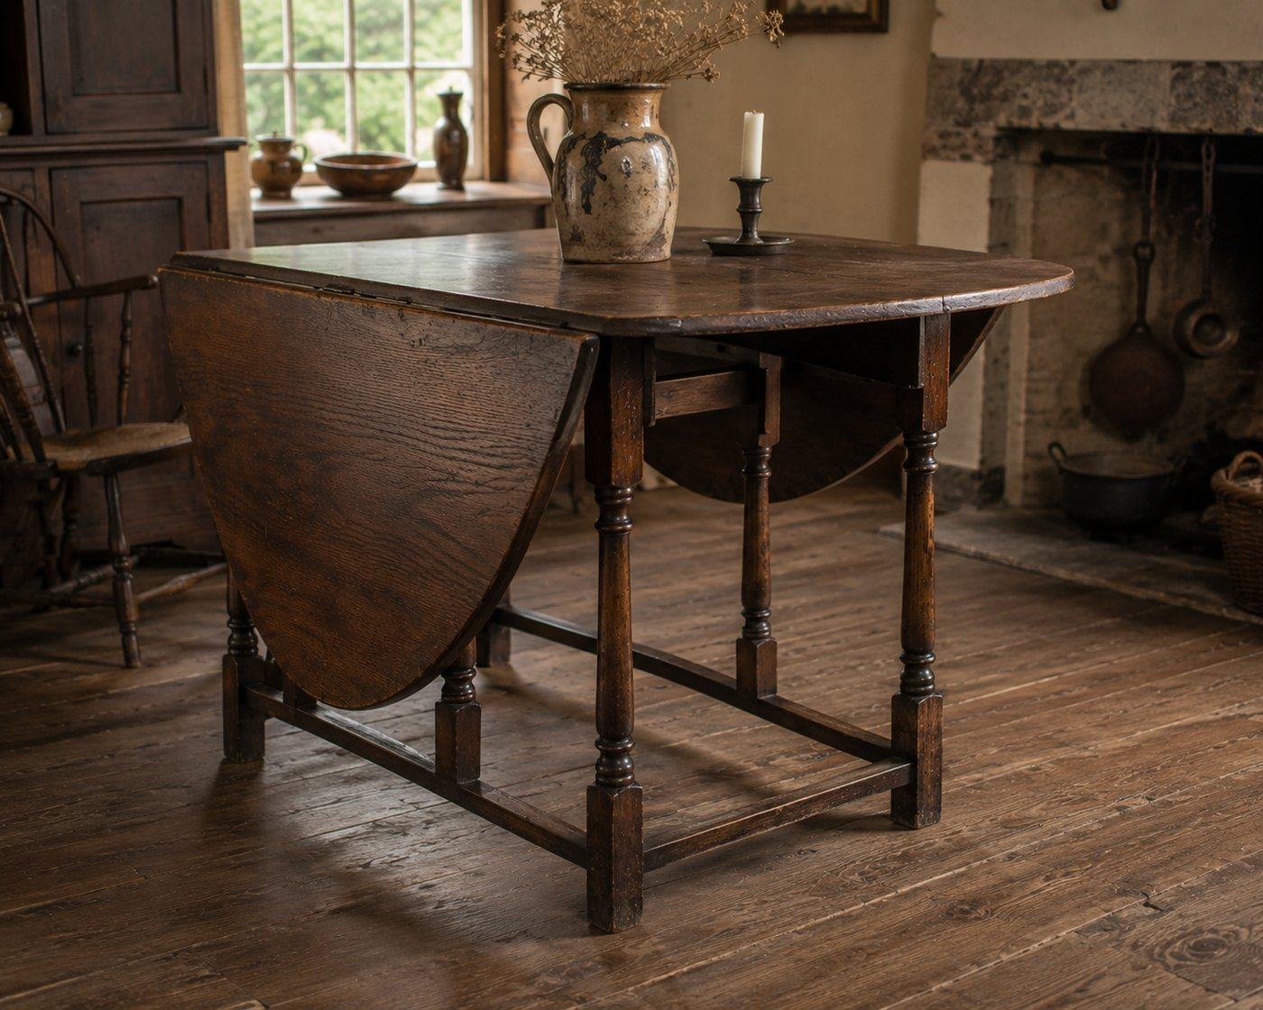

Rule it out in 10
A gateleg table is a drop-leaf whose raised leaves are held up by swinging gate-like leg assemblies: hinged legs joined by stretchers that pivot out from the base like a gate. Count the legs, often six to eight including the swinging gates.
If the leaves are held by simple brackets or fly rails rather than a swing-out leg-and-stretcher gate, it is an ordinary drop-leaf, not a gateleg. The gate is the whole identification.

What it is
The gateleg is the dramatic member of the drop-leaf family. When closed it is narrow with the leaves hanging; when open, the gates swing out and the legs march around the perimeter to carry a generous round or oval top. Legs and stretchers are usually turned, often barley-twist, ring-turned, ball-turned, or bobbin-turned. The form emerged in late seventeenth-century England, reached American colonial production by about 1700, and was reproduced heavily in the Colonial Revival.

On the short list, confirm and date it
- Confirm the swing-gate support, the key identifier.
- Because revival and import copies are everywhere, early-period attribution must rest on construction, not the Jacobean look: hinge type, rule and knuckle joints, the gate-swing wear pattern, turning style, secondary woods, oxidation, tool marks, and fasteners. (Run the period-or-reproduction tree.)
- Machine-uniform turnings, modern fasteners, and crisp unworn gate joints point to twentieth-century revival.

Do not confuse it with
Form | What it really is | The tell that separates it
Gateleg table | Drop-leaf with swing-leg gates | Hinged leg-and-stretcher gates swing out
Drop-leaf table | Hinged leaves, fixed supports | Brackets or fly rails, no swing gates
Sutherland table | Very narrow drop-leaf | Tiny center, large leaves, gate or swing support
Butterfly table | Drop-leaf with wing brackets | Solid butterfly-shaped wing supports, not full gates

What hurts the value
- Replaced gates, leaves, or stretchers, and re-turned parts.
- A revival copy sold as period, the most common pitfall.

What it is worth, in plain terms
A genuine early gateleg with honest wear and original turnings is desirable and premium. A Colonial Revival gateleg, which is far more common, is moderate to modest, useful and attractive but not an antique in the early sense. Construction evidence, not silhouette, sets the range.

Quick field routine
First, confirm the swinging gate support. Second, count and read the turnings. Third, date by construction and gate-wear, not the Jacobean look. Fourth, decide period or revival with the tree.
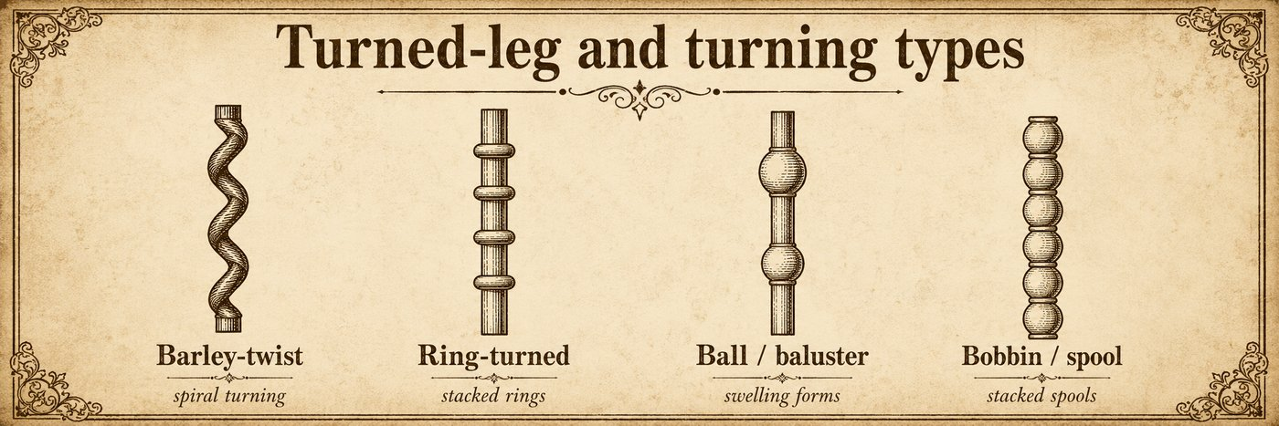

TABLES

The Tilt-Top Table
also called: tip-top table, snap table, tripod tilt-top, tea table (loosely)
Era: 1840 ░░ then two lanes: original 1730–1800 ████ and Colonial Revival 1880 ██████ 1940 ▒. Silhouette never proves the early date.
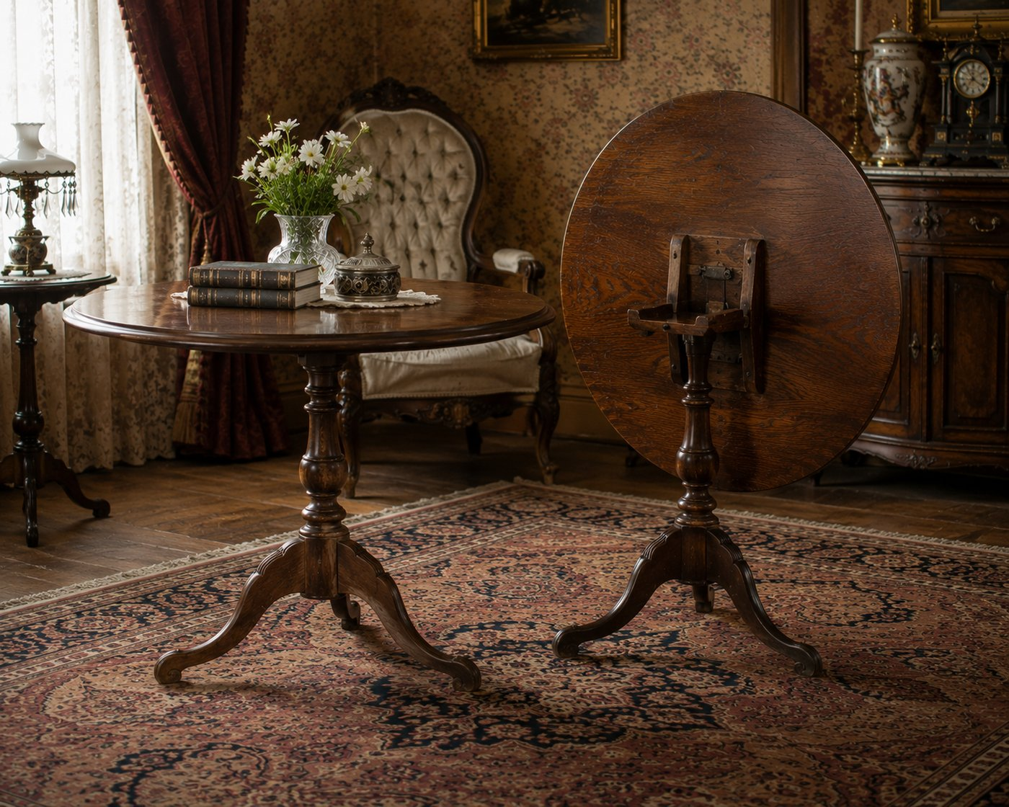

Rule it out in 10
A tilt-top table has a top that pivots from flat-for-use to vertical-for-storage, held flat by a catch or latch and usually set on a central pedestal with a tripod base.
If the top is fixed and does not tilt, it is a plain pedestal table, not a tilt-top. The working tilt mechanism is the defining feature.

What it is
The tilt-top stood flat for tea or display, then tipped vertical to tuck against a wall and show off its top. Most are pedestal tables on a tripod base, with a turned shaft and three spreading feet. A catch, latch, wedge, or thumb screw secures the top down, and many have a birdcage, a small block-and-post fitting under the top that also lets it rotate. Tops may be round, square, dished, or carved into a piecrust edge.
Two lanes dominate, and telling them apart is the whole game:
- Eighteenth-century originals, roughly 1730 to 1800.
- Colonial Revival and later reproductions, especially 1880 to 1940 and after.
They can look nearly identical in silhouette, so form and style alone never prove an eighteenth-century date.

On the short list, confirm and date it from the underside
Flip it over. The underside carries the strongest evidence: the battens and cleats, the screws and hinge plates, the latch and its wear, oxidation, and the arc-shaped wear where the top has rotated on the birdcage. Read these against the Method section.
- Hand tool marks, irregular hand-cut parts, early fasteners, and deep honest oxidation point to a period piece.
- Machine-uniform turning, modern screws, crisp unworn latches, and clean undersides point to revival.
When unsure, run the period-or-reproduction tree. This is the form it was practically made for.

Do not confuse it with
Form | What it really is | The tell that separates it
Tilt-top table | Pedestal table with a tilting top | Working tilt mechanism and catch
Pedestal table | Central-support table, fixed top | Top does not tilt
Candle stand | Small tripod stand | Smaller, may or may not tilt
Piecrust table | Carved-edge tilt-top | A tilt-top subtype with a scalloped edge

What hurts the value
- A replaced top, birdcage, or latch, and a married top and base.
- A revival piece presented as eighteenth-century, the costly mistake.

What it is worth, in plain terms
A documented eighteenth-century tilt-top, especially a carved piecrust example, is premium and serious. A Colonial Revival tilt-top, which is what you will usually meet, is moderate to modest. The gap between the two is large, so get the dating right from the underside before you price it.

Quick field routine
First, confirm the top actually tilts and latches. Second, flip it and read the underside, the real evidence. Third, decide period or revival with construction and the tree. Fourth, check top-to-base continuity for a marriage.

TABLES

The Pembroke Table
also called: breakfast table (early), sofa-side table (loosely)
Era: 1840 ░░ then English from 1760, American Federal 1780–1815 ████, Colonial Revival 1890 ██████ 1940 ▒.
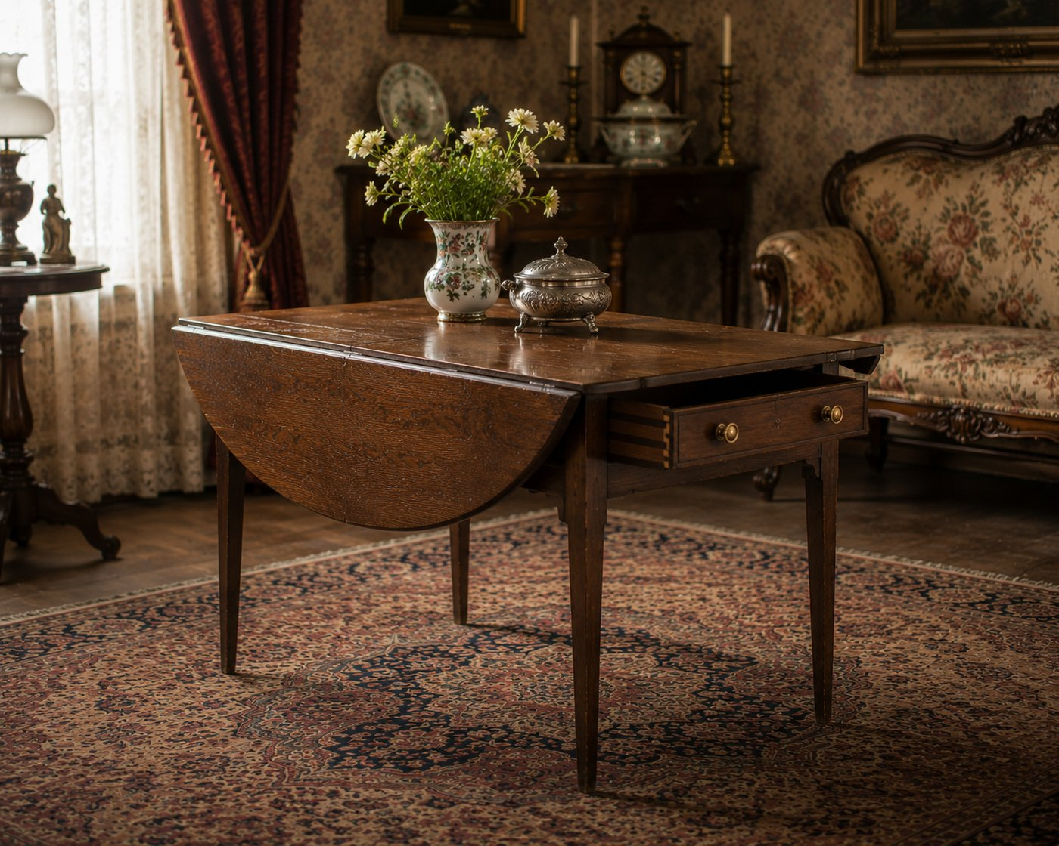

Rule it out in 10
A Pembroke table is a small, refined drop-leaf with short hinged leaves on the long sides and a drawer in the apron, light enough to move easily.
If it is a large or plain drop-leaf with no drawer, it is an ordinary drop-leaf. If the leaves are held by swing-leg gates, it is a gateleg. The Pembroke is the compact, drawer-bearing, refined one.

What it is
The Pembroke is the elegant small table of the late Georgian and Federal years. It has drop leaves on the long sides held by brackets or fly rails (not swing-leg gates), one or more drawers under the apron, often with a matching false drawer on the opposite end for symmetry, and a light, movable body about 27 to 30 inches high. It was used for writing, tea, reading, games, and bedside service. Higher-style examples show slender tapered or reeded legs, brass casters, inlay, stringing, banding, and figured veneer, with mahogany dominating Federal and revival pieces. Named in the English tradition for the Earl of Pembroke, it runs from about 1760 in England, peaks in American Federal production around 1780 to 1815, and returns strongly in Colonial Revival, roughly 1890 to 1940.

On the short list, confirm and date it
- Confirm the compact drop-leaf body plus the apron drawer, the combination that names it.
- Read the legs and refinement: tapered or reeded legs, inlay, and stringing point to Federal or to a good revival; confirm which with construction.
- Date by construction (Method section). Hand-cut dovetails on the drawer, early fasteners, and honest wear point to the Federal period; machine dovetails and modern fasteners point to Colonial Revival.

Do not confuse it with
Form | What it really is | The tell that separates it
Pembroke table | Compact refined drop-leaf with a drawer | Short side leaves plus an apron drawer
Drop-leaf table | Plain hinged-leaf table | Usually larger, no apron drawer
Gateleg table | Drop-leaf with swing-leg gates | Swinging gates, not brackets
Side table or nightstand | Fixed small table | No drop leaves (later bedside use can confuse this)

What hurts the value
- Replaced leaves, drawer, or hardware, and a married top and base.
- Lost inlay or stringing, and refinishing on a fine Federal example.

What it is worth, in plain terms
A genuine Federal Pembroke with good inlay, original surface, and crisp construction is premium. A Colonial Revival Pembroke is moderate to modest. The drawer construction, the legs, and the originality of the surface and inlay set the range.

Quick field routine
First, confirm the compact drop-leaf plus apron drawer. Second, read the legs and refinement for the period. Third, date by drawer construction and fasteners. Fourth, check for a marriage and replaced leaves.

TABLES

The Candle Stand
also called: candlestand, lamp stand, plant stand (modern use)
Era: 1840 ██████████████████ 1940. Made throughout. Construction dates it, and revival copies are common.
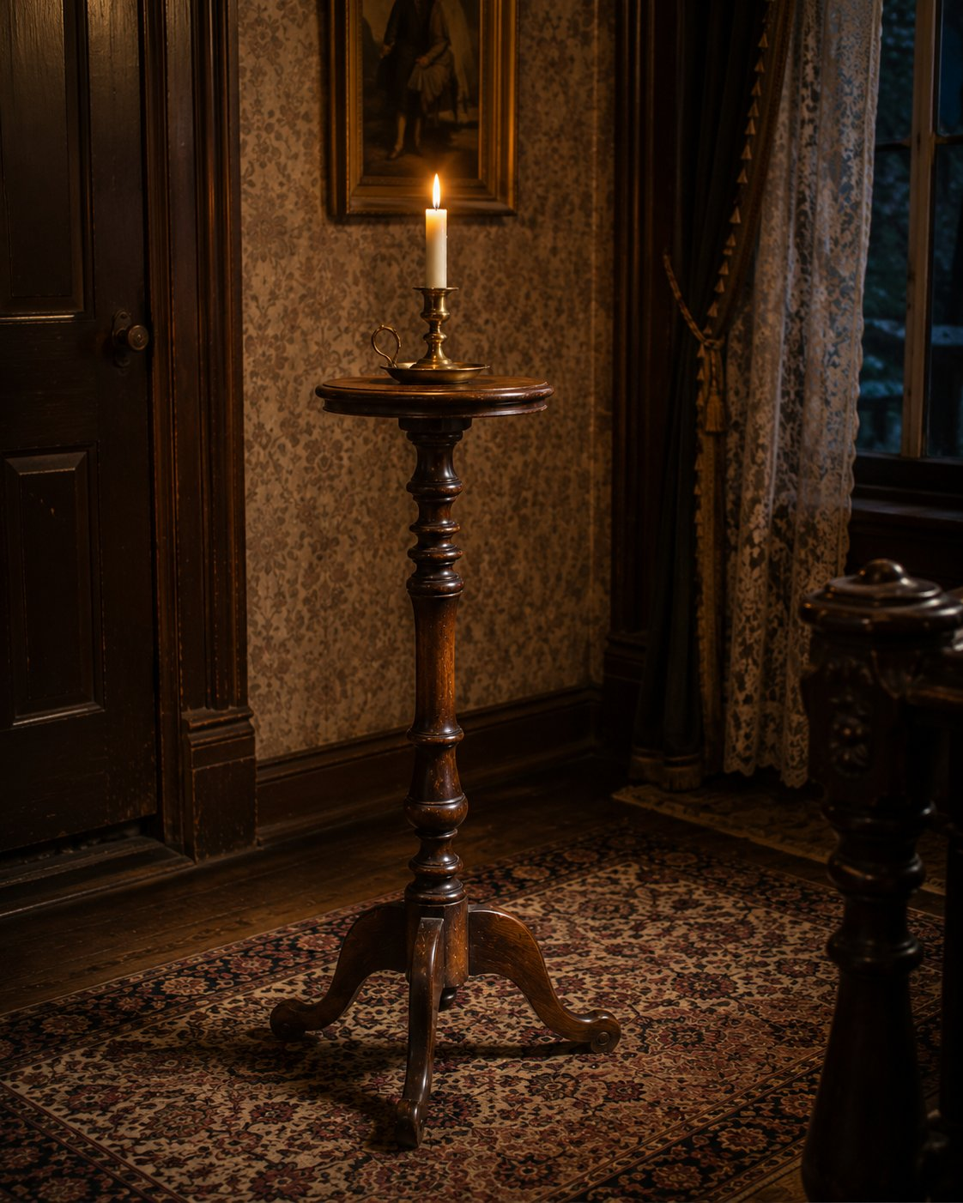

Rule it out in 10
A candle stand is a small, tall, light stand with a tiny top, commonly 8 to 18 inches across, built to hold one object: a candle, a lamp, or a plant. It is highly movable and has essentially no storage.
If the top is large enough for tea service or display of several things, it is a tilt-top or tea table. If it is a full table with storage, it is something else. The candle stand is defined by small scale and single-object support.

What it is
The candle stand is the smallest of the pedestal tables, made to carry light from room to room before fixed lighting. Most are pedestal or tripod stands with a slender turned shaft and three feet, and many of the best tilt like their larger tilt-top cousins. The form runs the whole American range, which means, as with the tilt-top, that eighteenth-century originals and Colonial Revival copies look alike and must be told apart by construction.

On the short list, confirm and date it
- Confirm small scale and single-object support.
- If it tilts, flip it and read the underside, the same evidence as the tilt-top: latch, birdcage, wear arc, oxidation, fasteners.
- Date by construction: shaft turning, foot carving, tool marks, and wear (Method section). Machine-uniform turning and modern fasteners point to revival. When unsure, the period-or-reproduction tree applies.

Do not confuse it with
Form | What it really is | The tell that separates it
Candle stand | Small single-object support stand | Tiny top, tall, light, movable
Tilt-top table | Larger tilting pedestal table | Bigger top for service or display
Tea table | Service-oriented table | Larger, made for tea service
Plant stand | Object stand (overlaps) | Often taller and narrower, later use

What hurts the value
- A replaced top or married base, common on small light stands.
- A revival piece presented as eighteenth-century.

What it is worth, in plain terms
A documented eighteenth-century candle stand, especially a fine tripod with good carving, is premium. A Colonial Revival candle stand is common and modest. Underside evidence and construction, not silhouette, set the range.

Quick field routine
First, confirm small scale and single-object support. Second, if it tilts, read the underside. Third, date by construction and turning, not the antique look. Fourth, decide period or revival with the tree.

TABLES

The Work Table
also called: kitchen work table, baker's table, harvest work table, sewing table (refined cousin)
Era: 1840 ██████████████████ 1940. A working form across the whole period. Wear and construction date it.
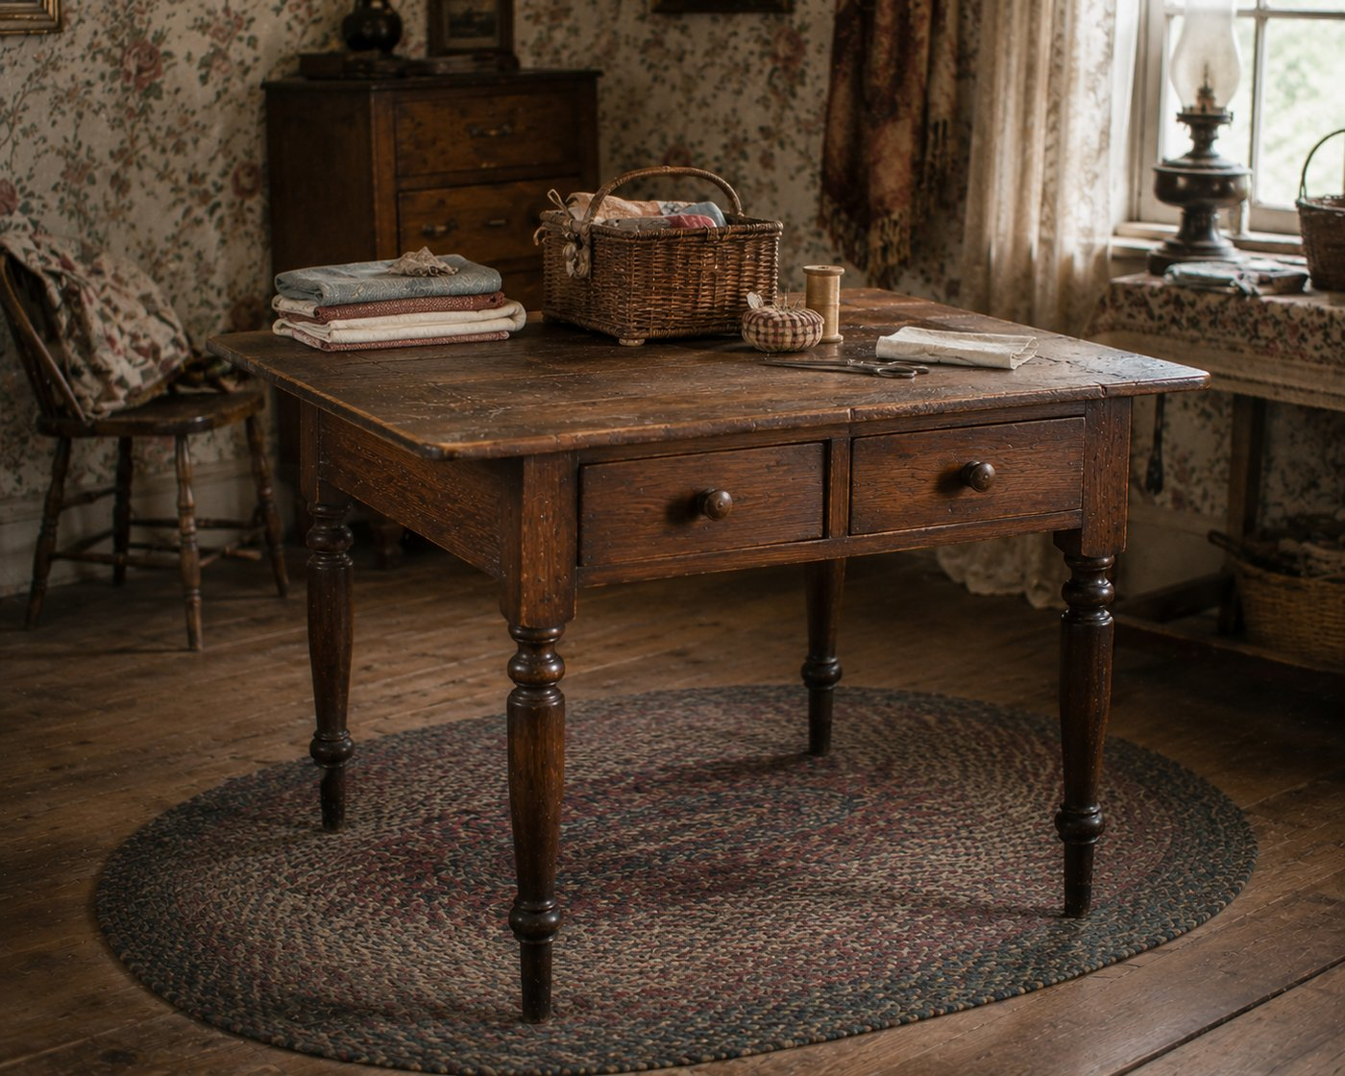

Rule it out in 10
A work table is a task table: a sturdy, function-first surface built for kitchen, craft, or shop use, usually showing honest work wear, often with a drawer, bin, shelf, or stretcher for the job.
If the table is decorative and balanced for a parlor, it is a parlor or occasional table. The work table is defined by utility first: durability, task fittings, and the marks of real use.

What it is
The work table is where things got done: food prepped, dough rolled, sewing and crafts worked. Function shapes it, so it is usually more durable and plainer than formal tables, with a thick or scrubbed top, simple sturdy legs, and task-specific fittings (a deep drawer, a bin, a lower shelf). Expect stains, knife cuts, scrubbing wear, and old utility repairs, which are honest character, not damage.
A refined cousin is worth knowing: the sewing or work table of the Federal and Victorian parlor, a small elegant table with fitted compartments and sometimes a cloth work bag hanging below. That is a decorative form, the opposite end from a scrubbed kitchen table, though both wear the "work table" name.

On the short list, confirm and date it
- Confirm the task-first character and any work fittings.
- Read the wear as evidence of real use and age, then date by construction: joinery, fasteners, saw marks, and secondary woods (Method section).
- For a refined sewing table, date by drawer construction, inlay, and legs, like a Pembroke.

Do not confuse it with
Form | What it really is | The tell that separates it
Work table | Function-first task table | Sturdy, worn, task fittings
Parlor or occasional table | Decorative table | Balanced, ornamented, room-facing
Sewing table | Refined fitted work table | Small, fitted interior, sometimes a work bag
Hoosier cabinet | Kitchen workstation case | A tall case with flour bin, not a table

What hurts the value
- Over-restoration that sands away the honest work surface (on country pieces the scrubbed top is the character buyers want).
- A married or replaced top.

What it is worth, in plain terms
A plain country kitchen work table is common and modest, though scrubbed-top farmhouse tables have a steady, friendly market. A fine Federal sewing table with inlay and an original bag is desirable and premium. Honest surface, original fittings, and construction set the range.

Quick field routine
First, confirm task-first character and work fittings. Second, read the wear as honest use. Third, date by construction. Fourth, separate the scrubbed kitchen work table from the refined sewing table.

Case and Storage

CASE AND STORAGE

The Chest of Drawers
also called: chest, bureau (regional), tall chest, lingerie chest, semainier
Era: 1840 ██████████████████ 1940. Made continuously. The form does not date the piece. The construction does.
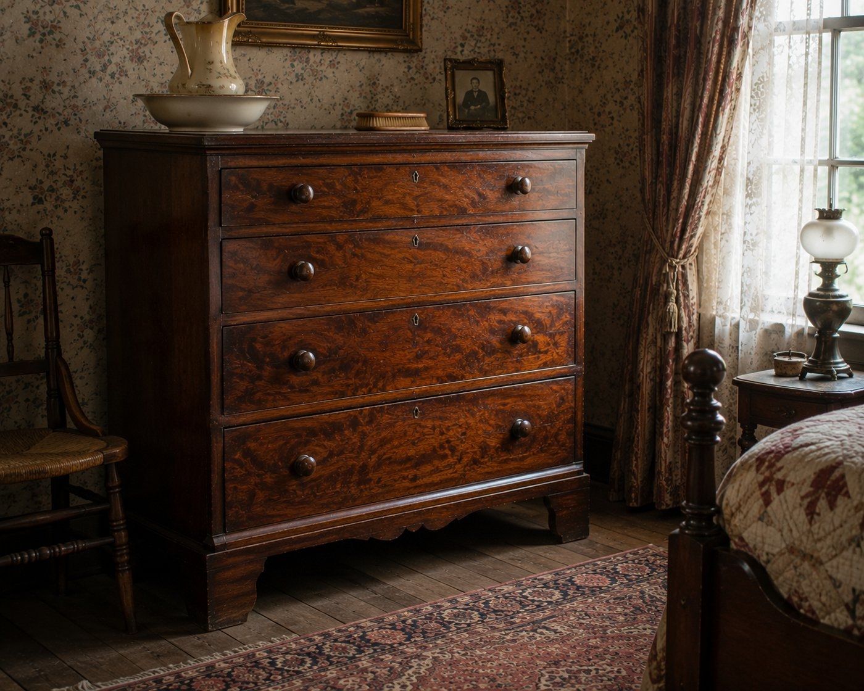

Rule it out in 10
Picture the proportions and the storage. A chest of drawers is taller than it is wide, it is all drawers with no cabinet doors, it has no knee opening, and it is a single case, not two stacked boxes.
If it is wider than tall with a usable dressing top, that is a dresser. If it has a knee opening to sit at, that is a dressing table or a desk. If it is two carcasses stacked, that is a chest-on-chest or a highboy. A plain tall stack of drawers, no doors, no knee hole, is a chest of drawers.

What it is
The chest of drawers is one of the most consistently produced pieces in American furniture, made from about 1700 right up to today. It is vertical storage at its simplest: a single case of drawers stacked top to bottom, the top surface secondary to capacity. In late Victorian and early twentieth-century homes it was usually part of a bedroom suite, paired with a dresser, a bed, and a nightstand.
Because the form barely changed in two hundred years, the form is not your dating clue. This is the piece where you stop looking at shape and start reading construction.

On the short list, date it by construction
Here the method does all the work. Open a drawer and turn the piece around.
- Dovetails. Pull a drawer and look at the corners. Hand-cut dovetails, uneven and few, point to earlier or shop-made work. Perfectly even, identical machine dovetails point to factory production after about 1860 to 1870. (See the dovetail diagram in the Method section.)
- Nails and screws. Cut nails suggest roughly 1790 to 1890. Round wire nails mean after about 1890. A Phillips screw means modern, at least in that part. (See the nail and screw diagrams.)
- Saw marks. Straight saw kerfs are earlier. Circular saw arcs on a secondary surface mean after about 1830, and usually later factory work.
- Secondary woods and backboards. Different, cheaper woods for drawer sides, bottoms, and backs are normal and honest. A single uniform wood throughout, or plywood, points later.
- Hardware. Pulls and escutcheons help, but they are the most-replaced part on any chest, so weigh them lightly. Look for extra holes from earlier hardware.
Stack the tells, do not lean on one. This is the same "stack the evidence" habit from the decision tree, just applied drawer by drawer.

Do not confuse it with
Form | What it really is | The tell that separates it
Chest of drawers | Tall, drawer-only single case | Taller than wide, no doors, no knee hole, one case
Dresser | Wider dressing case | Wider than tall, usable top, often a mirror
Dressing table or vanity | Grooming station | Has a knee opening to sit at
Chest-on-chest or highboy | Stacked drawer cases | Two carcasses stacked, often a base and a top
Chest of drawers on a stand | Case set on legs | A separate base or legs under the drawer case

What hurts the value
- Replaced hardware that does not match the holes, or shiny modern pulls on an old case.
- A married top, base, or feet. Check that wood, wear, and color of age agree all around.
- Stripped or heavily refinished surfaces on an otherwise good early chest.

What it is worth, in plain terms
Age and originality set the range. A late Victorian walnut or oak factory chest is common and modest, useful and affordable. An earlier chest with hand-cut dovetails, original surface, and original hardware climbs toward premium. Condition of the surface and the honesty of the hardware move it most.

Quick field routine
First, confirm the form. Taller than wide, all drawers, no doors, no knee hole, single case.
Second, ignore the shape and read the build. Dovetails, nails, saw marks, secondary woods.
Third, weigh the hardware lightly. It is the most-swapped part.
Fourth, check it is honest all around. No marriage, no later feet, agreeing wear.

CASE AND STORAGE

The Dresser
also called: bureau (regional), standard, double, triple, or princess dresser
Era: 1840 ██████████████████ 1940. Like the chest, the form is timeless. Construction dates it.
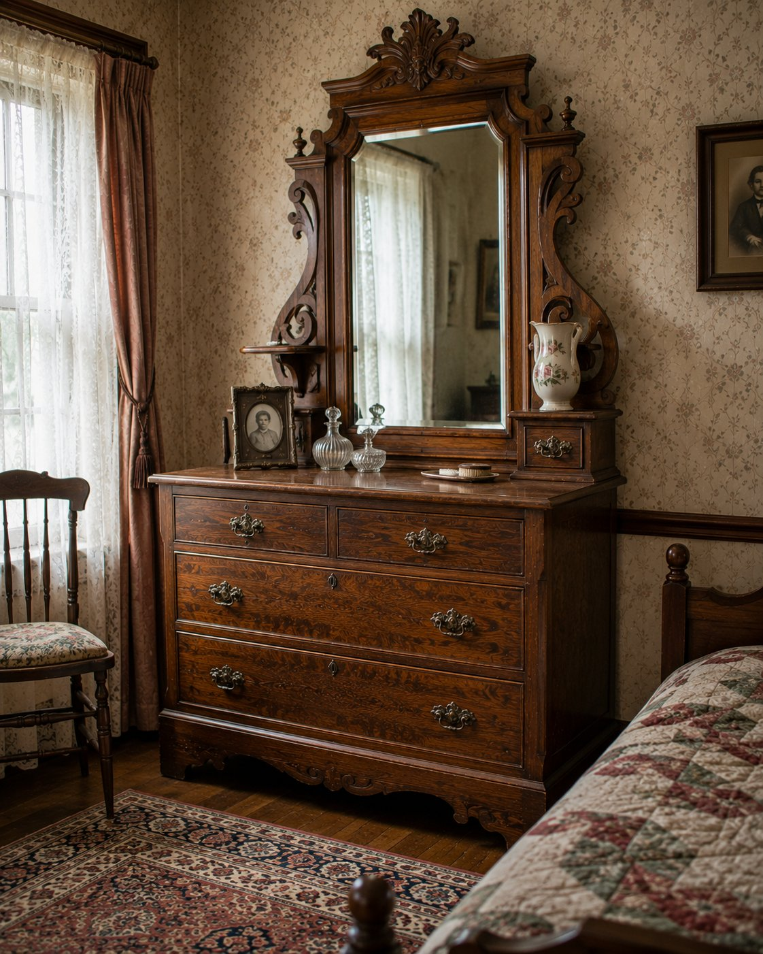

Rule it out in 10
A dresser is wider than it is tall, low enough to use the top as a dressing surface, with drawers in rows or side-by-side banks, and no knee opening. It very often has, or once had, a mirror.
If it is taller than wide with a single column of drawers, that is a chest of drawers. If it has a knee opening to sit at, that is a dressing table. Wide, low, broad usable top, multi-column drawers, no knee hole, is a dresser.

What it is
The dresser spreads clothing storage across width instead of stacking it. Its low, broad top is meant for daily grooming, which is why it so often carries a mirror on a harp or a pair of uprights. It was a core piece of the late Victorian and early twentieth-century bedroom suite, made to match a bed, a chest, and a nightstand. The mirror is frequently long gone, but the mounting holes and hardware on the back usually remain, which is your clue that one belonged there.

On the short list, date it by construction
The form will not date the piece, so read the build, exactly as you did with the chest of drawers. (Same habit, second piece.)
- Pull a drawer and read the dovetails, hand-cut and uneven versus machine-even.
- Check nails on the back and saw marks on secondary surfaces.
- Note the secondary woods in the drawer sides and bottoms.
- Look at the mirror supports. Original supports and matching wear say the mirror belongs; fresh holes say it was added or swapped.
- Treat the pulls lightly, they are the most-replaced part.
(See the dovetail, nail, and screw diagrams in the Method section.)

Do not confuse it with
Form | What it really is | The tell that separates it
Dresser | Wide, low clothing case with a dressing top | Wider than tall, multi-column drawers, often a mirror
Chest of drawers | Tall, narrow drawer stack | Taller than wide, single column
Dressing table or vanity | Seated grooming station | Has a knee opening
Sideboard | Dining-room storage and serving | Dining context, serving top, not bedroom

What hurts the value
- A married or replaced mirror that does not match the case.
- Replaced pulls that leave the old holes showing.
- Heavy refinishing that strips an honest old surface.

What it is worth, in plain terms
A late Victorian or early twentieth-century suite dresser in oak or walnut is common and modest. Value rises toward premium with an intact original mirror, original hardware, and a good honest surface. Completeness and originality, as always, do the lifting.

Quick field routine
First, confirm the form. Wide, low, dressing top, multi-column drawers, no knee hole. Second, look for the mirror or its mounting evidence. Third, date by construction, not shape. Fourth, check the hardware and mirror are honest, not married.

CASE AND STORAGE

The Dressing Table and Vanity
also called: vanity, vanity table, lowboy (early), poudreuse, toilet table
Era: 1840 ██████████████████ 1940. Victorian through the waterfall and triple-mirror vanities of the 1920s to 1940s.
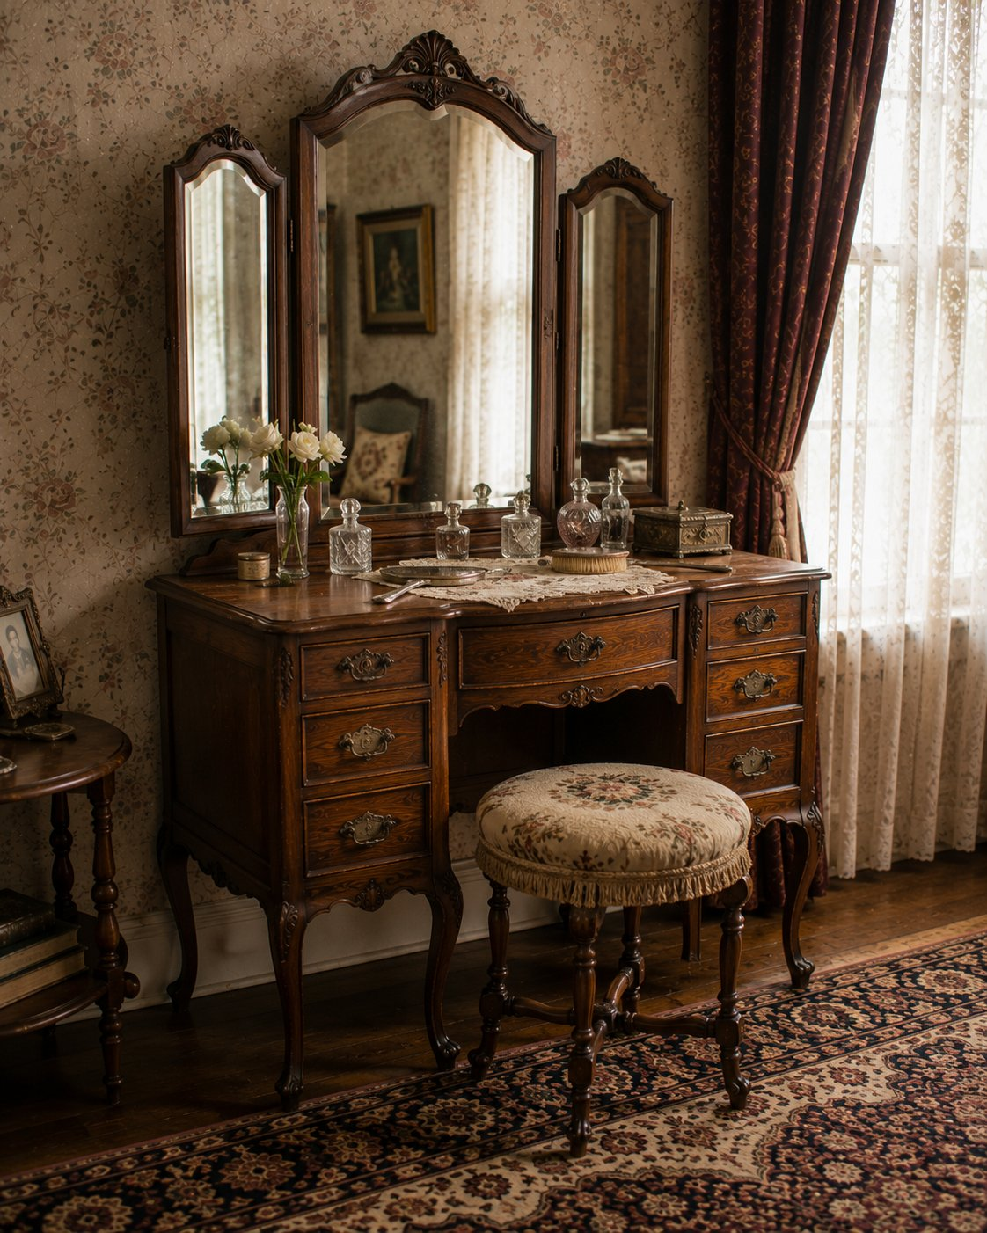

Rule it out in 10
A dressing table has a knee opening you sit at, a grooming surface at seated height (about 28 to 32 inches), and usually a mirror above. Ask the simple question: can a person sit at it?
If yes, dressing table. If it is a closed case with no knee opening, it is a dresser or a chest. The seated-use knee opening is the structural difference.

What it is
The dressing table, or vanity in retail language, is grooming furniture: a seated station with a knee opening flanked by small drawers for cosmetics, brushes, and jewelry, and a mirror, central or triple-fold, mounted above. It comes with a companion stool or bench. The mid-century triple-mirror vanity (about 1920 to 1960) and the Art Deco waterfall vanity are the late, very common examples you will meet.
A crucial caution, and it comes straight from how these get mislisted: the mirror is often gone, and a vanity without its mirror gets mistaken for a desk. But the mirror-mounting evidence usually remains, the holes, hardware, and vertical supports on the back. When the mirror is missing, let that mounting evidence and the seated-use proportions drive the call, not a guess of "desk."

On the short list, confirm and date it
- Confirm the knee opening and seated height, and look for mirror-mounting evidence even if the mirror is gone.
- Note the drawers are accessory-sized, cosmetics and jewelry, not bulk clothing.
- Date by construction (Method section). Victorian walnut and oak point earlier; waterfall veneer and triple-fold mirrors point to the 1920s to 1940s. A matched bedroom suite places it with its dresser and bed.

Do not confuse it with
Form | What it really is | The tell that separates it
Dressing table / vanity | Seated grooming station | Knee opening, seated height, mirror evidence
Dresser | Clothing storage case | Closed case, no knee opening
Desk | Writing furniture | Writing interior, work proportions, no grooming mirror
Washstand | Pre-plumbing washing station | Waterproof top, splash back, towel bars
Lowboy | Early dressing-related table | Earlier form on cabriole legs

What hurts the value
- A married or replaced mirror, and a vanity separated from its mirror or its suite.
- Replaced hardware and refinishing.

What it is worth, in plain terms
A complete vanity with its original mirror and as part of a suite is desirable. A common waterfall or single vanity is modest, useful and very saleable. The original mirror, the hardware, and suite completeness set the range.

Quick field routine
First, ask: can a person sit at it? Knee opening at seated height. Second, find the mirror or its mounting evidence. Third, do not call a mirrorless vanity a desk, read the seated-use proportions. Fourth, date by construction and suite style.

CASE AND STORAGE

The Washstand
also called: basin stand, water stand, chamber stand, pitcher and basin stand, shaving stand
Era: 1840 ██████████ 1900 ▒░ 1940. A pre-plumbing form, roughly 1820 to 1900, strongest 1860 to 1885. It faded as indoor plumbing arrived.
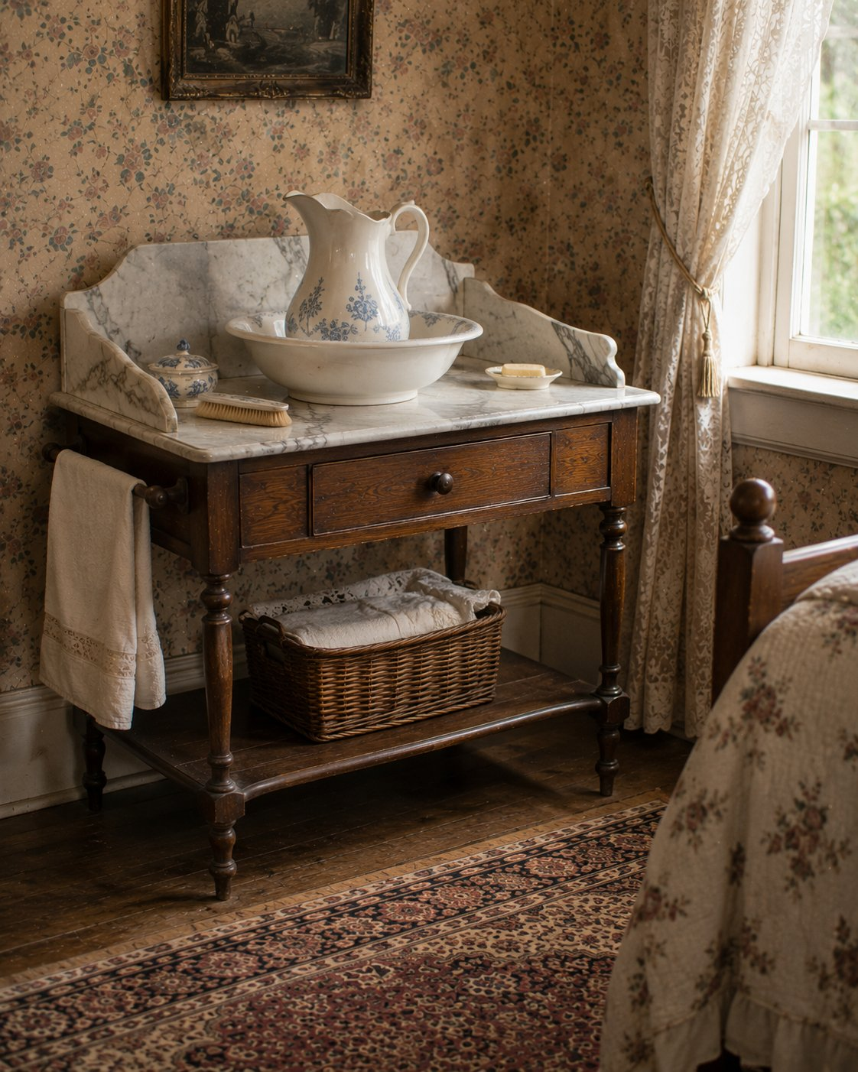

Rule it out in 10
Look at the top and the back. A washstand has a top built to get wet (marble, slate, tile, or zinc), a splash back behind it, and often towel bars on the sides or rear. It is sized to stand at and wash, not to store clothes.
If the top is plain wood meant for storage, the back is a decorative mirror frame rather than a waterproof splash, and the case is drawer-dominant, that is a small dresser or a side table. The washstand reads as a washing station first.

What it is
Before indoor plumbing, every bedroom had one of these. The washstand held the pitcher and basin you washed with. Its whole design is about water: a water-resistant top (commonly marble), a raised splash back to protect the wall, towel bars to dry your hands, a single shallow drawer or a drawer over a small cabinet, and a lower shelf or compartment for the chamber pot, soap, and linens. It stands at a comfortable basin height, compact and purposeful.
It is fundamentally a pre-plumbing solution, so its life tracks plumbing's arrival: bedroom first, briefly the kitchen during the transition, then gone, replaced by the bathroom sink.

On the short list, confirm it, even when parts are missing
This is the washstand's special lesson: the basin and pitcher are almost always long gone, and often the marble too, but the evidence stays. Look for:
- A water-resistant top, or the mounting and discoloration where one sat.
- A splash back or gallery, or the fastener holes and finish lines where it was removed.
- Towel-bar mounts on the sides or rear, even if the bars are gone.
- Water staining, rings, and finish loss concentrated on the top and rear, the fingerprint of real washing use.
- A storage layout that pairs a small drawer with an open shelf or little cabinet, sized for washing accessories, not clothes.
Read the scars. A piece that has lost its marble and basin still tells you it was a washstand if you know where to look.

Date it
- Construction first. Joinery, fasteners, saw marks, and finish layering date it more reliably than style. (The Method diagrams apply here too.)
- Style lags, especially here. Washstands are private bedroom furniture, and rural and Southern examples lag urban fashion by a decade or more. Painted, plain vernacular examples can look older than they are. Do not date on looks alone.
- The marble is a trap. Marble tops are often added, replaced, or married to a base later. Check that the marble's wear, fit, overhang, and color suit the base before you trust it.

Do not confuse it with
Form | What it really is | The tell that separates it
Washstand | Pre-plumbing washing station | Waterproof top, splash back, towel bars, water staining
Small dresser | Bedroom clothing storage | Drawer-dominant, plain wood top, decorative mirror not a splash
Side table | General utility surface | No splash, no towel bars, no water-resistant top
Dry sink | Kitchen water-work form | Larger, kitchen context, deeper well for dish washing

What hurts the value
- A married or replaced marble top presented as original.
- Calling it a dresser and missing what it is, or the reverse.
- Stripped or over-refinished surfaces that erase the honest water-use patina.

What it is worth, in plain terms
A refined marble-top walnut or mahogany washstand with its original gallery and towel bars sits in the nicer, more desirable range. A plain painted pine vernacular example is common and modest, though charming and very saleable, and there is a steady market for washstands converted to bathroom vanities. Originality of the top and the survival of the splash and towel hardware matter most.

Quick field routine
First, confirm the form. Waterproof top, splash back, towel bars, basin proportions. Read the scars if parts are gone.
Second, separate it from a dresser. Water evidence and washing layout, not clothing storage.
Third, date by construction, not style, and remember the rural lag.
Fourth, judge the marble. Original, or added later.

CASE AND STORAGE

The Sideboard
also called: buffet (casual or retail), hunt board (Southern, taller examples)
Era: 1840 ██████████ 1900 ▒░ 1940. The form runs from about 1780, through Federal and Empire and into the Victorian dining room.
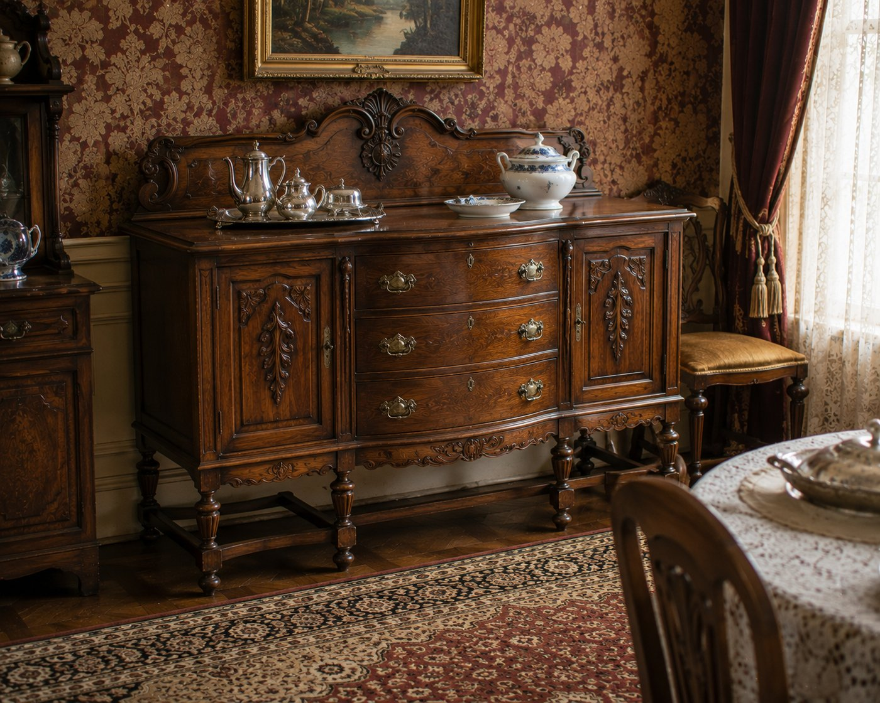

Rule it out in 10
A sideboard is a long, low dining-room case, wider than it is tall, with storage spread across its width in several side-by-side zones, and a broad serving top.
If it is a tall two-part piece with a display top, that is a hutch. If it is a small auxiliary piece with one or two drawers, that is a server. The sideboard is the long anchor along the dining-room wall.

What it is
The sideboard is the oldest and broadest of the dining-storage forms, made continuously from about 1780. Its signature is distributed storage across the width: banks of drawers for linen and silver beside cabinets for dishes and bottles, sometimes with cellarettes or bottle drawers, arranged side by side so the piece reads horizontally. The top is a real serving surface for platters and decanters. It appears across Federal, Hepplewhite, Sheraton, and Empire, and continues through Victorian production.

On the short list: sideboard, buffet, or server?
This is the call people get wrong, so run it deliberately.
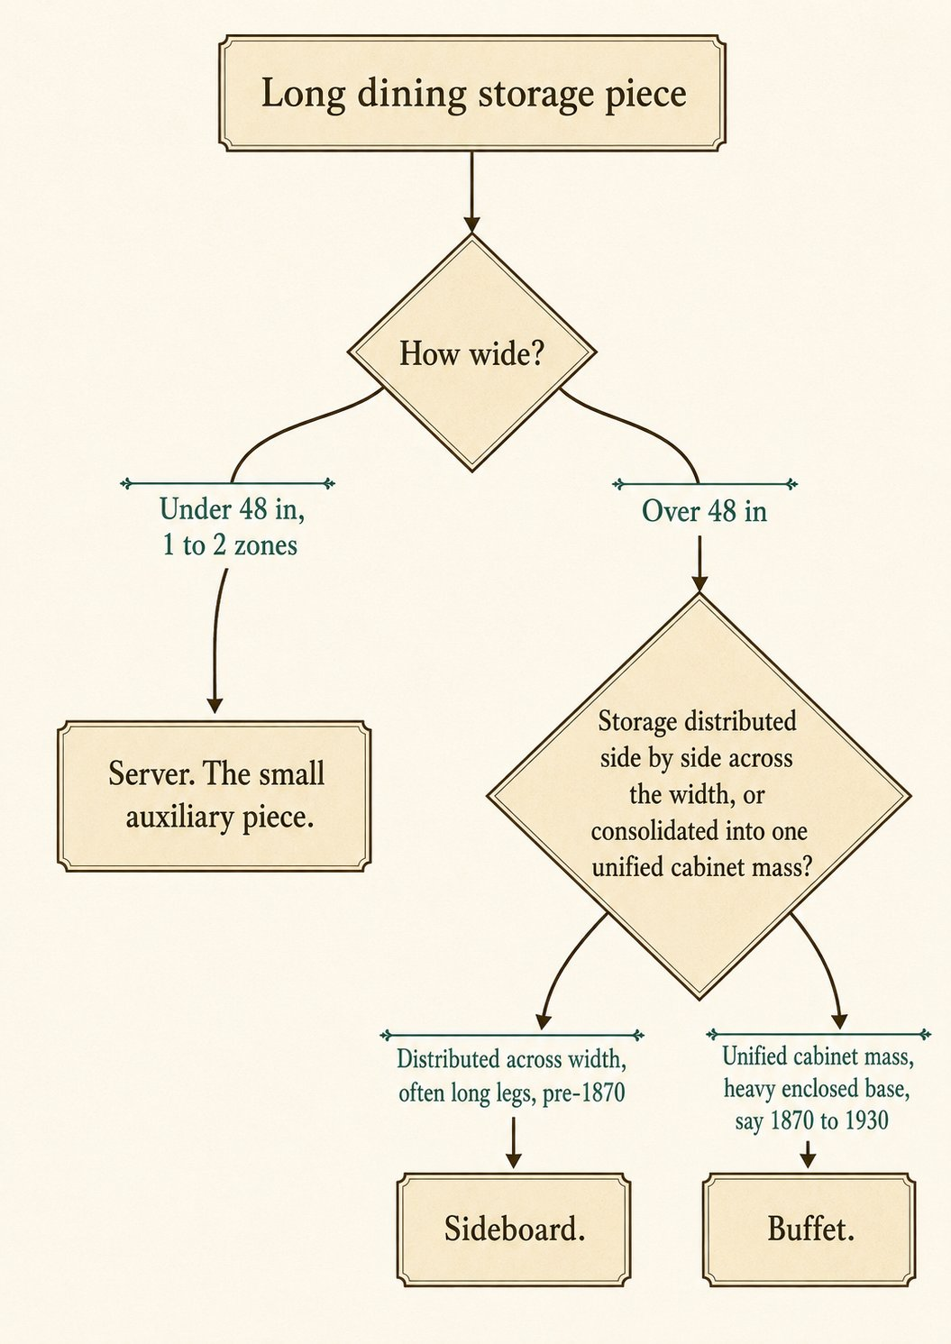
In words: measure the width, read whether the storage spreads across the width or consolidates into one block, and read the base. Long legs and distributed zones, especially before 1870, say sideboard. A heavy enclosed cabinet mass in a matched suite, with a mirror or plate rail, c. 1870 to 1930, leans buffet. Suite matching is supporting evidence only, confirm the structure first.

Date it
- Style and base. Federal and Hepplewhite and Sheraton and Empire styling, on long tapered or turned legs, point earlier (roughly 1780 to 1850). Heavy enclosed oak cabinet bases in dining suites point to the buffet era, 1870 to 1930.
- Construction. Read joinery, nails, and saw marks as always (Method section). Hand-cut dovetails and cut nails point earlier; uniform machine work points to factory Victorian and later.

Do not confuse it with
Form | What it really is | The tell that separates it
Sideboard | Long dining case, storage across width | Distributed zones, broad serving top
Buffet | Unified cabinet-mass dining storage | One consolidated block, suite piece, 1870 to 1930
Server | Small auxiliary serving piece | Under 48 inches, 1 to 2 drawers, light
Hutch | Two-zone display and storage | Tall, base plus a display superstructure

What hurts the value
- A married top or replaced legs, common on long case pieces. Check agreement all around.
- Replaced hardware and refinishing on a fine early example.

What it is worth, in plain terms
A genuine Federal or Hepplewhite sideboard with good lines, original surface, and inlay sits firmly premium. An oak Victorian or early-twentieth-century buffet-style piece is common and modest, useful and very saleable. Age, original surface, and quality of line set the range.

Quick field routine
First, confirm the form. Long, low, dining-room, distributed storage, serving top. Second, run the sideboard-buffet-server call by width, storage organization, and base. Third, date by style, base, and construction together. Fourth, check for marriage and replaced legs.

CASE AND STORAGE

The China Cabinet
also called: china closet, display cabinet, curved-glass cabinet
Era: 1840 ░░░░ 1880 ██████████ 1940. A late form. It begins around 1880 and peaks in the Golden Oak years.
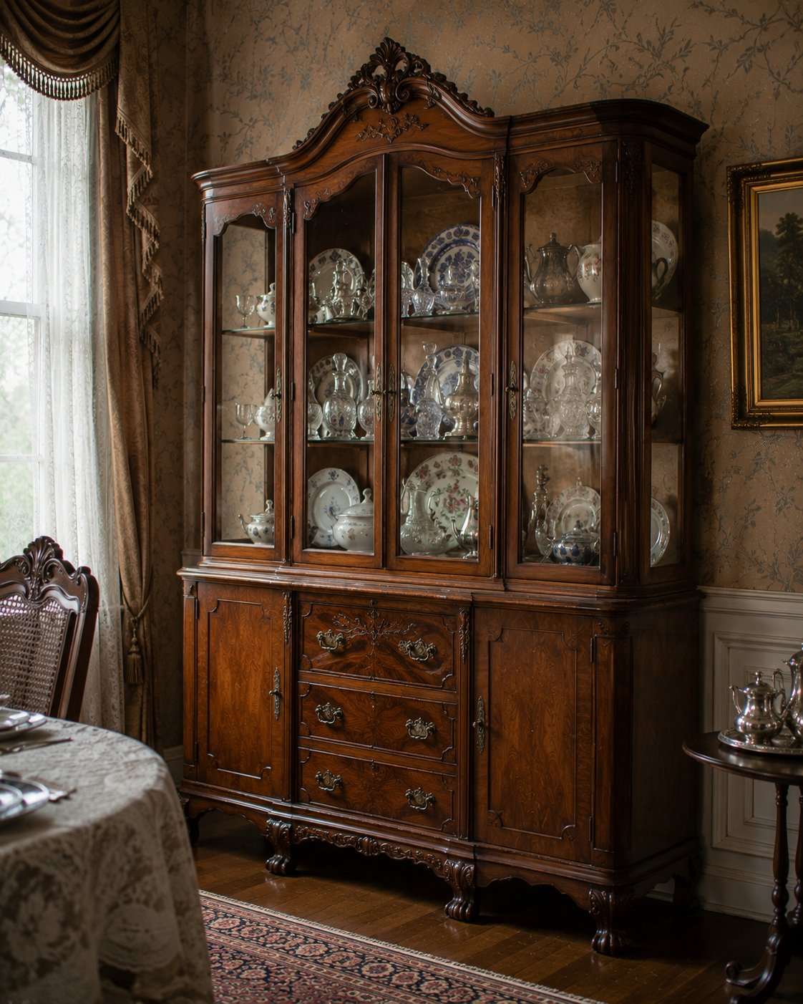

Rule it out in 10
A china cabinet is a one-piece glazed display case, a tall cabinet with glass doors and usually glass sides, made to show dishes and china behind glass.
If it is a two-part piece, a storage base with a separate display top, that is a hutch. If its back is angled to sit in a room corner, that is a corner cabinet. The china cabinet is a single unified glass display box.

What it is
The china cabinet is dining-room display furniture that arrives around 1880, as middle-class households wanted their good china seen. It is a single glazed case, often with glass shelves, sometimes a mirrored back, and frequently plate grooves to stand plates upright. Its golden moment is the Golden Oak era, roughly 1900 to 1915, when the classic American example appears: oak, curved or bowed glass on the front and sides, claw feet gripping glass balls, and applied carving.

On the short list, confirm and date it
- Curved or bowed glass front and sides point to the early 1900s Golden Oak peak. Curved glass is expensive to replace, so an intact original curve is a real plus.
- Claw-and-ball feet and applied carving fit the same period.
- Flat glass with lighter machine construction can be later, into the Colonial Revival and Depression years.
- Read construction as always: machine dovetails on any drawers, wire nails, uniform parts, all consistent with the 1880-and-after factory window.

Do not confuse it with
Form | What it really is | The tell that separates it
China cabinet | One-piece glazed display case | Single unified glass box for dishes
Hutch | Two-zone storage plus display | Storage base with a separate display top
Corner cabinet | Corner-fit display case | Angled or triangular back for a room corner
Curio cabinet | General display case | Built to show collectibles, not dining china
Bookcase | Shelving for books | No plate grooves, shelves spaced for books

What hurts the value
- Replaced curved glass with flat glass, or cracked original curves.
- Married tops or replaced feet, and refinishing that strips the oak.

What it is worth, in plain terms
An oak curved-glass china cabinet with claw feet and intact original glass is desirable and premium within this everyday category. A plain flat-glass later cabinet is common and modest. The single biggest swing is the curved glass: original and intact lifts it, replaced or broken drops it.

Quick field routine
First, confirm the form. One-piece glazed display case. Second, look at the glass. Curved and original is the prize. Third, date by glass, feet, carving, and construction. Fourth, separate it from a hutch (two-part) and a corner cabinet (angled back).

CASE AND STORAGE

The Corner Cabinet
also called: corner cupboard, corner china closet, corner hutch (in casual use)
Era: 1840 ██████████████████ 1940. Built since the 1700s, common in both early houses and later Colonial Revival interiors.
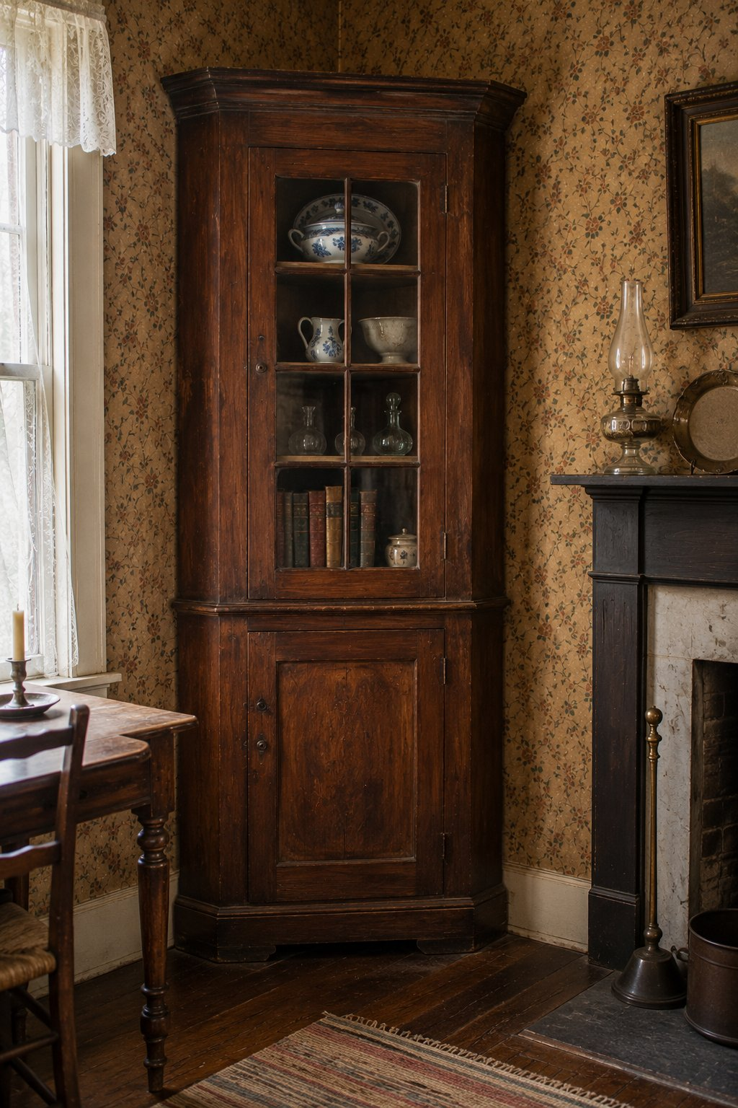

Rule it out in 10
Look at the back and the plan. A corner cabinet is built with a triangular, canted, or angled back so it tucks into a room corner. That single fact is the whole identification.
If the back is flat and the piece faces a wall, it is a china cabinet or a cupboard, whatever the tag says. Corner geometry outranks the seller's vocabulary. A glazed corner piece is still a corner cabinet, not a china cabinet.

What it is
The corner cabinet solves a specific problem: storage and display that fits the unused corner of a room. The front may be flat, bowed, arched, or glazed, but the rear geometry is corner-adapted, with side boards meeting at an angle and interior shelves often cut triangular or pie-shaped. It can be a built-in fitted to the architecture, or a freestanding case you can move. Upper sections commonly display china behind glass or on open shelves, with a closed cupboard below. A crown or cornice may follow the corner angle.
A warning that comes straight from how these get mislisted: a freestanding corner cabinet photographed only from the front looks just like an ordinary china cabinet. Always check the rear and the plan.

On the short list, confirm and date it
- Confirm the angled rear geometry and any triangular interior shelves.
- Decide built-in or freestanding. A built-in may share moldings, paint layers, or wall fabric with the room.
- Date by construction, as always (Method section). Early built-ins and period freestanding examples show hand work and early fasteners; Colonial Revival reproductions, common from the 1870s onward, show machine work and modern fasteners. When unsure, run the period-or-reproduction tree.

Do not confuse it with
Form | What it really is | The tell that separates it
Corner cabinet | Corner-fit display or storage case | Angled or triangular back, made for a corner
China cabinet | Wall-facing glazed display | Flat back, faces a wall
Hutch | Two-zone storage plus display | Flat back, base plus a display top
Cupboard | General enclosed storage | Flat back, general storage, no corner geometry

What hurts the value
- Marriages and replaced glazing on a fine early piece.
- Refinishing that erases original painted or early surfaces, especially on period built-ins removed from a house.

What it is worth, in plain terms
An early period corner cupboard, especially a fine freestanding one or an architectural built-in with honest old surface, is desirable and premium. A twentieth-century Colonial Revival corner cabinet is common and modest. Age, surface, and quality of the case set the range.

Quick field routine
First, check the back and plan. Angled for a corner, or flat for a wall. Second, decide built-in or freestanding. Third, date by construction and watch for the Revival reproductions. Fourth, remember corner geometry beats whatever the tag says.

CASE AND STORAGE

The Hoosier Cabinet
also called: Hoosier, Hoosier cupboard, baker's cabinet, kitchen workstation, Sellers cabinet, McDougall cabinet, Napanee cabinet
Era: 1840 ░░░░░ 1890 ███████ 1930s ███▒ 1940. Heyday roughly 1900 to the 1930s.
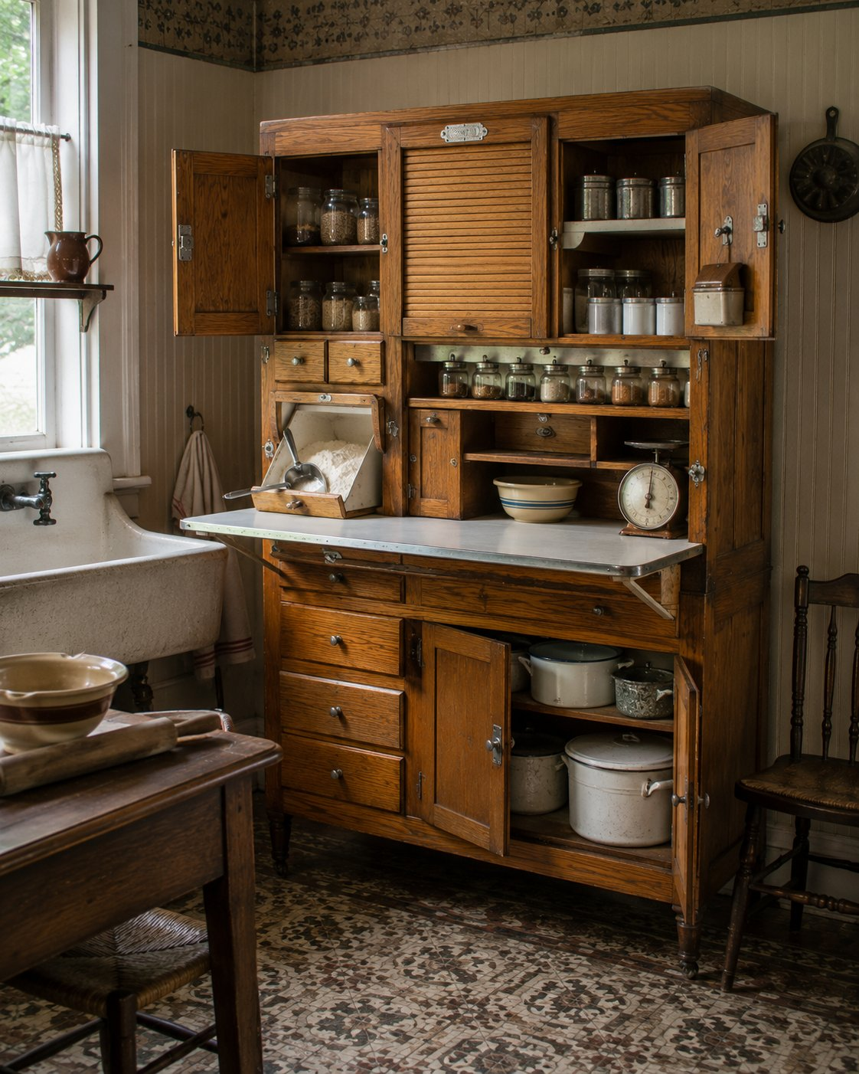

Rule it out in 10
Look for a work surface between an upper and a lower section, and any sign of a flour bin or ingredient fittings.
A Hoosier is not just a tall kitchen cupboard. It is a freestanding workstation. If the piece is only shelves and doors, with no pull-out or built-in work top and no kitchen-workflow fittings, it is a cupboard, a hutch, or a plain kitchen cabinet. Move on.
If it has a work surface plus a flour bin, a sifter, spice racks, or the scars where those once lived, you are on the short list. Keep going.

What it is
The Hoosier cabinet is the original all-in-one kitchen. Before built-in cabinetry, a family bought one freestanding piece that combined storage, food preparation, and a work surface into a single step-saving station. The name comes from Indiana, the home of the Hoosier Manufacturing Company and many competitors, but the form spread nationwide and was widely imitated. Its strongest years run from about 1900 into the 1930s, fading as built-in kitchens took over before and after the Second World War.
You can recognize the workflow built into it. A lower section with deep storage and drawers. A work surface in the middle, often a pull-out, frequently topped in enamel, porcelain, or zinc for a sanitary, wipe-clean prep area. An upper section organized for ingredients, with spice jar racks, small drawers, shelves, and often a tambour (roll-front) door that hides them. The signature feature is the flour bin with a built-in sifter, mounted in the upper section so the cook could measure and sift in one motion. Accessory hardware can include a sugar bin, a bread drawer, a pull-out recipe-card holder, labeled glass jars, and ant-proof casters.

On the short list, confirm it
Look for several of these, not just one:
- A flour bin or sifter, or clear scars and mounting holes where one was removed.
- A pull-out or fixed work surface, especially an enamel or porcelain top.
- Spice jar racks, small ingredient drawers, or a tambour door in the upper section.
- Accessory fittings: sugar bin, bread drawer, recipe holder, original labeled jars.
- A maker tag, metal plaque, decal, or branded hardware.
The more of the workstation system that survives, the more confident the call, and the more the piece is worth.

Real Hoosier, or just a cupboard?
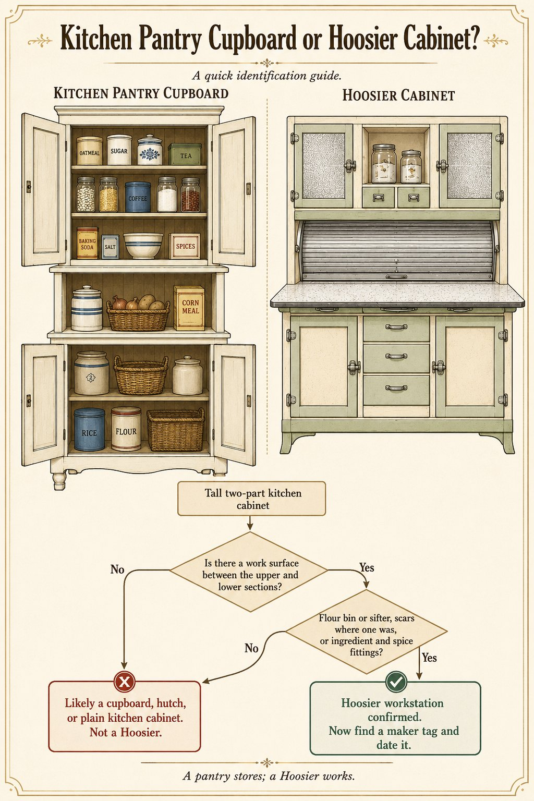

Date it
The Hoosier rewards a few specific tells:
- Material and finish. Earlier examples, roughly 1890 to 1915, often have oak cases with heavier, furniture-like construction. Later examples, roughly 1915 into the 1930s, are frequently painted or enamel-finished in coordinated kitchen colors. Depression-era and later refinishing can blur this, so read it alongside the hardware.
- Hardware and patents. Maker plaques, patented sifter and door hardware, and the flour-bin design are strong dating anchors. Patent dates stamped in metal give you a firm "not before" point.
- Construction. Machine-made case construction throughout is normal and expected here. This is factory furniture, so do not treat machine work as a strike against it the way you would on an early Windsor.
- Casters and tops. Ant-proof casters and original enamel tops are period-appropriate and add value when original.
A note on reproductions: nostalgic Hoosier-style cabinets have been made from about 1970 onward. Tell them by modern fasteners, plywood, modern drawer slides, decorative distressing, and replica hardware. The same logic you learned earlier applies here. When in doubt, run the period-or-reproduction decision tree from the Method section. Modern slides, plywood, and Phillips screws point to a later piece. (You will see that tree again because it works on almost everything, which is exactly the point.)

Do not confuse it with
Form | What it really is | The tell that separates it
Hoosier cabinet | Freestanding kitchen workstation | Work surface plus flour or ingredient fittings
Freestanding kitchen cabinet | Broader kitchen storage | Storage only, no workstation system
Hutch | Dining display and storage | Display and dining, no work surface or flour bin
Step-back cupboard | Cupboard geometry, storage | Storage only, no kitchen workflow fittings
Pie safe | Cools and stores baked goods | Ventilated or pierced tin panels
Jelly or jam cupboard | Stores preserved food | Storage of preserves, not active prep

What hurts the value
- Stripped and incomplete cabinets sold as complete. A missing flour bin, work top, jars, or upper doors lowers both confidence and price. Look for the scars and ask what is gone.
- Reproduction jars and replica hardware presented as original.
- Married pieces, where an upper from one cabinet meets a lower from another. Check that wood, wear, finish, and hardware agree top to bottom.
- Outright modern reproductions sold as period.

What it is worth, in plain terms
This is a gift-market and kitchen-nostalgia favorite, so a good one sells itself. The value lives in completeness and originality. A complete cabinet, with its original flour bin and sifter, original enamel work top, original hardware, and a maker label, sits firmly in the premium and very desirable range. A stripped or incomplete cabinet, or one wearing reproduction parts, is common and modest. The condition of the enamel top and the survival of the flour system move the needle more than anything else.

Quick field routine
First, confirm the form. A work surface between upper and lower sections, plus a flour or ingredient system. If those are missing, it is not a Hoosier.
Second, inventory what survives. Flour bin, sifter, work top, jars, tambour, accessory drawers. Completeness is value.
Third, find the maker. A tag, plaque, decal, or patented hardware.
Fourth, date and authenticate. Oak and heavier early, painted and enamel later, and watch for the reproduction tells.
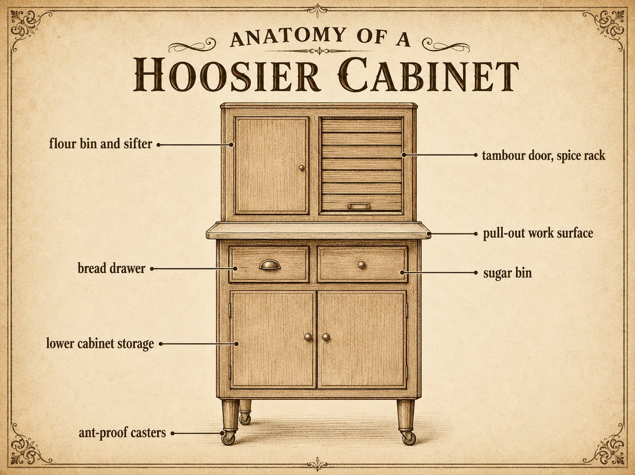

CASE AND STORAGE

The Blanket Chest
also called: six-board chest, dower chest, dowry chest, hope chest, coffer
Era: 1840 ██████████ 1900 ▒░ 1940. Made from about 1700 to 1900, the lift-lid storage box of the American household.
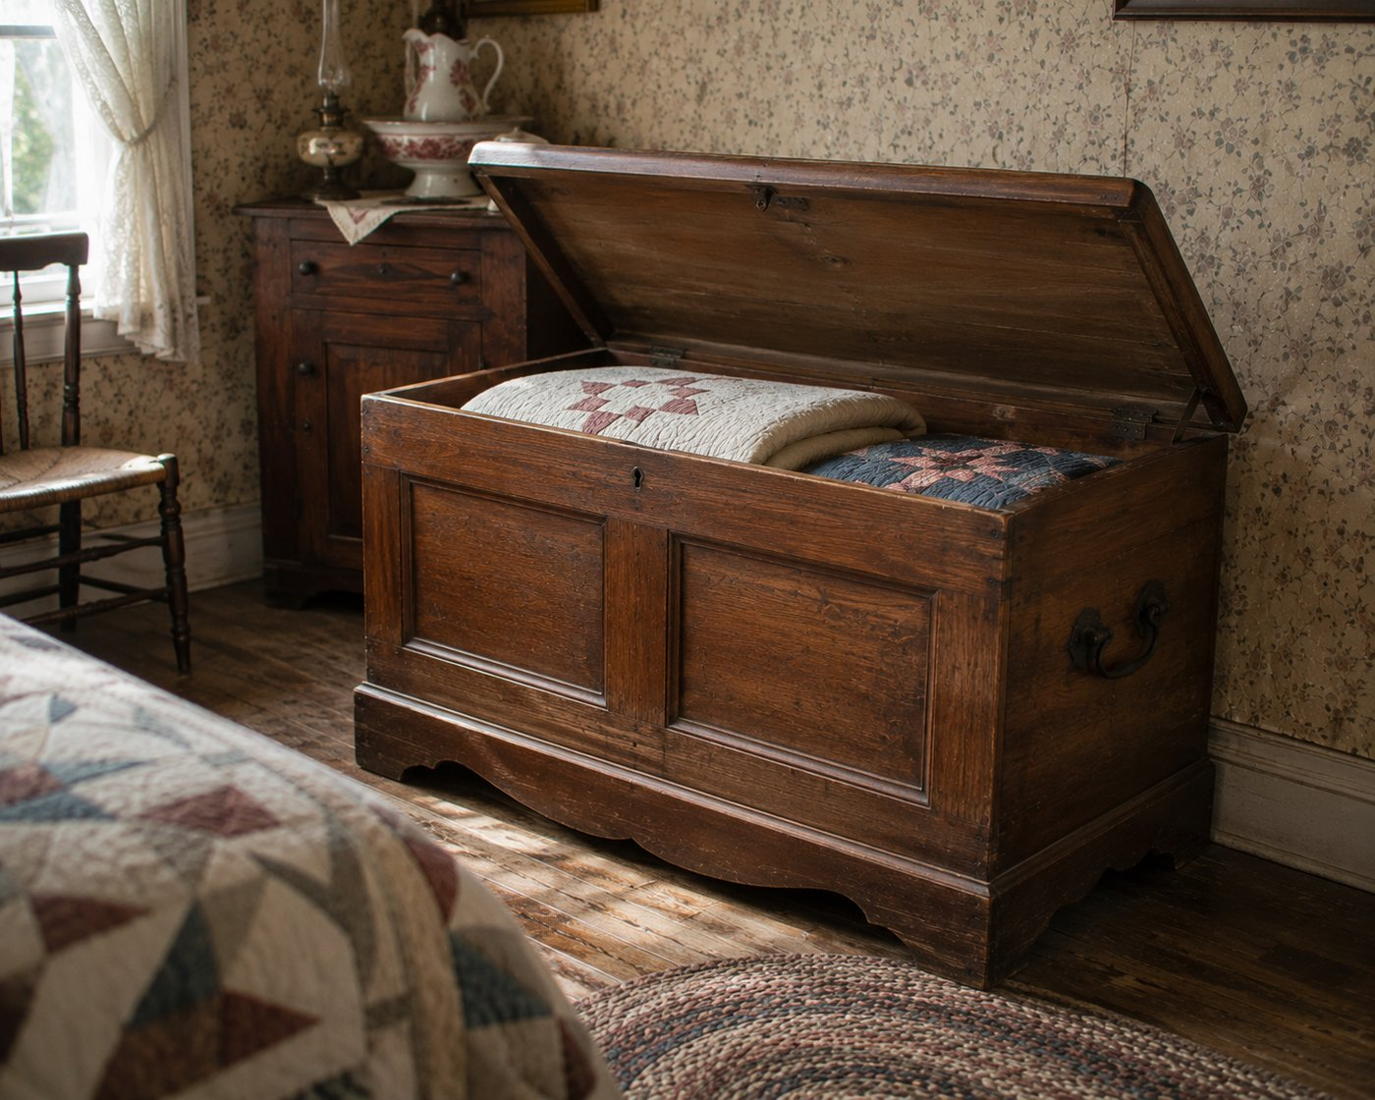

Rule it out in 10
A blanket chest is a rectangular box with a hinged lid that lifts from the top, opening into one large open cavity.
If the storage is drawers or doors, it is not a blanket chest. If it is built for travel, with a domed or leather-covered body and trunk hardware, it is a trunk. A plain rectangular case you open from the top, into bulk storage, is a blanket chest.

What it is
The blanket chest is the oldest and simplest case form: a box for storing textiles and household goods in volume. The hinged lift lid is the defining feature. Inside is a large open cavity, often with a small lidded till at one end for valuables. The base varies: bracket feet, bun feet, bootjack ends, or a simple board base. Surfaces range from plain to paneled to richly painted, and cedar linings are common. It is domestic, not portable, which separates it from a travel trunk.

On the short list, confirm and date it
- Confirm the lift lid and open cavity, and look for a till inside.
- Read the construction, which dates it more than anything. A simple six-board chest nailed together is the vernacular base case; a frame-and-panel chest is more refined. Hand-cut dovetails at the corners and cut nails point earlier; machine dovetails and wire nails point later. (Method section.)
- Read the base. Bracket and bun feet and bootjack ends each carry period and regional character.
- Read the surface, and read it carefully, because this is where the value lives.

A word on painted chests, and the prize
Many of the best blanket chests are painted, especially in the Pennsylvania German tradition: tulips, hearts, peacocks, distelfinks, and often a name and date. A dower chest, made for a young woman's marriage goods, is as much a cultural artifact as a piece of furniture.
Here is the rule, for the third time in this book and the most important one: original paint is the prize, and stripping it destroys the value. A decorated dower chest taken down to bare wood loses most of what made it worth having. Learn to tell original decoration (paint that has aged and worn in step with the chest, settled into the grain, crazed with the surface) from later applied decoration (paint that sits on top, too crisp, or wears differently than the wood around it). When in doubt, leave the surface alone and ask.

Do not confuse it with
Form | What it really is | The tell that separates it
Blanket chest | Lift-lid domestic storage box | Hinged top, one open cavity, often a till
Trunk | Travel storage | Portable build, often domed or leather, trunk hardware
Mule chest | Chest with drawers below the well | Lift-lid top over a row of working drawers
Six-board chest | Simplest blanket chest | A subtype: six boards, often nailed and painted

What hurts the value
- Stripping or repainting an original decorated surface. The single worst thing you can do.
- Replaced feet, lid, or hinges, or a married top and base.
- Later "folk" decoration added to plain chests and sold as period.

What it is worth, in plain terms
A Pennsylvania German painted dower chest with original decoration, a name, and a date can be highly desirable and premium. A plain six-board pine chest is common and modest, though always useful and saleable. Original paint, original surface, and an untouched interior move the value more than anything, every time.

Quick field routine
First, confirm the form. Lift lid, open cavity, maybe a till. Second, read the construction: six-board or paneled, hand or machine, the fasteners. Third, read the surface. Original paint is the prize. Do not strip it. Fourth, check it is honest: original feet, lid, and hinges, no marriage.
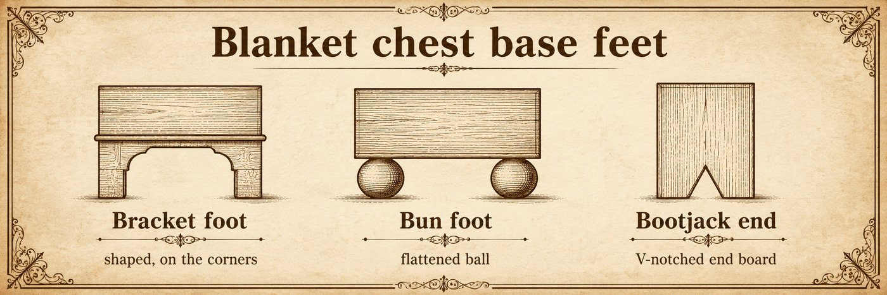

CASE AND STORAGE

The Armoire and Wardrobe
also called: clothespress, linen press, chifferobe (with drawers), Continental armoire
Era: 1840 ██████████████████ 1940. Made throughout, before built-in closets made the freestanding clothes cabinet standard.
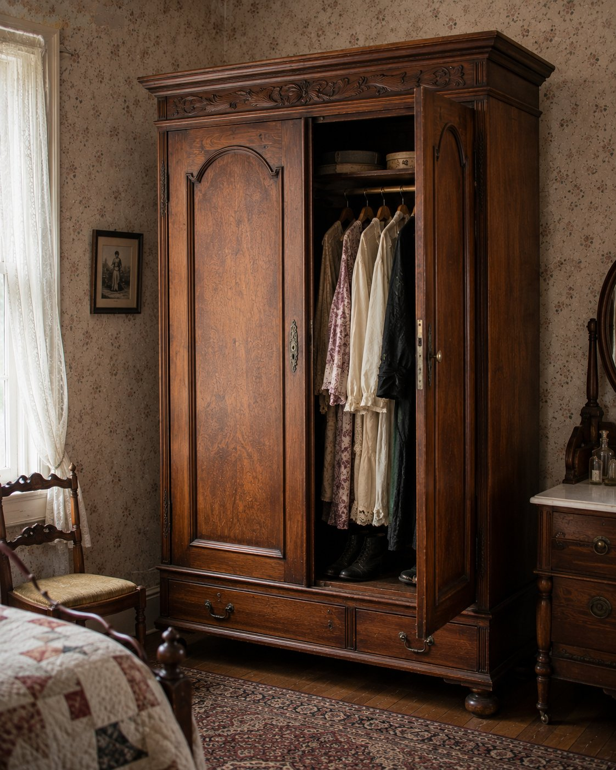

Rule it out in 10
A wardrobe or armoire is a tall enclosed cabinet with large doors for storing clothing and household goods, where door access is the primary function and the piece is too large to be a mere cupboard.
If it is a chest of drawers, the storage is drawers, not a hanging or shelved cabinet. The armoire and wardrobe are the big door-fronted clothes cabinets of the pre-closet home.

What it is
Before built-in closets, people hung and stored clothes in a freestanding cabinet. The two names overlap, and the difference is mostly degree:
- A wardrobe is the simpler, more clothing-functional version: tall, doored, fitted inside with a hanging rod, shelves, or drawers.
- An armoire is the broader, more decorative, more architectonic version, often with shaped cornice, carving, paneled doors, or Continental (French, French Canadian, Creole) styling, and frequently used for linens and household goods as well as clothes. A linen press is the shelved cousin.
A useful structural tell: many wardrobes and armoires are knock-down (KD) construction, built to disassemble into flat panels for moving through doorways. Look for bolts, pegs, or keyed joints at the cornice, sides, and back. That is normal and original, not damage.

On the short list, confirm and date it
- Confirm door-fronted clothes-cabinet function and read the interior (hanging rod, shelves, drawers).
- Check for knock-down joinery, which is typical and helps explain the build.
- Date by construction (Method section). Continental and fine early armoires show hand work; American Victorian and early-1900s wardrobes are usually machine-made factory pieces in oak or walnut.

Do not confuse it with
Form | What it really is | The tell that separates it
Armoire / wardrobe | Tall door-fronted clothes cabinet | Large doors, hanging or shelved interior
Chifferobe | Wardrobe plus a bank of drawers | Hanging side and a drawer side combined
Chest of drawers | Drawer storage case | Drawers, not a doored cabinet
China cabinet | Glazed display case | Glass doors for dishes, not clothes
Cupboard | General enclosed storage | Smaller, general storage, not clothing scale

What hurts the value
- Missing or replaced interior fittings (rod, shelves, hooks), and married cornice or doors.
- A refinished fine early or French example.

What it is worth, in plain terms
Be honest here: large brown clothes cabinets are a soft market, because few modern homes need them, so a plain American oak or walnut wardrobe is common and modest despite its size. A fine early or French armoire, or one with good carving and original surface, is desirable. There is also a steady market for large armoires converted to media or storage cabinets. Quality, period, surface, and Continental character set the range, not size.

Quick field routine
First, confirm a tall door-fronted clothes cabinet. Second, read the interior fittings. Third, look for knock-down joinery, normal and original. Fourth, date by construction, and price by quality, not by size.

Desks

DESKS

The Slant-Front Desk
also called: slant-top desk, fall-front desk, bureau desk, desk-on-frame
Era: 1840 ██████████ then mostly Colonial Revival. The form is the standard desk c. 1700 to 1860, heavily revived after 1880.
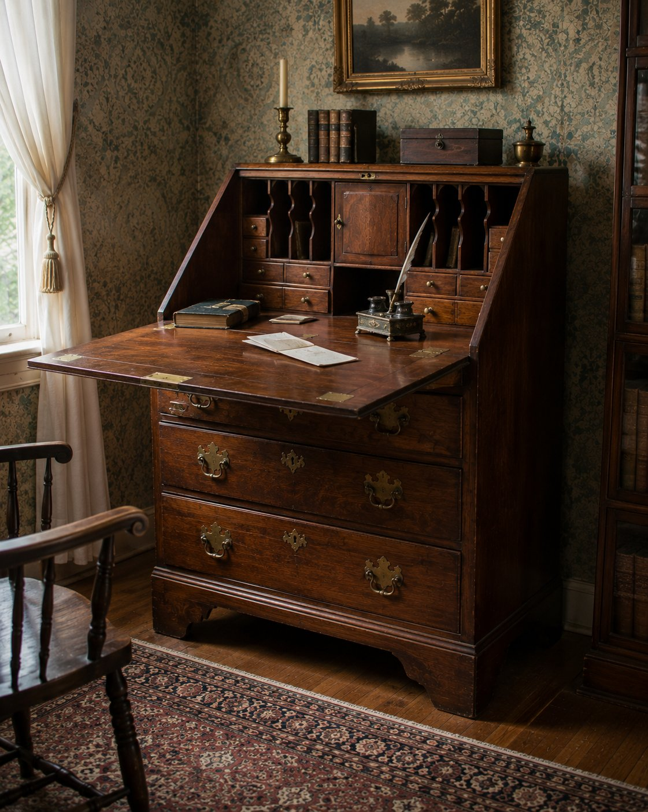

Rule it out in 10
A slant-front desk has a sloping lid that hinges down to form the writing surface, opening to reveal a fitted interior of pigeonholes and small drawers, usually over a chest of drawers below.
If the cover rolls or curves, it is a roll-top or cylinder desk. If there is a bookcase on top, it is a secretary. The slant-front is defined by the sloping fall-down lid.

What it is
The slant-front was the standard American writing desk of the colonial and Federal years, roughly 1700 to 1860. The sloping lid drops on hinges, often supported by pull-out lopers, to make a writing surface, and behind it sits a fitted interior of pigeonholes, document slots, and little drawers, sometimes with a central prospect door. Below is a case of graduated drawers. It was revived heavily in the Colonial Revival from about 1880, so most examples you meet are revival rather than period.

On the short list, confirm and date it
- Confirm the sloping fall lid, the lopers, and the fitted interior.
- Date by construction, since period and revival look alike: hand-cut versus machine dovetails on the drawers and interior, cut versus wire nails, saw marks, secondary woods, and the wear on the lopers and lid (Method section).
- Hand work and early fasteners point to the colonial or Federal period; uniform machine work points to Colonial Revival. Run the period-or-reproduction tree when unsure.

Do not confuse it with
Form | What it really is | The tell that separates it
Slant-front desk | Desk with a sloping fall lid | Sloping hinged lid over a chest
Secretary desk | Slant or fall front plus a bookcase top | A bookcase or cabinet above
Roll-top or cylinder desk | Desk with a rolling or curved cover | Moving cover, not a hinged slope
Drop-front (butler's) desk | Vertical fall front | Flat front drops flat, not sloped

What hurts the value
- A replaced lid, lopers, or interior, and a married top and base (desk-on-frame marriages are common).
- Refinishing on a fine period example.

What it is worth, in plain terms
A genuine colonial or Federal slant-front, especially in figured mahogany or walnut with a good interior, is premium. A Colonial Revival slant-front, which is what you will usually find, is moderate to modest. Construction dating and originality, not the colonial look, set the range.

Quick field routine
First, confirm the sloping fall lid, lopers, and fitted interior. Second, date by drawer and interior construction. Third, decide period or revival with the tree. Fourth, check for a desk-on-frame marriage and replaced parts.

DESKS

The Secretary Desk
also called: secretary, secretaire, bureau bookcase, secretary bookcase
Era: 1840 ██████████ then mostly Colonial Revival. The form runs c. 1700 to present, with a strong revival after 1880.
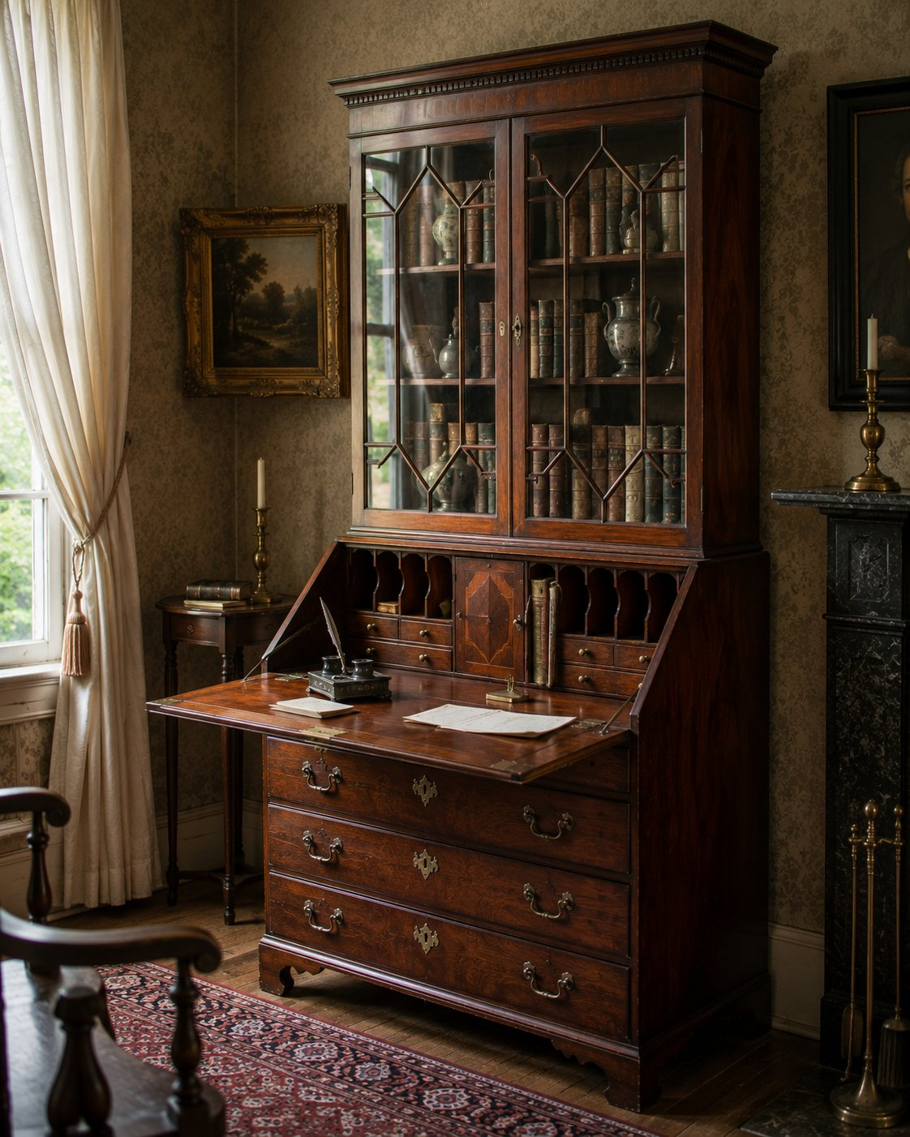

Rule it out in 10
A secretary desk is a two-part piece: a desk section with a fitted writing interior below, and a bookcase or cabinet on top. Tall, vertical, two stacked cases.
If it is a single desk with no upper bookcase, it is a slant-front or fall-front desk. If the cover rolls, it is a roll-top. The secretary is the desk-plus-bookcase tower.

What it is
The secretary combines writing and storage in one tall piece: a lower desk, often with a slant fall front or a drop front, opening to a fitted interior of pigeonholes and small drawers, set over a chest of drawers, with an upper bookcase above, frequently glazed with wood mullions or fitted with solid paneled doors. It is the formal writing-and-display piece of the home, made from about 1700 to the present and revived strongly in the Colonial Revival after 1880.

On the short list, confirm and date it
- Confirm the two-part desk-over-bookcase architecture and the fitted writing interior.
- Check the two halves belong together: matching wood, finish, proportion, and wear where the bookcase sits on the desk. Secretaries are a classic marriage risk, an old desk topped with a later or unrelated bookcase.
- Date by construction as always, hand versus machine joinery, fasteners, glazing bar construction, and secondary woods (Method section). Period and revival look alike, so build evidence, not silhouette.

Do not confuse it with
Form | What it really is | The tell that separates it
Secretary desk | Desk below, bookcase above | Two-part, fitted desk interior plus a bookcase top
Slant-front desk | Single desk, sloping lid | No bookcase top
Bookcase | Shelving only | No writing interior
Roll-top desk | Desk with a rolling cover | Moving cover, single case

What hurts the value
- A married top and bottom, the most common and most important issue here.
- Replaced glazing or interior, and refinishing on a fine period example.

What it is worth, in plain terms
A genuine period secretary with matching original halves and a good interior is premium, sometimes strongly so. A Colonial Revival secretary is moderate, and a married example is worth less than either honest piece would be alone. Matching halves, original surface, and construction set the range.

Quick field routine
First, confirm desk-below, bookcase-above, with a fitted interior. Second, prove the two halves are an honest pair, not a marriage. Third, date by construction. Fourth, check the interior and glazing are original.

DESKS

The Roll-Top and Cylinder Desk
also called: roll-top desk, cylinder desk, cylinder bureau, tambour cylinder desk, S-roll or C-roll desk
Era: 1840 ░░ 1870 ██████████ 1920 ███▒ 1940. The form goes back to the 1760s, but the office roll-top you will actually find is late Victorian, roughly 1870 to 1920.
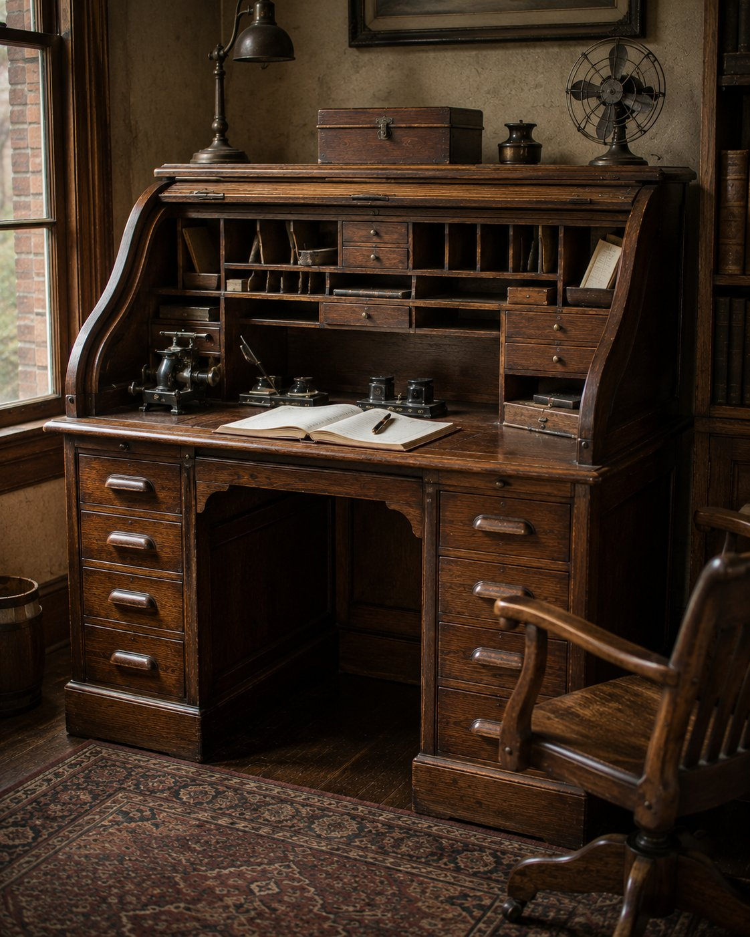

Rule it out in 10
Look for a cover that rolls or curves down to hide the writing surface, and a fitted interior of pigeonholes and little drawers behind it.
If the desk has a flat fixed top, or a flat lid that hinges down to write on, it is a different desk (a fall-front or slant-front). The roll-top and cylinder desk are defined by the moving cover that swallows the whole work surface and locks the clutter away. No moving cover, not this form.

What it is
This is the desk of the late Victorian office. A flexible slatted cover (a tambour) rolls down on tracks, or a single rigid curved panel (the cylinder) swings down, and the entire fitted interior of pigeonholes, ledger slots, and small drawers disappears behind it, often under one lock. It was the filing-and-privacy machine of its day, made in great numbers in oak from about 1870 to 1920.
Two close relatives sit under one roof here:
- A roll-top uses a flexible cover of many thin slats glued to a canvas backing, so it rolls into the desk.
- A cylinder desk uses a single rigid curved panel that lifts or swings as one piece.
Both enclose a fitted office interior. The slats versus the solid curve is how you tell them apart.

On the short list, confirm it
- A rolling slatted cover, or a rigid curved cylinder cover, with the track, hinge, or slat evidence to show which.
- A fitted interior built for paperwork: pigeonholes, cubbies, small drawers, sometimes a locking system.
- A writing surface that is either fixed or revealed when the cover opens.
- Drawers or pedestals below.
- Patent-style locking or concealment hardware points to specific quality makers, but do not name a maker without a label or a matching patent mark.

Date it
- Wood and market. The classic American office roll-top is oak, riding the Golden Oak office-furniture wave of roughly 1890 to 1915. Earlier and higher-style cylinder desks appear in walnut and mahogany.
- Hardware and patents. Patent-dated locks and roll mechanisms give a firm "not before" point. Late Victorian office hardware is machine-made and standardized.
- Construction. Machine-cut dovetails on the drawers and interior, wire nails on the back, and uniform machined parts all point to the 1870-to-1920 factory window. (Run the dovetail and nail diagrams from the Method section. Hand-cut dovetails and cut nails would suggest something earlier or a repair.)
- Reproductions exist. Modern plywood, modern slides, and Phillips screws give them away. When unsure, run the period-or-reproduction decision tree. You will keep meeting that tree, which is the idea.

Do not confuse it with
Form | What it really is | The tell that separates it
Roll-top desk | Desk with a flexible slatted rolling cover | Many thin slats on a canvas backing
Cylinder desk | Desk with a single rigid curved cover | One solid curved panel, not slats
Slant-front or fall-front desk | Hinged flat lid you write on | Lid hinges down, no rolling cover
Wooton desk | Elaborate cabinet-office desk | Swinging cabinet doors and a dense fitted interior
Secretary desk | Desk with a bookcase top | Glazed bookcase above the writing section

What hurts the value
- Replaced or rebuilt tambour slats. The rolling cover is the heart of the piece. A botched slat repair shows and costs.
- Reproductions sold as period.
- Married tops and bases, or a cover swapped from another desk. Check that wood, wear, and hardware agree throughout.

What it is worth, in plain terms
Size, wood, and the cover drive it. A large oak S-roll desk, with a full fitted interior and a working lock, is premium and very collectible. A small C-roll, or a desk with a damaged or replaced cover, is common and modest. A smooth-rolling original tambour and an intact interior are what buyers pay for.

Quick field routine
First, confirm the form. A rolling or cylinder cover that hides a fitted interior. No moving cover, different desk.
Second, name it. Flexible slats (roll-top) or a rigid curve (cylinder).
Third, date and authenticate. Oak and machine construction for the classic 1870-to-1920 office desk, patent hardware for a firm floor, and the reproduction tells from the tree.
Fourth, test the cover. A smooth, original, complete roll is much of the value.
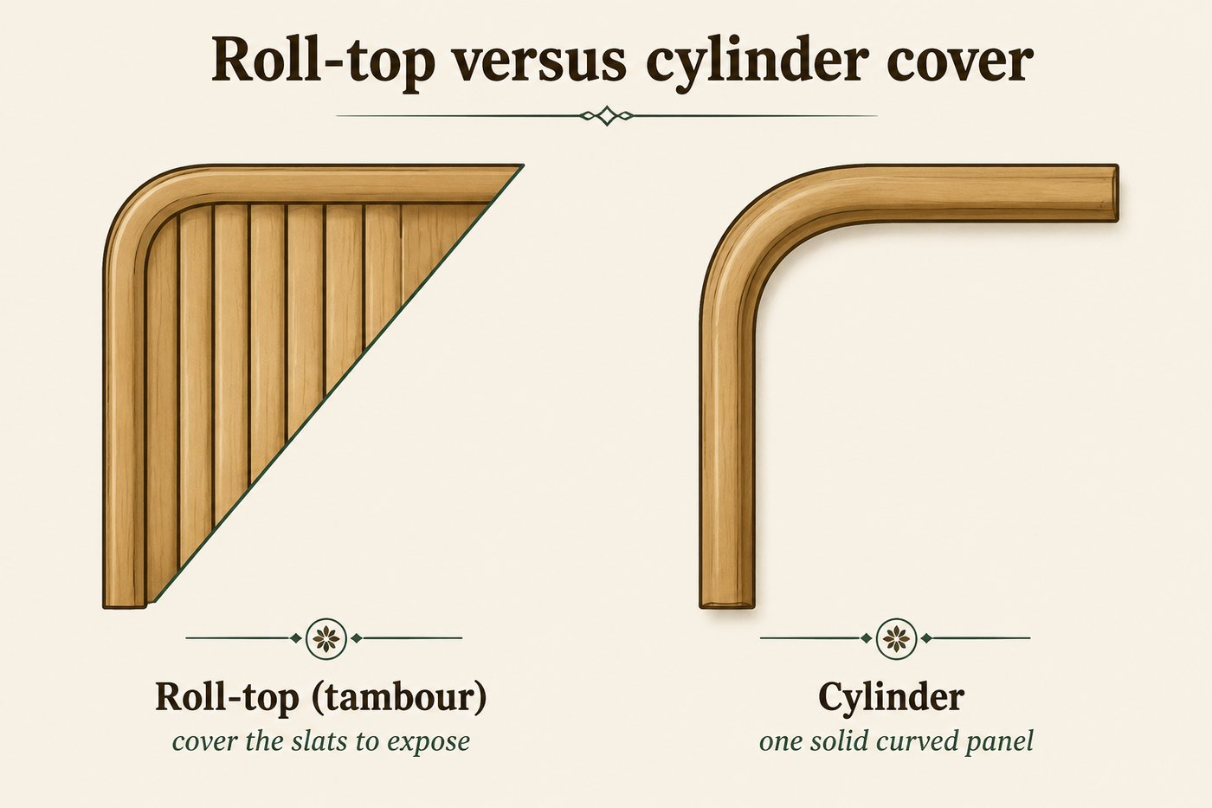

Beds

BEDS

The Iron Bed
also called: brass bed, metal bed, iron bedstead, hospital or sanitarium bed (institutional)
Era: 1840 ░░ 1850 ██████████ 1940 ▒░. Metal beds run strongest c. 1870 to 1940, with a brass-bed revival from the 1970s.
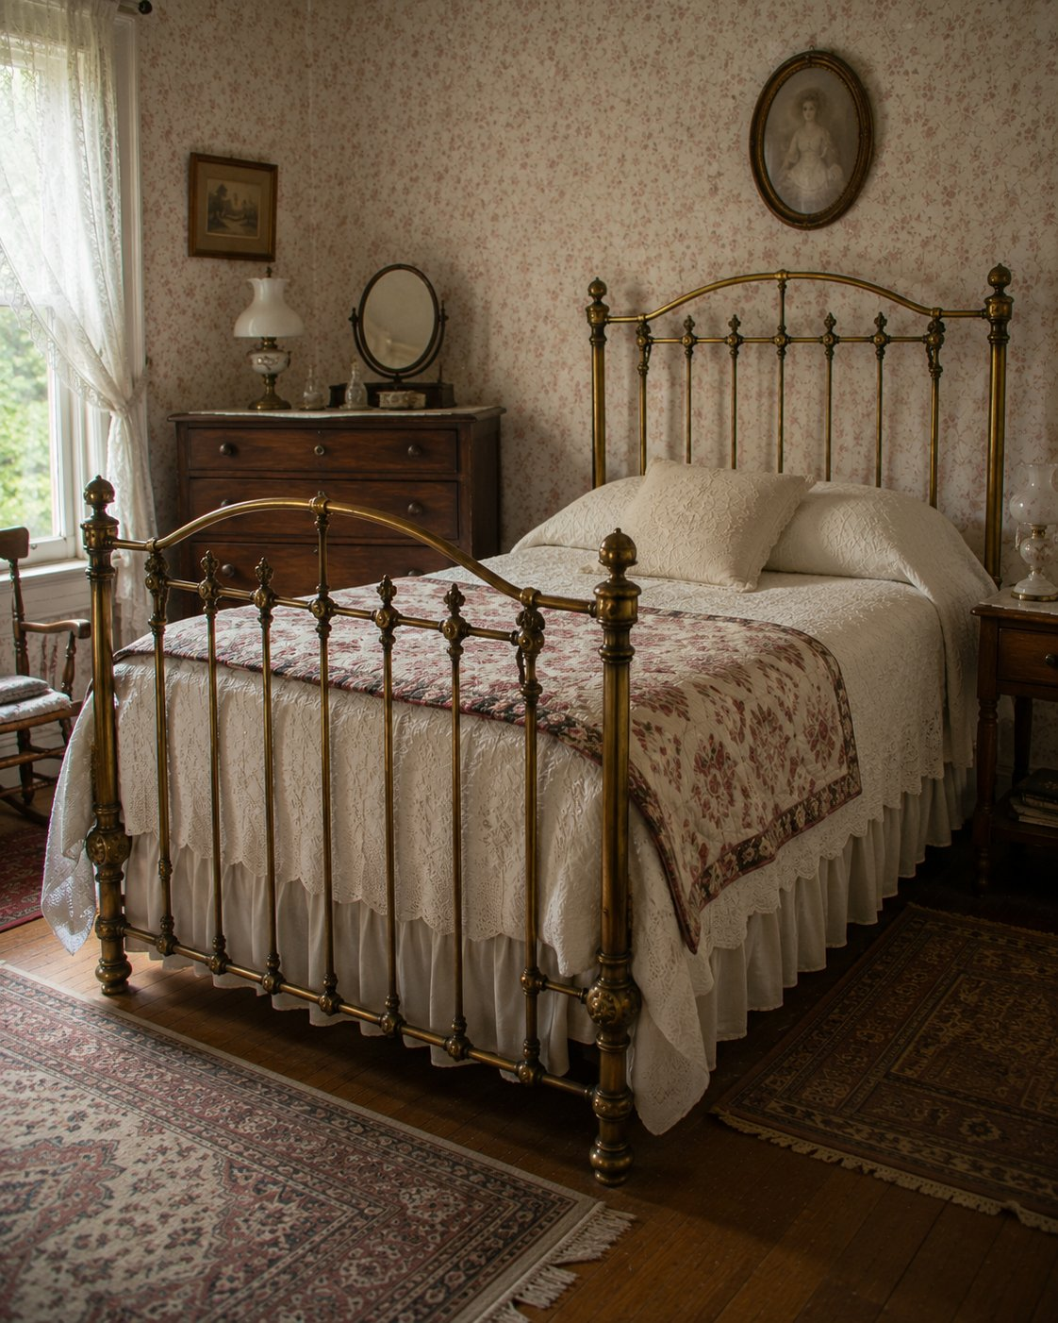

Rule it out in 10
An iron bed is built primarily of metal: cast iron, wrought iron, brass tubing, or steel, with the headboard and footboard made of castings, bent tubing, scrollwork, and finials rather than wood panels.
Here is the trap, and we watched our own software fall into it: a wooden bed with metal side rails is not an iron bed. Nearly every bed has metal rails. If the headboard and footboard are wood, it is a wooden bedstead. The metal has to be the structure.

What it is
The iron bed was the sanitary, fireproof, affordable bed of the late Victorian and early modern home, made strongest from about 1870 to 1940. Cast and wrought iron, brass tubing, and later tubular steel form the head and foot, often with arched or scrolled designs, knobs, rosettes, and finials. Side rails are angle or channel iron with hook-and-eye or bolt attachment. Because the material is metal, the dating logic is completely different from wood: forget species and joinery, and read the metalwork.

On the short list, date it by joining and finish
This is the iron bed's special method.
Joining method | Period it points to
Hand-forged | before 1900
Riveted | industrial, c. 1850 to 1940
Brazed (brass infill at tubing joints) | brass beds, late 1800s onward
Oxyacetylene or arc welded | after 1910
Spot welded (tubular steel) | after 1925
MIG or TIG welded | after 1948, a reproduction signal
Then read the finish: japanning (baked black, c. 1850 to 1910), painted (c. 1880 to 1940), brass plating over steel (c. 1880 to 1920, thin and worn through on period pieces), and modern powder coat (post-1960s, a reproduction signal). Casting seams and file marks show foundry origin. Casters help too: porcelain c. 1860 to 1900, cast iron c. 1880 to 1920. Look for maker stamps: Simmons, Foster Brothers, Wickersham, Adams and Westlake.
Reproduction tells: MIG or TIG welds, thick uniform plating with no honest wear-through, and powder-coat finishes.

Do not confuse it with
Form | What it really is | The tell that separates it
Iron bed | Metal-frame bed | Head and foot built of metal castings or tubing
Wooden bedstead | Wood-frame bed | Wood head and foot, even with metal side rails
Hospital or sanitarium bed | Institutional tubular steel | Crank or removable rails, institutional context

What hurts the value
- Replaced mattress support (very common, expected, minor).
- Married head and foot from different beds, and modern reproductions sold as period.
- Stripped or powder-coated over original japanning or period paint.

What it is worth, in plain terms
An ornate Victorian brass bed or a decorative cast-iron bed with original finish and brazed period construction is desirable. A plain painted iron bed is common and modest, and a modern brass-bed reproduction is modest. Original finish, period joining, and a maker mark set the range.

Quick field routine
First, confirm the head and foot are metal, not wood with metal rails. Second, read the joining method against the table. Third, read the finish and look for casting seams and a maker stamp. Fourth, watch for MIG or TIG welds and powder coat, the reproduction tells.

BEDS

The Wooden Bedstead
also called: bed, bed frame, four-poster, sleigh bed, spool bed, panel bed
Era: 1840 ██████████████████ 1940. Made throughout. Construction and subtype date it.
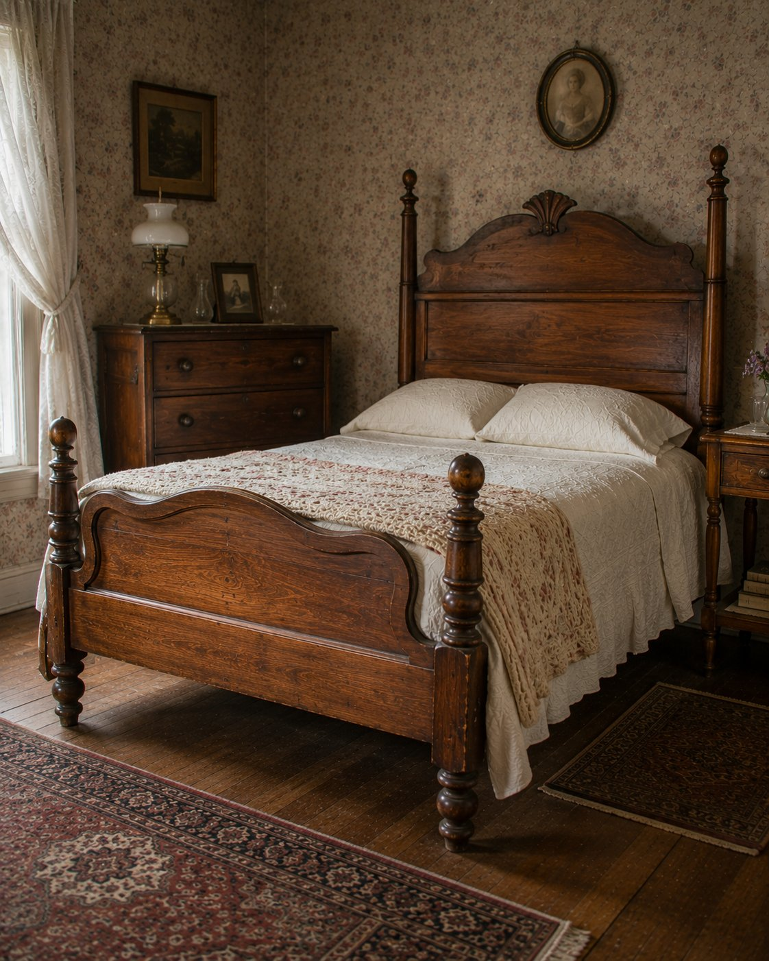

Rule it out in 10
A wooden bedstead is a wood-framed sleeping support: a wooden headboard, usually a footboard, and side rails, with a slat, rope, or platform mattress support.
If the head and foot are metal castings or tubing, that is an iron bed. Metal side rails do not change the answer: a wood head and foot make it a bedstead, even with iron rails (this is the companion to the iron-bed lesson).

What it is
The bedstead is the foundational wooden bed, made in every American period. A complete bedstead is more than a loose headboard, it is the full frame. Within the form live the familiar subtypes, and recognizing them is most of the work:
- Four-poster, four tall corner posts, sometimes for a canopy.
- Tester and half-tester, with a full or partial overhead canopy frame.
- Sleigh bed, scrolled head and foot curving outward, Empire and later.
- Spool and cannonball, turned posts of stacked spools or topped with a ball, common mid-1800s.
- Panel bed, flat paneled head and foot, the everyday late Victorian and early-1900s suite bed.

On the short list, confirm and date it
- Identify the subtype from the list, which carries period character (spool and sleigh point mid-1800s, panel beds point late Victorian to early modern suites).
- Date by construction: joinery on the head and foot, the rail-to-post joint (mortise, bolt, or hook hardware), wood, saw marks, and fasteners (Method section).
- Beds are often shortened, widened, or rebuilt to fit modern mattresses. Check the rails and joints for alteration.

Do not confuse it with
Form | What it really is | The tell that separates it
Wooden bedstead | Wood-frame bed | Wood head and foot, even with metal rails
Iron bed | Metal-frame bed | Metal castings or tubing head and foot
Daybed | Reclining or sleeping seat | Single long side, seat-and-sleep use
Loose headboard | Decorative panel only | No complete frame, not a full bedstead

What hurts the value
- Conversion: rails cut, lengthened, or replaced for a modern mattress.
- A married head and foot, or a head sold alone as a "bed."
- Refinishing on a fine early or original-surface example.

What it is worth, in plain terms
A complete early four-poster, sleigh, or fine spool bed with original rails is desirable. A late Victorian or early-1900s panel bed is common and modest, especially as part of a suite. Completeness, original rails, and an honest surface set the range. (Note the recurring market reality: beds without original rails are hard to sell.)

Quick field routine
First, confirm wood head and foot, metal rails do not matter. Second, name the subtype. Third, date by construction and the rail joint. Fourth, check for conversion and marriage.
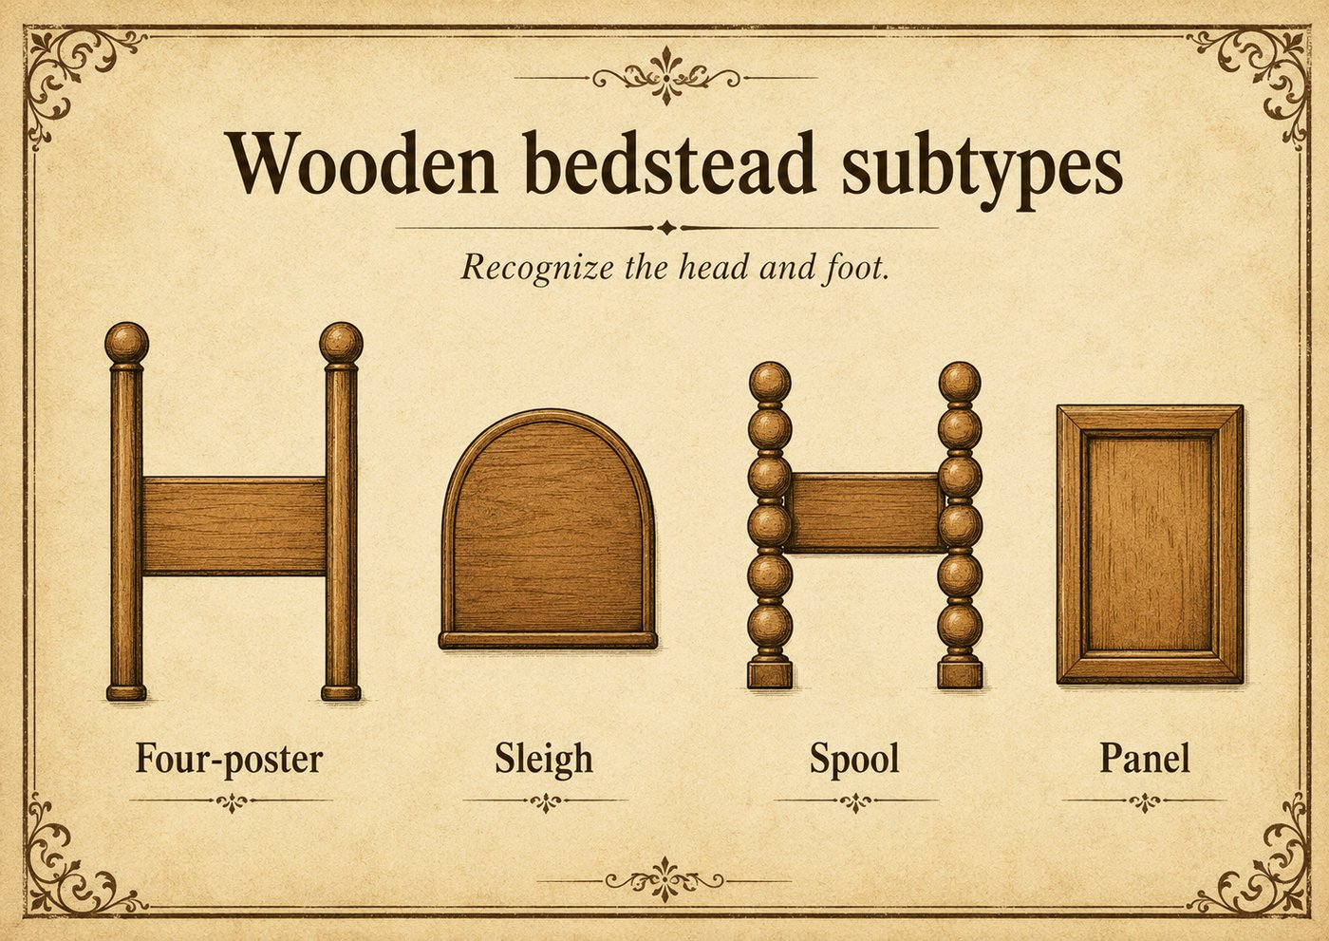

Everyday Pieces

EVERYDAY AND HIGH-RECOGNITION

The Telephone Stand
also called: telephone table, telephone cabinet (enclosed variant); see also gossip bench
Era: 1840 ░░░░░░░░ 1900 ██████████ 1940 ▒░. A telephone-era form, c. 1900 onward, strongest in the wired-phone decades.
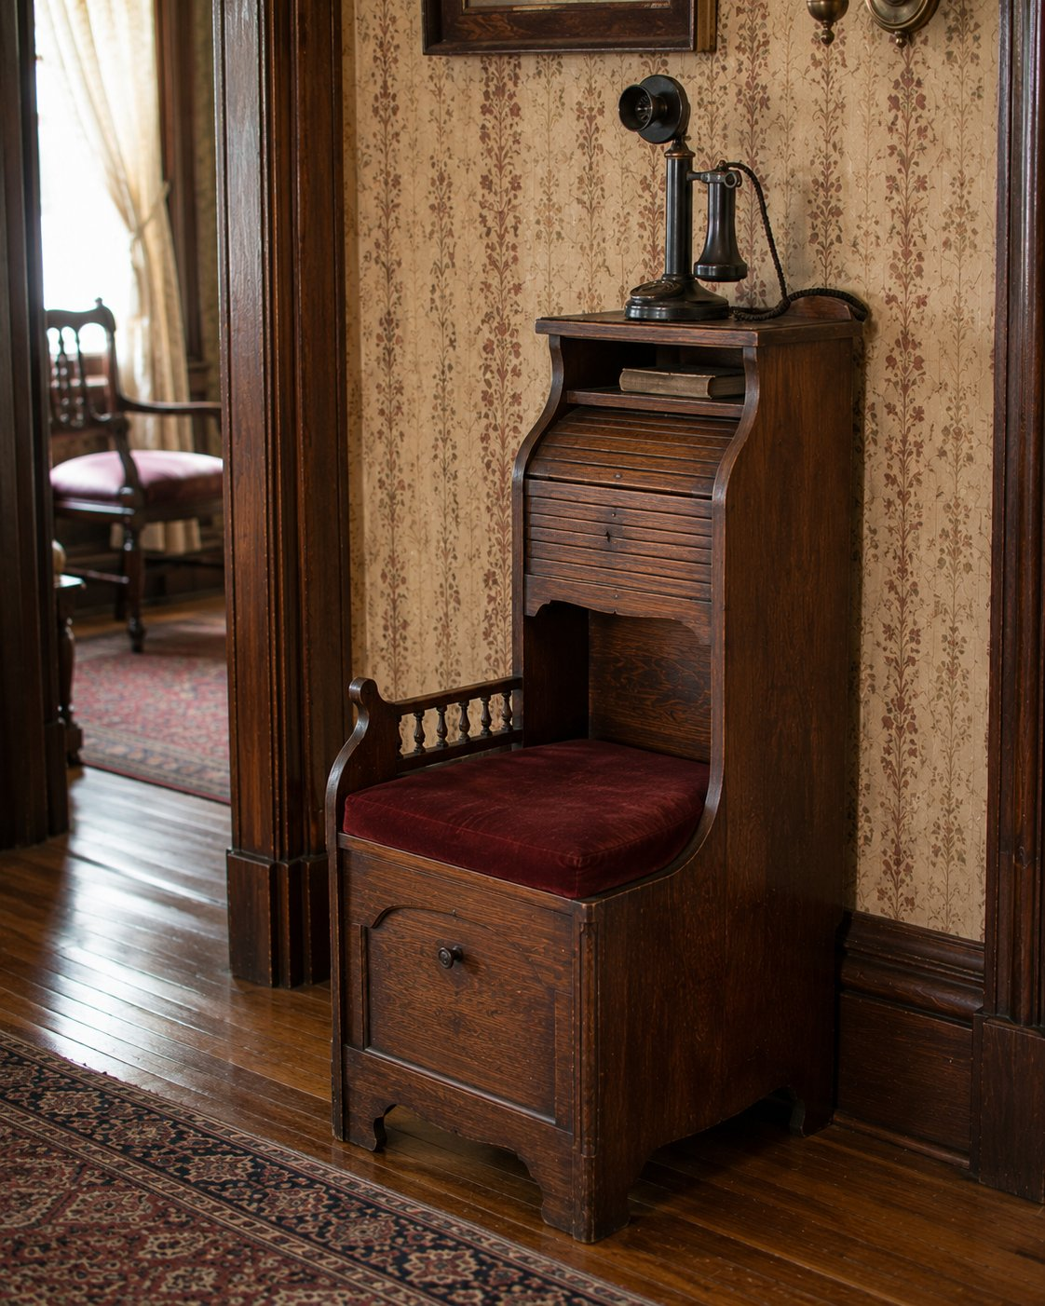

Rule it out in 10
A telephone stand is a compact stand or small cabinet made to hold a telephone, with a small top scaled to a phone (about 8 to 14 inches) and a shelf, drawer, or compartment for the directory.
Here is the affirmation test, and it matters: a small stand is not a telephone stand just because it is small. Without phone-era evidence (a phone-scaled top, directory storage), it is just a side table. Require the telephone purpose before you name it.

What it is
The telephone stand is purpose-built furniture from the wired-telephone decades, roughly 1900 onward. It is compact and tall enough to use standing or from a seat, with a small top for the phone and a lower shelf or drawer for the directory. The enclosed version is a telephone cabinet, where the phone sits in or atop a small closed compartment.
One important cousin: the gossip bench, the little seat-plus-phone-shelf combination, is actually a telephone desk, not a telephone stand, because it adds integrated seating and a writing surface. (Our own software once called a child's high chair a "telephone bench" on a seat-plus-surface alone, which is exactly the mistake this affirmation test prevents.)

On the short list, confirm and date it
- Confirm telephone-era evidence: a phone-scaled top and directory storage, not just small size.
- Date by construction: oak and Golden Oak vocabulary point to the earlier decades, waterfall and Art Deco lines point to the 1930s, and machine construction throughout is expected (Method section).

Do not confuse it with
Form | What it really is | The tell that separates it
Telephone stand | Compact phone-and-directory stand | Phone-scaled top plus directory storage
Gossip bench (telephone desk) | Seat plus phone shelf and writing surface | Integrated seat, it is a desk form
Side table | General utility table beside seating | No telephone purpose or directory storage
Nightstand | Bedside case | Bedside placement and scale

What hurts the value
- Calling a plain side table a telephone stand with no phone evidence (and the reverse).
- Replaced hardware and refinishing.

What it is worth, in plain terms
Most telephone stands are common and modest, charming and very saleable for their nostalgia. A nicely styled oak or Art Deco example, or a complete gossip bench, sits a step higher. Style, condition, and completeness set the range.

Quick field routine
First, confirm real telephone purpose: phone-scaled top, directory storage. Second, if it has a seat, it is a gossip bench (telephone desk), not a stand. Third, date by style and construction. Fourth, do not name it on small size alone.

EVERYDAY AND HIGH-RECOGNITION

The Nightstand
also called: bedside table, night table, bedside cabinet, bedside stand
Era: 1840 ██████████████████ 1940. Construction and suite context date it.
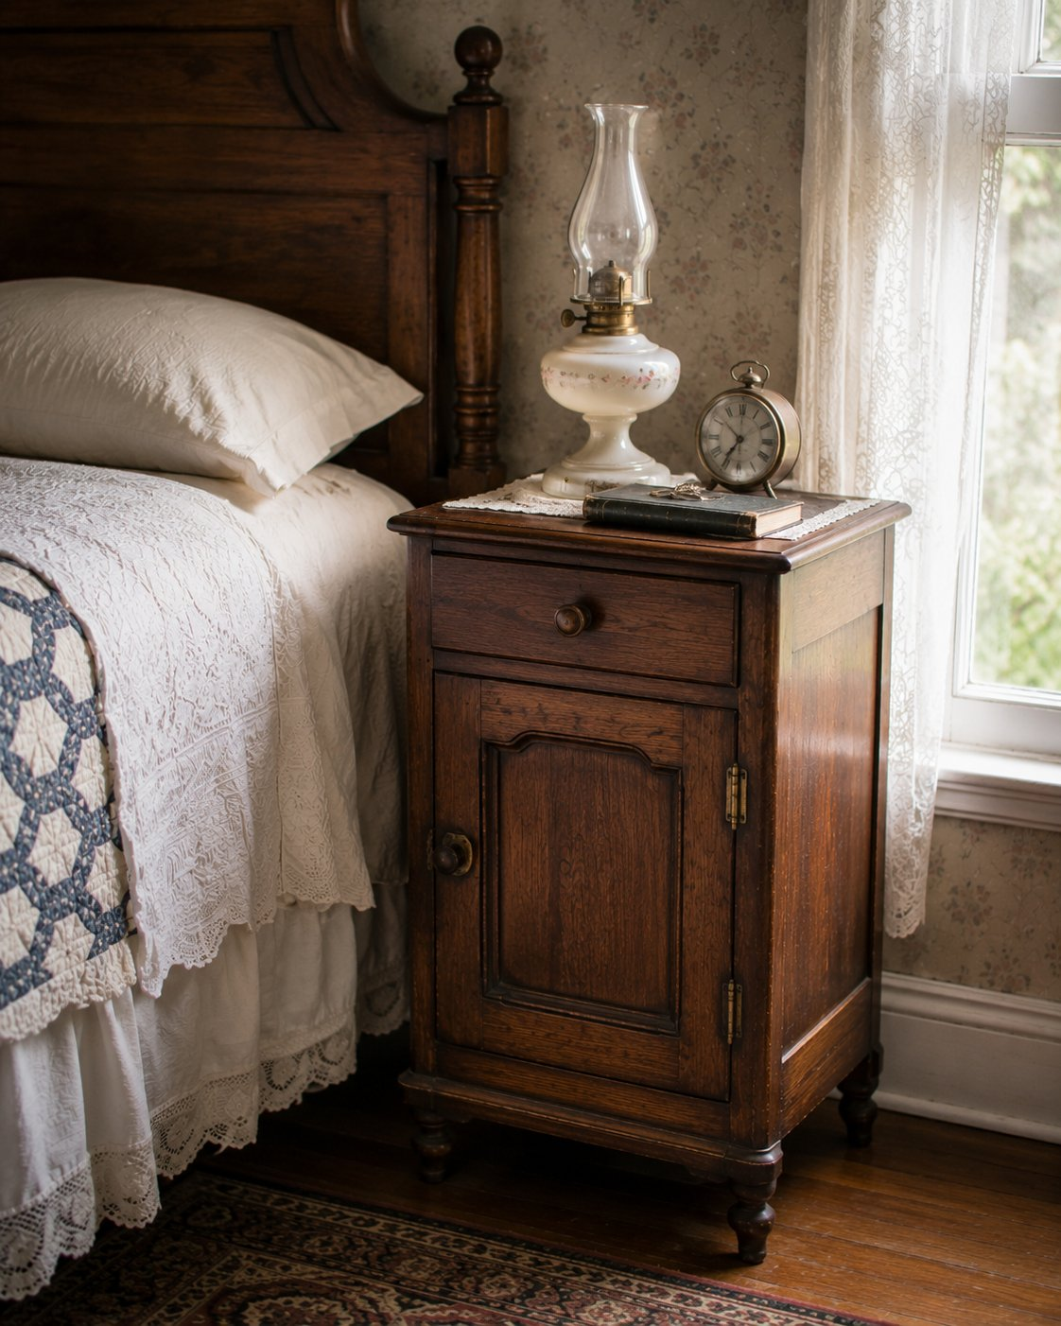

Rule it out in 10
A nightstand is a small bedside case at mattress or bed-rail height, with a top for a lamp, book, clock, or glass of water, and usually a small drawer, shelf, or little cabinet below.
If it is a low table beside seating, that is an end table. If it is a larger storage case, it is a chest or small cabinet. The nightstand is defined by bedside scale and immediate-access use.

What it is
The nightstand is bedside furniture, sized for reach from the bed. Surface comes first (lamp and clock and book), with storage secondary. From the late nineteenth century and especially in twentieth-century coordinated suites, it was made in pairs to flank the bed and match the dresser and chest. That suite context is a useful identification and dating clue: a nightstand whose wood, hardware, and style match a known suite places it with that suite.

On the short list, confirm and date it
- Confirm bedside scale and surface-first use.
- Look for a matching pair or suite, which both confirms the form and helps date it.
- Date by construction as always: joinery, fasteners, secondary woods, hardware (Method section). Style follows the bedroom-suite fashion of its decade.

Do not confuse it with
Form | What it really is | The tell that separates it
Nightstand | Small bedside case | Bedside scale, surface-first, often paired
End table | Small seating-area table | Living-room placement and use
Side table | General small table | Not specifically bedside
Small chest or cabinet | Storage-first small case | Storage dominates over surface and access

What hurts the value
- A split pair (a single sells for less than the matched two).
- Replaced hardware and refinishing, and a nightstand separated from its suite.

What it is worth, in plain terms
Single nightstands are common and modest. A matched pair, especially with its dresser and bed as a suite, is worth meaningfully more together. Pairing, suite completeness, and original hardware set the range.

Quick field routine
First, confirm bedside scale and surface-first use. Second, look for a matching pair or suite. Third, date by construction and suite style. Fourth, keep pairs together, they are worth more as two.

Clocks

CLOCKS (BONUS CHAPTER)

Clocks: Tall-Case and Shelf
tall-case also called: grandfather, grandmother, longcase. shelf also called: mantel, tambour, kitchen, gingerbread clock
Era: 1840 ██████████ 1940. Tall-case revival peaks c. 1880 to 1930; shelf and mantel clocks run strong across the whole window.
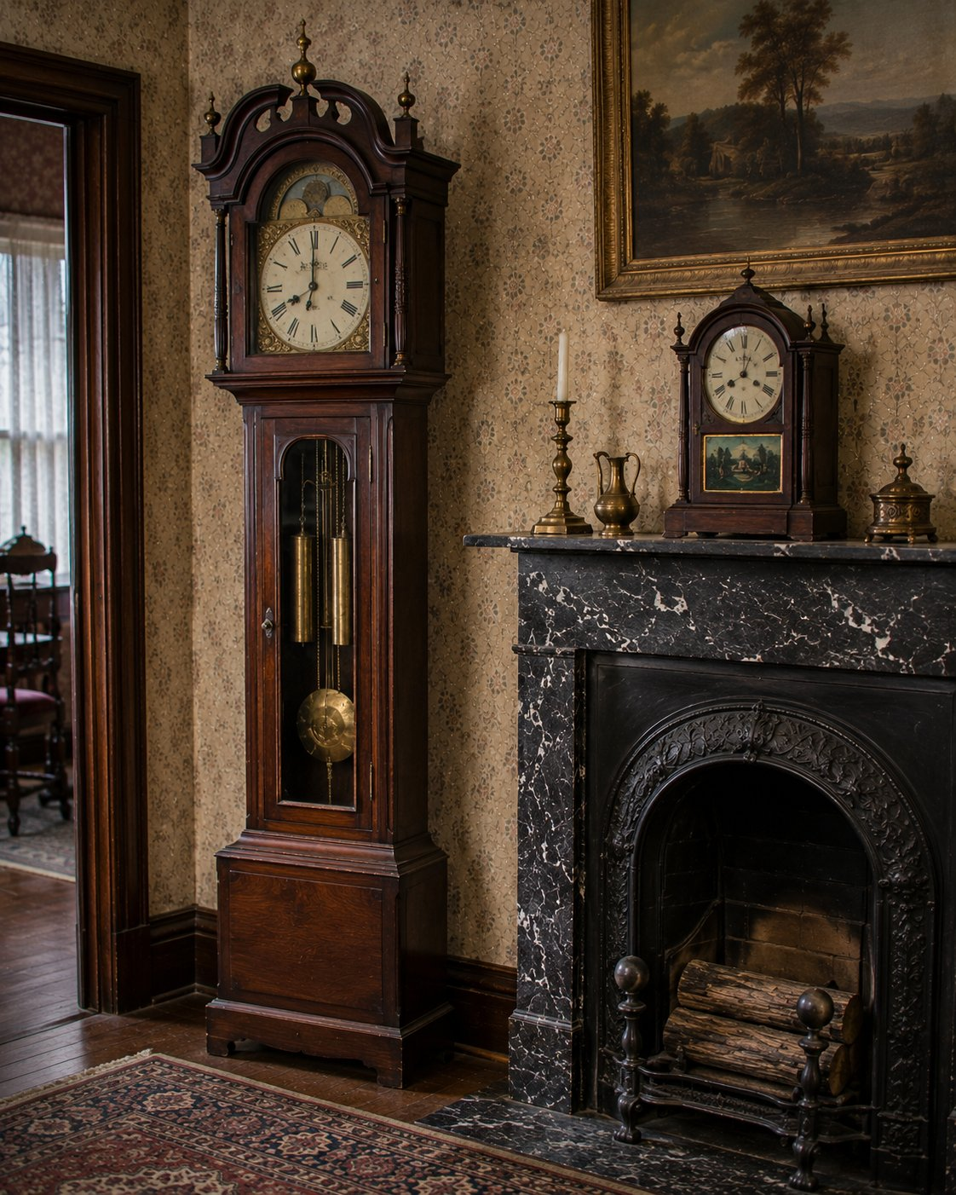

Rule it out in 10
Where does it sit? A tall-case clock stands on the floor, a full-height vertical cabinet. A shelf clock sits on a mantel, shelf, or table, compact with a flat base.
That single question sorts the two forms you will meet most.

The one rule that matters most
A clock is two things to date, not one: the case (the furniture) and the movement (the works inside). They can be, and often are, separated, swapped, or married. So date them separately, and never assume the case age proves the movement age or the reverse. The strongest evidence for the movement is inside: paper labels, maker stamps, and patent dates on the works or the case back.

Tall-case (grandfather) clock
A full-height freestanding case with a hood or bonnet, a trunk housing the pendulum and weights, and a base. Weight-driven longcase movements are typical. The term grandfather is later popular usage; the grandmother clock is simply a slimmer, shorter version. Most American tall-case clocks you find are Colonial Revival and Federal Revival, with peak production about 1880 to 1930, not eighteenth-century originals. Date the case by construction and the movement by its label, and watch for a revival case around an older or newer movement.

Shelf and mantel clock
A compact, surface-set, usually spring-driven clock with a decorative front, made to sit on a mantel or shelf. The Victorian American examples are everywhere: black mantel clocks in painted iron or slate, and ornate gingerbread (kitchen) clocks in pressed oak or walnut cases, by makers like Seth Thomas, Ansonia, Waterbury, New Haven, and Gilbert, roughly 1880 to 1920. Tambour clocks, with a low arched silhouette, are an Art Deco favorite, about 1900 to 1940. The maker's paper label inside the case is your best friend for both attribution and date.

Do not confuse them
Form | What it really is | The tell that separates it
Tall-case clock | Floor-standing longcase | Full height, hood, trunk, base, usually weight-driven
Shelf or mantel clock | Surface-set clock | Compact, flat base, usually spring-driven
Wall clock | Hung clock | Mounts on the wall, no floor or shelf base

What hurts the value
- A married case and movement, the central clock pitfall.
- A replaced dial, hands, or glass, and refinishing the case.
- Treating a Colonial Revival grandfather clock as eighteenth-century.

What it is worth, in plain terms
A documented period tall-case clock with a matching original movement is premium and serious. A Colonial Revival grandfather clock is moderate. Victorian black mantel and gingerbread clocks are common and modest but steady sellers, with named makers and original labels lifting them. Matching case and movement, an original label, and honest condition set the range.

Quick field routine
First, floor-standing (tall-case) or surface-set (shelf). Second, open it and read the movement's label and stamps. Third, date the case and the movement separately. Fourth, check they belong together, no marriage.
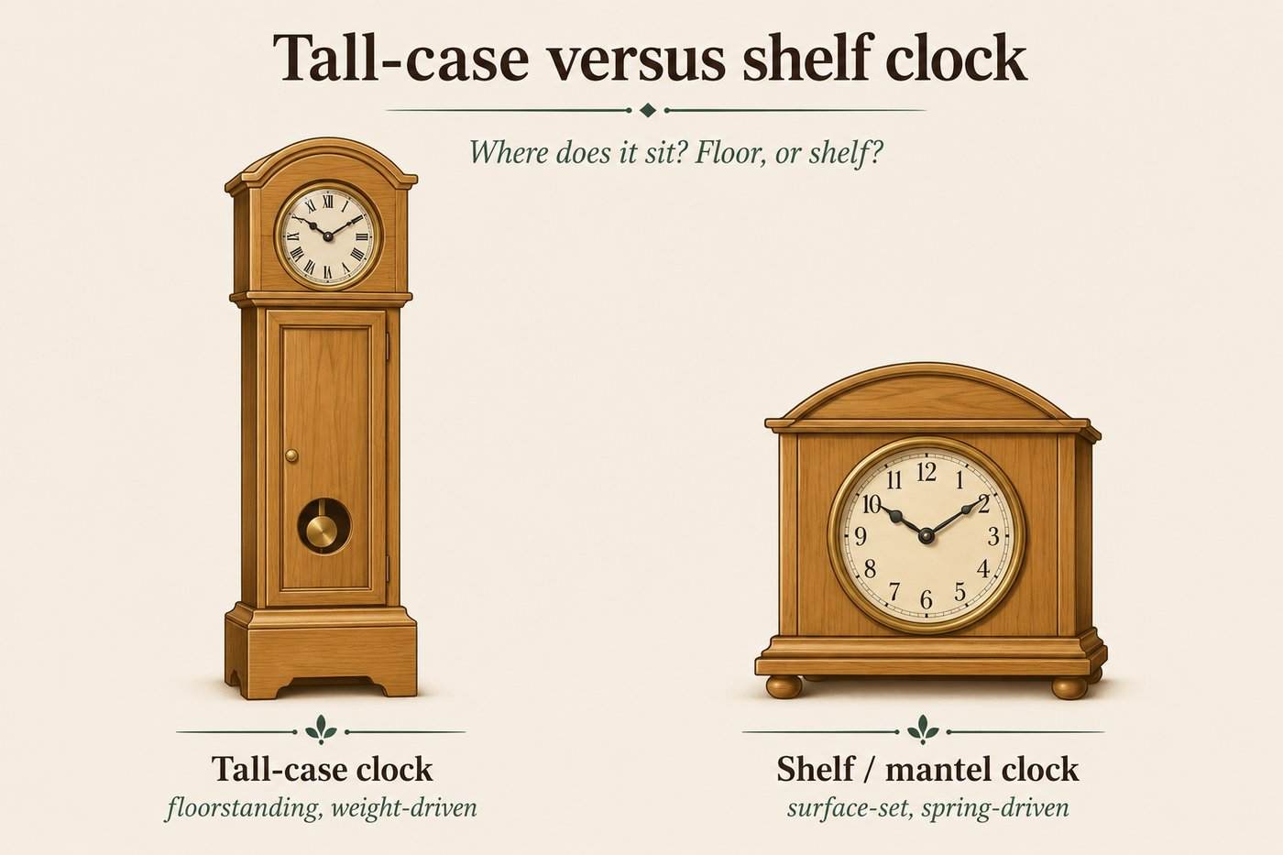

PART III · REFERENCE ATLASES

How to use the atlases
Part II tells you what to look at. Part III teaches you how to read it. The form chapters stay fast on purpose, so when one says "open a drawer and read the dovetails," it does not stop to teach dovetails. It sends you here.
Use these atlases two ways. Read them once, front to back, to build the eye. Then keep them as lookups: when a piece is on your short list and you are reading its construction, flip to the right atlas and match what you see against the tables.
Every atlas follows the same shape: the one rule or warning that matters most, then a table of types with how to tell each one and the date or quality it points to, then a short how to use it in the field.

The atlases in this part
- Fasteners · nails and screws, and the date each one pins.
- Joinery · how wood is joined to wood: dovetails first, then the rest.
- Saw marks and tool marks · what the cutting and shaping left behind, and the era it dates to.
- Wood species · the common American furniture woods, primary and secondary.
- Hardware and casters · pulls, knobs, hinges, and casters by period.
- Finishes · reading the surface, dating the finish, and protecting value.
- Glossary · plain definitions of the terms used throughout the guide.

The one habit to carry into all of them
No single atlas dates a piece by itself. A wire nail, a machine dovetail, a circular-saw arc, a sprayed lacquer: each is one layer. The method from Part I still governs here. Stack the evidence. Three layers pointing the same way is a conclusion; one is a hint.

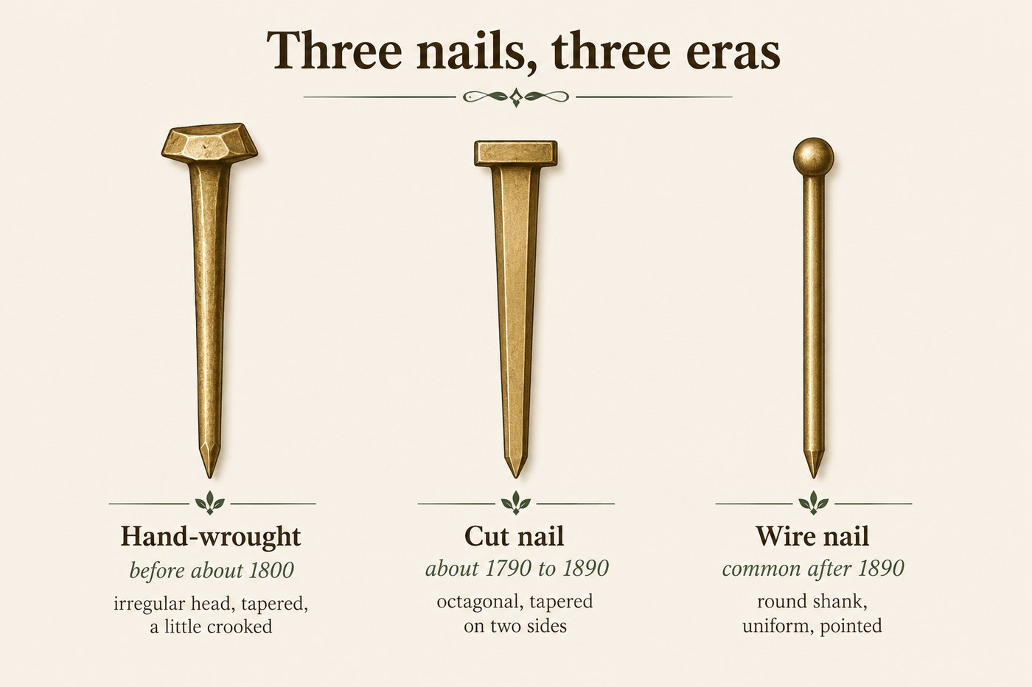
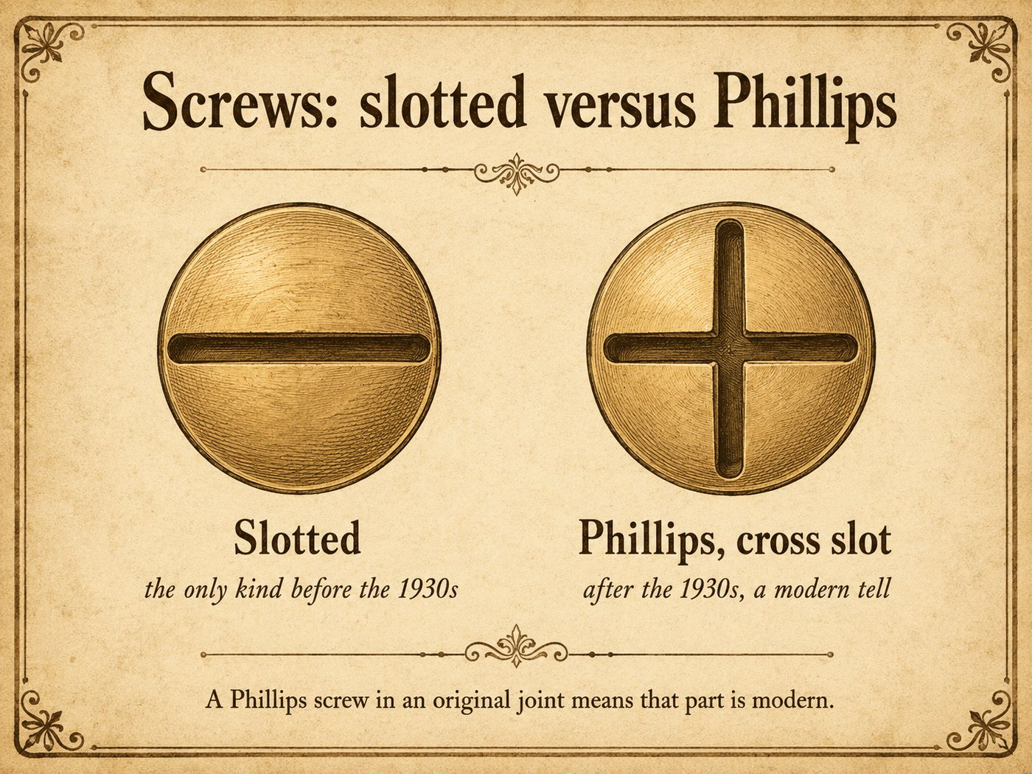

Nails
Nail | How to tell it | Date it points to
Hand-wrought | Irregular, tapered on all four sides, with a hand-hammered rose or L head; no two alike | before about 1800
Cut (square) | Machine-sheared from a sheet, rectangular and tapered on two sides only, with a blunt tip; head often slightly irregular | about 1790 to 1890
Wire (round) | Round shank, perfectly uniform, with a round flat head and a sharp point | common after about 1890
Reading nails: hand-wrought says early, cut nails say roughly the nineteenth century, wire nails say late nineteenth century or later. Remember a nail dates the board it is in, not always the whole piece, since repairs add later nails to old furniture.

Screws
Screw | How to tell it | Date it points to
Hand-made | Off-center slot, uneven threads, a blunt unthreaded tip, file marks on the head | before about 1846
Machine-made, slotted | Even threads, centered single slot, but still a gimlet (pointed) tip after about 1846 | most of the 1800s into the 1900s
Phillips (cross slot) | A cross-shaped recess | after the 1930s, a modern tell
The most useful single screw fact: a Phillips screw did not exist before the 1930s. A Phillips screw in a structural joint means that part is modern, full stop.

How to use this in the field
- A wire nail or a Phillips screw anywhere structural caps the earliest possible date.
- Cut nails and slotted screws keep the nineteenth century open.
- Hand-wrought nails and hand-made screws point genuinely early, but confirm with the rest of the construction, since both were also used in early repairs.



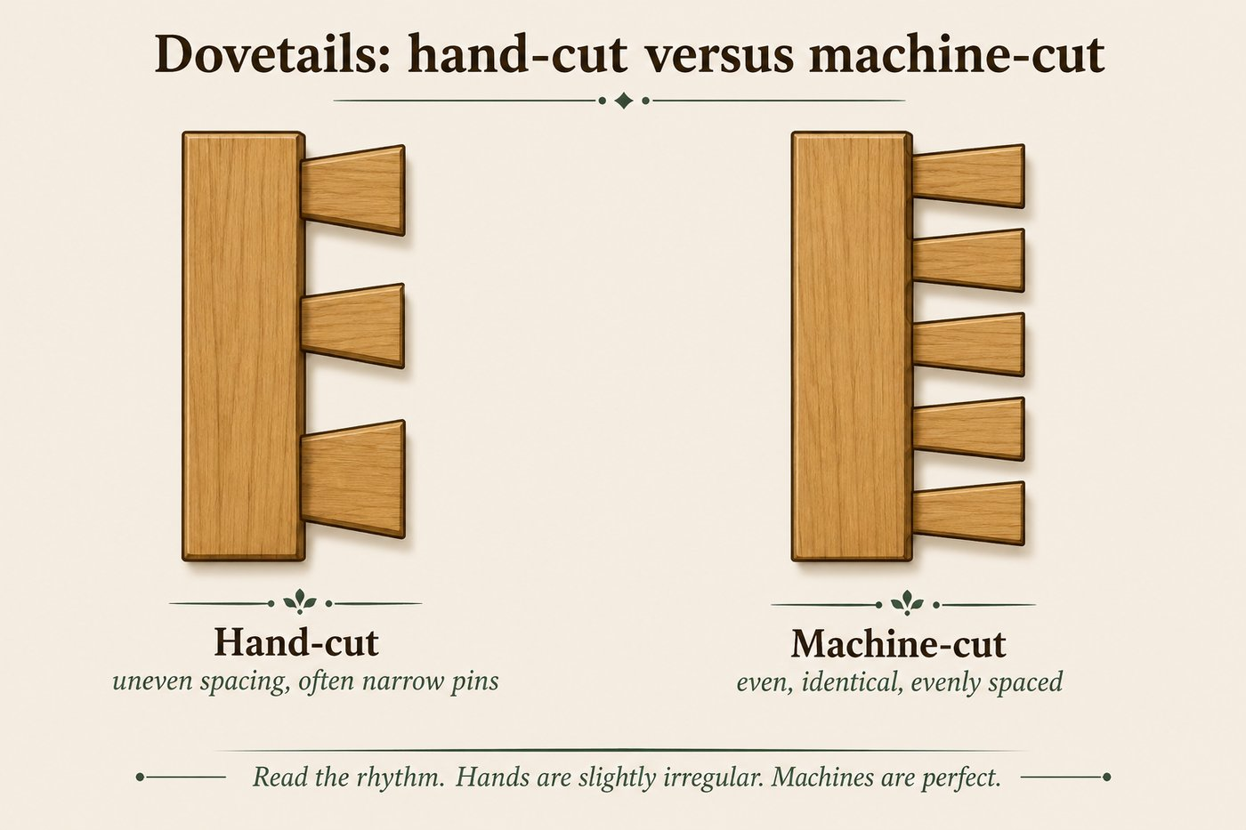

Dovetails, the most useful joint
Dovetails lock drawer corners with interlocking wedge-shaped pins and tails. They are the single best place to read a piece, so always pull a drawer.
Dovetail | How to tell it | What it says
Hand-cut | Few, often uneven in spacing, with thin narrow pins; slight irregularity between them; faint saw and chisel marks | shop-made, generally earlier
Machine-cut | Many, perfectly even and identical, evenly spaced, with pins and tails the same width | factory, after about 1860 to 1870
Half-blind | Visible only from the side, hidden on the drawer front | standard for quality drawer fronts, any period
The rhythm is the tell: people are slightly irregular, machines are perfect.

The other joints you will meet
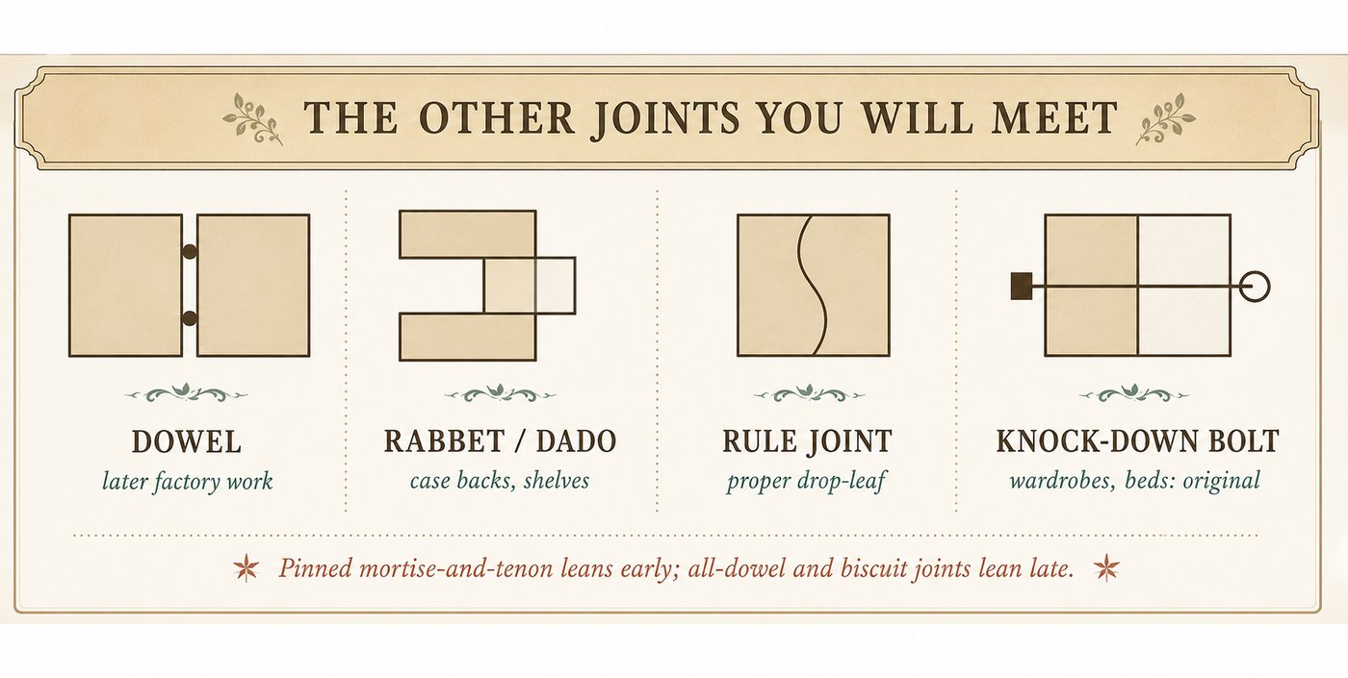
Joint | What it is | Notes
Mortise and tenon | A tongue (tenon) fits a slot (mortise); the backbone of frame and chair construction | spans all periods; pinned or wedged versions read earlier
Dowel | Round pegs join two parts | common in later factory work; all-dowel construction leans later
Rabbet and dado | A stepped or grooved channel holds a panel or shelf | common in case backs and shelves
Rule joint | A shaped interlocking hinge edge on drop-leaf tables | the mark of a proper drop-leaf
Knock-down (bolted) | Bolts, pegs, or keys let a piece disassemble | normal and original on big wardrobes and beds, not damage
Biscuit / pocket screw | Modern shop joints | a modern or reproduction tell

How to use this in the field
- Read the dovetails first: even and identical means factory and later, uneven and few means earlier shop work.
- Pinned mortise-and-tenon and wedged joints lean early; all-dowel and biscuit joints lean late.
- Knock-down bolts on a wardrobe or bed are expected and original.
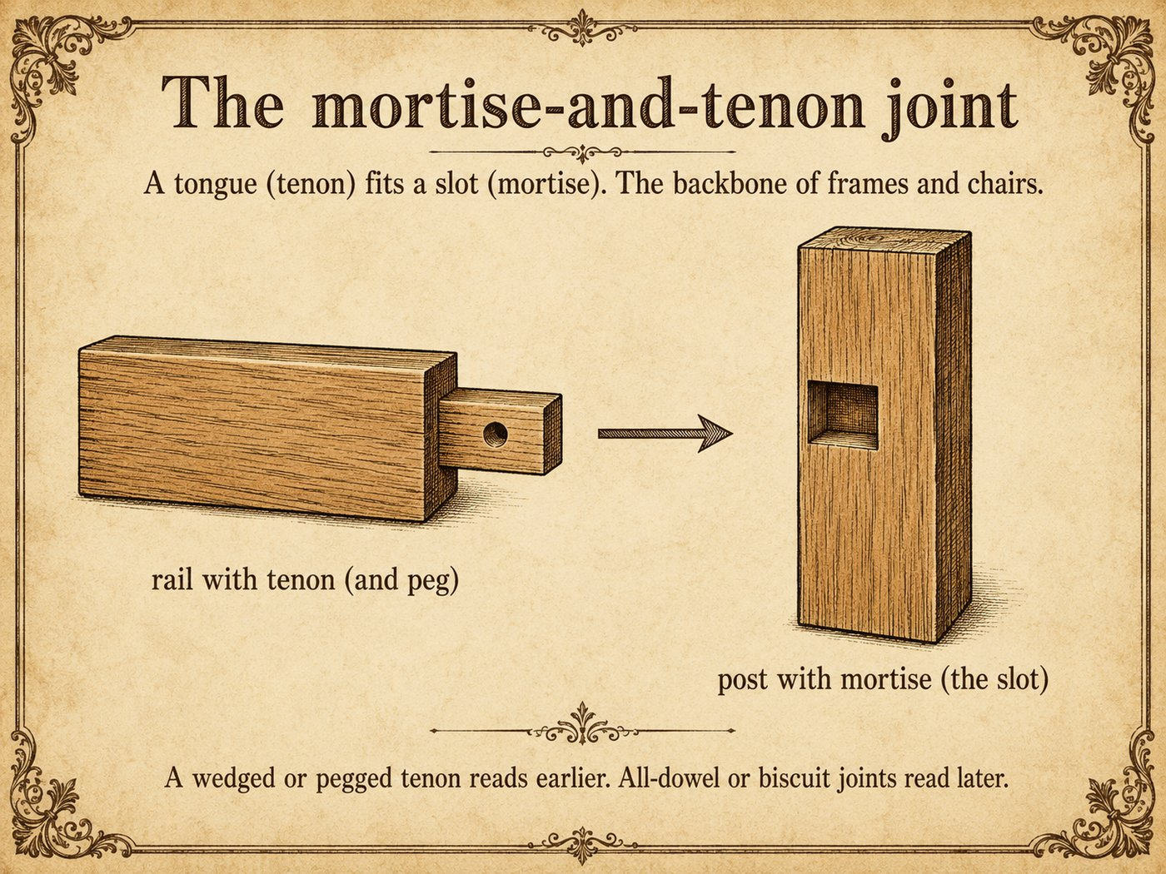

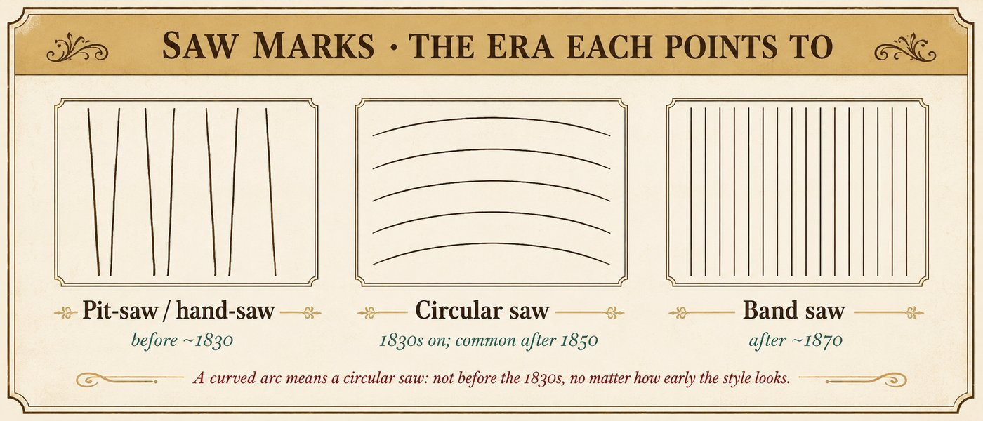

The rule, first: read the hidden surfaces
Saw and tool marks survive best where no one bothered to finish the wood: drawer bottoms, backboards, the undersides of tops and seats, the insides of cases. Turn the piece over and look where it was never meant to be seen. That is where the maker's tools still show, and where a date hides.
As always, a saw mark dates the board, not always the whole piece. Repairs and replaced parts carry their own, later marks.

Saw marks, and the era each points to
Mark | How to tell it | Period it points to
Pit-saw / hand-saw | Straight but slightly irregular strokes, not perfectly parallel, at a slight angle | before about 1830
Circular saw | Curved arc marks, evenly spaced, swept by a round blade | American use from the 1830s, common after 1850
Band saw | Straight, fine, very even parallel lines | after about 1870
Modern planer / wide-belt sander | No saw marks at all; surfaces milled flat or sanded glassy smooth | factory work, twentieth century
The single most useful tell: **a curved arc means a circular saw, which means not before the 1830s, and usually later.** A piece styled to look colonial that carries circular-saw arcs is a revival, no matter how early the legs look.

Tool marks, the shaping evidence
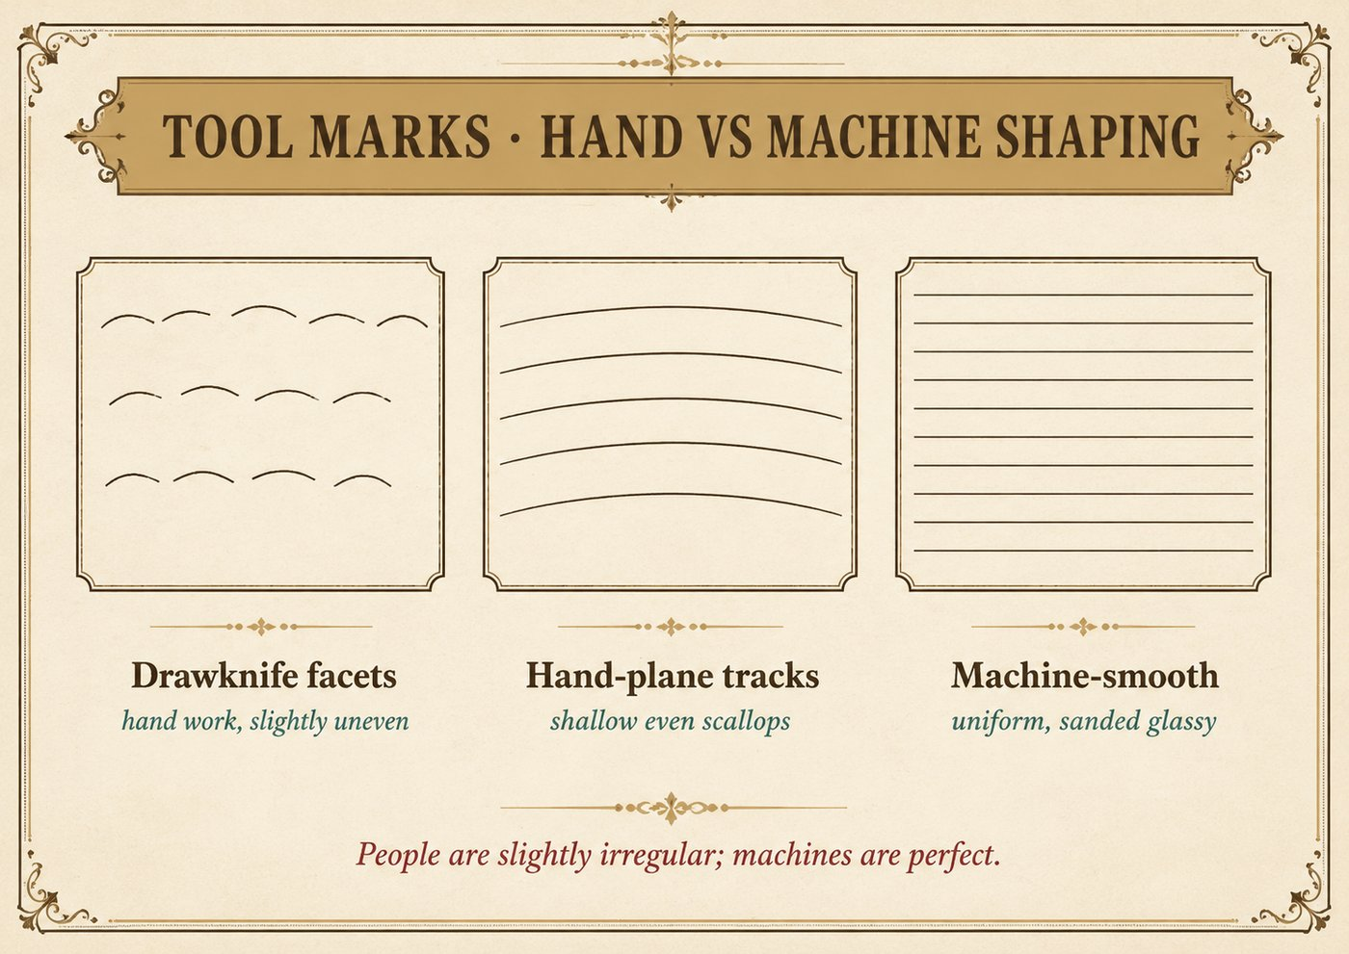
Mark | How to tell it | What it says
Drawknife / spokeshave facets | Faint shallow facets where spindles, seats, and legs were shaped by hand | hand work, generally earlier; parts vary slightly one to the next
Hand-plane tracks | Shallow, slightly uneven scallops across a surface from a hand plane | pre-machine surfacing, or careful shop work
Chisel and gouge marks | Irregular carving and mortise walls, no two strokes identical | hand joinery and carving
Uniform machine surfaces | Identical parts, surfaces sanded glassy smooth, no facets | machine reproduction or factory production
The rhythm is the same tell as joinery: people are slightly irregular, machines are perfect.

How to use this in the field
Turn the piece over before you decide anything. Find an unfinished secondary surface, raking the light across it so the marks read. Name the saw, name the shaping tool, and add those as layers to everything else: fasteners, joinery, wood, finish, wear. A circular-saw arc or a glassy machine surface is a hard ceiling on age, no matter what the style says.

The rule: wood supports a date, it never proves one
A wood species tells you about region, market, and style, and it reinforces a date, but wood alone never dates a piece. Walnut was used in the 1860s and again in 1930s veneer. Oak appears in 1700 and in 1905. Always read wood alongside construction.
Also learn the primary versus secondary wood idea: makers used a good show wood on the surfaces you see (the primary) and cheaper woods inside, on drawer sides, bottoms, and backs (the secondary). The mix of woods is itself a clue. A single uniform wood throughout, or plywood, leans modern.
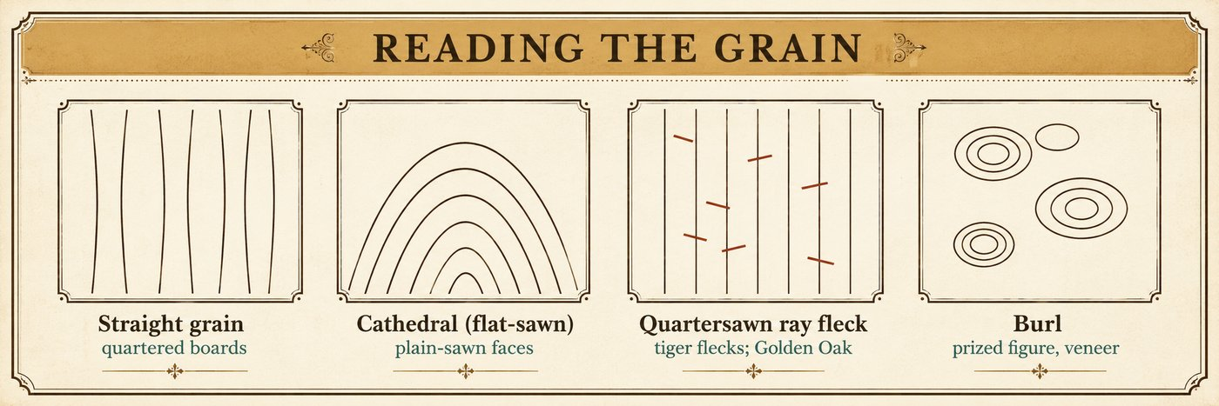
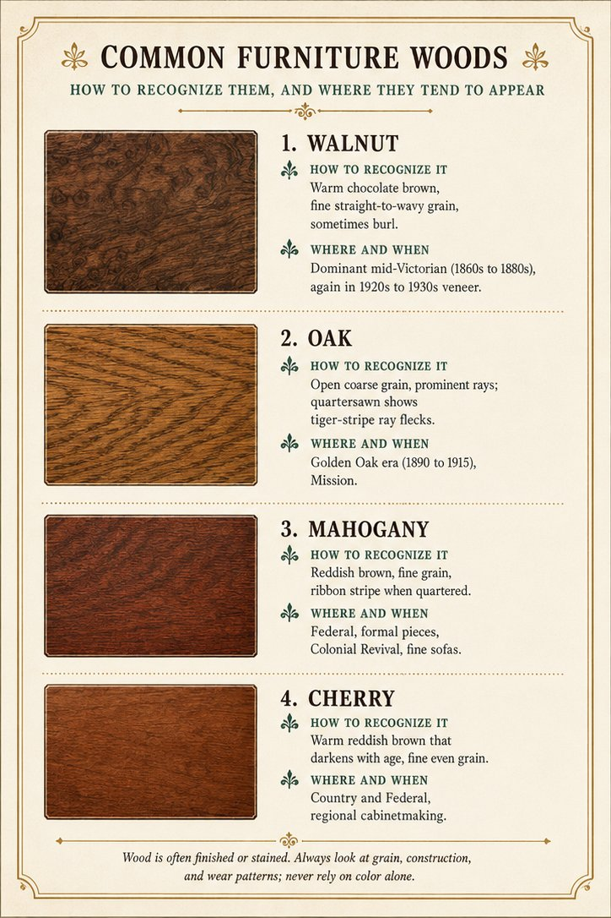
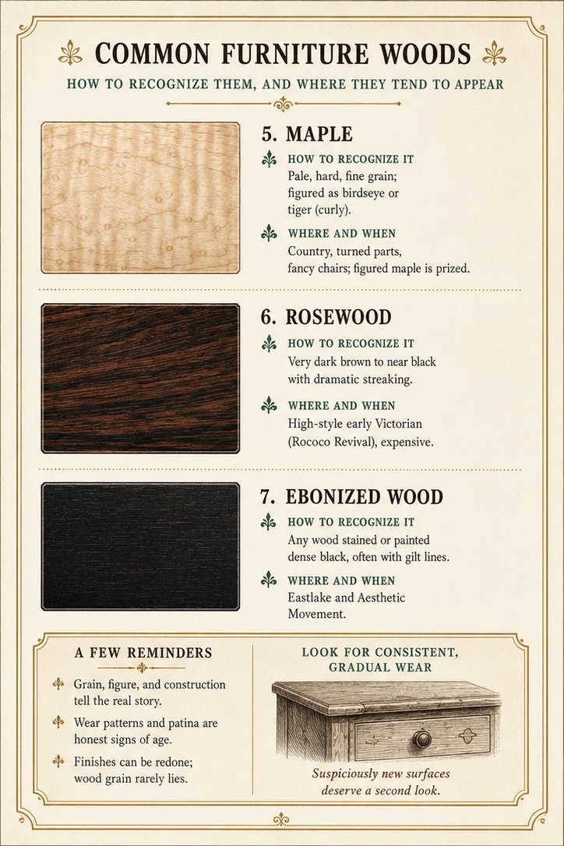
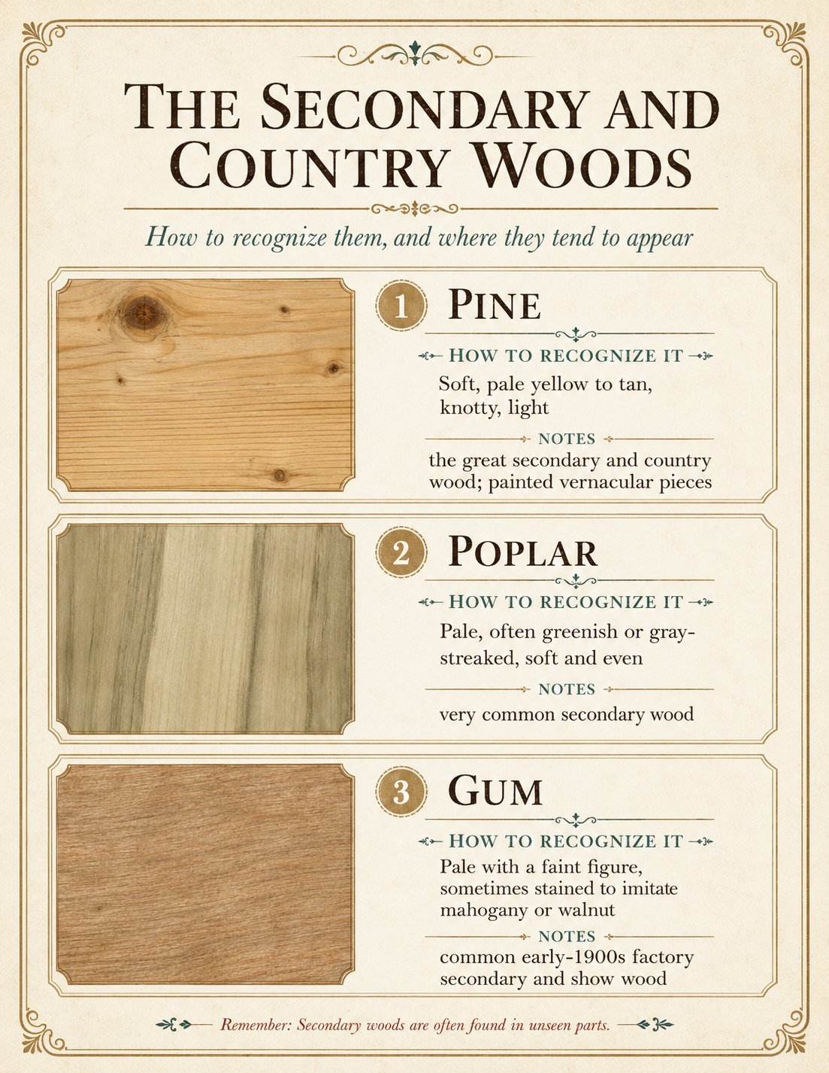
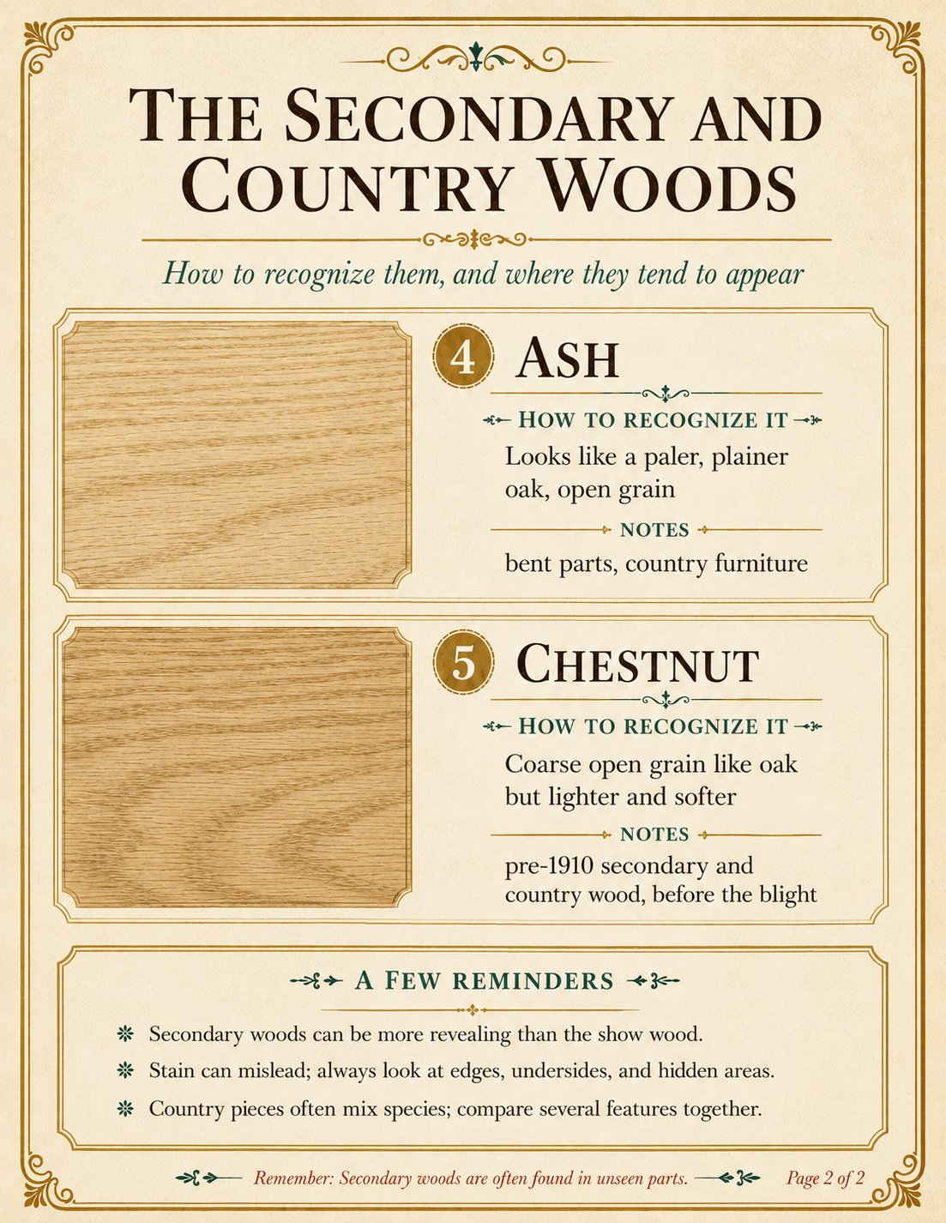
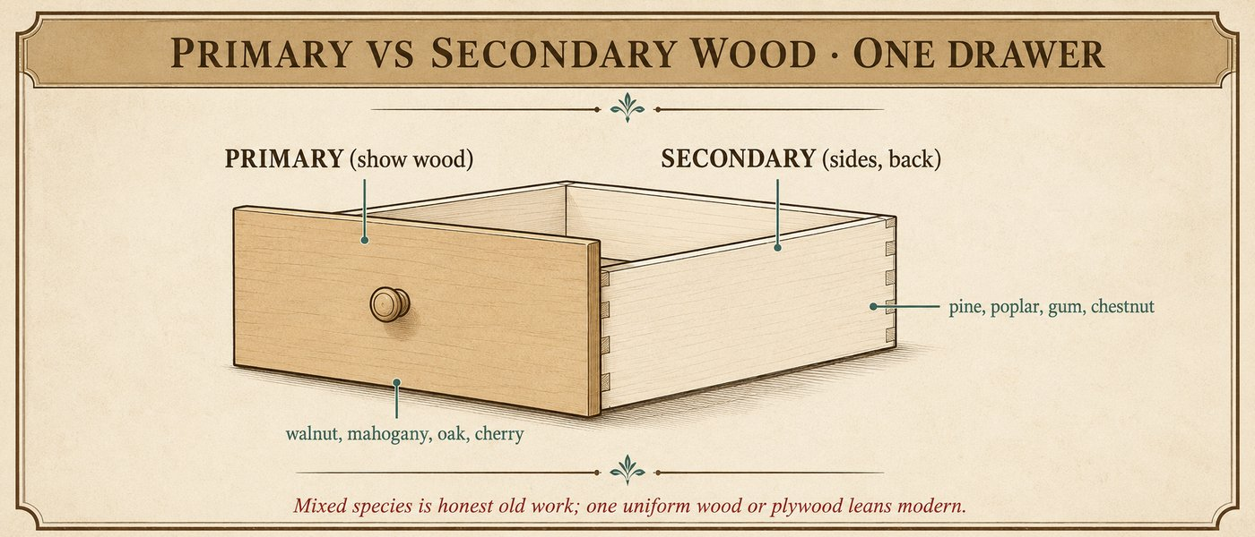

How to use this in the field
- Name the show wood for style and market, then read the secondary woods inside.
- Different secondary woods for drawer parts is honest old construction; one uniform wood or plywood leans modern.
- Never let the wood overrule the nails, the dovetails, and the saw marks.

The warning, first: hardware is the most-replaced part
Pulls, knobs, and casters are swapped more than any other part of a piece. A later caster or a shiny modern pull can fool you into dating the whole thing too late or too early. Weigh hardware lightly, and look for the evidence of earlier hardware: extra holes, shadow outlines, and unfilled mounting marks. (We watched our own software get fooled by a replaced caster, which is exactly why this warning leads the atlas.)
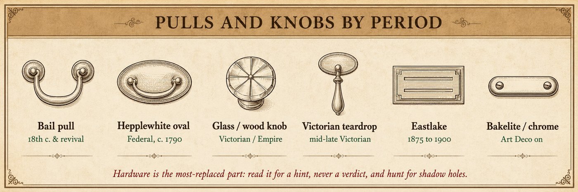

Pulls and knobs
Hardware | Look | Period it points to
Bail pull, willow or rococo backplate | A swinging handle on a pierced brass plate | eighteenth century and Colonial Revival copies
Oval or round stamped brass, Hepplewhite | Light stamped brass with a bail | Federal, c. 1790 to 1820, and revivals
Pressed-glass or wood knob | Turned wood knob, or a faceted glass knob | Victorian country and Empire, glass into the 1900s
Cast Victorian pull, teardrop or ring | Heavy cast brass or iron, ornate | mid-to-late Victorian
Eastlake stamped or cast | Geometric, incised, angular | 1875 to 1900
Oak-era bail and backplate | Stamped brass or brassed steel, often with lions or florals | Golden Oak, 1890 to 1915
Bakelite or chrome pull | Plastic or streamlined metal | Art Deco and later, 1925 onward

Hinges and escutcheons
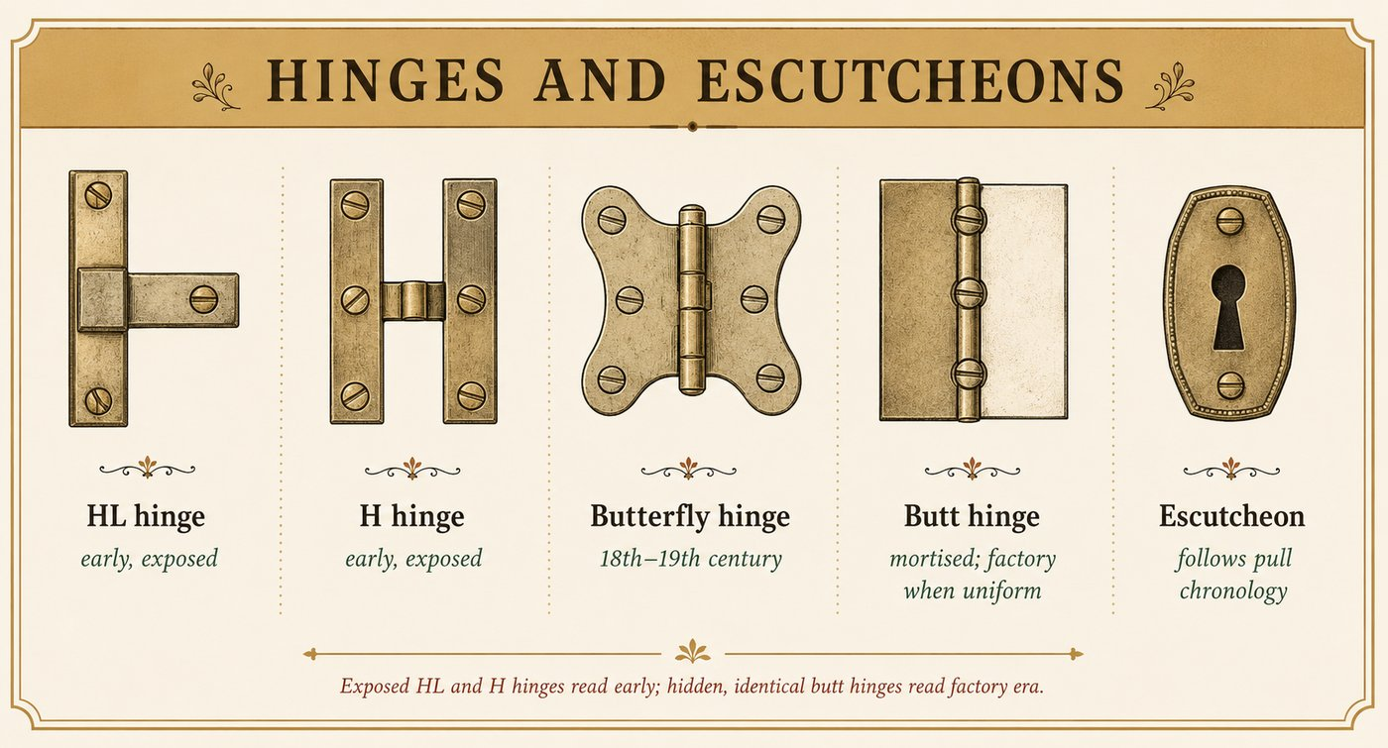
- HL and H hinges, exposed on cupboard doors, read early.
- Butterfly hinges, exposed and shaped like a bow tie, are an early cabinet hinge of the 18th and 19th centuries.
- Butt hinges, mortised and hidden, become standard; machine-made uniform butt hinges are factory era.
- Escutcheons (keyhole plates) follow the same style chronology as pulls.

Casters
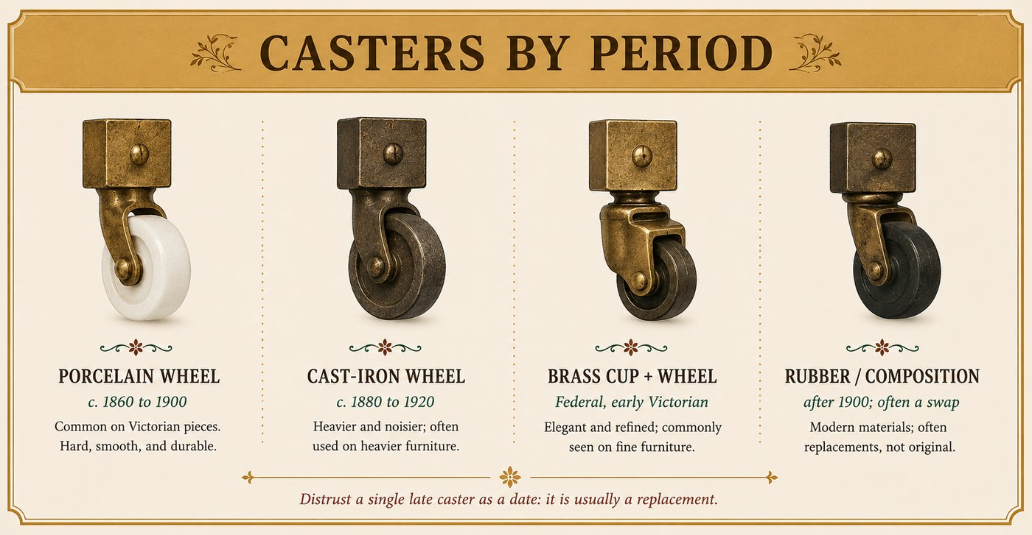
Caster | Look | Period it points to
Porcelain wheel | White or cream ceramic wheel in a metal cup | c. 1860 to 1900
Cast-iron wheel | Plain dark metal wheel | c. 1880 to 1920
Brass cup and leather or wood wheel | Earlier, finer | Federal and early Victorian, better pieces
Rubber or composition wheel | Black rubber or composite | after about 1900, and very often a replacement

How to use this in the field
- Read hardware style for a hint, never a verdict.
- Hunt for extra or shadow holes that betray earlier, original hardware.
- Distrust a single late caster as a dating clue; it is usually a swap.

The lesson, first: the original surface is the prize
Say it plainly, because it is the most expensive mistake people make: an original old surface is usually the single most valuable thing about a piece, and stripping or refinishing it destroys much of the value. This is true of painted country furniture, of stenciled rockers, of original-shellac Victorian pieces. When in doubt, do not strip, do not refinish, ask first. You can always finish later; you can never get an original surface back.

The finishes, and how to tell them
Finish | How to tell it | Period it points to
Milk or oil paint | Flat, chalky old paint, often layered and worn into the grain | country and painted furniture, all early periods
Shellac | Warm amber, dissolves with alcohol, shows fine cracking (crazing) with age | the dominant finish, c. 1820 to 1920
Varnish (oil) | Harder, glossier, ambers and alligators (deep crazing) with age | nineteenth century, durable surfaces
Japanning | Baked black asphalt finish, hard and glassy | early painted metal and some wood, c. 1850 to 1910
Lacquer (sprayed) | Even, thin, factory-sprayed, harder than shellac | factory furniture after about 1920
Polyurethane | Thick, plastic-like, modern, does not craze naturally | modern and refinished pieces, post-1950s
French polish | A high, deep shellac shine built in many thin coats | fine formal pieces

Reading the surface for age and honesty
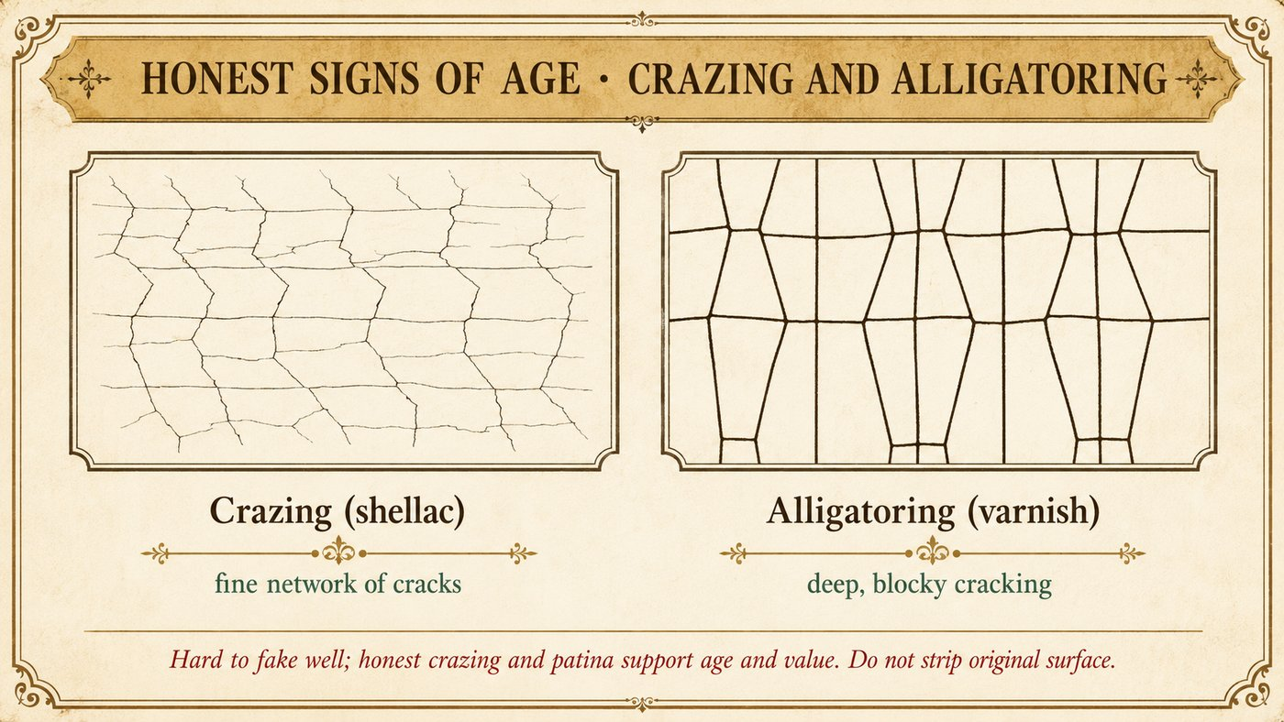
- Crazing and alligatoring, the fine and deep cracking of old shellac and varnish, are honest signs of age and hard to fake well.
- Patina, the soft depth and color that decades of light, oxidation, and handling build, lives on undisturbed surfaces and is destroyed by sanding.
- Wear in the right places, edges, arms, handles, feet, should match how a piece is actually used. Even wear everywhere, or none, is suspicious.
- A thick plastic film or a flat, fresh, even coat says refinished or modern.
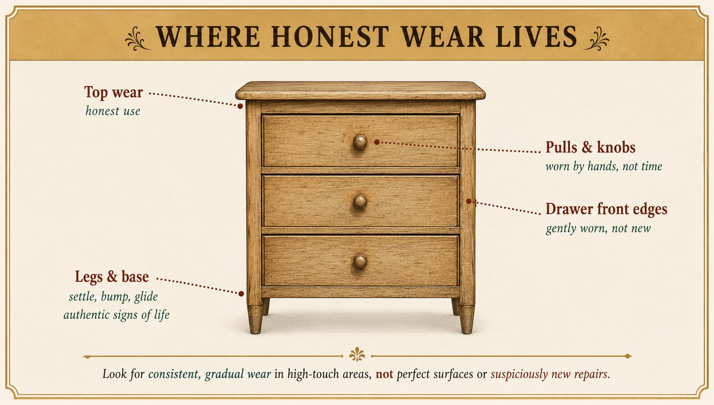

How to use this in the field
- Identify the finish, then ask whether it is original.
- Honest crazing, patina, and logical wear support age and value.
- A stripped or modern-coated surface lowers value, even on a genuine antique.
- Above all, on anything that might be original-painted or original-surface: leave it alone until you know.

Glossary
Part III reference. Plain definitions of the terms used throughout the guide.
Apron. The horizontal frame member below a tabletop or seat, between the legs.
Bonnet / hood. The top section of a tall-case clock that houses the dial and movement.
Bracket foot. A simple flat foot, shaped on its outer edges, common on case pieces.
Cabriole leg. An S-curved leg that swells at the knee and tapers to the foot; Queen Anne and Rococo.
Case piece. Any boxlike storage furniture: chest, dresser, cabinet, desk.
Cornice. The molded top edge of a tall case piece.
Crazing. The fine network of cracks that forms in old shellac and varnish with age.
Dovetail. An interlocking wedge-shaped joint used at drawer corners. Hand-cut reads earlier; machine-cut is even and identical.
Ebonized. Wood stained or painted dense black to imitate ebony; an Eastlake and Aesthetic trait.
Escutcheon. The plate or lining around a keyhole.
Fall front / drop front. A hinged panel that drops down to form a writing surface.
Fly rail. A pivoting rail that swings out to support a drop leaf.
Knock-down (KD). Construction that bolts or keys apart for moving; normal and original on big wardrobes and beds.
Loper. A pull-out arm that supports the open lid of a slant-front desk.
Marriage / married. Two unrelated parts (a top and a base, a case and a movement) joined to look like one original piece. A value problem.
Mortise and tenon. A joint where a tongue (tenon) fits a slot (mortise); the backbone of frames and chairs.
Patina. The depth of color and surface that decades of age, light, and handling build; destroyed by sanding.
Pediment. The decorative crowning element atop a tall case piece, often triangular or scrolled.
Pigeonholes. The small open compartments in a fitted desk interior.
Primary wood. The good show wood on visible surfaces. See secondary wood.
Quartersawn. Lumber sawn radially to show the ray flecks, prized in Golden Oak and Mission oak.
Rule joint. The shaped, interlocking hinge edge between a tabletop and its drop leaf.
Secondary wood. The cheaper wood used inside, on drawer sides, bottoms, and backs. The mix is a dating clue.
Splat. The central flat upright in a chair back.
Stile and rail. The vertical (stile) and horizontal (rail) members of a frame or frame-and-panel.
Stretcher. A horizontal brace connecting legs.
Tambour. A flexible cover of thin slats glued to a canvas backing, used on roll-top desks.
Till. The small lidded compartment inside the upper edge of a blanket chest.
Turning. A part shaped on a lathe: legs, spindles, posts. Barley-twist, ring, ball, spool, and bobbin are turning styles.
Veneer. A thin layer of show wood glued over a cheaper substrate.

