This document contains a compare and contrast figure that talks about the differences between STEVE and the auroras. There is also a graphic that Laura created that depicts Earth’s magnetic field and the latitude lines where the northern lights typically occur. Further down in this document we have a self-reflection piece where we discuss the division of the work. Below this, we have a plan for next week (we are still struggling with what exactly we plan on modeling so this was an attempt to get some sort of plan in place). And finally, we have created a dictionary (which we plan on possibly including in the poster) and a list of bullet points from the articles that we have read this week.

**Graphics:**

|  |  |
| --- | --- |
| Aurora | STEVE |
| * Usually green, yellow, and red * Can also be pink, violet, and blue * Curtain shaped * Can be seen 60-60 degree MLAT (magnetic latitude) * Formed by charged particles in solar wind that interact with the earth’s magnetic field * Last about 10 min to all night long * Highest season in northern latitude is spring because of sun magnetostorms * Activity happens in 11 year cycles that coincide with the 11 year cycle of the sun’s magnetic field * About 10 degrees latitude wide | * Purple * Sometimes has green aspects too * Vertical arc * Occurs further south than Aurora * Formed by subauroral ion drifts that occur during substorms * Last about 20 min to an hour * Seasonal: not observed in winter (October - February) * The Aurora Named STEVEAbout 0.5 degrees latitude wide |

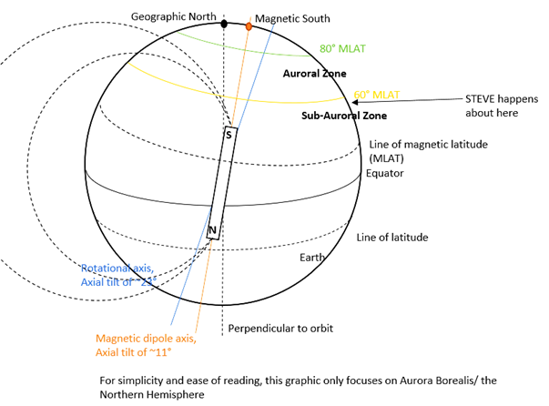

**Self-reflection on group work:**

We have been working together (literally, as in sitting with each other and talking about what we’re doing) and splitting the amount of reading, writing, note-taking, etc. evenly between the two of us. We’ve been working in a shared Google doc. We discussed the idea for the project together and agreed and then split up the number of articles we wanted to read evenly among us. We feel that the contributions have been equal.

**Next week:**

This represents a plan for moving forward with a simple model of particles moving through a magnetic field like Earth’s to show something similar to how Auroras form.

We will try out different levels of a code that describes a stream of charged particles moving through a field that is also at different levels of complexity. This might mean a stream of charged particles moving through a constant magnetic field, like a zoomed in rectangular region of Earth’s field and then zooming out to a field that has some curvature and possibly showing the whole shape of the field at the magnetic poles of Earth. We may also start with a single particle and modify the code for a stream of particles. If we get basic versions of this working quickly this week, we might consider adding information on the radiation of these particles.

To do list to accomplish above plan:

* Get code going with uniform magnetic field
* Get charged particle moving into magnetic field
* Research integration methods that can be used to get the particle’s position updated based upon the magnetic field
* Make charged particle spiral around magnetic field
* “Zoom” out so that the magnetic field is modelled for different latitudes (like 70-85)

Extra:

* Research composition of the atmosphere at different altitudes
* Create code that simulates the atmosphere (between certain altitudes like say 100-500km above the ground) at certain latitude
* Put earth’s magnetic field into the program (ie pick latitude and then compute the approximate magnitude of earth’s magnetic field at that point and put this into the code)
* Figure out if we care about programming emissions and how we can do that
* Create some sort of graph that shows the color spread of our simulation

Research the following modeling techniques:

**Rugna-Kutta (find python library for this)

Euler Cromer integration scheme

**Notes on what we read on background and theoretical model:**

**Dictionary:**

(we plan on including a portion of this on our poster)

* Geomagnetic storm: solar storm; disturbance of the earth’s magnetosphere caused by solar wind shock wave and/or magnetic field
* Magnetosphere: the region around earth where the magnetic field is the predominant magnetic field
* Substorm: around 1 hour or less, energy is rapidly released in the magnetospheric tail, auroras more widespread and intense, ions and electrons flow in greater numbers, present a clearer pattern than magnetic storms and are observable in polar regions
* Subauroral ion drift: also called polarization jets, form during substorms, happens at subauroral latitude, which is about 60 degrees above the equator (<http://www.aeronomie.be/infoday/infodayposter-subauroral-ion-drift.pdf>)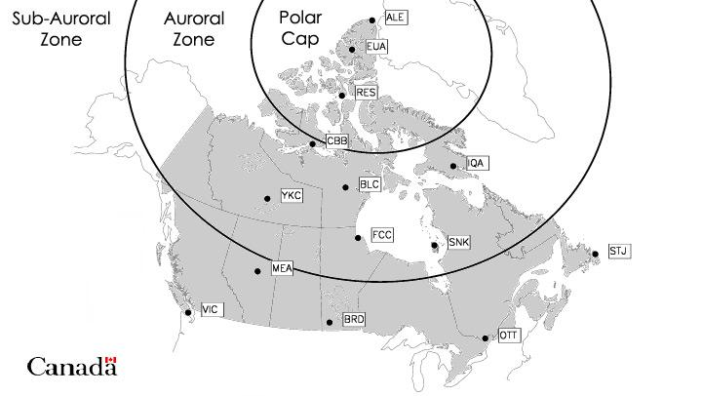
* Magnetotail: main source of polar auroras, explains why auroras are concentrated on side of Earth not facing sun (check if this is out of date info; from <https://www-spof.gsfc.nasa.gov/Education/wtail.html>)
* Birkeland current: electric currents in planet’s ionosphere that follow magnetic field lines, the plasma carrying these currents lead to acceleration of charged particles and element separation (like preferential ejection of oxygen ions), strengths of currents change with magnetosphere activity like in substorms (<https://en.wikipedia.org/wiki/Birkeland_current>)
* Global aurora: Happens when the planet has a global magnetic field (like earth) that causes the auroras to take place
* Local aurora: happens when the planet has local magnetic fields (like Mars has local umbrella-shaped magnetic fields that come out of the ground like mushrooms) that cause the auroras

Griffiths chapter 11 - radiation

* To-read next week, as needed for our model

STEVE

<https://news.nationalgeographic.com/2018/03/steve-auroras-identified-plasma/>

* Purple vertical arc
* Last about an hour
* More commonly seen auroras are red, green, or yellow, and curtain-shaped
* STEVE is also sometimes combined with unstable, smaller green picket fence-like features
* STEVE was mistakenly attributed to proton arcs before, but it actually comes from “subauroral ion drifts”
* STEVE is seasonal, not appearing in winter, coincides with space weather when charged particles are spewed out by the sun

<http://advances.sciencemag.org/content/4/3/eaaq0030>

* Regular aurora formed by the interaction of solar wind with the earth’s magnetic field which generates electrical currents in the magnetosphere
* These currents accelerate charged particles into the upper level of the atmosphere
* Collide with gases
* Randomly transfer energy to atmospheric atoms that release energy through fluorescent emission of photons
* About 65 to 80 degrees magnetic latitude
* Steve is not a proton arc as those are “subvisual,” broad, and diffuse
* Strong flow, density depletion, and temperature enhancement of steve indicates it’s associated with a subauroral ion drift
* But the flow speed and temperature are larger than typically reported which suggests that scientists still don’t know everything about steve
* Subauroral ion drifts are short events that have westward flows in a narrow region about 1 degree latitude wide in the evening just south of where auroras usually occur
* Scientists don’t know why steve is the color steve is but we might propose in our model that it is due to the birkeland currents in substorms that preferentially eject certain gases and those gases might be the ones that make purple
* Steve happens at boundary between auroral and subauroral zones

<https://www.express.co.uk/travel/articles/935071/the-northern-lights-2018-new-aurora-steve-discovered> (Brean)

<https://www.nasa.gov/feature/goddard/2018/nasa-needs-your-help-to-find-steve-and-heres-how> (Brean)

Lengthy, for future reference: <https://www.adphotography-online.com/single-post/2017/10/14/Beautiful-sub-auroral-arcs-across-the-sky-what-we-know-so-far-about-the-phenomenon>

* To read next week

Colors of Aurora

<http://www.webexhibits.org/causesofcolor/4D.html>

* Aurora occurs only above altitudes of 80 km and infrequently above 500 km
* Average for normal intensity: between 110 and 200 km
* “The atmosphere consists mainly of nitrogen and oxygen, which emit the characteristic colors of their respective line spectra. Atomic oxygen is responsible for the two main colors of green (wavelength of 557.7 nm) and red (630.0 nm). Nitrogen causes blue and deep red hues.”
* Altitude also affects the colors
* “The strong, green light originates at altitudes of 120 to 180 km. Red Northern Lights occur at even higher altitudes, while blue and violet occur mostly below 120 km. When the sun is "stormy," red colors occur at altitudes of 90 to 100 km. Entirely red Northern Lights may sometimes be seen, particularly at low latitudes.”



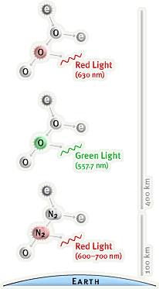

What causes Aurora

Basic - <https://www.aurorahunter.com/how-the-aurora-borealis-form.html>

* Most commonly occur between 60-75 degrees latitude
* Can reach 30 or lower latitude during great geomagnetic storms
* The best time to view them is between midnight at 2 am (not sure why??)
* On average there is an 11 year solar cycle which controls the tempo (not sure what this means) of the auroras (most recent peak was in 2014 and the next peak is predicted to be 2025)

<http://earthsky.org/earth/what-causes-the-aurora-borealis-or-northern-lights>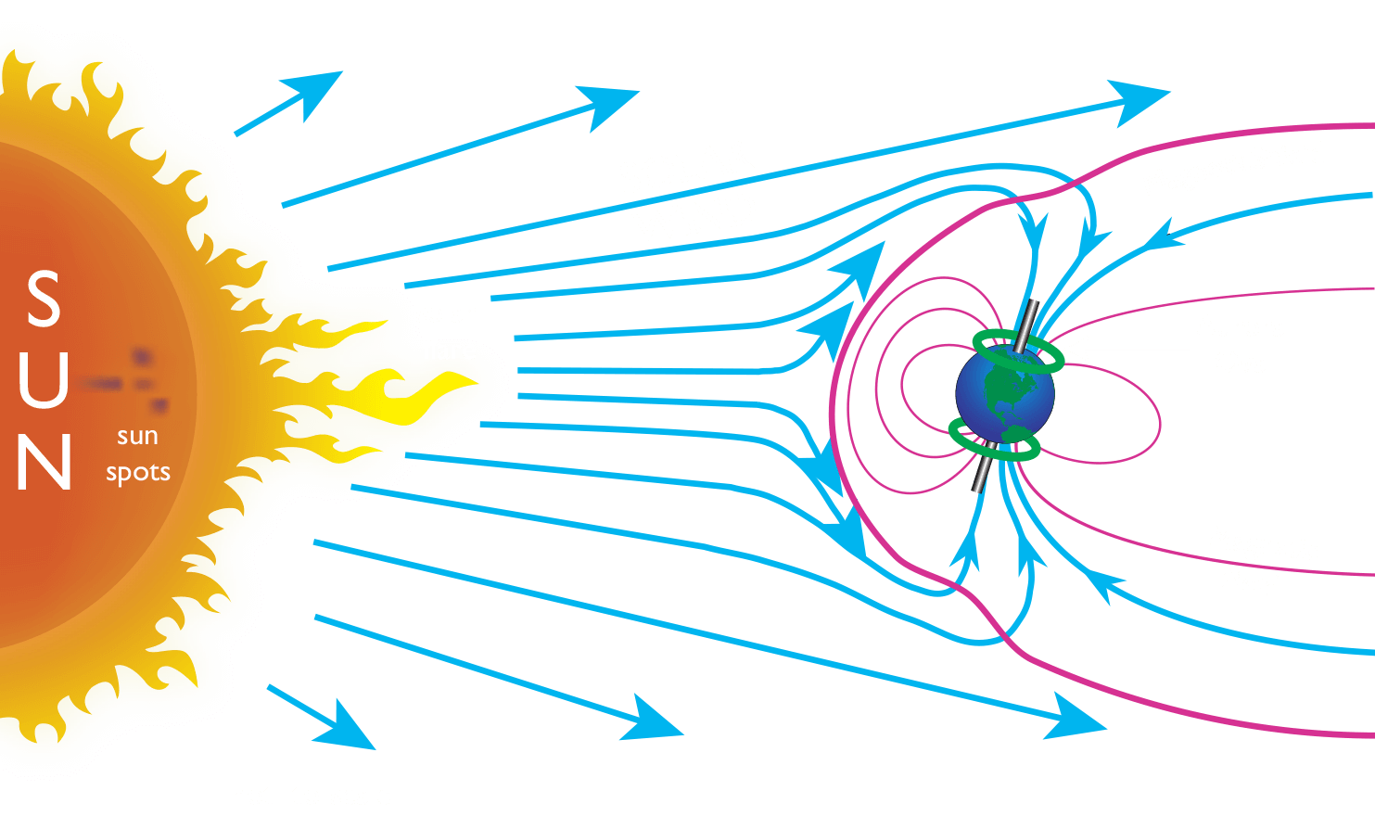

* Storms on sun send gusts of charged particles through space
* When this stream of particles hits earth it interacts with the magnetic field
* When the charged particles strike atoms and molecules in the earth’s atmosphere, they excite those atoms, causing them to light up
* Electrons to move to higher-energy orbits when particles strike atoms
* When they fall back down, they release photons
* Similar to neon lights
* Oxygen gives off green color, nitrogen causes blue or red

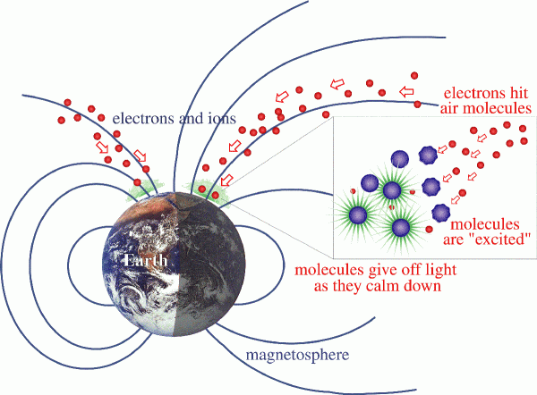

<https://www.space.com/g00/15139-northern-lights-auroras-earth-facts-sdcmp.html?i10c.encReferrer=&i10c.ua=1>

* The sun has many different magnetic fields and when they become knotted together and burst to create sunspots (which can be as large as the earth! See this [link](https://www.space.com/22393-sun-magnetic-field-explained-infographic.html) for an image)
* Plasma particles escape from sunspot regions (called solar wind); this solar wind can take around 40 hours to reach Earth which then causes the auroras
* Auroras happen on other planets
* Sunspots and solar storms happen roughly every 11 years (this also coincides with how the sun’s magnetic field switches every 11 years due to the inner magnetic dynamo reorganizing itself (more can be found [here](https://www.nasa.gov/content/goddard/the-suns-magnetic-field-is-about-to-flip/))
* Record keeping of the sun’s activity was started in 1749 and since then there have been 22 full cycles
* “The type of collision also makes a difference to the colors that appear in the sky: atomic nitrogen causes blue displays, while molecular nitrogen results in purple. The colors are also affected by altitude. The green lights typically in areas appear up to 150 miles (241 km) high, red above 150 miles; blue usually appears at up to 60 miles (96.5 km); and purple and violet above 60 miles.”
* Cave paintings in france thought to be 30,000 years old show the auroras
* Auroras are brighter and more ative for two days after sunspot activity

Talking about auroras on Mars: <https://science.nasa.gov/science-news/science-at-nasa/2015/11may_aurorasonmars>

* On mars, the auroras happen just 100km from the surface and on earth they range from 100-500 km

Definitions of things that cause STEVE

Substorm <https://www-spof.gsfc.nasa.gov/Education/wsubstrm.html>

See dictionary

Birkeland current <https://www.plasma-universe.com/Birkeland_current>

See dictionary