Laura Wood

1/26/18

Annotated bibliography

Griffiths, D. J. (2017). Introduction to electrodynamics. Cambridge: Cambridge University Press. Classical electrodynamics is already consistent with special relativity. Maxwell’s equations and the Lorentz force law apply in any inertial system. However, some corrections still need to be made since non-relativistic mechanics was used in electrodynamics originally (so it’s just a matter of expressing electrodynamics differently, not changing it fundamentally). For example, a current-carrying wire might be electrically neutral in one frame and charged in another. However, if there is a force on a charge in one frame, it must be there in the other as well. In one frame, this force is electrical, but in another it’s not electrical, but rather magnetic (525). There are equations describing the transformation rules for E and B. They suggest that E and B get mixed in different frames, so they can’t just be their own components of four-vectors. Instead, we can write the transformation rules as a 4x4 tensor.

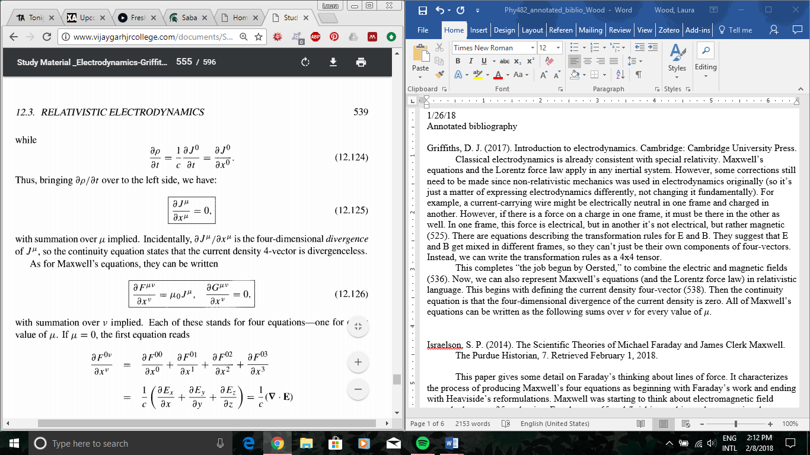 This completes “the job begun by Oersted,” to combine the electric and magnetic fields (536). Now, we can also represent Maxwell’s equations (and the Lorentz force law) in relativistic language. This begins with defining the current density four-vector (538). Then the continuity equation is that the four-dimensional divergence of the current density is zero. All of Maxwell’s equations can be written as the following sums over for every value of (539).

The vector and scalar potentials also makeup a four-vector. This leads to “the simplest and most elegant formulation of Maxwell’s equations.” , where the square is the d’Alambertian.

Israelson, S. P. (2014). The Scientific Theories of Michael Faraday and James Clerk Maxwell.

The Purdue Historian, 7. Retrieved February 1, 2018.

This paper gives some detail on Faraday’s thinking about lines of force. It characterizes the process of producing Maxwell’s four equations as beginning with Faraday’s work and ending with Heaviside’s reformulations. Maxwell was starting to think about electromagnetic field around when he was 25 at the time Faraday was 65 and finishing up his work, suggesting that magnetic lines of force (or sometimes authors say flux – I think he just wasn’t too committed to a word) extend into space, an idea that he didn’t live to see accepted. Faraday had little formal education (although talked little about the math basis of physics more because he didn’t think much of it rather than that he wasn’t taught it), while Maxwell had a good and broad mathematically based education, which likely positioned him well to pick up from Faraday. Since Faraday preferred to keep his physics conceptual and not mathematical, and he liked his theories to explain physical occurrences, he thought of his “magnetic lines of force” as physically existing because they could explain experimental results.

Faraday’s work includes discovering (or continuing work on) rotational magnetic field around electric current, induction, diamagnetism, dielectrics, and more. The way he thought about magnetic lines of force is not quite how we think of field now. He thought there were many particles in the medium between charges that all exerted forces, so he didn’t solve “action-at-a-distance,” but said it could only be small distances. Faraday’s theory was however “the first precise and quantitative concept of a field” (8). “The specific concepts that Maxwell adopted from Faraday included the field-based definitions of electric charge and current, the concept of conduction as the competition between polarization build-up and decay, and the reduction of all electric and magnetic actions to stresses in the field” (9). Basically, Maxwell wrote 20 field equations based on Faraday’s idea of field, and Heaviside condensed and refined them into four equations.

This paper describes the current forms in the following ways (10). Gauss’s law is the only one that only deals with the electrostatic field. The integral form relates the electric flux to an enclosed charge, and the differential form relates the tendency of charge to flow away (divergence) to the density of charge. Gauss’ law for magnetic fields says that the flux through any surface containing a magnetic dipole will be zero, because the lines add to zero, which seems related to Faraday’s idea that induction implies polarization. Faraday’s law relates the tendency of electric field lines due to moving charge to circle around a point to the rate of change of the magnetic field. The Ampere-Maxwell law is based on Ampere’s description of Oersted’s discovery that a steady electric current will create a magnetic force.

It concludes by saying, “Maxwell defined a new kind of theoretical physics in which the classification of mathematical quantities, vector symbolism, and Lagrangian dynamics became major construction tools,” so Maxwell did so much for modern physics it can’t be described by just focusing on the final product of a set of equations. The process is instrumental.

Sengupta, D. L., & Sarkar, T. K. (2003). Maxwell, Hertz, the Maxwellians and the Early History

of Electromagnetic Waves. IEEE Antennas and Propagation Magazine, 45(2), 13-19.

Retrieved February 1, 2018.

I’m reading this paper to get more information on the other scientists besides Faraday whose work Maxwell built on to understand where the equations come from (and why they have the name they do). That’s only a small part of the paper; mostly it’s about Hertz’s picking up of Maxwell’s work to develop the electromagnetic theory of light. This paper particularly looks at Maxwell’s idea that light could be a transverse wave which he came to from his equations. However, people think he may have thought that an actual impossibility, since he never talked about any other electromagnetic waves or how they could be made. Hertz’s discovery of electromagnetic waves was pivotal in cementing Maxwell’s theory. Hertz, Fitzgerald, and Lodge – the Maxwellians – are three others who expanded Maxwell’s work along with Heaviside.

Pre-Maxwell, Gauss thought that electric actions propagate with finite velocity, but since he couldn’t design a mechanism to show it, he didn’t publish. (I really want to know in what ways this work influenced Maxwell.) Riemann was a student of Gauss’s and kept trying to prove this. He suggested replacing Poisson’s equation for the electrostatic potential with a wave equation, which is technically correct (I need to do a little more research on what these equations are to understand this better). Maxwell basically synthesized the work of Oersted, Gauss, Ampere, Faraday, and others, adding the displacement current.

This lists most of Maxwell’s original equations with explanations of his notation, like below. Maxwell gave strong physical significance to the vector and scalar potentials, and also assumed a hypothetical mechanical medium to justify his displacement current in free space. Many scientists at the time opposed this, we don’t need it in the theory anymore, and we don’t use the same definition Maxwell had for displacement current, but keep the name. Hertz, on the other hand, in his modifications of Maxwell’s equations actually started from older, often rejected action-at-a-distance theories and got Maxwell’s equations in a different way.

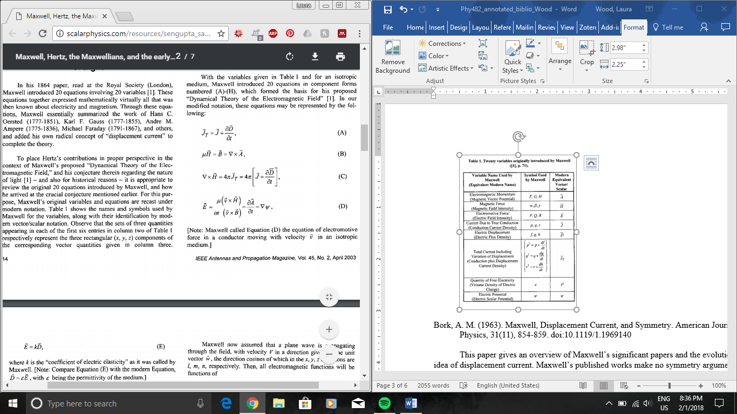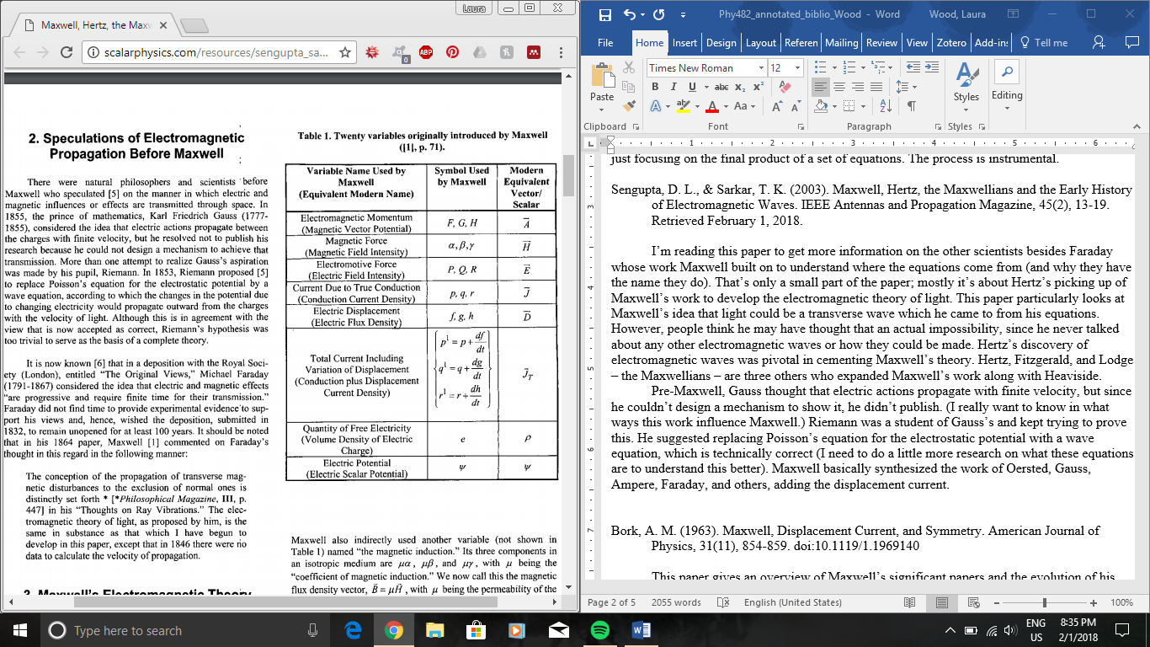 Maxwell’s notation

Bork, A. M. (1963). Maxwell, Displacement Current, and Symmetry. American Journal of

Physics, 31(11), 854-859. doi:10.1119/1.1969140

This paper gives an overview of Maxwell’s significant papers and the evolution of his idea of displacement current. Maxwell’s published works make no symmetry arguments for displacement current, but Oliver Heaviside does. Despite the fact that Maxwell doesn’t explicitly make these arguments, they’re often attributed to him and seem to have influenced his equation development.

Maxwell’s first of three major papers – all published before 1864 – is based on Faraday’s work. In the third – basically a refined version of his second paper – he’s collected the main equations from the 20 in the second paper and termed the “electromagnetic field.” The displacement current first appears in his second paper. In 1, the curl H equations have a conduction-current term in an unfamiliar form, and in 3, the curl H equations do not have time derivatives of displacement, but do in 2.

Maxwell also has 3 editions of “A Treatise on Electricity and Magnetism,” similar to his third paper and alludes to displacement, also saying that the displacement current is new, saying total current equals current of conduction plus electric displacement. He also has a short paper on light, comparing his work to Riemann, Weber, and Lorenz. In 1870, Maxwell finally discusses symmetry but not in relation to displacement current. Basically, Maxwell never explicitly discusses displacement current in conjunction with symmetry.

Maxwell’s work wasn’t well received at first, but some English scientists were heavily influenced by his work, like Watson and Burbury. Oliver Heaviside was first to explicitly talk about the symmetry of Maxwell’s equations. In “Electromagnetic Theory,” he “modifies and extends Maxwell’s equations” (5) building on it with rationalized units, vector notation, and symmetry. “He notes, ‘We must change magnetic force to electric force taken negatively, and electric current to magnetic current’” (5), suggesting displacement current. It sounds like today we use a form of “Maxwell’s equations” rather more like what Heaviside suggested.

On a side note, an important thing I learned is that Maxwell wrote poetry!

Dyson, F. J. (1990). Feynman’s proof of the Maxwell equations. American Journal of Physics,

58(3), 209-211. doi:10.1119/1.16188

This paper describes Feynman’s proof of Maxwell’s equations, in which he started only from Newton’s law of motion and the commutation relation for position and velocity of a nonrelativistic particle, and also comments on the historical context of this proof.

The crux of the proof of $divH=0$ is that $\left[\dot{x_{l}},H_{l}\right]=0$ is the same thing, of which I’m convinced since divergence is the derivative of each vector component added up, and that commutation relation means something like to sum the derivatives of each component of H with respect to each component of x. (I actually need to do some more convincing of that for myself, by reviewing commutation relations.) Then the latter equation can be proved from the initial commutation relation with the Jacobi identity. The other equation, $\frac{∂H}{∂t}=-curlE$ can be proved by differentiating and combining equations already used in proving the first.

“Modern students,” of the 1980s apparently find the results trivial and don’t understand the motivation of the proof, since the initial commutation rule implies the existence of a vector potential. Feynman, on the other hand, “hoped to find physical models that would not be describable in terms of ordinary Lagrangians and Hamiltonians (2). Feynman considered his proof a failure since it didn’t lead to new physics, but the author sees the proof as a successful historical relic, Also, “it was the incompatibility between Galilean mechanics and Maxwell electrodynamics that led Einstein to special relativity, … [but] here we find [them] coexisting peacefully” (2).

Arthur, J. W. (2013). The Evolution of Maxwells Equations from 1862 to the Present Day. IEEE

Antennas and Propagation Magazine, 55(3), 61-81. doi:10.1109/map.2013.6586627

This article shows the various forms of Maxwell’s equations throughout history and explains their mathematical meaning and how we got to the form we know today, but writes everything with modern symbols and conventions. This is to simplify messiness like how Maxwell originally didn’t use E for electric field and rather used P, Q, and R for the components. Maxwell’s contemporaries were Boltzmann, Hertz, Kirchoff, Lorenz, and Weber, and those who came after and clarified his equations were Hamilton, Heaviside, Gibbs, and Lorentz (predecessors: Gauss, Ampere, Biot, Savart, Faraday). The earliest form of Maxwell’s equations is from 1861 and include the proposal of displacement current.

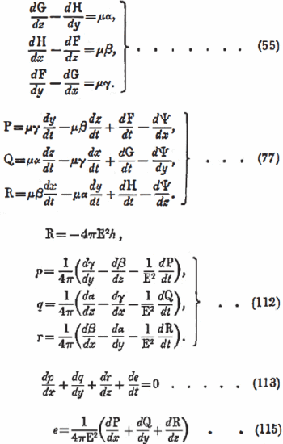

Maxwell’s equations in 1861-2

In 1864, he switched his mechanical analogy for Faraday’s abstract concept of electromagnetic field, managing to evade the problem of “action-at-a-distance” (Weber’s idea).

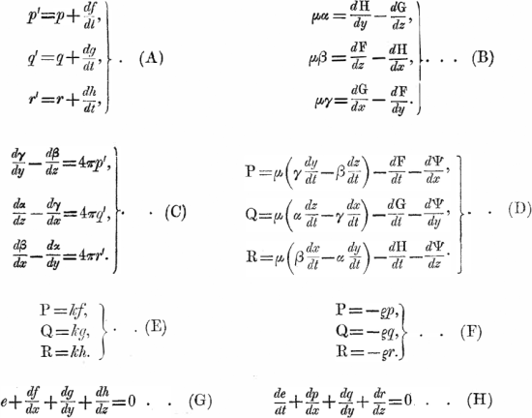

Maxwell’s 20 equations from his second paper also discussed in my summary of Bork’s paper

Maxwell seems to have been thinking about the ether still, possibly being the cause of him not distinguishing electric polarization from electric displacement, so his equation was just $D=εE$, rather than $D=ε_{0}E+P$. He saw that equation as acting similarly to $J=σE$. Hiw 1873 Treatise basically introduced the Lorentz force and also quaternions, similar to modern vector notation. So far, this is kind of an expansion of what Bork summarized.

Then, we come to Heaviside’s modifications. He converted quaternions – which he strongly disliked – to vector algebra notation, but did not condense the 20 equations to four as some say he did. However, his equations included four equations over months of time and work that look similar to ours now. Heaviside wrote out div and curl, and Gibbs introduced the symbols we use now. Hertz also did significant clarifying work on the equations (sometimes referred to as Maxwell-Hertz), mostly by removing the potentials and giving them separate forms for free space, conductors, and more. Lorentz presented a small set of equations for a microscopic model (interestingly never referencing Maxwell).

Now, we come to the modern forms and look at any different versions since the 1900s. Einstein developed special relativity and showed that Maxwell’s equations are covariant, and Minkowski applied relativity to Lorentz’s versions of the equations, showing that the components of E and B could also make a four-matrix, like a four-vector. There are also some other ways of writing Maxwell’s equations that take fewer additional equations to be complete, like using P and M (electric and magnetic polarization) instead of D and H.