Laura Wood

1/26/18

Annotated bibliography

Bork, A. M. (1963). Maxwell, Displacement Current, and Symmetry. American Journal of

Physics, 31(11), 854-859. doi:10.1119/1.1969140

This paper gives an overview of Maxwell’s significant papers and the evolution of his idea of displacement current. Maxwell’s published works make no symmetry arguments for displacement current, but Oliver Heaviside does. Despite the fact that Maxwell doesn’t explicitly make these arguments, they’re often attributed to him and seem to have influenced his equation development.

Maxwell’s first of three major papers – all published before 1864 – is based on Faraday’s work. In the third – basically a refined version of his second paper – he’s collected the main equations from the 20 in the second paper and termed the “electromagnetic field.” The displacement current first appears in his second paper. In 1, the curl H equations have a conduction-current term in an unfamiliar form, and in 3, the curl H equations do not have time derivatives of displacement, but do in 2.

Maxwell also has 3 editions of “A Treatise on Electricity and Magnetism,” similar to his third paper and alludes to displacement, also saying that the displacement current is new, saying total current equals current of conduction plus electric displacement. He also has a short paper on light, comparing his work to Riemann, Weber, and Lorenz. In 1870, Maxwell finally discusses symmetry but not in relation to displacement current. Basically, Maxwell never explicitly discusses displacement current in conjunction with symmetry.

Maxwell’s work wasn’t well received at first, but some English scientists were heavily influenced by his work, like Watson and Burbury. Oliver Heaviside was first to explicitly talk about the symmetry of Maxwell’s equations. In “Electromagnetic Theory,” he “modifies and extends Maxwell’s equations” (5) building on it with rationalized units, vector notation, and symmetry. “He notes, ‘We must change magnetic force to electric force taken negatively, and electric current to magnetic current’” (5), suggesting displacement current. It sounds like today we use a form of “Maxwell’s equations” rather more like what Heaviside suggested.

On a side note, an important thing I learned is that Maxwell wrote poetry!

Dyson, F. J. (1990). Feynman’s proof of the Maxwell equations. American Journal of Physics,

58(3), 209-211. doi:10.1119/1.16188

This paper describes Feynman’s proof of Maxwell’s equations, in which he started only from Newton’s law of motion and the commutation relation for position and velocity of a nonrelativistic particle, and also comments on the historical context of this proof.

The crux of the proof of $divH=0$ is that $\left[\dot{x_{l}},H_{l}\right]=0$ is the same thing, of which I’m convinced since divergence is the derivative of each vector component added up, and that commutation relation means something like to sum the derivatives of each component of H with respect to each component of x. (I actually need to do some more convincing of that for myself, by reviewing commutation relations.) Then the latter equation can be proved from the initial commutation relation with the Jacobi identity. The other equation, $\frac{∂H}{∂t}=-curlE$ can be proved by differentiating and combining equations already used in proving the first.

“Modern students,” of the 1980s apparently find the results trivial and don’t understand the motivation of the proof, since the initial commutation rule implies the existence of a vector potential. Feynman, on the other hand, “hoped to find physical models that would not be describable in terms of ordinary Lagrangians and Hamiltonians (2). Feynman considered his proof a failure since it didn’t lead to new physics, but the author sees the proof as a successful historical relic, Also, “it was the incompatibility between Galilean mechanics and Maxwell electrodynamics that led Einstein to special relativity, … [but] here we find [them] coexisting peacefully” (2).

Arthur, J. W. (2013). The Evolution of Maxwells Equations from 1862 to the Present Day. IEEE

Antennas and Propagation Magazine, 55(3), 61-81. doi:10.1109/map.2013.6586627

This article shows the various forms of Maxwell’s equations throughout history and explains their mathematical meaning and how we got to the form we know today, but writes everything with modern symbols and conventions. This is to simplify messiness like how Maxwell originally didn’t use E for electric field and rather used P, Q, and R for the components. Maxwell’s predecessors were Boltzmann, Hertz, Kirchoff, Lorenz, and Weber, and those who came after and clarified his equations were Hamilton, Heaviside, Gibbs, and Lorentz. The earliest form of Maxwell’s equations is from 1861 and include the proposal of displacement current.

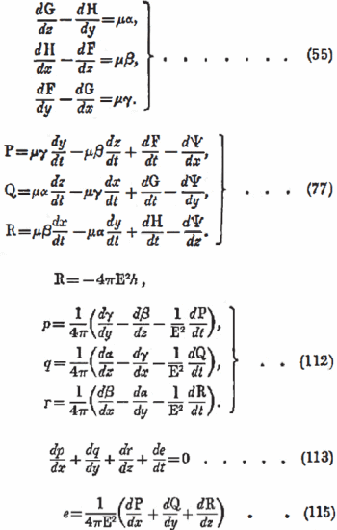

Maxwell’s equations in 1861-2

In 1864, he switched his mechanical analogy for Faraday’s abstract concept of electromagnetic field, managing to evade the problem of “action-at-a-distance” (Weber’s idea).

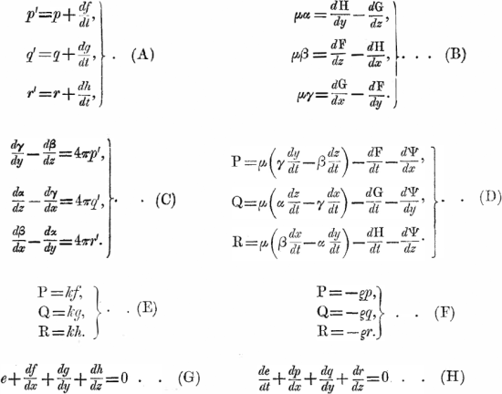

Maxwell’s 20 equations from his second paper also discussed in my summary of Bork’s paper

Maxwell seems to have been thinking about the ether still, possibly being the cause of him not distinguishing electric polarization from electric displacement, so his equation was just $D=εE$, rather than $D=ε_{0}E+P$. He saw that equation as acting similarly to $J=σE$. Hiw 1873 Treatise basically introduced the Lorentz force and also quaternions, similar to modern vector notation. So far, this is kind of an expansion of what Bork summarized.

Then, we come to Heaviside’s modifications. He converted quaternions – which he strongly disliked – to vector algebra notation, but did not condense the 20 equations to four as some say he did. However, his equations included four equations over months of time and work that look similar to ours now. Heaviside wrote out div and curl, and Gibbs introduced the symbols we use now. Hertz also did significant clarifying work on the equations (sometimes referred to as Maxwell-Hertz), mostly by removing the potentials and giving them separate forms for free space, conductors, and more. Lorentz presented a small set of equations for a microscopic model (interestingly never referencing Maxwell).

Now, we come to the modern forms and look at any different versions since the 1900s. Einstein developed special relativity and showed that Maxwell’s equations are covariant, and Minkowski applied relativity to Lorentz’s versions of the equations, showing that the components of E and B could also make a four-matrix, like a four-vector. There are also some other ways of writing Maxwell’s equations that take fewer additional equations to be complete, like using P and M (electric and magnetic polarization) instead of D and H.