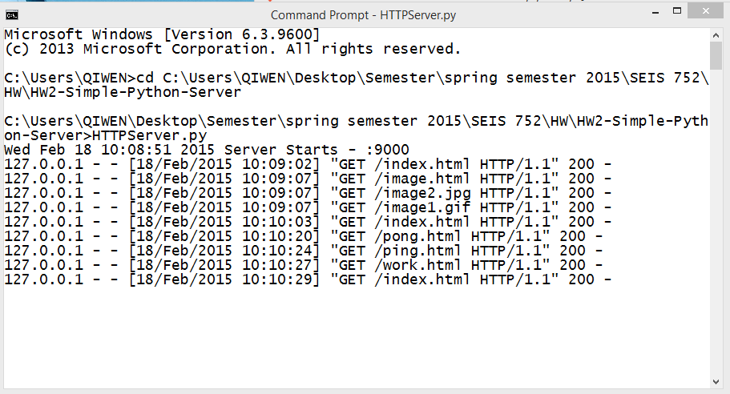

Click hyperlink to go to image.html and get response when images are loaded out

Initial to run index.html

Response that when I click different link to go to different page.