Operating Systems Lab Manual CSL303

Dr. Manvi Breja



Department of Computer Science and Engineering The Northcap University
Gurugram- 122001, India
Session 2025-26

Published by:

School of Engineering and Technology Department of Computer Science & Engineering The NorthCap University, Gurugram

- Laboratory Manual is for Internal Circulation only

© Copyright Reserved

No part of this Practical Record Book may be


reproduced, used, stored without prior permission of The NorthCap University

Copying or facilitating copying of lab work comes under cheating and is considered as use of unfair means. Students indulging in copying or facilitating copying shall be awarded zero marks for that particular experiment. Frequent cases of copying may lead to disciplinary action. Attendance in lab classes is mandatory.
Labs are open up to 7 PM upon request. Students are encouraged to make full use of labs beyond normal lab hours.

PREFACE
Operating System Lab Manual is designed to meet the course and program requirements of NCU curriculum for B.Tech III year students of CSE branch. The concept of the lab work is to give brief practical experience for basic lab skills to students. It provides the space and scope for self-study so that students can come up with new and creative ideas.

The Lab manual is written on the basis of “teach yourself pattern” and expected that students who come with proper preparation should be able to perform the experiments without any difficulty. Brief introduction to each experiment with information about self-study material is provided. The laboratory exercises will include familiarization with LINUX system calls for process management and inter-process communication; Experiments on process scheduling and other operating system tasks through simulation/implementation. Students would require design process synchronization, CPU scheduling algorithms, memory management and disc management algorithms in high level languages like c, c++, python. Finally, the students would require applying the operating system concepts by experimenting on either xv6/minix operating systems. At the start of each experiment a question bank for preparation and practice is suggested which may be used to test the basic under- standing of the students about the experiment. Students are expected to come thoroughly prepared for the lab. General disciplines, safety guidelines and report writing are also discussed.

The lab manual is a part of curriculum for the TheNorthCap University, Gurugram. Teacher’s copy of the experimental results and answer for the questions are available as sample guidelines.

We hope that lab manual would be useful to students of CSE, IT, ECE and BSc branches and author requests the readers to kindly forward their suggestions / constructive criticism for further im- provement of the work book.

Author expresses deep gratitude to Members, Governing Body-NCU for encouragement and moti- vation.

Authors The NorthCap University
Gurugram, India
CONTENTS
S.N. | Details | Page No.
 | Syllabus
1 | Introduction
2 | Lab Requirement
3 | General Instructions
4 | List of Experiments
5 | List of Flip Assignment
6 | List of Projects
7 | Rubrics
8 | Annexure 1 (Format of Lab Report)
9 | Annexure 2 (Format of Lab Certificate)

COURSE TEMPLATE
- Department: |  |  | Department of Computer Science and Engineering
- Course Name: Operating System |  |  |  |  | - Course Code | - L-T-P |  |  | - Credits
 |  |  |  |  | CSL303 | 3-0-2 |  |  | 4
- Type of Course (Check one): |  |  | Programme Core ✔ Programme Elective Open Elective
- Pre-requisite(s), if any: None
- Frequency of offering (check one): Odd ✔ Even Either semester Every semester
- Brief Syllabus:
This is an introductory course in Operating System concepts that forms an integral part of computer science engineering in development of software applications in many diverse areas, including Web Development, Windows Applications, Research, Analytics and Processing. It lays the foundation of Process Management, Scheduling, Memory Management, Deadlocks and other Operating system concepts.
Total lecture, Tutorial and Practical Hours for this course (Take 15 teaching weeks per semester): 75
Lectures: 45 hours |  |  |  | Practice
 |  |  |  | Tutorials: 10 hours |  |  | Lab Work: 20 hours
- Course Outcomes (COs)
CO 1 | Identify Operating Systems based on their features and functions and them based on modern system and network.
CO 2 | Compare and classify Process Scheduling Algorithms with application to real world problems.
CO 3 | Discuss and evaluate various Deadlock Avoidance & Recovery techniques.
CO 4 | Discuss and assess various Memory Management Techniques and disk scheduling algorithms.
CO 5 | Discuss various Disk management and file allocation methods and select which is suitable in different situations.
- UNIT WISE DETAILS No. of Units: 5
Unit Number: 1 |  | Title: Introduction to Operating System |  |  |  |  |  | No. of hours: 6
Content Summary:
Computer system organization/architecture, operating system structure and operations, Types of popular operating systems, Operating system services, System calls, types of system calls, Modern Operating system: Introduction to Network OS (Cisco IOS, Windows NT etc.), Real time OS (Symbian OS, Windows CE etc.), Distributed OS (LOCUS, MICROS), Mobile OS (Android, iOS etc. ), IoT/ Embedded device OS (Riot, Android Things, Noobs etc.) and Cloud OS(Cloud Me, Condor etc., Linux commands: File Management, Directory management, File permission/access modes, Process management, shell and its type, Shell Programming (Basic operations, Decision making and loops, and Regular expressions) .
Unit Number: 2 |  | Title: Process Management and CPU scheduling |  |  |  |  |  | No. of hours: 10
Content Summary:
Process Concept, Operations on Process, Inter-process Communication, Process Scheduling- Basic Concepts, Scheduling Algorithms- FIFO, SJF/ Priority, Round Robin, Multilevel Approaches, Multithreading Models, Multiprocessor, Real Time Scheduling, Earliest-Deadline-First Scheduling, Proportional Share and pthreads Scheduling .
Unit Number: 3 |  | Title: Process Synchronization and Deadlock |  |  |  |  |  | No. of hours: 11
Content Summary:
Process Synchronization: Background, The Critical-Section Problem, Synchronization Hardware, Mutex Locks, Semaphores, Classic Problems of Synchronization, Monitors, System model, deadlock characterization, Methods for handling deadlocks, Deadlock prevention techniques, Deadlock avoidance algorithms (Banker's algorithm), Deadlock detection and Recovery from deadlocks
Unit Number: 4 |  | Title: Memory Management (Main and Virtual memory) |  |  |  |  |  | No. of hours: 10
Content Summary:
Main memory basic hardware and the concept of address binding, Logical vs. Physical address space, Dynamic loading and linking, shared libraries, Swapping, Contiguous memory allocation, Segmentation, Paging, shared pages, Virtual memory and virtual address space, Demand paging, Page Replacement and Page replacement policies (FIFO, Optimal, LRU, LRU page approximation, Counting based page replacement), Thrashing and working set model.
Unit Number: 5 |  | Title: Storage Management and File structure |  |  |  |  |  | No. of hours: 8
Content Summary:
Disk structure, Disk scheduling algorithms (FCFS, SSTF, SCAN, C-SCAN and LOOK etc.), File and its types, Allocation methods (Contiguous, Linked, Indexed) and Free space management
- Brief Description of Self-learning components by students (through books/resource material etc.):

- https://ocw.mit.edu/courses/electrical-engineering-and-computer-science/6-828-operating-system-engineering-fall-2012/
- https://www.scs.stanford.edu/20wi-cs140/
GATE/NET/other Exams
- Operating System | CSE (Computer Science) - Gatequestions.Com
- Operating System Multiple choice Questions and Answers-GATE cse question paper (compsciedu.com)

- Advanced Learning Components
- Advanced Operating Systems | Department of Computer Science (utexas.edu)

Certification courses/programs for Skill Development
- https://www.redhat.com/en/services/certification/rhce
- https://www.lpi.org/our-certifications/lpic-1-overview
- Books Recommended:

Textbooks:
- Abraham Silberschatz , Peter B Galvin and Gerg Gagne, Operating system concepts, 9th ed, WILEY, 2018
Reference Books:
- Andrew S. Tanenbaum and Herbert Bos, Modern Operating Systems, 4th ed., Pearson, 2016.
- Sumitabha Das, UNIX concepts and applications, 4th ed., Tata McGraw Hill, 2017.

Reference Websites: (nptel, swayam, coursera, edx, udemy, lms, official documentation weblink)
- https://swayam.gov.in/nd1_noc19_cs50/preview
- Course Modules: (Cintana) SER 334: Operating Systems and Networks (asu.edu)
- https://nptel.ac.in/courses/106/106/106106144/#
- https://www.udacity.com/course/introduction-to-operating-systems--ud923
- https://www.udemy.com/course/operating-systems-from-scratch-part1/

  - INTRODUCTION

That ‘learning is a continuous process’ cannot be over emphasized. The theoretical knowledge gained during lecture sessions need to be strengthened through practical experimentation. Thus practical makes an integral part of a learning process.

The purpose of conducting experiments can be stated as follows:

    - To familiarize the students with the basic concepts, programming skill development and the take home laboratory assignments mainly implementation-oriented which have to be coded in high level language. The lab sessions will be based on exploring the concepts discussed in class.
    - Observing basic structure and characteristics of Operating Systems
    - Reporting and analyzing the complexities.
    - Hands on experience on the experimental setup and software tools

  - LAB REQUIREMENTS

S.No. | Requirements | Details
1 | Software Requirements | Linux’s Shell, Python/c/c++
2 | Operating System | Linux Operating System
3 | Hardware Requirements | Windows and Linux: Intel 64/32 or AMD Athlon 64/32, or AMD Opteron proces- sor  2 GB RAM  80 GB hard disk space
4 | Required Bandwidth | NA

  - GENERAL INSTRUCTIONS

- General discipline in the lab
  - Students must turn up in time and contact concerned faculty for the experiment they are supposed to perform.
  - Students will not be allowed to enter late in the lab.
  - Students will not leave the class till the period is over.
  - Students should come prepared for their experiment.
  - Experimental results should be entered in the lab report format and certified/signed by concerned faculty/ lab Instructor.
  - Students must get the connection of the hardware setup verified before switching on the power supply.
  - Students should maintain silence while performing the experiments. If any necessity arises for discussion amongst them, they should discuss with a very low pitch without disturbing the adjacent groups.
  - Violating the above code of conduct may attract disciplinary action.
  - Damaging lab equipment or removing any component from the lab may invite penalties and strict disciplinary action.
- Attendance

  - Attendance in the lab class is compulsory.
  - Students should not attend a different lab group/section other than the one assigned at the beginning of the session.
  - On account of illness or some family problems, if a student misses his/her lab classes, he/she may be assigned a different group to make up the losses in consultation with the concerned faculty / lab instructor. Or he/she may work in the lab during spare/extra hours to complete the experiment. No attendance will be granted for such case.

- Preparation and Performance

  - Students should come to the lab thoroughly prepared on the experiments they are as- signed to perform on that day. Brief introduction to each experiment with information about self study reference is provided on LMS.
  - Students must bring the lab report during each practical class with written records of
the last experiments performed complete in all respect.
- Each student is required to write a complete report of the experiment he has performed and bring to lab class for evaluation in the next working lab. Sufficient space in work book is provided for independent writing of theory, observation, calculation and con- clusion.
- Students should follow the Zero tolerance policy for copying / plagiarism. Zero marks will be awarded if found copied. If caught further, it will lead to disciplinary action.
- Refer Annexure 1 for Lab Report Format

- LIST OF EXPERIMENTS

Exp. No. | Division of Experiments | List of Experiments
1 | Basics of Linux | To familiarize the students to Linux interface and install Linux.
2 | Shell Programs | To write the shell programming code for the following.  a) Write A Shell Program of Hello World  b) Write a shell program to find factorial of a number.  c) Write a shell program to find gross salary of an employee.  d) Write a shell program to display the menu and execute instructions accordingly  (i)List of files (ii)Process Status (iii) Date (iv) users in program (v) Quit
3 | Shell Programs | To write the shell programming code for the following.  a) Write a shell program to find Fibonacci series.  b) Write a shell program to find largest of three numbers.  c) Write a shell program to find average of N numbers
4 | Shell Programs | To write the shell programming code for the following.  a) Write a shell program to check whether a number is even or odd  b) Write a shell program to find whether a number is prime or not.  c) Write a shell program to find whether a number is palindrome or not.  d) Write a shell program to type number 1 to 7 and then print its corresponding day of week
5 | CPU scheduling algorithms | Implement the following CPU scheduling Algorithms.  - FCFS with Arrival time  ii) FCFS without Arrival time
6 | CPU scheduling algorithms | Implement the following CPU scheduling Algorithms.  - SJF (Non-Preemptive)  - SJTF (shortest remaining time first -Preemptive SJF)
7 | CPU scheduling algorithms | Implement the priority scheduling.
8 | CPU scheduling algorithms | Implement the Round Robin scheduling.
9 | Synchronization algorithms | Write a program to implement reader/writer problem using semaphores.
10 | Synchronization algorithms | Write a program to implement Dining Philosopher’s problem using semaphores.
11 | Deadlock Management Technique | Write a program to implement Banker’s algorithm for deadlock avoidance.
12 | Page Replacement Algorithms | Write a program for page replacement policy using a) LRU b) FIFO c) Optimal.

- LIST OF FLIP EXPERIMENTS
- Execute the who command written in a file to instruct the shell to read input from a file called "myfile1" instead of from the keyboard. Use the more command to see the con- tents of myfile1.
- Use the date and who commands in sequence (in one line) such that the output of date will display on the screen and the output of who will be redirected to a file called my- file2. Use the more command to check the contents of myfile2
- Write a sed command that swaps the first and second words in each line in a file.
- Write a shell script that takes a command –line argument and reports on whether it is di- rectory, a file, or something else.
- Write a shell script that accepts one or more file name as arguments and converts all of them to uppercase, provided they exist in the current directory.
- Write a shell script that determines the period for which a specified user is working on the system.
- Write a shell script that accepts a file name, starting and ending line numbers as argu- ments and displays all the lines between the given line numbers.
- Write a shell script that deletes all lines containing a specified word in one or more files supplied as arguments to it.
- Write a shell script to perform the following string operations:
  - To extract a sub-string from a given string
  - To find the length of a given string

- LIST OF PROJECTS
- Case Study of Window OS
- Case Study of Linux OS
- Case Study of MAC OS

- RUBRICS

Marks Distribution
Continuous Evaluation(50 Marks) | End Semester Exam (20 Marks)
Each experiment shall be evaluated for 10 marks and at the end of the semester propor- tional marks shall be awarded out of 50. | End semester practical evaluation includ- ing Mini project (if any) carries 20 marks.
Following is the breakup of 10 marks for each
4 Marks: Observation & conduct of experi- ment. Teacher may ask questions about ex- periment.
3 Marks: For report writing
3 Marks: For the 15 minutes quiz to be conduct- ed in every lab.

INDEX

S. No. | Experiment | Date of Experiment | Date of Submission | CO Covered | Signature
1 | To familiarize the students to Linux interface and install Linux.
2 | To write the shell programming code for the following.  a) Write A Shell Program of Hello World  b) Write a shell program to find factorial of a number.  c) Write a shell program to find gross salary of an employee.  d) Write a shell program to display the menu and execute instructions accordingly  (i)List of files (ii)Process Status (iii) Date (iv) users in program (v) Quit
3 | To write the shell programming code for the following.  a) Write a shell program to find Fibonacci series.  b) Write a shell program to find largest of three numbers.  c) Write a shell program to find average of N numbers
4 | To write the shell programming code for the following.  a) Write a shell program to check whether a number is even or odd  b) Write a shell program to find whether a number is prime or not.  c) Write a shell program to find whether a number is palindrome or not.  d) Write a shell program to type number 1 to 7 and then print its corresponding day of week
5 | Implement the following CPU scheduling Algorithms.  - FCFS with Arrival time  ii) FCFS without Arrival time
6 | Implement the following CPU scheduling Algorithms.  - SJF (Non-Preemptive)  - SJTF (shortest remaining time first -Preemptive SJF)
7 | Implement the priority scheduling.
8 | Implement the Round Robin scheduling.
9 | Write a program to implement reader/writer problem using semaphore
10 | Write a program to implement Dining Philosopher’s problem using semaphore
11 | Write a program to implement Banker’s algorithm for deadlock avoidance.
12 | Write a program for page replacement policy using a) LRU b) FIFO c) Optimal.

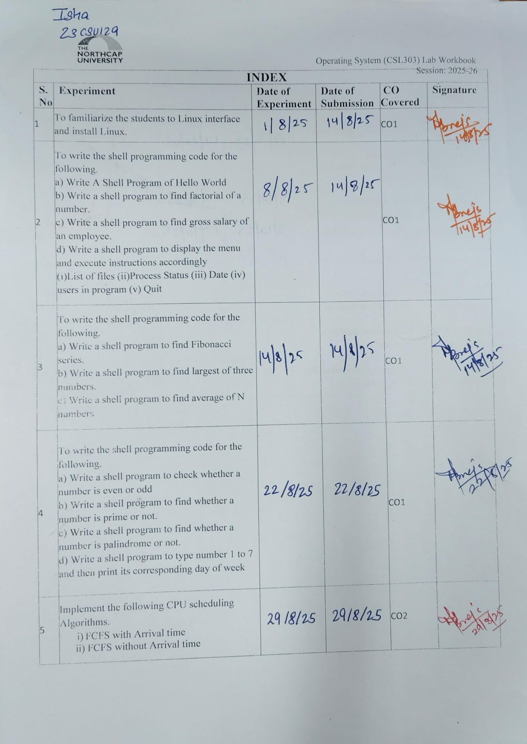
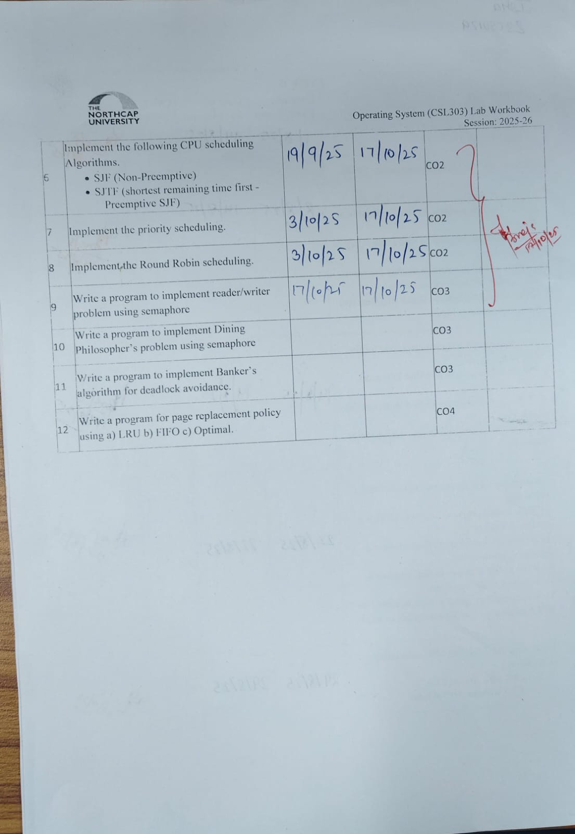
Experiment No: 1
Student Name and Roll Number: ISHA AGGARWAL 23CSU129
Semester /Section: 5th AIML - B

Link to Code:
Date: 01-08-2025

Faculty Signature:

Marks:

Objective(s):
To familiarize the students to Linux interface.
Outcome:
- The students will understand commands used in Linux.
Problem Statement:

Implement the following things:
- Linux Installation
Background Study:

Cygwin is a open source tool which provides that functionality of the Linux in windows Operating System. Cygwin is a large collection of GNU and Open Source tools which provide functionality similar to a Linux distribution on Windows. It is a DLL (cygwin1.dll) which provides substantial POSIX API functionality.

Question Bank:
- What is Linux?
- How will you List files from a directory?
- How files in a directory can be removed?
- How to find out a word in a file?
- What are wildcards?
Student Work Area
Algorithm/Flowchart/Code/Sample Outputs
Make/Remove Directory
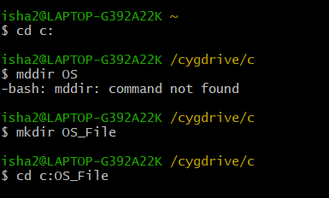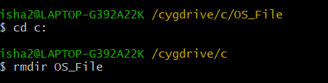
Create new File
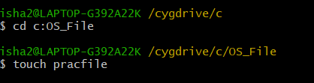
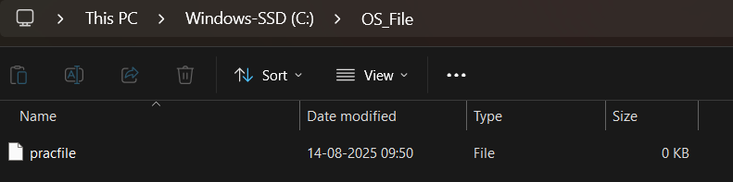
List all the files in the directory with all the attributes
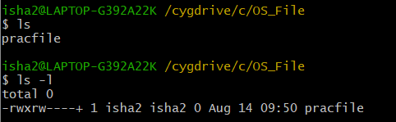
Rename the file in a directory
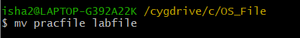
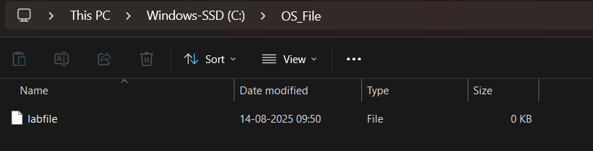
Copy of a file
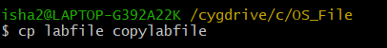
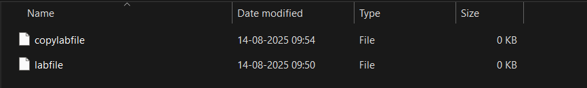
Write content In that file
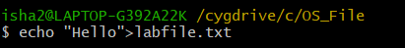
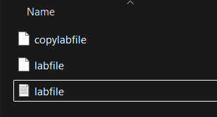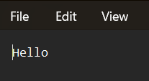
Appending new Content
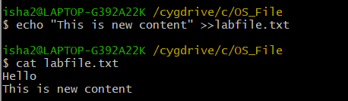

Copy the content of one file to another
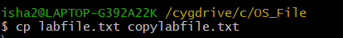
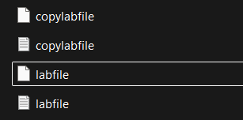

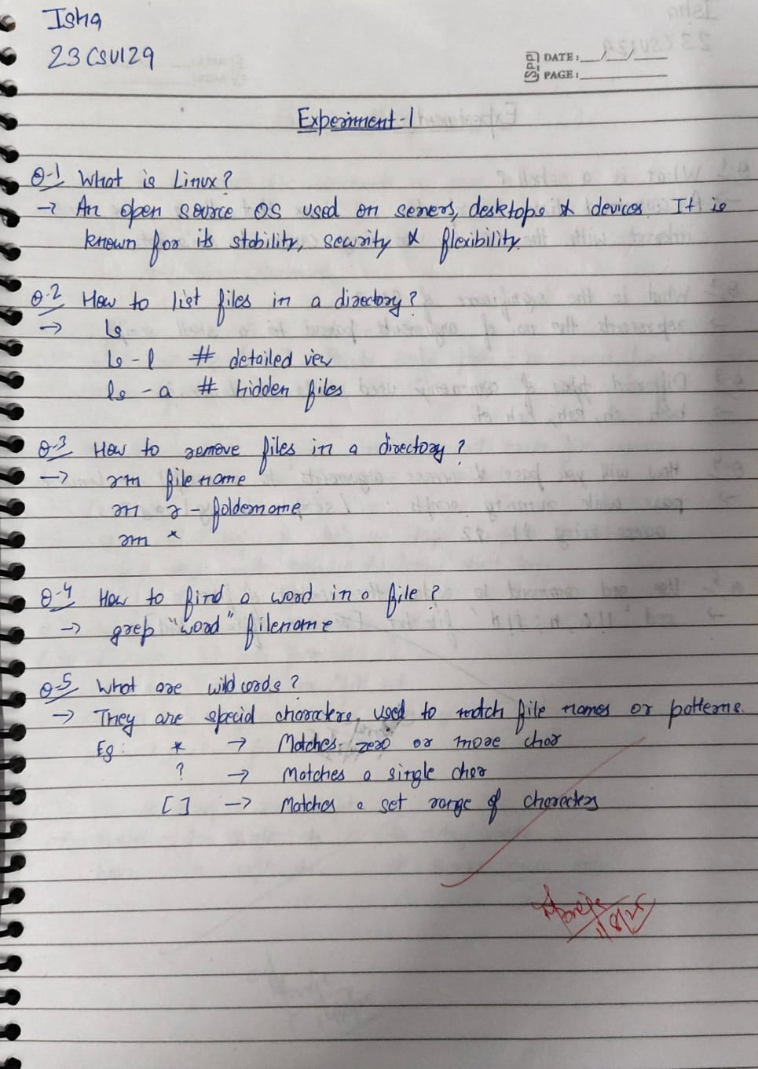
Experiment No: 2
Student Name and Roll Number: 23CSU129

Semester /Section: 5th AIML - B

Link to Code:

Date: 08-08-2025

Faculty Signature:

Marks:

Objective(s):
To write the shell programming code for the following.
Outcome:
- Student is able to write code in shell programming.
Problem Statement:

a) Write A Shell Program of Hello World
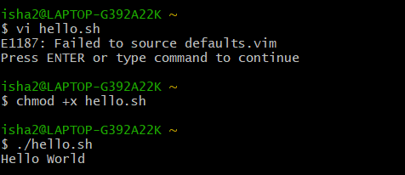
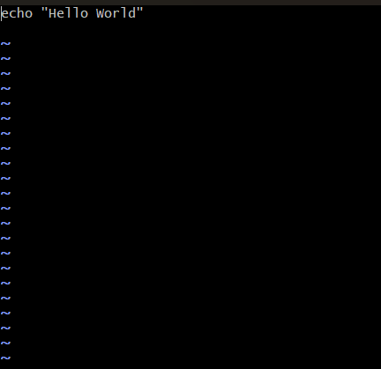
b) Write a shell program to find factorial of a number.
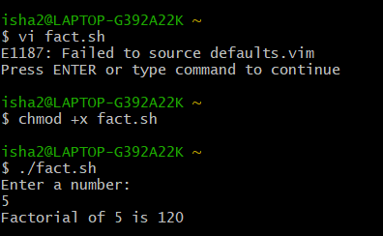
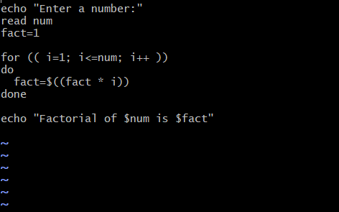
c) Write a shell program to find gross salary of an employee.
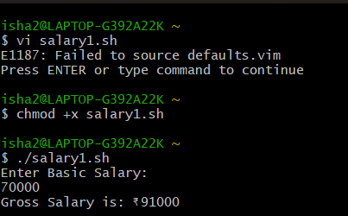

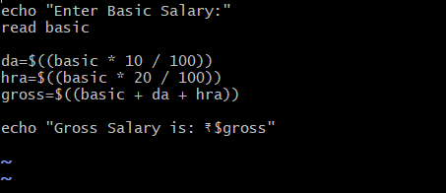
d) Write a shell program to display the menu and execute instructions accordingly
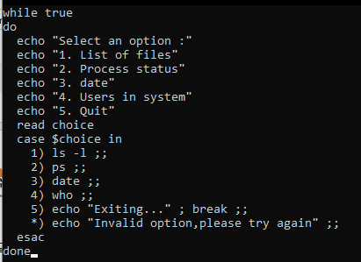
(i)List of files
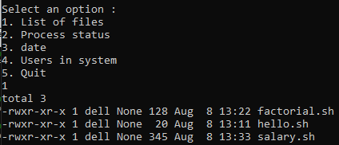
(ii)Process Status
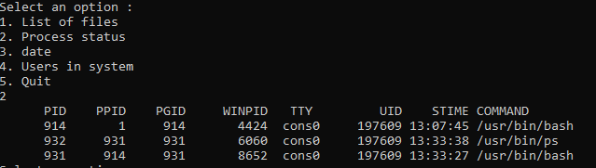
(iii) Date
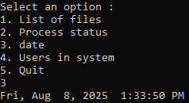
(iv) users in program
(v) Quit
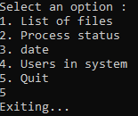
Background Study:

A shell script is a file with a set of commands in it. The shell reads this file and executes the instructions as if they were input directly on the command line.
A shell is a command-line interpreter and operations such as file manipulation, program execution and text printing are performed by shell script. So, we will use vi editor to edit our files.

Question Bank:
- What is a shell?
- What is the significance of $#?
- What are the different types of commonly used shells on a typical Linux system?
- How will you pass and access arguments to a script in Linux?
- Use sed command to replace the content of the file (emulate tac command)
Student Work Area
Algorithm/Flowchart/Code/Sample Outputs
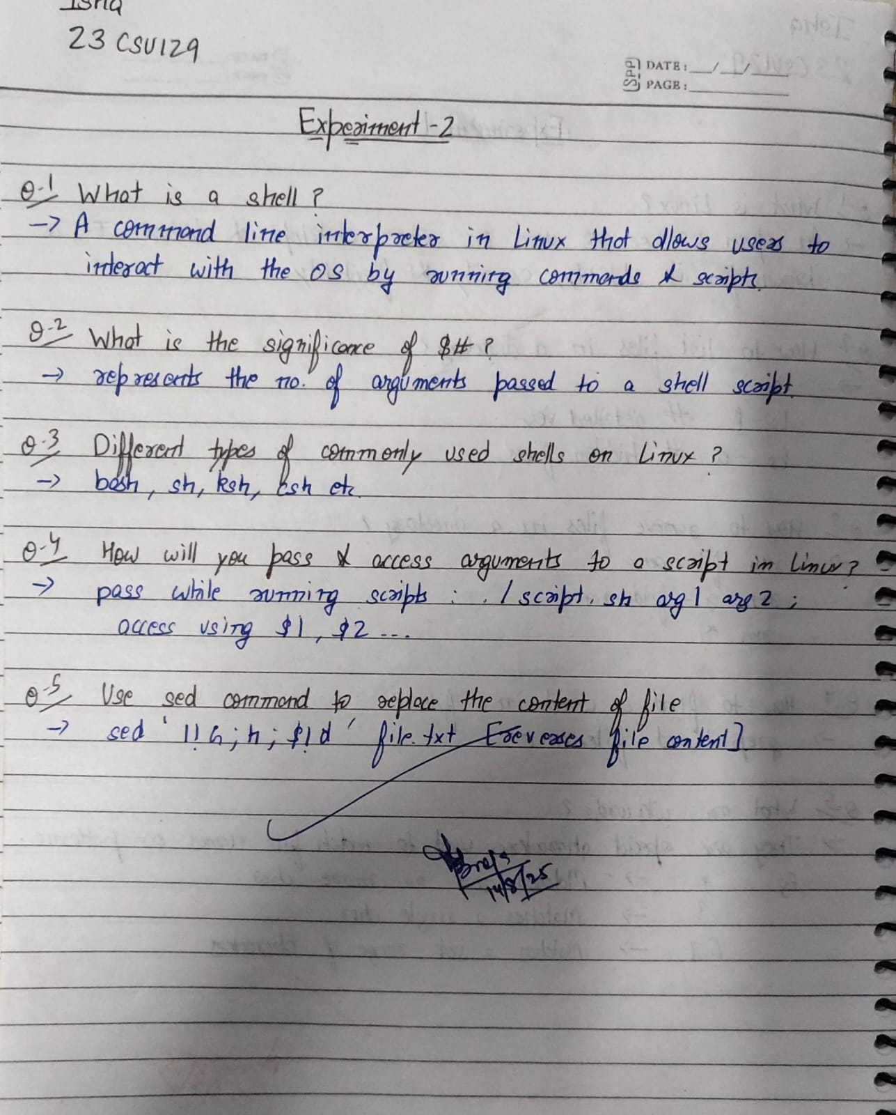
EXPERIMENT NO. 3
Student Name and Roll Number: ISHA AGGARWAL 23CSU129

Semester /Section: 5TH AIML 5B

Link to Code:

Date: 14-8-25

Faculty Signature:

Marks:

Objective:
To write the shell programming code for the following.

Outcome:
Student is able to write code in shell programming
Problem Statement:
a) Write a shell program to find Fibonacci series.
b) Write a shell program to find largest of three numbers.
c) Write a shell program to find average of N numbers

Background Study:

A shell script is a file with a set of commands in it. The shell reads this file and executes the instructions as if they were input directly on the command line.
A shell is a command-line interpreter and operations such as file manipulation, program execution and text printing are performed by shell script. So, we will use vi editor to edit our files.
Question Bank:
- How to use multi line comments in shell script?
- What is the difference between soft and hard links?
- Explain about loops and what are the loops available in LINUX?
- What are absolute and relative paths.
- How to debug a shell script.

Student Work Area
Algorithm/Flowchart/Code/Sample Outputs
- Write a shell program to find Fibonacci series.
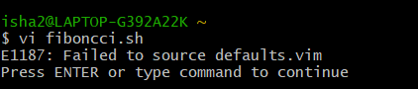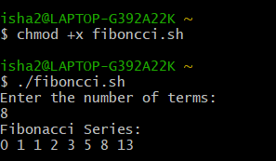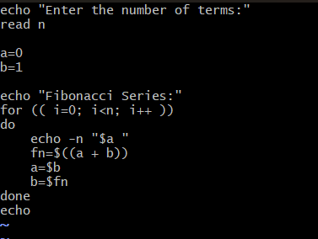
- Write a shell program to find largest of three numbers.
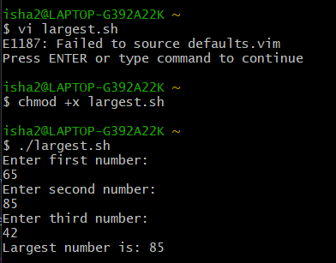
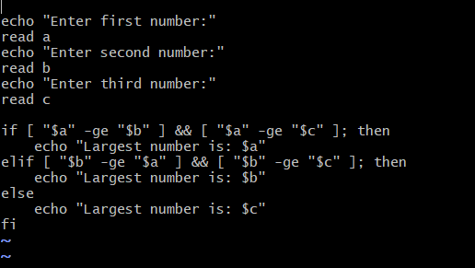

c) Write a shell program to find average of N numbers

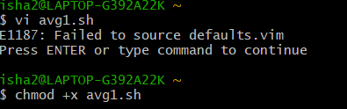
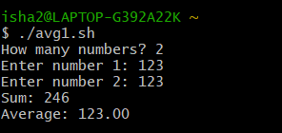
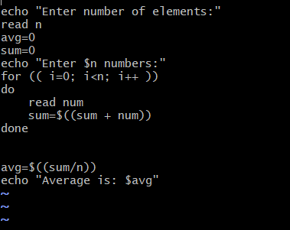

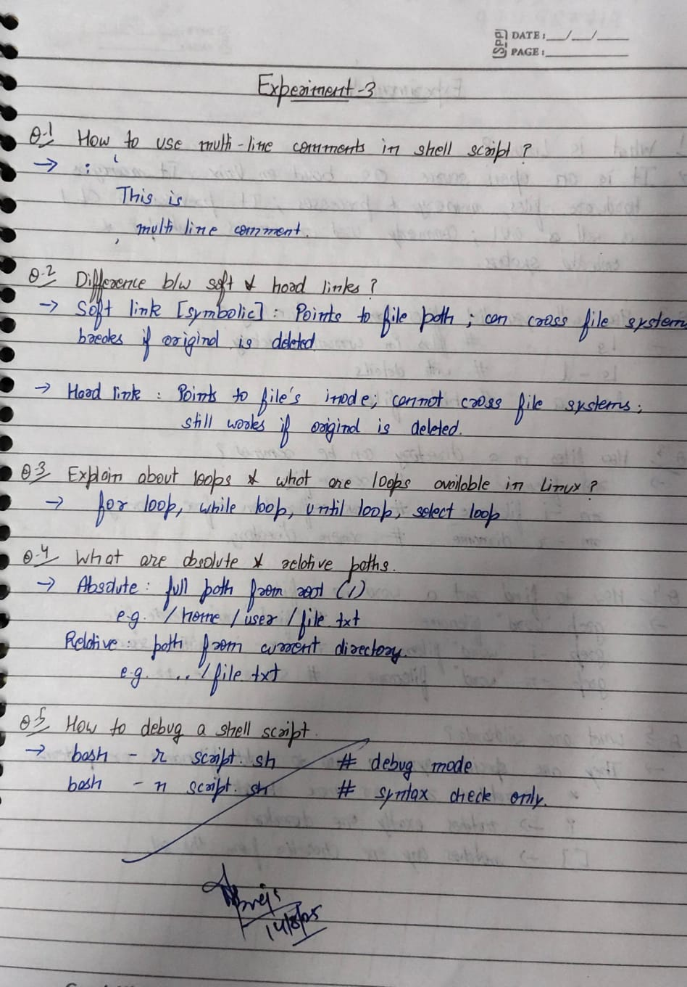
EXPERIMENT NO. 4
Student Name and Roll Number: ISHA AGGARWAL 23CSU129

Semester /Section: AIML5B

Link to Code:

Date: 22 AUGUST 2025

Faculty Signature:

Marks:

Objective:
To write the shell programming code for the following.

Outcome:
Student is able to write code in shell programming
Problem Statement:
a) Write a shell program to check whether a number is even or odd
b) Write a shell program to find whether a number is prime or not.
c) Write a shell program to find whether a number is palindrome or not.
d) Write a shell program to type number 1 to 7 and then print its corresponding day of week

Background Study:

A shell script is a file with a set of commands in it. The shell reads this file and executes the instructions as if they were input directly on the command line.
A shell is a command-line interpreter and operations such as file manipulation, program execution and text printing is performed by shell script. So, we will use vi editor to edit our files.
Question Bank:
- What are Zoombie Process?
- What are different types of variables used in shell script?
- What are the different types of modes available in Vi editor?
- What are the different types of permission at file level in shell?
- How to use comments in shell script.
Student Work Area
Algorithm/Flowchart/Code/Sample output
a)Write a shell program to check whether a number is even or odd
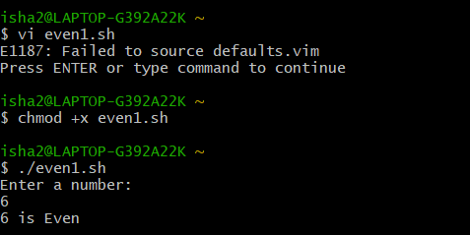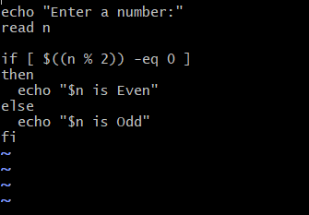

b) Write a shell program to find whether a number is prime or not.
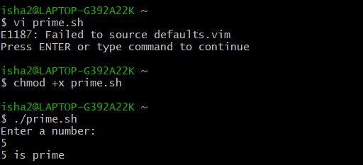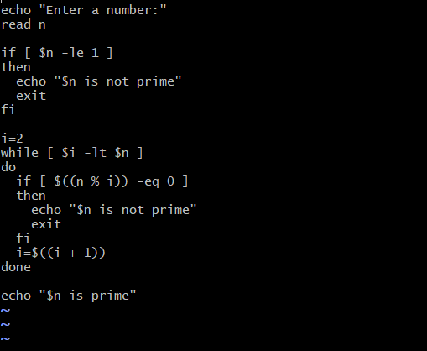

c) Write a shell program to find whether a number is palindrome or not.
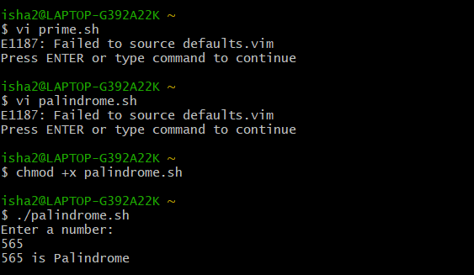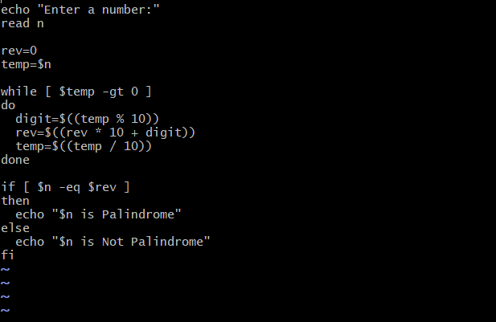

d) Write a shell program to type number 1 to 7 and then print its corresponding day of week
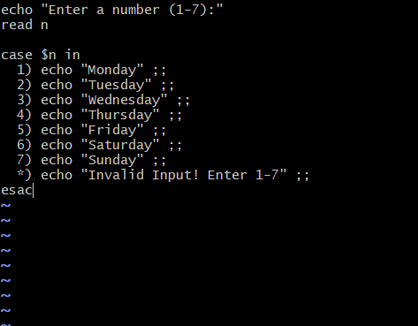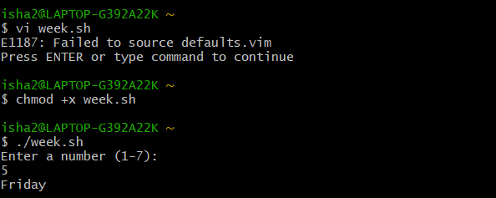

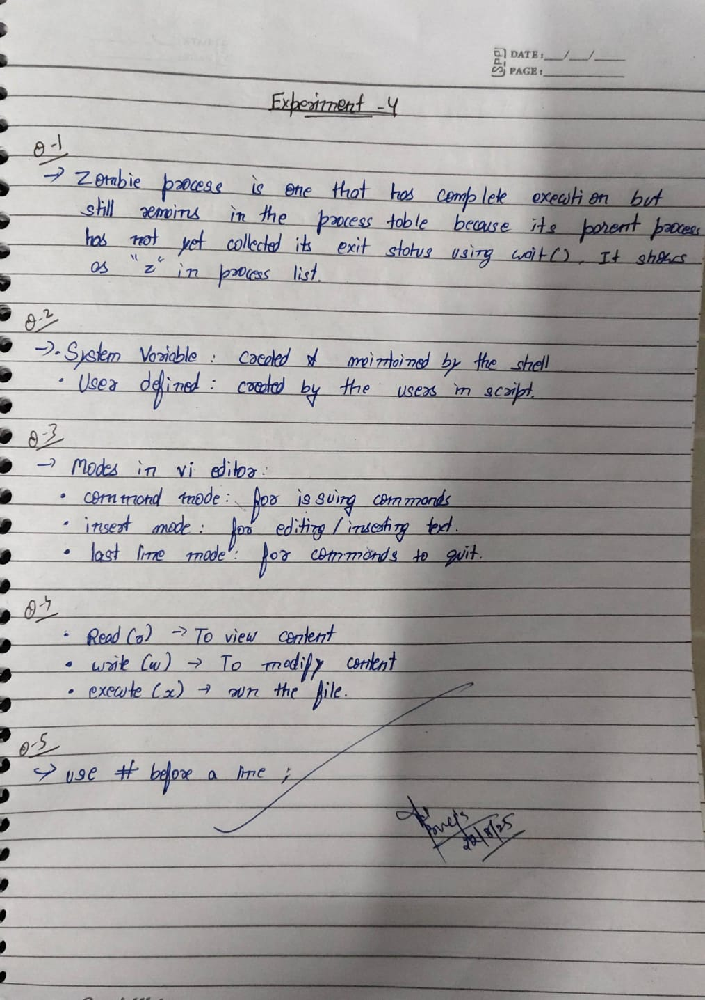
Experiment No: 5
Student Name and Roll Number: ISHA AGGARWAL 23CSU129
Semester /Section: AIML5B
Link to Code:
Date: 29 AUGUST 2025
Faculty Signature:
Marks:

Objective:
Write a program to implement CPU scheduling for first come first serve approach.
Outcome:
The students will understand the First-cum-first-serve algorithm
Problem Statement:
Implement the following CPU scheduling Algorithms.
- FCFS with Arrival time
- FCFS without Arrival time
Background Study:
FCFS
- The simplest CPU-scheduling algorithm is the first-come, first-served (FCFS) scheduling algorithm. With this algorithm, processes are assigned the CPU in the order they request it.
- There is a single queue of ready processes.
- The implementation of the FCFS policy is easily managed with a FIFO queue. When a process enters the ready queue, its PCB is linked onto the tail of the queue.
- The average waiting time under the FCFS policy, however, is often quite long.
Question Bank:

- Which module gives control of the CPU to the process selected by the short-term scheduler?
  - dispatcher
  - interrupt
  - scheduler
  - none of the mentioned

- The processes that are residing in main memory and are ready and waiting to execute are kept on a list called
  - job queue
  - ready queue
  - execution queue
  - process queue

- The interval from the time of submission of a process to the time of completion is termed as
  - waiting time
  - turnaround time
  - response time
  - throughput

- Which scheduling algorithm allocates the CPU first to the process that requests the CPU first?
  - first-come, first-served scheduling
  - shortest job scheduling
  - priority scheduling
  - none of the mentioned

- In priority scheduling algorithm

  - CPU is allocated to the process with highest priority
  - CPU is allocated to the process with lowest priority
  - equal priority processes cannot be scheduled
  - none of the mentioned

Student Work Area
Algorithm/Flowchart/Code/Sample Outputs
# FCFS(No Arrival Time)
n = int(input("Enter number of processes: "))
burst_times = []
for i in range(n):
bt = int(input(f"Enter Burst Time for Process {i+1}: "))
burst_times.append(bt)
time = 0
total_wt = 0
total_tat = 0
print("\nFCFS (No Arrival Time)")
print("PID BT ST CT WT TAT RT")
for i in range(n):
pid = f"P{i+1}" # Process IDs
at = 0
bt = burst_times[i]
st = time
ct = st + bt
tat = ct - at
wt = tat - bt
rt = st - at
total_wt += wt
total_tat += tat
print(f"{pid:<4} {bt:<3} {st:<3} {ct:<3} {wt:<3} {tat:<4} {rt:<3}")
time = ct
avg_wt = total_wt / n
avg_tat = total_tat / n
print(f"\nAverage Waiting Time = {avg_wt:.2f}")
print(f"Average Turnaround Time = {avg_tat:.2f}")
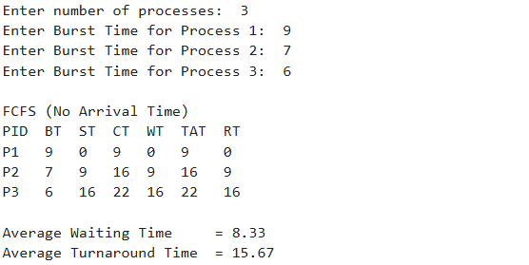

# FCFS (With Arrival Time)
n = int(input("Enter number of processes: "))
processes = []
for i in range(n):
at = int(input(f"Enter Arrival Time for Process {i+1}: "))
bt = int(input(f"Enter Burst Time for Process {i+1}: "))
processes.append((f"P{i+1}", at, bt))
processes.sort(key=lambda x: x[1])
time = 0
total_wt = 0
total_tat = 0
print("\nFCFS (With Arrival Time)")
print("PID AT BT ST CT WT TAT RT")
for pid, at, bt in processes:
if time < at:
time = at
st = time
ct = st + bt
tat = ct - at
wt = tat - bt
rt = st - at
wt = tat - bt
rt = st - at
total_wt += wt
total_tat += tat
print(f"{pid:<4} {at:<3} {bt:<3} {st:<3} {ct:<3} {wt:<3} {tat:<4} {rt:<3}")
time = ct
avg_wt = total_wt / n
avg_tat = total_tat / n
print(f"\nAverage Waiting Time = {avg_wt:.2f}")
print(f"Average Turnaround Time = {avg_tat:.2f}")
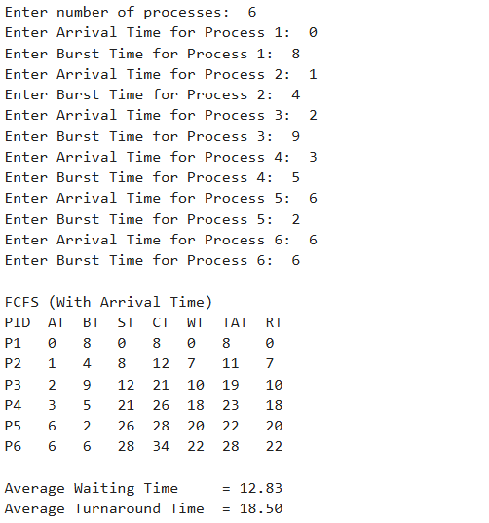

Experiment No: 6
Student Name and Roll Number: ISHA AGGARWAL 23CSU129
Semester /Section: AIML5B
Link to Code:
Date: 19 SEPTEMBER 2025
Faculty Signature:

Marks:

Objective:

Write a program to implement CPU scheduling for shortest job first (Preemptive and Non-Preemptive)
Outcome:
The students will understand the Shortest Job First scheduling mechanism
Problem Statement:
Implement the following CPU scheduling Algorithms.
- SJF (Non-Preemptive)
- SJTF (shortest remaining time first -Preemptive SJF)

Background Study:
- Shortest Job first is having the advantage of a minimum average waiting time .
- This algorithm associates with each process the length of the process next burst time.When CPU is available it assigned to the process that has the smallest next CPU burst time.if CPU burst time of two process is same then it follows FCFS.
- It may cause starvation if shorter processes keep coming. This problem can be solved using the concept of ageing.
- It is practically infeasible as Operating System may not know burst time and therefore may not sort them.
Question Bank:

- scheduling algorithm In multilevel feedback
A. processes are not classified into groups
B. a process can move to a different classified ready queue…
C. classification of the ready queue is permanent
D. none of the mentioned
- Select one which algorithms tend to minimize the process flow time?
A. First come First served
B. Earliest Deadline First
C. Shortest Job First
D. Longest Job First
- The process can be classified into many groups in
A. shortest job scheduling algorithm
B. multilevel queue scheduling algorithm
C. round-robin scheduling algorithm
D. priority scheduling algorithm
- The turnaround time for short jobs during multiprogramming is usually Shortened and that for long jobs is slightly ___________
A. Shortened
B. Unchanged
C. Lengthened
D. Shortened
- Time quantum can be said
A. multilevel queue scheduling algorithm
B. round-robin scheduling algorithm
C. shortest job scheduling algorithm
D. priority scheduling algorithm

Student Work Area
Algorithm/Flowchart/Code/Sample Outputs
# SJF Non-Preemptive
n = int(input("Enter number of processes: "))
processes = []
for i in range(n):
at = int(input(f"Enter Arrival Time for Process {i+1}: "))
bt = int(input(f"Enter Burst Time for Process {i+1}: "))
processes.append([f"P{i+1}", at, bt])
time = 0
completed = 0
total_wt = 0
total_tat = 0
done = [0]*n # track completed processes
print("\nSJF (With Arrival Time)")
print("PID AT BT ST CT WT TAT")
while completed < n:
# Find process with min BT among arrived and not done
idx = -1
min_bt = float('inf')
for i in range(n):
if processes[i][1] <= time and done[i] == 0 and processes[i][2] < min_bt:
min_bt = processes[i][2]
idx = i
if idx == -1: # no process arrived, increment time
time += 1
continue
pid, at, bt = processes[idx]
st = time
ct = st + bt
tat = ct - at
wt = tat - bt
total_wt += wt
total_tat += tat
done[idx] = 1
completed += 1
time = ct
print(f"{pid:<4} {at:<3} {bt:<3} {st:<3} {ct:<3} {wt:<3} {tat:<3}")
avg_wt = total_wt / n
avg_tat = total_tat / n
print(f"\nAverage Waiting Time = {avg_wt:.2f}")
print(f"Average Turnaround Time = {avg_tat:.2f}")
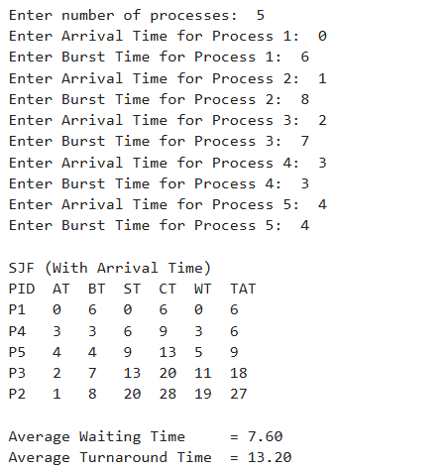
# SRTF Scheduling (Preemptive SJF)
n = int(input("Enter number of processes: "))
processes = []
for i in range(n):
at = int(input(f"Enter Arrival Time for Process {i+1}: "))
bt = int(input(f"Enter Burst Time for Process {i+1}: "))
processes.append([f"P{i+1}", at, bt, bt]) # last bt is remaining time
time = 0
completed = 0
total_wt = 0
total_tat = 0
start_time = [-1]*n
ct = [0]*n
print("\nSRTF Scheduling")
print("PID AT BT ST CT WT TAT")

while completed < n:
# Find process with min remaining time among arrived
idx = -1
min_rt = float('inf')
for i in range(n):
if processes[i][1] <= time and processes[i][3] > 0 and processes[i][3] < min_rt:
min_rt = processes[i][3]
idx = i

if idx == -1: # no process ready
time += 1
continue
# first time execution
if start_time[idx] == -1:
start_time[idx] = time
processes[idx][3] -= 1 # execute 1 unit
time += 1
if processes[idx][3] == 0: # process completed
completed += 1
ct[idx] = time
tat = ct[idx] - processes[idx][1]
wt = tat - processes[idx][2]
total_wt += wt
total_tat += tat
print(f"{processes[idx][0]:<4} {processes[idx][1]:<3} {processes[idx][2]:<3} {start_time[idx]:<3} {ct[idx]:<3} {wt:<3} {tat:<3}")

avg_wt = total_wt / n
avg_tat = total_tat / n
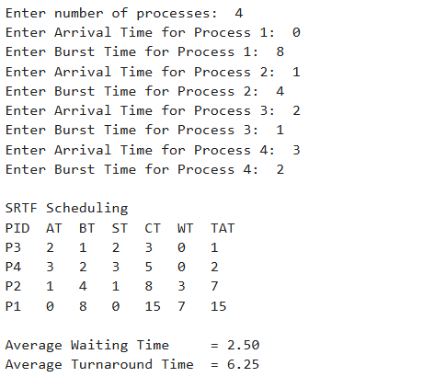
print(f"\nAverage Waiting Time = {avg_wt:.2f}")
print(f"Average Turnaround Time = {avg_tat:.2f}")

Experiment No: 7
Student Name and Roll Number: ISHA AGGARWAL 23CSU129
Semester /Section: AIML5B
Link to Code:
Date: 7 October 2025
Faculty Signature:

Marks:

Objective:
Write a program to perform priority scheduling among a set of processes.
Outcome:
Student will understand the working of priority scheduling among a set of processes.
Problem Statement:
Implement the priority scheduling.
Background Study:
Priority scheduling is a non-preemptive algorithm and used in batch systems. Each process is assigned a priority. Process with highest priority is to be executed first and so on.

Question Bank:
- What are advantages of Priority scheduling?
- What are disadvantages of priority scheduling?
- At the ready queue when a process arrives In priority scheduling algorithm, the priority of this process is compared with the priority of?
A. currently running process
B. parent process
C. all process
D. init process
- Differentiate between pre-emptive and non pre-emptive scheduling?

Student Work Area
Algorithm/Flowchart/Code/Sample Outputs
# Priority Scheduling (Non-Preemptive)
n = int(input("Enter number of processes: "))
processes = []
for i in range(n):
at = int(input(f"Enter Arrival Time for Process {i+1}: "))
bt = int(input(f"Enter Burst Time for Process {i+1}: "))
pr = int(input(f"Enter Priority (lower number = higher priority) for Process {i+1}: "))
processes.append([f"P{i+1}", at, bt, pr])
time = 0
completed = 0
total_wt = 0
total_tat = 0
done = [0]*n
print("\nPriority Scheduling (Non-Preemptive)")
print("PID AT BT PR ST CT WT TAT")

while completed < n:
# Find process with highest priority among arrived and not done
idx = -1
highest_pr = float('inf')
for i in range(n):
if processes[i][1] <= time and done[i] == 0 and processes[i][3] < highest_pr:
highest_pr = processes[i][3]
idx = i

if idx == -1: # no process arrived
time += 1
continue
pid, at, bt, pr = processes[idx]
st = time
ct = st + bt
tat = ct - at
wt = tat - bt
total_wt += wt
total_tat += tat
done[idx] = 1
completed += 1
time = ct
print(f"{pid:<4} {at:<3} {bt:<3} {pr:<3} {st:<3} {ct:<3} {wt:<3} {tat:<3}")
avg_wt = total_wt / n
avg_tat = total_tat / n
print(f"\nAverage Waiting Time = {avg_wt:.2f}")
print(f"Average Turnaround Time = {avg_tat:.2f}")
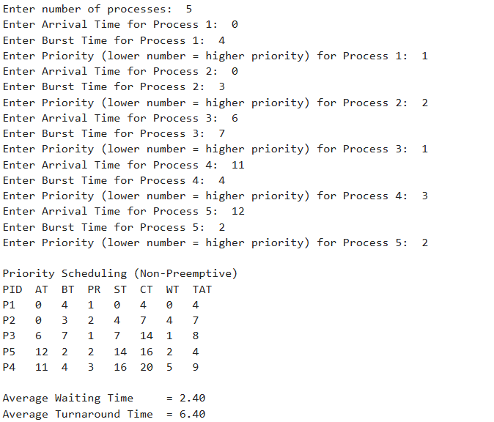
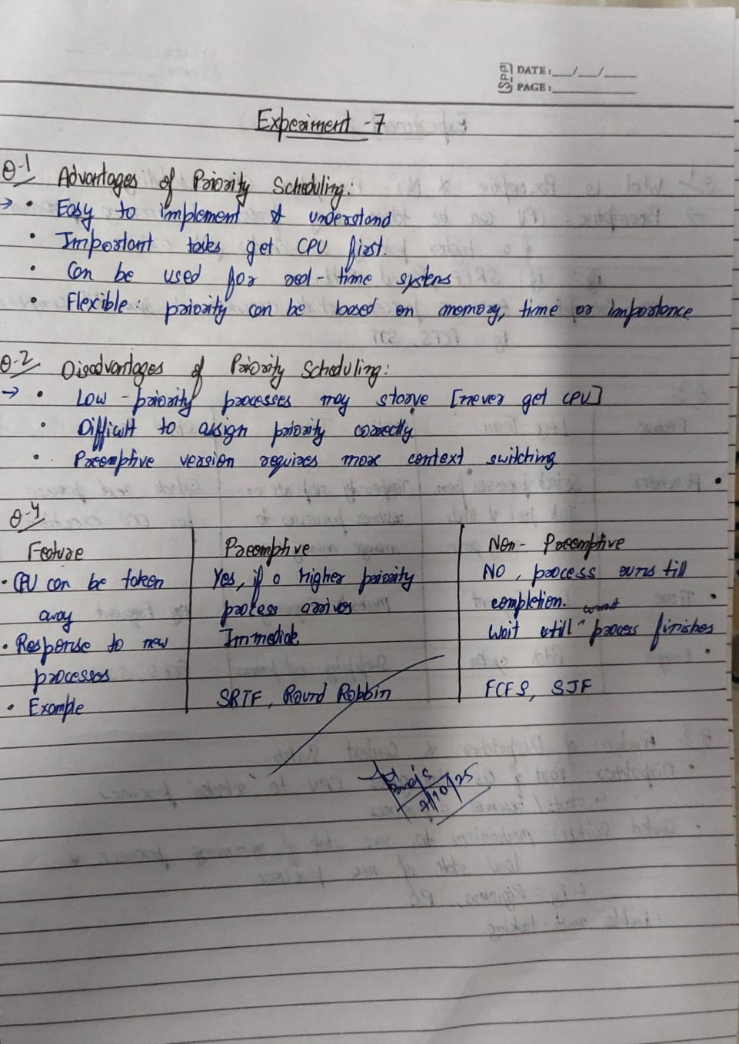
Experiment No: 8
Student Name and Roll Number: ISHA AGGARWAL 23CSU129
Semester /Section: AIML5B
Link to Code:
Date: 19 SEPTEMBER 2025
Faculty Signature:

Marks:

Objective: Objective
To familiarize the students about CPU scheduling Algorithms
Program Outcome
The students will understand the Round Robin Algorithm.
Problem Statement:
Implement the Round Robin Algorithm.
Background Study:
- In Round Robin each process is assigned a fixed time slot in a cyclic way and this is preemptive. It has a disadvantage of context switch and have quantum time
Question Bank:

- What is Preemptive and Non- Preemptive CPU scheduling? Explain with examples.
- Explain the difference between short term, long term and medium term scheduling.
- Explain the function of Dispatcher and Context Switch mechanism.
- What are the advantages and disadvantages of Round robin?
- Give the application are of Robin Robin.

Student Work Area
Algorithm/Flowchart/Code/Sample Outputs
# Round Robin Scheduling
n = int(input("Enter number of processes: "))
processes = []
for i in range(n):
at = int(input(f"Enter Arrival Time for Process {i+1}: "))
bt = int(input(f"Enter Burst Time for Process {i+1}: "))
processes.append([f"P{i+1}", at, bt, bt]) # last bt is remaining time
tq = int(input("Enter Time Quantum: "))
time = 0
queue = []
completed = 0
total_wt = 0
total_tat = 0
visited = [0]*n
print("\nRound Robin Scheduling")
print("PID AT BT CT WT TAT")

while completed < n:
# Add newly arrived processes to queue
for i in range(n):
if processes[i][1] <= time and visited[i] == 0:
queue.append(i)
visited[i] = 1
if not queue:
time += 1
continue
idx = queue.pop(0)
pid, at, bt, rt = processes[idx]
if rt > tq:
time += tq
processes[idx][3] -= tq
else:
time += processes[idx][3]
processes[idx][3] = 0
completed += 1
tat = time - at
wt = tat - bt
total_wt += wt
total_tat += tat
print(f"{pid:<4} {at:<3} {bt:<3} {time:<3} {wt:<3} {tat:<3}")
# Add newly arrived processes during execution
for i in range(n):
if processes[i][1] <= time and visited[i] == 0:
queue.append(i)
visited[i] = 1

# If process not finished, add it back to queue
if processes[idx][3] > 0:
queue.append(idx)
avg_wt = total_wt / n
avg_tat = total_tat / n
print(f"\nAverage Waiting Time = {avg_wt:.2f}")
print(f"Average Turnaround Time = {avg_tat:.2f}")
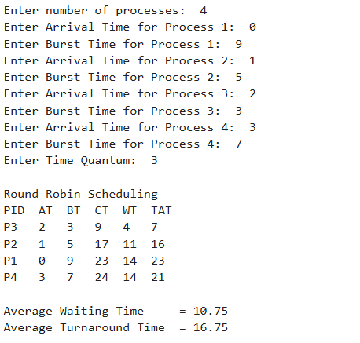

Experiment No: 9
Student Name and Roll Number: ISHA AGGARWAL 23csu129
Semester /Section: AIML5B
Link to Code:
Date: 17 OCTOBER 2025
Faculty Signature:

Marks:

Objective: Write a program to implement reader/writer problem using semaphore
Program Outcome
The students will understand the reader/writer problem using semaphore
Problem Statement:
Write a program to implement reader/writer problem using semaphore

Background Study: There is a shared resource which should be accessed by multiple processes. There are two types of processes in this context. They are reader and writer. Any number of readers can read from the shared resource simultaneously, but only one writer can write to the shared resource. When a writer is writing data to the resource, no other process can access the resource. A writer cannot write to the resource if there are non-zero number of readers accessing the resource at that time.

- An un-interruptible unit is known as ____________
a) single
b) atomic
c) static
d) none of the mentioned
- TestAndSet instruction is executed ____________
a) after a particular process
b) periodically
c) atomically
d) none of the mentioned
- Semaphore is a/an _______ to solve the critical section problem.
a) hardware for a system
b) special program for a system
c) integer variable
d) none of the mentioned
- What are the two atomic operations permissible on semaphores?
a) wait
b) stop
c) hold
d) none of the mentioned
- When several processes access the same data concurrently and the outcome of the execution depends on the particular order in which the access takes place is called ________
a) dynamic condition
b) race condition
c) essential condition
d) critical condition

Student Work Area
Algorithm/Flowchart/Code/Sample Outputs
import threading
import time
from threading import Semaphore
mutex = Semaphore(1)
wrt = Semaphore(1)
read_count = 0
is_writer_active = False
def reader(id):
global read_count, is_writer_active
for i in range(1, 6):
time.sleep(1)
print(f"Reader {id} wants to read...")
if is_writer_active:
print(f"Reader {id} is waiting — Writer is currently writing.")
mutex.acquire()
read_count += 1
if read_count == 1:
print(f"Reader {id} is blocking writers now.")
wrt.acquire()
mutex.release()
print(f"Reader {id} is reading... (Read {i}/5)")
time.sleep(0.7)
mutex.acquire()
read_count -= 1
if read_count == 0:
print(f"All readers done, writers can continue now.")
wrt.release()
mutex.release()
print(f"Reader {id} finished reading ({i}/5)\n")
time.sleep(0.5)
print(f"Reader {id} completed all 5 reads.\n")
def writer(id):
global is_writer_active
for i in range(1, 4):
time.sleep(2)
print(f"Writer {id} wants to write...")
if read_count > 0:
print(f"Writer {id} is waiting — Readers are currently reading.")
wrt.acquire()
is_writer_active = True
print(f"Writer {id} is writing... (Write {i}/3)")
time.sleep(1.5)
print(f"Writer {id} finished writing ({i}/3)\n")
is_writer_active = False
wrt.release()
time.sleep(1)
print(f"Writer {id} completed all 3 writes.\n")
r1 = threading.Thread(target=reader, args=(1,))
r2 = threading.Thread(target=reader, args=(2,))
w1 = threading.Thread(target=writer, args=(1,))
r1.start()
r2.start()
w1.start()
r1.join()
r2.join()
w1.join()
print("All Readers and Writers have completed their work successfully.")
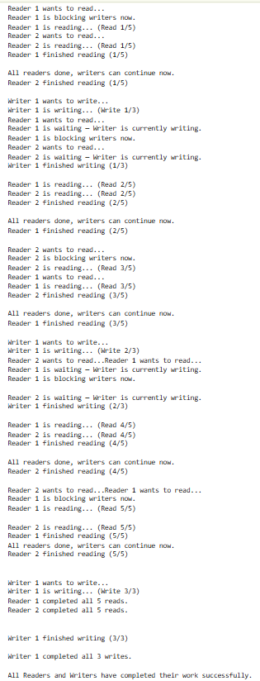

Experiment No: 10
Student Name and Roll Number: ISHA AGGARWAL 23csu129
Semester /Section: AIML5B
Link to Code:
Date: 14 NOVEMBER 2025
Faculty Signature:

Marks:

Objective:
Write a program to implement Dining Philosopher’s problem using semaphore
Outcome:
The students will understand the problem of synchronization among processes and its solution through Dining Philosopher’s problem using semaphore
Problem Statement:

Write a program to implement Dining Philosopher’s problem using semaphore

Background Study:
Five philosophers, spend their time thinking and eating spaghetti. They eat at a round table with five individual seats. For eating each philosopher needs two forks (the resources). There are five forks on the table, one left and one right of each seat. When a philosopher cannot grab both forks it sits and waits. Eating takes random time, then the philosopher puts the forks down and leaves the dining room. After spending some random time thinking he again becomes hungry, and the circle repeats itself.
Question Bank:

- Which one of the following is a synchronization tool?
a) thread
b) pipe
c) semaphore
d) socket
- A semaphore is a shared integer variable __________
a) that can not drop below zero
b) that can not be more than zero
c) that can not drop below one
d) that can not be more than one
- The bounded buffer problem is also known as ____________
a) Readers – Writers problem
b) Dining – Philosophers problem
c) Producer – Consumer problem
d) None of the mentioned
- In the bounded buffer problem ____________
a) there is only one buffer
b) there are n buffers ( n being greater than one but finite)
c) there are infinite buffers
d) the buffer size is bounded
- To ensure difficulties do not arise in the readers – writers problem _______ are given exclusive access to the shared object.
a) readers
b) writers
c) readers and writers
d) none of the mentioned

Student Work Area
Algorithm/Flowchart/Code/Sample Outputs
import threading
import time
from threading import Semaphore

n = 5 # number of philosophers
forks = [Semaphore(1) for _ in range(n)] # one semaphore for each fork

def philosopher(i):
for _ in range(3): # each philosopher eats 3 times
print(f"Philosopher {i} is thinking...")
time.sleep(1)

print(f"Philosopher {i} is hungry.")
# pick up left fork
forks[i].acquire()
print(f"Philosopher {i} picked up left fork.")

# pick up right fork
forks[(i + 1) % n].acquire()
print(f"Philosopher {i} picked up right fork and is eating.")
time.sleep(1)

# put down forks
forks[i].release()
forks[(i + 1) % n].release()
print(f"Philosopher {i} finished eating and put down forks.\n")

print(f"Philosopher {i} is done eating and leaves the table.\n")

threads = []
for i in range(n):
t = threading.Thread(target=philosopher, args=(i,))
threads.append(t)
t.start()

for t in threads:
t.join()

print("All philosophers have finished eating.")

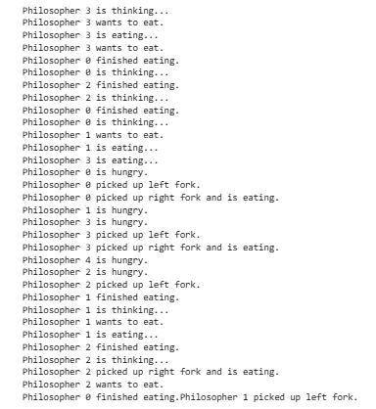

Experiment No:11
Student Name and Roll Number: ISHA AGGARWAL 23csu129
Semester /Section: AIML5B
Link to Code:
Date: 14 NOVEMBER 2025
Faculty Signature:

Marks:

Objective:
Write a program to implement Banker’s algorithm for deadlock avoidance.
Outcome:
The students will understand how system handles deadlock using Banker’s algorithm for deadlock avoidance
Problem Statement:
Write a program to implement Banker’s algorithm for deadlock avoidance.
Background Study:
The banker’s algorithm is a resource allocation and deadlock avoidance algorithm that tests for safety by simulating the allocation for predetermined maximum possible amounts of all resources, then makes an “s-state” check to test for possible activities, before deciding whether allocation should be allowed to continue. Banker’s algorithm is named so because it is used in banking system to check whether loan can be sanctioned to a person or not. Suppose there are n number of account holders in a bank and the total sum of their money is S. If a person applies for a loan then the bank first subtracts the loan amount from the total money that bank has and if the remaining amount is greater than S then only the loan is sanctioned. It is done because if all the account holders comes to withdraw their money then the bank can easily do it.

Question Bank:
- Each request requires that the system consider the _____________ to decide whether the current request can be satisfied or must wait to avoid a future possible deadlock.
a) resources currently available
b) processes that have previously been in the system
c) resources currently allocated to each process
d) future requests and releases of each process
- Given a priori information about the ________ number of resources of each type that maybe requested for each process, it is possible to construct an algorithm that ensures that the system will never enter a deadlock state.
a) minimum
b) average
c) maximum
d) approximate
- A deadlock avoidance algorithm dynamically examines the __________ to ensure that a circular wait condition can never exist.
a) resource allocation state
b) system storage state
c) operating system
d) resources
- A state is safe, if ____________
a) the system does not crash due to deadlock occurrence
b) the system can allocate resources to each process in some order and still avoid a deadlock
c) the state keeps the system protected and safe
d) all of the mentioned
- The two ways of aborting processes and eliminating deadlocks are ____________
a) Abort all deadlocked processes
b) Abort all processes
c) Abort one process at a time until the deadlock cycle is eliminated
d) All of the mentioned

Student Work Area
Algorithm/Flowchart/Code/Sample Outputs
def is_safe(processes, avail, max_need, alloc):
n = len(processes)
m = len(avail)

need = [[max_need[i][j] - alloc[i][j] for j in range(m)] for i in range(n)]

finish = [False] * n
safe_seq = []
work = avail.copy()

while len(safe_seq) < n:
allocated = False
for i in range(n):
if not finish[i] and all(need[i][j] <= work[j] for j in range(m)):
work = [work[j] + alloc[i][j] for j in range(m)]
safe_seq.append(processes[i])
finish[i] = True
allocated = True

if not allocated:
return False, []

return True, safe_seq

processes = [0, 1, 2]
avail = [3, 3, 2]

max_need = [
[7, 9, 3],
[3, 2, 2],
[9, 1, 2]
]

alloc = [
[0, 6, 0],
[2, 6, 5],
[3, 0, 0]
]

safe, seq = is_safe(processes, avail, max_need, alloc)

if safe:
print("System is in a SAFE state.")
print("Safe Sequence:", seq)
else:
print("System is NOT safe!")
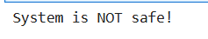

Experiment No: 12
Student Name and Roll Number: ISHA AGGARWAL 23csu129
Semester /Section: AIML5B
Link to Code:
Date: 14 NOVEMBER 2025
Faculty Signature:

Marks:

Objective:
Write a program for page replacement policy using a) LRU b) FIFO c) Optimal.
Outcome:
The students will understand concept of memory management through various page replacement policy using a) LRU b) FIFO
Problem Statement:
Write a program to implement page replacement policy using a) LRU b) FIFO c) Optimal.
Background Study:
In operating systems that use paging for memory management, page replacement algorithm are needed to decide which page needed to be replaced when new page comes in. Whenever a new page is referred and not present in memory, page fault occurs and Operating System replaces one of the existing pages with newly needed page. Different page replacement algorithms suggest different ways to decide which page to replace. The target for all algorithms is to reduce number of page faults.

Question Bank:

1. The main memory accommodates ____________
a) operating system
b) cpu
c) user processes
d) all of the mentioned
2. What is the operating system?
a) in the low memory
b) in the high memory
c) either low or high memory (depending on the location of interrupt vector)
d) none of the mentioned
3. In contiguous memory allocation ____________
a) each process is contained in a single contiguous section of memory
b) all processes are contained in a single contiguous section of memory
c) the memory space is contiguous
d) none of the mentioned
4. The relocation register helps in ____________
a) providing more address space to processes
b) a different address space to processes
c) to protect the address spaces of processes
d) none of the mentioned
5. With relocation and limit registers, each logical address must be _______ the limit register.
a) less than
b) equal to
c) greater than
d) none of the mentioned

Student Work Area
Algorithm/Flowchart/Code/Sample Outputs
#FIFO Page Replacement
def fifo(pages, frames):
memory = []
faults = 0

for p in pages:
if p not in memory:
if len(memory) < frames:
memory.append(p)
else:
memory.pop(0)
memory.append(p)
faults += 1
print(f"Memory: {memory}")

print("Total Page Faults:", faults)

pages = [7, 0, 1, 2, 0, 3, 0, 4, 2, 3]
fifo(pages, 3)
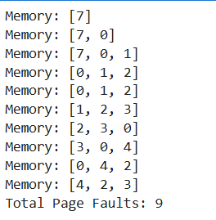

# LRU Page Replacement (Corrected)
def lru(pages, frames):
memory = []
recent = {}
faults = 0

for i, p in enumerate(pages):

# If page is not in memory → Page Fault
if p not in memory:
if len(memory) < frames:
memory.append(p)
else:
# Pick LRU only from pages inside memory
lru_page = min(memory, key=lambda x: recent.get(x, -1))
memory.remove(lru_page)
memory.append(p)

faults += 1

# Update recent usage
recent[p] = i

print("Memory:", memory)

print("Total Page Faults:", faults)

# Test
pages = [7, 0, 1, 2, 0, 3, 0, 4, 2, 3]
lru(pages, 3)
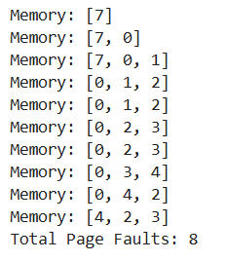
#Optimal Page Replacement
def optimal(pages, frames):
memory = []
faults = 0

for i in range(len(pages)):
p = pages[i]

if p not in memory:
if len(memory) < frames:
memory.append(p)
else:
farthest = -1
index_to_replace = -1

for m in memory:
if m in pages[i+1:]:
pos = pages[i+1:].index(m)
if pos > farthest:
farthest = pos
index_to_replace = memory.index(m)
else:
index_to_replace = memory.index(m)
break

memory[index_to_replace] = p

faults += 1

print("Memory:", memory)

print("Total Page Faults:", faults)

pages = [7, 0, 1, 2, 0, 3, 0, 4, 2, 3]
optimal(pages, 3)
