Individual Guide: A Friendly Guide
  - Start here, learn by doing, and find the task you need
Individual Guide project documentation
Beginner edition · Release 0.7.0 · 23 October 2026
Table of Contents

1 Welcome to Individual Guide
You can use Individual Guide without knowing R. The app helps you bring in data, clean it, make charts, and share results. You choose settings in forms. The app does the calculations for you.
Think of a project as a recipe. Your data are the ingredients. Each task is one step, such as sorting rows or drawing a chart. A flow, also called a pipeline, puts those steps together. You can save the recipe and use it again.
This guide covers Individual Guide 0.7.0, with 58 task types and 22 example projects. Start with installation and the first project. After that, read the task pages you need. You do not need to read the book from start to finish.

1.1 Find your starting point
What you want to do | Where to go
Install the Windows app | Installation and first launch
Try the app with ready-made data | Your first project
Bring in your own spreadsheet or CSV | Importing your data
Find a task and a matching example | Task finder
Make a report with a log | Reports and files
Fix a problem | Troubleshooting
Run the app through R instead | Optional: install with R

1.2 Six words you will see often
Word | Meaning in the app
Project | Your saved work: data, tasks, results, and notes
Table | Data arranged in rows and columns, like a spreadsheet
Task | One step that does a job
Flow | A group of connected tasks
Output | A result from a task, such as a table or chart
Log | A record of what happened when tasks ran
For example, a flower project can start with measurements, calculate a mean, draw a chart, and make a report. The arrows show which steps need results from earlier steps.
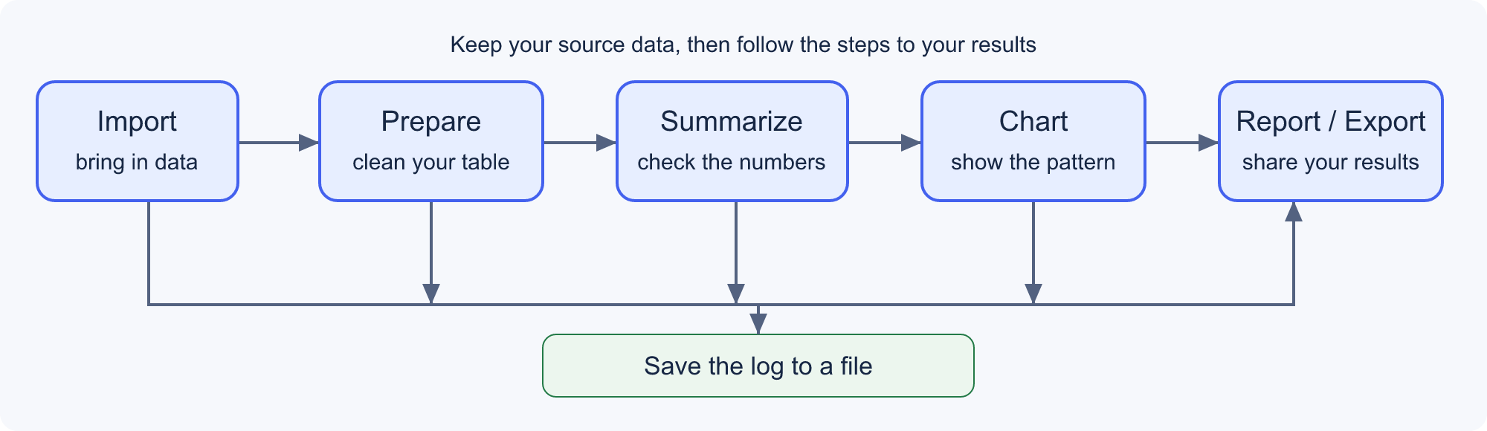
Figure 1. A flow takes data through tasks to results, reports, and a saved log.

1.3 How to follow this guide
Bold words, such as Run, name buttons or choices. File > Save project as… means open the File menu, then choose Save project as. The dots mean that another window will open. Text such as flowers is a name to type exactly.
The Windows app has menus across the top. If you open the app through R in a web browser, use the buttons inside the app for opening and saving projects. Some desktop features, such as restarting the R server from a menu, are only in the Windows app.
Some browser controls are icons. Point to an icon to see its name, such as Save project or Help.
The HTML book works offline after you download it. Use Find a chapter or task in its contents, or press Ctrl+F to search the page. The PDF is useful for printing. EPUB works in an e-reader, and Word lets you add your own notes.
Read the same guide in English or Français (Canada). Both editions have the same chapters, examples, and steps, with screenshots in their own language. Use the same language for the app and the guide so the buttons match the pictures.

2 Installation and first launch
For most Windows users, the Setup installer is the easiest choice. It includes R and the extra software the app needs. You do not need to install R or RStudio separately.

2.1 Download the public Windows release
You need a 64-bit Windows 10 or Windows 11 computer. Allow about 1.5 GB for the program, plus space for your projects. You need an internet connection to download Setup. The installed app and its examples can then work offline. Tasks that use an online database still need that connection.
- Open the public releases page.
- Under Assets, download IndividualGuide-0.7.0-Setup-Windows-x64.exe for this edition. If a newer release is shown, read its notes before choosing it. Find this book’s matching installer on the 0.7.0 release page.
- Close any running copy of Individual Guide. You do not need the files called Source code to use the desktop app.
- Double-click the downloaded Setup file. Choose English or Français (Canada) when it asks for a language, then follow its instructions. The usual installation is for your own Windows account.
- Open Individual Guide from the Start menu or desktop shortcut.
The installer is unsigned. Windows may show an unknown-publisher warning. Check that you downloaded it from woodtho/IndividualGuide before deciding whether to continue. If your work or school computer blocks it, ask your support team for help.

2.2 Open the app each day
Use the Start menu or desktop shortcut. Setup installs or updates the program; you do not need to run Setup each time.
The first launch may take longer than later launches. Wait while the startup screen shows its progress. The welcome screen then offers three choices. For the first exercise, choose Start with a blank canvas. This opens the workspace and makes the Help menu available.
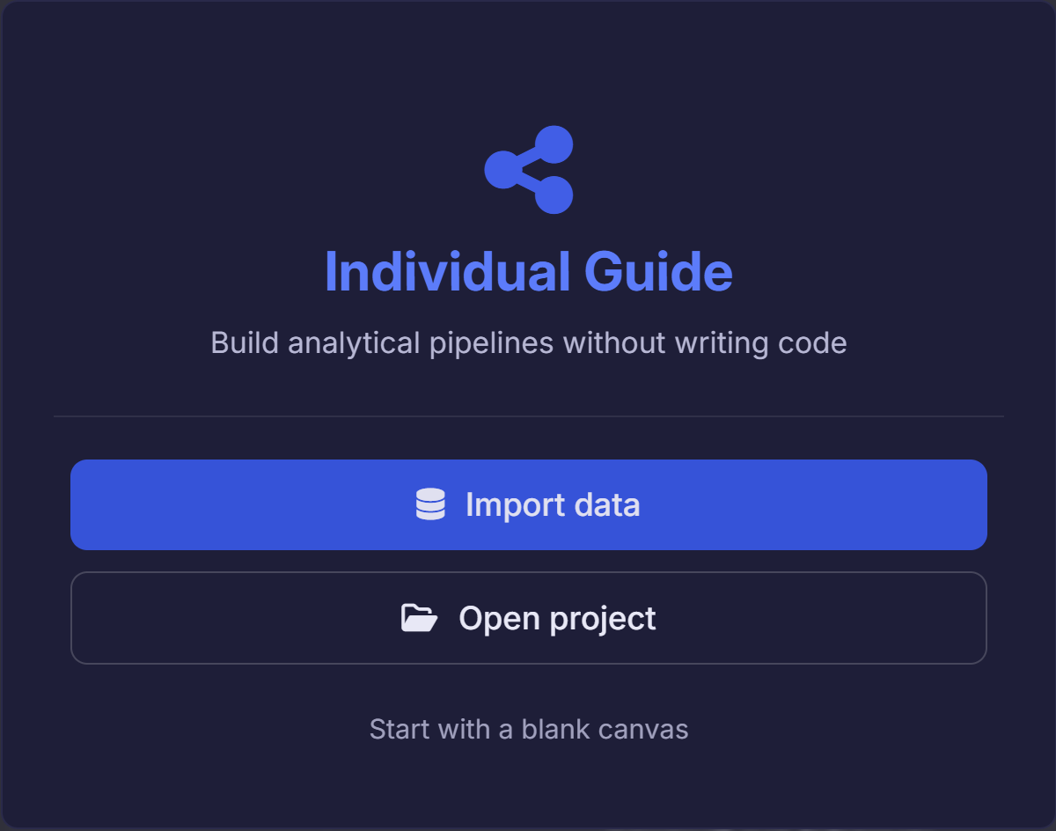
Figure 2. At the welcome screen, choose Start with a blank canvas to reach the workspace and its Help menu.
If startup stops with an error, choose Open startup log. See Troubleshooting for the next step. Repeatedly opening more copies usually does not help.

2.3 Choose or change your language
The app supports English and Canadian French. The Windows installer passes your choice to the app. You can change it later without restarting R or reopening the project.
- Choose English or Français (Canada) in the language list on the welcome screen or beside the app name.
- In the desktop app, you can also use the Language menu. In Settings, search for Interface language, then select Edit and Save option for a global default or project override.
- Check that the buttons and menus use your chosen language. The app remembers it on this computer.
The Language menu sets your global language. A project can override it in Settings. Your data, column names, file paths, formulas, and names you entered stay as you typed them. R commands and technical identifiers keep the spelling that R needs.

2.4 Update the app
- Save your project and close the app.
- Visit the public releases page.
- Download and run the newer Setup installer.
- Open the app from its shortcut. Check Help > About Individual Guide… to see the installed version.
The app does not update itself. Updating keeps saved projects and settings, but keep your own backup of important project files. Uninstalling through Windows removes the program and keeps separately stored user data.

2.5 Before your first project
Create a folder you can find again, such as Documents > Individual Guide Projects. Use it for saved projects and files you export. Give each project a clear name, such as flower-practice.igpx.
The file ending .igpx means an Individual Guide project. Open it through File > Open project…, or double-click it in Windows after installing the app.
You are ready to try your first project. The optional R installation steps are near the end of this guide; the Windows app does not need them.

3 Your first project
Start with an example that already works. You will open flower data, find a chart, check a report, and save your own copy. No typing of R code is needed for this first part.

3.1 Open the flower example
- If the welcome screen is still open, choose Start with a blank canvas.
- In the desktop app, choose Help > Application help. In a browser, select the Help button in the app header.
- Open Example projects and search for Iris exploration.
- Choose Open example. If an unsaved-work prompt appears, choose Cancel and save your current work before trying again. In the desktop prompt, Discard replaces the current work; the browser app calls this Discard and open example.
- Choose File > Save project as…. Save the project as flower-practice.igpx in your projects folder. In a browser, select Save project and choose the name and folder in the file picker that opens for this unsaved example.
Iris is a kind of flower. The example has measurements from 150 flowers in three species, with 50 flowers per species. Each row is one flower. The four measurement columns use centimetres. Species names the flower’s group.
Opening an example gives you a separate working copy. You can change it without changing the example that ships with the app. Save your copy if you want to keep those changes.
An example may show a software-version notice because its saved run came from another setup. You can inspect the saved results first. Before rerunning, check the export folders, then use the new task logs to check how the work runs on your computer. The review tools explain run records if you need to compare versions.

3.2 Look around before running anything
The left side lists the project’s tasks and data. The Flow tab shows connected steps. Select the source task and read its notes. Open its flower table and look at the column names.
The example uses labels that describe each step’s job. Select Summarize measurements, Compare mean petal length by species, and Explore relationships to open the Summary Statistics, Summary Tables, and Scatter Plot tasks. The task type appears in each panel. Open Results to inspect the saved result before running anything again. Names given to steps within a project stay in their original language.
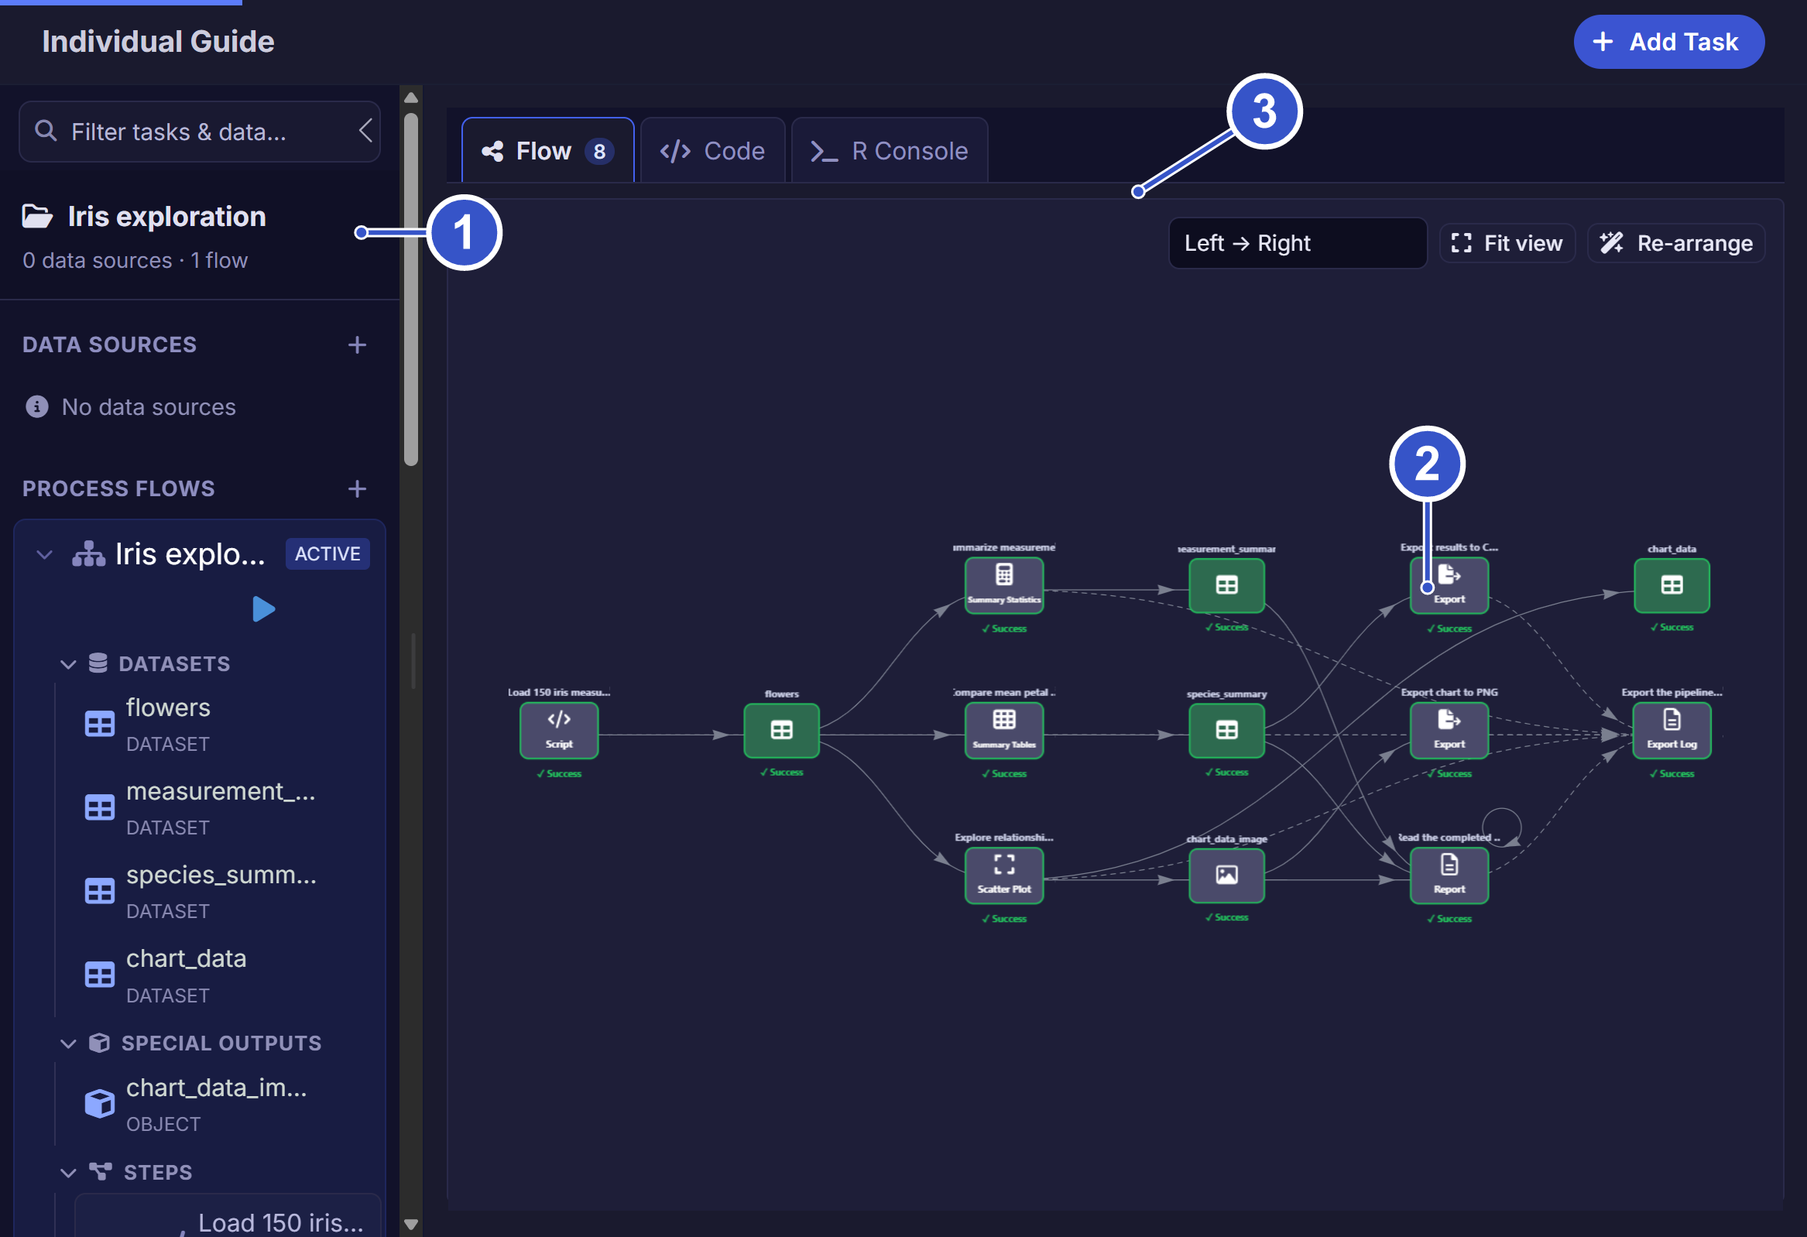
Figure 3. Callout 1 marks the project tree; 2 marks the connected flow; 3 marks the Flow, Code, and R Console tabs. Select a task to open its settings.
For the species summary, the mean petal lengths should be about:
Species | Mean petal length, in centimetres
setosa | 1.462
versicolor | 4.260
virginica | 5.552
You do not need to memorize these values. They give you a way to check that you are viewing the right table and settings.
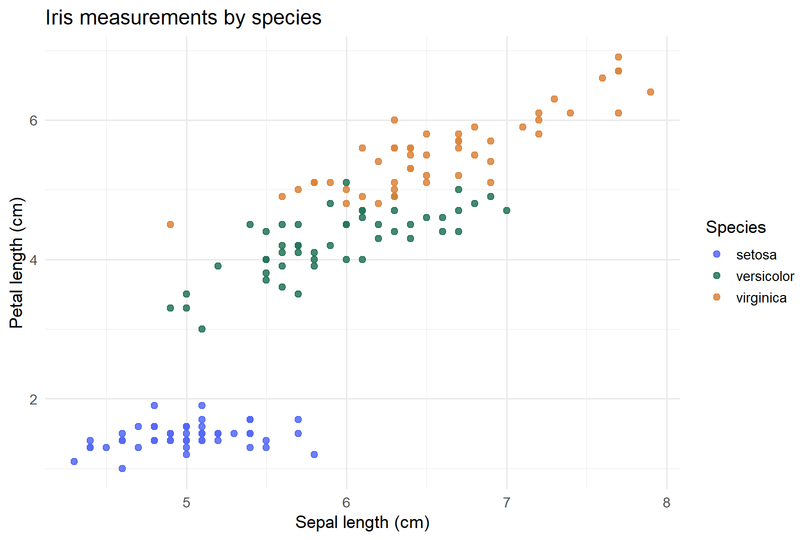
Figure 4. The flower example compares sepal length and petal length. Colour shows the species.

3.3 Make one small change
- Open the Scatter Plot task.
- Under Setup, change Y / value from Petal.Length to Petal.Width.
- Scroll down within Setup. Change Title to Petal width by sepal length. Set Y label to Petal width (cm).
- Click Run in the task header. Open Results and check the new chart.
- Open the Report task and select Generate Report so its chart matches your change.
- Choose File > Save project or press Ctrl+S.
Check that the vertical axis is labelled Petal width (cm). The source petal widths range from 0.1 to 2.5 centimetres.
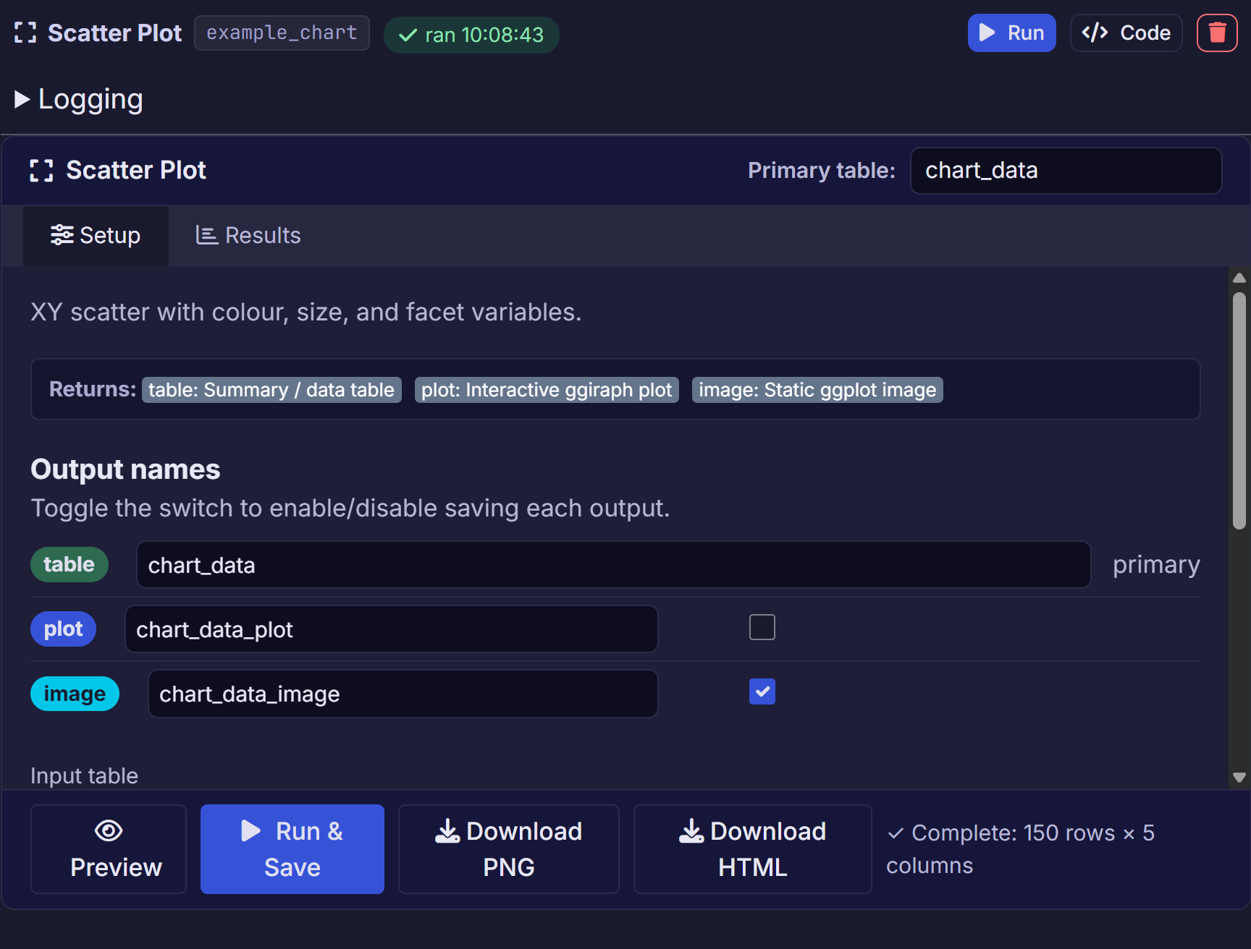
Figure 5. Start from these Scatter Plot settings and change Y / value to Petal.Width. Save Static ggplot image keeps a picture for the report.
Changing a setting does not update a saved report by itself. Run the changed task, then the later tasks that use its result. If you want to run everything again, use the flow’s play button. Before doing that, check the Export tasks’ folders and Overwrite settings.

3.4 Find the report and log
- Open the Report task. Under Appearance, select Include pipeline log in the report.
- Select Generate Report, then Download HTML. Save the file in your projects folder and open it in a browser.
- Check its headings, tables, chart, and Pipeline execution log section. The downloaded report is a separate file from the project.
Open Export Log to see how the example writes its log to a file. Before running this task, choose a destination you can find. Logs can include earlier runs as well as the latest one. Dates and times help you tell them apart.

3.5 Build a small flow yourself
This optional exercise builds the same kinds of results from a new project. It includes one short piece of R code that you can copy exactly. You do not need to understand the code to finish the exercise. Stay with the ready-made examples if you prefer.
Start with an empty project. In the Windows app, choose File > New project and save it as first-iris.igpx. In a browser, save your current work, refresh the page, and choose Start with a blank canvas. Then use Save project to create first-iris.igpx.
Use Add Task to find each task below. Task labels help you recognize a step. Output names tell later steps which result to use, so type those names carefully.

3.5.1 Step 1: load the practice data
- Select Add Task, open General, and choose Script.
- In the task header, set Primary table to flowers.
- Under Setup, leave Input tables / special outputs blank. This step supplies its own data.
- In Outputs, type flowers: table on one line. This tells the app to keep a table named flowers.
- Paste the following into R code, not the R Console:
flowers <- datasets::iris
log_event(sprintf("Loaded %d flowers", nrow(flowers)), "INFO")
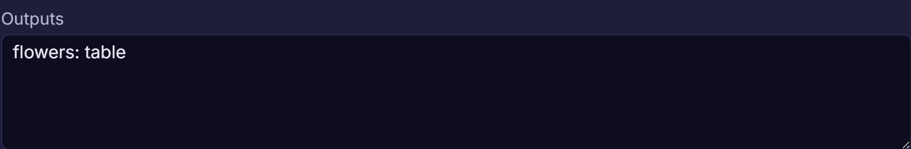
Figure 6. In Outputs, flowers: table declares the table to keep. Its name matches flowers in the copied code.
Click Run. Select flowers under DATASETS in the project tree and check for 150 rows and five columns. If it is missing, make sure Outputs contains flowers: table. The name must match the name in the copied code.

3.5.2 Step 2: summarize the measurements
- Select Add Task > Describe > Summary Statistics.
- Under Setup, select flowers in Input table.
- In Numeric columns, choose Sepal.Length, Sepal.Width, Petal.Length, and Petal.Width.
- Leave Save checked and enter measurement_summary in Output table.
- Select Analyze, then open Results.
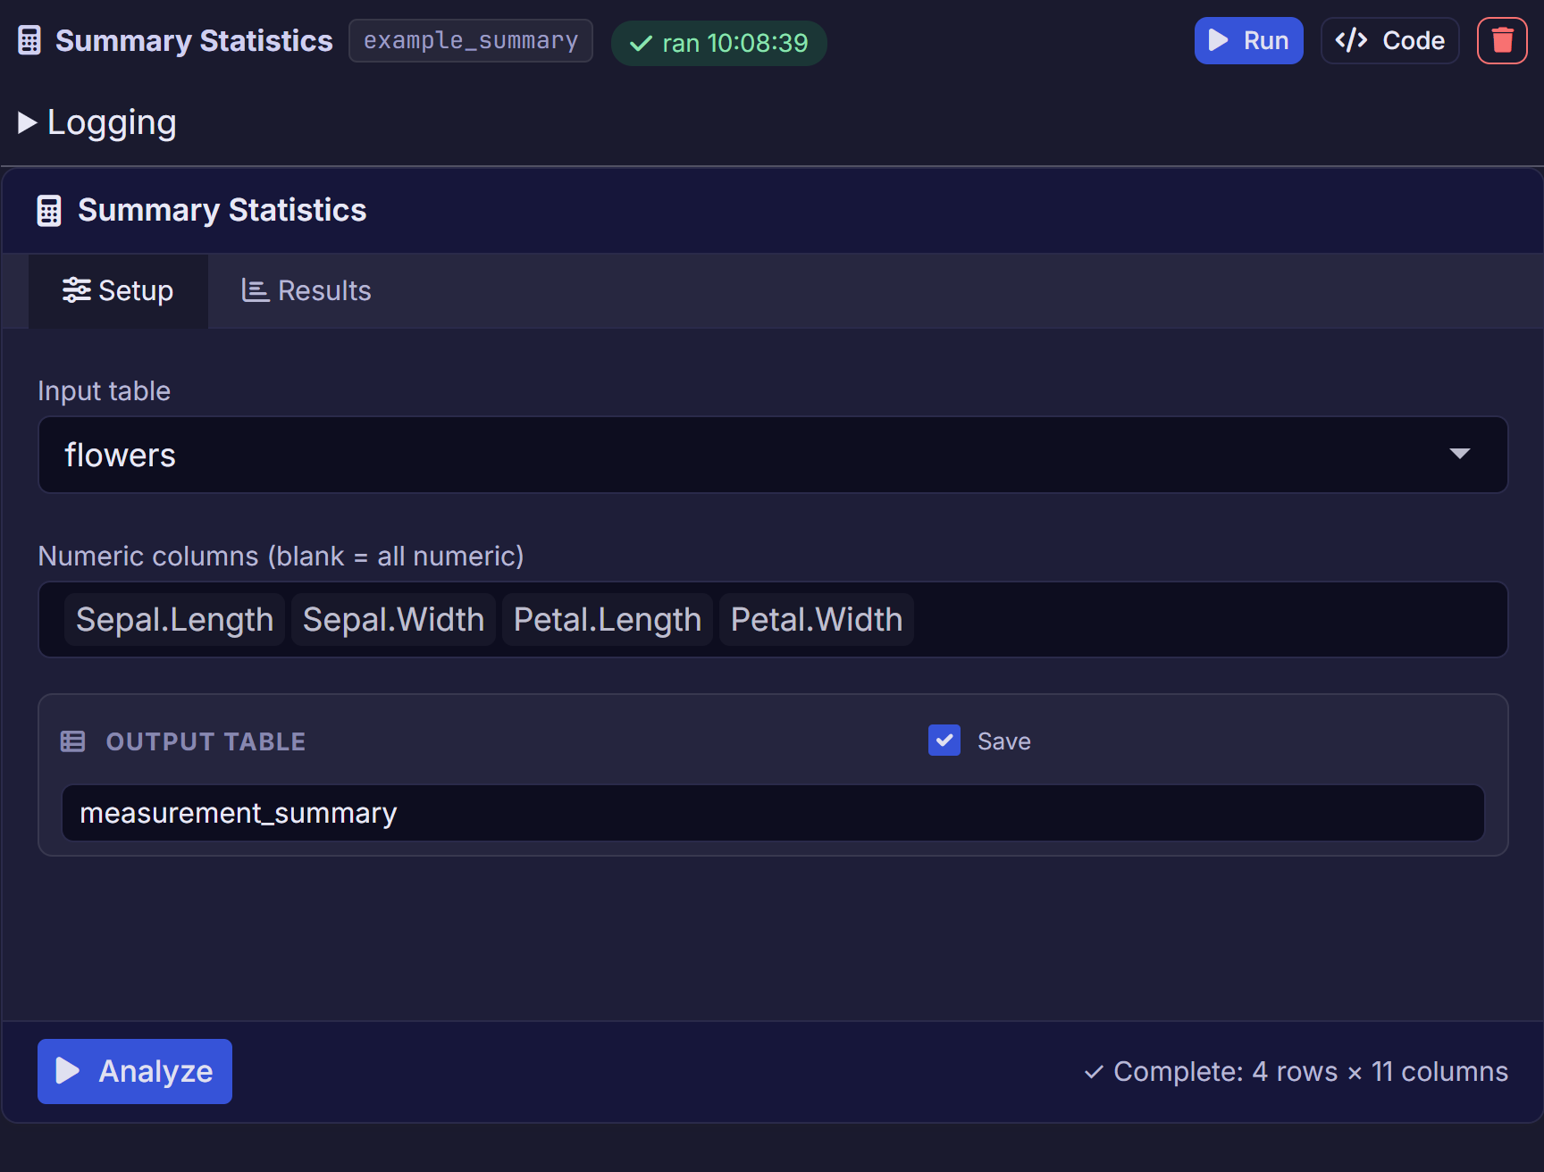
Figure 7. Summary Statistics needs an input table and numeric columns. The Save checkbox keeps its Output table for later tasks.
Under Results, select Data to read the saved table. Check the mean for Sepal.Length. It should be about 5.8433. A mean is the total divided by the number of values. The app may show fewer decimal places.

3.5.3 Step 3: compare the three species
- Select Add Task > Describe > Summary Tables.
- Under Setup, choose these settings:
Setting | Choice
Input table | flowers
Row variable | Species
Value variable | Petal.Length
Summary statistic | Mean
Output table | species_summary
- Leave Save checked and select Analyze.
- Open Results > Data and compare the three means with the table earlier in this chapter.

3.5.4 Step 4: draw the chart
- Select Add Task > Graph > Scatter Plot and choose flowers in Input table.
- Set X / category / date to Sepal.Length, Y / value to Petal.Length, and Group / colour to Species.
- Set Title to Iris measurements by species.
- Near the top of the panel, check Save Static ggplot image. Set Output name for Static ggplot image to iris_scatter_image.
- Select Run and open Results. Check for a chart like Figure 4.
A static image is a still chart that you can put in a report or export as PNG. The word ggplot names the chart tool; you do not need to learn it.

3.5.5 Step 5: save a table and chart as files
- Select Add Task > Output > Export. Choose species_summary in Output to export and CSV in Format.
- Select Choose folder… and choose your projects folder. In File name (without extension), type species-summary.
- Select Export and check for species-summary.csv in that folder.
- Add another Export task. Select iris_scatter_image, choose PNG, and use the same folder.
- Enter iris-scatter without the file ending. Set DPI to 150, select Export, and open iris-scatter.png.
DPI controls how many dots are used per inch. Check the text in the finished image before sharing it.
An existing file can block an export. Choose a new name, or enable Overwrite if the file already exists when you mean to replace it. An exported file is separate from your saved project.

3.5.6 Step 6: make a report
- Select Add Task > Output > Report. Under Content, add measurement_summary, species_summary, and iris_scatter_image. Give the items clear section headings.
- Under Appearance, choose HTML in Output format and set Report title to First Iris report.
- Select Include pipeline log in the report and leave Minimum log level at INFO.
- Select Generate Report, then Download HTML. Open the downloaded file and check for the two tables, the chart, and Pipeline execution log.

3.5.7 Step 7: save the log
A full path includes the folder address and filename together. Use your own projects folder; the practice folder shown in screenshots is only an example.
- Select Add Task > Output > Export Log.
- In Run after and include these tasks, select the preceding tasks, including Report, so it waits for them.
- Choose CSV. In Destination file path, enter the full path to iris-log.csv inside your projects folder. For example, use the folder’s address from Windows File Explorer, followed by /iris-log.csv.
- Run the active flow. Open the CSV and check for Loaded 150 flowers and the Report completion entry.
The report’s own log section is made before the report finishes. The final Export Log can record that later completion.

3.5.8 Step 8: close and reopen your work
- Choose File > Save project to save first-iris.igpx.
- Choose File > Close project, then File > Open project… and select that file. In a browser, use Open project in the app header after saving.
- Check that its table, chart, and report are still there. You have made a reusable flow with data, results, a report, and a log.

4 Find your way around
The project list, flow diagram, and task panels show the same work in different ways. Use whichever makes the next step easiest to find.

4.1 Open a task or result
Select a task in the project list or flow to open its panel. Its settings control what it does. Results show what happened when it last ran. Expand Logging to read recorded entries and set messages. Code, where offered, shows the R instructions; reading it is optional.
Closing a task tab hides that panel. It does not delete the task. Use the task’s delete action only when you want to remove the step itself.
If the diagram becomes crowded, choose View > Task list in the desktop app. In a browser, select Project tools, then Task list. Search for the step you need and open it from the list. Use Fit view to bring the whole flow back into view.

4.2 Set up and keep a task result
Most task pages in this guide start after you have opened a project and run the step that supplies the input table. To add a task, select Add Task, choose its category, then select its name. The Task finder lists those categories.
- Open Setup when the task has that tab. Choose the input table before choosing columns. A column list can stay empty until its input has run.
- Enter a unique output name. Keep any Save checkbox beside a wanted result checked. A result that is only displayed may not be available to a later task.
- Select Run in the task header. Some forms also have a more specific button, such as Analyze, Load, Export, or Generate Report. This guide uses that button name when helpful.
- Open Results, Data, or Preview, as directed. Check values and messages before moving on.
- Save the project to keep your work on disk. A task’s Save checkbox and Save project do different jobs.
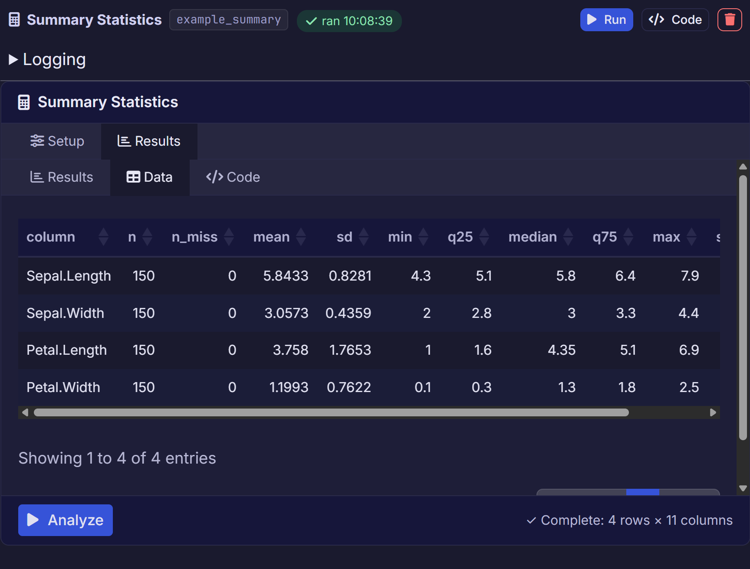
Figure 8. Under Results, the Data tab shows one row per numeric measurement. Check the mean and missing count before using the table in a report.
A form may scroll. If you cannot find an output control, look near the top of the task panel. If you cannot find its action button, look near the bottom. Screenshot colours may differ from your chosen theme; the labels and steps are the same.
Screenshots use a separate practice folder. Choose the folder you created during installation when your file address differs from the picture.

4.3 Understand the arrows
A later task needs the right input name. For example, a summary that uses flowers must wait for the task that creates flowers. The app draws the connection from those choices.
Dragging a task to a new place changes the layout. It does not change which tasks run first. To change that, edit its inputs or its branch and loop settings.

4.4 Choose useful names
Give tasks clear labels, such as Remove repeated customer rows. Use short, unique output names, such as customers_clean. After changing an output name, check later tasks’ inputs and rerun the flow.

5 Save, reopen, and share projects

5.1 Save your project
Use File > Save project or Ctrl+S in the desktop app. The first save asks for a name and folder. Use File > Save project as… to keep a separate copy before a large change.
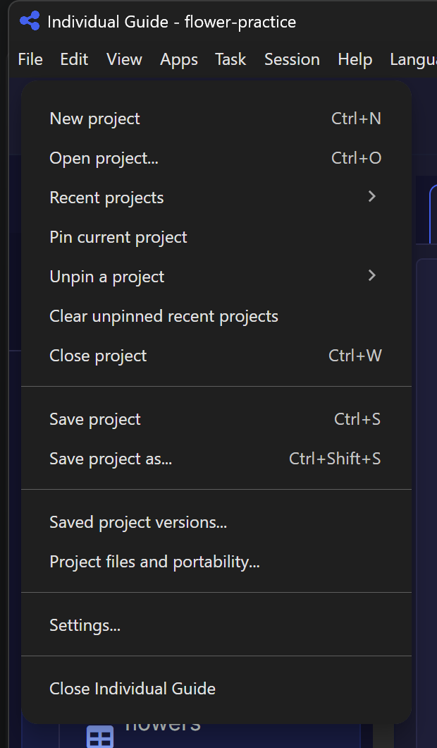
Figure 9. The File menu groups project saving, saved versions, portability, and settings. Use Save project as to make a separate copy.
In a web browser, use the app’s Save controls. Follow its file picker or download prompt and check where the file was saved.
A saved project keeps tasks, settings, available results, notes, and retained task logs. It does not automatically copy every outside file used by your tasks. Keep important input files in a stable folder.

5.2 Move work to another computer
- Save the project, then choose File > Project files and portability… in the desktop app. In a browser, open Project tools, then its project-files option.
- Check the list of outside files. Resolve missing files before making a portable copy.
- Select Save portable project to bundle supported inputs with the project.
- Open the copy on the other computer and check its inputs before running it.
Database connections still need access to the database. A Script may refer to a file that the portable export cannot find on its own. If so, include that file separately and update the path. A path is the address of a file or folder on your computer.
Reports and files that you already exported are separate copies. Saving the project again does not update those copies. Run the relevant Report or Export task when results change.

5.3 Recover interrupted work
The app keeps recovery information for unsaved work. After a crash or restart, it may offer a recovery copy. Read the prompt, recover the work you need, then save it with a clear filename.
Recovery helps after a problem. Keep using Save during normal work. If you need an earlier saved copy, choose File > Saved project versions… in the desktop app, or Saved versions from the browser app’s Project tools. Check the version date before restoring it.
- Save your current project before opening its saved versions.
- Open Saved project versions… for the project you mean to restore. Select Previous saved version by its date and time.
- Select Restore selected version. This opens the earlier work as an unsaved copy.
- Check its results, then use Save project as… to keep it under a separate name. Save project writes the restored work back to the current project file.

5.4 Share a project with care
A project can contain data, paths, logs, and R code. Share only information you mean to share. Open projects from people or sources you trust, because running tasks can run code and write files.
Before sending a project, save it, check its report, and try opening your saved copy. If the recipient only needs the results, send a report or CSV instead of the full project.

6 Run tasks and check results
Start with one task while you are learning. Once each step works, run the whole flow.

6.1 Run, Preview, and Save do different jobs
Action | What it does
Preview | Lets you inspect a trial result where the task supports it
Run or Run & Save | Runs the task and keeps its result in the project
Run flow | Runs connected tasks in the active flow
Save project | Writes your project to its .igpx file
After a Preview, use Run to keep the result. After running, use Save to keep the project on disk. A Script can write outside files even during a preview, so preview only code you trust.

6.2 Check the task status
A successful status means the task finished. Open its result to make sure it answered your question. An error means it needs attention. Expand Logging and read its recorded error entries.
A stale result means an input or setting has changed since that result was made. Run the affected task and the later tasks that use it. An old report may still open while it waits to be rebuilt.
A skipped task may belong to a branch that was not chosen. A waiting task may need an earlier task to finish. Check inputs and branch settings before treating either state as a failure.

6.3 Run the right part of a project
Use the flow’s play button to run the active flow. Check which flow is selected if your project has more than one. Right-click a task for Run to here or Run from here when those actions are available. These follow task connections, rather than the positions of shapes on the screen.
- In the desktop app, choose Task > Validate active flow… before a long run. In a browser, select Validate active flow in the app header.
- Read the listed problems. Close the dialog and correct any missing inputs or invalid settings.
- Validate again. Once the setup is ready, choose Task > Run active flow or use the flow’s play button.
Validation checks the setup. It cannot prove that your data or conclusions are correct.
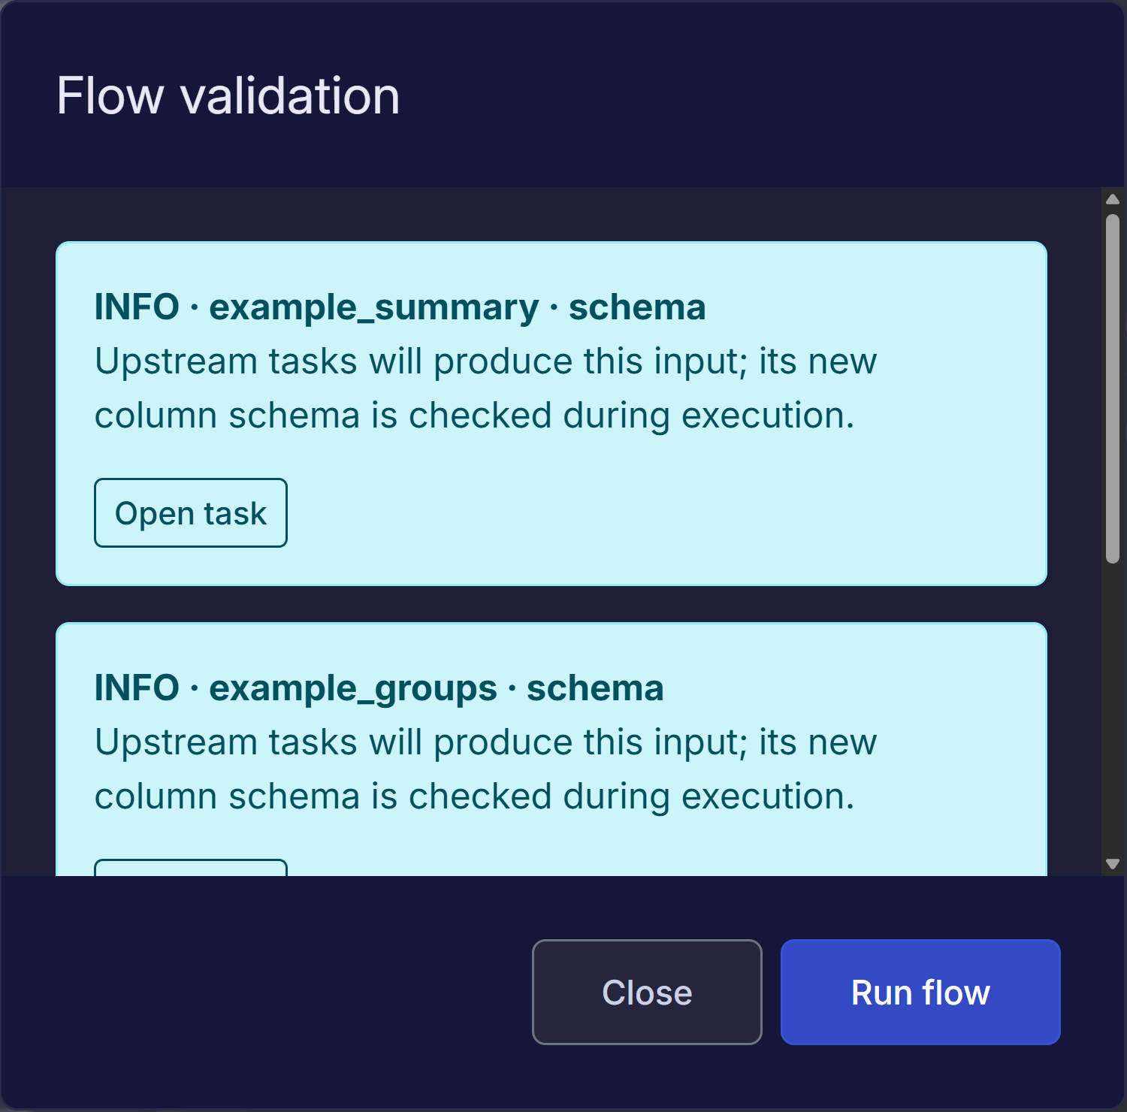
Figure 10. Validation lists problems or information about checks that will run later. Read each message and resolve blocking items before continuing.

6.4 Stop a run
Use Stop or Task > Stop run in the desktop app. Some work may need to finish its current step before it can stop. Wait for the status to change before starting another run.
Stopping does not undo files that tasks already wrote. Check export folders before running again. If you want to avoid replacing files, use new filenames or turn off Overwrite.

7 Importing your data
For a first import, use a small CSV or Excel sheet with one header row. Give every column a name. Keep titles, footnotes, and totals outside the data area.

7.1 Import Data
Use Import Data to bring a file or database table into the project.
- Select Add Task > Data > Import Data. Under Setup, choose File in Source.
- Select Browse… and choose your file. The app detects its type from the selected file.
- For CSV or other text files, check Delimiter and First row is header. A delimiter separates columns, often with a comma or tab. Open More file settings only if you need to change options such as text encoding.
- For Excel, choose the sheet and any row or range settings shown after selecting the file.
- Select Preview. Each field should be in its own column, with the right names and values.
- Enter a clear Output table name, such as sales_raw, then select Run import.
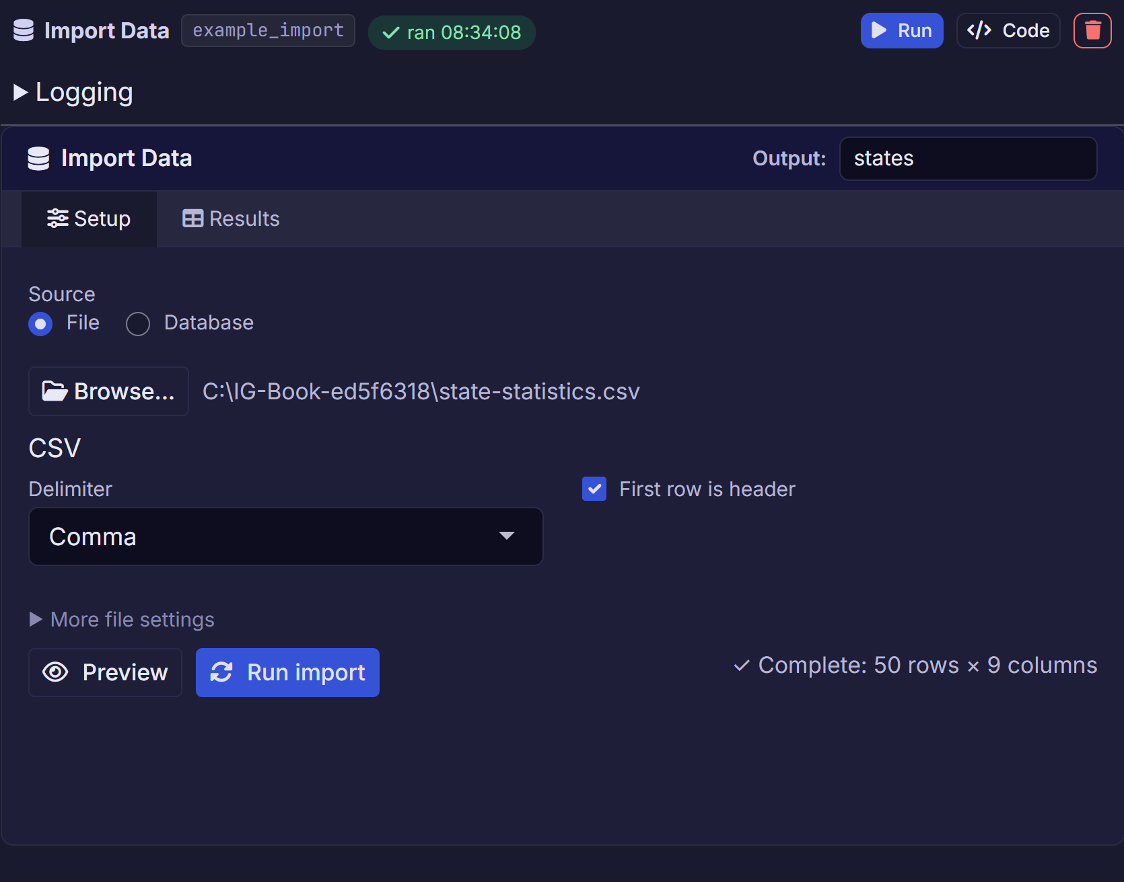
Figure 11. Import Data detects the selected CSV and offers delimiter and header settings. Preview it before running the import.
Open the new table and check its row count. Check dates, missing values, and identifiers such as postal codes. If an ID starts with zero, keep it as text so the zero is not lost.
Selecting a different file suggests a new output name based on that filename. Check Output table name again before rerunning an existing import. Later tasks still need the name they were set up to use.
If all values land in one column, check the separator. If the names become the first data row, check the header setting. If letters look wrong, try the file’s text encoding. The US states - import, join and filter example uses a real bundled CSV that you can inspect without finding your own file.

7.1.1 Keep zeros at the start of an ID
Use this when a CSV contains IDs such as 001 and you need to preserve their exact text.
- Select the CSV, then open More file settings.
- In col_types, type one lowercase c for each column, without spaces or quotes. Use cc for a two-column file or cccc for four columns. Each c tells the app to read that column as text.
- Preview the file and check that 001 still has its zeros. Confirm the output name, then select Run import.
- Use Change Column Types afterwards to convert measurement columns to numeric. Leave the ID column as text.
Use this option only when you need it. Reading every column as text means measurements need conversion before numeric charts or models can use them.

7.2 Work with a database
Ask the person who manages the database for its connection details and a small table to practise with. A driver lets the app connect to that kind of database. A DSN is a named connection set up on your computer.
- In Import Data > Setup, choose Database in Source.
- If a suitable Saved connection exists, select it and choose Load. Otherwise, choose Form under Connection and enter a clear Connection name.
- Choose Driver using your database contact’s advice. For a SQLite file, choose RSQLite::SQLite() and enter its full path in Database / file. For ODBC, choose odbc::odbc() and use the supplied DSN or connection details.
- Open More connection settings if you need Host, Port, or User. Enter a password only when the app requests it during connection.
- Enter Table and Schema, if required. Use Use SQL query only when you have a suitable query to paste into SQL.
- For a small, fixed practice copy, check Collect into memory immediately. This loads the result and closes the connection. Leave it off only when you intend to keep a live database reference.
- Set Output table name, select Preview, and check the columns. Select Run import, then check the saved table and row count.
Start with a small table or query. A live database result still needs its connection when later tasks use it. Record the date of a fixed copy when that matters to your report. A failed connection may mean an incorrect address, missing driver, or account restriction; use the exact error when asking your database contact for help.
The Windows app includes its normal app packages. An R-only installation may need a database package and a separate system driver. The optional R setup explains where to get packages. Do not put passwords in a report, log message, or shared Script.

8 Select, join, and calculate data
These tasks help you choose the rows and columns you need. Run the input task first so column lists can show its results.

8.1 Query Builder
Use Query Builder when you need to choose columns, join tables, filter rows, or make grouped totals in one task.
- Select Add Task > Data > Query Builder. In Select Data, choose the Primary input table.
- Use the plus buttons under Available columns to add columns to Selected columns. Use All if you need every column.
- If you need another table, open Join Tables > Add join. Choose the Right table, Join type, and matching key columns, then select Add join in the dialog.
- Use Filter Data > Add condition to keep matching rows. Use Sort Data > Add sort to choose their order.
- Enter an Output table name. Select Preview (1 000 rows) and inspect Results, then select Run & save to keep the full result.
A join matches rows using a shared key, such as a customer number. A left join keeps the rows from the first table and adds matches from the second.
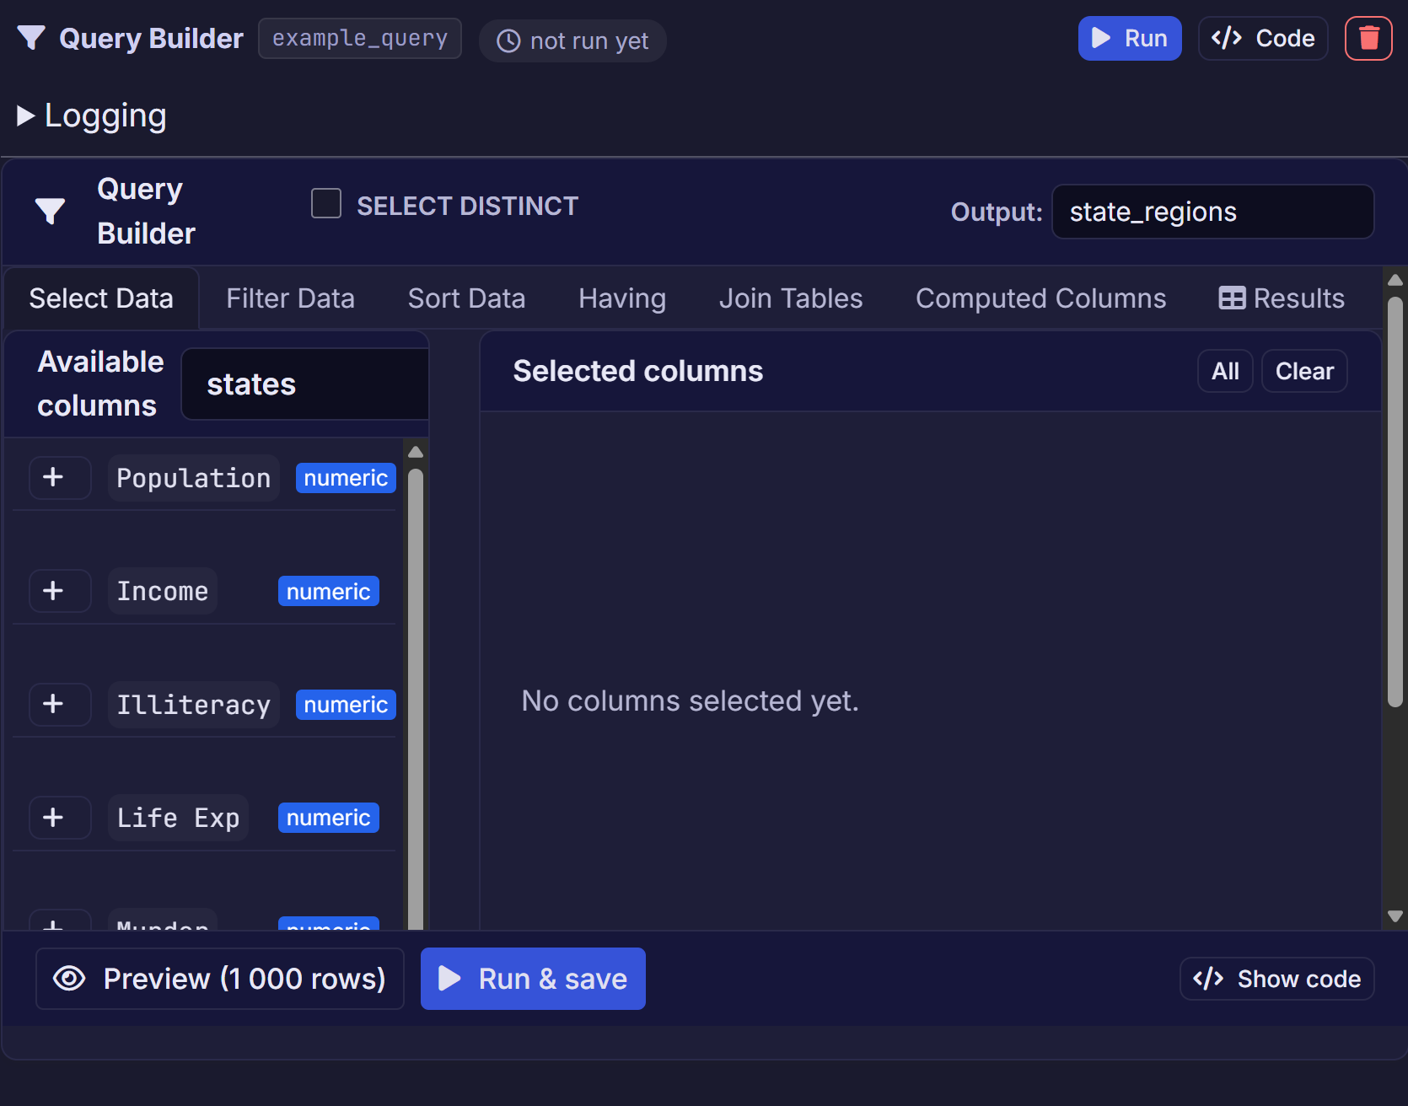
Figure 12. Query Builder separates column selection, filters, sorting, and joins into tabs. Add wanted columns to Selected columns before previewing.
Preview the result and check its row count. When it looks right, run the task to keep the result. If a key appears several times in both tables, a join can produce more rows than you expected. Check keys before calculating totals.
For grouped results, set a selected value column’s calculation to SUM or AVG. AVG means mean. The other selected columns without a calculation define the groups. Filter Data chooses input rows; Having filters the calculated group results. Start with the US states example to inspect a saved join result.

8.2 Filter and Sort
Use Filter and Sort to keep matching rows and put them in order.
- Select Add Task > Data > Filter and Sort, then choose Input table in the task header.
- Under Filter Data, select Add condition. Choose the column, operator, and value. For example, an amount greater than 100 keeps rows above that amount.
- If you add more conditions, check their AND or OR choice. AND needs both rules to match; OR needs at least one.
- Under Sort Data, select Add sort. Choose the sort column and direction. Ascending goes from smaller to larger, or A to Z; descending reverses that order.
- Enter an Output table name, select Run & Save, and open Results. Check a few rows at the top and bottom.
Missing values need their own rule. A missing value is an unknown entry, not the same as zero or an empty word. Use IS NULL to select missing values, or IS NOT NULL to keep known values.
Release 0.4.0 note: opening the saved Filter and Sort step in US states - import, join and filter can disconnect the workspace. Inspect its saved output instead, or add a fresh Filter and Sort task using the steps above. Save first. If needed, use the restart steps.

8.3 Derive Columns
Use Derive Columns to add a calculated column, such as a total or a value converted to new units.
- Select Add Task > Data > Derive Columns and choose Input table.
- Select Add. Enter New column name and R expression for new column. For example, if your table has price and quantity, enter total and price * quantity.
- Enter an Output table name and select Run & Save.
- Open Results and check the new column against a few values you calculate yourself.
Start with one new column. Run the task and check a few values by hand. Then add other calculations if needed. Keep units clear: changing the column name alone does not convert centimetres to metres.
Formulas use R expressions, so names and punctuation matter. Copy a working formula from a matching example when you are unsure. The Cars - prepare an analysis table example shows a calculated field. You can skip this task until you need a calculation that simpler tasks do not provide.

9 Optional: saved code steps

9.1 Script
Use Script when you have trusted R code to run as part of a flow. You can complete many projects using the other task forms instead.
- Select Add Task > General > Script. Under Setup, choose any Input tables / special outputs the code needs. These choices tell the flow which earlier results to wait for.
- Paste trusted code into R code. The first-project exercise supplies a complete two-line example.
- In Outputs, put each result on a separate line as name: kind. For a table called flowers, type flowers: table. For a model called fit, type fit: model.
- Select Run, then check the saved results and recorded entries under Logging.
Run the task and check Results and Log. If a result is missing, first compare its declared name with the code. Names are case-sensitive: Flowers and flowers are different.
The first-project exercise includes a two-line Script you can copy. The examples also contain prepared Scripts with notes. Read those notes before changing their code. Use the R Console for a quick trial, then keep repeatable code in a Script task. A console command on its own does not become a saved step in the flow.

10 Clean and reshape your data
Keep an unchanged input table, then give each cleaned result a new name. This makes it easier to check what changed. After each task, compare row counts, column names, and a few values.
Before you start, run the tasks that supply your input tables. Choose Add Task, then Data, to find the tasks in this chapter. The task controls guide explains where to run a task and name its output.

10.1 Append Table
Use Append Table to put rows from one table below rows from another. For example, you could combine January sales with February sales.
- In Tables to append, select at least two tables.
- Check that matching columns use the same units and compatible types. Use Fill missing columns with NA only if you want blanks where an input lacks a column.
- Leave Source ID column (.id) blank, or enter a name if you want to identify which table supplied each row.
- Enter an output table name and click Run.
The result contains the combined rows. Check its row count and any missing entries introduced by the fill option.
Appending adds rows. It does not match customer details across tables; use Query Builder for that. Open Iris - reshape and compare to see two species subsets combined into 100 rows.

10.2 Compare Data
Use Compare Data to check two tables for differences. It is useful after cleaning, importing a new extract, or reshaping data and changing it back.
- Select Table A (baseline) and Table B (comparison).
- If the tables should be sorted before comparison, select their shared Key columns. Leave this blank to compare their current order.
- Enter an output name and click Run.
- Open Results and read the reported differences.
Selecting keys sorts the tables for comparison; it does not join their rows. Column types and attributes can differ even when the displayed values look similar.
If the tables have different row counts, first find why. A filter may have removed rows on purpose. The Iris - reshape and compare example compares a table before and after a reshape. Use its notes to see which differences are expected.

10.3 Stack Columns
Use Stack Columns to turn several measurement columns into rows. This is often called making data long.
- Select the Input table.
- In Columns to pivot (stack), select the measurement columns. Leave identifiers, such as flower_id, unselected so they remain beside the stacked values.
- Enter the New names column and New values column names.
- Name the output, click Run, and check the long table in Results.
In Iris - reshape and compare, four measurements for each of 150 flowers become 600 rows. A flower identifier shows which rows belong together. Keep that identifier if you may want to turn the table back into columns later. Extra rows are expected here; they do not mean you have more flowers.
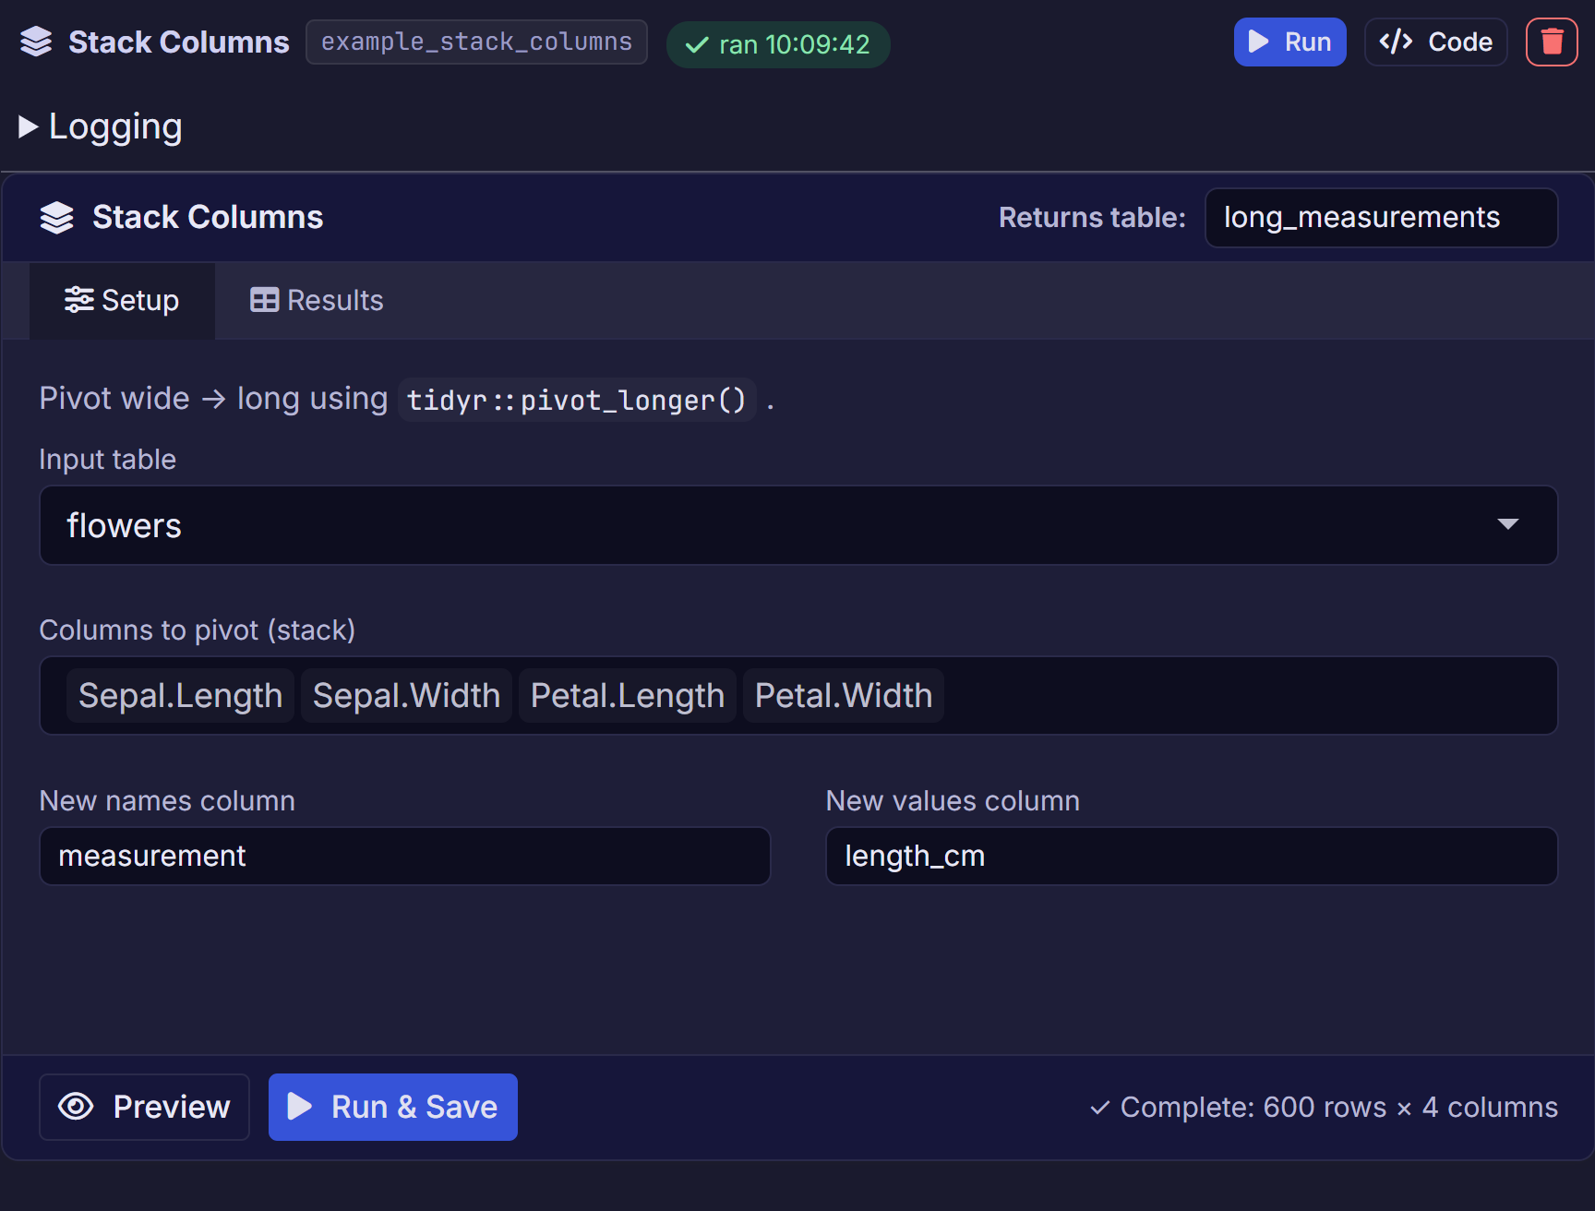
Figure 13. Stack Columns keeps unselected identifier columns and puts the selected measurements into two new columns: their names and values.

10.4 Split Columns
Use Split Columns to turn long-form values back into separate columns. This is often called making data wide. Here, Split Columns means reshaping a table; check its settings rather than assuming it splits words at commas.
- Select the Input table and its ID columns (keep as rows).
- In Names from, choose the column whose values should become headings.
- In Values from, choose the measurement column.
- Name the output and click Run. Check the new headings and row count in Results.
Each identifier and new-column pair should describe one value. If several rows claim the same place, inspect those rows before continuing. They may need a summary first. The Iris - reshape and compare example shows a full long-to-wide round trip using a flower identifier.

10.5 Transpose
Use Transpose to turn rows into columns and columns into rows. It is most useful for a small table that needs a different display shape.
- Prepare a small input first. Use Keep / Drop Columns and First / Last N Rows if you need a subset.
- In Transpose, select the Input table.
- Optionally select a Row ID column to supply the new headings.
- Name the output and click Run. Inspect the new table and its headings.
Transpose uses the selected input table; it does not offer a separate measurement-column picker. Prepare that selection in an earlier task.
Start with a few rows. Transposing a large table can create a very wide result that is hard to view or export. Mixing text and numeric values may also change how values are stored. The Iris - reshape and compare example deliberately transposes a small numeric subset.

10.6 Rank
Use Rank to add positions such as first, second, and third based on a column’s values.
- Select the Input table and Column to rank.
- For simple positions, choose Minimum rank or Dense rank in Method. Ties occur when rows have equal values. Other methods can return fractions or break ties by row order.
- Set the New column name. Use Group by only if ranks should restart within each group.
- Name the output and click Run.
The form ranks values in ascending order; it has no separate descending-order control. Minimum rank leaves gaps after a tie; Dense rank does not.
Check the highest and lowest values and at least one tie. A rank is a position, not the original measurement. Keep the original column if later work needs its values. The Cars - rank, scale and sample example shows ranked fuel economy.

10.7 Standardize Data
Use Standardize Data when numeric columns need a common scale before a later analysis. For example, weight and length can have very different ranges.
- Select the Input table and Numeric columns to standardize.
- Choose Z-score or Min-Max under Method.
- Leave Group by blank for the whole table, or select groups to scale separately.
- Name the output and click Run.
Z-score subtracts the mean and divides by the standard deviation, a measure of spread. Min-Max puts the observed range on a scale from zero to one. Both change the units of the selected columns.
Check the output and keep the original table for reference. A constant column has no spread, so it needs attention before some scaling methods work. Open Cars - rank, scale and sample for an example. Scaling is a choice for a later analysis, not a routine fix for every dataset.

10.8 Random Sample
Use Random Sample to choose part of a table without simply taking the first rows. It can help you try a flow on less data.
- Select the Input table.
- Under Sample by, choose a row count or proportion, then enter the amount. A proportion of 0.1 means 10%.
- Enter a Seed for a repeatable choice with the same data and order.
- Choose whether to Sample with replacement, name the output, and click Run.
With replacement means the same source row may be picked more than once. Without replacement, choose an amount that fits the available rows.
Check the sample count. Do not treat a small practice sample as if it were the full dataset. The Cars - rank, scale and sample example picks ten rows with seed 2026. Try a different seed in a saved copy and compare which rows were chosen.

10.9 Remove Duplicates
Use Remove Duplicates to remove repeated rows based on selected columns.
- Select the Input table.
- Under Scope, choose All columns (exact row duplicates) or Key columns only (keep first by key).
- If you chose keys, select the Key columns that define a duplicate.
- Name the output and click Run.
The key option keeps the first matching row in the current order. Sort first if that choice matters. Rows with the same customer number can still describe different real events.
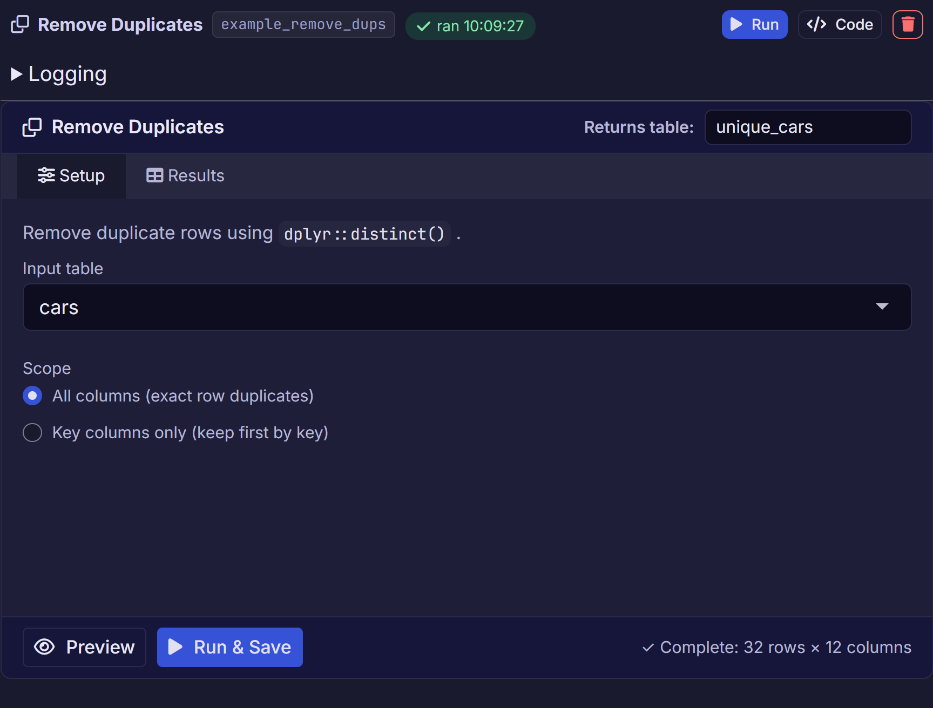
Figure 14. Remove Duplicates can compare complete rows or selected keys. Choose the scope before checking how many rows were removed.
Compare the row counts before and after. Inspect a few repeated cases if you are unsure. Two rows can look similar and still describe separate events, so do not remove them just to make the table smaller. Cars - prepare an analysis table adds one duplicate on purpose: its 33 source rows become 32 after this task.

10.10 Keep / Drop Columns
Use Keep / Drop Columns to choose which columns remain in a table.
- Select the Input table.
- Under Action, choose Keep or Drop.
- Select the Columns. Keep retains only this selection; Drop removes it.
- Give the output a new name and click Run.
Open the result and check its column names. Keep an ID column if later joins or checks need it. Removing a column from this output does not remove it from the unchanged source table. If a later task says a column is missing, check whether this step removed it. The Cars - prepare an analysis table example shows a smaller analysis table.

10.11 Rename Columns
Use Rename Columns to make headings easier to understand.
- Select the Input table.
- Under Rename pairs, click Add.
- Select the column to rename and enter its new name. Add another pair for each additional change.
- Name the output, click Run, and check the headings in Results.
Use unique names. Short names with letters, numbers, and underscores are easy to use in later formulas.
Renaming changes the label, not the values or their units. A weight column does not become kilograms because you call it weight_kg. Add a calculation when you need a real conversion. Check later tasks after renaming because their selected columns may need to change too. Cars - prepare an analysis table includes a rename you can follow.

10.12 First / Last N Rows
Use First / Last N Rows to keep a set number of rows from one end of a table.
- Select the Input table.
- Under Rows to keep, choose First or Last.
- Enter the number of rows in N.
- Name the output, click Run, and check the row count.
The table’s current order decides which rows come first or last. Sort first if you want, for example, the ten largest sales.
This task is useful for a quick check or a short display. It is not a random sample. If the first rows all come from one date or group, they may give a poor picture of the whole table. See Cars - prepare an analysis table for a small selection.

10.13 Replace Missing Values
Use Replace Missing Values when you have chosen a reason to fill unknown entries.
- Select the Input table.
- Select Columns to fill. A blank selection means all columns, so choose columns explicitly while learning.
- Under Fill with, choose the method. Enter a Replacement value if you choose a fixed value.
- Name the output and click Run. Check both the changed values and the number of missing entries left.
Keep the raw data and note the method you chose. Filling a gap does not recover the unknown original value. It can change summaries and models. Air quality - clean and compare uses mean replacement to teach the controls. That example is a practice choice, not a recommendation to fill every dataset that way. You can inspect the missing-value audit before changing anything.

10.14 Recode Values
Use Recode Values to replace selected values with new values or labels. For example, you might change 0 and 1 to Automatic and Manual in a display column.
- Select the Input table and Column to recode.
- Enter an Output column name if you want a separate labelled column.
- Add the old-to-new value mappings. Check the Else setting for values you did not list.
- Name the output table and click Run. Count the categories to check the changes.
Keep the original codes when you may need them for a later model. A model may expect numbers even when a chart is easier to read with words. Cars - prepare an analysis table shows labelled transmission values and how they relate to the original codes.

10.15 Change Column Types
Use Change Column Types when values are stored in the wrong kind of column. Common types are text, number, date, and factor. A factor stores a set of categories.
- Select the Input table.
- Under Type conversions, click Add.
- Select a Column to convert and its Target type. Repeat for other columns.
- Name the output and click Run. Check types, values, and any new missing entries.
The form has no custom date-format field. Standard date text such as 2026-10-19 is the simplest input. If dates use another format, prepare them before converting or use a trusted Script for that conversion.
Keep identifiers as text when leading zeros matter. Use numeric types for real measurements and categories for group labels. Cars - prepare an analysis table changes a category’s type. If a column is absent from a chart or model list, its current type is one of the first things to check.

11 Get to know your data
Look at your data before fitting a model. Check how many rows you have, which values are missing, and how each column is stored. These tasks help you spot surprises early.
Run the input task first. Find these tasks under Add Task > Describe. Their analysis controls and results appear in the same task panel; task controls explains the shared layout.

11.1 Characterize Data
Use Characterize Data for an overview of a table’s columns.
- Select the Input table.
- Set the Output table name if you want to retain its summary.
- Click Analyze, or use the task header’s Run button.
- Read Results for column types, counts, and missing-value information.
This task describes all columns in its input; it has no column-selection control. Check that measurements are numeric, group labels are categories or text, and date columns contain dates.
This is a good first step after Import Data. If a number column is stored as text, look for entries such as currency symbols or words before trying to convert it. Use Change Column Types once you know the intended meaning. The Tooth growth - descriptive analysis example starts with checks that help you understand the data before summarizing it.

11.2 List Data
Use List Data to page through a table in a readable view.
- Select the Input table.
- Set Rows per page to a comfortable display size.
- Enable and name the output table if you need a retained copy.
- Click Load or the task header’s Run button. Page through the result.
Rows per page changes the view, not the number of source rows. This form has no column picker. Use Keep / Drop Columns first when you want a smaller set of columns.
A short listing helps you spot misspelled categories, unexpected dates, and values in the wrong units. Check the displayed row count or limit before assuming the listing shows every record. Keep your full input table for calculations. See Tooth growth - descriptive analysis for a listing alongside summary tasks. Use Export when you need to deliver a data file rather than a view inside the project.

11.3 One-Way Frequencies
Use One-Way Frequencies to count how often each category appears in one column.
- Select the Input table and the category under Variable.
- Choose Sort by frequency if the most common values should appear first.
- Name the output and click Analyze or the task header’s Run button.
- Check the counts, percentages, and their total in Results.
The form does not offer separate percentage or missing-value switches. If a category seems to be missing, inspect blank values and spelling in the input.
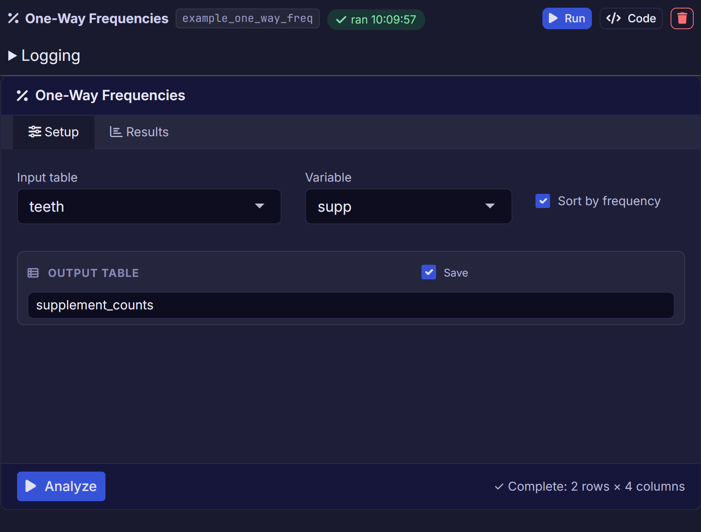
Figure 15. One-Way Frequencies counts the selected Variable. Sort by frequency changes the order, while Results lets you check the counts.
A count tells you how many records are in a group. A percentage also needs a denominator, such as all rows or only rows with known values. Check which rows the task includes before reporting percentages. Tooth growth - descriptive analysis counts supplement groups. You can also count the Iris species to check that each has 50 flowers.

11.4 Summary Statistics
Use Summary Statistics for numbers such as mean, median, minimum, maximum, and spread.
- Select the Input table.
- Under Numeric columns, select the measurements to summarize. Blank means all numeric columns.
- Enable and name the Output table if you want to retain it.
- Click Analyze or the task header’s Run button, then read Results.
Read the usable and missing counts as well as the mean. Ten known values and forty missing entries do not describe fifty complete observations.
In Data, n is the number of known values and n_miss is the missing count. sd means standard deviation, a measure of spread. These checks help you judge how much information supports a mean.
The mean is the average. The median is the middle value after sorting. A few very large values can pull the mean away from the median, so comparing both can help you spot an uneven pattern. Iris exploration gives you a simple check: mean sepal length is about 5.8433 centimetres. Keep units in the headings when you put the results in a report.

11.5 Summary Tables
Use Summary Tables to calculate a value for each group, such as mean sales by region.
- Select the Input table and Row variable for grouping.
- Leave Column variable (optional) blank, or choose a second grouping column.
- Choose the numeric Value variable and Summary statistic.
- Name the output and click Analyze or the task header’s Run button.
For the flower example, choose Species, Petal.Length, and Mean. The result has one mean for each species.
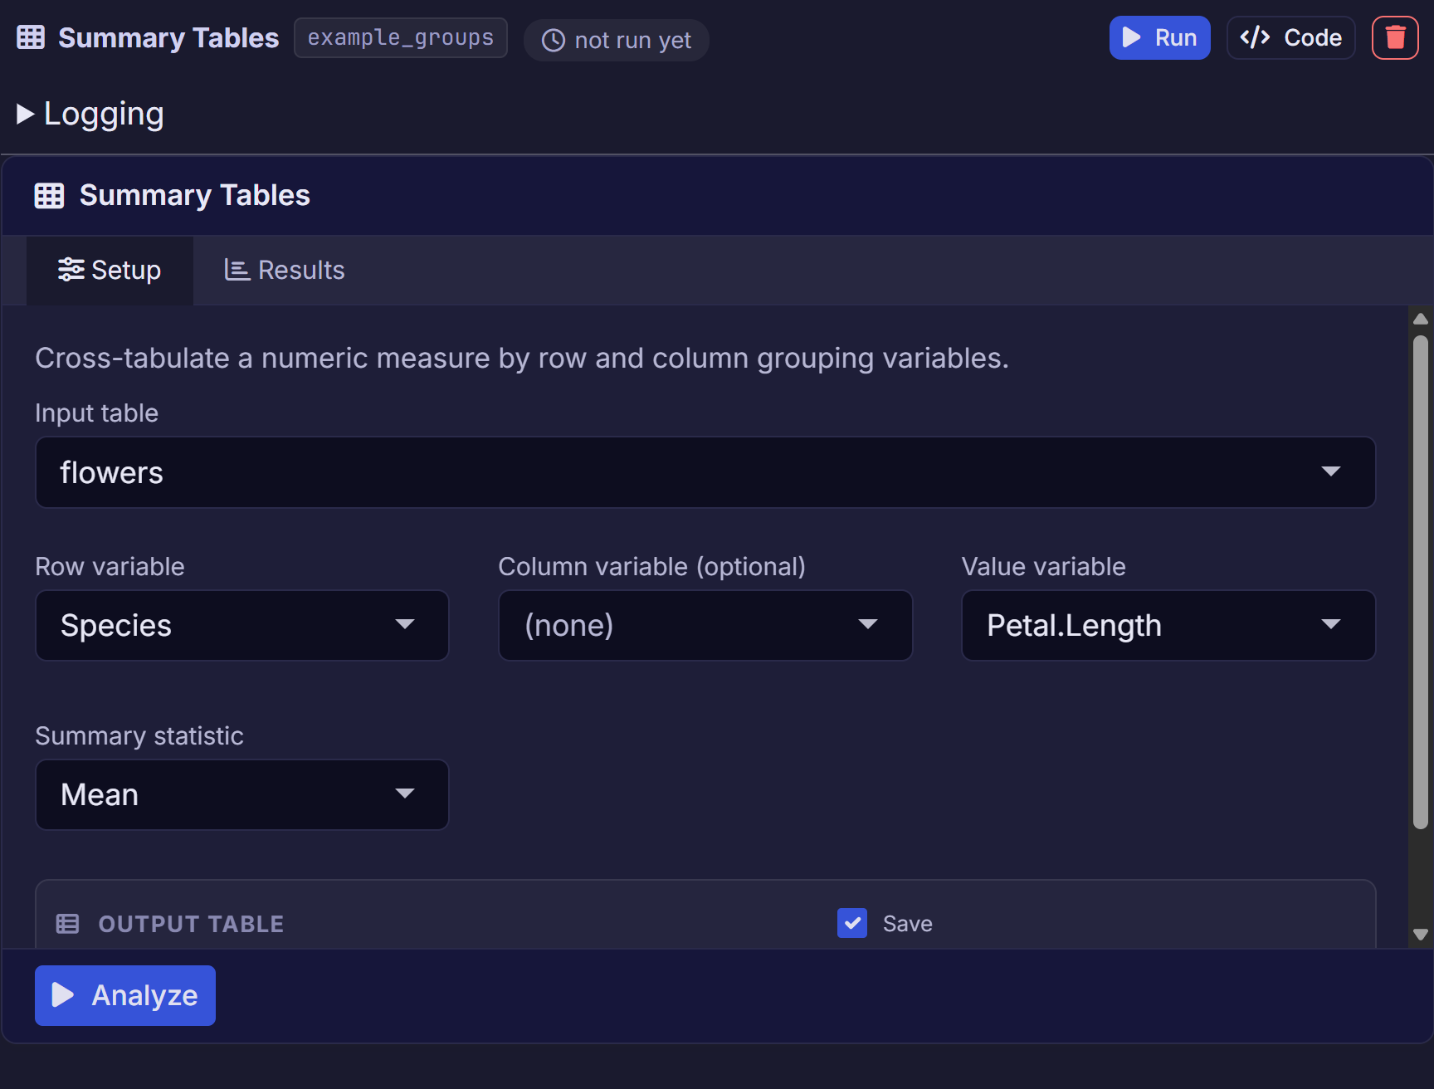
Figure 16. Summary Tables groups a Value variable by the Row variable. Leave Column variable blank for one grouping column.
Check how many groups appear and whether their labels match the source. Groups with missing measurements may have different numbers of usable values. Check the input and use a separate count summary when needed; a table of means does not also supply those counts. Iris exploration shows three species means, and Tooth growth - descriptive analysis shows another grouped summary. A grouped table is also a useful input for a report or bar chart.

11.6 Table Analysis
Use Table Analysis to compare two category columns in a cross-table. Each cell counts rows that match one category from each column.
- Select the Input table, Row variable, and Column variable.
- Set Show percentages to the view you need: none, row, column, or total.
- Check the output-table and chi-square output switches and names.
- Click Analyze or the task header’s Run button. Read the counts before the test results.
If you enable a chi-square test, it checks for evidence of a relationship between the categories. Small or empty cells can make that test unsuitable. A p-value helps judge evidence against the idea that the categories are unrelated. A small value does not tell you how large or useful the relationship is. Tooth growth - descriptive analysis cross-tabulates supplement and dose. It helps you see how the observations are divided among the study groups.

11.7 Distribution Analysis
Use Distribution Analysis to examine how a numeric column’s values are spread out.
- Select the Input table and numeric Variable.
- Set Bins, the number of ranges used in the histogram.
- Choose Density or Q-Q plot if you need those displays, and check the plot dimensions.
- Click Analyze or the task header’s Run button. Inspect Results, Plot, and Data.
Look for a long tail, several peaks, extreme values, and missing entries. A long tail means a few values extend far beyond most of the data. The Q-Q view compares the observed pattern with a normal, or bell-shaped, reference pattern.
Use what you see to guide your next question. Do not delete a large value just because it looks unusual; check whether it is a mistake or a real observation. Tooth growth - descriptive analysis includes this task beside counts and grouped summaries. Together, those views help you understand both the measurements and the groups that produced them.

12 Make charts people can read
Choose a chart based on the question you want to answer. Start with simple settings, then add a clear title, axis labels, and units.
The X setting usually controls the horizontal axis. Y controls the vertical axis. Group or colour separates categories. After running, check both the chart and the number of rows it uses.
Before following a task page below, run the task that creates your input table. Add charts from Add Task > Graph, then open Setup. Give each wanted output a unique name. The task controls explain how to keep results for later steps.

12.1 Keep the output you need
Chart tasks can offer plotting data, an interactive chart, and a static image. An interactive chart may show details when you hover. A static image is a still chart that works well in Word reports and image exports.
Enable the static image output if you want to export PNG. Then use an Export task to write the file. Making a chart in the project does not by itself write a picture into your chosen folder.
Some chart views and chart data outputs show only the first 1,000 rows. Check the task’s row limit before using a chart output as if it were the complete source table. Use a summary or sample on purpose when there are too many points to read.

12.2 Bar Chart
Use Bar Chart to compare category counts or a selected numeric summary.
- Choose Input table, then select the category in Category / X.
- Leave Value (optional) blank to count rows. To plot an existing numeric value, select that column instead. For a mean or other grouped calculation, make the summary table first; this form has no summary-method picker.
- Add Group / colour only if it helps the comparison. Set Title and Y label to explain what the bar height means.
- Select Run, then open Results > Plot. Compare the bars with the source counts or summary table.
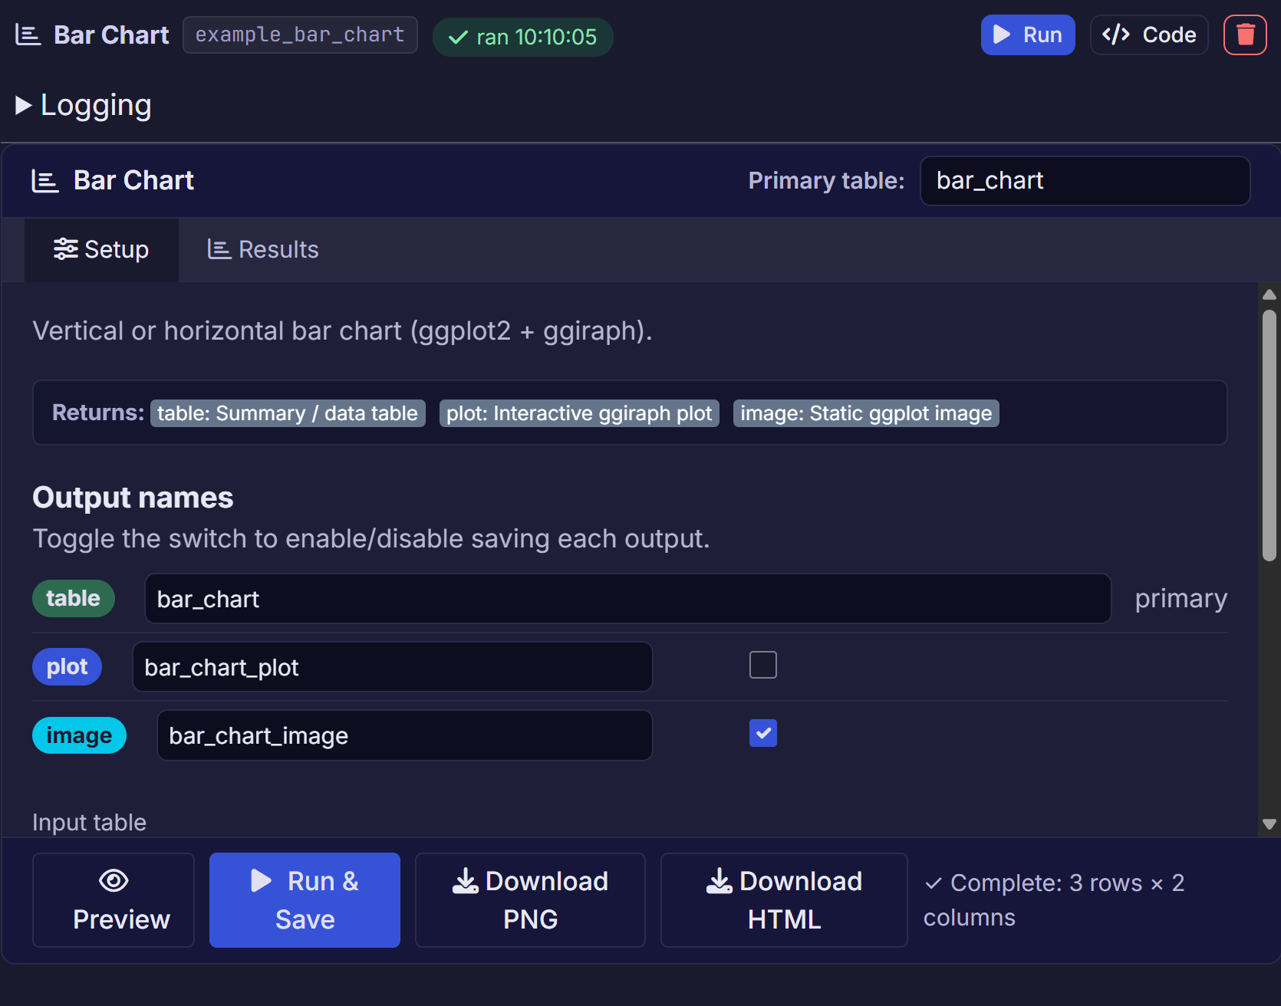
Figure 17. Leaving Value blank makes Bar Chart count observations. Select Species as Category / X to compare the three flower groups.
Keep category names readable. If the labels overlap, reduce the number of categories or change the layout. Flowers - categorical chart gallery counts the three species. Each bar should represent 50 flowers. Compare it with the frequency table if you are unsure what the chart is counting.

12.3 Bar-Line Chart
Use Bar-Line Chart to show bars and a line on the same category or time axis.
- Choose Input table. Set X / category / date to the shared category or time column.
- Choose Y / value. The bars and line use this measurement unless you also select Secondary Y (optional) for the second series.
- If you use a second series, fill in Secondary Y label. Add a clear Title and axis labels.
- Select Run, then open Results > Plot. Check which measurement each axis and series represents.
If the two values use different units or scales, explain both. Similar-looking heights on two axes do not mean equal values. Avoid using the chart to imply a relationship just because the shapes line up. Nottingham temperatures - time charts compares annual averages with observed ranges. The range is a difference between observed values, not a measure of uncertainty around the average.

12.4 Box Plot
Use Box Plot to compare the spread of a numeric measurement across groups.
- Choose Input table and select the grouping column in X / category / date.
- Select the measurement in Numeric value. Add Fill group only if needed.
- Select Run, then open Results > Plot. Check the group labels and measurement units.
The line inside the box marks the median, the middle value. The box covers the middle half of the data. Points beyond the whiskers highlight values that may deserve a closer look.
Read the plot alongside group counts. A small group gives less information than a large one, even if their boxes look similar. Check unusual points before deciding they are errors. Flowers - categorical chart gallery compares flower measurements by species. Use Summary Tables if you also need exact group values in a report.

12.5 Bubble Plot
Use Bubble Plot to show two numeric measurements, with bubble size showing a third.
- Choose Input table. Select two numeric columns in X / category / date and Y / value.
- Choose a third numeric column in Size / weight. Add Group / colour if useful.
- Select Run and open Results > Plot. Check that the size legend explains what larger bubbles mean. Keep units clear for all three measurements.
Overlapping bubbles can hide smaller ones. Try less data or a simpler Scatter Plot if the picture is hard to read. Use this task when size needs to change visibly; a Size field shared with other chart forms may not have that effect in Scatter Plot. Flowers - numeric chart gallery lets you compare both charts using the same observations.

12.6 Contour Plot
Use Contour Plot to see where pairs of numeric values are concentrated.
- Choose Input table and select two numeric columns in X / category / date and Y / value.
- Set Title and the axis labels so they identify the measurements and units.
- Select Run, then open Results > Plot. Read the contour lines as a guide to where more observations lie. Compare them with a Scatter Plot of the same columns.
The smooth shape depends on the data and chart settings. It does not show a measured boundary around a real group. A small sample can give a pattern that looks more certain than it is. Flowers - numeric chart gallery includes contours beside the individual flower points, which makes it easier to see what the smoothing adds and what it leaves out.

12.7 Histogram
Use Histogram to show how one numeric measurement is distributed.
- Choose Input table, then select the measurement in Numeric column.
- Set Bins, the number of ranges counted together. Start with the default if you are unsure. Leave Overlay density (density scale) off for a count chart.
- Select Run, then open Results > Plot. Check the horizontal axis and counts. Inspect the input or Characterize task for missing values.
Try a few sensible bin choices. Very wide bins can hide patterns, while very narrow bins can make random variation look important. A histogram’s bars represent numeric ranges; a Bar Chart usually represents separate categories. Flowers - numeric chart gallery includes a histogram you can compare with its Summary Statistics. Use both when you want a picture of the spread and exact values.

12.8 Line Plot
Use Line Plot to show change across an ordered column, often time.
- Choose Input table. Select the date or ordered column in X / category / date and a measurement in Y / value.
- Add Group / colour if you need separate lines. Leave Secondary Y (optional) blank for a single measurement.
- Check the source order and repeated time values. If you need one total or mean per time, prepare a summary table first.
- Select Run, then open Results > Plot and check the time range and gaps.
A line joins observations. It does not prove what happened between them, and it is not a forecast. Check gaps and the time range so readers can see where data are missing. Nottingham temperatures - time charts shows 240 monthly observations. Read the date column and units before comparing years or describing a seasonal pattern.

12.9 Pie Chart
Use Pie Chart for a simple view of category shares when there are only a few groups.
- Choose Input table, then choose the category column in Slice category.
- Leave Donut chart off for a filled pie, or select it for a ring with the same counts.
- Select Run, then open Results > Plot. Check each category’s count and share against a frequency table.
The slices count observations by category. A numeric amount column does not supply slice weights.
Use a frequency table to confirm the totals. Many small slices are hard to compare, so a Bar Chart may be easier to read when you have many groups. Flowers - categorical chart gallery uses the three Iris species. Its slices should be equal because each species has 50 observations. Changing colour affects the display, not the counts behind it.

12.10 Scatter Plot
Use Scatter Plot to look at the relationship between two numeric columns.
- Choose Input table, then select numeric columns in X / category / date and Y / value.
- Add Group / colour if helpful. Set Title, X label, and Y label with the measurement units.
- Select Run and open Results > Plot. Check the axis labels and units. Each visible point represents an observation, although points can overlap.
Look for a trend, curved pattern, separate groups, and unusual points. A visible trend does not prove that one measurement causes the other. Use Bubble Plot if you need a third measurement to control point size. Iris exploration compares sepal length with petal length by species. Try changing Y to petal width in a saved copy, then rerun the report so it shows your new chart.

12.11 Scatter Plot Matrix
Use Scatter Plot Matrix to compare several numeric columns in one grid.
- Choose Input table, then select three or four Numeric columns.
- Set Matrix view to Pairwise scatterplots. Choose Distributions instead when you want a separate histogram for each selected column.
- Select Run and open Results > Plot. In the pairwise view, read each panel’s row and column labels to identify its measurements.
Start with three or four columns. A large grid becomes hard to read, and display limits may show only part of a large dataset. If one pair is interesting, open a separate Scatter Plot for a clearer view. Flowers - numeric chart gallery compares the four Iris measurements. Use its matrix to choose a relationship to inspect, rather than trying to explain every panel at once.

13 Compare groups and fit models
A model describes a pattern in data. You do not need to write R to use these forms, but you do need to choose a method that fits your question. Start with an example whose question is close to yours.
A response is the result you want to explain or predict. Predictors are the columns you use to explain it. A coefficient describes part of the fitted relationship. A fitted value is the model’s estimate for a row it used.
Run the input first. Check missing values and column types before selecting a model. After fitting, read warnings and the number of rows used. Use summaries and charts to check the data as well as the model output.
Use the Task finder to find each task’s Add Task category. In its Setup tab, choose Input table before choosing columns. Near the top of the panel, keep the Save controls checked for the result tables you need. See Task controls if you are adding your first analysis task.

13.1 One-Way ANOVA
Use One-Way ANOVA to compare the means of a numeric response across groups.
- Choose Input table, then select the measurement in Response (numeric).
- Select one Group variable. Check the group names and counts in the input table.
- Select Run and open Results. Read the ANOVA table and the saved pairwise comparisons, if enabled.
The p-value in the ANOVA table helps assess evidence that the group means are not all equal. That overall test does not identify which pairs differ; the Tukey comparisons address pairs. Read the size of differences as well as their p-values.
The method assumes a suitable study design and data pattern. Repeated measurements on the same person, for example, need more care than unrelated observations. Plant growth - compare experimental groups uses 30 plant weights in three groups. Open it to see the response, group choice, summary, and report together before trying your own comparison.

13.2 t Test
Use t Test to compare two groups, paired measurements, or a single mean against zero.
- Choose Input table and Response (numeric).
- For two unrelated groups, choose Group (optional — two levels) and leave Paired measurements off. The input must contain exactly the two groups you mean to compare.
- For matched pairs, select Paired measurements and Second measurement (same row). Each row must contain one matched pair. Leave the group blank.
- For a one-sample test against zero, leave the group blank and paired setting off. There is no control for a different comparison value.
- Select Run, then open Results. Read the mean difference and interval alongside the p-value.
Check the paired setting carefully. For paired data, choose the second measurement column; each row must contain a matched pair, such as before and after values from the same person. Two unrelated groups are not paired. Run the task and read the mean difference and interval alongside the p-value. Plant growth - compare experimental groups includes a two-group example using a prepared subset.

13.3 Linear Models
Use Linear Models to explain a numeric response using one or more predictors, including groups.
- Choose Input table and select the numeric Response.
- Select Predictors. A group column should use a category type when its values name groups; check it with Characterize or Change Column Types first.
- Select Run, then open Results. Check the coefficients, model fit, and number of observations used.
Read the coefficient and fit tables together. A coefficient for a group is usually a comparison with a reference group; it is not that group’s raw mean in every model. The Plant growth example shows a model beside its group comparisons. Keep the model description in your report so a reader knows which predictors you included. A completed fit alone does not show that the model is useful.

13.4 Linear Regression
Use Linear Regression to model a numeric response from selected predictors.
- Choose Input table, then select Response and Predictors.
- Keep the coefficient and model-fit outputs. Select Save Fitted values (augment) if you also want row-level fitted values and residuals. A residual is the observed value minus the fitted value.
- Select Run, then open Results. Check the coefficients, fit, warnings, and the saved result tables.
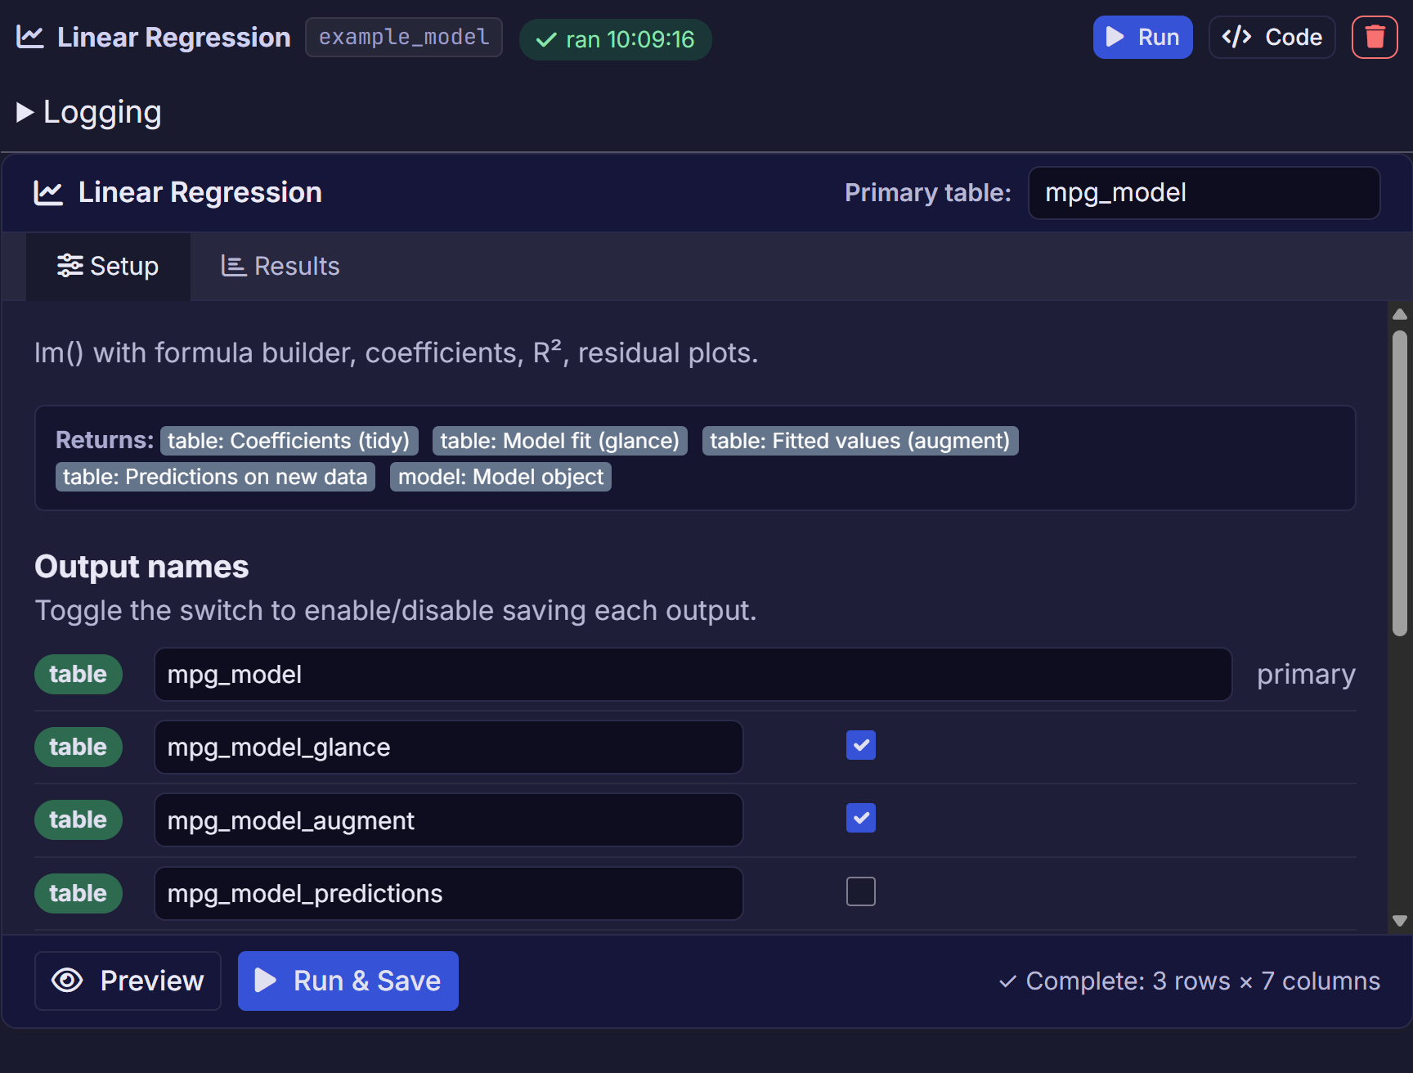
Figure 18. Linear Regression uses a response and selected predictors. Optional saved outputs include fitted values and a model object.
The Fuel economy model example uses 32 cars and predicts fuel economy from weight and horsepower. In that dataset, weight is in thousands of pounds. Check those units before explaining a coefficient. A fit to these observations is not proof that changing one car feature will cause the predicted change. Try removing one predictor in a saved copy and compare both the model and its warnings.

13.5 Logistic Regression
Use Logistic Regression for a response with two possible outcomes, such as 0 and 1.
- Choose Input table. In Response (0/1), select a column coded with 0 and 1. Confirm what 1 means.
- Choose Predictors and keep the output tables you need. Enable fitted values if you want row-level fitted results.
- Select Run, then open Results. Inspect the coefficients and fit information; read warnings before interpreting the result.
Fitted probabilities range from zero to one. The coefficients use a different scale, so they are not direct percentage-point changes.
Cars - binary outcome model treats 1 as manual transmission and 0 as automatic. It is a useful way to check what a probability refers to. Read warnings about convergence or separation. These can mean the model cannot estimate the relationship reliably. A green task status does not make extreme estimates safe to use without checking them.

13.6 Generalized Linear Models
Use Generalized Linear Models when the response needs a model family other than ordinary numeric regression.
- Choose Input table, Response, and Predictors.
- Choose GLM family using a matching example or analysis plan. For example, poisson is used for counts in the Loom breaks example.
- Select Run, then open Results and inspect warnings, coefficients, and fit information.
The family describes the kind of outcome. The form uses that family’s standard link, which controls how predictors connect to the expected outcome. You do not choose a separate link here.
Loom breaks - a count model uses a Poisson model for 54 counts of loom breaks. Counts are whole numbers of events, not percentages or rates. If exposure time differs between rows, the simple count example may not suit your question. Run the task and read warnings and fit information. A successful fit does not by itself show that the chosen family matches the data.

13.7 Nonlinear Regression
Use Nonlinear Regression to fit one of the supported curve forms to numeric measurements.
- Choose Input table and the numeric Response (y).
- Choose one numeric column in Predictor (x — first selected used), then choose Curve preset. Start with the matching example’s preset.
- Check for zeros and negative entries; some curve forms require positive values. The task prepares its own starting values.
- Select Run, then open Results and compare the fitted curve with the observed points.
Puromycin - fit a nonlinear curve uses positive concentration and reaction-rate values from a prepared subset. It shows a power curve as a teaching example. A different preset changes the model; it is not simply a repair button for a failed fit. If fitting fails, check valid input values and the selected form first. Be cautious about predictions beyond the observed range.

13.8 Correlations
Use Correlations to measure how pairs of numeric columns vary together.
- Choose Input table and select the wanted Numeric variables. Blank means all numeric columns, including any numeric IDs, so an explicit selection is often safer.
- Select Run and open Results. The task calculates Pearson correlations using available pairs when values are missing.
- Compare the table with Scatter Plots of interesting pairs. Values near 1 or -1 show a strong straight-line relationship. Values near zero do not rule out a curved pattern.
A correlation does not show that one value causes another. Groups and unusual points can also change the result. Flowers - multivariate structure compares the four Iris measurements. Inspect the species groups as well as the combined result. Check the number of usable observations when missing values mean different pairs use different rows.

13.9 Principal Components
Use Principal Components to combine several numeric columns into fewer summary directions. The task is often called PCA.
- Choose Input table. In Numeric variables, select only the measurements you want to combine. Leave IDs and group codes out.
- Keep the wanted outputs near the top of the panel. Enable Save Component scores (augment) if you need a component value for each row.
- Select Run, then open Results. Check variance explained and loadings. The task scales the measurements automatically.
Variance explained shows how much of the data’s spread each component represents. Loadings show how the original columns contribute.
Flowers - multivariate structure uses the four flower measurements and keeps species labels out of that input set. It uses scaling inside PCA. A component is a calculated direction, not a new measurement with a simple original unit. Use its scores to explore patterns, then return to the original columns to explain them.

13.10 Cluster Analysis
Use Cluster Analysis to group rows with similar numeric measurements.
- Choose Input table and the wanted Numeric variables. Standardize them first if a common scale is needed; this task does not do that automatically.
- Choose Method and set Clusters to the requested number of groups.
- For k-means, set Random seed so a rerun with the same data can repeat its random start. For Hierarchical, choose Linkage using your analysis plan or example.
- Select Run and open Results. Inspect group sizes and the saved cluster assignments.
Run the task and inspect group sizes and assignments. Very small groups or results driven by one large-scale column need attention. Flowers - multivariate structure creates three clusters. Three requested clusters do not prove that the data contain three natural groups, and clusters need not match the known species. Compare the result with the source measurements and charts before giving the groups names.

14 Check patterns and work with time
These tasks answer more specific questions. Read the matching example first, and keep the meaning and order of your data clear.
Run the input task first. Find each analysis task’s category in the Task finder, add it, then choose Input table under Setup. Keep the output controls enabled for results you want to use later.

14.1 CDF Plots
Use CDF Plots to see what share of observations is at or below a value. CDF stands for cumulative distribution function.
- Choose Input table and the measurement in Numeric variable.
- Add Group / colour (optional) only when you need separate group curves.
- Select Run, then open Results and inspect the plot. Pick a value on the horizontal axis and read the share on the vertical axis. A share of 0.75 means about 75% of observations are at or below that value.
This view can help you compare thresholds without choosing histogram bins. Check the units and missing-value count. It describes the data you supplied, not a guarantee about future measurements. Nile flow - distribution and stability includes this plot alongside a probability plot and control chart, so you can compare different views of the same 100 annual observations.

14.2 Probability Plots
Use Probability Plots to compare a numeric column with a normal distribution, a common bell-shaped pattern.
- Choose Input table, then choose the measurement in Numeric variable.
- Keep the plot output enabled. This task uses a normal reference; there is no reference-distribution picker.
- Select Run, then open Results and inspect the plot. Points near the line suggest a similar pattern. Curves and distant points suggest differences, especially near the extremes.
The plot is a check, not a pass-or-fail certificate for every later analysis. Read it with a histogram and the study context. Do not remove observations just to make the points straighter. Nile flow - distribution and stability gives you a worked normal probability plot. Use it to learn how the line and points relate before interpreting your own data.

14.3 Control Charts
Use Control Charts to inspect measurements in their recorded order and flag unusual patterns.
- Sort the input into observation order before adding the task. Choose Input table and Measurement.
- Leave Subgroup blank for an individuals chart. Select a subgroup column only when the rows form meaningful subgroups for an Xbar chart of subgroup means.
- Check Western Electric run rules if those extra pattern checks suit your use. These rules flag certain sequences, not just single extreme points.
- Select Run, then open Results. Inspect the plot and the table of points with control limits and flags.
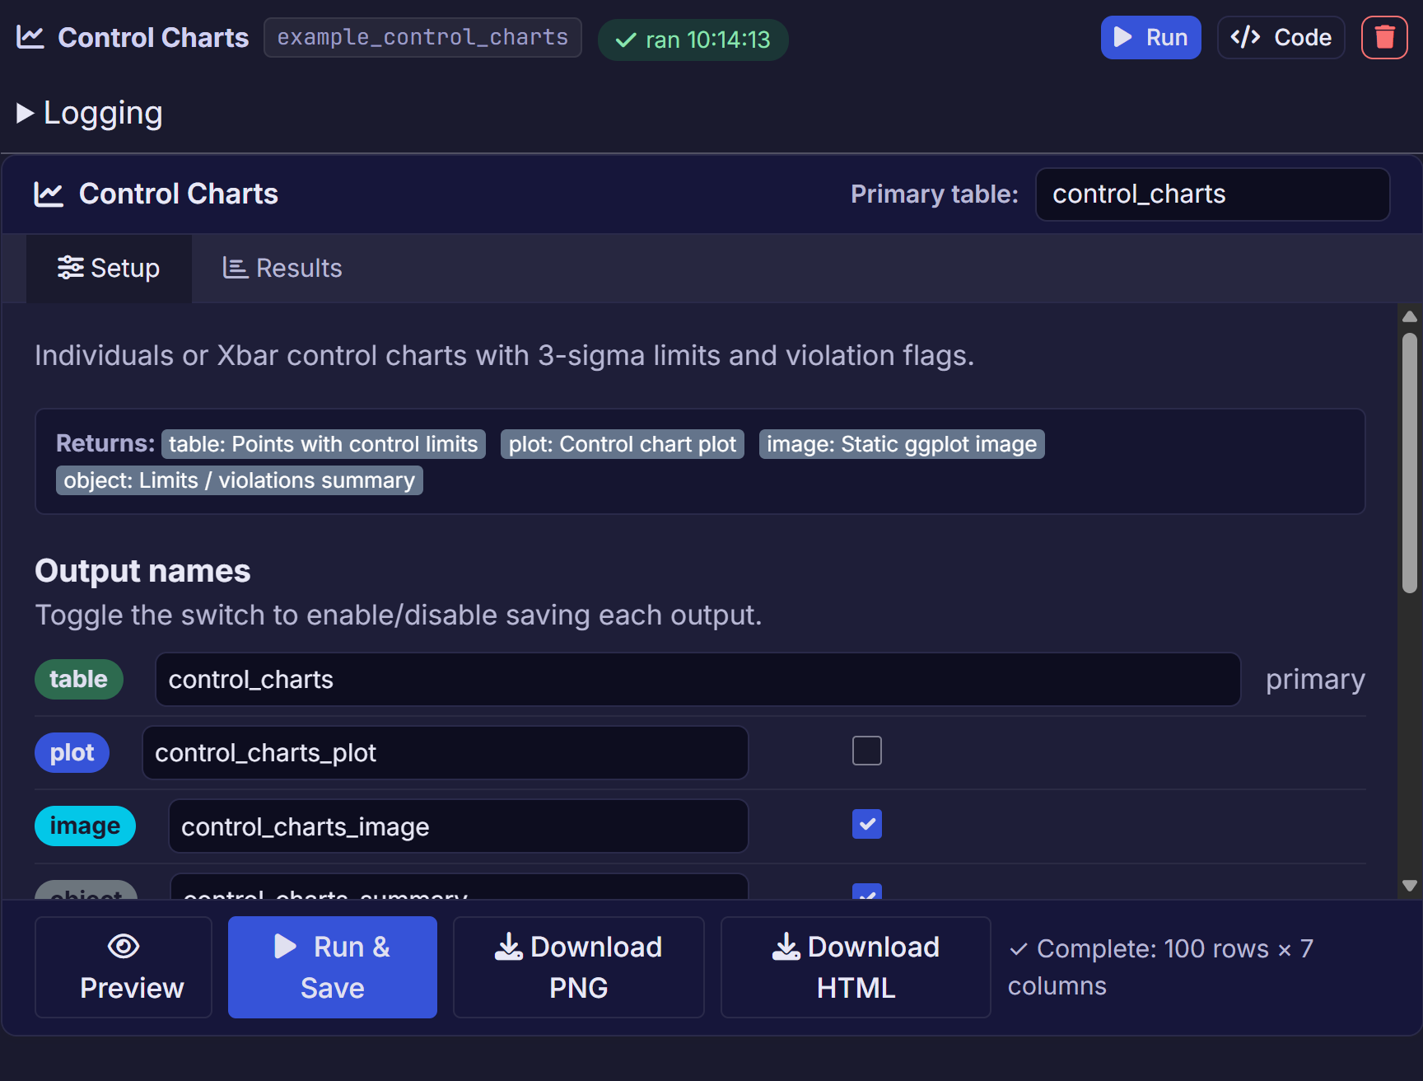
Figure 19. Control Charts uses the row order of the input. A blank Subgroup setting selects an individuals chart; run rules add pattern checks.
The app estimates limits from the data. Those limits are different from an outside target or an allowed tolerance set by a customer. A point inside a limit is not proof that it meets a product requirement. Nile flow - distribution and stability uses an individuals chart for practice. River observations are a teaching dataset, not a controlled factory process. Read the example’s notes before borrowing its settings for another purpose.

14.4 ARIMA / Basic Forecasting
Use ARIMA / Basic Forecasting to estimate future values from an ordered numeric series.
- Prepare one numeric value per equal time interval, such as one month. Sort the table into time order. The task needs at least eight values and no missing series values.
- Choose Input table, then select Series value (rows in time order).
- Set Forecast horizon (steps ahead). Enter 12 for twelve future intervals.
- Select Run, then open Results. Inspect the fitted model, forecast values, and intervals.
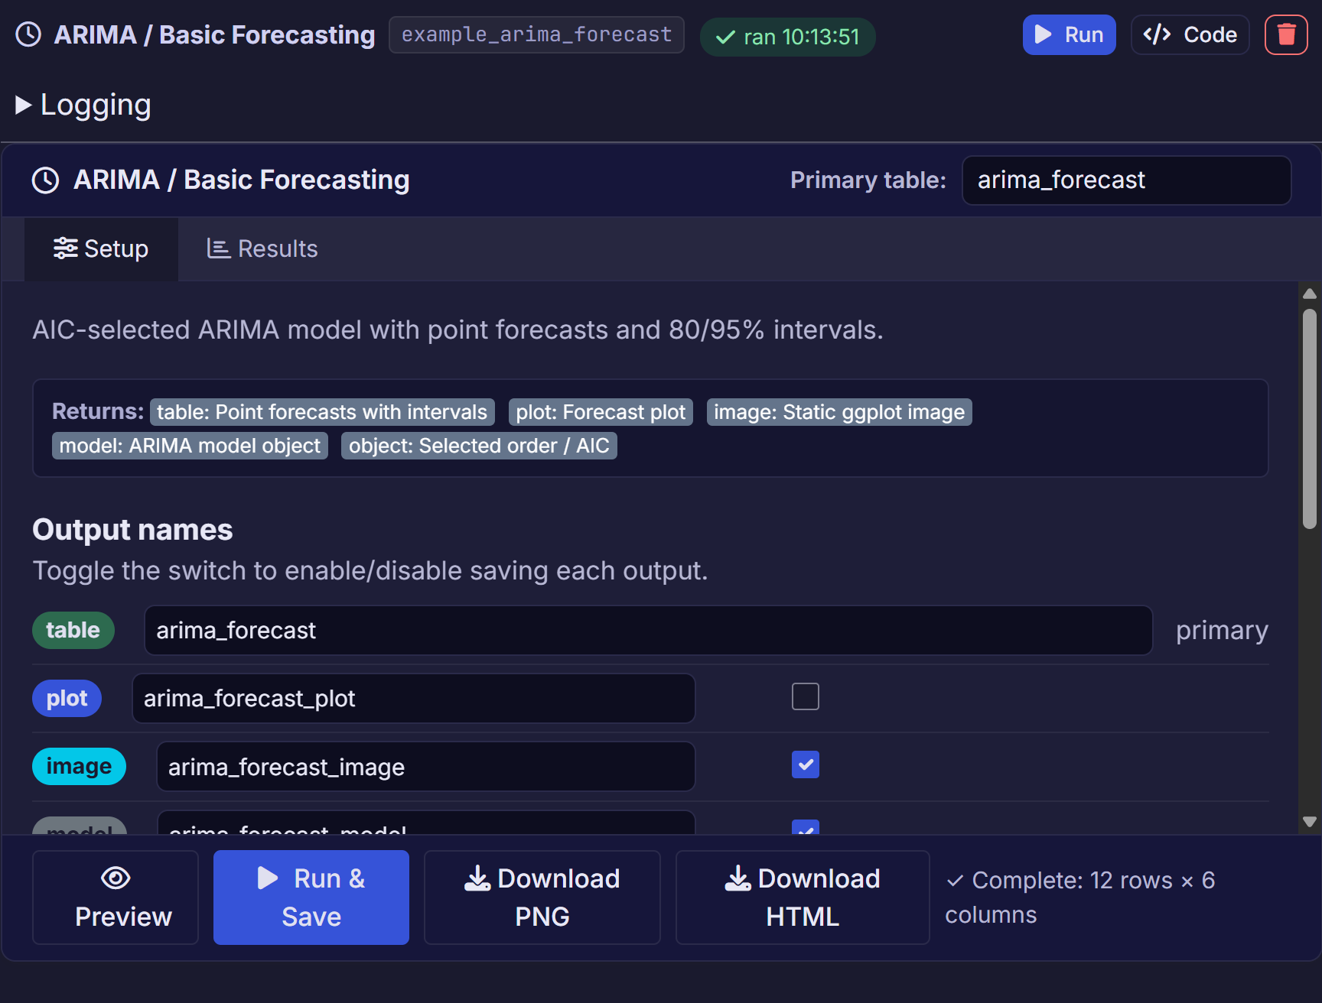
Figure 20. The forecasting form uses an ordered value column and a horizon measured in steps. It does not infer the calendar interval from a date column.
Air passengers - forecast a monthly series starts with 144 monthly values and forecasts 12 more steps. The task does not automatically turn every dated table into a tuned seasonal model. Check the settings and model used. The intervals show model uncertainty; they do not promise that future events will stay within them. Keep the time labels clear when reporting the result.

15 Time until an event
Survival tasks use a time column and an event indicator. An event might be a failure, a repair, or another outcome. A censored observation means the event had not been seen by the end of that observation’s follow-up.
For numeric event columns, check that 1 means the event occurred and 0 means it was not observed during follow-up. Convert other numeric codes first. For text or category columns, use Event level to name the value that means an event. The example prepares 0/1 codes and explains the change in its preparation task.

15.1 Life Tables
Use Life Tables to estimate how the chance of remaining event-free changes over time.
- Choose the prepared Input table. Select Time to event and Event indicator (1 = event, 0 = censored).
- If the event column contains text or categories, set Event level explicitly. For a numeric 0/1 column, keep that coding.
- Add one Strata column if you want separate curves. Only the first selected column is used.
- Select Run, then open Results. Check the number of usable rows and events. Confirm that time uses one unit and has no unexplained negative values.
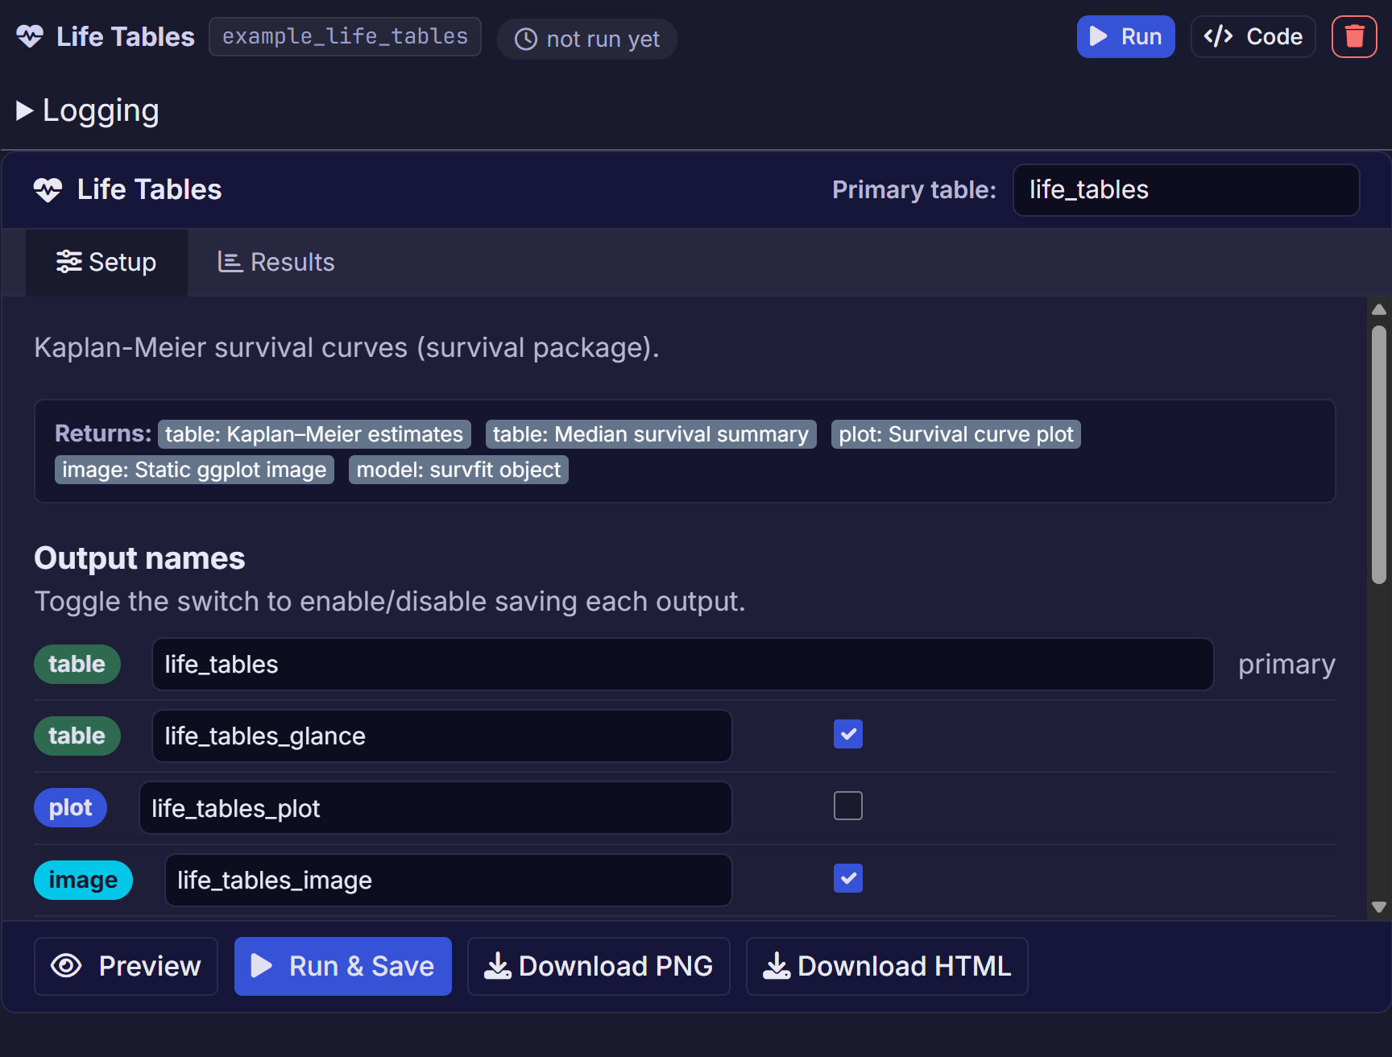
Figure 21. Life Tables separates follow-up time, event coding, and optional strata. Check the prepared event column before reading the curves.
Lung cancer - survival analysis keeps the 228-row original data and prepares a separate input for analysis. Its original event code of 2 is converted to 1. Open the preparation task before reading the curve. The example teaches app controls and coding checks. It is not a guide for making care decisions. Use suitable analysis advice before applying these methods to important decisions.

15.2 Proportional Hazards
Use Proportional Hazards to model the relationship between predictors and the rate at which an event occurs over time. This is often called a Cox model.
- Choose the prepared Input table, Time to event, and Event indicator (1 = event, 0 = censored).
- Select the predictors in Covariates. Set Event level if the event column uses text or categories.
- Check missing values and event coding, then select Run.
- Open Results. Read the coefficients, intervals, warnings, and number of included observations together.
Lung cancer - survival analysis includes an illustrative model. A hazard ratio compares fitted event rates; it is not a person’s absolute event probability. Use the example to learn the controls. Ask for method advice before relying on the model’s assumptions.

16 Run steps conditionally or repeatedly
Most first projects can use a straight sequence of tasks. Add a Branch when a decision should choose a path. Add a Loop when the same steps should repeat. Try the supplied example before building a large version.
Before starting, save a copy of your project and run its input tasks. Both tasks are under Add Task > Control Flow. A path token is a name that tells later tasks which route they belong to. Selecting a table supplies data; selecting a path token controls whether or how often a task runs.

16.1 Branch
Use Branch to run tasks only when a condition is met. For example, you could make a summary only when a table has enough rows.
- Add Branch. Under Setup, select the source table in Inputs / dependencies.
- Set Number of outgoing paths, then expand the first path’s settings. Enter a Path label and a unique Path token.
- For a row-count check, choose Dataset row count in Condition. Choose Dataset, Operator, and Row count. In the flower example, >= and 100 mean at least 100 rows.
- Set another path’s Condition to Fallback / else path if you need a route when no ordinary condition matches. Select Validate, then Evaluate, and read the decision.
- Open each task that should follow that decision. In Run after branch/loop path, select the intended path token.
- Run the active flow. Expand Logging to check the chosen route and any skipped tasks.
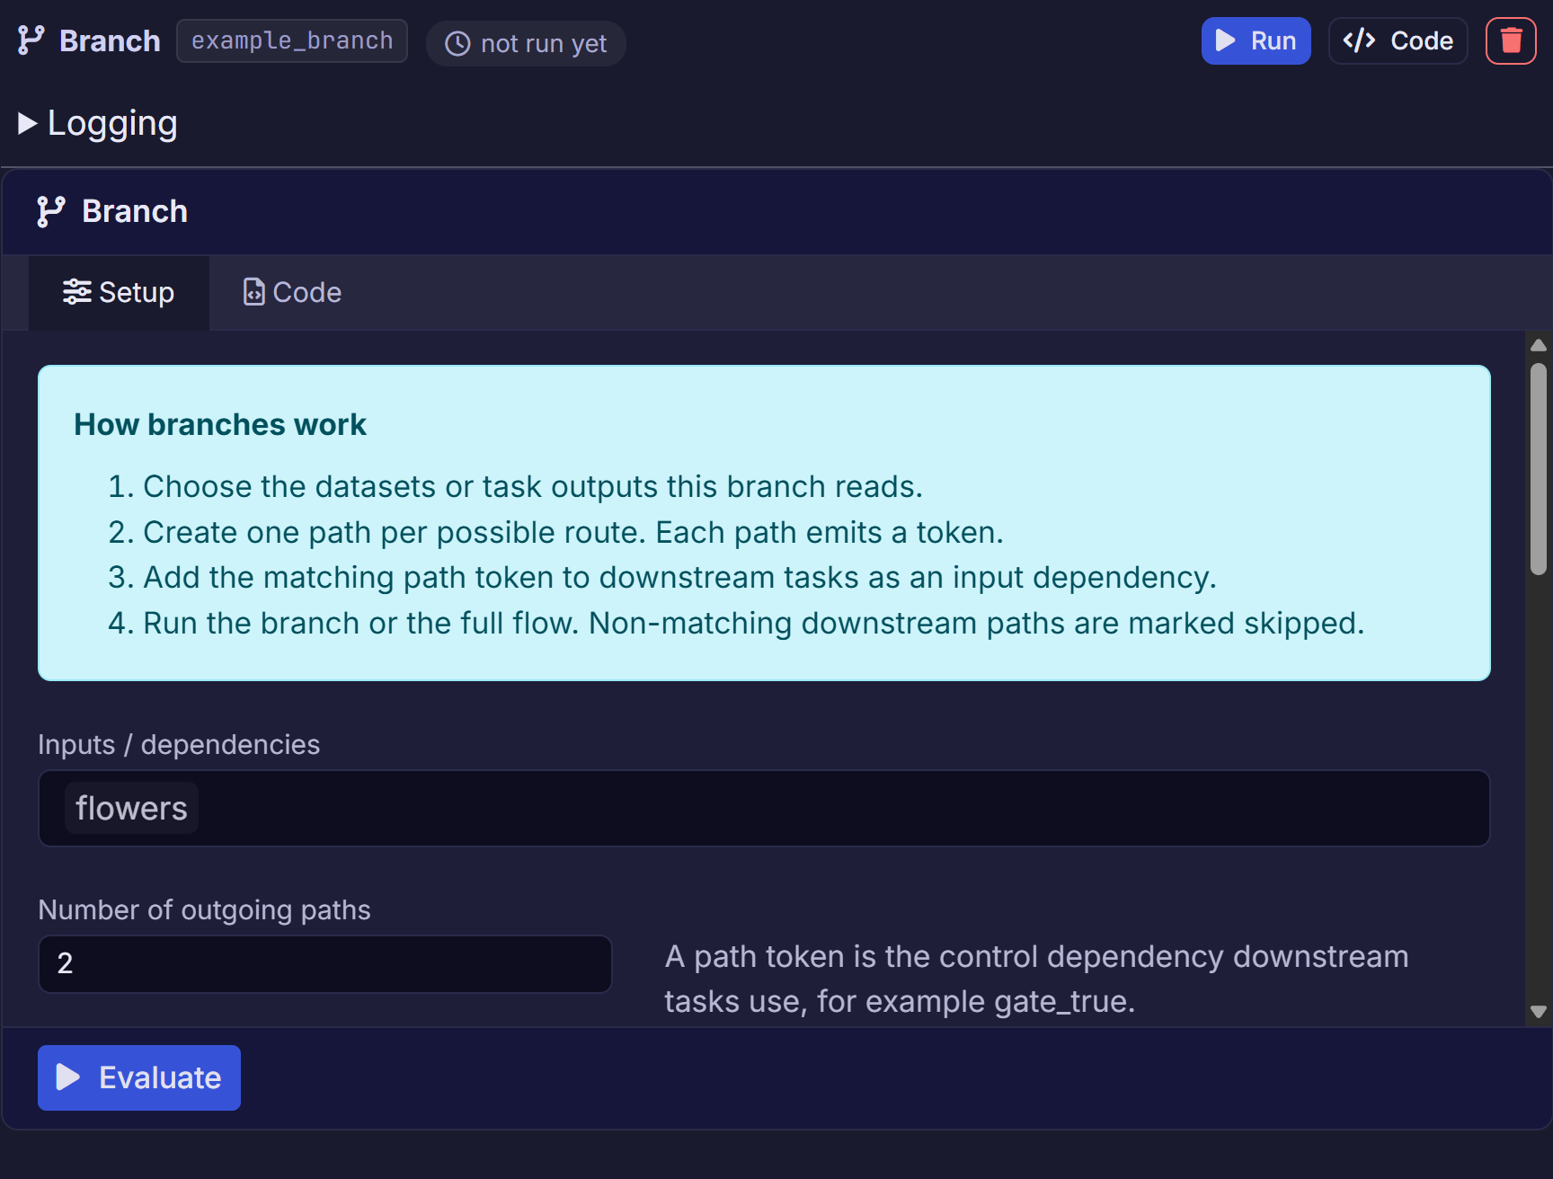
Figure 22. Branch settings name each path and its condition. The following task must also select that path in Run after branch/loop path.
Choosing an input table alone does not attach a task to a branch path. That separate path choice is needed. Flowers - conditional quality gate checks for at least 100 flowers. Change the threshold in a saved copy and run again to see which path is taken.

16.2 Loop
Use Loop to repeat tasks for several values, files, tables, or groups.
Start with Flowers - repeat by species. Its group loop runs one summary for each species. Follow the connection from the Loop path to the repeated Script. Inspect the three saved summaries and the iteration entries in the log.
To practise without writing code, save a copy of Flowers - repeat by species and use its prepared tasks. An iteration is one trip through the repeated steps.
- Open the example’s Loop task. Under Setup, check that Iteration type is Groups.
- Choose Source dataset / input alias and Group / value column.
- Keep the Loop variable name used by the prepared Script. This name lets that code use the current group. Do not change it in only one place.
- Keep the example’s Path token and Output naming rule while learning. The rule’s {index} part keeps a separate result for each iteration.
- Select Preview loop, then inspect Preview. Check that the listed groups are the ones you expect.
- Open the repeated task and select the loop token in Run after branch/loop path, alongside its normal inputs. Run the active flow and check the per-group results and log entries.
When building your own loop, add it from Add Task > Control Flow > Loop. Use a unique path token and an output rule such as {task}_{index}_{output}. Check later Report and Export inputs after changing output names.
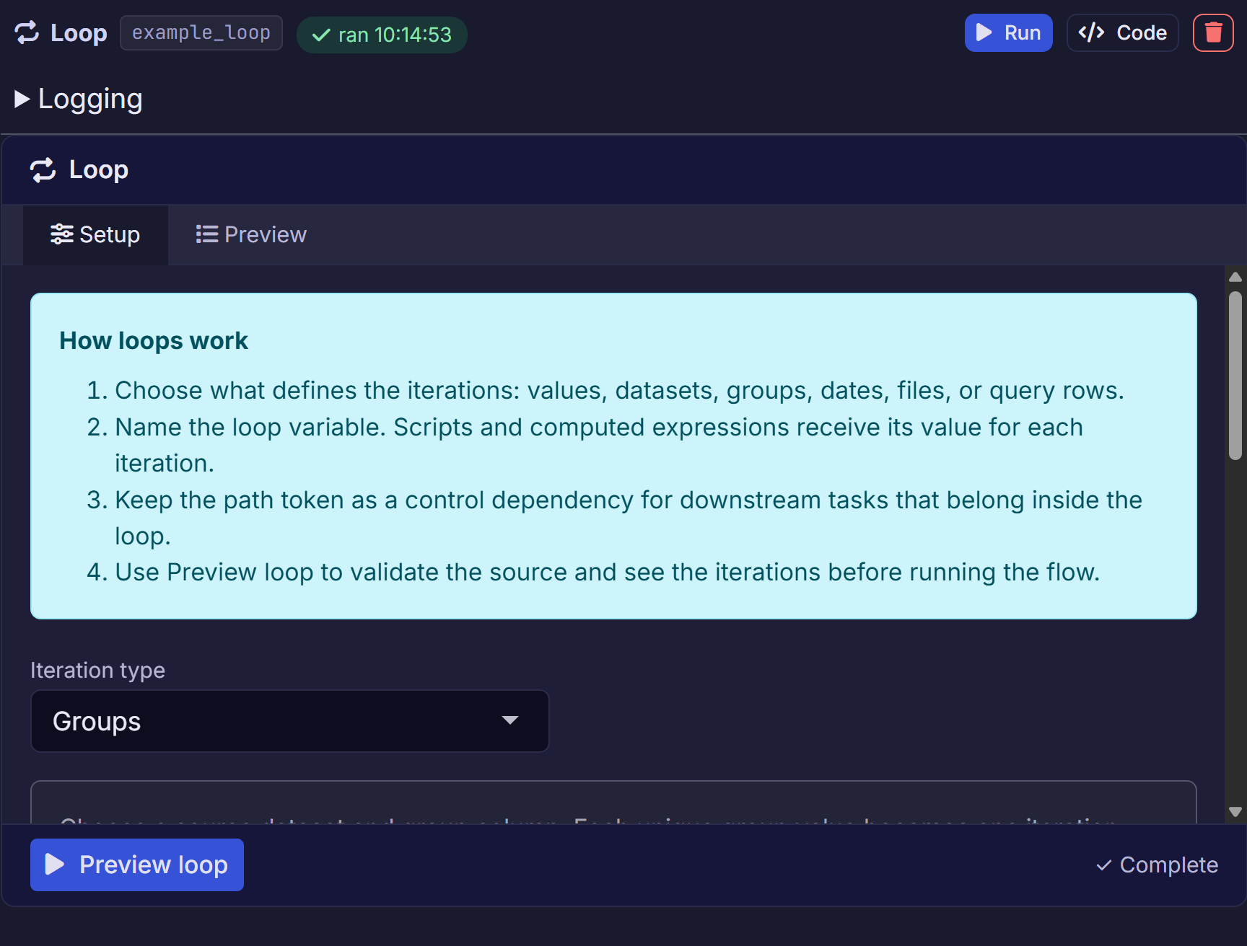
Figure 23. Loop settings choose the source of repeated work. Preview loop lets you check the planned groups before running the flow.
For exported files, give each iteration a different filename. A supported {index} placeholder can add the iteration number. If every iteration writes the same file with Overwrite on, only the last file may remain.

16.3 Choose a loop source
Source | What you provide
Parameter list | One value per line in Iteration values
Files | File paths or matching file patterns
Datasets | All loaded tables; Source dataset names the input alias used by repeated visual tasks
Groups | A source table and grouping column
Date ranges | One date or range per line, such as 2026-01-01 or 2026-01-01/2026-01-31
Database query results | A prepared result table whose rows supply the items
Check the preview before running. A missing file or a mistaken group can otherwise repeat the wrong work many times. If the repeated step uses code, begin with the working example and keep the loop variable name consistent with that code.

16.4 Start small
Try two or three iterations first. Check output names, file paths, row counts, and logs. Once those are right, expand the loop.
Place a final Report or Export Log outside the repeated path if it should run once at the end. Attach it inside the path only when you want one per iteration. A stopped or failed loop does not remove files that earlier iterations already wrote.

17 Keep a useful log
A log helps answer three questions: What ran? What changed? What went wrong? The app records task events, and you can add messages that explain your own checks.

17.1 Choose how much to record
Open a configured task and expand Logging, near the top of its panel. Keep Record task logs enabled, then choose Minimum severity to record. Severity means how serious a message is. The app calls these choices levels.
Level | Use it for
DEBUG | Extra details while finding a problem
INFO | Normal progress and results
WARN | Something to check, even if the task continues
ERROR | A failure or serious problem
INFO is a useful starting point. A minimum of WARN keeps warnings and errors but leaves out normal INFO messages. This choice affects which new messages are kept; raising the detail later cannot recover messages that were never recorded.

17.2 Customize a task’s message
- Expand Logging. Find the rule whose When setting is the event you need, such as task completion.
- Check Enable this rule and choose its Level. The level must also pass Minimum severity to record.
- Edit Message. Use Field to insert into a message and the rule’s insertion button for values such as task name or output row count.
- Set Preview an event to the same event. Use Example values to try sample counts, then read Rendered log entries. This preview does not run the task.
- Run the task and inspect its recorded entries under Logging. Check the timestamp so you read the new entry.
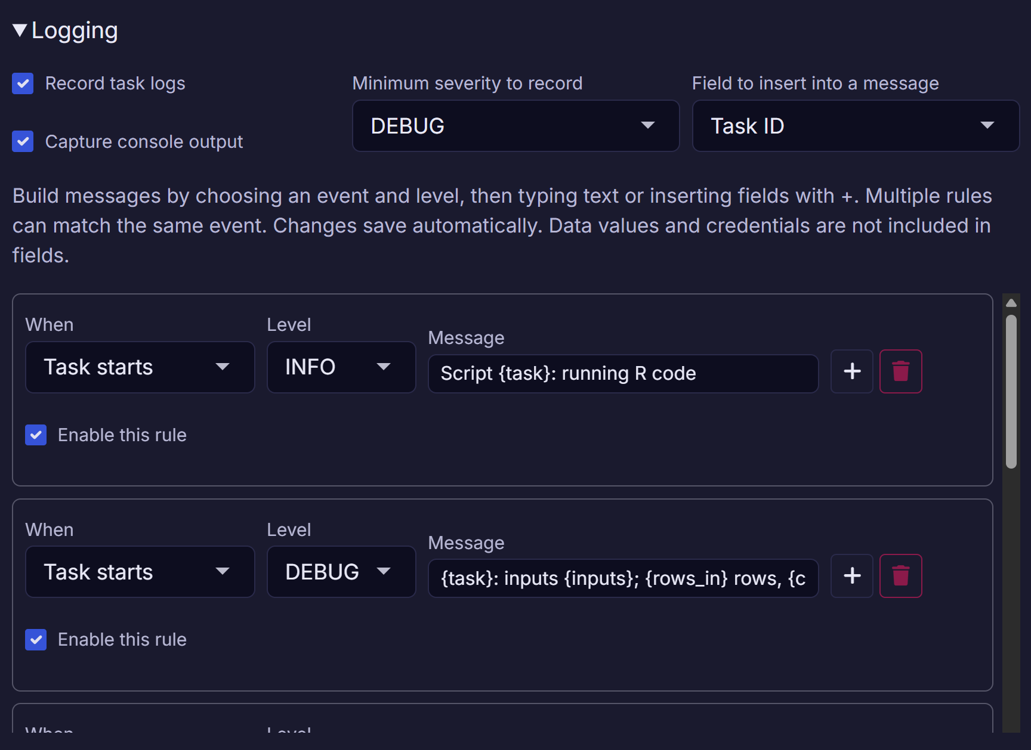
Figure 24. Task Logging lets you choose events, levels, and message fields. Test the wording in the preview before running the task.
For a table-cleaning task, you could use:
{task_name}: {rows_in} rows in; {rows_out} rows out.
The words in braces are placeholders. The app fills them with values from the run. Use the picker so you do not need to memorize their spelling. An output count may not exist at task start, so use it in a completion message. The practice text above stays identical in both editions; you can translate the words around the braces in your own messages.
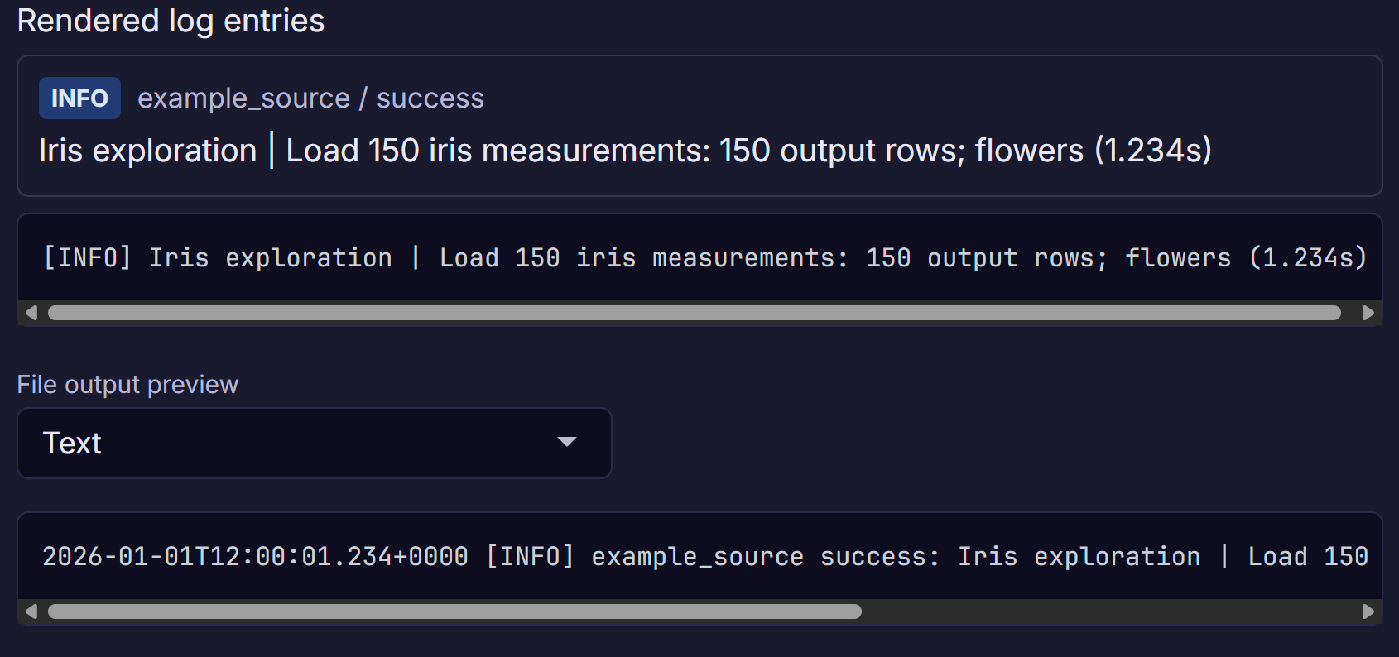
Figure 25. Read the rendered entry before running the task. File output preview lets you inspect Text, CSV, or JSON without writing a file.
Keep the original-message field in warning and error rules. That way, your friendly wording does not hide the reason something failed. If a placeholder stays visible, check the field and event in the preview.

17.3 Add a message inside a Script
This is optional. A Script can add a plain message with the supplied log_event() helper:
log_event("Checked the source data before making the report", "INFO")
Use messages to explain decisions, such as a filter or missing-value choice. Avoid printing private row-level information just to show that a step ran. The Cars - a report with an execution audit example includes a custom warning you can inspect.
A warning message alone does not stop a Script. If you need a quality condition to choose a different path, use a Branch. If you need code to fail on a bad condition, ask the code’s author to make that check explicit.

17.4 Export Log
Use Export Log to write selected task logs to a file as part of your flow.
- Add Export Log from Output.
- Choose the tasks in Run after and include these tasks. Include Report if you want its completion recorded. Blank means all other tasks in the active flow.
- Choose Text, CSV, or JSON in Format, then set Minimum severity to export. Leave Show example entries instead of retained logs off when checking your own run.
- Enter a full Destination file path in a folder you can write to. Include the matching file ending, such as /pipeline-log.csv after the folder address for CSV.
- Check Overwrite an existing file only if reruns should replace it. Select Export log, or Run in the task header. Open the file outside the app and check its dates and messages.
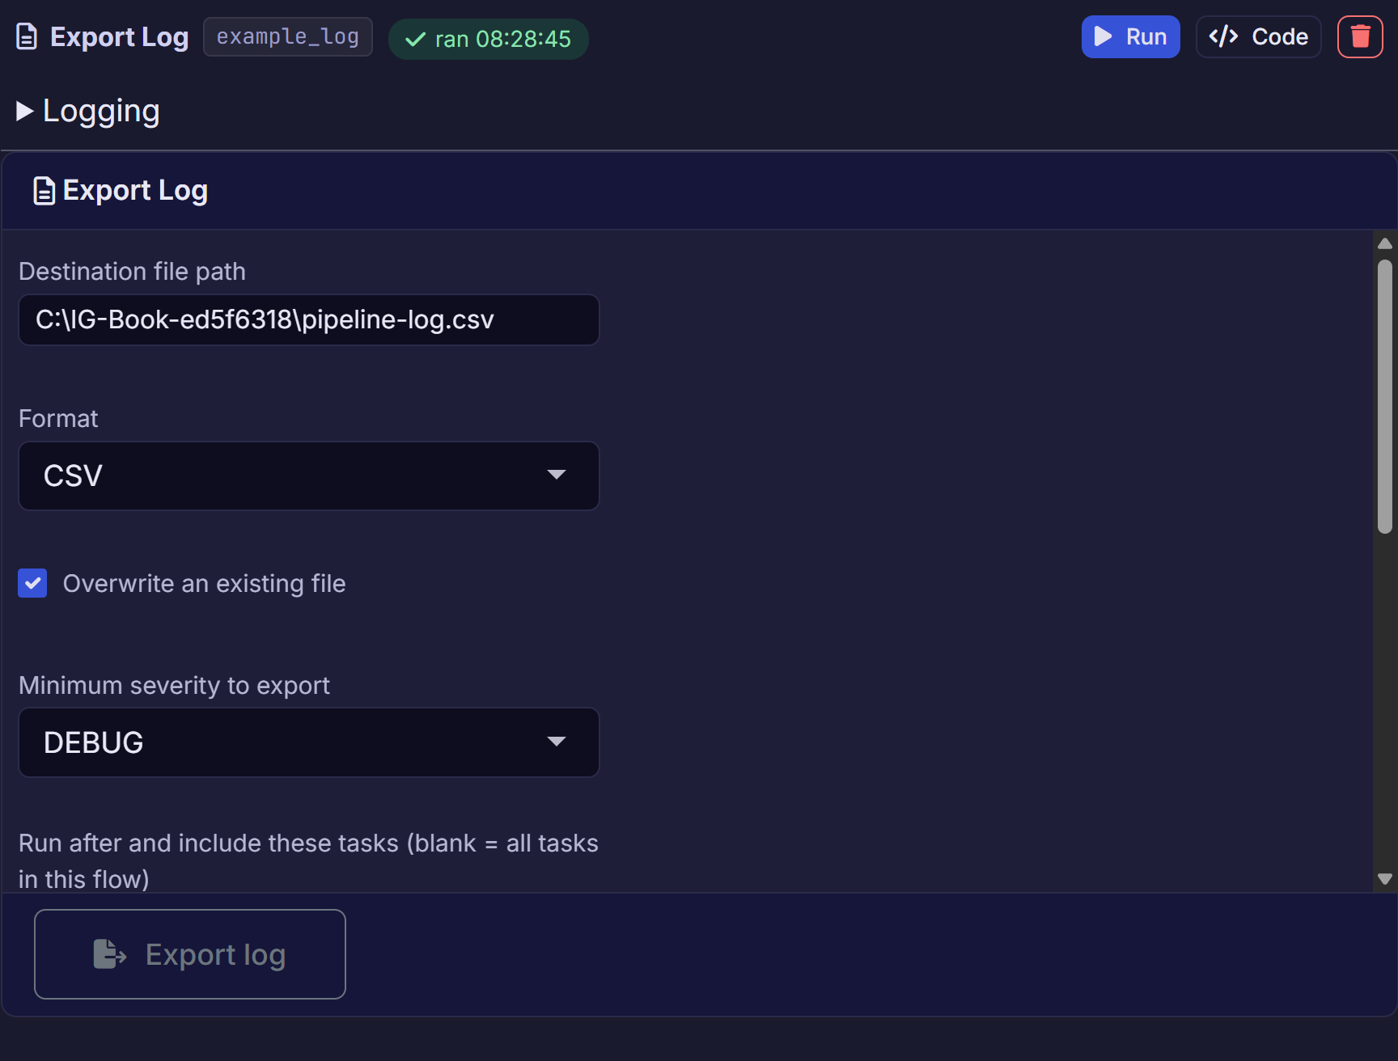
Figure 26. Export Log needs a complete file path, a format, and the tasks to wait for. Its severity filter applies to messages already retained by those tasks.
TXT is easiest to read as plain text. CSV opens in a spreadsheet with separate fields. JSON is useful when another program will read the records. Export Log writes a file rather than making a new data table.
If the flow stopped at an earlier error, run Export Log by itself afterwards when possible. It can help you collect the error messages. Its file cannot include the exporter’s own later completion message.

17.5 Put the log in a report
Built-in headings in saved reports keep their original language. This guide quotes Pipeline execution log exactly so you can find it in the downloaded file. You can write your own report title, notes, and log messages in French or English.
- Open a Report task after running the tasks whose logs you need.
- Under Appearance, check Include pipeline log in the report. Set Minimum log level to INFO for normal progress, or WARN for warnings and errors only.
- Select Generate Report, then Download HTML or Download DOCX. Open the file and look for Pipeline execution log.
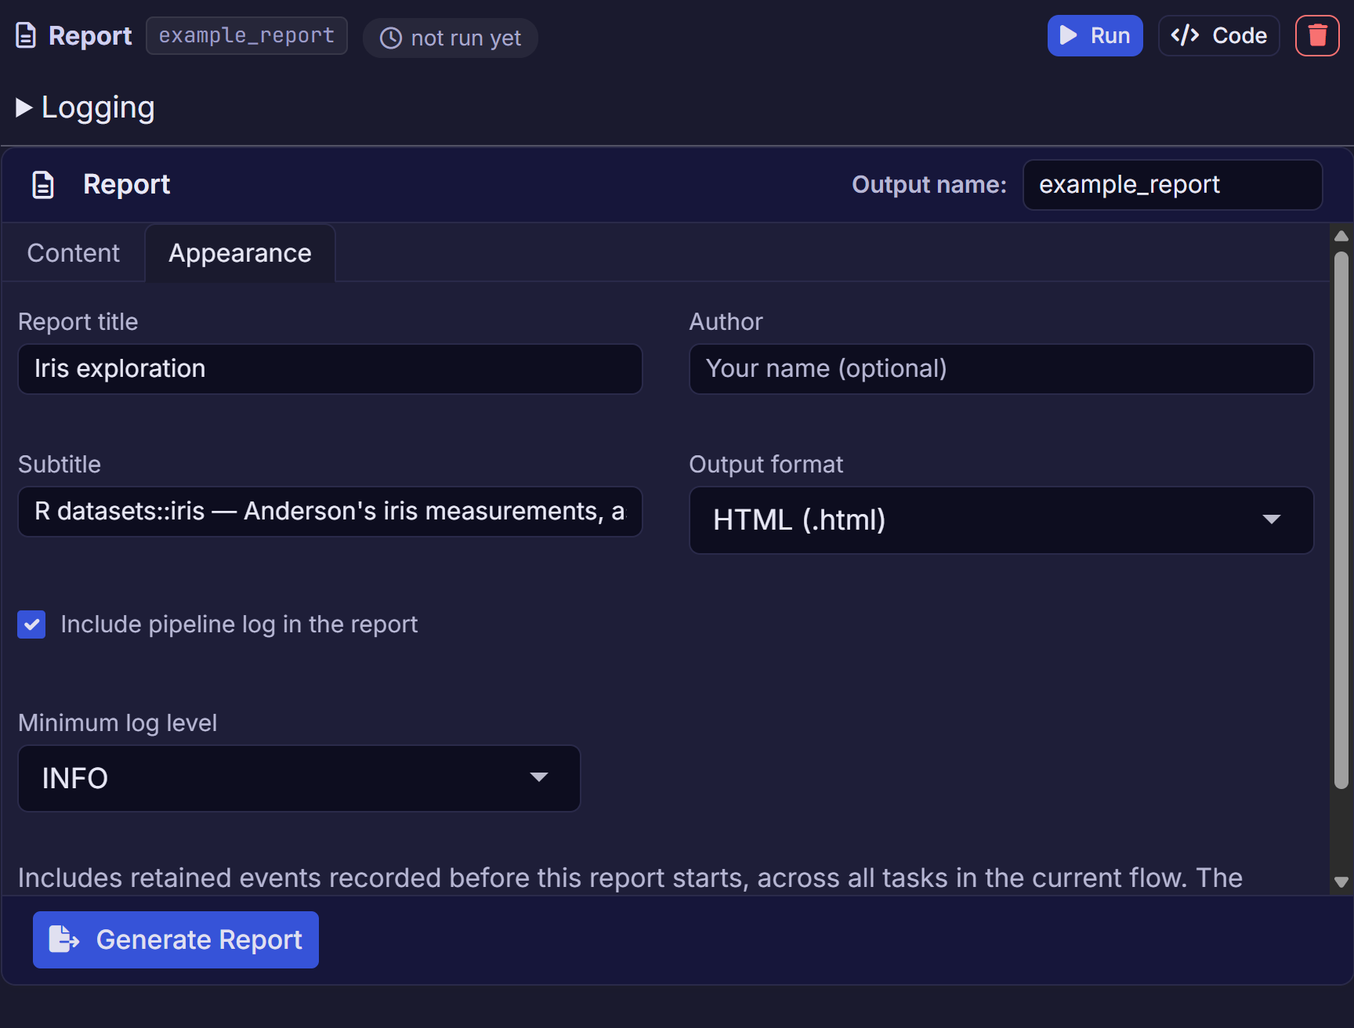
Figure 27. Report Appearance controls the log appendix and its minimum level. Generate the report again after changing this setting.
The report takes a snapshot of other tasks’ available logs before it is made. It cannot include its own completion at that point. Add Export Log after Report if you need that event in a separate file. You can also make a report containing only a log by enabling the log option without selecting ordinary report items.

17.6 Read dates as well as messages
Tasks keep up to 1,000 recent entries each, across runs. A saved project keeps those available entries. Running a flow again does not erase its older messages.
Use the timestamps and run identifiers to compare runs. Old warnings may still appear after you fix a problem. Long or very chatty runs can push old entries out of the retained log, so export important logs in time.

17.7 Use startup logs for startup problems
The desktop Session menu offers Open startup log, Open logs folder, and Save diagnostic log for connection and startup problems. Task logs help with the analysis itself. Before sharing a log, remove private data, passwords, and file paths you do not want to publish.

18 Share reports and files
Choose what your reader needs. Send a report for reading, a CSV for working with data, or a project for editing the flow. You can send more than one when each has a clear purpose.

18.1 Report
Use Report to bring tables, charts, and notes into an HTML or Word document.
First run the tasks that supply the results. For a chart in Word, keep its static image output enabled and run the chart again if needed.
- Add Report from Output.
- Under Content, use the plus button beside a result in Available outputs. Check that it appears under Report contents. Add items in the order you want readers to see them.
- For each item, fill in Section heading and Note. Explain the data source, units, and important choices. Leave Render style at Auto unless you need a specific display.
- Under Appearance, choose HTML or Word in Output format and enter Report title.
- Turn on Include pipeline log in the report if you want an execution-log section.
- Select Generate Report. When it finishes, select Download HTML or Download DOCX. Save the document and open it outside the app.
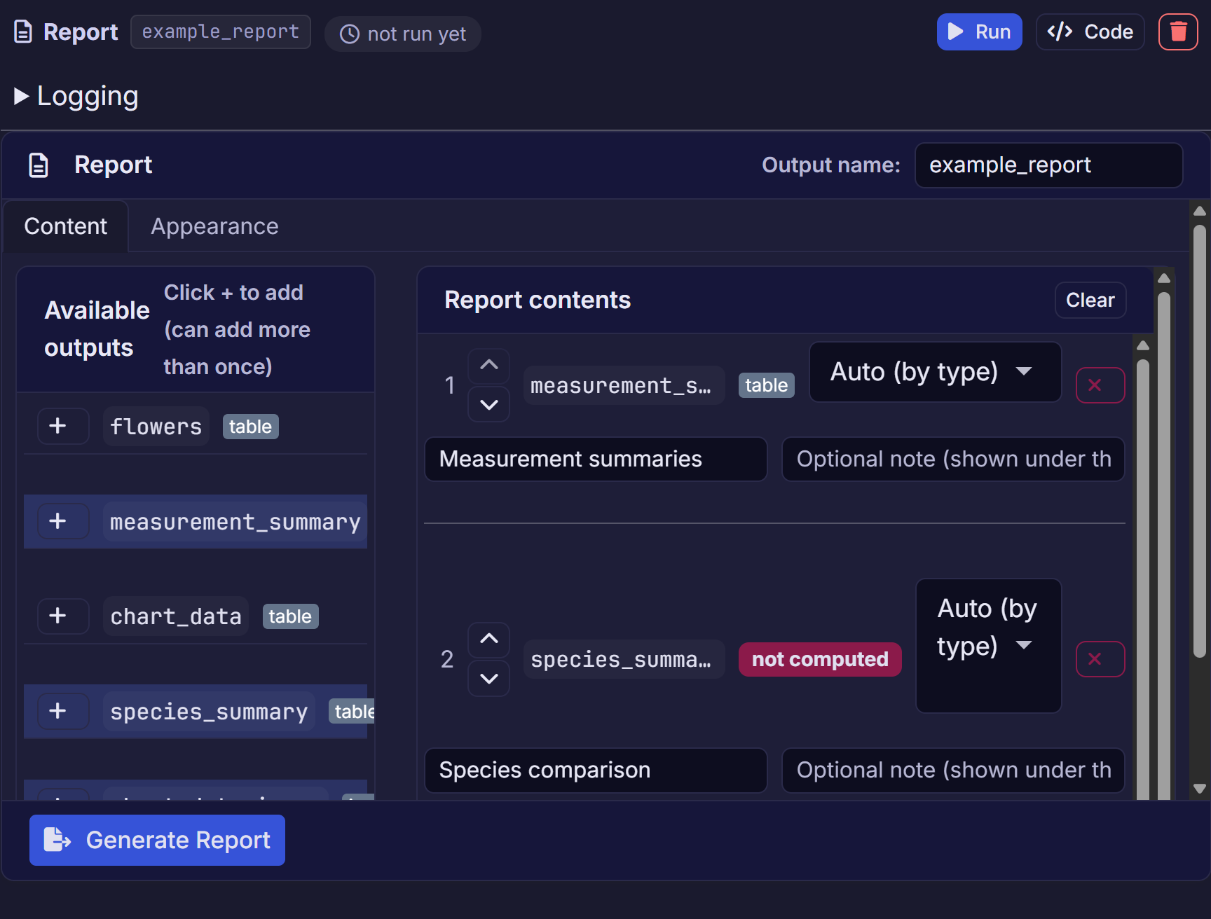
Figure 28. Add outputs on the left to build Report contents on the right. Each item can have its own heading, note, and render style.
Check the document itself before sharing it. A missing result can lead to a warning and an incomplete section. Run its source task, then regenerate the report. Iris exploration shows tables and a chart together. Cars - a report with an execution audit focuses on logging.

18.2 Choose HTML or Word
HTML opens in a web browser. It is a good first choice and can include interactive tables where supported. Download it and check it outside the running app.
Word produces a .docx file that you can edit in a compatible word processor. Use static charts and tables; a Word page cannot keep browser hover controls. If your chart is missing, enable its static image output, run the chart, and select that output in the report.
The Windows Setup includes the normal report tools. An R-only installation needs extra reporting packages, and Word also needs Pandoc. See Optional: install with R if that is how you run the app.

18.3 Pick a content style
Start with Auto. It chooses a display based on the actual result. Use a table style for a table and a figure style for a static chart. Print style shows an object’s text when that is what you need.
Give a reader enough context to understand a result. For example: Mean petal length by species, 150 flowers, measurements in centimetres is more useful than Output 2. If you change the data or chart, run Report again; a previously saved document will not update on its own.

18.4 Export
Use Export to write a table, chart, or supported object to an outside file.
Before starting, run the task that creates the result you want to export.
- Select Add Task > Output > Export. Under Setup, choose Output to export, then a compatible Format.
- Select Choose folder… and choose a destination you can find again.
- In File name (without extension), enter a name such as species-summary. Check the full file address shown by the app; it adds the format’s file ending.
- For an image, check its dimensions and DPI. Check Overwrite if the file already exists only if you mean to replace that file.
- Select Export. Open the finished file from the chosen folder and check its contents.
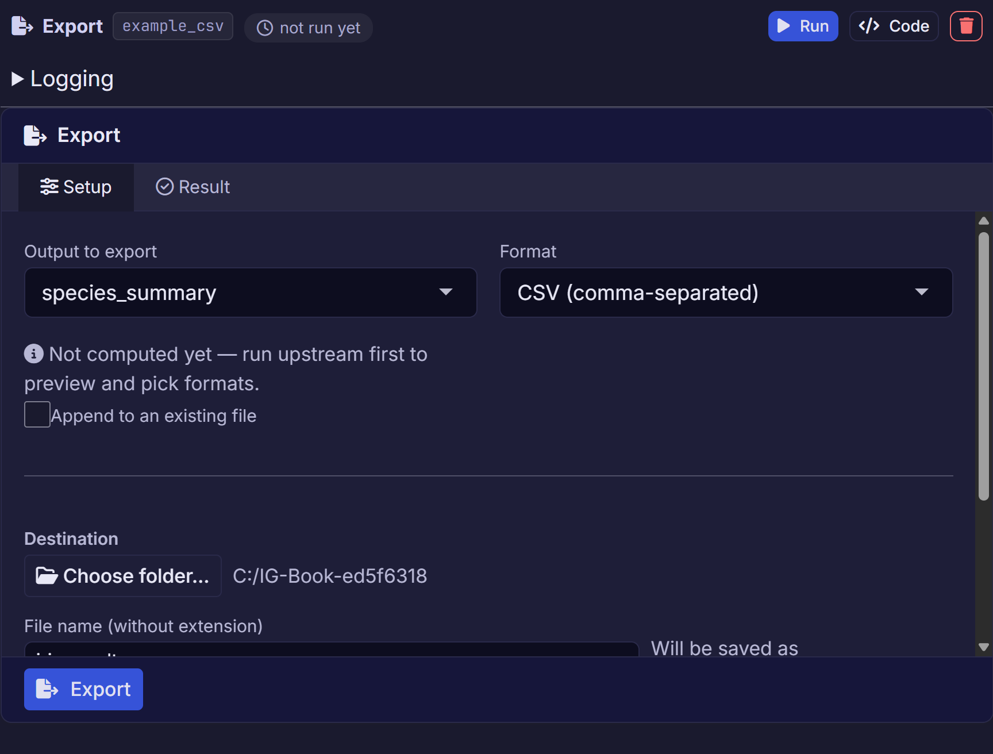
Figure 29. Export separates the destination folder from the filename. Check the complete file address before writing or replacing a file.
Start with CSV for data and PNG for a still chart. The source must be the right kind of result: exporting chart data as CSV is different from exporting the chart’s static image as PNG.
Check Overwrite before rerunning. Append is available for CSV and TSV when supported; it adds rows to an existing file. It is not a general way to add a sheet to Excel. An Export task writes a file and does not create a new table for later tasks. The original result remains the source for those tasks.

18.5 Choose an export format
What you need | A useful choice | What to check
Data for many other apps | CSV or TSV | Dates, text IDs, and missing values after opening
A spreadsheet | XLSX | Column types and the receiving spreadsheet’s limits
A still chart | PNG | Readable labels, dimensions, and resolution
A chart that can scale | PDF or SVG, when offered | That the receiving app can open it
Typed data for compatible tools | Parquet or Feather | Support in the receiving tool
Structured data for a program | JSON | The format expected by that program
An R result for another R user | RDS or RData | The recipient’s R and package support
You do not need to learn every format. Choose the one your reader or next tool can use. If leading zeros disappear in a spreadsheet, import the ID column as text in that spreadsheet. If a CSV opens as one column, use the spreadsheet’s text/CSV import command and choose comma as the separator.

18.6 Check a finished delivery
Save the project. Open the exported report and data files outside the app. Check titles, units, row counts, charts, and the log’s dates. Make sure you are sending the latest files from the folder you actually chose.
If you need a record that the report finished, send a final Export Log made after Report. Its events are later than the snapshot inside the report.

19 Optional: try the R Console
You can use the app without the console. It is there for quick questions and small trials when you want more control.
R is the calculation language behind the app. A command is an instruction you ask R to carry out. The console shows the command and its result. Start with this calculation:
2 + 3
The result is 5. You do not need to install anything to try this inside the desktop app.

19.1 Open the console and run a command
- Choose the R Console tab. In the desktop app, you can also use View > R console.
- Select the command area, type 2 + 3, and press Enter. Check that the transcript shows 5.
- Use Shift+Enter to add a line without running it. Use Ctrl+Enter to run a block of lines.
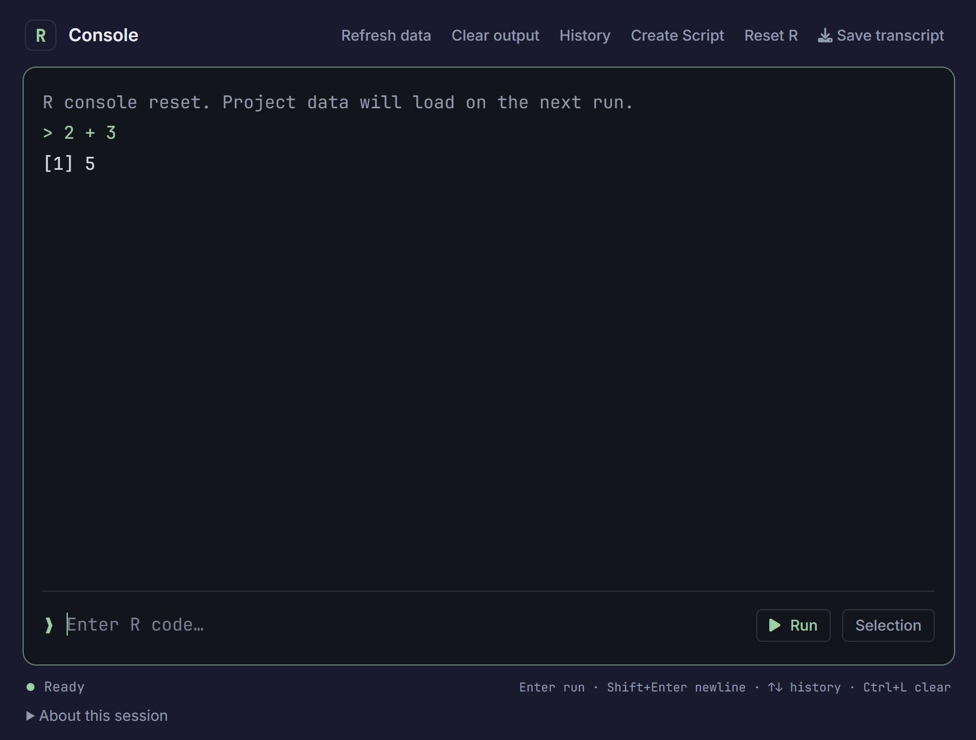
Figure 30. The R Console has a command area and transcript. Project-data controls supply working copies for trials; they do not add a step to the flow.
Commands, R output, and console messages keep their original text. The buttons use your chosen language.
The console loads copies of available project data when you first run a command. Select Refresh data after changing data in the flow. This replaces the imported copies while keeping other console values. Changing a console value does not automatically change the project’s table or flow.

19.2 Read a command before running it
Commands can calculate, change values, read files, or write files. Use code you understand or trust. For a simple practice with R’s built-in flower data, try:
mean(datasets::iris$Sepal.Length)
The result is about 5.8433. Here, mean asks for an average. The rest identifies the sepal-length column in the built-in flower data. You do not need to memorize that punctuation to use the task forms.

19.3 Find and reuse a command
Use the history controls to find earlier commands. Up and Down move through history when the cursor is at the command boundary; Alt+Up and Alt+Down also help. Ctrl+R searches command history.
Tab or Ctrl+Space offers completions when available. A completion helps type a name; it does not check that the finished command answers your question. Read errors and edit the command before trying again.

19.4 Clear, Stop, and Reset
Action | When to use it | What to expect
Clear output or Ctrl+L | You want a cleaner display | Clears the transcript and plots; working values remain
Stop | A command is taking too long | Stops console work and clears its working values; the transcript and history remain
Reset R | You want a fresh console | Clears its working values, transcript, history, draft, and plots
Restart R server | The app’s calculation service has stopped | Restarts the app session; save first if possible
After Stop, the next command loads fresh project-data copies. Values created only in the console are gone. These actions do not turn a trial command into a saved task.

19.5 Keep useful code in a task
- Select the useful code in the console, or leave it as the current draft or last command.
- Select Create Script. Open the new Script task and check the copied code.
- Check Input tables / special outputs and Outputs. An inferred name still needs to match the result the code creates.
- Run the Script and check its saved results. See the Script task guide for the output-line format.

20 Optional: export the flow as R code
The Code tab can export the active flow as a complete R script or a code bundle. This is useful when someone needs to rerun the analysis without opening Individual Guide.
A script is a text file of R commands. A bundle includes the script and supporting files with instructions. Choose a complete-flow export for a handoff; an individual task’s code may depend on earlier steps.
You can skip code export for everyday app use. A saved project is usually the easiest way to return to your work.

20.1 Share code that someone can run
- Run the flow and check its results. Select the flow you mean to share.
- Open Code, or View > Generated R code in the desktop app. Choose Complete script in Code view if you want to read all the exported instructions together.
- Select Download .R for one complete script, or Download bundle for a ZIP containing the pipeline, its supporting functions, and a README.
- Save the download. Include any needed input files separately and tell the recipient which outputs to expect. The code bundle does not collect your outside data files or database credentials.
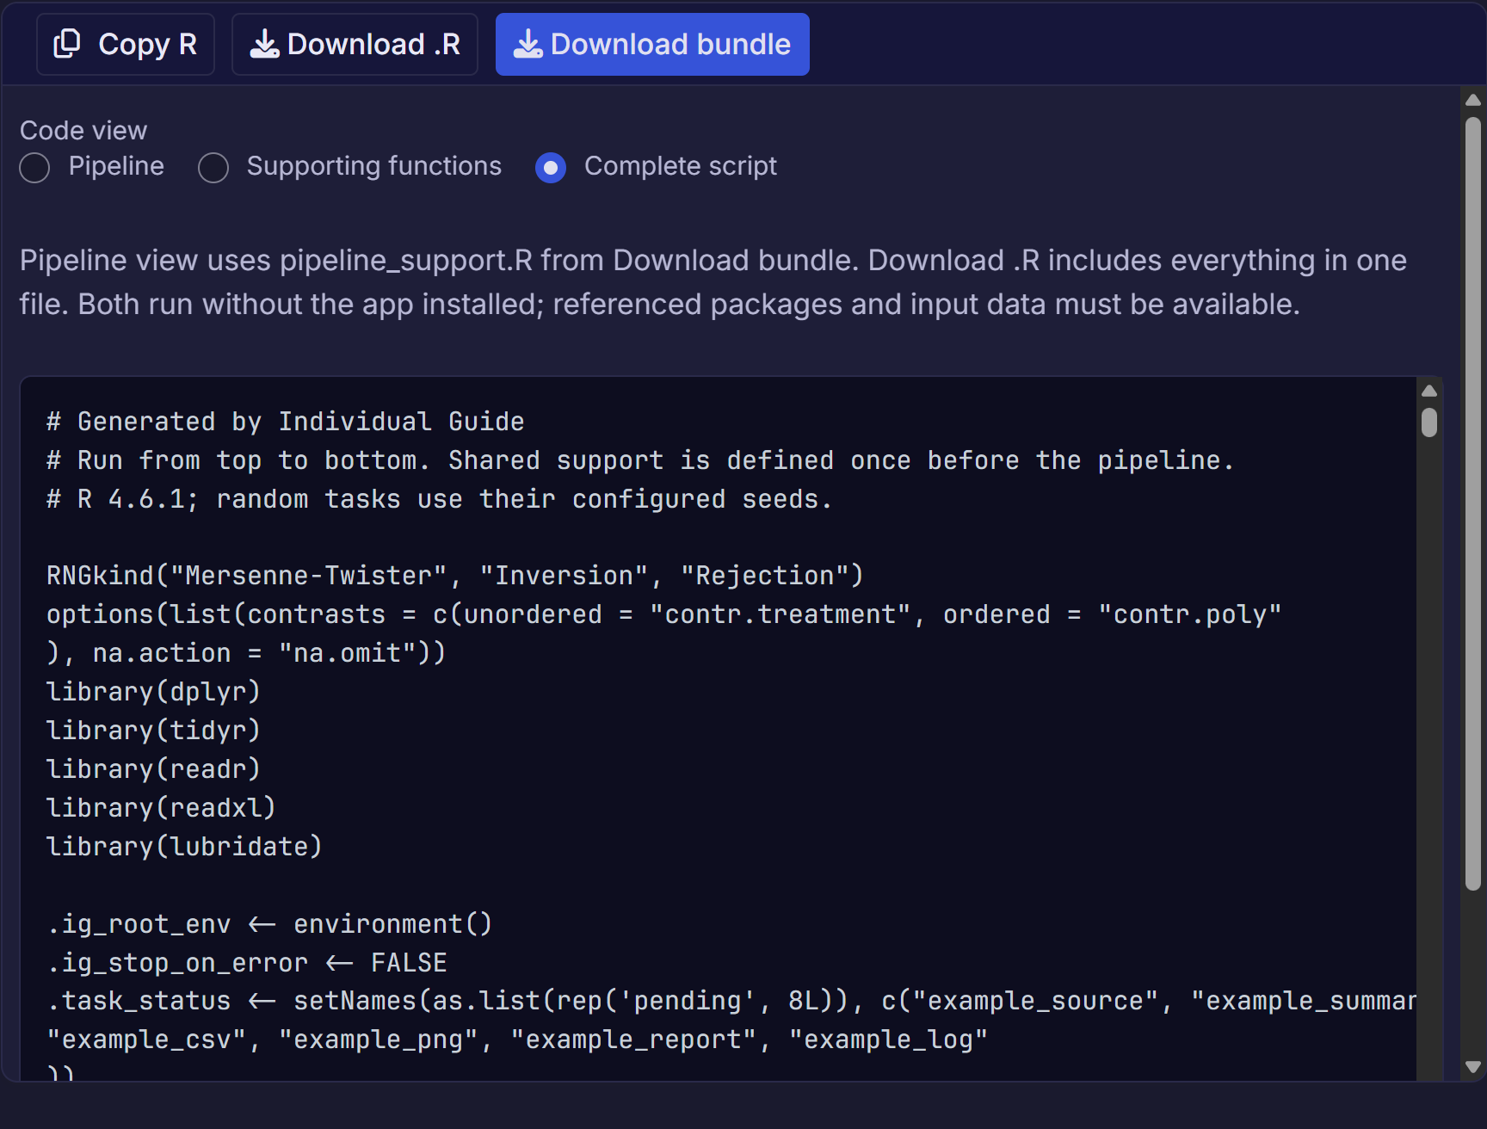
Figure 31. The Code tab separates the pipeline from supporting functions. Download .R includes both in one file; Download bundle keeps them together in a ZIP.
The recipient needs R, the packages requested by the script, and access to its inputs. The complete generated pipeline does not need the Individual Guide package itself. Database access and file locations still need to be set up on the receiving computer.
Open the bundle’s README and follow its instructions in a separate working folder. Check output destinations before running. Running a saved script can replace files just as running Export inside the app can.

21 Explain and review your work
A useful project tells another person what you did and why. A few clear notes can save much more time than a long trail of unexplained task names.

21.1 Add notes at decision points
Use task notes or project comments to explain choices. Record why you removed rows, filled missing values, chose a model, or set a threshold. Write for someone who sees the project for the first time.
- Right-click a task in the flow. Enter Note (shown as node tooltip), then select Save note. Point to the task later to read it.
- For a longer discussion, choose View > Comments… in the desktop app, or the browser app’s Comments button.
- Choose Attach to, enter an optional title, and type your comment. Select Comment to keep it, or Raise issue when it needs review.
- Save the project so the notes travel with it.
For example: We kept orders from January through March and excluded cancelled orders. That tells a reader more than Filter updated.

21.2 Check before sharing
- Choose View > Review dashboard… in the desktop app, or the browser app’s review control. Check outstanding issues before marking work ready for review.
- Choose View > Change history… to inspect saved project changes. Use its filters to find the task or time you need.
- Choose Task > Run records… to inspect previous executions. In a browser, these records are under Project tools > Run records.
- Compare records for the task you are checking. A run record helps identify changes in settings, inputs, and software versions; it does not replace reading the result.
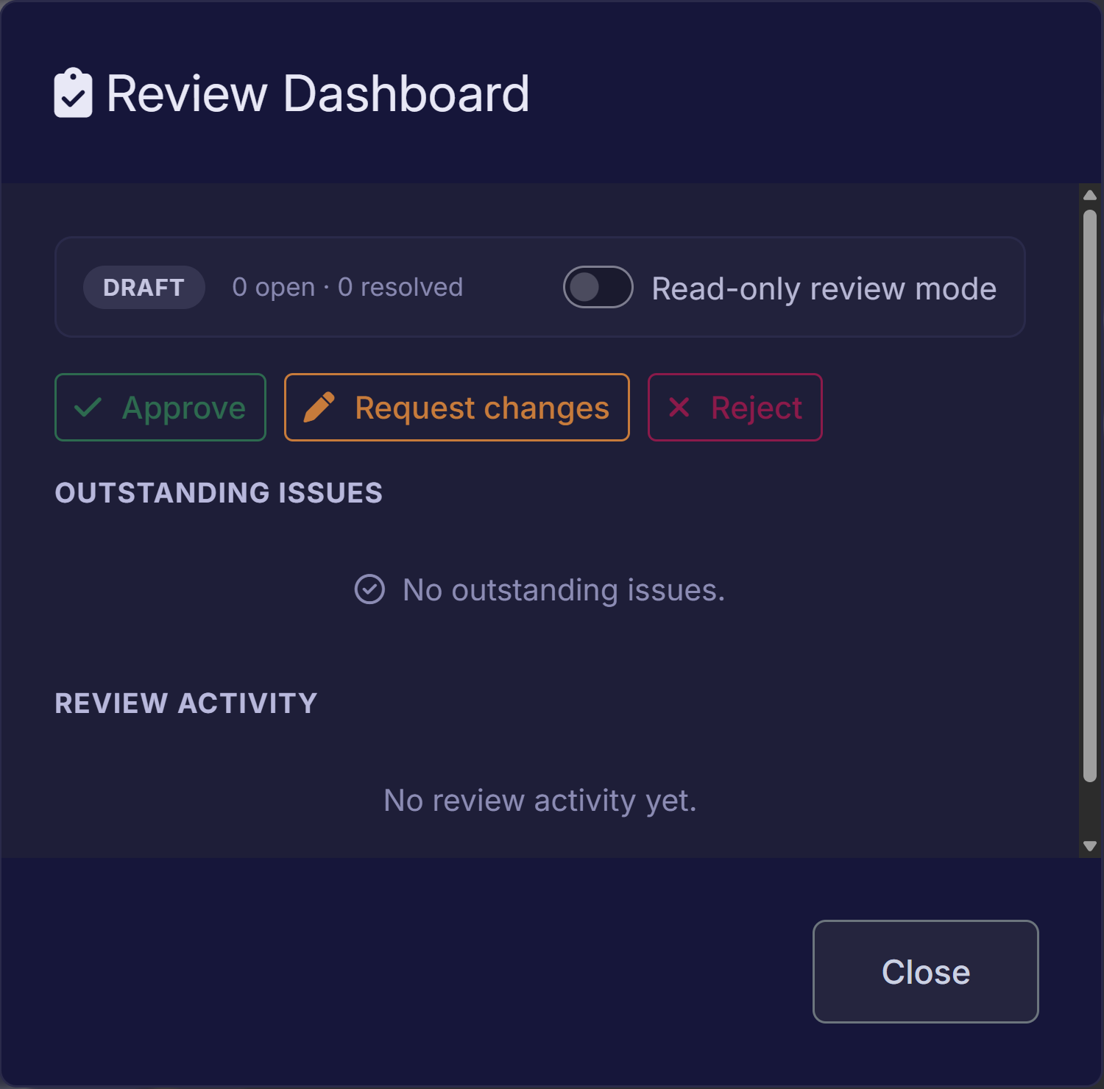
Figure 32. The review dashboard collects review status and issues. Notes and comments help another reader understand the choices behind the results.
Check the current results too. Old success messages do not prove that a changed task has run again. Update stale results and the report, then save.

21.3 Find something quickly
- In the desktop app, press Ctrl+Shift+F to open Global Search. In a browser, select the Global search button in the app header.
- Type part of a task name, column name, or comment. Select a result to open it.
- For a task-only view, choose View > Task list in the desktop app, or Project tools > Task list in a browser. Enter part of its name in Find a task, then open the matching row.
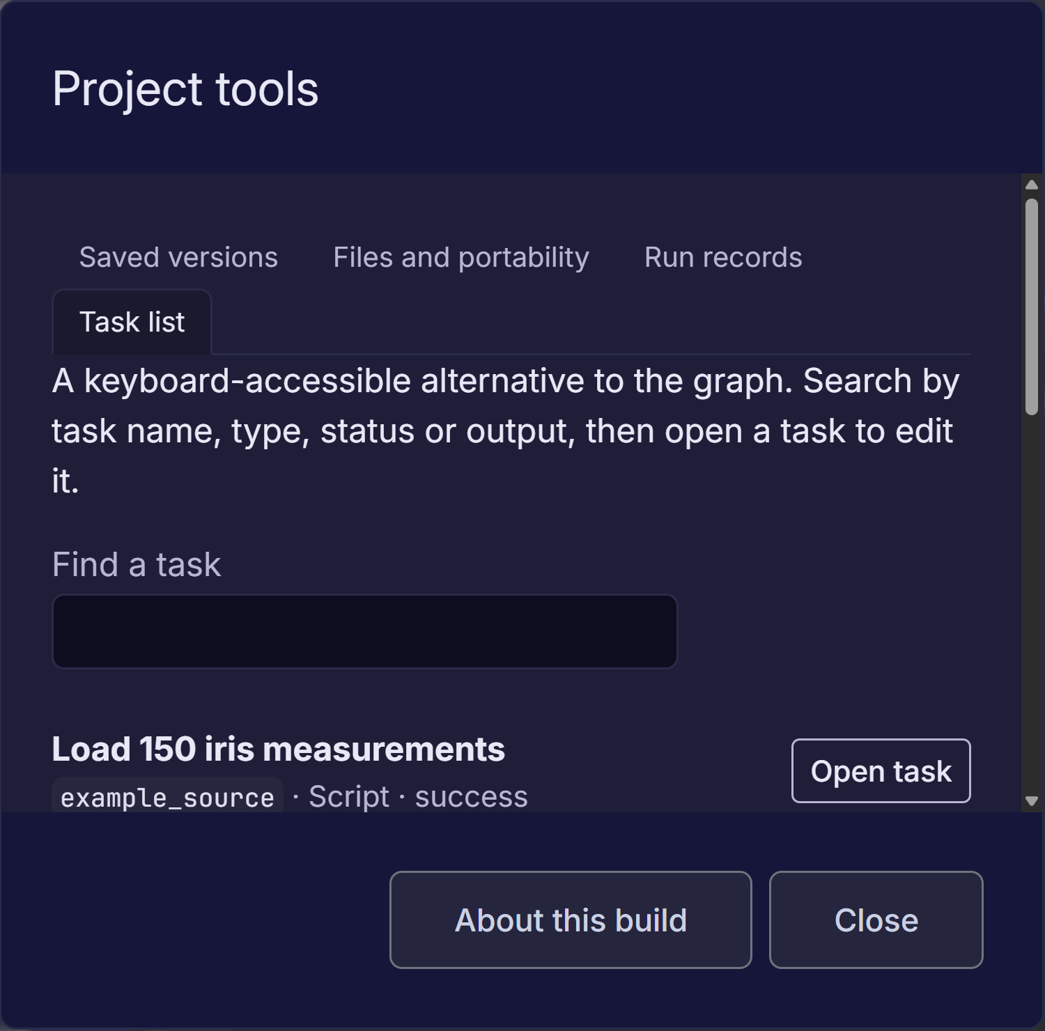
Figure 33. Task list provides a searchable alternative to the flow diagram. Find a task by its name, type, status, or output.
Undo can restore supported project changes, but it does not rewind every action. In particular, it cannot bring back the old contents of an outside file that Export overwrote. Save a separate copy before a large change.

21.4 A simple review checklist
- Can you name the data source and the date of the copy you used?
- Do row counts and missing values make sense after cleaning?
- Do charts show the correct columns, labels, and units?
- Have you checked model warnings and the number of rows used?
- Does the latest report match the latest results?
- Are logs and exported files in the folder you expect?
- Have you saved the project and checked the copy you will share?

22 Make the app comfortable to use
- Open a project, then choose File > Settings… in the desktop app. In a browser, select Settings in the app header.
- Choose Global defaults or This project, then search for a setting or select a category. Start with Appearance or Preview rows per page if the workspace is hard to read.
- Select Edit beside the option, change its value, then select Save option. Check the workspace. Save the project to keep project overrides.
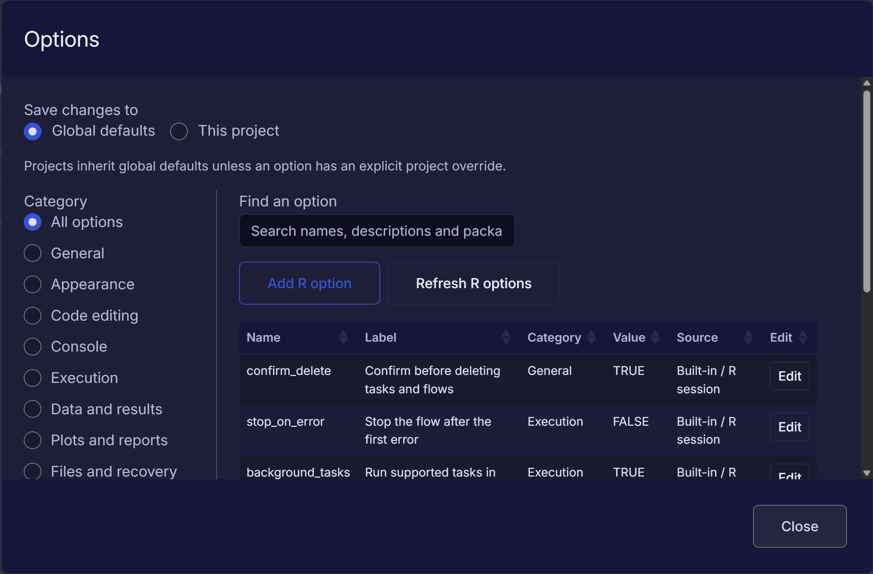
Figure 34. Options groups appearance, code editing, the console, execution and recovery settings. Choose a scope, find an option, then select Edit.

22.1 Global defaults and project overrides
Global defaults apply to projects that inherit them. This project saves only the values you override. Select Use global default to remove one project override. An explicit NULL R value removes an option; it does not mean inheritance. Older projects keep their saved preferences when opened.
The R-options categories list the bundled R reference and options registered by the app or console. Use Add R option for a package option that is not listed. Enter its name, choose a value type, and select Save option. The expression editor accepts vectors, lists and functions; expressions run when you save. Use the option’s documentation to choose a valid value. Some R options need a restart. If a saved R setting prevents startup, choose Session > Restart with default R options…, repair the setting, then restart normally.

22.2 Package versions
Choose Session > R packages…, or R package manager in Options. IG uses its own library. Enter a package name and an exact version, or leave the version empty for the latest available version. Pin installed version keeps the selected version. Export a lockfile to record the package profile; restore it to request those versions again. Save your project and restart R after package changes. The manager can restore a previous profile or return to bundled packages.

22.3 Display and navigation
Use Appearance to choose Dark or Light. Default plot theme and Default plot palette affect newly added charts; they do not restyle every existing chart. Code-editing and console categories control fonts, wrapping and other display choices. Use the desktop View menu’s zoom controls if text is too small. For a large flow, combine Fit view with Task list.
Keyboard navigation can help when a diagram is difficult to use. Tab moves focus through controls. The shortcut guide lists common desktop keys.

22.4 Saving and confirmation choices
Previous saved versions to keep sets the number of earlier explicit saves retained for a project. The default is 20; zero turns these versions off. Crash recovery is separate. Keep your own backups for important projects.
Enable Stop the flow after the first error while learning, so an error does not pass unnoticed. Run supported tasks in background workers helps keep the interface available during supported work; it does not make every task run at once. Recovery autosave interval (seconds) defaults to 30.
Leave useful confirmations on while learning. Read any warning about unsaved work before opening another project or example. Saving takes a moment and is easier than rebuilding changes later.

22.5 Trust and private information
Opening a project can make its saved tasks and code available to run. Accept projects from sources you trust. Review input paths, export destinations, and Script tasks before running someone else’s flow.
Treat a project as a file that may contain private information. A report or log can contain it too. Check the actual files before putting them in a public folder or attaching them to an issue.

23 Open other Shiny apps
A Shiny app is an interactive page that uses R behind the scenes. It may show a dashboard, a chart, or a form. You can open an app someone has shared with you inside Individual Guide. You do not need to copy its code into a pipeline.
Your Individual Guide project stays open. The other app runs in a separate copy of R. Its view fills most of the window, with an Individual Guide bar across the top.

23.1 What you need
Ask the app’s author for its complete folder and any setup instructions. A supported folder has either:
- One app.R file, plus any data and helper files it uses.
- Both ui.R and server.R, plus any other files it uses.
Keep the folder together. If it came in a ZIP file, extract it first. Selecting a file does not upload it or install packages. The app runs on this computer and can read or change files with your permissions. Use apps only from a source you trust.

23.2 Try the practice apps
- Download the Shiny practice apps for this release.
- Right-click the ZIP in Windows and choose Extract All. Choose a folder you can find again.
- Follow the steps below. Select iris-explorer/app.R for the flower app. Select the local-sales folder for the two-file app, which reads a CSV and can download a filtered copy. Both use packages included with Individual Guide.
The flower app has its own Language / Langue list. Choose Français (Canada) there to see French labels inside that app. That list changes the practice app only.

23.3 Open and run an app
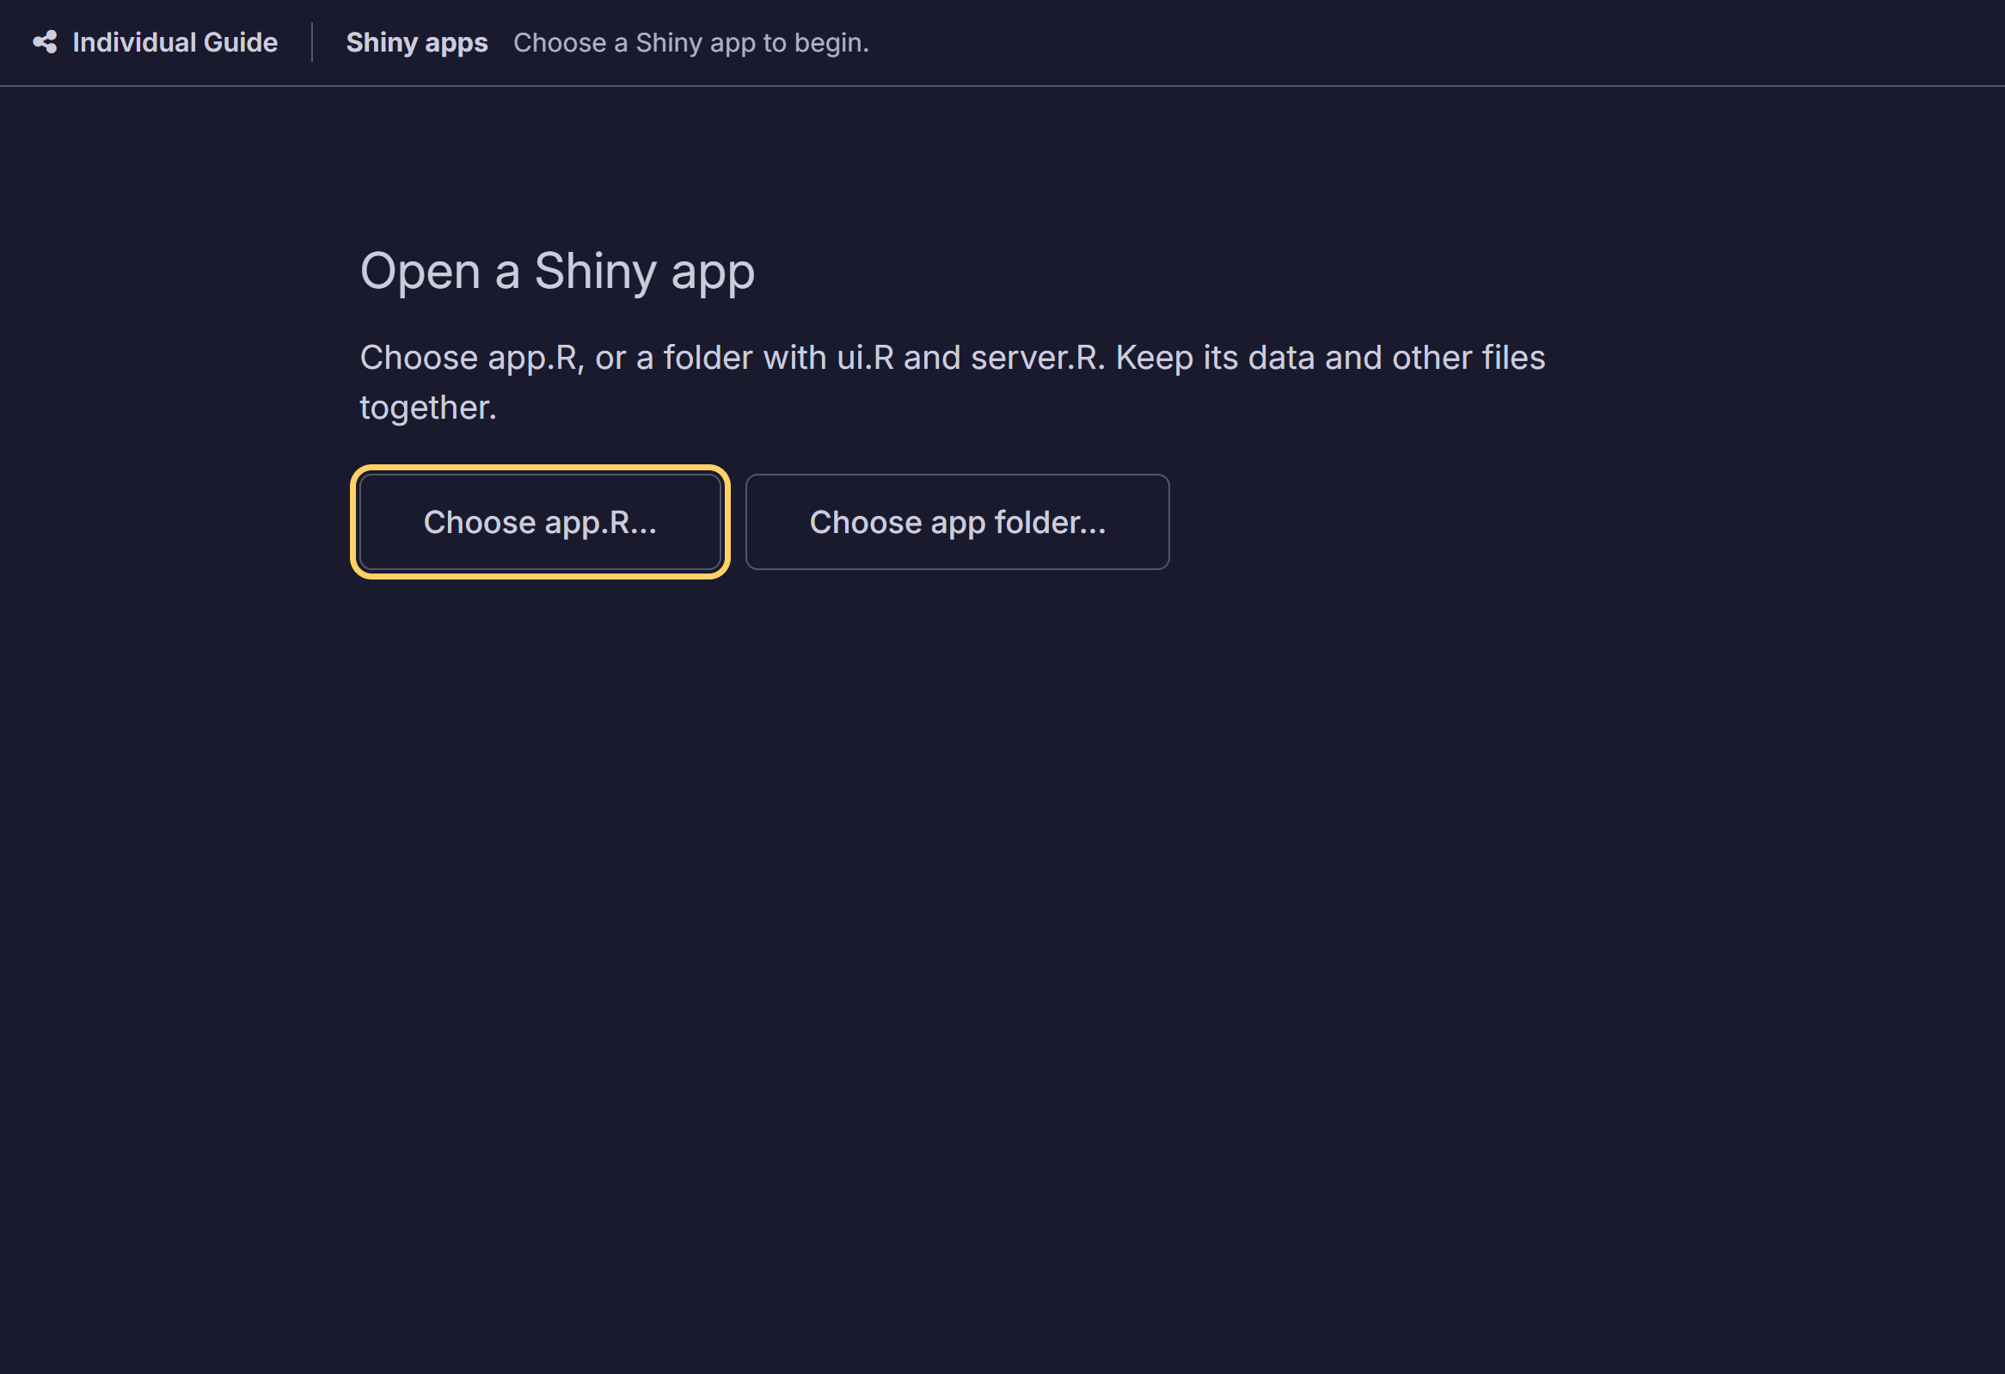
Figure 35. Choose a single app.R file or a folder containing both ui.R and server.R. Your Individual Guide project stays open behind this view.
- On the welcome screen, choose Open Shiny app. From your workspace, use the window icon beside the app name. In the desktop menu, File > Open Shiny app… opens the same view.
- Choose Choose app.R… for a single-file app, or Choose app folder… for a folder. For the two-file format, choose the folder that contains both files.
- Check the selected path. Keep any data, helper scripts, and www folder in their original places.
- If you trust the source, select I trust this app, then Run app.
- Wait for the app to appear. Use its own controls to work with its data. The Individual Guide bar stays above it.

23.4 Return to your project
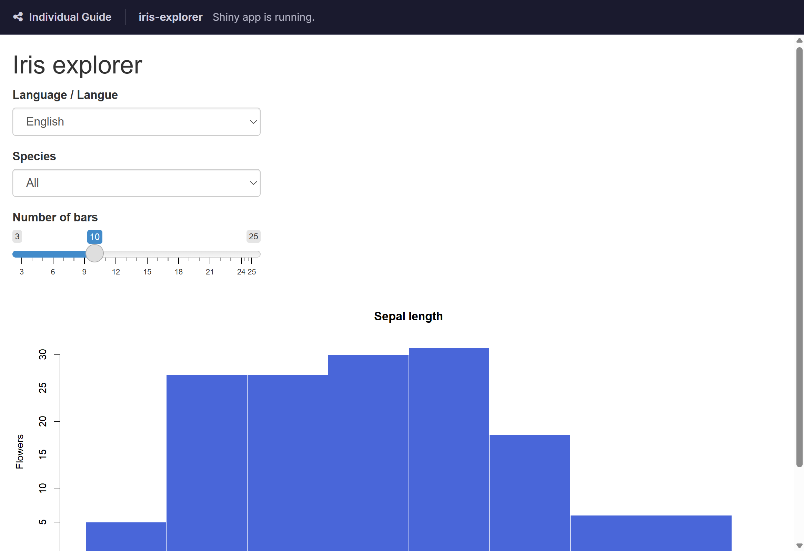
Figure 36. The loaded app fills most of the window. The Individual Guide bar keeps the workspace, app switcher, log and close controls within reach.
Choose Individual Guide at the left of the top bar. Your project is still there, with its inputs and results. The other app keeps running in the background.
Use the window icon again to return to the other app. Its inputs stay as you left them. In the desktop app, View > Individual Guide workspace also brings you back to your project.
Switching views does not restart either R process. If you are finished with the other app, close it to free its resources.

23.5 Close an app or open another
To stop an app, choose Close app in its top bar. Save any work using that app’s own controls first. Read the confirmation, then choose Close app again. Cancel keeps it running. Closing it leaves Individual Guide and your project open.
To switch apps, choose Open app…, then select another file or folder. Picking a file alone does not close the running app. You can choose Back to running app if you change your mind. When you select Run app, the previous app closes and the new one starts. Save work in the previous app before that step.
Closing Individual Guide stops the loaded app too. Its temporary session is not saved inside your .igpx project. Each app decides how to save its own data and settings.
Restarting the main R server also closes the loaded app. Save work in both apps before restarting.

23.6 If an app will not start
Choose App log to read its messages. The same control works while an app is running. Logs keep the app’s original language. Copy the exact error when asking its author for help.
- If a file is missing, check that you extracted and kept the complete folder.
- If a package is missing, follow the author’s public package instructions. Individual Guide includes its own packages, but it cannot include every package another app might need. Individual Guide does not install extra packages for that app.
- If the app stops or takes too long to start, the top bar stays available. You can run it again, choose another app, or return to your project.
The language choice in Individual Guide changes its own top bar and controls. The loaded app keeps the language and appearance supplied by its author. Its R code runs separately, with the package libraries available to Individual Guide. Apps that need another R version, external software, or a database still need their own setup.
This feature opens local apps. In the ordinary browser version, use a browser on the same computer that runs Individual Guide.

24 Keep work running smoothly
Try a small version of a flow before using a large dataset. Check its settings, then run the full version once you know what it will do.

24.1 When editing feels slow
Wait for an active run to finish, or use Stop if you do not need it. Close task panels you are not using and use the Task list to move around a large project. A smaller chart or sample can make exploration easier, but keep full data for calculations that need it.
If the app remains slow, save, close it, and open it again from its shortcut. Record which task and action cause the delay if you need help. A report such as Typing the output name is slow in a 40-task project is easier to investigate than The app is slow.

25 Troubleshooting
Start with the symptom below. Keep the exact error text when asking for help. It often points to a missing file, column, or package.

25.1 The app seems not to open
Use the installed Start menu or desktop shortcut. Wait for the startup stages, especially on the first launch. If you opened Setup, finish installation and then use the app shortcut.
If startup shows a failure, open its startup log. Save the error text. Check that the installer came from the public release page and that it matches your 64-bit Windows computer.

25.2 The app disconnects or the R server stops
- If the workspace still responds, save the project and wait for saving to finish.
- In the desktop app, choose Session > Restart R server…. If a reconnect screen is shown, its Restart R server button provides the same recovery route.
- Read the confirmation and restart. This stops active work and can lose unsaved changes.
- Wait for reconnection. Reopen your saved project, or select Restore if a Recover unsaved work? prompt offers the work you need. Save a recovered copy before continuing.
- Check the input paths and results before running the flow again.
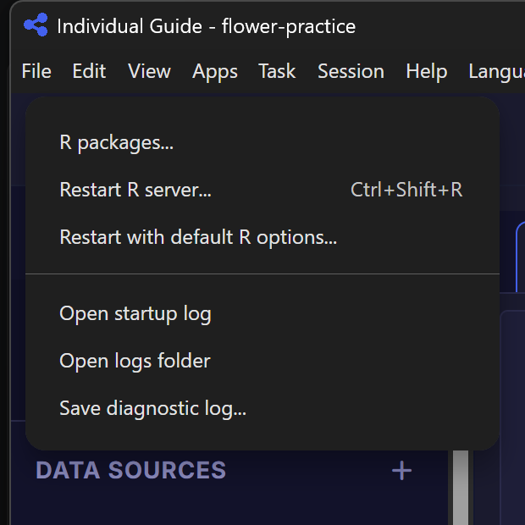
Figure 37. The desktop Session menu provides server restart and startup diagnostics. Use task logs instead when investigating an analysis result.
When running through R in a web browser, go to the R window that launched the app. Stop that session if needed and run the launch command again. See Optional: install with R. The browser version has no independent desktop Session menu.

25.3 A button or menu item is disabled
Finish any open dialog and check whether a flow is running. Open or create a project if you are still on the welcome screen. If the app is disconnected, reconnect or restart the R server first.

25.4 A file will not import
Check that the file still exists and that you can open its folder. For text files, check the separator and header. For Excel, check the selected sheet and range. Confirm the file type matches the import choice.
If the error names a missing package and you run through R, follow the public package instructions. If you use Setup, keep the full error and app version when reporting the issue.

25.5 A table or column is missing from a choice list
Run the task that creates the table. Check its output name and Results. Then check whether a cleaning step renamed or removed the column. A numeric-only list may hide a column stored as text; inspect its type before converting it.

25.6 A result is old, empty, or different from the preview
Check the selected input and filters. Use Run, rather than only Preview, to keep the result. Run later tasks again when their inputs change. Check branch decisions for skipped work and logs for failed earlier tasks.
Some views show only the first part of a large table. Read the row-count and limit information before assuming the full data are missing.

25.7 A model fails or looks strange
Read its first warning or error. Check response and predictor types, missing values, group counts, and the number of usable rows. Start with a matching example to check the setup. A model may need method advice even when all app settings are valid.

25.8 A report is missing a chart
Run the chart task and enable its static image output. Select that image in Report, then run Report again. Open the downloaded file to check the result.
If Word generation says Pandoc is missing, use the reporting setup in the optional R section. The Windows Setup already includes Pandoc. HTML is a useful first format to try.

25.9 An exported file is missing or will not update
Open its Export or Export Log task. Check the full destination, folder permissions, filename, and format. Run the task again. If the file already exists, decide whether to allow Overwrite or use a new name. Close the file in another program if it is locked.

25.10 A log seems empty
Check that task logging is enabled and that its rules are enabled. INFO messages will not appear with a minimum of WARN. Run a selected task again and check its own log before checking an export or report appendix.
The report’s log section contains earlier recorded events, not its own later completion. Put Export Log after Report when you need that entry.

25.11 Ask for help
Use the public issue tracker for app problems. A GitHub account is needed to create an issue. Include the app version, how you opened it, the last action, the exact error, and what you expected.
For startup or connection problems, use Session > Save diagnostic log… in the desktop app. For an analysis problem, export the relevant task log. Check attachments for private data and passwords before posting them. A small example using public data is often the easiest way to explain a problem.

26 Optional: install with R
Skip this chapter if you use the Windows Setup. These steps are for people who want to launch the app from R instead. You do not need to learn general R programming first.
R is the software that performs calculations. An R package is an add-on. IndividualGuide is the app’s package name. You install it once, then use a short command to open the app on later days.

26.1 Step 1: install R from its public website
- Go to the R download site, CRAN. Choose your operating system.
- On Windows, choose Download R for Windows, then base, then the current R installer. Download it and follow its instructions.
- Open R from the Start menu. Check for a console with a > prompt before continuing.
That R console is where you paste the installation commands below. Do not type the > itself. Use the separate R application for installation, rather than a Script task or the R Console inside Individual Guide.
On macOS, use the CRAN macOS download and open the R application. Linux users should follow CRAN’s instructions for their Linux version; extra system software may be needed for some packages.

26.2 Step 2: install the app from GitHub
You need internet access for installation. In the R console, paste these commands and press Enter. Installation can take several minutes and print many progress lines. Keep R open and wait for a new > prompt before moving on.
options(repos = c(CRAN = "https://cloud.r-project.org"))
install.packages("remotes")
remotes::install_github(
"woodtho/IndividualGuide",
ref = "v0.7.0",
dependencies = NA,
upgrade = "never"
)
This gets the app from its public GitHub release tag and its required add-ons from the public CRAN package service. It does not require you to download the source repository or find a local build folder. You normally do not need a GitHub account for this public download.
If R asks to create a personal package library, choose Yes. This means a folder for your installed add-ons. If Windows asks whether to compile packages from source when a ready-made version is available, choose No to use the ready-made version. If installation ends in an error, read it before trying to launch the app.

26.3 Step 3: add the features you need
The basic app installation includes its required packages. These extra public packages support reports and some analysis tasks. Install them once if you want to use those features or explore all the examples:
install.packages(
c("rmarkdown", "knitr", "survival", "forecast"),
repos = "https://cloud.r-project.org"
)
For Word reports, also install Pandoc using its official installer. Close and reopen R after installing it. You can check that R can find it with:
rmarkdown::pandoc_available()
TRUE means it was found. HTML reports have a simpler fallback, so you can start with HTML while sorting out Word support.
Only add database support if you need it. For a SQLite file, run:
install.packages("RSQLite", repos = "https://cloud.r-project.org")
For an ODBC connection, run:
install.packages("odbc", repos = "https://cloud.r-project.org")
ODBC may also need a driver from the database provider. Ask your database support contact which one to use. If you have trusted custom connection code, ask its author which extra packages it needs. These commands belong in the separate R application, with the app closed.

26.4 Step 4: open the app
In the R console, run:
IndividualGuide::run_app()
The app opens in a web browser. Keep the R window open while using it. That R session is running the app, so it is normal for its console to be busy.
Use the app’s own open and save buttons. The desktop File and Session menus belong to the Windows Setup version and are not present here.
When you finish, save the project first. Close the app’s browser tab, then stop the app in R with the Stop control or Esc as appropriate for your R window. Quit R when you no longer need it.

26.5 Open it next time
Open R and run only IndividualGuide::run_app(). You do not need to reinstall packages each day. If the browser does not open automatically, use the local address printed in the R console.
To update later, save and close the app, start a fresh R session, and follow the instructions for the release you want. The tag v0.7.0 deliberately selects the version used in this guide.

26.6 If package installation fails
If an optional task names a missing package, close the app and return to R. Use one of the single-package installation commands above, replacing its first quoted name with the package named in the error. Keep the CRAN address as shown.
Check your internet connection and copy the first useful error. A message about a missing system library or compiler needs the setup for that package and operating system; repeating the same command will not fix it. On Windows, the public Setup is the easier route if you do not need an R-managed installation.
The commands above follow the official remotes installation reference. Keep using the project’s public release notes for version-specific instructions.

27 Choose an example project
All 22 projects below come with data, configured tasks, saved results, logging, and output files. They use public sample data supplied with R or its packages. You do not need a separate data download to explore them.

27.1 Find an example by task
- Leave the welcome screen with Start with a blank canvas if needed. In the desktop app, choose Help > Application help; in a browser, select Help in the app header. Open Example projects.
- Search for a title or topic. Use the Task type filter to find a specific task, such as Rename Columns or Cluster Analysis.
- Use the Task category filter to narrow the list to a group, such as Graph or Survival Analysis.
- Choose Open example. If an unsaved-work prompt appears, cancel and save first. Choose Discard in the desktop prompt, or Discard and open example in a browser, only when you mean to replace that work. Use File > Save project as… in the desktop app to keep your own copy.
If nothing appears, clear the search and filters, then try just one filter. You can also use the Task finder at the end of this guide to see which projects contain a task.
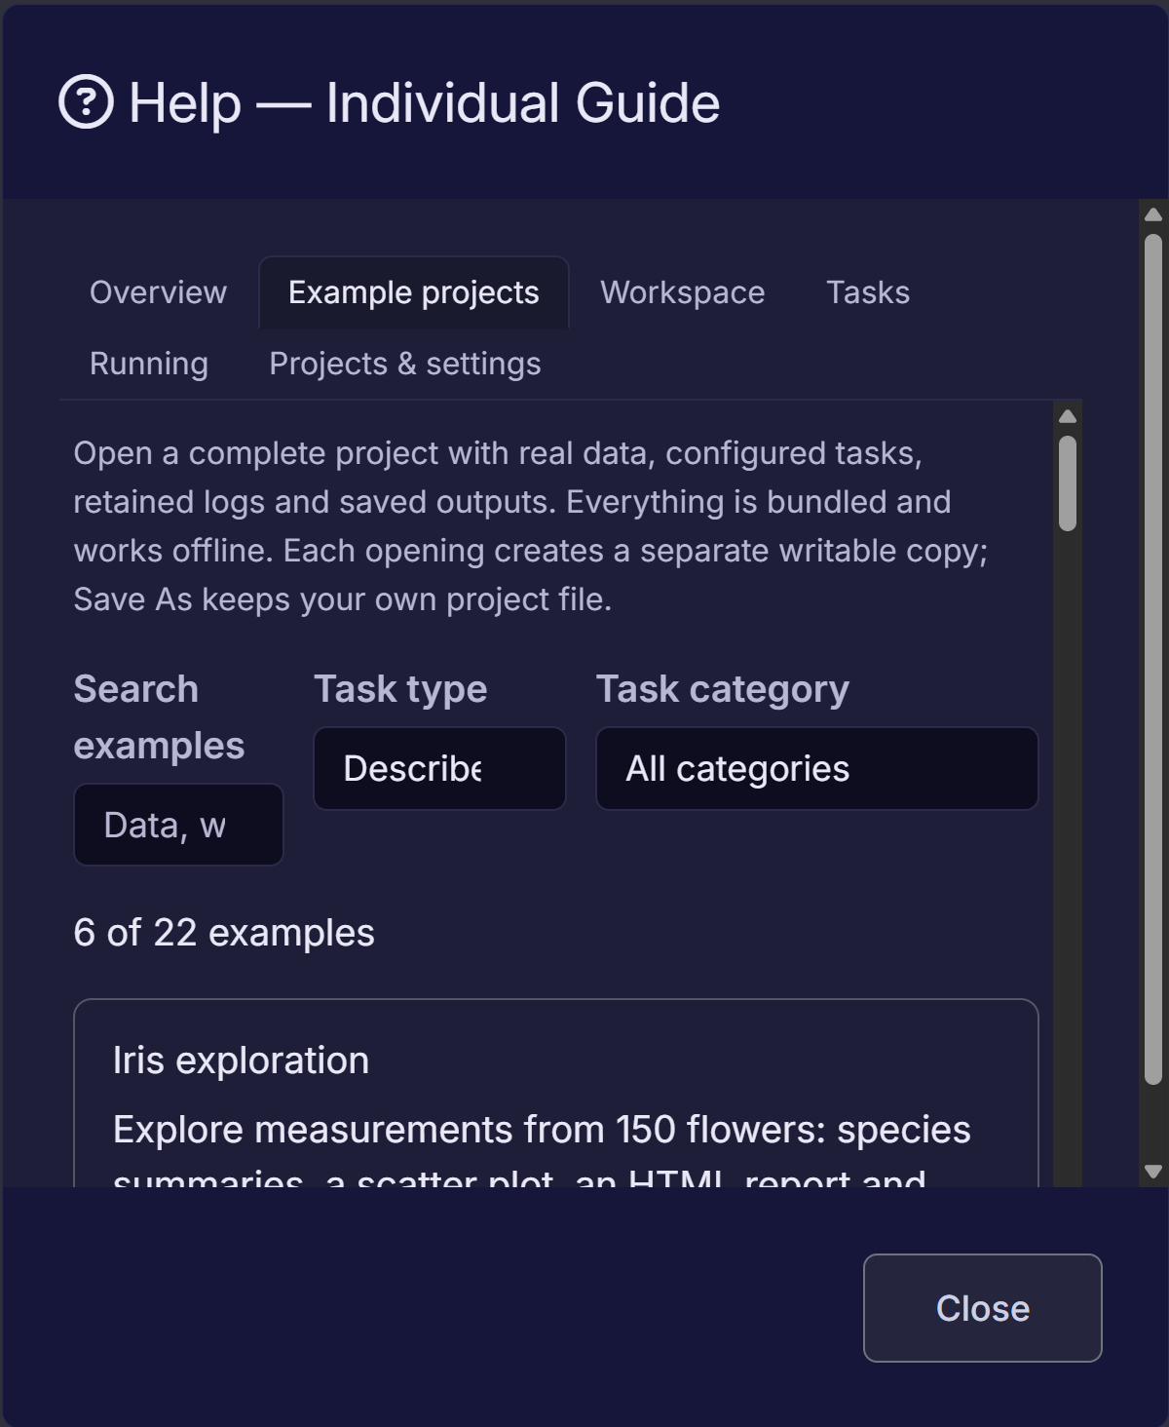
Figure 38. The Task type filter finds example projects that contain Summary Statistics. Clear a filter to return to the full list.

27.2 A simple learning route
Start with Iris exploration. Next try Cars - prepare an analysis table for cleaning, Flowers - categorical chart gallery for charts, and Cars - a report with an execution audit for reporting and logs. Choose models and control-flow examples when you need them.

27.3 Before you rerun an example
Read its notes and inspect its saved results first. Check Export and Export Log destinations before running the flow. Each opened example gets a separate working copy, but you should still choose folders and Overwrite settings that suit your own work.
These projects teach app controls. Their model and cleaning choices are examples, not a claim that those choices fit every dataset.

27.4 Iris exploration
Explore measurements from 150 flowers: species summaries, a scatter plot, an HTML report and exported results.
Data: 150 flowers, with 50 in each of three species.
Tasks to find: Script, Summary Statistics, Summary Tables, Scatter Plot, Export, Report, Export Log.
Check the result: Open the species summary. Mean petal lengths are about 1.462, 4.260, and 5.552 centimetres.
Try this next: Change the scatter plot’s Y column to Petal.Width. Run the chart and report again.
Open its report and log exports, then save your project copy if you want to keep your changes.

27.5 Air quality - clean and compare
Clean 153 daily New York air-quality observations, inspect missing values and compare ozone measurements with temperature.
Data: 153 daily New York air-quality observations, including missing measurements.
Tasks to find: Script, Summary Statistics, Replace Missing Values, Scatter Plot, Export, Report, Export Log.
Check the result: Compare the raw table, the missing-value audit, and the cleaned result. The example uses mean replacement as a teaching choice.
Try this next: Read the replacement task’s settings. In a copy, try another available method and compare the summary. Keep the raw data.
Open its report and log exports, then save your project copy if you want to keep your changes.

27.6 Fuel economy model
Use 32 Motor Trend cars to model fuel economy from weight and horsepower, inspect coefficients, fitted values and a model report.
Data: 32 cars, with fuel economy, weight, horsepower, and other measurements.
Tasks to find: Script, Summary Statistics, Linear Regression, Scatter Plot, Export, Report, Export Log.
Check the result: Open the model coefficients and fitted values. Weight is measured in thousands of pounds.
Try this next: Remove one predictor in a copy. Rerun the model and report and compare the results.
Open its report and log exports, then save your project copy if you want to keep your changes.

27.7 Cars - prepare an analysis table
Turn car measurements into a labelled, deduplicated analysis table and inspect each intermediate result.
Data: 32 original cars plus one duplicate row added for practice.
Tasks to find: Script, Remove Duplicates, Keep / Drop Columns, Rename Columns, Derive Columns, Recode Values, Change Column Types, First / Last N Rows, Characterize Data, Export, Report, Export Log.
Check the result: The duplicate-removal step reduces 33 rows to 32. Inspect the renamed columns and transmission labels.
Try this next: Open each cleaning task in order. Compare the table before and after it, then change one label in a saved copy.
Open its report and log exports, then save your project copy if you want to keep your changes.

27.8 US states - import, join and filter
Import a bundled CSV of state statistics, join a regional lookup, filter and sort the result.
Data: A bundled CSV with 50 US states, plus a state-to-region lookup.
Tasks to find: Script, Import Data, Query Builder, Filter and Sort, Export, Report, Export Log.
Check the result: The left join should retain the states and add region labels. The later filter keeps Income of at least 4500 and sorts it in descending order.
Try this next: In release 0.4.0, leave the saved Filter and Sort panel closed; see its task guide for the known disconnect issue. Add a fresh task to try an Income threshold, then check the rows and descending sort.
Open its report and log exports, then save your project copy if you want to keep your changes.

27.9 Iris - reshape and compare
Pivot flower measurements to long form and back, compare the round trip, append species subsets and transpose a small table.
Data: The 150 Iris flowers with an added flower identifier.
Tasks to find: Script, Stack Columns, Split Columns, Transpose, Compare Data, Append Table, Export, Report, Export Log.
Check the result: Stacking four measurement columns produces 600 rows. The identifier helps put the measurements back into columns. Two appended species subsets contain 100 rows.
Try this next: Compare the long and wide tables. Inspect Compare Data before assuming the round trip preserved every detail.
Open its report and log exports, then save your project copy if you want to keep your changes.

27.10 Cars - rank, scale and sample
Rank fuel economy, standardize predictors and draw a reproducible sample with an explicit seed.
Data: Measurements from 32 cars.
Tasks to find: Script, Rank, Standardize Data, Random Sample, Export, Report, Export Log.
Check the result: Inspect the rank and standardized columns before the ten-row sample. The sample uses seed 2026.
Try this next: Run the sample again with the same data, then change the seed. Compare row identities as well as the count.
Open its report and log exports, then save your project copy if you want to keep your changes.

27.11 Tooth growth - descriptive analysis
Inspect column structure, list observations, count supplement groups, cross-tabulate dose and summarize tooth lengths.
Data: 60 tooth-growth observations, with supplement and dose groups.
Tasks to find: Script, Characterize Data, List Data, One-Way Frequencies, Summary Statistics, Summary Tables, Table Analysis, Distribution Analysis, Export, Report, Export Log.
Check the result: Compare the frequency counts, dose-by-supplement table, and numeric summaries. Dose is stored as a category for the grouped examples.
Try this next: Choose a different grouping in a copy. Check what the counts and percentages refer to before describing them.
Open its report and log exports, then save your project copy if you want to keep your changes.

27.12 Flowers - categorical chart gallery
Compare species with bars, a pie chart and grouped box plots, then collect the figures into a report.
Data: 150 flowers in three equal-sized species groups.
Tasks to find: Script, Bar Chart, Pie Chart, Box Plot, Export, Report, Export Log.
Check the result: The species counts are 50 each. Compare bars, pie slices, and grouped box plots in the report.
Try this next: Change chart titles or category styles. Check that the report’s static figures update after you rerun it.
Open its report and log exports, then save your project copy if you want to keep your changes.

27.13 Flowers - numeric chart gallery
Explore numeric relationships with bubbles, density contours, histograms, scatter plots and a scatter matrix.
Data: The four numeric measurements from the 150 Iris flowers.
Tasks to find: Script, Bubble Plot, Contour Plot, Histogram, Scatter Plot, Scatter Plot Matrix, Export, Report, Export Log.
Check the result: Compare the histogram, bubble plot, contour plot, scatter plot, and matrix. Each view answers a different question.
Try this next: Change histogram bins or a selected measurement. Check axis labels and the chart’s data limit.
Open its report and log exports, then save your project copy if you want to keep your changes.

27.14 Nottingham temperatures - time charts
Chart twenty years of monthly temperatures and compare annual averages with their observed range.
Data: 240 monthly Nottingham temperature observations, with dates added for charting.
Tasks to find: Script, Line Plot, Bar-Line Chart, Export, Report, Export Log.
Check the result: Compare the monthly line with the annual average-and-range chart. The annual range is not a confidence interval.
Try this next: Inspect the date order. Change a title to include the temperature units and check both axes.
Open its report and log exports, then save your project copy if you want to keep your changes.

27.15 Plant growth - compare experimental groups
Compare plant weights across control and treatment groups, with ANOVA, a two-group t test and a general linear model.
Data: 30 plant weights in one control and two treatment groups.
Tasks to find: Script, One-Way ANOVA, t Test, Linear Models, Export, Report, Export Log.
Check the result: The ANOVA uses all three groups. The t test uses a prepared two-group subset, so the tests do not ask exactly the same question.
Try this next: Inspect the subset before the t test. Read group counts and means before the test tables.
Open its report and log exports, then save your project copy if you want to keep your changes.

27.16 Cars - binary outcome model
Model manual versus automatic transmission with a logistic regression and retain fitted probabilities and coefficients.
Data: 32 cars, with transmission coded as 0 for automatic and 1 for manual.
Tasks to find: Script, Logistic Regression, Export, Report, Export Log.
Check the result: The fitted probabilities describe the outcome coded 1. They use a different scale from the coefficients.
Try this next: Inspect the response coding, then try a different predictor in a copy. Read any fit warnings.
Open its report and log exports, then save your project copy if you want to keep your changes.

27.17 Loom breaks - a count model
Fit a Poisson model to counts of loom breaks by wool and tension, and retain model diagnostics.
Data: 54 loom-break counts, with wool and tension groups.
Tasks to find: Script, Generalized Linear Models, Export, Report, Export Log.
Check the result: The model uses a Poisson family for counts. Read the fit information rather than treating completion as proof of a good model.
Try this next: Inspect the selected response and groups. Compare count summaries with the model results.
Open its report and log exports, then save your project copy if you want to keep your changes.

27.18 Puromycin - fit a nonlinear curve
Fit a power curve to enzyme reaction rates in the treated sample and compare it with the observations.
Data: Puromycin enzyme measurements, filtered to the treated sample.
Tasks to find: Script, Nonlinear Regression, Filter and Sort, Export, Report, Export Log.
Check the result: The example fits a power curve to positive concentration and rate values. Read the preparation filter and compare the curve with the points.
Try this next: Inspect the selected curve and input range. Avoid explaining predictions far beyond the observed measurements.
Open its report and log exports, then save your project copy if you want to keep your changes.

27.19 Flowers - multivariate structure
Explore correlations, principal components and three clusters using the four flower measurements.
Data: Four numeric measurements from 150 flowers; species is kept as a known label.
Tasks to find: Script, Correlations, Principal Components, Cluster Analysis, Export, Report, Export Log.
Check the result: Compare correlations, scaled principal components, and three clusters. Clustering does not automatically use the same scaling as PCA.
Try this next: Inspect the cluster sizes and assignments. Compare them with species without assuming they must match.
Open its report and log exports, then save your project copy if you want to keep your changes.

27.20 Lung cancer - survival analysis
Prepare complete cases, translate the event code, inspect Kaplan-Meier estimates and fit an illustrative Cox model.
Data: 228 original lung-cancer observations, with a separate prepared analysis table.
Tasks to find: Script, Life Tables, Proportional Hazards, Export, Report, Export Log.
Check the result: The preparation converts the original status code 2 to event 1 and selects complete cases. Compare row counts before and after preparation.
Try this next: Read the time and event settings before the curves or model. Use this example to learn the controls, not to make care decisions.
Open its report and log exports, then save your project copy if you want to keep your changes.

27.21 Air passengers - forecast a monthly series
Forecast twelve months of airline passengers with the app’s ARIMA task, retaining point forecasts and intervals.
Data: 144 ordered monthly airline-passenger values.
Tasks to find: Script, ARIMA / Basic Forecasting, Export, Report, Export Log.
Check the result: The horizon is 12 future steps. Inspect the model summary and intervals. This is a basic forecasting example, not an automatically tuned seasonal analysis.
Try this next: Change the horizon in a copy. Check the number of forecast rows and explain what one step means.
Open its report and log exports, then save your project copy if you want to keep your changes.

27.22 Nile flow - distribution and stability
Inspect annual river flow with an individuals chart, empirical CDF and normal probability plot.
Data: 100 annual Nile-flow observations in their original order.
Tasks to find: Script, Control Charts, CDF Plots, Probability Plots, Export, Report, Export Log.
Check the result: Read the control-chart flags beside the CDF and normal probability plot. The limits are estimated from these observations.
Try this next: Inspect unusual points and their years. Keep the time order and distinguish chart limits from outside requirements.
Open its report and log exports, then save your project copy if you want to keep your changes.

27.23 Flowers - conditional quality gate
Use a row-count condition to activate a summary path and record the gate decision in the audit log.
Data: 150 flowers and a condition requiring at least 100 rows.
Tasks to find: Script, Branch, Summary Statistics, Export, Report, Export Log.
Check the result: The summary follows the chosen branch path. Check its Run after branch/loop path setting, not only its table input.
Try this next: Raise the threshold above 150 in a copy. Run again and inspect the decision and skipped work in the log.
Open its report and log exports, then save your project copy if you want to keep your changes.

27.24 Flowers - repeat by species
Loop over the three species, compute a separate summary per iteration and keep iteration-aware logs.
Data: 150 flowers split into three species groups.
Tasks to find: Script, Loop, Export, Report, Export Log.
Check the result: Find species_summary_1, species_summary_2, and species_summary_3. Each summarizes a group of 50 flowers.
Try this next: Read the iteration entries in the log. Check that the final report and log export sit outside the repeated body.
Open its report and log exports, then save your project copy if you want to keep your changes.

27.25 Cars - a report with an execution audit
Create a results report with a pipeline-log appendix, a custom warning and separate text, CSV and JSON log files.
Data: 32 cars, a numeric summary, and a custom teaching warning.
Tasks to find: Script, Summary Statistics, Export, Report, Export Log.
Check the result: Open the report’s Pipeline execution log and compare the TXT, CSV, and JSON log exports. The later export can include report completion.
Try this next: Set the report appendix to WARN and rerun it. Compare its shorter log with the INFO version and the full export.
Open its report and log exports, then save your project copy if you want to keep your changes.

28 Task finder
Find a task below, then follow its link for setup steps. The example links show up to three projects you can open from Help. Use the app’s task filter to find all matches. Start by inspecting a completed example rather than rebuilding it from scratch.
Task | Where to find it in Add Task | Examples to open
Import Data | Data | US states - import, join and filter
Query Builder | Data | US states - import, join and filter
Script | General | Iris exploration; Air quality - clean and compare; Fuel economy model
Branch | Control Flow | Flowers - conditional quality gate
Loop | Control Flow | Flowers - repeat by species
Append Table | Data | Iris - reshape and compare
Compare Data | Data | Iris - reshape and compare
Filter and Sort | Data | US states - import, join and filter; Puromycin - fit a nonlinear curve
Stack Columns | Data | Iris - reshape and compare
Split Columns | Data | Iris - reshape and compare
Transpose | Data | Iris - reshape and compare
Rank | Data | Cars - rank, scale and sample
Standardize Data | Data | Cars - rank, scale and sample
Random Sample | Data | Cars - rank, scale and sample
Remove Duplicates | Data | Cars - prepare an analysis table
Keep / Drop Columns | Data | Cars - prepare an analysis table
Rename Columns | Data | Cars - prepare an analysis table
First / Last N Rows | Data | Cars - prepare an analysis table
Replace Missing Values | Data | Air quality - clean and compare
Derive Columns | Data | Cars - prepare an analysis table
Recode Values | Data | Cars - prepare an analysis table
Change Column Types | Data | Cars - prepare an analysis table
Characterize Data | Describe | Cars - prepare an analysis table; Tooth growth - descriptive analysis
Distribution Analysis | Describe | Tooth growth - descriptive analysis
List Data | Describe | Tooth growth - descriptive analysis
One-Way Frequencies | Describe | Tooth growth - descriptive analysis
Summary Statistics | Describe | Iris exploration; Air quality - clean and compare; Fuel economy model
Summary Tables | Describe | Iris exploration; Tooth growth - descriptive analysis
Table Analysis | Describe | Tooth growth - descriptive analysis
Bar Chart | Graph | Flowers - categorical chart gallery
Bar-Line Chart | Graph | Nottingham temperatures - time charts
Box Plot | Graph | Flowers - categorical chart gallery
Bubble Plot | Graph | Flowers - numeric chart gallery
Contour Plot | Graph | Flowers - numeric chart gallery
Histogram | Graph | Flowers - numeric chart gallery
Line Plot | Graph | Nottingham temperatures - time charts
Pie Chart | Graph | Flowers - categorical chart gallery
Scatter Plot | Graph | Iris exploration; Air quality - clean and compare; Fuel economy model
Scatter Plot Matrix | Graph | Flowers - numeric chart gallery
One-Way ANOVA | ANOVA | Plant growth - compare experimental groups
t Test | ANOVA | Plant growth - compare experimental groups
Linear Models | ANOVA | Plant growth - compare experimental groups
CDF Plots | Capability | Nile flow - distribution and stability
Probability Plots | Capability | Nile flow - distribution and stability
Control Charts | Control Charts | Nile flow - distribution and stability
Linear Regression | Regression | Fuel economy model
Logistic Regression | Regression | Cars - binary outcome model
Generalized Linear Models | Regression | Loom breaks - a count model
Nonlinear Regression | Regression | Puromycin - fit a nonlinear curve
Correlations | Multivariate | Flowers - multivariate structure
Principal Components | Multivariate | Flowers - multivariate structure
Cluster Analysis | Multivariate | Flowers - multivariate structure
Life Tables | Survival Analysis | Lung cancer - survival analysis
Proportional Hazards | Survival Analysis | Lung cancer - survival analysis
ARIMA / Basic Forecasting | Time Series | Air passengers - forecast a monthly series
Export Log | Output | Iris exploration; Air quality - clean and compare; Fuel economy model
Export | Output | Iris exploration; Air quality - clean and compare; Fuel economy model
Report | Output | Iris exploration; Air quality - clean and compare; Fuel economy model

29 Shortcuts and everyday terms

29.1 Useful Windows desktop shortcuts
Use the menus while learning. These keys can save time once the actions feel familiar. A text editor or open dialog may use a key for its own controls.
Keys | Action
Ctrl+Shift+O | Open Shiny app
Ctrl+Alt+I | Return to Individual Guide workspace
Ctrl+N | New project
Ctrl+O | Open project
Ctrl+S | Save project
Ctrl+Shift+S | Save project as
Ctrl+Shift+F | Search project
Ctrl+Alt+L | Open Task list
Ctrl+Alt+R | Run active flow, when focus is outside an editor
Ctrl+Shift+F5 | Stop the flow run
Ctrl+Shift+R | Restart R server; save first if possible
F1 | Open app help
Tab / Shift+Tab | Move focus through controls
For more keys, open Help > Keyboard shortcuts…. If you run in a normal web browser, use the app buttons; the browser may use these same keys for its own actions.

29.2 A few more terms
Term | Plain meaning
Column type | The kind of value stored, such as text, number, date, or category
CSV | A text data file whose columns are separated by commas
Input | A table or result that a task needs
Missing value | An unknown entry; not automatically zero
Object | A saved result that is not an ordinary table, such as a model
Overwrite | Replace an existing file with a new one
Package | An add-on that gives R more features
Path | The address of a file or folder
Predictor | A column used to help explain or predict a response
Response | The outcome a model tries to explain or predict
Seed | A setting for repeating a random choice with the same inputs
Stale | A result that needs to be rerun after a change

29.3 Public downloads and help
- Current handbook and downloads: the latest reviewed HTML, PDF, EPUB, and Word guide. Books attached to older releases may be earlier editions.
- Individual Guide releases: public Windows Setup and R package files.
- Release 0.7.0: the version used by this guide.
- Report an app issue: include the version and exact error; check attachments for private information.
- Download R: needed only for the optional R installation route.
- Install Pandoc: for Word reporting when using your own R installation.
The example data come from R’s datasets package and the survival package. The example notes describe prepared fields and teaching choices. Individual Guide is an open-source project by Thomas Wood.

