

**ClassView  
User Guide - Spring 2014**

**TechSmith Corporation Representatives**

Glenn Hoeppner

Bill Scanlon

**Michigan State University Capstone Students**  
Eric Austin  
Rebecca Collins  
Kyle Woodward

**Table of Contents**

1. Summary...……………………………………………….………………………………....…3

2. Teacher Dashboard…………...………………………………………………………..…….4

3. Student Dashboard.………………………………………………………….……………..16

**1. Summary**

This document is intended to give a thorough overview of the ClassView Dashboard applications. The following sections will offer instructions on how to use the Student and Teacher Dashboards. TechSmith employees, teachers, and students will all be able to use parts of this document.

**2. Teacher Dashboard**

Once you have downloaded and installed the Teacher Dashboard from the internet, you can open it through the Chrome App Launcher.

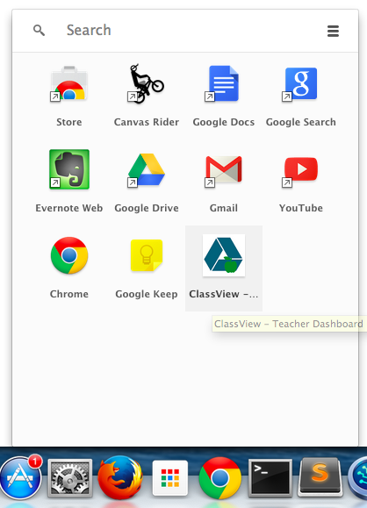

If you aren’t already logged into Google Chrome, ClassView will ask you login and you will link your account to the Teacher Dashboard.

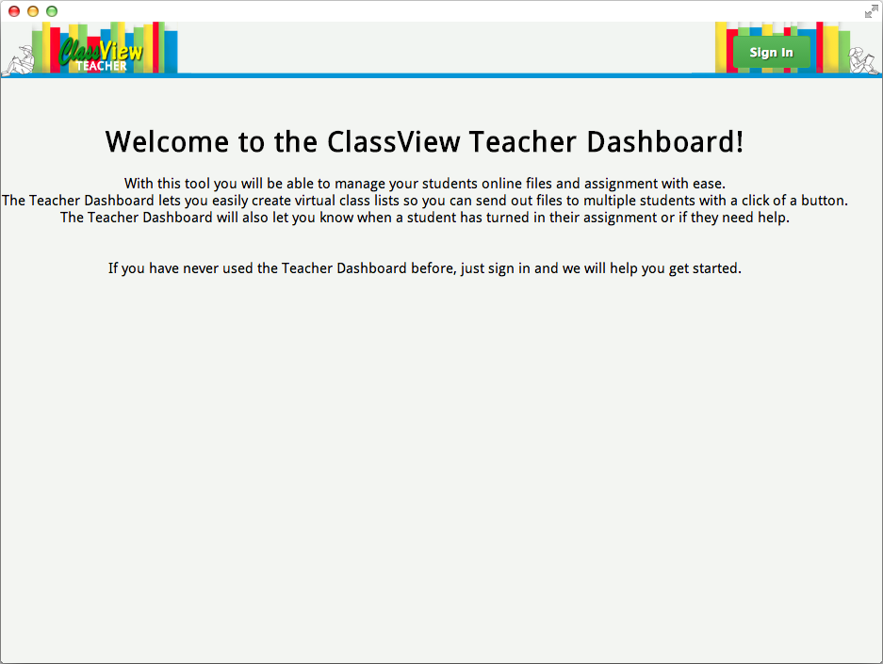

Once logged in, you will not have any classes, to create a class click the New Tab button.

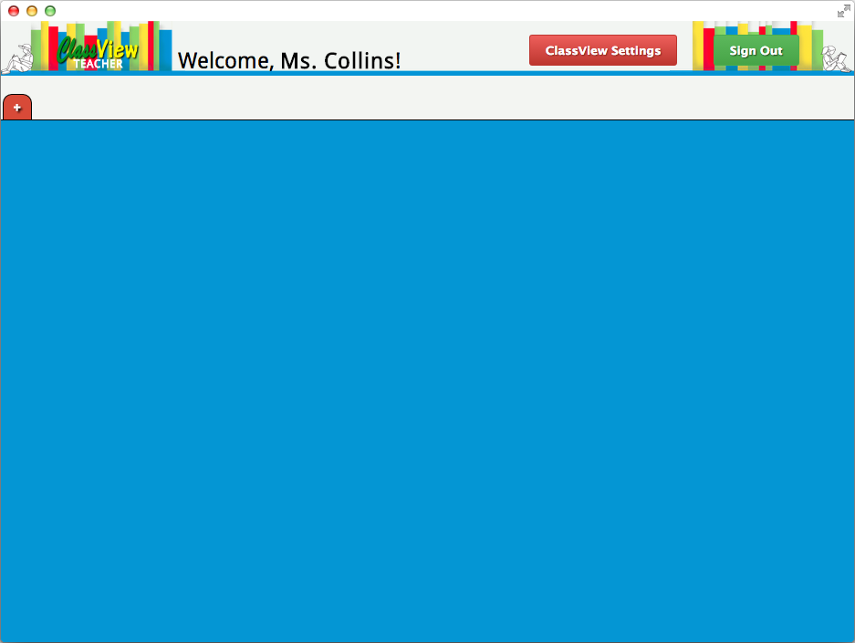

After you name the class, it will create a tab at the top of your screen.

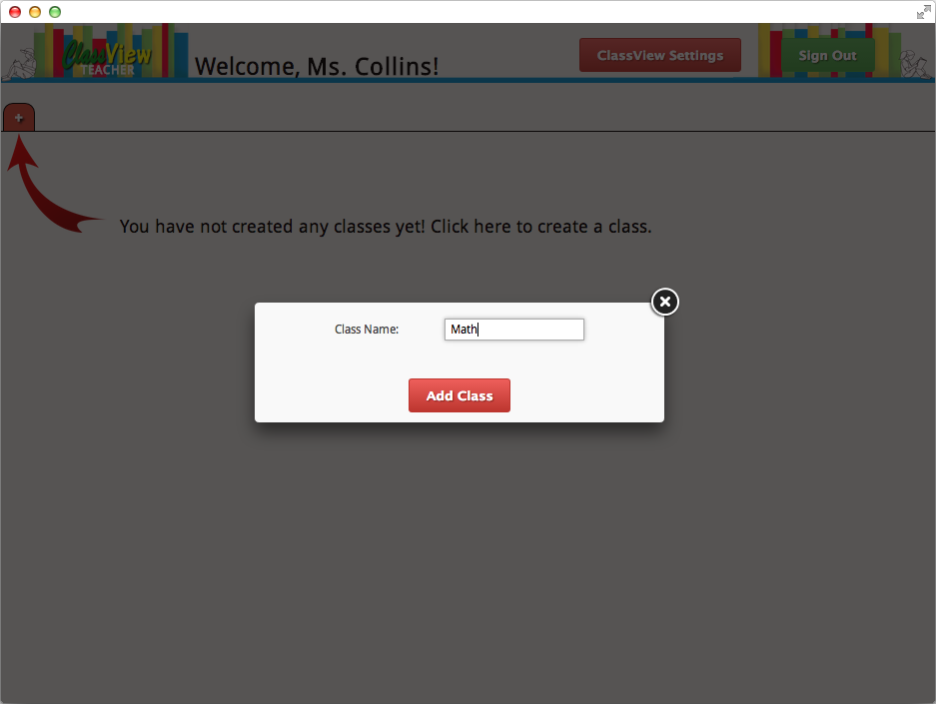

This class will be mirrored in your Google Drive Storage as a folder as seen below. For example if you created a class called Math, you will now have a folder on your Google Drive titled “ClassView - Math”.

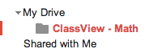

Now that you have created a class, you can click on the tab to make it your active class.

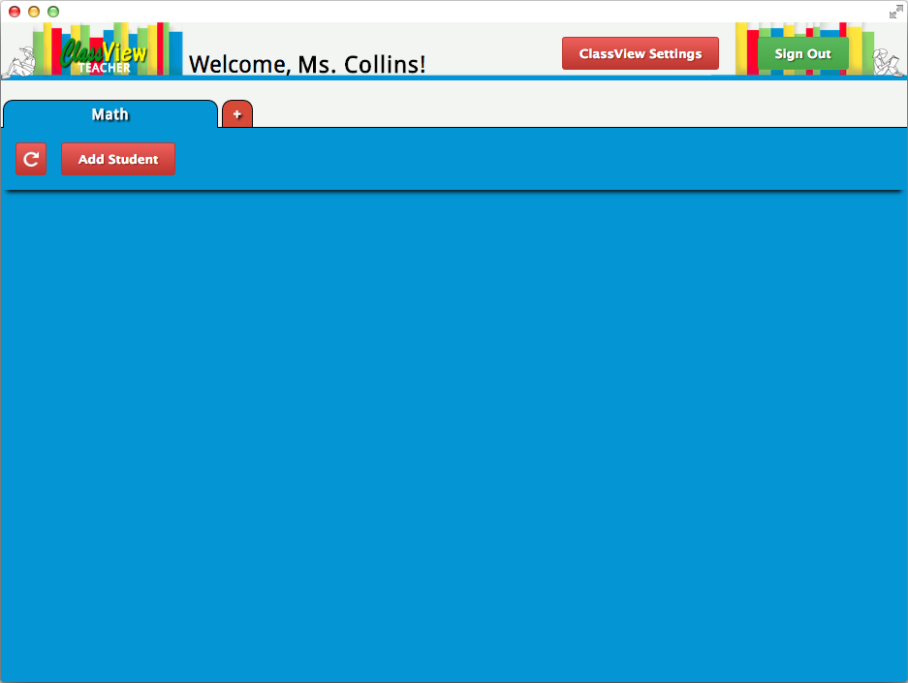

You can now click the “Add Student” button to add a student to your class. It will bring up a form asking for the first name, last name, and email of the student. This Email is the account that will have homework shared with them. When you have filled out all the information, click Add Student” within the popup dialog box.

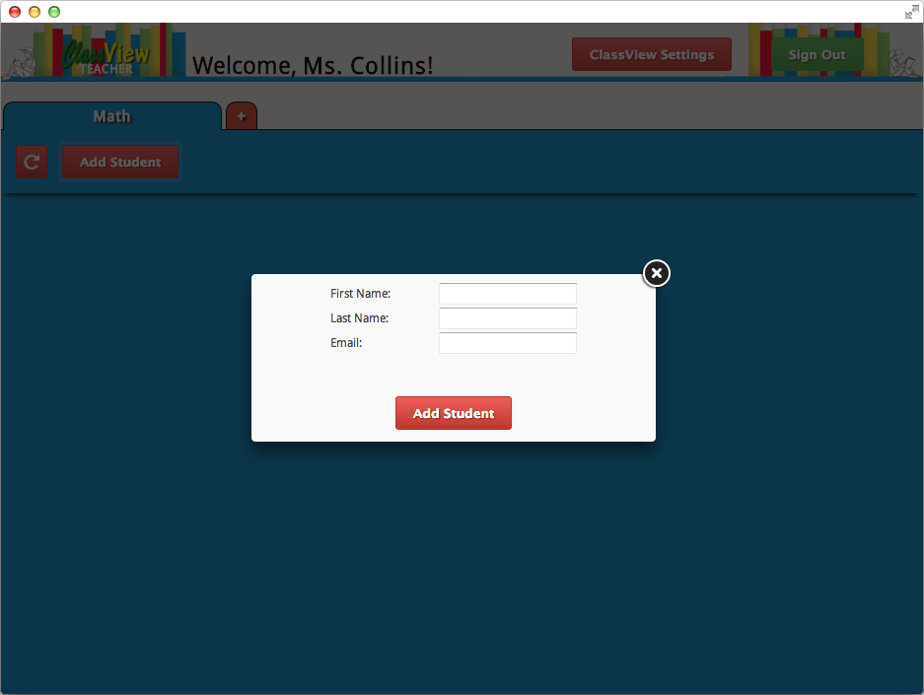

Students within classes are also represented by folders within the class folder on Google Drive as you can see below. For example, if you added a student named “Kyle Woodward” to your class “Math”, a folder would be created inside your “ClassView - Math” folder titled “ClassViewClass - Math - Kyle Woodward”.

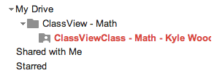

Now that your class has a student, you can continue to add more students, or start assigning files.

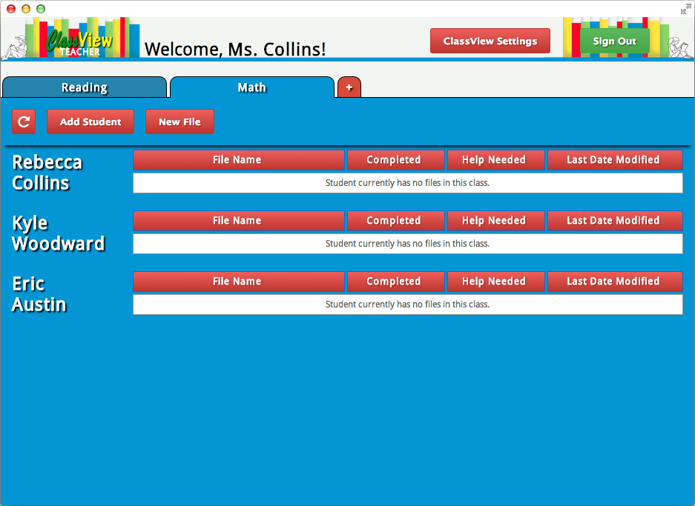

To assign files to students, click the “New File” button, this will bring up a dialog box with two buttons, “Upload an Existing File” and “Create a New File”.

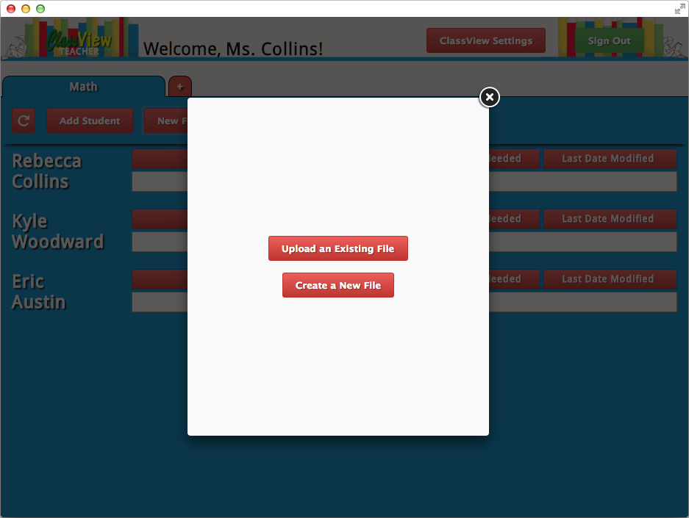

If you select “Upload an Existing File”, you will be given the option to either Browse and select the file from your computer, or you can drag and drop the file.

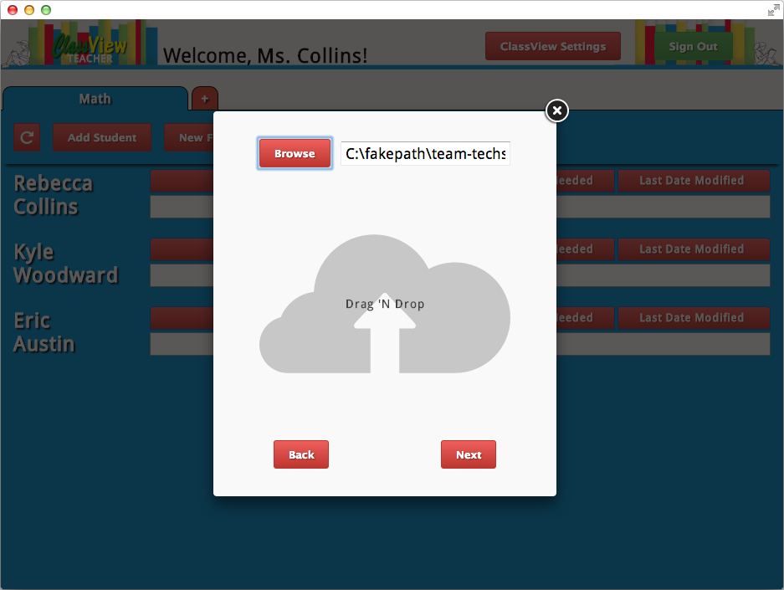

After you have selected the file with one of these two methods, you can click “Next” to be taken to a list of students in the current class.

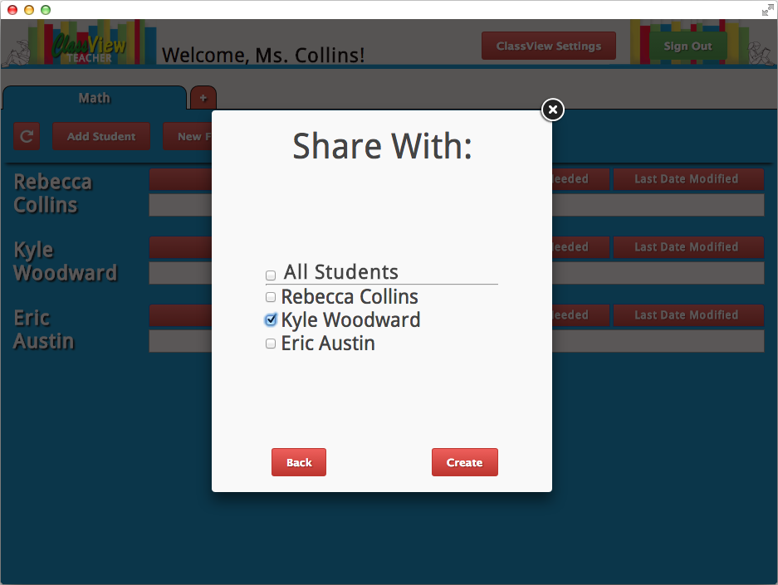

There will be an option with a checkmark box titled “All Students” which will select all the names on the list. You can also select individual users by just checking the box next to their name. When you have selected all the users that you want the file to be shared with click the “Create” button and your file listing for the class will be refreshed and repopulated.

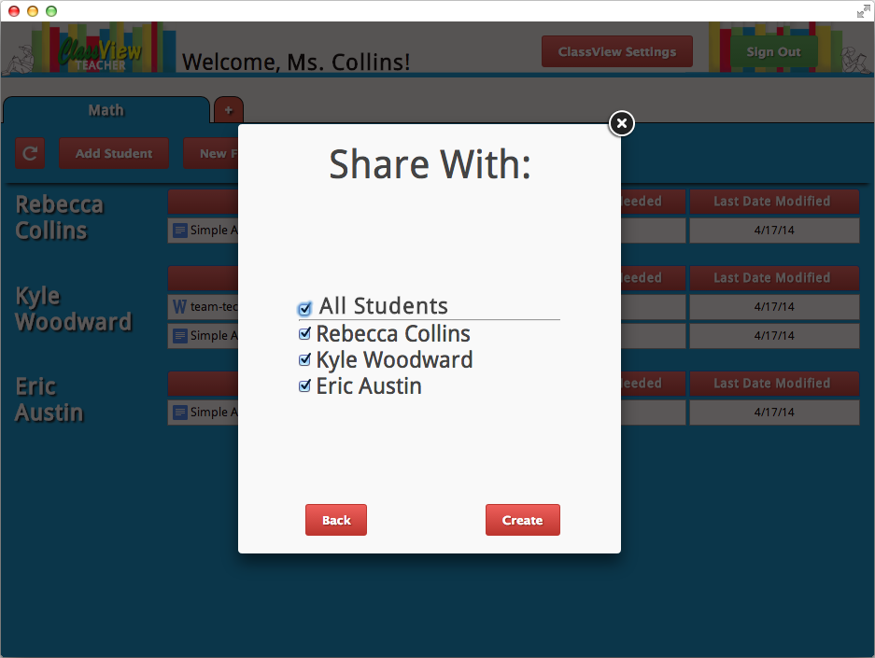

The other option for adding a file to the class was selecting “Create a New File”. If you select this option, you will be presented with a form asking for an assignment title and assignment details. This will create a Google Document with the name of whatever you put in the title input and contents containing what you put in the details textbox. When you are happy with it, click “Next” to proceed to the page to pick out students to share it with like explained above.

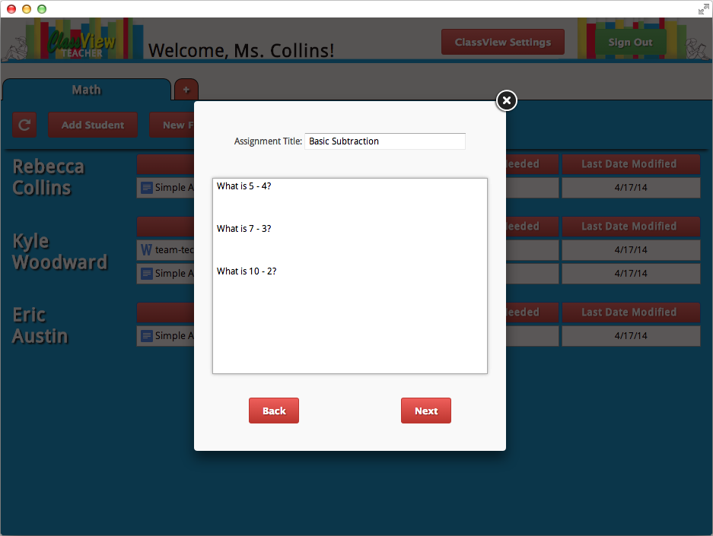

When you create a file within ClassView, a local copy is stored on your Google Drive within the class folder as seen below. It also creates a shared copy between you and a student, for every student that you have selected to share it with. For example, if you were in your Math class and uploaded Homework #1 and assigned it to Jack and Jill, 3 copies of the file would be made. One would be saved within your “ClassView - Math” folder, one would be saved within “ClassViewClass - Jack Doe” folder and shared with Jack, and one would be saved within “ClassViewClass - Jill Doe” folder and shared with Jill.

Now that you have assigned files within a class, a file listing is created for those files within the view of that class on your dashboard. Besides each students name, all their files will be listed. There are four columns in each file listing. The first column is “File Name” and contains the name of the file shared with that student and is preceded by an icon to indicate what kind of file it is. The second column is the “Completed” indicator, if the student has marked their homework as being complete and ready for grading, there will be a green circle with a checkmark visible in this column. The third column is the “Help Needed” indicator, if a student is having trouble with their assignment, there will be a blue circle with a question mark in the column. The fourth and final column is the “Last Date Modified” which displays the date of the last changes made to a file. All of these columns can be sorted for each student by clicking on the column header.

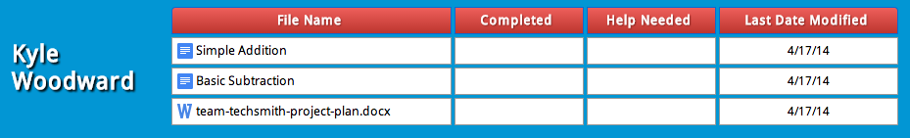

Clicking on a column header once will sort all the files in ascending order by that column. Clicking the header a second time will sort all the files in descending order by that column. If you have a student that has no files assigned to them within that class, a message with read “Student currently has no files in this class”.

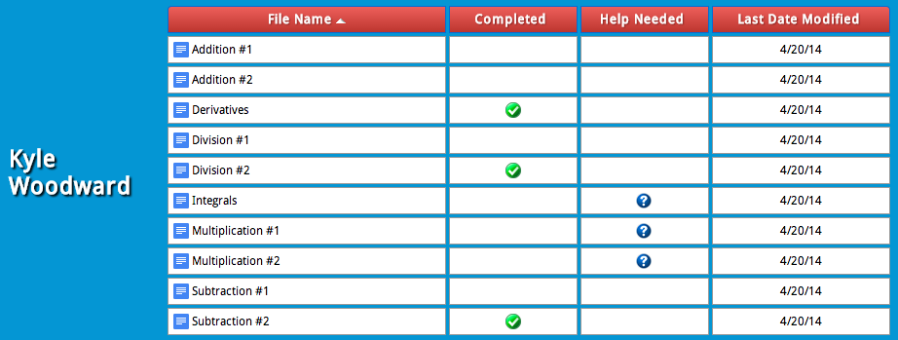

You can also sort through a whole class using the search bar. This is helpful to a teacher if they are trying to grade a particular assignment.

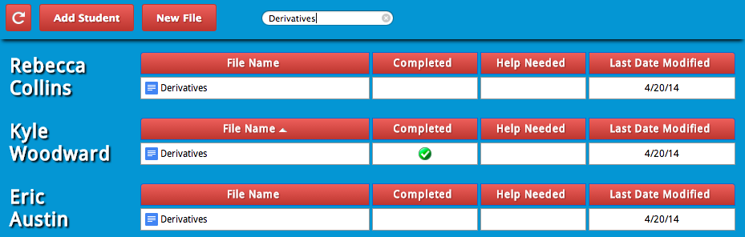

You can select a file by click on it’s row in the file listing. This will highlight the row in orange and the button bar will appear at the top of the class tab. The “Open” button will open that student’s file Google Drive, using this you can take a look at how far the student is or see what they are working on. The “Share” button will let you create a copy of this file and assign it to a different student. When you click the “Delete” button, a dialog box will appear to double check that you want to delete the file. The file will be permanently deleted if you agree. The “Download” button will download a copy to your local computer. If the selected file has the “Help Needed” indicator visible, another button will be available to the teacher, the “Resolve” button.

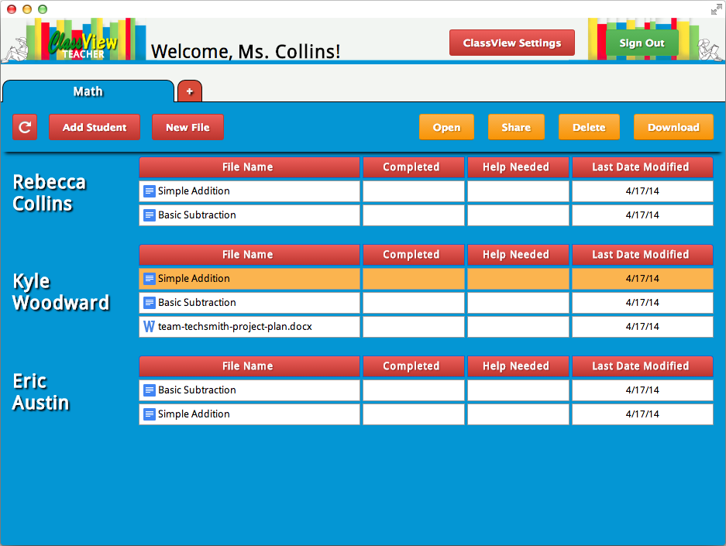

When a file has been marked with the “Help Needed” indicator, that means the student has requested help from the teacher with that assignment. When the student clicks the “Ask for Help” button through the Student Dashboard, they will be provided with an input textbox where they can ask their question. If a student opens a file that has the “Help Needed” indicator visible and checks the comments, they will see that the student has left a comment with details on what they need help with. Teachers can leave a response to that comment, make changes to the file itself, or communicate with the student in person or some other way. After the teacher has answered the student’s question, they will select the file from the Teacher Dashboard and select the “Resolve” button. Upon click that button, the teachers view of the class will be refreshed and the “Help Needed” indicator will be removed. This will alert that student that there is “New Feedback” on their file from the Student Dashboard.

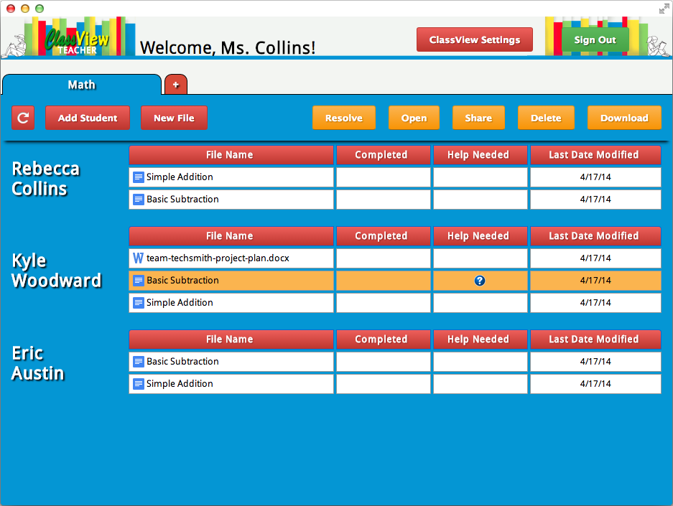

In the upper left hand corner of the tab, is the manual refresh button. This can be clicked at any time to repopulate the class file listing and refresh all the file properties. The file listing will also be manually refreshed by selecting the tab again.

18_manual_refresh.png

If you want to remove a class or a student from your Teacher Dashboard, you can click the “ClassView Settings” button. This will display your options for arrchiving.

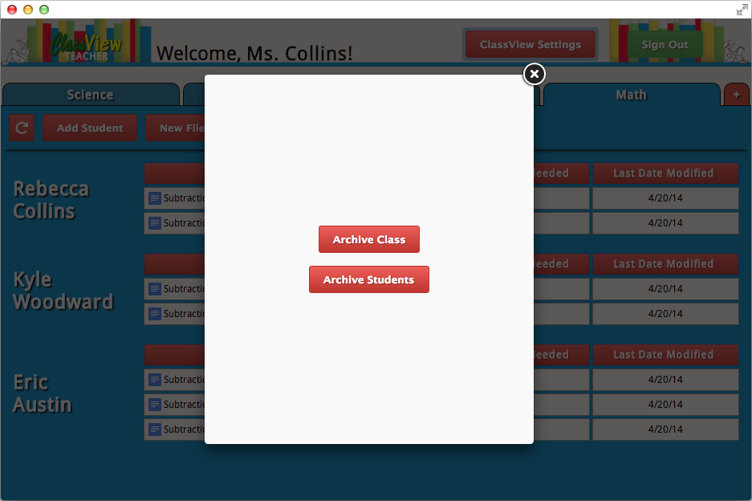

If you no longer want a class listed in your tabs, you can archive the class to hide it. By selecting the “ClassView Settings”, then selecting “Archive Class”. You will then be showed a list of your classes and can check the box of every class you want to archive and click “Update” to process it. To restore a class, return to this screen and uncheck the checkbox.

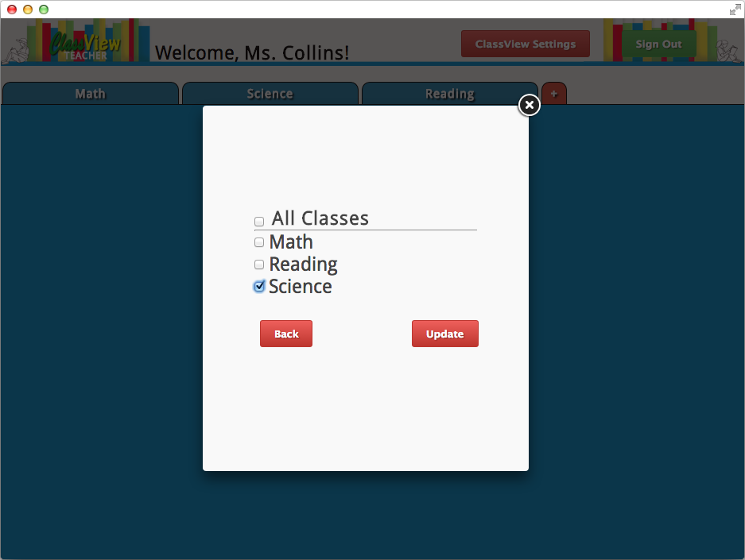

If you want to remove a student from your class listing, you can remove them by dropping them from the class. To do so, select the “ClassView Settings” button at the top of the screen and select “Archive Student”. You will be presented with a list of all the students in your class and can check the box by their name to move them to your archived student list when you click “Update”. To restore a student, return to this screen and uncheck the checkbox.

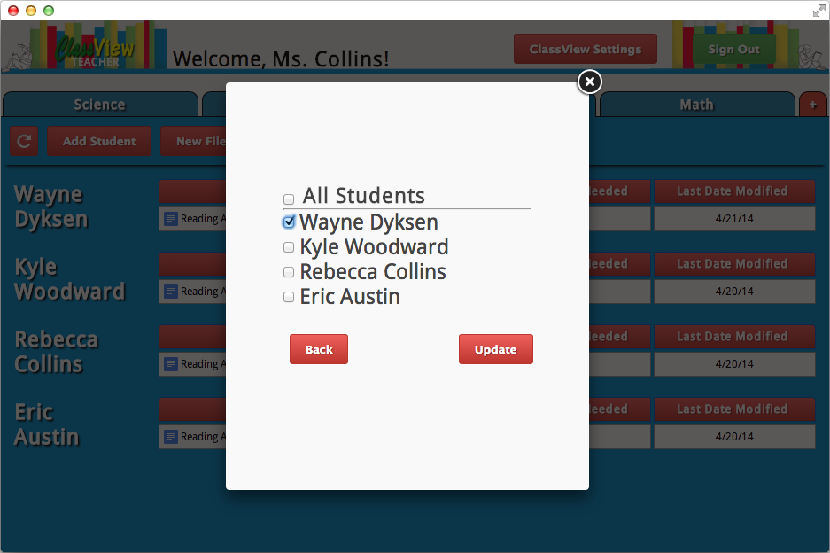

**3. Student Dashboard**

Once you have downloaded and installed the Teacher Dashboard from the internet, you can open it through the Chrome App Launcher.

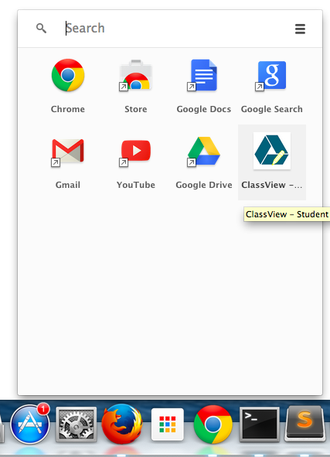

If you aren’t already logged into Google Chrome, ClassView will ask you login and you will link your account to the Teacher Dashboard.

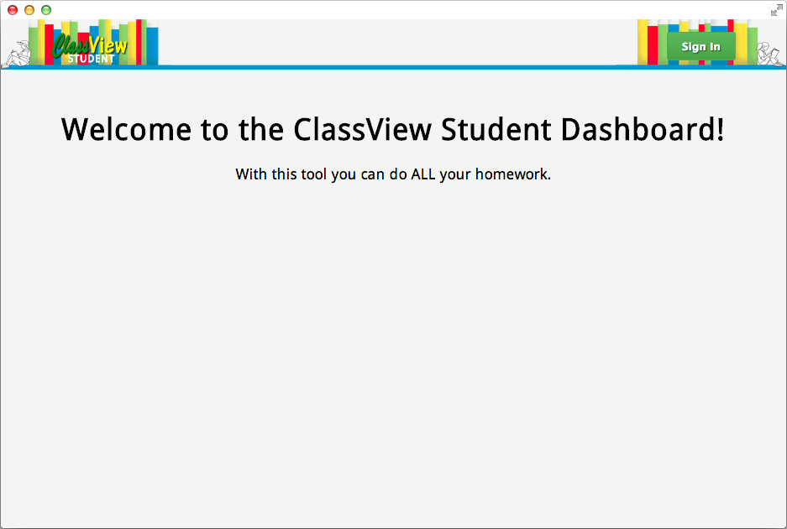

Once logged in, you will be able to see any classes that your teacher has added you too. These are represented as different colored tabs along the top of the application.

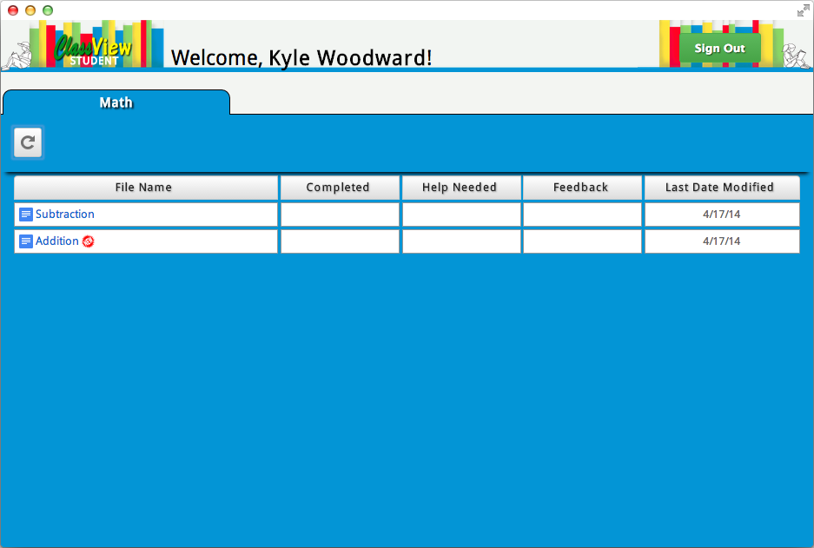

The classes you are added to will be mirrored in your Google Drive Storage as a folder as seen below. For example if you are in a class called Math, you will now have a folder in the “Shared with Me” section of your Google Drive titled “ClassView - Math - [your name]”.

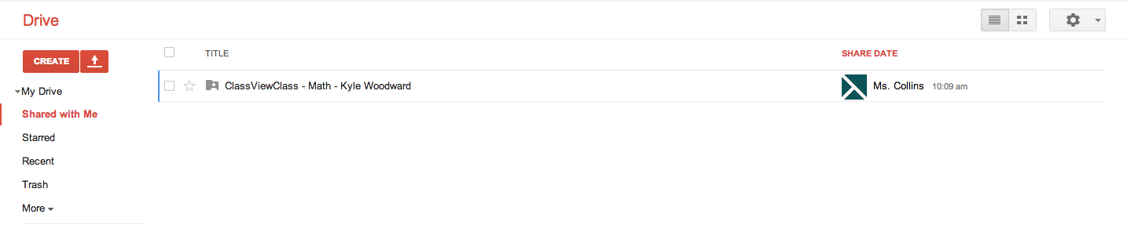

Click on a tab to make it your active class and view your files for that class. Any files that you have not yet viewed from the Student Dashboard will have a red “NEW” indicator next to their title. To view or edit a file, simply click on its title.

05_NEW_indicator.png

If an assignment is proving to be too challenging for you, help can be requested from your teacher. Click anywhere in the white row around the file to select it. The row turns orange when selected and a new row of buttons appears just below the class tabs.

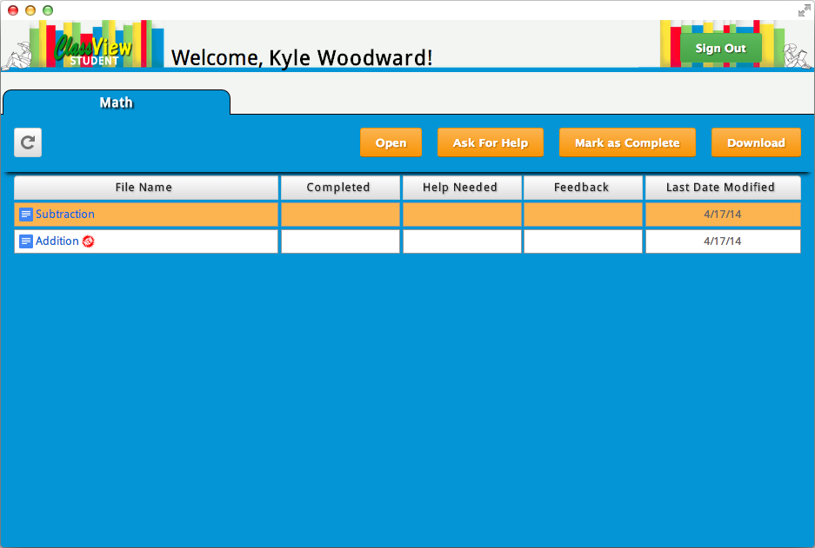

Clicking the “Ask for Help” button will bring up a dialog box allowing you to explain which part of your assignment you need help with. Once submitted, a blue question mark indicator will appear in the file’s “Help Needed” column.While viewing, you may also add comment to the file to better indicate the parts you have trouble with.

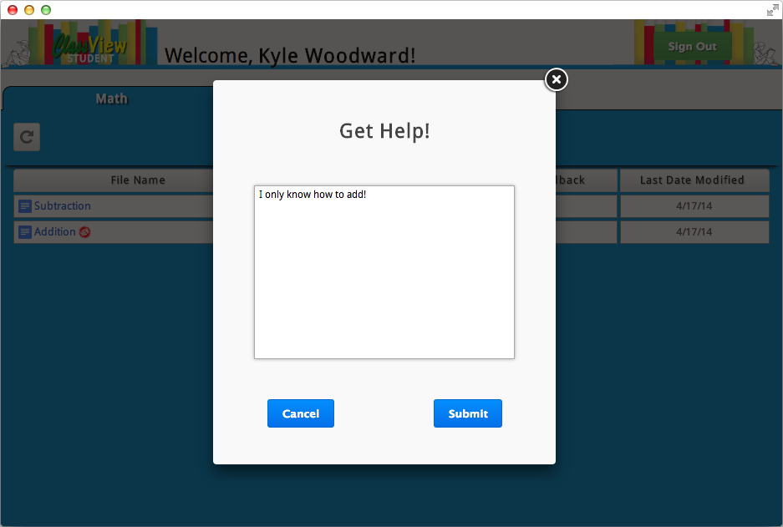

08_pending help.png

Once your teacher has viewed and responded to your request for help, the “Help Needed” column will be cleared and an indicator in the “Feedback” column will appear. To see what help they have given, simply view the file and their feedback will be in comments of your file.

09_pending_feedback.png

To work on a file offline simply select it by clicking on it’s white row and then clicking the “Download” button. You then will be able to save it to your computer and edit it without Internet access.

10_offline_download.png

To indicate to your teacher that you have completed an assignment, select the file and click the "Mark as Complete" button. The file will then have an indicator in the "Completed" column.

11_submit_complete.png

To arrange the order in which your files are displayed, click on the head of any of the columns of your files. You may sort by file name, completeness, help needed, feedback received, or the last date the file was edited.

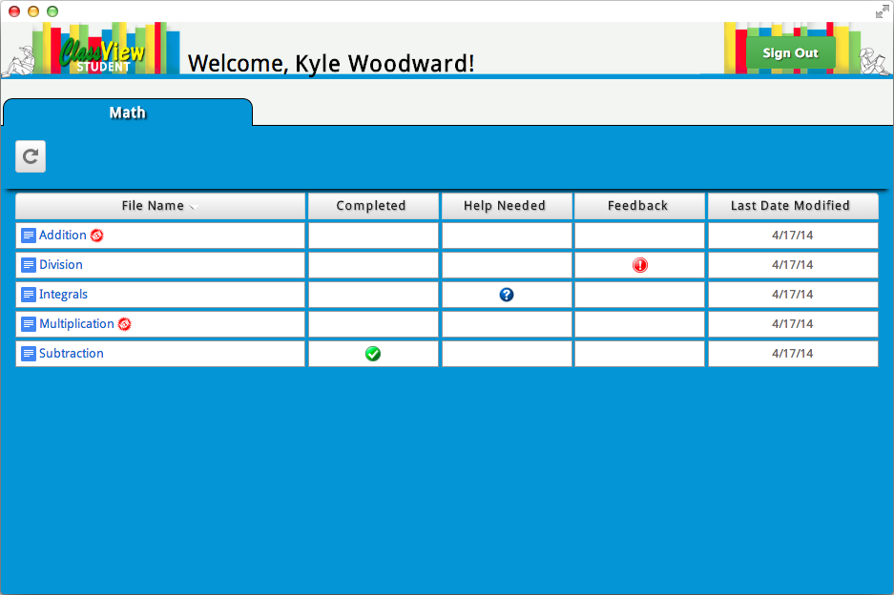

In the upper left hand corner of the tab, is the manual refresh button. This can be clicked at any time to repopulate the class file listing and refresh all the file properties. The file listing will also be manually refreshed by selecting the tab again.

13_manual refresh.png