Nottingham Trent University

School of Science and Technology

Domain Specific Language For Balancing Binary Search Trees

by

Joseph Woodward

in

2018

Project report in part fulfilment

of the requirements for the degree of

Bachelor of Science

in

Software Engineering

I hereby declare that I am the sole author of this report. I authorize the Nottingham Trent University to lend this report to other institutions or individuals for the purpose of scholarly research.

I also authorize the Nottingham Trent University to reproduce this report by photocopying or by other means, in total or in part, at the request of other institutions or individuals for the purpose of scholarly research.

Signature

Joseph L. Woodward

Abstract

A Binary Search Tree (BST) is an effective data storage technique used within programming languages, allowing one to store, organize and retrieve data in a—potentially—performant way.

There is, however, one bottleneck that may nullify the performance of BSTs, and that is the inefficient, non-hierarchical organization of the data stored within the BST itself: if data is stored linearly, then retrieving data from the BST will be linear, providing no positive usage over many other inherently linear structures. To combat this, one may use a BST Balancing Algorithm, which is used to ensure that all data is stored in a non-linear, hierarchical structure, thus increasing the efficiency of the retrieval of said data.

This work introduces the general topic of BSTs, including how data is stored and retrieved within them, how balancing algorithms can be used to maximize the efficiency of the structure itself. The primary bulk of this work, however, will be introducing a new Domain Specific Language (DSL), a DSL that will be used to allow one to easily experiment with one’s own design and implement of balancing algorithms, providing the capability to benchmark said algorithms with performant and common algorithms used within both the industry and within academia today.

No DSL currently exists for this specific purpose and, although the DSL discussed here has not fully integrated the capability to experiment with balancing algorithms themselves, information and details regarding how this would be achieved shall be discussed.

Fully completed and presented, however, is the base language itself. This language provides all capabilities of a basic programming language, from variable declaration to functions to loops and much more. So complete, in fact, is that, aside from only currently supporting primitive types, this language provides much of the capability of commonly-used languages such as Lisp and Python.

Acknowledgements

Firstly, I would like to thank my supervisor Dr Neil Sculthorpe, who has supported me greatly with both personal and academic queries and issues. His critique and guidance of my work and interest within the domain of programming languages—academic and beyond—has vastly increased both the quality of my work and my interest in programming language theory.

A special thanks to my love, Katarzyna, who not only took on the task of completing my extra-curricular activities, allowing me to solely focus my attention on this project, but whos love and kindness infuses within me the ability to stay calm, to stay peaceful, to stay thoughtful.

To my Mother, Mandy, whose sheer determination and ability to endure has motivated me more than She will ever know. I love you, Mum.

Lastly, to the Earth and all of Her inhabitants, whose interconnectivity has and continues to allow me to be.

Table of Contents

Introduction 1

1.1 General Problem Overview 1

1.1 Topic Introduction 2

1.1.1 What is a Binary Search Tree? 2

1.1.2 What is the Difference Between Balanced and Unbalanced BSTs? 3

1.2 Project Introduction 3

CONTEXT 6

1.1 Introduction 6

1.1.1 What Exactly is a Domain Specific Language? 6

1.1.2 What Are The Benefits Of A DSL? 7

1.2 Case Study of DSLs 9

1.2.1 LaTeX 9

1.2.2 Cascading Stylesheets (CSS) 11

New Ideas 13

1.3 Aims and Objectives 13

1.3.1 Overview 13

1.3.2 How will the DSL be implemented? 14

1.4 Project Scope, Milestones, Main Tasks & Deliverables 14

1.4.1 Overview 14

1.4.2 In-scope 15

1.4.3 Out-of-scope 16

1.5 Project Risks 17

1.5.1 Overiew 17

1.5.2 Task Overflow 17

1.5.3 Data Destruction 17

1.5.4 Project Member Propensities 18

1.6 Gantt Chart 18

IMPLEMENTATION 20

2 Introduction 20

RESULTS / DISCUSSION 22

3 Introduction 22

CONCLUSIONS / FUTURE WORK 23

Insert > Reference > Index and Tables … > Table of Contents

List of FigureS

List of Tables

dwqddwqdwqdwq

CHAPTER 1

Introduction

## **General Problem Overview**

A Data Structure is a specific way that data is stored and organized. The importance of choosing precisely what data structure to use varies greatly and is dependent on myriad variables: necessary capacity, frequency of both storing and searching, the need to be sortable, the stored data type, and many more.

One such data structure used frequently is a Binary Search Tree (BST). Due to its inherent capability to be performant, BSTs are frequently used for a multitude of domains, from compression algorithms—jpeg, mp3—to syntax trees—used by compilers for expression parsing.

There is, however, one primary problem with BSTs: the performance of insertion into or extraction from them can be greatly decreased if no balancing algorithm exists. A BST balancing specifies how the structure will be balanced, to ensure that it’s data storage is non-linear, for if the structure is unbalanced, it may store data linearly—its benefits virtually entirely nullified.

Many balancing algorithms exist, such as Red Black Tree and AVL, but the ability to implement and experiment with such algorithms is limited. The limitation primarily exists because it requires one to know the intricacies of both the BST implementation within the implementation language used and the intricacies of the implementation language itself. Only with such knowledge could one even begin to implement a balancing algorithm on a BST.

Parallel to this, there are few—if any—languages or frameworks that sufficiently benchmark balancing algorithms, which raises the aforementioned issue of experimentation, and disallows one to accurately benchmark self-designed algorithms against those frequently used within the industry, such as the aforementioned AVL or Red Black.

## Topic Introduction

### What is a Binary Search Tree?

A Binary Seach Tree (BST) is method of organising data hierarchically, allowing its efficient manipulation in a reversed, tree-like structure, with the root sitting at the top of tree. BSTs are commonly used to implement other data structures, such as Hash Trees and Abstract Syntax Trees. It consists entirely of nodes, nodes that store a particularly type—either composite or primitive—and pointers to other nodes. There are essentially two types of nodes: an internal node and a leaf node. An internal node is any node which has pointers to other existing nodes

i.e. an internal node is the parent of its child nodes (the root node is the only internal node which has no parent); whereas a leaf node is any node whose pointers to its children are non- existent, and thus is not a parent.

BSTs typically provide three operations:

* **Search**: when given a value, traverses the BST until either:
  + the value is found; or
  + all nodes have been searched.
* **Insertion**: when given a value, inserts a node into the correct location.
* **Removal**: when given a particular value, searches the BST for the correct node; if found, the node is removed.

An example of a BST:

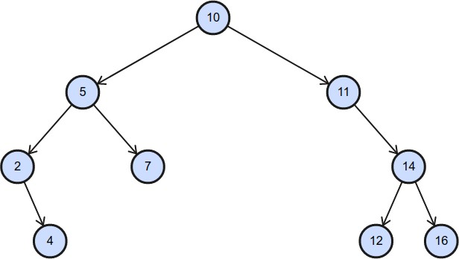

Within this example, the root node is 10, and its children 5 and 11. Node 11 has one child only, node 14, and nodes 4, 7, 12 and 16 have no children, and thus are leaves.

### What is the Difference Between Balanced and Unbalanced BSTs?

Given a BST with n nodes and a height h, a BST is balanced if and only if 2h-1 ≤ n ≤ 2h; ergo, the previous example is balanced. Balancing BSTs is essential for providing maximum performance, reducing the time complexity of its aforementioned operations. A balanced tree requires less time to performs its operations than an unbalanced tree—with the difference exponentially increasing with node count (an unbalanced tree takes O(log n) for its basic operations; an unbalanced tree, however, is O(n)).

## Project Introduction

This project aims to provide a solution to combat the difficulty of easily implementing and benchmarking BST balancing algorithms. One may ask: “Would not a simple framework for a currently existing language suffice?” To which the answer would be a resounding no. And for what reason the arrival at this answer is that, as aforementioned, this would still require one to understand the intricacies of language that the framework would be created for, which in and of itself causes an even greater problem: it restricts the experimentation with algorithms only to said persons who have knowledge of the implementation language.

Therefore, a fully operational Domain Specific Language (DSL) shall be presented here, which has all common features of basic programming language, such as loops, variable—both scoped and global—functions, conditional expressions, and more. It is hoped that the simplicity of the DSL provides the ease and capability to effectively allow one to implement balancing algorithms.

The language interpreter was originally written Haskell, due to its inherent capability to easily implementt DSLs. However, as this was a new technology learned solely for the purpose of this project—and exists as part of a programming paradigm that differs largely to what was, at that time, known—the interpreter was translated into Python, and thus Python was used to expand and finalise the DSL itself. However, the language choice for the DSL implementation matters very little for this particular project for one primary reason: the language implementation does not necessitate optimal performance.

The project outcome itself is not entirely dependent on the language developed; Instead, this report forms the foundation for the entire project. Sections existing within this report are:

* ***Introduction*:** including the section within which this text is written, the *Introduction* is a description of precisely what the project completion entails, including the problem domain, aims and objectives, and benefits of project outcome.
* ***Context:*** the context refers primarily to provide and explain the current State-of-the-Art work that currently exists within the field of the problem domain. This provides the elucidation of the gaps within the relevant field, and forms a foundation with which the problem solution is derived.
* ***New Ideas:*** As aforementioned, with the *Context* section detailing current State-of-the-Art—thus elucidating the gaps within the relevant field—this section extensively details the precise aspect that the outcome will focus on.
* ***Implementation or Investigation:*** This section largely discusses how the aims and objectives attempt to be achieved, methodologies used for software development, and the tools and resources used to ensure the correct, efficient implementation of the software.
* ***Results / Discussion:*** Detailed within this section is the oucome of the project itself—specifically, how the outcome relates to the proposed improvement within the field.
* ***Conclusions / Future Work:*** This section is a summary of the *Results / Discussion* section, including what has been developed relevant to the proposed aims, and what is uncompleted.

CHAPTER 2

CONTEXT

## Introduction

Discussed and presented within this section shall be the benefits of DSLs in general, supplimented by examples of previous work within the domain of DSLs and how they have benefited the subject area within which they exist.

Approaching this section in this particular way was discerned as suitable for one primary reason: there is very little—indeed, if any—previous work regarding the implementation of environments to ease the experimentation of BST Balancing Algorithms. Thus, when combining this with fact that this project itself focuses primarily on the design and implementation of a DSL, it is discerned as more suitable and illuminating that the benefits of DSLs within other areas will allow one to see the link between the decision to design and implement a DSL for this particular project, and the reasons chosen to implement DSLs within other domains.

### What Exactly is a Domain Specific Language?

Unlike a general-purpose programming language, which allows one to complete and solve a multitude of different programming tasks, a DSL is a (usually small), purpose-driven programming language that exists to allow one to complete a very specific task—or a very specific small set of sub-tasks. DSLs have been created to ease the completion of myriad tasks, from typesetting, to the creation and formatting of web pages, to database technologies, to spreadsheet manipulation and many, many more.

Table 1 provides a partial list of commonly used DSLs:

|  |  |
| --- | --- |
| **DSL** | **Usage** |
| HTML (HyperText Markup Language) | Web-based document markup |
| CSS (Cascading Style Sheets) | Web-based document styling |
| LaTeX | Document styling and layout |
| SQL (Structured Query Language) | Managing and manipulating database data |
| UML (Unified Modelling Language) | Visual Modelling |
| CUDA (Compute Unified Device Architecture) | Parallel Computing Platform |
| Makefile | Code Compilation Management |

### What Are The Benefits Of A DSL?

When considering using a DSL, one must ask oneself: *does using a DSL provides benefits over using a general purpose programming language?* To answer this question, one must understand the benefits of DSLs themselves.

Three primary benefits of DSLs are:

* they are quicker to write;
* they are simpler to understand; thus
* they can be used to complete tasks by non-programmers

***They are quicker to write.*** Due to the precise nature of DSLs, the functionality that the DSL provides is limited: it aims only to allow the completion of a specific task—or small set of subtasks—and thus greatly reduces the complexity of the language itself—only features that aid this completion usually exist.

***They are simpler to understand.*** As aforementioned, DSLs typically provide only the capability to complete a small—or small subset of—task(s). As a result, they are usually devoid of unncessary features, and their syntax greatly reduced in complexity. Take this very small example of LaTeX—a document layout and styling DSL:

**\begin{abstract}**

Just a small example of some abstract text.

**\end{abstract}**

This code automatically formats the abstract section of a report or document—it is not ambiguous; It is precise, assertive and extremely simple.

***They can be used by non-programmers.*** Evident from both previous points, DSLs provide a monumental advantage over general-purpose programming languages: non-programmers (typically) find it must easier and logical to complete tasks within them. Paul Hudak, former and late Professor of Computer Science at Yale University, states this as one the greatest advantages of DSLs (Hudak, 1997) when he says that it

helps bridge the gap (often a chasm) between developer and user, a potentially major hidden cost in software development. It also raises an important point about DSL design: a user immersed in a domain already knows the domain semantics. All the DSL designer needs to do is provide a notation to express that semantics.

## Case Study of DSLs

### LaTeX

As aforementioned, LaTeX is a popular DSL used for the formatting of documents. Primarily used for scientifiec document, due to it’s ability to elegantly format mathetmatical formulae and symbols, it can also be used for all documents of all types, due to its inherent ability to format all possible elements of documents.

LaTeX’s motto is indicative of that which it aims to achieve: “LaTeX is not a word processor! Instead, LaTeX encourages authors not to worry too much about the appearance of their documents but to concentrate on getting the right content” (LaTeX, 2018). And so beautifully it does.

Take the following code, which is a very basic example of LaTeX code:

**\maketitle**

**\begin{abstract}**

This is just a simple example of LaTeX's abstract formatting capability.\**\**

Lorem ipsum dolor sit amet, consectetur adipiscing elit. Nam faucibus vehicula urna vel mperdiet. Mauris vel mauris sodales odio rhoncus tempor id sit amet felis. Vestibulum vel vulputate erat. Pellentesque molestie mi non lacus ultricies hendrerit. Maecenas ut scelerisque orci, vitae vehicula enim. Mauris pellentesque et libero in aliquam. Ut.

**\end{abstract}**

This code produces an elegant front page, which states the document’s title, author, date, and abstract. This code example is simple to use: the syntax is very simple and the keywords exist as simple, elucidatory English-language words. Indeed, it is very easy to discern precisely what this code (aims) to achieve, and, even with very little—even non-existent—knowledge of LaTeX, one can quite simply discern the proposed outcome, which is:

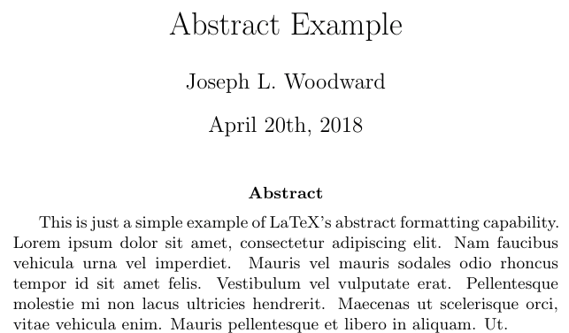

As aforementioned, LaTeX can format mathematical formulae and symbols extremely elegantly. For example, given the code

**\[**

**\frac{d}{dx}\left( \int_{0}^{x} f(u)\,du\right)=f(x).**

**\]**

the formatted document text will be provided through LaTeX as

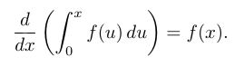

Granted, to achieve the first example in Microsoft Word would required little effort, but indeed it does assume that graphical word-processing applications format text documents precisely the same—indeed, this is not the case when considering the two primary graphical word-processing application, Microsoft Word and LibreOffice Writer.

The second—mathematical—example, however, would be extremely difficult in both Microsoft Word and LibreOffice Writer, if not entirely impossible. This would require the usage of another tool, and thus then inserting the formula into the document as an image, which requires great effort and time on the part of the user.

Indeed, LaTeX achieves the solving of it’s specific domain problem—that of elegantly formating documents—so well, that one particular study shows that over 95% of the mathematical documents inspected were written using LaTeX (Brischoux and Legagneux, 2009).

### Cascading Stylesheets (CSS)

Simply put, CSS files are used to assert styles and layout decisions for HTML elements. CSS stylesheet are simple, easy-to-understand and—at least, when the accompanying HTML is well-formatted—vastly ease the styling of HTML elements.

W3Schools, the premier resource for learning the basics of web-based development, states, simply, that “CSS saves a lot of work. It can control the layout of multiple web pages all at once” (W3Schools, 2018). And this is extremely true.

Take the following code:

**h1** { **color**: #111; **font-family**: 'Helvetica Neue', **sans-serif**; **font-size**: 275px; **font-weight**: bold; **letter-spacing**: -1px; **line-height:** 1; **text-align**: center; }

**h2** { **color**: #111; **font-family**: 'Open Sans', sans-serif; **font-size**: 30px; **font-weight**: 300; **line-height**: 32px; **margin**: 0 0 72px; **text-align**: center; }

**p** { **color**: #685206; **font-family:** 'Helvetica Neue', sans-serif; **font-size**: 14px; **line-height**: 24px; **margin**: 0 0 24px; **text-align**: justify; **text-justify**: inter-word; }

Granted, this is a little more complex than the LaTeX example, but, given a correct HTML document, this code produces the following output:

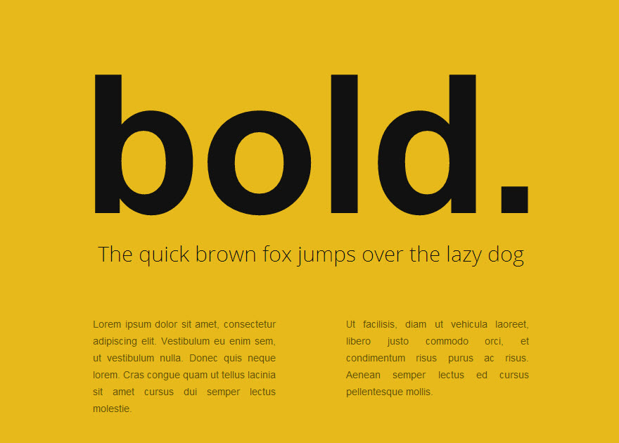

***(Both the Image and Code used within this example come from (WDExplorer, 2018)).***

This is just a small example of what CSS can achieve; Indeed, much more complex, elegant and pragmatic usage is everywhere, on all webpages, on myriad documents and, with the creation Electron—a desktop-based development suite that allows one to use HTML and CSS to design desktop-based application—is becoming increasingly popular with the development of desktop-based application, such as Discord.

CSS is so useful, so necessary, in fact, that it is supported by all web browsers, and is used for over 95% of all current websites (W3Techs, 2018), and is the the fourth most popular language used for projects that exist as repositories in GitHub: an astonishing 10% of all GitHub repositories use CSS (GitHub, 2019).

CHAPTER 3

New Ideas

## Aims and Objectives

### Overview

As aforementioned, the importance of BST balancing algorithms is paramount, and this project shall aim to reduce the programming complexity for algorithmic experimentation relative to this. This project aims to implement a Domain-Specific Language (DSL) which will provide high-level abstractions for BSTs, BST operations and a multitude of functionality for the self- development of balancing algorithms.

With this project being aimed at both new and seasoned students of Data Structures & Algorithms, the DSL will allow one to experiment with balancing algorithms without having to implement a BST oneself, which could be a daunting task for a new or seasoned student when one considers that the BST need be polymorphic, efficient, and provide all necessary functionalities for managing its balancing algorithm. Not only will this potentially allow an expansion of interest in BST balancing algorithms for beginning programming enthusiasts, but it decreases the complexity of algorithmic balancing for seasoned students who wish to measure the performance of algorithms in a more performant language, although without the initial overhead of learning the language complexities.

### How will the DSL be implemented?

A major part of this project itself will be the development and implementation of an interpreter, which will be responsible for interpreting the user-defined DSL source code and providing accurate, relative output regarding its operations. The interpreter will interpret the code through a defined semantics which, once the source code is broken down into individual components, commonly known as tokenization, will ensure that a statement is valid if and only if it adheres to the grammar rules.

## Project Scope, Milestones, Main Tasks & Deliverables

### Overview

Ass aforementioned, the primary project objective is to implement a fully-functional DSL, which will provide the capability of allowing BST balancing algorithm exploration for both novice and seasoned students. However, this provides only a broad view of the tasks to be undertaken, and focuses entirely on the language itself, disregarding the project entirety. The project stages (although overlapping) can be viewed as threefold:

* **Research**: the necessary research needed to undertake the project will need to be conducted.
* **Language Implementation**: the language itself—the project outcome—need be fully- functional.
* **Project Thesis:** as documentation of analyses, design, justification and criticial evaluation, a project report will elucidate the rationales for how, why and what exactly the project entails.

### In-scope

First and foremost, the language must work. Given a source code file written in the DSL, the interpreter must produce the correct output; this is the ultimate task. It must initially begin with research, research relative to both BST and programming languages; only then will

enough knowledge be amassed to understand precisely what capabilities the language will need to provide, and how it need be implemented.

Upon completion of primary research, one must implement the BST backend, which will be used by the interpreter to manipulate BSTs declared within the DSL. This backend BST will not only provide typical BST operations, but will also provide complex functionality to carefully manipulate BST balancing algorithms.

Next, the interpreter. This sits as a very large bulk of what allows the DSL to exist. Firstly, a Lexical Analyser need be developed, which, when given a source file, will tokenize the source file, with each token stating precisely what it is: TYPE, IDENTIFIER, KEYWORD, etc. Lexical Analysis methods have existed for ostensibly computing-time immemorial, and are a key component not only of interpreter development, but of compiler development also.

Once the source code is tokenized, it will then need to be parsed. There are opportunities to use a third-party parser, but for both the sake of learning and to ensure sufficient complexity, this project will implement a self-built parser. The parser is responsible for transforming the lexically analysed tokens into a context-free grammar (CFG). Once rules are generated, the parser will use the lexically analysed tokens to generate strings that exist within the grammar, called derviations.

Upon successful completion of both the lexical analyser and parser, the entire interpreter will need to be put together. Initially and to reduce complexity, they will be developed seperately, and will later be amalgamated to form the interpreter entirety. This is a monumental milestone, due to, as aforementioned, the interpreter being the primary bulk of the project, and, once completed, will require only testing.

Testing, however, will be both complex and necessiate pedantry; it will be divided into two sections: interpreter implementation testing and small DSL program testing. The interpreter implementation testing will test a varity of cases, from correct cases to slightly minor failed cases, to major failed cases. The DSL program testing itself will, as an extension of interpreter testing, test to ensure that, given correct code, it produces the correct output; given incorrect code, the program terminates.

The project thesis, which is also a major component of the project itself but differs greatly from the DSL development, is the final—aside from demonstration—milestone to be

completed. Although almost last, the project report will be partially completed even before the interpreter has been developed and tested. The final sections necessitate the analysis of the DSLs implementation, results and conclusions, and therefore must start only once the implementation is complete.

### Out-of-scope

Due to time constraints, there are a vast number of functionalities that is hoped to be implemented, but cannot be guaranteed. The primary out-of-scope functionality is a detailed, assertive and informative error-handling system—not too complex, but providing the user with a message that aids understanding.

## Project Risks

### Overiew

As is the case when undertaking any project—perhaps especially one as complex as developing a programming language—there are myriad risks. These risks can range from project member illness to unpredictability of equipment breakage to data destruction. With this particular project being completed individually, devoid of necessitating the usage of external equipment (exempting computer access and a hard drive), the primary risks involved exist within one of two categories:

* **Task Overflow:** Tasks taking longer than expected.
* **Implementation Language Knowledge**: Lack of knowledge regarding the implementation language.
* **Data Destruction**: data becomes inaccessible.
* **Project Member Propensities**: behavioural tendencies of project members that negatively impact on the completion of tasks.

### Task Overflow

Task overflow is extremely common within software development. This overflow usually occurs due one—or both—of two reasons: Unrealistic time assignment to individual tasks; And inability to overcome sub-tasks.

To combat these, tasks shall be allocated time that far surpasses the approximate task completion time, ensuring that if a task takes longer than expected or problems occur within sub-tasks—as is the case quite often within software development—then said time allocation will provide a time-period to complete them.

### Implementation Language Knowledge

Due to the writing of the DSL interpreter in Haskell, there is a possibility that a lack of Haskell- and functional programming-specific may cause some issues. To combat this, there will be frequent communication with the project supervisor—an individual who has vast knowledge of functional programming and specifically Haskell—whereby guidance should provide the ability to overcome such problems.

However, if this becomes a big problem early on within the implementation phase, Haskell could possibly be replaced by something simpler, something quicker to develop in, something that the developer has more knowledge about.

### Data Destruction

Data destruction exists in many forms, such as corruption, failure to save files, hardware fault, accidental power-off, and more. Within this project, the primary potential data desctruction refers to a hardware fault. To combat this (and other potential descruction), the project updates will daily be backed-up to two places: the cloud, and an external hard drive. Ergo, if a hardware fault occurs, there will be the ability to restore data that is at most one day old.

### Project Member Propensities

Undertaking arduous endeavours requires discipline, motivation, passion, intelligence, justification, planning, and much more. These are but a small sample of necessary behavioural components that one must ensure strict adherence to when undertaking a large, individually- based project. An inability to abide by these components must be remedied near- instantaneously—what seems like a small setback initially may transform into an ostensibly insurmountable setback, strengthening one’s self-perceived inability to continue. To combat this, there shall have weekly meetings with the project supervisor and project member, and, if negative propensities persist, it shall need to be discussed.

## Gantt Chart

The following Gantt Chart provides an illuminating view of how tasks have been 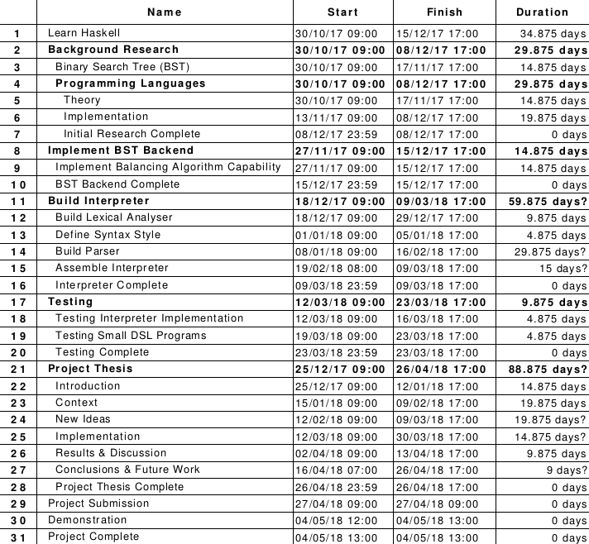assigned—both the order and the time allocation:

***(For a more graphical view, please see Appendix A)***

CHAPTER 4

IMPLEMENTATION

# Software Development Life-Cycle

A SDLC is a framework [that defines] tasks performed at each step [of a] software development process, . . . a structure followed by a development team” consisting “of a detailed plan describing how to develop, maintain and replace specific software” (Techopedia, 2018).

Having never previously worked with defining and implementing a programming language, the decision was made to use an Iterative SDLC model. Joseph Woodward (Woodward, 2017), describs the Iterative model as

a cyclical process that requires only a minor planning phase, a phase which details just enough requirements to allow a rapid prototyping of an application. Once this prototype is developed, then a small handful of stages are cyclically repeated, adding extra features and elimnating bugs with each cycle.

This was discerned as a suitable for several reasons. Firstly, this particular model would allow the rapid development a prototypal language, one that would provide basic language capabilities, such as variable decaration and definition, and console output. Secondly and depedent on the aforementioned point, this would allow the language features to be implemented iteratively: once one feature had been designed and implemented, the next feature could then be worked on.

# Language Design

## Syntax

Intentionally, the DSL syntax style correlated quite closely with that of the already existing, niche and functional language Lisp. Beaten only by Fortran, Lisp is the second-oldest high-level programming language whose use is still fairly vast, even today: the Tiobe Index—a popular website used to detail the popularity of programming languages—ranks Lisp as #21, beating the increasingly popular D Language and Scala.

Lisp pioneered, amongst other ideas, tree data structures, and thus it was this reason plus two more that it was discerned a suitable syntactic style for this particular DSL: Firstly, assuming code is written with illuminating spaces and carriage returns, the syntax is very readable; And secondly, the syntax itself is inherently and aesthetically beautiful. The parenthesized prefix notation—which enforces the pseudo-rule that everything (statement, expressions) are lists—is elegant, and minimizes the necessity to learn other starting and termination symbols for expressions and statements themselves.

Thus, for the DSL, one could consider all expressions and statement as a parenthesized, prefixed-notation list. In fact, an informal grammar for the language could be defined as:

program ::= ‘( begin )’

| ‘( begin ’ stmt ‘)’

stmt ::= ‘(‘ expr ‘)’

expr ::= stmt

| atom

| string

| exprOp

| exprConditional

| exprFunction

| exprLoop

| exprPrint

| exprConcat

| exprDefine

exprOp ::= operator expr expr

exprConditional ::= ‘if’ stmt stmt stmt

exprFunction ::= 'func ' atom stmt stmt

exprLoop ::= 'loop ' atom atom string '()' stmt

| 'while ' atom 'i' (exprOp)

exprPrint ::= ('put' | 'putln') stmt

exprConcat ::= 'concat (' stmt* ')'

exprDefine ::= 'var ' atom stmt

lol

- discuss language design decisions

- discuss language features and their implementation

CHAPTER 5

RESULTS / DISCUSSION

# Introduction

The technique developed as your project is supposed to show improvement on techniques previously available. Therefore it may be necessary to spend time investigating whether this is true. Perhaps you need to set up some sort of quantitative test and do a little statistical analysis to confirm the improvement. Perhaps a group of your friends could test out the user interface and provide comment on its suitability for the task. Try to estimate the limitations of your work and if it does not cover certain aspects that a user might expect then say so and make sure the system will reject input it is not expected to cope with.

CHAPTER 6

CONCLUSIONS / FUTURE WORK

Introduction

Whatever it was that your results showed should be summarised here. Hopefully the conclusion will be that your proposals proved to be brilliant and now the results bear this out. On the other hand your proposals may, in the light of the results obtained, prove to be less successful than you had hoped. In this case the conclusions should state why.

In either case there should be some reference to future work, either to forward and expand on the successful outcome or to test ways of overcoming the shortfall in your ideas that didn't work out quite as expected but there should be something that shows you can see further implications of what you have achieved.

This chapter should also include a discussion of the four PSEL issues (Professional, Social, Ethical and Legal) and the way in which you project has/will/could impact on each.

ReferenceS

<https://pdfs.semanticscholar.org/b06c/06de5335a0e53ad7122419886890c2cab2a4.pdf> - benefits of a DSL

<https://www.latex-project.org/about/>-- latex motto

<http://www.cebc.cnrs.fr/publipdf/2009/BTS24_2009.pdf>– latex usage

<https://www.w3schools.com/css/css_intro.asp>– css

<https://w3techs.com/technologies/details/ce-css/all/all> – css usage

<http://githut.info/> -- css usage again

<https://www.techopedia.com/definition/22193/software-development-life-cycle-sdlc> -- what is a SDLC

Bibliography

Vogt, C. 1999. Creating Long Documents using Microsoft Word. Published on the Web at the Nottingham Trent University.

Coote, H., Dobbs, B. & Jones, C. (1996). Defining databases. Wiley: Melbourne.

Applications and Science in Soft Computing, Lotfi, Ahmad; Garibaldi, Jonathon M. (Eds.) 2004, X, 346 p. Springer, ISBN: 3-540-40856-8

**Note:** References are a list that includes the essential bibliographical details for each item to which you have referred in the body of your paper. It should ONLY include items to which you have made direct reference. A direct reference is where you have quoted/reproduced text or diagrams from another author or mentioned/referred to the work of another author in your report. That is quoted directly what they have said about something or mentioned their views or conclusions in your report. For details of citation and references see the information in the Project Guide.

A Bibliography is a list of published materials that you have read or consulted for general information in the preparation of your work, concerning the subject of your Project, but have not made any direct reference to in your report i.e. 'background reading'.

You should always provide a Reference List. **A Bibliography is optional but when provided it should include all items in your Reference List as well as any additional items consulted in preparation of your work.**

Appendix A

The content of these will differ with the different types of project. Any design and analysis charts/diagrams will be included here in full. In projects where software has been developed there will be an appendix for this. Our departmental requirement is that a CD, DVD or USB memory stick of all source code is submitted to your project supervisor. The appendix contained in the report will refer to this CD, DVD, or USB memory stick, provide a directory style listing of the files submitted and instructions for rebuilding and running the software. This might be source code of programs written in high level languages (C, C++, etc) together with any pertinent files ('make' files, non-standard libraries, etc). Alternatively, or in addition, you can place some or all of the source code in the appendix. In any case the source code needed to reconstruct any software you have developed must be submitted in its entirety in the CD, DVD, or USB memory stick. (Any code that has been used from a third party should reference the original developer).

Hardware designs will require schematics/circuit diagrams, PCB layouts, simulation tests and pin outs.

Most projects will require some form of user documentation to explain how to use the software/hardware produced. A researcher following up the work may wish to utilise the work of the original author and an appendix laying out the format of input files and how to interpret the output is required.