A mathematical model of perennial grass-clover dairy pasture for control of post-reproductive pasture quality using water and grazing management

Running Title—Pasture quality model
Simon J. R. Woodward*¹
David G. McCall¹
Christopher J. Korte?²
¹AgResearch Ruakura
Private Bag 3123, Hamilton, New Zealand
Tel: +64 7 838 5914
Fax: +64 7 838 5117
Email: woodwards@agresearch.cri.nz

²Agriculture Victoria
Hamilton, Victoria, Australia

*corresponding author

For Agricultural Systems
File Name: PQpaper9.3.doc

Abstract
A differential equation model of tissue flows in temperate perennial grass-clover pasture is formulated for use in maximising supply of quality pasture for summer-autumn dairy production. The model consists of nine plant tissue categories: vegetative grass leaf and sheath, reproductive grass leaf and sheath (on emerging, emerged or decapitated tillers), reproductive grass stem (emerging, emerged or decapitated), clover, and dead material. Flows between the tissue categories are described mechanistically, and the dependence of various parameters on season, temperature and moisture is emphasised. Soil nutrient relationships are assumed to be non-limiting in the current version. The model equations are described, and the dynamics are validated against detailed spring-summer-autumn pasture growth data. Responses to reproductive development, defoliation and water stress accurately mirror the pasture dynamics observed in the field.

Keywords: mathematical-model, dairy, Lolium perenne, perennial ryegrass, Trifolium repens, white clover, irrigation

Introduction
In New Zealand dairy farms, summer-autumn milk production is limited by the availability of quality pasture. Three management options for the improvement of summer-autumn pasture quality are grazing management, water application, and fertiliser application (particularly nitrogen). Because grazed pasture is a complex, dynamic system, where the fluxes of green, dead and stem material are interrelated, choice of optimal grazing, water and fertiliser regimes is non-trivial. A mechanistic model of pasture growth and quality under grazing is therefore highly useful to explore options for improved seasonal pasture supply.
The reviews of Hanson et al. (1985) and Herrero et al. (1997) highlight the fact that existing models of grazed pasture have been built for a variety of purposes. Models range from simple biomass models to study particular interactions (Noy-Meir, 1975; Hirata et al., 1991; Woodward et al., 1995) through conceptual-mathematical systems (Sheehy et al., 1980; Johnson & Parsons, 1985; Schwinning & Parsons, 1996) to computer simulation models with large numbers of parameters and state variables (McCall, 1984; Hanson et al., 1988; Blackburn & Kothmann, 1989; Hunt et al., 1991; Seligman et al., 1992; Mohtar et al., 1994; Barioni, 1997; Moore et al., 1997; Herrero et al., 2000a,b). Many are system specific, such as those that consider arid (Hacker et al., 1991) or nitrogen-limited (van de Ven, 1992) pastoral systems. Of special note is the recently published account of the Hurley Pasture Model, which documents 20 years of animal-grass-soil ecosystem modelling by an extensive network of researchers (Thornley, 1998).
Certain physiological processes are common to almost all of these grassland or pasture models. These include photosynthesis, nutrient uptake and partitioning, new growth, tissue death, litter decomposition, soil water and nutrient cycling, and defoliation. Standardised models for these processes have been slow to emerge, due to the variety of purposes for which pasture models are built and the relative shortcomings of different methods in different applications and at different levels of detail (Hanson et al., 1985)—it is important to strike the right balance between a model that is over-simplistic for a particular application and one that is too detailed and hence data-hungry. A necessary first step is therefore to identify the essential biophysical processes which impact on the management issue at hand.
Our model is novel in that it aims to predict changes in quantity and quality of temperate grass-clover pasture and so must encapsulate particular aspects of plant physiology and animal behaviour. Firstly, the components of pasture quality must be represented as these affect selection and nutrition (Hodgson, 1982). Because the seasonal variation in digestibility, energy content and chemical composition of particular pasture fractions (e.g. green grass leaf, green pseudostem, dead material) is much less than the variation between fractions (D.J. Barker, unpublished data; C.J. Boom & G.W. Sheath, unpublished data), simply modelling the accumulation of these fractions gives a good first approximation to pasture quality as it relates to grazing animals. This approach has been taken in various pasture models (McCall, 1984; Doyle et al., 1989; Blackburn & Kothmann, 1989; Hirooka, 1990; Herrero et al., 1997; Moore et al., 1997), and was adopted here.
Secondly, since preferential removal of pasture fractions by grazing animals has a profound effect on the future growth and development of the sward, it is important that the model properly represent the differential defoliation of the different fractions by different animals under varying levels of grazing intensity. Mechanistic grazing models are a relatively recent development (Loewer et al., 1987; Doyle et al., 1989; Parsons et al., 1994; Herrero et al., 1997; Woodward, 1997a; N.J. Hutchings & I.J. Gordon, unpublished manuscript), and no standard has yet emerged. A mechanistic model of selective grazing by dairy cattle is being developed in association with this project, based on recent work by one of the authors in this area (Woodward, 1997a, 1997b, 1997c). The details of the grazing model will be published separately.
Thirdly, the interaction between defoliation and the physiological mechanisms whereby perennial pasture grasses reproduce in spring strongly influences the amount of dead material produced (Korte et al., 1982, 1984) and the capacity for new growth (Matthew et al., 1989) later in the year. Of the models reviewed, only McCall (1984) and Seligman et al. (1992) explicitly considered the effects of grass reproduction, and the former treated this empirically. The present model explicitly models the dynamics of spring reproduction in grass. As well as considering the mass of vegetative and reproductive tillers separately, we allow for their differential morphology, light capture, photosynthetic capacity, shoot-root partitioning and vulnerability to defoliation.
Fourthly, the accumulation of dead material in summer pastures following reproduction or during periods of water stress may depress pasture growth rates (Korte et al., 1982). Models to predict leaf and tiller death in grass pasture were developed by Woodward (1998a). Dead material in the sward also depresses pasture growth by intercepting incoming light, thereby reducing light capture and photosynthesis by green leaf.
Finally, pasture quality in summer is sensitive to water stress resulting from relatively high temperatures and low rainfall (Reference). Water stress inhibits growth of green leaf (Jones, 1988), earthworm activity (Baker, 1993) and decomposition of dead material (Andrén et al., 1993). In addition, warmer temperatures accelerate senescence (Woodward, 1998a), and this is further exacerbated by drought conditions (References). Therefore an important component of the current model is parameter sensitivity to environmental variation. A simple soil water balance model was developed by Woodward et al. (2000) and used to predict soil moisture impacts on growth and decomposition.
In summary, the pasture quality model presented in this paper attempts to represent mechanistically the essential processes affecting cycling of pasture tissue in grazed temperate grass-clover pasture, and to simplify the system so that the interactions can be analysed more easily. While no existing model was found that adequately described all of the desired pasture processes, particularly in relation to reproductive growth, aspects of existing models have been incorporated where appropriate. The model is described mathematically as a dynamical system, similar to the models of Johnson & Parsons (1985) and Thornley (1998), as this discipline encourages rigour in the formulation, facilitates formal systems analysis and allows improved numerical methods to be used (e.g. Runge-Kutta integration, Press et al., 1989). The dynamical systems methodology has been described and advocated by Edelstein-Keshet (1987) and Woodward (1997a).
This paper focuses on the formulation of the model, tuning and validation against a detailed pasture data set, and application to the issue of optimal stock management and irrigation scheduling to maximise summer-autumn supply of green pasture in New Zealand dairy farms.

Model Description

Philosophy and Aims
The model described in this paper was developed to provide (1) a tool to aid in pasture management decisions on farm, and (2) a general purpose pasture model capable of predicting year-round pasture growth and quality, including reproductive season growth. It was also intend to assemble explicit methods for modelling each of the biological processes which would make the model open to detailed critique.
The level of detail required from the model was that necessary to predict short term changes in leaf-stem-dead ratios resulting from differences in environment and defoliation, as measured in the experiments of Korte et al. (1982, 1984). Previous models of this type have typically not considered reproductive season growth, and have been validated only in terms of predictions of annual herbage production (e.g. Moore et al., 1997; Herrero et al., 2000b).
Detailed plant physiology, species competition, and nutrient cycling models were not attempted for several reasons. First, the additional detail required would demand significant increases in the number of model processes and parameters without necessarily giving improved predictions at the paddock scale. Furthermore, some of these additional processes may not be sufficiently well understood to build reliable submodels, so that additional unknown parameters may be introduced. Second, an assumption of non-limiting soil fertility was made in the first instance. Third, the processes driving species competition in grasslands are not sufficiently well understood..

Pasture Species
The particular species modelled were perennial ryegrass (Lolium perenne) and white clover (Trifolium repens). These are the most important species in New Zealand dairy pastures, and each have a large body of literature which provides detailed information for model building. The model structure and equations, however, are generic enough to represent almost any improved pastures used on New Zealand farms, by choosing parameters appropriately (Sheehy & Peacock, 1975; Eagles & Othman, 1986; Daly, 1990).

Herbage Components
Building on the earlier work of McCall (1984), the model was originally conceived as having three components—green, stem and dead. In order to model the mechanisms of reproductive grass growth in pastures, especially as affected by defoliation, green was split into vegetative and reproductive grass. Emerging, emerged and decapitated tiller reproductive leaf and stem categories were added next in order to properly model reproductive development, especially in the case of intensive grazing of reproductive tillers, where freshly decapitated reproductive grass tillers could be grazed a second time within one day. Finally, a clover component was added to represent the most important non-grass species in New Zealand farms.
The model therefore considers grass-clover pasture as being a mixture of three “crops”; the first consisting of the vegetative grass tillers, the second, the reproductive grass tillers, and the third, clover (Fig. 1). Although the model is mass- rather than tiller-based, the physiology of individual grass tillers and clover stolons has been considered when constructing the model equations. Within these three crops there are a total of nine categories of plant tissue (V, R1-3, S1-3, C and D, Fig. 1, Table 1), which are defined in herbage mass units, i.e. kg dry matter (DM) ha⁻¹. Herbage mass units were chosen because this is the most common measurement on farm. These nine tissue categories are considered to be the minimum needed to describe the physiological features of a reproductive grass-clover pasture which affect pasture quality.
(Fig. 1 near here)
(Table 1 near here)
The vegetative grass crop consists of green leaf lamina plus pseudostem plus soluble substrates (V). Leaf lamina typically accounts for 60% of leaf mass, the remainder being pseudostem (Davies, 1971; Robson, 1973; Barker et al., 1989). The vegetative grass crop is dominant in the autumn and winter, when the reproductive crop disappears and clover growth is slow.
The reproductive crop model consists of green leaf lamina plus pseudostem plus substrates (R1-3), and growing green reproductive stem (S1-3). Each of these fractions is further separated into emerging (1), emerged (2) and decapitated (3) tillers. Tillers can be regarded as “reproductive” once stem elongation has been initiated, since elongated tillers in perennial ryegrass pastures are almost all reproductive (Korte, 1981; Korte et al., 1987). Reproduction affects tillers’ photosynthetic capacity, export of photosynthate to root growth, and senescence (Parsons & Robson, 1981; Woodward, 1998b, 1998a). Green reproductive stem (S) is defined as being stem that grows, has live leaves attached, is highly digestible (70% or more—Terry & Tilley, 1964; Johnston & Waite, 1965; Browse et al., 1984), and is assumed to be palatable, and hence vulnerable, to grazing animals. It becomes “mature” (tissue category S2) at the time of full ear emergence, after which quality is quickly lost and it is considered to be “dead”. Stem that has been decapitated by grazing or cutting is also considered “mature” (tissue category S3) (Woodward, 1998a).
Clover is treated as a perennial crop, and consists of leaf (lamina and petiole) (C). Stolon material is not considered, being assumed to lie on the soil surface or below ground. Since recruitment from seed is relatively unimportant in established ryegrass-white clover swards, clover flowering is not modelled.
Dead matter (D) is pooled across all three crops, and includes both leaf and stem material.

Validation Data
In order to use the model to identify control strategies for pasture quality, it was important to ensure that it adequately predicts the dynamics of leaf-stem-dead ratios in response to reproductive development, defoliation and water stress. To do this, a detailed data set was required that measured these same responses in the field. The data set chosen was that of Korte et al. (1984), which provides detailed pasture measurements over summer 1976-77 on a weekly basis for four treatments differing in the timing and intensity of defoliation (in this case, by sheep). The site of the trial was the Massey University experimental farm at Tuapaka, near Palmerston North. Weather data from Palmerston North were used, as was soil type information from Tokomaru silt loam (Scotter et al., 1979a,b; Barker et al., 198x). A second similar data set, from Korte et al. (1982) was also available for further testing if required.
Detailed data of this kind is not particularly common, a fact which has been lamented by numerous modellers attempting to validate complex pasture models (e.g. Herrero et al. 2000b). Because of this, validation of pasture models has typically been at a very gross level, such as total annual herbage production. However, if pasture modelling is to move beyond ad hoc practices, far more rigorous evaluation methodologies are needed (Woodward, 2000EI). Detailed comparison of model predictions to field data sets is needed to evaluate the practical utility of pasture models, and clear explanation and careful criticism of model equations is likewise necessary to ensure biological realism at the process level, as well as to establish standard models for the various processes in pasture.

Herbage Quality
The “quality” of the various herbage components is related to their crude protein (CP) content, in vitro digestibility (q_{i}), and metabolisable energy (ME) content (Table 1). The figures in Table 1 represent the average quality of each component through the canopy, which in general declines from the sward surface to ground level. Quality values for the various fractions were obtained by near-infrared spectroscopy (NIR) analysis (D.J. Barker, unpublished data) from samples taken from vegetative and reproductive swards in March and November respectively, and confirmed that the average quality of most of the individual components does not change greatly throughout the year (see also C.J. Boom & G.W. Sheath, unpublished data), although the relative quantity of each component in the sward and in animals’ diet may. For this reason the first priority of modelling was to predict leaf-stem-dead ratio changes through the year.

Model Equations
The rate of change (kgDM ha⁻¹ d⁻¹) of each of the pasture variables (V, R1-3, S1-3, C and D) is described by a differential equation (Fig. 5). There are also equations describing the rate of change of soil water (Eqn. 200, below) and average growth temperature of the grass crop (Eqn. 2p). These rates of change are calculated as the sum of the rates of the individual processes affecting that variable, which are represented by arrows in the schematic diagram (Fig. 1). These equations may be used to perform simulations of the system and to carry out mathematical analysis of system dynamics. In the present paper we restrict ourselves to the former.
(Fig. 5 near here)
As well as the state variables, the model equations (Fig. 5) contain growth rate functions (G_{i}) and a number of parameters (e.g. z, σ_{v}, φ), many of whose values vary with the weather and/or the time of year. These functions and parameters are described in detail below.

Weather Inputs
The model requires three types of environmental inputs (Table 40). The first of these is daily light energy. The specific data used by the model are daylength (h, h d⁻¹), sunshine hours (h_{0,s}, h d⁻¹), average intensity of direct beam radiation (J_{o,s}, J PAR m⁻² s⁻¹) and average intensity of diffuse radiation (J_{o,d}, J PAR m⁻² s⁻¹) at the sward surface. In the field, light is usually measured in terms of daily solar radiation receipt (rad, MJ m⁻² d⁻¹) and/or sunshine hours (h_{0,s}, h d⁻¹). Johnson et al. (1995) and Woodward et al. (2000) provide methods for calculating the required daily light data from these measurements, and when one or both of these measurements are unavailable.
(Table 40 near here)
The second set of weather data required are daily minimum and maximum temperature (T_{min}, T_{max}, ºC). These are both used in the water balance submodel (Woodward et al., 2000) but other model processes use only mean daily temperature (T, ºC), which is calculated as the average of T_{min} and T_{max}.
The third type of environmental inputs required by the model are variables affecting soil water balance and water stress. The data required for this purpose are daily rainfall (rain, mm d⁻¹) and daily potential evapotranspiration (PET, mm d⁻¹). Woodward et al. (2000) and Smith et al. (1996) give methods for estimating PET from other weather variables (including wind run and pan evaporation data if these are available).

Water Balance Submodel
In order to predict the effects of water availability on growth, senescence, decomposition, and earthworms, a simple soil water balance model was developed (Woodward et al., 2000). This model predicts changes in soil water deficit (W), which is a negative number that represents millimetres of water below field capacity (Scotter et al.1979a). The water balance model also predicts the water deficit (W_{s}) in a rapidly recharged (and depleted) surface zone, which holds up to 25 mm of water (i.e. –25 ≤ W_{s} ≤ 0). The majority of grass and clover roots lie in this layer. The accuracy of the Woodward model has been confirmed for a range of pastoral soils throughout New Zealand (Woodward et al., 2000). In differential equation notation, the water balance model can be written as:
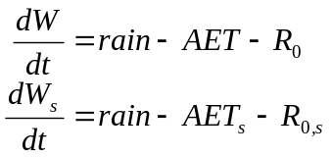 (200)
where rain is daily rainfall, AET and AET_{s} are the daily evapotranspiration, and R₀ and R_{0,s} the daily drainage, from each zone. If irrigation water is applied, this is simply added to rain. The actual evapotranspiration and drainage functions are given in Woodward et al. (2000).

Water Conversions
Several of the model processes (e.g. decomposition, earthworm activity) depend on the soil moisture content near the surface, rather than the soil water balance as such. This is typically expressed in one of three ways.
Volumetric soil water content near the soil surface (θ_{s}) is the percentage of soil volume occupied by water. According to Woodward et al. (2000), θ_{s} can be estimated as
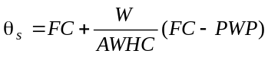 (c9)
where FC is the volumetric soil water content at “field” capacity, PWP is the volumetric soil water content at “permanent wilting point”, and AWHC is the total soil available water holding capacity. For a Tokomaru silt loam soil, FC is around 50%, PWP around 10%, and AWHC around 192 mm (Scotter et al., 1979a; Barker et al., 19xx).
Gravimetric soil water content near the soil surface (GSWC_{s}) is calculated by dividing θ_{s} by soil bulk density (BD):
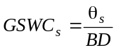 (c6)
BD was 1.1 g cm^{–3} near the surface of the Tokomaru silt loam soil studied by Scotter et al. (1979a).
Finally, soil water potential (ψ_{s}, kPa) is commonly used in detailed plant growth models (e.g. Thornley, 1998). Thornley & Johnson (1990) give,
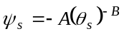 (c11)
The data of Barker et al. (19xx) were used to estimate the parameters A and B as 1.53×10⁻³ and 7.75 respectively.
Other model processes (e.g. growth, senescence) depend on the water available to the plant (i.e. via the roots). These will be discussed below.

Soil Fertility
The present model assumes a level of soil fertility that is non-limiting to pasture growth and not responsive to fertiliser. This assumption is appropriate in highly fertilised New Zealand dairy farms, but may be relaxed to link into soil nutrient models. In this case, soil fertility would affect the values of the model parameters, but not the model structure itself. The pastures observed in the trial of Korte et al. (1984) was provided with generous levels of nitrogen and phosphate fertiliser, so this assumption is likely to have been met.

New Growth
Models of photosynthesis in plant canopies have generally focussed on a single plant component (Saeki,, 1960; Monteith, 1965; Johnson & Thornley, 1983; Johnson et al., 1995). Only more recently have attempts been made to incorporate multiple components into photosynthesis models (Ross et al., 1972; Johnson et al., 1989; Ryel et al., 1990; Sinoquet et al., 1990; Sinoquet & Bonhomme, 1991; Parsons et al., 1991a; Thornley et al., 1995). This is complicated because when the components are not completely mixed through the canopy, the equations for instantaneous canopy photosynthesis cannot be derived analytically (Johnson et al., 1989).
Real pastures grown for grazing animals consist of mixtures of components that compete with one another for light (e.g. Faurie et al., 1996). In grass-clover pastures for example, reproductive and vegetative grass tillers must compete with one another and with clover for light. Consequently, the elevation of photosynthetic surfaces due to reproductive stem elongation may have a profound effect on the growth and composition of the sward. Conversely, high levels of dead material in may depress canopy light capture and thus photosynthesis (Korte et al., 1982, 1984).
In the growth submodel, photosynthesis by the V, R and C components are responsible for growth of the vegetative grass crop, reproductive grass crop (including stem) and clover crop respectively. Light capture by dead material D reduces the amount of radiation available to these other components. It is assumed that carbohydrate reserves do not significantly contribute to growth (Harris, 1978). Functions for light capture, photosynthesis, respiration and new growth in grass-clover pasture are based on the work of Johnson and Thornley (Johnson & Thornley, 1983; Johnson et al., 1989, 1995; Thornley, 1998). The rates of new growth of V, R, S and C are G_{v}, G_{r}, G_{s} and G_{c}, respectively (Fig. 1).

Leaf Photosynthesis
Leaf photosynthesis, P_{l}(J_{l}), is the rate of carbon assimilation per unit area by a leaf receiving light intensity J_{l}. There are two widely accepted models for P_{l}(J_{l}). The first is the detailed photochemistry model developed by Farquhar and others (Farquhar, 1989). This model has provided a focus for much research into the within-leaf biochemistry of photosynthesis (e.g. Pearcy et al., 1997). However its many parameters are difficult to measure, and scaling the model up to predict canopy photosynthesis is a non-trivial problem (Leuning et al., 1995; de Pury and Farquhar, 1997). The second widely used model is the empirical non-rectangular hyperbola response curve for leaf photosynthesis developed by Johnson and Thornley (1984). Because this second model summarises photosynthesis at the leaf rather than at the cellular level, it is more appropriate for scaling up for canopy level predictions (Farquhar, 1989). Furthermore, the Johnson and Thornley non-rectangular hyperbola model is essentially a simplification of the Farquhar scheme (de Pury and Farquhar, 1997) in which the enzyme Rubisco (and hence nitrogen) is assumed to be non-limiting. The Johnson and Thornley model offers the additional advantage of being relatively amenable to mathematical analysis.
The non-rectangular hyperbola model is (Johnson and Thornley, 1984),
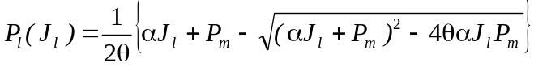 (4)
where J_{l} J m^{–2} (leaf) s^{–1} is the irradiance incident on the leaf, α mg CO₂ J^{–1} is the quantum efficiency, P_{m} mg CO₂ m^{–2} (leaf) s^{–1} is the maximum rate of leaf photosynthesis, and θ is a dimensionless curvature parameter.

Effect of Temperature on Leaf Photosynthesis
The leaf photosynthesis parameters in Eqn. 4 (α, θ and P_{m}) vary in response to environmental factors, particularly leaf temperature, leaf nitrogen and plant water. However, it is thought likely that α and θ are relatively constant with respect to variation of these environmental variables (Tenhunen & Westrin, 1979; Johnson & Thornley, 1984; Johnson et al., 1995). The “leaf photosynthetic capacity” parameter P_{m}, on the other hand, increases strongly with leaf temperature in both grass and clover leaves (Woledge & Dennis, 1982; Johnson & Thornley, 1984; Woledge & Parsons, 1986; Frame et al., 1998). This dependence may be modelled using an Arrhenius function (Tenhunen et al., 1976; de Pury & Farquhar, 1997), or a simpler linear model (Johnson & Thornley, 1984):
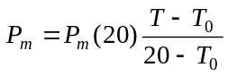 mg CO₂ m^{–2} (leaf) s^{–1} (1x)
where 20°C is the reference temperature and T₀ is the temperature below which photosynthesis ceases.
It has been shown that ryegrass and clover leaves have similar photosynthesis rates in summer as in winter when at the same irradiance and temperature (Woledge & Dennis, 1982; Woledge et al., 1989). Therefore, leaf growth temperature can be assumed to have little effect on P_{m}. However, ryegrass leaves grown in shade have significantly lower photosynthetic capacity than leaves grown under bright light (Woledge & Parsons, 1986) This is the main cause of the lower photosynthetic capacity of leaves in dense, vegetative grass swards compared to more open, reproductive swards (Parsons, 1988).
Based on these assumptions, the data of Woledge & Dennis (1982) and Woledge & Parsons (1986) were used to calibrate Eqn. 1x for clover, ryegrass leaves grown in bright light, and ryegrass leaves grown in shade (Table 4). The derived temperature dependencies are shown in Fig. 4x. As noted by Parsons (1988), ryegrass leaves grown in shade have much lower photosynthetic capacity than those grown in bright light conditions. In the model, vegetative grass leaves were assumed to have grown in shade, and reproductive leaves were assumed to have grown in bright light.
(Table 4 near here)
(Figure 4x near here)

Leaf Area
The light capture capacity of each component consists of the leaf area index of leach component (L_{i}) and it’s light extinction coefficient for diffuse and scattered radiation (k_{i}).
Considering the V component first, field measurements indicate that leaf accounts for around 60% of above-ground green mass in vegetative swards (Davies, 1971; Robson, 1973; Parsons et al., 1991b) and that the specific leaf area of vegetative ryegrass leaf is around 0.0030 ha (leaf) kgDM⁻¹ (Davies, 1971; Barthram and Grant, 1994; cf. Parsons et al., 1991b). The light extinction coefficient for leafy ryegrass swards is around k_{v} = 0.5 m² (ground) m⁻² (leaf) (Brougham, 1956; Davies, 1971; Woledge and Leafe, 1976).
Reproductive grass swards (component R) have similar extinction coefficients to vegetative (i.e. k_{r} = 0.5), but the specific leaf area on these tillers is higher, around 0.0035 (Davies, 1971). Reproductive stem itself is surrounded by leaf sheath, and therefore makes little contribution to light capture and photosynthesis, unless it has emerged (S2). In the model emerged stem is converted a leaf equivalent using the parameter ξ_{s}, which is the leaf ratio of reproductive stem. The value of this parameter was estimated by model fitting.
White clover has a higher extinction coefficient than grass (k_{c} = 0.8, Johnson et al., 1989), because its leaves are relatively horizontal. As in ryegrass, leaf makes up around 60% of shoot mass by weight (Parsons et al., 1991b). Specific leaf area is greater than that of vegetative ryegrass, around 0.0035 (Parsons et al., 1991b; Barthram and Grant, 1994).
Light capture due to dead material is assumed to be the same as that for vegetative grass, with a specific leaf area of 0.0030 and an extinction coefficient of 0.5. Although this material has relatively low leaf area index, it also has low dry weight, due to translocation of soluble substrates back into the main shoot at the time of death (Robson and Deacon, 1978; Woodward, 1998a).

Structure Of Grass-Clover Canopies
In order to calculate photosynthesis by the various canopy components, it is necessary to model the structural arrangement of the canopy. In particular, the elevation of grass leaf and stem during reproductive growth in grass-clover dairy pasture, and also the effect of dead material in the canopy must be modelled. Vertical distributions of plants in mixed pastures have been measured in a number of studies (Woledge, 1988; Johnson et al., 1989; Ryel et al., 1990; Woledge et al., 1992; Faurie et al., 1996). The more detailed component dissections given in Milne et al. (1982) and Collins (1989) show that vegetative, reproductive, legume and dead material are mixed unevenly through the layers of grazed grass-clover pasture. Dead leaf and grass and clover stem are located in the lower layers of the sward, while grass and clover leaf is more evenly distributed through the canopy.
Neither of these studies separated vegetative grass leaf and stem from reproductive leaf and stem. In fact, data on the morphology and elongation of reproductive leaf and stem are rare. Moore et al. (1991) give a qualitative description of the development of reproductive grass tillers, and Lauer and Simmons (1989) measured the competition for light between reproductive and vegetative barley (Hordeum vulgare L.) tillers. From these it is reasonable to suppose that reproductive leaf area, attached to elongating stems, would occupy a higher position in the sward than vegetative leaf area, and thus shade vegetative tillers to some extent.
For the purposes of modelling canopy photosynthesis, it is not necessary to describe the sward architecture in detail. Inspection of the data in Milne et al. (1982), Collins (1987) and Moore et al. (1991) suggests that a useful model of reproductive grass-clover pasture might consist of three layers: an elevated layer containing reproductive grass leaf, sheath and stem; a mixed layer containing vegetative and reproductive grass leaf and stem material, as well as clover and some dead matter; and a base layer containing the balance of the dead material, grass pseudostem and clover stolon (in the case of white clover) (Fig. 6). It is assumed that no photosynthesis takes place in the base layer (Robson,, 1973).
(Fig. 6 near here)
Pooled fitting of the nine ryegrass-white clover sward types given in Milne et al. (1982) (e.g. Fig. 7) suggested that photosynthesis by the grass and clover components would be most accurately predicted by a 3-layer model (Fig. 6) if the proportion of dead material in the mixed layer was assumed to be w_{d} = 28% (R² = 0.98). This was assuming no elevated layer, since Milne et al.’s (1982) data were collected in late summer, when there was little reproductive stem material remaining in the pasture.
(Fig. 7 near here)
(Fig. 27 near here)
The contents of the elevated layer can be estimated by assuming that the proportion of reproductive tissue (R+S) in this layer, ε, is dependent on the stem-leaf ratio of the reproductive tiller, and is
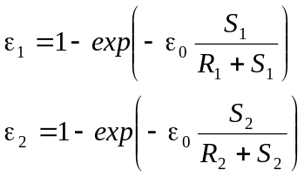 (31y)
Therefore, the quantity of reproductive tissue in the mixed layer is then 1–ε₁ or 1−ε₂ (see Fig. 6). The parameter ε₀ was estimated by fitting, and the functions in Eqn. 31y are shown in Fig. 27.

Potential Daily Canopy Photosynthesis of a Monoculture
Can I just refer to someone else’s model?
The irradiance inputs define the light environment at the sward surface. As one descends through the canopy the intensity of diffuse irradiance, J_{d}, is attenuated, and the proportion of leaves in direct sun, f_{s}, is also reduced due to shading within the canopy. However, the intensity of direct sunlight, J_{s}, remains constant. These rates of attenuation relative to leaf area l may be expressed in differential equation form, and solved:
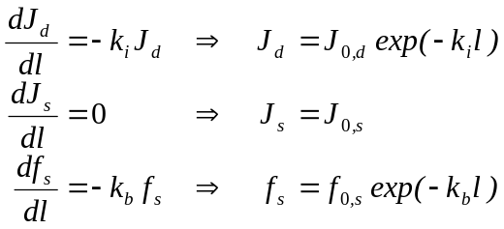 (1)
where k_{i} is the extinction coefficient for diffuse and scattered radiation. The extinction coefficient of direct beam sunlight (k_{b}) is 0.5/sinβ, where β is the sun elevation angle and a spherical leaf angle distribution is assumed (de Pury & Farquhar, 1997).
The intensity of light incident on a leaf is k_{s}J_{s}+k_{d}J_{d} for sunlit leaves and k_{d}J_{d} for diffusely lit leaves, where k_{s} is the direct beam extinction coefficient modified for scattering, and τ is the leaf transmission coefficient (taken to be 0.1, Johnson ??, 19xx). The proportions of leaves in direct and diffuse light are f_{s} and 1–f_{s} respectively. Light transmission through the leaves can be neglected, because only a small proportion of intercepted light is transmitted and this is mainly light of poor quality for photosynthesis (Johnson et al., 1995). It is assumed that light scattering effects are subsumed into the extinction coefficient, and that effects of variation in leaf angle are negligible (Goudriaan, 1988). A fourth equation,
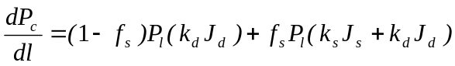 (2)
then integrates leaf instantaneous gross photosynthesis (P_{l}, mg CO₂ m^{–2} (leaf) s⁻¹) down through the canopy to give canopy instantaneous gross photosynthesis (P_{c}, mg CO₂ m^{–2} (ground) s⁻¹).

Method for Rapid Calculation of Photosynthesis in Mixed Canopies
While it is straightforward to integrate Eqn. 3 numerically, the fact that the integral contains L means the integration must be done at run-time. An alternative approach which allows very rapid run-time calculation, even in mixed canopies, and which facilitates mathematical manipulation, is to find an analytical approximation to Eqn. 3.
Eqn. 2 may be expressed as a function of K, where 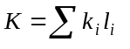represents the sum of light extinction due to all canopy components i above a given layer in a mixed canopy:
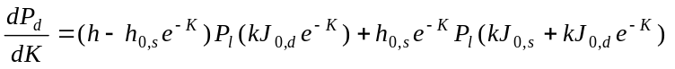 (5)
The right hand side of this equation depends on the weather variables on a given day and the physical and photosynthetic parameters of the plant component in question, but is independent of the leaf area or position in the canopy. The function is shown in Fig. 3 for a typical set of parameter values. The initial slow decline in the function reflects the relative inefficiency of photosynthesis under high light intensities (i.e. at the top of the canopy). The integral under this curve is the daily gross canopy photosynthesis for a monoculture with 100% light capture, P_{d}*, which is calculated by integrating Eqn 3 from l = 0 to ∞:
(6)
(Fig. 3 near here)
We wish to calculate the daily photosynthesis of a plant component in a mixed canopy. If the light extinction due to this component is K_{i}, then the daily photosynthesis of this component is,
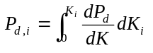 (7)
where the integrand is given by Eqn. 5 (and K must be expressed as a function of K_{i}).
Suppose we now approximate Eqn. 5 by an exponential function:
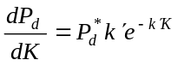 (8)
where k’ (<1) is an attenuation factor for photosynthesis, rather than for light. This approximation preserves the potential photosynthesis of the canopy, but approximates where in the canopy that photosynthesis takes place. This is reasonable since in practice we are often dealing with fully closed mixed canopies or monocultures, or weakly stratified canopies where it is difficult to be precise about the vertical positions of the various canopy components (e.g. Milne et al., 1982; Woledge et al., 1992). The approximation is not suitable for tree/pasture systems, for example, where the strata do not overlap. In summary, the approximation is very accurate for closed, homogeneously mixed canopies, but less accurate for strongly stratified canopies or for canopies with low light capture.
Consider a grass-clover pasture with a top layer consisting only of grass, with extinction K_{t}, and a second layer consisting of grass (K_{g}) and clover (K_{c}) mixed homogeneously (so that K_{g}/K_{c} = constant). Then in the mixed layer,
K = K_{t} + K_{g} + K_{c} = K_{t} + 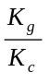K_{c} + K_{c} (9)
and photosynthesis by the clover is calculated by (using Eqns 7 and 8),
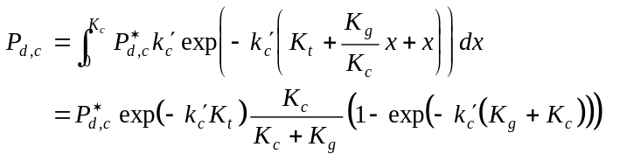 (10)
This is similar to the calculation for light capture by a canopy component—in that case we would have k’=1. Eqn. 10 is easily extended to any canopy which can be represented as a series of homogeneously mixed layers, although the warning is repeated that the approximation is least accurate in strongly stratified canopies.
Calculation of P_{d}* may be done numerically without knowing the structure of the canopy. Potential canopy gross photosynthesis is given in Fig. 4 for vegetative grass (P_{d,v}*), reproductive grass (P_{d,r}*), and clover (P_{d,c}*) monocultures for the irradiance data in Fig. 2.
(Fig. 4 near here)
Simulations of Eqn. 10 against Eqn. 3 based on the weather data presented in Fig. 2 for the photosynthesis of vegetative grass, reproductive grass, and clover canopy components in grass-clover canopies showed that good predictions are obtained using the attenuation factors k_{v}’=0.88, k_{r}’=0.92, and k_{c}’=0.84 respectively for the three components. The simulations assumed a random overlying elevated layer (i.e. K_{t}=0–1), a random leaf area of the component in the range 0-8 in the mixed layer, and a random amount of other material in the mixed layer (e.g. K_{g}/K_{c}=0–1). The calculations are compared with numerical integration of Eqn. 5 in Fig. 5. As expected, the errors were largest when K_{t} was large or when the total canopy leaf area was small. Furthermore, these errors were more pronounced on days with a strong component of diffuse light, because the approximation is least accurate in the “elbow” of the P_{l} curve (i.e. near αJ_{l}/P_{m}=1, Eqn. 4).
(Fig. 5 near here)
The fact that P_{d}* can be calculated a priori speeds up calculations during dynamic simulations of the pasture model. The methodology is also attractive because it separates seasonal patterns of canopy photosynthesis (represented by P_{d}*) from canopy structure (represented by the rest of Eqn. 10). For simple canopy structure models, this then allows steady state, stability, optimal control and other mathematical analyses to be carried out analytically.
The light extinction due to total leaf area in each of the three layers is (from Fig. 6),
1. Elevated layer: K₁ = (εS)c_{r}R
2. Mixed layer: K₂ = c_{v}V+c_{c}C+c_{d}w_{d}D+(1–εS)c_{r}R
3. Base layer: K₃ = c_{d}(1–w_{d})D. (12)
From Eqn. 10 the gross photosynthesis of the vegetative grass, reproductive grass, and clover components of the canopy are then:
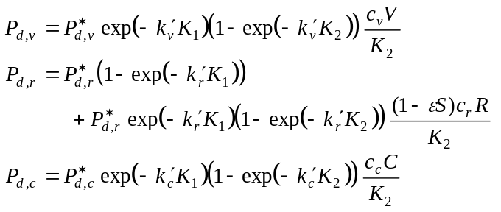 (13)
(Note that P_{d,r} has contributions from both the elevated and mixed layers). These functions are clearly much more straightforward to calculate at run-time than the integral in Eqn. 3, once the values of P_{d}* have been calculated a priori (Fig. 4).

Qualitative Testing of Photosynthesis Model
One practical question which can be studied using this model is the depression of canopy photosynthesis caused by the presence of dead material in the sward. This was thought to be one cause of the low growth rates recorded by Korte et al. (1982) in laxly grazed spring swards, which contained up to 4000 kgDM ha⁻¹ of dead material. In order to separate the effects of dead material from those of reproductive growth, simulations were carried out for two-layer swards (no elevated layer) with varying quantities of dead material in the mixed layer. The results are presented in Fig. 8 for two swards with contrasting green mass (GM = V+C). Even with 500 kgDM ha⁻¹ dead material in the mixed layer, light capture by the photosynthetic surfaces (and therefore photosynthesis) was depressed 15% by the presence of the dead material.
(Fig. 8 near here)
A second question is the extent to which the elevation of reproductive stem and leaf in reproductive pastures promotes the growth of reproductive tillers at the expense of vegetative tillers. For example, Ryel et al. (1990) showed that the slight height advantage of wheat over wild oats when grown together in a mixture significantly increased the wheat’s net photosynthesis. Simulations were carried out to examine this question for reproductive ryegrass swards at two leaf area indices (L) which were 20% or 40% reproductive (by mass) (Fig. 9). When 40% of reproductive material was elevated, for example, there was a 12–15% increase in the proportion of light captured by the reproductive fraction of the L=2 swards, and a 24–34% increase in the L=4 swards, the greater increases coming in the “20% Repro” swards, where the reproductive material had more competition from other material. Consequently there was also a matching decrease in capture by the vegetative fraction.
(Fig. 9 near here)
These results highlight the role that canopy structure plays in determining the light capture and carbon assimilation of a grass sward.

Dark Respiration
Once assimilated, some carbon is respired in the maintenance of existing tissue and in the growth of new tissue, and the remainder is converted into new growth. Johnson et al. (1995) give the expression for the respiratory loss rate of a canopy component i (here denoted Q_{i}) in the form,
Q_{i} = (1 – Y)(π_{i}P_{d,i} – R_{i}W_{i}) + R_{i}W_{i} mg CO₂ m⁻² (ground) d⁻¹ (14)
where Y is the efficiency of converting substrate to structure, π_{i} is the proportion of assimilate partitioned to shoot growth of component i (see below), R_{i} is the leaf respiration rate, and W_{i} kgDM ha⁻¹ is the herbage mass of the component. This formulation of respiration (Eqn. 14) assumes that a fraction of assimilate is first partitioned to the roots, maintenance demands are met next, and finally what is left over is used for growth. Little assimilate is exported to other tillers even in ungrazed swards (Colvill and Marshall, 1984).
The rate of dark respiration of plant tissue (R_{i}, Eqn. 14) has been shown to increase exponentially with temperature (Robson, 1981; Woledge & Dennis, 1982; Woledge & Parsons, 1986; Harley et al., 1992; de Pury & Farquhar, 1997). This is the main cause of the suboptimal net photosynthesis rates observed at high temperatures in pasture plants (McWilliam, 1978). The relationship for a given leaf depends on the temperature at which the leaf has developed (Fig. 3a). Calibration to the perennial ryegrass data of Robson (1981) and the clover data of Woledge & Dennis (1982) gave the following respiration model for the two species (Fig. 3a),
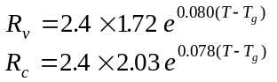 mgCO₂ m⁻² d^{–1} (kgDM ha^{–1}) ^{–1} (2x)
where T_{g} is the temperature at which the leaf was grown and T is the measurement temperature. The factor 2.4 in Eqn. 2x converts between the units shown in Fig. 3a and the units required for R_{i} in Eqn. 14. In our model, T_{g} was estimated by using exponential smoothing of the daily temperature data (Kendall & Ord, 1990). Using σ_{v} (i.e. the senescence rate of grass leaves) as the smoothing coefficient gave T_{g} as the average birth-day temperature of the leaves in the population, using the formula
(Figure 3a near here)

Partitioning of Photoassimilate
The parameter π_{i} in Eqn. 14 is the proportion of assimilate partitioned to shoot growth of component i. By drawing carbon away from the shoot, the process of assimilate partitioning has a major impact on crop growth. Parsons & Robson (1981) showed that, in perennial ryegrass, the fraction of assimilate partitioned to shoot growth decreases with reproductive development. Based on their data we take π_{v} = 88% and π_{r} + π_{s} = 96%. Colvill & Marshall (1984) found that, prior to anthesis, leaves of reproductive ryegrass tillers export around π_{s} = 30% of assimilated carbon, most of which goes into stem and ear growth. Therefore π_{r} = 66%.
Jørgensen & Ledgard (1997) found that growth rate of stolons plus roots in white clover was 96% of the leaf growth rate on the same plants. This implies that 51% of carbon is partitioned to leaf growth (including petiole). Danckwerts & Gordon (1989) similarly found that 51% of labelled carbon ended up in leaf tissue 18 days after assimilation. These data lead to a value of π_{c} = ***51% for white clover, although Frankow-Lindberg (1997) showed that this figure might decline in autumn as reserves are being prepared for overwintering. This simplistic approach neglects seasonal patterns of assimilate partitioning, storage and remobilization (Danckwerts & Gordon, 1989; Frankow-Lindberg, 1997).

Growth
The daily above-ground rate of growth of component i is then (adapted from Johnson et al., 1995),
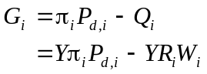 mg CO₂ m⁻² (ground) d⁻¹ (15)
G_{i} may be converted to units of dry matter (kgDM ha⁻¹ d⁻¹) by dividing by γ, where
(16)
is the conversion factor from kgDM ha⁻¹ to mgCO₂ m⁻² units, assuming that dry matter consists principally of C₆H₁₂O₅-units (this conversion is modified from Johnson et al., 1995).
Rates of new growth of the V, R, S and C components of our grazed pasture model (Fig. 1) are then,
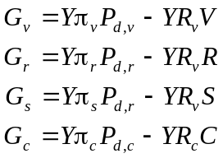 mg CO₂ m⁻² (ground) d⁻¹ (17)
Note that in this model photosynthesis from the leaves on reproductive tillers (P_{d,r}) is partitioned to both leaf (π_{r}) and reproductive stem growth (π_{s}).

Effect of Water Stress on Growth
While the rate of photosynthesis itself is insensitive to the mild water stresses likely to occur in moist temperate climates such as New Zealand, leaf expansion is one of the first processes to be affected by even mild stresses (Kramer, 1983; Jones, 1988; Barker et al., 1989).
Barker & Dymock (1997) have suggested that water stress response depends on the proportion of plant roots able to take up water from the soil. Their data found that root distribution in pasture follows the relation,
= 0.31 exp (–0.31 x) (300)
Scotter et al. (1979b) measured herbage accumulation rates under different soil water deficits. The results were reported by Parfitt et al. (1985) and the relative herbage accumulation rate factor given as:
RHA = 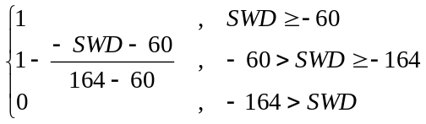 (27)
so that pasture growth rate was depressed at water deficits below –60 mm and ceased altogether below –164 mm. The effect of soil water deficit in the top soil layer (SWD’) on growth was modelled by multiplying SWD’ by 7.3, the ratio of the largest possible soil water deficits in each of the two layers (–183 and –25 mm respectively), and applying Eqn. 27 to give:
RHA’ = 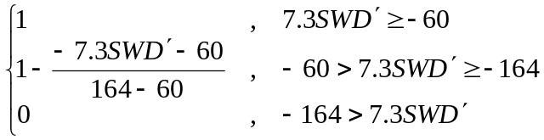 (28)
The maximum of these two factors (Eqns 27 and 28) was used in the model to depress the conversion of photosynthate into new growth (Eqn. 17, c.f. Mougin et al., 1995), i.e.,
g_{w} = max( RHA, RHA’ ) (29)
Is this way, water in the top soil layer or in the deeper soil layer were able to compensate for water deficit in the other layer, so that dry topsoil did not necessarily depress growth, and rain following a dry period was able to produce a relatively quick growth response even when the overall soil water deficit was still large. Figure 4 gives the seasonal pattern of water stress limitation to growth (g_{w}) calculated from the, 1991/1993 weather data from Palmerston North.
(Figure 4 near here)
The factor g_{w} was also used to predict clover growth under water stress.***

Grass Leaf Senescence
Leaf and tiller death are important processes affecting pasture quality because they drive the production of dead material in the pasture. Tissue death rates were calculated for perennial ryegrass in an earlier paper (Woodward, 1998a), as:
σ_{v} = (1 – μ) LDR + TDR kg kg⁻¹ d⁻¹. (311)
where σ_{v} is the relative senescence rate (kg kg⁻¹ d⁻¹), μ is the fraction of leaf mass remobilised by the plant prior to leaf death (taken to be 0.3), LDR is the leaf death rate (kg kg⁻¹ d⁻¹) and TDR is the background rate of tiller deaths (kg kg⁻¹ d⁻¹) (estimated by Woodward, 1998a to be 0.0013). Woodward (1998a) showed that LDR in perennial ryegrass varies linearly with soil temperature (T °C) in winter, and derived the relationship,
LDR = 0.0016 T + 0.0035 kg kg⁻¹ d⁻¹. (31)
Subsequent testing revealed that this relationship greatly overestimates LDR in summer, when shorter leaf lifespan is offset by increasing numbers of leaves per tiller (Vine, 1983).
Bowman et al. (1982) argued that this correlation was due to the water deficits caused by high temperatures. While severe water stress may increase tiller death rates, the consistency of the temperature-leaf senescence relationship over several data sets (Cayley et al., 1980; Chapman et al., 1984; Vine, 1983; see also Lemaire & Chapman, 1996) supports the hypothesis that senescence is primarily temperature dependant in temperate perennial grasses. Unless water stress is severe, leaf senescence rate is relatively insensitive to water availability (Jones, 1988).
Vine (1983) observed that, prior to flag leaf emergence, the rate of senescence of leaves attached to reproductive ryegrass tillers was the same as that for vegetative tillers (Woodward, 1998a). The flag leaf itself appeared seven days sooner than expected but had a similar life-span to previous leaves (Vine, 1983). Increasing leaf numbers per tiller at this time occur because leaves appear more rapidly while their life-span remains similar, so that leaves per reproductive tiller reaches a peak of 5.0 following flag leaf appearance (Vine, 1983; Chapman et al., 1984). In a previous paper, Woodward (1998a) suggested that flag leaf longevity would depress senescence rates in reproductive tillers. However, the evidence from Vine (1983) and Chapman et al. (1984) is far from unequivocal. In the current model, therefore, the senescence rate of reproductive leaves σ_{r} is modelled as being equal to that of vegetative leaves, i.e. σ_{r} = σ_{v}.

Clover Leaf Senescence
The processes that drive the death of clover leaves (C) are quite different from those that drive death in grass leaves (cf. Woodward SEN). The main causes of leaf death in white clover are:
- Leaf ageing.
- Death of petiole after lamina has been removed.
- Annual patterns of stolon turnover.
- Stolon death due to grazing damage.
Data for leaf death due to ageing in sheep grazed pasture are given in Chapman et al. (1984) and Chapman (1986). Harris & Clark (1996) give data on annual patterns of leaf and stolon content in dairy pasture.
Accelerated senescence rates with increased temperature are observed in most pasture plants (McWilliam, 1978).
Under field conditions, white clover leaves have a lifespan of 4-5 weeks (Frame et al., 1998). The data of Chapman et al. (1984) agree, but also include lifespans of 6-10 weeks through the autumn and winter.

Grass Reproductive Development
The model of reproductive grass tiller dynamics used here was formulated in Woodward (1998c). This model does not attempt to predict the onset of reproductive development or the date of head emergence (maturation) of reproductive stem. Instead, it is assumed that the rate at which vegetative tillers are becoming reproductive at day t, z day⁻¹, and the rate at which reproductive tillers are maturing, m day⁻¹, are known a priori (Woodward, 1998c). The amount of vegetative green material (V) going reproductive at day t is then,
zV kg ha⁻¹ d⁻¹, (13)
and the rates of stem maturation and associated leaf death on reproductive tillers are respectively,
mS and mR kg ha⁻¹ d⁻¹. (14)
Using the data of L’Huillier (1987) and Elgersma (1990), Woodward (1998c) estimated these functions to be (for a ryegrass pasture in New Zealand):
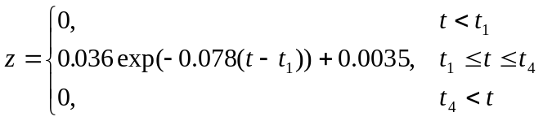 (15)
where the date of first stem elongation was t₁ = 30-Sep, the last stem elongation date was t₄ = 10-Jan; and
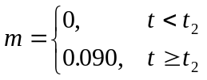 (16)
where the date of first ear emergence (tiller maturation) was t₂ = 2-Nov. These two functions provide a simple model of the reproductive development of pasture grasses. The dates and rates of reproductive development may be altered to reflect the flowering patterns of different ryegrass cultivars or even alternative pasture grasses, such as browntop (McCall, 1984).
By the time the reproductive stem matures, little live leaf remains (Johnston & Waite, 1965; Vine, 1983). We consider that any remaining leaf begins to die at this point, adding an additional loss of reproductive leaf, at rate,
m(t)R kg ha⁻¹ d⁻¹. (32)
This leaf is moved to the F pool, and subsequently dies (Eqn. 16.1).
When growing reproductive tillers (represented by R & S) mature (Eqns 14 and 16) or are decapitated (Eqns 11 and 12), they are considered to be “dying” and are represented by the herbage components F (leaf and sheath) and M (stem), respectively (Fig. 1). As discussed above, both F and M are assumed to be readily grazed by animals. However, as the tiller dies, these components quickly lignify and lose their palatability. Johnston & Waite (1965) observed that 50% of ryegrass leaves were either dead or dying about 10 days after head emergence (which we define as the point of reproductive tiller maturation). Assuming the death rates of F and M are respectively,
φ_{f} F and φ_{m} M kg ha⁻¹ d⁻¹, (16.1)
this observation implies that φ_{f} = – ln(0.5) / 10 = 0.07 d⁻¹. Stem was assumed to lignify more slowly, so that φ_{m} was set at 0.03 d⁻¹.

Decomposition of Litter
The two main processes affecting the disappearance of dead material in pasture are microbial decomposition and removal (ingestion, burial) by earthworms. The excellent decomposition model of Hunt (1977) proposed that pasture litter should be considered to consist of two forms: water-soluble materials that are subject to leaching, and non-soluble materials which are not subject to leaching. This has been supported by decomposition studies on material harvested while green (e.g. Yates, 1982; Wardle et al.1994; Bloemhof & Berendse, 1995) which show an initial burst of rapid litter decay followed by a longer period of slower activity. However, other studies suggest that naturally senescent plant material contains little soluble organic matter, this having been remobilised prior to death (Parsons & Robson, 1981; Yates, 1982; Thomas & Asakawa, 1993; Bloemhof & Berendse, 1995). In our model therefore, we assume that dead material D consists wholly of insoluble components.
Insoluble plant litter is subject to microbial decomposition which is dependant on moisture and temperature (McCall, 1984; Andrén & Paustian, 1987; Hunt et al., 1991; Andrén et al., 1993). Decomposition has been shown to be a first order process (Hunt, 1977; Yates, 1982; Andrén & Paustian, 1987; Hirata, 1992; Andrén et al., 1992, 1993; Thomas & Asakawa, 1993; Bloemhof & Berendse, 1995), so that the rate of litter disappearance can be modelled as
δ_{d} d_{T} d_{w} D kgDM ha⁻¹ d⁻¹ (33)
where the effects of temperature and moisture are modelled through the factors d_{T} and d_{w}. Based on the data of Wardle et al. (1994), the base (maximum) decomposition rate was estimated to be δ_{d} = 0.0148 d⁻¹ for naturally senescent Lolium perenne–Trifolium repens litter (Fig. 5a).
(Figure 5a near here)
Temperature is an important variable affecting the rate of decomposition (Andrén & Paustian, 1987; Facelli & Pickett, 1991; Andrén et al., 1993; Bloemhof & Berendse, 1995). The influence of temperature seems to depend on overall fertility, as the temperature factors given by Hunt (1977) for natural grassland in the USA are much lower than those given by other authors (Andrén & Paustian, 1987; Andrén et al., 1992, 1993; Bloemhof & Berendse, 1995) for more fertile, arable land in northern Europe. The latter are probably more akin to New Zealand pastoral soils, so we adopt the decomposition temperature factor from Andrén et al. (1992, 1993):
d_{T} = 2.0 ^{(T – 20) / 10} , T > 0°C (34)
which is a Q₁₀-type (power) relationship, a form which is particularly suited to modelling biological activity (Andrén et al.1989, p.99). There is no decomposition when T ≤ 0°C (Andrén & Paustian, 1987) (an unlikely event in New Zealand, recalling our definition that T is daily average temperature). The parameter d_{T} may exceed 1 on days when average air temperature T exceeds 20°C.
Decomposition is also affected by moisture (Swift et al., 1979; Andrén et al., 1992, 1993; Thomas & Asakawa, 1993). Swift et al. (1979, p.260) showed that the effects of temperature and moisture on decomposition rates are approximately multiplicative, with increased temperature making decomposer organisms more sensitive to water availability or stress. The exception occurs when the soil becomes waterlogged, in which case decomposition is inhibited (Hunt, 1977), but this seldom occurs in well-drained agricultural soils (Andrén et al., 1989). Furthermore, under normal circumstances, waterlogging on the soil surface (i.e. puddles) is short-lived, so we consider that this effect may be ignored in the case of surface litter.
Andrén et al. (1989, 1992, 1993) used a log-linear multiplier to express the effects of water stress on decomposition:
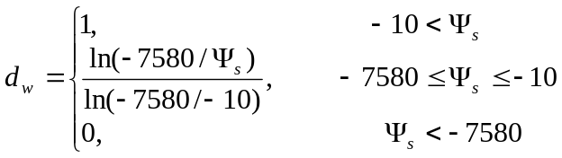 (35)
where Ψ_{s} is the soil water tension in the topsoil in kPa (Eqn. 37). This form is suited to modelling the effect of moisture on biological activity (Andrén et al., 1989, p.99). Eqn. 35 was found to work well in moist conditions (Andrén et al., 1992) but underestimated the depression of decomposition in dry conditions (soil water content < 25%) (Andrén et al., 1993). The authors suggested that this lack of fit could have been caused by inaccuracies in their methods for estimating Ψ_{s} from volumetric soil water content data or estimating the effect of soil cracking. This problem may be avoided if Ψ_{s} can be estimated more accurately.
We also assume that d_{w} = 1 on any day on which rain falls or irrigation water is applied (McCall, 1984).

Removal of Litter by Earthworms
Litter is also removed by earthworms. The dominant earthworms in New Zealand pastoral soils are the topsoil mixers Aporrectodea caliginosa and A. trapezoides and the surface feeder Lumbricus rubellus (Martin, 1978). While L. rubellus feeds primarily on decomposing litter on the soil surface, the Aporrectodea spp. prefer organic matter rich soil, but will also consume decomposed litter if it is present in quantity (Waters, 1955; Edwards & Bohlen, 1996). Earthworm numbers often exceed 1000 per square metre in these soils (Springett, 1992; Fraser & Piercy, 1996), and these worms are responsible for the turnover of a large quantity of organic matter both within the soil and on the soil surface (Sharpley et al., 1979; Daniel, 1991; Edwards & Bohlen, 1996). Removal of litter from the soil surface by earthworms depends on the earthworm populations at that time of year (Martin, 1978; Marinissen, 1992; Baker et al., 1992, 1993; Fraser & Piercy, 1996), how close they are to the surface (Marinissen, 1992; Baker et al., 1992, 1993), the quantity of available litter (Daniel, 1991; Edwards & Bohlen, 1996) and their activity (Daniel, 1991).
Earthworm populations and depth are primarily driven by soil moisture (Fraser & Piercy, 1996; Edwards & Bohlen, 1996). Baker et al. (1992) measured populations of Aporrectodea caliginosa and A. trapezoides at several pasture sites in South Australia, and observed the dependence of these populations on month, soil moisture content, and depth in the soil. Analysis of their data showed that the total population of Aporrectodea spp. in the top 10 cm of the soil (E worms m⁻²) was closely correlated to 10 cm gravimetric soil water content (Eqn. 361) from April to October (earthworms were absent from the top soil layer through the summer):
E = 655 × max(0, min(1, 5.0 × GSWC _{s} – 1.0 )), R² = 0.97 (38)
That is, Aporrectodea spp. numbers in the top 10 cm rose linearly from zero at GSWC_{s} = 20% to a ceiling of 655 m⁻² at GSWC_{s} = 40%. We assume that the number of worms in New Zealand soils will be similar (Martin, 1978; Springett, 1992; Fraser & Piercy, 1996; Fraser et al., 1996).
These species of earthworm have an average live weight of approximately 0.2 g per individual (Martin, 1978; Fraser et al., 1996), so that the earthworm biomass in the top 10 cm of soil (B g m⁻²) can be estimated as,
B = 0.2 × E (39)
Some authors have proposed that litter consumption by such earthworms is correlated to cast production (Sharpley et al., 1979; Edwards & Bohlen, 1996; Loganathan, 1997). Sharpley et al. (1979) and Loganathan (1997) measured cast production and litter removal by earthworms from pasture at Palmerston North, New Zealand. Absolute rates of litter removal (kg ha^{–1} d^{–1}) were not well correlated with either cast production or soil moisture patterns. However, another author has shown that the rate of litter removal by earthworms is relative to the amount of litter available (Daniel, 1991). We therefore assume that earthworm grazing is a first order process (approximating the model of Daniel, 1991), so that the rate of litter removal is,
δ_{e} e_{T} e_{w} B D kgDM ha⁻¹ d⁻¹ (40)
where δ_{e} is a constant and the moisture and temperature dependence is modelled through the factors e_{w} and e_{T}.
Daniel (1991) measured and modelled the ingestion of dried grass leaves by the deep burrowing earthworm Lumbricus terrestris over a range of soil moisture and temperature. Assuming that New Zealand worms prefer somewhat cooler temperatures than L. terrestris (14°C as opposed to 22°C), the following temperature and moisture response factors were adapted from his paper (Daniel, 1991):
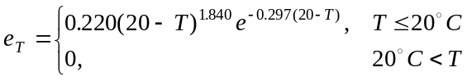 (41)
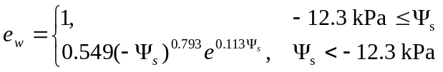 (42)
Daniel (1991) also found that, when litter was plentiful and environmental conditions optimal, L. terrestris earthworms at a density of 234 g m⁻² consumed approximately 55% of available litter in 7 days, implying that δ_{e} = –ln(1–0.55)/(7×234) ≈ 0.0005 m² g⁻¹ d⁻¹. Although this species behaves quite differently to the New Zealand worms mentioned above, we will assume that litter consumption scales across species according to live weight, so that this constant may be used also for New Zealand worms. This is considerably higher than the estimate of earthworm grazing derived by McCall (1984) from the data of Sharpley et al. (1979).
The total relative daily rate of dead matter disappearance (δ) due to microbial decomposition and earthworm removal is therefore,
δ = δ_{d} d_{T} d_{w} + δ_{e} e_{T} e_{w} B (43)

Model Validation
The motivation for developing the PQM model is to identify water and grazing patterns that optimise the production of green pasture on dairy farms in the summer-autumn period for the purpose of feeding lactating dairy cows. The parameters given in Tables 2 and 3 have been chosen with this purpose in mind.
Comparison with the earlier work of Baars et al. (1976) and Wright & Baars (1976), simple irrigation and pasture production models applied in NZ. Can I justify this model over their work?
Spring summer dairy.
Contrasting weather and grazing patterns

Model Application

Discussion
This paper describes a new model of perennial grazed pasture which includes the effects of grazing during plant flowering.
What have we achieved? Enumerate.
It should be noted that this is not a “light use efficiency” model, as proposed by some authors (Monteith, 1977; Haxeltine and Prentice, 1996). Here, P_{d}* is a non-linear function of the light inputs. Furthermore, the fact that k’<1 implies that light use efficiency is not a constant average, but increases as light intensity decreases through canopy profile.
Several of the model parameters are sensitive to changes in the environment (i.e. light, temperature, water and soil fertility). In addition, animal grazing parameters (Table 2) may change with animal physiological state (Woodward, 1997b) or level of supplementary feeding (Rook et al., 1994a).
As discussed above, in this paper we assume that soil fertility is non-limiting to pasture growth. The effects of nitrogen or other nutrient limitations would need to be modelled through their influence on each of the pasture sub-processes such as growth, death and reproduction.
Hanson et al. (1985) noted that most grassland growth models have combined the effects of light, nutrient and water limitations using Liebig’s Law (i.e. the most limiting factor is the one that limits growth) or multiplication of limiting factors. These methods are difficult to validate, and our approach has been instead to consider the effects of light, nutrient or water limitations on individual parameters in the model mechanisms. It turns out that the effects of a resource limitation (e.g. water stress) can be modelled by simple changes in only two or three key parameters. Furthermore these relations may be able to be derived and parameterised from component studies.
The aim of this paper was to develop a simple model of photosynthesis and growth in plant canopies consisting of several plant components (viz. vegetative and reproductive grass tillers, clover, and dead material), in order to allow rapid calculations of daily growth of these components for a dynamical systems model of tissue flows in a grazed pasture (Fig. 1) or similar mixed canopy. The model provides the necessary functions (Eqns 6, 12, 13, 17) to calculate daily new growth of the pasture components V, R, S and C respectively (Fig. 1).
The model was based on Johnson et al.’s (1995) analytical model of daily canopy photosynthesis in a monoculture due to direct and diffuse light. This was modified so that canopy photosynthesis could be expressed as the product of a seasonal (potential) term and a structure term (e.g. Eqn. 10). A multiplicative formula such as this has been used in previous models (e.g. Williams et al., 1983), derived theoretically (Haxeltine and Prentice, 1996) and observed in simulations of high nitrogen canopies (Leuning et al., 1995). In the current study, this result was achieved by using an exponential approximation (Eqn. 8) to the attenuation of photosynthesis through the canopy (Fig. 2).
This new photosynthesis model was coupled to a simple model of grass pasture canopy architecture (Fig. 6), consisting of three homogeneous layers. The resulting model was used to demonstrate that high levels of dead material in pasture can significantly depress light capture and photosynthesis (Fig. 8), as suggested by Korte et al. (1982).
Simulations also demonstrated that elevation of leaf on elongating reproductive grass tillers in spring pastures can significantly boost light capture by these tillers at the expense of vegetative tillers (Fig. 9). This contributes to high rates of growth in the reproductive fraction of spring swards (Korte et al., 1984), but also exacerbates the mass deaths of vegetative tillers observed at this time of year in uncontrolled swards (Ong et al., 1978; L’Huillier, 1987; Lauer and Simmons, 1989).
Functions to account for grazing and senescence in a grass-clover pasture have been developed in earlier papers (Woodward, 1997, 1998a,b). The complete system of equations describing the dynamical pasture model is currently being assembled (Woodward et al. manuscript in preparation). Nevertheless, the functions developed in this paper stand alone, and provide a summary of current photosynthesis modelling knowledge, which is easily adapted for use in other dynamical models of light competition between plant components in a canopy.
Does it describe additional tiller effects? E.g. expression of repro buds, mass deaths due to shading.
- Full treading and fouling effects to come later.
- More detailed water relations to come later.
- Pasture nutrient interactions to come later
- Assimilate storage compartment to come later
- Animal nutrition effects of intake

Conclusion

Acknowledgements
The development of this model has benefited greatly from the input of a number of colleagues, including J. Brock, D.F. Chapman, D.A. Clark, H. Clark, G. Cosgrove, P.M. Fraser, J. Hodgson, I.R. Johnson, C. Matthew, P. Newman, A.J. Parsons and S.L. Woodward. This research was funded by the New Zealand Foundation for Research, Science and Technology.

References
Abu-Zanat, M.M.W. (1990) Ingestive behaviour of cattle grazing in lightly- and heavily-grazed patches of Lehmann lovegrass (Eragrostis lehmanniana Nees). Dissertation Abstracts International. B: Sciences and Engineering, 51(2): 524B.
Andrén, O. & Paustian, K. (1987) Barley straw decomposition in the field: A comparison of models. Ecology, 68(5): 1190-1200.
Andrén, O., Lindberg, T., Paustian, K. & Rosswall, T. (1989) Ecology of arable land—Organisms, carbon and nitrogen cycling. Ecological Bulletins, 40: 1-222.
Andrén, O., Rajkai, Kálmán & Kätterer, T. (1993) Water and temperature dynamics in a clay soil under winter wheat: Influence on straw decompositon and N immobilization. Biology and Fertility of Soils, 15: 1-8.
Andrén, O., Steen, E. & Rajkai, Kálmán (1992) Modelling the effects of moisture on barley straw and root decomposition in the field. Soil Biology and Biochemistry, 24(8): 727-736.
Arditi, R. & Dacorogna, B. (1988) Optimal foraging on arbitrary food distributions and the definition of habitat patches. The American Naturalist, 131: 837-846.
Baars, J.A., Wright, A. & Wilson, D.A. (1976) Use of a simulation model for scheduling irrigations on pasture. Proceedings of Soil and Plant Water Symposium, Palmerston North, May, 1976, New Zealand Department of Scientific and Industrial Research, 96-102.
Baker, G.H., Barrett, V.J., Carter, P.J., Williams, P.M.L. & Buckerfield, J.C. (1993) Seasonal changes in the abundance of earthworms (Annelida: Lumbricidae and Acanthodrilidae) in soils used for cereal and lucerne production in South Australia. Australian Journal of Agricultural Research, 44: 1291-1301.
Baker, G.H., Barrett, V.J., Grey-Gardner, R. & Buckerfield, J.C. (1992) The life history and abundance of the introduced earthworms Aporrectodea trapezoides and A. caliginosa (Annelida: Lumbricidae) in pasture soils in the Mount Lofty Ranges, South Australia. Australian Journal of Ecology, 17: 177-188.
Barioni, L.G. (1997) A dynamic simulation model for planning and controlling grazing systems. M.Appl.Sci. Thesis, Massey University, Palmerston North, New Zealand. 176pp.
Barker, D.J., Chu, A.C.P. & Korte, C.J. (1985) Depletion of soil water from a Tokomaru silt loam by a perennial ryegrass sward. New Zealand Journal of Agricultural Research, 28: 525-530.
Barker, D.J., Chu, A.C.P. & Korte, C.J. (1989) Ryegrass herbage yield components and their response to water deficit stress. Proceedings of the XVI International Grassland Congress, Nice, France, 503-504.
Barthram, G.T., and Grant, S.A., 1994. Seasonal variation in growth characteristics of Lolium perenne and Trifolium repens in swards under different managements. Grass and Forage Science 49: 487-495.
Betteridge, K., Shioya, S. & Ochiai, K. (1991) Bite size characteristics of Holstein and Japanese Black steers grazing ryegrass-dominant pasture of different heights in boxes. Bulletin of the National Grassland Research Institute, Japan, 45: 73-82.
Blackburn, H.D. & Kothmann, M.M. (1989) A forage dynamics model for use in range or pasture environments. Grass and Forage Science, 44: 283-294.
Bloemhof, H.S. & Berendse, F. (1995) Simulation of the decomposition and nitrogen mineralization of aboveground plant material in two unfertilized grassland ecosystems. Plant and Soil, 177: 157-173.
Bowman, P.J., White, D.H. Cayley, J.W.D. & Bird, P.R. (1982) Predicting rates of pasture growth, senescence and decomposition. In Animal Production in Australia, Proceedings of the Australian Society of Animal Production, 14: 36-38.
Brougham, R.W., 1956. Effect of intensity of defoliation on regrowth of pasture. Australian Journal of Agricultural Research 7: 377-387.
Brown, K.R. & Evans, P.S. (1973) Animal treading: A review of the work of the late D.B. Edmond. New Zealand Journal of Experimental Agriculture, 1: 217-226.
Browse, J.A., Haslemore, R.M. & Thaine, R. (1984) Factors influencing the yield and feeding value of pasture grown for conservation. New Zealand Journal of Experimental Agriculture, 12: 7-18.
Cayley, J.W.D., Bird, P.R. & Chin, J.F. (1980) Death and decay rates of perennial pasture as affected by season. In Animal Production in Australia, Proceedings of the Australian Society of Animal Production, 13: 469.
Chapman, D.F., Clark D.A., Land, C.A. & Dymock, N. (1984) Leaf and tiller or stolon death of Lolium Perenne, Agrostis spp. & Trifolium repens in set stocked and rotationally grazed hill pastures. New Zealand Journal of Agricultural Research, 27: 303-312.
Colvill, K.E., and Marshall, C., 1984. Tiller dynamics and assimilate partitioning in Lolium perenne with particular reference to flowering. Annals of Applied Biology 104: 543-557.
Da Silva, S.C. (1994) A study of spring grazing management effect on summer-autumn pasture and milk production of perennial ryegrass x white clover dairy swards. Ph.D. thesis, Massey University, Palmerston North, New Zealand.
Daniel, O. (1991) Leaf-litter consumption and assimilation by juveniles of Lumbricus terrestris L. (Oligochaeta, Lumbricidae) under different environmental conditions. Biology and Fertility of Soils, 12: 202-208.
Davies, A. (1971) Growth rates and crop morphology in vernalized and non-vernalized swards of perennial ryegrass in spring. Journal of Agricultural Science, Cambridge, 77: 273-282.
de Pury, D.G.G., and Farquhar, G.D., 1997. Simple scaling of photosynthesis from leaves to canopies without the errors of big-leaf models. Plant, Cell, and Environment 20: 537-557.
Distel, R.A., Laca, E.A., Griggs, T.C. & Demment, M.W. (1995) Patch selection by cattle: maximization of intake rate in horizontally heterogeneous pastures. Applied Animal Behaviour Science, 45: 11-21.
Doyle, C.J., Baars, J.A. & Bywater, A.C. (1989) A simulation model of bull beef production under rotational grazing in the Waikato region of New Zealand. Agricultural Systems, 31: 247-278.
Dumont, B., D’hour, P. & Petit, M. (1995) The usefulness of grazing tests for studying the ability of sheep and cattle to exploit reproductive patches of pasture. Applied Animal Behaviour Science, 45: 79-88.
Edelstein-Keshet, L. (1987) Mathematical models in biology. McGraw-Hill, New York, 586pp.
Edwards, C.A. & Bohlen, P.J. (1996) Biology and Ecology of Earthworms. Third Edition. Chapman & Hall, London.
Edwards, G.R., Parsons, A.J., Newman, J.A. & Wright, I.A. (1996) The spatial pattern of vegetation in cut and grazed grass/white clover pastures. Grass and Forage Science, 51: 219-231.
Edwards, G.R., Parsons, A.J., Penning, P.D. & Newman, J.A. (1995) Relationship between vegetation state and bite dimensions of sheep grazing contrasting plant species and its implication for intake rate and diet selection. Grass and Forage Science, 50: 378-388.
Elgersma, A. (1990) Seed yield related to crop development and to yield components in nine cultivars of perennial ryegrass (Lolium perenne L.). Euphytica, 49: 141-154.
Facelli, J.M. & Pickett, S.T.A. (1991) Plant litter: Its dynamics and effects on plant community structure. The Botanical Review, 57: 1-32.
Farquhar, G.D., 1989. Models of integrated photosynthesis of cells and leaves. Philosophical Transactions of the Royal Society of London Series B 323: 357-367.
Faurie, O., Soussana, J.F., and Sinoquet, H., 1996. Radiation interception, partitioning and use in grass-clover mixtures. Annals of Botany 77: 35-45.
Focardi, S., Marcellini, P. & Montanaro, P. (1996) Do ungulates exhibit a food density threshold? A field study of optimal foraging and movement patterns. Journal of Animal Ecology, 65: 606-620.
Fraser, P.M. & Piercy, J.E. (1996) Effects of summer irrigation on the seasonal activity, population size, composition and biomass of Lumbricid earthworms in a long-term irrigation trial at Winchmore, New Zealand. Proceedings of the ASSSI and NZSSS National Soils Conference, July, 1996, 89-90.
Fraser, P.M., Williams, P.H. & Haynes, R.J. (1996) Earthworm species, population size and biomass under different cropping systems across the Canterbury Plains, New Zealand. Applied Soil Biology, 3: 49-57.
Ganskopp, D., Angell, R. & Rose, J. (1992) Response of cattle to cured reproductive stems in a caespitose grass. Journal of Range Management, 45(4): 401-404.
Ganskopp, D., Angell, R. & Rose, J. (1993) Effect of low densities of senescent stems in crested wheatgrass on plant selection and utilization by beef cattle. Applied Animal Behaviour Science, 38: 227-233.
Goudriaan, J., 1988. The bare bones of leaf-angle distribution in radiation models for canopy photosynthesis and energy exchange. Agricultural and Forest Meteorology 43: 155-169.
Hacker, R.B., Wang, K.M., Richmond, G.S. & Lindner, R.K. (1991) IMAGES: An integrated model of an arid grazing ecological system. Agricultural Systems, 37: 119-163.
Hampton, J.G., Clemence, T.G.A. & Hebblethwaite, P.D. (1987) The effect of lodging on ¹⁴C-assimilate distribution after anthesis in Lolium perenne, cv. S24, grown for seed. Grass and Forage Science, 42: 121-127.
Hanson, J.D, Parton, W.J. & Innis, G.S. (1985) Plant growth and production of grassland ecosystems: A comparison of modelling approaches. Ecological Modelling, 29: 131-144.
Hanson, J.D, Skiles, J.W. & Parton, W.J. (1988) A multi-species model for rangeland plant communities. Ecological Modelling, 44: 89-123.
Haxeltine, A., and Prentice, I.C., 1996. A general model for the light-use efficiency of primary production. Functional Ecology 10: 551-561.
Hebblethwaite, P.D. & McGowan, M. (1977) Irrigation and nitrogen studies in S23 ryegrass grown for seed: 2. Crop transpiration and soil-water status. Journal of Agricultural Science, Cambridge, 88: 615-624.
Hebblethwaite, P.D., Burbidge, A. & Wright, D. (1978) Lodging studies in Lolium perenne grown for seed: 1. Seed yield and seed yield components. Journal of Agricultural Science, Cambridge, 90: 261-267.
Herrero, M., Dent, J.B. & Fawcett, R.H. (1997) The plant-animal interface in models of grazing systems. In: Peart, R.M. & Curry, R.B. (eds) Agricultural Systems Modeling and Simulation. Marcel Dekker, New York.
Hirata, M. (1992) Decomposition of surface litter, stolon and root in bahiagrass (Paspalum notatum Flügge) swards under different cutting heights. Bulletin of the Faculty of Agriculture, Miyazaki University, 39(1): 41-48.
Hirata, M., Sugimoto, Y. & Ueno, M. (1991) Use of a mathematical model to evaluate the effects of dung from grazing animals on pasture production and utilization and animal production. Journal of the Japanese Society of Grassland Science, 37(3): 303-323.
Hirooka, H. (1990) Monte Carlo sensitivity analysis of a complex ecosystems model. Japanese Journal of Zootechnical Science, 61(1): 67-73.
Hodgson, J. (1982) Influence of sward characteristics on diet selection and herbage intake by the grazing animal. In: Hacker, J.B. (ed.) Nutritional Limits to Animal Production from Pastures. Commonwealth Agricultural Bureau, 153-166.
Holmes, C.W. & Wilson, G.W. (1984) Milk Production from Pasture. Butterworths, New Zealand.
Hunt, H.W. (1977) A simulation model for decomposition in grasslands. Ecology, 58: 469-484.
Hunt, H.W., Trlica, M.J., Redente, E.F., Moore, J.C., Detling, J.K., Kittel, T.G.F., Walter, D.E., Fowler, M.C., Klein, D.A. & Elliott, E.T. (1991) Simulation model for the effects of climate change on temperate grassland ecosystems. Ecological Modelling, 53: 205-246.
Illius, A.W., Wood-Gush, D.G.M. & Eddison, J.C. (1987) A study of the foraging behaviour of cattle grazing patchy swards. Biology of Behaviour, 12: 33-44.
Ingvartsen, K.L. (1994) Models of voluntary food intake in cattle. Livestock Production Science, 39:, 19-38.
Johnson, I.R. & Parsons, A.J. (1985) A theoretical analysis of grass growth under grazing. Journal of Theoretical Biology, 112: 345-367.
Johnson, I.R. & Thornley, J.H.M. (1983) Vegetative crop growth model incorporating leaf area expansion and senescence, and applied to grass. Plant, Cell and Environment, 6: 721-729.
Johnson, I.R., and Thornley, J.H.M., 1984. A model of instantaneous and daily canopy photosynthesis. Journal of Theoretical Biology 107: 531-545.
Johnson, I.R., Parsons, A.J. & Ludlow, M.M. (1989) Modelling photosynthesis in monocultures and mixtures. Australian Journal of Plant Physiology, 16: 501-516.
Johnson, I.R., Riha, S.J. & Wilks, D.S. (1995) Modelling daily net canopy photosynthesis and its adaptation to irradiance and atmospheric CO₂ concentration. Agricultural Systems, 50: 1-35.
Johnston, M.J. & Waite, R. (1965) Studies in the lignification of grasses: 1. Perennial ryegrass (S24) and cocksfoot (S37). Journal of Agricultural Science, Cambridge, 64: 211-219.
Jones, M.B. (1988) Water relations. In Jones, M.B. & Lazenby, A. (eds) The Grass Crop, Chapman and Hall, London, 205-242.
Korte, C.J., Watkin, B.R. & Harris, W. (1987) Tillering in 'Grasslands Nui' perennial ryegrass swards: 3. Aerial tillering in swards grazed by sheep. New Zealand Journal of Agricultural Research, 30: 9-14.
Korte, C.J., Watkin, B.R. & Harris, W. (1982) Use of residual leaf area index and light interception as a criteria for spring-grazing management of a ryegrass-dominant pasture. New Zealand Journal of Agricultural Research, 25: 309-319.
Korte, C.J., Watkin, B.R. & Harris, W. (1984) Effects of the timing and intensity of spring grazings on reproductive development, tillering, and herbage production of perennial ryegrass dominant pasture. New Zealand Journal of Agricultural Research, 27: 135-149.
Kramer, P.J. (1983) Water Relations of Plants. Academic, New York. 489pp.
L’Huillier, P.J. (1987) Tiller appearance and death of Lolium perenne in mixed swards grazed by dairy cattle at two stocking rates. New Zealand Journal of Agricultural Research, 30: 15-22.
Laca, E.A. & Demment, M.W. (1990) Modelling intake of a grazing ruminant in a heterogeneous environment. In: Vegetation-Herbivore Relationships in Grassland Ecosystems, Proceedings of an International Symposium, 29-31 August, 1990, Shiobara, Tochigi, Japan. Japanese Society of Grassland Science. pp57-76.
Laca, E.A. & Demment, M.W. (1996) Foraging strategies of grazing animals. In Hodgson, J. & Illius, A.W. (eds) The Ecology and Management of Grazing Systems, CAB International, 137-158.
Lauer, J.G., and Simmons, S.R., 1989. Canopy light and tiller mortality in spring barley. Crop Science 29: 420-424.
Laycock, W.A. & Harniss, R.O. (1974) Trampling damage on native forb-grass ranges grazed by sheep and cattle. Proceedings of the 12th International Grassland Congress, 349-354.
Lemaire, G. & Chapman, D.F. (1996) Tissue flows in grazed plant communities. In Hodgson, J. & Illius, A.W. (eds) The Ecology and Management of Grazing Systems, CAB International, Wallingford, UK, 3-36.
Leuning, R., Kelliher, F.M., de Pury, D.G.G., and Schulze, E.D., 1995. Leaf nitrogen, photosynthesis, conductance and transpiration: Scaling from leaves to canopies. Plant, Cell, and Environment 18: 1183-1200.
Loewer, O.J., Taul, K.L., Turner, L.W., Gay, N., Muntifering, R. (1987) GRAZE: A model of selective grazing by beef animals. Agricultural Systems, 25: 297-309.
Loganathan, P. (1997) Modelling seasonal earthworm casting activity., 1997 Annual Report of the Massey University Agricultural Research Foundation, Palmerston North, New Zealand, 20-22.
Marinissen, J.C.Y. (1992) Population dynamics of earthworms in a silt loam soil under conventional and “integrated” arable farming during two years with different weather patterns. Soil Biology and Biochemistry, 24(12): 1647-1654.
Martin, N.A. (1978) Earthworms in New Zealand agriculture. Proceedings of the 31st New Zealand Weed and Pest Control Conference, 176-180.
Matthew, C., Xia, J.X., Hodgson, J. & Chu, A.C.P. (1989) Effect of late spring grazing management on tiller age profiles and summer-autumn pasture growth rates in a perennial ryegrass (Lolium perenne L.) sward. Proceedings of XVI International Grasslands Congress, Nice, France, 521-522.
McCall, D.G. (1984) A systems approach to research planning for North Island hill country. Ph.D. thesis, Massey University, Palmerston North, New Zealand.
Milne, J.A., Hodgson, J., Thompson, R., Souter, W.G. & Barthram, G.T. (1982) The diet ingested by sheep grazing swards differing in white clover and perennial ryegrass content. Grass and Forage Science, 37: 209-218.
Mohtar, R., Buckmaster, D. & Fales, S. (1994) A model for grass growth under grazing system. Presented at the, 1994 Winter Meeting of the American Society of Agricultural Engineering, Atlanta. Paper No. 947525, ASAE, 2950 Niles Road, St Joseph, MI 49085-9659, USA.
Monteith, J.L., 1965. Light distribution and photosynthesis in field crops. Annals of Botany 29, 17-37.
Monteith, J.L., 1977. Climate and the efficiency of crop production in Britain. Philosophical Transactions of the Royal Society of London Series B 281: 277-294.
Moore, K.J., Moser, L.E., Vogel, K.P., Waller, S.S., Johnson, B.E., and Pedersen, J.F., 1991. Describing and quantifying growth stages of perennial forage grasses. Agronomy Journal 83: 1073-1077.
Mougin, E., lo Seen, D., Rambal, S., Gaston, A. & Hiernaux, P. (1995) A regional Sahelian grassland model to be coupled with multispectral satellite data. 1: Model description and validation. Remote Sensing of Environment, 52(3): 181-193.
Noy-Meir, I. (1975) Stability of grazing systems: an application of predator-prey graphs. Journal of Ecology, 63: 459-481.
Ong, C.K., Marshall, C., and Sagar, G.R., 1978. The physiology of tiller death in grasses: 2. Causes of tiller death in a grass sward. Journal of the British Grassland Society 33: 205-211.
Parfitt, R.L., Roberts, A.H.C., Thomson, N.A. & Cook, F.J. (1985) Water use, irrigation, and pasture production on Stratford silt loam. New Zealand Journal of Agricultural Research, 28: 393-401.
Parsons, A.J. & Robson, M.J. (1981) Seasonal changes in the physiology of S24 perennial ryegrass (Lolium perenne L.): 3. Partition of assimilates between root and shoot during the transition from vegetative to reproductive growth. Annals of Botany, 48: 733-744.
Parsons, A.J. (1988) The effects of season and management on the growth of grass swards. In Jones, M.B. & Lazenby, A. (eds) The Grass Crop, Chapman and Hall, London, 129-177.
Parsons, A.J., Harvey, A., and Johnson, I.R., 1991a. Plant-animal interactions in a continuously grazed mixture: 2. The role of differences in the physiology of plant growth and of selective grazing on the performance and stability of species in a mixture. Journal of Applied Ecology 28: 635-658.
Parsons, A.J., Harvey, A., and Woledge, J., 1991b. Plant-animal interactions in a continuously grazed mixture: 1. Differences in the physiology of leaf expansion and the fate of leaves of grass and clover. Journal of Applied Ecology 28: 619-634.
Parsons, A.J., Thornley, J.H.M., Newman, J. & Penning, P.D. (1994) A mechanistic model of some physical determinants of intake rate and diet selection in a two-species temperate grassland sward. Functional Ecology, 8: 187-204.
Parsons, L.M. (1997) Optimal Foraging Models for Dairy Cows. MSc thesis, The University of Auckland, New Zealand.
Pearcy, R.W., Gross, L.J., and He, D., 1997. An improved dynamic model of photosynthesis for estimation of carbon gain in sunfleck light regimes. Plant, Cell, and Environment 20: 411-424.
Press, W.H., Flannery, B.P., Teukolsky, S.A. & Vetterling, W.T. (1989) Numerical recipes in Pascal: The art of scientific computing. Cambridge University Press, New York. 759pp.
Robson, M.J. (1973) The growth and development of simulated swards of perennial ryegrass: 1. Leaf growth and dry weight change as related to the ceiling yield of a seedling sward. Annals of Botany, 37: 487-500.
Robson, M.J., and Deacon, M.J., 1978. Nitrogen deficiency in small closed communities of S24 ryegrass: 2. Changes in the weight and chemical composition of single leaves during their growth and death. Annals of Botany 42: 1199-1213.
Rook, A.J., Huckle, C.A. & Penning, P.D. (1994a) Effects of sward height and concentrate supplementation on the ingestive behaviour of spring-calving dairy cows grazing grass-clover swards. Applied Animal Behaviour Science, 40: 101-112.
Rook, A.J., Huckle, C.A. & Wilkins, R.J. (1994b) The effects of sward height and concentrate supplementation on the performance of spring-calving dairy cows grazing pernennial ryegrass-white clover swards. Animal Production, 58: 167-172.
Ross, P.J., Henzell, E.F., and Ross, D.R., 1972. Effects of nitrogen and light in grass-legume pastures—a systems analysis approach. Journal of Applied Ecology 9: 535-556.
Ruyle, G.B., Hasson, O. & Rice, R.W. (1987) The influence of residual stems on biting rates of cattle grazing Eragrostis lehmanniana Nees. Applied Animal Behaviour Science, 19: 11-17.
Ryel, R.J., Barnes, P.W., Beyschlag, W., Caldwell, M.M, and Flint, S.D., 1990. Plant competition for light analyzed with a multispecies canopy model: 1. Model development and influence of enhanced UV-B conditions on photosynthesis in mixed wheat and wild oat canopies. Oecologia 82: 304-310.
Saeki, T., 1960. Interrelationships between leaf amount, light distribution and total photosynthesis in a plant community. The Botanical Magazine, Tokyo 73, 55-63.
Schwinning, S. & Parsons, A.J. (1996) Analysis of the coexistance mechanisms for grasses and legumes in grazing systems. Journal of Ecology, 84: 799-813.
Scotter, D.R., Clothier, B.E. & Corker, R.B. (1979a) Soil water in a fragiaqualf. Australian Journal of Soil Research, 17: 443-453.
Scotter, D.R., Clothier, B.E. & Turner, M.A. (1979b) The soil water balance in a fragiaqualf and its effect on pasture growth in central New Zealand. Australian Journal of Soil Research, 17: 455-465.
Seligman, N.G., Cavagnaro, J.B. & Horno, M.E. (1992) Simulation of defoliation effects on primary production of a warm-season, semiarid perennial-species grassland. Ecological Modelling, 60: 45-61.
Sharpley, A.N., Syers, J.K. & Springett, J.A. (1979) Effect of surface-casting earthworms on the transport of phosphorus and nitrogen in surface runoff from pasture. Soil Biology and Biochemistry, 11: 459-462.
Sheath, G.W. & Boom, C.J. (1997) Impact of beef cattle grazing systems on treading levels and forage supply. Proceedings of the New Zealand Grasslands Association, 59: 87-92.
Sheehy, J.E. & Peacock, J.M. (1975) Canopy photosynthesis and crop growth rate of eight temperate forage grasses. Journal of Experimental Botany, 26: 679-691.
Sheehy, J.E., Cobby, J.M. & Ryle, G.J.A. (1980) The use of a model to investigate the influence of some environmental factors on the growth of perennial ryegrass. Annals of Botany, 46: 342-365.
Shipley, L.A., Spalinger, D.E., Gross, J.E., Hobbs, N.T. & Wunder, B.A. (1996) The dynamics and scaling of foraging velocity and encounter rate in mammalian herbivores. Functional Ecology, 10: 234-244.
Sinoquet, H., and Bonhomme, R., 1991. A theoretical analysis of radiation interception in a two species plant canopy. Mathematical Biosciences 105: 23-45.
Sinoquet, H., Moulia, B., Gastal, F., Bonhomme, R., and Varlet-Grancher, C., 1990. Modeling the radiative balance of the components of a well-mixed canopy: Application to a white clover-tall fescue mixture. Acta Oecologia 11: 469-486.
Springett, J.A. (1992) Distribution of Lumbricid earthworms in New Zealand. Soil Biology and Biochemistry, 24(12): 1377-1381.
Swift, M.J., Heal, O.W. & Anderson, M. (1979) Decomposition in Terrestrial Ecosystems. Blackwell, Oxford.
Terry, R.A. & Tilley, J.M.A. (1964) The digestibility of the leaves and stems of perennial ryegrass, cocksfoot, timothy, tall fescue, lucerne and sainfoin, as measured by an in vitro procedure. Journal of the British Grassland Society, 19: 363-372.
Thomas, R.J. & Asakawa, N.M. (1993) Decomposition of leaf litter from tropical forage grasses and legumes. Soil Biology and Biochemistry, 25(10): 1351-1361.
Thornley, J.H.M., Bergelson, J., and Parsons, A.J., 1995. Complex dynamics in a carbon-nitrogen model of a grass-legume pasture. Annals of Botany 75: 79-94.
Thornley, J.H.M., Parsons, A.J., Newman, J. & Penning, P.D. (1994) A cost-benefit model of grazing intake and diet selection in a two-species temperate grassland sward. Functional Ecology, 8: 5-16.
van de Ven, G.W.J. (1992) Grasmod, a grassland model to calculate nitrogen losses from grassland. Centre for Agrobiological Research, Wageningen, Netherlands, 109pp.
Vine, D.A. (1983) Sward structure changes within a perennial ryegrass sward: leaf appearance and death. Grass and Forage Science, 38: 231-242.
Wade, M.H. (1991) Factors affecting the availability of vegetative Lolium perenne to grazing dairy cows with special reference to sward characteristics, stocking rate and grazing method. PhD Thesis, University of Rennes.
Wardle, D.A., Nicholson, K.S. & Rahman, A. (1994) Influence of herbicide applications on the decomposition, microbial biomass, and microbial activity of pasture shoot and root litter. New Zealand Journal of Agricultural Research, 37: 29-39.
Williams, J.R., Dyke, P.T., and Jones, C.A., 1983. EPIC: a model for assessing the effects of erosion on soil productivity. In: Analysis of Ecological Systems: State-of-the-Art in Ecological Modeling eds W.K. Laurenroth et al.., pp. 553-572. Elsevier, Amsterdam.
Woledge, J., 1988. Competition between grass and clover in spring as affected by nitrogen fertiliser. Annals of Applied Biology 112: 175-186.
Woledge, J., and Leafe, E.L., 1976. Single leaf and canopy photosynthesis in a ryegrass sward. Annals of Botany 40: 773-783.
Woledge, J., Davidson, K., and Dennis, W.D., 1992. Growth and photosynthesis of tall and short cultivars of white clover with tall and short grasses. Grass and Forage Science 47: 230-238.
Woodward, S.J.R. (BK=1997a) Dynamical systems models and their application to optimising grazing management. In Peart, R.M. & Curry, R.B. (eds) Agricultural Systems Modeling and Simulation. Marcel Dekker, New York, 419-474.
Woodward, S.J.R. (BS=1997c) Bite mechanics of cattle and sheep grazing grass-dominant swards. Applied Animal Behaviour Science, 56: 203-222.
Woodward, S.J.R. (GT=1997b) Formulae for predicting animals’ daily intake of pasture and grazing time from bite weight and composition. Livestock Production Science, 52: 1-10.
Woodward, S.J.R. (SEN=1998a) Quantifying different causes of leaf and tiller death in grazed perennial ryegrass swards. New Zealand Journal of Agricultural Research, 41: 149-159.
Woodward, S.J.R., Wake, G.C. & McCall, D.G. (1995) Optimal grazing of a multi-paddock system using a discrete time model. Agricultural Systems, 48: 119-139.
Wright, A. & Baars, J.A. (1976) A simulation of a grazing model with particular reference to soil-plant-climate relationships. Symposium on Meteorology and Food Production, New Zealand Meteorological Service, Wellington, 1975, pp183-196.
Yates, J.J. (1982) A technique for estimating rate of disappearance of dead herbage in pasture. Grass and Forage Science, 37: 249-252.

Tables
Table 1: Table of symbols. Note: “i” represents one of the herbage mass components V, R, S, D or C.
Symbol | Typical Value/Units | Description
α | 0.01 kg CO₂ J⁻¹ | peak leaf photosynthetic efficiency
c_{i} | ha kgDM⁻¹ | “light capture efficiency”
C | kgDM ha⁻¹ | herbage mass of clover
D | kgDM ha⁻¹ | herbage mass of dead material
ε | 0.0005 kgDM⁻¹ ha | coefficient representing elevation of reproductive leaf
G_{v} | mgCO₂ m⁻² (ground) d⁻¹ | growth rate of V
G_{r} | mgCO₂ m⁻² (ground) d⁻¹ | growth rate of R
G_{s} | mgCO₂ m⁻² (ground) d⁻¹ | growth rate of S
G_{c} | mgCO₂ m⁻² (ground) d⁻¹ | growth rate of C
GM | kgDM ha⁻¹ | green mass of the sward (= V+C)
γ | 161 mgCO₂ m⁻² (kgDM ha⁻¹)⁻¹ | conversion from kgDM ha⁻¹ to mgCO₂ m⁻² mass units
h | s d⁻¹ | day length
h_{0,s} | s d⁻¹ | hours of direct sun at the top of the canopy
h_{s} | s d⁻¹ | hours of direct sun within the canopy
J₀ | J (PAR) m⁻² (ground) s⁻¹ | daily mean irradiance at the top of the canopy
J_{0,d} | J (PAR) m⁻² (ground) s⁻¹ | daily mean diffuse irradiance at the top of the canopy
J_{0,s} | J (PAR) m⁻² (ground) s⁻¹ | daily mean direct sun at the top of the canopy
J_{d} | J (PAR) m⁻² (ground) s⁻¹ | intensity of diffuse light within the canopy
J_{l} | J (PAR) m⁻² (leaf) s⁻¹ | intensity of light on a leaf
J_{s} | J (PAR) m⁻² (ground) s⁻¹ | intensity of direct beam sunlight within the canopy
k | m⁻² (ground) m² (leaf) | light extinction coefficient
k’ | dimensionless | correction factor for attenuation of photosynthesis
K | dimensionless | total light extinction
K_{i} | dimensionless | light extinction due to i
l | m² (leaf) m⁻² (ground) | cumulative leaf area index
L | m² (leaf) m⁻² (ground) | total leaf area index
P_{d} | mgCO₂ m⁻² (ground) d⁻¹ | daily canopy photosynthesis
P_{d}* | mgCO₂ m⁻² (ground) d⁻¹ | potential daily canopy photosynthesis
P_{l} | mgCO₂ m⁻² (leaf) s⁻¹ | rate of leaf photosynthesis.
P_{m} | 1.0 mgCO₂ m⁻² (leaf) s⁻¹ | maximum rate of leaf photosynthesis
R_{l} | mgCO₂ m⁻² (leaf) s⁻¹ | rate of dark respiration
π_{i} | dimensionless | partition of assimilate to shoot growth
Q_{i} | mgCO₂ m⁻² (ground) d⁻¹ | daily respiration
R | kgDM ha⁻¹ | herbage mass of green on reproductive grass tillers
S | kgDM ha⁻¹ | herbage mass of green reproductive grass stem
θ | 0.75 | curvature parameter in leaf photosynthesis response
V | kgDM ha⁻¹ | herbage mass of green on vegetative tillers
w_{d} | 0.28 | proportion of D in the mixed layer
W_{i} | kgDM ha⁻¹ (ground) | herbage mass of component i (e.g. W_{v}≡V)
ξ_{i} | ha (leaf) kgDM⁻¹ | leaf area ratio
Y | 0.75 | efficiency of converting substrate to structure
Table 40: Daily weather data used by the model.
Variable | Units | Description
T_{min} | ºC | Daily minimum temperature
T_{max} | ºC | Daily maximum temperature
rain | mm d⁻¹ | Daily rainfall
pan | mm d⁻¹ | Daily pan evaporation (optional)
h_{0,s} | h d⁻¹ | Sunshine hours (optional)
rad | MJ m⁻² d⁻¹ | Daily solar radiation receipt (optional)
wind | km d⁻¹ | Daily wind run (optional)
Table 4: Photosynthetic parameters for perennial ryegrass (V and R) and white clover (C) derived from fitting (least squares) the photosynthesis model (Eqns 4w and 1x) to leaf gross photosynthesis data. Where absent, ryegrass respiration per unit leaf area was estimated using a model of the form of Eqn. 2x fitted to the clover respiration data in Woledge & Dennis (1982). θ was only fitted for clover, and the same value then used for ryegrass.
 | α | P_{m}(20) | T₀ | θ | Data Used
clover (C) | 0.0096 | 1.19 | -5.2 | 0.81 | Woledge & Dennis (1982)
ryegrass (shaded) (V) | 0.0082 | 0.64 | -7.9 |  | Woledge & Parsons (1986) Expts 4, 6, 8
ryegrass (unshaded) (R) | 0.0117 | 1.17 | -7.5 |  | Woledge & Dennis (1982),  Woledge & Parsons (1986) Expt 1
Table 1a: Assumed quality parameters for the various herbage categories in vegetative (veg) or reproductive (rep) pastures, from dairy pastures at Himatangi, near Palmerston North, New Zealand (David J. Barker, unpublished data).
Tissue Category | Model Symbol | Crude Protein % | In Vitro DM Digestibility % | Metabolisable Energy (MJ/kgDM)
Grass lamina (veg) | V | 27.7 | 75.9 | 12.0
Grass pseudostem (veg) | V_{p} | 13.2 | 68.9 | 10.9
Grass lamina (rep) | R, F | 23.9 | 71.7 | 11.3
Grass pseudostem (rep) | R_{p} | 11.2 | 65.6 | 10.3
Grass reproductive stem (rep) | S, M | 11.5 | 61.5 | 9.7
Clover leaf (veg) | C | 31.8 | 78.3 | 12.4
Clover leaf (rep) | C | 26.7 | 74.0 | 11.7
Clover stolon | C_{s}
Dead material | D | 9.6 | 58.6 | 9.2
Silage | U

Figures
Fig. 1: Schematic of tissue flows in the pasture model. Not shown are defoliation, fouling and treading effects, which affect all tissue components.

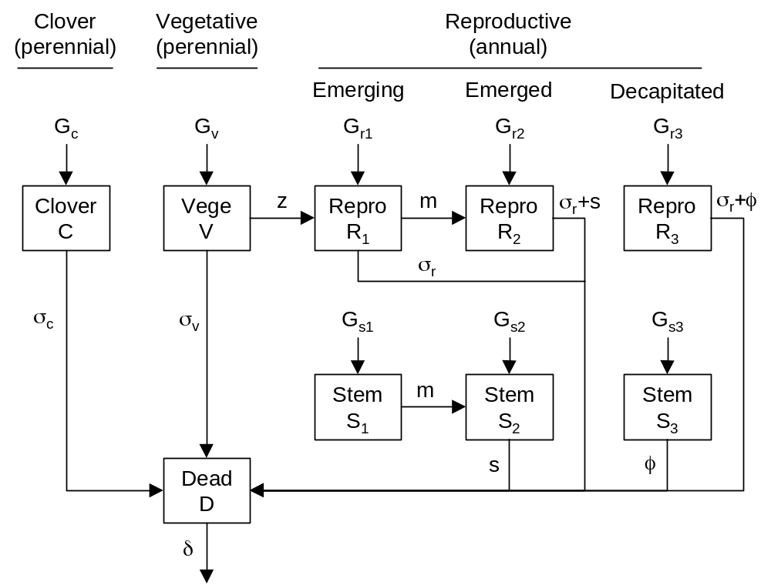

Fig. 5: The complete system of model equations. Not shown are defoliation, fouling and treading effects, which affect all tissue components. Abbreviations: rep. = reproductive development, sen. = senescence.
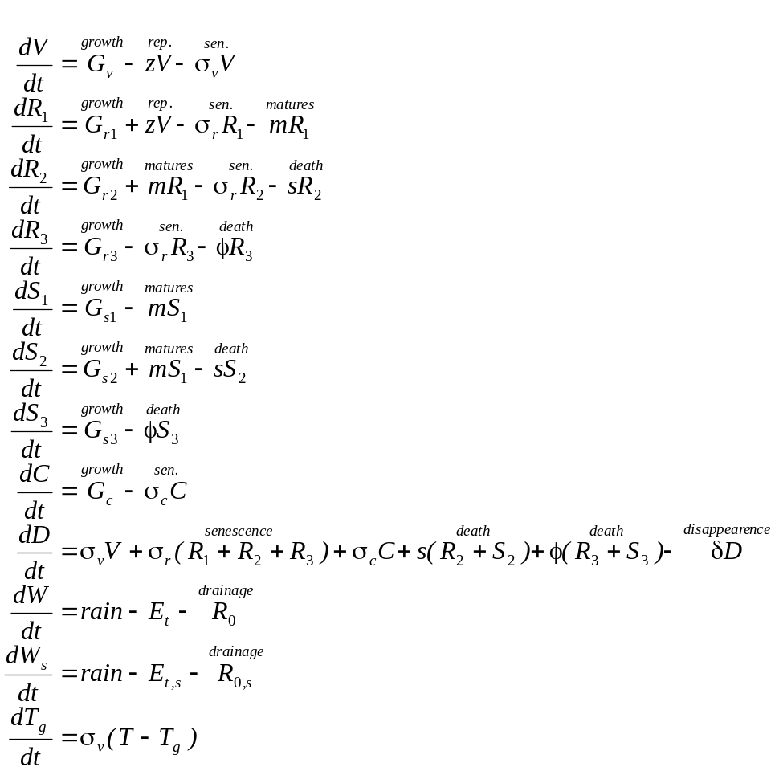
Fig. 4: Seasonal pattern of the water stress factor for pasture growth (g_{w}) calculated from weather data from Palmerston North.
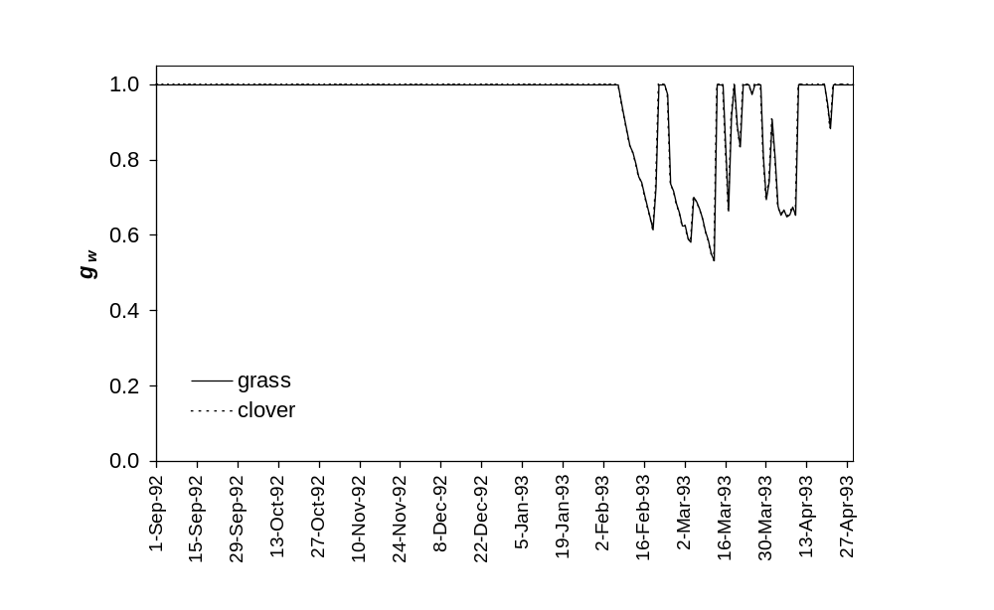
Fig. 5a: Litter decomposition submodel simultaneously fitted to the (a) Lolium perenne and (b) Trifolium repens data of Wardle et al. (1994). Symbols represent data for the three litter preparation treatments. The solid line shows the model predictions. The model estimated that 70% of Lolium perenne and 43% of Trifolium repens litter consisted of insoluble compounds, which decomposed at a base rate of 1.48% per day (modifed by temperature and moisture).
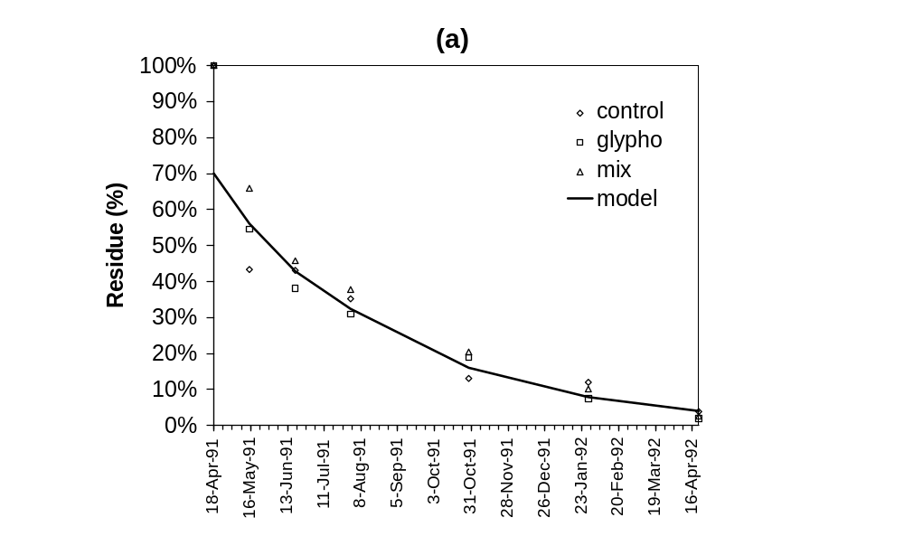
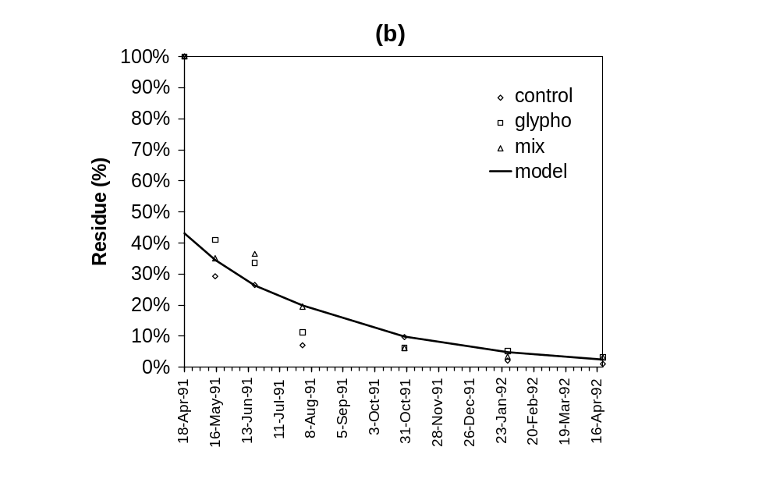
Fig. 2: Seasonal pattern of potential (J_{0,p}), total (J₀), direct sun (J_{0,s}) and diffuse (J_{0,d}) irradiance at the top of a canopy in a moist temperate climate (Hamilton, New Zealand, 1992–1993).

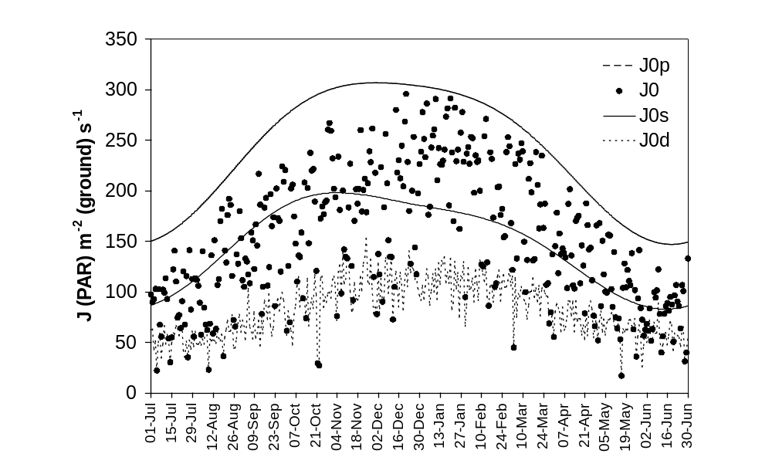
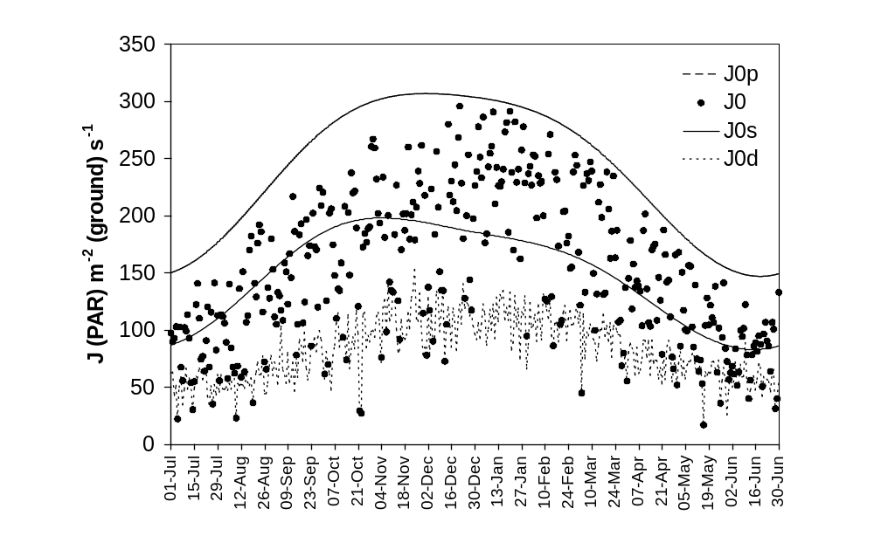
Fig. 4x: Leaf photosynthetic capacity (P_{m,i}) for leaves of white clover and perennial ryegrass (grown in either shaded or unshaded conditions).
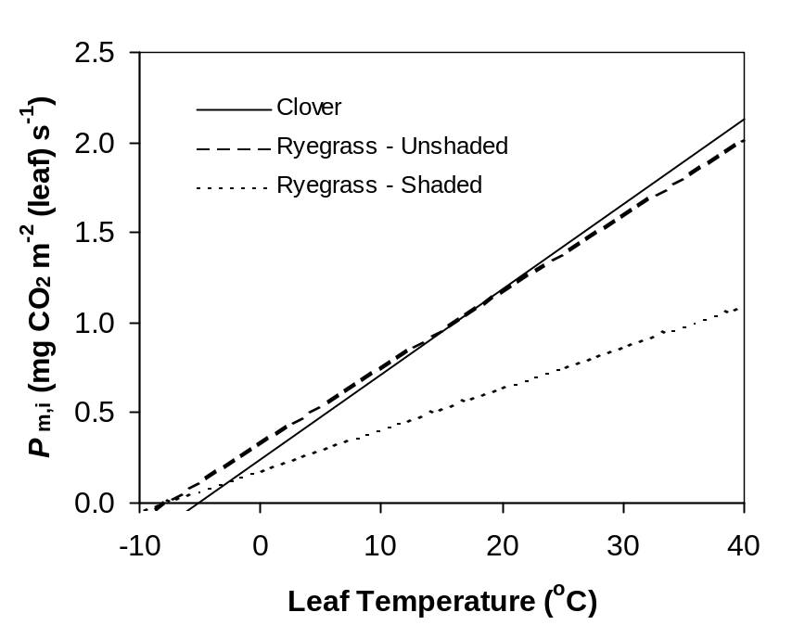

Fig. 3: Attenuation of photosynthesis (dP_{d}/dK) as one descends through a clover canopy, for a typical spring day in Hamilton, New Zealand. Numerically calculated photosynthesis (Eqn. 5) is given for diffuse, direct and total light components, and exponential approximations (Eqn. 8) are given with k’ = 1.00 (no correction) and k’ = 0.84 (an average best correction value for clover swards).
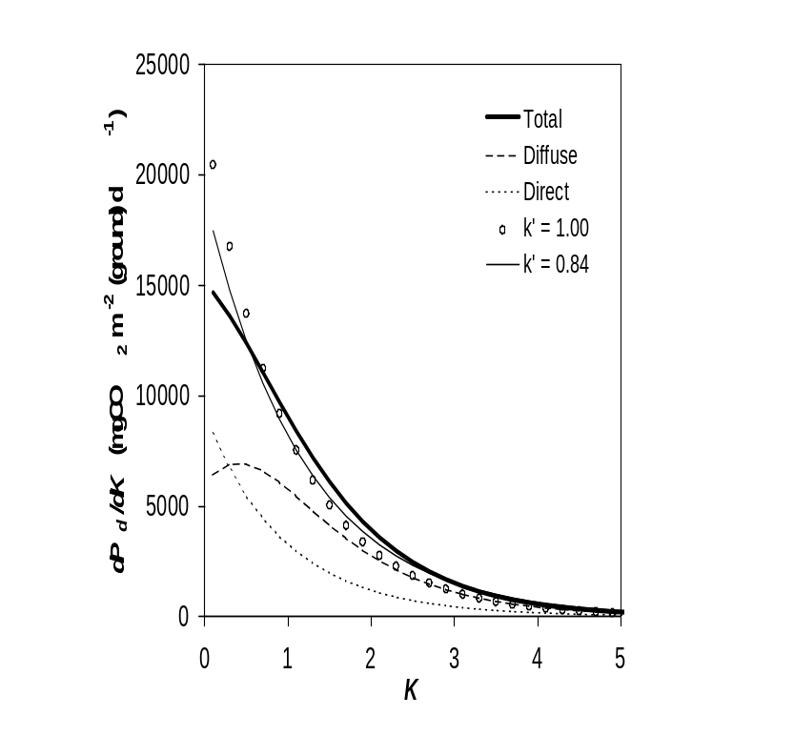
Fig. 5: Accuracy of approximate calculations of daily photosynthesis (Eqn. 10), expressed as percentage of potential canopy photosynthesis.

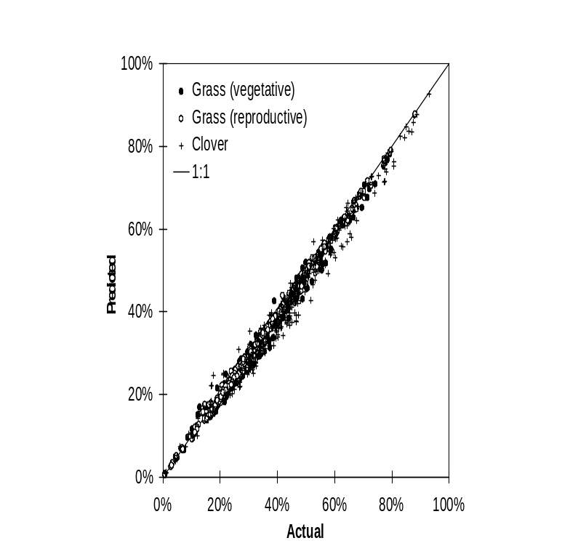
Fig. 7: Vertical profile of a ryegrass-white clover sward prepared by regular cutting through early summer (Sward “MC”, Milne et al., 1982). Sward herbage mass = 2700 kgDM ha⁻¹.
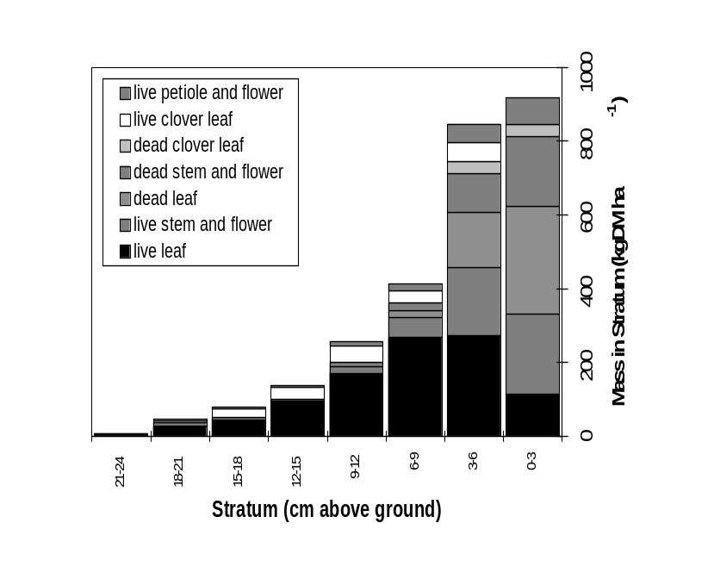
Fig. 8: Effect of dead material content in the mixed layer on photosynthesis (expressed as a percentage of potential, P_{d}*) for two swards with different quantities of green mass (GM).
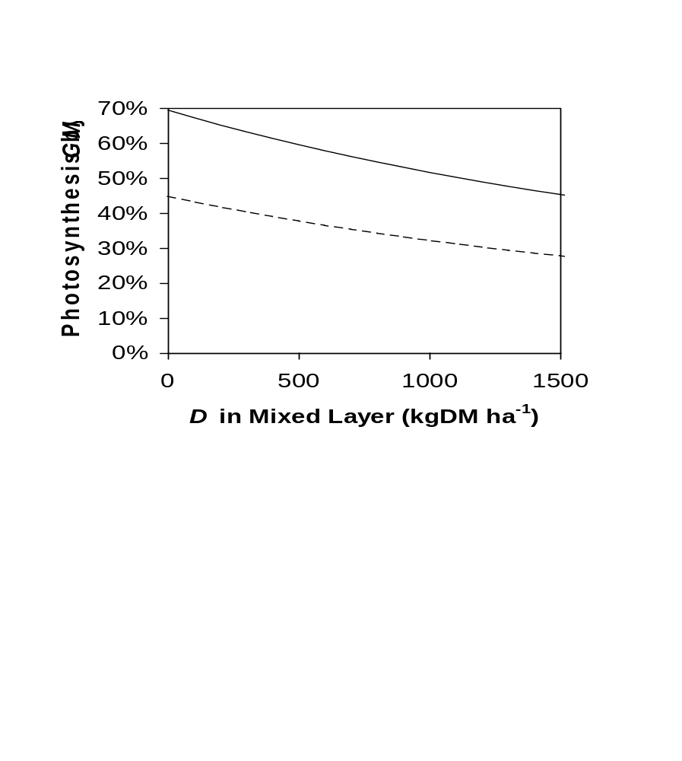
Fig. 9: Effect of reproductive leaf, sheath and stem elevation on photosynthesis by reproductive tillers for two swards with contrasting leaf area index (L), where (a) 20% or (b) 40% of the sward is reproductive.
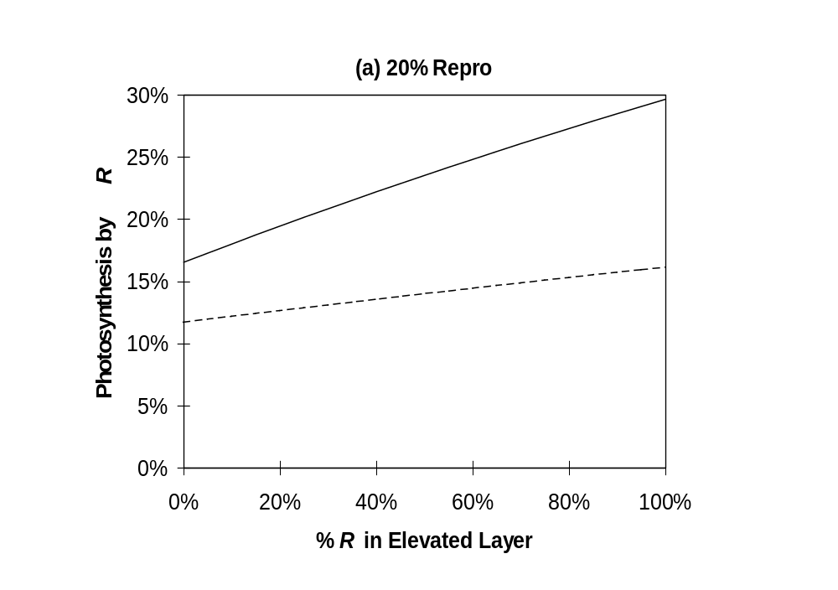
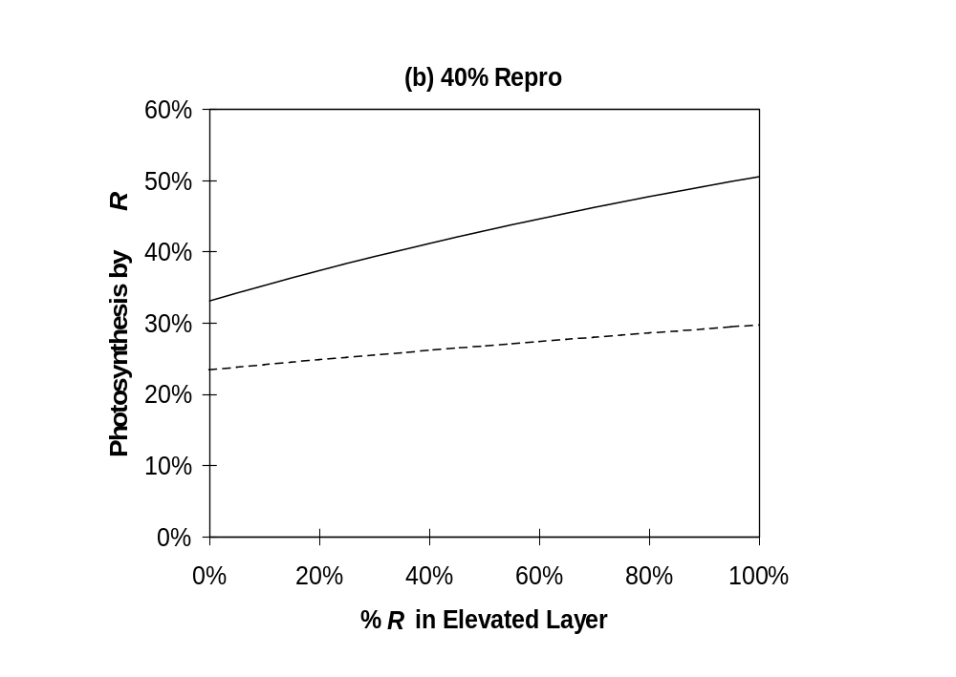
Fig. 3a: Leaf dark respiration data for perennial ryegrass grown at either 5ºC or 25ºC (triangles, Robson, 1981) and white clover grown at either 6ºC or 16ºC (squares, Woledge & Dennis, 1982). The solid and dashed lines show the model fits (Eqn. 2x) to the ryegrass and clover data respectively. The dotted line (- - - - - -) gives the function for perennial ryegrass grown at 25ºC from Penning de Vries, Witlage & Kremer (1989).
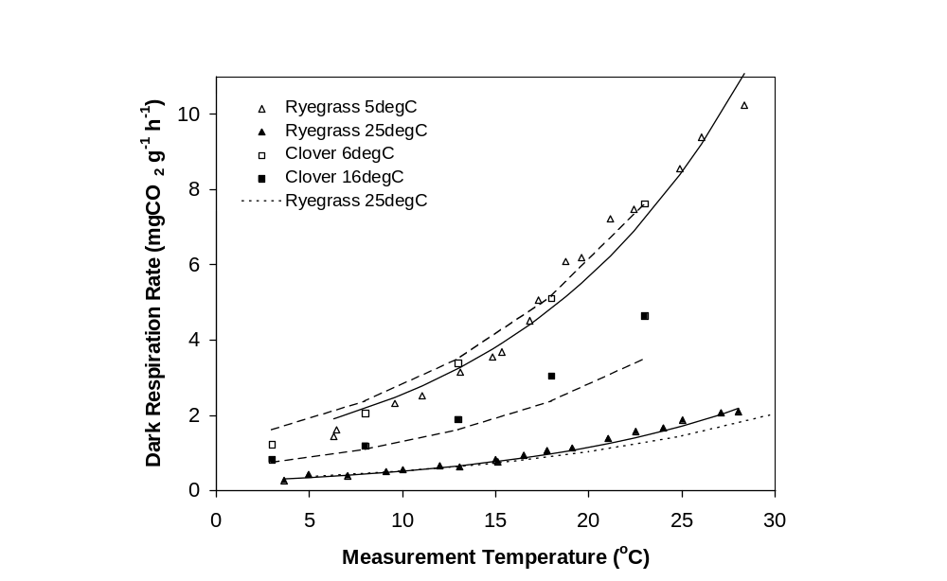

Fig. 6w: Three-layer pasture canopy model. V, R, S, C, D are the herbage masses of vegetative grass tillers, reproductive grass tiller leaf, reproductive grass stem, clover, and dead material respectively. w_{d} is the proportion of D in the mixed layer and ε_{i} is the proportion of reproductive material in the elevated layer.

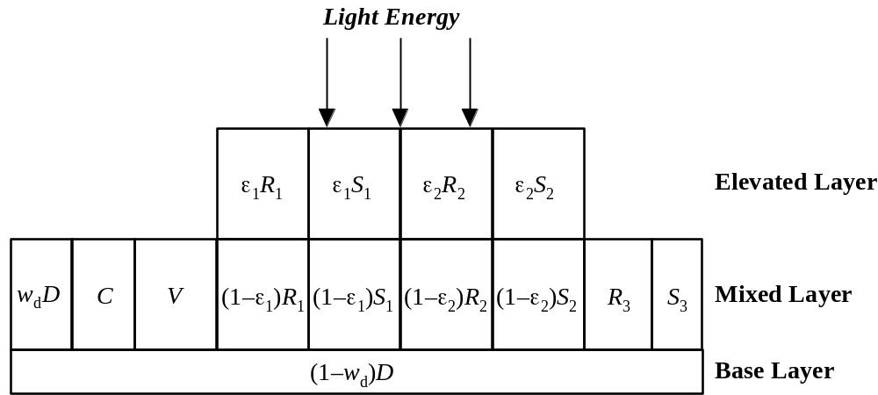

Fig. 3: Seasonal patterns of potential canopy photosynthesis for pure vegetative (P_{d,v}*) and reproductive (P_{d,r}*) ryegrass canopies, and for pure clover (P_{d,c}*) canopies, calculated from irradiance data from Palmerston North.
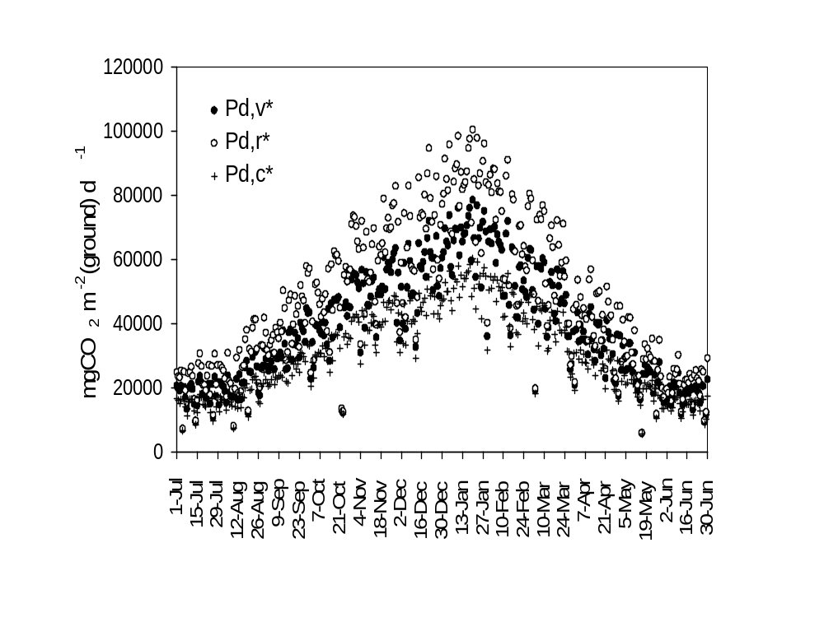
Fig. 2: Grass reproductive development model fitted to the data of L’Huillier (1987). LSR= low stocking rate (2.77 cows ha⁻¹) treatment. HSR= high stocking rate (4.28 cows ha⁻¹) treatment. ZSR= zero stocking rate simulation. The half-tone curves indicate the split between immature reproductive tillers A₁ and mature reproductive tillers A₂.

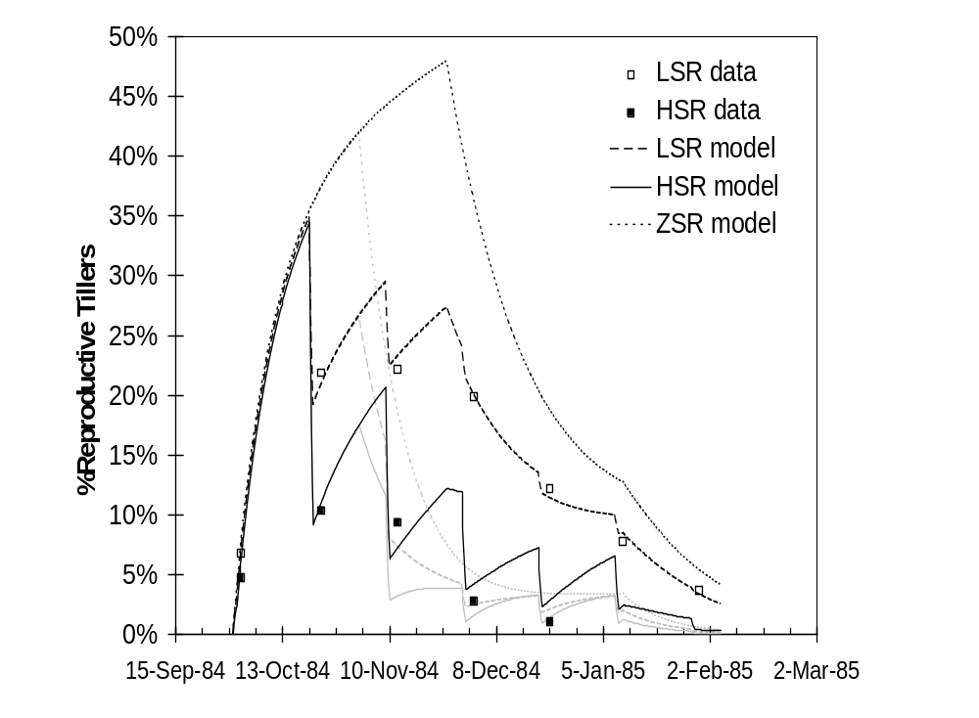
Fig. 27: Function for elevation of reproductive grass leaf and stem above other sward components.

