1.1

a. Lexical error: >=(

b. Syntax error: 9 = “This will never work.”;

c. Static Semantic Error:
char *string = “This will also fail.”; printf(“%d”, string);

d. Dynamic Semantic Error: int i[5]; printf(“%d”, i[10]);

e. Error uncaught by compiler: double *zero; zero = malloc(0);

1.6

The dependence management would be very accurate, because the dependencies are explicitly stated within the Makefile. Whenever a source file was changed that another source file was dependent on, Makefile would detect this and recompile the source that had the dependency.

This could lead to unnecessary work in the event that the internals of a function in source B were changed, but the signature of that function remained unchanged. Source A does not need to know exactly what is happening within that function, it only needs to know the function signature so it can pass the proper parameters, and know what type of value will be returned.

If the situation mentioned above occurred, but the function signature were changed, this could lead to a failure to compile situation. Also, if a source file name were changed, this could also lead to a situation in which something that needed to be recompiled failed to recompile.

2.1

^+ means at least one

a. string → “ (character)* | (\ ( ' | ” | \ ) )* “

b. Pascal comment → (* character* *) | { character* }

c. decimal digit → 0 | 1 | 2 | 3 | 4 | 5 | 6 | 7 | 8 | 9
octal digit → 0 | 1 | 2 | 3 | 4 | 5 | 6 | 7
hex digit → 0 | 1 | 2 | 3 | 4 | 5 | 6 | 7 | 8 | 9 | (a|A) | (b|B) | (c|C) | (d|D) | (e|E) | (f|F)

decimal integer → (decimal digit)^+ (u | U | l | L | ll | LL | є)
octal integer → 0 (octal digit)* (u | U | l | L | ll | LL | є)
hex integer → (0x | 0X)(hex digit)^+ (u | U | l | L | ll | LL | є)

decimal float point → (decimal digit)^+ (. | (e|E) ) (decimal digit)^+ (f | F | l | L | є)
hex float point → (hex integer) ( (. (hex digit)^+ ) | (p|P) ( (+ | - | є) (decimal digit)^+) (f | F | l | L | є)

d. digit → 0 | 1 | 2 | 3 | 4 | 5 | 6 | 7 | 8 | 9
decimal → digit^+ ( (_digit)* | digit*) . digit^+ ( (_digit)* | digit*)
integer → digit^+
exponent → (e|E) (+ | - | є) integer
real → (integer exponent | decimal (exponent | є)) |
(decimal # (integer # exponent | decimal # (exponent | є)))

e. digit → 0 | 1 | 2 | 3 | 4 | 5 | 6 | 7 | 8 | 9
imprecise number → digit^+ #* ( . (digit* | #*) | є)

f. digit → 1 | 2 | 3 | 4 | 5 | 6 | 7 | 8 | 9
start three → digit digit digit | digit digit 0 | digit 0 digit
group three → start three | 0 digit digit
start → digit | digit digit | digit 0 | digit , group three | digit digit , group three | digit 0 , group three | start three
financial quantity → $ (*)* start ( (, group three)* | є) (. (0|digit) (0|digit) | є)

2.13

a.
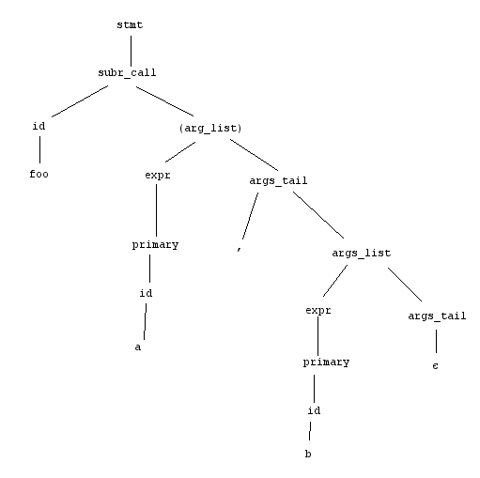

b.

stmt | → | subr_call
 | → | id (arg_list)
 | → | id expr args_tail
 | → | id expr , arg_list
 | → | id expr , expr args_tail
 | → | id expr , expr є
 | → | id expr , primary є
 | → | id expr , id є
 | → | id expr , b є
 | → | id primary , b є
 | → | id id , b є
 | → | id a , b є
 | → | foo a , b є

2.17

The below statements are added to the grammar in Figure 2.24

cond_op | → | > | >= | < | <= | == | !=
if | → | Expr cond_op expr stmt_list
while | → | Expr cond_op expr stmt_list loop
loop | → | stmt_list loop

