3.2

Pascal:

program Fail;
begin
staticInt: integer = 10;
setInt(staticInt, 15);
writeln(staticInt);
end.

When setInt returns, the value of staticInt will still be 10 because the function only received a copy of the variable, instead of being able to manipulate the variable itself. The reason for this is because the variable was allocated statically.

Scheme:

(define useless1
(let (a (cons 1 2)))
(useless2 a)
)

(define useless2 somethingUseless
(add (car somethingUseless (cdr somethingUseless)))
)

Because 'a' is defined on the stack, the operations performed in useless2 will not affect 'a'.

3.4
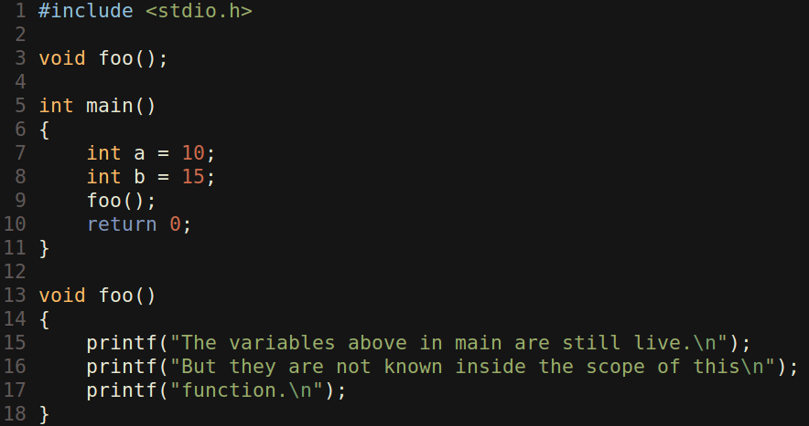

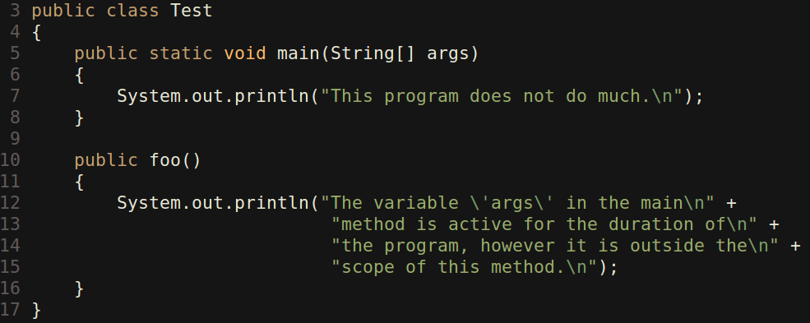

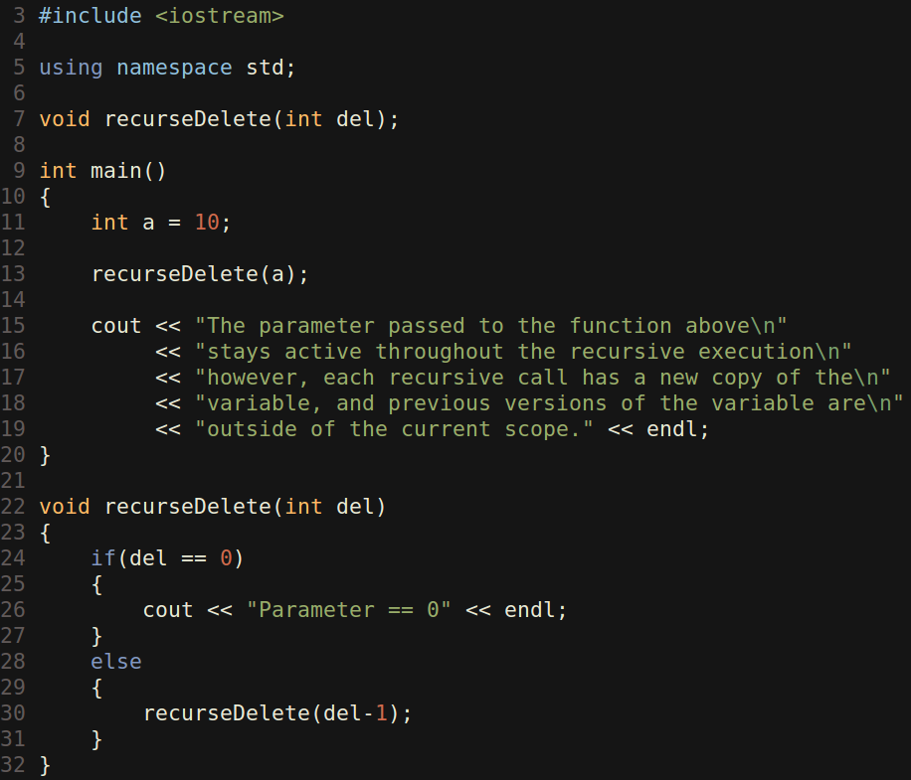

3.5

C-rules

Line 7: “1 1”
Line 11: “1 1”
Line 14: “1 2”

C#-rules

Line 7: “3 1”
Line 11: “1 1”
Line 14: “1 2”

3.7

She will tell him that L is never reset to its beginning index in reverse. Because of this, when delete_list() is called on L, the while loop is never executed. As a result, there are now two copies of the list left in memory. To fix the problem, he needs to return L to the initial list item before returning the reversed list. He might even consider deleting L at the end of the reverse() function.

3.14

The program prints “1 1 2 2” for static scoping and “1 1 2 1” for dynamic scoping. The reason for this is because in the dynamic scope, the function second() is only modifying its local variable 'x'. It sets it to 2, and then prints it. Once the function exits however, that local 'x' is gone, and the subsequent print_x is now referring to the global variable.

3.18

The program prints “1 0 2 0 3 0 4 0” for shallow binding and “1 0 5 2 0 0 4 4” for deep binding. The reason for this is, in the shallow binding, both set_x() and S() are affecting the global variable. In the deep binding implementation however, set_x() only affects the local variable, and S() only affects the global variable.

