2.2.1

a.
S
=> SS*
=> SS+S*
=> SS+a*
=> Sa+a*
=> aa+a*

b.
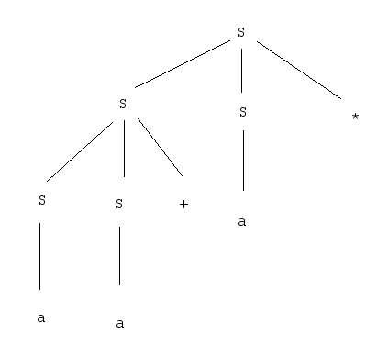

c.

The grammar generated by this language is a series of postfix operations consisting only of addition and multiplication.

2.2.3

c. String: ()() can be parsed multiple ways
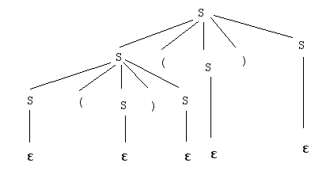
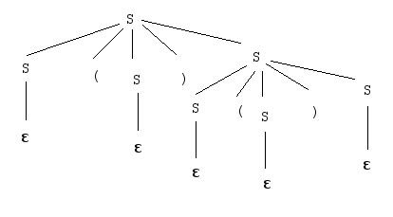

d. String: abab can be parsed multiple ways.
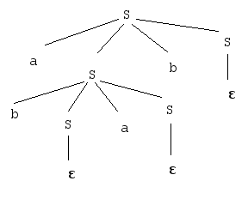
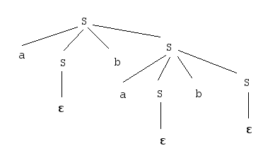

e. String: a*aa+(a) can be parsed multiple ways.
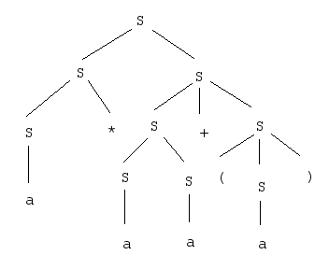
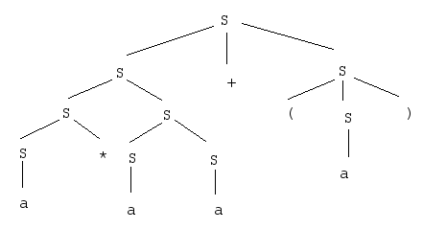

2.2.4
a.
S →S S + | S S - | S S / | S S * | x

b.
S→identifier , terminal | terminal
identifier→identifier , terminal | terminal
terminal→a
c.
S→terminal , identifier
identifier→terminal , identifier | terminal
terminal→a

d.
S→identifier operator identifier
identifier→integer operator identifier | integer
operator→ + | - | * | /
integer→0 | 1 | 2 | 3 | 4 | 5 | 6 | 7 | 8 | 9

