***Designing a Database for Commonwealth Transport Services***

# Introduction

Commonwealth Transport Services (CTS), a private company, specialises in providing transportation services to various events. Recently, it has been sub-contracted by the Commonwealth Games Federation to transport officials during the Commonwealth Games in 2018. The company now realises that it needs a modern computerised system for efficient and reliable management and documentation of its services. CTS has hired you as a database professional to design and develop a database system which can meet CTS’s needs as specified below.

# Business Rules

* CTS owns a fleet of vehicles, which vary from sedans to vans. Attributes of a vehicle include: ***VIN, Rego, Make, Model, Color, Odometer,*** and ***seat capacity***. NOTE: ***VIN*** stands for Vehicle Identification Number, which uniquely identifies a vehicle. To assist vehicle assignment, CTS requires that the new system be capable of indicating whether a vehicle and a driver are currently available. A vehicle that is under maintenance should be flagged as not available. The table below shows a *small* sample of CTS's vehicle assets:

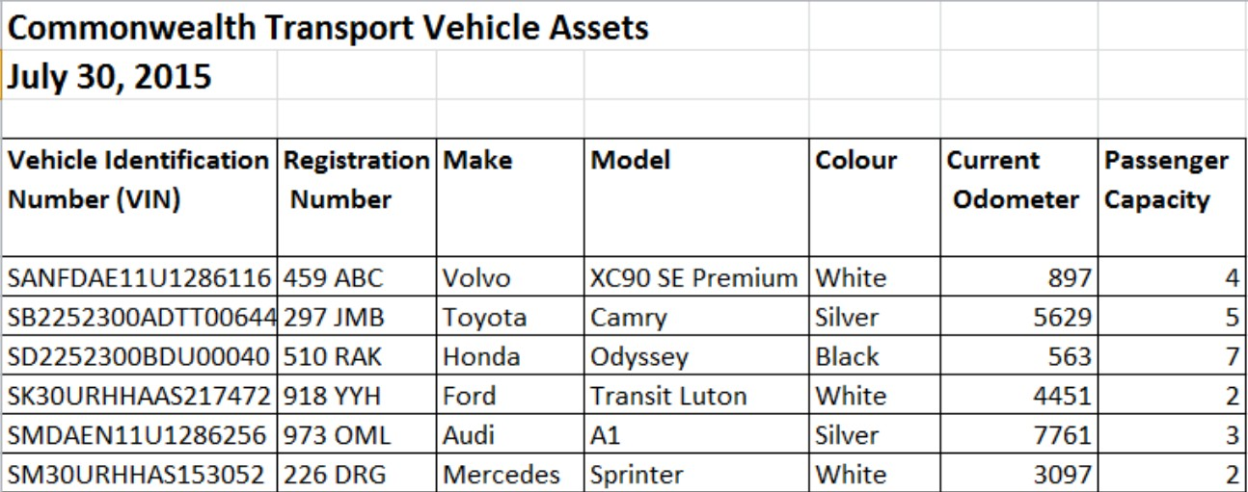

* Games ***officials*** from all participating countries use CTS's services. The ***official's Commonwealth ID*** (8 characters), ***his/her name*** (***first name*** and ***last name*** should be stored separately), ***role*** at the Games (e. g. head-coach, judge, physician etc.) and the official's preferred language. ***Roles*** of officials should be administrated by CTS. Information like ***role id*** and ***descriptions*** should be recorded. An official may use CTS's services multiple times (even during a single day); the only limiting factor is whether a suitable vehicle is available at the time they wish to travel.
* CTS Vehicles are driven by the company's drivers. The driver's ***name*** (***first name*** and ***last name*** should be stored separately), ***driver license number*** (9 digits in QLD) and the ***level of clearance*** granted to the driver are recorded. The clearance levels are digits from 1 to 4 representing the security clearance of the driver (4 is the highest ***level of clearance***). Also, the ***availability*** of driver can help company to administrate and coordinate trips.
* Before using a ***vehicle***, it must be booked. This booking will take place via a computer program to be created; you are not concerned with this program. However, the back-end database needs to support such an activity. ***Booking reference number*** should be able uniquely identify each record. Transport bookings require the assignment of a suitable ***driver*** to a suitable ***vehicle*** matching the needs of the ***official***. Besides driver information (license number), car (VIN and rego) and passenger (official identification), the ***start timestamp*** (***date*** and ***time***) and ***start mileage*** are recorded when a booking is first placed, while the ***end timestamp*** (***date*** and ***time***) and ***end mileage*** (in km) are recorded when a ***trip*** is finished. The ***pickup location*** and ***drop off location*** are also recorded.
* ***Locations*** are specified with location ids, location name, location postcode, and suburb name.
* In addition, CTS records the ***languages*** that a ***driver***/***official*** speaks using two- character ISO639‐1 language codes [1] – some ***drivers***/***officials*** speak several languages. The employee organising a booking will try to match the language of an ***official*** with that of the ***driver***.

# Assessable Tasks

From the CTS’s business requirements specified above, prepare a document according to the followings:

1. Use the supplied template for your Assignment submission.
2. An appropriate title page that includes an acknowledgement of all students you have spoken to about the assignment.
3. A table of contents and page numbers.
4. An ERD using Crow’s Foot notation. The diagram should include:
   1. all entities, attributes, and relationships (including names) ;
   2. primary keys (underlined) and foreign keys (italic) identified;
   3. cardinality and modality (optional / mandatory) symbols; and
   4. assumptions you have made, e.g., how you arrived at the cardinality and/or participation for those not mentioned or clear in the business description, etc.
5. Normalisation of the relations which identifies:
   1. dependency diagram for each relation
   2. the level of Normalisation achieved for each relation
   3. the reasons for any relation that is NOT maintained in 3NF.
6. A bibliography, containing all resources used to complete the assignment. If no resources have been used, please indicate this appropriately

# Assessment Criteria and Marking Overview

|  |  |
| --- | --- |
| **Tasks** | **Marks** |
| **1. Presentation**  How clear and well-presented your submission is. | **10** |
| **2. ERD**  Adherence to the standard of the course, assumptions made, | **50** |

|  |  |
| --- | --- |
| inclusion of correct primary and foreign keys, appropriate entities,  relationships, and attributes. |  |
| **3. Normalisation**  Appropriate interpretation of each normal form, arguments for leaving the schema in the normal form you consider optimal. | **40** |
| **Total** | **100** |

**References:**

[1] Language Codes, https://en.wikipedia.org/wiki/List_of_ISO_639-1_codes. Last accessed on 21 July 2017