CRTPX: Tactical Risk Management for the Passive Fund
Potomac Fund Management | Woody Wiegmann | February 2026
Common period: June 2021 - February 2026 | Risk-off days: 39% | Regime switches: 41 (8.8/yr)
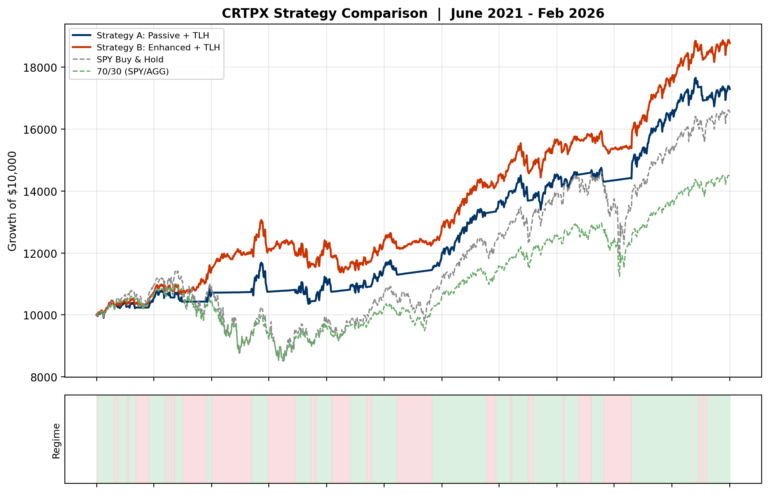

Performance Comparison
Metric | Strategy A  (Passive) | Strategy B  (Enhanced) | SPY  Buy&Hold | 70/30  (SPY/AGG)
CAGR | 12.45% | 14.45% | 11.35% | 8.20%
Total Return | 72.9% | 87.7% | 65.1% | 44.4%
Max Drawdown | -11.41% | -12.94% | -25.43% | -22.16%
Volatility | 9.40% | 10.10% | 17.07% | 12.44%
Sharpe | 0.87 | 0.99 | 0.48 | 0.38
Sortino | 0.96 | 1.32 | 0.66 | 0.52
Calmar | 1.09 | 1.12 | 0.45 | 0.37
Beta | 0.30 | 0.29 | 1.00 | 0.72
Alpha | 5.95% | 8.08% | -0.88% | -1.74%
Up Capture | 54.8% | 54.6% | 100.0% | 77.0%
Down Capture | 21.5% | 10.1% | 100.0% | 81.5%

Signal: Penta (Both Strategies)
# | Indicator | Ticker | Rule
1 | S&P 500 Trend | SPY | Close > 50-day SMA
2 | Dow Transports | IYT | Close > 50-day SMA
3 | NYSE Breadth | ^NYA | Close > 50-day SMA
4 | Corp Credit | LQD | Close > 50-day SMA
Penta ON = 3+ green. 3-day confirmation before switching.

Allocations
Regime | Strategy A | Strategy B
Risk-On (Penta >= 3) | 100% VOO | 100% VOO
Risk-Off (Penta <= 2) | 100% SGOV | 40% DBMF + 30% CAOS + 30% SGOV
Strategy B risk-off blend based on Baltussen et al. (FAJ 2026): trend-following (DBMF) + convexity (CAOS) + cash anchor (SGOV). 222-year evidence shows 50/50 trend+convexity is optimal for drawdown reduction.

Operating Guide
Daily Check:
1. Pull closing prices for SPY, IYT, ^NYA, LQD.
2. Compare each to its 50-day SMA. Count greens (0-4).
3. If score differs from current regime for 3 consecutive days, switch.
4. Check current holding for >3% unrealized loss (TLH trigger).
Risk-On to Risk-Off:
1. Check equity lot for unrealized loss. If loss: sell first (harvest).
2. Buy defensive: (A) 100% SGOV, or (B) 40% DBMF + 30% CAOS + 30% SGOV.
3. Record sold ticker + wash sale expiry (T+31 days).
Risk-Off to Risk-On:
1. Check defensive lots for unrealized loss. If loss: sell first.
2. Buy equity: VOO (or next in ring if wash sale active).
3. Record wash sale dates.
TLH Swap Rings:
Side | Primary | Swap 1 | Swap 2
Equity | VOO | IVV | SPLG
Cash | SGOV | BIL | SHV
Loss trigger: -3%. Wash sale window: 31 calendar days. Always use next available ticker in ring.

AmiBroker Implementation
Strategy A (Passive):
SMA_Period = 50; ConfirmDays = 3;
Penta1 = Foreign("SPY","C") > MA(Foreign("SPY","C"), SMA_Period);
Penta2 = Foreign("IYT","C") > MA(Foreign("IYT","C"), SMA_Period);
Penta3 = Foreign("~NYA","C") > MA(Foreign("~NYA","C"), SMA_Period);
Penta4 = Foreign("LQD","C") > MA(Foreign("LQD","C"), SMA_Period);
PentaScore = Penta1 + Penta2 + Penta3 + Penta4;
RawOn = PentaScore >= 3;
ConfOn = Sum(RawOn, ConfirmDays) == ConfirmDays;
ConfOff = Sum(!RawOn, ConfirmDays) == ConfirmDays;
Buy = ExRem(ConfOn, ConfOff);
Sell = ExRem(ConfOff, ConfOn);
SetPositionSize(100, spsPercentOfEquity);
// Trade SPY or VOO. Risk-off = cash (or model SGOV via SetForeign).

Strategy B (Enhanced) -- risk-off return:
// Same signal as above. When Sell fires, risk-off return =
RiskOffRet = 0.40 * ROC(Foreign("DBMF","C"),1)/100
+ 0.30 * ROC(Foreign("CAOS","C"),1)/100
+ 0.30 * ROC(Foreign("SGOV","C"),1)/100;
// Use SetForeign or rotational mode to apply blended risk-off.

Sensitivity test these parameters:
Parameter | Default | Test Range
SMA Period | 50 | 20, 50, 100, 200
Confirmation Days | 3 | 1, 2, 3, 5
Penta Threshold | 3/4 | 2/4, 3/4, 4/4
DBMF / CAOS / SGOV wts | 40/30/30 | 50/25/25, 30/40/30

Why this isn't overfit: 4 standard indicators, 1 parameter each (50-day SMA). 3-day confirmation is a standard anti-whipsaw filter. Risk-off blend derived from 222-year evidence (Baltussen et al. 2026), not from fitting to this period. Only 2 free parameters total.

