|  |  |  |  |  |  |  |  |  |  |  |  |  |  |  |
| --- | --- | --- | --- | --- | --- | --- | --- | --- | --- | --- | --- | --- | --- | --- |
|  | | | | | | | | | | | | | | |
| 备注 | 重新加载 | 删除 | 放行 |  |  |  |  |  |  |  |  |  |  |  |

|  |  |
| --- | --- |
|  | Image/jpeg |
| css |
| Js |
| Js |
| HTTP CONNECT建立的HTTPS会话 |

|  |  |
| --- | --- |
| TextView标签 | HTML/JS/CSS 可以看到响应内容 |
| Raw标签 | 可以查看响应报文和响应体 |

配置:

Tools->options->HTTPS:

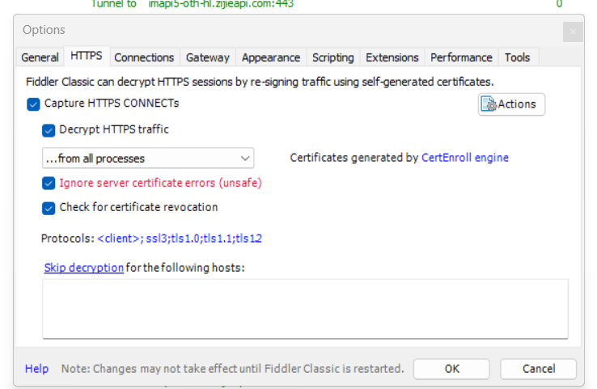

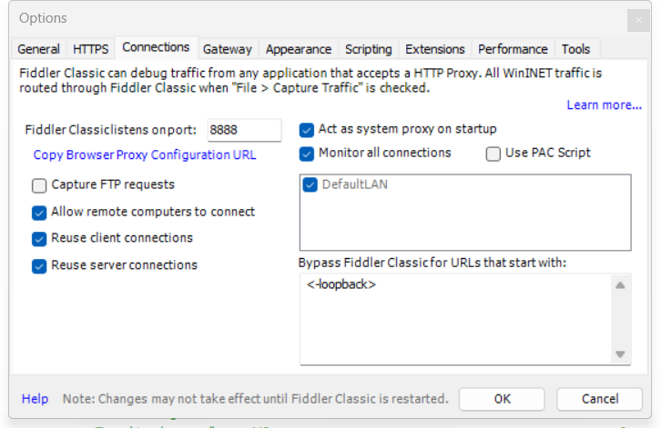

手机访问电脑地址加端口8888 如:192.168.101.109:8888

在页面中下载证书,然后再设置中安装证书

iPhone->设置->通用->关于本机->信任证书