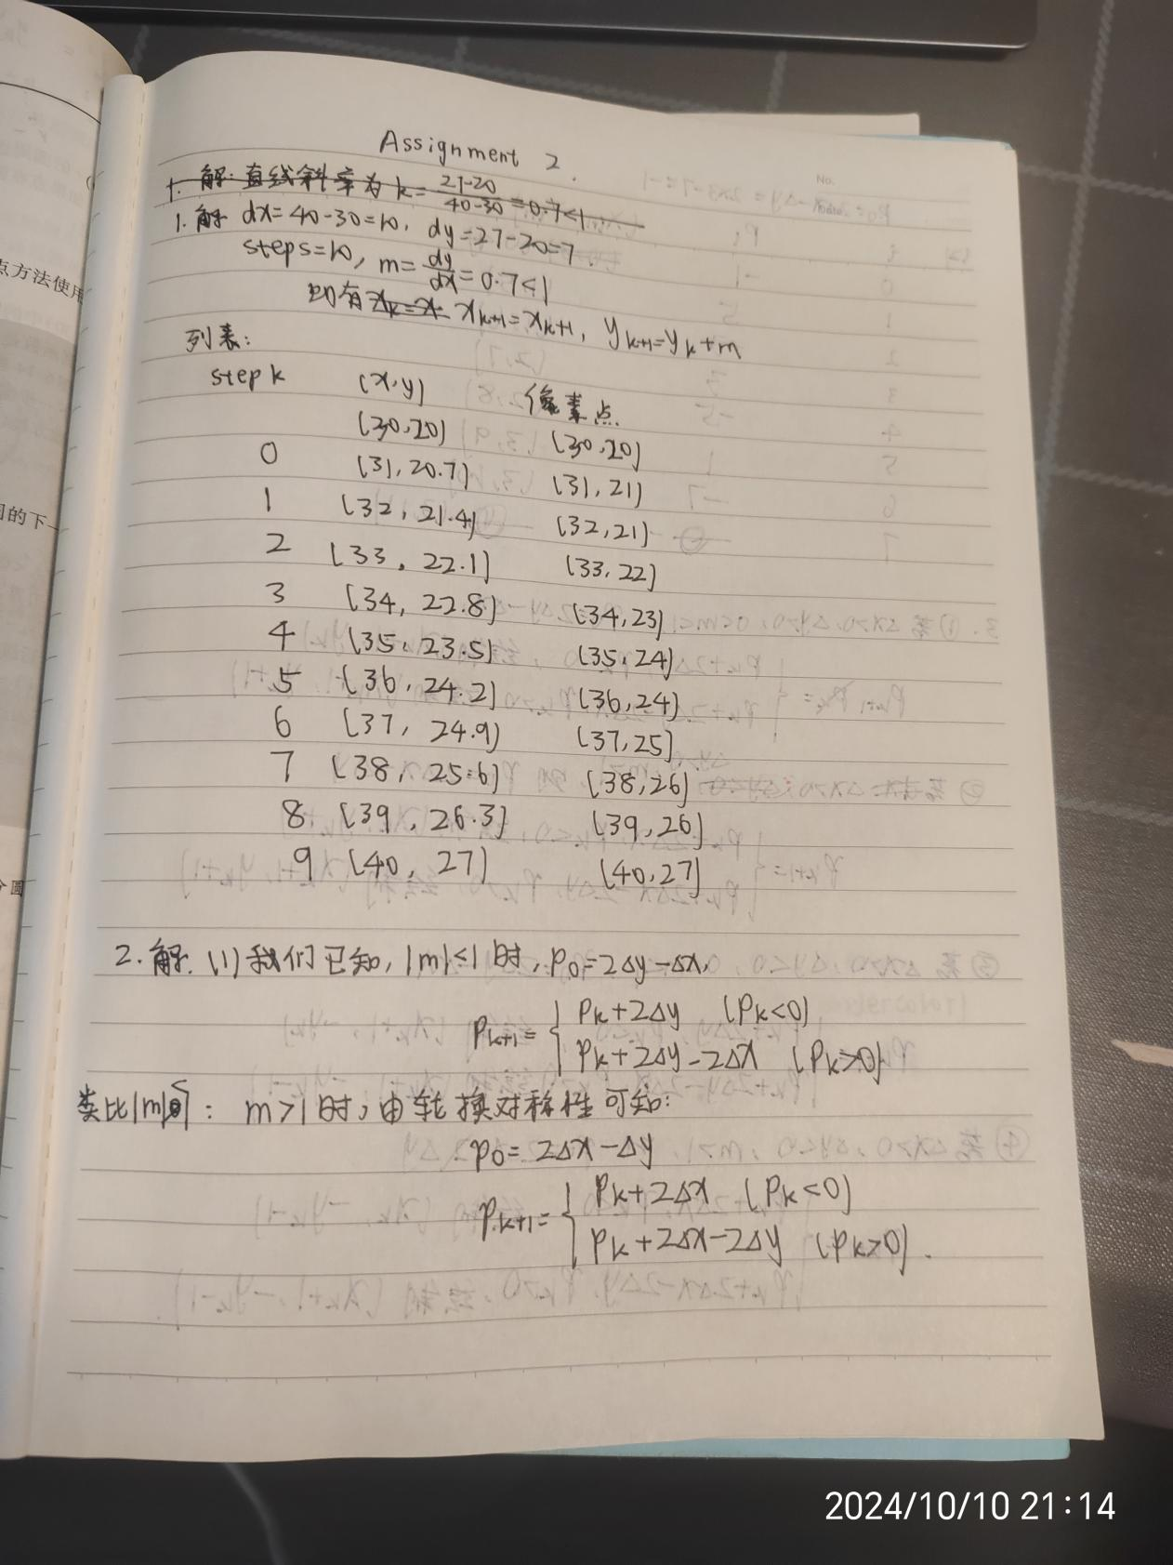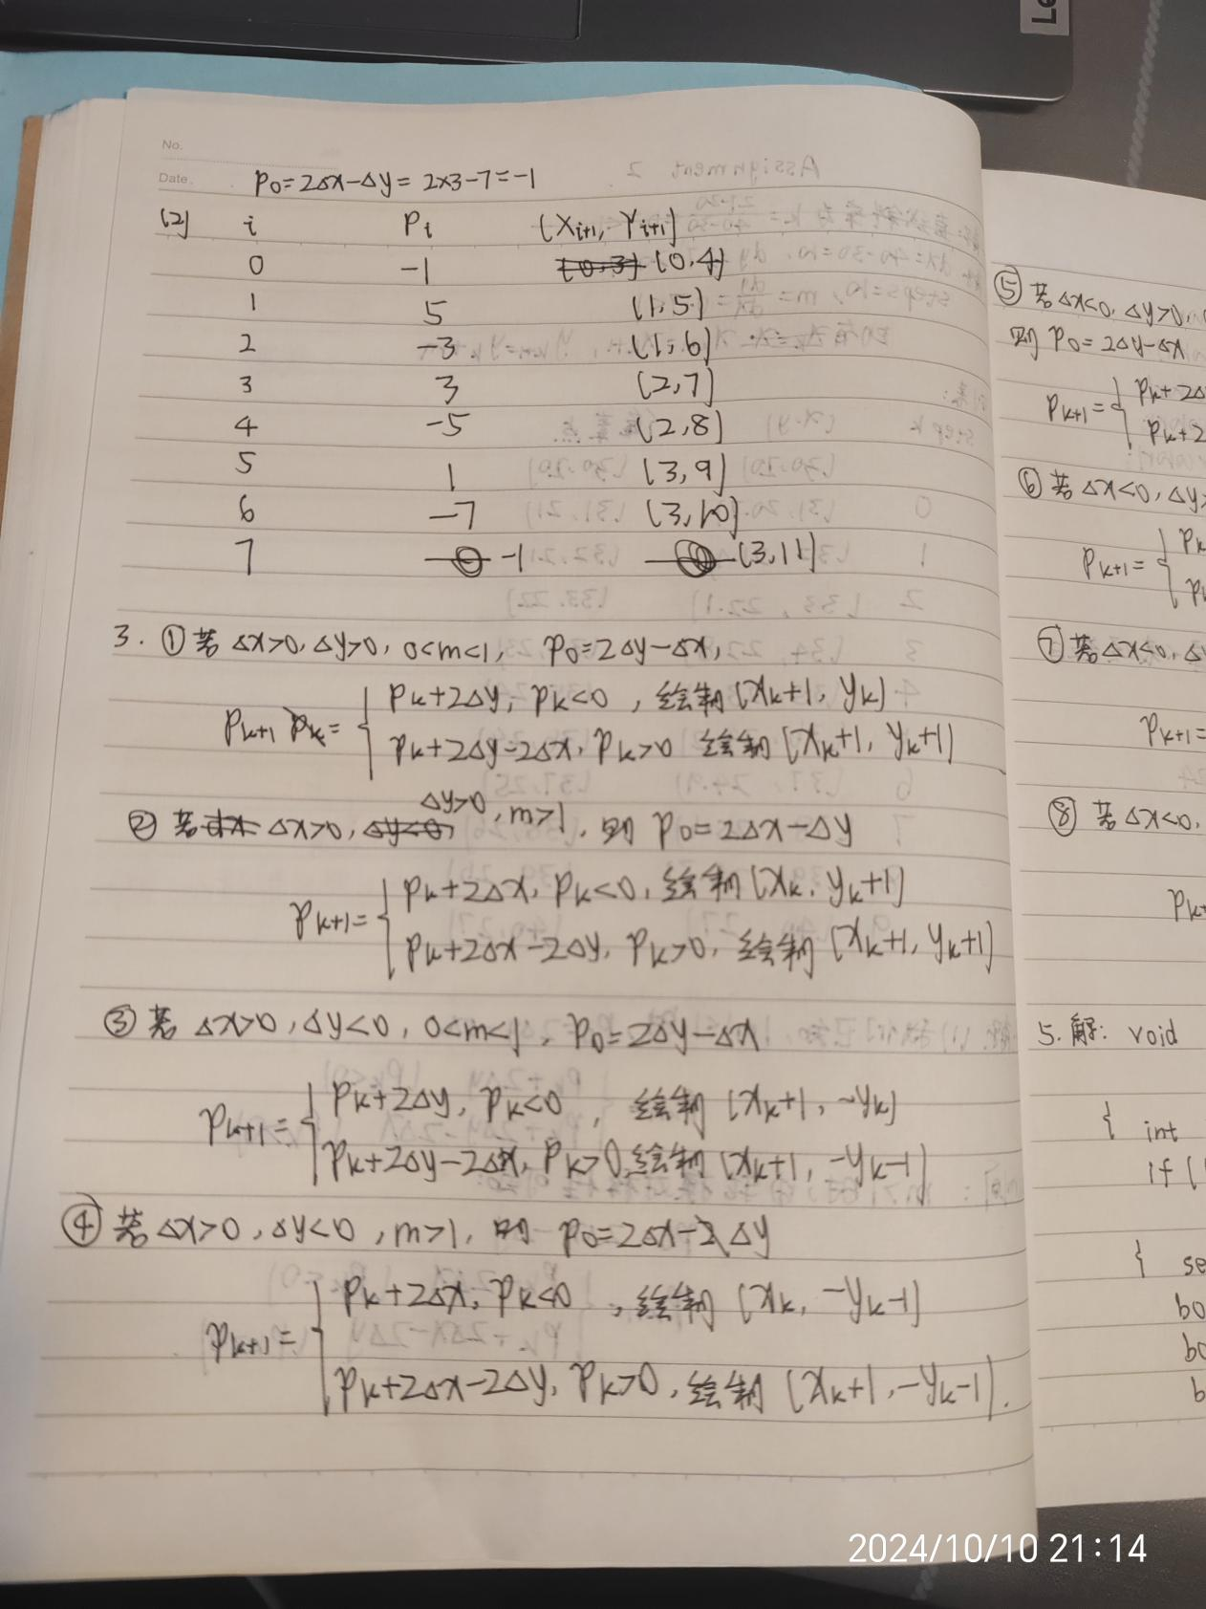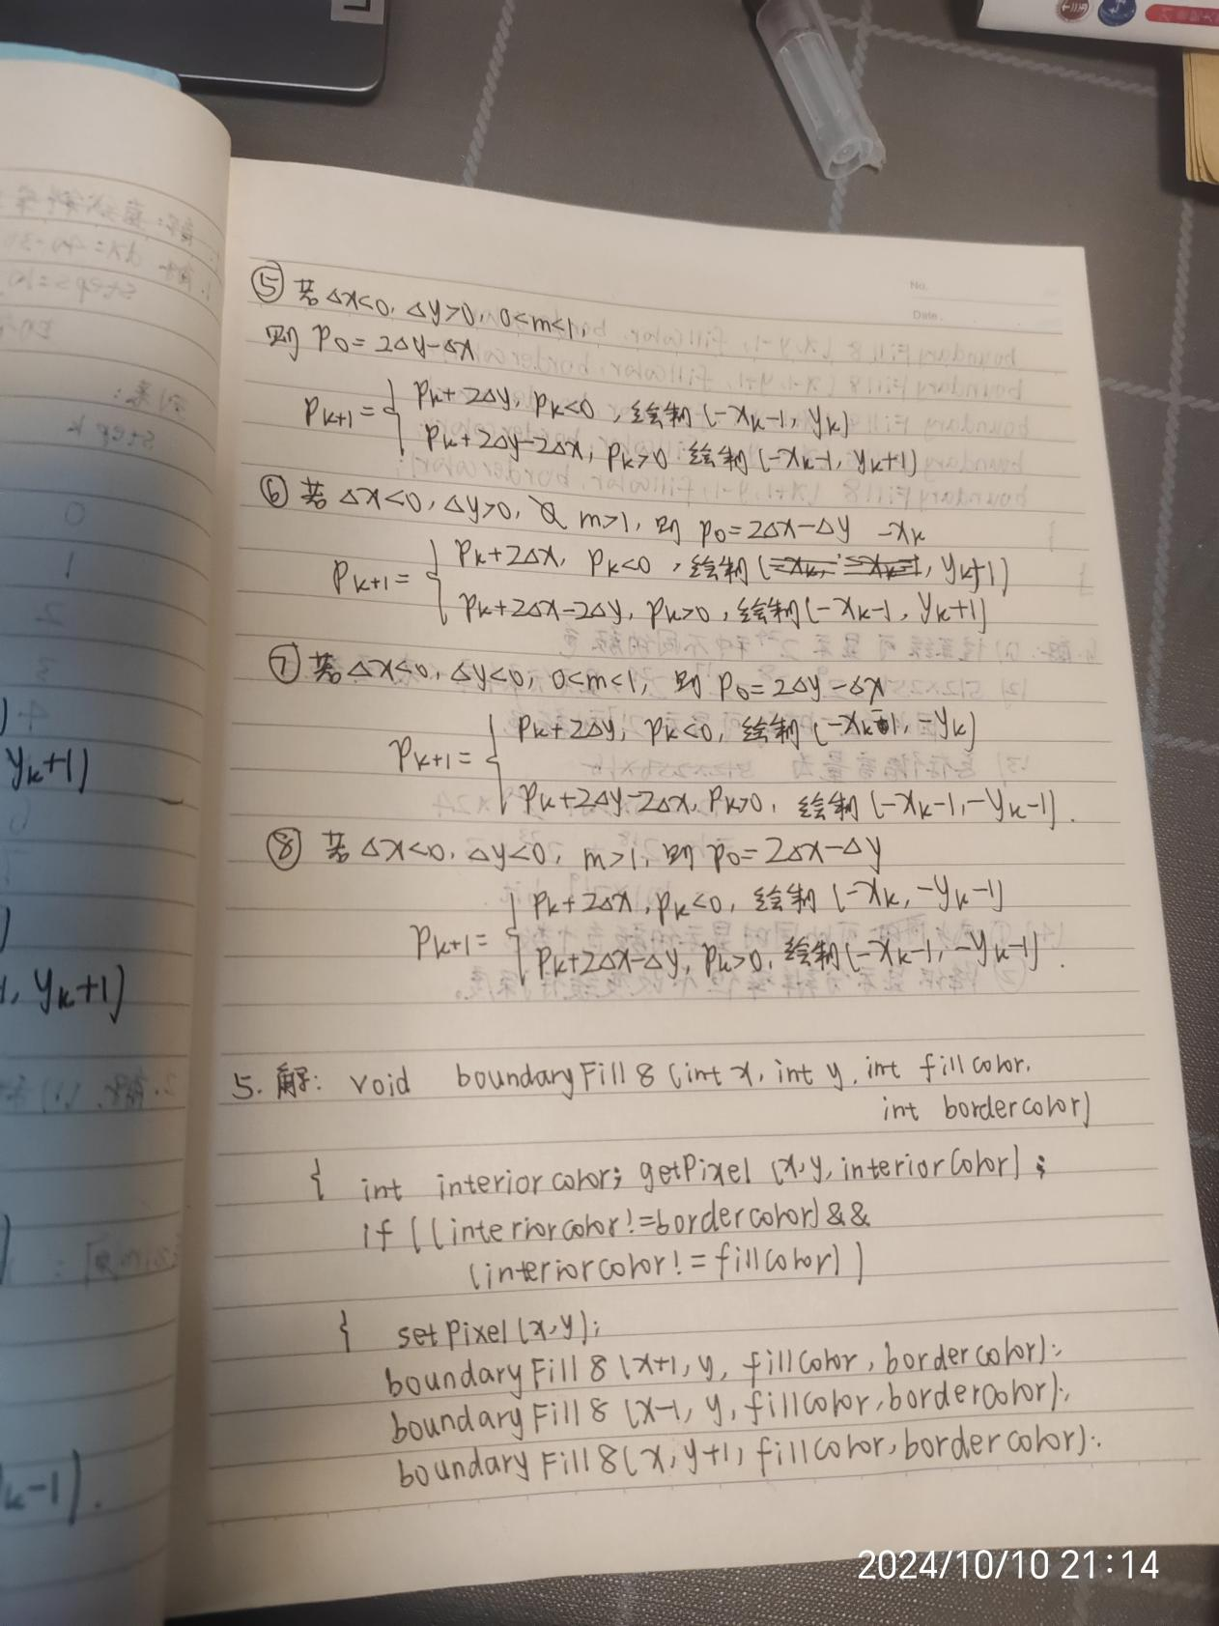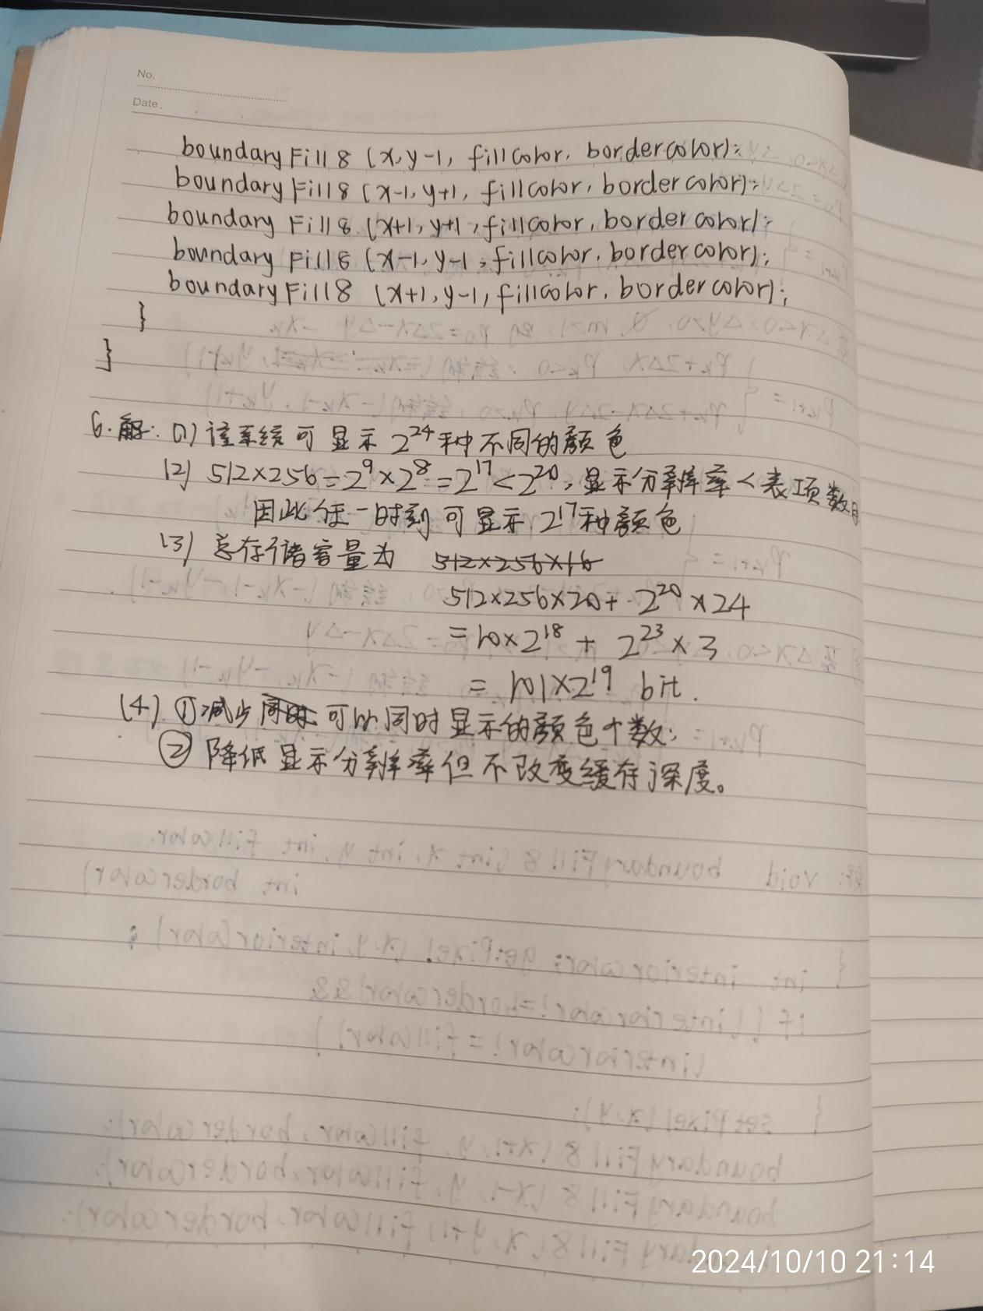
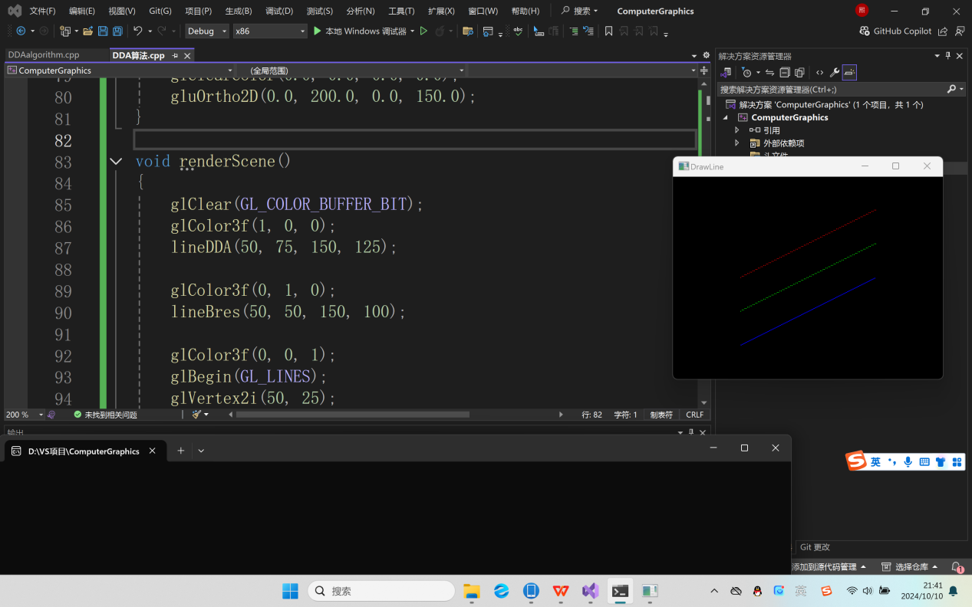
代码实现：

- #include <GL/glut.h>
- #include <stdlib.h>
- #include <math.h>

- inline int round(const float a) { return int(a + 0.5); }

- void setPixel(GLint xCoord, GLint yCoord)
- {
- glBegin(GL_POINTS);
- glVertex2i(xCoord, yCoord);
- glEnd();
- }

- void lineDDA(int x0, int y0, int xEnd, int yEnd)
- {
- int dx = xEnd - x0, dy = yEnd - y0, steps, k;
- float xIncrement, yIncrement, x = x0, y = y0;

- if (fabs(dx) > fabs(dy))
- {
- steps = fabs(dx);
- }
- else
- {
- steps = fabs(dy);
- }
- xIncrement = float(dx) / float(steps);
- yIncrement = float(dy) / float(steps);

- setPixel(round(x), round(y));

- for (k = 0; k < steps; k++)
- {
- x += xIncrement;
- y +=yIncrement;
- setPixel(round(x), round(y));
- }
- }

- void lineBres(int x0, int y0, int xEnd, int yEnd)
- {
- int dx = fabs(xEnd - x0), dy = fabs(yEnd - y0);
- int p = 2 * dy - dx;
- int twoDy = 2 * dy, twoDyMinusDx = 2 * dy - 2 * dx;
- int x, y;

- if (x0 > xEnd)
- {
- x = xEnd;
- y = yEnd;
- xEnd = x0;
- }

- else
- {
- x = x0;
- y = y0;
- }
- setPixel(x, y);

- while (x < xEnd)
- {
- x++;
- if (p < 0)
- {
- p += twoDy;
- }
- else
- {
- y++;
- p += twoDyMinusDx;
- }
- setPixel(x, y)；
- }
- }

- void Init()
- {
- glClearColor(0.0, 0.0, 0.0, 0.0);
- gluOrtho2D(0.0, 200.0, 0.0, 150.0);
- }

- void renderScene()
- {
- glClear(GL_COLOR_BUFFER_BIT);
- glColor3f(1, 0, 0);
- lineDDA(50, 75, 150, 125);

- glColor3f(0, 1, 0);
- lineBres(50, 50, 150, 100);

- glColor3f(0, 0, 1);
- glBegin(GL_LINES);
- glVertex2i(50, 25);
- glVertex2i(150, 75);
- glEnd();

- glFlush();
- }

- int main(int argc,char**argv)
- {
- glutInit(&argc, argv);
- glutInitDisplayMode(GLUT_SINGLE | GLUT_RGB);
- glutInitWindowPosition(50, 100);
- glutInitWindowSize(400, 300);
- glutCreateWindow("DrawLine");

- Init();
- glutDisplayFunc(renderScene);
- glutMainLoop();

- return 0;

- }

