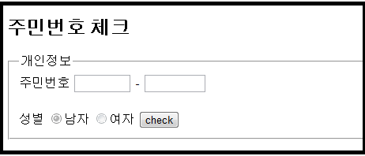

주민번호 앞자리 6자리 체크

주민번호 뒷자리 7자리 체크

**<form name=**"form"**>**

**<fieldset>**

**<legend>개인정보</legend>**

**<label for=**"jumin1"**>주민번호</label>**

**<input type=**"text" **name=**"jumin1" **id=**"jumin1" **size=**"6" **maxlength=**"6"

**onkeyup=**"focusChange(this);" **/>** **-**

**<input type=**"text" **name=**"jumin2" **id=**"jumin2" **size=**"7" **maxlength=**"7"

**onblur=**"genderCheck( this.value , form )"**/>** **<br/>** **<br/>**

**<div id=**"display"**>** **</div>**

**<label for=**"gender"**>성별</label>**

**<input type=**"radio" **name=**"gender" **value=**"man"

**checked=**"checked" **disabled=**"disabled"**/>남자**

**<input type=**"radio" **name=**"gender" **value=**"woman"

**disabled=**"disabled"**/>여자**

**<input type=**"button" **value=**"check" **onclick=**"**check()**" **/>**

**</fieldset>**

**</form>**