셀 스크립트 활용 과제
20252336 송우진

ex3-0.sh
vim ~/.bashrc
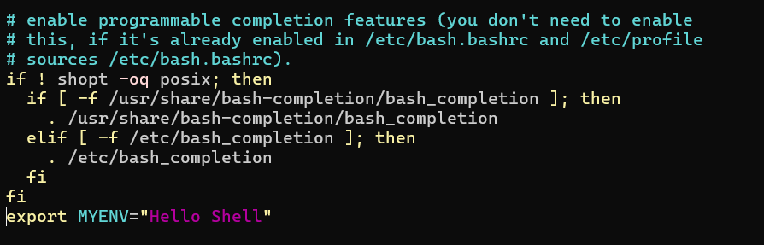
source ~/.bashrc
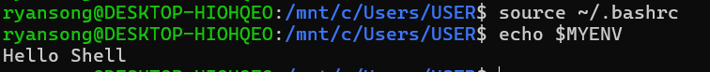
unset MYENV
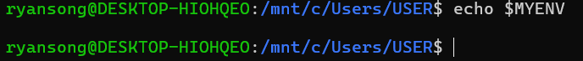
ex3-1.sh
#!/bin/bash

num1=$1
num2=$2

echo "Add: $(($num1 + $num2))"
echo "Sub: $(($num1 - $num2))"
echo "Mul: $(($num1 * $num2))"
echo "Div: $(($num1 / $num2))"
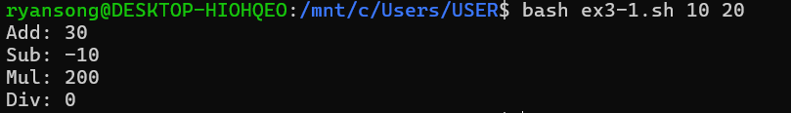
ex3-2.sh
#!/bin/bash

for x in "$@"
do
result=$(echo "0.5 * $x * $x" | bc -l)
echo "x=$x, y=$result"
done
ex3-3.sh
#!/bin/bash

sum=0
count=$#

for score in "$@"
do
if [ "$score" -ge 90 ]; then
echo "Score: $score -> A"
else
echo "Score: $score -> B"
fi
sum=$(($sum + $score))
done

avg=$(($sum / $count))

if [ "$avg" -ge 90 ]; then
echo "Average : A"
else
echo "Average : B"
fi
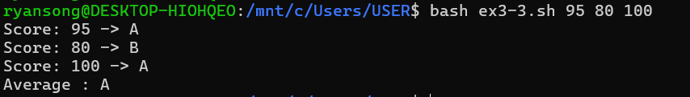
ex3-4.sh
#!/bin/bash

scores=()

while true; do
echo "1) 과목 성적 추가 2) 입력된 모든 점수 보기 3) 평균 점수 확인 4) 평균 등급(GPA) 변환 5) 종료"
read -p "선택: " menu

case $menu in
1)
read -p "점수 입력: " s
scores+=($s)
;;
2)
echo "입력된 모든 점수: ${scores[@]}"
;;
3)
if [ ${#scores[@]} -gt 0 ]; then
sum=0
for i in "${scores[@]}"; do

sum=$(echo "$sum + $i" | bc -l)
done
# 평균 점수 = 총점 / 개수
echo "평균 점수: $(echo "$sum / ${#scores[@]}" | bc -l)"
else
echo "입력된 점수가 없습니다."
fi
;;
4)
if [ ${#scores[@]} -gt 0 ]; then
sum=0
for i in "${scores[@]}"; do

sum=$(echo "$sum + $i" | bc -l)
done

gpa=$(echo "$sum / ${#scores[@]}" | bc -l)
echo "평균 등급 (GPA): $gpa"
else
echo "입력된 점수가 없습니다."
fi
;;
5)
echo "종료"
break
;;
esac
done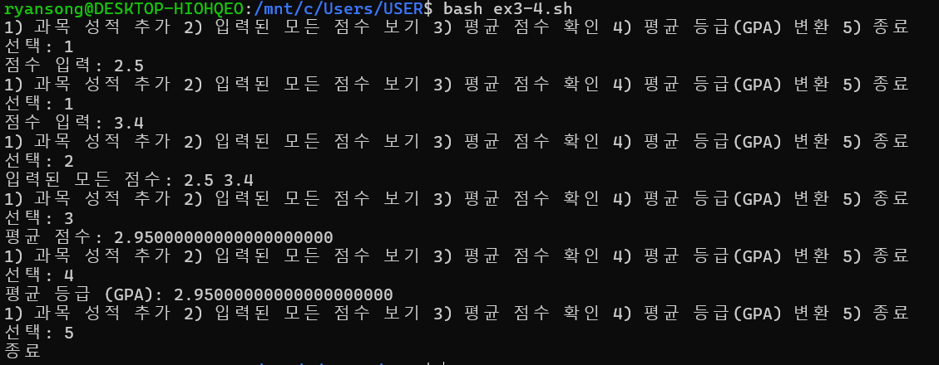
ex3-5.sh
#!/bin/bash
run_cmd() {

eval "$@"
}

run_cmd "$@"
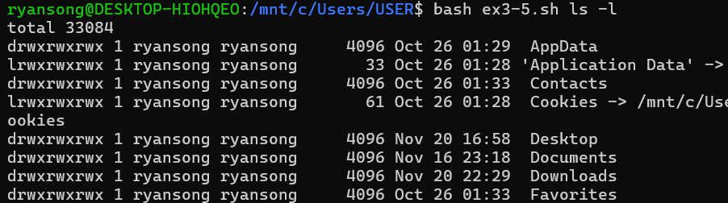
ex3-6.sh
import sys
print("Args:", sys.argv[1:])
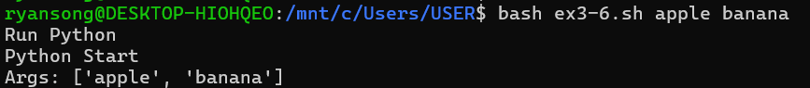
#!/bin/bash
echo "Run Python”
python3 my_prog.py "$@"
ex3-7.sh
#!/bin/bash
echo "1) 사용자 2) CPU 3) 메모리 4) 디스크"
read -p "선택: " choice

case $choice in
1) whoami ;;
2) top -b -n 1 | head -n 5 ;;
3) free -h ;;
4) df -h ;;
esac
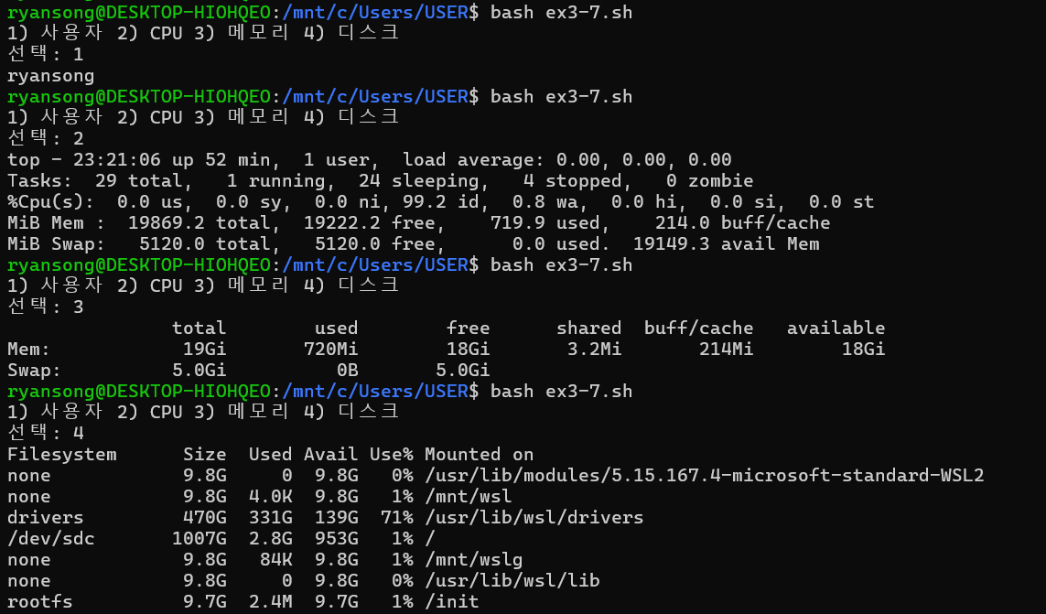
ex3-8.sh
#!/bin/bash
mkdir -p DB

touch DB/file1.txt DB/file2.txt DB/file3.txt DB/file4.txt DB/file5.txt
tar -cvf DB/files.tar DB/file*.txt

mkdir -p train
ln -s ../DB/file1.txt train/link1
ln -s ../DB/file2.txt train/link2
ln -s ../DB/file3.txt train/link3
ln -s ../DB/file4.txt train/link4
ln -s ../DB/file5.txt train/link5
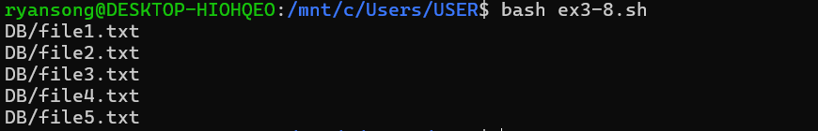
ex3-9.sh
#!/bin/bash
DB_FILE="DB.txt"
# 파일이 없으면 빈 파일 생성
touch $DB_FILE

while true; do
echo "1) 팀원추가 2) 기록추가 3) 팀원검색 4) 기록검색 5) 종료"
read -p "선택: " menu

case $menu in
1)
read -p "이름 전화번호: " info
echo " $info" >> $DB_FILE
;;
2)
read -p "날짜 내용: " log
echo " $log" >> $DB_FILE
;;
3)
read -p "검색할 이름: " name
grep "$name" $DB_FILE
;;
4)
read -p "검색할 날짜/내용: " query
grep "$query" $DB_FILE
;;
5)
break
;;
esac
done
