**Part 1**

1. **Create table `students`:**

CREATE TABLE students (

name TEXT PRIMARY KEY NOT NULL,

marks INTEGER NOT NULL

);

1. **Populate data**

BEGIN TRANSACTION;

INSERT INTO students (name, marks) VALUES

('Alice', 70),

('Bob', 100),

('Woojoo', 85);

COMMIT;

1. **Check the table**

SELECT * FROM students;

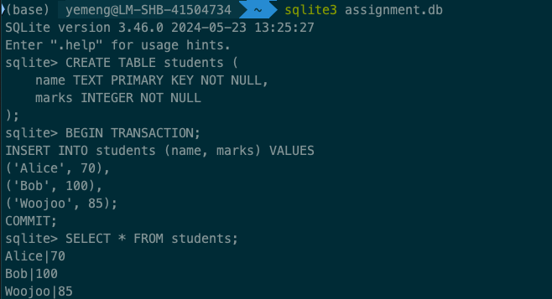

**Part 2**

After insert more data, now students table has 6 rows as following:

Test case 1: ram

Test case 2: RAM

Test case 3: empty string

Test case 4: TestS (not in the DB)

**Part 3**

Link: https://github.com/woojoo520/prework