AI607 Graph Mining and Social Network Analysis

Homework 3 Report

20214487 이건주

1. There are 4039 nodes and 176468 edges.
2. 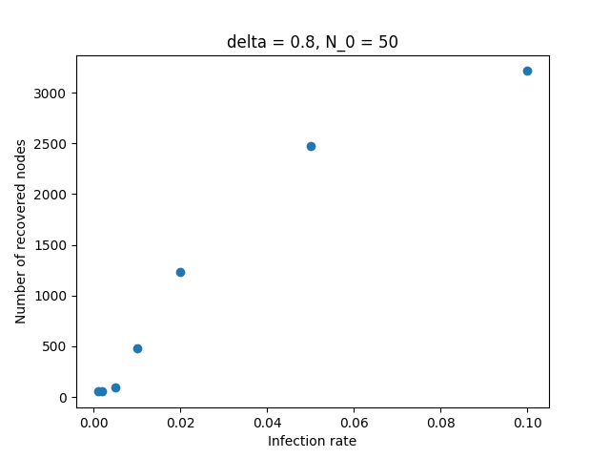Effect of the infection rate β

Figure 1 : A graph of infection rate and the final number of recovered nodes where recovery rate(δ)=0.8 and the number of initial active nodes($N_{0}$)=50.

Figure 1 shows the relation between infection rate and the number of recovered nodes.

We can see that the final number of recovered nodes is highly affected by infection rate(given that the recovery rate is quite high). There are almost zero recovered nodes where infection rate is almost zero, but the number of recovered nodes grows logarithmically as infection rate increases, and with infection rate 0.1, 3214.39 nodes recovered on average, which are almost 80 percent of the total nodes.

1. 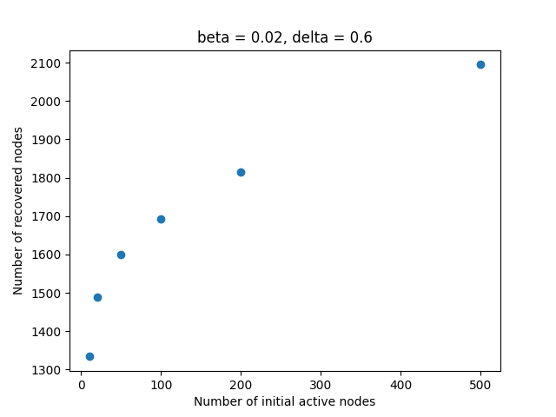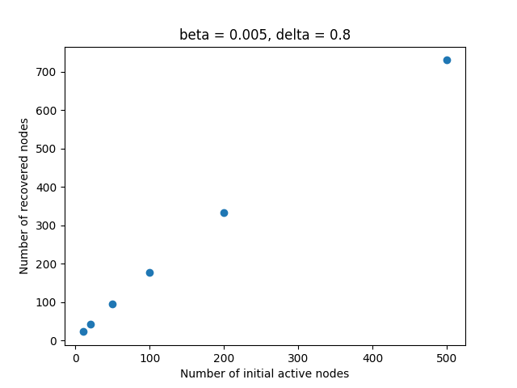Effect of the number of the initial active nodes $N_{0}$

Figure 2 : A graph of the number of initial active nodes and the final number of recovered nodes where infection rate(β)=0.02 and the recovery rate(δ)=0.6.

Figure 3 : A graph of the number of initial active nodes and the final number of recovered nodes where infection rate(β)=0.005 and the recovery rate(δ)=0.8.

Figure 2 and 3 shows the relation between the number of initial active nodes and the number of recovered nodes.

Where the infection rate is 0.005 and the recovery rate is 0.8, the final number of recovered nodes almost linearly increase as the number of initial active nodes increases, and the numbers are not quite different. This is because the infection rate is too low, so that the epidemic almost cannot spread and infected nodes are recovered almost immediately.

Contrastively, where the infection rate is 0.02 and the recovery rate is 0.6, the final numbers of recovered nodes are much greater and increase logarithmically, which means that the final numbers of recovered nodes are not affected much as figure 2, because the infection rate is high enough.