http://scikit-learn.org/stable/index.html

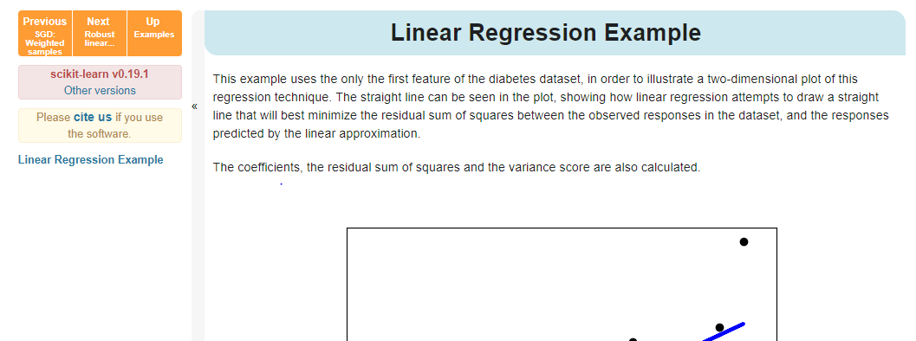

[**sklearn.svm**](http://scikit-learn.org/stable/modules/classes.html#module-sklearn.svm)**.SVC**

http://scikit-learn.org/stable/modules/generated/sklearn.svm.SVC.html