1. If you fail to add any parenthesis, the program returns a error missing parentheses in call to function. If you leave one parenthesis it will not return any value.

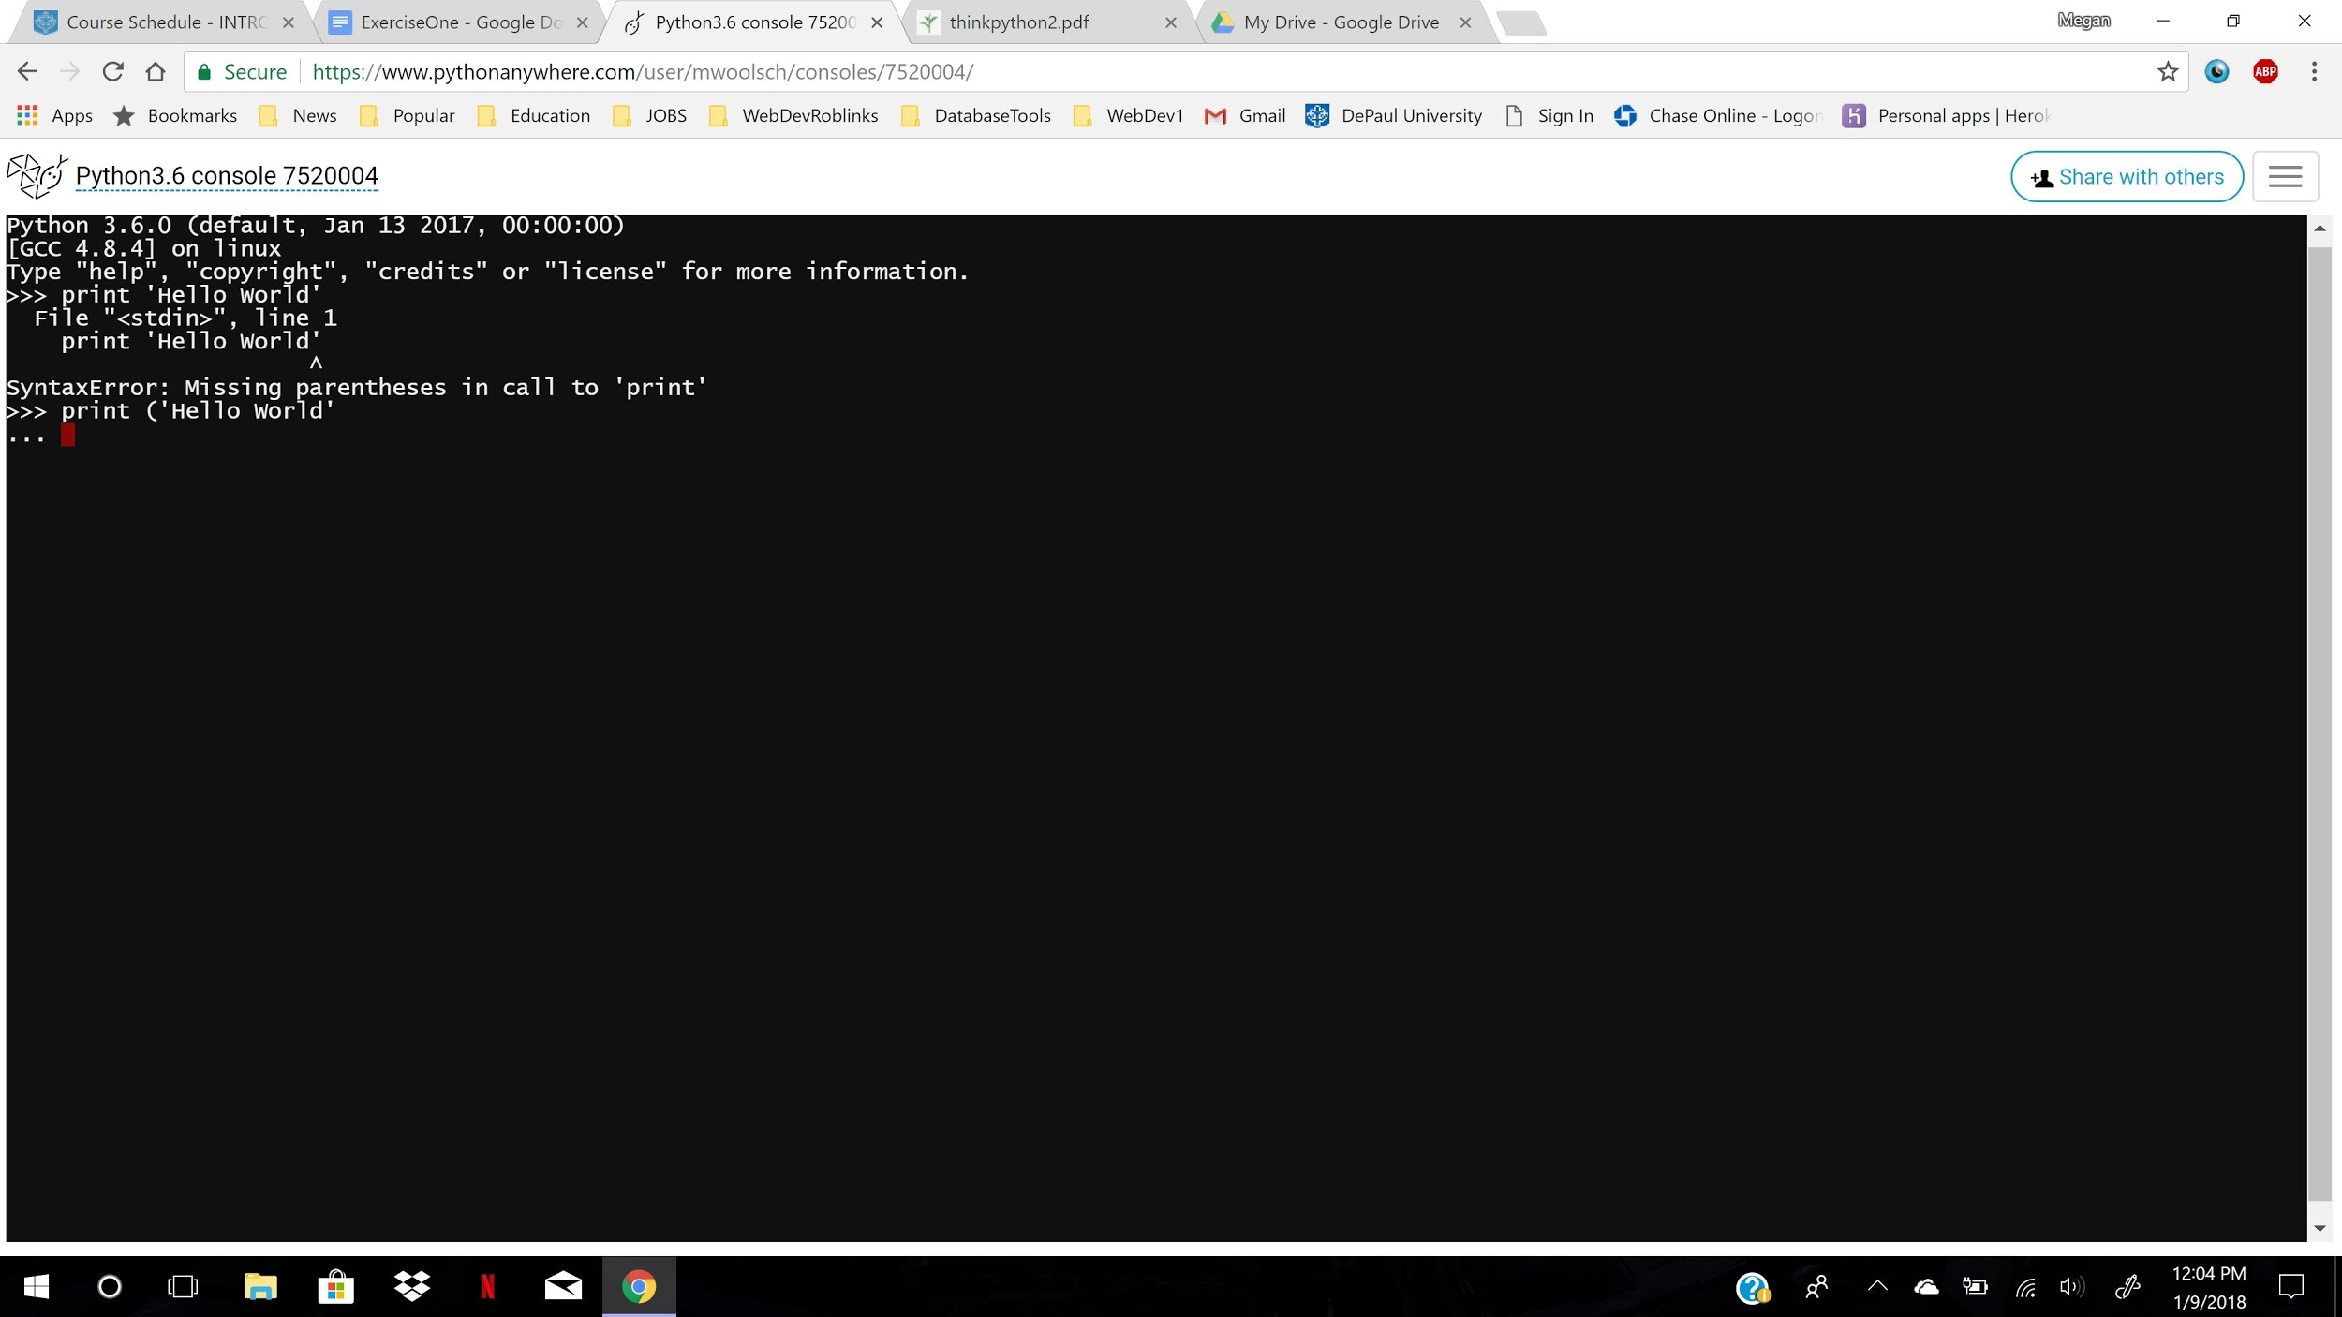

2) Invalid syntax if leaving both quotation marks out, and a end of line error while scanning

a string literal.

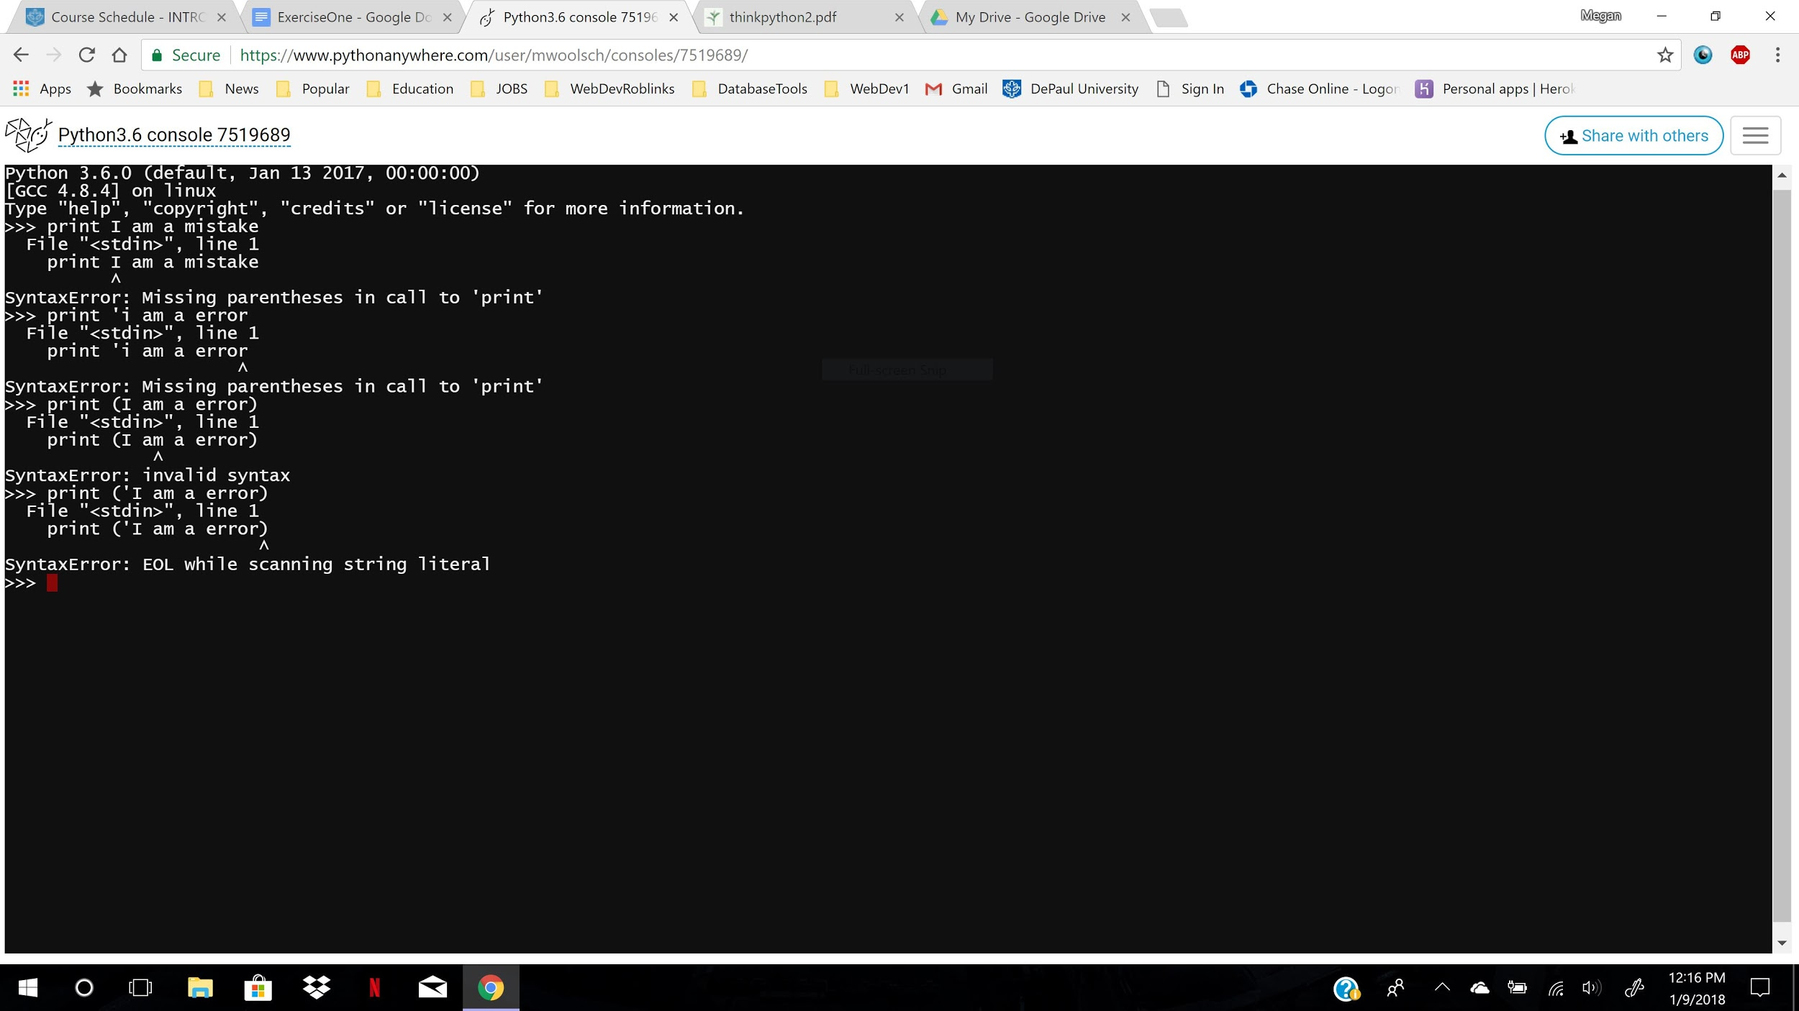

3) It did not change any of the equations output or answer, it performed the function. They are considered legal tokens.

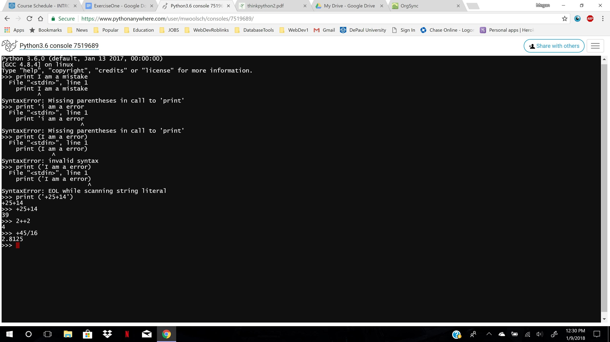

4)If you attempt to do a function with a leading 0, you will get a syntax error.

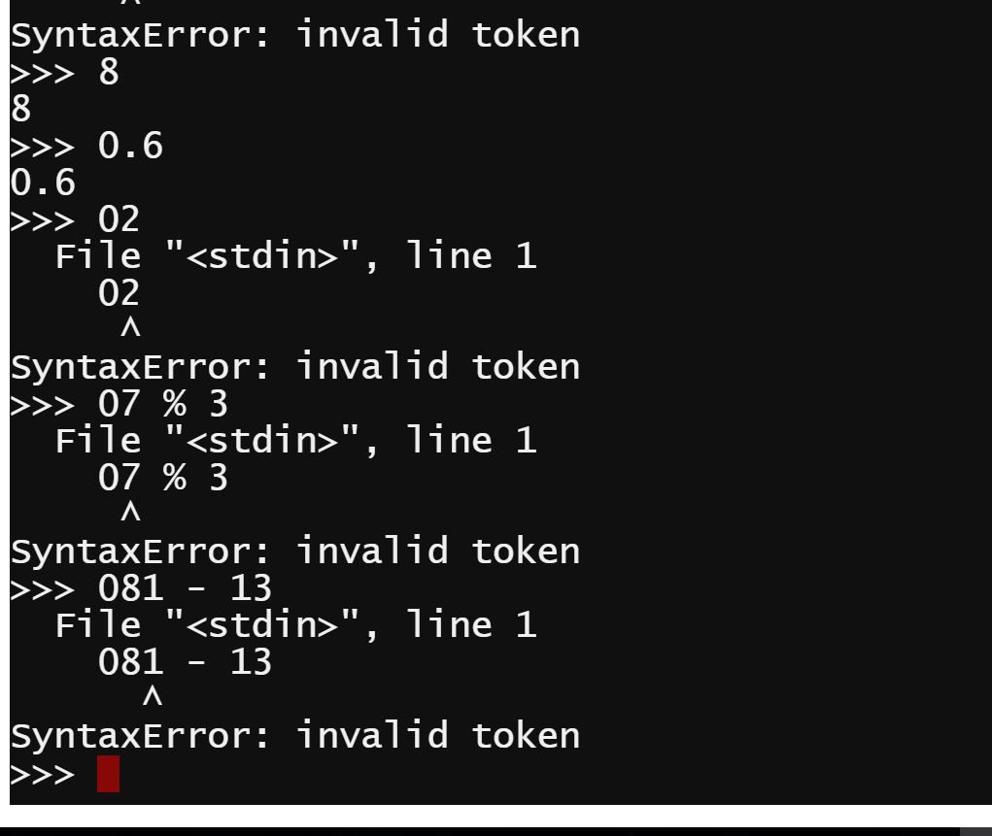

5) A syntax error happens if you forget a operator.