1. Syntax error: 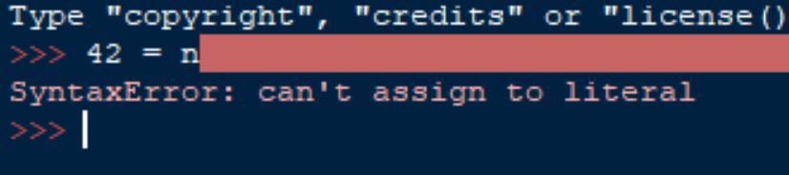
2. It runs but, prints out no output: 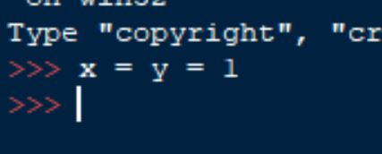
3. It does not include the ; it prints out the variable: 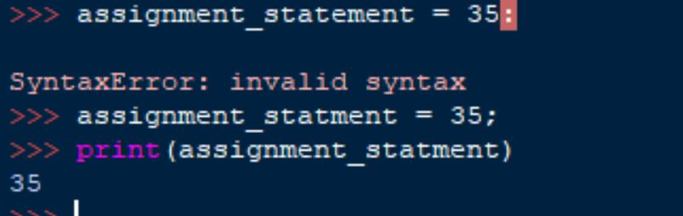
4. Converts the number to a float value: 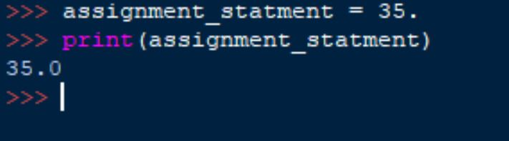
5. Thinks the output is a variable not defined: 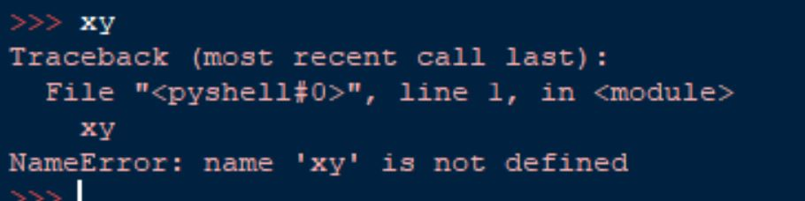
6. 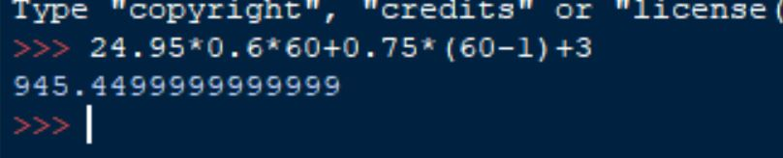
7. 7:30 AM I don’t know how to do it in python. 