**Small molecules tested for BADASS analysis**

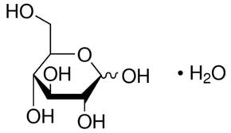**Sugars**

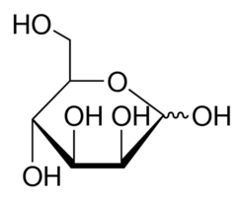

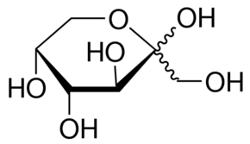

D-(-)-fructose

D-(+)-glucose

D-(+)-mannose

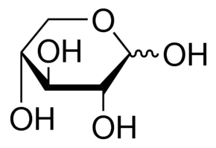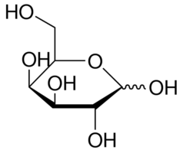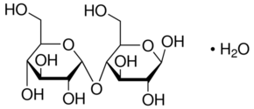

D-(+)-galactose

D-(+)-xylose

D-(+)-maltose monohydrate

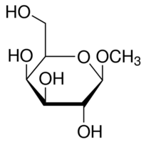

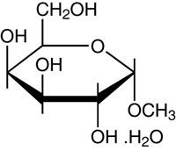

Methyl β-D-galactopyranoside

Methyl α-D-galactopyranoside

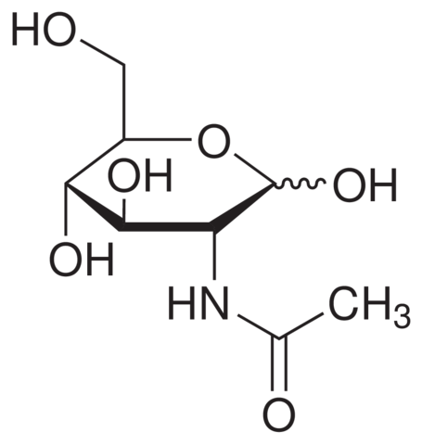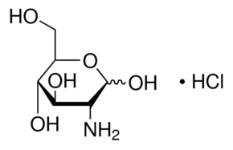

D-(+)-glucosamine

N-acetyl-D-glucosamine

**Amino acids**

**Fatty acids**

Myristic acid (C14)

Palmitic acid (C16)

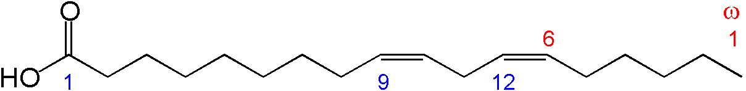

Stearic acid (C18)

Linoelic acid (C18)

Nervonic acid (C24)

Palmitoleic acid (C16)

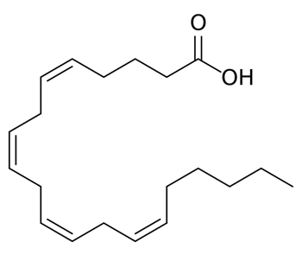

Oleic acid (C18)

Arachidonic acid (C20)

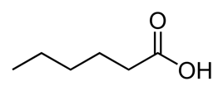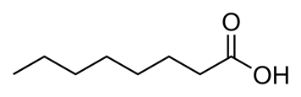

Butyric acid (C4)

Hexanoic acid (C6)

Octanoic acid (C8)

Decanoic acid (C10)

Dodecanoic acid (C12)

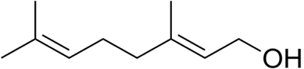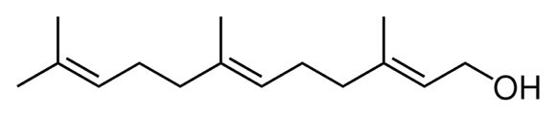

Geraniol (not a fatty acid)

Farnesol (not a fatty acid)

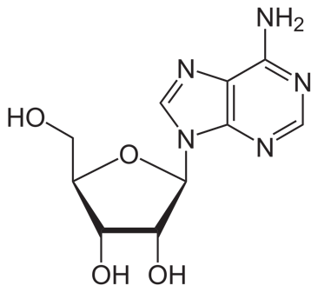**Nucleobases**

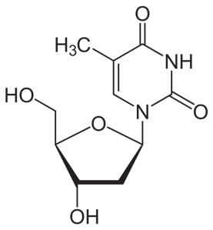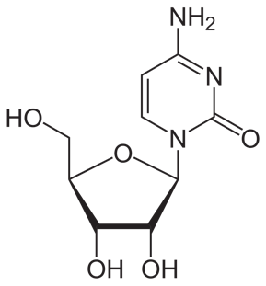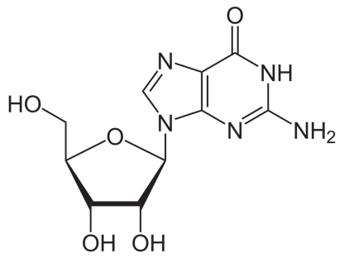

Guanosine

Adenosine

Thymidine

Cytidine

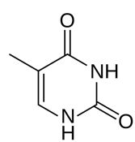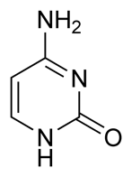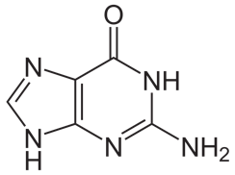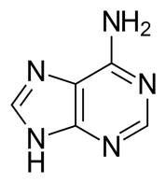

Thymine

Cytosine

Adenine

Guanine