Part A – Linear Regression

[a] and [b]

[Paste the predicted values for Group A & B Here. See sample format below. Same for Part B & C]

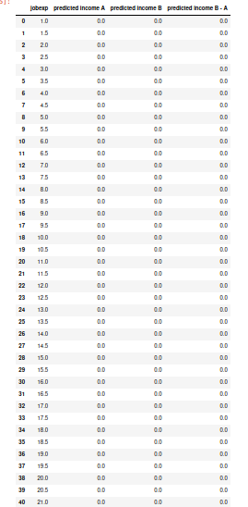

[c]

[Paste Chart Here]

Part B – Decision Tree

[a]

[Paste the Fitted Tree Here]

[b] and [c]

[Paste the predicted values for Group A & B Here.]

[d]

[Paste Chart Here]

Part C – KNN

[a] and [b]

[Paste the predicted values for Group A & B Here.]

[c]

[Paste Chart Here]