**HW3 Writeup**

**Prepared By: Woon Kim**

**UNI: wk2371**

**Date: February 13 2022**

[a]

Set the input to PowerTransformer as method = ‘box-cox’, standardize = False

Optimal lambda = -0.202

Skew.before = 4.016

Skew.after = 0.101

A side-by-side before- and after-transformation histograms are below:

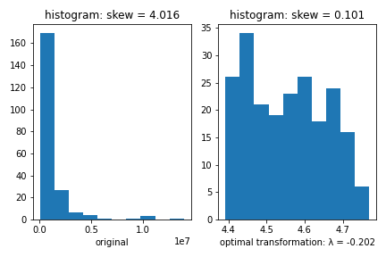

[b]

Beta_hat =

|  |  |
| --- | --- |
| Intercept | 4.0550 |
| EDUCATION | 0.0134 |
| NUMHH | 0.0076 |
| Ln(INCOME) | 0.0251 |
| MARSTAT = 0 | -0.0464 |
| MARSTAT = 2 | -0.0184 |

Sigma_hat = 0.1032

R2 = 0.3336

[c]

F = 20.72

Critical value for MARSTAT = 0 is 0.010

Critical value for MARSTAT = 2 is 0.609

H0 cannot be rejected since the p-value for MARSTAT = 2 was greater than 0.05.

[d]

Predicted amount = $561452.22

Prediction interval = ($460992.19, $461912.25)