Writeup

[a] Bayes Classifier decision regions

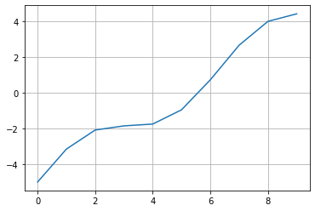

[b] The overall Bayes error rate =

[c] KNN (K=5) Classifier decision regions

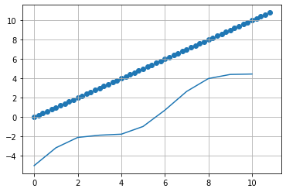

[d] Estimated KNN (K=5) Classifier test error rate via 5-fold CV