Writeup

[a] Bayes Classifier decision regions

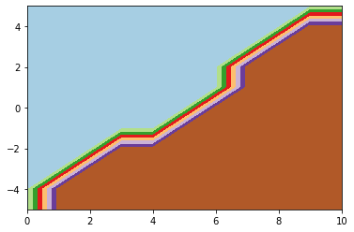

[b] The overall Bayes error rate = 0.1499999999999999

[c] KNN (K=5) Classifier decision regions

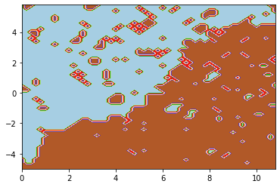

[d] Estimated KNN (K=5) Classifier test error rate via 5-fold CV

|  |  |
| --- | --- |
| **Validation Set** | **Estimated Test Error Rate for this Validation Set** |
| 1 | 0.30413223140495865 |
| 2 | 0.2809917355371901 |
| 3 | 0.2909090909090909 |
| 4 | 0.2628099173553719 |
| 5 | 0.3256198347107438 |
| Estimated KNN (5) Error Rate | 0. 2928925619834711 |